COVER

Employability Skills in the Workplace

Personal change and mindset for E-commerce in the 21st century.

BMSK4005 Lloyd Beharry
LEVEL4 Group3
1712412 Douglas Bousquet

CONTENTS:

INTRODUCTION
LIFE-LINE REFERENCE reflections
Historical reflections. New learning Skills and Values

- COURSE EVALUATION: SWOT / PESTEL / FUTURE AMBITIONS

- IMPROVEMENT SKILLS – LEADERSHIP / MANAGEMENT
(PDP personal development plan)
Managerial roles taken on by the prime activists for the platform need to be functional in a number of skills under the title hat of leader (The Mintzberg’s Managerial roles diagram [Here]
X3 references Identified positions. Degree of risk taking – leaving a position of work JOB – just over broke. Awareness of creative abilities verses working the system of poverty. – create your own. Residual income from various other sources.
- EMPLOYABILITY SKILLS NEEDED / SOUGHT – GREATER UNDERSTANDING
TOP X10 SOUGHT AFTER SKILLSETS FROM EMPLOYERS

Communication / creativity / Qualifications – Mentoring others – motivation and application.
Good at mapping out processes and funnels

Leaders and Managers needed skills:
Technical / Human – ability to work well with other people / Conceptual skills – work with and through abstract and complex situations concerning the organization.
GDPR legal.

CONCLUSIVE ANALYSIS: REFELECTIVE WALK – New learning
What is not working - Do it all yourself.
Collaborations (with the right people). Applying what you have and build.
Re-education when needed in new to the market areas, tools and applications. (To life experience of working for another).

Bibliography
BIBLIOGRAPHY – Referencing and sources. Listing of ref bibliography.

Ken Blanchard, Patricia and Drea Zigarmi (2015). The One minute Manager.New & updated edition. Thorsons Classics an imprint of Harpers Collins 2015.

Oyakhilome,C.(2016) The Power of the Mind.Believers Love World Pub.Pg29

Robbins, S. and Coulter, M (2016). Management. 13th ed. Boston [etc]: Pearson.
Top x10 Skills required by employers. Website Accessed Sept (2019) https://targetjobs.co.uk/careers-advice/career-planning/273051-the-top-10-skills-thatll-get-you-a-job-when-you-graduate
.

Stevenson, W. (2009). Operations management. 9th ed. Boston: McGraw-Hill/Irwin.

INTRODUCTION
BE ONE WITH THE JOURNEY -APPLIED TO BUSINESS
This report will be a reflective review of the influence of re-education while at the University of Wales Trinity Saint David, over my working experience. The course which covers aspects such as employability skills for the work place and uses academic theories and skillset knowledge required for the working environment are looked at with my view to expand a position of self-employment and future effective growth of a business platform online.
Aspects to be explored will include reflective review of lifeline experience, historical overview for the context of then and now. The effects of re-education while studying the courses at UWTSD, (University of Wales Trinity Saint David); Swot ,smart and Pestle analysis in relation to business platform choices and a personal development plan to establish areas of improvement and steps moving forward. To close, my ambitions outlined and concluding summary analysis.
While the task has asked to consider the skills required for effective employability in the workplace, I have adopted a position of employer seeking to find such required qualities and skills in potential working partners, staff to train (in full or part-time capacity). Such skills as time management, analytical thinking, proactive planning for operations and problem solving along with good communication abilities are now measurable following the course studied and will be highly desired and sought-after requirements of any working partnership relations.

LIFE LINE REFERENCE - REFLECTIONS
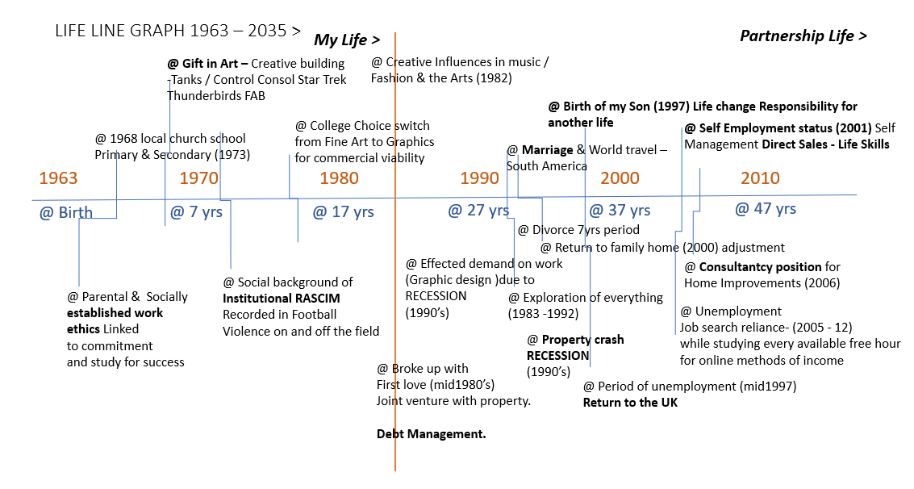
Lifeline chart variant a (Andy Chan @2008)

My full time position as an Online Marketer establishing a web-based platform in support of local business promotions (Changeandeffect Ltd) has allowed me to manually apply the theories explored through the university course to work direct to a real life situation. By applying my natural talents and past working experiences I have validated some of the findings defined in the course.

Career changes - Employability Skills in the Work-Place applied.
I am currently working to establish a start-up business platform, supporting the needs of local business owners in their effective promotions of their brand, product and services. The platform is web-based and encompasses additional aspects which are designed to enhance creative skill for young people in the integration of technologies with commerce. For skilled trainees, creative artist using digital means. As well as the new marketplace of integration of social media with business.
The desire to work on and develop with the Platform ‘Change and effect Ltd’ is born out of an increased awareness of purpose. Emphasising my abilities to do; and historical experience in fields such as Direct Selling (Local Business Discount cards), Marketing (Freemans Mail Order Catalogues), Packaging (Superdrug stores), Independent Specialist design firms ( Major Display, Perfect Publishing) and Design Consultancy for Kitchens & Bathrooms in home improvements for the ‘sheds’(Wickes, Homebase).
The creative strengths I possess have been the focus of my academic career being natural in feel and application. I feel a greater understanding through visual responsive learning.
The direction to move from the creative discipline of fine arts to a more commercial discipline of commercial art with Graphics and Media were based on the realisation of ‘How to make money with something I loved to do? Art as a natural talent – expression to commercialism – skillset acquisition – Purpose in life.
The skill to produce commercial art that paid for itself beyond being a unique creative talent were fashioned from learning and honing skills required in critical thinking of designing for the disciplines in processes of design brief solutions, research and design development as a problem solution for an end result. Interpersonal skills for interpretation, analysis, creativity and resolutions to tasks all came from the experience of the design processing in use with the development of the technological options being applied to complete for the end result.
The collaboration of my desires, skills history and abilities into the factors which act as my guide and criteria for business success. A conscious move from the ‘ You should do things this way’ to ‘ Do you want to do things this way’ and ‘How can I best apply my abilities to achieving this with my unique experience. Attitude.
Spiritual nurturing and awareness (in fellowship and study of the WORD) to who I am and my defined purpose in life act in support of my desires, aims and ambitions were identified with the return to learning through the course in a new and divergent way. Creating a far more interesting and rewarding experience of development in the thinking process and personal growth as a result. Acting as a time reflecting on the abilities to do; for what is genuinely purposeful, defining my worth and connecting me with all important things in life for a positive and productive outcome. “Therefore, don't be conformed to this world. Don't live like them, or think like them, or see from their perspective. Instead, be transformed, transfigured, and translated by the renewing of your mind.” Oyakhilome,C.(2016) The Power of the Mind.Pg29
Raised at a time in the 70’s in a backdrop of racial hostility; being exposed openly too the introduction of a generation welcomed to the country as laborers, has changed radically in my lifetime of some fifty years. In many ways and in some ways not. The resentment to the influx of workers, distinctive in colour of skin and culture have been suppressed by changes to the nation through integration and with the offspring of mixes of people. Living standards have been earned and have challenged the acceptance of inclusion, through high demand in skills, ability and characteristics of the uniqueness of those brought to a new land from their ethnic origins and highlighted in sports, arts, and entertainment. The sterio-type of old had been broken by that of the current and the challenges of present are being managed by the new.
In contrast to the old former ways of being educated, to fit into social norms, suppressive frameworks may have got the immediate job done, but inevitably would create situations further down the line which should be given the human element of creativity and enginuity to come out with a new way of thinking formed by a new way of learning. The challenge to society is whether the support for this new thinking is encouraged in time for new approaches and situations or would be made in time before it’s too late and society “stalls”. Through applying outdated methods and principles or to adapt to change by engrossing it.
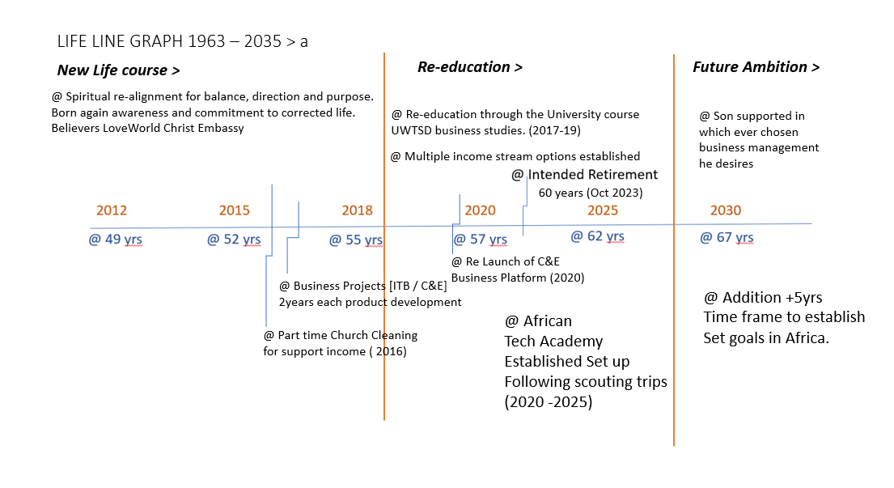Lifeline chart variant b (Andy Chan @2008)

SWOT
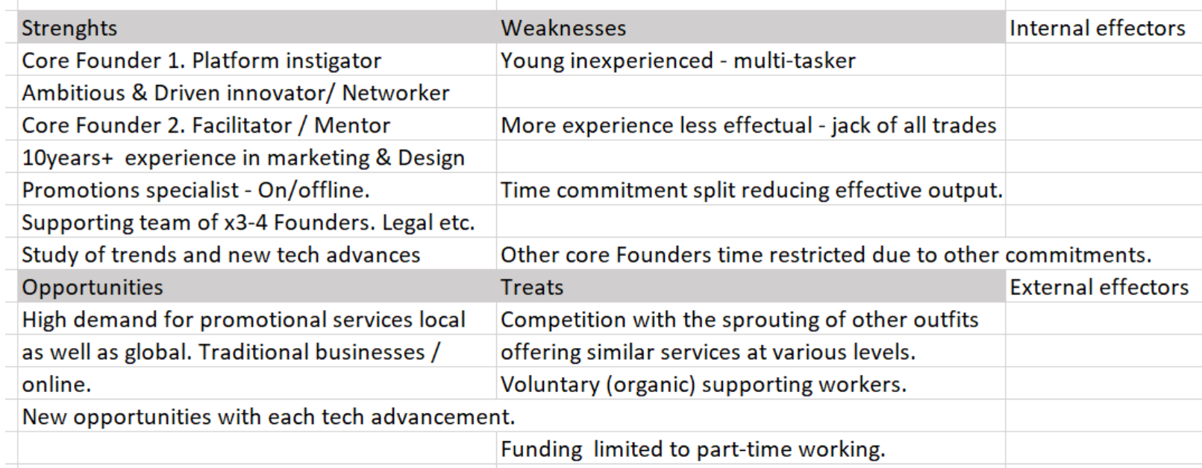
SWOT for online platform Change and effect Ltd and Founder members

Personal reflections and competency in working effectively and development plan.

Personal Strengths:
Considerate; great ability, committed, Supportive ambition, visual perceiver, grifted artistic skills, developed good use of the English language. Strong work ethic, time management, patience. Team and solo worker. Self-determination – drive for desires. Ambition.

Personal Weaknesses:
Complicating processes, unfocused, Supportive ambition- attainment through others, poor numeracy /arithmetic skills,

OPPORTUNITY: Personal development in the application of leadership as role model (mentor) within the platform Change and effect Ltd.

TREATS: Increased competition as the new positions of integration of technologies into everyday use commerce’s is expanded upon by other trained individuals.

Using the commonly known assessment of SWOT, to analyse personal as well as business factors in a manner which a strategy can be adopted for a particular end result. Exploring strengths and weaknesses reflectively usually internal influences comma and opportunities and threats which pose externally influencing factors, to consider. The nature of the outside business environment.

Personal development plan.
Personal Strengths
Good verbal communication skills – speech, presentation
Non-verbal Empathy, Skills
Transferable skills
Experience in sales (direct and consultancy), Education in Graphic Design, Print, Packaging and Publicity.
Solo disciplines and team worker, Time management and appreciation.

Critical analysis – design background
Solution funding and conveying messages

Life balance (50 years+)
Character and emotions – Drive and ambitions
Experience over financials – giving back
Genuine, quality first, giving back, reciprocity
Unique mix of experiences and skills combined into new technology study for a digital marketing platform.

PDP:
- CURRENT ROLE AND FUTURE ASPIRATIONS
Over the past 2 years my work has been in exercising the skills acquired through my working life and creative education. With the critical analytical evaluation of a task or brief, the functioning operations of a platform to produce and provide a source of positive trainings to allow for expression and education using the technology of present and future enhancements applied to the offline urban business and youth employment workshops and marketspaces.

- GOALS
For the next 2 years my plans are to establish solid foundations in mentorship for local or global training workshops.

Provide an E-commerce platform solution for the subscription of any individual seeking to establish a residual income and financial independence.

Develop skillset training for management of Freelancers and outsourcers in the supply of services to local business through the platform Changeandeffect Ltd.

Continue to hone and refine the automation systems of service provision to move from a position of mid-management top management level.

- MODERATION
Monitoring of progress will be periodical, quarterly (each x3 months) and reviewed in collective meetings of the current CORE leaders of the platform.

S.M.A.R.T. Goal setting
By using the tool acronym a review of tasks and goals can be established for monitoring progress to an end goal.
Day today jobs
(S) Specific
increase revenue to platform by targeted pictures of a single service provision equals page one search rankings placement for any business with an advertising budget.
(M) Measurable
CRM management of emails times 2 Daily Times 10 weekly times 30 plus monthly. Target monthly and quarterly reviews pricing no fee until placed. Then 297 pounds per week maintenance unlimited visitors, unlimited buying customers.
(A) Achievable
one person’s focus achievable. Yes, Map out process for others to replicate or provide to outsource multiply.
[R) Relevant
the result is important to bring income to a self-funding project. Allowing services to continue in the development of the platform in other areas.
(T) ‘Time bound lie’ efficiency in completing tasks measured monthly and quarterly from May, 2019 platform structure development from September 2016 2 to date. 297 pounds per week times 4 equals £188 per month divide by 2 split 4 Co-founders 594 H. For one client. You line from my list in smart goal setting, I can establish a game plan that will address my immediate objective , that of continuing participation of the platform by ensuring income is made when the platform continues to be viable and self-reliance. (At this current time without external investment). Leadership skills through delegation as well as hands on application is a secondary position positive to the set tasks of the following month.
1.Refocus of prospect pool. Foot pain recipients of service provided.
2.Focus on one service for all potential client of a similar niche group.
3.Multiply by systemising the pitch and fulfilment of service offering.
4.Monitoring processing funnel, for communication, fulfilment and follow up to pitches to prospects in an attempt to increase ROI on service offerings.
5.Scheduled to allow for additional projects rolling alongside. Monthly and quarterly assessments asset as standard. Smart goals
6.Establish a working funnel for the effective prospecting of business clients by providing a key service as an introduction to other potential offerings under platform umbrella of services. You line for film and can be via the core members or outsources and sales personnel.
7.Evaluation will be made weekly, monthly, quarterly from CRM stats and email responses recorded. Timeline
8.Reviewed as with milestones.

_{FUTURE ACTIONS :}

Focus on a service provision then multiply.

Isolate a market sector (Niche) and produce a ‘demo pitch format’ as a mass marketing tool / portfolio.

Take advantage of the pools of business networks in exhibitions / chamber of commerce and online data bases such as LINKEDin and Google search.
Affiliate marketing options in support of alternative income streams for platform maintenance.
Milestones:
Sales of first £100 income Product value £ 97 / £297 / recurring monthly subscriptions
Sales of first £500 income
Sales of first £1000 income

Sept 2019 = Create sales demo pages for niche categories of focus. (Produce the work first then pitch to likely prospects on mass for the respondents to be serviced.
Oct 2019 = Refine engagement funnels for prospecting and conversions. Optimised for sales options and alternatives for each prospect. Ensuring over delivery of value to maintain customer engagement and satisfaction for a long-term working relationship.
Target Milestones:
First £100 income (£97 per service provision) x10
First £500 income (£297 per service provision) +2
First £1000 ( £497 per service provision ) +2

FUTURE GROWTH AMBITIONS
COURSE EVALUATION - models and questionnaires
In our first lesson we reviewed the most likely important requirements for successful exchanges within a working group concerning behavioural expectations. This included codes of behaviour in a classroom or study environment following the expression of some students’ grievances concerning relocation of campus. In the light of poor communication, exchanges between certain individuals the ability or in-ability to express concerns, or views effectively were demonstrated. Some of the other considerations are listed below:
Considering the individual as well as the collective.
Co-operation and mutual respect
Constructive and appreciative contributions from all members
Agreed code of conduct – talking one at a time. Listening to all views. Debate – brainstorming.
Progression of ideas, conversations and expressions. Offering solutions not problems. These factors were apparent in the exchange and a ‘live’ expression off what we were engaged in studying through the course modules was made.
We consider also a personal development plan briefly touching on measurable tools to monitor our findings such as SWOT analysis and SMART acronym highlighting personal confidence and competencies in the reflective views of our professional career development.
Overall a positive attitude to learning as well as towards others in the group of varying learning abilities and confidence levels in both verbal and non-verbal expression / communications were factors to consider. 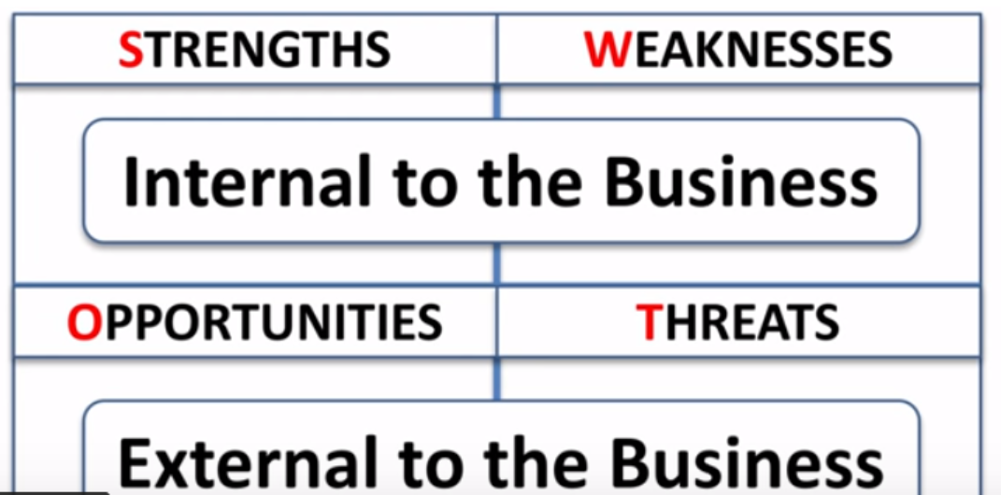
Assessment of business model SWOT quadrants Analysis

- STRENGHS – Creative interest in present and future technologies.
Cultural and social heritage perspectives.
Desire to pass on knowledge and information.

- WEAKNESS – Larger projects, fewer active members
Lack of experience in execution.

- OPPORTUNITIES – New marketplace and niche markets
- Technological influence.
- Global economic transition in trade and finance.
- Hunger for economic growth, locally and globally.

- THREATS – lack of funding to maintain and support ongoing running costs and growth.

The VARK (2005) acronym, questionnaire model, for preferred learning styles identifies me as being predominately visual in learning preference with kinaesthetic appreciation as a compliment. Relying upon auditory awareness the least. This awareness definition was heavily apparent in my course work and submissions in the compilation of notes, referencing and presentations.

EMPLOYABILITY SKILLS NEEDED / SOUGHT – GREATER UNDERSTANDING
READYNESS FOR EMPLOYMENT OR EMPLOYER ROLE
TOP x7 SKILLS EMPLOYERS WANT:
- COMMUNICATION SKILLS – VERBAL AND NON-VERBAL APRECIATION
- TEAM WORKING SKILLS – COLLECTIVE INPUT
- NEGOCIATION AND PRESENTATION SKILLS – CONFIDENCE
- PROBLEM SOLVING ABILITIES – ANALYSIS, INTUITION AND PRO-ACTIVITY
- LEADERSHIP ABILITY – SMALL MANAGEMENT TO OVERSEA GROUP ACTIVITIES / PROJECTS
- PERCERVERANCE, DILLIGENCE AND MOTIVATION
- ABILITY TO WORK UNDER PRESSURE

With a personal history of working for others in various positions the development of skills listed above for improvements in results was encouraged by the required tasks of each job for efficiency and better outcomes as a result. And would be sought by any individual seeking to contribute to the platform.

Wisdom (thinking further than the present) and the mix of current technological advances in use in the marketplace give for a unique position of advantage. The marketplace shift from employee to inspirational leader requires and inspires creative solutions. The conclusion of the Brit-exit decision (Summer of 2019) will create a new environment forcing change. New thinking for exploration and elaboration of old practises.
Academic structuring coming quite late on as a rounding up of experiences finding together changes and developments. Practiced and applied recognised pattern theories and principles of operations in the business environment.
knowledge has come about not by being informed of a pattern of work but by a greater understanding of the requirements and rules applied to the standard majority of workforces. On how things work. How to produce and gather information and ultimately process it effectively to produce a greater outcome. Shut storytelling past experiences to solve the problem.

ANAYLITICAL REPORTING
WHO AM I LOOKING TO WORK WITH?
Those who I seek to work with will be unconventional in ideas, creative in expression and resolve and have a driving force / passion for what they get involved with. A reflection of my own values in a strong work ethic. Disciplined in Setting about a task, overcoming obstacles and maintaining high levels of application to complete the task required. Seek to learn, develop and improve on results. Again, strong work ethics in time management, listening and communication skills needed. Also, an inter-dependant ability to work solo or as a team member for mutual outcomes and positive gains. A reflection or clone of myself.

The collaboration with core individual in this process has to some degree attempted to be applied. The principles highlighted by the Johari window and is only gradually being adopted. Partly due to personal intimacy trust establishment comma and partly due to the multi trading approach applied. To have an effective launch of the platform and its services.
I believe that more than simply applying my experience and skill set to establish the platform objectives that of supporting the community in talent expression, creativity and entrepreneurial spirit, growing trust and engagement overtime will increase my open free window area to include other aspects which are not solely applicable to methodology, skill-set, application of a craft or management of operations.

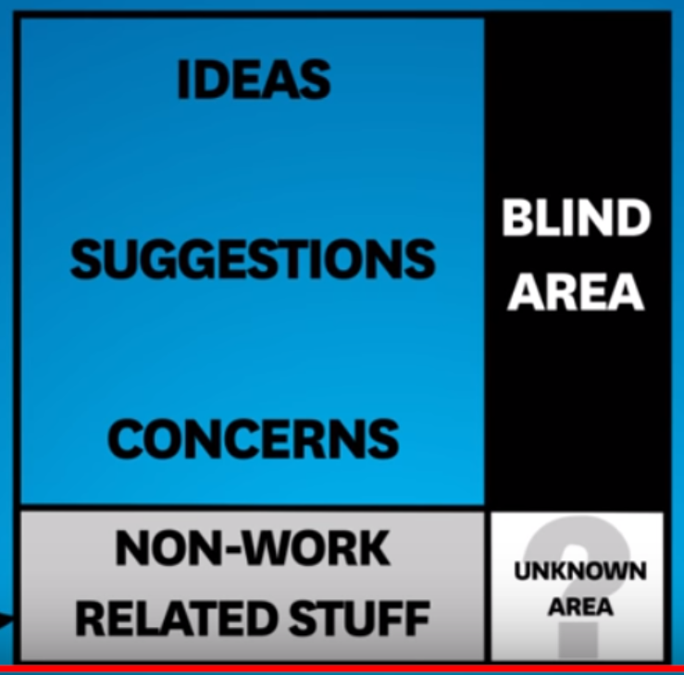 Joseph luft and Harry Ingham. (1955). Johari Window model.

Johari window is a recognise study of influential effects in communication through and with the team knowledge of individuals through a quadrant categorization. When applied to me, to the business, so a greater understanding can be developed as well as trust. (Joseph luft and Harry Ingham. 1955).
Further action development equals greater use of the Johari window principles to establish trust and confidence between team members of the platform company. Both at a core-founder level as well as a more regulated version for the support workers and outsources.
Two years working on the project development for C&E has established a credibility based on similar values and ambitions to support others in growth through expression of skills and talent as well as presenting new ways for wealth creation and generation. Primarily to local business operators, filling in the gap left by large business operators servicing providers seeking larger paying clients has more viable business proposition. The small business owner aware of the need to be more effective in promoting one of our target market sectors for generation of revenue the business.
The collaboration with core individual in this process has to some degree attempted to be applied. The principles highlighted by the Johari window and is only gradually being adopted. Partly due to personal intimacy trust establishment comma and partly due to the multi trading approach applied. To have an effective launch of the platform and its services.
I believe that more than simply applying my experience and skill set to establish the platform objectives that of supporting the community in talent expression, creativity and entrepreneurial spirit, growing trust and engagement overtime will increase my open free window area to include other aspects which are not solely applicable to methodology, skill-set, application of a craft or management of operations.

Awareness of self and to others within the working environment for greater understanding and trust between colleagues using the Johari Window model.

Using the commonly known assessment of -SWOT, to analyse personal as well as business factors in a manner to which strategy can be adopted for a particular end result. Exploring strengths and weaknesses reflectively usually internal influences comma and opportunities and threats which pose externally influencing factors, to consider. The nature of the outside business environment.

Diversity of skill set mixed with creativity Business strengths.
Working along-side artists, musicians, image graphic artists and photographers, actors, writers and entrepreneurs a versatile management of communication skills with sound team working and leadership abilities would be required to maximize potentials in platform use.
Personal strengths good verbal communication skills, speech, presentations. Non-verbal empathy, skills. Transferable skills. Experience in sales direct and as a consultant. Education in graphic design, print, packaging, publicity. Solo disciplines and team worker, time management and appreciation. Critical analysis, from design background, solution finding and conveying of messages. Life balance, 50 years plus. Emotional and character, drive ambition. Experience over financial. Giving back. Character, genuine, quality first, giving plus receiving Newmarket offering C&E unique mix of services, digital marketing. Lead advantage. Reciprocity. Cialdini, R. (2017)

The VARK (2005), questionnaire model for preferred learning styles identifies me as being predominately visual in learning style with a kinaesthetic compliment relying on auditory awareness skills the least. This awareness was heavily apparent in my course work and submissions in the compilations of notes and referencing.

EMPLOYABILITY SKILLS NEEDED / SOUGHT – GREATER UNDERSTANDING
READYNESS FOR EMPLOYMENT OR EMPLOYER ROLE
TOP x7 SKILLS EMPLOYERS WANT:
COMMUNICATION SKILLS – VERBAL AND NON-VERBAL APRECIATION
TEAM WORKING SKILLS – COLLECTIVE INPUT
NEGOCIATION AND PRESENTATION SKILLS – CONFIDENCE
PROBLEM SOLVING ABILITIES – ANALYSIS, INTUITION AND PRO-ACTIVITY
LEADERSHIP ABILITY – SMALL MANAGEMENT TO OVERSEA GROUP ACTIVITIES / PROJECTS
PERCERVERANCE, DILLIGENCE AND MOTIVATION
ABILITY TO WORK UNDER PRESSURE

Weakness
category numeracy mental arithmetic. Multitasking to effect. Generating wealth.
KPI, key performance indicators.
USP, (Unique selling point of platform), urban digital marketing network with crossover into youth creative hearts, fashion and entrepreneurship. Yet to be established. Visibility. Profit margin, operating currently without external investment support. Brand recognition, organically developed through the ethos, customer loyalty, giving back to the next generation through mentoring. Be one with the journey.
Value growth potential equals global.
Self-monitoring for quality service provisions. Leadership and skills development.

Opportunities and threats using pestle model.
To assess the external opportunities which could effect, personally and in business the platform C&E. How advantage could be made into opportunities.
Gathering grassroots support through local business ownership, charities, government support projects, national funding projects I Prince's Trust, angel investors, partnerships with entrepreneurs.
Factors outside your control but positive in results. On the negative reflection the threats, would be competing operations providing matching services. In the area of social media content management, regular advertising methods her digital advertising.
Educational in the service provided. Not fully understood as technologies rapidly upgrading and changing. Too high tech to be fully applied understood.
Creativity mixed with tech require for innovative solutions both as unique selling point and as a threat if mixed mixture is not achieved and conveyed.

In refence to Hersey and Blanchard and their reflections on ‘Situational Leadership’ I have learnt that:

MOTIVATION
Having left the position of work to start something yet to be established as proven on the grounds of personal satisfaction above financial security, I believe I am strongly motivated and have shown over time that I have strong motivational drive. Combined with positive thinking and spiritual balance in direction of purpose my persistence is forging the channels to my success and the fruits of ‘the seeds’ song to date. Day to day practices of reviewing my ambitions, targets and set goals have become my focus living and breathing consideration in life. My help, dreams and visions are encouraged with like- minded individuals striving for their aspiration, hopes and dreams but being willing to help and support others along the way. Being one with the journey, of self-expression for the positive growth in order to empower the whole in community throughout generations. Through change and effect Ltd. Motivational environment. Through co founders having accountability and like-minded ambition.
With an ethos of supporting others along the way in a creatively expressive environment, catches the reasoning for the last two years of committed development to the platform change and effects primarily on the business operations side

John Adair Decision Making and Problem Solving

Using the commonly know assessment template SWOT to analysis (Person as well as business) factors in a manner in which a strategy can be adopted for a particular end result. Exploring strengths and weaknesses reflectively usually internal influencers and opportunities and tweaks which pose externally influencing factors to consider the nature of the outside business environment.

Business strengths
Diversity in skillset, creatives, (Artist, musicians, image graphics Artist, Photographers, Actors, writers and Entrepreneurs

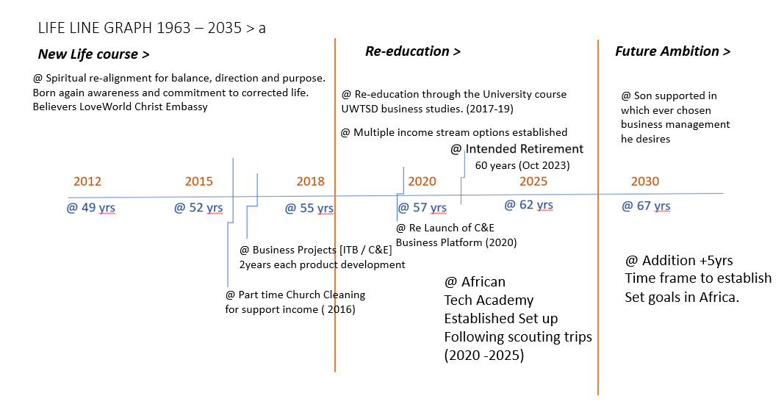
Continued lifeline chart b – Ambitions and future planning

ACTION PLAN - I feel I will required ongoing study development in leadership skills. Refs: 1-3 books / online resources
By doing so I will take charge of my own learning improvements in an proactive manner. This will most likely strengthen my resolve through greater understanding and produce faster outcomes of desired results.
The role of managers are to…. Ref / Level of management (P37)

Establish fully functional platform to execute:
- Youth support in creative expression – Changing the narrative and providing options for creative positive growth as an alternative to knife crime entertainment.
- Business support in the urban landscape focusing on local business operators. Bridging the gap between the educated and digital savvy business owner and the already established but flagging local trader.
- Providing self sufficiency to those with an entrepreneurial spirit using E-commerce as the cornerstone tool for income streams.

FEELINGS-
FEELING before /during and afterwards. Feelings of others -verified by reaching similar conclusions to anticipated outcomes. Your feeling now?
In retrospect, / on reflection my initial strategizing have been proven to be validated over time. I should exercise more confidence in my thinking of operations to exact quicker productive responses to the tasks, goals and objectives set out in the progression of the platform changeand effect Ltd.

With an ethos of supporting others along the way in a creatively expressive environment, catches the reasoning for the last two years of committed development to the platform change and effects primarily on the business operations side

(PDP) Personal Development Plan
Using the assessment formula for future development action a swot has been outlined below and reviewed.
.Weakness category
Numeracy – mental arithmetic
Effective Multi-tasking
Generating wealth – mindset to achievement surrounding myself in the right environment for attainment – like minded individuals.
KPI = Key performance indicators – ability to generate income for the platform from conversion of services.
USP = Urban Digital Marketing Network with cross over into youth creative arts, fashion and entrepreneurial spirit.
Operating currently through self-funding.
Yet to exercised VISIBILITY, for BRAND recognition. Organically developed response of interest through the platform ethos ‘Be one with the journey,’ customer loyalty and interest; giving back to next generation through positive role models and mentoring.
Value of growth potential = global reach.
Self-regulating, for quality control and service provisions.

IMMEDIATE TARGET / GOALS:
Focus on 1 (Niche area and one service supply)
Pitch re-presentation – lead from defining the value from the work required to achieve marketing targets.
Replace myself with skilled task providers – outsourcers and freelancers.

MID TERM TARGET / GOALS 3-5years:
More study and reflection on management roles and assessments for more productive results.
Longer term 5-8 years:
Research and visits to potential new markets in Africa to establish a tech school/ training academy in the current and future applications for digital marketing exercised through Change and effect Ltd.

Opportunity and threats using PESTLE model.
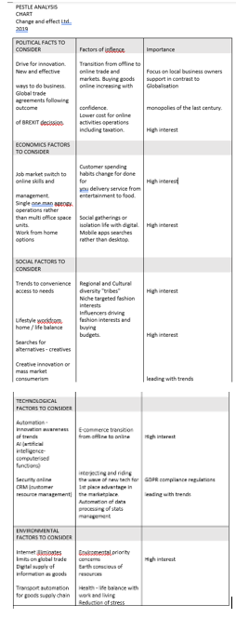
Pestle Analysis on Change and effect business platform 2019.

To assess the external opportunities which may impact the business platform … How much of an advantage through these opportunities.
Gathering grass roots support through local business owners, charities, government support projects and voluntary groups : National funding support including investment angels and Entrepreneurial partnerships.
Factors outside your control but positive in results. On the negative reflective side, threats would be the competing operators who provide matching or similar service offering to us as a digital marketing provider. Including immerging business categories such as social media management, video optimisation and 360 mapping.
EDUCATION (not fully understood in the general marketspace for customer nor business owner) The practical integration of the two is where the creative mix is best applied. For innovative functional solutions.

Ken Blanchard series of management
Ken Blanchard, Patricia and Drea Zigarmi (2015).

Feelings of the likelihood of action taking a lot longer to streamline as commitment, experience and … variable due to a number of factors.

SUMMARY CONCLUSIVE ANALYSIS: REFELECTIVE WALK
Game plan
improvements required
New horizons

When I consider what was not working out positively I was lead to a greater understanding of the shortfall in knowledge and experience I have in leadership rolls or mentoring. I have the relaxed ability to work with many individuals of varying character traits in a positive and supportive manner toward fulfilling tasks. Change and effect working collaboration allowed for the continued development of the skills applied for efficient managing and mentoring.
Badly – consequence… Until the correct working structures are in place it will be difficult for other to follow in the desired end results without a common goal or perspective.
GIBBS REVIEW+
Having set out the plan from the vision the next step was to ensure the tasks are completed effectively to produce positive outcomes and income goals. During the process of reviewing strengths and weaknesses of team members involved….

Plans to make revision of materials related to management development weekly through videos, following mentoring guides and readings on a regular basis should re-enforce the leadership skills brought to my attention through the course at UWTSD. Restructuring leadership effectiveness with other team members will both increase my awareness of its effectiveness from direct feedback at the same time become more comfortable and confident in the areas of resistance by illustration of my observations. Doing so in my strength choice of communication visualization, Kinaesthetic and auditory appreciations will be strengthened and developed. Through practice in a real-life situation the habit-forming conditioning can be exercised into normal reflective behaviour.
As an employer my desired special and specific attributes for co workers will be focused on reducing my need to be hands on and more directional in instruction, relying on the individuals ability to receive information and communicate concerns if unclear of instructions, ability to interpret and process instructions to provide quality and effective end results. Pro-active in group participations in a creative and compassionate manner, showing initiative when required to work independently on specific solo tasks in a timely manner. The Ultimate goal of employing others to the platform is to take on passionate self-motivated individuals that are or will be encouraged to take opportunities for growth, expansion and development doing the things that they enjoy and have an influential positive effect not only on other platform workers but as positive role models to future artist, business minded individuals and youth. Nationally and internationally.

Change and effect ltd
A business conceptual platform (online) acting as the opportunity to showcase positive talents of all forms. Inspiring positive development of mentally and spiritual attitudes to life, work and expressions.
Provide opportunity for positive change through changing the narrative and applying digital skills education and integration into daily life and business.
Mentoring principles from the older to the younger, passing on the understanding, experiences and skills to the next generation (pass it forward). In the hope of a brighter future.

BIBLIOGRAPHY

Andy Chan outline model Life line exercise (2008) https://www.gsb.stanford.edu/sites/gsb/files/alumni-migration/files/alumni_migration/career/careerlifevision/pdf/Lifeline_Exercise.pdf
Cialdini, R. (2007) The psychology influence of persuasion. Revised edition (2007). Harper Collins Books. New York.
Gibbs(1984) university of Bradford 2010(Gibb’s reflective cycle model x6 stages further development of Kolb’s cycle )
In refence to Hersey and Blanchard

Joseph luft and Harry Ingham. (1955). Johari Window model.

John Adair ( ). Decision Making and Problem Solving. Kogan Page Pub
Honey & Mumford learning styles moodle topic 2

Oyakhilome,C.(2016) The Power of the Mind.Pg29
Vark (2005) V Chislett MSc and A. Chapman (2005) www.businessballs.com

Adair,J.(2019) Develop your leadership skills: Fast effective ways to become a leader People want to follow (Creating Success) Kogan Publishing. 3rd June 2019.
John Adair (2009). New Revised Edition. Decision Making and Problem Solving. Kogan Page Pub

(Gibb’s reflective cycle model x6 stages further development of Kolb’s cycle ). Gibbs(1984) university of Bradford 2010

BIBLIOGRAPHY

Andy Chan outline model Life line exercise (2008) https://www.gsb.stanford.edu/sites/gsb/files/alumni-migration/files/alumni_migration/career/careerlifevision/pdf/Lifeline_Exercise.pdf
Gibbs(1984) university of Bradford 2010(Gibb’s reflective cycle model x6 stages further development of Kolb’s cycle )
In refence to Hersey and Blanchard

Joseph luft and Harry Ingham. (1955). Johari Window model.

