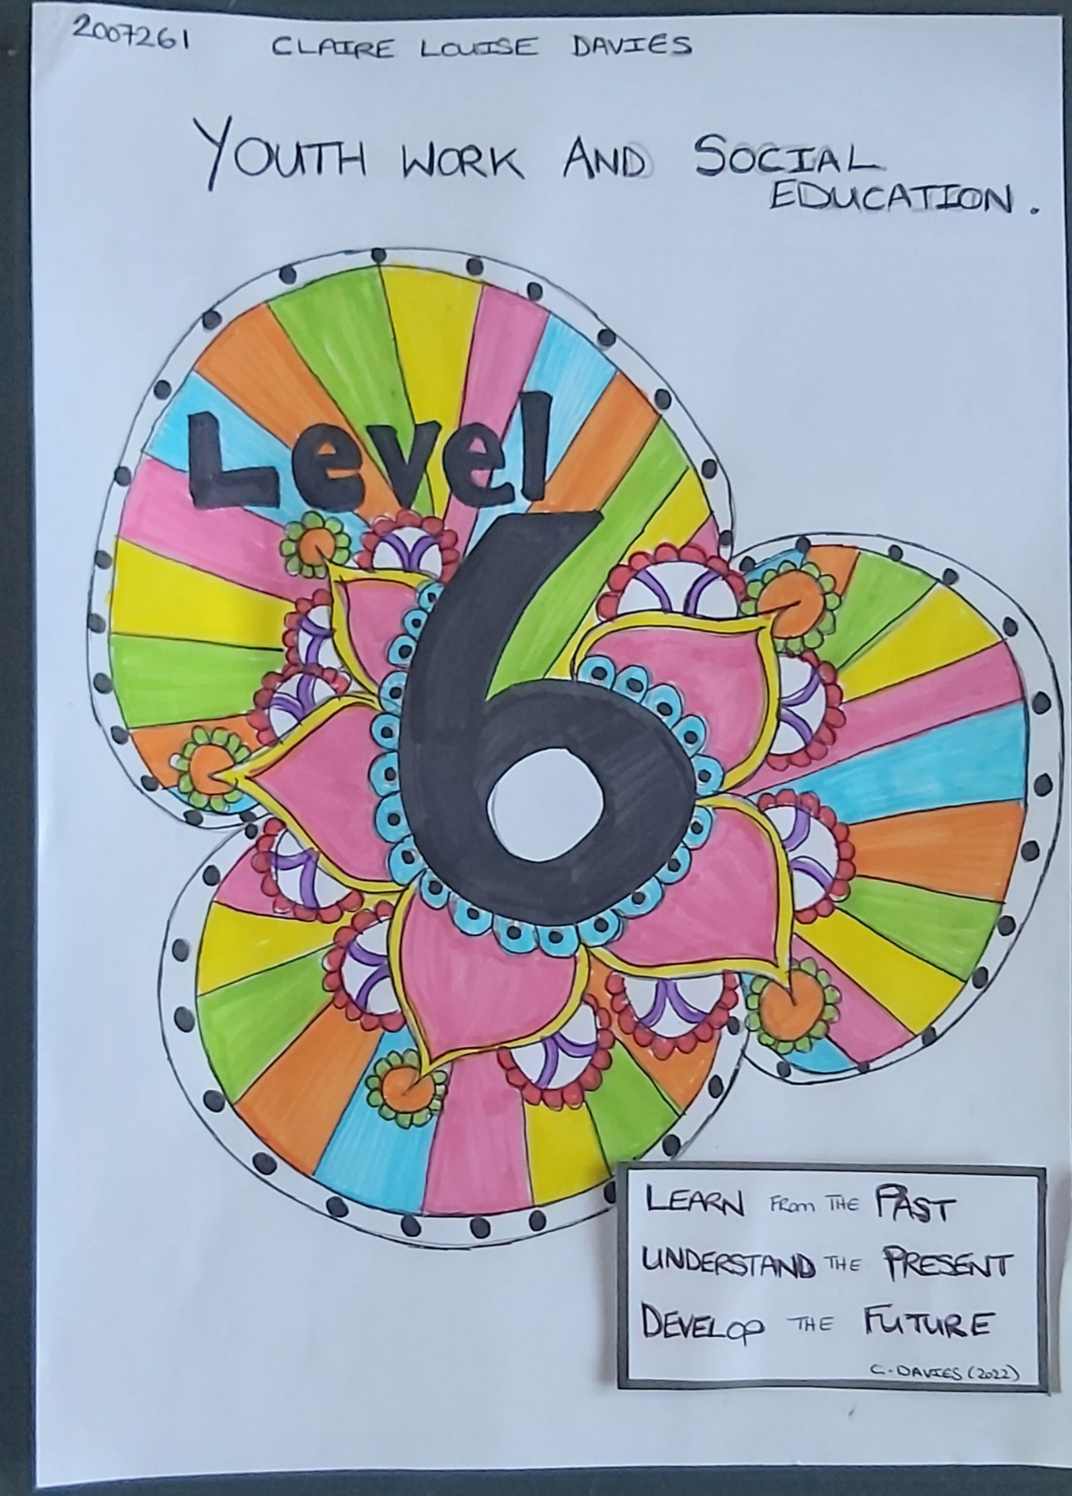

Acknowledgements

I would like to take this opportunity to thank my tutors at the UWTSD for all the support and guidance provided along my last 3 years of learning. To my placement providers I would also like to express my gratitude, for welcoming me to their organisations and providing me with an abundance of learning opportunities. To the young people that I have worked with, and for, over the last three years I would like to say Thank you, you are all an inspiration.

Appendices

- Introduction
- Placement Information sheet
- Critical analysis of a trainee youth worker and Summary of own learning.
- Community profile
- SWOT Analysis
- Conclusion
- Appendix

Introduction

The information provided within the portfolio will demonstrate my developing knowledge that I have learned over the last three years within the Youth work and community education programme. I feel that I have developed an abundance of knowledge within the sector to enable myself to become a Youth worker and to provide young people and their communities with the guidance and understanding that is needed within the provision.

Placement Information sheet

  - YSGOL MAES –Y-GWENDRAETH


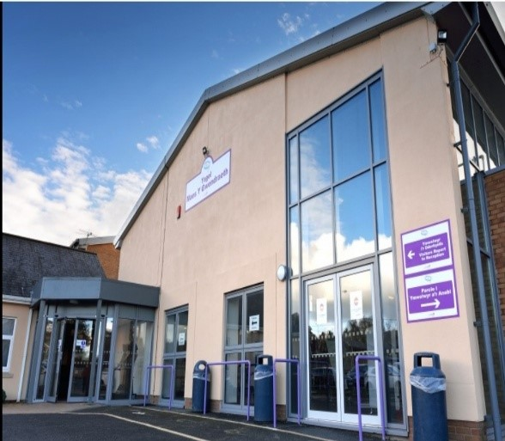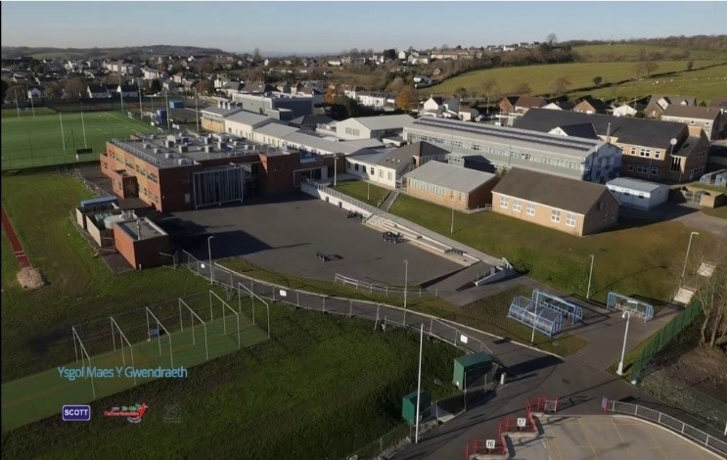
Ysgol Maes y Gwendraeth was established in 2013, it is a Welsh medium community school with their core values based on mutual respect, honesty, and concern for others. The school's focus is to help all pupils achieve their full potential with every effort to the highest standard. Providing these firm foundations will enable pupils to widen their horizons so that each pupil can become an active and responsible member of their communities (Maes y Gwendraeth.org, 2022).

The school supports a variety of departments within its umbrella, Canolfan yr Eithin, is a specialist county provision for pupils with SLD, PMLD and/ or Autism (Carmarthenshire.gov, 2022). Provisions of specialist and inclusivity teaching to an exceedingly high standard. Enabling young people to make valuable progress and preparation for their futures after leaving school.



The school itself has clear and elevated expectations which are supported by the pupils and their families. One of the prominent cornerstones of the school is the mission to work with the young people on their moral, spiritual, and physical development. The school is fully supported by the surrounding community sporting associations as well as by the WRU (Maes y Gwendraeth, 2022).





In 2019-20 the school received a PDG (Pupil Depravation Grant) of £82,800. This grant was provided to promote progress and remove barriers to learning for students eligible for funding.
Some provisions the grant has helped to fund are:
- Enhanced teaching provisions with learning and support programmes
- To provide sustainable intervention and support programmes
- Refine data tracking systems to identify learners needs
- Improve attendance rates of targeted pupils
- To develop leadership capacity to monitor the progress of improvement plans and measure their impacts on groups of pupils.
(Ysgol Maes y Gwendraeth, 2022)

Roles and responsibilities of a trainee youth worker within the school.

- To work as part of a hub with current staff members.
- To undertake JAFF assessments with identified young people and their families.
- To maintain appropriate records.
- To support identified young people to engage with other initiatives and projects.
- To plan, prepare and deliver training, learning resources to young people.
- To develop and foster effective relationships with parents/guardians.
- To develop and contribute key initiatives that support the general aims of the school and its projects.
- To offer support to young people and their families with further education, higher education, training, and employment.

Future visions.
The school's future vision is to keep the provision of Welsh language education (R.Lloyd, blogspot,2016) and to help pupils to flourish and grow within the education system. Allow for Inclusivity of all individuals within the school and its surrounding communities. Provisions for the development of the young people's mental health and well-being sessions, to provide a more established link between teachers and pupils (R. Adams,2022).
Consistent communication between staff and management on all levels within the school to provide the best educational experience possible (Malenfant, 2022).

References
(no date) Maes y Gwendraeth. Available at: https://sites.google.com/hwbcymru.net/maesygwendraeth (Accessed: November 11, 2022).
Lloyd, R. (2016) Bird's eye view of the new Ysgol Maes y gwendraeth, Bird's eye view of the new Ysgol Maes Y Gwendraeth. Blogger. Available at: https://sirgarblog.blogspot.com/2016/11/birds-eye-view-of-new-ysgol-maes-y.html (Accessed: November 18, 2022).
Malenfant, N. (2022) “Better communication and consistency between staff and management.” Carmarthenshire: Maes y gwendraeth.
Maes y Gwendraethcefneithin, Llanelli, SA14 7DT (no date) Maes Y Gwendraeth. Available at: https://www.carmarthenshire.gov.wales/home/council-services/education-schools/find-a-school/secondary-school/maes-y-gwendraeth/ (Accessed: November 18, 2022).
Adams, R. (2022) “Provisions for development”. Carmarthenshire: Maes y Gwendraeth.
Ysgol Maes y gwendraethcefneithin, Llanelli, SA14 7DT (no date) Ysgol Maes Y Gwendraeth. Available at: http://www.carmarthenshire.gov.wales/home/council-services/education-schools/carmarthenshires-sustainable-communities-for-learning-programme/secondary-school-investment/ysgol-maes-y-gwendraeth/ (Accessed: November 15, 2022).

A Critical analysis of a Trainee youth workers role and a summary of own learning.

What are the roles and responsibilities of a youth worker while on placement?
They would all depend on the organisation that the trainee youth worker was shadowing. Youth Work Strategy for Wales (2017) states that ‘Youth work can mean different things to different people, it is not confined to a single setting or context, Youth work can and will also adapt without compromising its values and principles’.
A trainee Youth worker should be about to start or on a journey to complete the relevant qualifications needed to be knowledgeable, skilled, and prepared for their future roles as Youth workers. A trainee youth worker should look to gain the relevant qualifications that are ETS endorsed (Education training standards), they should also have a full DBS (Disclosure and Barring service) check done and once qualified to register with the EWC (Education Workforce Council).
- ETS endorsed training for youth work are requirements of the Joint Negotiating Committee (JNC) for professionally qualified status
- ETS Wales is the Professional Statutory and Regulatory Body (PSRB) for Youth Work.
- Holding a JNC-recognised Youth Work qualification allows individuals to register with the Education Workforce Council (EWC) for Wales. EWC is the regulatory body for the teaching, further education, Youth Work and work-based learning professions.
(ETSWales.org, 2020)
Once on placement the trainee Youth worker should adhere to the organisations guidelines and protocols as well as following their own Youth work guidelines and principles. The Youth Work in Wales: Principles and purposes handbook helps to deliver the Five pillars within the setting, Youth work has a value based and grounded respect for young people and through its distribution offers: Educative, Expressive, Empowering, Participative and Inclusive opportunities (YWW,2022).
The National Occupational Standards (CLD, Scotland, 2019) also supports the roles of a youth worker by delivering the provision of guidelines to follow and educate in working with young people and other professionals.

Current placement roles and responsibilities

- To work as part of a hub with current staff members.
- To support identified young people to engage with other initiatives and projects.
- To plan, prepare and deliver training, learning resources to young people.
- To develop and contribute key initiatives that support the general aims of the school and its projects.
- To offer support to young people with further education, higher education, training, and employment.
Currently my role on placement requires me to help guide young people who are struggling to complete their schoolwork and to provide well-being sessions to a handful of young people who require my assistance.

‘High quality youth work has an important role to play supporting many young people to achieve their full potential.’
(The national youth work strategy for wales,2018)

Shadowing the pastoral team at the secondary school is a process that is unlike youth work itself. Schools themselves must conform to their own guidelines, policies, and curriculums but Youth workers usually work in a targeted and fluid process. Raj.Lehal, (2010) supports that targeted youth work will and can develop new skills, relationships, and knowledge inside and outside of formal education.
Youth work interventions are enabling young people to access education and learning support by supporting their emotional & social needs by teaching them life skills, e.g., how to communicate with others, create new friendships, coping mechanisms and stress management to allow for better behaviour in class (V.Rogers, p.9, 2016.)
My role in the wellbeing sessions is to provide the young person with an environment to feel relaxed, positive, and calm. To be open to disclosure and feel the confidence to unburden themselves of any negative thoughts, behaviour, or emotions. The principles of Youth Work in Wales (2022) states that ‘Youth work has at its core the importance to provide a safe environment.’ Wiley (2013) advocates that by offering the ability to have space for reflection, new experiences it provides the young person with purpose and allows for growth and development (Wiley. T., p.63, 2013).
Smith (2008) identifies that informal and formal learning are separate learning processes but can work together in a continuum, with one on either end of the scale and the central column where they meet and merge. Youth work differs from that of formal education by allowing for young people to be included within the environment that they are educated, to allow for inclusivity and empowerment within the provisions given. The United Nations Conventions on the Rights of the Child (UNCRC, 1989) States:

Children have the right to participate in the decision-making process that may be relevant in their lives and to influence decisions taken in their regard, within the family, school, or community.
(UNCRC, 1989, p.4)

The School Youth Worker must be adaptable to their surroundings and the educational setting provider must also be open and prepared for new opportunities, approaches, and unexpected situations. Fletcher (2008) wrote that young people are powerful, purposeful catalysts for the institutional growth and transformation of youth work (Sapin, p.5, 2013).
Working within the educational setting of a secondary school has been slightly confusing due to the prevalence of pupils unable to easily access the School Youth worker. This to me has been a negative impact on my further learning within the role of a school-based Youth worker as written in my SWOT analysis as a weakness. Coburn (2011) Supports this by writing ‘By offering choices about the environment of participation within schools for access to youth work, young people retain the control over their individual participation’ (Batsleer, Davies, 2011).
One of the recommendations was to make a simple alteration of moving the Youth worker to a more accessible setting within the main school building would be of more purpose to the pupils and teachers thus allowing for the Youth worker to carry out their purpose of ‘helping young people to learn about themselves, others and society through non-formal educational activities which combine, fun, enjoyment, challenges, and happiness’. (CWVYS,2022)
Currently I am still in the process of educating myself on the school curriculum and where a School based Youth worker may be of assistance for the pupils within the constraints of the educational setting. Teachers have an understandably high and stressful workload to provide the young people with, but it does not and should not take away from the daily struggles of many young people who are suffering individual obstacles.
Many Young people face dilemmas or difficulties in their home life and are incredibly good at hiding their emotional or mental distress, Nulty (2022) supports this with evidence of research that 53% of young people contemplate hiding their mental health difficulties from friends or family. Mind (2019) also supports this by their research,’ Three in five young people (59 per cent) have either experienced a mental health problem themselves or are close to someone who has ‘.
It also highlights how secondary schools are creating the environment in promoting and supporting their pupil wellbeing. Welsh government consider that the purpose of the Whole-school approach (WSA) framework has a key purpose to ensuring pupils have access to excellent quality metal health and well-being provisions (Welsh Government, 2021). One of my main future goals is to create an environment within the educational setting where all pupils can access a Youth worker during school hours without having to provide a reason as to why, young people should have access to someone to unburden themselves no matter the dilemmas.

‘Prevention is better than cure.’
(Desiderius. Erasmus, 1500)

References
(2022) YOUTH WORK IN WALES: PRICIPLES AND PURPOSES. Youth Work in Wales Review Group.
Batsleer, J. and Davies, B. (2010) “Participation,” in What is youth work? Exeter: Learning Matters, p. 21.
Batsleer, J. and Davies, B. (2010) “Youth work as border pedagogy,” in What is youth work? Exeter: Learning Matters, p. 45.
Mackinnon, D., Harrison, R. and Curran, S. (2013) “Crossing the boundaries? Working informally in formal settings.,” in Working with Young People. 2nd edn. Milton Keynes: SAGE Publications, p. 128.
Mackinnon, D., Harrison, R. and Curran, S. (2013) “Youth work in a cold climate,” in Working with Young People. 2nd edn. Milton Keynes: SAGE Publications, p. 63.
National Occupational Standards (no date) CLD Standards Council for Scotland. Available at: https://cldstandardscouncil.org.uk/resources/standards-and-benchmarks/national-occupational-standards/ (Accessed: December 9, 2022).
(YW18) Engage with young people to promote their well-being and mental health.
Rogers, V. (2016) An independent evaluation of youth work in schools in Wales. Available at: https://gov.wales/sites/default/files/publications/2018-02/an-independent-evaluation-of-youth-work-in-schools-in-wales-vanessa-rogers-may-2016.pdf (Accessed: December 13, 2022).
Sapin, K. (2013) “Understanding Youth Work- Building relationships,” in Essential skills for youth work practice. 2nd edn. Los Angeles, Calif: SAGE, p. 5.
Services, E.I. (2020) Guidelines, Endorsement Guidelines - ETS Wales. Available at: https://www.etswales.org.uk/endorsement-guidelines (Accessed: December 10, 2022).
Three in five young people have experienced a mental health problem or are close to someone who has (no date) Mind. Available at: https://www.mind.org.uk/news-campaigns/news/three-in-five-young-people-have-experienced-a-mental-health-problem-or-are-close-to-someone-who-has/ (Accessed: December 14, 2022).
Whole-school approach to Mental Health and Wellbeing Framework Guidance: Impact Assessment [HTML] (no date) GOV.WALES. Available at: https://gov.wales/whole-school-approach-mental-health-and-wellbeing-framework-guidance-impact-assessment-html (Accessed: December 14, 2022).
Youth work methodology handbook (no date) CWYVS. Available at: https://www.youthworkwales.org.uk/wp-content/uploads/2017/11/HB-Youth-Workers-in-Schools.pdf (Accessed: December 13, 2022).
Youth work strategy 2019 (no date) GOV.WALES. Available at: https://gov.wales/youth-work-strategy-2019 (Accessed: December 10, 2022).

‘Community Profile’

Young people and their community in the Amman valley.

Claire Louise Davies (2007261)
2022

AIM
The aim of creating this community profile is to develop an understanding on the past, current, and future lives of the young people and their surrounding communities in the Amman valley.
As stated by Christakopouloiu,2001, p.5, Community profiling is to enable the reader a better insight into the lives of people in a social, economic, political, and understanding manner.
Evidence shown by Hawtwin & Percy – Smith, (2007) states that community profiles are also intended to enable youth workers, young people, community councils, shareholders, and other relevant professionals to develop a forward-thinking mindset with the overall outcome of creating a better future for our young people.
Community profiles help to provide information for funding and grants, to prioritize best use of facilities, to find out if people’s needs are being met, young or old. Sapin (2013) advocates this by writing ‘effective management requires consideration for needs and interests of stakeholders, young people, and communities, whilst also taking into consideration the feasibility of compromise for the project.
To develop some knowledge on the surrounding community and its inhabitants while evaluating services and projects within the area, enabling promotion or criticism of already established groups or organizations open and accountable to users ARVAC (2001) Community research: Getting started. London: ARVAC: 2

‘A youth and community profile is a planning tool for workers and contains a description of the local area, as it impacts on young people. It should contain information about the key features that shape a young person’s experience and future. It should include statistical evidence and qualitative information, gained from a variety of sources.
National Youth Agency (2006)

Statistics and information

Hawtwin & Percy-Smith (2007) supports that by using secondary statistical evidence and information regarding how the area and people have and can be changed can help the researcher/reader to understand where provisions are generally doing well or if they could improve.
The population in the Amman valley is a constant growing number, below is a recent population chart to show the statistics:
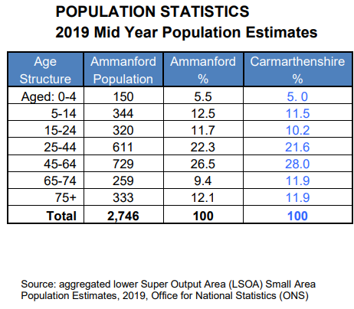
The population has grown by +3.2% between the 2011 - 2019 census.

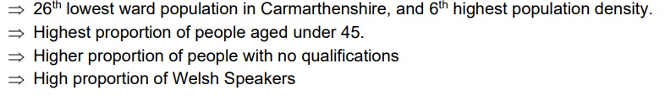
(Carmarthenshire county council, 2022)

The Amman Valley while having a steady growing number of inhabitants has according to the DWP (2021) an exceedingly high rate of benefit claimants, as shown in the graph below:

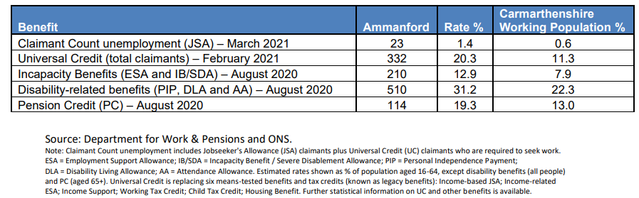

Due to the high number of benefit claimants and the ever-decreasing economy, which in turn creates increased poverty. Huskins, 2001, p.161, supports that some young people and their adult counter parts may fall into the area of crime just to survive and provide. This can be classed as an ACE (Adverse Childhood Experience), these are experience’s that children and young people can go through while transitioning their development into adulthood. CDC (Centre for childhood Diseases,2022) state ‘The first step to helping young people at risk for ACEs is for everyone in our communities to better understand these experiences.’ Household adversity is one of the ACE’s that are supported by the UCL- Institute for health equity (2022), Household adversity is when there is a combination of risks e.g., Drug and alcohol misuse, domestic violence, divorce, criminality, mental health etc.
Williamson. H, 1997, accounted that many young people will usually fall into crime or poverty when not supported and guided in education, home, or society.
The national occupational standards state (YW09) to support young people to become responsible citizens through active involvement in the community, this I believe to be a large part of a youth workers position to encourage young people within their communities.

Dyfed Powys police statistics for crime in the Amman Valley are as below:

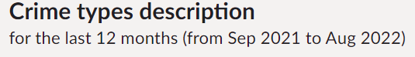

Type | Total | Percentage
Anti-social behaviour | 108 | 13.8%
Burglary | 24 | 3.1%
Criminal damage and arson | 97 | 12.4%
Drugs | 56 | 7.2%
Other theft | 31 | 4%
Possession of weapons | 3 | 0.4%
Public order | 95 | 12.1%
Shoplifting | 49 | 6.3%
Violence and sexual offences | 293 | 37.4%
Vehicle crime | 14 | 1.8%
Other crime | 7 | 0.9%
Robbery | 1 | 0.1%
Bicycle theft | 3 | 0.4%
Theft from the person | 2 | 0.3%
[Text Wrapping Break] Dyfed Powys police (2022)
As shown in the crime statistics graph Anti-social behaviour is one of the higher rated crimes.

The Crime and Disorder Act 1998 defines antisocial behaviour as:
Acting in a manner that caused, or was likely to cause harassment, alarm, or distress to one or more persons, not of the same household as [the perpetrator]. This has since been updated as the Anti- social behaviour Act 2003.
Maguire. M, (2009) believes that the risks of offending are offset by many protective factors such as positive parenting, educational attainment, social and emotional wellbeing, and confidence, having those protective factors in built, can help a young person make the correct choice.

THE PAST

The Amman valley was once a thriving industry build on mining and community spirit. Over the last 20 years it has all but waned from the community spirit of trust and inclusion for all ages. One of the theories from the Youth work in Wales: principles and practice guidelines, (2018) states that Inclusion is to enable young people to develop knowledge, understanding and positive attitudes, this I feel some people from the older generation should be educated on.
Furlong et al. (1997) however suggested a model to create a relationship between young people and their communities is Citizenship: this model of youth work is where young people are offered a political and social education through both extra-curricular activities in school and projects in the community.
Building community relationships is beneficial to all young people in the integration to becoming active participants within their communities. Rosseter (1987) supports this with a discussion on the educational philosophy of youth work (Jeffs and Smith, 2010, p.91).

PREVIOUS WORK WITHIN THE COMMUNITY

Many of the local villages would have had Youth clubs or organisations running at least twice a week, enabling the future young people an opportunity to develop in a participative, empowering, educative and inclusive way. Many of the National occupational standards support youth workers to use these ways by, supporting young people to become responsible citizens (YW09) to engage with young people to promote their emotional well-being and mental health (YW18).
Many local sports or social clubs would have provided meeting spaces for young people in the past, but many have now closed or run out of funding.
The Amman valley was once a thriving hub for young people to meet and socialise amongst their peers and enjoy. At one point there was a youth club in every village, compared to now where the youth now feel they must congregate in town or parks due to the lack of establishments and support being available.
Wylie. T, believes this will develop negative public attitudes about young people, making it increasingly harder to argue a case for development (Curran, Harrison, Mackinnon, 2013, p.65).
Young people are not currently supported or looked upon as needed members of the community, but they are looked upon as ‘A nuisance.’ Sapin. K, 2013 argues that ‘perceptions of difference can lead to negative discrimination, harmful attitudes and oppressive practice by individuals, groups in powerful positions over those who are not as fortunate in accessing opportunities.

CURRENT
Currently in the Amman valley there is only one youth club available on a Tuesday and Thursday evening in the locality for young people, there are many other youth provisions, but these are only accessible through a referral service or under the Additional needs bracket. Out of a 15-mile radius, only 2 youth clubs run for young people to attend without referral or cost (Carmarthenshire County council, 2022).
Spending on youth services has been cut by £6.1m in the last four years by councils in Wales, a trade union has claimed. Unison said that more than 100 youth centres have also closed, and 360 jobs have been lost in that time. A conference organised by Unison on Friday will be told closures “Are failing a generation of young people", (BBC, Wales, 2022).
Lack of provisions, organisations for some young people is detrimental to their future as part of the community. Sapin. K, (2013) Supports this by writing that oppressive behaviour can have a negative impact on a developing young person’s mind, by allowing for inclusion and equality, youth work focuses on activities that bring people together rather than to isolate them (Payne 2005).
Currently clubs on offer for the young people in the Amman valley are extremely limited, ACTIVE Sir Gar, the leisure centre run clubs for young people on a limited access basis. They provide leisure activities for ages 11-17years old but not on a regular basis. Smith, (2006), believes that activities provide young people with a potential for learning development, social learning, and an enablement to interact with others. Thurlow, (2004), also supports this theory.

Local authorities have a duty to provide sufficient educational and leisure-time activities for young people aged 13–19-year-olds
(Enoch, A. 2022).

FUTURE

Potential future outcomes could be delivered with the 5 ways to wellbeing in mind. According to Melo.Cymru, 2022, these are:
Connect- connection can help build a sense of belonging and self-worth.
Be active- regular activity boosts our ‘Feel good factor,’ boosts confidence and improves energy levels.
Take notice- Pay more attention to your moods, thoughts, and feelings, be present, take note of your surroundings and appreciate life itself.
Keep learning- Learning new skills can improve your mental wellbeing, build confidence and self-esteem.
Give- being kind to others helps improve your mental health, giving you a sense of self-worth, sense of purpose and creates positive feelings, helping to reduce anxiety, stress and lift our moods.

Providing a positive place for young people to meet and develop their skills is a provision that must be met in the Amman valley. Provisions could be through new youth clubs being set up, be it out in the community, in permanent settings or online. Youth works heartbeat is to develop a provision of importance for safety, warmth, engagement, and support (CWVYS, 2022).

Young people are today struggling to develop their emotional, social, & mental skills because of the lack of resources. Dr.Abigail.Wright (2022), states that helping young people to reflect and understand can provide positive and unique changes, while also provide hope within communities in these challenging times (Swansea University, 2022).

CONCLUSION
As a future youth worker, I would like to change these perceptions, following the Youth work principles and purposes. This would enable myself to provide young people with new opportunities, enable them to develop holistically and to work with them to build on their social and personal development. LGA (Local Government Association, 2022) ‘Bright futures: our vision for youth services’ document supports my dream for young people.
The National Occupational Standards for Wales state that a youth worker should, enable young people to identify, reflect and use their learning to enhance their future development (YW05). By enabling a young person or persons to identify and reflect in their surroundings and needs they will be empowered to develop a culture where they promote inclusivity and diversity but also recognise that they have rights, under the UNCRC, article 12, all children and young people have the right to a voice (Carmarthenshire.gov.wales,2021).

4 Key points for myself to understand for future youth work within the community.
- Provisions – to provide a better service.
- Opinions – advocate for and on behalf of young people.
- Change perceptions – create relationships with outside agencies, professionals, and communities to better understand young people.
- Funding- to gain a better understanding on where we can source future funding for the provision of young people.

References

BBC News. 2022. Youth services spending 'cut by £6.1m in four years'. [online] Available at: <https://www.bbc.com/news/uk-wales-38012042> [Accessed 13 October 2022].
Bright futures: Our vision for youth services (no date) Local Government Association. Available at: https://www.local.gov.uk/about/campaigns/bright-futures (Accessed: November 1, 2022).
Carmarthenshire.gov.wales. 2022. Ammanford ward. [online] Available at: <https://www.carmarthenshire.gov.wales/media/1225608/ammanford-ward.pdf> [Accessed 10 October 2022].
Cldstandardscouncil.org.uk. 2022. Youth Work NOS | CLD Standards Council for Scotland. [online] Available at: <https://cldstandardscouncil.org.uk/resources/standards-and-benchmarks/national-occupational-standards/youth-work-nos/> [Accessed 10 October 2022].
Curran, S. et al. (2013) “Youth work in a cold climate,” in Working with Young People. 2nd edn. Los Angeles, CA: SAGE, p. 65.
Dyfed Powys police. 2022. local crime report. [online] Available at: <https://www.police.uk/pu/your-area/dyfed-powys-police/ammanford/?tab=statistics> [Accessed 11 October 2022].
Hawtin, M. and Percy-Smith, J., 2007. Community Profiling. 2nd ed. Maidenhead: Open University Press [Imprint], pp.5, 66.
Jeffs, T. and Smith, M., 2010. Youth Work Practice. Basingstoke: Palgrave Macmillan, p.58, p.91, p.161.
Jeffs, T. and Smith, M. (2010) “Education and learning through activities,” in Youth work practice. Basingstoke, Uk: Palgrave Macmillan, p. 91.
Maguire, M., 2011. Law and Youth Work. 2nd ed. London: SAGE Publications, pp.66,67,68.69.
Sapin, K., 2013. Essential skills for youth work practice. 2nd ed. Los Angeles, Calif.: SAGE, p.108, p.183.
Williamson, H., 1997. Youth and policy. LONDON & NEW YORK: Routledge revivals, pp.140,141.
Wlga.Wales. 2022. Youth Service - WLGA. [online] Available at: <https://www.wlga.wales/youth-service> [Accessed 11 October 2022].
Wright, A. (2022) “Centre for children and young people's mental wellbeing.” SWANSEA, UK: Dr. Abigail. Wright.
(2022) YOUTH WORK IN WALES: PRINCIPLES AND PURPOSES. Youth Work in Wales Review Group.

SWOT Analysis

SWOT- what is a SWOT Analysis? Leigh, 2006, states that a SWOT analysis is produced to provide a framework for the recognition of useful information to develop an understanding on an organisation (Sapin,2013, p.37).

Below are a couple of examples used to develop a SWOT analysis.

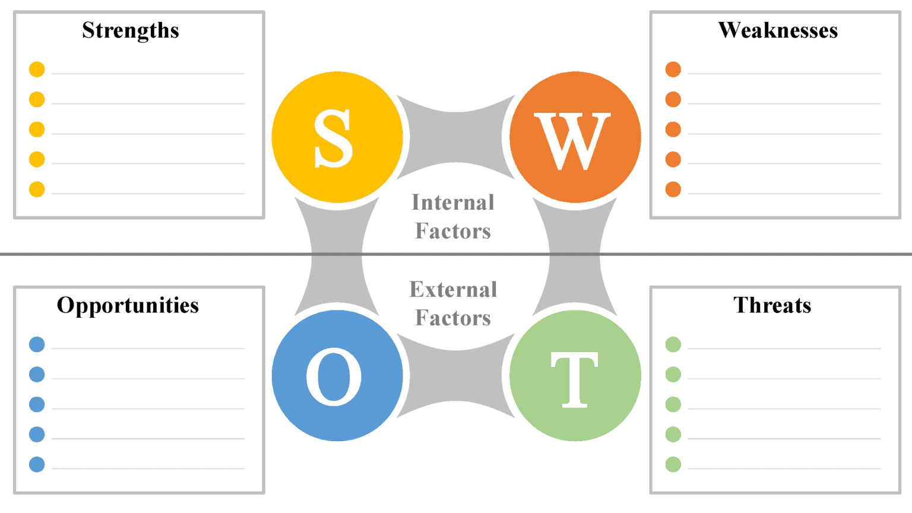
(Bing, 2022)

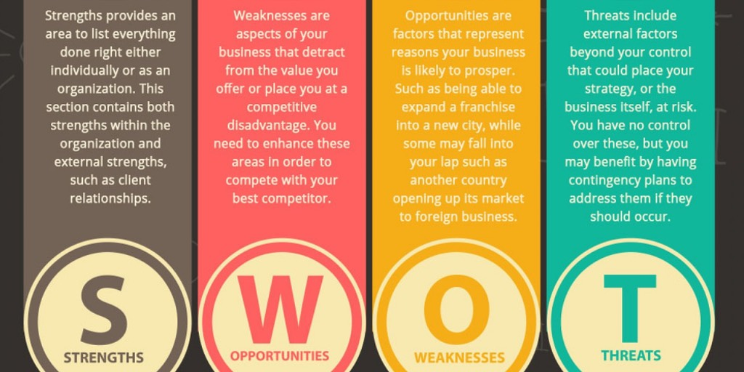
(Bing, 2022)

Placement Level 6 Analysis – Ysgol Maes y Gwendraeth, Secondary school.

Developing a SWOT analysis for my current placement setting will help myself to understand and produce new findings on where and how the setting can change and move forward in a positive manner with the help of a youth worker.
The Youth work strategy for Wales (2017) states that ‘Youth work brings significant benefits to young people, by supporting young people to lead fulfilling lives as valued members of society’ (YWSW, p.23, 2017).
Sapin believes that analysing and evaluating an organisations strengths and weaknesses will also require the knowledge of young people whose interests the environment is meant to support (Sapin. K.,2013, p.39).

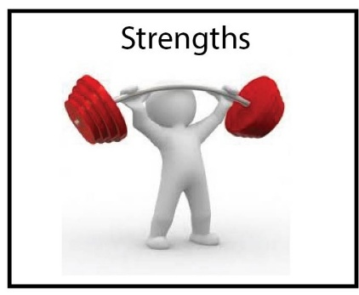
- Welcoming environment.
- Staff and pupil well-being.
- Additional opportunities for learning for pupils and staff through The Duke of Edinburgh club, URDD, after school clubs and community clubs.
(Highlighted in green are the points I have used in my SWOT analysis)

Currently the school has an abundance of online and in house activities to provide well-being sessions to young people who attend the school. These provisions can be found on their website, under the ‘Pupil’ tab, ranging from meditation, mindfulness, counselling, creative arts, music etc. In house resources are provided by the current teaching staff, daily with the aid of the youth worker as well as provisions by myself, the trainee youth worker, on a weekly basis while completing my Level 6 placement.
The Well-being of Future Generations (Wales) Act, 2015 states that ‘creating an environment for young people to live and be educated in will prevent problems and produce a better more resilient, healthy, and prosperous Wales for our young people to develop.
Provisions of Extra training and learning within the school and outside in the community is in constant development, providing a diverse and inclusive environment for the young people to create new friendships and build knowledge through new experiences is necessary for young people while transitioning through adolescence. Bronfenbrenner, 1979, believed that relationships are built on diverse levels as systems that are nestled within each-other like a set of ‘Russian dolls’ (Bronfenbrenner. U., p.21, 2012).

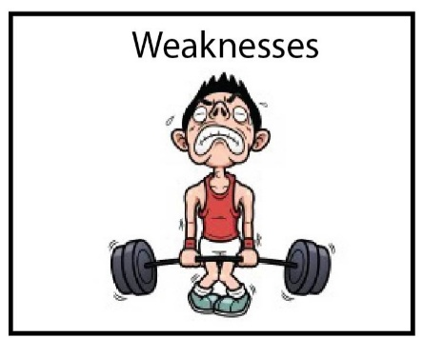
- Communication.
- Consistency.
- Respect.
- Discipline.
- Resources.
- Youth worker not easily accessible.
- Hectic environment.

Merton (2010) writes that ‘Developing a clear and concise communicative relationship between staff and pupils is key to a cohesive and understanding environment.
The school staff find it difficult to communicate their concerns regarding pupils, other staff members, management, and resources due to the lack of departmental meetings and the consistency in which staff follow guidelines. Watson (2006) Believes that the shaping of relationships, understandings bring completion to tasks within the organisation which will in turn continue to improve for the future (Tyler, Hogarth and Merton, p.9, 2010).

The provisions of resources are dependent on the funding that is provided. Funding for different departments will vary depending on the needs of the previous year. This to me is a negative as you cannot predict what funding you may need for the future; many obstacles may crop up without a moment's notice.
Economical costs can have an impact on resources as well, with the cost of materials and equipment rising, energy costs and worldwide crisis happening in different countries can also influence the funding costs (Dauncey, 2019).
A recent study done by The Children, Young People and Education (CYPE) Committee (2019) found that schools are concerned over the budgets that are provided to them from the Local Authorities due to budget cuts. School Funding in Wales (2018) state that the process of allocating funding is complex and can be altered by many factors within government itself.

Government funding can also have a massive impact on the School Youth workers role. Rogers (2016) supports that if more budget cuts and restructures are undertaken in the school's youth provisions, then the service will be left vulnerable to change (Independent evaluation of youth work in schools in Wales, 2016).
Currently the school's youth worker is not positioned in an easily accessible part of the school, negatively it is placed in a separate part to the main building through locked doors. The pupils must give a reason as to why they wish to visit the youth worker rather than having the choice of anonymity and confidentiality.
The National occupational standards (CLD Standards, Scotland, 2019) supports the youth worker to ‘Engage and promote the young person’s well-being and mental health (YW18). The Youth worker is unable to do this if the young people are unable to easily access the help when they most need it.

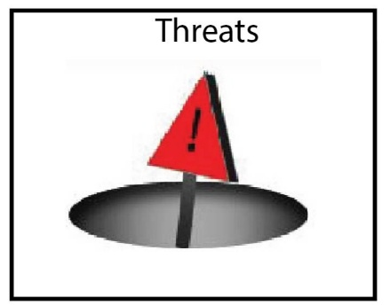
- Funding/ Government cuts
- Staffing / Inadequate training
- Resources / Availability of materials
- Lack of specialist support- Youth workers
Sapin (2013) believes that Youth workers may have to explain the enjoyable nature of youth work practice to others whose job it is to provide pre-planned programmes or to facilitate highly formal workloads (Sapin, p.38, 2013). Staffing issues have been an increased issue since the return to school after Covid, With the effects of anxiety, depression and financial implications on staff and pupils as-well as their families. Covid has placed a significant impact on the return balance to ‘Normal’(WalesOnline, 2022).
Schools are resorting to the use of Youth workers as a member of the teaching staff, as and when needed to support the lack of adequate teaching staff provisions. Being used as a safeguarding measure if in an emergency when staff are unavailable due to illness or sickness.
Without the School based youth workers, we will be unable to provide young people with a targeted support system that will help them to become active and participating individuals within the community (YW09), Lack of adequate training and knowledge within the school-based youth worker and teaching staff will allow for poor support and stability for the young people.

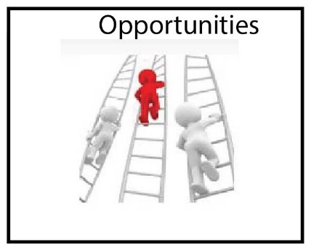

- Fundraising – create own funding resources
- Working Partnerships – Local sponsorship
- Youth workers - Employ more educated and fully qualified
- Engagement days – To create a specific departmental team building day
- School based training days for staff and pupils

Sapin (2013) writes that involving young people in fundraising projects from the beginning to the end will enable them to develop a profound sense of achievement and self-worth, this can be linked to Maslow’s hierarchy of needs (1970).
School based youth workers are a benefit to young people in providing the abilities to enable young people to achieve these needs and provide a positive mindset.
The school currently works with a select group of local businesses for sponsorship but with the ever-increasing costs of resources, it would be of benefit to the young people to create new relationships with more local businesses who could help provide materials for free or at a reduced cost. Supported by YW21 – Secure funding and resources for youth work and YW23- Engage young people in the strategic development of youth work (CLD Scotland, 2019).
Two theorists that support the Positive mindset theory are Seligman and Csikszentmihalyi (2000), they both support the reasoning behind ‘positive psychology’, the building of characteristics, including the capacity for love and vocation, courage, inter-personal skills, spirituality, and sensibility. By providing young people with these skills is to empower and enrich them (Hendry and Kloep, p.151, 2012). One of the Youth work principles backs this information with Empowering young people and the effects it can and will have on them in a beneficial way (CWYVS, 2022).
Empowerment starts with the individual and can be defined by

The process where the individual feels increasingly in control of their own affairs and …. for them to be in control is a pre-requisite for them to feel they can help someone else.
(Lord and Farlow, 1990: 3)

References

Children, Young People and Education (CYPE) Committee, (Accessed: December 8, 2022).
Dauncey, M. (no date) How are schools in Wales funded and what are the main issues? Ymchwil y Senedd | Senedd Research. Available at: https://research.senedd.wales/research-articles/how-are-schools-in-wales-funded-and-what-are-the-main-issues/ (Accessed: December 9, 2022).
Hendry, L.B. and Kloep, M. (2012) “Towards a new positive theory of human development,” in Adolescence and adulthood: Transitions and transformations. Basingstoke: Palgrave Macmillan, p. 151.
Hendry, L.B. and Kloep, M. (2012) “Urie Bronfenbrenner's ecological model,” in Adolescence and adulthood: Transitions and transformations. Basingstoke, Hampshire: Palgrave Macmillan, p. 21.
Horwood), (I.M. et al. (2022) Major problems facing Wales' schools in the wake of Covid, WalesOnline. Available at: https://www.walesonline.co.uk/news/education/absences-staffing-crisis-lost-skills-23328283 (Accessed: December 9, 2022).
How are schools in Wales funded and what are the main issues? (No date) Ymchwil y Senedd | Senedd Research. Available at: https://research.senedd.wales/research-articles/how-are-schools-in-wales-funded-and-what-are-the-main-issues/ (Accessed: December 9, 2022).
Jeffs, T. (2010) “The cultivation of gifts in all directions,” in Youth work practice. Basingstoke: Palgrave Macmillan, p. 67.
“Malow's hierarchy of needs” (2016) in An Introduction to Childhood studies and Child psychology. 3rd edn. Milton Keynes: Open University, p. 121.
National Occupational Standards (no date) CLD Standards Council for Scotland. Available at: https://cldstandardscouncil.org.uk/resources/standards-and-benchmarks/national-occupational-standards/ (Accessed: December 9, 2022). (YW18) Engage with young people to promote their well-being and mental health.
Rogers, V. (2016) “An Independent Evaluation of Youth Work in Schools in Wales - From the Perspective of Teaching Professionals,” AN INDEPENDANT EVALUATION OF YOUTH WORK IN SCHOOLS IN WALES, p. 13. Available at: https://gov.wales>publications (Accessed: December 9, 2022).
Sapin, K. (2013) “Building relationships,” in Essential skills for youth work practice. Los Angeles, Calif: SAGE, pp. 36–39.
Tyler, M., Hoggarth, L. and Merton, B. (2009) “Introduction,” in Managing modern youth work. Exeter: Learning Matters, p. 9.
Tyler, M., Hoggarth, L. and Merton, B. (2009) “Managing in a complex and fast changing policy environment,” in Managing modern youth work. Exeter: Learning Matters, p. 128.
(2022) YOUTH WORK IN WALES: PRICIPLES AND PURPOSES. Youth Work in Wales Review Group.

Conclusion to My portfolio

To Conclude my final portfolio for my Youth work and community Education programme, I would like to thank my tutors for the guidance and knowledge provided over the last three years. The knowledge that I have been able to gain through educating myself on the policies and research within the youth work provision have been most helpful to myself in gaining a better understanding on young people and how to provide and advocate for them in my future as a Youth worker, wherever it may be.

‘It’s being in the right place at the right time and taking advantage of the opportunities’
(Lee Majors, 2022)

PROFESSIONAL DEVELOPMENT PLAN
For completion by the student after consultation with the Learning Mentor and Fieldwork Supervisor at the outset of the Placement
Student | Claire Louise Davies
Learning Mentor | Emma Timothy-Cooper
Placement | Ysgol Maes y Gwendraeth
Date | 11/10/2022
Students will be expected to consider their placement experience to demonstrate competence in the key aspects of youth work outlined in the table below based on the National Occupational Standards for Youth Work (CLD Standards Council Scotland, 2019) and the Youth Work in Wales: Principles and Purposes Document (YWWRG, 2018).
Learning Mentor’s opening comments about the placement – exactly what type of work will the placement involve?
Actively getting involved with the student's wellbeing and promoting inclusion of all learners and their abilities.
Preparing 1-1 wellbeing sessions with a venerable pupil.

Student initial comments about the Placement.
Maes y gwendraeth secondary school is a Welsh medium education setting with over 1000 pupils. The school is set in a small village but services many communities within its wide range.
I am looking forward to taking my Level 6 placement in an educational setting amongst numerous young people from a variety of backgrounds.
I hope to use my developmental and caring knowledge as a future youth worker to help young people in education think and understand differently.
Allow my knowledge in the youth work sector to help all young people feel inclusive and empowered with their peers.
Develop an understanding of how the school works alongside the youth workers and other staff members.

PROFESSIONAL DEVELOPMENT PLAN
Please note that at Level 5 we expect students to be functioning as professional youth workers developing and delivering youth work activities. Please complete the form electronically to enable the boxes to expand, ensuring you provide adequate detail.

 | Youth Work National Occupational Standards (CLD Standards Council Scotland, 2019)
 | 1. Work in accordance with the 5 pillars of Principles and Purposes of Youth Work in Wales (YWWRG, 2018) (Educative, Expressive, Participative, Inclusive, Empowering). | 2. Work with young people and others | 3. Facilitate learning and development of young people through planning and implementing learning activities | 4. Actively demonstrate commitment to inclusion, equity and young people’s interests and health and wellbeing | 5. Plan and implement strategy and youth work activities for young people | 6. Develop, lead, and manage self and others | 7. Work with communities
What do you need to learn? | To educate myself on the educational setting and its participants.  Hawtin and Percy-Smith (2007) compiling a community profile helps to establish useful information and research on communities and their needs, creating useful contacts.  To encourage full participation and take every opportunity shared with them.  To develop a relationship whereby they feel confident enough to share their views and thoughts without feeling judged.  Sapin, (2013) sees that building a relationship with young people will always develop a need for future communication and understanding.  To fully support and guide the young people where needed to encourage their views and voices to be acknowledged. | Allow for the young people to communicate ‘their way’. YW08- engage with and empower for use of digital media and the impacts on daily lives.  Use my listening skills, reflect on conversations, and develop new and improved sittings.  Batsleer, (2013) believes that listening helps to develop a strength and resilience against judgement.  Understand the participants needs and constraints. YW01- Initiate, build and maintain relationships with young people.  Russel and Rigby, (1908) the theory of ‘starting where young people start- then seek to motivate and support.  To provide new life skills and educate on grounds where knowledge is needed. | Promote inclusion, equality surrounding young people’s interests and wellbeing  Get to know the participants and talk to staff regarding backgrounds. YW19- To develop a culture and ethos that promotes inclusion and values diversity.  Create a warm and welcoming environment.  Develop interests that allow for valuable learning experiences.  To promote knowledge and understanding on current and diverse subjects related to young people.  Provide an educated and situated learning experience for all.  Being responsible for my own knowledge, being up to date and consistent. | Group sessions, making sure all young people are included.  Various tasks for everyone, to provide for all abilities.  Underpinning the values of youth work with inclusivity and equality. | How to help. Guide and assess a young person’s thoughts.  Understand the setting and their curriculum.  Develop a knowledge of the curriculum and its constraints.  Know the safeguarding policies.  Risk assessments. | To undertake tasks when given.  Helping young people to develop an understanding on their behaviours and reactions.  Emotional wellbeing and mental health worksheets or tasks. | How the school works within the community.  Understand the values and principles of the school.  The integration of future young people from the locality.
Activities you will learn from (how will you learn, what will you learn from) | Working with Young people and staff. Learning the ropes and helping in group and individual sessions.  To understand the various needs of the young people in the classroom.  In school educational tasks, lunchtime and breaks, allowing myself time to get to know the young people and understand them. | Individual sessions, Talking, Planning and preparing a project or activity.  Shadowing a member of staff within the professional department.  To develop an understanding on the ethical conduct of the educational setting. | Group sessions, making sure all young people are included.  Underpinning the values of youth work with inclusivity and equality.  Using school curriculum task sheets, setting attainment tasks.  Helping a young person to build their knowledge by using the library and resources provided.  (YW13) Access information with and for young people. | Group sessions, making sure all young people are included.  Various tasks for everyone, to provide for all abilities.  Underpinning the values of youth work with inclusivity and equality. | Shadow and prepare sessions for young people. | Group work, individual sessions.  Partake in any inhouse training. | Sporting facilities, community projects within the school.
Student | Claire Louise Davies
Supervisor | Emma Timothy-Cooper
Date | 11/10/2022

FIELDWORK PRACTICE SUPERVISION
Supervision is a crucial aspect of the placement and helps the student gain deeper understandings. The purpose of fieldwork supervision is to enable the student to ultimately deliver the best possible service possible to young people. The supervisor has a key part to play in both ensuring that the student is making progress but also enabling this progress to take place.
These functions of supervision can be achieved by supervisors being clear of their educational role in the development of the student. However, as individuals learn differently it may be necessary for the supervisor to adapt her/ his approach to suit the needs of the student in order to achieve the desired learning outcomes.
This ability may at times involve adopting a person-centred approach being mindful of the restorative function of supervision and at other times being more task focused and focusing on the normative function and being concerned with standards.
However, the overwhelming focus of the supervision must be on the learning and development of the student. This learning may be achieved in a number of ways through supervision but must remain the overall priority of fieldwork supervision.
When preparing for a Supervision meeting
When preparing for supervision students can ask themselves a number of questions including:
Have I prepared examples from my reflective journal for discussion?
Have I set aside adequate time to prepare for supervision and to identify agenda items?
Am I open to feedback from my supervisor?
Am I able to acknowledge my own strengths and areas for development?
How well do I respond to new ideas, challenges, or constructive criticism?
Would I like my supervisor to do anything differently?
What could I do differently next time?
What learning have I gained?
How will I improve my practice as a result of this supervision session?

On the next page is a supervision recording pro forma. Please ensure you are addressing agreed learning outcomes in your discussions. These are an important source of evidence for the student’s portfolio of evidence.

Supervision Recording Format
SUPERVISION RECORDING
DATE:
TIME:
PEOPLE PRESENT:
DURATION OF THE MEETING:
AGENDA/ DISCUSSION POINTS
1.
2.
3.
4.
5.
6.
NOTES/ ACTION OF EACH ITEM
1.
2.
3.
4.
5.
6.
PROBLEMS ENCOUNTERED
REFLECTION ANALYSIS AND LEARNING Links between theory and practice can be made here and referenced in the usual way. Also, reflection on effectiveness of supervision.
QUESTIONS ARISING
DATE OF NEXT MEETING:
SIGNED:
STUDENT
SUPERVISOR

FIELDWORK SUPERVISOR’S FINAL REPORT – This wil be completed and inserted by Cindy Hunt

Engagement with supervision is crucial to aid reflective practice and analysis; its importance cannot be overestimated. Supervision is integral to fieldwork and as a fieldwork supervisor you are invited to make an assessment of the extent to which the student has engaged with the process of supervision. The table below provides guidance on how to grade students according to how well they have engaged with you. Please use the table for guidance when completing the supervisor final report on the following page.

Key areas of competence
When considering the level of competence of a student please refer to the marking criteria outlined below:
Grade | Description | Equivalent % marks towards HE qualification
A | An exceptional trainee Youth worker who is a reflective practitioner; shows initiative and an ability to work independently for a sustained period; demonstrates thoroughness and commitment to all aspects of professional practice. | 70%+
B | An effective trainee youth worker who displays a degree of independence and commitment to further professional development. | 60-69%
C | A satisfactory trainee youth worker who has met the requirements appropriate for a professionally qualified Youth Worker and with further experience should develop into an effective youth worker. | 50-59%
D | A rather weak trainee youth worker with a basic level of knowledge or skill. May be very poorly organised with very limited understanding of important concepts. | 40-49%
E Fail | A weak trainee youth worker who has been unable or unwilling to meet the required standard, may demonstrate inappropriate values or lack understanding or attention to detail. | Below 40%

This section of the report should be completed by the fieldwork supervisor. To complete the report, we would like you to use the headings below giving specific examples to support your observations.
How did the student use supervision and respond to feedback?
To what extent did the student seek challenging situations, and how were these worked with?
To what extent did the student show enthusiasm, commitment, creativity, and innovation?
How well was the student able to relate theory to practice and reflect on her/his own practice and that of others?
How did the student articulate her/his own beliefs and values and relate them to the work?
How pro-active was the student in demonstrating anti oppressive beliefs, language, and behaviour?
In your professional opinion has the student achieved the necessary standards to function as a professionally qualified Youth and Community Worker? (Please circle)
Yes No

Please provide a grade and % mark reflecting your experience of the student
Grade: % Mark:

Signed Supervisor | Cindy Hunt
Signed Student | Claire Louise Davies
Date | 18/11/2022
LEARNING MENTOR’S FINAL REPORT
The University would like to remind the learning mentor of the importance of their role in the assessment of the student. This role is fundamental in ensuring standards of practice of those working with young people in communities and cannot be taken lightly.
To ensure the desired results are achieved, all those involved in the placement are required to understand and remain committed to the process of supervised practice. Issues of competence which might jeopardise a student’s ability to complete workplace/work-based practice successfully should be identified and communicated to the visiting tutor or fieldwork coordinator as soon as possible.
After the student’s induction to the placement, the student will have drawn up a professional development plan balancing the needs of the student and the requirements of the programme. As learning mentor, you will have carried out managerial supervision and an interim review of the placement. This document is the final report and will include your final assessment of the standards achieved by the student on placement and your assessment of the student’s planned observation of practice.
Key areas of competence
When considering the level of competence of a student please refer to the marking criteria outlined below:
Grade | Description | Equivalent % marks towards HE qualification
A | An exceptional trainee Youth worker who is a reflective practitioner; shows initiative and an ability to work independently for a sustained period; demonstrates thoroughness and commitment to all aspects of professional practice. | 70%+
B | An effective trainee youth worker who displays a degree of independence and commitment to further professional development. | 60-69%
C | A satisfactory trainee youth worker who has met the requirements appropriate for a professionally qualified Youth Worker and with further experience should develop into an effective youth worker. | 50-59%
D | A rather weak trainee youth worker with a basic level of knowledge or skill. May be very poorly organised with very limited understanding of important concepts. | 40-49%
E Fail | A weak trainee youth worker who has been unable or unwilling to meet the required standard, may demonstrate inappropriate values or lack understanding or attention to detail. | Below 40%

LEARNING MENTOR’S FINAL REPORT (continued)
Work in accordance with the pillars of Youth Work in Wales: Principles and Purposes
A Exceptional  70%+ | B Effective  60-69% |  | C Satisfactory  50-59% |  |  | D Rather weak  40-49% |  | E Weak  0-39%
A Exceptional70%

Work with young people and others
A Exceptional  70%+ | B Effective  60-69% |  | C Satisfactory  50-59% |  |  | D Rather weak  40-49% |  | E Weak  0-39%
A Exceptional 70%

Facilitate learning and development of young people through planning and implementing learning activities in youth work
A Exceptional  70%+ | B Effective  60-69% |  | C Satisfactory  50-59% |  |  | D Rather weak  40-49% |  | E Weak  0-39%
B Effective 60-90%

Actively demonstrate commitment to inclusion, equity and young people’s interests and health and wellbeing
A Exceptional  70%+ | B Effective  60-69% |  | C Satisfactory  50-59% |  |  | D Rather weak  40-49% |  | E Weak  0-39%
A Exceptional 70%

Plan and implement strategy and youth work activities for young people
A Exceptional  70%+ | B Effective  60-69% |  | C Satisfactory  50-59% |  |  | D Rather weak  40-49% |  | E Weak  0-39%
A Exceptional 70%

Develop, lead, and manage self and others
A Exceptional  70%+ | B Effective  60-69% |  | C Satisfactory  50-59% |  |  | D Rather weak  40-49% |  | E Weak  0-39%
A Exceptional 70%

Work with communities
A Exceptional  70%+ |  | B Effective  60-69% |  | C Satisfactory  50-59% | D Rather weak  40-49% |  | E Weak  0-39%
UNABLE TO ANSWER DUE TO NOT WORKING WITH A COMMUNITY

LEARNING MENTOR’S FINAL REPORT (continued)
How has the student developed during the placement?
Intergrated well with staff and pupils & interactive with pupil wellbeing sessions.

What is your feedback on observing the student’s planned piece of practice?
I have not observed the student due to the nature of sessions having to be a 1-1 situation and due to the pupil’s background.

What are your suggestions for further professional development?
Possibly look at developing your own task sheets devised more to suit the individual that you are working with. Rather than using generic sheets of the internet.

Has the student passed the placement? Please take into account your view of the student’s performance in each of the Key Aspects of Youth Work (Please circle clearly).
Yes, Pass
Please provide a grade and % mark reflecting your experience of the student
Grade: A % Mark:70% +

Signed Learning Mentor | Emma Timothy-Cooper
Signed Student | Claire Louise Davies
Date | 16/12/2022

Appendices

APPENDIX 1. PLACEMENT PROVIDER EVALUATION REPORT
To be completed by the fieldwork placement provider
The University of Wales Trinity Saint David would be grateful to receive your comments:
Name of Placement Organisation | Ysgol Maes y Gwendraeth
Name of Student | Claire Louise Davies
How appropriate was the information you received from the institution in advance of the Placement? | Prior to the commencement of the placement, a meeting was held with all stakeholders present to outline the process and requirements. The meeting was beneficial, and everything was clear and concise.
Do you have any comments you would like to make about the Placement? | From the school’s point of view, we have found the placement invaluable as the student has been able to support the work that we do within our Hafan and has also worked one to one with various pupils who are emotionally and socially vulnerable.
Do you have any recommendations for future placements? | We very much hope that the provision will continue as it benefits both the school and the student. As the provision develops, we would be better placed to put a more structured and robust plan in place.
Name:  Signed:  Date: | Rhian Adams  Rhian Adams  16/12/22
Contact Telephone No:  Email address: | 01269833900  Rhian.Adams@maesygwendraeth.org
Thank you for your support and co-operation

Reflective sessions

Reflective session 1 – First day
- Long awaited start to my placements first day, feelings of apprehension, nervousness, uncertainty, and excitement.

- Unsure how my language skills would affect my emotions. (Toung tied, mix up words, embarrassed)

- Understanding to take a more relaxed approach, not to panic If I found my words getting muddled. To draw upon my past and current language skills to develop my future language abilities.

- Viewing the setting in an open-minded manner not to judge before all sides are heard, a very hectic full-on environment in constant movement.

Sapin, 2013, supports that all youth workers will go through various feelings of emotions and thoughts regarding a new placement, its only human nature. But to always recognise that support is available to us as youth workers as well as young people.

Reflective session 2 – Situation
- Group of pupils from another secondary school (on inset) congregating outside the school bus bay. This could be construed as a safeguarding issue.

- Teacher’s reactions were quick to react and try to disperse the young people, by talking and explaining why them being there would be a distraction and possible upset the school pupils not on inset.

- Feeling of slight confusion for the other young people and their reasoning behind being there and not elsewhere. Why not enjoy the inset day by doing something a little more interactive. Finding out knowledge on the reasoning then understanding.

- Reasoning of the benefits of talking, explanation and being calm regarding a situation including a group of young people not fully associated with yourselves can help. Sapin supports this by writing that having a positive approach to young people is more beneficial than a judgemental or preconceptual attitude (Sapin. K, 2013).

Safeguarding should be an integral part to the foundations of youth work/ provision. Most organisations will have their own safeguarding procedures, these should be always adhered to when working within the organisation.
Always remember that as a trainee youth worker we should report any problems we see as a safeguarding issue (Tyler, Hoggarth, Merton, 2010).

Reflective session 3

Progressive morning session, helping young people to complete their schoolwork. Happy to say I helped two young people complete their work ready to hand in to their teachers. The feeling of pride for both the young person and me was amazing. Seeing the young person's smile when they had completed their task was fantastic. A few of the youth work principles supports this with being educative and empowering.

Taking one of the young people to show the completed work to the teacher was a warm and happy feeling, knowing how proud the young person was of her work and the reaction of the teacher in high positivity that she had completed her work and even before the other class members. This young person’s confidence was on top level, and she was looking forward to returning to school the following week to partake in her textiles class rather than in the hafan. This is supported by the national occupational standards YW05 – Enable young people to identify, reflect and use their learning to enhance their future development.

Reflective session 4

Building trust and relationships. YW01- initiate, build and maintain relationships with young people.
Being asked to communicate with a troubled young person and help her to understand her feelings and actions. Understanding the young person’s reasons behind her actions and emotions.
Collander – Brown, (2010), states that developing a trusting relationship with the young person will allow myself as a future youth worker to be more open for conversation and gain trust within the school's young people.

Reflective session 5

Morning session, one to one meeting with a young person who currently does not attend school. The young person lives in a busy environment with family issues &loss of a sibling at an early age has affected their emotional regulation. Mother has a reoccurring illness that prevents her from doing everyday tasks, young person feels they need to be there to help.

My session was to find out about the young person themselves, as stated by Sapin ‘start where the young people are at.’ Using my Youth worker head rather than a teacher's point of view, I developed a trusting, communicative relationship with the young person. By starting with understanding the young person and their interests I could build a new welcoming relationship back into the school environment.

Erikson (1959) believes that if the Identity process is interrupted in adolescents, it can create a role-confusion.

Reflective session 6

Observation of a class of year 10, the lesson was well-being. In my observation part of the class was disrespectful, unruly and had no regards for the young teacher. Some were taking part in a task that was asked of them, but some were uninterested and became talkative and took no notice of the tasks asked of them.

In my opinion, the class size was too large for the teacher to control and create an interesting environment for the young people, who had requested to take part in this class.

The purpose of my observations was to see if any young people would need my intervention as a youth worker. To be honest the young people I had been told to look out for were more than capable of taking part in the task asked of them, I found that it was a separate table of young people who were being disrespectful would benefit from my assistance more.

When I return to placement this week, I will be returning my opinions to the head of department with my recommendations.

Reflective session 7

Morning session in the hafan, talking to a young person on the safety measures to take while on the Internet. (YW01) to initiate build and maintain relationships with the young person while also (YW13) helping them to access information for young people to make informed decisions (National Occupational Standards, 2019).

Guiding a young person on the legalities of having a partner, legal age 16, (YW16) equip young people with safeguarding techniques.

Helping the young person to understand the responsibilities of having a child at a young age. One of the pillars of youth work is to be Educative, to enable young people to gain the skills and knowledge for their development and fulfilment (Youth work in Wales,2018).

Reflective session 8

Second one to one session on well-being with another pupil. Developing self-understanding and self- worth. Completing well-being work sheets to create an understanding on the young person's background and where we can follow up on our next session. On completion of the session, I asked the young person if they would like to return next week for another session? They replied with a ‘Yes please.’ That made me feel like I had accomplished at least one step in the right direction.

Friendships cannot be forced; they must come naturally. The most the leader can do is to pave the way for them by creating confidence and trust....
(Henriques, 1933).

