

Food & Beverage Operations
Menu Engineering

Student name: Cristina Hondor
Student ID: 2246595
Module title: Food&Beverage Operations BMIH4002
Lecture name: Antoinette Milne
Word count: 400

PART 1:
Restaurant concept
Hotel Trinity is a four-star City Centre hotel based in the United Kingdom currently offering our fusion dining concept called “Epicurean Fusion Feasts”. This particular concept is mainly associated with the idea of food fusion that focuses on the combination of different elements from distinctive culinary traditions and incorporating the contracting technique into a single dish (Davis et al., 2013). The concept of this particular restaurant would be mainly associated with table serving, although buffet and counter service could also be provided as per the choice of the customer. The concept of table service is mainly focused on serving the guests who are seated at tables by the waitstaff appointed by the restaurant (Cousins et al., 2014). The reason for choosing this particular service is that it involves more interaction between the customer and the waitstaff.

Target audience
Target audience refers to the particular group of people who would be most potential consumers for the products or services that the organisation is offering (Brown, 2003). The target audience for the new concept of “Epicurean Fusion Feasts” would be mainly associated with local food enthusiasts as well as international travellers who are interested in experiencing a fusion meal sharing some common traits of different food cultures approach the globe. The fusion mail would mainly be associated with the blending of French culinary elegance along with the Italian zest for seasoning and other intriguing Global influences from various countries like Indian and Mexican cuisine which will be helpful in addressing the expectations of the different taste palates (Johnson and Clarke, 2005).

The reason behind menu choices
There are several reasons behind the choice of this particular menu of “Epicurean Fusion Feasts”. The hospitality, food and beverage industry of the UK is highly characterised by innovation and uniqueness in a highly competitive culinary landscape which is the major reason for establishing this particular menu choice which will be appealing to the diverse target audience (Lelieveld and Motarjemi, 2013). The major aim for this particular menu choice is associated with the creation of a memorable dining experience that helps create an equilibrium between the
3

familiarity and novelty of the food palette. This particular menu design is associated with the reflection of global inspiration in food habits of different culinary traditions that would be accessible for people associated with complimentary flavours and help maintain the profitability of the restaurant (Corrado et al., 2019).

PART 2: Menu Design
Conceptualisation
This particular menu design is associated with a multi-course dining experience for individual customers. Multi-course dining refers to the process of serving meals through multiple courses and follows a standard sequence which was mainly influenced by traditional French Haute Cuisine (Foskett et al., 2021). Each course within this particular menu of “Epicurean Fusion Feasts” would be associated with a mixture of different culinary traditions. The table service facility would be associated with the attentive and unobtrusive style of surface that will help the guest to feel relaxed and enjoy their time in the restaurant.

Menu Items
The description of the menu items is as follows.
Appetisers
- Mediterranean Mezze: It is a combination of Greek Lebanese and Italian small starters such as shrimp and other seafood salads. (Vegan and vegetarian salads would also be available on request) (£25-£35)
- Sushi Tempura Tacos: The combination of Japanese and Mexican delight for people enjoying crispy starters. (£28-£33)
Main courses
- Thai Tom Yum Soup: A vegan/vegetarian option with a vibrant and spicy flavour of Italian cuisine. (£25-£29)
- Ravioli: handmade pasta infused with tender steak/lobster (£28-£33)
- Lamb Osso Buco: European comfort food with the fusion of Indian spices (£38-£45)
Side Dishes
- Thai Basil Brussels Sprouts: Southeast Asian dish with a hint of classic European flavour. (£15-£21)
- Purple Potato Puree: Combination of South American and European flavour. (£18-£21)
- Vegan/vegetarian options: Lasagna, canoe and American pie. (£15-£21)
Desserts
- Cheesecake: Combination of Japanese and American tastes (£11-£14)
- Chocolate samosa: Indian crispy pastry with moulding chocolate (£11-£14)
- Fruit salad: Vegetarian/vegan option (£11-£14)
Beverage options
- Alcoholic: Wines/Spirits (Gin and Tequila) (£32-£51)
- Non-alcoholic: Fusion Mocktails (Depend on the seasonality) (£12-£18)

Pricing Strategy
Pricing strategy refers to the process of identifying the most suitable selling points for a particular product or service offered by the organisation. The pricing is highly dependent on the overall market conditions, the quality of the product and the willingness of the consumers to pay (Hendriks et al., 2021). In this particular menu design, the three-tier pricing strategies would be introduced based on the wedding budget of the consumers along with the services obtained by them.
- The Silver tier pricing would focus on providing a three-course experience to the target audience which consists of the appetiser, main courses and desserts.
- The Golden tier associated with the menu is available on the silver tier along with the wine packages.
- The Platinum tire is associated with the complete menu available in the house with a premium selection of wine or other alcoholic beverages.

Menu Design

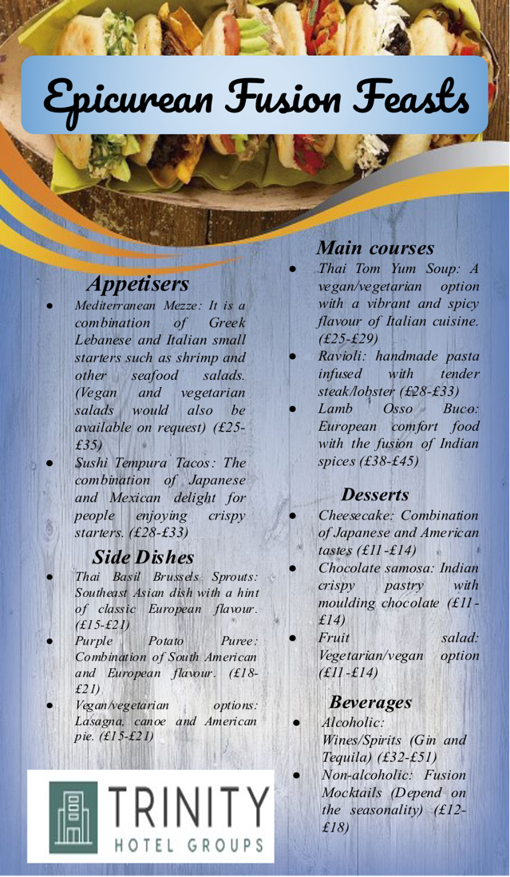

Sustainability and Seasonality
Sustainability is one of the most important aspects associated with this particular organisation and the process of designing the menu. The consent of sustainability is to be facilitated with the help of effective sourcing to the fresh local room and seasonal ingredients for the dishes presented in the epicurean menu. This particular aspect is associated with the process of identifying the highest quality of the food
7

and flavour associated with the dishes (Zutshi, 2019). Similarly, it is also related to the process of reducing carbon footprint from the process of sourcing ingredients which is one of the most important Major of responsible sourcing practices. Cruelty-free meat options along with ethically sourced lobster and shrimp have also been considered in the process of reducing the seasonality and sustainability of the food options (Kim and Hall, 2020). To reduce food waste, the organisation has incorporated if it is energy efficient practices along with providing take-outs which will contribute to the overall environmental conservation in terms of providing an effective dining experience to the guests.
8

References
Brown, D.R., 2003. The restaurant manager's handbook: How to set up, operate, and manage a financially successful food service operation (Vol. 1). Atlantic Publishing Company.
Corrado, S., Caldeira, C., Eriksson, M., Hanssen, O.J., Hauser, H.E., van Holsteijn, F., Liu, G., Östergren, K., Parry, A., Secondi, L. and Stenmarck, Å., 2019. Food waste accounting methodologies: Challenges, opportunities, and further advancements. Global food security, 20, pp.93-100.
Cousins, J., Lillicrap, D. and Weekes, S., 2014. Food and beverage service. Hachette UK.
Davis, B., Lockwood, A., Pantelidis, I. and Alcott, P., 2013. Food and beverage management. Routledge.
Foskett, D., Paskins, P., Pennington, A. and Rippington, N., 2021. The theory of hospitality and catering. Hachette UK.
Hendriks, S., de Groot Ruiz, A., Herrero Acosta, M., Baumers, H., Galgani, P., Mason-D'Croz, D., Godde, C., Waha, K., Kanidou, D., Von Braun, J. and Benitez, M., 2021. The true cost and true price of food. SC-FSS.
Johnston, R. and Clark, G., 2005. Service operations management: improving service delivery. Pearson Education.
Kim, M.J. and Hall, C.M., 2020. Can sustainable restaurant practices enhance customer loyalty? The roles of value theory and environmental concerns. Journal of Hospitality and Tourism Management, 43, pp.127-138.
Lelieveld, H.L. and Motarjemi, Y. eds., 2013. Food safety management: A practical guide for the food industry. Academic Press.
Zutshi, A., 2019. How to develop well-informed and assured teams to embed food safety compliance in the UK catering and hospitality industry. Perspectives in Public Health, 139(6), pp.294-295.

