

Programme: Master of Business Administration
Module: Marketing Management
Module Code: LCMB7024
Lecturer Name: Tushara balendra
Student Name: Dhrupalsinh Vijaysinh Gohel
Student ID: 2541188
Portfolio Brand Development

Table of Contents
Element 1: Sustainable Brand Extension Poster Presentation 3
Element 2: Segmentation, Targeting, Differentiation, and Positioning (STDP) Analysis for the brand extension 4
Element 3: Marketing Mix (4Ps) 7
Element 4: Reflection 11
References 13

Element 1: Sustainable Brand Extension Poster Presentation
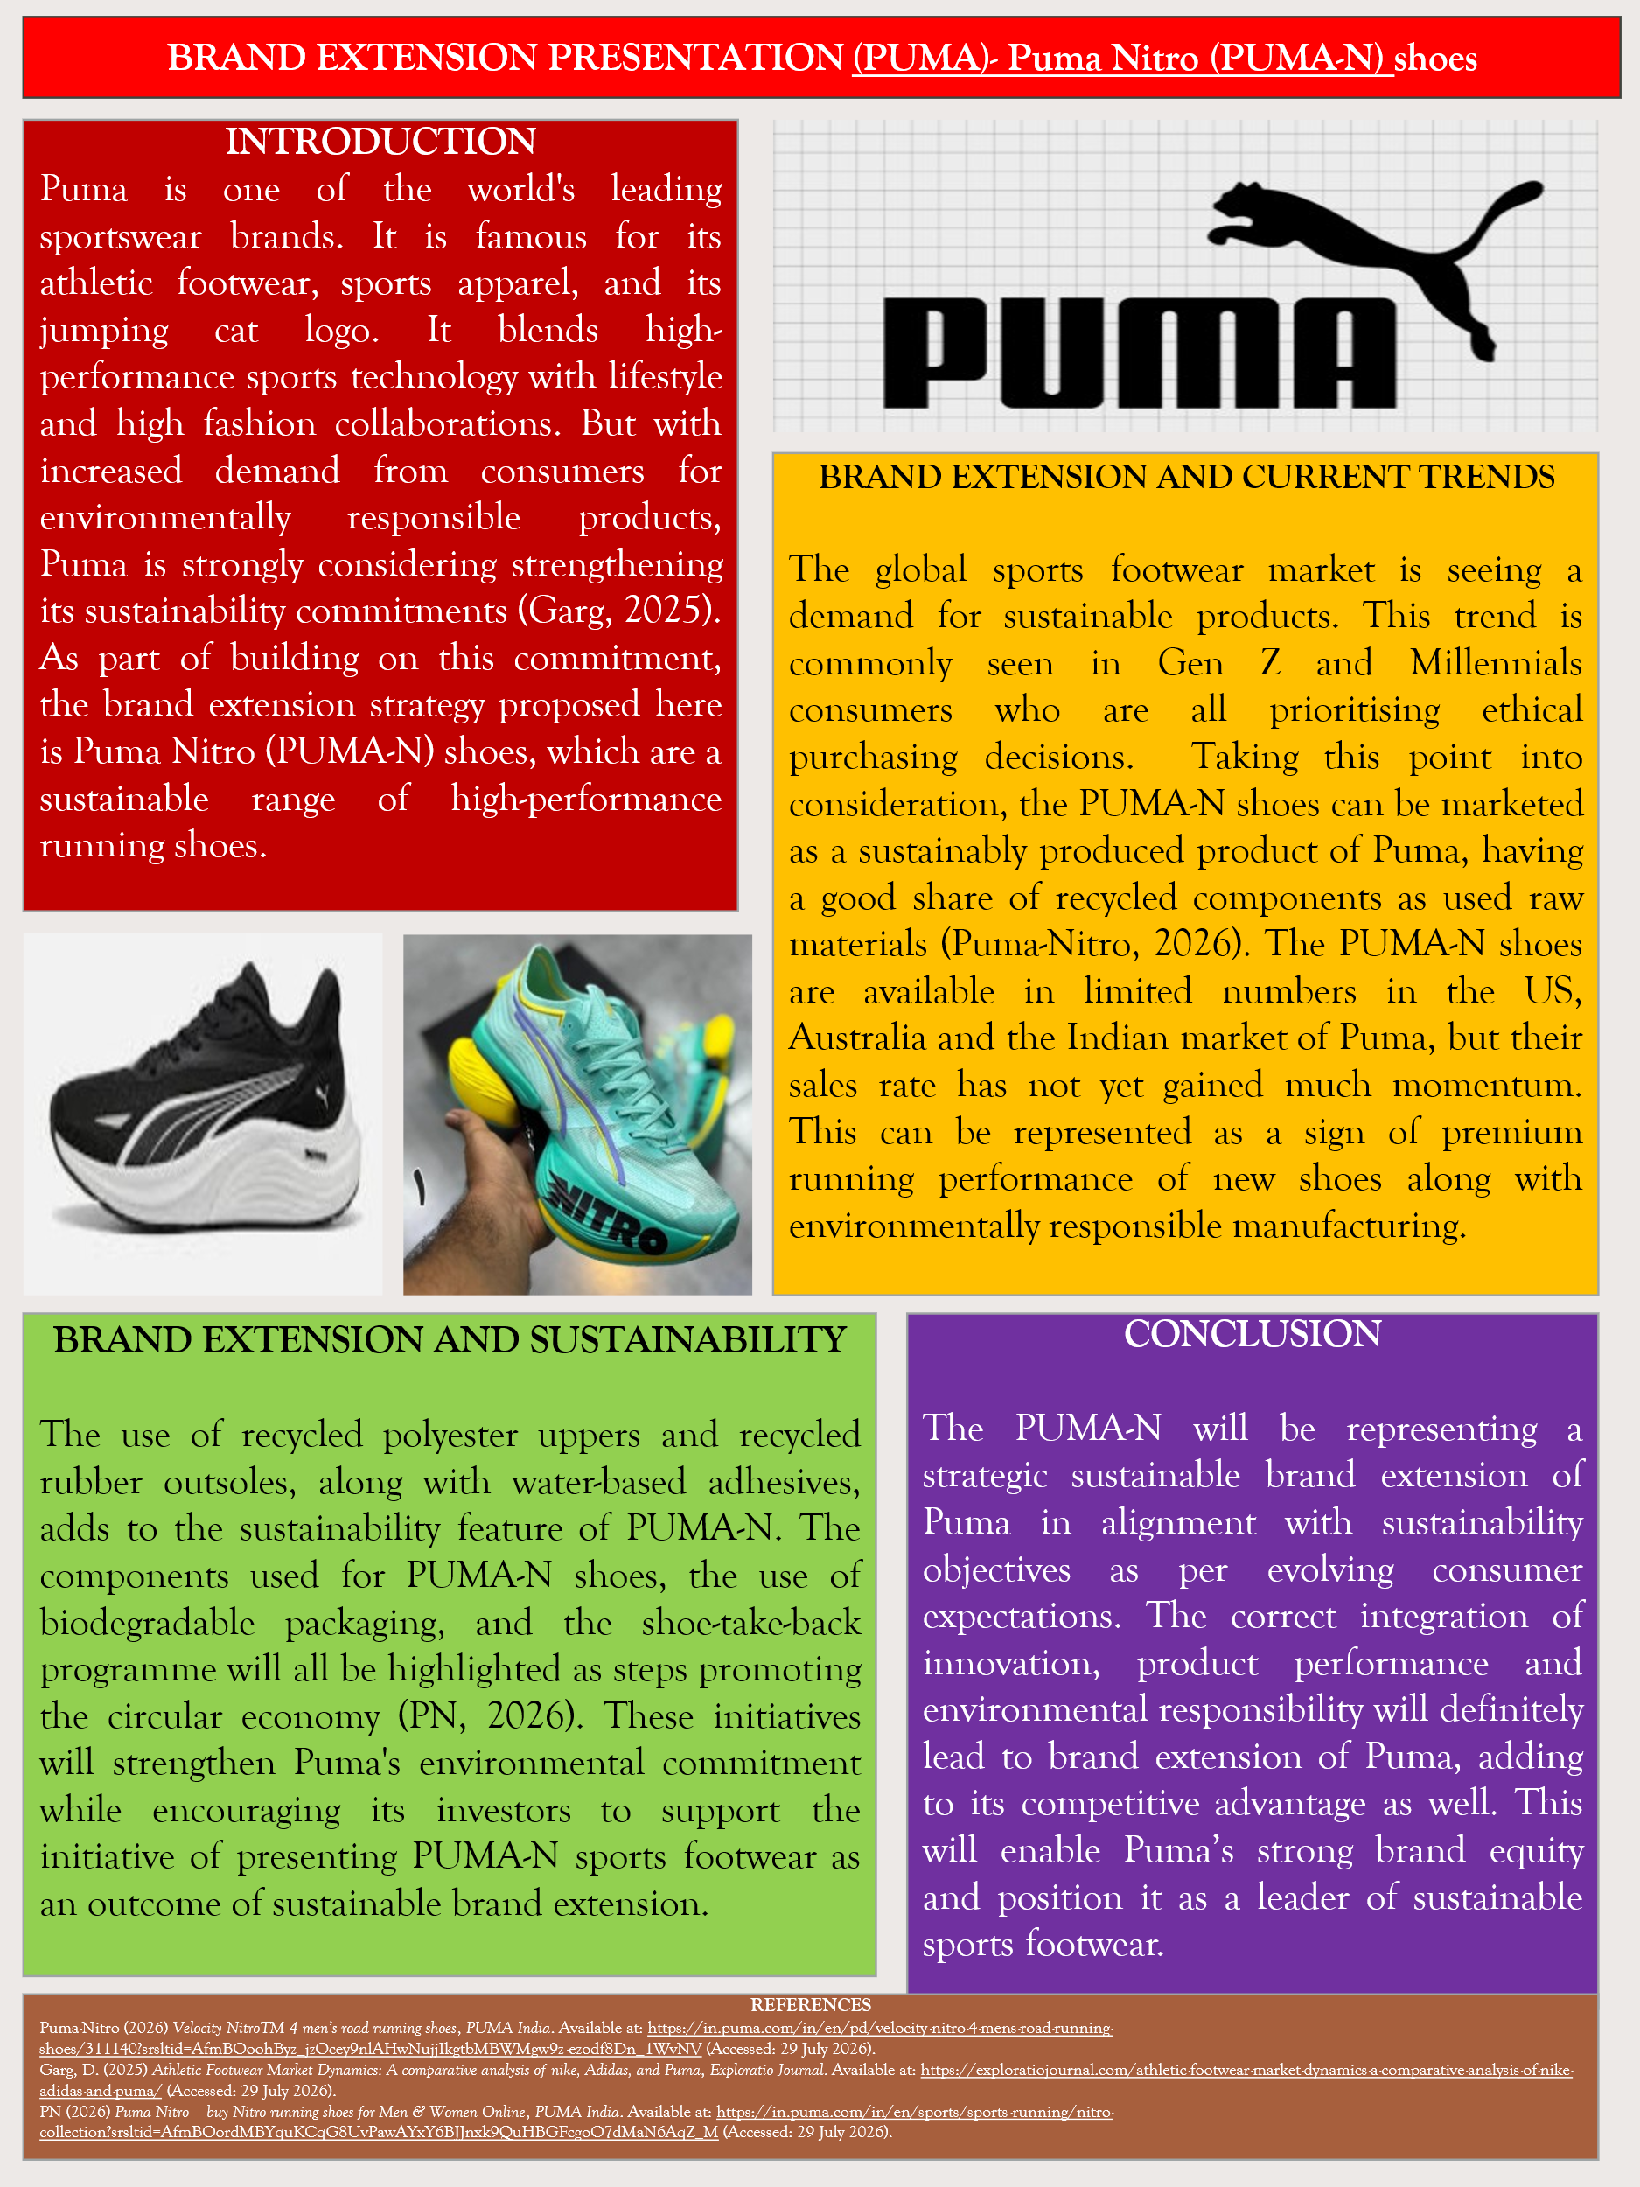

Element 2: Segmentation, Targeting, Differentiation, and Positioning (STDP) Analysis for the brand extension
Segmentation
The step of market segmentation helps organisations to properly divide the heterogeneous market into small groups. For the proposed new sustainable PUMA-N footwear models, the segmentation is done here considering four types.
Geographic- These new PUMA-N shoe models should primarily target the metropolitan and urban markets where there has been a growing awareness of the sustainability aspect and increased participation in sports cum fitness activities as well. There is a good option for Puma to target the US, Australia, UK, and India markets at first. The main reason for selecting only these four countries is that there has been a growing demand for environmentally responsible sportswear, along with respective national governments promoting the idea of sustainability as well (Ling and Li, 2025). Also, Puma already has a strong presence in major cities of all four countries, thus allowing it the leverage to make use of digital-retail infrastructure for marketing the new PUMA-N models.
Demographic- The target demographics will be the consumers in the age group of 18-40 years. This will include active sports players, fitness enthusiasts, students and young professionals on a sequence-wise basis in decreasing order. The consumers possessing a medium to high range of disposable income will be targeted, as this segment of consumers will show willingness to purchase new PUMA-N models for their environmental benefits (Pybus et al., 2022). The footwear availability should be of both male and female variants as a part of Puma's inclusive brand strategy. The sustainably aware and educated consumers should be specifically targeted based on their social media posts and product purchase patterns to increase the popularity of new PUMA-N models.
Psychographic- The main targeted consumers should be the environmentally conscious individuals who have started to emphasise and have been well adapting to sustainable practices as a part of their value system. Some examples of this type of consumers are the ones who are into regular exercising, running, gym workouts and play different types of sports (Bernstorff et al., 2023). This type of consumer has a tendency to check the level of ethical sourcing and carbon control initiatives undertaken by a brand prior to product purchase (Gao and Souza, 2022). The Gen-Z and millennial segment of customers have a good chance of preferring PUMA-N's new shoe models based on alignment with personal environmental and social values.
Behavioural - This aspect includes consideration of the purchase mentality of consumers, product usage rate and their loyalty towards a particular brand. The eco-labelling of PUMA-N's new shoe models will appeal to consumers, especially those who frequently wear sports or running shoes and change them within a 6 to 12 month period. In this regard, the loyal customer segment of Puma can also be targeted as their brand familiarity decreases the chance of perceived buying risk and quick adoption of PUMA-N footwear as a part of sustainable innovation.
Targeting
Based on the above segmentation strategy, Puma should consider making use of a differentiated targeting strategy. It is characterised by a company targeting two or more distinct market segments by creating tailored products (Nashiroh et al., 2024). In this case, Puma should target the environmentally conscious Gen-Z and millennials aged 18-40 living in urban and metropolitan areas. These consumers have strong purchasing power and invest a part of their disposable income to purchase premium sportswear. As opined by Pathak and Malakar (2024), the younger generation presently is willing to pay a higher price for sustainable products in comparison to the previous generation. Also, this target market tends to closely align with Puma's existing brand image of innovation and performance, which will allow it to further expand its brand reputation as a sustainability leader in its domain.
Differentiation
The selection of the correct differentiation strategy enables organisations to attain a competitive advantage which distinguishes the brand's product from competitors. As the main competitors of Puma, such as Adidas and Nike, already have sustainable footwear products, Puma should highlight the internal material's sustainability factor along with emphasising its sustainability ecosystem (Garg, 2025). The new PUMA-N running shoes can be termed as eco-friendly upgrades of existing Nitro shoe variants, with their upper construction using 30% recycled materials (Puma-Nitro, 2026). This is in addition to nitrogen-infused midsoles for maximum energy return on running. This information should be made available to consumers by enabling them to scan QR codes attached to the outer body of the biodegradable shoe package. PUMA can also run an old shoe take-back programme to popularise the new models as an attempt at a sustainable brand-building initiative as well. This will lead to meeting circular economy principles along with enhancing long-term brand loyalty.
Positioning
This is meant to establish a distinctive place of the brand/brand product in consumers' minds compared to its competitors.
High Sustainability
Low Sustainability
Low performance
High performance
Adidas
PUMA-N
Fila
Reebok
Nike

Figure 1: Positioning Map of PUMA-N shoe
(Source: Author)
This positioning map is done as per the characteristics of sustainability and performance. This step will help Puma to develop tailored marketing strategies for better positioning of its PUMA-N model, ensuring competitive advantage as well.

Element 3: Marketing Mix (4Ps)
The application of the 4Ps marketing mix model has been used here as a supporting framework to explain how Puma can better launch its new PUMA-N shoes to its target purchasers while setting a clear sales goal of sustainable brand extension.
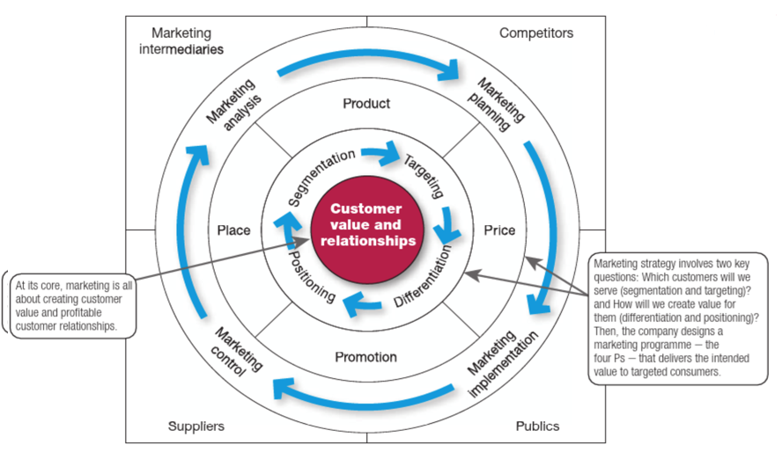
Figure 2: 4Ps of Marketing Mix strategy
(Source: Week 4, Session 1, Slide 4)
Product
The main offering is PUMA-N shoes, which are advanced high-traction rubber-made, supportive carbon-plate-enabled, nitrogen-infused running shoes. These features add to the light nature, bouncy and grippy characteristics of the shoes on different surfaces. But in addition to these points, PUMA-N is also considered to be a premium sustainable running shoe. It can be used for professional and recreational running purposes. This product is a perfect example of a product that combines athletic performance with the brand's environmental responsibility (PN, 2026). The use of recycled polyester uppers and recycled rubber outsoles, along with water-based adhesives, adds to its sustainability features. The enhanced durability and application of breathable materials make it suitable for regular fitness activities, thus adding to the core customer value aspect as well. Puma should offer a 1-year quality warranty assurance to the customers along with product material information availability via QR codes. The availability of a shoe recycling programme and free replacement service for manufacturing defects will add to the product's popularity as well. In addition to this, the shoe recycling programme and use of eco-friendly packaging will add to the sustainability image building of Puma as well. All these features of the PUMA-N product will serve a dual purpose of increasing customer value while facilitating circular economy principles as well.
Price
Based on the targeted consumer base of the PUMA-N product, it is recommended for Puma to adopt the value-based premium pricing strategy. As opined by Unnissa et al. (2025), this type of pricing strategy sets the product price high, taking into cognisance of consumers' desire and willingness to pay instead of focusing on recovering the cost of product manufacture.
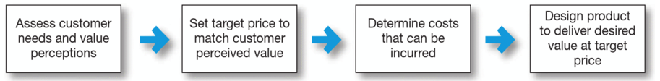
Figure 3: Basic concept of Value-based pricing
(Source: Week 4, Session 2, Slide 5)
This strategy has a significant impact on enhancing brand reputation and makes good use of the product’s uniqueness to justify the premium price of the product compared to the competitors. Also, there is a general tendency among consumers to associate the aspect of sustainability with high quality and ethical sourcing standards of the product. Hence, the slightly higher pricing of PUMA-N shoes compared to conventional running shoes is justified here. The recommended retail price of PUMA-N shoes should be kept at US$150-160 (for the US market), and prices should be varied on a country-wise basis accordingly. This pricing, in a way, will communicate superior Value without limiting accessibility, thus strengthening the brand image of Puma. Moreover, the feature of student discounts and loyalty rewards can be granted to encourage quick adoption of the product among the targeted consumer base.
Place
This point describes the marketing channel which should be used by an organisation for making a new product reach the targeted consumers as part of its sustainable brand building strategy. There are different types of marketing channels, such as direct, indirect, vertical, horizontal and multi-channel distribution systems (Shen, 2025). But the most appropriate for the present scenario is none of these but instead an omnichannel distribution strategy. For this purpose, the first requirement which needs to be fulfilled is to make the PUMA-N product available on Puma's official websites (on a country-wise basis), flagship stores, selected retailers, along with online marketplaces, and also in its official mobile app. This will prove to be immensely advantageous for Puma in terms of getting connected paths, enhanced customer focus and generation of real-time data (Guo and Keskin, 2023). Under the present scenario, Puma should prioritise the major metropolitan markets of the selected four countries to get clarity about whether sustainability innovation turns into actual sales numbers or not. Additionally, the digital channels will make it easier for customers to get related information about product lifecycle and recycled material information, thus encouraging them to purchase the shoes.
Promotion
In this regard, the application of Integrated Marketing Communication (IMC) based promotional strategy is most suitable for Puma. The IMC strategy is referred to the practice of coordinating all promotional tools/channels for delivering one consistent and clear message to targeted customer base (Aritzis and Antoniou, 2025).
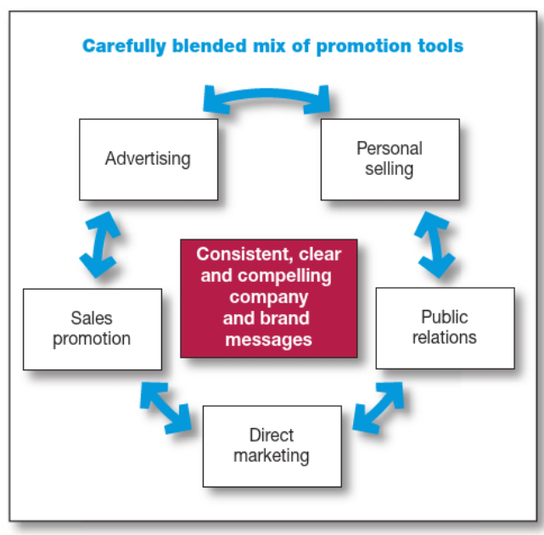
Figure 4: Basic principle of IMC strategy
(Source: Week 5, Session 2, Slide 5)
The good application of this IMC strategy for promotion facilitates customers trusting the brand faster and remembering it whenever they think about purchasing a particular product. The promotional strategy should be planned by Puma in such a manner that it highlights both the athletic performance of PUMA-N shoes and its sustainability feature. The IMC strategy can include social media campaigns, advertisements, posts, collaboration with celebrities and Instagram influencers (Rehman et al., 2022). There is also a good option for sustainability storytelling by Puma about the shoe manufacturing process, components used in it and how it is different from existing sports shoes of Puma. This will help in building public relationships while highlighting measurable environmental benefits as a part of sales promotion, which in turn will help enhance Puma's brand credibility as well.
In the end, it can be summarised here that the 4Ps of the marketing mix model will result in the creation of strategic consistency between the sustainability objectives of Puma and corresponding customer expectations from its new PUMA-N footwear model. The product innovation supports differentiation along with a premium pricing strategy best applicable for reinforcing perceived Value. The application of an omni-channel distribution strategy will enhance accessibility of the new footwear product, and integrated promotion will ultimately contribute to enhanced brand awareness. The correct application of this 4Ps marketing mix strategy will help in marketing PUMA-N as a sustainable footwear brand of Puma, making it capable of competing with Adidas, Nike, Fila and Reebok. This, in a way, will support Puma's long-term environmental commitment while enabling sustainable business growth.

Element 4: Reflection
The reflective account has been prepared here by describing the learnings as per 5-staged Gibbs reflective cycle.
Description
This portfolio assessment was to develop a strategy for sustainable brand extension of the multinational brand Puma. Based on the brief requirement, I selected PUMA-N shoes and proposed to brand it as a sustainable running shoe of Puma in alignment with the criteria of environmental responsibility. Firstly, a poster is designed in element 1 briefly highlighting the requirements of Puma and the main purpose of brand extension. It is followed by the STDP analysis in element 2 and the 4Ps marketing mix strategy application in element 3. My main focus has been to present how sustainability-driven extension can improve a brand’s competitiveness.
Feelings
I believed that sustainability by organisations can be attained by making products using environmentally friendly materials. But during this portfolio development, I realised that it is more than that and is not at all a very simple process. I understood that the sustainability factor extends beyond product manufacturing to sourcing, production, price setting, selection of marketing channels and also end-of-life management to gain optimum Value out of a product/process. I struggled a bit while integrating marketing theories into the portfolio but gradually understood the relevance of sustainable brand extension.
Evaluation
I was able to properly use marketing frameworks of STDP and the 4Ps marketing mix for justifying the brand extension. I learned how to identify the correct customer, position the product and design a coherent marketing strategy. I prepared the positioning map myself, comparing the main competitor brands of Puma while comparing performance and sustainability as two main aspects to meet the portfolio's condition.
Analysis
I was able to understand the relevance of sustainability integration to be considered strongly across all elements when planning a marketing strategy. This sort of holistic perspective has provided me insights about how marketing decisions contribute to sustainable development without compromising commercial performance standards. From Puma’s context I was able to understand that consumers tend to prefer brands only after evaluating the level of ethical sourcing and environmental transparency whenever there is a new product launch taking place.
Conclusion
This portfolio development has contributed to my enhanced knowledge of how to do strategic marketing planning for sustainable brand management. I have gained confidence to make correct use of theoretical marketing frameworks for proper handling of practical business scenarios related to contemporary sustainability challenges. After this assessment, I will start doing evidence supported decision-making whenever proposing new products for brand extension purpose.
Action Plan
In my future professional domain, I intend to strengthen my marketing analysis by not just only relying on secondary data but also by incorporating primary data. I will collect primary data from customer surveys and focus groups for validating the strategic recommendations. I also have good scope for improving my ability of studying and analysing sustainability performance metrics that will improve my decision-making ability while strategizing for brand extension.

References
Aritzis, T. and Antoniou, A. (2025) ‘AI and integrated marketing communication tools to promote, educate and explain the benefits of sustainability and the hydrogen economy: The cases of Cyprus and Peru’, International Journal of Business and Economic Sciences Applied Research (IJBESAR), 18(2), pp.29-38. Available at: https://www.econstor.eu/bitstream/10419/341740/1/1972979795.pdf
Bernstorff, M.A., Schumann, N., Finke, A., Schildhauer, T.A. and Königshausen, M., (2023) ‘Popular gym fitness sport: An analysis of 1387 recreational athletes regarding prone to pain exercises and the corresponding localisations’, Sports, 12(1), p.12. Available at: https://www.mdpi.com/2075-4663/12/1/12
Gao, F. and Souza, G.C. (2022) ‘Carbon offsetting with eco-conscious consumers’, Management Science, 68(11), pp.7879-7897. Available at: https://papers.ssrn.com/sol3/Delivery.cfm?abstractid=3440652
Garg, D. (2025) Athletic Footwear Market Dynamics: A comparative analysis of nike, Adidas, and Puma, Exploratio Journal. Available at: https://exploratiojournal.com/athletic-footwear-market-dynamics-a-comparative-analysis-of-nike-adidas-and-puma/ (Accessed: 29 July 2026).
Guo, J. and Keskin, B.B. (2023) ‘Designing a centralized distribution system for omni‐channel retailing’, Production and Operations Management, 32(6), pp.1724-1742. Available at: https://papers.ssrn.com/sol3/Delivery.cfm?abstractid=3317160
Ling, J. and Li, S. (2025) ‘The role of green commodities in the sports industry imports: shaping green growth in high-income countries’, Humanities and Social Sciences Communications, 12(1), pp.1-8. Available at: https://www.nature.com/articles/s41599-025-04816-w.pdf
Nashiroh, A.A.S., Shiddiqy, I.A. and Hidayat, M.N. (2024) ‘Exploring the depths of digital marketing: a systematic literature review on segmentation, targeting, differentiation, and positioning strategies’, International Journal of Business, Law, and Education, 5(1), pp.1270-1283. Available at: https://pdfs.semanticscholar.org/45c4/c2e99c8ad8645df88e11d1e23c436d6252f8.pdf
Pathak, D. and Malakar, D. (2024) ‘Willingness to pay more for green products: a challenge for young consumers’, EuroMed Journal of Management, 6(4), pp.281-293. Available at: https://www.researchgate.net/profile/Dipankar-Malakar/publication/385473183_Willingness_to_pay_more_for_green_products_a_challenge_for_young_consumers/links/67aebdc24c479b26c9dfdb01/Willingness-to-pay-more-for-green-products-a-challenge-for-young-consumers.pdf
PN (2026) Puma Nitro – buy Nitro running shoes for Men & Women Online, PUMA India. Available at: https://in.puma.com/in/en/sports/sports-running/nitro-collection?srsltid=AfmBOordMBYquKCqG8UvPawAYxY6BJJnxk9QuHBGFcgoO7dMaN6AqZ_M (Accessed: 29 July 2026).
Puma-Nitro (2026) Velocity NitroTM 4 men’s road running shoes, PUMA India. Available at: https://in.puma.com/in/en/pd/velocity-nitro-4-mens-road-running-shoes/311140?srsltid=AfmBOoohByz_jzOcey9nlAHwNujjIkgtbMBWMgw9z-ezodf8Dn_1WvNV (Accessed: 29 July 2026).
Pybus, K., Power, M., Pickett, K.E. and Wilkinson, R. (2022) ‘Income inequality, status consumption and status anxiety: an exploratory review of implications for sustainability and directions for future research’, Social Sciences & Humanities Open, 6(1), p.100353. Available at: https://www.sciencedirect.com/science/article/pii/S2590291122001073
Rehman, S.U., Gulzar, R. and Aslam, W. (2022) ‘Developing the integrated marketing communication (imc) through social media (sm): the modern marketing communication approach’, Sage Open, 12(2), p.21582440221099936. Available at: https://journals.sagepub.com/doi/pdf/10.1177/21582440221099936
Shen, Y. (2025) ‘Channel Integration Through a Wireless Applet and an E-Commerce Platform’, Journal of Theoretical and Applied Electronic Commerce Research, 20(1), p.51. Available at: https://www.mdpi.com/0718-1876/20/1/51
Unnissa, M.M., Kalpanapriya, D. and Jalapathy, P. (2025) ‘Optimal Pricing and Extended Warranty Strategies for Maximizing Profit in (Re) manufacturing With Customer Returns and Production Recovery’, IEEE Access, pp. 130029-130065. Available at: https://ieeexplore.ieee.org/stamp/stamp.jsp?arnumber=11075790

