NAME: SANDRA CRISTINA OROZCO CARVAJAL

STUDENT ID : 2416899

ASSIGNMENT: TASK 2

LECTURE NAME: MARK KANE

MODULE CODE: LCHS 4010- LON

MODULE NAME: PSYCHOLOGY IN HEALTH SOCIAL CARE

1. INTRODUCTION

This inform present two research theories based on Vygotsky and Maslow theories , these theories focus on finding strategies, to help people over 65 years of age who suffer from dementia and psychological, because the dementia is a syndrome usually of a chronic or progressive nature that leads to deterioration in cognitive function (I, e, the ability to process thought), beyond what might be expected from the usual consequences of biological ageing in affect memory, thinking, orientation, comprehension, calculation, learning, capacity, language, and judgement dementia result from a variety of disease and injuries that primarily or secondarily affect the brain, such, as Alzheimer, disease or stroke. Thomas kit wood was first in his field to look at people diagnosed with dementia and see beyond the diagnosis he authored many text throughout his death in 1998 dementia reconsidered the person comes first was published, it is considered his greatest work within those pages are years of studies kit wood carried out examining the experiences of the people living with a dementia. His findings challenged the old culture of care by advocating for a new one, one that would be built from compassion.


2. Setting old people living in a dementia a care home.

People with dementia are placed in residences according to their specific needs which can range from assisted living facilities in the early stages to specialist dementia homes or memory care units for those requiring more medical support and specializes care these residences offer different levels of care to manage changing symptoms and difficulties and daily activities, the location it is very important for people with dementia where these are recommended for people with dementia who exhibit more complex symptoms such as aggression, as they provide a safe environment and a team with the appropriate training to handle these behaviours.

It very important key consideration, it is vital to find a facility that can offer continuous care day and night if needed, the symptoms of dementia, such aggression, confusion, or behavioural problems, the safety and support it is essential that the chosen location can safely manage the changing needs and health issues that often accompany dementia.

3 DETAILED OVERVIEWS OF TWO THEORIES.

The theories we will develop are Maslow, and Vygotsky.

Vygotsky theory applies to people over 65 by highlighting the importance of social interaction and participation in activities are essential for lifelong learning and maintaining cognitive function , this can be achieved by creating, the zone of proximal development (ZPD). Activities should be designed to be just beyond the reach of individual ability, but achievable with appropriate help, avoiding both frustration and boredom, because psychological tools the introduction and use of tools such as schedules, apps, or formulas, can help people master their own cognitive functions, such as memory and attention, Vygotsky developed his sociocultural theory primarily in the context of children learning, it is care principals are highly relevant to understand development in older adulthood , Vigosky emphasizes that cognitive functioning is shaped by social interaction , cultural tools, and the zone of proximal development ZPD), all of which continue to play a role throughout the lifespan the (ZPD), defined as the distance between what a person can do alone and what they assistance is also applicable to aging, older adults may benefit from scaffolding provided by caregivers, peer, family member or technology, support helps them perform tasks that are challenging due to age related changes, such as using digital tools or manging daily activities.

Maslow hierarchy of need is a widely used framework in dementia care to help identify and address the holistic need of individuals several academic papers and guidelines discuss it is application and some are available as the theory the Maslow emphasize person cantered care which focuses on the individual remaining abilities and well being rather than just deficit , because need basic, survival ensuring fundamental needs like food, water, warmth sleep, and personal hygiene are met this ca be complex in dementia care, because in safety needs this includes physical safety fall prevention and emotional security a needs – led framework for understanding the impact of caring for a relative with dementia this paper explore how Maslow needs led approach can provide a framework for supporting carers and people with dementia.
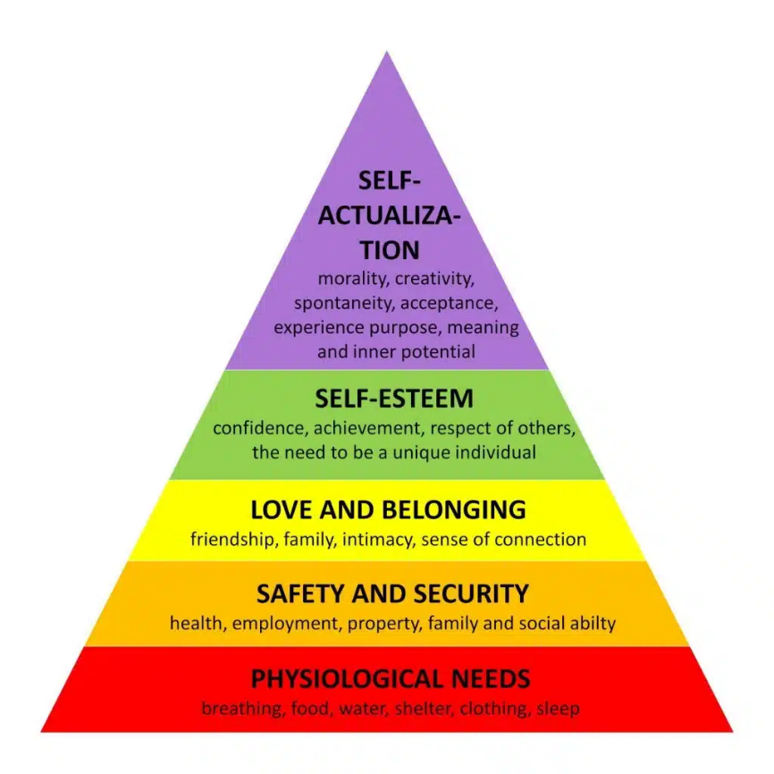

HOW CAN THE TWO THEORIES BE APPLIED:
Vygotsky theory can be applied by fostering social connection and continuo learning analysing the changes that come with advance age, and showing that people over 65 can continue learning and actively participating if they give adequate support, valuing the wisdom and experience they possess, insolation can negatively impact their mental , emotional, and physical health , Maslow theory hierarchizes human needs into 5 levels , physiological, safety, love, belonging, esteem, and self-actualization in people over 65 years of age, emphasis is placed on love and belonging and the needs for interpersonal relationships such as friendship intimacy, and family.

According Vygotsky the social environment that most help older people (and everyone), is one that foster social interaction and collaboration with “family peers educators”, within their zone of proximal development (Z P D), providing support guidance and cultural tools (such as language), to build knowledge, keep their higher cognitive function active, and develop new skills, thus enabling them to continue growing and actively participating in their culture and society, not only as children , but throughout their lives,

Key elements of the Vygotsky social environment for older adults:
Scaffolding: adults or more capable peers offer temporary support (explanations, demonstration, question), to help the older person perform task they could not do alone facilitating their transition to autonomy.
Cultural tools and language: the use of language storytelling participation in social ritual, and the use of tools (from technologies to everyday objects for maintaining and developing the ming.
Extended (Z P D); Although to applies to children the Z P D, is also relevant to older adult, helping them to reach their potential in new task or to overcome cognitive declines, with the right help
Social and cultural context: an environment that valves the experiences of the elderly and allo was them to continue being an active participant passing on wisdom, taking care of gran children participating in community activities nurtures their continuous development a social environment that offers guided support meaningful participation and active use of language and culture is fundamental for older people not only to maintain their abilities but also to continue learning and developing according to Vygotsky social cultural theory, for example: people who Actuant as cultural mediators transmit language, symbols, and cultural tools that transform basic cognitive skills into higher function , enriching the understanding of the world, cultural mediators are those who guide individuals through the zone proximal development.

Maslow: to support the elderly according to Maslow theory is a social environment, we most ensure their basic needs (health found safety), and encourage their affiliation and love (participation in group activities, affection, strengthen their self-esteem recognition of their achievement , respect and facilitate self-realization activities purpose , such as volunteering or new skills, Maslow physiological and safety need environment ensure good nutrition for example in part social provide support so that they do not feel alone in their basic care and build trust in their caregivers and environment , promote activities that reinforce their identity and worth such as teaching others participating in community decision , or simple listening to their stories for example: estimating cognitive platform digital , offer rehabilitation programs, occupation in therapy , courses volunteering , loneliness in older people how to help it is benefit for person or activities that allow them to continue learning and feeling useful and fulfilled .
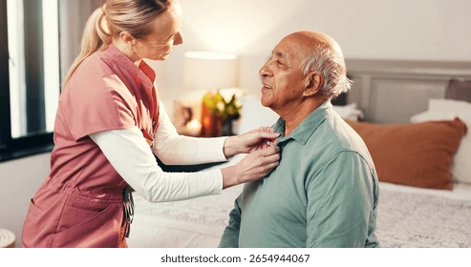

CONCLUSION:
Both theories are important , Vygotsky allows us to see again not as a period of stagnation but as a stage of continuous development driven by sociocultural interaction and assisted learning, there is no Maslow theory of dementia but the Maslow hierarchy of need , is a useful tool for understand and caring for people with dementia, focusing om meeting their basic need physiological, safety, love, and belonging and higher needs esteem self-actualization to maintain their wellbeing and dignity, need physiological ensure food, hydration, hygiene, rest and medication, in dementia adapt the diet assist with eating , maintain physical confronter very important this theory is security needs, and protection, older stability predictable environment, because needs for belonging and love , focus affection social relationships, feeling of belonging, in dementia the physical contact meaningful interaction music, games, avoid isolation, create community in summary Maslow does not have a theory of dementia, but rather his theory of needs is a framework for comprehensive care, focused on dignity and wellbeing of the older adult with dementia, thanks to Kit wood a dementia diagnosis is no longer as dauting a prospect as it was once was people living with a dementia are finally living life on their own term.

References

Association, U.N. (2024). US Nanny Association | Elevating Nannies & Parents. [online] Usnanny.org. Available at: https://www.usnanny.org/.
Evolve Care Group (2025). Who is Thomas Kitwood? [online] Evolve Care Group. Available at: https://www.evolvecaregroup.com/who-is-thomas-kitwood/.
McLeod, S. (2025a). Maslow’s hierarchy of needs. [online] Simply Psychology. Available at: https://www.simplypsychology.org/maslow.html.
McLeod, S. (2025b). Vygotsky’s sociocultural theory of cognitive development. [online] Simply Psychology. Available at: https://www.simplypsychology.org/vygotsky.html.
NIHR (2019). NIHR | National Institute for Health Research. [online] Nihr.ac.uk. Available at: https://www.nihr.ac.uk/.
Us Nanny (2024). US Nanny Association | Elevating Nannies & Parents. [online] Usnanny.org. Available at: https://www.usnanny.org/.

