Crinela -Corina Covaci
BMSW4001

Employability Skills

Academic and Employability Skills
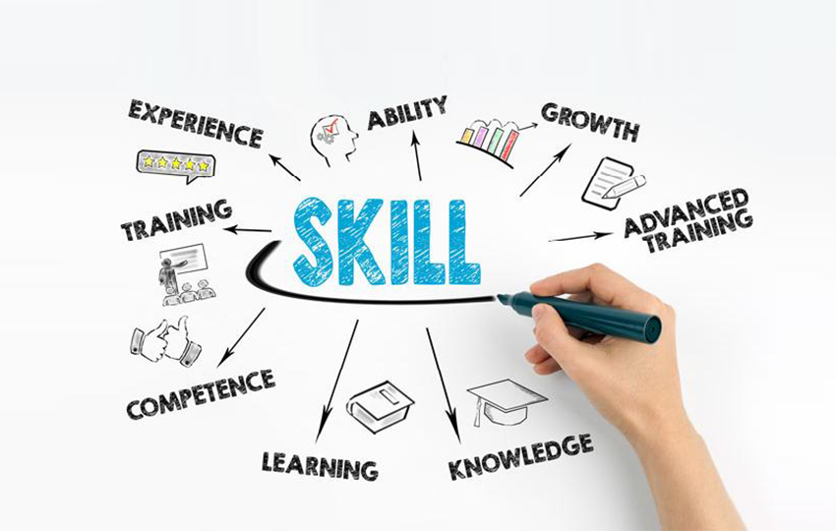

Contents Page
  - Introduction (page 3)

  - Main Findings ( page 4)

2.1 Resilience Skills ( page 4)
2.1.1 What are Resilience Skills ?
2.1.2 Examples of Resilience Skills and Why are they important?
2.1.3 How to improve your Resilience Skills?

2.2 Emotional Intelligence ( page 5)
2.2.1 What is Emotional Intelligence?
2.2.2 Examples of Emotional Intelligence and why are they important?
2.2.3 How to improve your Emotional Intelligence?

2.3 Digital Competence ( page 6)
2.3.1 What is Digital Competence?
2.3.2 Examples of Digital Competence and why are they important?
2.3.3 How to improve your Digital Competence?

  - Conclusion

0.4 References
Introduction

What are Employability Skills?

According to online research “ Employability Skills can be defined as the transferable skills needed by an individual to make them 'employable'. Along with good technical understanding and subject knowledge, employers often outline a set of skills that they want from an employee”.

Why are Employability Skills important?

Employability Skills are important for employers because they are indicators of how well you work with others, how well you handle tough situations, and whether you will be able to perform well at your job and succeed in your career.

2.1 Resilience Skills
2.1.1 What are Resilience Skills

Resilience Skills are when a person is capable of overcoming challenges by facing them and adapting to them effectively. When a person is resilient, they are not affected by setbacks, so they can handle disappointments with a sense of perseverance.

2.1.2 Examples of Resilience Skills and Why are they important?

A few Examples of Resilience Skills are Self-Confident, Communication and Teamwork, and Problem Solving.
As a result of resilience, people are able to adapt to hardship by giving themselves the strength they need to overcome it.

2.1.3 How to improve your Resilience Skills?

There are multiple ways of improving your Resilience Skills in the Workplace to which some of them include by getting associated and receiving support, guidance, and acceptance from loved ones and friends in good and bad times if you build strong, positive relationships with them
You can also improve your Resilience by Joining a faith and spiritual community or volunteer to establish other vital connections, Learning from your mistakes and, by not ignoring your problems and resolve the problem.

2.2 Emotional Intelligence
2.2.1 What is Emotional Intelligence?
Emotional Intelligence is where you have the ability to understand, utilise, and manage your emotions into successes and failures when dealing with stress, communicating effectively, empathising with others, overcoming challenges, and resolving conflicts are all important aspects of emotional intelligence.

2.2.2 Examples of Emotional Intelligence and Why are they Important?

A couple examples of Emotional Intelligence are
Self-Awareness, Internal motivation, Empathy, and Social Awareness.
You can achieve your career and personal goals when you have emotional intelligence, including building stronger relationships and being successful at work.

2.2.3 How to improve your Emotional Intelligence?

There are multiple ways you can Improve your Emotional Intelligence to which some include by being aware of your reactions as you interact with others, Before you take action, consider the effect your actions will have on others, Think and identify the ways in which you respond when a stressful situation arises and, make sure you take accountability and admit the things you do.

2.3 Digital Competence
2.3.1 What is Digital Competence?
According to online sources “Digital Competence is one of the eight key competences and refers to the confident and critical usage of the full range of digital technologies for information, communication and basic problem-solving in all aspects of life”.

2.3.2 Examples of Digital Competence and why are they important
Some examples of Digital Competence include
Digital Literacy, Internet Literacy and, Information Literacy.
Digital Competence is important for both individuals and organisations to remain competitive, increase efficiency and explore new products and processes. People who don’t possess the digital skills are excluded from all new possibilities.

2.3.3 How can you improve your Digital Competence?

When leaning about how you can improve you digital skills you have to adapt your online communication methods to meet the needs of others, If you are doing a job, doing a hobby, or showing off your work on the web, offer yourself the opportunity to explore technology, Online courses are free for you to take which will help you learn new skills and, educate others about digital skills to which they can educate you as well.

0.3 Conclusion
In conclusion we learned that we found out what employability skills mean in the work place.
Overall resilience skills are important in the work place because communication is the important thing when discussing about work with your group.
Team works also is important in the work place.
We also learned how we can improve our skills in the work place which some include taking accountability and admit the things you do. Since humans play an integral part in every aspect of our professional lives, emotional intelligence is essential.
It can also be concluded that a person's quality of life is improved by their level of resilience.

  - References

- Introduction “What are Employability Skills?” (Page 3)
https://www.exeter.ac.uk/students/ambassadors/HESTEM/resources/General/STEMNET%20Employability%20skills%20guide.pdf

- 2.3 Digital Competence (2.3.1) “What is digital Competence?” (Page 6)
https://www.schooleducationgateway.eu/en/pub/resources/tutorials/digital-competence-the-vital-.htm

