University of Wales Trinity Saint David
MARKETING FUNDAMENTALS
PRET A MANGER

Vasile Ene, ID 1817171 –Background/history of company
Iuliana Teodora Stoianescu, ID 1812952 – Product

Anatoli Petrov Tsvetanov, ID 1817788 – Price
Aygyul Shakirova, ID 1818045 - Place
Nicola Gil, ID 1818044 - Promotion

Tushara Baladran

2019
History of the Company and the mission statement – Vasile Ene

The name of the company can be confusing, PRET A MANGER, at first glance you say that it is a cafe of French origin, so if you read the name in French of the company but this company is purely British, established in London more than 30 years ago .
In October 1983, Jeffrey Hyman opens the first Pret a Manger shop but after an 18-month period sales will drop drastically and the company will go into liquidation. Right now, the founders of law, Sinclair Beecham and Julian Metcalfe, are taking over the name and visual branding and creating a new concept in terms of coffee, restaurant, freshly baked products, salads, soups, fresh foods all under one roof in a new concept called PRET A MANGER. The two high school colleagues will open the first PRET A MANGER in Victoria Street with the desire to provide quality services for customers by offering simple, delicious and served food by friendly and motivated staff.
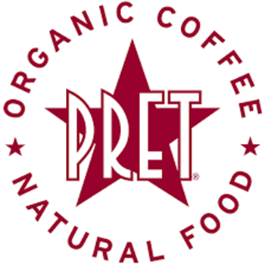
https://encrypted-tbn0.gstatic.com/images?q=tbn:ANd9GcR7gFbwv2UDIvk9e_nqxlh9Bi2tI-2deSrf3CPEaQXPs6k2Nldv&s
“There was nowhere you could get in and out quickly and find something to eat that was consistently good, fresh and value for money. This is typical not just of London, but the world.” Julian Metcalfe quoted in (Fraser 1995).
Julian Metcalfe finds this regarding the offer at that time on the market and the two are trying to achieve and bring something new in this niche of the market so sensitive that is the food.
At the beginning of the 1990s, after the experience that the two have accumulated, they will open one more shop and one more so that in 1997 there will be 53 shops. In each of these units the quality of the products, the freshness of the ingredients and the friendliness with which the consumer is served will be the most important assets of the company that slowly creates its name, a brand.
“Quite rightly, with hindsight, we realised that what brings customers back is a good product at the right price and with the right service. That is 95% of the battle, since what makes us a success is repeat trade. You can fool a customer once or twice but after that they won’t come back” (Fraser 1995)
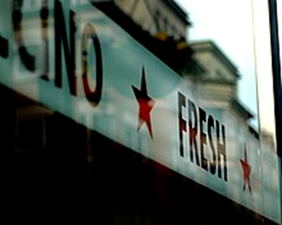https://upload.wikimedia.org/wikipedia/commons/thumb/e/e8/Pret_a_manger.jpg/220px-Pret_a_manger.jpg
PRET grows permanently, grows in geometric progression does not discount quality, continues the way as it has proposed that the products are always fresh, focuses on selling quality, top sandwiches and at the same time to have a price end of sale accessible to the buyer, a reasonable price. Diversifying its products offers over 80 products for sale as well as various types of coffee that is 100% organic. Prêt produces sandwiches, filled baguettes, soup, salad and coffee. It also prepares desserts, muffins (the American variety), cakes, and croissants. Some locations also serve sushi and noodles. Prêt has a range of vegetarian options including roasted vegetable sandwiches and hummus wraps. In marketing though, customers seek to purchase its quality and benefits (Rix, 2004).

https://encryptedtbn0.gstatic.com/images?q=tbn:ANd9GcRwOfeVoEpwsDz_fxYvtoHtdLrQa801vc1i3P0E2Vd_uOeh3ErPA&s
In 2000, PRET left for the first time the borders of London to cross the ocean and open a shop in New York on Broad Street. The step is taken, the company is closely watched by McDonalds, which in 2001 bought 33% of the shares but in 2008 sold its stake to the private equity firm Bridgepoint Capital. Even the short-term participation of the world leader in fastservice in this company will open new opportunities in the market for PRET, which will materialize by opening 74 other stores in the United States.
With the growth of business year by year, the desire to expand the business has increased as well, as PRET has opened new restaurants on the Asian continent, in Dubai as well as on the European continent, the last restaurant opened in 2018 in Germany.
PRET A MANGER's mission is “to create hand made, natural food, avoiding the obscure chemicals, additives and preservatives common to so much of the 'fast' food market.”
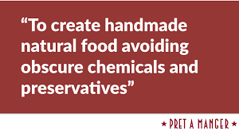
https://encryptedtbn0.gstatic.com/images?q=tbn:ANd9GcS7pN8ctdqOPHdzXMy8yibQjomQeGjxW9V3wBCdBdP-xnVzYvA_7g&s
The declared mission of the organization is defined in two competitive purposes (Kotler 1995) the industrial one and the one of the market segment. For the industrial purpose the company is placed in the fast food market segment, accepts the challenge and focuses its activity on quality and time and for the second purpose the organization has the mission not to depart from the niche of the market it has won.
Pret’s Mission Statement has a strong influence on how they do business. Pret builds its culture around three “Core Behaviours” – passion, clear talking and team working. As they say on their website, “you can’t hire someone who can make sandwiches and teach them to be passionate. So we hire passionate people and teach them to make sandwiches”.
“We are passionate about people and our staff. They are extremely important and we make sure they have the right opportunities and rewards, that they are paid correctly and that they have fun working for us. We have and will always have a great culture and energy.” - Andrew Rolfe, partner, shareholder and chairman of the overall operation.

References
Fraser I (1995) Legends in their own lunchtime. In Marketing Business(December/January), 30–33.
Kotler P (1995) Marketing management: Analysis, planning, implementation and control. Prentice Hall, Englewood Cliffs, NJ.
Matt Blumberg (16 May 2011). "Pret A Manger". Business Insider. Retrieved 24 September 2017.
"About Pret". Pret.co.uk. Archived from the original on 11 May 2015. Retrieved 10 August 2017.
"About the Founders". Pret A Manger. Retrieved 23 January 2012.
"The Pret Behaviours". Pret.com. Retrieved 23 March 2017.
https://willgardner.co/pret-a-manger-mission-values
https://www.ukessays.com/essays/marketing/market-and-company-overview-of-pret-a-manger-marketing-essay.php
https://startups.co.uk/pret-a-manger-julian-metcalfe-and-sinclair-beecham/
https://en.wikipedia.org/wiki/Pret_a_Manger

Product - Iuliana Teodora Stoianescu
Pret a Manger is a renowned company, which serves freshly prepared food and beverages in the UK for the last 35 years. In order to increase brand image and notify customers about new product launches and other company-related specification, they use blogging. This is because it helps to boost optimization of search engine and strengthen customer base. In the current blog, product specification of Chicken, avocado and basil sandwich is discussed to spread awareness about its nutritious value to make it a popular healthy choice for breakfast among people (Pret.co.uk, 2019). 15% UK population of all age groups, who are interested in a healthy diet will benefit reading this blog.
67% of the UK population prefers sandwiches for breakfast, which also needs to be healthy. In order to satisfy customer demand, a little twist is given to 1990’s Bill Granger’s avocado toast with people’s favourite regular sandwich (Pret.co.uk, 2019). Thus, this company invented this product. Availability of this product is 200 units per day. Price of it is £ 2.99, which is affordable and not pricey at all keeping in mind of familiar people. This sandwich is available both offline and online orders.
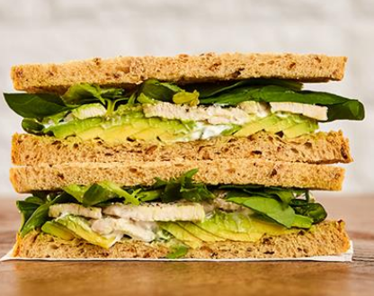
This sandwich is a healthy choice, especially for those fitness freaks who mostly work on building muscles. Although this preparation is made up of necessary ingredients like milk, egg, cereals consisting of gluten still, it is delicious. In this recipe, sliced avocado (30%), basil leaves and chicken (20%) is mixed up with salads (spinach, red chard, lettuce, red salanova and so on) and yoghurt (Stratman, 2014). Around 440 calories are there. Apart from this, rapeseed oil, lemon juice, pepper and so on are also added.
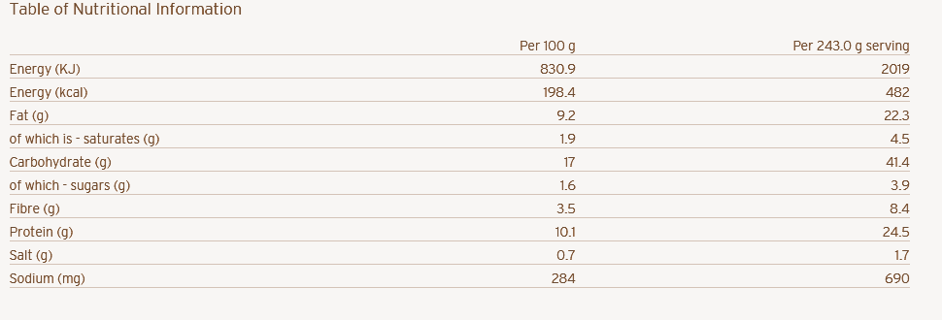
Before including this item officially in menu, a pilot study is done by serving free samples of this sandwich to 6 voluntary random customers to collect feedback. 4 out of 6 participants liked the combination of Basil's minty taste with peppery chicken with a touch of avocado's buttery texture. They appreciated the company's initiative for healthy diet chart. Thus, it can be said that Pret, a Manger company, has done a great job in this sandwich in terms of taste, colour and presentation (Stratman, 2014). Launching a fresh and healthy food product with high nutritional value gives a view that the company is concerned for their customer’s health.

Pret a Manger is a famous company established in 1986, and since then, they are serving freshly prepared food to the UK population. It serves foods like organic coffee, sandwiches like a superb classic club, free-range egg mayo, and so on. Currently, they have introduced a new product in their items named Chicken, Avocado and Basil Sandwich (Pret.co.uk, 2019). Now, the question might arise among readers. Why buy this item? The reasons are as follows:
- Since preparation time is less, therefore, customers do not have to wait long for this sandwich.
- It is very healthy because fresh and direct-from-farm vegetables are supplied to the kitchen.
- It contains high nutrition.
- It satisfies hunger and a full stomach for a longer time.
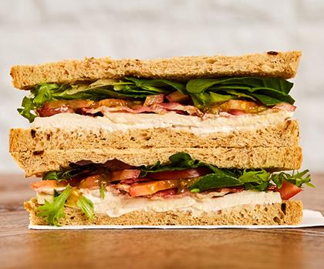
This product contains energy (198.4 kcal) and carbohydrate (17g) which allows people to work energetically throughout day. It contains fats (9.2) which resists hunger, proteins (10.1 g), fibres (3.5g) and sugar (1.6g) which is good for appetite (Stratman, 2014). Apart from this, it also contains minerals like salt and sodium, which also helps to keep one's body in balance. Safety Act approves all these ingredients used for this item for food 2010.
Now some readers or customers who are going through this blog might interrogate how come a product be so healthy and have no harmful effect? Since this product contains wheat, many people, who have a wheat allergy can get affected to streaming eyes, nausea, and so on. To maintain safety, milk and eggs are included in the recipe, which helps in allergy reduction. Barley, GF oats and Rye also reduces glutens in food. Company has provided allergen list on their official site so that customers can select their correct allergen-free food (Verma, 2014). As demand for other sandwiches (Classic superb sandwich, free-range egg mayo sandwich), to sustain this popularity and reduce monotony in menu, this new Healthy product is introduced.
Thus, it can be concluded that customers prefer Chicken, Avocado and Basil sandwich very much due to its healthiness, taste and nutrients contained.

Reference List
Stratman, L., 2014. The Comedienne. CutBank, 1(80), p.33.
Verma, K., 2014. Quality characteristics of value added chicken meat noodles. Nutrition & Food Sciences.
Websites.
Pret.co.uk, 2019. CHICKEN, AVOCADO & BASIL. Viewed on 27/12/2019 https://www.pret.co.uk/en-gb/475-sandwiches-chicken%2c-avocado-%26-basil.aspx

Price - Anatoli Tsvetanov
Price of coffee in one of biggest chains of UK increased by about 10p to support fund cost of new national wage for living of UK government. Pret A Manger has raised price of Cappuccino, Flat White and Latte to about £2.15 and £2.25. On other hand, cost of Americano is caused from about £1.75 to about £1.85. This has been admitted that such increase is because of “in part” towards riser within costs of labour just after introducing national wage for living. This observed inches in basic pay from about £6.70 to about £7.20 (Telegraph.co.uk, 2016). This became amid Cabinet row on whether new wage can fuel the immigration until the UK leaves European Union.
Culture Secretary, Whittingdale and Commons Leader, Grayling has recommended that UK workers can get lose out due to higher rates of wages that can attract more of the European workers for coming to UK. Moreover, Cameron has rebutted specific claims for wage for living that can trigger surge within migrants of EU. They can also warn UK that still need to accept freedom for movement, in case, if this voted for leaving. In the opinion of Cameron, national living wage appears as well deserved inches in payment for sure of lowest-paid workers in UK (Pret.com, 2019). Besides, Pret is having tasty, fresh and fair trade, though their attitude towards VAT is quite negative. Furthermore, they boost morale with perspective that this feels annoying, inconvenient and even abusive of their rights to cheap coffee (Theblogofkevin.wordpress.com, 2009).
On contrary, the benefit for having such national wage for living as well as staying within reformed EU has been leading to achieve acceptance along with their welfare changes. This leads to the fact that they fail to get complete access to welfare system of UK for 4 years. In case, if they left EU and conduct an agreement in Norway style with any sort of deal that involved completely access towards single market, then they can have free people’s movement without any such welfare changes (Telegraph.co.uk, 2016).
Chancellor Osborne, in 2015 commented that national living wage can be deserved rise in pay for UK and can rise to about £9 per hour within 2020. In comparison to this, spokesperson of Pret A Manger opines that they have selected to take new legal needs of UK government as challenge towards raised pay in almost all levels regarding their shop teams to raise their starting rate. Thus, rising costs, involving those around their ingredients along with their people to make them raise prices varying from time. In addition to this, there has been done rarely with best efforts to keep these as minimal (Pret.com, 2019). However, coffee with milk is 100% organic, while unfold food has been delivered through fleets of the vans towards proper charities at end of every day. Pret also have friendly structure, such that its employees are boosted for climbing ranks (Fizzoflife.com, 2017).
Event at airport price, one-size drinks of Pret is above in New Street Station. It is still cheaper rather than all options at its rivals, such as Starbucks and Caffe Nero. Although, this charges over Pret regarding all of coffees, the Caffe Nero have narrowest prove differences between inside stations as well as outside it with prices increasing from about £2.75 to about £2.80 and from about £3 to about £3.05. For instance, regarding new charges by Pret, customers are buying cappuccino and latte in New Street, which is presently charged for about 2.55. It is hike of 10p on price at year's end (Birminghammail.co.uk, 2019). On other hand, top of 10p, such rise in New Year increased across group and has now slapped extra 20p upon price of 12oz coffee. Besides, before Christmas, drink's cost is about £2.45, which now costs whopping for about £2.75. It is because Pret has been standing on floor above railway station that cannot travel anywhere because they are at present charging the airport prices (Pret.com, 2019).
Varieties | New Street Station | New Street
Latte, flat white and cappuccino | 8oz | 8oz
Mocha | £2.75 | £2.55
Americano | £2.20 | £2.10
Espresso | £1.85 | £1.75
Filter coffee | 99p | 99p
Strong | 50p | 45p
Shot | 50p | 45p
Table 1: Price Differences between New Street Station and New Street
(Source: Birminghammail.co.uk, 2019)

References
Websites
Birminghammail.co.uk, 2019. Pret a Manger coffee shock as 'airport prices' arrive at New Street Station. Viewed on 20th December 2019. <https://www.birminghammail.co.uk/whats-on/food-drink-news/pret-manger-coffee-shock-airport-16188679>
Fizzoflife.com, 2017. PRÊT À MANGER, BLOOMSBURY. Viewed on 20th December 2019. <http://fizzoflife.com/2017/04/25/pret-a-manger-bloomsbury/>
Pret.com, 2019. ESPRESSO. Viewed on 20th December 2019. <https://www.pret.com/en-us/our-menu/196-espresso.aspx>
Pret.com, 2019. EVERY CUP TELLS A STORY. Viewed on 20th December 2019. <https://www.pret.com/en-us/coffee-story>
Pret.com, 2019. ICED COFFEE. Viewed on 20th December 2019. <https://www.pret.com/en-us/our-menu/194-iced-coffee.aspx>
Telegraph.co.uk, 2016. Cost of Pret A Manger coffees rises by 10p to help fund new national living wage. Viewed on 20th December 2019. <https://www.telegraph.co.uk/news/2016/04/01/cost-of-pret-a-manger-coffees-rises-by-10p-to-help-fund-new-nati/>
Theblogofkevin.wordpress.com, 2009. Anyone for a coffee (and tax) break? Viewed on 20th December 2019. <https://theblogofkevin.wordpress.com/tag/pret-a-manger/>

Place – Aygyul Shakirova

Kotler et al (2017:50) state that “Place includes company activities that make the product available to target consumers. Place includes:
- Channels; - Coverage; -Locations, - Inventory; - Transportation; - Logistics;”

Pret a Manger website link is: https://www.pret.co.uk/en-gb/find-a-pret

“WE'RE GLOBAL
At Pret shops on high streets and sidewalks all around the world, more than 450 wonderful teams are hard at work. Every day (throughout the day) they create beautiful and delicious sandwiches, salads, baguettes and wraps. Phew.


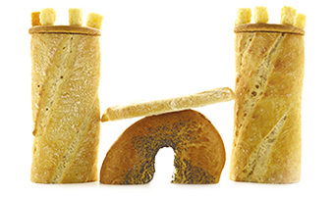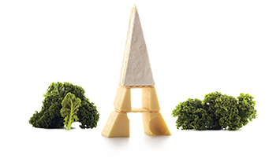
UK FRANCE

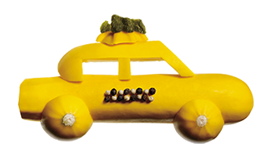
USA HONG KONG

- 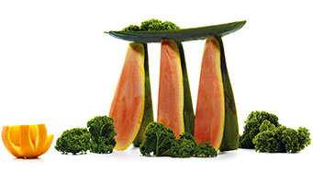
SINGAPORE DUBAI

- 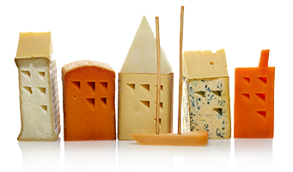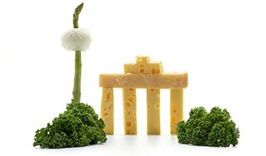
DENMARK GERMANY

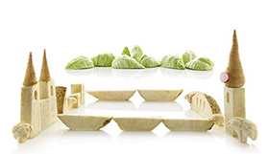

SWITZERLAND BELGIUM

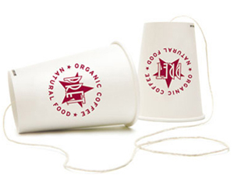

TALK TO PRET
If you’re a Pret customer, you deserve to be heard
and listened to.
GET IN TOUCH >

NEW LOCATIONS
We're always on the lookout for new locations.
Perhaps you know of a great site for the next Pret?”
(https://www.pret.co.uk/en-gb/find-a-pret)

References:
Kotler, P., Armstrong, G., Harris, L., Piercy, N., (2017), Principles of Marketing, 7th Edition, Pearson;
https://www.pret.co.uk/en-gb/find-a-pret

Nicola Gil - Promotion
Promotion is the forth P from the marketing mix and it is about advertising a product or
service. Using promotional strategies to communicate a massage to the targeted audience
is fundamental and crucial for boosting the sales up and enhancing the brand recognition of
a company. Promotion consist of various elements such as: sales organizations, public
relations, advertising and sales promotions (Acutt, 2015). The variety of methods to
promote and market a product usually cover advertising, media such as newspapers or
magazines, television or radio. Posters or billboards and adverts on public transport also
are tools used to transmit a message which intention is to inform or influence people who
receive them. The aim of the promotion is to ensure that the message sent links to the
real features, description and benefits of the product or service that is been promoted
and endorsed (Martin, 2014). None of the four elements of the marketing mix work in
isolation, thus they act as one body of information necessary to transmit the activities
within these four P’s.



Figure.1

Pret A Manger uses promotional strategy quite different to its competitors as the
company spends only 1% of its annual turnover on conventional marketing as
opposed to the industry standard which is 7% (Pret A Manger, 2019). However
this daring decision made by the marketing director of the company it seems to
have positive impact on the brand recognition and the numbers, as the compound
annual rate is growing year after year. Pret A Manger strongly relies on customers
experience and good service to create loyal consumers who are happy to spread
word of mouth their experience at every Pret store, as this is the physical evidence
the company applies as main marketing strategy. Company’s philosophy of creating
fresh, handmade food with freshly prepared ingredients and improving its in store
experience, instead of spending huge amounts on TV campaign or other conventional
media, has been the chosen strategy to promote and market itself (Pret A Manger,
2019). By investing in the ingredients that matter the most for Pret A Manger:
people, service, food and their local community, it is all delivered following high
standards and values.
Although using the conventional methods of advertising such as media: newspapers
and magazines or television and radio, very large target audience can be reached, thus
accessing to a wide target market, the company’s marketing director decides to invest
more in its in-store experience and kind of direct consumer approach as this is
going to sustain long term positive approach for the clients. Therefore word of
mouth referrals are likely to occur, which is kind of publicity with its strengths of
being cost free and effective at the same time as having the power of a happy and
satisfied customer spreading the message to another potential customer for the
company.
Pret A Manger also uses social media as part of the Integrated Marketing
Communication (IMC). In the summer of 2016 when launching Veggie Pret,
the company took a different approach and used Twitter to bring its
community into a conversation with the CEO of the company, who started with
a blog post (Gioglio, 2016). This kind of strategy and approach using social media
is a perfect platform to share feedback, ideas and allowing customers to speak up
and feel more involved in the decision making of the company and seeing their
requirements turn into reality.
Strengths and Weaknesses of the promotions strategies used by Pret A
Manger: both approaches to promote itself are very cost effective, as the company
does not spend huge amounts on conventional marketing, but rather focuses on the
direct approach to its costumes making them feel appreciable. As main weakness
could be mentioned that with social media one is opened to negative feedbacks and
discussions and once you start it you need to maintain it on an ongoing basis.

References

Accut, M. (2015). The Marketing Mix 4P’s and 7P’s Explained., marketingmix.co.uk

Martin. (2014). Marketing Mix / Promotion in Four P’s., cleverism.com/promotion-four-ps-marketing-mix/

Figure.1., https://www.locusassignments.com/solution/unit-2-marketing-mix-assignment

Pret A Manger (2019)., pret.co.uk/en-gb/media-centre#.,
pret-files.azureedge.net/pretamanger-uk/media-centre/Pret_Annual_Report_2017.pdf

Gioglio, J. (2016). Why Pret A Manger Is Using Twitter to Plan Its Next Move

