DS 1 Template

My Screenshots/Photos

Screenshot/Photo 1
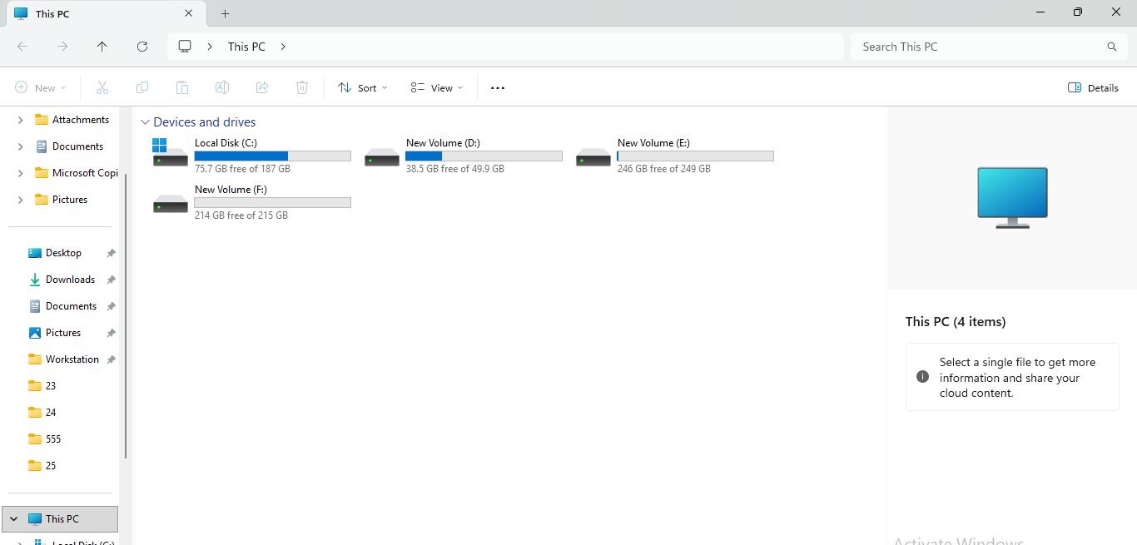
I am accessing the drives and folders of my computer via File Explorer. It assists me in finding files and managing the storage capacity of my computer.

Screenshot/Photo 2
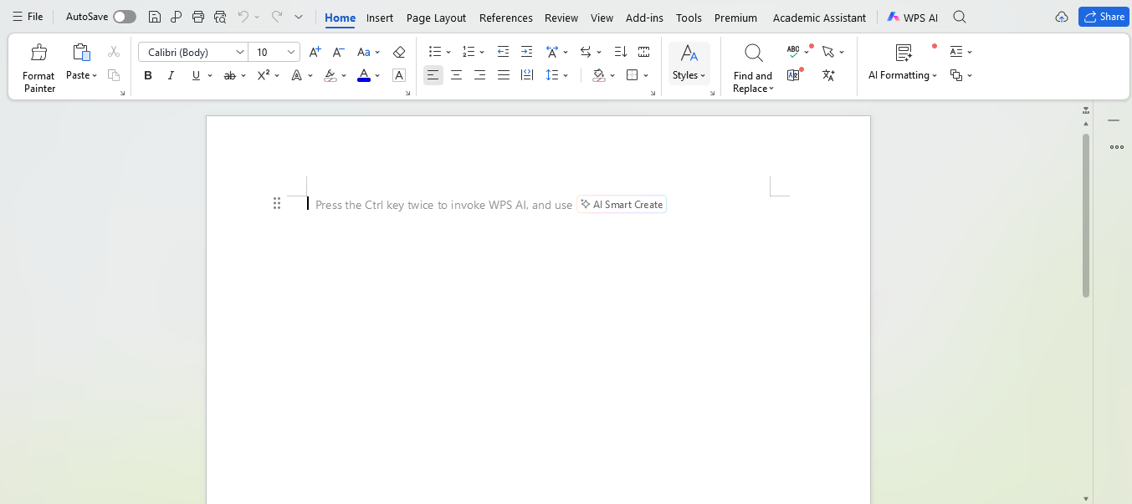
I write and edit written documents using WPS Writer. The formatting options make it easy for me to present information clearly for my studying and other work.

Screenshot/Photo 3
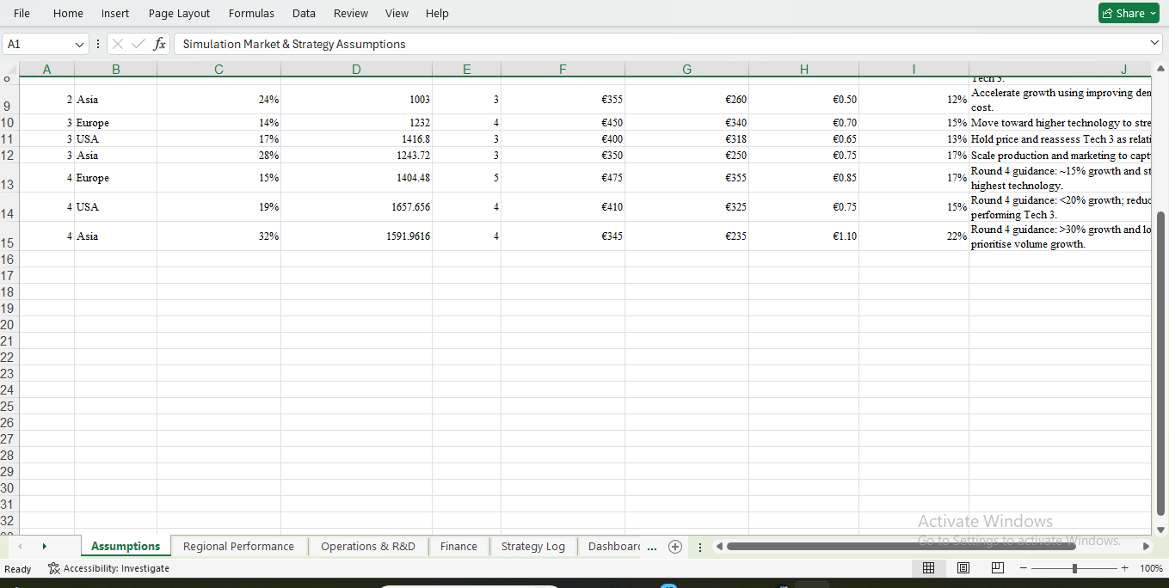
Organise numbers and compare information in a spreadsheet. This spreadsheet displays the format I use for making assumptions, numerical data, and notes in a simulation.

Screenshot/Photo 4
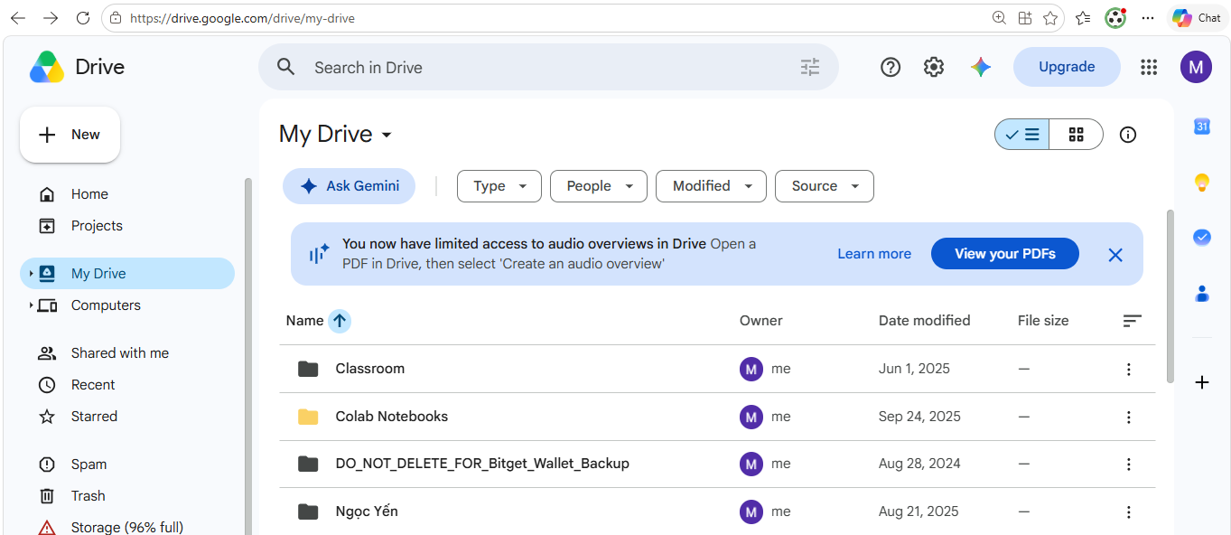
I can access files online and locate shared study documents using Google Drive. It helps to have access to important materials from other devices.

Screenshot/Photo 5
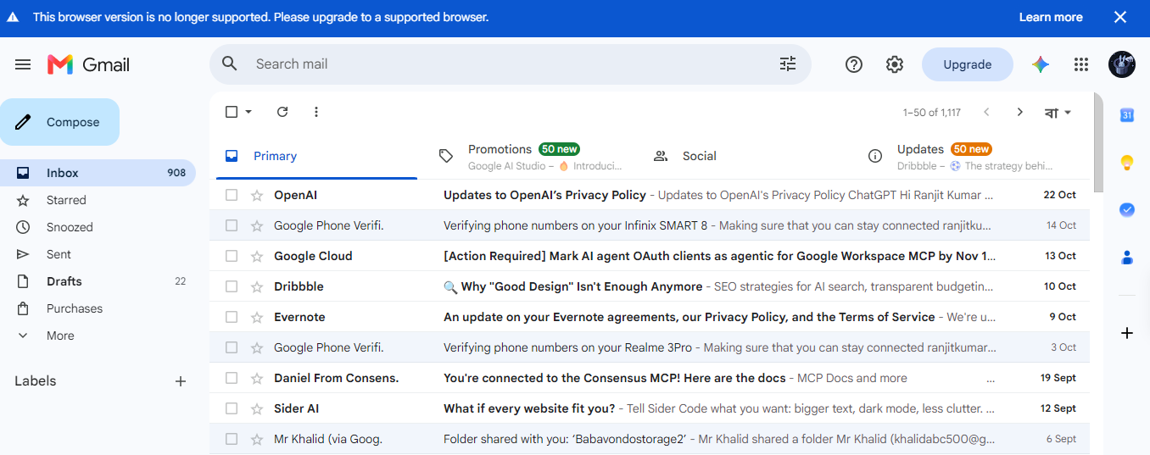I use Gmail for receiving messages, updates and account notifications. I like to see what's in my email so I can stay up to date on important email communications.

Screenshot/Photo 6
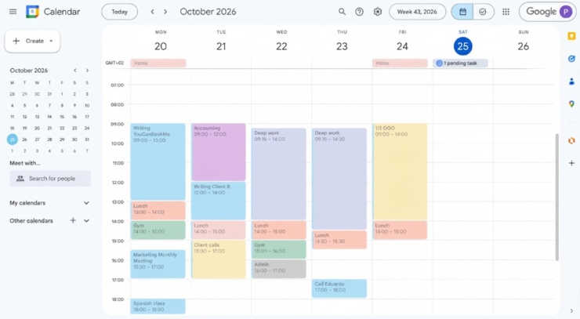 I keep a weekly task and appointments plan on Google Calendar. The weekly view is useful for me in organising my actions and handling my time.

My Short Reflection
- Write 5–8 simple sentences about your digital life.
- You can use the sentence starters below if helpful.
I use digital tools for study and personal purposes on a daily basis. I use WPS Writer to write documents and Excel to organise information. Additionally, I also use Google Mail to receive mail and Google Drive to store important files. I can rely on myself to do work with these tools. Google Calendar enables me to schedule my activities and manage my time. I sometimes have a difficult time keeping things neat and tidy. I wish to become more proficient with spreadsheets and have my digital storage better organised. I hope this module will enable me to be more confident and organised with the use of technology.

Sentence starters
- I use digital tools to …
- I feel confident when I …
- I want to improve …
- I often use these tools: …
- I sometimes feel nervous about …
- I hope this module will help me …
- Digital skills are important for me because …
You can write more if you want.

Submission Checklist
Before you submit, please check:
​​​ ☒ I added 4–6 screenshots
☒ I wrote short sentences for each screenshot
☒ I wrote my short reflection
☒ My work is my own
☒ My file opens correctly
​​☒ My file opens correctly

