Is the Yin Yang Symbol reflective of the Mind, Body and Planet?
Does interconnectivity operate upon multiple levels
Introduction
Whilst Daoism is a philosophy that is often practiced as a religion (REF). Whilst its ancient roots make it appear at face value less relevant to a modern living, the great Dao is considered a principle of life and an unchanging source of all things (Ball, 2006, p. 12-17), I argue that that it is still important from a modern-day perspective to incorporate knowledge of present day into a greater holistic framework.
According to the Dao, the universe is a continuum, dualistic in nature with all in existence on earth being manifestation on via virtue of the yin and yang (Lynn, 1994, p. 9). Everything has in it either yin or yang characteristics and exhibits, or more precisely should exhibit either yin or yang behavior. Superiors are yang subordinates are yin. Yang is the male yin is the female (Lynn, 1994 p. 9). The yin and yang are also classed as positive and negative. The Daoist claim that there is a great ultimate course which cannot be named which generates the two modes of duality yin and yang (Lynn, 1994, p.65) (Ball, 2006, p.18). Yin and yang are the polarity or balance between all things and their cause. The Tao believe there is an ultimate reality which dictates everything we see, in the external world as well as within the man and society, due to an interconnection and dependency between all living things and that all duality exists into unity, (Ball, 2006, p. 18). The Dao see all psychological, social and physical occurrences as operating in conjunction with natural cycles and continuous patterns (Kohn, 2009, p.71), and see all the plants, humans and animals as the creation of not only earth but also heaven (Kohn, 2009, p.70).
The origins of concept of yin and yang are difficult to trace, with some placing its first appearance within the scriptures of Lao Zi’s Dao De Jing, (Classics of path and virtue) (Zheng-Cai, 1999, p. 38) and others dating it further back, through The I Ching (Ball, 2006, p. 111) of which the most ancient accounts were given carved into bone, metal, shell and stone by an unknown authorship (Lynn, 1994, p. 4).
The yin yang symbol, often called the Tai Ji Tu is often attributed to Chen Tuan, during the song dynasty, and used to represent the uttermost polarity of the cosmos which divides in two sides. (Zheng-Cai, 1999, p. 47)
The names themselves are taken from the sunny and shady side of a mountain, due to the yin yang representing hot and cold (Ball, 2006, p. 47)
I consider the yin yang symbol itself to be simplistic though for those who comprehend its significance is ample. Daoism indicates that “anything that develops to its extreme will eventually revert to its opposite qualities” (Ball, 2006, p. 37). Therefore, the yin yang symbol should be three dimensional and in motion of flux within change until the black side becomes white with a black dot and the side which was white has become black with a white dot to represent the full cycles of Dao experienced upon earth.
We find duality nearly everywhere (On earth), north and south poles, the left and right side of the human body, Light and dark, day and night. We even think dualistically and the language we use reflects our dualistic thinking. Hot and cold, big and small, rich and poor, beginning and the end. You may think this is not true, and there are in-betweens. However, these are not a third concept, only an intermediary between the extremes. The human being is and only is a manifestation of the universal energy that exists. Such as masculinity and femininity. There can be no third gender, only a combination of the two, in various proportions or the absence of either. Just in the way in which afternoon is not a third concept, only an intermediary between day and night. You may try to introduce east and west however this only serves to add another duality. Even water can not constitute a third concept as is only intermediary to ice and steam, due to the frequency of vibration of the molecules and is still a polar molecule due to its ionic bonds between positive and negative.
DNA and Dao
With all being manifestation of the Dao, therefore this includes all biological matter on the planet, including DNA. As Lao Zi’s scriptures were written centuries BC, modern science is viewed as a separate phenomenon. It was originally forbidden to look inside the Human body during this era as considered sacred with Daoist practitioners using different techniques to view the inside of the human. However, now such discoveries have been made, the human body, full of automatic mechanisms and unseen forces (such as those involved with DNA), should still operate under the rules of Daoism.
Whilst the Dao view the man as a mini version of the Universe, human biology explains DNA as a miniature version of the man. Each cell contains the genetic information (DNA) for the whole genome with exceptions such as red blood cells. This is how cloning can be achieved, as the whole body is contained within each part. The DNA is stored within the nucleus classified as the information center of the being. This genome contains the information for every single part of the body and brain (though not mind). This DNA consists of two strands having a dualistic nature. These two strands are named the coding strand and template strand, based on their role in transcription and translation the copying of genetic information. Both strands contain four types of nucleotides; adenine guanine cytosine and thymine, which are the individual structural units for DNA. We see both strands are equal and opposites or complimentary. This is described by scientists as male and female pairing; yin and yang.
Anthropologists Jeremy Nearby, draws upon the connections between Caduceus and DNA. The caduceus features two snakes wrapped around each other, in an identical fashion to what the two strands of DNA are woven around each other (The ladder formation of the double helix). This symbol has been used throughout numerous cultures for natural and modern forms of healing. He then moves to assert that the Caduceus (See Fig) is synonymous with the yin-yang; representing two snakes coiled within complementary forms into a single androgynous vital principle. The two strands can be viewed as the mythical snakes’ dragons and serpents involved in all creation
stories. Viewing one strand of DNA as the black anaconda which created the world as the yang male and the other strand as the rainbow-colored boa constrictor the yin female.
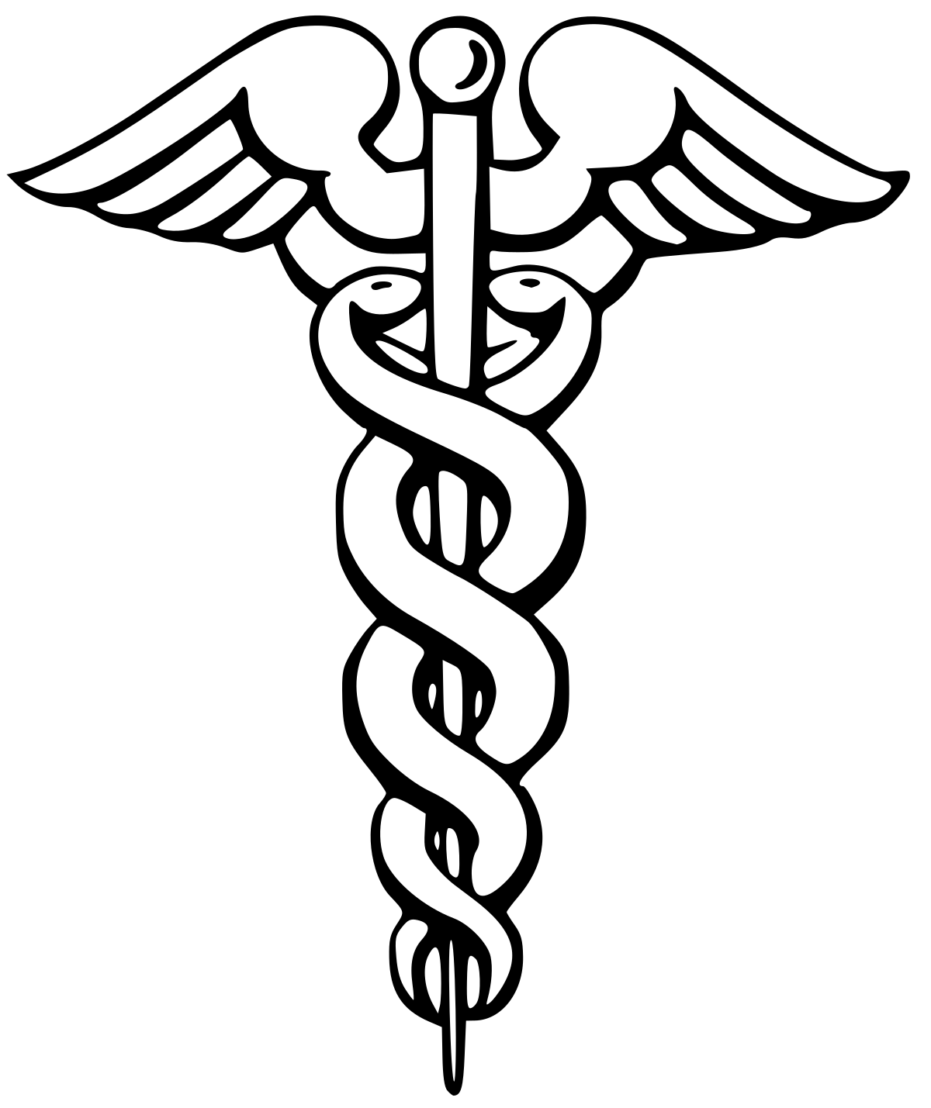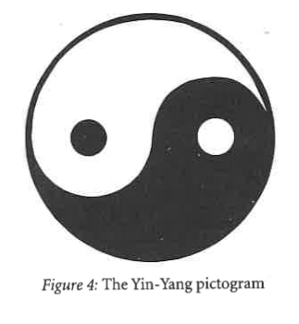 Figure 1 Add double helix picture and yin yang picture
Narby (1999) believes Lao Zi (Chang Tzu), as the founder of Daoism (Taoism) must have had knowledge of DNA as too did various other races, pre-science, through omniscient methods. We have reasoned the Dao and DNA have a connection. From an eastern perspective, in terms of Yi duo bu fen, There, is no heaven divisible from earth, and no god separate from self, therefore, there can be no spirituality apart from the biological self and mind. An image of the Dao as the yin yang and DNA has begun to emerge. Though before we can further explore the implications of DNA and Dao we must first comprehend the Dao significance to the human and the planet.
The Human Brain
As we see the yin yang symbol expressed within the genome, fittingly we also find the duality of yin and yang within the human brain and body, due to the genetic code being a miniature version of the whole body, two which we then find the same duality within the brain existing within the mind. The Brain is split into two hemispheres, divided by the interhemispheric fissure. (Figure 4) Add picture of the Brain. The left hemisphere is often termed the male brain, having qualities of mathematics and science, logic etc. With the right hemisphere dubbed to contain the qualities of art and creativity (Bartholemy, 2019). Art itself may be a result of suppression, as much of religious activity (REF) as is generally considered a release of tension, generally caused by the dominance. To express itself in ways prevented by marginalization.
For most people the left brain is dominant, however, this is not a clear-cut division, and can be reversed for some people. However, the last decade has seen dozens of contradictory scientific claims regarding the hemisphere’s qualities and capabilities. This is not however problematic to my theory as the yin contains the seed of yang and likewise yang contains the seed of yin, symbolized by the white dot within the black part and the black dot within the white part. Yin and yang are only relative and only often found out of proportion and in constant change of balance, whilst remaining the same essence. However, what is clear cut and undeniable is the duality and the dominance, therefore suggesting the essence of the yin and yang is responsible.
Jeremy Narby (1999) reiterates the same phenomena of the DNA for the brain as both are found within his Shamanic anthropological studies to be represented by the rainbow boa constrictor snake and the black anaconda used to represent the male and female energy of binary opposition, again synonymous with the yin yang symbol, and depicted as two snake occupying either hemisphere of the brain (See Fig 5). Other sources indicate similar beliefs found within the ancient Pagan Wicca religion with the left-hand and right-hand paths corresponding to the right and left hemispheres of the brain (Gardiner, 2005, p. 128)
Fig 5
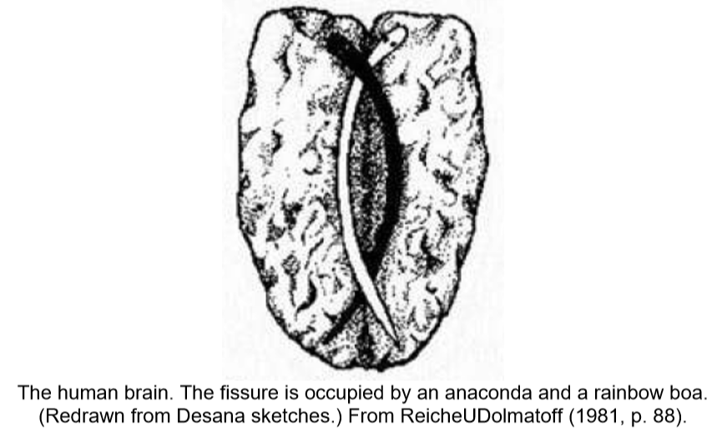
(Narby, 1999)
The human brain is manifestation of the Dao, evidenced through its duality, and the external word as manifestation of the brain. So, if we check we expect to find further correspondence. One of the most refuted claims about the dualistic human brain its hemispheres dominance. How is this relevant to humanity and society?
From a psychological perspective on social interaction including intimate relationships many individuals have a will to control. Whilst many individuals want to be controlled or dominated. This hemispheric dominance is stereotypical of human social structure. It is no coincidence we find the same occurring in the world and is reflective of our core nature, reminiscent of the dominance and subordination of the yin and yang principle.
We find equals and opposite paring throughout our society, man and wife, teacher and student, slave and master. As yin and yang is in constant flux we are aware these roles can change, and we are not fixed in one role or position, as throughout life a man can be multiple of these roles through one life experience, yet not simultaneously the opposite, in any one interaction. And whilst man cannot become wife gender roles can change.
It appears that due to our nature of yin yang brain and mind, all human activities become naturally shaped by this principle. When one individual talk another must listen otherwise there can be no communication, if both talk neither can listen or both listen there would be no talk to listen to.
Suppression of the Feminine
Whilst it has long been believed that the right hemisphere of the brain has minimal to know language skills (n for both left and right-handed individuals, this is not fact. Whilst all language is contained within the Wernicke’s (give details) and Broca’s area of the brain both situated within the left hemisphere, it has now been revealed through case studies that the submissive right hemisphere can acquire language in the absence of the dominating left hemisphere. A young boy had to have the left hemisphere removed at age 2.5. When such an operation has been conducted for adults there has been drastic effects with all language capabilities lost. However, this young individual was able to learn and develop language abilities to a normal standard.
This is not to refute prior science, only to add to it by explaining how things that have yin characteristics, can become yang. Thinking the submissive artistic right hemisphere could not become yang dominant and perform logical functions of language recognition would be to assume a student cannot become a teacher, or a slave could never gain freedom. The yang dominance of the right hemisphere is not an absolute rule. The only absolute rule is Dao, which is only momentary, ever changing and constantly in flux.
Dominance of language found within the mind and society suggests, from a Daoist’s perspective that the external is a reflection of the internal. This theory clearly correlates with modern physics that the mind is creating the world we are within; thus, Dao and physics are not necessarily contrary. Whilst theories upon the correspondence between the external and internal often exist in such an abstraction, I will elucidate upon direct specific discoveries within history which point to this principle.
The male of the species has throughout the prior millennia prevented suppressed and forbidden formal education for women within their own families and communities, just as the male brain has suppressed the female brain preventing the acquisition of language. Resultantly it was believed women lacked intelligence which men had, however it is now considered that women’s situations were the result of their submissions to dominate male, just as we have found the suppressed hemisphere can acquire language. I use this comparison not as a metaphor, but to show how the external is a mirror of the internal in terms of male dominance and the acquisition of knowledge.
Additionally, whilst women have been persecuted by the male, to the degree of even being burnt and accused of witchcraft. Right handed western invaders have persecuted and suppressed left handers during invasions of pre-colonial Brazil and even here in Wales. It was believed that the left hand was evil and capable of acts like witchcraft, resultantly sorcerers were executed all over the South American region. The use of the left hand was forbidden within the education system in the United Kingdom amongst other regions and stigmatized as evil, ill-morale, and even clumsy up until late last century. This is relevant as the human being appears cross wired, with the left hand corresponding to activity in the right hemisphere of the brain and thee activity of the left hemisphere of the brain corresponding with movement of the right hand. Once again, we find suppression of the feminine within society (women) as well as within the body (the left hand for the right hemispheres suppression).
Chinese language emerged around 1600 BCE in the beginning of the Shang Dynasty, with writing itself existing from 3000 BCE in the Middle East. The Chinese writing, amongst many other forms of early literature such as hieroglyphics were given in the form of pictograms. This reflects a right brained way of thinking. Additionally, many such as the Arabs and Hebrew written from right to left, which is more practical for a left hander, so not to smudge their ink. It appears simultaneously across the globe this writing emerged and then changed in nature. This may be reflective of cycles of earth and the fluctuation from a right hemispheric way of thinking, where by the right hemisphere was yang, with the right becoming yin, to a left hemisphere dominated brain, in which the left hemisphere became yang.
Modern day forms of language such as English are written from left to right. With Chinese Hanzi being Latinized to using European Letters: pinyin, for the use of telecommunication. Whilst Latin the derivative of the English language was first used around 200AD, a more liner logical form of communication. It appears that many ancients ere more of a right brained species, (Huntington Moore, 2019) with a reversal of dominance. It may be that the ancients did not write at all not due to being undeveloped or civilized but harbored an alternative way of thinking.
Deutscher (REF, YEAR) displays anthropological studies into tribal people who have no word for right or left within the dictionary. They instead think in terms of north, south east and west, and just the same as many animals who migrate, have the ability to detect, cardinal directions without exogenous cues e.g. the sun. They instead have greater sense of magnetism. Due to being in balance and at one with nature. Culture shapes language and language shapes culture, which is why it becomes central point to comprehension of thought. If we were to remove the terms left and right from parts of the body, could this result in a reduction in handedness altogether. Yet only if we were to become more in tune would we uncover our innate abilities with the world and ourselves, which I will later show are the same thing from a Dao perspective.
It is not only that I compare the left and right hemisphere to the east and west, but also allege that when a western individual uses science, he speaks of the world from a left brained perspective and when an eastern philosopher speaks of nature, they speak from a right brained perspective. With the mind creating the world, they only speak of their own mind they experience, coupled with the paradox of the environment effecting the mind simultaneously. Whilst this is the balance of the yin and yang collectively the balance should be achieved within self.
Balance
An eastern perspective believes balance is necessary; the ancient Chinese believed that yin and yang must remain in balance, thus practices such as Chi Gung and mediation were designed to keep the universal aspects of yin and yang aspects of the brain synchronized, this carries increased health benefits, cognitive abilities, organization and decision making, whilst granting a greater perspective, e.g. the ability to see the interconnectivity of all existence (Barthelemy, 2019).
This principle is not exclusive to China or Daoism. Pythagoras once formed his own religion or belief system in Greece post his travels to the middle east. He introduced methods for balancing the body by becoming ambidextrous (REF). All esoteric systems believe in the fusion of the male and female, (yin and yang) (anima or animus) to achieve an enlightened state of consciousness, thus aligning themselves with a power or source (Gardener, 2005, p.36) of which even the Dao themselves do not know the name of (REF)
Other techniques for greater harmonization of the yin yang balance include listening to or playing music, a quintessential characteristic of the right brain (Barthelemy, 2019. The Drum beat of the African Shamans is considered the coming together of the male and female forces (Gardener, 2005 p. 21) With music associated with the right hemisphere acts as a stimulus to balance the brain to induce trance to perform rituals (REF). It is believed that mantra can calm the left hemisphere. This is where all the mind’s anxiety is stored. Mantra causes the body to swap over from the left to right hemisphere mode of activation (Huntington Moore, 2019)
This principle I, therefore assume that kaons, function to stimulate both hemispheres simultaneously, to create an awakening, as only through the unity of both perspectives can one achieve the correct or true perspective, superior to either perspective.
Robin Royston (REF) talks about the issues with right handers. How trauma experienced within childhood can accumulate within the left hemisphere, with an individual; causing anger within their unconscious and conscious self. They may be unable to alleviate this tension, as due to areas dormancy, they cannot active this gyrus to retrieve the memory and digest the anger reflective of an imbalance.
However modern science attempts to propose that ambidextrousness is no advantage. They claim ambidextrous people are more schizophrenia, yet we know this condition is genetic, and related to the path of the shaman. They claim that it is linked to no-heterosexual behaviors, however this is again miscomprehension of true balance. These claims are more likely reflective of a bias consensus; an imbalanced western left brained mindset attempting to remain such, similar to the prior propaganda spread about left handers.
Many Spiritual individuals may be anti-science and vice versa, again these mind states are reflective of the Ying Yang nature of mankind collectively. However, the true eastern mind is one of balance and as we see through the works of Pythagoras so to the west. Each imbalanced perspective will balance out eventually, with male domination of women, leading to movements such as the suffragettes and modern-day feminism. Whilst previous periods were ruled by the feminine, others have been ruled by the masculine as we move toward perfect balance through the natural cycles. right hemisphere of our brain, the unconscious intuitive knowing, Left hemisphere, of stringent knowing,. Also, in many ways I allege the duality of yin and yang comparable to east and west.
Autism
Autistics have previously been described as having an extreme male brain, which I will compare to a western mentality. Despite certain savant’s extreme mathematical ability to count the number of trees growing in a patch of land e.g. 276, some of these individuals can never comprehend that this is in fact a forest or wood (Royston and Humphries, 2007). Another example, whilst being aware, there are 97 people in a room with 121 different alcoholic drinks, they cannot realize this is a party.
This is similar to Westerners perspective, whilst highly intelligent in many forms, can identify all the parts of the world as separate, down to the smallest cell in biology or atom in chemistry and electron or quark in physics, yet are unable to view the heart mind, internal and external, heaven and earth as one. Autism is still on the increase (Maguire, 2009). This correlates with the increase of a male dominated western left brained world. Fittingly with my theory there are much higher rates of autism in US are rising to 1 in 50 remain as low as 1 in 1000 on China. (Maguire, 2009) As well as predominantly affecting males (REF)
Dream
If so, this would explain the ancient practices all being associated with the Left hemisphere. It has long been asserted within neuropsychology that dream is predominantly a feature of the left hemisphere. (REF). This may explain the reverence of the Dream culture referred to by the ancient aboriginal people of Australian aboriginal, South American Shamanism as well as Daoism (Godwin, 2005), who as previously mentioned all form practices and believes around the concept of the male female duality (Narby, 1999).
East and West
As the Dao is the body brain and mind, the internal, we find the same within the external socially, historically and culturally. Here I present the east and west as two side of the yin yang duality. We can comprehend the Western world as yang, in terms of actions, beliefs, mentalities and systems, and the eastern as yin, in terms of the same criteria. As we have discussed, the concept of duality is found through many ancient practices, cultures and symbology, before the recent evidence of neuroscience correlating to the two hemispheres of the brain. African Shamans deal with the male and female duality. They describe people from the western, left brained dominant cultures as people of the line and represent this by as a 1 to represent masculinity and describe people from the eastern right brained hemisphere dominated cultures as people of the dot, represented by the binary symbol 0, representing femininity (Gardiner, 2005, p. 23).
As the right hemisphere is dormant whilst the left hemisphere is active, this aids in the comprehension of the male and female as not only representing the left and right hemisphere, but also as functions of the conscious mind and the subconscious mind (Gardener, 2005, p. 48). Giving validity to the general expression of female intuition, from a neurological perspective.
The Sun is considered masculine, whilst the moon is considered feminine (Gardener, 2005, p. 22). This makes it clear in terms of east and west why the sun forms the basis for the Gregorian calendar in western countries such as UK and the moon forms the basis for the calendar of China: the Chinese Zodiac known as Sheng Xiao. Thus, we find the eastern and western mentalities are not only intrinsic to human nature, but also the greater cosmos.
East and West
Everything in the universe contains two aspects a basic duality, to make one whole, however within each lies the seed of the opposite, and in due course as the cycles of life progress, the polarities turn into the other (Ball, 2004, p. 124). This includes the east and the West. The symbol, yin-yang, represents the conflicting facets of humanity and the cosmos, e.g. male and female, light and dark, day and night but also east and west. The division represents duality. Whilst the merging of the two poles represents the interconnectedness, so to depict the ultimate unity of one and many.

The east and the west duality, are both part of the great Dao. Where dualism exists from a western perspective, from an eastern perspective is all one. Humanity mentality exist as two different perspectives which when combined create the whole. Both perspectives, are part of a greater whole as are both expression of the yin-yang. Previous studies have attempted to use to science to prove religion, this theory differs, with the claim that the holistic theory of the eastern is not complete without incorporating the western ideals, thus merges science and spirituality
The east and the west often have contrasting views, in terms of their consensus systems. Whist USA, for example deals with human rights, which are absolute, which creates regulations for the treatment of Children by parents, laws which are imposed for governance. China more so deal with duties, one should do for another, i.e. their duty to care for the parents. Both are moral standpoints to be comprehended from any philosophical individual. This reflective of their individualistic verse communal societies. Whilst the west asks the question of who I am, China deals with the notion of self-cultivation, and does not consider the individual to exist separate from the family structure, nor society generally. The links with how the Chinese uses the term yi duo bu fen, approximately translated as “the indivisible one and many”. For instance, whilst Chinese philosophy consider heaven and earth one, western systems consider them two separate entities.
Whilst many western physicians within bio medicine claim and operate under the premise the body and mind are two separate entities. The traditional Chinese approach is that the body and mind are one. We can reason that neither can be correct. E.g., if the body and mind were not one entity, psychosomatic symptom with no biological cause would not occur, such as ulcers nor would stress lead to disfunction of organs or tension in muscles etc. However, if the body and mind were not separate when we experience casualty within a dream and suffer due to the mind the body would suffer also thus, we neither can be correct though we have also reasoned both contain elements of the truth but are not always true. We find these are two contradictory views which are simultaneously true. One from a left brained physical western perspective and the other from a wholistic eastern right brined perspective. Although the eastern and western perspectives contradict, I claim both are necessary, to achieve the true holistic perspective. It is only through the combination of both can the whole truth of self be found, and ontological questions answered.
Whilst the traditional eastern view Xin, is the heart and mind are one entity, and function in unity in terms of thought. The west not only claim the brain and heart as separate entities, but the divide it into the left and right hemispheres, which becomes comparable to the division of the yin and yang, in terms of mind reflecting existence. The male and female poles are present yet ever changing, hence why neurologists can never find clear cut division or rules for hemispheric characteristics, even when trends characteristics are apparent; due to the interconnectedness, and the lack of genuine absoluteness.
Mind of Knowing
The Dao deal with an intuitive knowing from within, which is yin. Whilst the western science which is currently the dominant paradigm deal with an object knowing, externally, where an absolute knowing can be achieved, which is yang. Whilst these two types of knowing or belief of knowing are very different both are expressions of the Dao. The former being yin and the latter being Yang. Both forms are essential and dependent on each other, as yin and qualities for instance, if you have a yin feeling, that a friend is untrustworthy, you then search for a yang knowing i.e. proof or evidence. Or if you find yang evidence to suggest a friend is untrustworthy, who you otherwise trust, and they swear their innocence, you search for a yin feeling, as they may have been set up. Yin yang are the two necessary view point. In terms of Yang knowing, we are estimated to have over 130 million books in the world, however you could never read them all or know which to read to get the knowledge you want, or even know what knowledge it is you desire before you find it. Whilst these books are useful, from a Dao perspective theory must be developed through vision, an intuitive knowing from within to bring about the knowledge through seeing the bigger picture of which oneself is a part of. Biological reductionism as a yang perspective on medicine, is incomplete without yin intuitive and even emotional level, when allows us to view action as incorrect, without yang instructions of religious doctrine. To comprehend the Dao, you must view it as a universal or energy, not as a Chinese religion. You cannot entirely learn Dao from books, this must be achieved through connecting with the force. For instance, an individual could read 100 books about you, but if they have never met you, they surely cannot know you. Same with Dao, you must be one with the Dao to know it. Although it would take a whole life time to start from scratch, thus books are important to.
Man, Earth & Cosmos
The Dao see man as the same nature as the earth, for this reason simplistic claims are made such as the earth having 365 days, whilst the human body has 365 qi points, 12 months of the year corresponding to the body’s 12 channels or meridians (jīng luò) and the earth has four seasons, whilst the human body has four limbs This extends to more complex relationships between the star constellations, the earth and the human. (Liu & Hua, 1999, pp. 40-41). Additionally, Han cosmology see the body as a miniature copy of the Universe. Daoist’s would align themselves with the universal energy (Dao) to create a cosmic sense of self through meditative focus, so to be able to gain control over the body’s rhythm, as operating in accordance with a function of the Universal forces, which are higher than the ordinary man (Kohn, 2009, pp.142-143).
We have now explored DNA as a miniature version of the Man. We can now investigate the man as a miniature version of the earth. Therefore, if we check we should expect to find the same things. We find the same forces at work within the man and the earth such as the Magnetism and electricity, and of course the cycles of the earth which of which some no doubt correlate with our biological cycles, such as our sleep wake cycle. (Link to cycles written in house section)
The whole body is an outer expression of the DNA with the duality of the mind reflected in the body which appears cross-wired with the left-hand side. Wish helps with the comprehension of why the right hand is in association with the left hemisphere. Within the human body we find the same duality of the male and female.
This is perfectly evidenced through the undeniable resemblance of the energy meridians found within the Indian Chakra system. Not only do the channels of Ida and Pingala (named after the rivers in India) exist in the dualistic form of the male and female, directly correspond to the male and female strands of DNA when within the Double helix formation. But also bear the same physical appearance of the male and female energy lines which flow through the earth; known within the western world as lay lines, whilst referred to in China as dragon lines. The reason why Tibetan mythology claims there is a female dragon pinned to the earth underneath Tibet as the female line runs directly through Tibet and is also rumored to be responsible for the presence of numerous spiritual practitioners. These lines have been referred to by many a name including spirit lines within the Americas pre-Columbus and dream lines by the Aboriginal people of Oceania, hence again not unique to Daoism as a truly global phenomenon. Daoist’s who practice Chinese nomenclature follow a system by which Ida and Pingala and instead named the female and male channel respectively, so we find the same male female duality within the DNA, the man and the earth. Dao however has a similar system for meditation by which they focus upon the back (tu-mai) and front (jen-mai) chi channels.

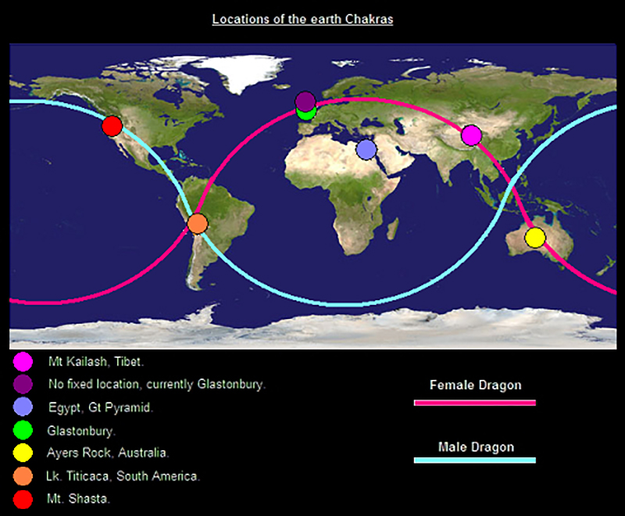
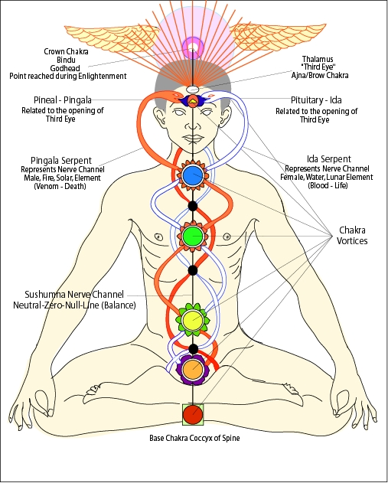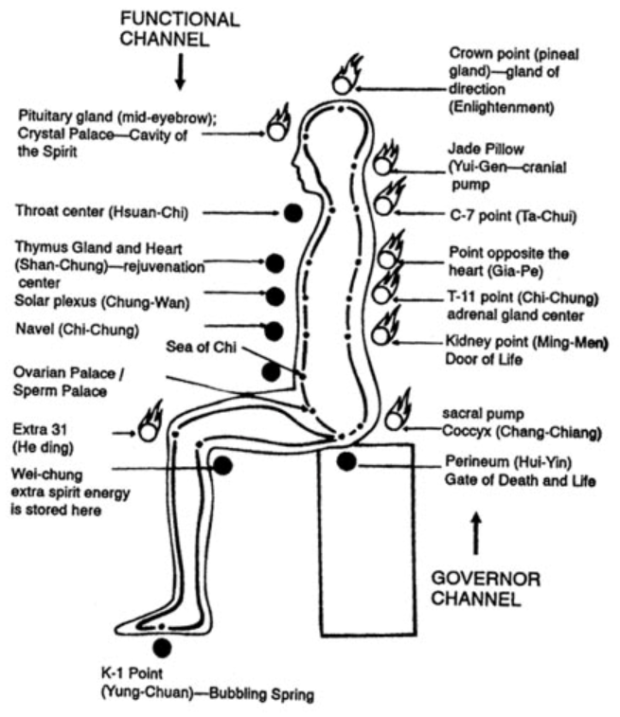

We can now view DNA as a miniature version of the man and man as a miniature version of the planet. We can now further comprehend the claim made by Narby that the yin yang symbol was representing the same force as the referred to synonymous with God in other cultures including Ancient Greece and Australia and South American Shamanism, as is the life force we discover existing on multiple levels of our being our own awareness.
the same forces and energy; the crossing over of the Chi channels or meridians is less relevant to the acupuncture practiced within both traditions, which likely share a common source and more so representational of the serpentine energy which rises during meditation. Many a practitioner do not care for the difference in meridian claim and focus purely on the meditation. Whilst the Indian and Chinese schools slightly differ on the location of the meridians, and chakras, they both believed in the lay lines and acupuncture based upon the yin yang and the represent, which both directly correspond with the internal body organs this may be symbolic
Creation
The Dragons/serpent is also revered in China, besides the Yin Yang symbol and is dated to approximately 5000BC; It was claimed that they were descended from it and was symbolically revered as a giver of life (Gardener, 2005, p. 141) Whilst the Dogan Tribe to the Celtic people, report almost identical beliefs. As we have previously discussed with Narby the dragons and serpents are asserted as synonymous with the yin yang and even DNA through the Caucasus symbol, in terms of representation. These subjective truths or myths assist in comprehending the objective truth, of the nature of man, earth, cosmos as one, the Dao. Within the Dao creation story, the Dao rested in deep chaos, next it evolved into the, considered the great ultimate of cosmic unity, becoming the energies of yin and yang from which all creation came fourth (Kohn, 2009, p.25). The early Daoist scriptures describe this original state of the Dao, as a shapeless sac of cosmic chaos (Hundun), giving rise to all the creatures including humans which populate the Earth (Kohn, 2009, pp.116-117). “The way runs through and connects everything, it that way they are all one” (Cooper, 2012, p. 47). This creation story refers not only to eons ago when the world came into being, but also the process by which all things come into being in each moment they manifest, from the Dao, as is always at work. Whilst we only see the physical means it which it is produced, there is also the energy at an unseen level, of the yin and yang interactions which cause each creation, existing on a higher and more subtle level of frequency; which causes of weather patterns, growth of plants and even the formation of empires or cities.
When we look at the behavior of the DNA molecule we find similar behavior. The formation of DNA alluded to thus far; the double helix, only occurs during protein synthesis (transcription and translation) and cell division (mitosis). Whilst DNA, is not undergoing cell replication (the stages of meiosis and mitosis), it exists in the original or resting form of Chromatin: an unordered seemingly random form, its original state of, within a round black cell organelle called a nucleus. This is reminiscent of Hundun, unordered chaos within a big black egg. Hundun is described as muddles unintelligible mess; a nebulous state: cloudy or ill-defined. Much like Chromatin (REF). However, when DNA undergoes cell replication in lines up into the male (Yang) and female (Yin) strand (or called the coding and template strand. Like when the Universe was born, from the primordial chaos of Hundun, it split and divided into the male and female elements yin and yang.
Furthermore, Narby (1999) draws the connections between the cosmic snakes depicted in Columbian tribal mythology and the anaphase of mitosis (where DNA forms a U-shape). What I wish to add is that again, as creation occurs on a cellular level, we find duality, as the cell forms two poles before splitting. In the previous chapter I mentioned the two snakes placed in either hemisphere of the brain. (Narby, 1999) (See Fig). The Tribal people of Columbia (The Desarna), additionally assert that the groove in the middle of the brain (The Hemispheric fissure), is occupied by snake and was put the at the beginning of time. This represents the yin and yang, male and female qualities with the mind of the human, innately and eternally, with the Snake equivocal to the Dao itself or the mythical dragon that the Chinese are descendant form, the Dao. 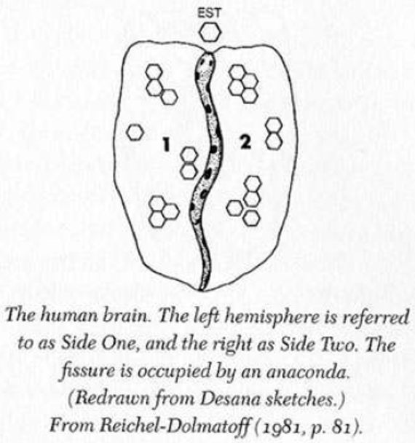
Here is would like to focus on again the dual aspects of Yin and Yang within Creation. When the Earth was made during the big bang, due to the forces of magnetism and gravity weak and strong nuclear forces. The duality of the North and South pole emerged. Whilst the Southern hemisphere experiences winter (Yin) the Northern experiences Summer (Yang). And whilst the Northern hemisphere experiences winter (Yin) the hemisphere experiences summer (Yang)(REF). Thus, again we find the Yin Yang duality upon multiple layers of existence within the earth and Man. Concerning reversion of the Dao, and the transformation of yin to yang and yang to yin. It is believed the poles of the earth may switch in our lifetime. This is simply viewed as a natural cycle of the Dao. If the Poles swapping, is linked in with global warming as many believe, this is only another cycle of the planet Earth, change renewal, which is not a bad thing. Yet nor is death from a Daoist perspective Either.
Evolution Daoism and Expression of genes
All major events and minor events are the result of tian. From rulers to natural disasters (Kohn, 2009, pp.78-79). Yet this a two-way causation, with cyclers of tian affect earth and the actions of individuals; and with the actions of individuals affecting earth and tian, which in turn affects earth...and so on and so on. All life on the planet contains DNA. Bacteria, humans, animals, and all plant forms. From a modern biological perspective, all things evolve due to evolution. First a random mutation occurs. Often his initially has minimal effect, until an environment changes, at which point it becomes advantageous or disadvantageous, causing life to flourish or in extreme cases can cause extinction. From a Dao perspective, all things have a time and place to interact and evolve within a great scheme of order; this is cyclical and governed by universal laws (Ball, 2004, p. 37).
The issue here is the notion of random. From a scientific perspective, there is no evidence to suggest random mutations are random. All is of higher order; therefore, randomness has a cause and effect, which only appears random to those unaware of the sequence. Fibonacci sequence may seem random to one ignorant of mathematics, likewise the changes of DNA on the planet seem random to an individual unaware higher order of causation. All of physics obeys the laws of mathematics, which is never random. Biological and chemical processes obey the laws of physics. Thus, we see this universe is not a random one but a structured one. There can be no such thing as random. If I was to throw a ball on a playground it may appear to just bounce randomly, however a physicist would know, this is based upon the density of the ball, its mass/weight, initial speed and trajectory. It is not random. Biology is reductionist and is often correct in isolation. Behind the changes in population of humans, plants and animals, and bacteria is the Dao, responsible for not only the changes in DNA structure (random mutation) but also the environmental changes in climate, disease, and war which directly affect this.
Science itself is still evolving. Evolution is a theory created prior to the discovery of DNA. The mutations of DNA were later adapted into this evolving theory. More recent discoveries, support my hypothesis from experimentation of maize plants, we find mutation is not random and neither is what was termed random assortment during meiosis (The creation of sex cells for reproduction; which creates the DNA code for the next generation of offspring) is at that the DNA itself is intentionally creating masses of mutations, then testing out which combinations work well with each other, DNA appears to be a self-governing molecule, and what was prior through of as mistakes are actually just parts of a genome. It appears biologist has a complete comprehension of this molecule. Nor the force mind or consciousness being the intentionally formation of new genetic codes (EPIC/GENETIC, 2019). Bacteria evolve with a natural place and order. We cannot force disease to cease (Mao, 2018), it has a time and place on earth is part of the natural sequence and will only revert when ready, thus through modern medicine attempting to go against the Dao, not with the Dao problems will inevitably arise, thus side effects are inevitable. We cannot reduce the level of negative energy or bacteria in the world, only ensure our own immune systems are strong enough to resist. (Mao, 2018)
Organ Transplantation & Gene Therapy
Daoist’s believe the world is made of five major elements, Metal, wood, Water, Fire and Earth. All processes of nature and specifically human biology in terms of their organs are expressions of energy that can be found in both the universe. All which are the same energies which are believed to move and control all the celestial bodies of the heavens or galaxies. When we can view the body as a miniature version of the universe, we can see an organ is not merely a bunch of random cells. The body cannot be considered just a collection of its parts and must be considered whole, one, and at one with all. The Dao is responsible for the whole of nature and for the nature and essences of each individual human being (Cooper, 2012, p.47), therefore this includes personality traits, however this does not immediately negate biological personality theories which attribute innate tendencies to DNA. Once we have attributed the nature of DNA to the Dao, we can also view innate tendencies as virtue of the Dao.
Current research suggests that many individuals who have organ transplants report changes within their conscious self which correlate with the personality, emotions, preferences and even memory traits of the donor; this is especially common for hearts (Joshi, 2011). These include food, music and gender preferences as well as unexplained dreams relating to the donor’s life (Joshi, 2011). Whilst in the west since the Roman period the brain was declared the entre of consciousness. Whilst in the east: the heart, from around the pharaonic period has been considered the mind and moral guidance system. This is not to insinuate organ transplant is wrong, ill-morale or dangerous, but to place this act within the wider context which it belongs. With a greater understanding of what we are. Which may encourage some people to opt in and cause others to opt out, granting a greater frame of reference form which to make a choice. Additionally, if greater verification occurs open a debate into who should donate blood, e.g. intelligent, peaceful etc. and how we should match donors, e.g. by personality including sexuality. There are multiple competing theories for why this is possible, which negating specifics I refer only to the model of levels of being which I already have outlined, which is that the whole is contained within the part.
Gene therapy also attempts to manipulate the biology of the human by changing the genes of a cell. A healthy gene is inserted into a body cell using a vector. Usually a modified virus is used. This modification allows the gene to be added to the nucleus of the cell using the virus’s own mechanism, yet without infecting the recipient with the virus. This gene replaces the malfunctioning or missing gene which is causing dysfunction of the body, with a functioning gene which codes for beneficial body proteins (U.S. National Library of Medicine, 2019).
We see the layers of the universe are just part of a greater whole and are one. We cannot manipulate one layer without affecting another. Thus, gene therapy, acting on only a cellular level, has effects for the whole organism, which could have effects on a global level or even cosmic, as we have reasoned that we are the universe at large GT can lead to health problems for the individual as well as other unforeseen consequences. These could be will be adverse, if we move against the Dao. The same principle remains for genetic modification of plants, this is more obvious as works to affect humans through the food chain (Ayres, 2019). As the evolutionary process is not truly random REF and is geared towards creating pathways for pathogens, it leads to resistant strains of bacteria, which can cause greater a global concern (Ayres, 2019). This is comparable metaphorically to the butterfly affect; how one small change can create devastation effects elsewhere later. Whilst neuroscientific research shows that mindfulness alone can affect the gene expression (REF). This is the correct way to move with the Dao by aligning self with the universe and acting in accordance (wu-wei), to bring about changes at a cellular level by the action/nonaction performed on a cosmic level. In the same way which it is difficult to roll a boulder up hill and much easier to roll one downhill. It is much easier to work with the energies of the Dao than against them.
What we find here is that the western techniques of neuroimaging bring greater comprehension to Eastern mindfulness. Eastern interconnectivity brings greater clarity to biological truths in isolation. Whilst part of the learning cycle of man, true progression cannot be reached this way and thinking, though it is natural to try. However, we must learn to manipulate the universe. We must view DNA as spiritual just the same as pagans view the earth Gaia as spiritual, whilst also acknowledging the biological nature of DNA and the earth. Only through the combination of the science and spirituality can we have a complete comprehension of the biological body in terms of yin and yang.
The human body does many things it does without the human knowing consciously it is doing them, such as control of the Heart-beat. These are termed automatic processes, controlled by the limbic system and often referred to as the reptilian brain (Naumann et al., 2015). Those who master meditation can speed up or slow down their heart rate at will (REF). Thus, meaning have over-powered the reptilian brain or limbic system if you prefer. Though considered spiritually due to the effects of the Chi channels or rising serpents energy. Though is both a biological and spiritual phenomenon. As we have mentioned previously, meditation can also affect gene expression (production of proteins within the process of transcription and translation) (REF). As all life on earth holds DNA. I ask if through meditation; we can affect the earth, and its other living organisms, as well as the planet itself due to its energy channels and the interconnectivity between all levels of existence, by tapping into the storehouse of the Dao?. All other mythical serpents and dragons are used synonymously with the Dao, on different levels, with different cultural stories expressing the different occurrences e.g. The big bang. The same Serpent which created the universe is the same symbolic serpent, which runs, through the lay lines, the same serpent power that rises through our meridians during meditation, the same serpent contained in our DNA. Whilst the term reptilian brain appears at face value only a coincidence, it is still inadvertently is the same serpent power, we can master of become one with.
Wu-wei
One way in which we can calculate the Dao is through wu-wei. During wu-wei we are guided subconsciously and do not do any calculations at all. Knowing without knowing. Wu-wei translates approximately as no-action, instead of acting, allowing the matter to unfold (Ball, 2004, p.14). There are many people on this earth, some acting in accordance with the Dao, and some not, or to be more realistic all acting in accordance some time and not at other times, though some more than others. We aim to bring ourselves in line with the Dao. To this is not a physical position or location, it is a frequency of mind and thought. Which results in correct thought, action, and speech as well as a balance of harmony with the planet, people and organisms. This can be achieved through meditative states. All which unfold upon the earth is part of a greater cyclical flow of energy. we must tune ourselves in to this frequency to flow with the energy and become part of a greater whole (Ball, 2004, p. 44). For instance, there is a time for change. When the heaven dictates it you can be successful, however if your plan does not match the universes plan, change it.
We have looked at the left hemisphere as reflective of the east; we have spoken about its lack of comprehension of time and we have reasoned that the man is a miniature version of the cosmos. Now if we add all three of these presuppositions together, we are in a position to analyses wu-wei. We have shown Dao in the brain and mind, the body (DNA), the earth and cosmos Interconnectivity between ourselves and the cosmos eludes to why the wu-wei is possible. The sophisticated knowledge of science aids in the comprehension of how action potentials through electronic activity of neurons trigger the contractions of tendons; thus, thought can move the arm. An understanding of complete connectedness explains how the universe can move us.
Modern psychologists have re-packed wu-wei and sold it to a western consumer under the title of flow, or in the zone. Whilst wu-wei is more of a spiritual practice and deals with harmonizing with nature and allowing the forces of the Dao to guide one self. Neuroscientific research has looked at what happens to athletes spontaneously, when these forces (the right hemisphere) take over without trying and attempted to research the phenomena and of course recreate it (REF). However, in terms of the Dao, taking over the vessel of the body when in alignment, there is no difference, it is the same force. Furthermore, not only has modern science elucidated to the idea of there being no such thing as time, but also neuroscience shows us that the right hemisphere has minimal comprehension of time (ref), as operates outside of our 3-dimensional world. Both wu-wei and flow deal with the idea of loss of the sensation of time (Ball, 2004, p. 40). (REF-FLOW). During wu-wei we do not move, we tune in and harmonies, and allow the subconscious mind to estimating the perfect time to move.
Biological order of the Flea
Mathematician; Augustus De Morgan, uses the poem the “the biological order of the flea” to describe the multi layered nature of the universe.
“Big fleas have little fleas,
Upon their backs to bite 'em, and little fleas have lesser fleas,
And so, ad infinitum.”
“Sometimes a second verse appears, with lines such as
And the great fleas, themselves, in turn have greater fleas to go on;
While these again have greater still, And greater still, and so on.” (de Morgan, 2008)
This refers to taxonomic rank and expresses the parasitic nature of existence here on earth. Often a brutal form of interconnectedness and dependency named predation, though not necessarily, such as with the dependency of squirrels on trees or microscopic bacteria upon the human body. This deals with the conversion of energy from one form to another. This can also be used to refer to many a rank or hierarchy. Ball (2004, p. 37) uses this phrase in reference to the manifestations of the energy of the Dao within the universe, which of course, all things are, including the biological, no other patterns would occur which do not reflect the nature of the Dao; the dynamic interconnectedness and relationships between things, including ourselves.
I adopt the term flea to indicate level of existence and expression of the Dao’s polarity from the micro level to the macro. To review the levels. The lowest level (or flea) is the Dao, which is the essence of all things, which divides into duality to bring about the structure of our DNA. DNA: the essence of man is the next level up the chain which enters its polar formation during cell division, of which we were first created from the embryonic stage. The Human is the next level as a miniature version of the Earth, again containing the male and female duality with the Chi energy running through the mirroring channels, with corresponding cycles. Thus, we can reason, it is likely the earth is a miniature version of the cosmos, by the act this repeating pattern. Besides the Daoist claim of the man as a miniature version of the universe. However, I will not delve to deeply into this, phenomena scientifically as being the scope of the biological, sociological and psychological.
Though De Morgan’s poem states “to infinitum”. This list contains only a list of 5 levels. This is insufficient to constitute infinitum. So where does this Daoist Russian doll set which we are; have within us and are bound within; begin and end. Perhaps external to the three-dimensional universe? Within Eastern philosophy there is generally considered to be no beginning of the universe (REF). If this notion were correct, it would suggest within the fifth dimension hold the key, where there is no concept of time, as time is considered the fourth dimension.
Whilst we have mathematically deduced that the fifth dimension exists, no human mind is capable of perceiving it visually nor has the capabilities to even imaging the awesomeness. Though it appears feasible believe this of Dao-DNA-Man/Mind-Earth- Universe- will end where it began outside of existence again as pure Dao, which created the Universe; un-subject to the human notions and experience of earthly cycles of time. We when refer to the infinitum, we encounter an issue from a right brained perspective. Whilst all modern mathematics and science accept infinity theoretically they fail to imagine it. This is not cognitively possible. It may be that only in trance like states or right hemisphere, yin modes, can we know the Dao, and the infinity that we are. A power of which only the subconscious (right hemisphere) can anchor. All is contained within the store house of the Dao; the ultimate and infinite mind (REF). I propose that this is the mind that humanity is progressing towards, round the curve of time as well as the learning curve through cycles of the earth and cosmos. It is only through experience that we progress and evolve in terms of mind collectively; to eventually become one with the Dao. A higher state of being and mind. So how can we be progressing towards what already exists. Because whilst the human mind experiences time, past, present and future, all exist simultaneously (REF). It is as if higher consciousness entered a lower form or state, the human condition.
House and Family
However, this ontological theory remains simplistic and incomplete. There remain other arenas in which the Dao express itself within infinite immeasurable and un-calculable ways. And of course, man is not the only flea upon the earth, there is also woman, who man pairs with, completing a dualistic union of yin and yang for the creation of the next cycle of man. This allows us to view marriage in a non-religious sense, the combination of two becoming one, verse, two halves becoming one. Also, DNA is not the only essence of man. There is also consciousness, which I have briefly drawn close to in terms of mind.
What I wish to add here is the other intermediary flea of a man’s house, traditionally shared with his partnering female children and in China even the grandparents. To which we achieve a hierarchy of fleas where the baby is parasitic to the parents in terms of milk who were parasitic to their parents, yet are now also the career of their parents, with the children recently emerging from the spirit world and the grandparents about to return to it completing a cycle through reversion. You may think house? This is not universal law, such as science and Dao, from eastern and western perspectives. This appears more akin to the dictations of Confucius or western sociology. Yet I will show you that it is universal law.
There is an unseen connection between the man and the house in terms of energy. Feng Shui (translating to wind and water) is an ancient practice from around 5,000 years ago, it deals with the natural flow of energy between the polarities of yin ang yang within our own personal living space; our houses (Ball, 2004, p. 126). A Dao practitioner of this of the healing art will balance the internal and external energies to achieve this task, this is conduction in conjunction with our body’s aura our own natural energy field and the Dao. This can also be used to achieve a harmonious lifestyle as well as form productive business (Ball, 2004, p. 126).
Just as the actions on the heavens and earth correlate, the positioning of the home and the experience of the man correlate. The layout of the home is responsible for the experiences in our lives which can be beneficial or detrimental (Ball, 2004, p. 127). There are three main schools of Feng Shui. The location of the house is also important to Feng-Shuai, the compass school use divination methods from the I Ching and takes astrological sequence into account to decipher if a position is favorable or unfavorable form the construction of a house. Whilst the most modern school, the black hat school has roots within Tibet Buddhism as well as Daoism and takes into account features of the man such as his date of birth (Ball, 2004, p. 130). The Fengshui principle of building can be extrapolated beyond the activity of a single building or home to a site, such as the ancient grounds which Peking University was built upon. The form school focus on the features of a surrounding landscape such as hills, contours and other natural features (Ball, 2004, p.127). Thus, once again we see the house, man, earth and cosmos all as one; nothing exists in isolation and there are relationships and interconnectivity between all things (Ball, 2004, p. 37).
Just as there are cycles of the Dao, such as Universe such as the orbits of Planets earth, spring summer autumn winter, which relate to the movement of yin ang yang (Ball, 2004, p.124). There are cycles of the human body, besides the cycles of life death and re-birth itself. These include the sleep wake cycle, which whilst a cycle of the earth is also a cycle of the human, which one must align with the Dao to wake in the morning a sleep at night in accordance with the changes in light. This is no more spiritual than it is biological. Our internal hormonal system of chemical release such as of melatonin. The body’s natural biological rhythm. We see the effects of the house in action. The effect of living in a house with individuals can tend to synchronize your sleep wake cycle, this is not the only affect. It is known for a woman’s monthly menstrual cycle to synchronize with the other women living within the same house as them. The house we live in can even affect our ADH hormone release, with the body’s natural navigation system being triggered by drawing close to your house, resulting in the need to urinate. We have prior made the connection between, the Chi Channels, the Chakras and the human’s bodily organs (REF). Modern Hindu theorists have claimed, homelessness is due to an imbalance of the chakras is the cause of homelessness (Ozaniec, 1996). Form of instability in one’s mental state linking with the physical state and therefore life and home. Showing another connection between home, self and health, concurring with Feng Shui and without contradicting Daoism
Dao & Mathematics
The Dao claim that everything in the Universe is a manifestation of the Dao. This of course includes. The earth, people, biological organisms. As we find mathematical patterns naturally occurring within these things, according to the Daoist principles mathematics must therefore be of the Dao.
The golden ratio is a syllable from the language of the Universe, which is not Sanskrit, Hebrew or Tibetan as many a religious claim has been made; or English put forward sociologically as a universal language, but mathematics. No Greek, Indian nor Babylonian genius invent this. They all discovered it. It is again manifest from the great Dao or any other Universal force by name. Over the later part of the last century theories relating to the hidden power of the mind we popular within and outside of the mainstream of science and spirituality. Little relevance has been payed to the hidden power within DNA.
However, the evidence is there for vast amounts of knowledge being contained within the genome. For instance, it has been found that sunflowers petals form patterns which correspond to the golden ratio, with the number of spirals in relation to the Fibonacci sequence. Therefore, this pattern, number or sequence is of universal, showing a higher order or meaning of the living things within nature and is undoubtably a result of the Sun-flowers DNA code, but does the sunflower know this. More curiously, spiders have been found to spin webs in accordance with the Golden mean, we can hypothesize that the spider is unaware of this. And is only an automatic result of either The DNA code or a mathematical law of nature; by which the properties of the Universe shape things. Like water flowing into a mould.
The golden ratio is also present in the human genome. Determining the ratios and relations of limbs and body sizes as well as facial proportions, with those closest to it and most symmetrical being considered the most attractive. However, the people who are attracted to these faces, presumably due to the genetic makeup, are not necessarily aware of this phenomenon. The golden ration proportion is found within the man the earth and the mind and appears a force beyond our ordinary consciousness. Is it coincidence it is also found within the buildings we build? Or is it our nature?
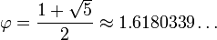
The golden ratio is associated with the Fibonacci sequence (0,1,1,2,3,5,8,13,21,34,55……) by which each number is the sum of the prior two numbers. This ratio is ascetically pleasing and found within Art, architecture and nature. It is often termed the Divine ratio.
The ancient megalithic structure contain the golden ratio (Phi φ) include, Pantheon of ancient Greece (447–432 BC), The Stupa of Borobudur, built 8th to 9th century in Java Indonesia and the Great pyramids of Giza around (2570 BC) and Stonehenge (3100 BC – 2200 BC). Just as the spider constructs its domiciles in accordance with the geometry of the golden mean so does the man. So, what does this allegedly divine mathematics have to do with anything? they coincide with the lay lines (dragon lines), the male and female energy meridians which pass through the earth. This highlights the connection between, divine mathematics within the mind and body, and the lines of the earth itself. A debate concerning lay lines as to whether ancient civilization such as the pica civilization who constructed Stonehenge were purposely erecting these megalithic stone structures on lay lines due to knowledge they possessed (yang) or were drawn to them due to the connection between themselves and nature, by their intuitive/subconscious mind (yin).
We cannot Calculate the Dao
As we have discussed, mathematics is a function of the left brain. Modern western paradigms attempt to map and predict weather patterns by gathering large amounts of data, calculating averages and mapping trends using Newtonian methods. Large amounts of data are quintessential ideals of a left brained ideology. To be reliable we would have to begin measurements from the beginning of time and space itself whilst having all the relevant knowledge concerning temperature, sea levels, volume of ice on the planet, tectonic plate formation gas levels including CO_{2…,} whilst accounting for external factors such as human interventions as well as intergalactic activity orbiting bodies such as the moon. Whilst this has proved affective for the weather next week, it has proved unsuccessful for larger scale prediction due to what is termed the Butterfly affect. Put simply any small factor missed out from the calculations may cause an estimation error.
Similar feats were attempted to calculate the economy but again proved to be beyond the scope of current mathematics. This of course was unsuccessful. Which the Universe itself may consist of purely mathematical elements, man-made non-physical constructs cannot be classified or mapped as orbits of planets.
The I Ching was originally used as a divination manual (Lynn, 2004, p. 1). This is stereotypical of the ancient’s nature, as a right brained eastern individual. Thus, again we see the east and western methods of calculations are reflection of the yin yang male and female nature of societies with both having their benefits. Divination of course takes into account all the information and factors from not only the whole past of the Universe but also the future, hence how it can predict it. Yet of course works from the unconscious mind.
Conclusion
The duality of nature exists on many levels. This paper not only brings an up to date biological perspective on Daoism but also incorporate science into a wholistic perspective, revealing how it can be detrimental to ourselves if performed incorrectly without a greater awareness of the whole. The qualities of the mind are the same as the qualities in the world. Whilst many philosopher, biologist, physicist and psychologist have searched the internal and the external for the answers to life. This theory presents them as one in the same. With regards to the philosophy of know thy self, this provides greater understanding of self, building upon Daoist theories by the addition of scientific and social theory, to greater comprehend the self, planet and universe as one, as claimed within eastern philosophy. This can lead to greater action taken, not only caring for the planet as if one’s self, but also the other people as if one self also, in line with multiple eastern and western philosophies. Whilst many comprehend interconnectivity on an intuitive(yin) level, explains interconnection in a non-doctrinal or mythological method, whilst explaining the requisite of balance, from a scientific viewpoint.
Word count (11,369)

References

Ayres, C. (2019). 13 Advantages and Disadvantages of Genetic Engineering. [online] Vittana.org. Available at: https://vittana.org/13-advantages-and-disadvantages-of-genetic-engineering [Accessed 8 Mar. 2019].
Ball, P. (2004) The essence of Tao. London, Arcturus.
Cooper, D. E. (2012) Convergence with nature: a Daoist perspective. Totnes [UK], Green Books.
de Morgan, A. (2008). A Budget of Paradoxes, Volume II. 1st ed. [ebook] Gotenburg: D. Starner & K. Edkins. Available at: http://www.gutenberg.org/files/26408/26408-h/26408-h.htm [Accessed 1 Nov. 2018].
Gardiner, P., 2005. The Serpent Grail. 1st ed. London: Watkins Publishing.
Huntington Moore, D., (2019) Mantra: The Stoics were Right Hemisphere Thinkers. [online] Thefirstscience.org. Available at: http://www.thefirstscience.org/mantra-the-stoics-were-right-hemisphere-thinkers/ [Accessed 8 Mar. 2019].
Joshi, S. (2011) Memory transference in organ transplant recipients. Namah: Journal of New Approaches to Medicine and Health. 19(1)
Kohn, L. (2009) Introducing Daoism. Milton Park, Abingodn, Oxon, Routledge.
Liu, Z., & Hua, K. (1999). A study of Daoist acupuncture & moxibustion. Boulder, CO, Blue Poppy Press.
Lynn, R. J. (2004). The classic of changes: a new translation of the I Ching. Irvington, Columbia University Press.
Narby, J. (1999). The cosmic serpent, DNA and the origins of knowledge. London, Phoenix.
Ozaniec, N. (1996). The elements of the chakras. Shaftesbury, Element.
Posamentier, A. S. (2007). The fabulous Fibonacci numbers. Amherst, N.Y., Prometheus Books.
Royston, R., & Humphries, A. (2007) The hidden power of dreams: an essential guide to interpreting your dreams. London, Bantam.
U.S. National Library of Medicine. (2019) How does gene therapy work?. [online] Available at: https://ghr.nlm.nih.gov/primer/therapy/procedures [Accessed 8 Mar. 2019].

