Il casa del fauno
Region VI.12.2
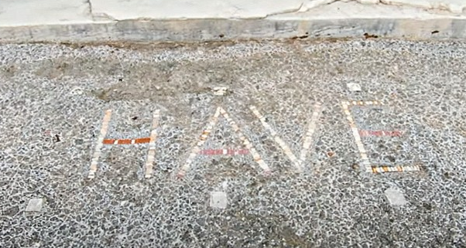

Introduction
Il casa del fauno (the house of the faun) is a large property discovered in excavated Pompeii, dating back to the second century BCE during the Samnite period, and gets its name from a bronze statue of a dancing faun in the main atrium. This house occupies an entire city block (insulae), and the expanse of this property gives an indication to what the elite lifestyle was like in ancient Pompeii. Being deemed as one of the wealthiest buildings excavated, this house offers a glimpse into the lives of those living within, the different types of things that the elite could buy and what the architecture of the house itself can infer about this time period.
Figure 1 = Limestone mosaic in the style of a door mat with the word 'HAVE' translating from Latin to 'Welcome'. This language has been seen as wealthy due to Oscan being the common language in this time period. (Berry, 2014)

House discovery
The house of the faun was originally excavated in 1830-32, in which it was stripped of elaborate mosaics, art works, furniture and any additional decorations by the excavators. It is thought that some of these items from the house can be found within the storage of the Naples Archelogy Museum, however, it is difficult to confirm whether an item is from the house without any proof. This is due to the question of validity of any original excavation documents, the damage to any documents between 1830 to the present, and a lack of any documents, labels or identifying information about the items in this storage. There has however been some evidence of finds on the land that the house sits upon, this includes evidence of pottery from the sixth century BCE along with the remains of a prior house from the third century BCE, which was subsequently replaced by the current house of the faun when it was built in the century after.
After the excavation was completed and ultimately left for another dig site, the house lay abandoned to the elements until it was damaged in allied bombing in 1943, during the second world war. This has led to irreversible damage and loss to the majority of the house structure that was excavated – this alongside the damage sustained and repaired during the earthquake in 62 CE and further damage from the eruption of Mount Vesuvius in 79 CE. This has left the house barren of the majority of its decorations, wall paintings and plaster, with only this small bare brick portion of the walls and the floor left to be seen today.

Architecture
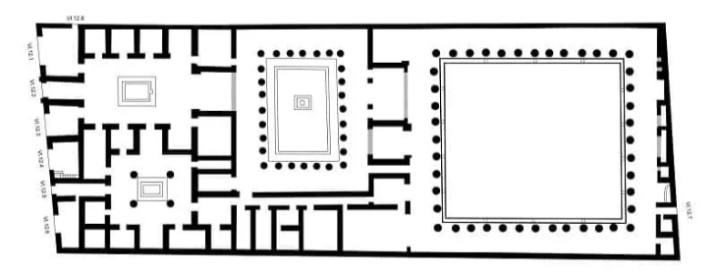
Generally, the size of the house has been deemed to indicate its wealth and surmises that the house was home to only the one family with the potential of owning slaves. The attributes of the house come into play when surmising the meaning attached to the house, this includes the features found around the house, including peristyles, multiple atria, exedra and tabernae. These features show different signs of wealth than what the potential decoration can, as the structure of the house alone proves that the multitude of differently styled rooms housed various meaning. Simply looking at the layout of the building shows the amount of rooms and can only guess as to the uses. However, placing these features together furthers the belief that this house is the wealthiest, as the size of the house alongside the features, but without the majority of artistic decorations and any furniture evidence the use of the many rooms cannot be used to further this point. The knowledge of the rooms uses are limited to the size and potential uses, with no definitive answer on them all. The larger rooms, atrium and the peristyle garden may have been used for entertainment and feasts for other Pompeiian elites, and the smaller for bedrooms, storage or slaves. This emphasised that features such as decoration, personal affects and trinkets are needed to be used alongside the architecture of the property in which they belong to formulate clearer ideology of the uses and meanings behind the choices made in this different time, and the formulated picture into the lives of those living there.
Figure 2 = The archaeological plan of the house of the faun.
  - Elements of the house:
- Scholarly debated square footage of the building (Wallace-Hadrill states 2865 square meters, but others, such as Berry suggest up to 3000 meters or 32,000 square feet)
- 2 atria - 1 being the largest in excavated Pompeii (roughly 16 meters in length)
- The main entrance and tabernae face the Via Della Fortuna.
- Possible separate service quarters around the smaller atrium with a long entrance corridor to another part of the house.
- A suspected upper floor (however the size is unknown)
- A 'kitchen garden' which was replaced in the 2nd century BCE with a formal peristyle garden (this served the previous house that was built over with the house of the faun)

Alongside the size, we can consider other aspects such as the location of the house as a sign of its potential wealth. The region in which the house can be found is on the edge of the city and has a sea view, adding to the wealth imbued into the house. Being this close to the sea, having the main entrance facing via della fortuna (one of the main road in ancient pompeii), alongside the former mentioned features make the house one of the most known and important in excavated Pompeii. All of these appealing features that uplift the status of the house are an ‘excellent example of irrelevance of shops in facade to the standing of a house’, this could indicate that the wealth of the house is not reflected in the use of the tabernae, but could be a potential for renting them out to lower class citizens.

Material culture
The house of the faun has been described as a palatial house that has outstanding mosaics, and examples of all four art styles throughout. The house has more notable style I art decorations, with some examples of II, III, IV, this could be due to the owners wanting more of a traditional style house; however, some of these decorations may date to roughly 200 yrs old at the time of eruption in 79 AD.
The various styles and depictions in these mosaics and art forms have no correlation to each other and links between any of the material culture still seen in the house is hard to associate due to the dating of the pieces. Due to the removal of the majority of finds it is nearly impossible to accurately confirm that any of the items in the Naples Archaeological Museums storage. Therefore, the only material culture that can be used when attempting to describe the house itself, its wealth or links to the owners, are the mosaics and material culture.
  - Signs of religion
Not having much of the original pieces within the house due to previously mentioned reasons, there is little evidence through material culture about any signs of religions connected to the house. The only evidence of religious activity in the house are some built in shrines, a mosaic of Baccus and drawings from the nineteenth century. These drawing depict candelabra, bronze jugs, amphora, different types of furniture, a flute, a ‘sistrum’ (‘ritual rattle used in the worship of Isis’) and multiple other items were found belonging to the house. This sistrum and the mosaic of Bacchus are some of the only items that show any potential links to religion within the house, leaving the question of which was the most recent religion practiced, whether there were multiple religions practiced at the same time or if other signs of religious activity has since been lost.
  - Assortment of mosaics:
- Marine flora and fauna (including an octopus and lobster fighting)
- River Nile imagery (including scenes of fish, ibises and ducks)
- Doves
- Tragedy masks
- Bacchus riding a tiger
- Satyr and nymph
- Battle of Alexander the great and King Darius

Located upon an exedra floor, at just under 20 square meters, there is a mosaic of Alexander the great in battle against king Darius III of Persia during the conquest of Asia. This mosaic is the most famous in excavated Pompeii due to the size and the style; of which is Opus Vermiculatum, a method of mosaic making using small tesserae and focusing on outlines that emphasise the main design. This method has been deemed the one of the most demanding and elaborate forms of mosaic work. This mosaic consists of roughly one million tesserae pieces and shows the skill in which was needed to make such a large mosaic in this style.
These mosaics and art piece may seem unique, but the ideas can be seen in other regions of Pompeii. Within the triclinium of the house of the faun, a mosaic of a lobster and octopus fighting can be found. This mosaic is not as unique as some of the other mosaic pieces found inside the house, due to being able to be compared with a very similar scene found in the House of the Geometric mosaics (region VIII.2.14).
The bronze faun statue in which the house is named after is a satyr in faun form and the original resides in the Naples Museum of Archaeology. The statue can be found in the impluvium (water basin) at the centre of the main atrium. Similar statues can be seen across excavated Pompeii, an example is the House of the Large Fountain, in which a bronze statue can be found inside an impluvium depicting a cherub holding a dolphin.

Modern conservation
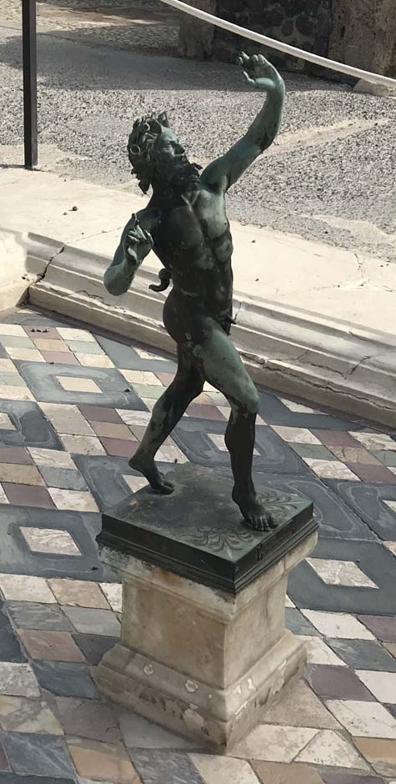
Due to the house being void of any physical items only the structure is left to be protected and preserved. This restoration can be seen inside the Naples Archaeological Museum with multiple of the mosaics being restored and placed on display, alongside the bronze statue of the faun of which the house is named after. These pieces were replicated in almost the exact style to keep the originality of the style in which they were made and were placed inside the house for visitors to see what features the house had, without the possibility of the original pieces being deteriorated by the elements and damage further. The house is also protected by barriers to sections of the house that is more delicate than others to prevent any accidents with visitors or collapse of any of the structure.
An example of these replicated pieces from the house are the bronze statues of the dancing faun and the mosaic of the battle between Alexander and Darius. This mosaic replica was estimated to have taken roughly one million tesserae to complete. Researchers believe that the original mosaic may have been made as a copy of a painting completed closer to the time of the battle, in which the painting has been mentioned in Natural history by Pliny the Elder; this may be possible due to the mosaic potentially being dated to late second century BCE.
Figure 3 = Replica statue insitu at the house of the faun.
After the previously mentioned bombing in world war 2, there was reconstruction work to the columns within the peristyle areas of the house. In 1946, the columns were reconstructed using metal supports and cement mortars which became unsuitable for conservation. After being further damaged following restoration work after the 1980 earthquake, some columns are stabilised with metal and wooden planks while other remain in a ‘rather advanced level of degradation’. Further works to support the columns and walls of the house of the faun continue alongside the protection of areas from visitors by removing access to certain spaces.

Conclusion
The House of the Faun remains one of Pompeii’s most significant finds, and examining its features highlights its importance. Its early excavation revealed a large elite residence, while the architectural layout, with the two atria and peristyles demonstrates how space was used to project status and wealth. The material culture, mosaics, statues and furniture , further reflects the household’s elegance, art style traditions and status. Ongoing conservation challenges underline the fragility of such sites and the need for sustained preservation. Together, these elements show how the House of the Faun offers an insight into Roman life and the responsibilities involved in preserving important parts of Ancient Pompeii.

Bibliography
Andrew Wallace-Hadrill, Houses and Society in Pompeii and Herculaneum (Princeton university press 1994).
Joanne Berry, The Complete Pompeii (First paperback edition 2013, Reprinted 2014, Thames & Hudson 2014).
Britannica, Opus Vermiculatum, Roman Art, Tesserae, Decoration, https://www.britannica.com/art/opus-vermiculatum, 2015, accessed 01/2026.
‘THE RESTORATION OF THE COLUMNS OF THE HOUSE OF THE FAUN’ (Pompeii Sites, 15 January 2021) <https://pompeiisites.org/en/comunicati/the-restoration-of-the-columns-of-the-house-of-the-faun/> accessed 01/2026.
Samuli Simelius, ‘Unequal Housing in Pompeii: Using House Size to Measure Inequality’ (2022) 54 World Archaeology 602.

  - Picture bibliography
Figure 1 = pompeii in pictures, courtesy of Rick Bauer 2019, https://pompeiiinpictures.com/pompeiiinpictures/R6/6%2012%2002%20p1.htm, accessed 01/2026.
Figure 2 = maidan project, https://madainproject.com/house_of_the_faun, accessed 01/2026.
Figure 3 = pompeii in pictures, courtesy of Rick Bauer 2019, https://pompeiiinpictures.com/pompeiiinpictures/R6/6%2012%2002%20p2.htm, accessed 01/2026.

Simelius, pg.604
Berry, pg. 163.
Berry, pg. 163.
Berry, pg.163.
Wallace-Hadrill, 1994.
Berry, 2014.
Simelius, pg. 605.
Berry, 2014.
Wallace-Hadrill, 1994.
Wallace-Hadrill.
Berry, pg. 165.
Berry, 2014.
Berry, pg. 167.
Britannica
Wallace-Hadrill, pg. 336.
Pompeii sites
Pompeii sites

