

Applied Industrial Placement (SPORT)
M5X02295
Placement Portfolio Template

Student Name
Name – Jack Roberts
P Number – 1701927
Report
Title – Placement Portfolio
Word Count – 3396
References (Total) – 8
Job Title –
Organisation
Name –
Address –
Email –
Telephone Number –
Line Manager
Name –
Position –
Email –
Telephone Number –

TASK A – (Reflective Learning Log 1 - 500 words – First Experience of Placement)
Recommend to link the reflective experience to two different key themes.
Planning and Reviewing
Planning is the most important part of any stage, it is fundamental to the success of any session as Vlad states “the importance of planning for successful coaching, considering that this is what performance in sports starts with.” (Vlad, 2017, p.517), I spent many hours researching and planning my sessions as “The aim of planning in a coaching process directed towards excellence is to identify the work that the athlete or the team needs to do in order to approach achieving success” (Vlad, 2017, p.517-18). An example of how planning was important during my time coaching at the LC is the use of the backup activities within my session plans, Penllergaer primary school were coming to the LC for an activity session with us and my role was to coach these children the correct technique around throwing underarm and overarm, and that is was my session plan focused upon for the day. However, I planned an activity that would see the children spilt into teams and throw bean bags in to hoops that were placed on the floor, each hoop being further away with points being awarded every time they managed to get one in, the further the hoop the more amount of points the team got, however I wasn’t seeing much improvement or enjoyment from the children, which was leading to a very unsuccessful session which is when my session plan came into this, I had included a backup activity which was a modified game of dodge ball where players had to hit the balls instead of the other players, due to the fact I prepared a back-up game I had made sure we could move on quickly and students had more fun during their session.
When in the planning stage it is also crucial to research how much time the session will actually run for so the coach can prepare a session that can run the course of time without the participants becoming bored within that session, leading to less improvement in their skills. In a session with Lonlas primary I had planned a session that would improve the students catching skills, however the warm up had students throwing items back and fore, which they picked up quickly, this lead to students becoming restless and not taking the session as serious which lead to disruptions, this lead me to moving onto the main activity prematurely, this damaged our main session because students found the activity repetitive after a few attempts. Students skill level wasn’t improved due my poor planning on this day.
Reviewing is a major part of the coaching process, it gives me insight to how my session was conducted, which helps me to determine if it was a success or not, as Gilbert and Trudel write to become “better skilled at one’s professional practice, a novice teacher or coach needs to do more than simply spend time on the job’. It has been repeatedly suggested that the key to experiential learning is reflection.” (Gilbert, Trudel, 2006, p-114). Whilst conducting session plans, I would always include a section that would allow me to review my session, this would allow me to improve the session if I was to ever run the same activity. I planned a session with Brynmill, the session was designed to improve the catching technique of the participants but at the end of the session the skill level hadn’t improved, I thought the session went well but during the review I discovered flaws in my session, I discovered that I had rushed my demonstrations only delivering the technique twice, I also I didn’t direct any questions to the students to check their understanding, which lead to the students being unsure on the correct method. By conducting this review, I was able to provide more demonstrations and question understanding in future sessions to the participants to help improve their understanding of the activity.

TASK A – (Reflective Learning Log 2 - 500 words – Mid Point Experience)
Recommend to link the reflective experience to two different key themes.
Themes – Coaching and Mentoring
Coaching is the most important step of this process as it’s through this process that students will improve their ability in, as stated “Coaches are educators in that their role is to work with one or more athletes in order to move the latter’s performance to an improved level. Coaching is a process akin to teaching, tutoring or mentoring.” (Wikeley, Bullock, 2006, p-14)
During the first term of my second year on the course the focus was on coaching and delivering multiple sessions to many schools within the local area this took place at the LC. one session at the LC we welcomed Penllergaer primary school, we took the kids through a multi skills session with 2 students assigned to each station, my role was to coach them how to use the correct technique to throw, to start the session I demonstrated the correct throwing technique both over arm and underarm to the kids, I showed them this demonstration three or four times to ensure they understood it and then asked them questions to see if they were paying attention from this demonstration we then moved in to paring up the children having each throw small light objects back to each other switching from overarm to underarm just so they could work on the technique, we then moved into developing a little competition between them making them work faster and see if they still used the correct techniques, I set up hoops each a certain amount of distance away from the students, the further away the hoop the more amount of points it was worth if they got it in, however this game wasn’t working and as I mentioned in the planning example I prepared a back-up game for when children weren’t having much success or developing their skills, which led to me moving onto an adapted game of dodge ball where the children wouldn’t aim for the other kids instead aim for objects placed on the cones after all items have been knocked off the children had a specific amount of time to throw all the items they could into the other teams side, with the team having the least amount of items in their half being the winner. I would look for the correct technique being used and would stop the session to remind the students of the technique.

Mentoring is almost as important as coaching in this process as it helps the mentees draw from other people’s opinions and improve in areas they need to be stronger in, as Cushion alerts to “the key for Successful mentoring it would seem is to assist the protégé to become the focus and to develop their abilities to analyse and draw meaning from the experiences” (Cushion, p-137)
Our second half of our year was then focused on the mentoring aspect. In the first couple weeks of our mentoring assessments we paired up with another student and watched them coach fellow students and asses their performance as a coach, in these weeks I assessed Matt, before the session he explained what type of session he had planned and give me his session plan to have a more detailed look on what he wanted to achieve in that session, during his session I watched out for how and if he carried out the appropriate safety checks at the start of the session, I would then look at how well he executed his demonstrations, which would move at then looking at his actual session, within this session I looked at more at how this session would have worked for actual kids, this was only a warm up session to ensure that we knew exactly what to look out for in the actual session in the next couple of weeks.
A couple weeks later we then fully assessed our partners in a session that they run with a local primary school, the session revolved around helping improve the children’s badmintons skills, I had my mentoring sheet which I had designed for the lesson based on the previous session I had watched. He went through all the necessary safety checks, at the start of his session and the overall session went according to plan it went very well, which I got my point across with him when I went through how the session went after he had finished, whilst mentoring Matt I did discover that he could have used more efficient techniques to ensure that he had more control over the children he was coaching.

TASK A – (Reflective Learning Log 3 - 500 words – Mid Point Experience)
Recommend to link the reflective experience to two different key themes.
Themes – skill development

Developing the skills of the participants was always the main goal of our sessions and within the coaching process it is a fundamental to any individuals or team within training. As Jones writes “Helping athletes to learn and develop – and so improve their performance– is the essence of sports coaching” (Jones, p-2)
Along with coaching at the LC we also did some session at the secondary school Bae Baglan, we did these with NPT Pass, we worked with children that ranged from all ages as this was conducted during the half term. Within these sessions we were required to design a session that improve at least one skill for all the participants, the coaching group that I was placed in was asked to help develop students running with an activities game, I was in charge with designing and conducting the main activity that would be in-between the warm-up and the cool down, the warm up was focused around demonstrating and coaching the correct running technique, I picked a game called Shark Attack where one individual would be the shark (Catcher) and the rest would be the prey, I placed four hoops in each corner of the field, which the prey would have to get to without being caught by a shark, sharks could not tag until I say so, if a person were tagged by a shark that person would then become a shark, we would praise students for using the correct technique during the activity. This activity helped develop running but also develop participants coordination skill.
We also worked on skill development at the LC with a skill development session with Lonlas primary school. In this session my role was to use a session that would develop the students throwing ability, before the start of the session I demonstrated the correct technique to the students, then moved onto the warm up I paired up each student with each other and had them stand across from each other throwing bean bags back and fore, I’d swap the technique that students would have to use every so often, we then moved on to the main activity which was a game called 10 second dodge ball, this is an adapted game of dodge ball where the players would have to stay in a certain area of the pitch and were only allowed to underarm, to help them work on the technique, if anyone didn’t throw underarm they would have a 15 second time out. This game focused on throwing but also helped develop the students catching skills.

TASK A – (Reflective Learning Log 4 - 500 words – Near end of Experience)
Recommend to link the reflective experience to two different key themes.
Themes – Risk management. and demonstrations
Though coaching, planning and mentoring were the focus of the sessions with the primary schools, safety checks also became a massive focus for us during lectures, we would work on designing our own risk assessments, looking at every possible factor that may provide risk to the kids that were taking part in the session and ensuring that they were properly managed. As Spengler, Connaughton and Pittman write “risk management entails reducing or eliminating the risk of injury and potential liability that comes about through involvement with sport.” (Spengler, Connaughton, Pittman, P-2)
Many of the primary schools that visited us whilst we were coaching at the LC came to us in large groups which made the use of risk assessments even more important to ensure the safety of these kids. On one visit from Lonlas primary school they brought a high amount of kids, along with another group from another school who were working with the first year students, included in my risk assessment was to look out for items on the court that could trip up students, we had mats were placed around the LC for students to place bags on for them not to get in the way of the sessions, however some of these bags would sometimes spill out onto the session floor, I had to make sure to complete a safety checks between breaks to ensure the safety of the children.
Safety checks were also a vital part of the visit from Brynmill primary school, during these types of visits we dealt with a large group of kids within a small section of the LC, with activities that do include running, accidents did occur when children fell or run into one another, this would always be included in my risk assessments along with a contingency with what to do if this did happen. Whilst coaching a group from Brynmill we played a game of dodge ball and I was panning on using bean bags and some hard balls, based on my risk assessment I discovered that this would have posed risk to the children and this was switch to soft balls based on recommendations. This was clear during the session due to the high volume of children that got hit in the face during the session.
Demonstrations were a fundamental part of any activity session we conducted at the LC or any other location we conducted sessions at during the coaching module of the term, as Hodges and Franks write “demonstrations help form an image of the act which enhances memory for the correct sequence.” (Hodges, Franks, p-153). I would always have to ensure that I gave a demonstration before every activity it helped the kids understand how to conduct the activity which leads to more success when developing their skills. an experience of this was when coaching a group from Lonlas primary school, we were conducting a skills session where we had to teach the children the correct running technique, before the start of the session I demonstrated the correct technique, I repeated this demonstrations around 3 times to the students, this was then followed then me directing questions to the students I did this to find out if they were paying attention and to show me that they understood the demonstration. I then repeated this when going through the session for the children.
Another experience I had with demonstrations is letting one of the students help showing the other children with Brynmill primary school. During this session some of the students were struggling, I stopped the activity a few times during this session to demonstrate the correct throwing technique due the students struggling to use the correct technique during the session, but I felt that they needed to see a fellow student using the technique, after taking time to watch the students I picked out a couple of students using the correct throwing technique and asked them for help in demonstrating. I did this without criticising the other students and making them feel like they weren’t as strong as the others.

TASK A – (Add 250 words on link to future Continued Professional Development and Reference list based on total referenced material in Task A)

Continued Professional Development post placement (250 words - Link to pre placement module)
By using CPD I will be able to ensure that the skills I have earned from coaching will stick with me for life. As stated, “CPD concerns practices aimed at employees’ development beyond that derived from their initial training.” (Collin, Heijden, Lewis, P-155). Through coaching at the LC and Bae Baglan I have become a lot stronger as a coach, I have learnt my strengths and weaknesses, and the coaching sessions have improved my confidence not just as a coach but in everyday life. I hope to take these experiences into the future with me, however I don’t foresee me going into coaching within the future as it is not the career path I wish to pursue, however the experience I have had with planning and leading groups will help me greatly In the future with any type of career I wish to have, especially that I wish to purse management roles.

References from TASK A (10+ references)

- Cushion, harnessing the power of experience, Jones, Robyn L.,The Sports Coach As Educator : Re-Conceptualising Sports Coaching. New York: Routledge. 2006, p-137

- Roşca, Vlad. "Planning, Implementing and Evaluating in Sports Coaching." Revista De Management Comparat International 18.5 (2017): 515-26.

- Wikeley F, Bullock K, coaching as an educational relationship Jones, Robyn L.The Sports Coach As Educator : Re-Conceptualising Sports Coaching. New York: Routledge. 2006, p-14.

- Gilbert W, Trudel P, the coach as a reflective practitioner Jones, Robyn L.,The Sports Coach As Educator : Re-Conceptualising Sports Coaching. New York: Routledge. 2006. P-114.

- Jones R, (2006) The Sports Coach As Educator : Re-Conceptualising Sports Coaching. P-2

- Spengler J, Connaughton D, Pittman A, Decision making and managing risk, Risk management in sport and recreation 2006, p-2

- Hodges N, Franks I, instructions, demonstrations and the learning process, Williams M, Hodges N, Skill acquisition in sport, 2006, p-153

- Collin K, Heijden B, Lewis P, Continuing professional development, international journal of training and development, 2012, P-155

hg TASK B – (Picture Board – 5 pics (40MB upload limit to Turnitin) (Experience, Roles, Improvements)
Picture | Text (Paragraph)
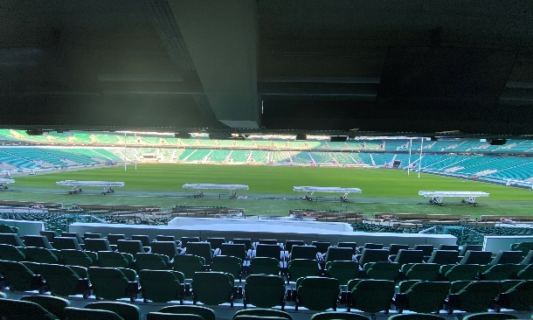 | The picture to the left shows Twickenham the home of English rugby it was taken during the 2020 trip to London with the university, whilst having a tour of the stadium.
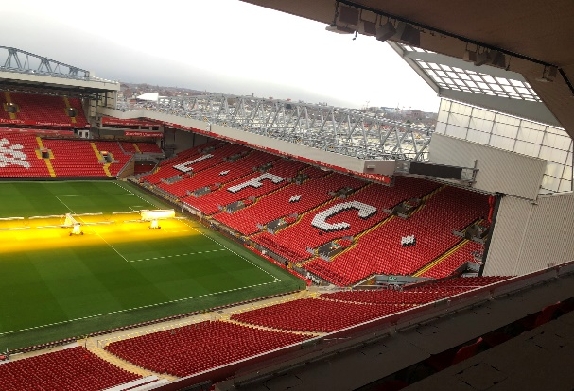 | This picture was taken in the box stands overlooking Anfield in 2019 on our trip to Liverpool, it was during our tour of the stadium, where we learned all about the history.
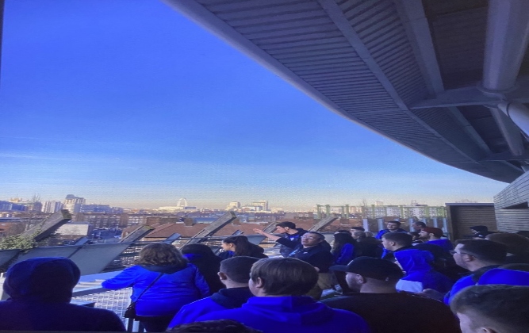 | This picture shows us on London 2020 trip, at the Oval cricket ground, this picture was taken within the box stands of the ground, these are most luxury seats within the stadium. We were also learning the history of the stadium from our guide.

TASK B – (Picture Board Cont.–5 pics (40MB upload limit to Turnitin) (Experience, Roles, Improvements)
Picture | Text (Paragraph)
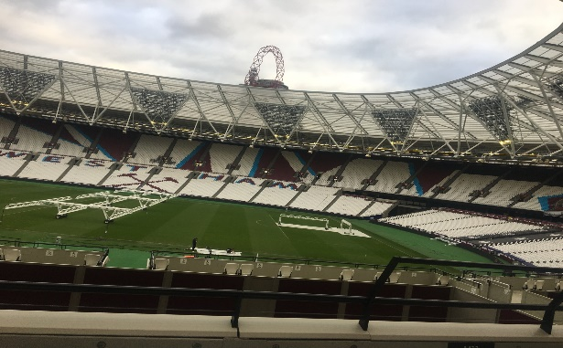 | This picture was taken in 2018 on the trip to London. It is a side view of the London stadium picture where West Ham play their football. Where we were given a tour of the stadium discovering how it operates.
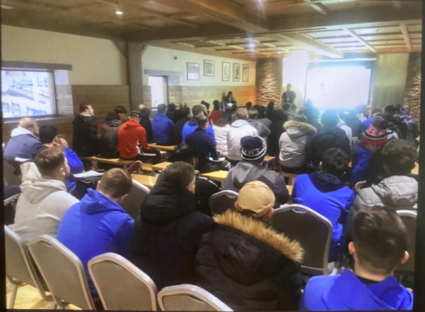 | This picture was taken at the chill factore, it is home to longest indoor skiing slope in the UK, it also offers various other activities. In this picture we are learning how the facility operates as a business from a member of their team.
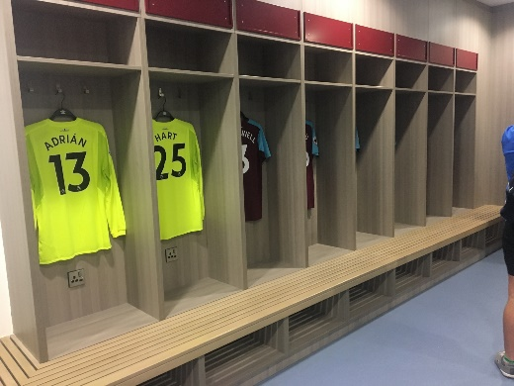 | This picture is also from the trip to the London stadium in 2018, it shows the inside of the West Ham dressing home which is used by the team before they step onto the pitch.
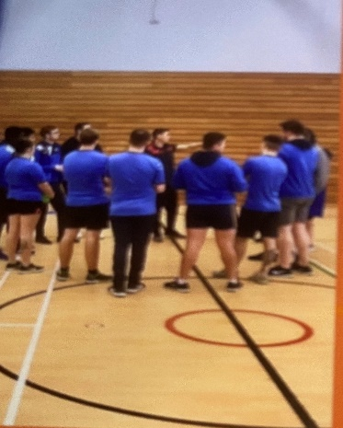 | In this picture a group pf us are currently going over last-minute preparations for our coaching session with a local primary school at the LC. This session involved teaching the students the correct throwing technique.
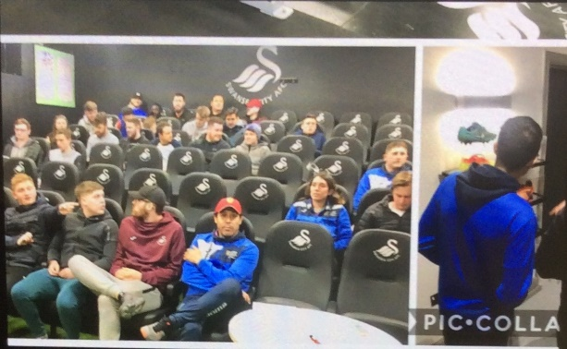 | This picture shows the university trip to Swansea training ground Fairwood, the trip was for an upcoming assignment. It shows us in the players meeting room, learning how this facility operates on a regular day to day basis.
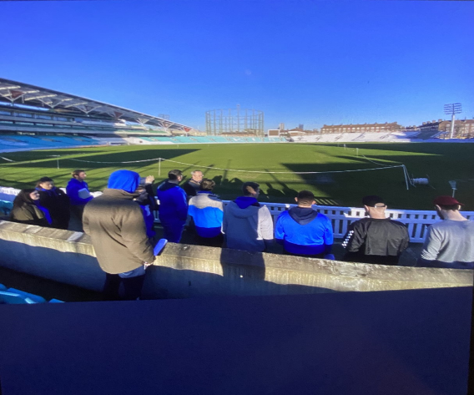 | This picture was taken at the Oval cricket ground, in the lower stands of the ground. At this time, we were learning about the ground from our tour guide.
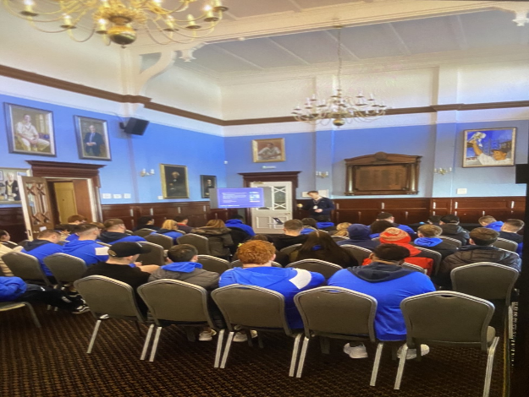 | This picture was also taken at the long room located at the Oval cricket ground. In this picture we are receiving a talk from member of the marketing team, learning how they operate.



UWTSD SPORT
Placement

