Cristian Dabija
212 33 01
25 February 2022

Professional Career Development Reflection and Application

BMSW4005
UNIVERSITY OF WALES TRINITY SAINT DAVID

Table of Contents
An Assignment 1
On 1
Professional Career Development 1
Table of Contents 2
Componnent-1 4
Introduction 4
Overview 4
Johari Window 4
SWOT and Conversation Strategy 5
Strengths 6
Weakness 6
Opportunities 6
Threats 6
SMART Goals 6
Name 6
Description 6
Personal Development Plan 7
Learning Style Questionnaire 8
Visual 8
Aural 8
Read and Write strategy 8
Kinaesthetic 8
Materials: 8
Application 9
Analysis 10
Personal Development Plan of Myself 11
Focus Area 11
Where am I Now 11
Where will be? 11
How much known 11
Activities 11
Nodded Recourse 11
Training time 11
Reward 11
Conclusion 12
Reference 14

Componnent-1

Introduction
Professional career development is a process of acquiring and learning activities that develop knowledge and skills (Hall and Kaufman, 1975). Which is a must related to career. Ranges of a personal development career can be the four years degree or it could be three months training. This process helps to make decision for long term (Tamášová, 2015). The decision making is aligned with the need of an individual which can be both physical and psychological (Hall and Kaufman, 1975). These needs must be cover career advancement opportunities. There are methods which can help a person to develop his/her professional career such as: Johari window, personal development plan, SMART goal, SWOT analysis and Learning style questionnaire. In this repot, I write briefly about these strategies. Also try to give a scenario of my own application and analysis of these strategies.

Overview

Johari Window
The Johari window is a procedure and technique which helps people to learn about themselves and others better (Verklan, 2007). In 1955, two psychologists named Joshep Luft and Harrington Inghom Verklan, 2007. The primarily uses of this model were self-help and corporate setting as a heuristic practice. The “Johari” name comes from the combination of their first name. In these techniques, a person has to select a number of adjectives from a list, picking ones the person feels that he or she describe his/her personality (Luft and Ingham 1961). The peers of the particular person also get the same list, every one of them select a same number of adjectives that represent the person. After that the adjectives are put into a cell which is a two-by-two grid of four cells. This concept also called the “Johari house with four rooms” (Luft and Ingham 1961).

Known to self Not known to self
Known to others

Unknown to others
Figure 1: Johari Window (The Johari Window Model, 2022)
Room number one represents how we as well as others see us. The room number two show us how other people think about us. But this part is unaware from us. Third room contains the hidden aspects of us which we always hide from others. The fourth and last room contains those aspects which are unknown and unconscious part of our life. Nobody is aware about those aspects.

SWOT and Conversation Strategy
For developing a better career, SWOT analysis is very important. It helps to identify what is your strength, weakness, opportunity and threats (Leigh, 2009). These criteria define the best choice for a person.
Figure 2: SWOT Analysis (Leigh, 2009)
This SWOT and conversion strategy gives the following answer.

Strengths
To find what is the uniqueness inherent on the person (Sarsby, 2016). It helps to identify in which area a person better than anyone else. Also help to identify that what other people see on him or her.

Weakness
To identify what is the avoidable issues and what makes nervous the person always. Things that make you fear.

Opportunities
In this section, a person can identify what new sources can help you. Secondly, which method or way make the road easy for going further (Sarsby, 2016). There are some ways to find useful opportunities. These include network events, classes or conferences. An individual also can enrol in new and challenging project that helps him/her to learn new skills.

Threats
Threats are those things that create obstacles and challenge to achieve the goal.

SMART Goals
SMART stands for specific, measurable, achievable, relevant and time-bound (Les, 2012). These parameters of goals help a person to achieve his/her objectives within a definite time-frame. This approach does not depend on the guesswork and generalities (Les, 2012). Rather it targets the objective, make a clear goal, and eliminate the unnecessary things. After that work for achieving the objectives. The guideline of writing an effective SMART goal is described in following table.
Name | Description
Specific (also called a heart of a plan) | Identify what is need to be completed  Define the people who are responsible for it  Select the steps that are need to be achieved the plan.
Measurable | Choose a benchmark  Make it easier and clear to track progress  Have a clear mind set when you have to finish the goals.  Make the goal quantifiable
Achievable | Make sure that the goal is realistic  Make sure the goal is reasonable to accomplish
Relevant | Think about the big picture  Make it relevant with your long-term goal
Time Bound | Know about the time horizon and limit  Decide when you have to start and end
Table 1: the guidelines of SMART goal

Personal Development Plan
Personal development planning is a process of reflecting learning, performance and achievements of a person himself/herself (Eisel et al, 2013). It is helpful for planning a better personal, educational and career development. Also help to think more cautiously about future goal. This process leads a person to clear career goal which makes study easy and increase self-confidence (Eisel et al, 2013). Not only future goal, it also very relevant to academic skill as it works for increase the analytical and thinking skill. PDP can vary person to person, carer to career.

Academic skills and experiences
Work experiences and skills for employability
Personal & Social skills experiences

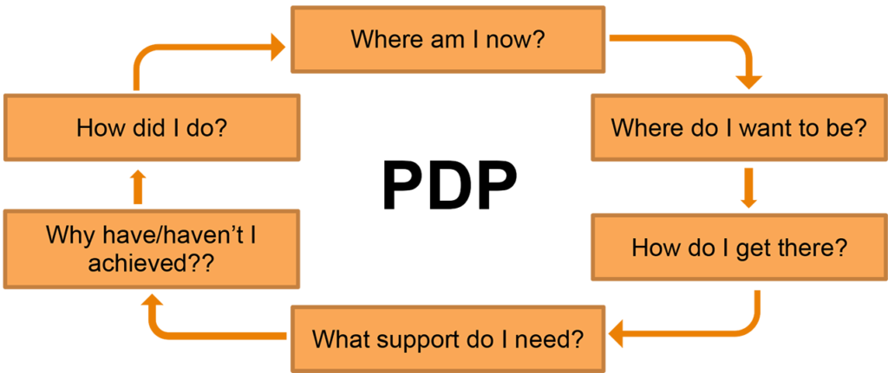
Figure 3 : How PDP works (Beausaert et al, 2011)

Learning Style Questionnaire
The purpose of the Learning style questionnaire is to help the candidates determine which learning style they belong to (Carraher, 1995). This method usually works as form of questionnaire. Candidates have to choose the best answer from the multiple option. The answer reflects the person’s character resemblance Carraher, 1993). This form of learning has four strategies. This model also called VARK learning style model.
Visual | Aural | Read and Write strategy | Kinaesthetic
Gesture and picturesque language in class.  Materials:  Pictures, videos, posters, slides, flow charts, underlining different colours and highlights, textbooks with diagrams and pictures, graphs. | Attend lectures, tutorials, group study, discussion with lecturer Taking notes, tap recording, remember the jokes and stories | Lists, headings, directories, glossaries,  handouts, textbooks, reading in library, lecture notes, essays and manuals. | Enable the 5 senses including smell, hear, touch, sight and taste.  Using laboratories, field tours and trips. Prefer the lectures who give real life examples, real life applications.

Table 2: VARK learning style model (Loo *, 2004)
The VARK learning style model follow a process. The process is given following.

Figure 4: How VARK model works (Loo *, 2004)

Application
I as a student apply all the models several times. I have some career choice as I want to be a market researcher. Because I have always thirst for finding new ways of knowledge, comparing statistics and finding the new meaning of different issues. But I also have little bit interest in Multinational Corporation. As Multinational Corporations always bring challenging job. Challenges like meeting sales, production, ensuring customer satisfaction, create customer lifetime value, market forecast etc. That’s why I have decided to blend my career choice, I want to do research work that is related to business. Rather it can be said that I want work in marketing analytics or market research.
For achieving my goal, I also blend the strategies that I learned throughout the semester from this course. At first, I tried to identify what is my strength and weakness. I did my SWOT analysis. I noted what is my strength and weakness, what will be upcoming opportunities. And also try to find out what will be the threats and obstacles that will block my road to reach my goal. I decided to turn my weakness into strength and also decide to find new ways to overcome obstacles. That’s why after that, I apply Johari window in my career goal. Because I also want to be aware about what other people think about me. What will happen if I overjudge me, may it could be the threats. If I do not know myself better, I cannot develop myself. Then I did apply “Johari window” to analyse myself and others. Also, to find out my qualities and faults. Later, I applied the SMART goal. It helps me to find out whether my career choice was right for me or not. Because after analysing SWOT and Johari, I found out that I am not able to go for several career choices at the same time. My weakness was communication and for becoming a researcher it is important, that is why I specify to improve my communication skill. Then I measured it that it was possible as well as achievable. Then I made it relevant with my career choice as a researcher need communication skill to data collection and present the report. I also implemented it within 6 months. To make it true, I linked the SMART goal with my personal development plan. I also take help from learning style questionnaire to define my own learning style. Since it will help me for learning in a better way.

Analysis
I applied almost every model, but I use mostly SMART goal and learning style questionnaire. The result was a little bit ambiguous at the first time. I took aural learning as my learning method, after some time I realized that it was not the most effective learning style for me. Because I am not following only a particular method, rather I am user of a multiple learning styles at the same time. It varies from course to course and time to time. For example, I prefer visual strategy for mathematical course and historical course demand aural strategy. Then it was also somewhat impossible to define the relevancy and measure your objective. Sometimes any sudden and unexpected event can happen. I also find that it was not always possible to understand the idea within a time frame, I achieved more results after the time elapsed. Finally, I can say that one single approach is not applicable and always right for any individual. Rather a person should use the combination of these approaches. In regards to weaknesses, digital communication and presentation in front of a crowd are not my strong qualities. Following learning styles stated above and continuing my university course I expect a boost of confidence and knowledge in both communications styles by the end of the course (January 2023). There are new opportunities unveiling since the beginning of the pandemic in 2020 as customers are now purchasing digitally and this trend appears to remain in place long term. Improving my digital skills will help me generate more sales and leads by email and short product podcast, I am applying this technique in my current employment with moderate success. There are some threats and always will be in any competitive environment, my current job included. New employees with fresh ideas and skills have been employed, also two new rival companies have emerged within the last year that have taken a small share of the market. To stay relevant, I am keeping up to date with new vehicles news (my trade), sales techniques and other compatible skills and knowledge required to keep me informed and successful. Reading magazines, books, viewing tv shows and related podcast kept me well informed so far, I intent to continue doing so.

Personal Development Plan of Myself
As I already said that I prefer a combination style. So, in this part I am creating a personal development plan linking with my smart goal. In my plan I want to develop my two employability skills which are communication and team work.

Focus Area | Where am I Now | Where will be? | How much known | Activities | Nodded Recourse | Training time | Reward
Creating planning to communicate with my team workers and peers | Could be better | Confident and active | I will be a best presenter who can communicate well including every group member | Participate in different public speaking, debate club | Campus debate club, competition,  Text books | By august
Following the plan | Feeling confident | Best communicator and team leader |  | doing various social work, group work, also participating in various group competition | Different social clubs and voluntary activities | By September | Now do better
Implement | advances | Fluent | An active leader | Lead in team and participate in academic competition | Campus activities and internship | By October

Table 3: Personal Development Plan of Myself

Conclusion
Professional career development is an important for every individual. But I have to choose how to do it, which can be applicable for it. The best outcome come from a combination strategy, none of the strategy is the perfect alone for one individual. Sometimes it is known to us or sometimes unknown. I need to deliberate the analytical terms of research effectively.

Reference
Beausaert, S., Segers, M. and Gijselaers, W., 2011. The Personal Development Plan Practice Questionnaire: the development and validation of an instrument to assess the employee's perception of personal development plan practice. International Journal of Training and Development, 15(4), pp.249-270.
Carraher, S., 1995. On the Dimensionality of a Learning Style Questionnaire. Psychological Reports, 77(1), pp.19-23.
Carraher, S.M., 1993. Another look at the dimensionality of a learning style questionnaire. Educational and Psychological Measurement, 53(2), pp.411-415.
Communication Theory. 2022. The Johari Window Model. [online] Available at: <https://www.communicationtheory.org/the-johari-window-model/> [Accessed 6 February 2022].
Eisele, L., Grohnert, T., Beausaert, S. and Segers, M., 2013. Employee motivation for personal development plan effectiveness. European Journal of Training and Development.
Hall, D. and Kaufman, H., 1975. Obsolescence and Professional Career Development. Administrative Science Quarterly, 20(3), p.474.
Leigh, D., 2009. SWOT analysis. Handbook of Improving Performance in the Workplace: Volumes 1‐3, pp.115-140.
Les MacLeod EdD, M.P.H., 2012. Making SMART goals smarter. Physician executive, 38(2), p.68.
Luft, J. and Ingham, H., 1961. The Johari Window: a graphic model of awareness in interpersonal relations. Human relations training news, 5(9), pp.6-7.
Sarsby, A., 2016. SWOT analysis. Lulu.com.

