

Master Project

Programme Name: MSc Cybersecurity & Digital Forensics

Module Name: MASTER PROJECT

Module Code: ACFA7003

Lecturer: Mohammed Ghanem

Student Name: Deep Desai

Student ID: 2421862

Topic: Blockchain-Based Secure File Upload and Integrity Verification System using AES Encryption

Abstract
Files are copied, shared and stored more than ever, yet most storage systems still cannot answer a simple question is this file exactly the one that was saved Unauthorised access and quiet tampering are real risks, and conventional storage offers few ways to spot them. This dissertation describes the design and evaluation of a Secure File Upload and Integrity Verification System that uses blockchain alongside established cryptography to close that gap.
Three mechanisms do the work. AES encryption keeps the contents of each file private. SHA-256 hashing gives every file a fingerprint that changes if even one byte is altered. A blockchain ledger holds those fingerprints, so an attacker cannot simply rewrite them to hide an edit. A user uploads a file, the system encrypts it and records its hash, and at any later point the file can be checked against the ledger. To see whether this holds up under pressure, a hacker attack simulation module was also built to tamper with stored files on purpose.
The prototype was written in Python with Flask and SQLite, with an HTML, CSS and JavaScript front end. Testing covered core functionality, security behaviour, accuracy of integrity checks and the detection of tampering. Across these tests the system encrypted files correctly, produced valid SHA-256 hashes, wrote verification records to the blockchain and flagged every tampered file it was given.
The findings suggest that combining blockchain with standard cryptographic controls is a practical way to improve confidentiality, integrity and trust in file storage, and the project adds a working example to the growing research on blockchain-based security.
Keywords: Blockchain, AES Encryption, SHA-256, File Security, Integrity Check, Cybersecurity, Cryptography.
ACKNOWLEDGEMENT
I would like to thank my project supervisor for their guidance and patience throughout this project. Their advice, and their willingness to question my ideas, made this a much better piece of work.
I am also grateful to the academic staff at the university for the teaching, resources and support that made the research possible.
My family and friends deserve special thanks. They put up with long evenings of coding and writing and kept me motivated when progress was slow.
Lastly, I acknowledge the many researchers whose published work on blockchain, cryptography and security I have drawn on in this dissertation.

TABLE OF CONTENTS
Abstract
Acknowledgement
Declaration
Chapter 1 – Introduction
1.1 Background and Context
1.2 Problem Statement
1.3 Research Aim
1.4 Research Objectives
1.5 Research Questions
1.6 Scope and Limitations
1.7 Dissertation Structure
Chapter 2 – Literature Review
2.1 Introduction
2.2 Evolution of Digital Data Security
2.3 Blockchain Technology
2.4 Cryptography and Information Security
2.5 Advanced Encryption Standard (AES)
2.6 SHA-256 Hashing and Integrity Verification
2.7 File Integrity Verification Systems
2.8 Secure File Storage Systems
2.9 Blockchain-Based File Security Solutions
2.10 Existing Research and Comparative Analysis
2.11 Research Gap Identification
2.12 Justification of the Proposed System
2.13 Blockchain Security Challenges
2.14 Comparison Between Traditional and Blockchain-Based Storage Systems
2.15 Chapter Summary
Chapter 3 – Requirements Analysis and System Design
3.1 Introduction
3.2 Research Methodology
3.3 System Requirements Analysis
3.4 Proposed System Architecture
3.5 Technology Stack
3.6 Use Case Analysis
3.7 Data Flow Diagram (DFD)
3.8 Security Workflow
3.9 Chapter Summary
Chapter 4 – System Implementation and Results
4.1 Introduction
4.2 User Registration Module
4.3 User Login Module
4.4 Dashboard Module
4.5 Secure File Upload and Encryption Module
4.6 Encrypted File Download Module
4.7 Decrypted File Recovery Module
4.8 SHA-256 Hash Generation and Verification Module
4.9 Blockchain Ledger Module
4.10 Integrity Verification Module
4.11 Hacker Attack Simulation Module
4.12 System Implementation Summary
4.13 Chapter Summary
Chapter 5 – Testing and Validation
5.1 Introduction
5.2 Testing Strategy
5.3 Functional Testing
5.4 User Authentication Testing
5.5 AES Encryption Testing
5.6 SHA-256 Hash Verification Testing
5.7 Blockchain Verification Testing
5.8 Integrity Verification Testing
5.9 Hacker Attack Simulation Testing
5.10 Security Evaluation
5.11 Performance Evaluation of the Proposed System
5.12 Limitations of the Proposed System
5.13 Testing Summary
5.14 Chapter Summary
Chapter 6 – Evaluation and Analysis
6.1 Introduction
6.2 Evaluation Criteria
6.3 Future Enhancements
6.4 Evaluation of Confidentiality
6.5 Evaluation of Integrity
6.6 Evaluation of Blockchain Verification
6.7 Evaluation of Tamper Detection
6.8 Comparative Analysis with Traditional Systems
6.9 Strengths of the Proposed System
6.10 Limitations of the Proposed System
6.11 Achievement of Research Objectives
6.12 Chapter Summary
Chapter 7 – Discussion
7.1 Introduction
7.2 Discussion of Research Objectives
7.3 Discussion of Security Improvements
7.4 Discussion of Tamper Detection Capability
7.5 Discussion of Blockchain Integration
7.6 Discussion of System Performance
7.7 Comparison with Existing Approaches
7.8 Limitations and Challenges
7.9 Overall Discussion
7.10 Chapter Summary
Chapter 8 – Conclusion and Future Work
8.1 Introduction
8.2 Research Summary
8.3 Achievement of Research Objectives
8.4 Key Findings
8.5 Contributions of the Research
8.6 Limitations of the Research
8.7 Future Work
8.8 Final Conclusion
References
Appendices
Appendix A – Development Environment
Appendix B – Project Structure
Appendix C – Major Functions
Appendix D – Core Implementation Code
Appendix E – Detailed Test Cases
Appendix F – Installation and User Guide
Appendix G – Glossary

LIST OF FIGURES
Figure No | Title
Figure 1.1 | Traditional vs Proposed Secure Storage Framework
Figure 1.2 | Research Problem Overview
Figure 2.1 | Evolution of Data Security Technologies
Figure 2.2 | Basic Blockchain Structure
Figure 2.3 | AES Encryption Workflow
Figure 2.4 | SHA-256 Integrity Verification Process
Figure 2.5 | Traditional vs Blockchain Integrity Verification
Figure 2.6 | Blockchain-Based File Security Framework
Figure 2.7 | Comparative Analysis of Existing Approaches
Figure 2.8 | Identified Research Gap
Figure 3.1 | Research Methodology Framework
Figure 3.2 | Proposed System Architecture
Figure 3.3 | Use Case Diagram
Figure 3.4 | Data Flow Diagram
Figure 3.5 | Security Workflow
Figure 4.1 | User Registration Page
Figure 4.2 | User Login Page
Figure 4.3 | Dashboard Page
Figure 4.4 | File Upload and Encryption Result Page
Figure 4.5 | Downloaded Encrypted File
Figure 4.6 | Decrypted File Download Result
Figure 4.7 | SHA-256 Hash Verification Result
Figure 4.8 | Blockchain Verification Module
Figure 4.9 | Integrity Verification Failed Result
Figure 4.10 | Hacker Attack Simulation Result
Figure 6.1 | Traditional System vs Proposed System

LIST OF TABLES
Table No | Title
Table 2.1 | Comparative Analysis of Existing Solutions
Table 3.1 | Functional Requirements
Table 3.2 | Non-Functional Requirements
Table 3.3 | Technology Stack
Table 5.1 | Functional Testing Results
Table 5.2 | Authentication Testing Results
Table 5.3 | AES Encryption Testing Results
Table 5.4 | SHA-256 Testing Results
Table 5.5 | Blockchain Verification Testing Results
Table 5.6 | Integrity Verification Testing Results
Table 5.7 | Hacker Attack Simulation Testing Results
Table 5.8 | Security Evaluation Summary
Table 6.1 | Evaluation Criteria
Table 6.2 | Comparison with Traditional Systems
Table 6.3 | Achievement of Research Objectives
Table 7.1 | Comparison of Security Approaches

Chapter 1 – Introduction
1.1 Background and Context
Almost every organisation now runs on digital files. Hospitals keep patient records electronically, firms exchange contracts by email, universities store research data on shared drives and government departments hold archives that stretch back decades. Keeping all of this information confidential, accurate and available is one of the central problems in information security [1].
Much of this data still sits in centralised storage, where files live on one server or in one database. That is convenient, but it also puts everything in one place. Unauthorised access, tampering, insider misuse, ransomware and simple hardware failure all threaten such systems [2]. When a central store is breached, an attacker can edit, delete or swap files, and the change might not be discovered for weeks. By then the damage may include financial loss, reputational harm, legal consequences and users who no longer trust the service.
Integrity is especially important where people depend on information being authentic. A single altered figure in a financial report, a changed dosage in a medical record or an edited clause in a legal document can lead to bad decisions and regulatory trouble. Security systems therefore need a reliable way of noticing when data has been changed without permission.
Cryptography provides some of the tools for this. The Advanced Encryption Standard (AES) is one of the most trusted symmetric ciphers available [3], and it turns readable data into ciphertext that is useless without the key. Encryption, though, only hides content. It does not tell you whether a file has been altered since it was encrypted, so something else is needed to check integrity.
That something is usually a cryptographic hash function such as SHA-256 [4]. A hash function reduces a file to a short, fixed-length fingerprint, and changing even one bit of the input produces a completely different result. If the hash recorded at upload matches the hash calculated later, the file has not changed.
The weak point is where the reference hash is kept. If it sits in an ordinary database, an attacker who reaches that database can alter the file and then update the hash to match, and the check will pass. This is the problem that has led researchers to consider blockchain as a place to store integrity records.
Blockchain was introduced as the technology underneath Bitcoin [5]. It is a ledger in which every block carries a cryptographic link to the block before it, so an old record cannot be changed without rebuilding everything that follows [6]. For applications that rely on trust and verifiable records, that property is extremely useful.
Putting these pieces together gives a stronger model for file storage. Encryption protects what is inside the file, hashing reveals whether it has changed, and the blockchain keeps the reference hashes somewhere an attacker cannot easily reach. Each layer covers a weakness in the others.
Organisations need storage they can trust, and blockchain is being tried in a growing number of sectors. Both points make blockchain-based file security worth studying. This project builds and tests a secure file upload and integrity verification system that uses AES encryption, SHA-256 hashing and a blockchain ledger to protect data and to expose unauthorised changes.

Figure 1.1 – Traditional vs Proposed Secure Storage Framework
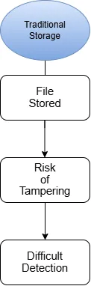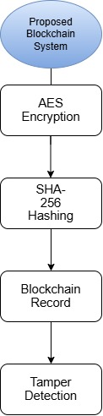

1.2 Problem Statement
The spread of digital storage has brought serious security problems with it. Centralised systems are regularly hit by unauthorised access, file tampering, data breaches, ransomware and insider threats [2]. Most existing systems do have access controls and many use encryption. What they usually lack is a transparent way of proving that stored files have not been touched.
In most conventional systems, a file can be changed without anyone being told. An attacker who gets in can edit or delete important data and leave little trace. Integrity records, where they exist, are often held in the same database as the files, so one breach exposes both. Once that happens, the organisation cannot say with confidence whether its data is still genuine.
Hashing with SHA-256 is a well-known answer to the integrity problem [4], but it is only as trustworthy as the stored reference value. Ordinary databases do not protect records from being rewritten, so an attacker can change a file and then change its hash to match. In a centralised setup, this makes integrity checking far less dependable than it first appears.
Blockchain offers a way out because it gives integrity data a home that is decentralised and very hard to alter [6], [7]. File hashes and verification events stored on the chain become a reference point that an attacker cannot quietly edit, which makes unauthorised changes much easier to catch. Used together with AES encryption and SHA-256 hashing, a blockchain ledger can support a framework that deals with confidentiality and integrity in one place.
Research on blockchain applications is expanding quickly. Even so, most file security tools still focus on encryption and do little to check integrity in a decentralised way. Working systems that combine encryption, hashing, blockchain storage and tamper detection in one easy-to-use platform are still uncommon.
What is missing, then, is a file management system that keeps files private with AES, checks them with SHA-256 and protects the resulting integrity records on a blockchain. This project aims to fill that gap by designing and evaluating a Blockchain-Based Secure File Upload and Integrity Verification System that can detect unauthorised changes and improve data security overall.
Figure 1.2 – Research Problem Overview
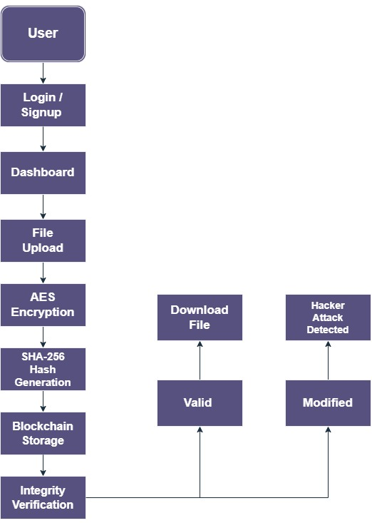
Flow:
Traditional File Storage
→ Centralised Database
→ File Modification Risk
→ Integrity Record Manipulation
→ Difficult Tamper Detection
Proposed Solution
→ AES Encryption
→ SHA-256 Hash Generation
→ Blockchain Ledger Storage
→ Tamper Detection & Verification

1.3 Research Aim
The aim of this project is to design, build and evaluate a Blockchain-Based Secure File Upload and Integrity Verification System that uses the Advanced Encryption Standard (AES) and the Secure Hash Algorithm (SHA-256) to improve the confidentiality, integrity and tamper detection of stored files.
1.4 Research Objectives
To reach this aim, the project set the following objectives:
1. To identify the main weaknesses and security risks of conventional file storage.
2. To examine whether blockchain can support secure, transparent and tamper-resistant record keeping.
3. To assess how well AES encryption protects the confidentiality of stored files.
4. To use SHA-256 hashing to verify file integrity and detect tampering.
5. To build a working blockchain-based file upload and verification system with Flask and supporting tools.
6. To test the system and analyse its performance, security and effectiveness.
7. To judge whether blockchain, encryption and hashing together protect files better than traditional storage.
1.5 Research Questions
Primary Research Question
How can blockchain, used together with AES encryption and SHA-256 hashing, improve the security and integrity of digital file storage?
Secondary Research Questions
- What are the main security weaknesses of traditional file storage systems?
- How well does AES encryption protect uploaded files from unauthorised access?
- How can SHA-256 hashing be used to verify file integrity and reveal tampering?
- What does blockchain add when it is used to store integrity records?
- How reliably can a blockchain-based framework detect unauthorised changes to files?
- What are the benefits and drawbacks of adding blockchain to a secure file management system?

1.6 Scope and Limitations
Scope of the Research
The project covers the design, implementation and evaluation of a secure file management system built on blockchain, AES encryption and SHA-256 hashing.
Its scope includes:
- User registration and authentication.
- Secure file upload functionality.
- AES-based file encryption.
- SHA-256 hash generation.
- Blockchain-based integrity record storage.
- File integrity verification.
- Tamper detection through hash comparison.
- Controlled hacker attack simulation for security evaluation.
- Performance and security testing of the proposed system.
The system was written in Python using Flask and SQLite, with a custom blockchain module and standard cryptographic libraries.
Limitations of the Research
The work also has some clear limitations:
• The blockchain is a research prototype, not a platform for large-scale commercial use.
• All testing took place in a controlled environment, which may not reflect a real enterprise network.
• The focus is on confidentiality and integrity; complex access-control models are not covered.
• The available hardware and testing time limited the performance evaluation.
• The system does not run on a fully decentralised public blockchain.
• Scalability with very large datasets was not tested.
Within these limits, the system still gives a clear, working demonstration of how blockchain and cryptography can be combined to protect files.
1.7 Dissertation Structure
The dissertation has eight chapters.
Chapter 1 – Introduction
Sets out the background, problem statement, aim, objectives, research questions, scope and limitations, and explains how the dissertation is organised.

Chapter 2 – Literature Review
Reviews published work on blockchain, cryptography, AES, SHA-256, secure storage and integrity verification, and identifies the gaps that this project addresses.
Chapter 3 – Requirements and System Design
Explains the research approach, requirements, architecture, security model, technology choices and data flow of the proposed system.
Chapter 4 – System Implementation
Describes how the system was built, module by module, from user authentication through to the hacker attack simulation.
Chapter 5 – Testing and Validation
Reports the tests used to check functionality, security, reliability and tamper detection, along with their results.
Chapter 6 – Evaluation and Analysis
Evaluates the system through security analysis, performance assessment and comparison with conventional storage.
Chapter 7 – Discussion
Discusses the findings, how far the objectives were met, the strengths and weaknesses of the project and what it means in practice.
Chapter 8 – Conclusion and Future Work
Summarises the work, states its contributions and suggests where it could go next.

CHAPTER 2 – LITERATURE REVIEW
2.1 Introduction
Digital technology has reshaped the way organisations create, store and share information, and the more they depend on it, the more exposed they become. Breaches, ransomware and unauthorised changes to files now threaten the confidentiality, integrity and availability of data on a daily basis [2], [1]. Security research has had to keep pace with attackers whose methods change constantly.
Traditional storage follows a centralised model, with data and its supporting records held on a single server or database. It is efficient and simple to run, but it concentrates risk. A breach of the central repository can lead to unauthorised reading, silent modification or outright loss of data. Conventional controls also say very little about whether stored data is still the same as when it was saved.
Researchers have approached this problem from several directions. Encryption, with AES as the usual choice, protects secrecy [3]. Hash functions such as SHA-256 reveal whether data has changed [4]. More recently, blockchain has been proposed as a way of producing records that are both transparent and hard to falsify [7].
This chapter reviews the literature in each of these areas: blockchain, AES encryption, SHA-256 hashing, secure file storage, integrity verification and blockchain-based security frameworks. The aim is to set out the theory behind the project and to show where existing work falls short.
2.2 Evolution of Digital Data Security
Data is now among the most valuable assets an organisation has. Cloud computing, mobile devices, the Internet of Things (IoT) and wider digital transformation have all pushed the volume of stored data sharply upwards. More data means more for attackers to target [1].
For a long time, protecting data mostly meant keeping outsiders out with passwords and access rules. Attackers have since found ways around those defences. Stored files are now a common target for ransomware gangs, malicious insiders, database intruders and supply chain attacks [2].
The literature therefore argues for defence in depth, with several controls layered together. Encryption, hashing, authentication, auditing and integrity checks are all standard parts of modern security models [1], [8]. One question remains awkward, though: how can we be sure that the integrity logs themselves have not been altered.

Figure 2.1 – Evolution of Data Security Technologies
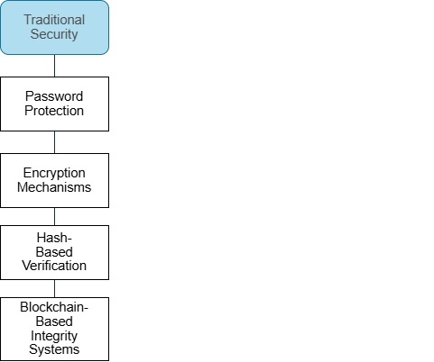
2.3 Blockchain Technology
A blockchain is a ledger shared across a network of nodes [6]. Records are grouped into blocks, and each block contains a hash of the one before it. Because of this chaining, changing an old record would mean recalculating every block that came after it, which is what makes the data so hard to alter once it has been written [9].
The idea reached a wide audience in 2008, when Satoshi Nakamoto published the design for Bitcoin [5]. Since then, blockchain has been explored well beyond digital currency, in areas as varied as healthcare, supply chains, digital identity, finance and cybersecurity [10], [11].
Immutability is the feature most often highlighted. Since every block depends on the hash of its predecessor, tampering with stored data breaks the chain in a way that is easy to detect [12]. This is why blockchain suits integrity checking so well.
Several authors report that blockchain resists tampering better than a conventional database [7], [13]. A distributed ledger removes the single point of failure and makes it much harder for an insider to rewrite records without being noticed.
The technology has well-known drawbacks too. It scales poorly, adds processing overhead, needs ever more storage and can be difficult to integrate with existing systems [13], [14]. Any practical design must work around these limits.
Figure 2.2 – Basic Blockchain Structure
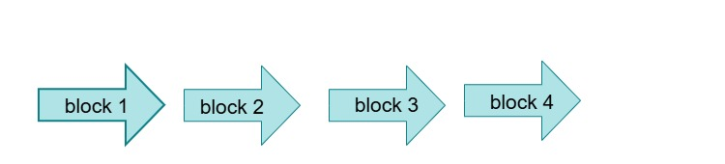

Each block contains:
- Data
- Timestamp
- Current Hash
- Previous Hash
2.4 Cryptography and Information Security
Cryptography underpins almost every modern security system. It relies on mathematics to protect information from being read or changed by the wrong people, and it is normally described in terms of four goals: confidentiality, integrity, authentication and non-repudiation [1], [15].
Encryption turns readable plaintext into ciphertext, and only someone with the right key can reverse the process. Schemes fall into two broad families, symmetric and asymmetric.
In symmetric encryption the same key both locks and unlocks the data, which keeps it fast. Asymmetric encryption uses a public key and a private key. That is more flexible, particularly for exchanging keys, but it is also much slower [15].
Real systems tend to mix the two, using each where it fits best.
2.5 Advanced Encryption Standard (AES)
AES is the most widely used symmetric cipher today. NIST adopted it as the replacement for the older Data Encryption Standard (DES), whose 56-bit key had become too short to be safe [3], [15].
AES works with 128, 192 or 256-bit keys, and AES-256 is generally treated as the strongest option. Data passes through a series of rounds of substitution, shifting and mixing until the plaintext has been turned into ciphertext [3].
Textbooks and studies alike present AES as a sound choice for protecting sensitive data [1], [8], mainly because of its:
- Strong security
- Computational efficiency
- Resistance to brute-force attacks
- Wide industry adoption
- Regulatory acceptance
It is used in secure messaging and web protocols, cloud storage, banking, government systems and a wide range of commercial security products.

Figure 2.3 – AES Encryption Workflow
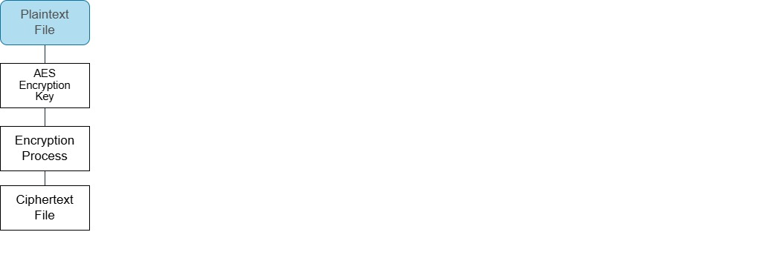
2.6 SHA-256 Hashing and Integrity Verification
Integrity is a basic requirement of any secure system. AES can keep data secret, but it cannot show whether that data has been changed after encryption. For that, a separate mechanism is needed, one that can reveal unauthorised changes and confirm that content is genuine.
Hash functions are the usual tool. A hash function accepts input of any length and returns a fixed-length value, often described as a digital fingerprint [15]. The smallest change to the input gives a completely different output, and that sensitivity is exactly what makes hashing useful for spotting tampering.
SHA-256 is one of the most widely used hash functions in security. It belongs to the SHA-2 family, which was designed by the U.S. National Security Agency (NSA) and published by NIST, and it always produces a 256-bit digest [4]. Its resistance to collisions and its steady performance explain why it appears in blockchains, digital signatures, authentication schemes and secure storage tools [12].
Its security depends on a handful of properties:
- Deterministic output generation.
- Fixed output length.
- High collision resistance.
- One-way computational design.
- Sensitivity to input modifications.
Studies consistently show SHA-256 to be a reliable basis for integrity checks. If a file is edited, corrupted or deliberately tampered with, its hash changes straight away and the problem can be flagged.

Figure 2.4 – SHA-256 Integrity Verification Process
2.7 File Integrity Verification Systems
File integrity verification simply means confirming that stored data is still identical to the original. It matters because attackers often try to change data in ways that will not be noticed quickly.
Checksums, digital signatures and cryptographic hashes are the traditional tools [1]. The trouble is that many systems store integrity records alongside the files they describe. An attacker who reaches the database can therefore change a file and then fix its record so that nothing looks wrong.
Proposed answers to this problem include:
- Remote integrity verification systems.
- Distributed auditing frameworks.
- Trusted third-party verification services.
- Blockchain-based integrity management solutions.
The shift to cloud storage has made the issue more pressing. When critical data is held by a third party, organisations need a way of proving that it has stayed unchanged throughout its life.
Integrity frameworks typically try to do three things:
- Detecting unauthorised modifications.
- Preserving trust in stored information.
- Supporting forensic investigations following security incidents.
Blockchain looks especially promising here, because it lets integrity records live in an immutable ledger instead of an ordinary database.
Figure 2.5 – Traditional vs Blockchain Integrity Verification
Traditional System:
File → Database → Integrity Record
Blockchain System:
File → SHA-256 Hash → Blockchain Ledger → Verification
2.8 Secure File Storage Systems
Secure storage systems are meant to protect information from being read, changed, deleted or disclosed without permission. Over the last decade, many organisations have moved their storage to the cloud because it is scalable, easy to reach and relatively cheap.
That move brings its own risks, for example:
- Data breaches.
- Insider threats.
- Account compromise.
- Misconfigured access controls.
- File tampering attacks.

To manage these risks, secure storage frameworks combine authentication, encryption, access control, monitoring and auditing. Practical guidance, such as the OWASP recommendations for file uploads, also stresses validating uploaded files and keeping them isolated before storage [16].
Encryption keeps coming out as one of the most effective protections for stored files. If data is encrypted before it is saved, a breach exposes far less. What encryption cannot do is prove that a file is authentic or unaltered.
For this reason, researchers increasingly recommend pairing encryption with integrity checks, so that files stay both private and verifiable for as long as they are kept.
2.9 Blockchain-Based File Security Solutions
Blockchain has drawn a great deal of interest as a way of improving file security. Where traditional storage keeps a single editable copy of each record, blockchain offers a decentralised ledger in which transactions and audit trails are effectively permanent [7].
Many blockchain-based file management designs have appeared in the academic literature. Most keep metadata, integrity records, access logs or ownership details on the chain and store the files themselves elsewhere [13].
The benefits usually claimed for this approach are:
- Tamper resistance.
- Transparency.
- Decentralisation.
- Auditability.
- Improved trustworthiness.
Because hash records written to a blockchain cannot easily be changed without detection, studies have found that blockchain makes integrity verification considerably more reliable [10].

The same studies point to several practical difficulties:
- Scalability limitations.
- Storage overhead.
- Transaction processing delays.
- Integration complexity.
- Resource consumption.
This is why many working systems use a hybrid design: the blockchain holds the integrity records, while the encrypted files stay in a normal database or cloud store [17], [18].
Figure 2.6 – Blockchain-Based File Security Framework
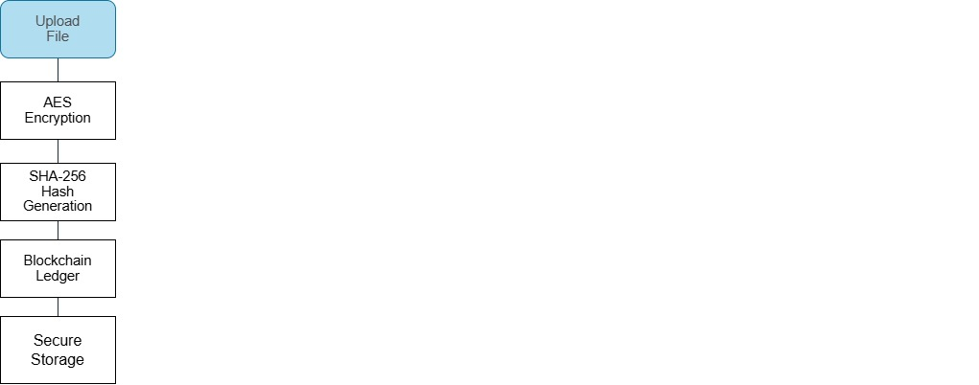
2.10 Existing Research and Comparative Analysis
As blockchain has matured, researchers have looked at what it could offer cybersecurity and secure storage. A number of studies have combined it with cryptography to improve data protection, integrity checking and trust. Progress has been real, but so have the limitations.
The earliest work in this area relied on encryption. By converting plaintext into ciphertext, these systems stopped unauthorised users from reading stored data. AES-based storage in particular has been studied widely and holds up well against brute-force attacks while running efficiently on different platforms [15]. Most of these systems, however, gave little or no support for checking integrity independently.
Later studies added hash functions such as SHA-256 to deal with integrity, and hash-based checks proved good at catching both deliberate changes and accidental corruption. A problem kept appearing, though. The hashes were stored in ordinary databases, so an attacker with enough privileges could change a file and its hash together, and the verification process would be none the wiser.
Blockchain offered a fix. Researchers began writing file hashes to a blockchain ledger rather than a database [7], [13]. Since chained records cannot be edited without detection, tampering becomes far harder. Experimental work has reported better transparency, traceability and trust as a result.
Many of these blockchain storage solutions, however, never go beyond a theoretical model or a limited proof of concept. Some use blockchain purely as a log and leave out strong encryption. Others include encryption and hashing but offer little in the way of a usable interface or real file management.
Very few solutions in the literature bring all three core components together:
- AES Encryption for confidentiality.
- SHA-256 Hashing for integrity verification.
- Blockchain Technology for tamper-resistant record management.
Many also skip realistic attack testing altogether, so it is hard to know how well their tamper detection would work in practice. With threats changing as fast as they do, this kind of hands-on evaluation matters increasingly.

Table 2.1 – Comparative Analysis of Existing Solutions
Security Feature | Traditional Storage | AES-Based Systems | Blockchain Systems | Proposed System
File Encryption | ❌ | ✅ | ❌ | ✅
Integrity Verification | ❌ | Partial | ✅ | ✅
Tamper Detection | ❌ | Partial | ✅ | ✅
Blockchain Security | ❌ | ❌ | ✅ | ✅
User Authentication | Partial | Partial | Partial | ✅
Attack Simulation | ❌ | ❌ | Limited | ✅
Practical Implementation | ✅ | ✅ | Limited | ✅
Figure 2.7 – Comparative Analysis of Existing Approaches
2.11 Research Gap Identification
Looking across the literature, several gaps stand out.
First, conventional storage is designed mainly for easy access and efficient use of space, not for resisting manipulation or attacks on integrity.
Even where encryption is in place, integrity checks often depend on a central database that is itself an attractive target.
Second, AES does an excellent job of keeping contents secret but says nothing about whether a file has been changed since it was encrypted. A separate mechanism is needed for that.
Third, hash-based verification systems often keep their reference values in conventional storage. Compromise that storage and an attacker may be able to change a file and its verification data together.
Fourth, a good deal of blockchain security research remains conceptual. It is often only loosely connected to encryption, hashing, authentication and everyday file handling, and it pays limited attention to usability or deployment.
Practical testing is another gap. It is widely argued that blockchain strengthens integrity verification, yet relatively few experiments show what actually happens when an attacker deliberately modifies stored files.
Finally, lightweight blockchain file security for universities, research groups and small organisations has received little attention. Enterprise solutions exist, but they are often too complex for smaller settings.
Taken together, these gaps make a strong case for one system that combines encryption, hashing, blockchain, authentication and practical tamper detection.
Figure 2.8 – Identified Research Gap
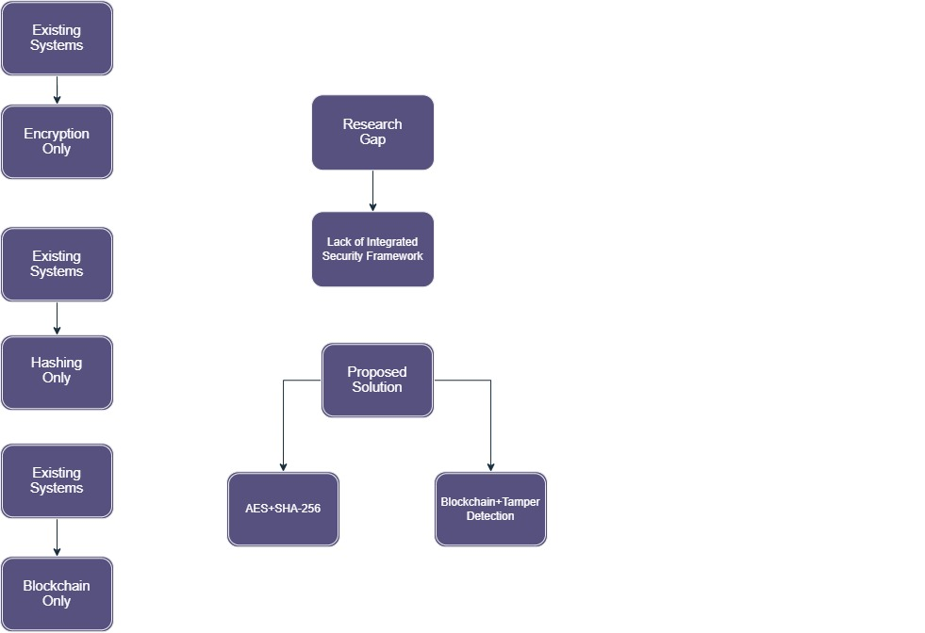

2.12 Justification of the Proposed System
The gaps described above explain why an integrated, blockchain-based file security system is worth building.
For confidentiality, the system uses AES. Every uploaded file is encrypted before it is stored, which limits what an attacker could learn from a breach.
For integrity, the system uses SHA-256. Each file's hash works as a unique identifier, so any later change shows up as a different value.
Where this approach differs from many others is in keeping integrity data on a blockchain ledger. Recorded hashes cannot be altered without detection, which gives the verification process a much firmer footing.
The system also includes a hacker attack simulation, so that tamper detection can be demonstrated and measured instead of simply assumed.
Bringing these technologies together in one platform produces a layered design that tackles several weaknesses common to existing solutions. The project is therefore of practical as well as academic interest for secure file management.
2.13 Blockchain Security Challenges
Blockchain has its own security problems. Scalability is probably the biggest. The chain grows with every transaction, so storage and processing demands keep rising, and performance and running costs suffer [14]. On public networks, the consensus process can also make transaction confirmation slow.
Another risk is the 51% attack, where one party gains control of most of the network's computing power and can rewrite recent history [19]. Such attacks are hard to pull off against large networks, but a successful one would badly damage trust in the data. Privacy is also a concern, since ledger entries stay visible permanently. That openness supports accountability, but it can leak sensitive metadata if nothing is done to protect it [9].
Smart contracts introduce a further risk, because badly written contract code can contain exploitable bugs [20]. Proof-of-work consensus is also very demanding in terms of computing resources. These issues are a reminder that blockchain works best alongside strong cryptographic controls like AES and SHA-256, not as a replacement for them.
2.14 Comparison Between Traditional and Blockchain-Based Storage Systems
Most file storage is still built on centralised databases run by a single authority. They are simple to maintain, but everything depends on one server. If that server is compromised, an attacker can read files, alter records or take the service down.
Blockchain-based storage takes a decentralised approach. Integrity logs are written to a ledger that resists modification rather than to one central database, and each block is tied to the previous one by a hash, forming a chain of trust [18].
Any unauthorised change alters a hash and shows up as soon as the file is checked.
In security terms, this means better tamper resistance, transparency and traceability. Centralised systems, on the other hand, often rely on administrators to check integrity by hand.
With blockchain, verification can be automated using hashes, and because no single authority controls the records, the scope for insider tampering is reduced.
The trade-off is that blockchain usually needs more computing power and storage than a traditional database. Pairing it with strong encryption such as AES strikes a reasonable balance between security and performance, and that is the route taken in this project: AES for confidentiality, blockchain for integrity.
2.15 Chapter Summary
This chapter has reviewed research on blockchain, cryptography, AES, SHA-256, file integrity verification and secure storage. A recurring theme is that traditional storage still struggles with unauthorised access, manipulation of files and the protection of integrity records.
The literature supports AES as a means of keeping data confidential and SHA-256 as a means of checking integrity. It also points to blockchain as a promising place to keep records that need to be tamper-resistant.
Comparing existing studies revealed a reliance on centralised storage, weak integration between security mechanisms and little real testing of tamper detection. These shortcomings leave room for an integrated framework that combines encryption, hashing, blockchain and practical attack simulation.
These findings form the theoretical basis for the proposed system. Chapter 3 goes on to describe the methodology, requirements and design used to address the gap identified here.

Chapter 3 – Requirements Analysis and System Design
3.1 Introduction
This chapter moves from the literature to the design of the system itself. Using the gaps identified in Chapter 2 as a starting point, it explains the research methodology, the functional and non-functional requirements, the architecture, the technology stack, the security workflow and the role played by the blockchain.
The goal is to show how each design decision responds to a weakness in conventional file storage, and to set up the implementation work described in Chapter 4.
3.2 Research Methodology
The project followed Design Science Research (DSR). DSR is common in information systems and security research because it is built around creating an artefact, such as a piece of software, and then evaluating how well it solves a defined problem.
This fitted the project well. The intention was not only to study a security problem but to build something that addresses it.
The work was organised into five stages:
Stage 1 – Problem Identification
Reviewing the literature brought several problems with traditional file storage to light, including:
- File tampering.
- Integrity verification weaknesses.
- Centralised storage risks.
- Unauthorised access.
- Lack of immutable audit records.
Stage 2 – Requirement Analysis
The literature review and an analysis of the intended system were used to define the functional and security requirements.
Stage 3 – System Design
The architecture was designed around a blockchain ledger and brings together:
- AES Encryption.
- SHA-256 Hashing.
- Blockchain Ledger.
- User Authentication.
- File Verification Mechanisms.

Stage 4 – System Development
The system was built in Python on the Flask framework, with supporting libraries for cryptography and data storage.
Stage 5 – Testing and Evaluation
The finished system was then put through:
- Functional Testing.
- Security Testing.
- Integrity Verification Testing.
- Hacker Attack Simulation.
Figure 3.1 – Research Methodology Framework
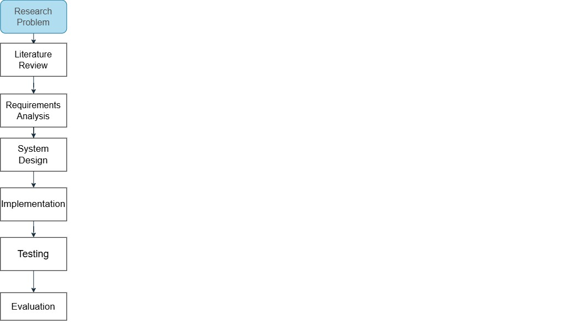
3.3 System Requirements Analysis
Before development began, a requirements analysis established which features and security controls the system would need.
The requirements fall into two groups:
- Functional Requirements
- Non-Functional Requirements

3.3.1 Functional Requirements
Functional requirements state what the system has to do.
FR1 – User Registration
The system shall allow users to create an account using valid credentials.
FR2 – User Authentication
The system shall authenticate users before granting access to system resources.
FR3 – File Upload
The system shall allow authenticated users to upload files.
FR4 – AES Encryption
The system shall encrypt uploaded files before storage.
FR5 – SHA-256 Hash Generation
The system shall generate a unique SHA-256 hash value for every uploaded file.
FR6 – Blockchain Recording
The system shall store integrity-related information within a blockchain ledger.
FR7 – Integrity Verification
The system shall verify uploaded files using stored hash records.
FR8 – File Download
The system shall allow users to retrieve stored files.
FR9 – Tamper Detection
The system shall detect unauthorised file modifications.
FR10 – Attack Simulation
The system shall support controlled hacker attack simulation for evaluation purposes.

Table 3.1 – Functional Requirements
Requirement ID | Description
FR1 | User Registration
FR2 | User Authentication
FR3 | File Upload
FR4 | AES Encryption
FR5 | SHA-256 Hash Generation
FR6 | Blockchain Recording
FR7 | Integrity Verification
FR8 | File Download
FR9 | Tamper Detection
FR10 | Attack Simulation
3.3.2 Non-Functional Requirements
Non-functional requirements describe how well the system should work rather than what it does. They cover quality attributes such as security, speed and ease of use.
For this project, security, reliability, usability and performance were treated as the most important of these.
NFR1 – Security
Every uploaded file must be protected from unauthorised reading and modification. AES encryption, SHA-256 hashing and blockchain verification together should provide this protection.
NFR2 – Reliability
Uploads, encryption, integrity checks and blockchain operations must work consistently, without unexpected failures.
NFR3 – Availability
Authorised users should be able to use the system whenever they need to, with stable performance under normal load.
NFR4 – Usability
The interface should be simple enough that users can upload, verify and download files without any specialist knowledge.
NFR5 – Performance
Encryption, hashing and verification should finish within a reasonable response time.
NFR6 – Scalability
The design should leave room for more users and files in the future.
NFR7 – Maintainability
The code should be modular, so that parts can be maintained or replaced without rewriting the whole application.
Table 3.2 – Non-Functional Requirements
Requirement ID | Description
NFR1 | Security
NFR2 | Reliability
NFR3 | Availability
NFR4 | Usability
NFR5 | Performance
NFR6 | Scalability
NFR7 | Maintainability

3.4 Proposed System Architecture
The architecture brings user authentication, file encryption, hashing, blockchain verification and secure storage together in one framework, so that files are protected at each stage of their life in the system.
A layered design was chosen, with each responsibility handled by its own component. Keeping concerns separate in this way makes the code easier to maintain and extend, reduces complexity and limits the impact of a fault in any one part.
A typical session runs as follows. The user logs in and uploads a file through the web interface. The file is encrypted with AES and saved, and at the same time its SHA-256 hash is calculated and added to the blockchain ledger. When the user later asks for the file to be verified, a new hash is calculated and compared with the one on the blockchain. If they match, the file is unchanged.

As a result:
- Confidentiality is maintained through AES encryption.
- Integrity is verified through SHA-256 hashing.
- Tamper resistance is achieved through blockchain storage.
- User access is controlled through authentication mechanisms.

Figure 3.2 – Proposed System Architecture
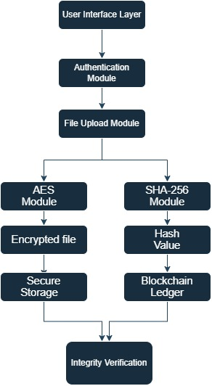
3.5 Technology Stack
Several technologies had to work together to build the system. Each one was chosen for its fit with the project, its security features, its performance and how easily it could be combined with a blockchain component.
Python
Python was used as the main language. It is readable, has a very large library ecosystem and is well supported for both security work and blockchain development.
Flask Framework
Flask provided the web framework. It is lightweight and flexible, and it connects easily to back-end services [21].
SQLite Database
SQLite stores user accounts and application metadata. It needs no separate server, which makes it easy to deploy for a project of this size.
AES Encryption
AES provides confidentiality for stored files.
SHA-256 Hashing
SHA-256 produces the fingerprint used to check each file's integrity.
Blockchain Ledger
A custom blockchain was written to store hash records in an append-only, tamper-evident structure.
HTML, CSS and JavaScript
These were used to build the front end and keep the interface clear and responsive.
Table 3.3 – Technology Stack
Technology | Purpose
Python | Backend Development
Flask | Web Framework
SQLite | Database
AES | Encryption
SHA-256 | Integrity Verification
Blockchain | Tamper-Resistant Ledger
HTML/CSS/JS | User Interface

3.6 Use Case Analysis
A use case analysis was carried out to map out how users interact with the system.
There is one main actor, the authenticated user, who reaches the security features through the web interface.

Main User Activities
- Register Account
- Login
- Upload File
- Encrypt File
- Download File
- Verify Integrity
- View Blockchain Records
- Simulate Attack
Figure 3.3 – Use Case Diagram
Actors:
- User
- System
Use Cases:
- Register
- Login
- Upload File
- Encrypt File
- Download File
- Verify Integrity
- View Blockchain
- Simulate Attack
3.7 Data Flow Diagram (DFD)
The data flow diagram traces how information moves through the system during upload, encryption, blockchain recording and verification.
It begins with the user uploading a file. The file goes to the encryption module, where AES is applied. The SHA-256 hash of the file is calculated and written to the blockchain ledger, and the encrypted file is stored. At verification time, a fresh hash of the stored file is compared with the blockchain value to decide whether the file is intact.

Figure 3.4 – Data Flow Diagram
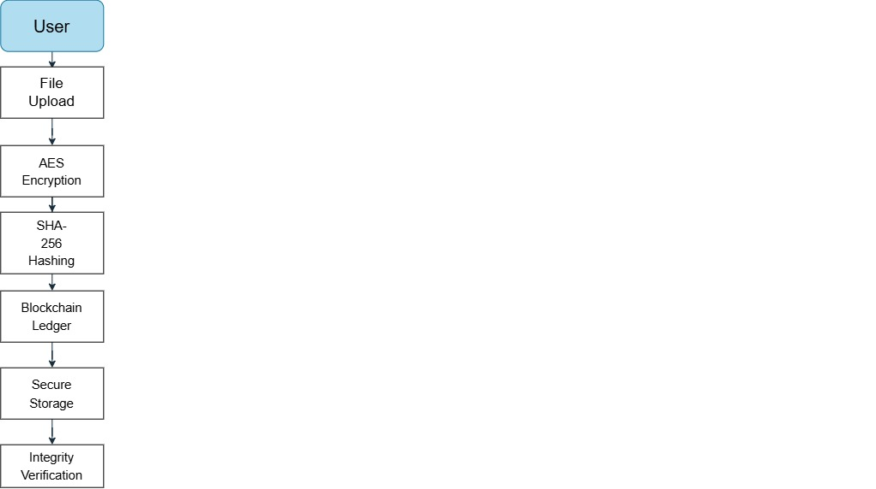
3.8 Security Workflow
The security workflow shows how the layers of protection fit together.
Many systems rely on encryption or access control alone. This one follows a defence-in-depth approach, so that if one control fails, others are still in place.
The workflow has eight steps:
Step 1 – User Authentication
The user has to log in before any service is available.
Step 2 – File Upload
The user chooses a file and uploads it through the interface.
Step 3 – AES Encryption
The file is encrypted before it is written to storage.
Step 4 – SHA-256 Hash Generation
A SHA-256 hash of the file is calculated.
Step 5 – Blockchain Recording
The hash is added to the blockchain ledger.
Step 6 – Secure Storage
The encrypted file is saved in the storage folder.
Step 7 – Integrity Verification
On request, the file is checked against the hash held on the blockchain.
Step 8 – Tamper Detection
If the two hashes differ, the file has been modified without authorisation.
Figure 3.5 – Security Workflow
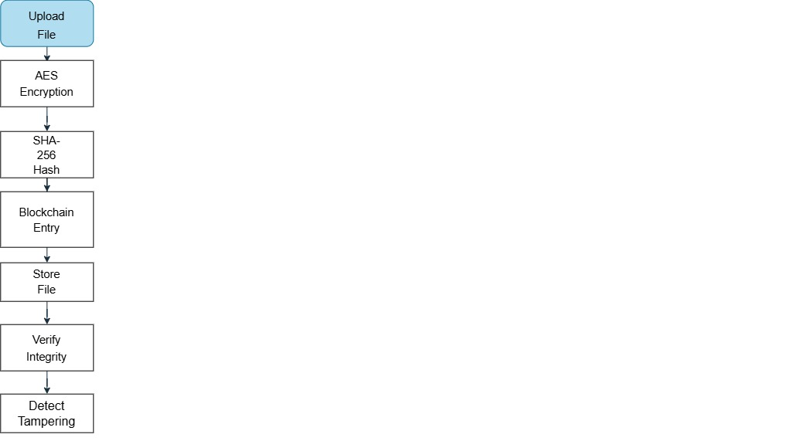
3.9 Chapter Summary
This chapter has described the methodology, requirements, architecture and technical design of the system. The requirements guided development, and the design showed how AES encryption, SHA-256 hashing, the blockchain ledger and user authentication fit into one framework.
It also covered the technology choices, the use cases, the flow of data and the overall security workflow, which together provide the blueprint for the implementation.
Chapter 4 now turns to how the system was actually built, from user authentication and file upload to encryption, blockchain integration, integrity checking and attack simulation.

CHAPTER 4
SYSTEM IMPLEMENTATION AND RESULTS
4.1 Introduction
This chapter describes how the Blockchain-Based Secure File Upload and Integrity Verification System was implemented and presents screenshots of the working application. The system runs on Flask and uses AES encryption, SHA-256 hashing and a blockchain ledger to store files securely and check their integrity. It is made up of modules for authentication, secure upload, encryption, blockchain verification and attack simulation, each of which is covered below.
4.2 User Registration Module
New users create an account here by choosing a username and password. The credentials are saved securely in the database and used each time the user logs in.
Features
- New user account creation
- Username and password validation
- Secure storage of user credentials
- Prevention of unauthorized access
Figure 4.1: User Registration Page
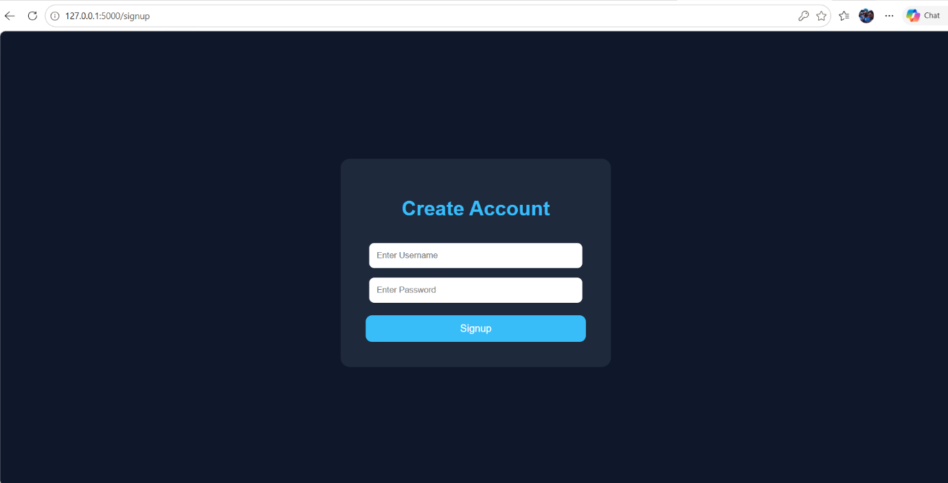
Description
The page is a short form asking for a username and password. After registering, the user is sent to the login page to sign in.

4.3 User Login Module
This module checks a user's identity before letting them into the system.
Features
- User authentication
- Session management
- Secure access control
- Restricted access to authorized users only
Figure 4.2: User Login Page
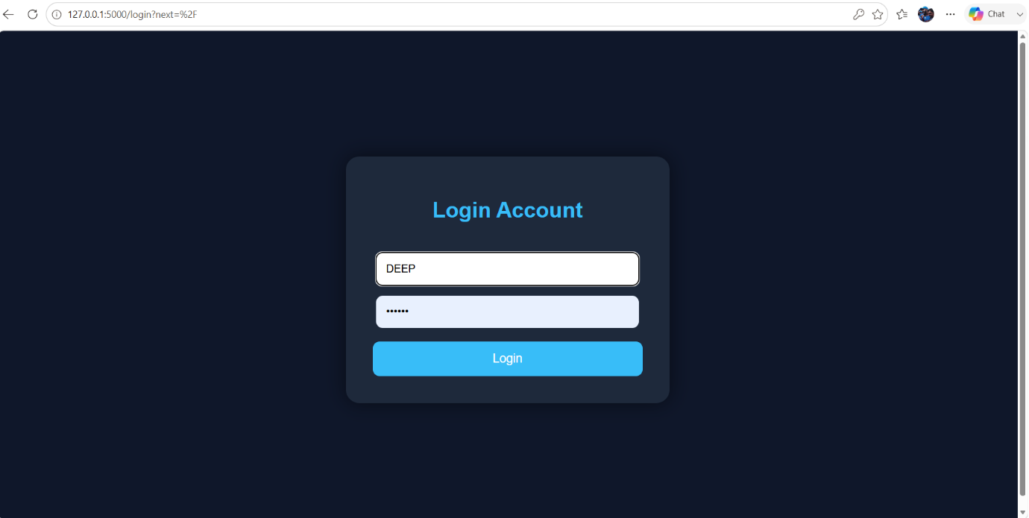
Description
The user signs in with their username and password. If the details are correct, they are taken to the dashboard, where all file operations are carried out.
4.4 Dashboard Module
Once logged in, users land on the dashboard, which is the main screen of the application.
Features
- User dashboard access
- File upload functionality
- Display of uploaded file count
- Secure navigation and session control
- Centralized access to system features

Figure 4.3: Dashboard Page
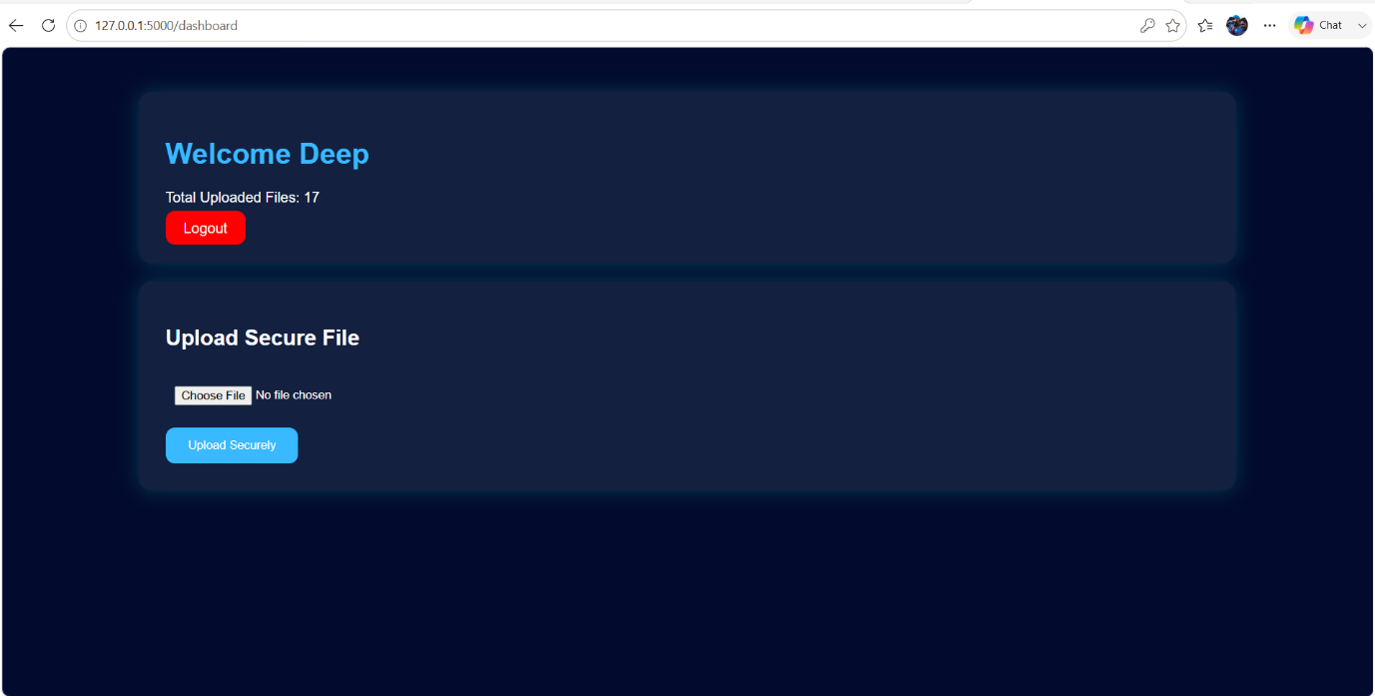
Description
The dashboard shows the logged-in username and how many files that user has uploaded. It is also where files are uploaded for encryption and blockchain verification, so in effect it is the control panel for everything else the system does.
4.5 Secure File Upload and Encryption Module
This module handles file uploads and applies AES encryption and blockchain verification to each file.
Features
- Secure file upload
- AES file encryption
- SHA-256 hash generation
- Blockchain integrity verification
- Encrypted and decrypted file download
- Hacker attack simulation

Figure 4.4: File Upload and Encryption Result Page
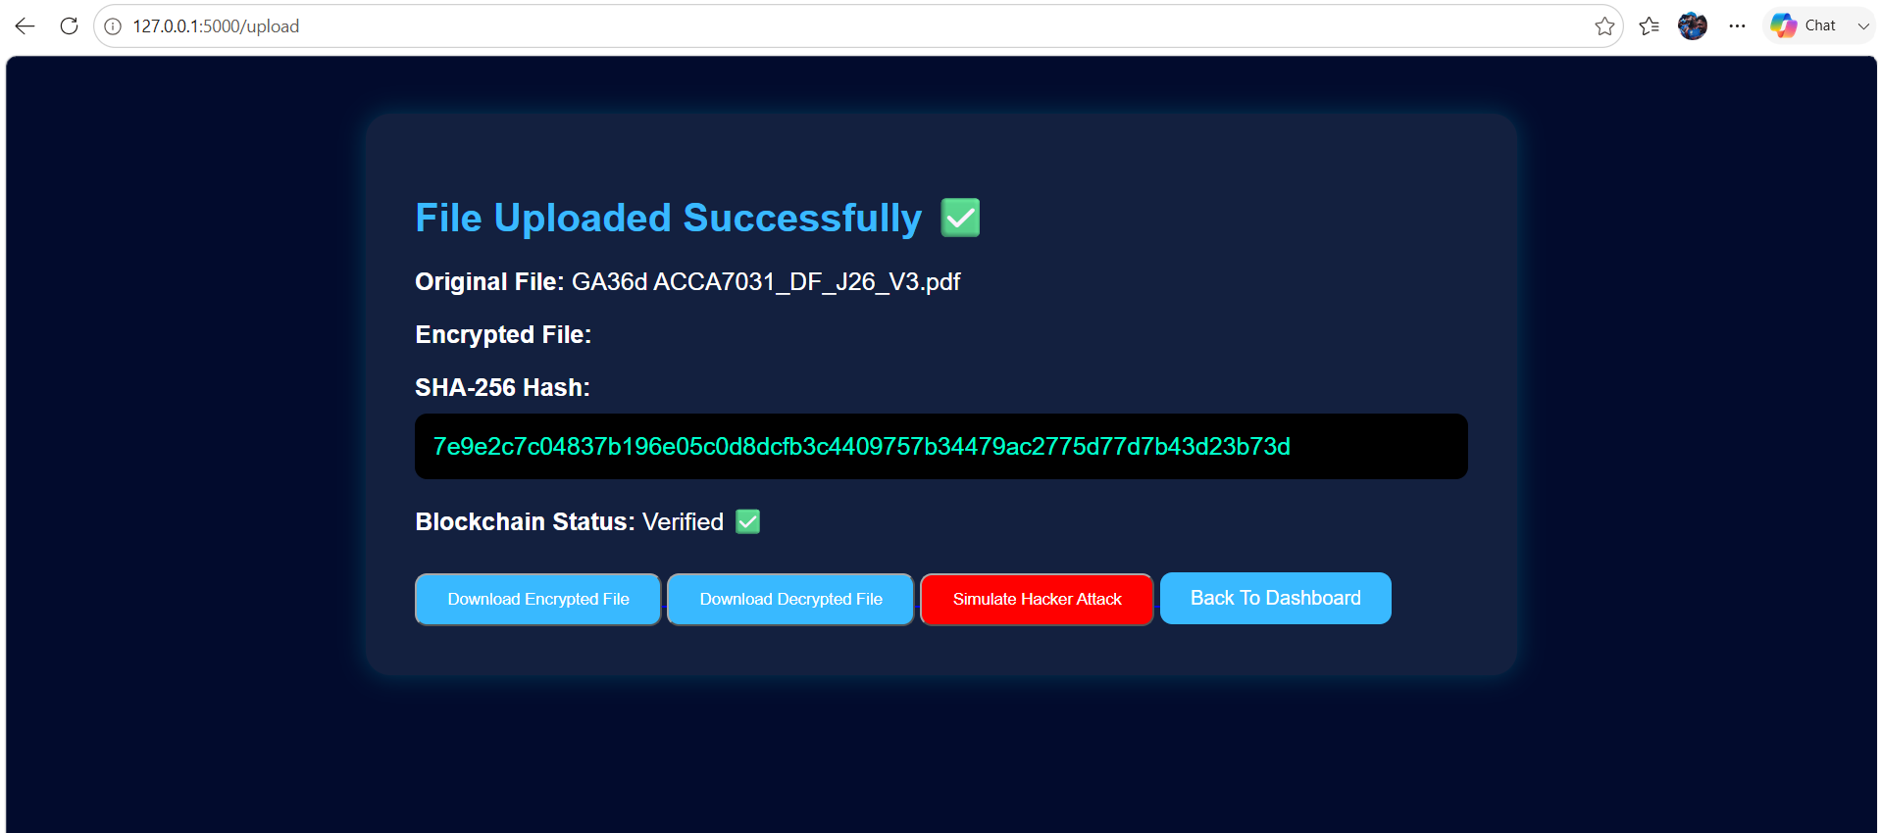

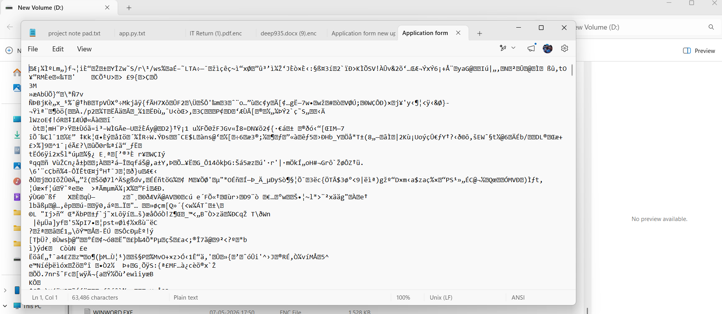

Description
As soon as a file is uploaded, the system encrypts it with AES and calculates its SHA-256 hash, which is then recorded on the blockchain. The results page lists the original file name, the hash and the blockchain verification status. From here the user can download the encrypted file, retrieve the decrypted version or launch the hacker attack simulation to see how the system reacts.

4.6 Encrypted File Download Module
Users can download the AES-encrypted copy of any file they have uploaded.
Features
- Download encrypted files
- Secure file storage
- Protection against unauthorized access
- Encrypted file format generation
- Data confidentiality preservation
Figure 4.5: Downloaded Encrypted File
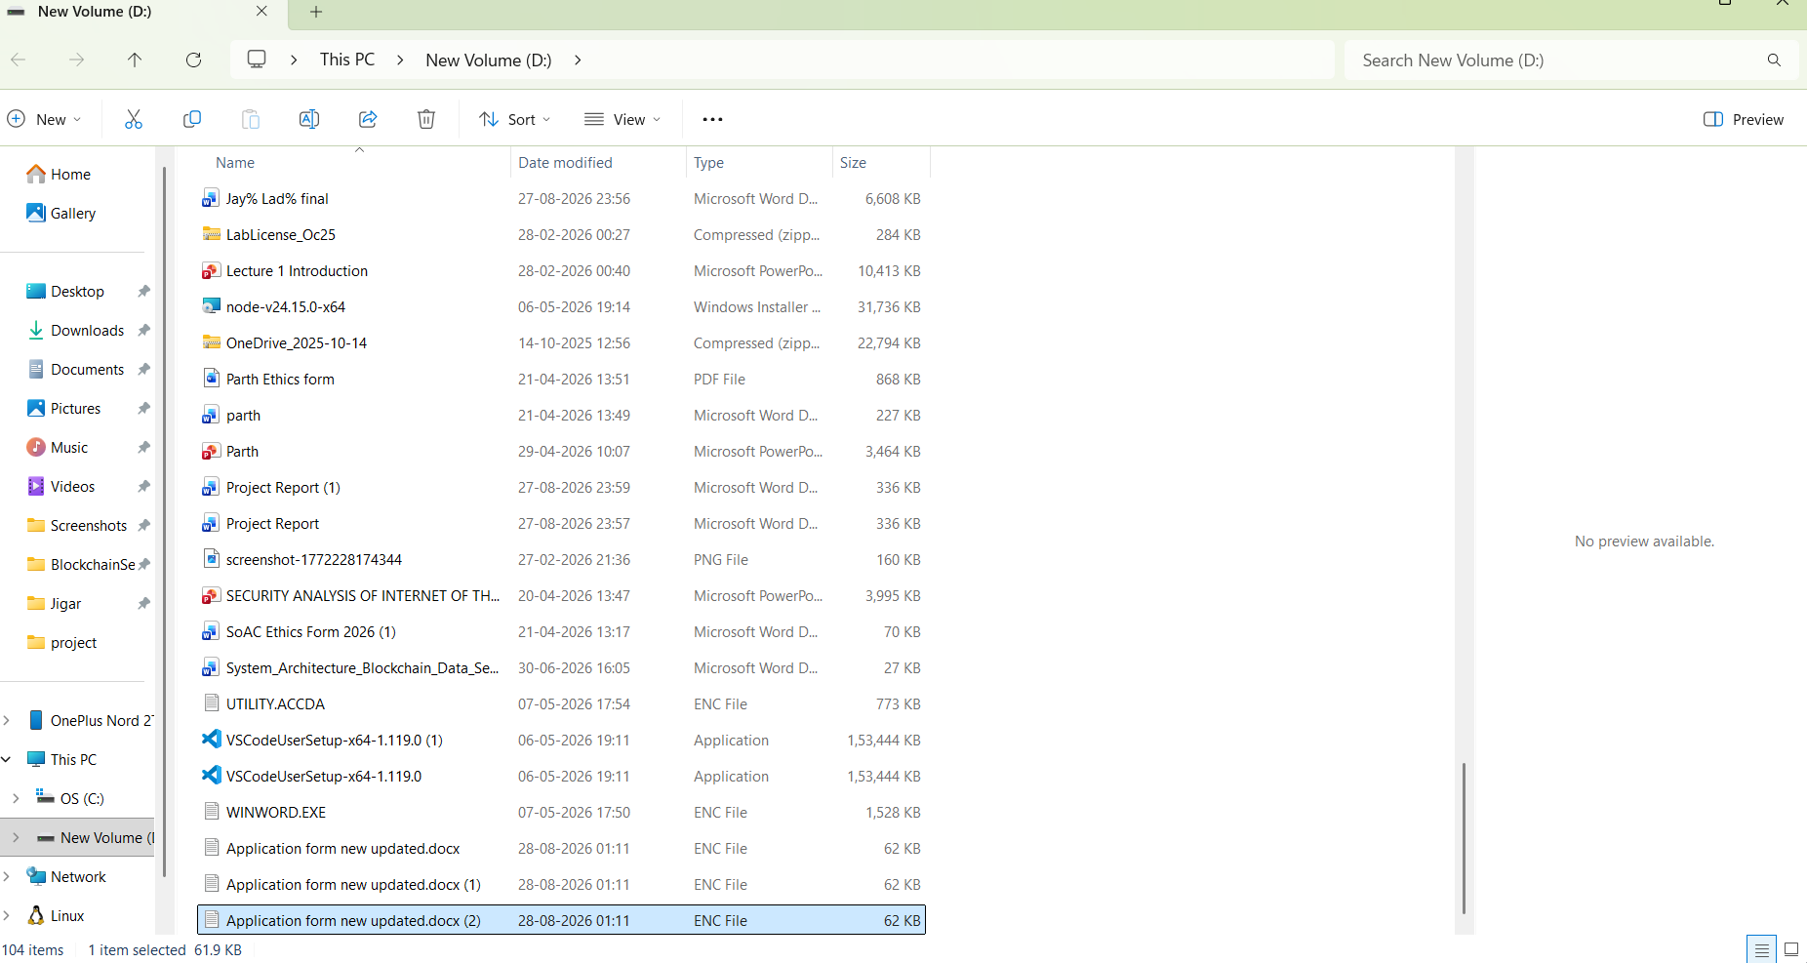
Description
After encryption, the user can download the encrypted copy of the file. Opened directly, it shows nothing but unreadable characters, and without the key its contents can neither be read nor sensibly edited. This is a simple but convincing check that the original data is protected.

4.7 Decrypted File Recovery Module
This module restores an encrypted file to its original form and lets the user download it.
Features
- File decryption functionality
- Recovery of original file content
- Secure download of decrypted files
- Preservation of data integrity
- Authorized file access
Figure 4.6: Decrypted File Download Result
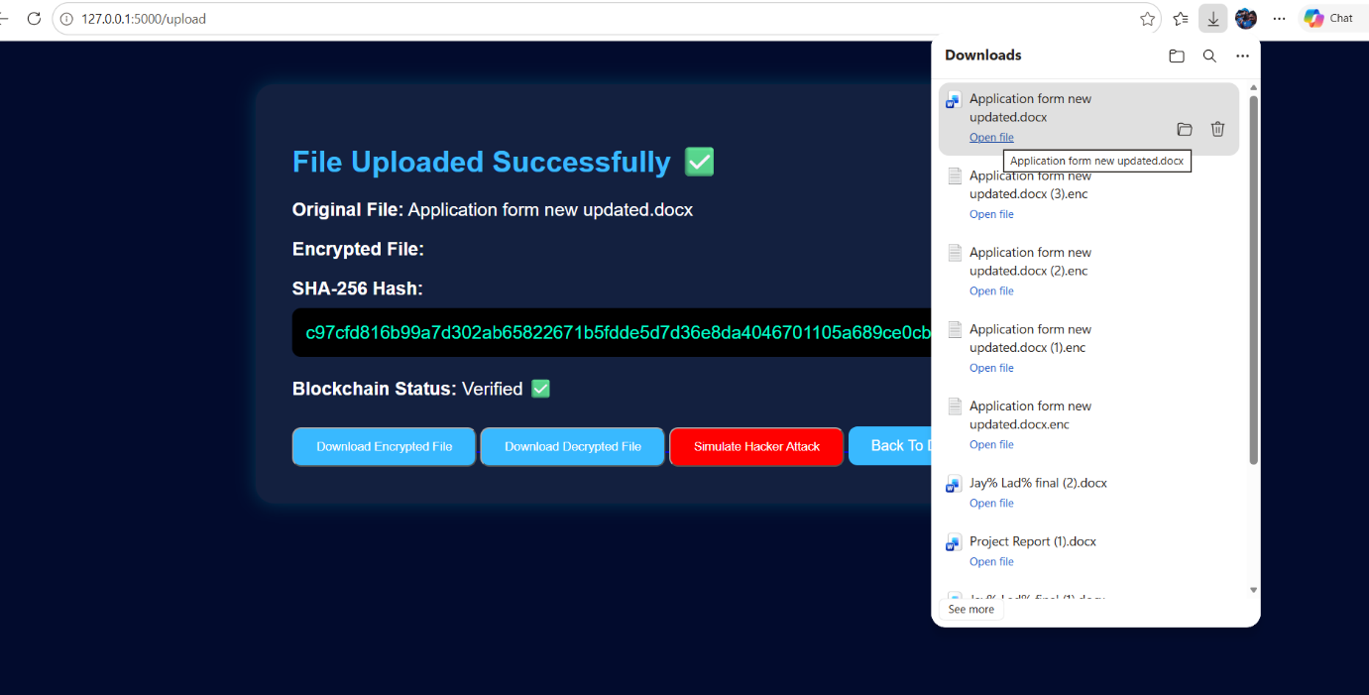
Description
Using the correct AES key, the system decrypts the stored file and returns the original content, so authorised users can get their data back whenever they need it. The recovered file matching the original confirms that encryption and decryption are working correctly as a pair.

4.8 SHA-256 Hash Generation and Verification Module
This module calculates a unique hash for every uploaded file so that its integrity can be checked later.
Features
- SHA-256 hash generation
- Unique file fingerprint creation
- Integrity verification
- Tamper detection support
- Blockchain compatibility
Figure 4.7: SHA-256 Hash Verification Result
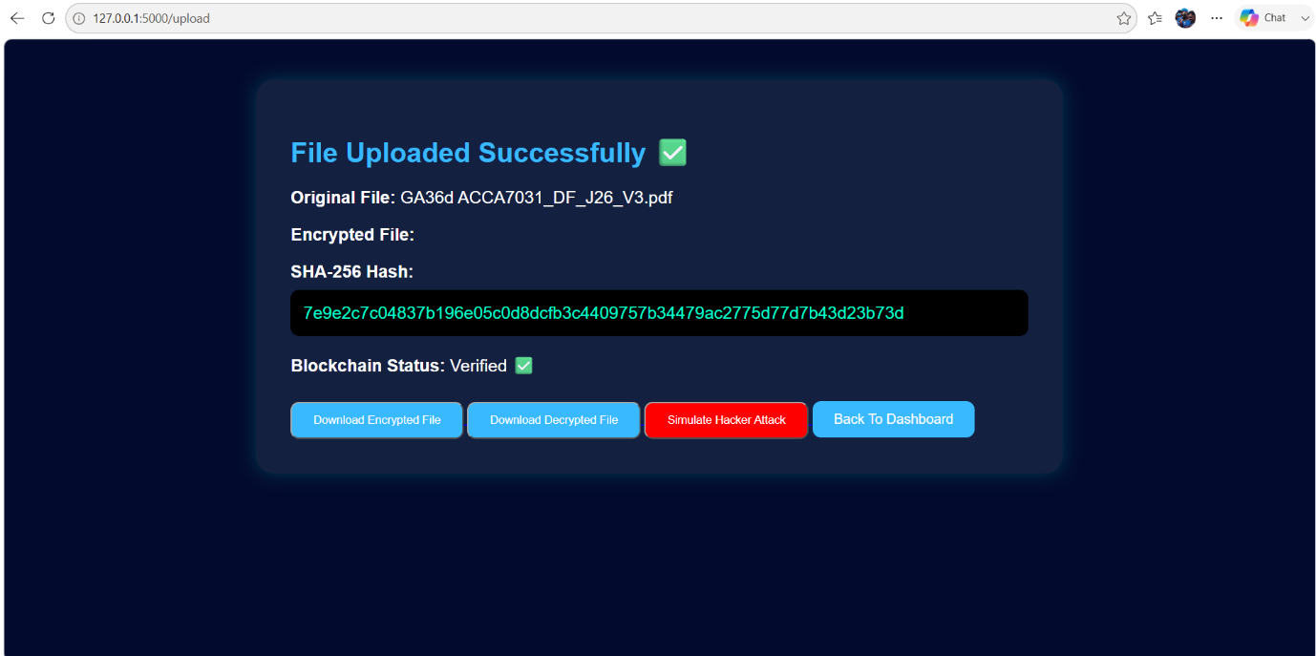
Description
On upload, the system runs the file through SHA-256 and displays the resulting hash to the user before recording it on the blockchain. To verify the file, the system hashes it again and compares the new value with the stored one. A match means the file is intact. Any change at all, even a single character, produces a different hash, which is what makes this such a sensitive test for tampering.

4.9 Blockchain Ledger Module
The blockchain ledger stores the integrity record for each file in a form that cannot be quietly changed.
Features
- Blockchain-based record storage
- Immutable transaction history
- Secure hash storage
- Integrity verification support
- Tamper-resistant architecture
Figure 4.8: Blockchain Verification Module
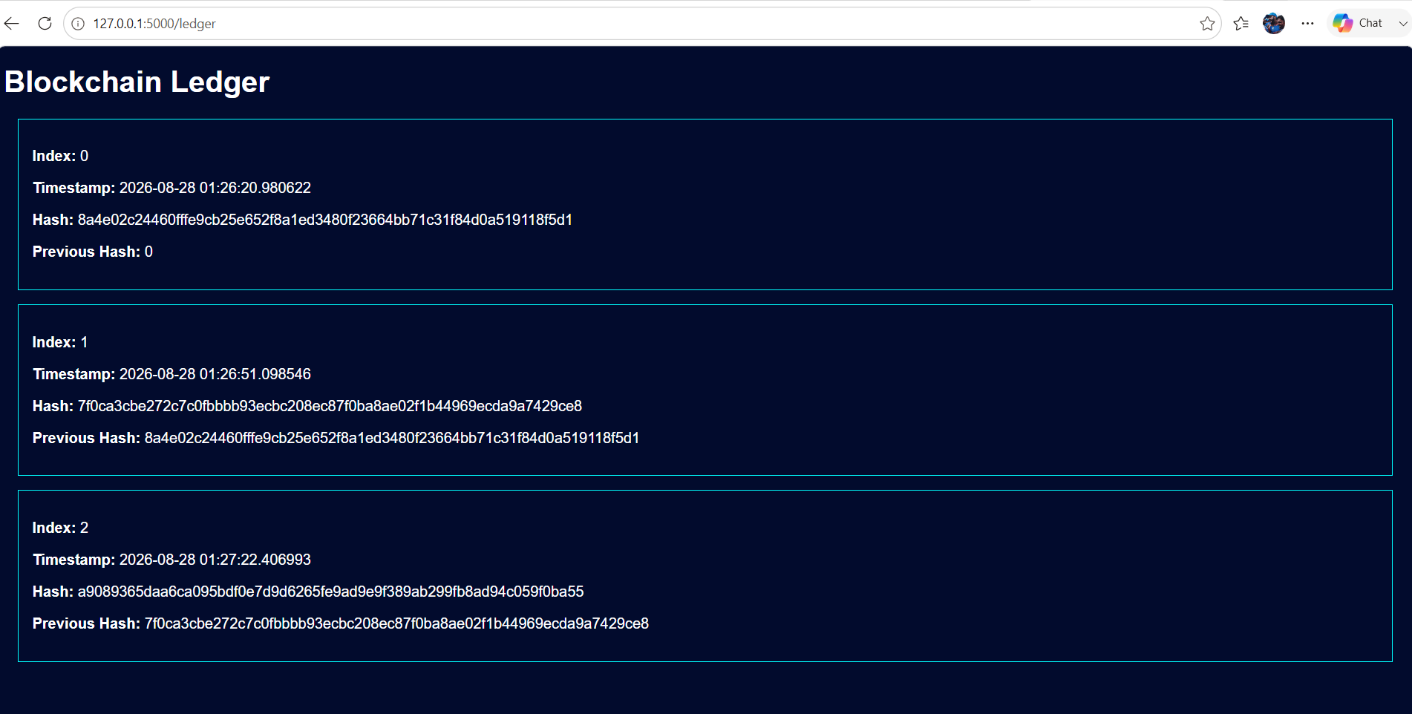
Description
Once a file's hash has been calculated, it is written into a new block on the ledger along with the details needed for later verification. Each block is linked to the one before it, so altering a stored record would break the chain and be noticed. This protects the verification records themselves, which is the key difference between this design and one that keeps hashes in an ordinary database.

4.10 Integrity Verification Module
This module checks whether a stored file is still the same as when it was uploaded.
Features
- File integrity verification
- SHA-256 hash comparison
- Blockchain record validation
- Detection of unauthorized modifications
- Integrity status reporting
Figure 4.9: Integrity Verification Failed Result
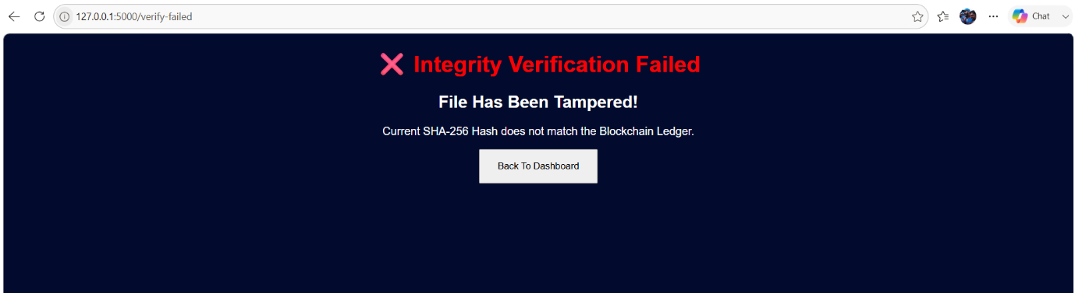
Description
Verification compares the file's current SHA-256 hash with the original hash on the blockchain. In the example shown, the values do not match, meaning the file has been changed since upload, so the system displays an "Integrity Verification Failed" message. The screenshot shows the system doing exactly what it was designed to do: catching an unauthorised change.
4.11 Hacker Attack Simulation Module
This module was added to show what happens when an attacker modifies a stored file and how the system responds.
Features
- Simulated cyber-attack environment
- File tampering demonstration
- Security testing functionality
- Real-time integrity validation
- Tamper detection analysis

Figure 4.10: Hacker Attack Simulation Result
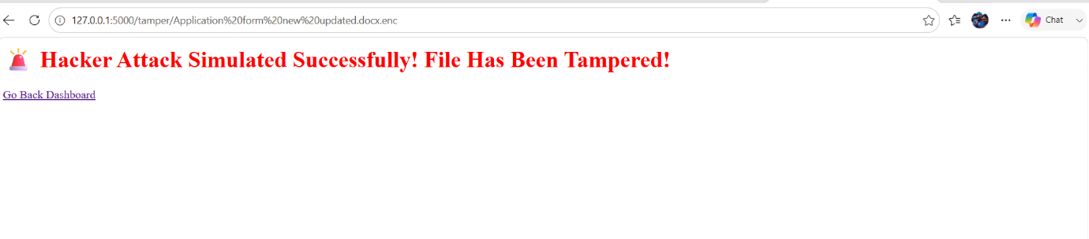Description
The simulation deliberately alters an uploaded file, imitating a real tampering attack, and then reruns the integrity check. Because the file's new hash no longer matches the one on the blockchain, verification fails and the user is warned that the file's integrity has been compromised.
4.12 System Implementation Summary
The finished implementation brings several security technologies into one platform, providing authentication, AES encryption, SHA-256 hashing, blockchain verification, secure storage and attack simulation.
Implemented Modules
- User Registration Module
- User Login Module
- Dashboard Module
- Secure File Upload Module
- AES Encryption Module
- SHA-256 Hashing Module
- Blockchain Verification Module
- Hacker Attack Simulation Module
- Tamper Detection Module
- File Recovery and Download Module
Achievements
- Successful user authentication
- Secure file encryption
- Reliable hash generation
- Blockchain-based integrity verification
- Effective tamper detection
- Successful attack simulation testing
- Secure file recovery
Having all of these modules working together shows that blockchain and standard cryptography can be combined in practice to protect both the confidentiality and the integrity of files.
4.13 Chapter Summary
This chapter has walked through the implementation of the system. AES encryption, SHA-256 hashing, blockchain verification and tamper detection were built into a single application, and each module was checked to confirm that it worked and protected uploaded files as intended.
The system can store files securely, verify them against blockchain records and detect unauthorised changes through hash comparison. Chapter 5 describes the testing used to assess how well it does these things.

CHAPTER 5
TESTING AND VALIDATION
5.1 Introduction
This chapter reports on the testing and validation of the system. The purpose was to confirm that every module works as intended and that the security requirements set at the design stage have been met.
Testing concentrated on functionality, reliability, security, integrity verification and tamper detection. A set of scenarios was designed to exercise the authentication, encryption, blockchain verification and attack simulation modules.
The results were then reviewed against the objectives of the project.
5.2 Testing Strategy
Testing followed a structured plan covering both functionality and security.
The testing activities included:
- Functional Testing
- Authentication Testing
- File Upload Testing
- AES Encryption Testing
- SHA-256 Hash Verification Testing
- Blockchain Verification Testing
- Integrity Verification Testing
- Hacker Attack Simulation Testing
The aim was to make sure each module did its own job correctly and that the system worked as a whole without errors.

5.3 Functional Testing
Functional testing checked each module against the requirements listed in Chapter 3.
Table 5.1 Functional Testing Results
Test ID | Function Tested | Expected Result | Actual Result | Status
FT01 | User Registration | User account created successfully | Successful | Pass
FT02 | User Login | User authenticated successfully | Successful | Pass
FT03 | File Upload | File uploaded successfully | Successful | Pass
FT04 | AES Encryption | File encrypted successfully | Successful | Pass
FT05 | SHA-256 Generation | Hash generated correctly | Successful | Pass
FT06 | Blockchain Verification | Hash stored and verified | Successful | Pass
FT07 | File Download | File downloaded successfully | Successful | Pass
FT08 | File Decryption | Original file recovered | Successful | Pass
Every core function behaved as specified.
5.4 User Authentication Testing
These tests checked that registration and login work properly and keep unauthorised users out.
Test Objective
To make sure that only registered users can reach the system's features.
Test Procedure
- Register a new user account.
- Login using valid credentials.
- Attempt login using invalid credentials.
- Observe system behaviour.

Table 5.2 Authentication Testing Results
Test Scenario | Expected Result | Status
Valid Registration | Account created | Pass
Valid Login | Access granted | Pass
Invalid Password | Access denied | Pass
Unauthorized Access | Restricted | Pass
Result Analysis
Only users with valid credentials were able to get in; invalid logins were rejected.
5.5 AES Encryption Testing
These tests checked that files are actually encrypted before storage.
Test Objective
To confirm that uploaded files are encrypted before they are stored.
Test Procedure
- Upload a file.
- Execute AES encryption.
- Download encrypted file.
- Open encrypted file using text editor.
Expected Result
The encrypted file should appear as unreadable ciphertext.
Actual Result
When opened in a text editor, the downloaded file contained only unreadable characters.
Table 5.3 AES Encryption Testing Results
Test Parameter | Result
File Encryption | Successful
Encrypted File Generated | Yes
Cipher Text Produced | Yes
Confidentiality Maintained | Yes
Result Analysis
AES turned the plaintext into ciphertext as expected, keeping the file's contents confidential.
5.6 SHA-256 Hash Verification Testing
The SHA-256 module was tested to make sure it gives each file its own fingerprint.
Test Objective
To confirm that hashes are generated correctly and can be used for verification.
Test Procedure
- Upload a file.
- Generate SHA-256 hash.
- Record generated hash.
- Verify hash consistency.
Table 5.4 SHA-256 Testing Results
Test Parameter | Result
Hash Generated | Yes
Hash Length Correct | Yes
Unique Fingerprint Created | Yes
Verification Successful | Yes

Result Analysis
Each file received a correct, unique SHA-256 hash that could be relied on for later integrity checks.
5.7 Blockchain Verification Testing
This test examined whether integrity records are stored on the blockchain correctly and can be used for verification.
Test Objective
To confirm that the SHA-256 hash is written to the blockchain ledger and can be read back during verification.
Test Procedure
- Upload a file to the system.
- Generate a SHA-256 hash value.
- Store the generated hash in the blockchain ledger.
- Retrieve the stored blockchain record.
- Compare the blockchain hash with the current file hash.

Expected Result
For an unchanged file, the hash on the blockchain should match the newly calculated hash.
Actual Result
The hashes matched and the file was confirmed as intact.
Table 5.5 Blockchain Verification Testing Results
Test Parameter | Result
Blockchain Record Created | Yes
Hash Stored Successfully | Yes
Hash Retrieved Successfully | Yes
Verification Successful | Yes
Integrity Maintained | Yes
Result Analysis
The blockchain module recorded integrity data correctly and kept it available for later checks, giving a fixed point of reference for verification.
5.8 Integrity Verification Testing
This test checked whether the system correctly recognises files that have not been changed.
Test Objective
To confirm that verification based on SHA-256 and blockchain records gives the right result for an unaltered file.
Test Procedure
- Upload a file.
- Generate and store the SHA-256 hash.
- Perform integrity verification.
- Compare the generated hash with the blockchain-stored hash.
Expected Result
The system should report that the file is unchanged.
Actual Result
The file was verified and no unauthorised changes were reported.

Table 5.6 Integrity Verification Testing Results
Test Parameter | Result
File Uploaded | Yes
Hash Generated | Yes
Blockchain Record Available | Yes
Hash Match Detected | Yes
Integrity Verified | Yes
Result Analysis
Unaltered files were correctly recognised as authentic, showing that SHA-256 and the blockchain work well together as a verification method.
5.9 Hacker Attack Simulation Testing
This test checked whether the system notices when a file has been deliberately changed.
Test Objective
To find out whether blockchain-based verification catches a tampered file.
Test Procedure
- Upload and verify a file.
- Simulate a hacker attack by modifying the file.
- Generate a new SHA-256 hash value.
- Compare the modified hash with the original blockchain-stored hash.
- Observe verification results.
Expected Result
The system should find that the hashes differ and report a verification failure.
Actual Result
The tampering was detected and an integrity failure message was displayed.

Table 5.7 Hacker Attack Simulation Testing Results
Test Parameter | Result
File Modification Performed | Yes
New Hash Generated | Yes
Hash Mismatch Detected | Yes
Integrity Verification Failed | Yes
Tampering Detected | Yes
Result Analysis
The system caught the modification immediately. The hash stored on the blockchain served as a reliable reference, which is exactly what the design intended.
5.10 Security Evaluation
A security analysis looked at how well the system meets its three main goals: confidentiality, integrity and tamper detection.
Confidentiality
AES encryption turned uploaded data into ciphertext, so anyone without the key would see nothing useful.
Integrity
SHA-256 hashes were calculated for every file and checked against the blockchain. Since any change to a file changes its hash, violations of integrity could be picked up reliably.
Tamper Detection
In the attack simulation, modified files were identified and verification failure alerts were raised.
Table 5.8 Security Evaluation Summary
Security Objective | Technology Used | Status
Confidentiality | AES Encryption | Achieved
Integrity | SHA-256 Hashing | Achieved
Verification | Blockchain Ledger | Achieved
Tamper Detection | Hash Comparison | Achieved
Authentication | Login System | Achieved

Result Analysis
The system met each of its main security goals. Encryption, hashing and the blockchain together gave several independent layers of protection against unauthorised access and modification.
5.11 Performance Evaluation of the Proposed System
The system was also assessed for encryption efficiency, accuracy of integrity checks and general usability. During testing, users were able to upload files, see their hashes and have integrity records saved to the blockchain without difficulty.
AES encryption added only a small delay to each upload, so it did not get in the way of normal use, and files were never stored in readable form. SHA-256 gave every file a distinct hash, and changing even a small part of a file produced a completely different value, which is what makes the integrity checks so precise.
The blockchain gave integrity records a permanent home. Once a hash was on the chain, changing it would have meant rewriting every later block, which added noticeably to the trustworthiness of the system. In testing, altered files were always detected because their new hash no longer matched the blockchain record.
On usability, the Flask interface keeps things simple. Registration, login, upload, encryption, verification and tamper simulation are all reachable from one dashboard. Having all of these on one platform shows that blockchain can be a practical part of a file management tool rather than a purely academic idea.
5.12 Limitations of the Proposed System
The system does what it set out to do, but it has limitations. It runs locally and uses a simplified blockchain intended for demonstration, so it lacks the decentralisation of a real blockchain network.
Storage is one such limitation. Encrypted files are kept on the local server, which simplified development but would not suit a large organisation. A future version could use cloud storage while keeping integrity checks on the blockchain.
The blockchain also runs on a single node. That is enough to show the principles, but a network of several nodes with a proper consensus mechanism would be more decentralised, more fault-tolerant and much harder to manipulate.
Authentication is by username and password only; adding multi-factor authentication would strengthen access control. The system also concentrates on integrity and does not include detailed permission management.
Even so, the prototype shows clearly how blockchain, AES and SHA-256 can be combined to protect files, and it gives a solid base for further work.
5.13 Testing Summary
The tests in this chapter show that every major component worked as intended. Authentication, secure upload, AES encryption, SHA-256 hashing, blockchain verification and attack simulation all produced the expected results.
The results confirmed that:
- Files were securely encrypted.
- Unique hash values were generated correctly.
- Blockchain records were stored successfully.
- Integrity verification operated accurately.
- Tampered files were detected immediately.
- Security objectives were achieved.
Overall, the system proved reliable and its security features behaved as designed.
5.14 Chapter Summary
This chapter has presented the testing and validation of the system, covering functionality, security, integrity verification and tamper detection.
The results show that the system encrypts files, produces unique SHA-256 hashes, stores integrity records on the blockchain and spots unauthorised changes through hash comparison. The attack simulation added further evidence that tampered data is caught.
With every test case passed, the system can be said to meet its objectives. Chapter 6 builds on these results with a fuller evaluation of the system as a whole.

CHAPTER 6
EVALUATION AND ANALYSIS
6.1 Introduction
This chapter steps back from individual test cases and asks how well the system performs overall. Using the results from Chapter 5, it evaluates confidentiality, integrity, blockchain verification and tamper detection, and compares the system with conventional file storage.
It also sets out the main strengths and weaknesses of the system and checks each research objective against what was achieved.
6.2 Evaluation Criteria
The evaluation criteria were taken from the research objectives and the security requirements defined during design.
The evaluation looked at:
- Confidentiality
- Integrity
- Tamper Detection
- Authentication
- Reliability
- Usability
- Security Performance
Between them, these criteria cover both the security and the practical usefulness of the system.
6.3 Future Enhancements
Although the system already handles encryption, integrity checks and tamper detection, there is plenty of scope to extend it.
Cloud storage is an obvious next step. Supporting services such as Amazon S3, Microsoft Azure Storage or Google Cloud Storage would let encrypted files be kept remotely while their integrity continues to be checked against the blockchain.
The blockchain itself could be expanded from a single local node to a multi-node network, making it genuinely decentralised and much more resilient.
Smart contracts could automate parts of the process, checking hashes, enforcing access rules and raising alerts when something looks wrong [20]. Machine learning could also be used to flag unusual user behaviour before it turns into an incident.
For administrators, a real-time dashboard with security analytics, audit logs and blockchain history would be useful, and a mobile app would let users manage and verify files from their phones. Changes like these would bring the system closer to something an organisation could deploy.

Table 6.1 Evaluation Criteria
Evaluation Criterion | Purpose
Confidentiality | Protect files from unauthorised access
Integrity | Ensure files remain unchanged
Authentication | Restrict access to authorised users
Tamper Detection | Detect file modifications
Reliability | Ensure stable operation
Usability | Provide user-friendly interaction
Security Performance | Evaluate overall protection

6.4 Evaluation of Confidentiality
Confidentiality means keeping information away from people who are not entitled to see it. Here it is provided by AES encryption.
Every uploaded file was converted to ciphertext and stored correctly. Without the key, the stored files could not be read, so even an attacker who copied them would gain nothing useful.
Opening an encrypted file directly showed only meaningless characters, which is good evidence that the encryption was doing its job.
Evaluation Findings
- AES encryption successfully protected uploaded files.
- Encrypted files remained unreadable without decryption.
- Confidentiality objectives were achieved.
Result
Confidentiality Level: High
6.5 Evaluation of Integrity
Integrity means being able to trust that stored data has not been changed.
The system gives every file a SHA-256 fingerprint, stores it, and uses it later to check the file.
For files that had not been touched, the recalculated hash always matched the blockchain record, showing that the integrity check works as intended.

Evaluation Findings
- SHA-256 hashes uniquely identified uploaded files.
- Integrity verification produced accurate results.
- File authenticity was successfully validated.
Result
Integrity Protection Level: High
6.6 Evaluation of Blockchain Verification
The blockchain was added to make the integrity records themselves more trustworthy.
Keeping verification data on a blockchain rather than in a normal database makes it much less likely that an integrity record could be changed without anyone noticing.
Throughout testing, blockchain records were created, stored and read back without any problems.
Evaluation Findings
- Blockchain records remained available throughout testing.
- Verification processes completed successfully.
- Trustworthiness of integrity records improved.
Result
Blockchain Verification Effectiveness: High
6.7 Evaluation of Tamper Detection
Detecting unauthorised changes to files was one of the main goals of the project.
The attack simulation put this to the test. Once a file had been modified, its SHA-256 hash no longer matched the value stored on the blockchain.
The system picked up the mismatch immediately and reported a failed integrity check.
Evaluation Findings
- File modifications were successfully detected.
- Hash mismatch identification worked correctly.
- Verification failure alerts were generated.
Result
Tamper Detection Capability: High
6.8 Comparative Analysis with Traditional Systems
To put the results in context, the system was compared with a typical traditional storage setup.

Table 6.2 Comparison with Traditional Systems
Feature | Traditional System | Proposed System
User Authentication | Basic | Advanced
AES Encryption | Limited | Yes
SHA-256 Verification | No | Yes
Blockchain Integration | No | Yes
Integrity Verification | Limited | Yes
Tamper Detection | No | Yes
Secure File Recovery | Limited | Yes
Audit Capability | Limited | Enhanced

Analysis
Traditional storage is mostly about holding data and controlling who can get to it. It rarely has any strong way of checking whether files have been changed.
The proposed system fills that gap by combining cryptography with a blockchain. Blockchain verification and tamper detection make a clear difference to its overall security.

Figure 6.1 – Traditional System vs Proposed System

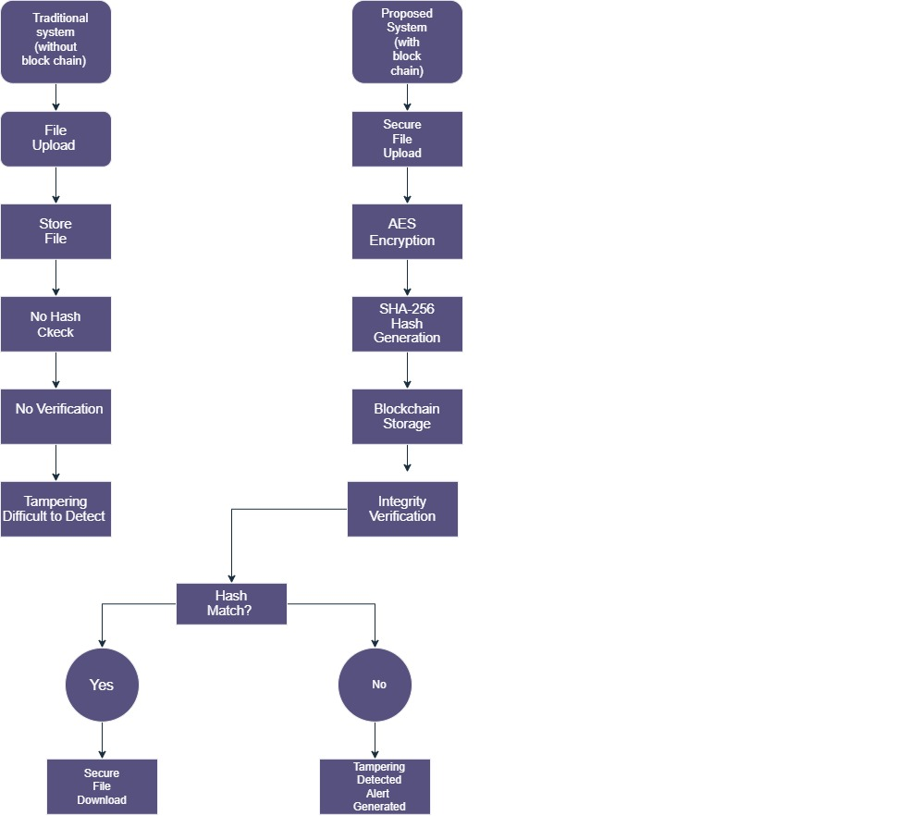
6.9 Strengths of the Proposed System
Several strengths came out of the evaluation.
Strong Security
AES, SHA-256 and the blockchain each add a separate layer of protection.
Reliable Integrity Verification
The blockchain ledger gives the system a trustworthy reference for every integrity check.
Effective Tamper Detection
Hash comparison reliably reveals unauthorised changes.
User-Friendly Interface
The web interface makes secure file handling easy for non-specialists.
Practical Implementation
The project shows blockchain being used for a concrete security task, not only in theory.
6.10 Limitations of the Proposed System
The evaluation also exposed some limitations.
Limited Scalability
The blockchain was built as a research prototype and has not been tested at scale.
Local Deployment
All testing was done on a local machine rather than a distributed production network.
Resource Constraints
The hardware available placed limits on performance testing.
Simplified Blockchain Architecture
The blockchain is aimed at integrity verification and is not fully decentralised.
None of these undermines the main finding, which is that blockchain can be built into a file security system in a practical way.
6.11 Achievement of Research Objectives
Each objective set in Chapter 1 was met, as the table below shows.
Table 6.3 Achievement of Research Objectives
Objective | Status
Investigate traditional security challenges | Achieved
Analyse blockchain technology | Achieved
Implement AES encryption | Achieved
Implement SHA-256 verification | Achieved
Develop secure file system | Achieved
Evaluate system performance | Achieved
Detect file tampering | Achieved

Meeting every objective suggests that the research approach was the right one for this problem.

6.12 Chapter Summary
This chapter has evaluated the system against its security goals. AES encryption delivered confidentiality, SHA-256 hashing delivered integrity checking, and the blockchain delivered tamper-resistant record keeping.
Compared with traditional storage, the system is clearly stronger, especially in verifying integrity and detecting tampering. It has limitations, but it provides a workable foundation for making digital files more secure.

CHAPTER 7 - DISCUSSION
7.1 Introduction
This chapter reflects on what the implementation, testing and evaluation have shown. It looks at how far the research objectives were met and how well the system answers the security problems raised at the start of the project.
It also considers what each of the three core technologies, blockchain, AES and SHA-256, actually contributed.
7.2 Discussion of Research Objectives
The central aim was to build a secure file storage and integrity verification system by combining blockchain with modern cryptography.
The results show that each objective was achieved, as discussed below.
Objective 1:
To investigate security challenges associated with traditional file storage systems.
The literature review highlighted unauthorised access, data tampering, integrity violations and a lack of effective verification. Traditional systems tend to concentrate on controlling access and offer little protection once someone is inside [2], [1].
Nothing in this study suggests that these problems have gone away; they remain real concerns for anyone managing digital files.
Objective 2:
To analyse the application of blockchain technology in file security.
The project showed that blockchain is a good fit for storing trusted integrity records. In testing, the ledger stored verification data correctly and supported reliable checks.
Put simply, records that cannot be changed make verification easier to trust.
Objective 3:
To implement AES encryption for file protection.
AES was integrated into the upload process and kept every file confidential.
Encrypted files could not be read without decryption, so their contents were safe from unauthorised users.
Objective 4:
To implement SHA-256 hashing for integrity verification.
SHA-256 gave each file its own fingerprint, which made reliable integrity checks possible.
These hashes were used throughout testing and exposed every file that had been tampered with.

Objective 5: To evaluate the effectiveness of the developed system.
The system was tested thoroughly and met its objectives, protecting uploaded files against unauthorised changes.
7.3 Discussion of Security Improvements
Perhaps the most important finding is how much security improves when several mechanisms are layered together.
Conventional storage usually relies on access control as its main defence. The proposed system adds several more layers:
- User Authentication
- AES Encryption
- SHA-256 Hashing
- Blockchain Verification
- Tamper Detection
With these layers in place, an attacker has to defeat several controls instead of one, which makes the system far more resilient.
Key Security Benefits
- Enhanced confidentiality through encryption.
- Improved integrity verification through hashing.
- Trusted verification records through blockchain technology.
- Immediate detection of file tampering.
- Stronger protection against unauthorised modifications.
7.4 Discussion of Tamper Detection Capability
The attack simulation produced some of the most useful evidence in the project.
It confirmed that any change to a file gives it a different SHA-256 hash. When that new hash was compared with the blockchain record, the system spotted the difference immediately and reported a failed integrity check.
In other words, users are warned before they rely on a file that may have been compromised.
This is strong evidence that the verification framework works.
7.5 Discussion of Blockchain Integration
Adding the blockchain was well worth the effort.
Instead of leaving integrity data in an ordinary database, the ledger gave it an extra layer of trust and transparency. Because blockchain records cannot be changed without detection, it becomes very difficult for anyone to tamper with verification data and get away with it.
In testing, blockchain records were created, stored, retrieved and used for verification without any failures.
This fits with the wider interest in blockchain as a tool for cybersecurity and digital trust [13], [18].
7.6 Discussion of System Performance
The system ran reliably throughout development and testing.
Every major module worked as expected:
- Registration
- Login
- File Upload
- Encryption
- Hash Generation
- Blockchain Verification
- File Recovery
- Tamper Detection
No critical failures occurred, which suggests the security components were integrated properly.
Users also found the web interface simple to work with.
7.7 Comparison with Existing Approaches
These findings agree with earlier studies that see blockchain as a way to improve data integrity and trust [7], [10].
Much of that earlier work, however, deals with blockchain or encryption on its own.
This project differs in bringing together:
- AES Encryption
- SHA-256 Hashing
- Blockchain Verification
- Tamper Detection
within a single framework.
The result is a more complete solution than one that relies on a single mechanism.

Table 7.1 Comparison of Security Approaches
Security Mechanism | Traditional Systems | Proposed System
User Authentication | Yes | Yes
Encryption | Limited | Yes
Hash Verification | Limited | Yes
Blockchain Records | No | Yes
Tamper Detection | No | Yes
Integrity Validation | Limited | Yes
The table makes the extra capabilities of the proposed framework easy to see.
7.8 Limitations and Challenges
The project met its objectives, but not without difficulties along the way.
Development Challenges
- Integration of blockchain with file verification processes.
- Management of encrypted and decrypted file operations.
- Ensuring consistency between blockchain records and generated hash values.
System Limitations
- The blockchain was designed for teaching and research purposes.
- Testing was conducted within a controlled local environment.
- Large-scale performance evaluation was beyond the scope of this project.
Even with these limitations, the system shows that blockchain-based integrity verification is achievable.
7.9 Overall Discussion
Looking at the project as a whole, the results show that blockchain combined with AES and SHA-256 can make file storage considerably more secure.
The system dealt with the three problems highlighted in the literature: confidentiality, integrity and tamper detection.
Building and testing a working system provides practical evidence, not just an argument, that blockchain-based security can be used in file management.
The project therefore adds to the growing body of work on blockchain in cybersecurity and secure data management.

7.10 Chapter Summary
This chapter has discussed what the project found. The system met all of its research objectives and protected files well against unauthorised access and tampering.
Together, AES encryption, SHA-256 hashing and the blockchain created a secure and reliable framework for storing and verifying files. There are limitations, but the approach offers clear advantages over traditional storage.

CHAPTER 8
CONCLUSION AND FUTURE WORK
8.1 Introduction
This chapter brings the project "Blockchain-Based Secure File Upload and Integrity Verification System using AES Encryption" to a close. It summarises the findings, reviews the objectives, sets out the contributions and suggests directions for future work.
The project set out to tackle the security problems of file storage and integrity verification by combining blockchain, AES encryption and SHA-256 hashing in one framework.
8.2 Research Summary
As more and more information is held digitally, keeping it secure, confidential, accurate and trustworthy becomes harder. Traditional storage offers little protection against unauthorised changes, which makes it difficult to be sure that a stored file is genuine.
To address this, the project designed and built a secure file upload and integrity verification system that combines cryptography with blockchain.
The system is made up of:
- User Registration and Authentication
- Secure File Upload Mechanism
- AES Encryption and Decryption
- SHA-256 Hash Generation
- Blockchain-Based Integrity Verification
- Hacker Attack Simulation
- Tamper Detection Mechanism
It was built with Python, Flask, SQLite, HTML, CSS and JavaScript and tested for functionality, security and reliability.
Testing showed that it encrypted files, produced unique hashes, stored integrity records on the blockchain and detected unauthorised changes.
8.3 Achievement of Research Objectives
The evaluation confirms that every research objective was met.
Objective 1
To investigate security challenges associated with traditional file storage systems.
The literature review identified unauthorised access, data tampering and weak integrity verification as the key problems.
Status: Achieved

Objective 2
To analyse the role of blockchain technology in improving file security.
Blockchain was shown to provide trusted, tamper-resistant integrity records.
Status: Achieved
Objective 3
To implement AES encryption for file confidentiality.
AES was integrated and kept uploaded files safe from unauthorised access.
Status: Achieved
Objective 4
To implement SHA-256 hashing for integrity verification.
SHA-256 produced a unique fingerprint for each file and supported reliable integrity checks.
Status: Achieved
Objective 5
To develop and evaluate a secure blockchain-based file verification system.
All the required security components were brought together in one working system.
Status: Achieved
8.4 Key Findings
Several key findings came out of the research and testing.
Enhanced Confidentiality
AES encryption kept uploaded files unreadable to anyone without the key.
Reliable Integrity Verification
SHA-256 proved a dependable way to fingerprint files.
Effective Blockchain Integration
Storing integrity records on the blockchain made them far harder to tamper with and increased trust in the system.
Successful Tamper Detection
The attack simulation confirmed that tampered files are reliably detected.
Improved Security Framework
Layering encryption, hashing and blockchain gave more protection than conventional storage.
8.5 Contributions of the Research
The project contributes a working example of blockchain-assisted integrity verification to the fields of cybersecurity and secure file management.
Its main contributions are:
- Development of a secure file upload platform.
- Integration of AES encryption and decryption functionality.
- Implementation of SHA-256-based integrity verification.
- Design of a blockchain-based verification framework.
- Demonstration of tamper detection through attack simulation.
- Evaluation of a multi-layered security architecture.
Taken together, these show how blockchain can be put to use in a practical file security tool.
8.6 Limitations of the Research
Some limitations need to be acknowledged.
Limited Scale Testing
Testing took place on a local development machine, not in a large production environment.
Simplified Blockchain Architecture
The blockchain was aimed at integrity verification and did not run on a fully decentralised network.
Resource Constraints
Hardware resources and the project timeline limited the amount of testing that could be done.
Performance Evaluation Scope
Security and functionality were prioritised over large-scale performance benchmarking.
These limitations do not change the central result: blockchain-based file integrity verification works in practice.
8.7 Future Work
There are several ways the system could be developed further.
Cloud Integration
Cloud storage support would allow files to be managed securely from anywhere.
Advanced Blockchain Networks
The blockchain could be moved onto a distributed network of nodes.
Multi-Factor Authentication
One-time passwords or biometric login would add a further layer of protection.
Smart Contract Integration
Smart contracts could automate integrity checks and access control [20].

Performance Optimisation
Performance could be tested with much larger datasets and higher volumes of files.
Artificial Intelligence-Based Threat Detection
Machine learning could be used to spot suspicious behaviour and possible threats automatically.
8.8 Final Conclusion
This project has designed, built and evaluated a Blockchain-Based Secure File Upload and Integrity Verification System using AES Encryption. It has shown that the approach can address the core concerns of confidentiality, integrity and trust in file management.
By combining AES encryption, SHA-256 hashing and a blockchain ledger, the system provides layered protection that keeps files private and catches attempts to tamper with them. Testing confirmed that it works reliably and meets its objectives.
The prototype has limits in scale and decentralisation, but it demonstrates that blockchain-backed integrity checking is a realistic addition to secure file storage, and it offers a solid starting point for the future work described above.
References
[1] W. Stallings, Cryptography and Network Security: Principles and Practice, 7th ed. Harlow, U.K.: Pearson, 2017.
[2] J. Andress and S. Winterfeld, Cyber Warfare: Techniques, Tactics and Tools for Security Practitioners, 2nd ed. Waltham, MA, USA: Syngress, 2014.
[3] National Institute of Standards and Technology, “Advanced Encryption Standard (AES),” Gaithersburg, MD, USA, FIPS PUB 197, Nov. 2001.
[4] National Institute of Standards and Technology, “Secure Hash Standard (SHS),” Gaithersburg, MD, USA, FIPS PUB 180-4, Aug. 2015.
[5] S. Nakamoto, “Bitcoin: A peer-to-peer electronic cash system,” 2008. Accessed: Aug. 10, 2026. [Online]. Available: https://bitcoin.org/bitcoin.pdf
[6] D. Yaga, P. Mell, N. Roby, and K. Scarfone, “Blockchain technology overview,” National Institute of Standards and Technology, Gaithersburg, MD, USA, NISTIR 8202, Oct. 2018.
[7] Z. Zheng, S. Xie, H. Dai, X. Chen, and H. Wang, “An overview of blockchain technology: Architecture, consensus, and future trends,” in Proc. IEEE Int. Congr. Big Data (BigData Congress), Honolulu, HI, USA, 2017, pp. 557–564.
[8] B. A. Forouzan and D. Mukhopadhyay, Cryptography and Network Security, 3rd ed. New Delhi, India: McGraw-Hill Education, 2015.
[9] A. Narayanan, J. Bonneau, E. Felten, A. Miller, and S. Goldfeder, Bitcoin and Cryptocurrency Technologies. Princeton, NJ, USA: Princeton Univ. Press, 2016.
[10] M. Crosby, P. Pattanayak, S. Verma, and V. Kalyanaraman, “Blockchain technology: Beyond bitcoin,” Applied Innovation Review, no. 2, pp. 6–19, Jun. 2016.
[11] M. Pilkington, “Blockchain technology: Principles and applications,” in Research Handbook on Digital Transformations, F. X. Olleros and M. Zhegu, Eds. Cheltenham, U.K.: Edward Elgar, 2016, pp. 225–253.
[12] A. M. Antonopoulos, Mastering Bitcoin: Programming the Open Blockchain, 2nd ed. Sebastopol, CA, USA: O’Reilly Media, 2017.
[13] Z. Zheng, S. Xie, H.-N. Dai, X. Chen, and H. Wang, “Blockchain challenges and opportunities: A survey,” Int. J. Web Grid Services, vol. 14, no. 4, pp. 352–375, 2018.
[14] F. Tschorsch and B. Scheuermann, “Bitcoin and beyond: A technical survey on decentralized digital currencies,” IEEE Commun. Surveys Tuts., vol. 18, no. 3, pp. 2084–2123, 2016.
[15] C. Paar and J. Pelzl, Understanding Cryptography: A Textbook for Students and Practitioners. Berlin, Germany: Springer, 2010.
[16] OWASP Foundation, “File upload cheat sheet,” OWASP Cheat Sheet Series. Accessed: Sep. 24, 2026. [Online]. Available: https://cheatsheetseries.owasp.org/cheatsheets/File_Upload_Cheat_Sheet.html
[17] Hyperledger Foundation, “Hyperledger Fabric documentation.” Accessed: Sep. 24, 2026. [Online]. Available: https://hyperledger-fabric.readthedocs.io
[18] IBM, “What is blockchain?” Accessed: Sep. 24, 2026. [Online]. Available: https://www.ibm.com/topics/blockchain
[19] J. Bonneau, A. Miller, J. Clark, A. Narayanan, J. A. Kroll, and E. W. Felten, “SoK: Research perspectives and challenges for Bitcoin and cryptocurrencies,” in Proc. IEEE Symp. Security and Privacy, San Jose, CA, USA, 2015, pp. 104–121.
[20] G. Wood, “Ethereum: A secure decentralised generalised transaction ledger,” Ethereum Project Yellow Paper, 2014.
[21] Pallets Projects, “Flask documentation.” Accessed: Sep. 24, 2026. [Online]. Available: https://flask.palletsprojects.com

APPENDIX A – DEVELOPMENT ENVIRONMENT
This appendix lists the software and hardware used to develop and test the prototype.
Software Requirements
Software | Version
Python | 3.x
Flask | Latest Stable Version
SQLite | SQLite3
HTML | HTML5
CSS | CSS3
JavaScript | ES6
Visual Studio Code | Latest Version

Hardware Requirements
Component | Specification
Processor | Intel Core i5 or Higher
RAM | 8 GB Minimum
Storage | 256 GB SSD
Operating System | Windows 10/11

APPENDIX B – PROJECT STRUCTURE
Figure B.1 shows how the project files are organised. Application logic, templates, static assets, encrypted files and the database are kept in separate folders so that each part of the system can be maintained independently.
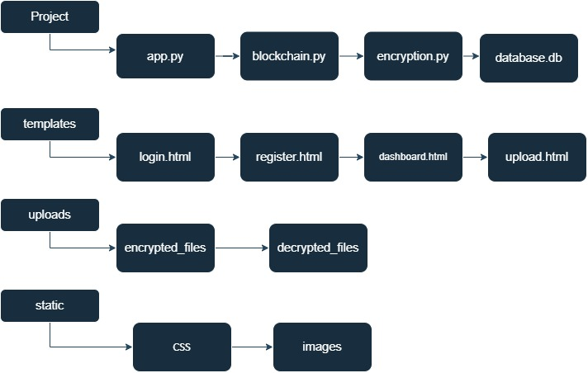
Figure B.1 – Project Folder Structure

APPENDIX C – MAJOR FUNCTIONS
The main functions of the system are grouped below by the security role they perform.
User Authentication
- User Registration
- User Login
- Session Management
File Security
- AES Encryption
- AES Decryption
- SHA-256 Hash Generation
- Blockchain Verification
Security Validation
- Integrity Verification
- Hacker Attack Simulation
- Tamper Detection
APPENDIX D – CORE IMPLEMENTATION CODE
The listings below are shortened excerpts from the main modules of the system. Configuration, HTML templates, logging and some error handling have been left out so that the security logic is easier to follow.
D.1 AES Encryption and SHA-256 Hashing (crypto_utils.py)
This module encrypts and decrypts files with AES-256 in CBC mode, using a fresh random initialisation vector (IV) for every file, and calculates the SHA-256 fingerprint of the original content.
import os
import hashlib
from cryptography.hazmat.primitives.ciphers import Cipher, algorithms, modes
from cryptography.hazmat.primitives import padding

KEY = os.urandom(32) # 256-bit AES key (in the full system it is loaded from a protected key file)

def encrypt_file(data: bytes) -> bytes:
"""Encrypt file bytes with AES-256 in CBC mode. The IV is stored in front of the ciphertext."""
iv = os.urandom(16)
padder = padding.PKCS7(128).padder()
padded = padder.update(data) + padder.finalize()
encryptor = Cipher(algorithms.AES(KEY), modes.CBC(iv)).encryptor()
return iv + encryptor.update(padded) + encryptor.finalize()

def decrypt_file(blob: bytes) -> bytes:
"""Reverse encrypt_file: split off the IV, decrypt and remove padding."""
iv, ciphertext = blob[:16], blob[16:]
decryptor = Cipher(algorithms.AES(KEY), modes.CBC(iv)).decryptor()
padded = decryptor.update(ciphertext) + decryptor.finalize()
unpadder = padding.PKCS7(128).unpadder()
return unpadder.update(padded) + unpadder.finalize()

def sha256_hash(data: bytes) -> str:
"""Return the SHA-256 fingerprint of the original file as a hex string."""
return hashlib.sha256(data).hexdigest()

D.2 Blockchain Ledger (blockchain.py)
Each block stores the file name, the file's SHA-256 hash, a timestamp and the hash of the previous block. The is_chain_valid method recalculates every block hash, so any edit to a stored record breaks the chain and is detected.
import hashlib
import json
import time

class Block:
def __init__(self, index, filename, file_hash, previous_hash):
self.index = index
self.timestamp = time.time()
self.filename = filename
self.file_hash = file_hash
self.previous_hash = previous_hash
self.hash = self.compute_hash()

def compute_hash(self):
content = json.dumps({
"index": self.index, "timestamp": self.timestamp,
"filename": self.filename, "file_hash": self.file_hash,
"previous_hash": self.previous_hash,
}, sort_keys=True)
return hashlib.sha256(content.encode()).hexdigest()

class Blockchain:
def __init__(self):
self.chain = [Block(0, "genesis", "0", "0")]

def add_record(self, filename, file_hash):
block = Block(len(self.chain), filename, file_hash, self.chain[-1].hash)
self.chain.append(block)
return block

def get_record(self, filename):
for block in reversed(self.chain):
if block.filename == filename:
return block
return None

def is_chain_valid(self):
"""Recalculate every block hash and check each link to the previous block."""
for i in range(1, len(self.chain)):
current, previous = self.chain[i], self.chain[i - 1]
if current.hash != current.compute_hash():
return False
if current.previous_hash != previous.hash:
return False
return True

D.3 Integrity Verification and Attack Simulation (verify.py)
Verification decrypts the stored file, hashes it again and compares the result with the blockchain record. The attack simulation flips the bits of one byte in the stored ciphertext to imitate an attacker editing the file on disk.
from crypto_utils import decrypt_file, sha256_hash

def verify_integrity(chain, filename, encrypted_blob):
"""Decrypt the stored file, re-hash it and compare with the hash held on the blockchain."""
record = chain.get_record(filename)
if record is None or not chain.is_chain_valid():
return False
try:
current_hash = sha256_hash(decrypt_file(encrypted_blob))
except ValueError: # padding error: ciphertext has been altered
return False
return current_hash == record.file_hash

def simulate_attack(encrypted_blob: bytes) -> bytes:
"""Hacker attack simulation: flip bits in one byte of the stored ciphertext."""
tampered = bytearray(encrypted_blob)
tampered[len(tampered) // 2] ^= 0xFF
return bytes(tampered)

D.4 Secure Upload Route (app.py excerpt)
The upload route ties the modules together: the file is hashed, encrypted, written to disk as ciphertext only, and its hash is recorded on the blockchain.
import os
from flask import Flask, request, session, redirect, url_for, render_template
from werkzeug.utils import secure_filename
from crypto_utils import encrypt_file, sha256_hash
from blockchain import Blockchain

app = Flask(__name__)
app.secret_key = os.environ.get("SECRET_KEY", os.urandom(24))
UPLOAD_FOLDER = "encrypted_files"
os.makedirs(UPLOAD_FOLDER, exist_ok=True)
ledger = Blockchain()

@app.route("/upload", methods=["POST"])
def upload():
if "user" not in session:
return redirect(url_for("login"))
uploaded = request.files["file"]
filename = secure_filename(uploaded.filename)
data = uploaded.read()

file_hash = sha256_hash(data) # 1. fingerprint the original file
encrypted = encrypt_file(data) # 2. encrypt with AES-256
with open(os.path.join(UPLOAD_FOLDER, filename + ".enc"), "wb") as f:
f.write(encrypted) # 3. store only the ciphertext
block = ledger.add_record(filename, file_hash) # 4. record hash on the blockchain

return render_template("result.html", filename=filename,
file_hash=file_hash, block=block)

APPENDIX E – DETAILED TEST CASES
Table E.1 lists the individual test cases that were run against the system. The results are summarised in Chapter 5.
Table E.1 – Detailed Test Cases
Test ID | Module | Test Action | Expected Result | Result
TC01 | Registration | Register with a new username and password | Account created; user redirected to login | Pass
TC02 | Registration | Register with an existing username | Error message; no duplicate account | Pass
TC03 | Login | Log in with valid credentials | Access granted; dashboard shown | Pass
TC04 | Login | Log in with a wrong password | Access denied with error message | Pass
TC05 | Access control | Open the dashboard URL without logging in | Redirected to login page | Pass
TC06 | File upload | Upload a text file from the dashboard | File accepted; result page shown | Pass
TC07 | AES encryption | Open the stored .enc file in a text editor | Only unreadable ciphertext visible | Pass
TC08 | AES decryption | Download the decrypted file | Content identical to the original | Pass
TC09 | SHA-256 | Upload the same file twice | Identical hash values produced | Pass
TC10 | SHA-256 | Change one character and upload again | Completely different hash produced | Pass
TC11 | Blockchain | Upload a file and view the ledger | New block added with file hash and previous hash | Pass
TC12 | Blockchain | Edit a stored block record manually | Chain validation fails | Pass
TC13 | Integrity check | Verify an unchanged file | “Integrity Verified” displayed | Pass
TC14 | Attack simulation | Run hacker attack simulation, then verify | “Integrity Verification Failed” displayed | Pass
TC15 | Session | Log out and press the browser back button | Protected pages not accessible | Pass

APPENDIX F – INSTALLATION AND USER GUIDE
F.1 Installation
1. Install Python 3.10 or later and confirm the installation with the command below.
python --version

2. Open a terminal in the project folder, create a virtual environment and activate it.
python -m venv venv
venv\Scripts\activate (Windows)
source venv/bin/activate (Linux/macOS)

3. Install the required packages.
pip install flask cryptography

4. Start the application and open http://127.0.0.1:5000 in a web browser.
python app.py

F.2 Using the System
1. Register a new account on the registration page, then log in with the same details.
2. On the dashboard, choose a file and click Upload. The system encrypts the file, calculates its SHA-256 hash and adds a record to the blockchain.
3. The result page shows the file name, its hash and the blockchain verification status.
4. Use Download Encrypted File to obtain the ciphertext, or Download Decrypted File to recover the original.
5. Click Verify Integrity at any time to compare the stored file with its blockchain record.
6. To see tamper detection in action, click Simulate Hacker Attack and then verify the file again. The system reports that integrity verification has failed.
7. Log out when finished to end the session.
APPENDIX G – GLOSSARY
Term | Meaning
AES | Advanced Encryption Standard, a symmetric block cipher standardised by NIST in FIPS 197.
Blockchain | A chain of records (blocks) in which each block contains the hash of the previous one, making past records very hard to alter.
Ciphertext | Data that has been encrypted and cannot be read without the key.
CBC mode | Cipher Block Chaining, a mode of operation in which each block of plaintext is combined with the previous ciphertext block before encryption.
Hash value | The fixed-length output of a hash function, used as a digital fingerprint of data.
Immutability | The property of a record that cannot be changed once written without the change being detected.
Initialisation vector (IV) | A random value used with a cipher so that the same file encrypted twice gives different ciphertext.
Integrity | Assurance that data has not been altered in an unauthorised way.
Plaintext | Readable data before encryption.
SHA-256 | A member of the SHA-2 family of hash functions that produces a 256-bit digest, defined in FIPS 180-4.
Tamper detection | Identifying that stored data has been modified without authorisation.

