Student Number:
Student Name: Dr Iyad Al-Muzaffar
Assignment Title: Reflection on Clinical Leadership
Institution: University of South Wales Trinity Saint David

Content: Pages:

Assessment component 1:
Critical analysis of personal leadership style 3-6
Appendix A: Leadership learning log 7-10
Appendix B: Leadership personal development plan 11-12

Assessment component 2:
Reflection Models 13-15
Reflection One: My Healthcare Leadership Model 360º Individual Report 16-19
Reflection Two: Myers-Briggs Type Indicator (MBTI) 20-23
Reflection Three: Belbin Team Role Report 24-27
Reflection Four: Mental Toughness MTQ48 development report 28-30
Reflection Five: Influencing styles - Push-Pull Questionnaire 31-325
Bibliography: 33-34

Assessment Component 1:
Critical analysis of personal leadership style
I am a consultant neonatologist working in Wales for past 17 years. A Neonatologist is a doctor specialising in the management, assessment and care of newborn babies. I am going to start by reflecting on my leadership career. I have experienced several leadership roles throughout my career. I had the experience of being a clinical director in charge of Women and Children Directorate in my local healthcare organisation, at a critical period prior to a key organisational change. This was a really challenging time. I have devoted a lot of time and effort addressing challenging situations. Having just completed the Medical Leadership Programme, I wish I have had that sort of structured training prior to becoming a clinical director. I currently manage several leadership roles in addition to working as a full-time clinician. I am currently the lead for neonatal service for my health board, the lead for clinical audit and quality improvement, the honorary senior lecturer for Cardiff University school of medicine, in charge of planning and delivering local hospital placements for year four medical students, and the regional lead for South Wales for the Royal College of Paediatrics and Child Health. My leadership roles span clinical health service, medical education and quality improvement.
I have signed up for the medical leadership programme few weeks before the start of the course. I remember my medical director asked me at the time, why do you want to do this course at this time? Do you really need it? I paused to ask myself Why? Why now? I was curious to explore my leadership style. I thought that this course was an opportunity to have a structured training in leadership and management. I was excited by what the programme has to offer. I was looking forward to learning more about myself and why I do things the way I do them. I am leading a key service improvement project. The aim of the project is to improve the experience and quality of care for children born early. I thought that this leadership programme will help me deliver on this project. I was hoping to gain transferrable skills that I will no doubt continue to use in my day to day life. The first challenge I faced was organising my timetable to facilitate the time commitment needed for the Medical Leadership Programme, which spanned over a year. I was successful in managing my time effectively. I have managed to attend and participate in all planned learning activities and workshops. I have enclosed my leadership log of learning as Appendix A.

Al-Sawai (2013) describes leadership as ‘the behaviour of an individual when directing the activities of a group toward a shared goal’. Leadership style describes the manner and approach we use to provide direction, implement plans and motivate people to deliver. I ask myself what is my preferred style of leadership? I do not think I have a preferred or a dominant leadership style. My leadership style is flexible and depends on the situation and team characteristics. Now that I have learnt the terminology of different leadership styles, I am more comfortable describing and explaining what leadership style I have used for what situation. Hersey and Blanchard (1977) have developed the situational leadership theory. The situational leadership theory suggests that no single leadership style is best. Instead, it all depends on the situation at hand and which type of leadership and strategies are best-suited to the task. According to this theory, the most effective leaders are those that can adapt their style to the situation and look at cues such as the type of task, the nature of the group, and other factors that might contribute to getting the job done. Hersey and Blanchard (1977) categorized all leadership styles into four behaviour types, which they named S1 to S4. The right leadership style will depend on the person or group being led. The Hersey-Blanchard Situational Leadership Theory identified four levels of Maturity M1 through M4. Hersey and Blanchard suggested that there are four primary leadership styles:
- Telling (S1): The leader tells people what to do and how to do it.
- Selling (S2): Leaders “sell” their ideas and message to get group members to buy into the process.
- Participating (S3): The leader offers less direction and allows members of the group to take a more active role in coming up with ideas and making decisions.
- Delegating (S4): Team members tend to make most of the decisions and take most of the responsibility for what happens.
The right style of leadership depends greatly on the maturity level (i.e., the level of knowledge and competence) of the individuals or team. Hersey and Blanchard’s theory identifies four different levels of maturity:
- M1: Team members lack the knowledge, skills, and willingness to complete the task.
- M2: Team members are willing and enthusiastic but lack the ability.
- M3: Team members have the skills and capability to complete the task but are unwilling to take responsibility.
- M4: Team members are highly skilled and willing to complete the task.
Goleman (2017) describes six distinct situational leadership styles:
- Coercive or directive leaders demand immediate compliance
- Authoritative or visionary leaders mobilize people toward a vision
- Affiliative leaders create emotional bonds and harmony
- Democratic or participative leaders build consensus through participation
- Pacesetting leaders expect excellence and self-direction
- Coaching leaders develop people for the future
Leaders with the best results do not rely on only one leadership style. To succeed as a situational leader, I need to nurture certain characteristics: Insight, flexibility, Trust, problem solving and coaching. I need to be able to understand the needs of my team and adjust my leadership style to meet those needs. I need to be able to move seamlessly from one type of leadership to another. I need be able to gain my team members’ trust and confidence. I need be able to solve problems using the best leadership style available. I need to be able to evaluate the maturity and competence of my team members and then use the right leadership style to enhance the team member and their personal character.
Situational leadership does not work well in all circumstances. Situational leadership has the advantages of being easy to use, simple, flexible and has intuitive appeal. However, there are disadvantages to situational leadership that I need to be aware of. This North American style of leadership does not take into consideration priorities and communication styles of other cultures and there is risk that a situational leader may divert attention away from long-term strategies and politics.
I have learnt that a good leader develops the competence and commitment of their followers so they are self-motivated rather than dependent on the leader for direction and guidance. Reflecting on my experience as a leader, I have experienced all six styles of leadership. I have been directive, visionary, affiliative, participative, pacesetting and coaching leader. In some situations, my choice of leadership style was not as effective and did not yield the desired results. Over the past year, I have learnt about leadership styles and theories, influencing styles, personality type characteristics, team roles preference and impact of organisational culture. This rich learning has enhanced my capability as a leader. I am now more relaxed in my work. I am confident analysing the situation and choosing the right leadership style and influencing strategies. I have learnt about leadership influencing in different organisational cultures. The research-based Four Stages of Contribution model (Dalton, Thompson & Price, 1977) describes the impact individuals have throughout their career stages. The model provides a framework for increasing one’s organizational impact and influence over time. The four distinct career stages are:
- Stage one: contributing dependently.
- Stage two: contributing independently.
- Stage three: contributing through others.
- Stage four: contributing strategically
I feel that I am performing at the stage four by providing strategic direction to the organisation, driving critical opportunities and needs, exercising authority responsibly and representing my organisation on critical strategic issues.
Personal Development Plan
My journey as a leader continues. Learning does not stop here. I have selected a number of objectives for development as a leader for the year ahead. I strive to be an inspirational leader. I have enclosed my personal development plan as Appendix B.
Appendix A: Leadership Learning Log
for Dr Iyad Al-Muzaffar for the period 18th October 2018 to 13th September 2018
Date | Title of the CPD activity | Learning Outcomes
5th July 2018 | Medical Leadership Programme  Action Learning Set 5 & Applying Positive Psychology Workshop | - Learnt about applied positive psychology  - Participated in action learning set
20th June 2018 | Medical Leadership Programme  Leading and Communicating with Impact  Media Communication Training workshop  Communicating through Social Media workshop | - Understood the requirements for communicating through media channels and how to project key messages  - Understood how you may use social media to engage staff, patients and the wider public  - Understood my personal impact when communicating and influencing others
5th June 2018 | Medical Leadership Programme  Academic Study Session, Project Presentations  & Action Learning Set | - Presented my patient impact project and received constructive feedback  - Participated in action learning set
23rd May 2018 | Medical Leadership Programme  Coaching for performance workshop | - Understood the philosophies of coaching and mentoring  - Recognised the impact of values and beliefs in the coaching process  - Identified the benefits of adopting the OSCAR coaching approach  - Received a mini coaching session
10th May 2018 | Medical Leadership Programme  Leading and influencing and Mental Toughness workshop | - Identified the core principles that enhance a leader’s ability to influence with integrity  - Recognised and explored my primary influencing style through the Push-Pull questionnaire  - Improved my understanding of my mental toughness and resilience when faced with challenging and difficult circumstances  - Developed understanding of the skills and attributes that help to sustain high performance when leading and managing others
21st-23rd March 2018 | Medical Leadership Programme Residential Course  Learning Community ‘Leading Teams & People’ | - Explored Leadership Styles and appropriate application  - Explored effective and high performing Team Theory and understood the key enablers to effective team working  - Explored Team Role Theory (Belbin) and observed own preferred style in practice as team member and team leader, identifying areas for development  - Provided support to team colleagues to enable them to develop effective team working skills  - Developed leadership skills and behaviours to lead teams effectively, through participating in team games
15th February 2018 | Medical Leadership Programme  ‘Leading Engagement – Leading Across Boundaries’ Workshop | - Understood the benefits of an engaged workforce  - Discussed the challenges and barriers to engagement and the factors underlying successful engagement  - Explored the relationship between attitude, behaviour and outcomes as aspects of engagement  - Appreciated the impact of organisational culture  - Explored own behaviours and strategies to develop positive attitudes and enhance engaging behaviours
31st January 2018 | Medical Leadership Programme  ‘Leading the Quality and Safety Agenda’ | - Understood the issues that affect quality of care for patients  - Understood the importance of analysing patterns in incident reporting  - Discussed human factors role in clinical and patient safety incidents  - Explored the key learning from national reports e.g. Andrews, Francis, Keogh and Berwick  - Understood the role of Healthcare Inspectorate Wales and the Welsh Risk Pool
16th January 2018 | Medical Leadership Programme  Understanding Self and Others using the  Myers Briggs Personality Type Indicator (MBTI)  & Action Learning Set 2 | - Appreciated personality type differences and potential drivers for conflict in teams  - Understood the impact and influence of my personality type on others  - Participated in an action learning set
5th-6th Dec 2017 | Medical Leadership Programme  ‘Leading Improvement’ 2-day Workshop | - Learnt about a range of service improvement and organisational change tools, models and theories  - Completed NHS Wales ‘Improving Quality Together’ silver level training  - Improved my understanding of the effects of human factors on human behaviour  - Learnt about models of leadership that can support innovation and improvement culture  - Explored co-production and the use of patient centred methodologies in redesigning services  - I had opportunity for peer review and feedback in relation to my improvement project plan
9th November 2017 | Medical Leadership Programme  ‘Understanding the Political and Strategic Context’ Workshop | - Explored the Health and Social Care structures within Welsh Government and NHS Wales  - Explored the Strategic Health Agenda for Wales  - Discussed the impact of English Policy on the Welsh agenda  - Explore new workforce models and what impact they may have on future service configuration  - Understood the challenges Executive Medical Director face  - Gained an understanding of NHS Wales Planning and Finance Framework
18th-19th October 2017 | Medical Leadership Programme (MLP)  Introductory workshop  MLP programme structure / expectations/ scoping improvement project / project planning and Action learning set | - Introduced to the principles of coaching and mentoring  - Understood the concept of Action Learning  - Explored action learning approaches, tools and techniques  - Learnt about Healthcare Leadership Model 360°  - Learnt about the principles of leadership and management

Appendix B: Leadership Personal Development Plan
For Dr Iyad Al-Muzaffar for the period 1st October 2018 to 30th September 2019
Development Objective | Start Date | Target Date | Development Outcome | Planned CPD Actions
Improve my active listening skills | 1st October 2018 | 28th Feb 2019 | Improve my communication skills  Improve team working  Listen more and Talk less | Complete critical reading of Nancy Kline’s books ‘Time to Think’ & ‘More Time to Think’ (Books purchased)  Practice active learning skills
Improve my time-management skills | 1st Oct 2018 | 30th June 2019 | Efficient use of my time resource  Reduce stress and pressure-prompted approach to tasks | Explore and trial of using time management tools and techniques  Read about time management skills
Continue to lead my improvement project “Supporting Children born early” | 1st Oct 2018 | 30th September 2019 | Improve the experience and quality of care for children born early.  Effective, efficient use of resources for targeted enhanced developmental follow-up of children born early | Develop business case collaborating with physiotherapy and occupational therapy colleagues for resources required for the project.  Introduce new developmental surveillance tools int practice  Introduce audit tool to measure process and outcome of enhanced developmental follow-up programme
Develop transformational style of leadership | 1st Dec 2018 | 30th September 2019 | Help me develop as an effective leader through period of service change | Read Transformational leadership style literature  Critically Reflect on my leadership experiences from a transformational perspective

Assessment component 2:
Reflection Models
Reflection is a form of mental processing with a purpose and/or anticipated outcome that is applied to relatively complex or unstructured ideas for which there is not an obvious solution (Moon 2004). Reflection is an exploration of events, not just a description of them. It is often useful to reflect forward to the future as well as reflecting back on the past. Dewey (1933, p118) defines reflection as an “active, persistent and careful consideration of any belief or supposed form of knowledge in the light of the grounds that support it and the further conclusions to which it tends”. Bulman (2008) describes reflection as “reviewing experience from practice so that it may be described, analysed, evaluated and consequently used to inform and change future practice”. Schon (1983) states that reflective writing is one of the defining characteristics of professional practice. It is a metacognitive strategy which can be used as a process for recapturing experience, considering what occurred and why, what may need to be done differently in the future and the implications of doing so. It is an active and individual process which should culminate into a personalised action plan.
Critical Reflection is the process of analysing, reconsidering and questioning experiences within a broad context of issues (Murray, Kujundzic, 2005). Hatton & Smith (1995) have identified four different levels of reflective writing:
- Descriptive Writing: a description of events that occurred with no attempt to provide reasons or justification for events
- Descriptive Reflection: a description of events but with some attempt to provide reason justification for events or actions but in a descriptive way. Some recognition of alternate viewpoints in the research and literature which are reported
- Dialogic Reflection: demonstrates a “stepping back” from the events/ actions leading to a different level of mulling about, discourse with self and exploring the experience, events, and actions using qualities of judgements and possible alternatives for explaining and hypothesising
- Critical Reflection: demonstrates an awareness that actions and events are not only located in, and explained by, reference to multiple perspectives but are located in, and influenced by multiple historical, and socio-political contexts
While studying the Medical Leadership Programme, I was exposed to several reflection theories and reflection. A widely used reflection model is Gibbs’ (1988) cycle. Gibbs’ cycle guides us through six stages of reflection:
- Describe the event
- Identify your feelings
- Evaluate the experience
- Analyse the experience
- Draw conclusions
- Draw up an action plan
Kolb’s reflective model (Kolb 1984) is referred to as “experiential learning”. Kolb’s experiential learning theory works on two levels: a four-stage cycle of learning and four separate learning styles. The basis for this model is our own experience, which is then reviewed, analysed and evaluated systematically in three stages. Once this process has been undergone completely, the new experiences will form the starting point for another cycle. The four stages of Kolb’s Learning Cycle:
- Experience: doing it
- Observations and reflections: reviewing and reflecting on the experience
- Development of ideas: learning from the experience
- Testing ideas in practice: planning, trying out what you have learned
Kolb identified four learning styles which correspond to these stages. The styles highlight conditions under which learners learn better. These styles are:
- Assimilators: learn better when presented with sound logical theories to consider
- Convergers: learn better when provided with practical applications of concepts and theories
- Accommodators: learn better when provided with hands-on experiences
- Divergers: learn better when allowed to observe and collect a wide range of information
Rolfe’s framework for reflective practice (Rolfe, Freshwater and Jasper, 2001) was derived from Borton’s developmental model (Boyd and Fales, 1983). This is a simple model which poses three questions:
- What? – describe the situation; achievements, consequences, responses, feelings, and problems.
- So what? – discuss what has been learnt; learning about self, relationships, models, attitudes, cultures, actions, thoughts, understanding, and improvements.
- Now what? – identify what needs to be done in order to; improve future outcomes, and develop learning
The Six Thinking Hats model was created by Edward de Bono (1999). Thinking Hats is a simple, effective model that helps people be more productive, focused, and mindfully involved. De Bono believes that when the thinker has to deal with a wide range of information and perspectives at once, the thinker loses focus and thinking becomes muddled. To help separate information and perspectives De Bono created a tool called the Six Thinking Hats with each hat being a different colour. By separating and focusing upon parts of the problem, the thinker will be able to make clear choices. I have learnt to reflect using De Bono’s six hats. The principle here is that as I reflect, I ‘wear’ each hat in turn (the order of my choosing) and look at experience or situation from ‘that point of view’ for a few minutes. The Six Thinking Hats adapted for use as a reflective model:


The White Hat
Facts, figures and description

The Yellow Hat
What went well, what were the positives?
The Black Hat
What could be improved?

The Red Hat
Express your feelings

The Green Hat
Focuses on creativity: the possibilities, alternatives and new ideas

The Blue Hat
Processes and function, how will you do what needs doing?
Reflection One: My Healthcare Leadership Model 360º Individual Report
I am going to use Gibbs’ (1988) cycle. Gibbs’ cycle as the basis for this reflection.
- Describe the event:
I have participated in the Healthcare Leadership Model 360 analysis and feedback process.
- Identify your feelings
I have received structured feedback on the report from an external facilitator provided the Medical Leadership Programme. I was pleased to know that I was rated strong to proficient in all nine domains. There was close correlation between my self-perception and that of my raters. The 360º report indicated that I am strong to proficient in all leadership domains. So how do I improve? I have found the raters’ comments very helpful. These feedback comments were powerful. I have received many positive comments on what I do well in my role as a leader. This feedback was gratifying and pleasing to read. It is good to learn that others think very high of me as a leader and appreciate my leadership.
- Evaluate the experience
The purpose of the report was to help develop my work performance and provide me with feedback and focus for future leadership development. I want to be a better leader. I want to know what others think of me as a leader. The way that we manage ourselves is a central part of being an effective leader. It is vital to recognise that personal qualities like self-awareness, self-confidence, self-control, self-knowledge, personal reflection, resilience and determination are the foundation of how we behave.
This Healthcare Leadership Model 360º Individual report collated and evaluated perceptions of my own leadership behaviour in the workplace. Ratings are based on my responses and the responses of my raters. The results have given me an indication of my current performance and suggestions for improvement.
The healthcare leadership model is made up of nine dimensions: inspiring shared purpose, leading with care, evaluating information, connecting our service, sharing the vision, engaging the team, holding to account, developing capability and influencing for results (NHS Leadership Academy, 2018). The report is based on the Healthcare Leadership Model which is made up of nine leadership dimensions. The diagram below (Figure 1) displays the average ratings from all my raters and from myself on the nine leadership dimensions of the Healthcare Leadership Model. Feedback has been collated from five perspectives: me, my line manager, my colleagues and a diverse selectin of people I work with. There were 21 raters in total. All 360º behaviours were rated against the five levels of behaviour: insufficient, essential, proficient, strong and exemplary.
- Analyse the experience
I have looked at the comments themed on what I do less well as a leader. I have noted a key theme emerging around active listening skills. A selection of the comments I have received: “I think it would help him to listen more and talk less”. “Understanding others, differing personalities within the team”. “Sometimes Iyad can have a tendency to feel passionately about a matter that he may not listen to the views of others or give them the opportunity to speak so you can be left a little deflated and sometimes defensive”. “Very difficult to listen to others’ opinions if they are matching his”. “Will not always strive to engage with the less enthusiastic or motivated members of the team. Sometimes lacks tolerance to those who are not engaged”. I was motivated to learn from my raters’ feedback comments on how I can improve in my role as a leader. These are some of the improvement suggestions I have received from my raters: “Enhanced listening, understanding of self and others, dealing with conflicts”. “Listen more others point of view”. “To be more flexible in listening to other team members and able to compromise for his team”. “Tries hard and achieve excellence in too many projects and invests a lot of personal time. To reduce workload”. “Listen to other opinions, be a little more tolerant”. “He does not always look relaxed and often looks very serious which makes him appear difficult to approach although in reality he is approachable”.
- Draw conclusions
What have I learnt or become aware of from reading my healthcare leadership model 360º report? I have many strengths as a leader.
- Draw up an action plan
I have identified one key area for personal development. According to Hunsaker and Alessandra (2008), when people are listening, they can be placed in one of four general categories: non-listener, marginal listener, evaluative listener, and active listener. Active listening is the highest and most effective level of listening, and it is a communication skill that can be developed. I have learnt more about active listening skills from participating in the Medical Leadership Programme over the past year. I was introduced to the work of Nancy Kline. Kline (1999) in her book Time to Think describes the ten components of a thinking environment: attention, incisive questions, equality, appreciation, ease, encouraging, feelings, information, place and diversity. ‘Timed talk’ is one tool I found useful when planning difficult conversation. It is a way to keep thinking when the tensions are high. Basically, we agree to take turns talking, three minutes each without interrupting each other, and take as many turns as necessary to resolve the issue. Now, I use ‘Timed Talk’ when chairing presentation meetings. This can be difficult to stick to at times but find the meeting to be more productive that way. I now consciously use Thinking partnership to free my thinking. I have a close colleague that I share with him thinking sessions on a regular basis. Kline (1999) describes six parts to a thinking session: saying everything, recognising what you want to achieve from the rest of the session, finding the limiting assumption, asking the incisive question, writing it down and appreciating each other at the end of the thinking session. I try my best to avoid interrupting others, summarise and paraphrase what I have heard. My personal development plan is to complete critical reading Nancy Kline books (1999, 2015); ‘Time to Think’ and ‘More Time to Think’ by end of February 2019 and to continue to observe and reflect on my practice of active listening skills.
Figure 1:
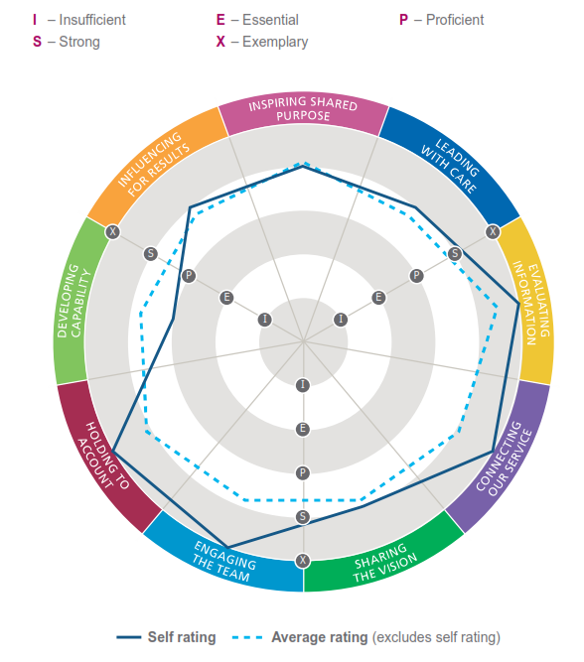

Reflection Two: Myers-Briggs Type Indicator (MBTI)
I am going to use Rolfe’s framework for reflective practice (Rolfe, Freshwater and Jasper, 2001) fr this reflection.
What? – describe the situation; achievements, consequences, responses, feelings, and problems
I have completed the MPTI Step II personality assessment (MBTI, 2018). The MBTI instrument was developed by Isabel Myer and Katherine Briggs as an application of Carl Jung’s theory of psychological types. The essence of the theory is that we have opposing ways of gaining energy (Extraversion or Introversion), gathering or becoming aware of information (Sensing or Intuition), deciding on or concluding about the information (Thinking or Feeling), and dealing with the world around us (Judging or Perceiving). MBTI Step II includes description of a person’s behaviour using 5 facets for each of the four categories of MBTI, therefore overall it lists 20 facets to describe a preference or a personality Type (Kummerow and Quenk, 2003). I have completed the MBTI questionnaire to help me become aware of my preferred personality style and to better understand and appreciate how people differ in personality. My personality type came as no surprise INTP (Introversion, Intuition, Thinking, Perceiving). I have enclosed the summary graphs of my personal report in figures 2 & 3.
So what? – discuss what has been learnt; learning about self, relationships, models, attitudes, cultures, actions, thoughts, understanding, and improvements
I have learnt that INTPs are typically logical, analytical and objectively critical. They like to find the principles underlying interesting ideas and develop additional principles. They organise ideas and knowledge rather than situations or people. They are curious and can become so absorbed in what they are doing that they lose track of time. INTPs are somewhat quiet and reserved. However, when a topic is of great interest to them, they have many theories and insights to offer and share with others. INTPs prefer the challenge of finding a solution to the challenge of implementing a solution. They consider opposing points of view in an objective, dispassionate manner, applying logic to sort through those views. INTPs are likely to be most satisfied in a work environment that values logic and allows them to work with autonomy. They want to follow their ideas and find the theoretical underpinnings for those ideas. People can count on them to identify the core of the situation and offer ideas to help others understand the situation logically. This is an accurate description of my personality.

I have a strong preference for abstract. I like to go beyond the surface and read between the lines. I have a strong preference for questioning. I use questions to clarify ideas. Although I have preference for thinking, I am concerned with how people will react to a decision that will hurt them. I prefer to use gentle persuasion to influence others. I am pressure-prompted. I am motivated by pressure. I am easily bored when not doing something. Success using this approach depends on excellent timing and planning skills. Reflecting back on how I managed my patient impact project, I am self-aware that my colleagues sometimes take my questioning style as challenging rather than helpful in resolving issues. I kept reminding myself to be clear about the intent of my questions and to be more accommodating of others. Although I am methodical in my approach, I was more tolerant of others who sometimes tended to plunge in without planning. I am self-aware that I am pressure-prompted when it comes to work. I have coped with this issue by setting myself early deadlines to complete tasks. This pressure of working at the last minute continues to be a weakness for me. It annoys me and adds stress that I can do without. I have paused several times in the past year to take stock of my workload and correct work-life imbalance. I had some success, but this continues to be work in progress.
Six different ways of evaluating information, called decision-making styles, have been identified based on two facets of the Thinking-Feeling dichotomy: Logical-Empathetic and Reasonable-Compassionate. My style is midzone with an underlying Thinking preference. I pay attention to the Thinking and Feeling perspectives when considering and making decisions. I continue to make decisions from either points of view, depending on the circumstances. In group problem-solving, I need to actively seek out people with different views. Ask for their concerns and perspectives. The essence of personality type involves the way information is gathered (Sensing and Intuition) and how decisions are made (Thinking and Feeling). Each type has favourite ways of doing these two things. The two middle letters of my four-letter type (S or N and T or F) show my favourite processes. Their opposites, whose letters don’t appear in my four-letter type, are third and fourth in importance for my type. INTPs use thinking mainly internally to analyse and logically reach conclusions and use intuition mainly externally to see possibilities and meanings. As an INTP, I rely too much on my thinking, I may forget to compliment people when I should and ignore the impact of my decisions on others.
Now what? – identify what needs to be done in order to; improve future outcomes, and develop learning
My action plan is to use the knowledge of my personality type to help me:
- better understand myself; knowing my own personality type helps me understand the assets and liabilities of my reactions
- understand others; knowing about personality type helps me recognise that other people may be different and to use these differences constructively
- Gain perspective; seeing myself and others in the context of type will help me appreciate the legitimacy of other points of view and improve my active listening skills
- Reading about personality type and observing myself and others from the standpoint of type will enrich my understanding of personality differences and encourage constructive uses of those differences

Figure 2:
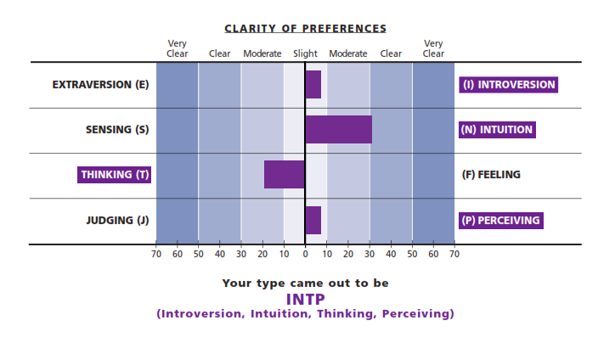
Figure 3: 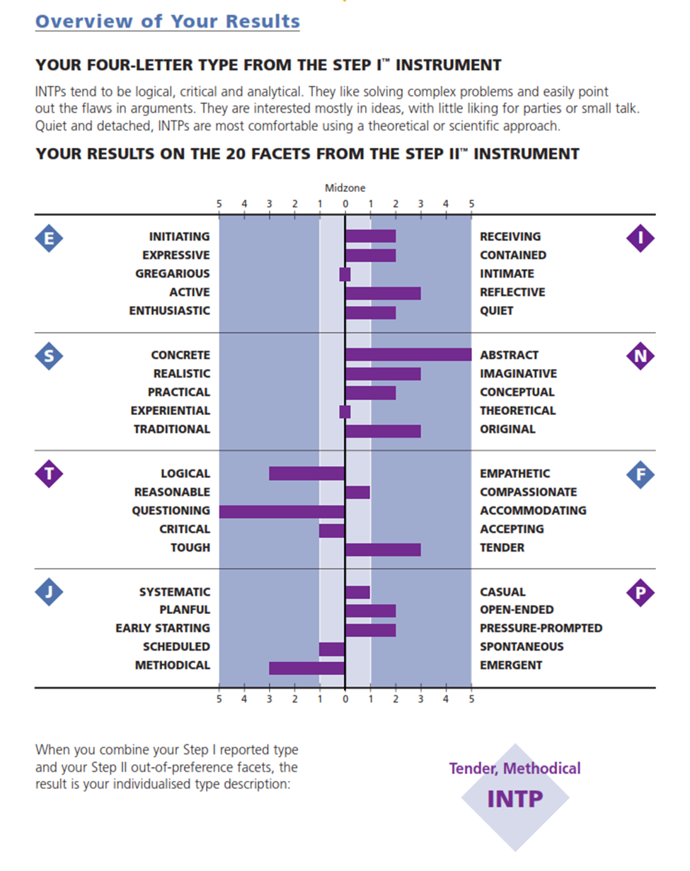

Reflection Three: Belbin Team Role Report
I am going to use Rolfe’s framework for reflective practice (Rolfe, Freshwater and Jasper, 2001) for this reflection.
What? – describe the situation; achievements, consequences, responses, feelings, and problems
I did not hear about Belbin Team role before this year. The Medical Leadership Programme provided this valuable learning opportunity. A team role is defined by Dr Meredith Belbin as “a tendency to behave, contribute and interact with others in a particular way” (Belbin, 2018). Belbin Team Roles are used to identify people’s behavioural strengths and weaknesses in the workplace. This information can be used to raise self-awareness and personal effectiveness and foster productive working relationships. Belbin Team Roles measure behaviour, not personality. The value of Belbin Team Role theory lies in enabling an individual or team to benefit from self-knowledge and adjust according to the demands made by the external situation. Sharing of Team Roles increase understanding and enables mutual expectations to be met. By identifying our team roles, we can ensure that we use our strengths to advantage and that we manage our weaknesses as best we can. Effective teams are usually comprised of between five and seven members and contained a blend of team role types.
My Belbin team role report was based on me completing a questionnaire. This report was based on self-perception only (figures 4 & 5). This self-analysis has allowed me to better understand myself and learn about my weaknesses as well as my strengths as a team member. Reflecting on my Belbin team role report, my strongest role preferences were resource investigator and specialist. As a resource investigator, I am enthusiastic to explore new opportunities. I am a specialist in the field of Neonatology. My preferred style is that of an enthusiastic expert, who has the confidence in a subject and enjoys exploring new ideas and opportunity in his chosen field. My patient impact project is in my specialist field of practice. I need to keep reminding myself not to get carried away, stop and listen to the team, be receptive to other team members’ ideas and Keep the team engaged from the beginning of a project.
So what? – discuss what has been learnt; learning about self, relationships, models, attitudes, cultures, actions, thoughts, understanding, and improvements
I am dynamic and entrepreneurial. I enjoy work where I can use my personal initiative. I do prefer to work in my field of neonatology, where my experience and ability counts for more management.
I am good at generating the drive and enthusiasm which can motivate others in my team. However, sometimes, I am inclined to press ahead and get things done without adequate consultation. I need to take this into consideration and ensure that I listen to my team and take the time to get them all onboard. Although I like to explore new fields of interests, I am reluctant to venture too far away from my specialist area. This presents me with something of a dilemma. The further I get involved in broader projects and activities, the less time I am present on the floor in the neonatal unit. I need to strike a balance and mange my work load and priorities effectively. A resource investigator is probably the most likeable member of the team. His response tends to be positive and enthusiastic. The resource investigator is the member of the team who goes outside the group and brings information, ideas and development back to it. He is rarely in his office. Within the team he is a good improvisor, active under pressure. The specialist is a dedicated individual who prides himself on acquiring technical skills and specialised knowledge. Priorities centre on maintaining professional standards and on furthering and defending their own field.
Now what? – identify what needs to be done in order to; improve future outcomes, and develop learning
As well as the strength or contribution they provide, each Team Role has an allowable weakness. This is a flipside of the behavioural characteristics, which is allowable in the team because of the strength which goes with it. By identifying my Team Roles, I can ensure that I am using my strengths to advantage and manage my weaknesses as best as I can. My action plan is to use the knowledge I have gained from Team Role analysis to help me:
- develop active listening skills.
- Review my work load and set my priorities for the coming year
- Explore time management tools as well as project management skills
Figure 4:
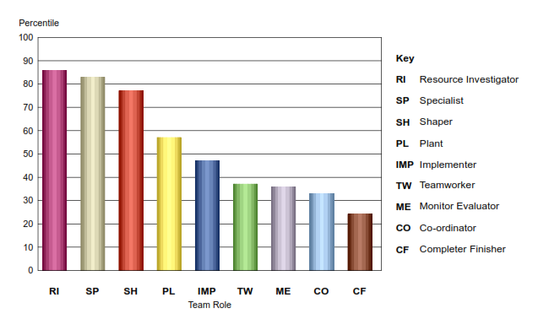
Figure 5:
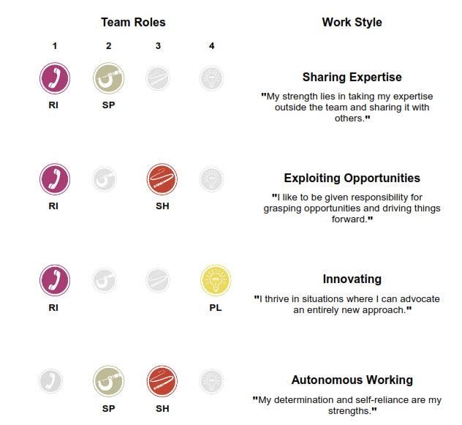
Reflection Four: Mental Toughness MTQ48 development report
I am going to use Kolb’s reflective model (Kolb 1984) for this reflection.
Experience: doing it
Mental toughness is about how effectively we respond when faced with stress, pressure and challenge. The MTQ48 instrument (AQR International, 2018) is a psychometric tool that measures and reports a person's Mental Toughness. Where many psychometric tests aim to measure how we behave and act, the MTQ48 explores how we think. Understanding how we think is essential if we are to change and develop our behaviours; to respond differently – our thinking drives our behaviour. It's an inside-out approach to change and development. The results of the MTQ48 test enables the user to pinpoint the areas for development, together with practical strategies for implementation. The MTQ48 assessment, developed by Clough, Earle, and Sewell (2002), is a unique 48 item high-quality psychometric measure that measures Mental Toughness which describes the mindset that every person adopts in everything they do (figure 6). It is closely related to qualities such as character, resilience, grit and perseverance.
The MTQ48 reports a person's mental toughness over 4 areas; Commitment, Challenge, Confidence, and Control- the 4 C’s:
- Challenge– seeing a challenge as an opportunity and getting comfortable with being uncomfortable
- Confidence– having high levels of self-belief and confidence in interpersonal interactions
- Commitment – goal setting and being able to stick to tasks
- Control – self-esteem, being comfortable in your own skin and managing emotions
Observations and reflections: reviewing and reflecting on the experience
My overall mental Toughness score was 10 out of 10. The report indicated that I am a person who has the capability to withstand a significant amount of stress. I felt good about that. However, I wanted to identify areas for improvement. I found out that I have some weakness in Emotional Control area, were I scored 7 out of 10. I have paused to explore this further. Whilst I may worry about important aspects of my life, I do not usually get this out of proportion. I normally remain cool, calm and collected but from time to time I may have difficulty in controlling my emotions. I tend to suppress these emotions and deal with them internally. I may appear physically upset from facial expressions or look more serious. To develop myself in this area, I need to remind myself repeatedly that what I do really matters. I need to recognise the difference between the things that can be controlled by me, the things that I can influence, and the things completely outside my control.
Development of ideas: learning from the experience
I am going to explore relaxation techniques, for example breathing exercises and walking may help me cope effectively with very stressful events. I am going to take time to understand the people around me – their strengths and their weaknesses and to recognise contributions made by others – and give praise where praise is due. I am going to take time to consider the impact of my ideas and my actions on others on whom I rely on to achieve goals. I am going to reflect on how they might be made comfortable with my approach to change and challenge. Highly confident individuals will always say yes when asked to do something, when sometimes it is better to say no. I am going to look at time management tools and techniques to help you organise things better. I plan to reorganise my work schedule and aim to reduce my workload. I need to watch out for over-confidence. I am more aware that sometimes I dominate my team to the point of inhibiting others. I need to try to be quiet in meetings from time to time; allowing other people to contribute and have their say. I am definitely going to develop my active listening skills over the next six months.
A key developmental goal for me for the year ahead is to further develop myself as a transformational leader. Transformational leadership is a style that involves generating a vision for the organization and inspiring followers to meet the challenges that it sets, leader's ability to appeal to the higher values and motives of followers and to inspire a feeling of loyalty and trust. While transactional leadership is a style based on the setting of clear goals and objectives for followers and the use of rewards and punishments to encourage compliance. Bernard M. Bass, an early theorist of transformational leadership, said that it occurs when “leaders broaden and elevate the interests of their employees, when they generate awareness and acceptance of the purposes and mission of the group, and when they stir their employee to look beyond their own self-interest for the good of the group”. Stone, Russell and Patterson (2004) argue the transformational leader’s focus is “directed towards the organisation, and his or her behaviour builds follower commitment toward organisational objectives, while the servant leader’s focus is on the followers, and the achievement of organisational objectives is a subordinate outcome”.

Figure 6: (Adapted from AQR International, 2018)
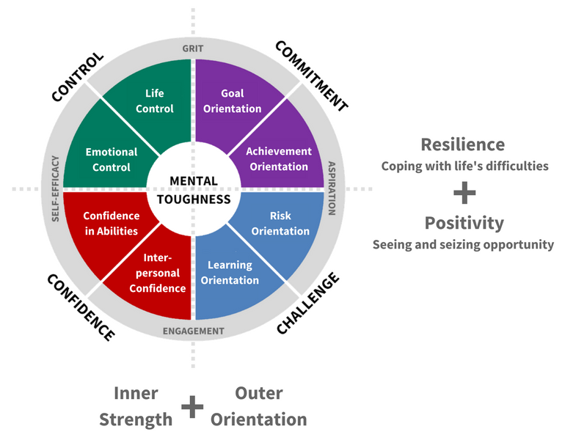

Reflection Five: Influencing styles - Push-Pull Questionnaire
I am going to use the Six Thinking Hats model for this reflection.
The White Hat: Facts, figures and description
Influencing is defined as the ability to affect others’ attitudes, beliefs and behaviours without using force or formal authority (Dent & Brent, 2006). Influencing is essentially an interpersonal and communication skill that largely depends on your ability to interact with others in a way that appeals to them, to gain their attention and commitment.
In a Medical Leadership Programme workshop, I got to learn about influencing skills. There are many different styles of influencing and it is important to recognise which styles will work for different situations. There are two main influencing styles – Push and Pull and within each style there are two sub-styles: Push – directive and persuasive reasoning & Pull – collaborative and visionary (Dent, 2018). Push styles are about moving a person to change their viewpoint. Pull styles are about motivating a person to see the possibilities of changing their viewpoint. Engaging with my team and building relationships requires careful choice of influencing style as a leader. This is particularly important when dealing with and planning major service changes. The push/pull model explores the ways in which leaders exert influence to reach organisational goals. Influence is exerted through a mixture of two different styles. It is either forced (pushed), or encouraged (pulled).
I have completed the Push- Pull questionnaire (Ctr, 2018), which is based on self-perception. The purpose of this 'diagnostic toot' is to help assess the leader’s influencing skills and create awareness of two particular styles of influencing, Push and Pull. My overall Push-Pull scores were almost equally balanced. I have a slight preference for joint problem solving, persuasion and bridging consensus. My scores were spread across the different Push and Pull influencing styles.
The Red Hat: Express your feelings
It was reassuring to me to know that I have no strong influencing style preference. I have balanced approach and not limited in choice of influencing styles. Learning about influencing styles in a special workshop as part of the Medical Leadership was quite empowering for me. I have enjoyed participating in the exercises and the opportunities to practice various influencing styles and techniques.
The Black Hat: What could be improved?
I need to further develop my influencing skills. Understanding my influencing styles is helping me develop as a leader. I am reading more literature abut influencing styles and use new knowledge to critically reflect my own influencing styles.
I have had a great year learning and enhancing my experience as a leader. I look forward to the future with confidence and enthusiasm to make a positive impact in all my pursuits.

Bibliography:
Al-Sawai, A. (2013) “Leadership of Healthcare Professionals: Where Do We Stand?”, Oman Medical Journal, 28 (4), pp. 285-287.
AQR International (2018) Mental Toughness MTQ48. Available at: https://aqrinternational.co.uk/mtq48-mental-toughness-questionnaire
[Accessed 23/11/2018]
Bass, B.M. (1990) “From Transactional to Transformational Leadership: Learning to Share the Vision. Organizational Dynamics”, 18, pp. 19-31. http://dx.doi.org/10.1016/0090-2616(90)90061-S
Bulman, C. and Schutz, S. (2008) Reflective Practice in Nursing. Chichester: Blackwell.
Boyd, E. and Fales, A. (1983) “Reflective Learning: The Key to Learning from Experience”. Journal of Humanistic Psychology, 23 (2), pp. 99-117.
Clough, P. J., Earle, K. and Sewell, D. (2002) “Mental toughness: the concept and its Measurement”. In I. Cockerill (Ed.), Solutions in Sport Psychology, pp. 32-43. London: Thomson.
Ctr Training & Consultancy (2018) Influencing styles - Push and Pull Questionnaire. Available at: http://www.ctrtraining.co.uk/documents/PushMePullYouDiagnosticTool.pdf
[Accessed 23 November 2018]
Dalton, G. W., Thompson, P. H., and Price, R. L. (1977) “The four stages of professional careers- A new look at performance by professionals”. Organizational Dynamics, 6(1), pp. 19-42. https://doi.org/10.1016/0090-2616(77)90033-X.
De Bono, E. (2016) Six Thinking Hats. Little, Brown and Co: London.
Dent, F.E., 2018. Influence with style. [pdf]. Available at: http://tools.ashridge.org.uk/Website/IC.nsf/wFARATT/Influence%20with%20Style/$file/InfluenceWithStyle.pdf
[Accessed 12 September 2018].
Dewey, J. (1933) How We Think, New York: D. C. Heath.
Gibbs, G. (1988) Learning by Doing: A guide to teaching and learning methods. Further Education Unit. Oxford Polytechnic: Oxford.
Goleman, D. (2017) Leadership That Gets Results. Reprint ed. Harvard Business Review Press.
Hatton, N. and Smith, D. (1995) “Reflection in teacher education: Towards definition and implementation”. Teaching and Teacher Education, 11(1), pp. 48-49.
Hersey, P. and Blanchard, K.B. (1977) Management of Organisational Behaviour: Utilizing Human Resources. 3rd Edition, Englewood Cliffs, N.J.: Prentice-Hall.
Hunsaker, P.L., Alessandra, T. and Alessandra, A.J. (2008) The new art of managing people, updated and revised: Person-to-person skills, guidelines, and techniques every manager needs to guide, Direct, and Motivate the Team. Simon and Schuster Inc, New York NY, USA.
Kline, N. (2015) More Time to Think. 2nd edition. London: Cassell Illustrated.
Kline, N. (1999) Time to Think: Listening to Ignite the Human Mind. 1st edition. London: Cassell Illustrated.
Kolb, D.A. (1984) Experiential learning: experience as the source of learning and development. Englewood Cliffs, NJ: Prentice Hall.
Kummerow, J.M and Quenk, N.L. (2003) Understanding your MBTI Step II Results: A step-by-step guide to your unique expression of Type. CPP. Unites States of America.
Moon, J. A. (2004) A Handbook of Reflective and Experiential Learning: Theory and Practice, London: Routledge Falmer.
Murray, M., Kujundzic, N., (2005) Critical Reflection: A Textbook for Critical Thinking. Québec, Canada: McGill-Queen’s University Press.
Myers-Briggs Type Indicator instrument (2018) The Myers & Briggs Foundation. Available at: https://www.myersbriggs.org/
[Accessed 12 September 2018].
NHS Leadership Academy (2018) Healthcare leadership model 360 degree feedback tool.
Available at: https://www.leadershipacademy.nhs.uk/resources/healthcare-leadership-model/supporting-tools-resources/healthcare-leadership-model-360-degree-feedback-tool/
[Accessed 23 November 2018].
NHS Leadership Academy (2018) The nine leadership dimensions.
Available at: https://www.leadershipacademy.nhs.uk/resources/healthcare-leadership-model/nine-leadership-dimensions/
[Accessed 12 September 2018].
Rolfe, G., Freshwater, D. and Jasper, M. (2001) Critical reflection in nursing and the helping professions: a user’s guide. Basingstoke: Palgrave Macmillan.
Schon, D.A. (1983) The Reflective Practitioner. Temple Smith: London.
Belbin (2018) Belbin Team Roles. Available at: https://www.belbin.com/
[Accessed 12 Septembers 2018].
Stone, A. G., Russell, R. F. and Patterson, K. (2004) “Transformational versus servant leadership: A difference in leader focus”. Leadership & Organization Development Journal, 25(4), pp.349-361.

