Heritage & the Heritage Industry
AHHE4001

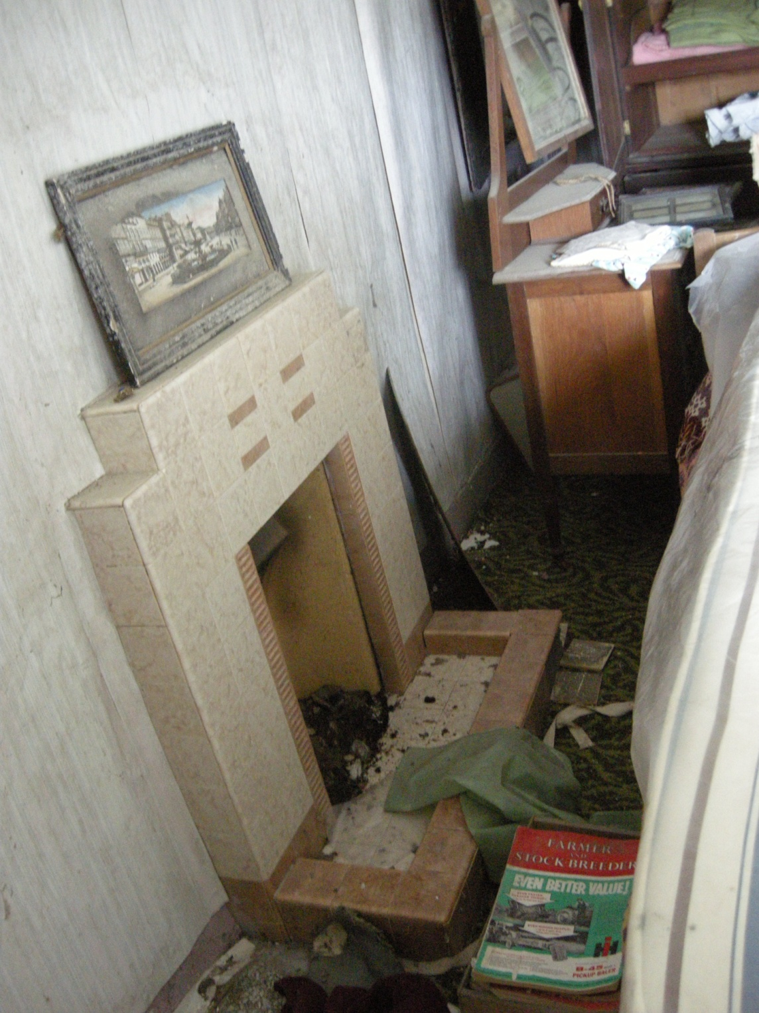

AHHE4001 Lecture programme:
Thursdays 9.00am – 13.00am – Tucker 02

6th Oct what is heritage?
13th Oct museum approaches
20th Oct authenticity
27th Oct Llanerchaeron field class
3rd Nov technologies
7th – 11th Nov READING WEEK
17th Nov Carmarthen Museum field class
Tuesday 13th Dec (midnight) ESSAY 1 DUE
24th Nov heritage that hurts
1st Dec community heritage
8th Dec Newport ship field class

15th Dec politics of heritage – Newport ship
TBC heritage management workshop
Tuesday 24th Jan (midnight) ESSAY 2 DUE

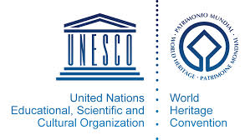

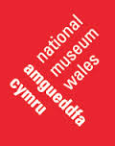

Assessment pattern
100% course work consisting of 2 x 2500 word essays (50% each)

Essay 1 (2500 words – 50% of overall assessment)
Choose one of the following questions:
- what are the main issues that confront the museum sector today
- how important is authenticity within the heritage sector
- using examples, discuss how technology may enable heritage management and presentation

Essay 2 (2500 words – 50% of overall assessment)
Choose one of the following questions:
- drawing on a particular example of your choice, discuss how communities may engage with their heritage
- does heritage have ethical boundaries
- where next for the ‘Newport Ship’?

General Bibliography
Benton, R. (2010) Understanding Heritage and Memory (Understanding Global Heritage). Manchester: Manchester University Press
Cleere, H (ed.) (1989) Archaeological Heritage Management in the Modern World. London: Routledge
Fairlough, G. et al (2008) The Heritage Reader. London: Routledge
Harrison, R. (2010) Understanding the Politics of Heritage (Understanding Global Heritage). Manchester: Manchester University Press
Hirsch, E (2006) ‘Landscape, Myth and Time’ in Journal of Material Culture 11 (1/2): 151-165
Hobsbawn, Eric and T. Ranger (eds) (1983) The Invention of Tradition. Cambridge: Cambridge University Press.
Labadi, S and C. Lang (2010) Heritage and Globalisation, London: Routledge
Lowenthal, David (1985) The Past in a Foreign Country Cambridge: Cambridge University Press (Chapter 1 and 6)
Lowenthal, David (1998) The Heritage Crusade and the Spoils of History. Cambridge: Cambridge University Press
West, S. (2010) Understanding Heritage In Practice (Understanding Global Heritage). Manchester: Manchester University Press

Web resources
www.unesco.org.uk
http://whc.unesco.org/
www.cadw.wales.gov.uk
http://www.english-heritage.org.uk
http://www.icomos.org/en/
http://www.museumwales.ac.uk

Bibliography

what is heritage and the heritage ‘industry’?
Adorno, T (2001) The Culture Industry: Selected Essays on Mass Culture. London: Routledge
Carman, John (2005) Against Cultural Property: Archaeology Heritage and Ownership, Duckworth Debates in Archaeology (Chapter 5)
Clifford, James (1988) The Predicament of Culture: Twentieth-Century Ethnography, Literature, and Art. Cambridge, Mass: Harvard University Press (On collecting art and culture’, pp215-251)
English Heritage. (2008) ‘Sustaining the Historic Environment: New Perspectives on the Future’ in The Heritage Reader, G. Fairclough et al (eds), pp. 313-322. London: Routledge
Fairclough, G. (2008) ‘New Heritage, A Introductory Essay – People, Landscape and Change’ in The Heritage Reader, G. Fairclough et al (eds), pp. 297-312. London: Routledge
Harrison, R (2010) ‘What is Heritage’ in Understanding the Politics of Heritage, R. Harrison (ed.), pp. 5-43. Manchester: Manchester University Press

Harrison, R and A. Linkman (2010) ‘Critical Approaches to Heritage’ in Understanding the Politics of Heritage, R. Harrison (ed.), pp. 5-43. Manchester: Manchester University Press
Hewison, R (1999 [1987]) ‘The Climate of Decline’ in Representing the Nation: A Reader. Histories, Heritage and Museums, D. Boswell and J. Evans (eds), pp. 151-162. London: Routledge in association with The Open University
Hewison, R (1987) The Heritage Industry: Britain in a Climate of Decline. London: Methuen

Reburial and Human Remains: Introducing Heritage and Human Rights

Bray, L and T. Killon (eds.) (1994) Reckoning with the Dead: The Larsen Bay Repatriation and the Smithsonian Institution. Washington: Smithsonian Institution Press

Kramer, J (2004) ‘Figurative repatriation: First Nations ‘artist-warriors’ recover, reclaim, and return cultural property through self-definition. Journal of Material Culture 9(2): 161-82

Krmpotich, C et al. (2010) The substance of bones: The emotive materiality and affective presence of human remains. Journal of Material Culture 15(4): 371-84

Krmpotich, C. (2010) Remembering and Repatriation: The Production of Kinship, Memory and Respect. Journal of Material Culture 15(2): 157-179

Meskell, L. (2010) Human Rights and Heritage Ethics.Anthropological Quarterly 83(4): 839-59.

Nash, S. E. And C. Colwell-Chanthaphonh (2010) NAGPRA after Two Decades.Museum Anthropology 33(2): 99-104.

Silverman, H and D. Fairchild Ruggles (ed.) (2008) Cultural Heritage and Human Rights. London: Springer

Strathern, M (2004) ‘The Whole Person and its Artifacts.Annual Review of Anthropology 33: xiv, 1-19

Watkins, J. (2003) Beyond the Margin: American Indians, First Nations, and Archaeology in North America. American Antiquity 68(2): 273-85

Cultural Restitution: Cultural Rights
Brodie, N. et al (eds.) (2001) Trade in Illicit Antiquities: The Destruction of the World’s Archaeological Heritage. Cambridge: McDonald Institute
Cleere, H. (1993) Managing the Archaeological Heritage, Antiquity 67: 255: 400-402.
Greenfield, J. (1986) The Return of Cultural Property, Antiquity 60: 29-35.
Greenfield, J. (1989) The Return of Cultural Treasures. Cambridge: CUP
O’Keefe, P. (1993) The European Convention for the Protection of Archaeological Heritage, Antiquity 67: 255: 406-413.

Intangible Cultural Heritage
Brown, M.F. Can Culture Be Copyrighted? Current Anthropology 39(2): 193-222.
Harrison, R. and D. Rose (2010) ‘Intangible Heritage’ in Understanding Heritageand Memory (Understanding Global Heritage). R. Benton (ed.), pp 238-276 Manchester: Manchester University Press
Kurin, R (2004) ‘Safeguarding Intangible Cultural Heritage in the 2003 UNESCO Convention: A Critical Appraisal’, Museum International 56(1-2): 66-77

Managing and Presenting Heritage: Education, Entertainment and Economics
Fairlough, G. et al (2008) The Heritage Reader. London: Routledge
Hooper-Greenhill, Eileen (1992) Museums and the Shaping of Knowledge, London: Routledge
Greenhalgh, Paul (1989) ‘Education, Entertainment and Politics: Lessons from the Great International Exhibitions’ in The New Museology P. Vergo (ed) pp 74-98 London: Reaktion Books
West, S. and E. McKellar (2010) ‘Interpretation of Heritage’ in Understanding Heritage in Practice (Understanding Global Heritage) S. West (ed.). Manchester: Manchester University Press

Tourist Trails: The Commodification of Heritage
Bender, Barbara (1998) Stonehenge: Making Space Oxford: Berg
Boniface, P. (1995) Managing Quality Cultural Tourism. London: Routledge
Boniface, P. and P.J. Fowler (1993) Heritage and Tourism in the ‘Global Village”. London: Routledge
Hamilakis, Y. and P. Duke (eds.) (2007) Archaeology and Capitalism: From Ethics to Politics (One World Archaeology). Walnut Creek, CA: Left Coast Press
Kurst, M. (2010) ‘Heritage and Tourism’ in Understanding Heritage in Practice (Understanding Global Heritage) S. West (ed.) pp. 205-239. Manchester: Manchester University Press
Stone, P. (2008) ‘Stonhenge – A Final Solution’ in The Heritage Reader, G. Fairclough et al (eds), pp. 524-535. London: Routledge
Watson, Steve (2000) ‘Theorising Heritage Tourism: A Review’ in Tourism and Heritage Relationships: Global, National and Local Perspectives M. Robinson, N. Evans, P. Long, R. Sharpley and J. Swarbrooke (eds) pp. 449-465 Sunderland: Centre for Travel and Tourism in association with Business Education Publishers

the Local Community

Breglia, L. (2006) Monumental Ambivalence: The Politics of Heritage. Austin, TX: University of Texas Press
Dodd, Jocelyn (1999 [1994]) ‘Whose museum is it anyway? Museum education and the community’ in The Educational Role of the Museum, E. Hooper-Greenhill (ed) London: Routledge
Hampton, M. (2005) ‘Heritage, Local Communities and Economic Development’, Annals of Tourism Research 32(3): 735-59.
Hodder, I. (2010) ‘Cultural Heritage Rights: From Ownership and Descent to Justice and Well-Being’ Anthropological Quarterly 83(4): 861-882
Jones, C. and M. Munday (2001) ‘Blaenavon and United Nations World Heritage Site Status: Is Conservation of Industrial Heritage a Road to Local Economic Development?’,Regional Studies 35(6): 585-90

Economic Exploitation of Heritage: Commodification, Tourism and Sustainable Development
Bender, Barbara (1998) Stonehenge: Making Space Oxford: Berg
Boniface, P. (1995) Managing Quality Cultural Tourism. London: Routledge (Especially Part 3)
Boniface, P. and P.J. Fowler (1993) Heritage and Tourism in the ‘Global Village”. London: Routledge
Breglia, L. (2006) Monumental Ambivalence: The Politics of Heritage. Austin, TX: University of Texas Press
Carman, John (2005) Against Cultural Property: Archaeology Heritage and Ownership, Duckworth Debates in Archaeology
Hamilakis, Y. and P. Duke (eds.) (2007) Archaeology and Capitalism: From Ethics to Politics (One World Archaeology). Walnut Creek, CA: Left Coast Press
Hampton, M. (2005) ‘Heritage, Local Communities and Economic Development’, Annals of Tourism Research 32(3): 735-59.
Hinsley, Curtis (1991) ‘The World as Marketplace: Commodification of the Exotic at the World’s Columbian Exposition, Chicago, 1893’ in Exhibiting Cultures: The Poetics and Politics of Museum Displays I. Karp and S. Lavine (eds) pp 344-365 Washington, D.C.: Smithsonian Institution Press.
Kurst, M. (2010) ‘Heritage and Tourism’ in Understanding Heritage in Practice (Understanding Global Heritage) S. West (ed.) pp. 205-239. Manchester: Manchester University Press
Lafrenz Samuels, K. (2010) ‘Material Heritage and Poverty Reduction’ in Heritage and GlobalisationS. Labadi and C. Lang (eds), pp. 202-217. London: Routledge
Moffatt, Ian (2000) ‘Kakadu: Managing Sustainable Tourism in a World Heritage Site’ in Tourism and Heritage Relationships: Global, National and Local Perspectives M. Robinson, N. Evans, P. Long, R. Sharpley and J. Swarbrooke (eds) pp 301-313 Sunderland: Centre for Travel and Tourism in association with Business Education Publishers
Ray, C. (1998) Culture, Intellectual Property and Territorial Rural Development.SociologiaRuralis 38(1): 3-20
Stone, P. (2008) ‘Stonhenge – A Final Solution’ in The Heritage Reader, G. Fairclough et al (eds), pp. 524-535. London: Routledge
Watson, Steve (2000) ‘Theorising Heritage Tourism: A Review’ in Tourism and Heritage Relationships: Global, National and Local Perspectives M. Robinson, N. Evans, P. Long, R. Sharpley and J. Swarbrooke (eds) pp. 449-465 Sunderland: Centre for Travel and Tourism in association with Business Education Publishers

Heritage and Nationalism
Anderson, B. (2006 [1983] Imagined Communities: Reflections of the Origin and Spread of Nationalism. London: Verso. Available as an e-book.
Allen, R (2010) ‘Heritage and Nationalism’ in Understanding the Politics of Heritage, R. Harrison (ed.), pp. 197-233. Manchester: Manchester University Press.
Appadurai, A et al (2008) ‘The Globalization of Archaeology and Heritage: A Discussion with Arjun Appadurai’ in The Heritage Reader, G. Fairclough et al (eds), pp. 209-218. London: Routledge
Askew, M. (2010) ‘The Magic List of Global Status, UNESCO, World Heritage and the agendas of states’ in Heritage and Globalisation S. Labadi and C. Lang (eds), pp. 19-44. London: Routledge
Boswell, D. and J. Evans (eds.) (1999) Representing the Nation: A Reader. Histories, Heritage and Museums, London: Routledge in association with The Open University
Friedman, Jonathan (1992b) ‘The Past in the Future: History and the Politics of Identity’ in American Anthropologist 94 (4): 837-859.
Kohl, Philip L and Clare Fawcett (eds) (1995) Nationalism, Politics and the Practice of Archaeology Cambridge: Cambridge University Press
McCann, W.J. (1990) ‘Volk and Germanentum: The Presentation of the Past in Nazi Germany’ in The Politics of the Past P. Gathercole and D. Lowenthal, (eds) pp. 74-90. London: Unwin Hyman
Hall, S. (2008) ‘Whose Heritage? Unsettling ‘The Heritage’, re-imagining the post-nation’ in The Heritage Reader, G. Fairclough et al (eds), pp. 219-229. London: Routledge.
Hobsbawm, Eric (1990) Nations and Nationalisms since 1780: Programme, Myth, Reality. Cambridge: Cambridge University Press.

Conflict Heritage
Beck, C, Johnson, W & Schofield, J (Eds) (2002) Materiel Culture: The Archaeology of 20th Century Conflict (One World Archaeology) Routledge
Breglia, L. (2006) Monumental Ambivalence: The Politics of Heritage. Austin, Texas: University of Texas Press.
Carman, J (2006) Bloody Meadows: Investigating Landscapes of Battle The History Press Ltd
Cleere, H (1989) Archaeological heritage management in the modern world (One World Archaeology, 9) London ; Boston : Unwin Hyman 930.1 ARC
Cooksey, J & Lynch, T (2007) Battlefield Archaeology The History Press Ltd
Fairclough, G. et al (2008) The Heritage Reader. London: Routledge
Gerstenblith, P (2009) Archaeology in the Context of War: Legal Frameworks for Protecting Cultural Heritage during Armed Conflict Archaeologies, 5, no. 1 (2009): 18-31
Harrison, R & Schofield, J (2010) After Modernity: Archaeological Approaches to the Contemporary Past OUP Oxford
Krech, S (1993) Battlefield archaeology under fire Nature, v365 n6442 (19930909): 116-116
Layton, R; Thomas, J & Stone, P (2001) Destruction and conservation of cultural property (One World Archaeology, 41) London ; New York : Routledge, 930.1 DES
Lowenthal, D (1998) The Heritage Crusade and the Spoils of History. Cambridge: Cambridge University Press
Moshenska, G (2010) Charred churches or iron harvests?: Counter-monumentality and the commemoration of the London Blitz Journal of Social Archaeology, v10 n1 (2010 02 01): 5-27 PER 930.1
Orr, D (2003) Landscapes of Conflict Historical Archaeology, 37, Part 3 (2003): 1-2 PER 930.1
Pollard, T & Banks, I (2007) Scorched Earth: Studies in the Archaeology of Conflict Brill
Ryan, C (2007) Battlefield Tourism: History, Place and Interpretation (Advances in Tourism Research) Elsevier Science
Saunders, N & Cornish, P (Eds) (2009) Contested Objects: Material Memories of the Great War Routledge
Schofield, J (2005) Combat Archaeology: Material Culture and Modern Conflict (Duckworth Debates in Archaeology) Gerald Duckworth & Co Ltd
Schofield, J (2009) Aftermath: Readings in the Archaeology of Recent Conflict: Readings in Contemporary Conflict and Battlefield Archaeology Springer
Shackel, P (2003) Archaeology, Memory, and Landscapes of Conflict Historical Archaeology, 37, Part 3 (2003): 3-13 PER 930.1
Starzmann, M (2008) Cultural Imperialism and Heritage Politics in the Event of Armed Conflict: Prospects for an `Activist Archaeology' Archaeologies, 4, no. 3 (2008): 368-389
Stone, P (2011) Cultural Heritage, Ethics, and the Military Boydell Press
Uzzell, D &Ballantyne, R. (2008) ‘Heritage that Hurts: Interpretation in the Postmodern World’ in The Heritage Reader, G. Fairclough et al (eds), pp. 502-512. London: Routledge
Wilson, R (2009) Memory and trauma: Narrating the Western Front 1914-1918 Rethinking History, 13, no. 2 (2009): 251-267 PER 905
Winter, J (1995) Sites of memory, sites of mourning : the Great War in European cultural history Cambridge ; New York : Cambridge University Press 940.3 WIN

Media and New Technologies
Blockley, M. (2006) Heritage Interpretation. London: Routledge
Gero, Joan and Root, Delores (1990) ‘Public Presentations and Private Concerns: Archaeology in the pages of the National Geographic’ in The Politics of the Past P. Gathercole and D. Lowenthal, David (eds) London: Unwin Hyman
Jameson Jnr, J.H. (2008) ‘Presenting Archaeology to the Public, Then and Now: An Introduction’ in The Heritage Reader, G. Fairclough et al (eds), pp. 427-456. London: Routledge
Lutz, C and J.L. Collins (1993) Reading National Geographic. Chicago: Chicago University Press
Uzzell, D and R. Ballantyne (2008) ‘Heritage that Hurts: Interpretation in the Postmodern World’ in The Heritage Reader, G. Fairclough et al (eds), pp. 502-512. London: Routledge
Walsh, Kevin (1992) The Representation of the Past: Museums and Heritage in the Postmodern World, London: Routledge (Chapter 5)
Walter, Tony (2004) ‘Plastination for Display: A New Way to Dispose of the Dead’ in Journal of the Royal Anthropological Institute 10(3): 603-27

Museums and the Viewers’ Gaze
Appadurai, A. (1988) The Social Life of Things: Commodities in Cultural Perspective. Cambridge: Cambridge University Press
Bennett, Tony (1995) The Birth of the Museum: History, Theory, Politics London: Routledge (Chapter 5)
Carbonell, B.M. (2004) Museum Studies: An Anthology of Contexts. Malden, MA: Blackwell Publishing
Fairlough, G. et al (2008) The Heritage Reader. London: Routledge (Especially the range of chapters in Section Three)
Hooper-Greenhill, Eileen (1992) Museums and the Shaping of Knowledge, London: Routledge
Kaplan, F. S. (1994) Museums and the Making of ‘Ourselves’: The Role of Objects in National Identity. London and New York: Leicester University Press
Lumley, Robert (1988) ‘Introduction’ in The Museum Time Machine: Putting Cultures on Display R. Lumley (ed) pp 3-22 London: Routledge
Tilley, Christopher (1991) ‘Interpreting Material Culture’ in The Meanings of Things: Material Culture and Symbolic Expression I. Hodder (ed) 185-194 London: HarperCollins Academic
Simpson, M. (2001) Making Representations: Museums in the Post-Colonial Era. London: Routledge.
Vergo, Peter (1989) ‘The Reticent Object’ in The New Museology P. Vergo (ed) pp 41-59 London: Reaktion Books
Urry, J. (1999) ‘Gazing on History’ in Representing the Nation: A Reader. Histories, Heritage and Museums, D. Boswell and J. Evans (eds), pp. 151-162. London: Routledge in association with The Open University
Walsh, Kevin (1992) The Representation of the Past: Museums and Heritage in the Postmodern World, London: Routledge (Introduction)
West, S. and E. McKellar (2010) ‘Interpretation of Heritage’ in Understanding Heritage in Practice (Understanding Global Heritage) S. West (ed.). Manchester: Manchester University Press
The Politics of the Past
Hirsch, E (2006) ‘Landscape, Myth and Time’ in Journal of Material Culture 11 (1/2): 151-165
Hobsbawn, Eric and T. Ranger (eds) (1983) The Invention of Tradition. Cambridge: Cambridge University Press.
Lowenthal, David (1985) The Past in a Foreign Country Cambridge: Cambridge University Press (Chapter 1 and 6)
Lowenthal, David (1998) The Heritage Crusade and the Spoils of History. Cambridge: Cambridge University Press

