assignment 2: Practical & Professional Development
Changemakers: Creativity & Value Creation Ben Jones (2405039)

Contents
Introduction 2
Practical Development/Implementation 2
Initial Feedback 2
Implementation 3
Enterprise 5
PEST Analysis 7
Project Feedback and Reflection 8
Appendices 10
JavaScript code used in the app 10
Project Progress Sheets 18
References 20

Introduction

The ever-growing advancement in digital technology is changing the way that individuals go about their day-to-day lives. In the context of my project, I will be looking into the innovative impact that mobile and web applications can have. They are able to offer opportunities to address real-world challenges through creative solutions. This report will aim to outline the planning, reflection, development and implementation of an innovative application designed to meet user needs. This application will be a useful tool that will allow people to track their calories and steps, support their fitness goals, and offer useful feedback from an artificial intelligence assistant.
By discussing each stage of this project, the report will demonstrate the technical and creative skills involved in the development of the app as well as the critical thinking and continuous improvement involved. Fundamentally, this report highlights how innovation can be effectively applied to create substantial digital solutions.

Practical Development/Implementation

Initial Feedback

To be able to gain initial feedback of my project idea prior to its development, I created a simple questionnaire to ask crucial questions. These questions were able to help me gather people’s thoughts on my project idea and design work. I used Microsoft Forms to achieve this and gathered a few responses from some of my peers.
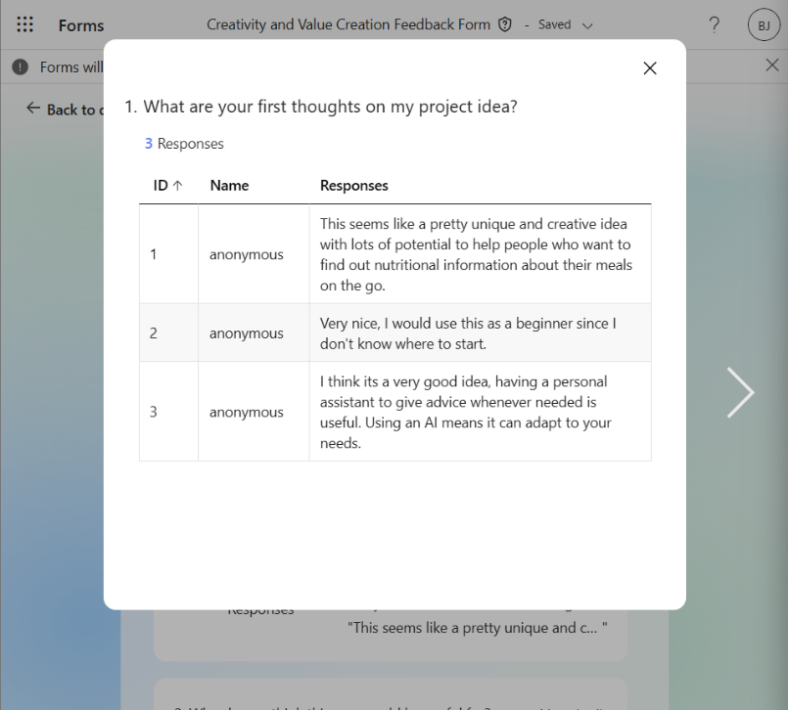
The first question on my questionnaire was for my respondents to share their initial thoughts on my project idea. All of the respondents seemed to enjoy the idea of my project and all stated that they’d be open to using the app and confident that it would be very useful.
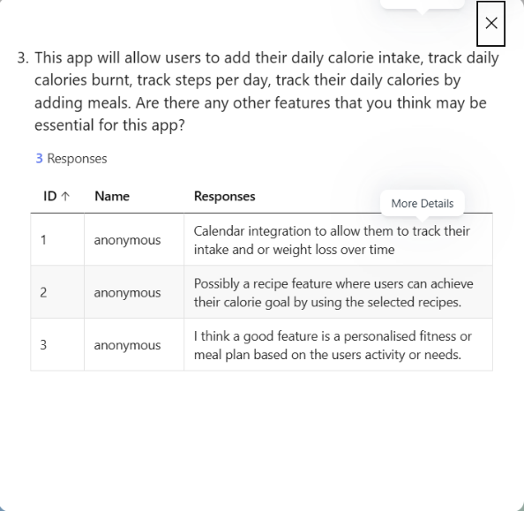
I then asked who they think would benefit the most from the app. Where they said anyone from beginners who are unfamiliar with health and fitness to people who are passionate about dieting, bodybuilding or athletes. It was also mentioned that it can be helpful for those who are unable to afford help from experts like personal trainers.
I then listed the numerous features that would be included in the app and asked whether there were any other features that they could suggest. One respondent mentioned that integrating a calendar system would further support the tracking of calorie intake and weight change over time. Another said that a recipe feature where users can create and save personal recipes as well as premade recipes. Another feature mentioned was to include personalised details such as fitness routines or meal plans based on the individual.

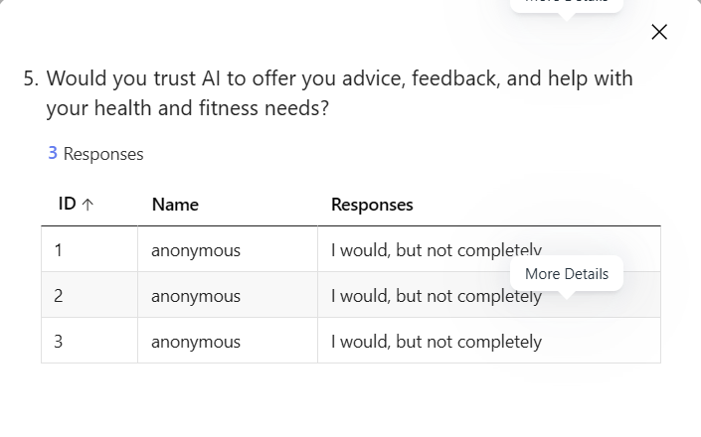
I then asked how often the respondents would likely use the app, and they all offered positive responses stating that they would use the app often, and some even saying that they would use it on a daily basis.
The final question that I decided to ask was if the respondents would trust AI to offer them advice, feedback, and support with their health and fitness needs. Where the respondents all answered with yes, but not completely. This isn’t a surprising answer as even though AI is seeming to be more and more impressive by the day, AI can still offer inaccuracies. Potentially with the future growth of AI, maybe this answer would change in the future.
Using all of this useful feedback from my peers, I would likely implement the recipe feature that was mentioned. This would offer the user more freedom on the app to be able to use their own custom recipes as well as be able to use recipes from other users to assist them with their goals.

Implementation

To bring this project to life, I made use of the programming language JavaScript to write my code. I created this code via Visual Studio 2022, which is a great platform for writing and testing code. All of the code that has been used is included in the appendices.

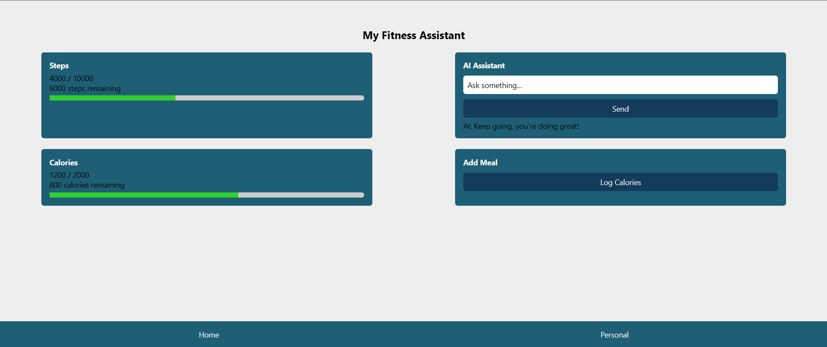

The screenshot above is what my home screen looks like. It is comprised of a step counter/tracker, a calorie tracker, the AI assistant, and the button to be able to log calories. The design is very simplistic whilst ensuring that everything that the user needs is on the home page. Along the bottom is the navigation bar, which also includes a personal page. This page includes text boxes for the user to enter their name, weight, and number of steps they wish to aim for every day.
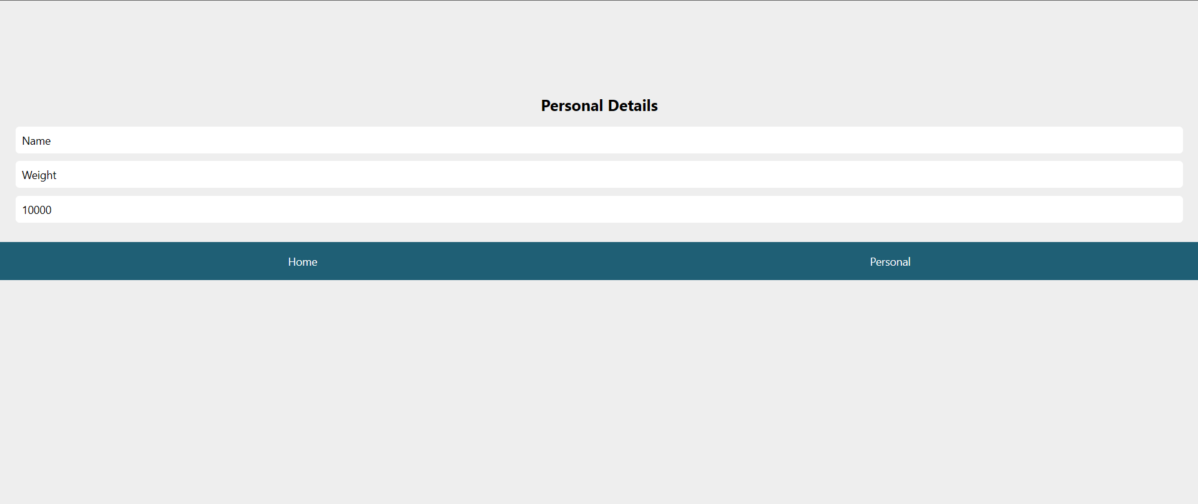
When the user clicks the log calories button, they are sent to another page where they can enter the type of food they have eaten and the weight of that food.
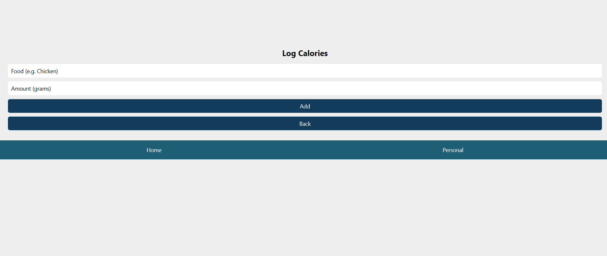
In terms of the AI assistant, I very much struggled to get this idea physically working as I have not worked with JavaScript before and found it immensely difficult to achieve. To help with the implementation of this, I made use of ChatGPT to help with code as well as any troubleshooting issues I came across. This was a massive help in making sure parts of my code were working correctly. To be specific, there was one stage of the development process where I couldn’t get back and forth between the different pages. This was due to a syntax error that ChatGPT had found and helped me resolve.

Enterprise

After some careful consideration over a few potential start-up names, I have decided on MacroAI. I think that this is a great, straightforward, and easy to market name that is simplistic. A few names that were in contention were MacroMind, MacroMates, and BiteWise. However, these names were already taken in the UK.
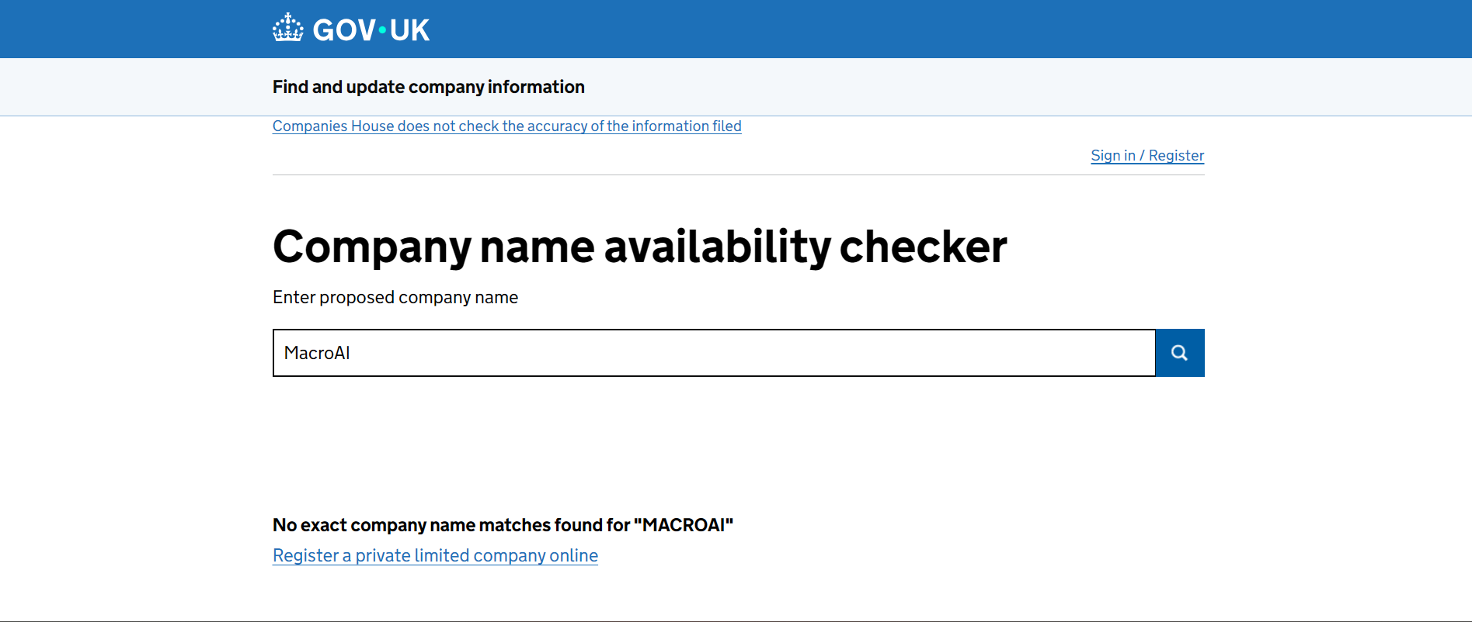

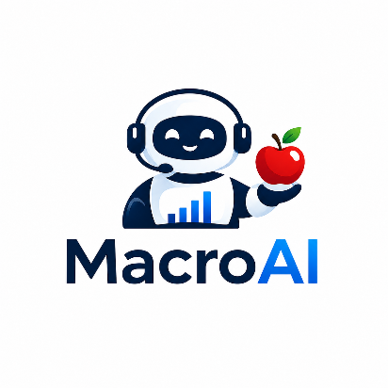
After some creative thinking and brainstorming, this is the final logo that I have come up with. When I initially thought what this logo may look like, I immediately thought about including a robot/AI friend/assistant to the logo. This really showcases what the app is all about and I feel that the addition of a friendly AI assistant shows that it is there to support users. I made use of the blue colour scheme that I used throughout the design of my app which instills consistency. Within the AI assistant, there are progress bars visible on his chest which are a minor detail to showcase the function of the app. I made use of ChatGPT to create this logo by telling it exactly what I was imaging, and it was able to bring it to life.

Macro AI will fall under the Private Limited Company (Ltd) business type. This seems like the ideal choice as this business type is a separate legal entity to its owners – meaning that all personal assets of the shareholders are protected if the business was ever to run into debt or legal issues. This only means that the money invested by a shareholder into the business is the only money that is at risk. Furthermore, due to the company being able to issue shares through being a Private Limited Company, it can make it much easier to bring in new investors, add business partners, and offer incentives based on equity. There are also many tax benefits that come from this business type. However, establishes a business under this business type can come with expensive legal setup costs [1].

The aim of this company is to offer a unique, supportive, and educational service to anyone who wishes to better their health, fitness, and wellbeing.
- Provide insightful knowledge to help improve users understanding of health and fitness.
- To offer a platform for users to keep track of their day-to-day progress (steps, calories, weight, etc).
- Provide great user experience to allow the app to be simple and easy to use.
- To hopefully encourage more people to want to improve their health and fitness.
- To offer 24/7 assistance via the built-in AI assistant for any health and fitness needs
- To ensure simplicity and offer an effortless experience by simplifying nutrition and avoid overwhelming users
- To offer support whilst avoiding judgement by encouraging consistency and celebrating small wins/milestones
- To ensure that our AI assistant is friendly, helpful, conversational and supportive and not to feel robotic.

In terms of potential funding for my startup, Innovative UK are the government’s innovation agency who provide innovative businesses with funding and support. They have many different funding schemes that can help businesses and organisations who are looking to innovate products and services.

PEST Analysis

There are many political factors that come into consideration when working on a tech company such as this. When it comes to health and nutrition, the government is always promoting healthier eating, obesity reduction and preventing healthcare meaning that opportunities are always able to be created. When it comes to the built in AI assistant in the app, there are potential impacts that it can have including requirements on transparency, restrictions on automated health advice and potential compliance standards for AI systems. Furthermore, the company may have to clearly communicate that some information such as calorie estimates are approximate, and that the information provided by the AI is informational and not to be taken as medical advice. There are also many laws and acts that must be followed in the UK including The Data Protection Act 2018 [2], The Computer Misuse Act 1990 [3] and many others. It is crucial that these acts are respected and followed as failure to do so can result in fines, reputational damages and legal action.
With the use of an AI assistant in the app, it means that AI APIs and cloud hosting become essential to the functionality of this app where this infrastructure can become very expensive as the company begins to grow. Other costs relating to this may include database storage and server hosting. Due to this, it is essential that the business is able to handle user growth and operational costs. The health-tech market already has lots of consumers spending money on fitness, nutrition and wellness apps meaning that our app must be able to compete with these apps as this is a very competitive market.
Our target audience is ever-growing as more and more people are focusing on improving themselves via calorie tracking, weight management, etc. This directly supports the demand for the business as health and fitness is most peoples number one priority. Furthermore, it is essential that we successfully meet the needs of users. This can include ensuring efficient user experience with minimal effort. In addition to this, it is also vital to prevent potential negative affects on users, such as, obsessive tracking, unhealthy eating behaviours and pressure on people’s own body image. Therefore, our business should heavily promote balanced habits and supportive messaging.
To ensure that our app is maintained, we will be heavily relying on third party AI providers, databases, and cloud platforms meaning that factors such as price and potential downtime will play major roles in the future success of our business. In addition to this, with third party services as well as our own app there are cybersecurity risks. Due to our app storing user health data, threats like data breaches, account theft and phishing attacks can be extremely harmful meaning that adequate security measures must be in place. These may include strong encryption and authentication.

Project Feedback and Reflection

After carrying out the implementation of the project, I created a reflection feedback questionnaire to gain the thoughts of my peers after creating the app.
The first question that I asked was of their first thoughts of the implementation of the app so far. I am content with these responses as they offer positive points regarding the early stages of the app.
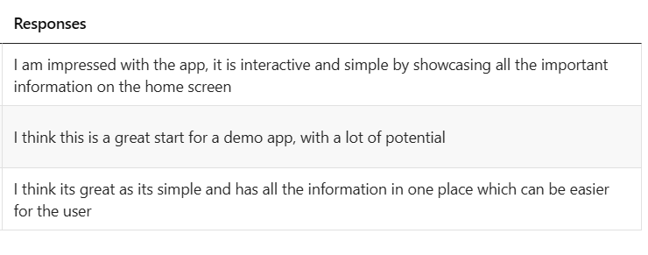
The second question was regarding any additional features that they may deem useful to be included. There were some great ideas that I would definitely implement to the app in future. Many of these features are ideas that I already thought of but weren’t able to implement so far.
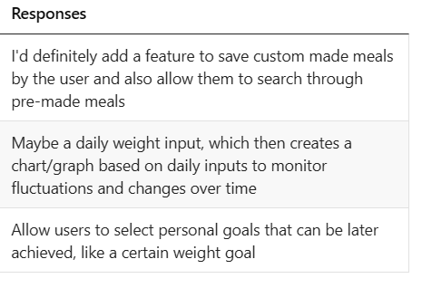

I then asked for their thoughts on the colour scheme and design of the app. The respondents seemed to like the simplicity of the design but mentioned how including images, additional colours and a more detailed navigation menu could be advantageous which I completely agree with.

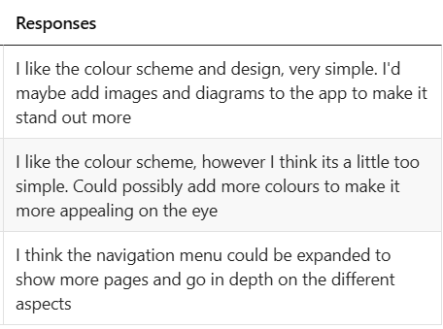

Finally, I asked if they had any final potential enhancements/changes to make to improve the app in the future. These ideas are fantastic, especially the idea of being able to use the devices camera to scan barcodes or take pictures of food to automatically track which is something that I’d definitely look to include in the future.
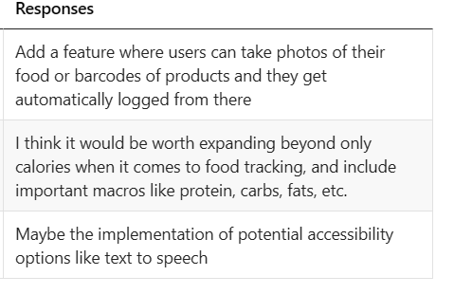

After undertaking this module, I am content with the new skills and knowledge that I have been able to take away from it. Mainly the use of JavaScript as I have never programmed in this language before. It was fun to learn this language using online sources and AI to develop my understanding and use it successfully in my app. I believe that my project could have a very positive impact on society as it can encourage more people to focus on their health and fitness by using this interactive, easy to use app. The use of the AI assistant may help educate them on the importance of it all.

Appendices

JavaScript code used in the app

import React, { useState } from "react";
import {
View,
Text,
TextInput,
TouchableOpacity,
StyleSheet,
ScrollView,
} from "react-native";

// Progress Bar
const ProgressBar = ({ progress }) => {
return (
<View style={styles.progressBar}>
<View style={[styles.progressFill, { width: `${progress}%` }]} />
</View>
);
};

export default function App() {
const [screen, setScreen] = useState("home");

const [steps, setSteps] = useState(4000);
const [stepGoal, setStepGoal] = useState(10000);

const [calories, setCalories] = useState(1200);
const [calorieGoal, setCalorieGoal] = useState(2000);

const [message, setMessage] = useState("");
const [response, setResponse] = useState("");

const [name, setName] = useState("");
const [weight, setWeight] = useState("");

// Log food
const [food, setFood] = useState("");
const [grams, setGrams] = useState("");

const sendMessage = () => {
setResponse("AI: Keep going, you're doing great!");
setMessage("");
};

const addCalories = () => {
if (!grams) return;

// Simple estimate: 1 gram = 2 calories (placeholder logic)
const added = Number(grams) * 2;
setCalories(calories + added);

setFood("");
setGrams("");
setScreen("home"); // go back home after adding
};

// HOME
const HomeScreen = () => (
<>
<Text style={styles.title}>My Fitness Assistant</Text>

<ScrollView contentContainerStyle={styles.grid}>
<View style={styles.box}>
<Text style={styles.boxTitle}>Steps</Text>
<Text>{steps} / {stepGoal}</Text>
<Text>{stepGoal - steps} steps remaining</Text>
<ProgressBar progress={(steps / stepGoal) * 100} />
</View>

<View style={styles.box}>
<Text style={styles.boxTitle}>AI Assistant</Text>
<TextInput
placeholder="Ask something..."
value={message}
onChangeText={setMessage}
style={styles.input}
/>
<TouchableOpacity style={styles.smallBtn} onPress={sendMessage}>
<Text style={styles.btnText}>Send</Text>
</TouchableOpacity>
<Text>{response}</Text>
</View>

<View style={styles.box}>
<Text style={styles.boxTitle}>Calories</Text>
<Text>{calories} / {calorieGoal}</Text>
<Text>{calorieGoal - calories} calories remaining</Text>
<ProgressBar progress={(calories / calorieGoal) * 100} />
</View>

<View style={styles.box}>
<Text style={styles.boxTitle}>Add Meal</Text>
<TouchableOpacity
style={styles.smallBtn}
onPress={() => setScreen("log")}
>
<Text style={styles.btnText}>Log Calories</Text>
</TouchableOpacity>
</View>
</ScrollView>
</>
);

// PERSONAL
const PersonalScreen = () => (
<View style={{ padding: 20, marginTop: 50 }}>
<Text style={styles.title}>Personal Details</Text>

<TextInput
placeholder="Name"
value={name}
onChangeText={setName}
style={styles.input}
/>

<TextInput
placeholder="Weight"
value={weight}
onChangeText={setWeight}
style={styles.input}
/>

<TextInput
placeholder="Step Goal"
value={String(stepGoal)}
onChangeText={(val) => setStepGoal(Number(val))}
style={styles.input}
/>
</View>
);

// LOG CALORIES SCREEN
const LogScreen = () => (
<View style={{ padding: 20, marginTop: 50 }}>
<Text style={styles.title}>Log Calories</Text>

<TextInput
placeholder="Food (e.g. Chicken)"
value={food}
onChangeText={setFood}
style={styles.input}
/>

<TextInput
placeholder="Amount (grams)"
value={grams}
onChangeText={setGrams}
keyboardType="numeric"
style={styles.input}
/>

<TouchableOpacity style={styles.smallBtn} onPress={addCalories}>
<Text style={styles.btnText}>Add</Text>
</TouchableOpacity>

<TouchableOpacity
style={styles.smallBtn}
onPress={() => setScreen("home")}
>
<Text style={styles.btnText}>Back</Text>
</TouchableOpacity>
</View>
);

return (
<View style={styles.container}>
{/* SCREEN SWITCH */}
{screen === "home" && <HomeScreen />}
{screen === "personal" && <PersonalScreen />}
{screen === "log" && <LogScreen />}

{/* NAV */}
<View style={styles.bottomNav}>
<TouchableOpacity onPress={() => setScreen("home")}>
<Text style={styles.btnText}>Home</Text>
</TouchableOpacity>

<TouchableOpacity onPress={() => setScreen("personal")}>
<Text style={styles.btnText}>Personal</Text>
</TouchableOpacity>
</View>
</View>
);
}

// STYLES
const styles = StyleSheet.create({
container: {
flex: 1,
backgroundColor: "#eee",
paddingTop: 50,
},
title: {
fontSize: 20,
textAlign: "center",
marginBottom: 10,
fontWeight: "bold",
},
grid: {
flexDirection: "row",
flexWrap: "wrap",
justifyContent: "space-around",
},
box: {
width: "40%",
backgroundColor: "#1f5f75",
padding: 15,
marginVertical: 10,
borderRadius: 5,
},
boxTitle: {
color: "white",
fontWeight: "bold",
marginBottom: 5,
},
input: {
backgroundColor: "white",
padding: 8,
marginVertical: 5,
borderRadius: 5,
},
smallBtn: {
backgroundColor: "#133b5c",
padding: 8,
marginVertical: 5,
borderRadius: 5,
},
btnText: {
color: "white",
textAlign: "center",
},
progressBar: {
height: 10,
backgroundColor: "#ccc",
marginTop: 5,
borderRadius: 5,
},
progressFill: {
height: "100%",
backgroundColor: "limegreen",
},
bottomNav: {
flexDirection: "row",
justifyContent: "space-around",
backgroundColor: "#1f5f75",
padding: 15,
},
});

Project Progress Sheets

Name: Ben Jones (2405039)
Programme: Changemakers: Creativity and Value Creation

Project Aim: To create a health and fitness app including an AI Assistant to help with the health and fitness needs of users.
Project Objectives:
- Provide insightful knowledge to help improve users understanding of health and fitness.
- To offer a platform for users to keep track of their day-to-day progress (steps, calories, weight, etc).
- To hopefully encourage more people to want to improve their health and fitness.

Weekly Project progress forms:

Date: 09/04/2026

Progress:
- Initialise project ideas and begin conceptualising the project

Actions:
State priority actions to undertake over the next week below.
- Chose Project idea and scope
- Decide the requirements and needs for the app

Next review date: 16/04/2026.

Date: 16/04/2026

Progress:
- Begin designing and setting up app environment

Actions:
State priority actions to undertake over the next week below.
- Create diagrams and app designs for layout and colours
- Initialise the app environment ready for development

Next review date: 23/04/2026.

Date: 23/04/2026

Progress:
- Start working on writing and testing code for the app

Actions:
State priority actions to undertake over the next week below.
- Begin writing JavaScript code to get basic functions working
- Create Stylesheet for the design/style of the app

Next review date: 30/04/2026.

Date: 30/04/2026

Progress:
- Finalise the writing of code for app and test functions

Actions:
State priority actions to undertake over the next week below.
- Finish writing code and ensure all features are included
- Test features and functions of app and alter code where needed
- Any last-minute changes to be done here

Next review date: 07/05/2026.

Date: 07/05/2026

Progress:
- Ensure that everything is done adequately and accurately

Actions:
State priority actions to undertake over the next week below.
- Ensure that report includes all necessary information
- Ensure that all code is present in report

References

[1] | “Types of business organisations,” BBC, 2026. [Online]. Available: https://www.bbc.co.uk/bitesize/guides/zpx7gdm/revision/5. [Accessed 7 May 2026].
[2] | “Data Protection,” Gov.UK, 2026. [Online]. Available: https://www.gov.uk/data-protection. [Accessed 7 May 2026].
[3] | “Ethical, legal and environmental impact - CCEA,” BBC, 2026. [Online]. Available: https://www.bbc.co.uk/bitesize/guides/z8m36yc/revision/5. [Accessed 7 May 2026].

