2022
Network & Cyber Security Essentials
assignment 1
GRI19845230

Introduction 1
Possible Network Vulnerabilities 1
Potential Issues 1
Protection 1
Network Threats, Weak Points & Assaults 2
Network Threats 2
Ransomware Attacks 2
Phishing, Vishing & Smishing 2
Rootkits 2
Botnets & Zombies 3
Security Demonstration 4
Batman Textiles – Cyber Security Guidelines 5
Introduction 5
E-Mails 5
Administrators 5
Online Activity 5
Account Security 5
Bypassing Firewalls 5
Rogue Wireless Access Point 6
References 7
Appendix 9

Introduction
Batman’s Textiles have gone under attack and hired us to educate and help prevent this from occurring in the future.

Possible Network Vulnerabilities
An employee gets fired and uses the opportunity to tamper with the network – potentially hurting the business with loss of data, theft and releasing private information about the business, and employees.

Potential Issues
When an employee is fired who has access to data with administrative privileges, they can use that opportunity to get revenge on those who fired them. There is a business next door with Wi-Fi which is not protected using the same network as those who work in textiles, this could be used as a potential gateway into accessing private information available on the network’s servers.
Workstations could be left unlocked while nobody is operating them which could lead to anyone gaining access to an account which is not theirs of whom may have administrative privileges and access to most – if not, all the networks.
An attack could have been due to the fierce employee’s account not being disabled which allows them time to do damage.
As the business evolves the jobs of the employees may be altered or roles will be changed completely overtime, and this could lead to shifts in quality of work being given. Network management could decrease in their quality of work which may result in an unsafe, unmonitored network.
The network could have been exploited through the Wi-Fi for a malicious program to be installed onto the server. The machines themselves can be accessed as there could be no real protection preventing direct, physical access for tinkering with.
The attack could have been initiated through an E-Mail which an accountant could have opened and clicked the link that may force a malicious download to occur.

Protection
Laying a member of the team off can strike rage and irrationality into them, this can could potentially cause a network attack if given the opportunity.

To prevent this from happening the fired individual can have their rights, admin privileges and account disabled or deleted from the network.

For workstations which are left unlocked in the absence of their user, this can be fixed with locking their account down until they get back to their machine, a strong password is also advised for logging back into their account.

If an attacker exploits the vulnerability through Wi-Fi, they could potentially send viruses over the network onto the server, a network without an anti-virus will not prevent this from occurring regardless of what the malicious program does to the data.

Thorough introductions and training will be required for new employees regardless of previous experience with managing networks. No network is the same and this should be treated as such. Training and introductions can avoid potential mishaps that result in accounts & data being compromised, leaked and stolen.

To prevent an untrusted user to access the network through an unprotected wireless connection, instead of allowing a direct connection to the network through a router, a Wireless Access Point (WAP) can be utilised with limitations that can be set-up through a firewall to block specific ports and domains. This limits the chance for exploitation of network weaknesses.
The least cost-effective solution is to set-up and configure a whole new network for the other unrelated business, but this can increase the network managers required for managing both networks as it would be difficult to manage both simultaneously.

To prevent direct access to machines for when nobody is around which could result in malicious activity, securing rooms with sensors, biometric scans or voice recognition, etc. This can be used to log the user that entered the room last in-case of having to identify a suspect in tampering with the machines.

To prevent the potential malicious files and malware being downloaded accidentally, reviewing and deleting suspicious e-mails with links will increase the safety of the network as employees are aware of the risks of opening unrecognised e-mails.

Network Threats, Weak Points & Assaults
Protecting the network is important and being aware of the kinds of attacks and vulnerabilities which may occur to the network will help prevent those said attacks in the future.

Network Threats
A network can be threatened by botnet attacks, ransomware, malware, sniffers, phishing, Trojans, rootkits and many more. These attacks threaten the network all with a similar goal: To steal information and sell it to competitors, to blackmail and extort in exchange for data to be retrieved, to take advantage of vulnerable businesses that rely on computers.
Threat severity varies based on their intentions, blackmail and data loss is severe, especially if sensitive information is leaked due to a ransom.

Ransomware Attacks
The attack which could have most likely occurred on the Batman’s Textiles network is an insider attack. [1], [2] This can happen within any business regardless of their internal size. The suspect most likely logged into their account after being fired and installed ransomware which encrypted important data on the network and machines to a “.rekt” file. [3], [4]
A ransomware attack can be solved by identifying the infection which can help decrypt the contents. There are websites like ID Ransomware & No More Ransom which can assist with identification. [5], [6] Providing a ransomware note along with a sample file will let the user know about whether or not their contents are able to be decrypted. No More Ransom also provides tools for various kinds of ransomware infections. [7]
Your normal files are turned into .Rekt files using a ransomware like REKTLocker. [8] To remove the ransomware an anti-virus would be required like AVG Anti-Virus. [9] REKTLocker has been used on machines since 2016, there are tools which claim they can decrypt ransomware encrypted files by paying for their software. [10], [11] A free alternative to try and decrypt .REKT files is the HiddenTear Decrypter developed by Michael Gillespie since .REKT is a HiddenTear variant of ransomware files. [12], [13]
Decryption could take longer than a whole workday as decryption would need to be done on each machine that has been affected including the network’s servers, and a full recovery of data is not guaranteed which could lead to setbacks on future deadlines that may reduce the quality of work.

Phishing, Vishing & Smishing
Phishing is a method of obtaining information or user data by creating clones of a website, it is an easy way to trick someone into providing information like credit card numbers, e-mails along with passwords and other sensitive information. This is known as a socially engineered attack that can be escalated into blackmail and fraud. [14], [15]
Vishing is like Phishing, but it is done over a telephone call where the suspect attempts to talk you into providing personal information like credit card details, usernames and passwords by pretending to be a website administrator, services like the police and MI6 or a bank they suspect the victim is using.
Smishing is like phishing which as well uses links over text where they redirect the victim to a website, to call a phone number or to open other applications like E-Mail that can escalate into providing personal and sensitive information via false information being provided. [15]
To prevent any form of socially engineered attack, the user needs to observe, ask questions and ignore any information if there is any doubt in the integrity of the information provided.

Rootkits
A rootkit is a piece of malicious spyware that sits silently on a machine collecting information, this information can range from keys pressed to steal passwords and bank details, rootkits can give the attacker full control over your computer, meaning remote access which can be done during down times, while the user is away from operating their machine. The severity of a rootkit is dependent upon its privileges, on the system. Kernel rootkits can control your hardware, boot kits can start the rootkit from the boot menu of the machine. The most common rootkit is application-based which can modify program behaviour with injections and modify files on the available drives. [16]

Botnets & Zombies
Botnets are primarily used as a method to attack networks using infected computers that have malicious software installed on their computers that are controlled by the attacker, infected computers are referred to as “Zombie Computers”, zombie machines are used to carry out multiple cyber-attacks. [17] Botnets can use multiple connections such as Internet Relay Chats (IRC), Client-Server Model architectures, Peer-to-Peer (P2P). [18]
Botnet connections determine how difficult it can be to stop an attack in the process of using the victim’s machine for the attacker’s suspected purpose.
Botnets are used to participate in Denial-of-Service attacks (DoS / DDoS), mining crypto-currency using victim’s hardware, using victim hardware as a server for illegal distributions of pirated products and very questionable content, etc.
Preventing a botnet from using the victim’s machine for their desired attack or purpose can be done by using an anti-virus to remove malware, disable internet access for troubleshooting.

Packet Tracer Demonstration of Network Configuration
We created a packet tracer simulation for the network to improve with configurations based on the physical topology with skills developed from Net Academy. [19] [See Appendix, “1” & “2”]

The router for Batman’s Textiles had the Gigabit Ethernet ports enabled and IP (Internet Protocol) addresses were configured for the network. [See Appendix, “3”]

Security was provided for the router featuring SSH encryption for passwords, password minimum lengths, start-up configurations and generated keys for passwords. [See Appendix, “4”]

Sensors can and alarms can be used to log movement once the building has been locked as physical security.

Batman Textiles – Cyber Security Guidelines

Introduction
Due to recent events, we have drafted guidelines for everyone who uses their computer within the workplace.

E-Mails
Electronic-Mail is a medium of sharing information and should remain as such.
E-Mail can be used to transmit malware, viruses, Trojans, rats and key loggers onto your system when links are clicked.
Do not open any unrecognised mail or click on their attachments, there is a good reason to do so.
Following these steps will keep your account and data safe, as well as the information of others around you.

Administrators
Network administrators must keep sensitive and private data, confidential and unavailable to anyone without proper authorisation for the safety of others.
Staff members who endanger the network – regardless of whether it is intentional – must have their rights and account disabled until further notice.
Staff members which are no longer working for Batman’s Textiles will have their user account disabled and deleted with no access to the network. This prevents the opportunity for previous staff members to attack, exploit and destroy the network.

Online Activity
When using the network to surf the internet using a machine, visiting inappropriate websites is forbidden. Websites that are considered inappropriate feature adult-rated content and entertainment, social media platforms that are not relevant to the establishment, browser-based video games and multiplayer online games too, are forbidden from being used on the network.
Administrators do monitor the activity and can suspend your account from not using the machines professionally for their intended purpose.

Account Security
Everyone who uses a computer inside and outside of the workplace will require a password to use their account to read, edit and save their data. A strong password featuring more than eight characters, at least one number and special character will suffice.
To keep your account safe, do not share your password as it is confidential information which can result in your account getting disabled if whomever has your password will misuse your machine on the network.
Changing your password every few months can help keep your account safe and from others accessing your account, if your password has been compromised unknowingly.

Bypassing Firewalls
Firewalls are in place to maintain productivity within the work environment by blocking certain ports and web domains / IP addresses. Attempting to bypass the network’s firewalls will result in an account being disabled until further notice.
Bypassing the firewall is done by using a proxy on a device which is connected to the network, this will allow access to potentially blocked content.
A VPN (Virtual Private Network) is used too, this will allow blocked content to be viewed and traffic be redirected to another server. [20], [21]
Attempting to utilise a VPN and/or a proxy on the network will result in an account getting disabled until further notice.

Rogue Wireless Access Point
Using personal equipment like a cellular device or anything with 802.11x hardware is forbidden. Using a personal wireless access point cannot be monitored and exposes the network itself to attacks along with being able to bypass firewalls in place.
An unmanageable WAP on the network is considered rogue. [22], [23]

References

[1] | R. Net, “15 Types Of Cyber Attacks To Look Out For,” 01 11 2019. [Online]. Available: https://youtu.be/NDcEOW8r0xc?t=271. [Accessed 24 01 2022].
[2] | Techopedia, “Insider Attack,” 28 10 2011. [Online]. Available: https://www.techopedia.com/definition/26217/insider-attack. [Accessed 24 01 2022].
[3] | FBI, “Ransomware,” N/A N/A N/A. [Online]. Available: https://www.fbi.gov/scams-and-safety/common-scams-and-crimes/ransomware. [Accessed 24 01 2022].
[4] | files.tips, “.REKT File Extension,” N/A N/A N/A. [Online]. Available: https://files.tips/extension/rekt. [Accessed 24 01 2022].
[5] | Malware Hunter Team, “ID Ransomware,” 04 01 2022. [Online]. Available: https://id-ransomware.malwarehunterteam.com/. [Accessed 24 01 2022].
[6] | No More Ransom, “Crypto Sheriff,” No More Ransom, N/A N/A N/A. [Online]. Available: https://www.nomoreransom.org/crypto-sheriff.php?lang=en. [Accessed 25 01 2022].
[7] | No More Ransom, “Decryption Tools,” No More Ransom, N/A N/A N/A. [Online]. Available: https://www.nomoreransom.org/en/decryption-tools.html. [Accessed 25 01 2022].
[8] | V. Krastev, “Remove REKTLocker Ransomware and Restore .rekt Encrypted Files,” Sensors Tech Forum, 10 08 2016. [Online]. Available: https://sensorstechforum.com/remove-rektlocker-ransomware-restore-rekt-encrypted-files/. [Accessed 25 01 2022].
[9] | AVG, “Free Ransomware Protection Tool,” AVG, N/A N/A N/A. [Online]. Available: https://www.avg.com/en/signal/ransomware-protection-tool. [Accessed 25 01 2022].
[10] | O. Morelli, “REKTLocker ransomware / virus (Free Instructions),” 2SpyWare, 10 08 2018. [Online]. Available: https://www.2-spyware.com/remove-rektlocker-ransomware-virus.html. [Accessed 25 01 2022].
[11] | admin, “AIO Ransomware Decryptor Tool,” AntiHackers, 28 08 2021. [Online]. Available: https://antihackers.net/2021/08/28/aio-ransomware-decryptor-tool/. [Accessed 25 01 2022].
[12] | New Jersey Cybersecurity & Communications Integration Cell, “Hidden Tear,” New Jersey Cybersecurity & Communications Integration Cell, 07 11 2016. [Online]. Available: https://www.cyber.nj.gov/threat-center/threat-profiles/ransomware-variants/hidden-tear. [Accessed 25 01 2022].
[13] | File-Extensions, “Hidden Tear Decrypter,” Michael Gillespie, N/A N/A N/A. [Online]. Available: https://www.file-extensions.org/hidden-tear-decrypter-file-extensions#desc. [Accessed 25 01 2022].
[14] | Cyphere, “The top 10 network security vulnerabilities for businesses in 2021,” Cyphere, N/A N/A 2021. [Online]. Available: https://thecyphere.com/blog/network-security-vulnerabilities/. [Accessed 25 01 2022].
[15] | Cybersecurity & Infrastructure Security Agency, “Avoiding Social Engineering and Phishing Attack,” Cybersecurity & Infrastructure Security Agency, 25 08 2020. [Online]. Available: https://www.cisa.gov/uscert/ncas/tips/ST04-014. [Accessed 25 01 2022].
[16] | V. Polston, “What is Rootkit?,” Malware Fox, 31 03 2019. [Online]. Available: https://www.malwarefox.com/rootkit/. [Accessed 25 01 2022].
[17] | M. Dinita, “What Is a Zombie Computer?,” Technipages, 03 03 2021. [Online]. Available: https://www.technipages.com/what-is-a-zombie-computer. [Accessed 25 01 2022].
[18] | S. Mishra, “Vulnerabilities From Botnets To Cybercrime,” C-SharpCorner, 04 09 2020. [Online]. Available: https://www.c-sharpcorner.com/article/from-vulnerabilities-to-botnets-and-cybercrime/. [Accessed 25 01 2022].
[19] | CISCO, “Introduction to Packet Tracer,” CISCO Net Academy, N/A N/A N/A. [Online]. Available: https://www.netacad.com/courses/packet-tracer/introduction-packet-tracer. [Accessed 26 01 2022].
[20] | Palone, “Bypassing Firewalls – But How?,” Palone, 20 08 2019. [Online]. Available: https://palone.blog/bypassing-firewalls-but-how/. [Accessed 24 01 2022].
[21] | Palone, “Bypassing Firewalls – But why?,” Palone, 02 08 2019. [Online]. Available: https://palone.blog/bypassing-firewalls-but-why/. [Accessed 24 01 2022].
[22] | G. GLOVER, “Wireless Access Point Protection: 5 Steps to Find Rogue Wi-Fi Networks and Comply with PCI DSS Requirement 11.1,” n/a n/a 2019. [Online]. Available: https://www.securitymetrics.com/blog/wireless-access-point-protection-finding-rogue-wi-fi-networks. [Accessed 24 01 2022].
[23] | D. Leslie, “Rogue Wireless Access Point Detection and Remediation,” 09 09 2004. [Online]. Available: https://www.giac.org/paper/gsec/4060/rogue-wireless-access-point-detection-remediation/106460. [Accessed 24 01 2022].

Appendix
Appendix Number | Referred Item | Item Description
1 | 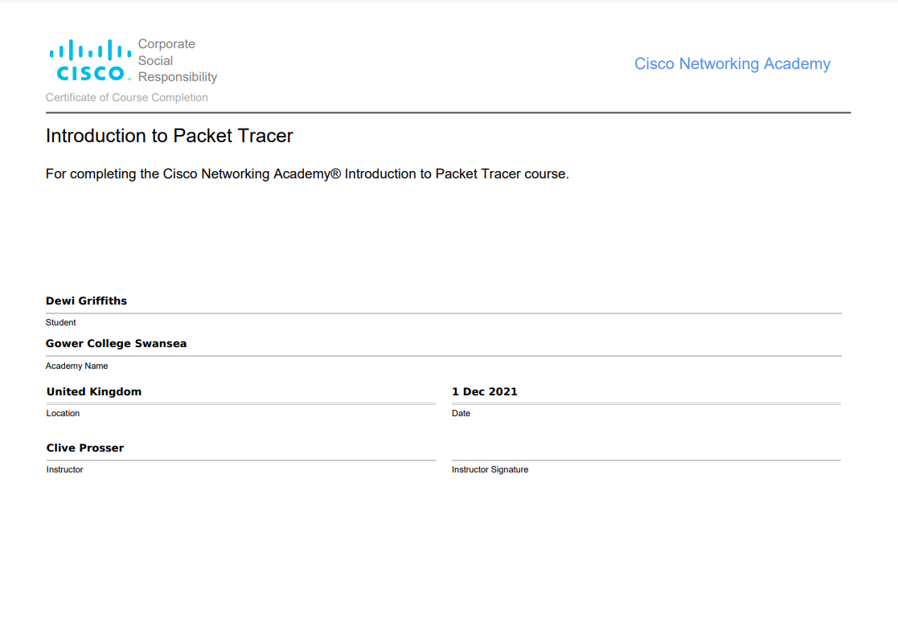 | CISCO – “Introduction to Packet Tracer” – Certificate of Completion for Dewi Griffiths, a student.  This certificate was completed on the 1st of December 2021.  Dewi’s instructor is Clive Prosser.
2 | 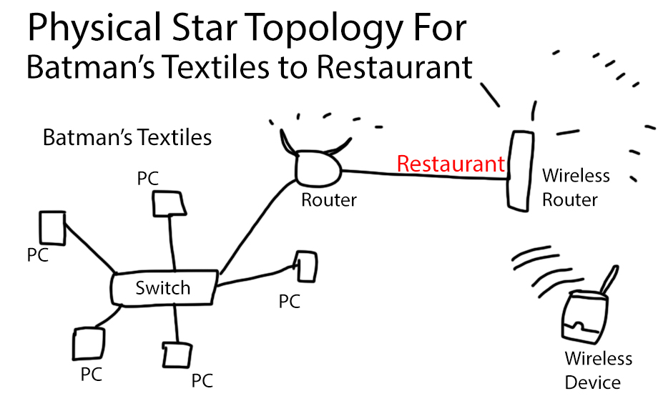 | Physical star topology of the scenario featured in the assignment brief.
3 | 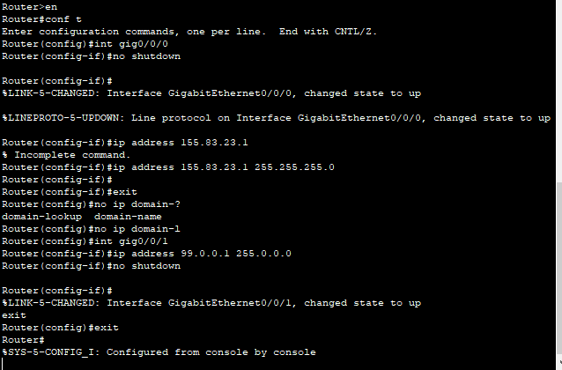 | The Gigabit Ethernet Ports were enabled and provided with internet protocol addresses.
4 | 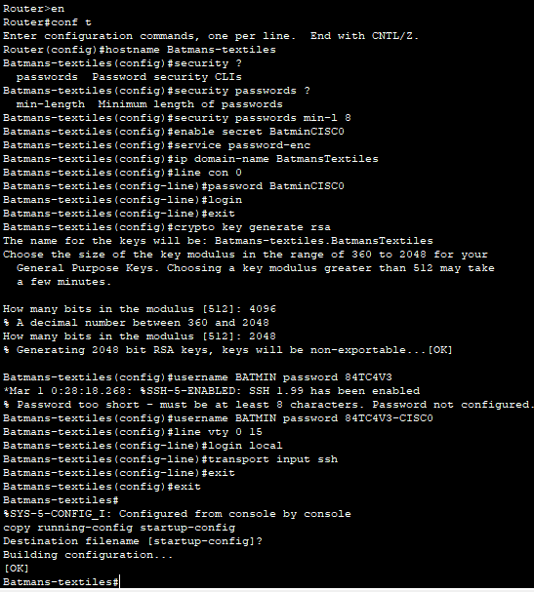 | Demonstration of security being configured for the router.  A password length was set for the router itself.  The password is made secret for it to not show up while being typed.  Key encryptions were generated.  An SSH encryption login was created.  The configuration was applied at Router start-up.
5 | 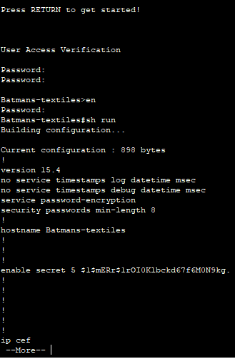 | This is a demonstration of the security measures applied in Appendix 4.
6 | 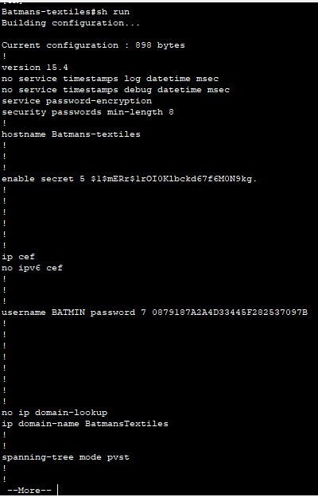 | This is a demonstration of security and encryption enabled while starting the router up.
7 | 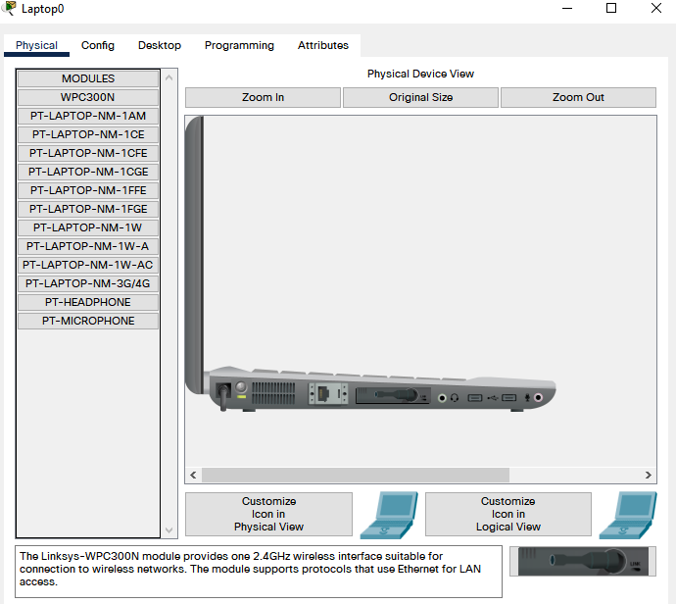 | A wireless network card is placed onto a laptop for wireless configuration of a wireless router.
8 | 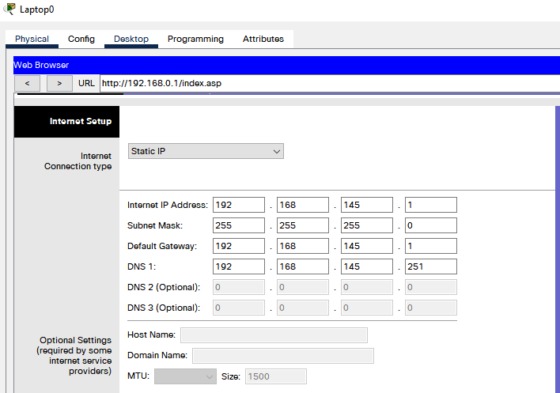 | Laptop configuring the internet set-up for the wireless router with static IP addresses.
9 | 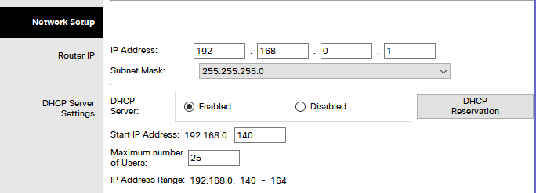 | The network setup has been given an IP address with several maximum users to connect at once.
10 | 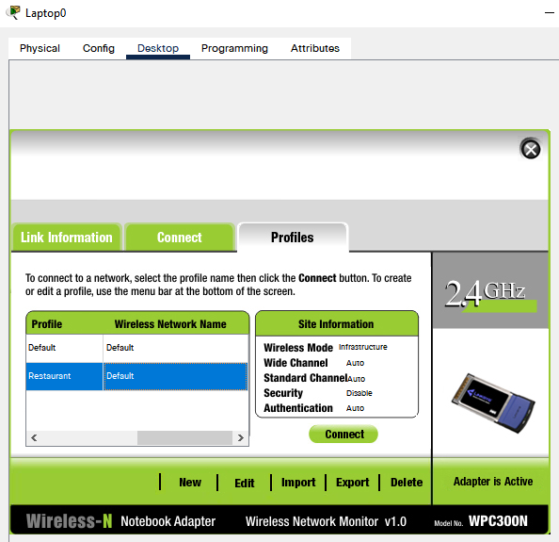 | Laptop created a profile to connect to the wireless router with no security and automatic configurations.
11 | 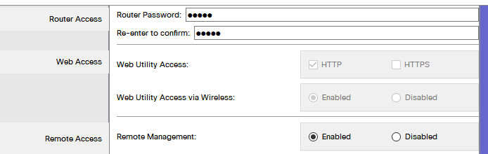 | Remote management has been enabled using the laptop to configure.
12 | 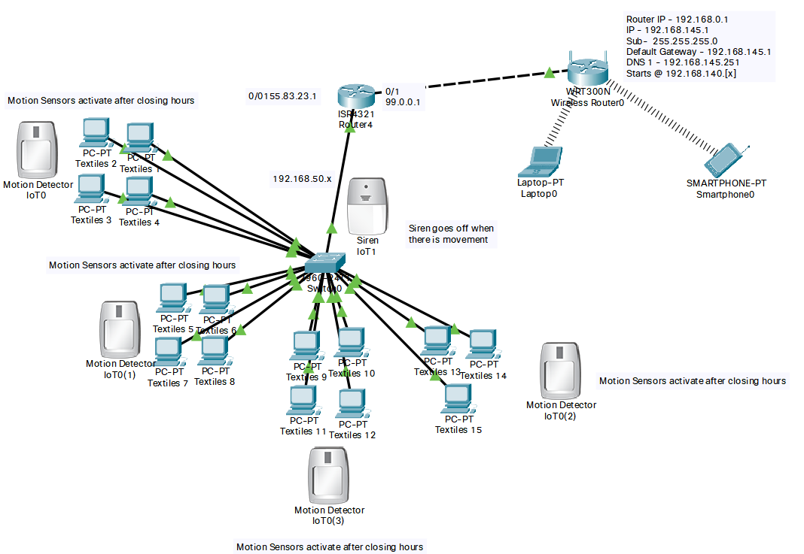 | An overview of the configured network

