

Industry Destination Review : Cuba

Celia McClelland
1813622

19th June 2020

—

GLOBAL TOURISM AND DESTINATION MANAGEMENT M6X01932

—

Dr Olu Adegbite

Growth of trends in global tourism markets
Introduction

The purpose of this report is to review Cuba. This review, is to provide an industry focused critical insight into Cuba’s location and its strategic tourism development, which would benefit tourism professionals.


 |  | Growth of trends in global tourism markets
There are lots of captivating developments taking place in the worldwide travel industry currently, and some of the momentous is the increasing effect of wealth vacationers from “evolving” market on international locations on trip that entail spending finance as well as investment.

In height development of the evolving trends will carry on forming the travel industry, so firms should orient in direction of new areas and business models to remain competitive. This demand tidal wave of trends will form companies and infrastructure within the future years (Singh, 2016).
 | the brand-new tendencies in tourism are an increasing urge for Travel. Firstly, international wanderlust is on the upward thrust and is mirrored in 2018 worldwide vacationer arrivals, which grew 6% attributable will increase in all. |  |  |  | - Reliable bookings  - Religions  - Experiential tourism  - Reasonably priced luxury travel  - Personalization in travel  - Accountable tourism  - Sustainable tourism
 | The vacationer trade is rising in keeping with the WTTC,as stated by Martin(2020) “persist a period of 365 days trip , the holiday business had grown by 3.9 %, overhead world GDP development of 3.2 % and paying a file £8.8 trillion including 319 million jobs to the sector finances. Outgoings from worldwide vacationers besides enhanced to 28.8 %in 2018, up from 27.3% in 2017”  The explanation for that is as a result of quicker air travel- Making beforehand far pitched areas accessible. extra paid holidays- individuals are inclined to grab various small detailed holidays in place of one big one. amplify in number of disposable incomes. |  |  |  | The way forward for tourism is predicted to extend with future. The collection of worldwide vacationers is anticipated to extend by 3.3% per a period of 365 days as much as 2030, reaching 1.8 billion vacationer arrivals.  Despite the fact that all areas are set to grow, the quickest progress might be in rising economies in Asia, Africa, and the center East.  The way forward for tourism might be impacted by the importance of environmental ,technological ,political , economic and social changes (Martin, 2020).

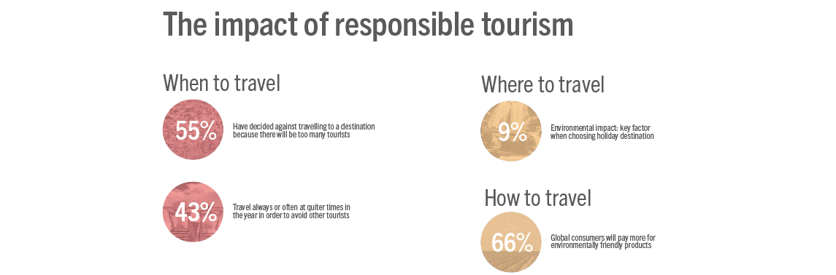
(Martin, 2020)

Cuba
Climate :
- Tropical & humid
- January – July - 73 – 80 degrees Fahrenheit
- April – November – Dry season
- May – October - wet season
(Britannica, 2020)

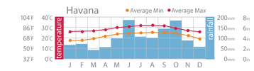

Geography of Cuba
Cuba is located stated by Britannica (2020) “south of the tropic of Malignant development at the merging of the Atlantic Sea, bay of Mexico & Caribbean Ocean . Cuba's topography contains mountains within certain ranges, but some parts of the landmass has little developing grasslands throughout the island. It has beautiful coastal view on the island, and discover v marshlands and large mountain “in Cuba:

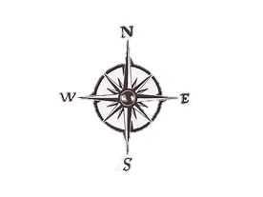
the Escambray Mountains:
Central

The Sierra del Rosario

Sierra Cristal

Cuba is separated into 5 regions listed below:
- Havana
- Western Cuba
- West Central Cuba
- Central Cuba
- Eastern Cuba

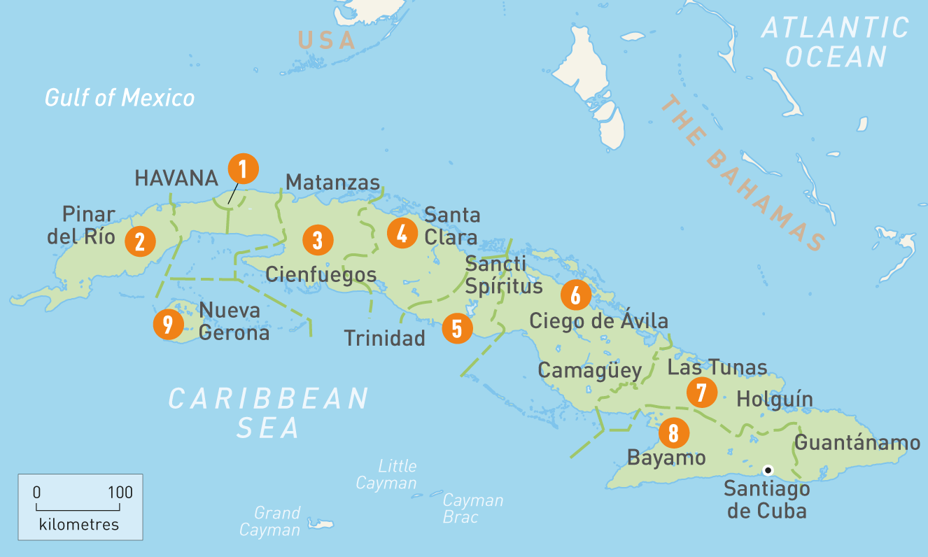

Culture of Cuba

Population : 11.34 million ( 2018)
(Britannica, 2020)

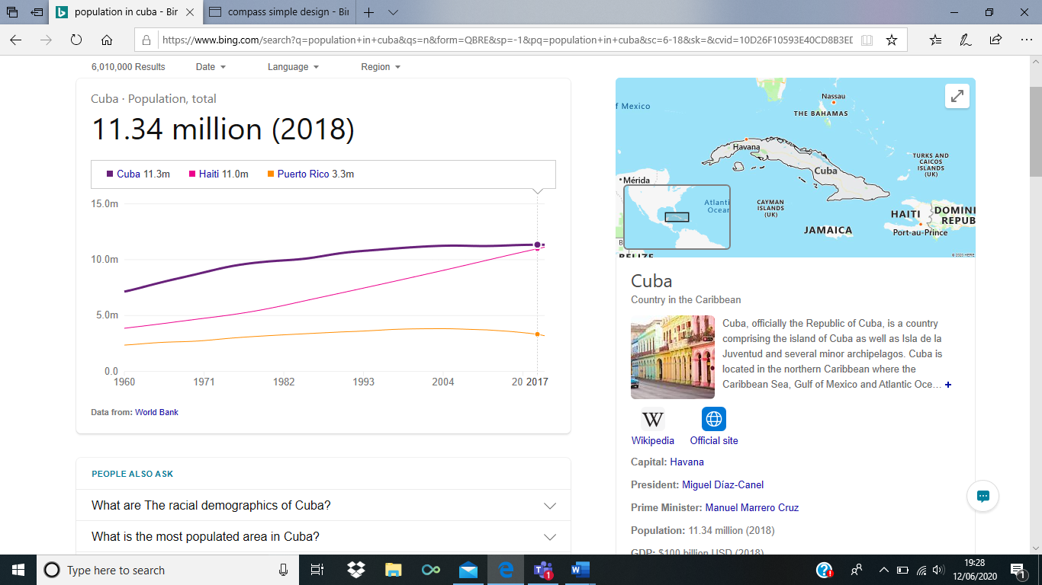
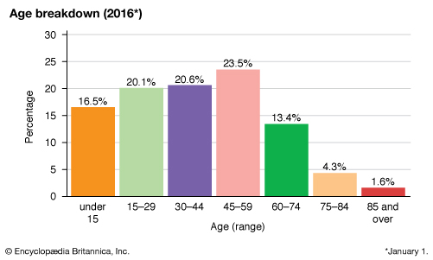
The residents of Cuba are half mulatto, a blend of African and European heritage .
(Britannica, 2020)
Language in Cuba

Cuba is a Spanish speaking country , however there are also other languages spoken which are listed below:
- Spanish
- Portuguese
- English
- Creole
The implication of these for tourism professionals shows both positive and negative features. The negative being a barrier language of communicating and trying to engage a proposition of a business strategy which relates to their social foundations. However, because most of their land is protected for wildlife and their communities it may cost a lot more depending on the business proposal as they are very strict about developing sustainable businesses.
The positive feature is that Cuba is vocation when tourism professional visit or show interest. Since 01/01/1959 Cuba had a revolution of liberating new possibilities to merging their cultural Cuban identity creating a transculturation (unknown,2020

Cuban heritage

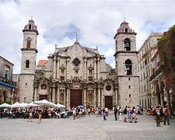
Cuba culture is beautiful , full of life and colorful and modern as it is world-renowned. The vibrant and elegant history which remains has beautiful architecture , tasty food , national traditions and cultural customs.
Cuba presents historical UNESCO world heritage sites listed below:
- Archaeological Landscape of the First Coffee Plantations in the South-East of Cuba
- Historic Centre of Camagüey
- Old Havana and its Fortification System
- San Pedro de la Roca Castle, Santiago de Cuba
(Too, 2020)

Cuba stated by Safa, (2005) is “global renowned for classical music and ballet as well for a partying destination with their powerful and colourful festivals. This is a tourist attraction that will always be up to date with the latest travel trends as it meets the needs of every tourist. From the beautiful countryside and restoration of the beautiful historical sites, with the beautiful contemporary artists”.

Cuba city of Havana once was listed as one of the grandest cities in the world. Cuba is world renowned for hosting exclusive events and venues as it ticks all the boxes of what is needed such as weather , food , entertainment etc.

Cuba social context

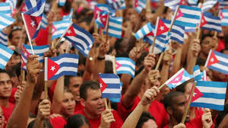
Cuba is a collective country with a revolutionary government. The government applies direct power. Geert Hofstede created a list of 6 measurements to divide societal labeling following scientific research on many nations. However, listed below is a diagram to help individuals get a better understanding on how this method works :

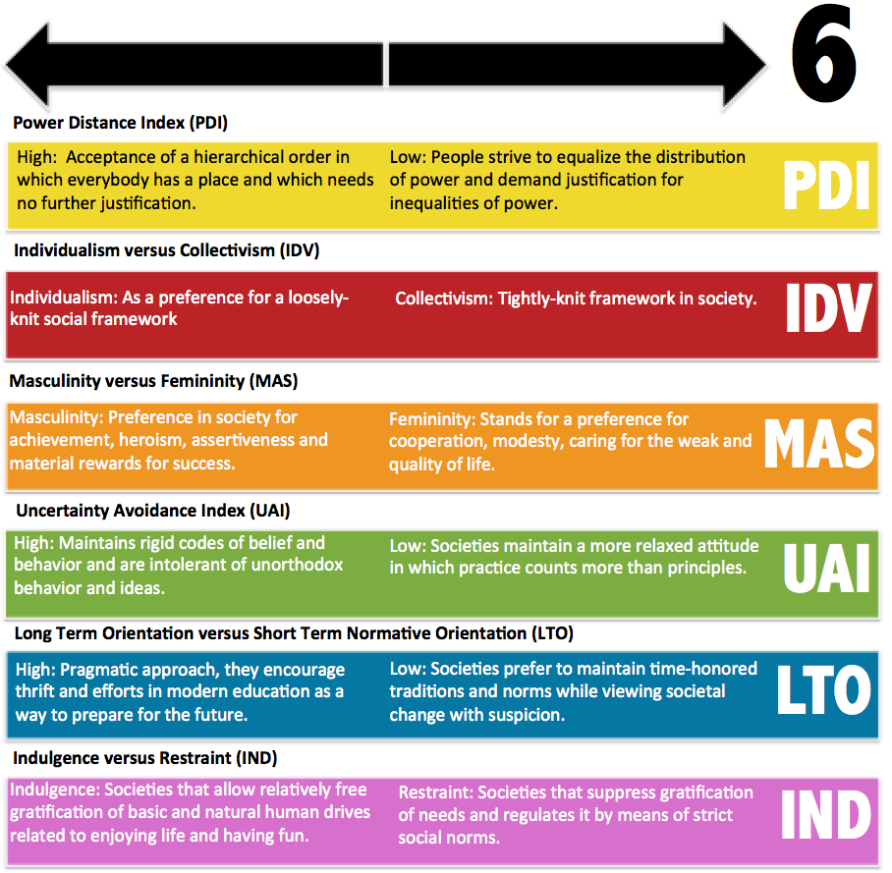

Independence/community & power separation
The residents of Cuba are regarded as community minded and generous, The reason for this is because of the communalist government that remind the Cuban residence that this is the roots of their nation which they have learnt it shows positive government behavior and increase the economy through finance. Cubans have recognized this trend and show unbelievable pride for their nation’s liberation . The communal happenstances are systematized focusing on social congregations. (World Press,2020)

Manliness/Femininity

In Cuba the social foundations are built on the resident’s knowledge of numerous potentials and proclivities . From this Cuba is known for being collectivist, feminine, as well as momentary decided nation it has in height power parting and susceptibility circumvention. By acknowledging these communal foundations, the residents educate themselves with innumerable abilities and proclivities. (World press , 2020)

Long term orientation vs short term normative orientations

The negative impact of Cuba is that its illegal for residents to plan for upcoming political and financial fluctuations. This leaves the residents with little choice on having to live each day as it come due to not being updated on what could change. This reverberation of the nation's collectivism and fascism.
This has cause Cuba to become strong on equal power separation and vulnerability avoidance.
The authoritative parting shows that the values frequently recognize inequities reliant on issues such as inspiration, resources, and regulations .
For the residents of this beautiful nation they have high vulnerability avoidance subsequently they have no authority or voice on what will happen in the near future . The residents are adapted to authorities making decisions . This is due to high vulnerability, forcing them to tolerant the laws in Cuba .
(world press , 2020)

Cuba’s emphasis placed on tourism as an industry

Firstly, Cuba introduced tourism in the 1900’s because it was a vital support system in the revaluation of its economic plan. Cuba is known to rely on tourist coming to improve their countries incomes, it is popular for health tourism for more than 20 years, the annual finance from this yearly to support the economy is around £40 million ( Castillo ,2002 )
Cuba is praised for:
Music,
Tropical climate and natural creation
History
Culture
Cuban hospitality.
It has been stated by Castillo (2002) estimated that in 2020 4.3 million tourists will visit, which will collect £5 million for the economy. Yet a problem arises for tourists since 5/06/ 2019, voyagers cannot travel to Cuba because of a new law called the "person to persons" act (which was basically applied by the guided visit organizations and journey lines), This stops tourist traveling to Cuba deprived of a Visitor Card Combined with a visa and handling expenses , but these can be brought on entry point to the country. This is a strong foundation as it allows the country to adapt to sustainability by controlling the number of tourists who visit this paradise.
Since the global paramedic of COVID-19 it did not have any effect within the first 2 months of business however due to being outdoor activities, trading and projects. However, from May onwards bookings for the year began to incline , many hotels in Trinidad, Cuba, had to delay work due to the reduced trading from Europe.

However other countries have tried to support Cuba , such as England which is helping get businesses set up a project in Havana for April 2020-21 . This is designed to help partnership between the both nations. The United Kingdom will help fund the project with up to £10,000 which can lead to more project being carried out for developing Cuba. The reason for this is that the United Kingdom has noticed that Cuba is world renowned for life of science , biotech and medicine.
(worldpress,2020)

The suitability of Cuba

Stated by Corporal (2020) “In 2020 Cuba has been listed the most sustainable developed country in the world. This was stated by sustainable development index in 2015 rated out of 146 countries. Cuba is well known for being eco-friendly . In 1990 Cuba hit a financial crisis due to the failure of the Soviet Union. When their government stepped in, they embraced become sustainable by doing what no other country has done by introducing environmentalism”. This included :
- Minimized carbon footprints
- Reducing waste of natural resources

In the year of 2006 after the government taking this risk, they were the first nation in the world to be acknowledged what sustainable development was, this was recognized with the WWF and Fidel’s anti-globalization movement. This was a massive achieved as it got Cuba recognized by the world and sustainable tourists (Corporal,2020).
An example of how Cuba strived was by when they had a food crisis, the government looked into all sustainable solutions. The one that was selected was by encouraging the residents to produce / grow their own fruits and vegetables. In the future this led to Cuba having private organic farms which has now grown into a massive tourist destination for a farmer’s market. A popular destination in Cuba is the Las Terrazas which has a high tourist request for the organic meals (Corporal,2020).
As word of mouth had reached other countries organization such as the U.S embargo have helped assist Cuba with preserving the ecosystem such as the coral reefs , marine life. This partnership has created a strong bond between Cuba and the U.S conservationists. The reason why this partnership began was because of Cuba being the only the Caribbean island to have a coral reef , and because of this there was a high tourist count which was damaging the costal regions and negatively impacted on the marine life. This is why the government introduced the step by step regulation to keep control of the amount of tourist.
Finally, because Cuba is known for being a socialist nation the government are strong willed by being sustainable meaning:
- Protecting the residence
- Keeping the villages , landscapes and towns clean
- Keeping C02 emissions down by encouraging cycling
- Reforest and marine protection programmed
- Coffee plantations
- Outdoor activities which are eco-friendly such as zip wiring , cycling etc.
(Corporal,2020)
The future of Cuba is supporting economic stagnation by having outside investments help tackle the problem. This has helped Cuba by having new products as well as developing old strategies. This will help worldwide as scientists have predicted climate change could get worse meaning the climate temperatures will increase , increase on tsunamis , decrease in wildlife and marine life. Because of the increase of tourism trends such as medicine , health , sports , scientific , volunteer , cultural and many more. The government remain to advance of sustainable tourism as their economic, political and social factors depend on it.

Conclusion
Since 1990 Cuba has changed insignificantly with the influence of their government vowing to become a sustainable nation. They have created strong relations with many countries who have identified their research by investing in the nation or helping protect their marine , rainforests and lifestyle. However, the negative impact which has been uncovered is that the residence does not have a say on laws being created as well as electing power. But the residence have seen an impact on the governments choice which is bringing in tourism for different trends and helping the nation to evolve ahead of the times by researching a number of methods which they test in their nation funded by outside investors , such as America , England which are strong nations. The downfall is that because china is emerging with technology their will doubtful be relationship between China and Cuba due to the laws and regulations in Cuba of not harming their environment where if they did team up with china they would be able to create a solution in making technology ecofriendly which is massive task. However, with limited importations I acknowledge that Cuba has set roots on what all counties should follow as they are more advanced in being a proud sustainable nation. However, looking at the other financial of Cuba they have invested on imported and exports with china , Spain ,Germany , Singapore and Indonesia. They are most famous for trading , sugar , tobacco products , oil , machinery and pharmaceutical goods. So, by investing in these it involves business professional to go on a work tourism venture which is a good tourism trend to be involved with.
The reason why Cuba had to build strong relations with outside investments was because the collectivist society and financial resources had been important. Relating to the tourism at one point it did decline since the financial collapse, intensifying foreign venture struggles and doubts. The internal financial restrictions deficiency of foreign investment did have negative effect on Cuba until they researched areas of what would benefit themselves as well as the other country.
Cuba has been redeemed as a safe nation to visit as it was reviewed in 2020, there has been some recorded minor crime such as scams and pickpocketing. Because of Cuba being a communist country the WIFI access is difficult to get hold of due to the government restricting it as it is expensive to access the internet. This is a downfall in the tourist sector as some who travel like to take images and upload them on social media , however this could be beneficial for more wealthy tourists as they try to escape the world of social media to be one with nature.
However, reviewing this mobile phone are tricky in Cuba due to them owning their own telecommunication provider , unless you have an American telecom provided it won’t be so hard to get reception.
Cuba is a good opportunity for work professional depending on the line of work on the company they work for however by Cuba having a popular hospitality and culture. The facts listed above have a very strong for and against for tourist professionals in Cuba who show interest for a sustainable business , as they the country is developed , and is showing a promising future. My opinion is the company want to become sustainable Cuba is the best solution as they are more advanced in sustainable tourism then any other country in the world.

References

- Britannica, 2020. Cuba - Soils. [online] Encyclopedia Britannica. Available at: <https://www.britannica.com/place/Cuba/Soils#ref54393> [Accessed 14 June 2020].
- Corporal.J. (2020). Cuba ranks as world’s most sustainable developed country – all about Cuba’s eco ways. Available: https://cubaniatravel.com/stories/cuba-ranks-as-worlds-most-sustainable-developed-country-all-about-cubas-eco-ways/. Last accessed 14/06/2020.
- Martin, R., 2020. How Emerging Market Growth Is Changing Tourism. [online] World Economic Forum. Available at: <https://www.weforum.org/agenda/2015/05/how-emerging-market-growth-is-changing-tourism/> [Accessed 14 June 2020].
- Martin, R., 2020. How Emerging Market Growth Is Changing Tourism. [online] World Economic Forum. Available at: <https://www.weforum.org/agenda/2015/05/how-emerging-market-growth-is-changing-tourism/> [Accessed 14 June 2020].
- Too.K., 2020. UNESCO World Heritage Sites in Cuba. [online] World Atlas. Available at: <https://www.worldatlas.com/articles/unesco-world-heritage-sites-in-cuba.html> [Accessed 14 June 2020].
- Safa, H., 2005. The Cuba Reader: History, Culture, Politics (review). Cuban Studies, 36(1), pp.168-171.
- Singh, T., 2016. A future beyond growth: towards a steady state economy. Tourism Recreation Research, 42(1), pp.125-126.
- the independent, 2020. The Top Travel Trends For 2020, According to The Experts. [online] The Independent. Available at: <https://www.independent.co.uk/travel/news-and-advice/travel-trends-2020-voluntourism-dogs-train-overtourism-a9225076.html> [Accessed 14 June 2020].
- Westlake, J., 1989. Mega trends in international tourism. Tourism Management, 10(1), p.76.
- World Press. (2020). Cuban Culture According to Hofstede. Available: https://sites.psu.edu/aspsy/2015/10/07/cuban-culture-according-to-hofstede/. Last accessed 14/06/2020.
- unknown. (2020). Cuban Cultural Scenario. Available: https://www.cuba.travel/en/about-cuba/culture/cultural-scenario-in-cuba. Last accessed 17/06/2020.
- Castillo.o & Gaspar.N. (2002). Tourism Development for the Cuban Economy (English version) . Available: https://revista.drclas.harvard.edu/book/tourism-development-cuban-economy-english-version. Last accessed 17/06/2020

