Research, build and deploy a Virtualised Network
Nicholas Gelstharp (2211042)
Network Operating Systems and Services

Contents

Task One: 2
Hypervisors: 2
IP Addressing 3
Routing 4
Network Services 5
Task Two: 6
2.1: Choosing a Hypervisor: 6
2.2: Download and Setup: 7
Windows Server 2022 Installation 9
Windows 10 Client Installation 14
2.3: Configure IP Addressing & 2:4 Testing and Troubleshooting : 22
Configuring Windows Server 2022 22
I want to now configure the client Windows PC. 41
Linus Server Installation 47
References 87

Task One:

Hypervisors:
The functionality of a hypervisor can be summarised as virtualisation of machines that will allow multiple virtual machines to be created through the utilisation of resources such as memory, CPU and I/O from a host machine [1] [2]. There are two architectural types of hypervisors classified as type 1 and type 2. A type 1 hypervisor will assume control of the physical computing resources which is sometimes referred to as a bare-metal hypervisor. As this is installed directly on to the hardware, all physical computing resources are available to the OS which means that that performance can be better on a type 1 than a type 2, even if the physical computing resources are identical [3] [4] [5]. These classifications are helpful, however they may not be sufficient as it is possible to install a type 1 hypervisor OS within a virtual environment which is something not considered by these source. Further research indicates that the performance gained from a type 1 is offset by the prohibitive costs both for the hardware and also the associate technical support costs as specialists may be required. Type 1 hypervisors are therefore more often deployed where intensive workloads are anticipated. Common examples of Type 1 hypervisors include Xen and Hyper-V
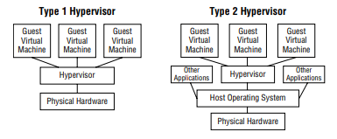 [6]
Type 2 hypervisors run within an operating system and access to the physical computing resources are managed through software. Research shows that the primary advantage of this type of hypervisor is that it can run on a large range of different hardware, and it is also more easily administered which means the technical cost of implementing the technology can be less. However, performance is sacrificed as previously mentioned. Security is also not as good with type 2 as it is with a type 1 hypervisor because attackers have more potential avenues of exploitation which includes the operating system [7] [8] [9]. Common examples of a type 2 hypervisor would include virtual box and VMware. These are more likely to be installed in smaller organisations with less network traffic, however larger organisations are unlikely to implement this solution due to the security implications and performance loss. The nature of a business is not considered in this research, but could also be a contributing factor to the choice of hypervisor required.
The features of a hypervisors can include allowing multiple OS’s to be installed on the same server, desktop virtualisation, security, network management and hardware optimisation/resource management [10] [11].

IP Addressing
During a group discussion it was generally agreed that data is transferred from one machine to another using TCP/IP protocols where packets of data are transmitted across networks to allow devices to communicate with each other. Most network devices use IPv4 which has been around for a significant period of time and will ultimately be replaced with IPv6. However, this transition is taking more time than initially considered due to a reluctance to move from existing network infrastructures and also the development of technologies used by ISP’s such as NAT and PAT that increases the efficiencies of their IP address allocations which is limiting the expense of previously having to manually assign IP addresses to individual properties or accounts, and also a general limitation of how many IP addresses that can be allocated mathematically across the globe. The ISO defined the OSI model which is used to enable commonality between manufacturers and developers which is key in allowing disparate devices of multiple natures to be able to communicate with each other [12] which I have shown in the diagram below combining multiple sources of research
OSI Layer | Example
Application – Layer 7 | User interface layer  Http, FTP, IRC, SSH, DNS
Presentation – Layer 6 | Concerned primarily with formatting  Mac addresses, PPP protocol
Session – Layer 5 | Determines the management of data within sessions between application  RPCs, NFS
Transport – Layer 4 | Transmission of data end to end  TCP, UDP
Network – Layer 3 | Packets being moved between different networks though use of logical addressing  RIP, Routing, IP addresses
Data Link – Layer 2 | Ensures reliable data transfer across a single network  MAC Addresses, Ethernet frames, switch operations
Physical – Layer 1 | Cables (Ethernet, fibre) and transmission of data
Figure 1 - OSI Model
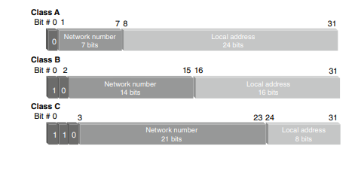
[13] [14]. This summary of research indicates that the success and current ubiquity of the internet is largely down to this acceptance of a common standard and without this, it would be impossible to achieve the level of communication today. Ip addressing occurs at Layer 3 of the OSI Model and was originally developed by the US military in the 1960s, scaling since this point to seamlessly support over 4.5 billion users communicate daily, [12] [15]. Ip addressing can be summarised simply as the process of giving a unique address to a network device. 3 classes exist as shown below here [16]. Research shows that despite its age the scalability and adaptability of IP addressing is quite staggering.

Routing

Routing can be summarised as the process taken to select pathways between devices and networks [17]. Routing occurs at layer 3 of the OSI model. A switch (layer 2) will only forward packets based on MAC addresses and does not perform routing. Routers as the name suggests will perform the routing functions to allow efficient and safe communication between networks.
LAN

WAN
Computer
Computer
Switch
Router

Figure 2 - Basic network illustration
Their primary function can essentially be broken down into determining the most efficient path to send packets and to forward packets of information [18]. The router will achieve this using a routing table and can either use static or dynamic routing.
Static routing is where the user will designate manually the “route” that data will be transmitted through, for example specifying within a network the default gateway router will force all traffic for those machines to be directed here. The advantages of static routing are that you will know the exact path that the data will travel through, thus enhancing security. The destination can also not be advertised over the network which will improve security. However, the disadvantages are that it can be difficult to scale and it requires a complete understanding of the network environment in order to be efficiently implemented [19].
Dynamic or adaptive routing are generally used in larger networks. As the name suggests a dynamic network will utilise different protocols to create dynamic routing tables. These protocols include distance vector protocols which include RIP or IGRP which can be summarised as routers sending out their touring tables to other routers or link state protocols such as OSPF or IS-IS which exchange a link state packet with another router which contains information such as data transfer speeds that is used to construct routing tables from analysis of this information [20] [21].
The advantages of dynamic routing are that they more robust to network failures and can dynamically route around issues if possible. They are also far easier to administer and can be more efficient. The disadvantages are that due to their more complex nature the physical resources required such as CPU, RAM etc are more demanding that the static alternative, and they are also less secure. [22]
Research has suggested [21] that dynamic routing could also be evolved in the future moving towards more intelligent network management standards allowing learning driven network management through utilisation of the ever evolving AI tools available on the market which sounds interesting, though standardisation may be difficult to achieve if all networks, learn and develop independently.

Network Services

Network services can be summarised as tools that run on networks to provide specific functionality. One example of a network service would be a VPN (Virtual Private Network) [23]. A VPN allows connections to a secure network, from an insecure location. An example of this is home working, which will often allow users to connect to the private work networks of their organisations from their home internet, which would not be considered a secure or trusted network from the viewpoint of the organisations network. This functionality has been increasingly important since COVID and the expectation of employees to be allowed to work remotely, which has also in turn led to an increase in cyberattacks [24].
Another network service is DHCP (Dynamic Host Configuration Protocol). This used to automatically assign IP addresses to devices within a network, most machines will not have a static IP address within the home and work environment and the DHCP server will allocate from its pool of available IP addresses when a device joins the network. This allows more efficient network configuration and flexibility. [25]

Figure 3 - Summary of DHCP process
Active directory is an example of a commonly used Microsoft network service. Its functionality can be summarised as a storage utility for user and device information. It controls these on the network and can be used to establish domain trusts and access to resources that are stored on the domain, it acts as a domain controller providing authentication services for all mentioned above [26]. The advantage of this is that it provides a GUI that is easy to interact with an allows very simple administration when compared to its CLI counterparts.

Task Two:

2.1: Choosing a Hypervisor:

Based on the research performed the hypervisor that will be used is type 2. Whilst the advantages of a type 1 hypervisor in performance would be of benefit, the cost implications of having a type 1 hypervisor prohibit its use within this assignment. As well as cost there is the impact of accessibility that also must be considered and although a VPN could be utilised to get around this hurdle through use of Microsoft Azure, this would require sufficient internet speeds within the home network that would allow it to be used efficiently. The type 2 hypervisor can be installed on a laptop which is sufficiently powerful with an i9 processor, 32GB or Ram and 2 TB of HDD space and is readily available. The benefit of this particular device is also that it can run on university, organisation and home networks allowing accessibility regardless of physical location.
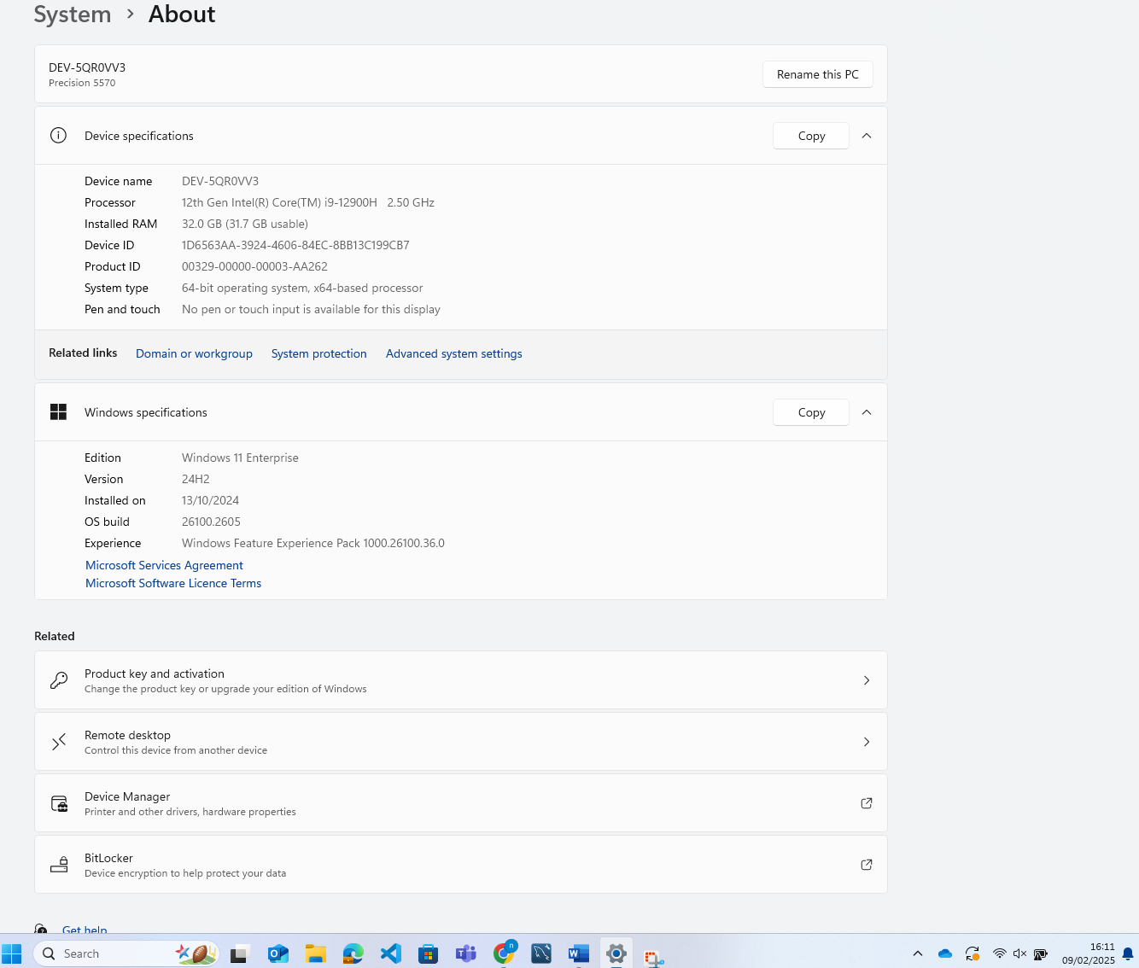
Figure 4 - Laptop hardware specifications for Type 2 Hypervisor
Now that the type of hypervisor has been chosen, the actual software needs to be considered. As the operating system is windows the software must be compatible with that operating system. Examples of choices would include VMWare, Hyper-V, Citrix HyperVisor and VM server. All of these would be perfectly acceptable examples, and most of them are free which means that cost does not need to be factored in. For ease of use, Oracle VirtualBox was chosen as the hypervisor. The primary reason for this is that it has been utilised in the past, and therefore no further learning would be needed on how to use the hypervisor allowing for full concentration on the task of setting up virtual machines, which will make the assignment significantly simpler as there are simply less things to have to learn to achieve the overall objectives.

2.2: Download and Setup:

Oracle VirtualBox can be downloaded from https://www.virtualbox.org/wiki/Downloads choosing the Windows Hosts options from the menu to ensure that the download is compatible with the operating system on the laptop
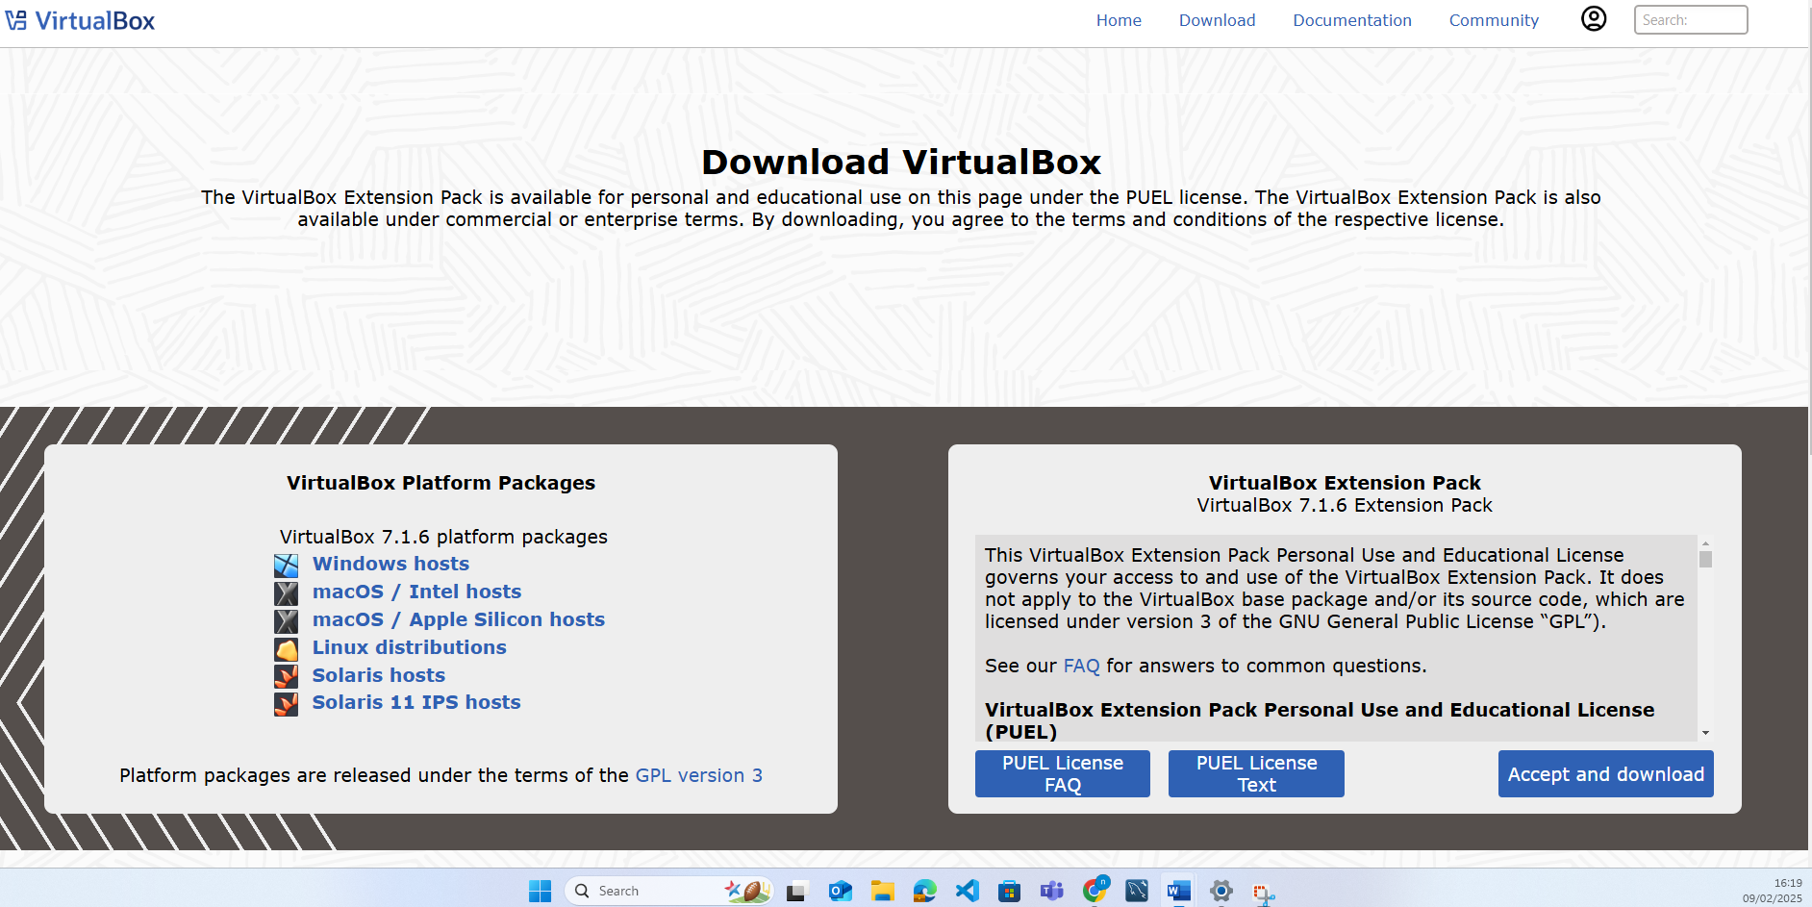
Once the .exe file has downloaded choosing the next option allows for the download to proceed. From the options screen, it was decided that all features would be installed to the local machine. This was primarily because that would ensure that all features would be available should they be needed, as a further assignment with unknown tasks meant that this would be the safer option. With the installation of Virtual box completed. The ISO files were then needed for Windows Server 2022, and Windows 10 as shown below.
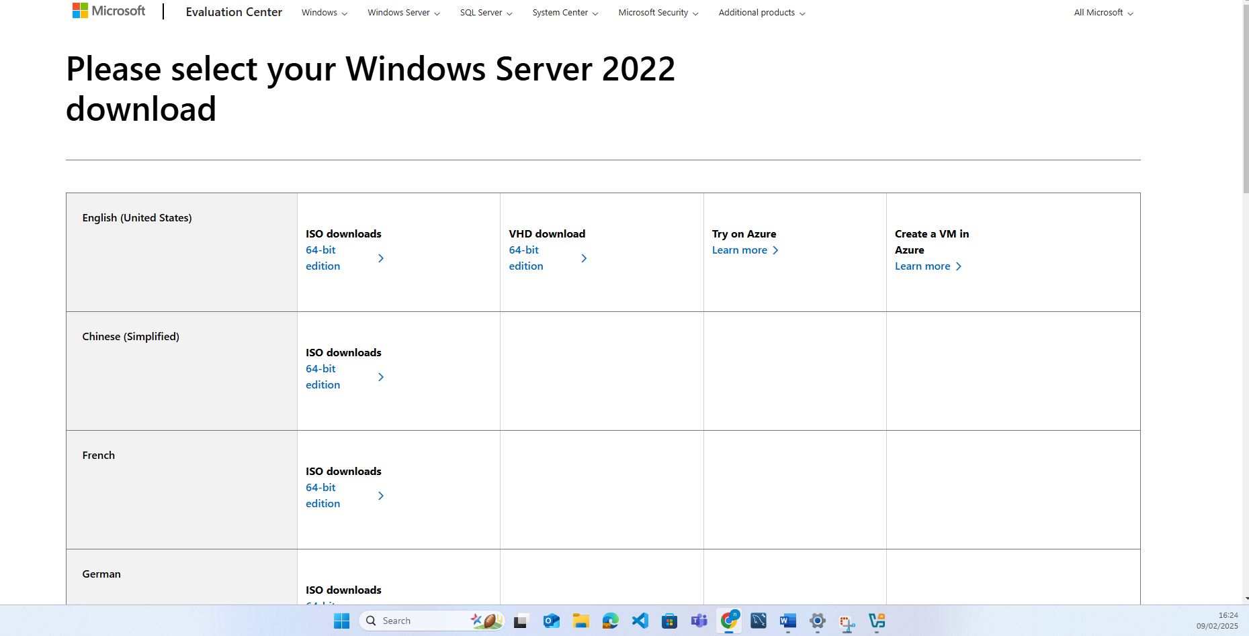
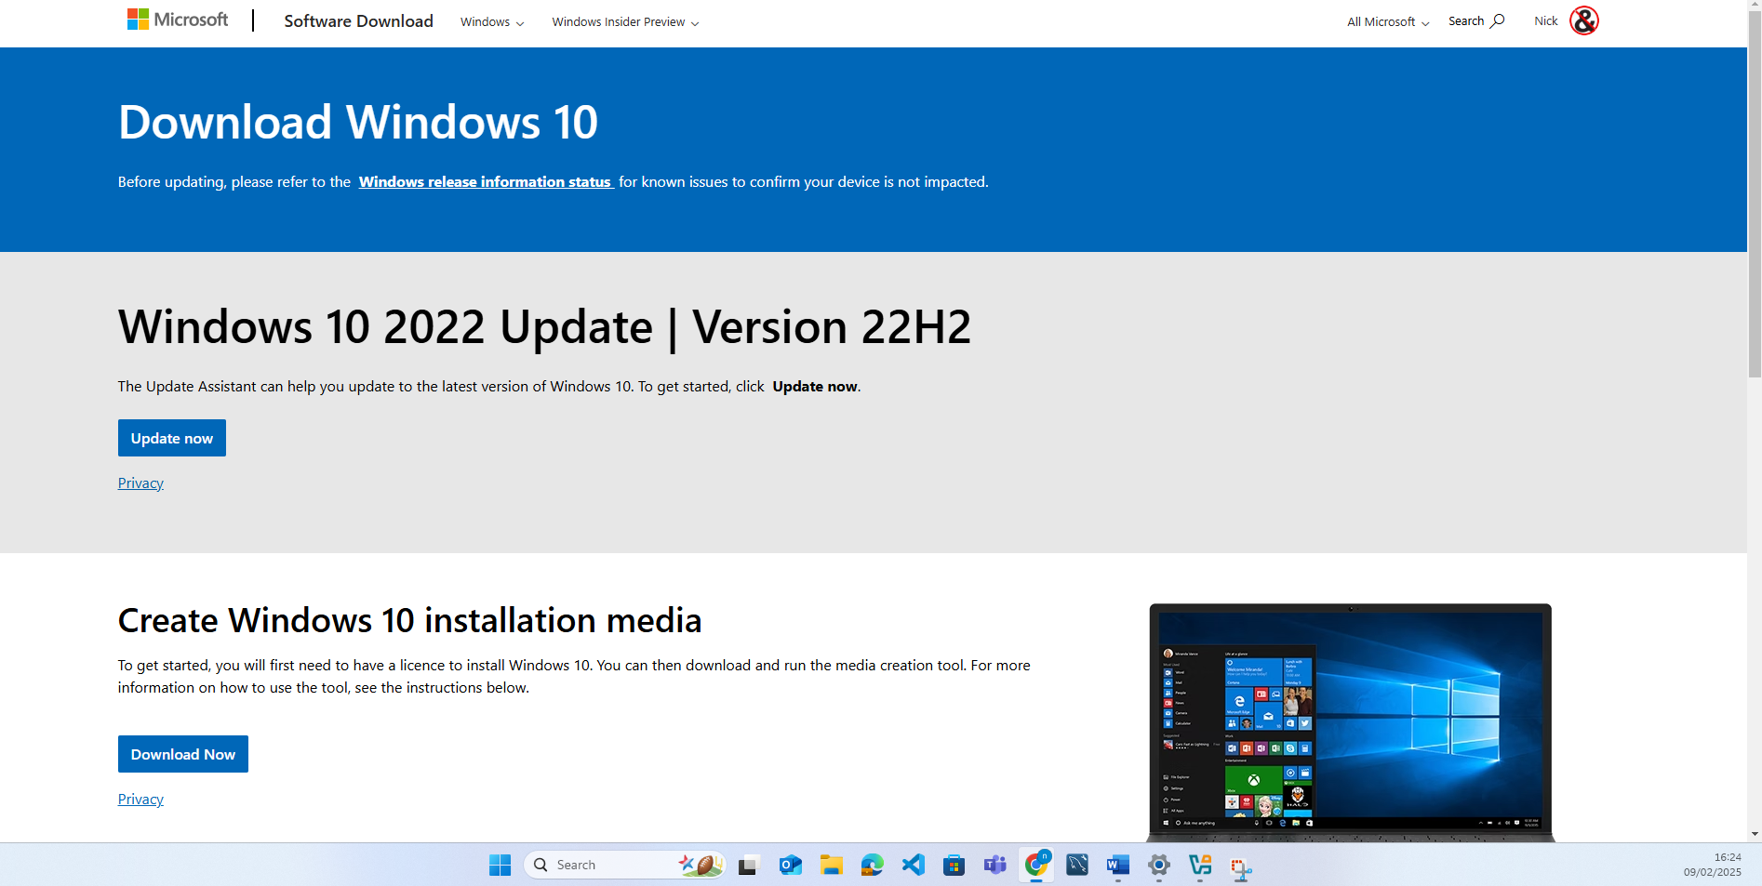
.
With the ISO images download, the server was installed first as shown in the screenshots below

Windows Server 2022 Installation
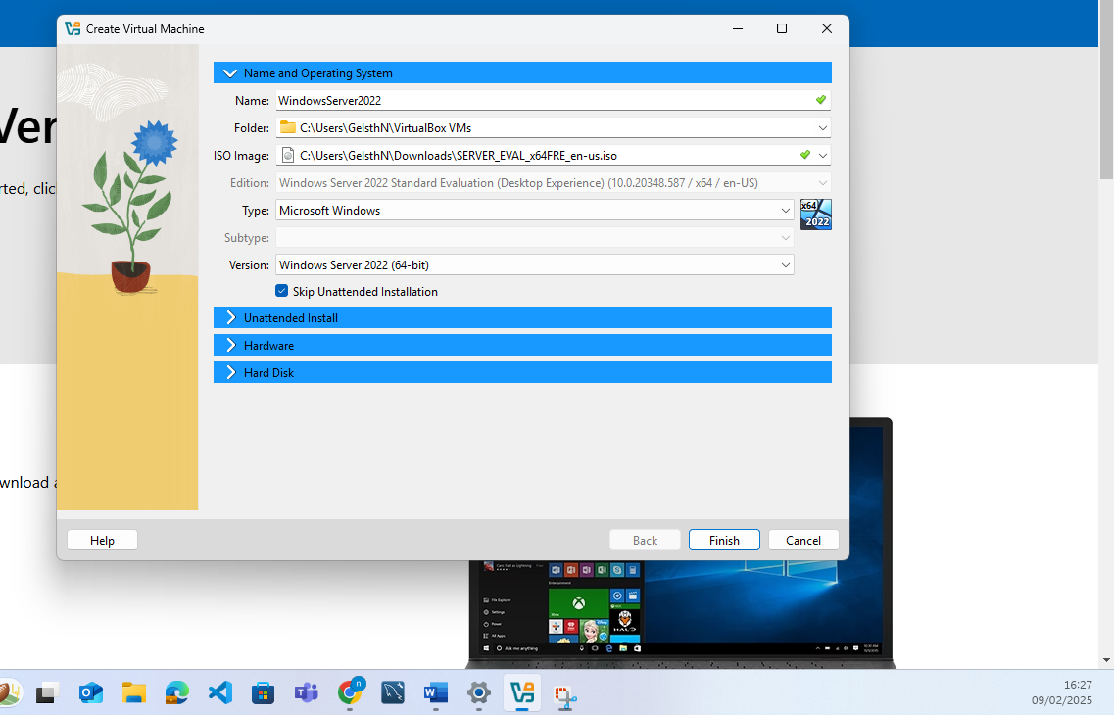

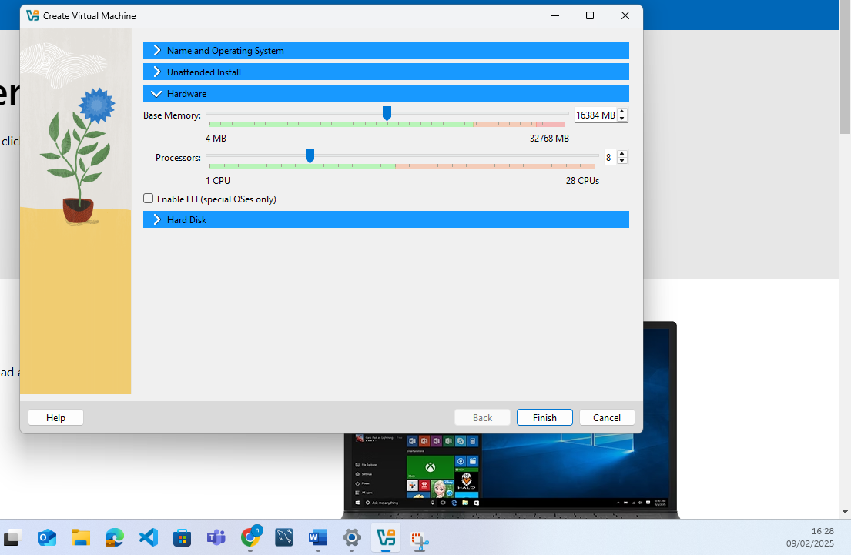
I have chosen to give a high proportion of RAM and Processors as the windows server is the one that will utilised the most through out the assignment. 100GB of HDD space was also allocated to allow for partitions to be created as well as sufficient room for the OS and any potential files that would be needed later on.
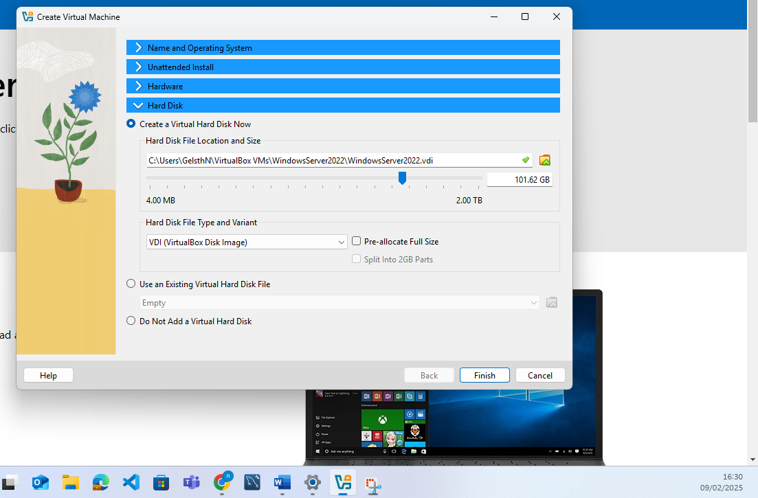

The language settings were changes to uK to ensure that the keyboard would work as required
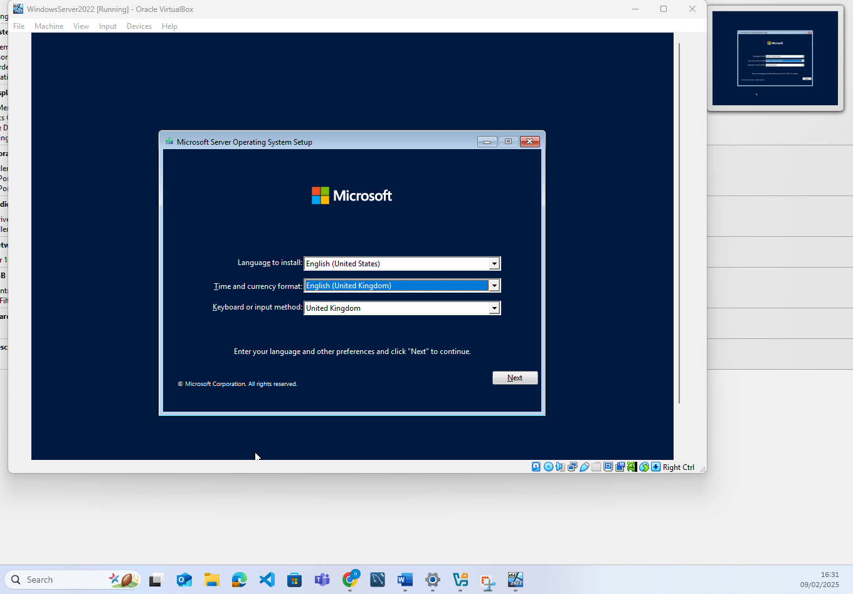
The Desktop Experience was chosen to ensure a GUI instead of CLI interface (this was initially an error and I uninstalled and re-installed the Datacentre Desktop Edition as requested which is why the timestamp here is different to the others).
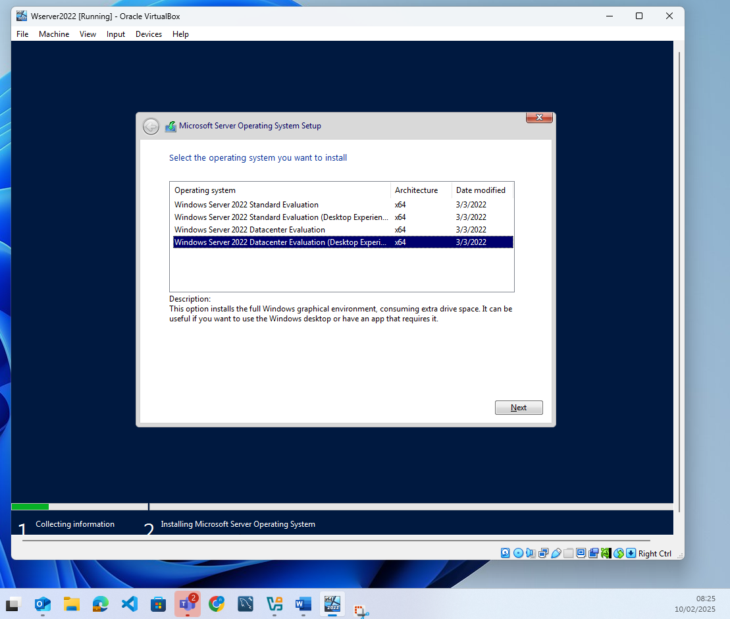
Below shows the partition created as instructed
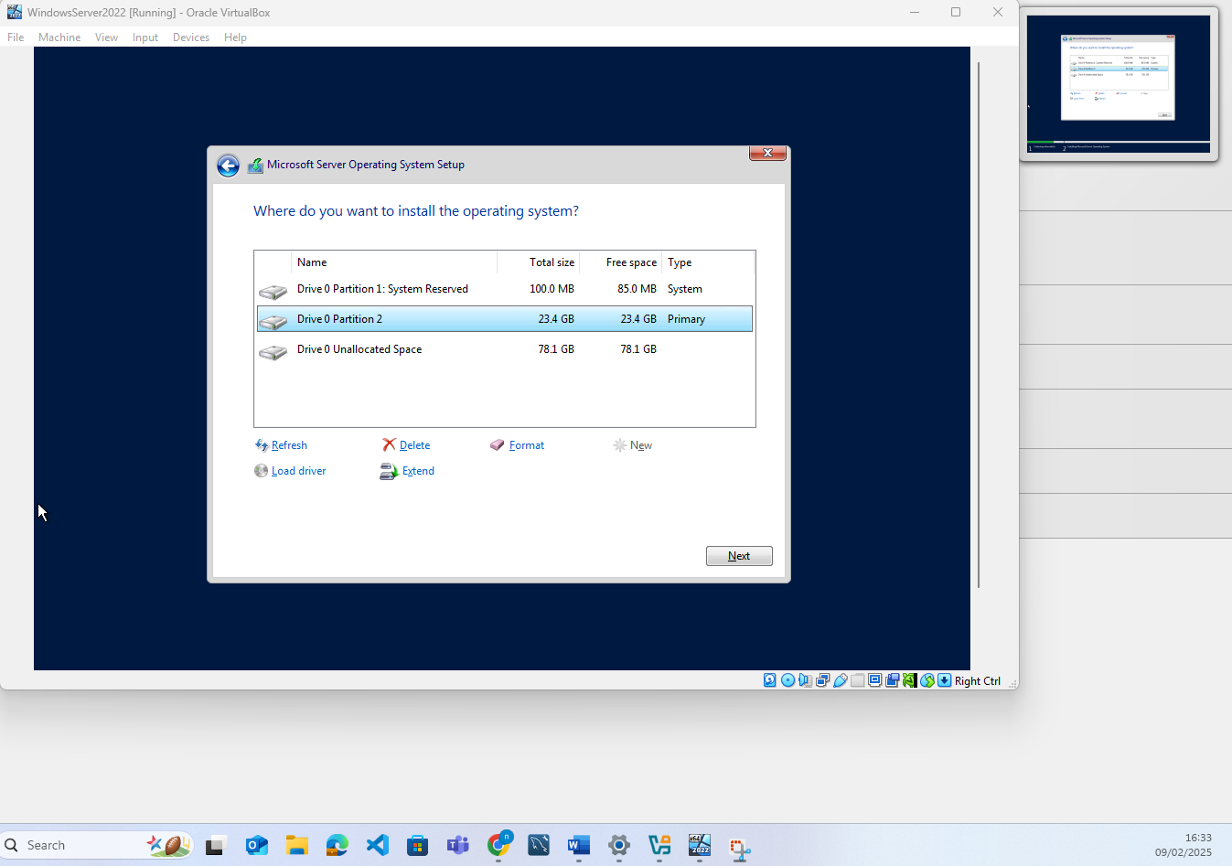
The installation then proceeded
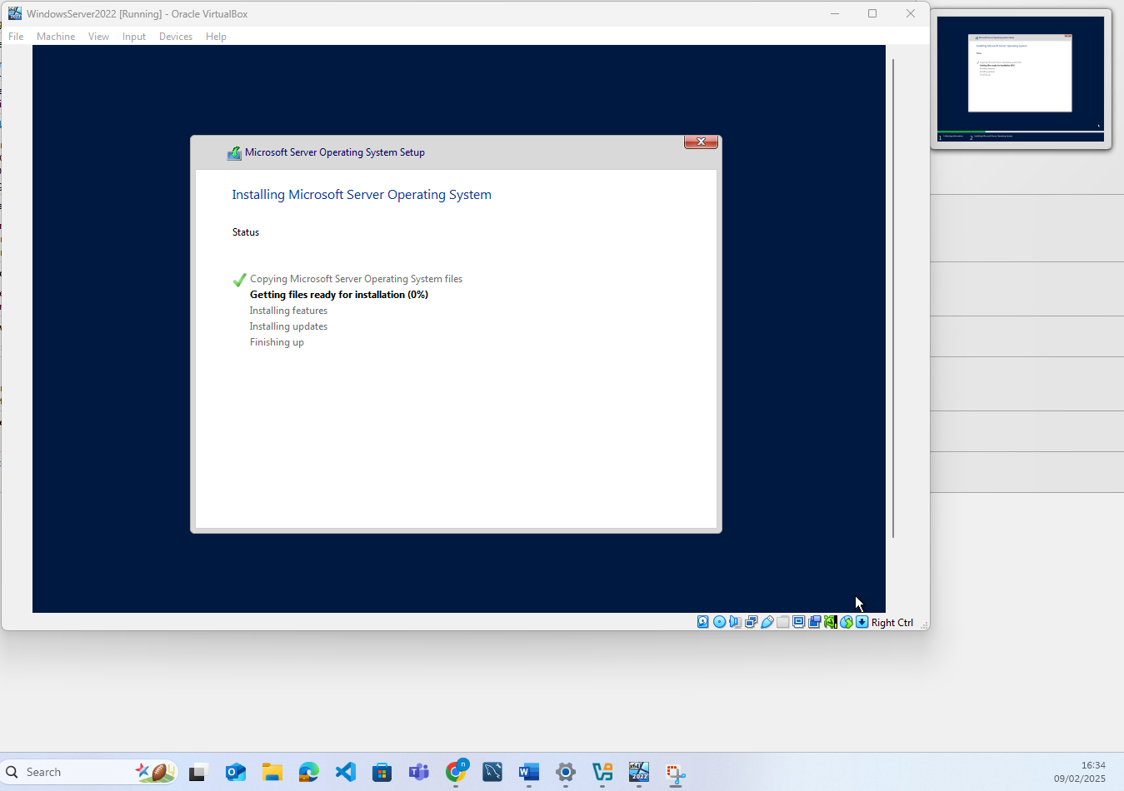

I then configured the administrator account when prompted with a password
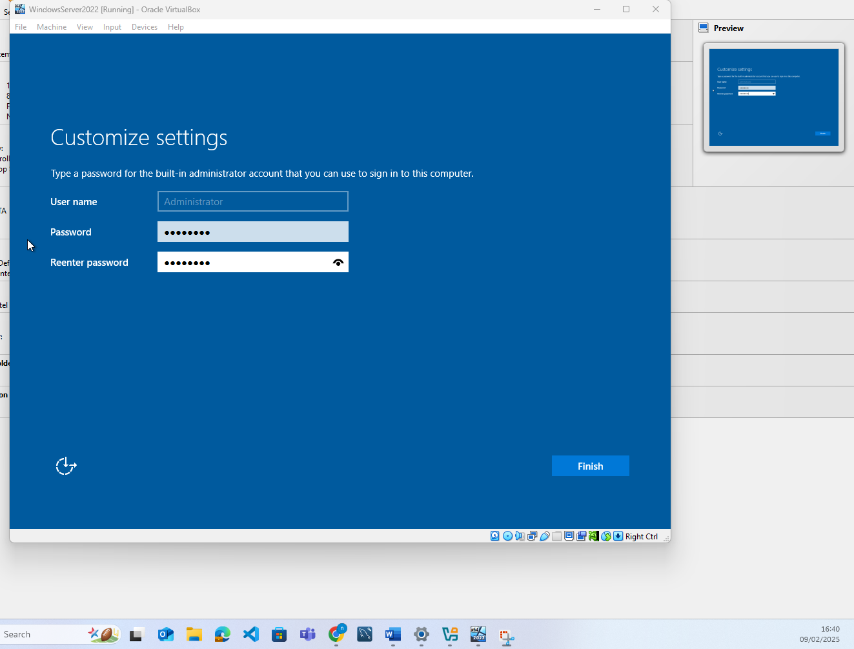
This completed the initial setup
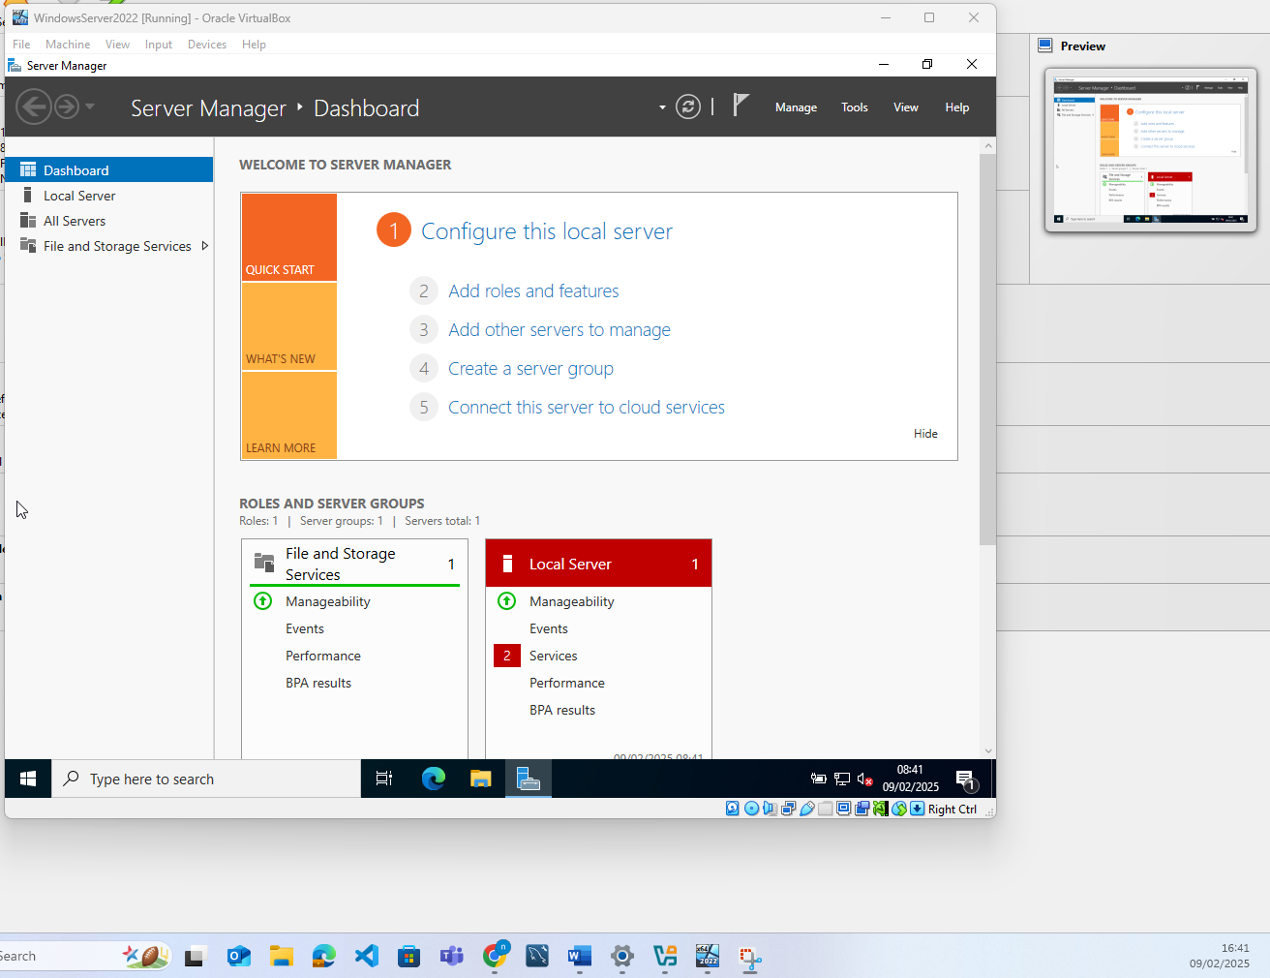

Windows 10 Client Installation
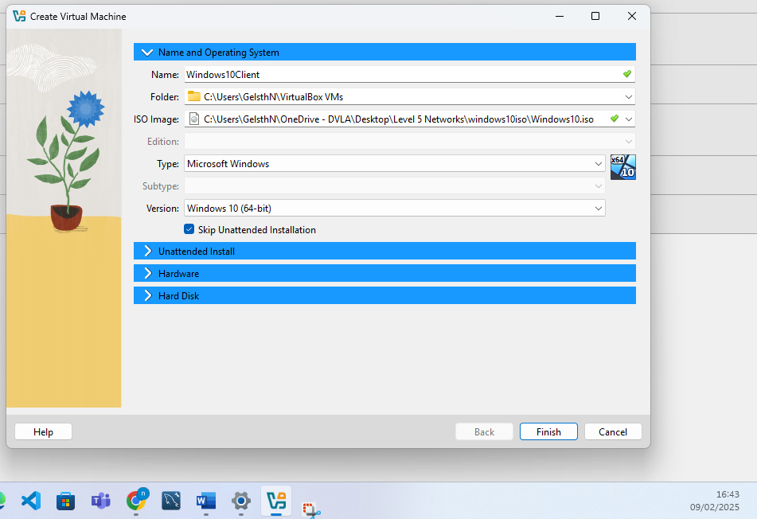
The amount of memory and processing power was reduced for the client machine as it would not be utilised as much and didn’t require the same amount of resource allocation
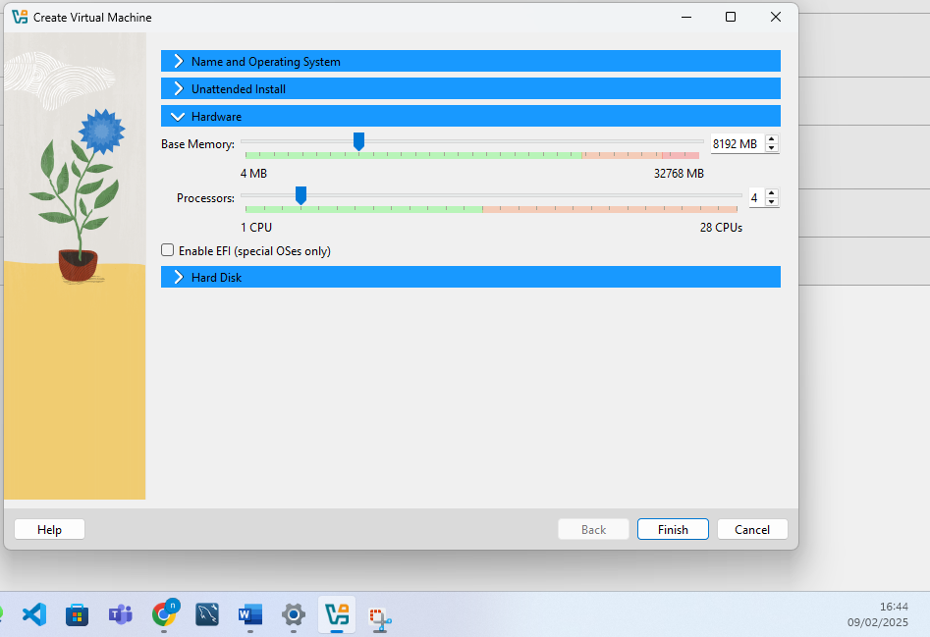

80GB of HDD disk space was allocated to allow sufficient space for the OS and a partition to be created as well
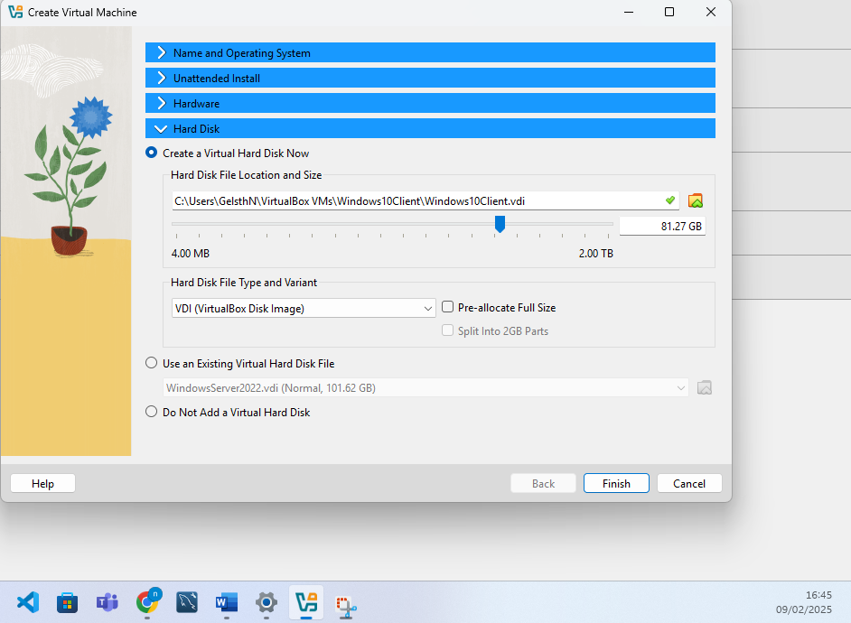
UK settings were chosen to ensure compatibility with keyboard being used throughout the activity 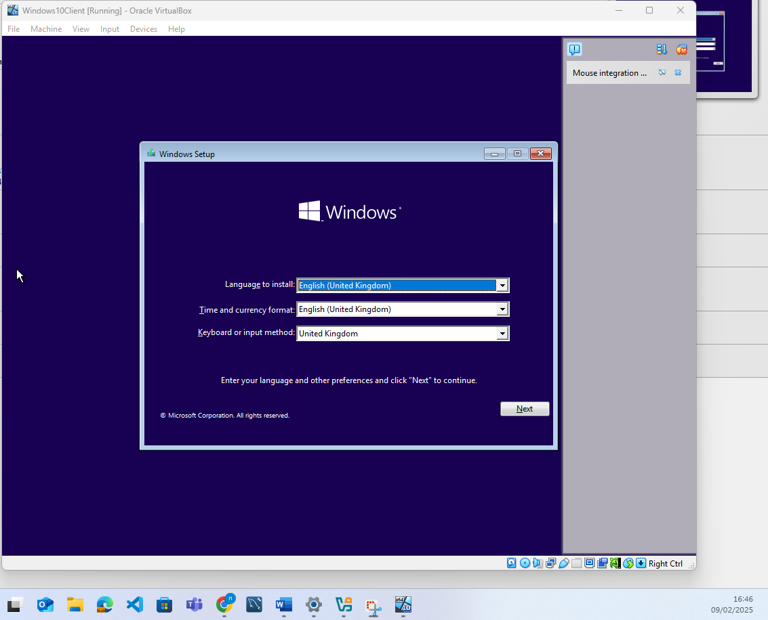
Windows 10 Pro edition was selected from the menu
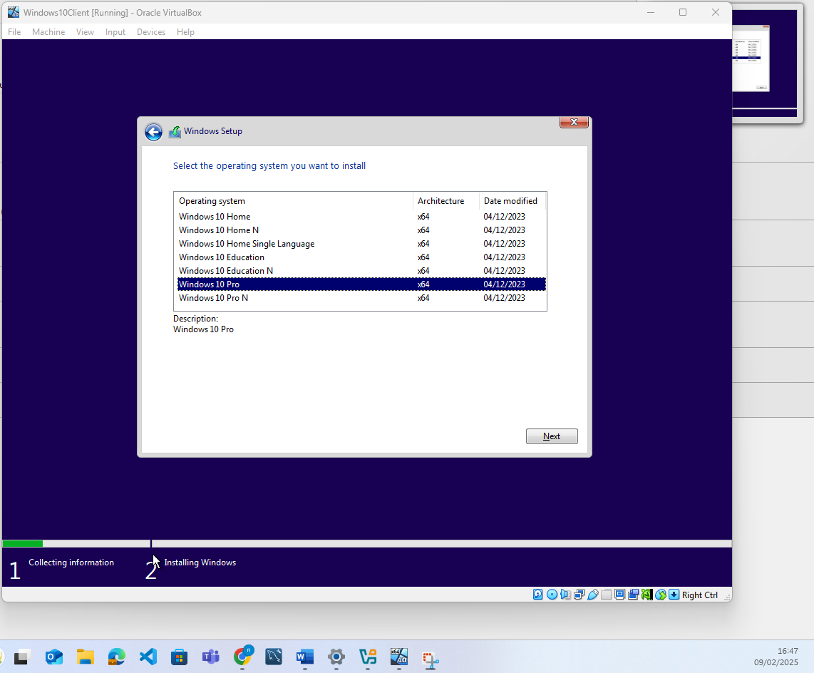a file partition was created

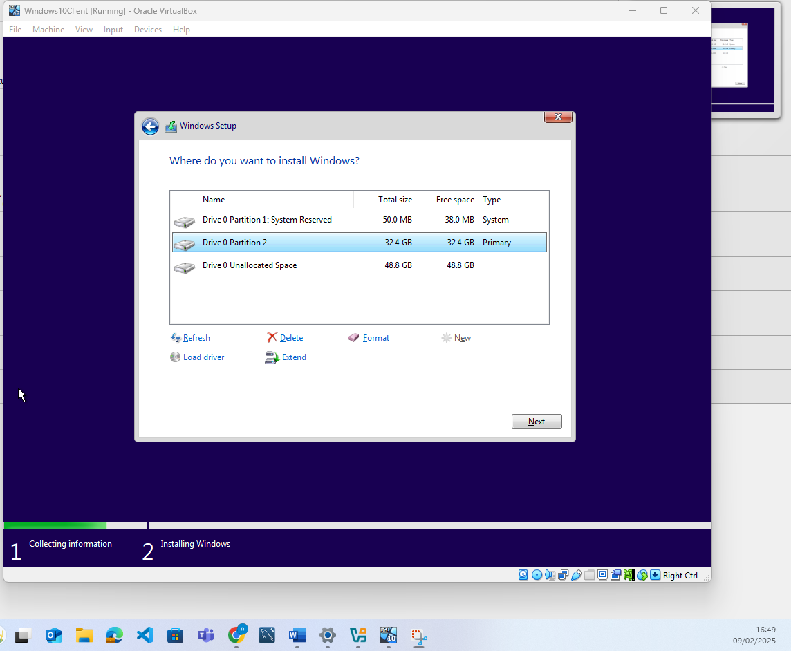
The installation then run
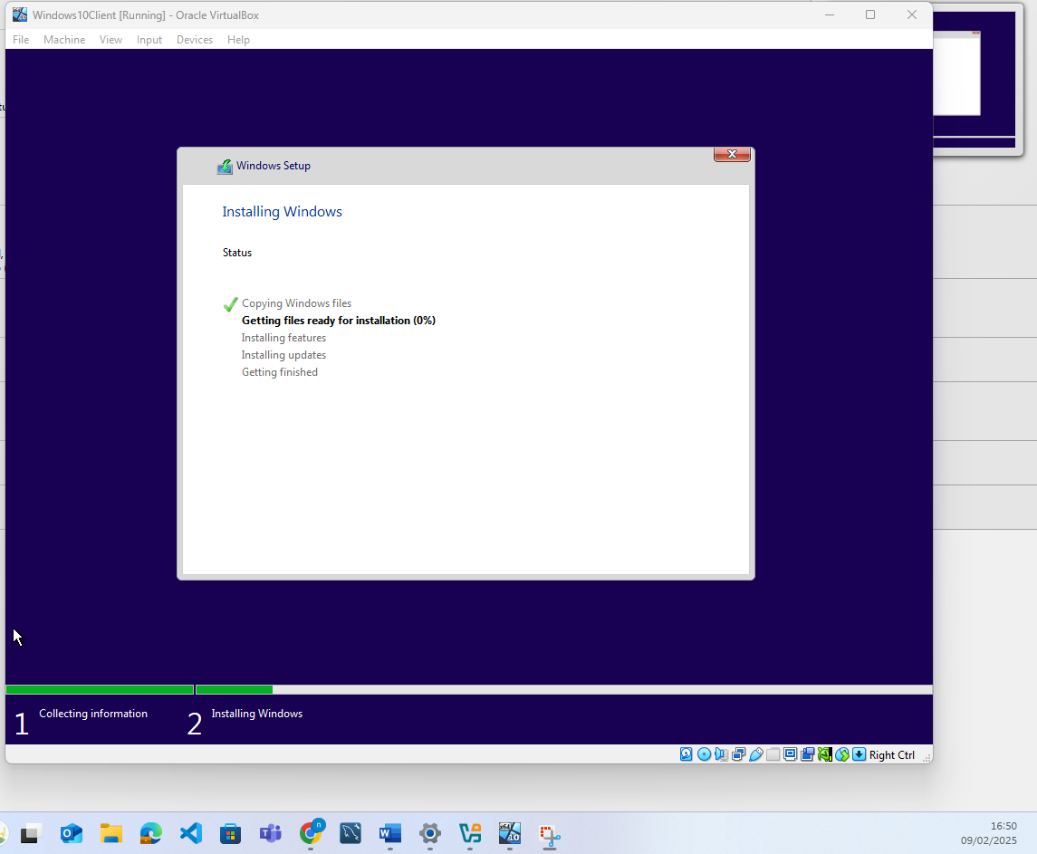
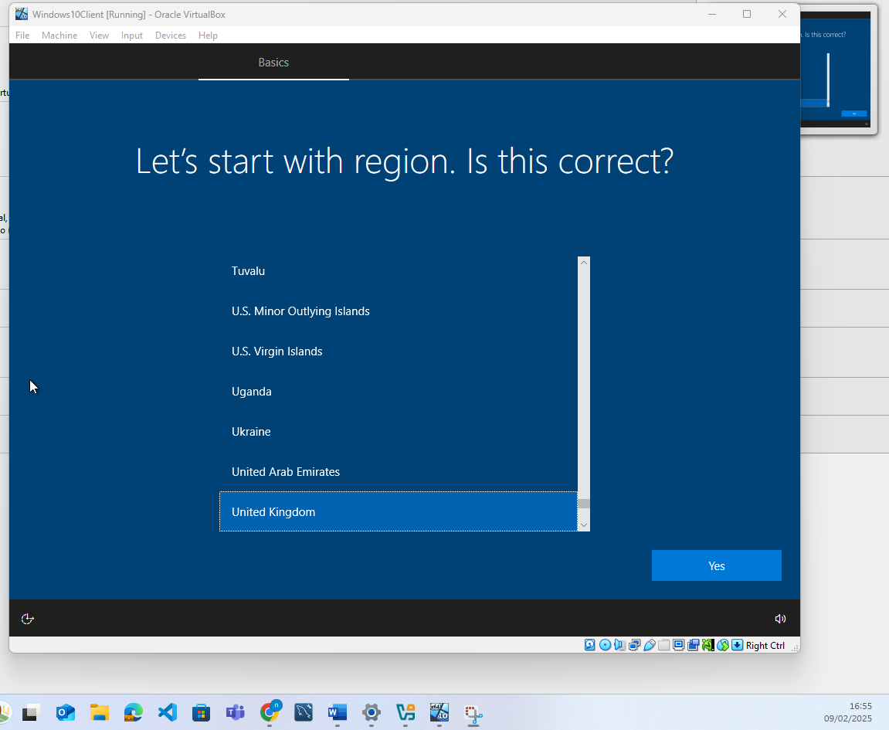
I then made a local account for a user
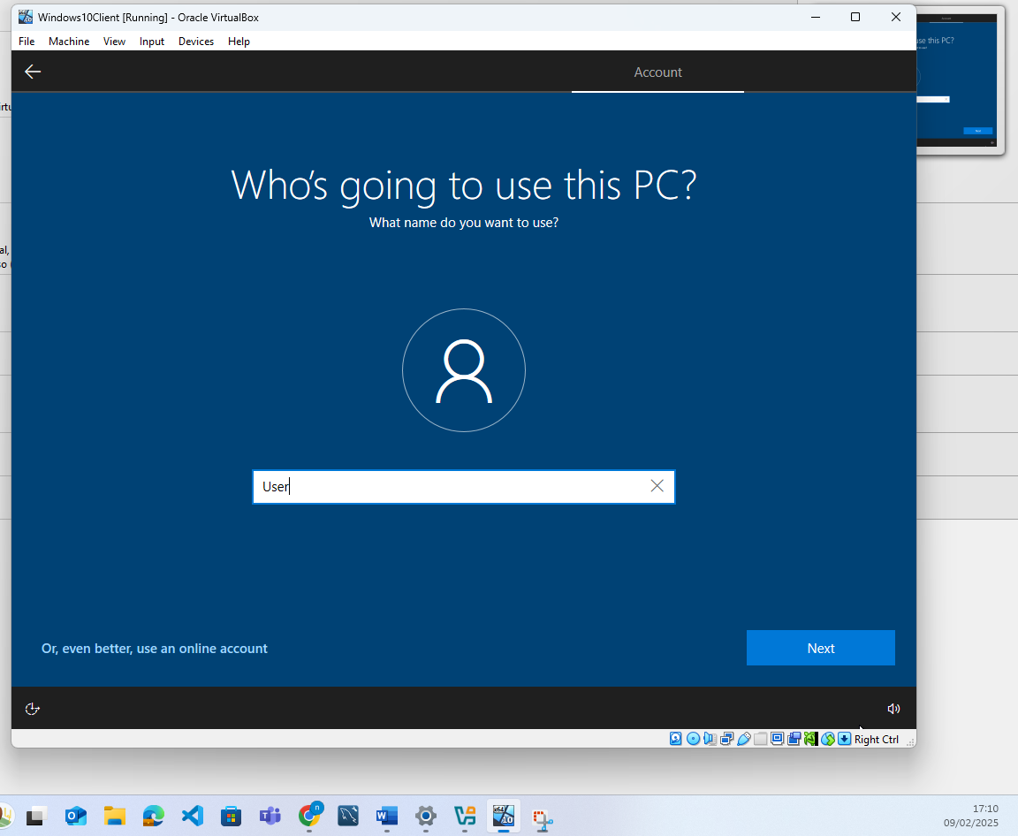

I then turned off location and other services as I was prompted to ensure that the installation used as little resources as possible. This completed the installation of the windows client machine.

2.3: Configure IP Addressing & 2:4 Testing and Troubleshooting :

Configuring Windows Server 2022
I am now going to configure Windows Server. The first thing I checked was the network settings being used, using ipconfig in the command prompt this showed me that only one network adapter was set up
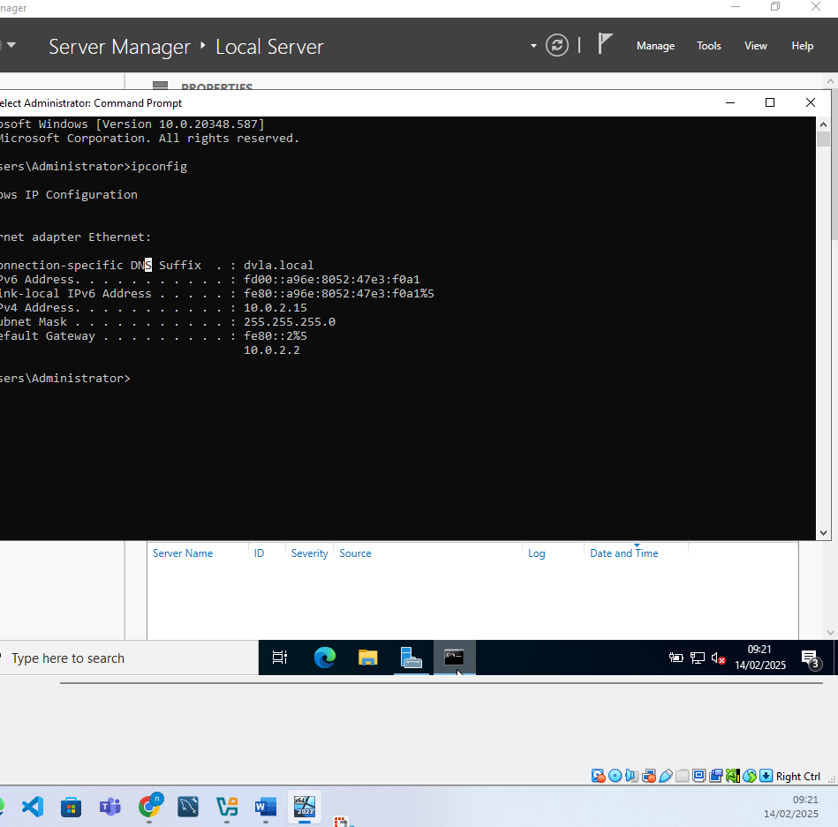

And so the first thing I did was to install the second network adapter. To do this I have to shut the server down, which I do selecting a hardware installation as the reason. I then open Virtual box and enable adapter 2 using the settings below
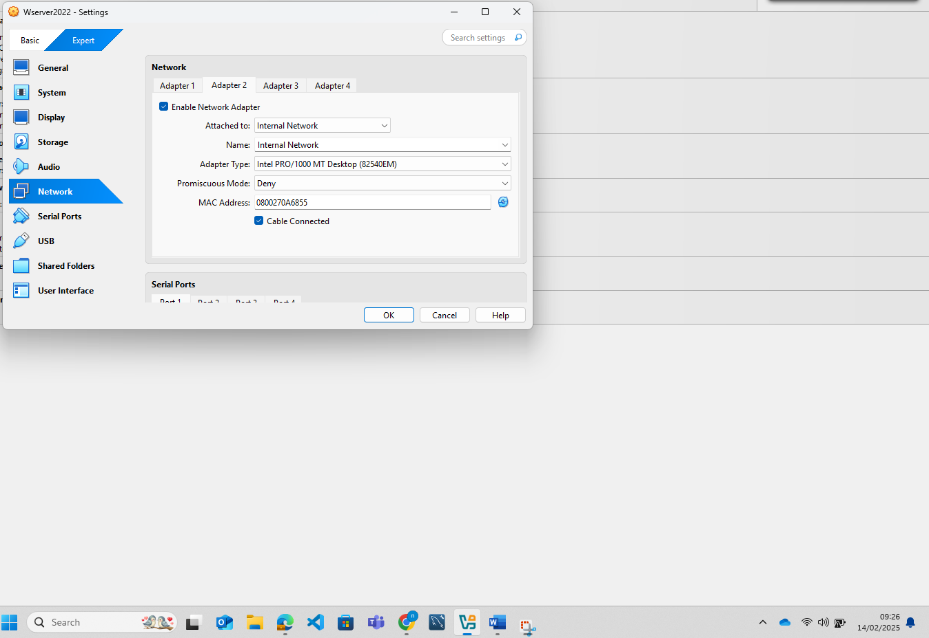
I then power on the server and check the network adapter settings which shows that this has been installed as required. When they load I rename them to Internal and External.
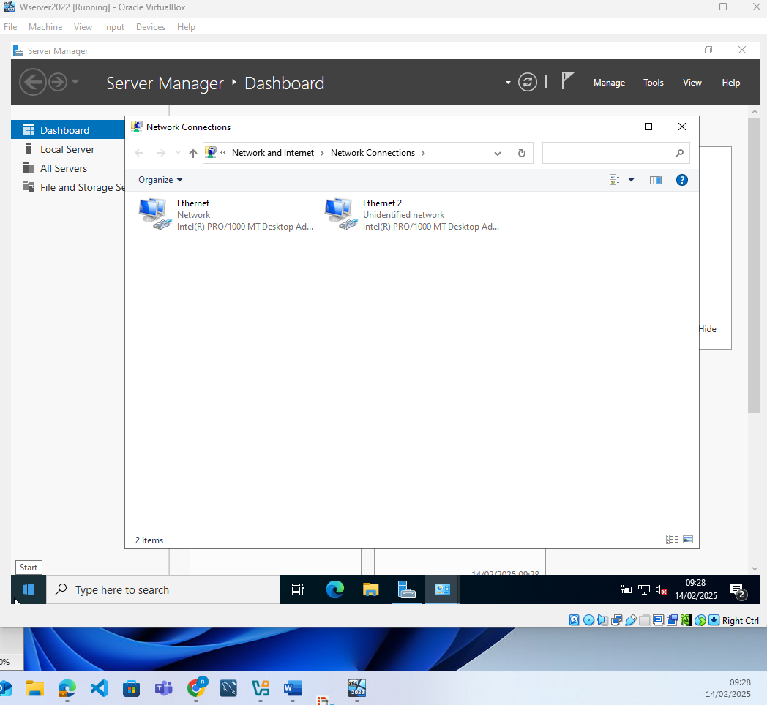
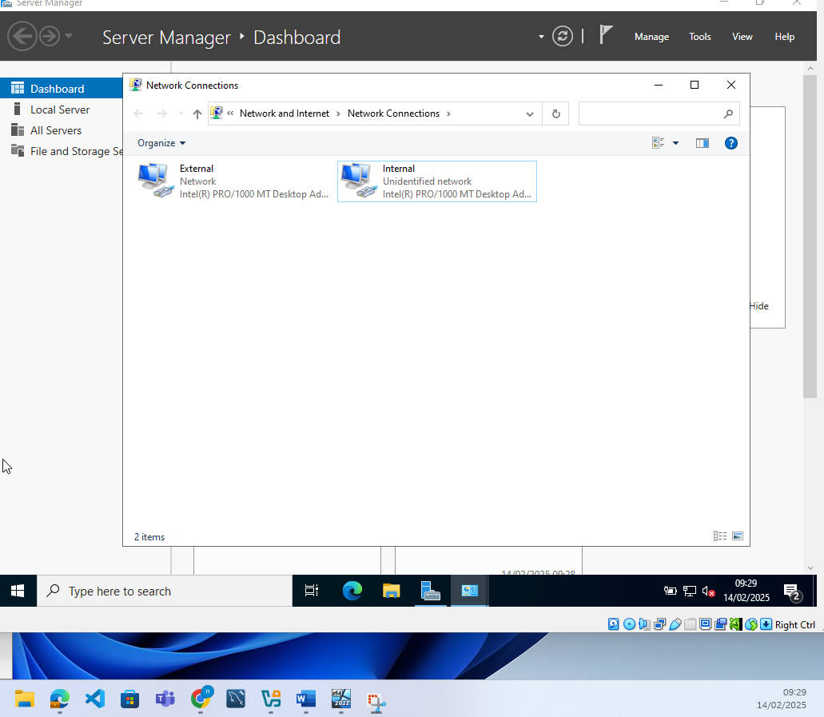
I then configure the internal network adapter assigning the server IP address as directed
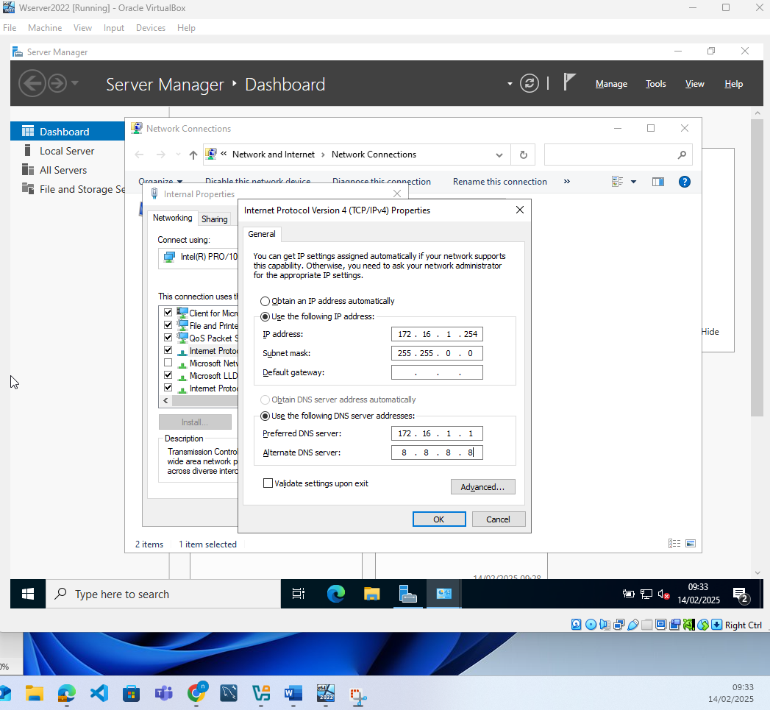
I then change the server name to S-DC and also turn off the firewalls in Windows defender for the Domain profile, Private Profile and also the public profile
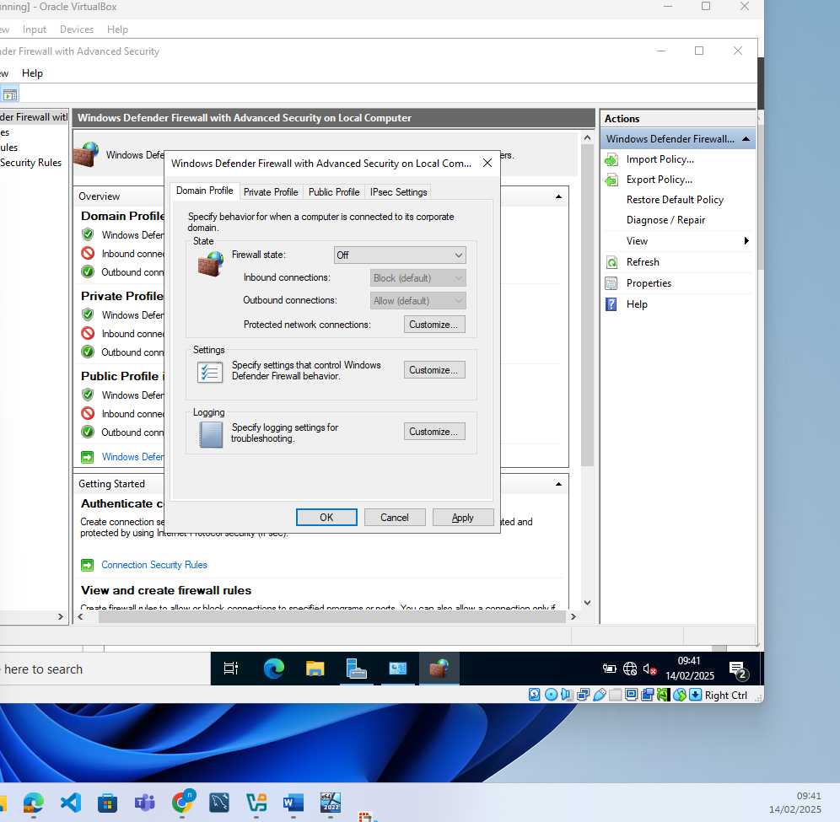
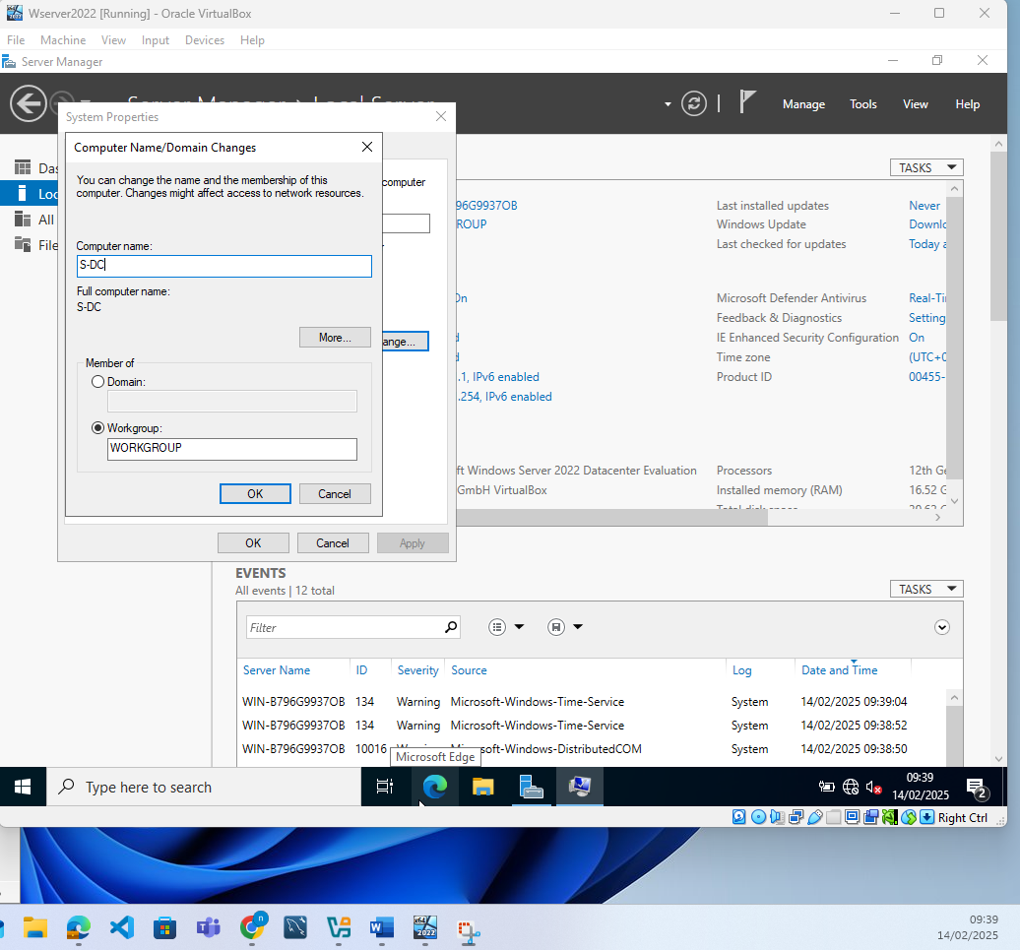

I then restart so that it the change of name will apply. I can see from the Server manager that all of the changes so far have been successful.
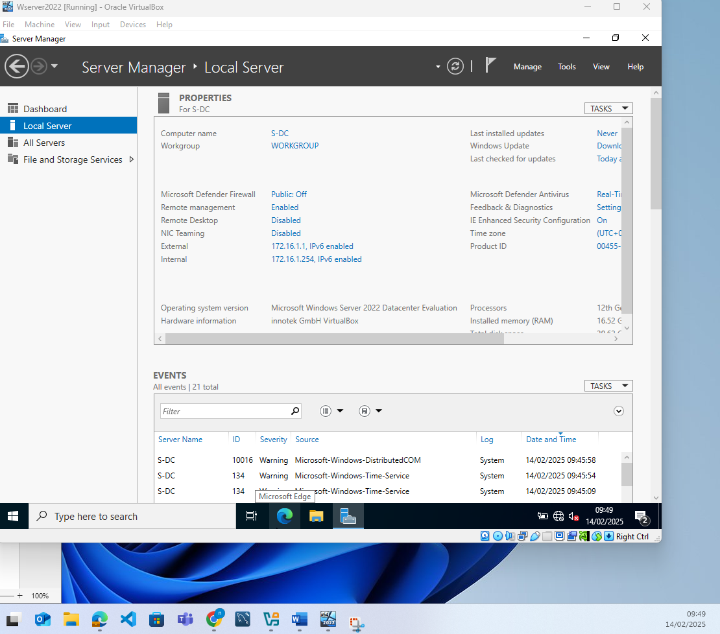
The next action is to enable DHCP on the server so that IP addresses are automatically assigned. From the server manager I choose to install features, I then choose Role-based or feature based installation and I choose my server from the server pool
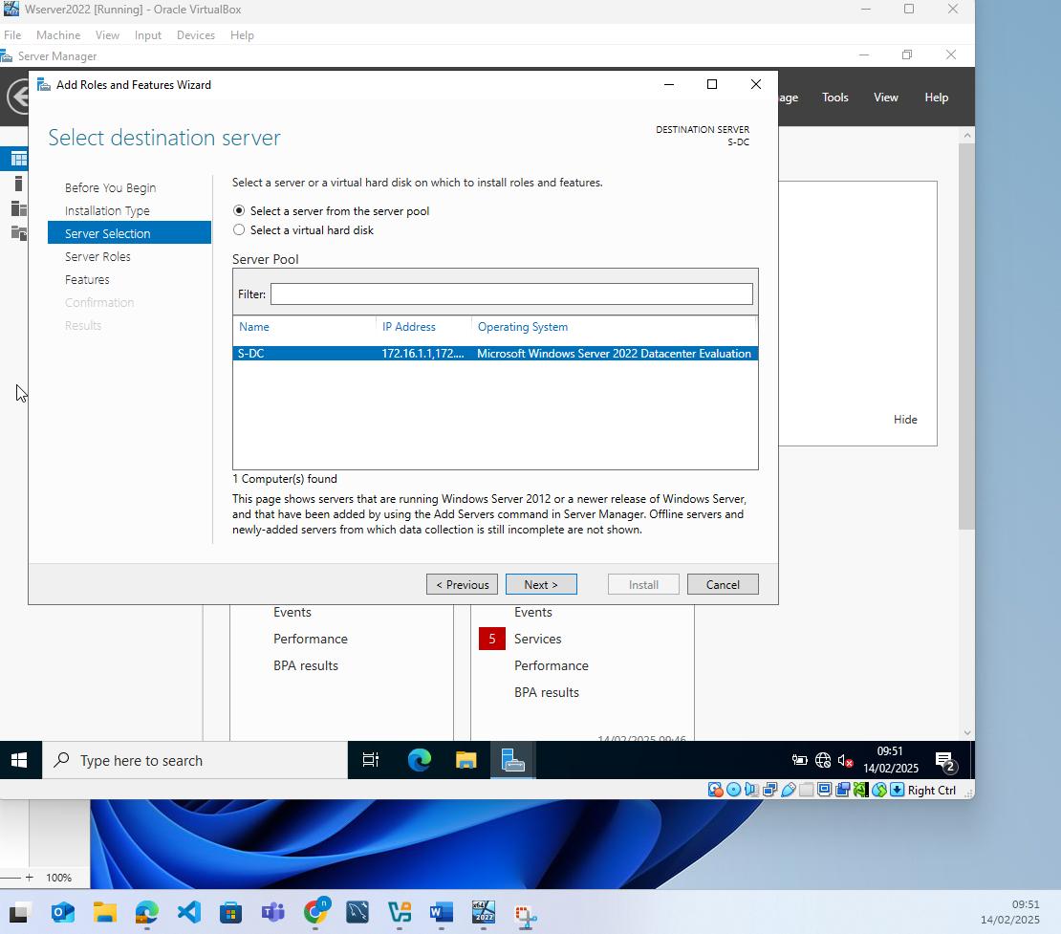

From the next screen I choose to install DHCP server and include management tools
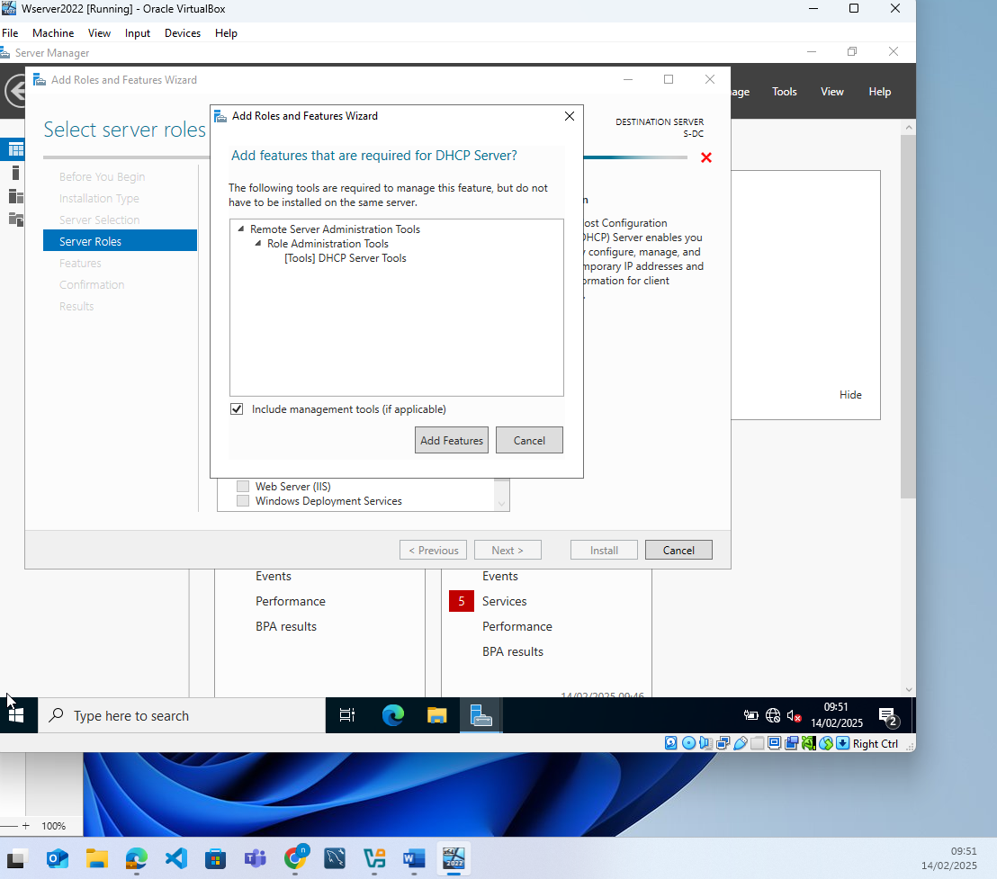
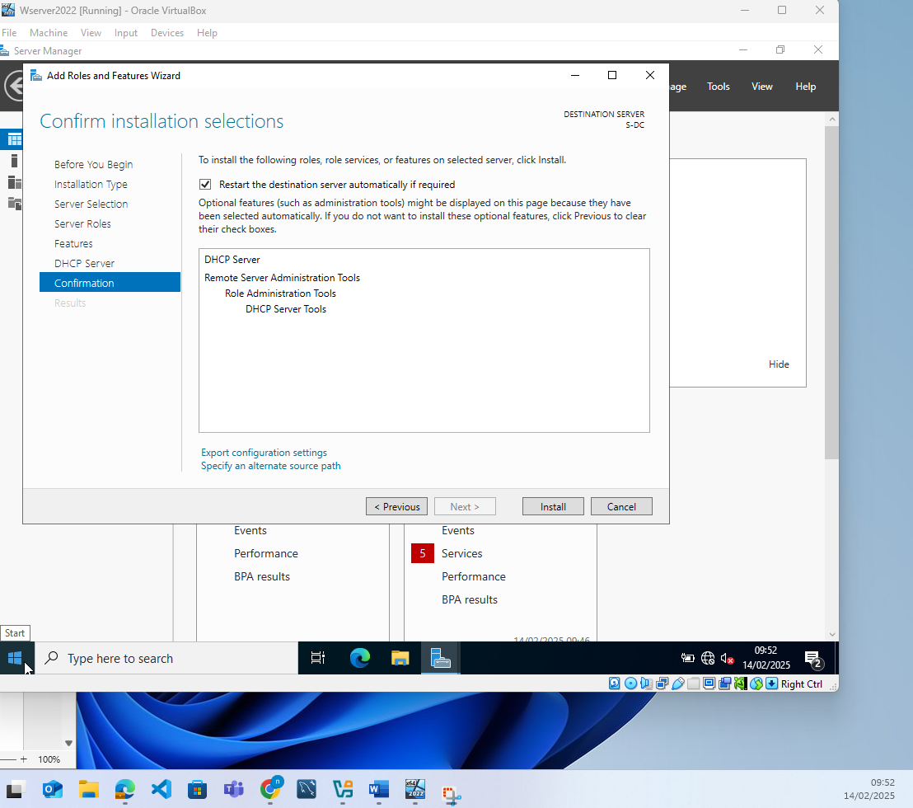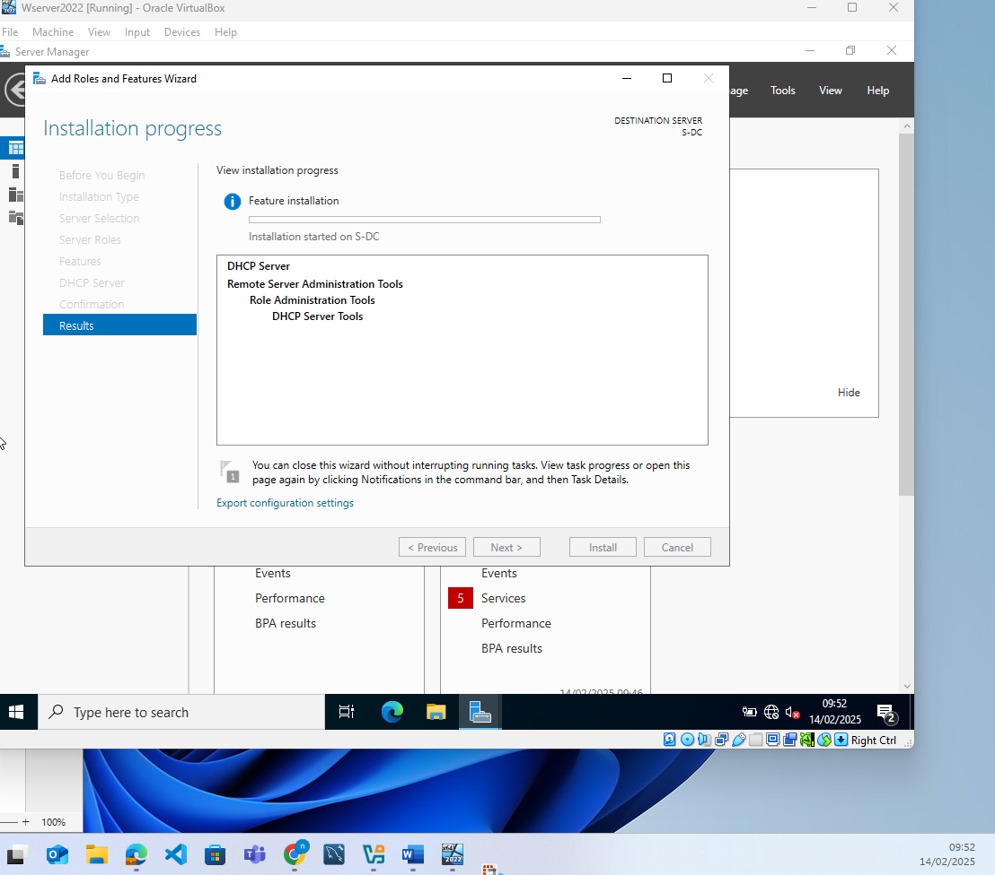
Once DHCP has been installed on the server I choose to go into the post-install configuration wizard
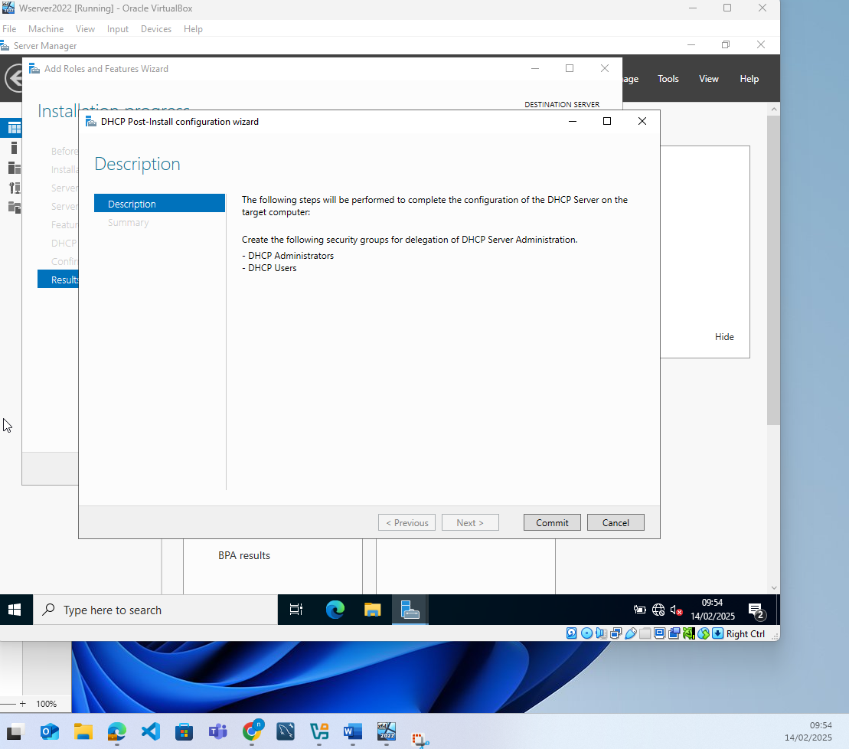
The new security groups are created and the server is restarted to allow the changes to take effect
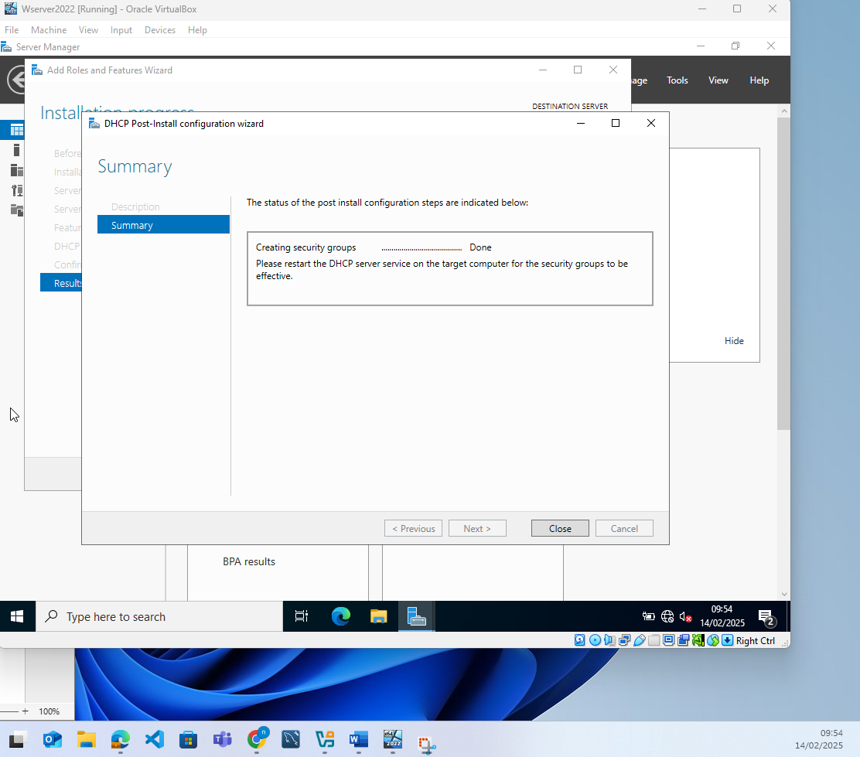
Once the restart is completed, I can see the DHCP feature from the server manager dashboard which confirms that the feature is installed
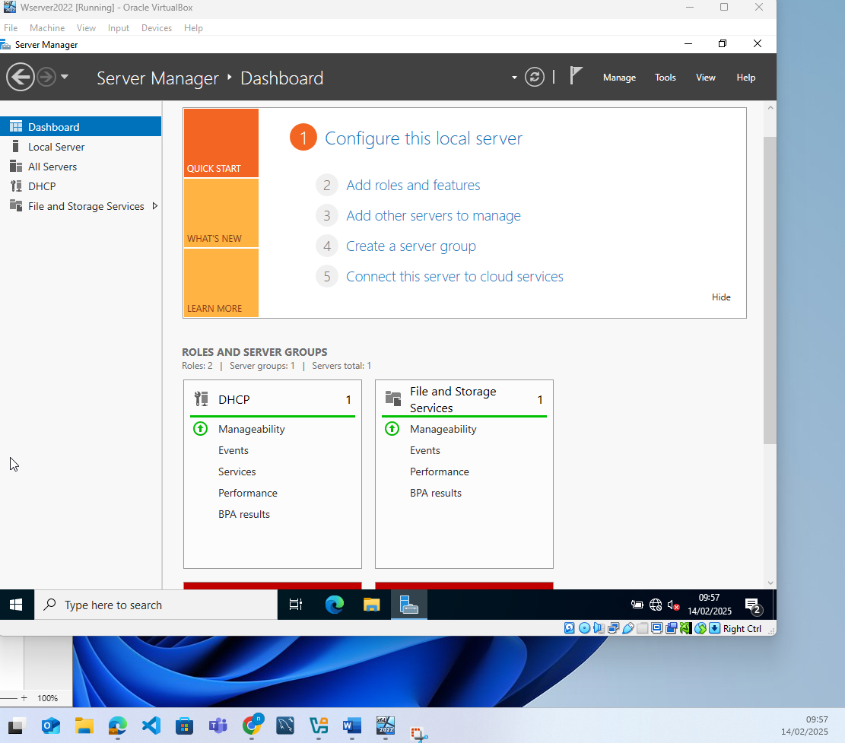
I open up the DHCP app, and create a new scope, I choose to allow 8 ip’s as I only currently have 1 client so the range shouldn’t need to be any larger at this point
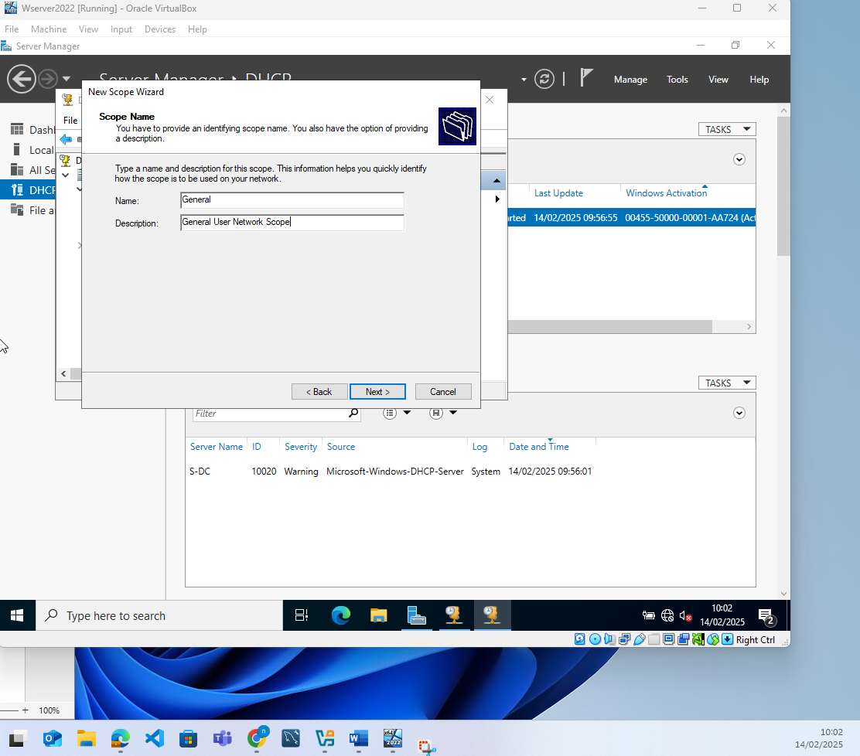
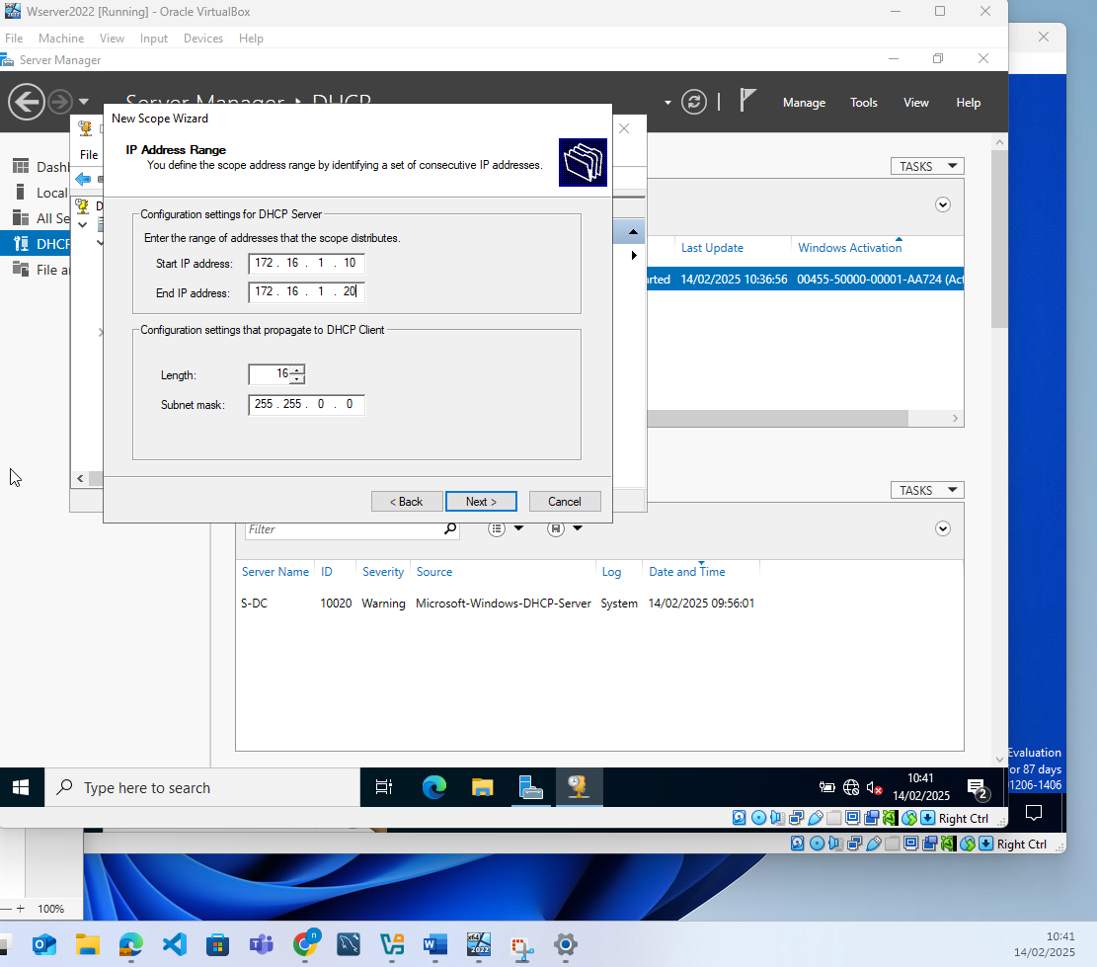
I do not put in any exclusions and set the lease duration to 1 day
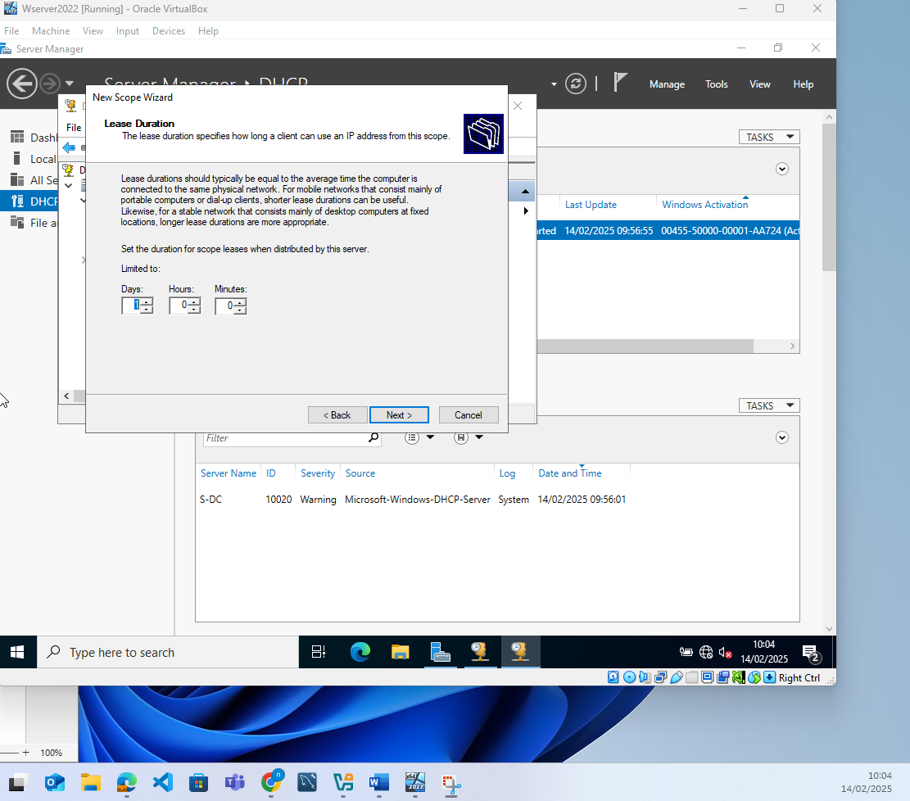
With this I saved and set up I moved on to the client machine.

I want to now configure the client Windows PC.

The first thing that I do on the windows client is to disable the firewall so that I can pint between the machines.
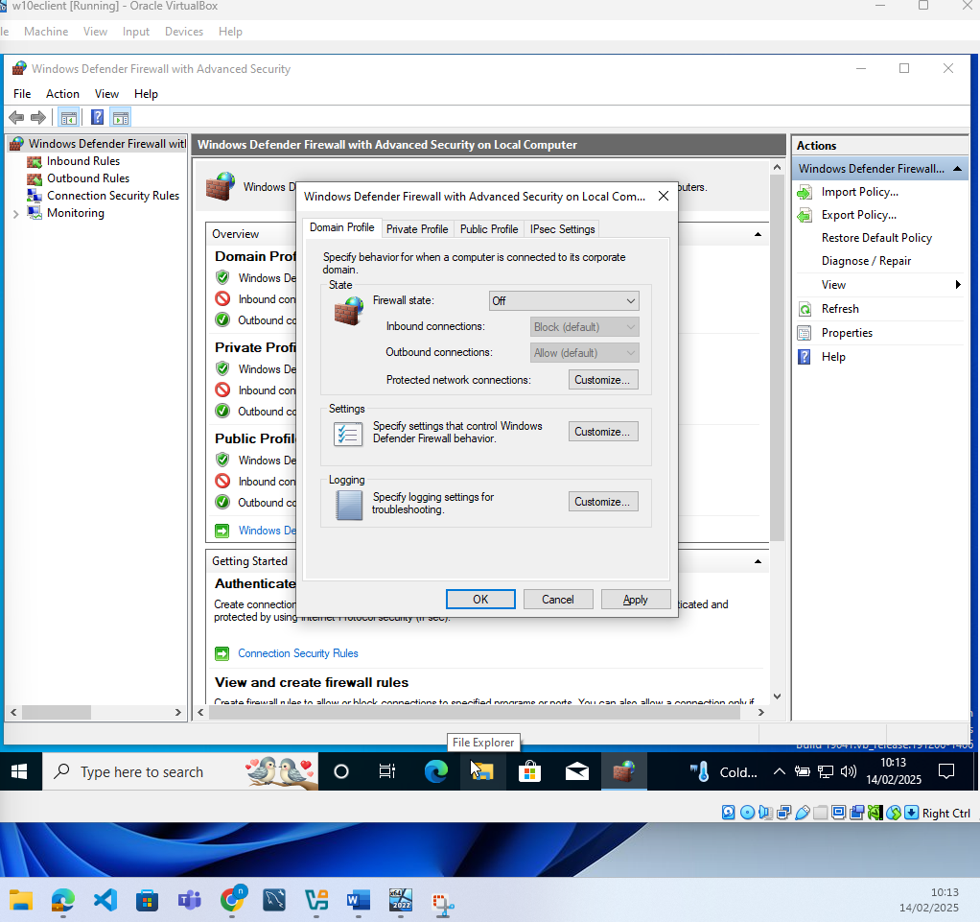
I check the network adapter settings and ensure DHCP is enabled, and then run ipconfig to see what Ip has been assigned
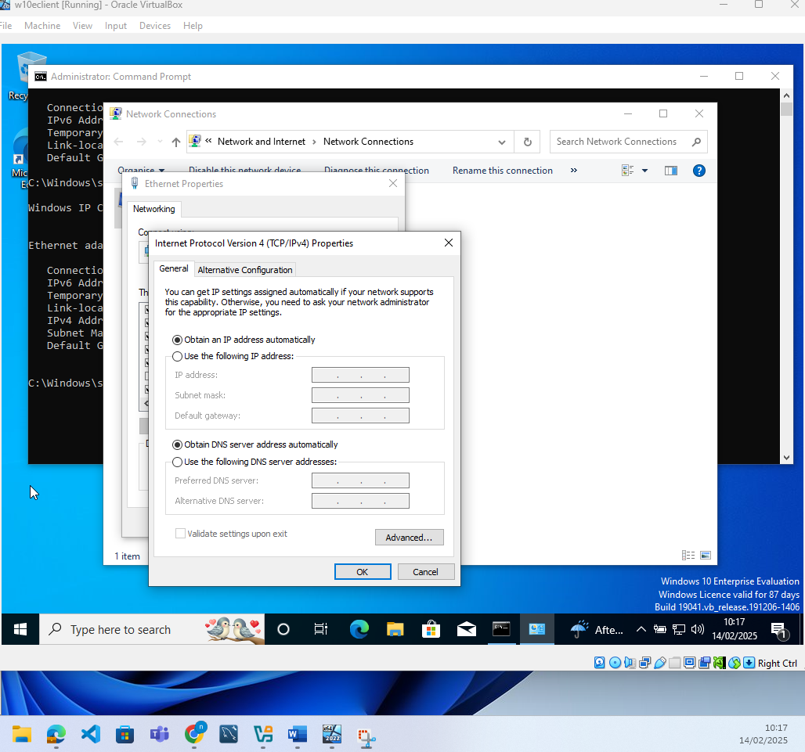
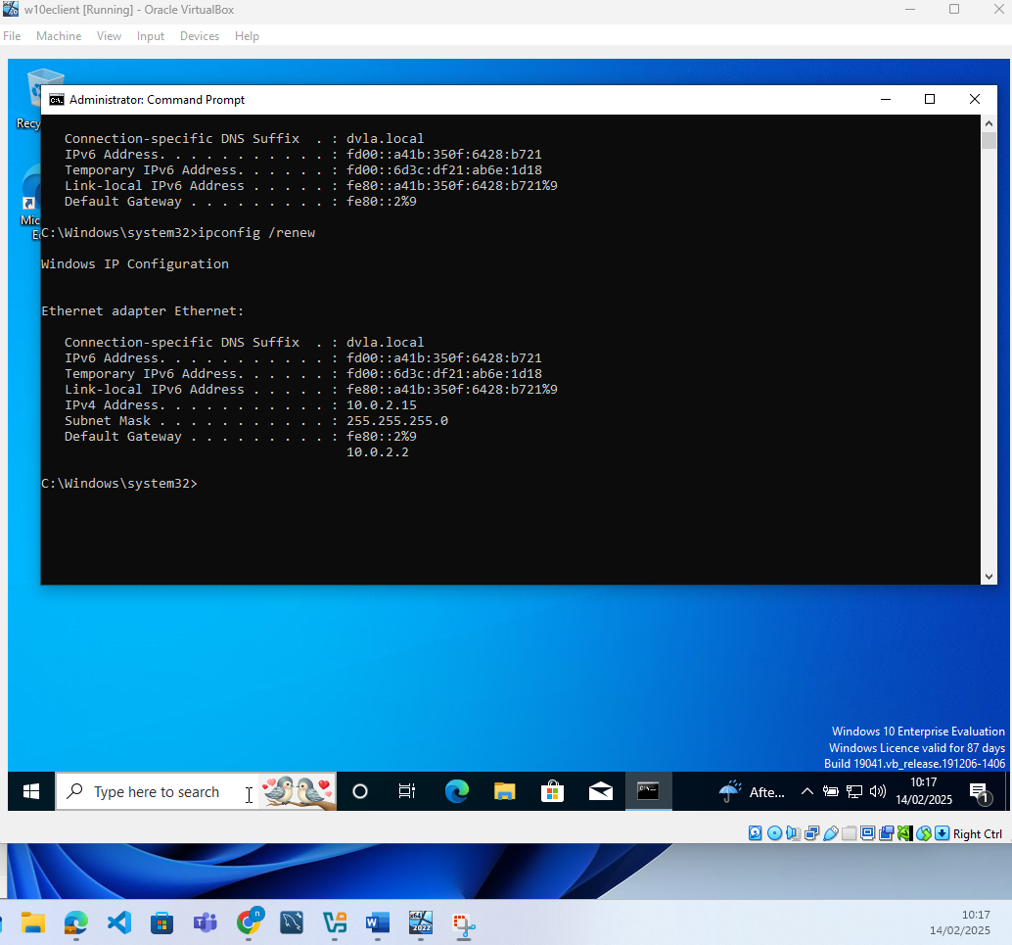
This clearly shows that the client is successfully using DHCP but not from the server that I have configured. I believe that this is because the adapter is connected to an external client and I need it to point to the virtual internal network. I change this in virtual box and the reboot the client machine
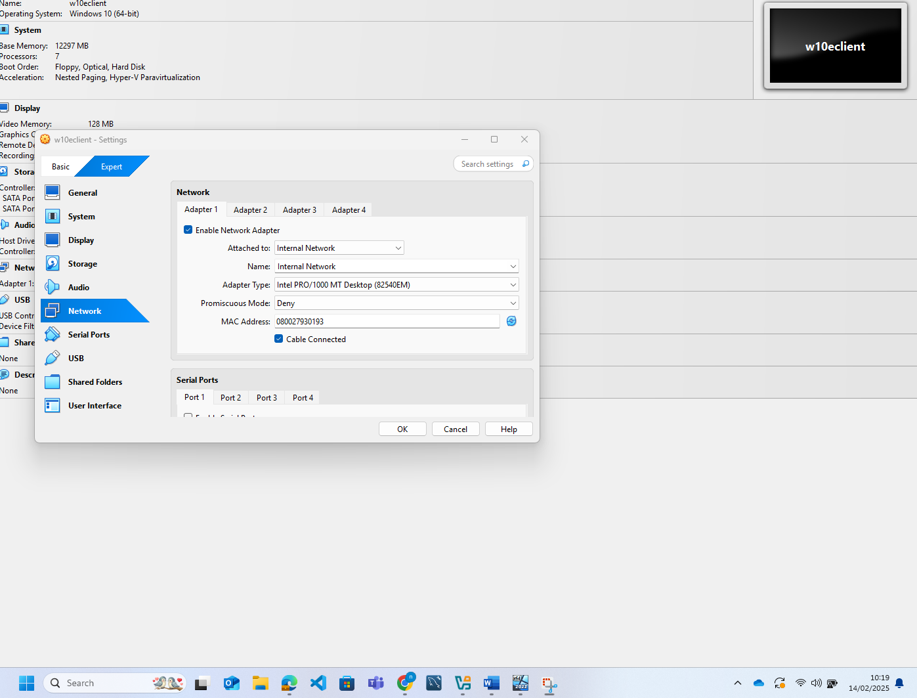
With this done I then rebooted the client machine, and ipconfig/ release and ipconfig /renew just to ensure that the IP address would be reset. With this done I then did ipconfig and I could see that the IP address assigned was within the range requested
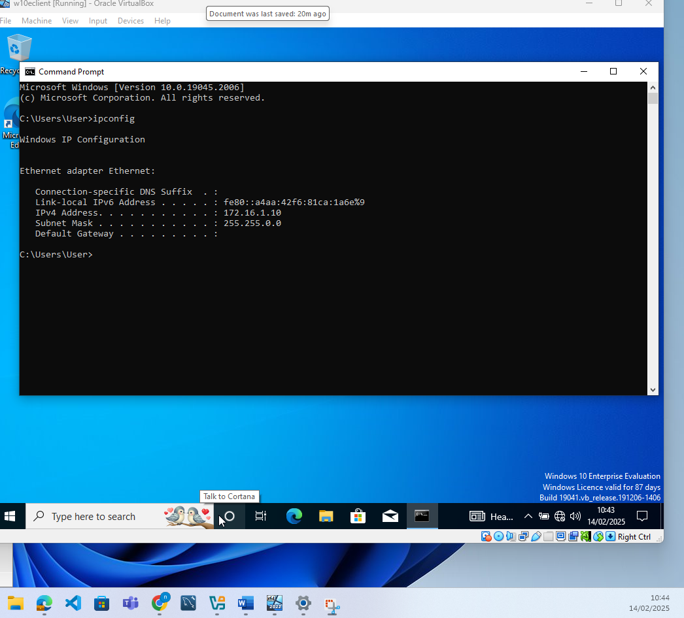
I then pinged the server to ensure that the network connection was working and that the firewalls were disabled and this also worked, I also did a tracert which would show me the server name. Both of which run successfully as shown
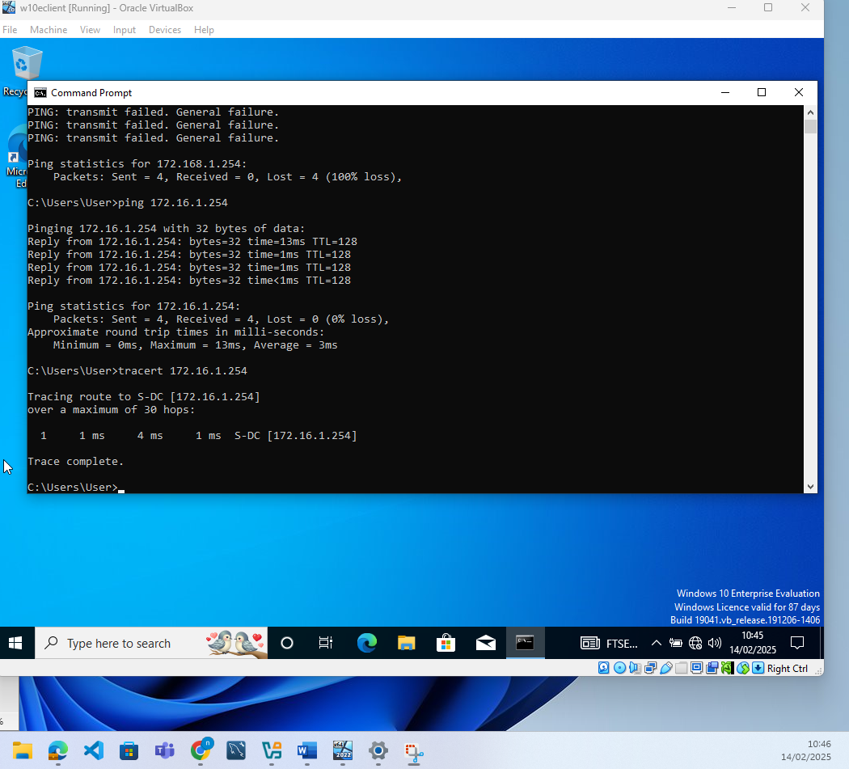
I then logged on to the server to see if I could ping the client machine and this worked successfully showing that the windows network was working as required.

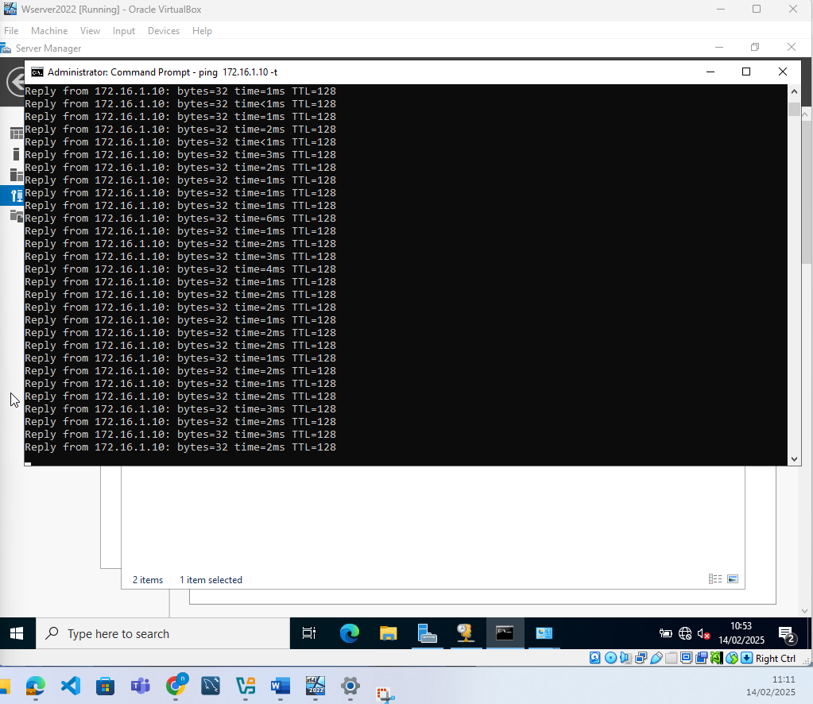

Linus Server Installation

I downloaded the ISO for Devian server from https://www.debian.org/devel/debian-installer/ . Once the ISO was installed I browsed to its location in vritual box
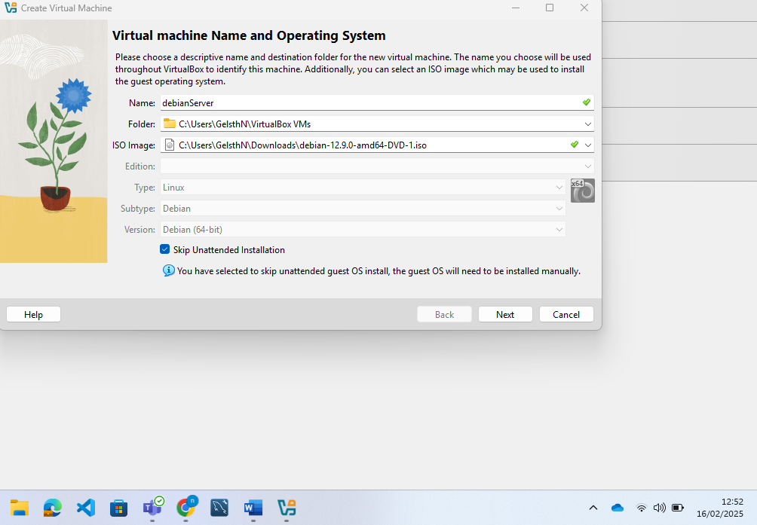
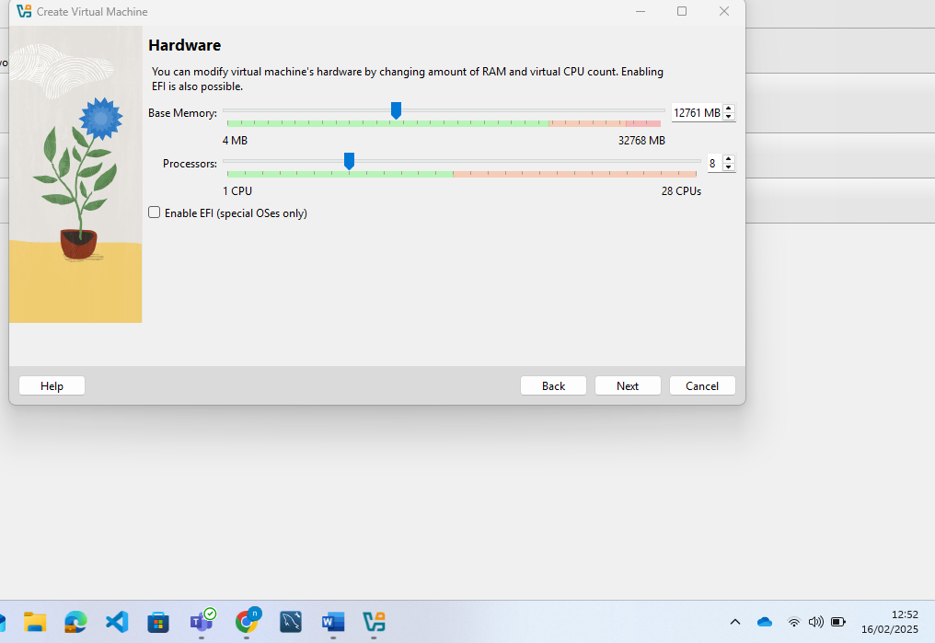
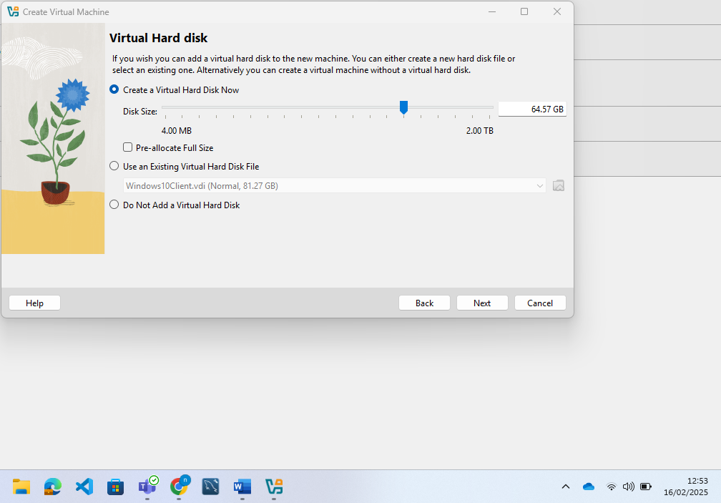I then run the virtual machine and completed the following installation
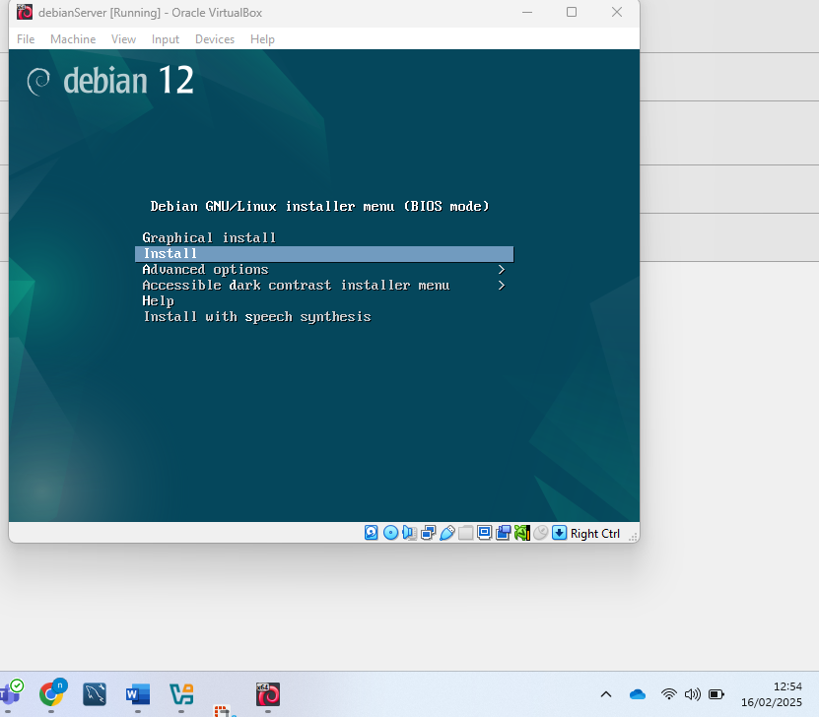
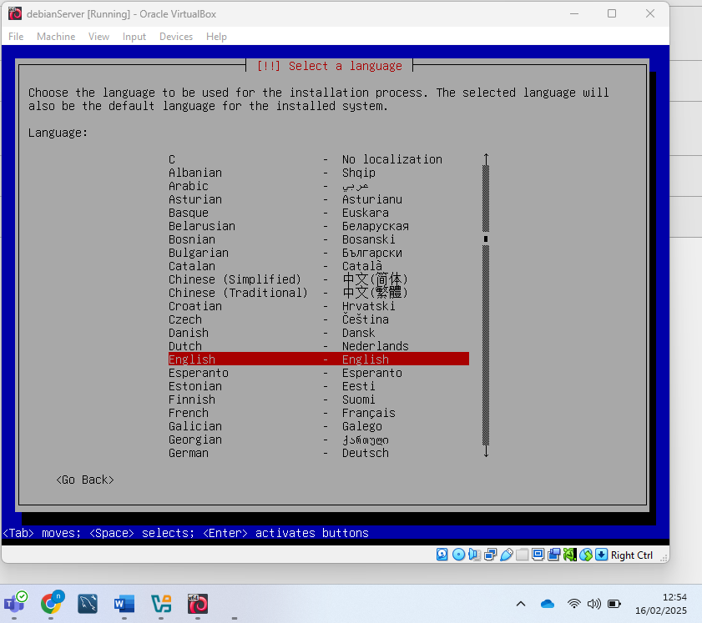
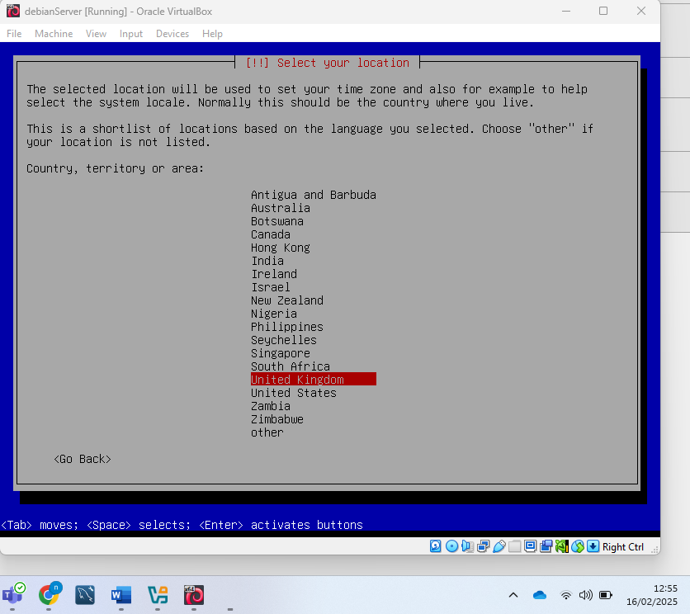
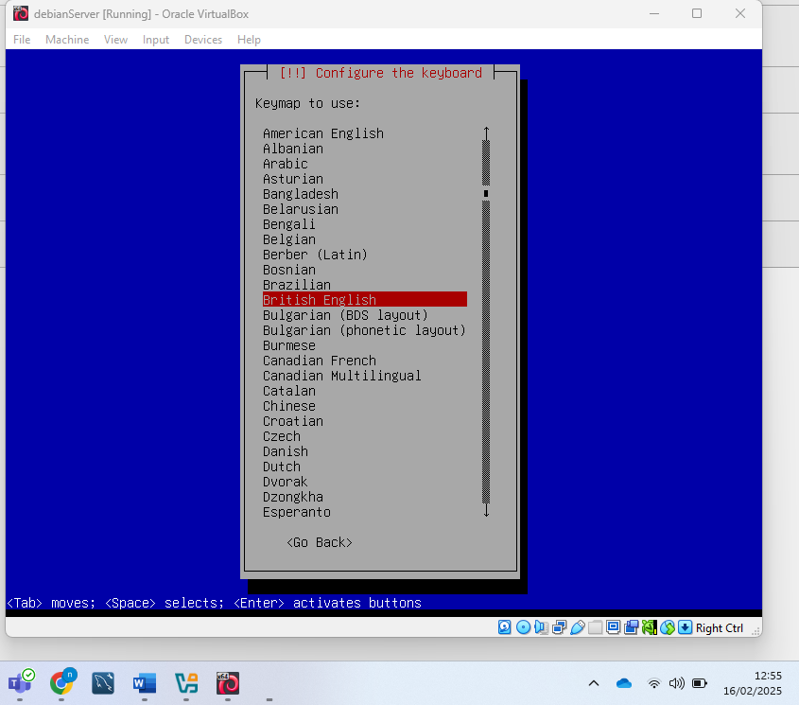
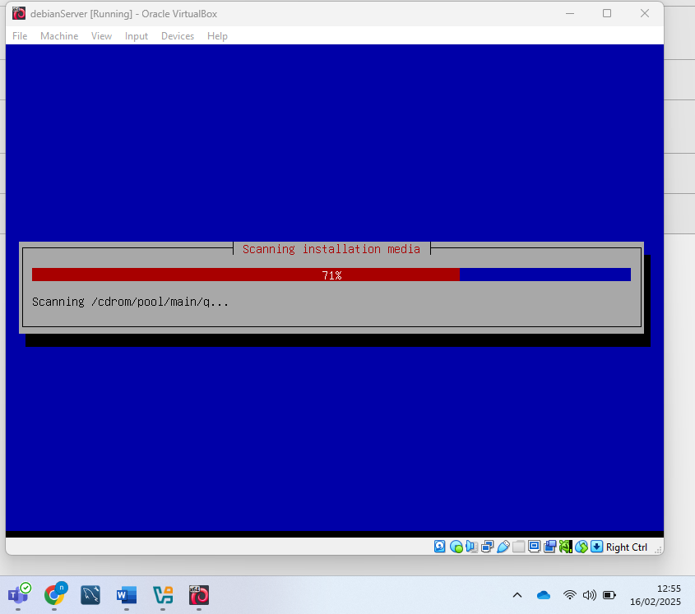
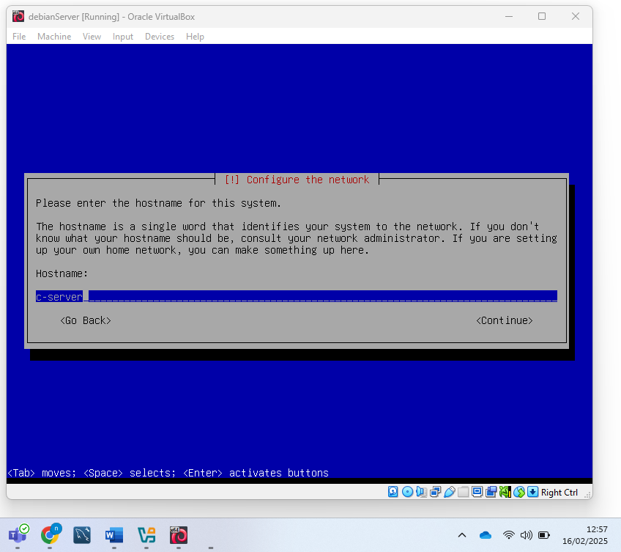
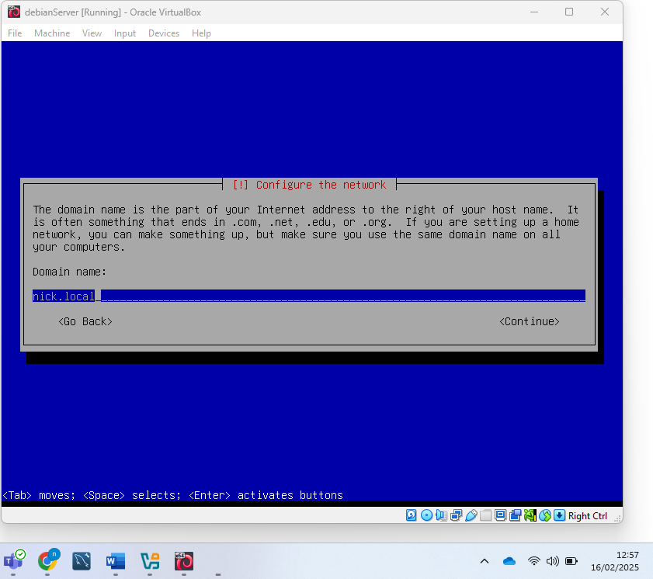
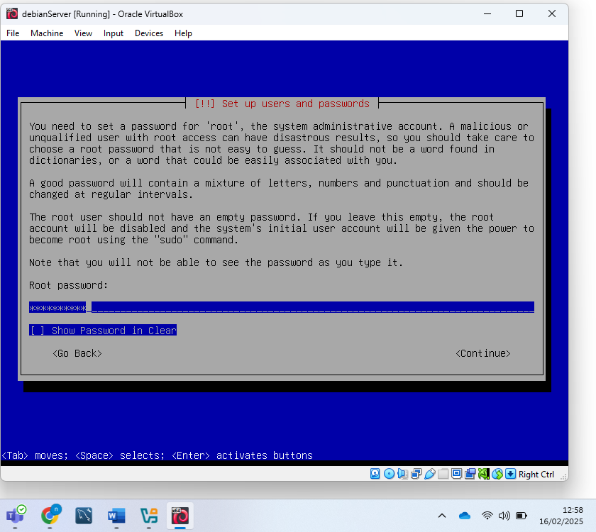
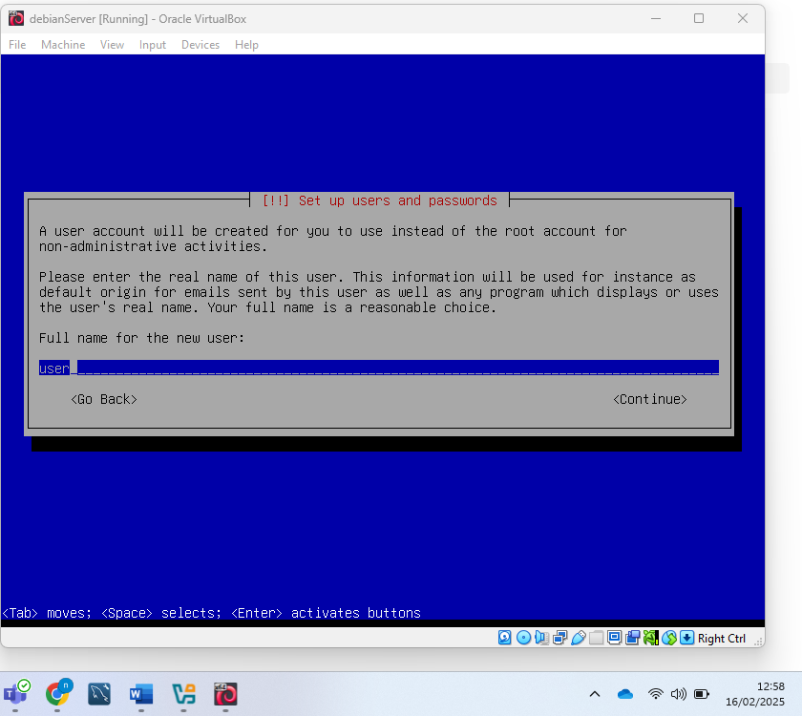
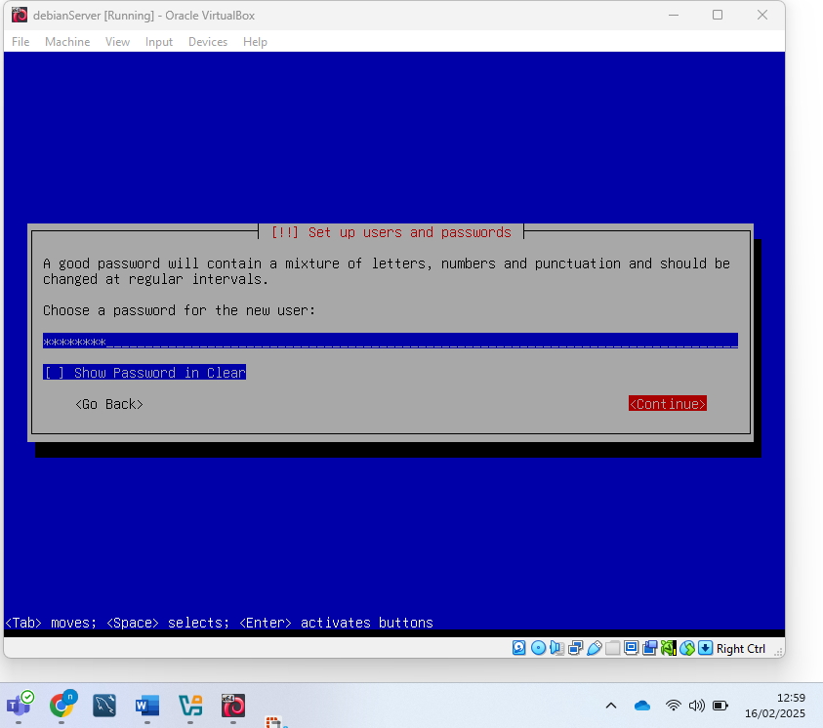
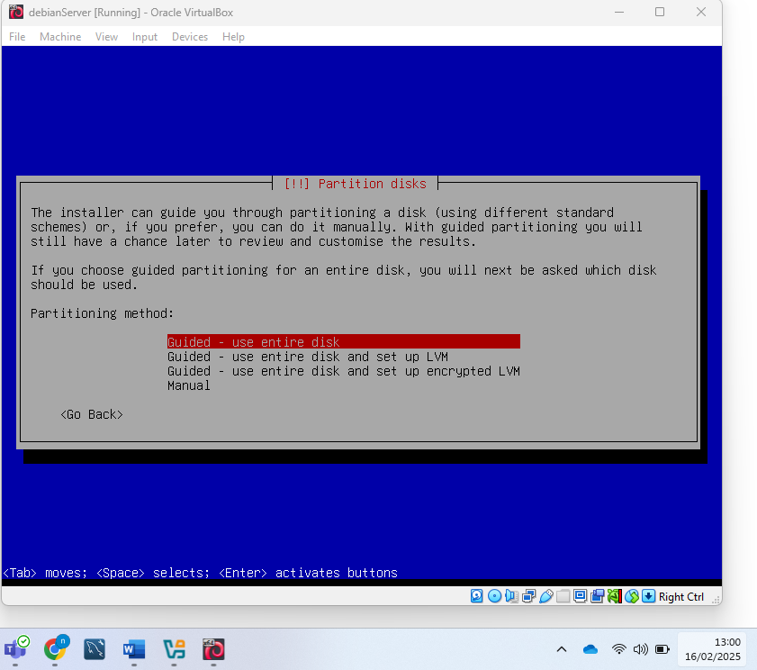
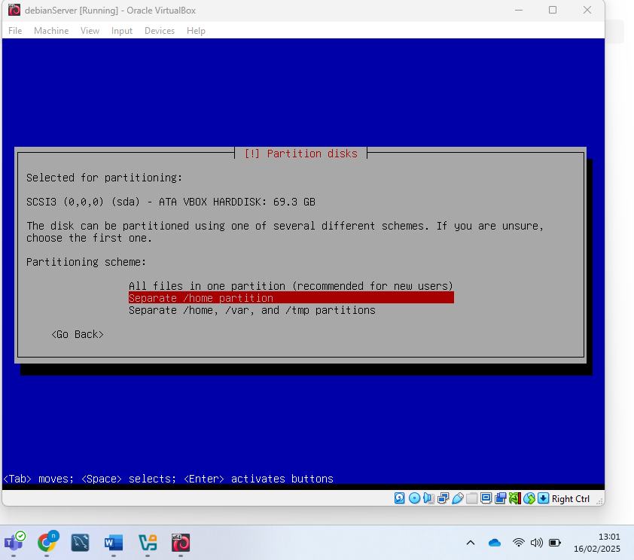
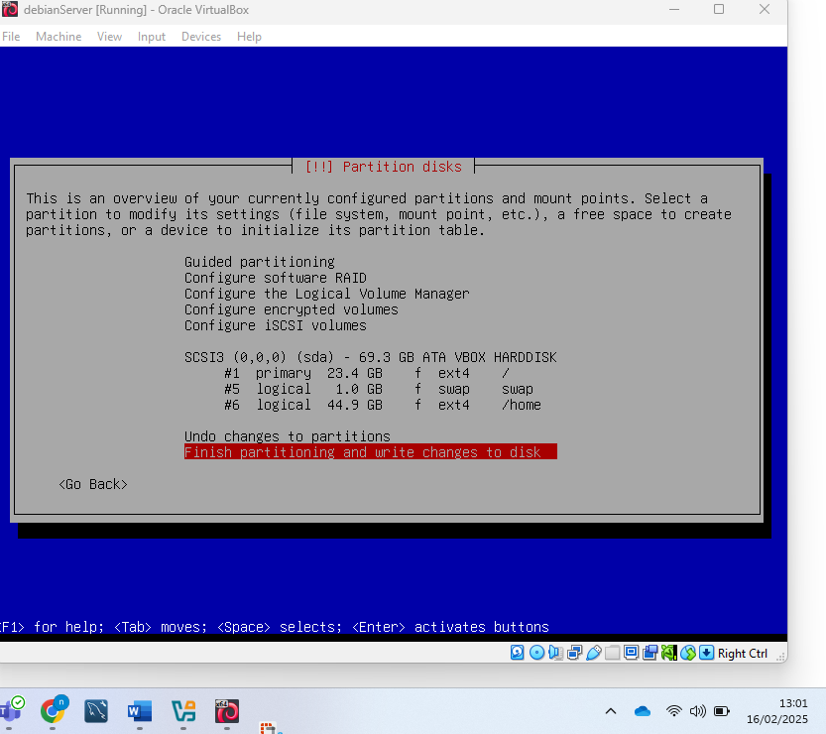
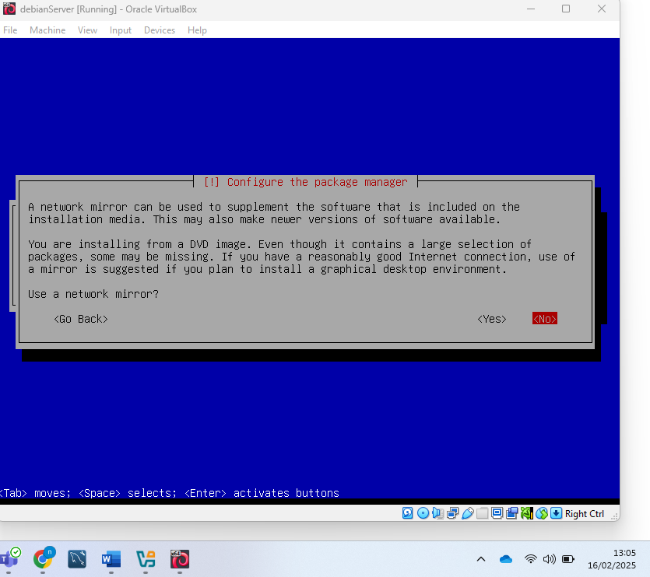
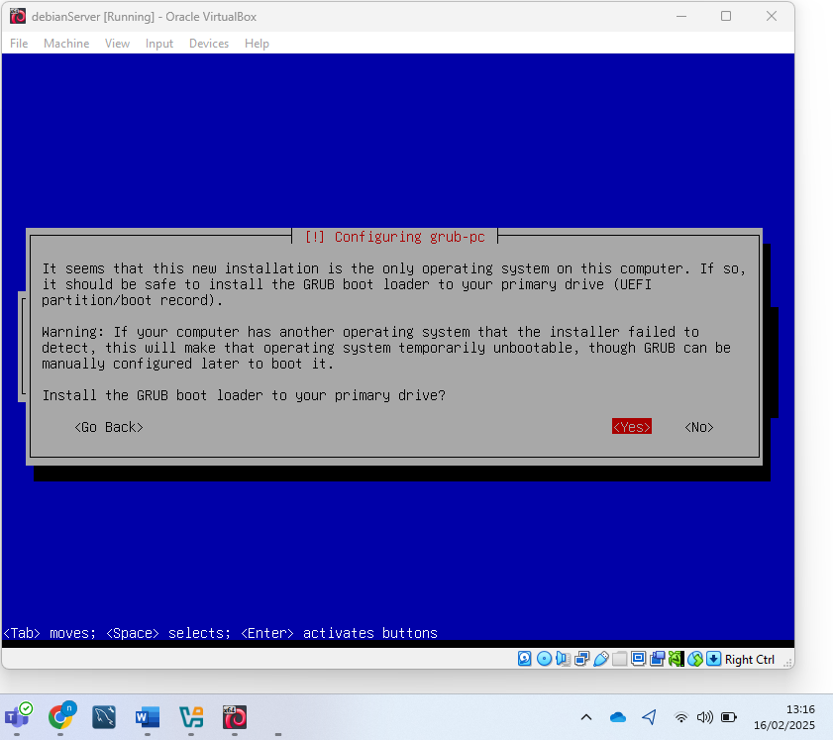
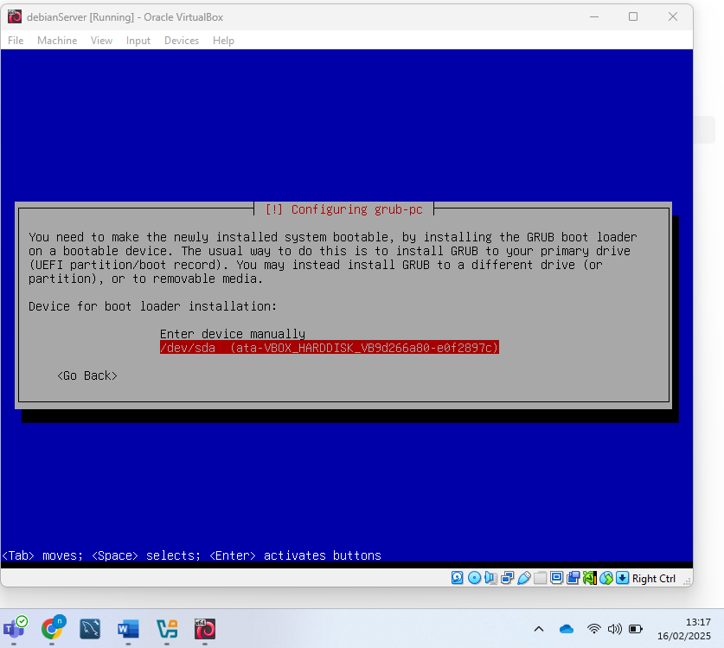
With this the installation was completed and the system operating system booted successfully. I used the terminal and then proceeded to complete the installation of the DHCP server
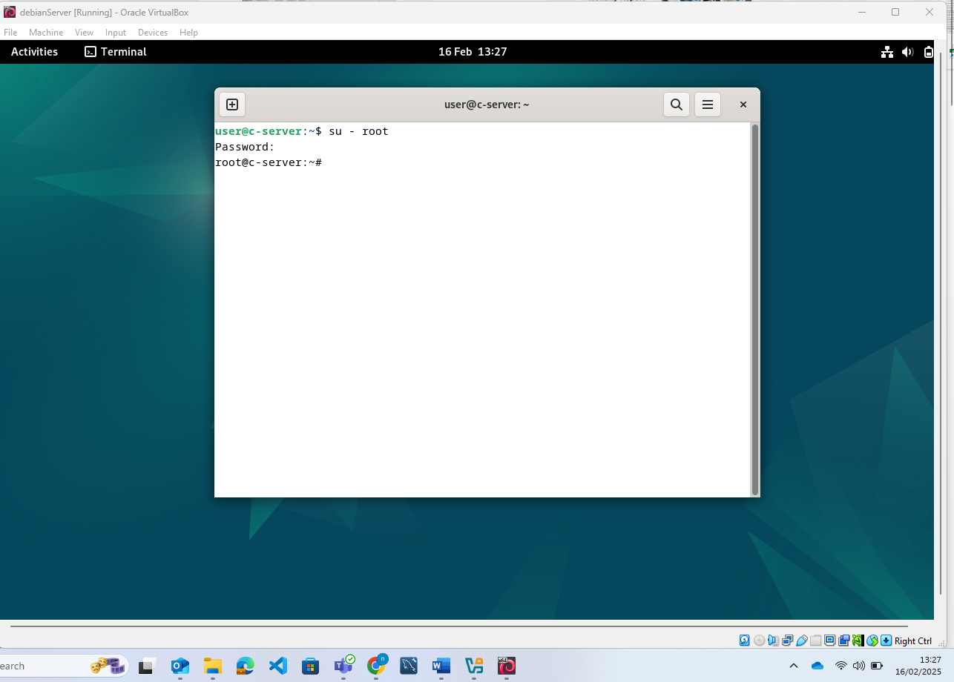
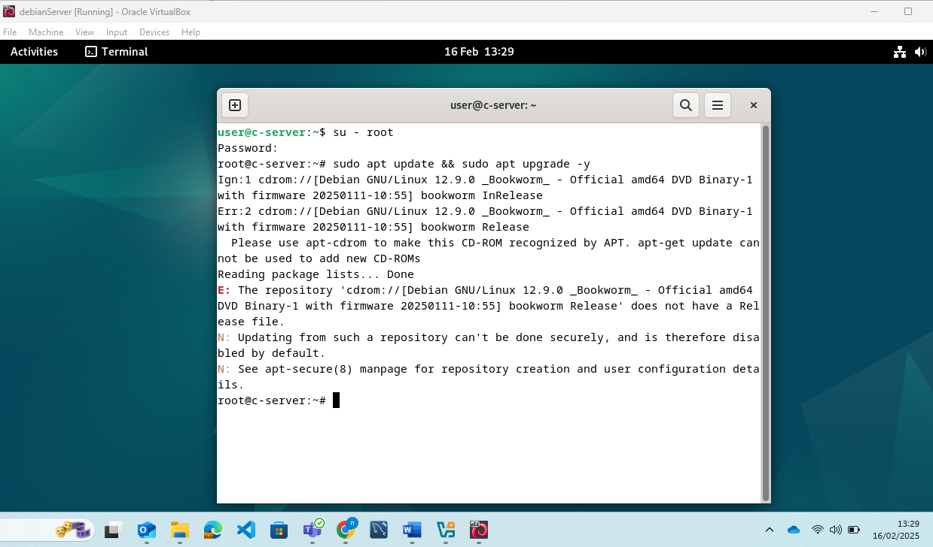
As the required software wasn’t installed I returned to the boot menu and installed all optional packages. This would ensure access to all elements for this and any future requirements of the assignment
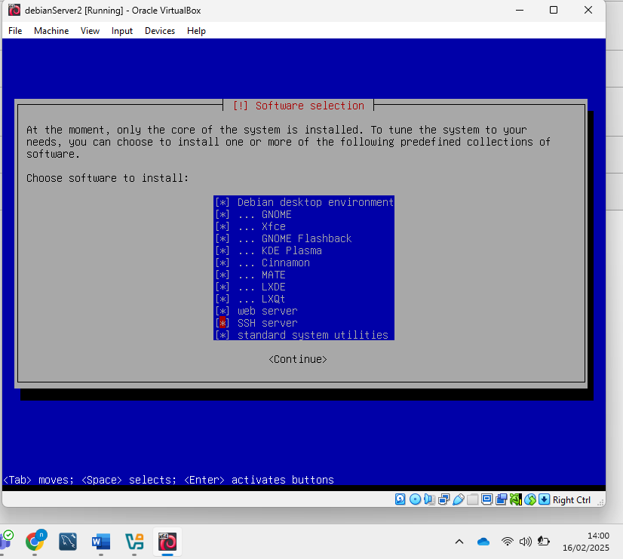
From this screen I decided to also set up the network settings
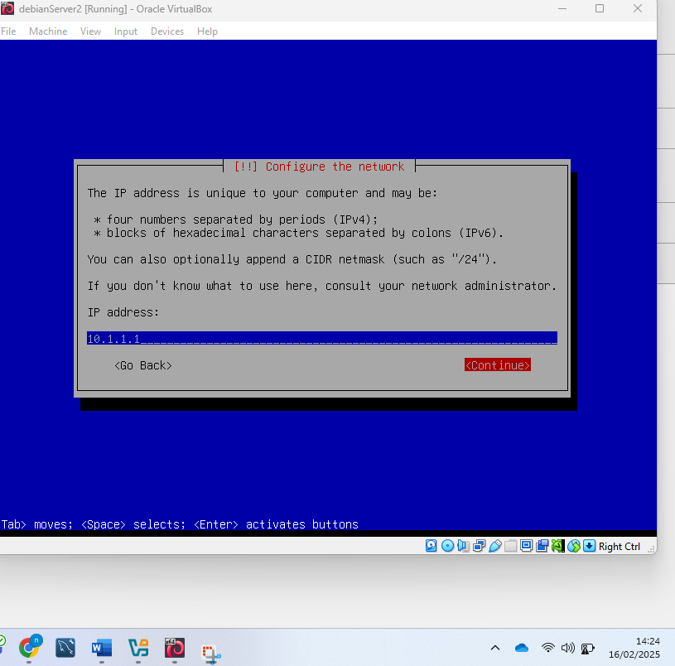
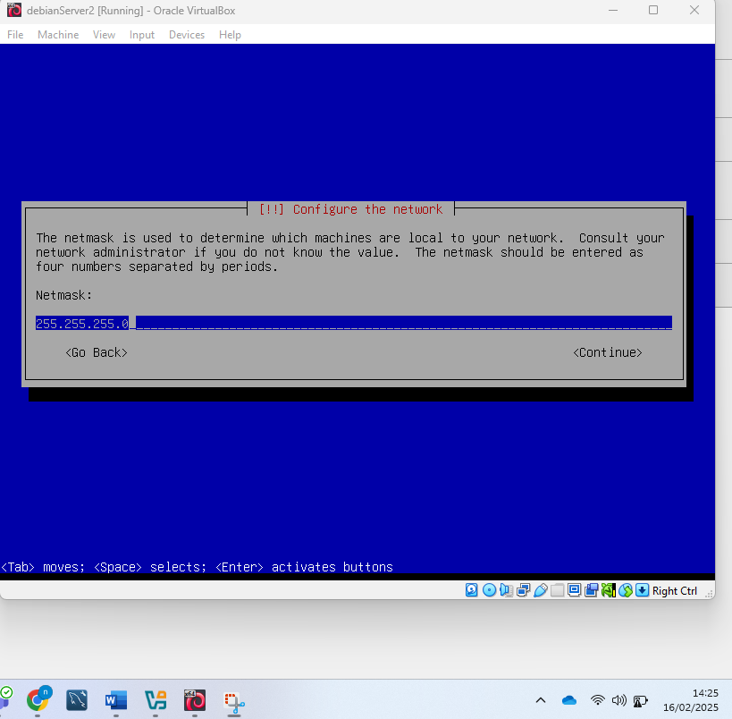
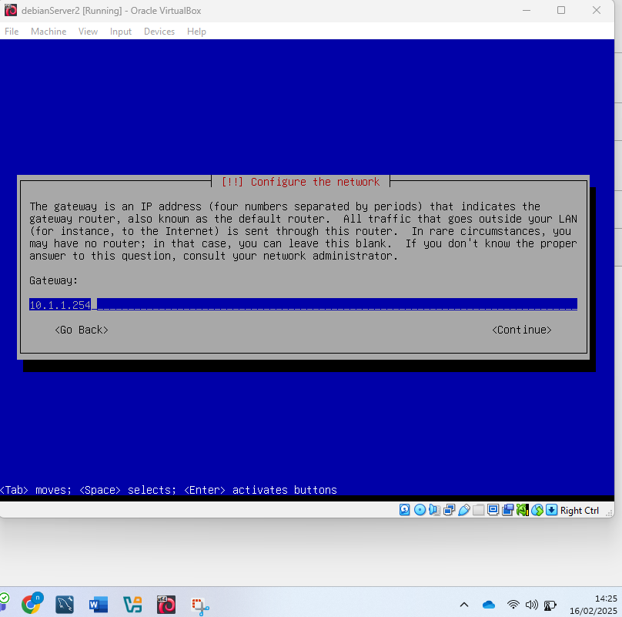

With this the additional packages were installed and I started the server and opened the terminal and check my IP address has been assigned as designated
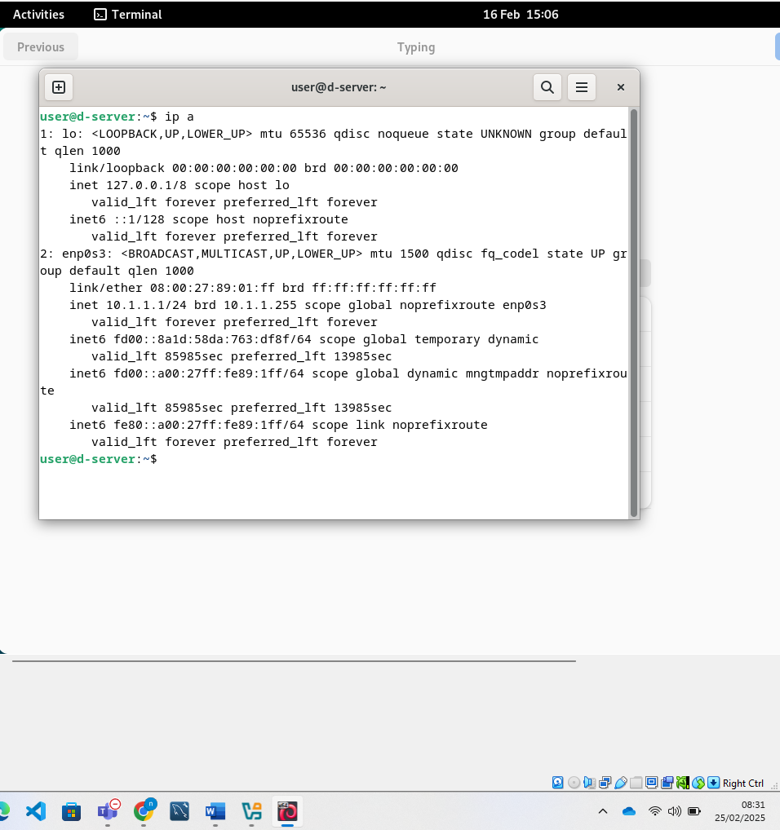

I then login as root user to access administrator privileges
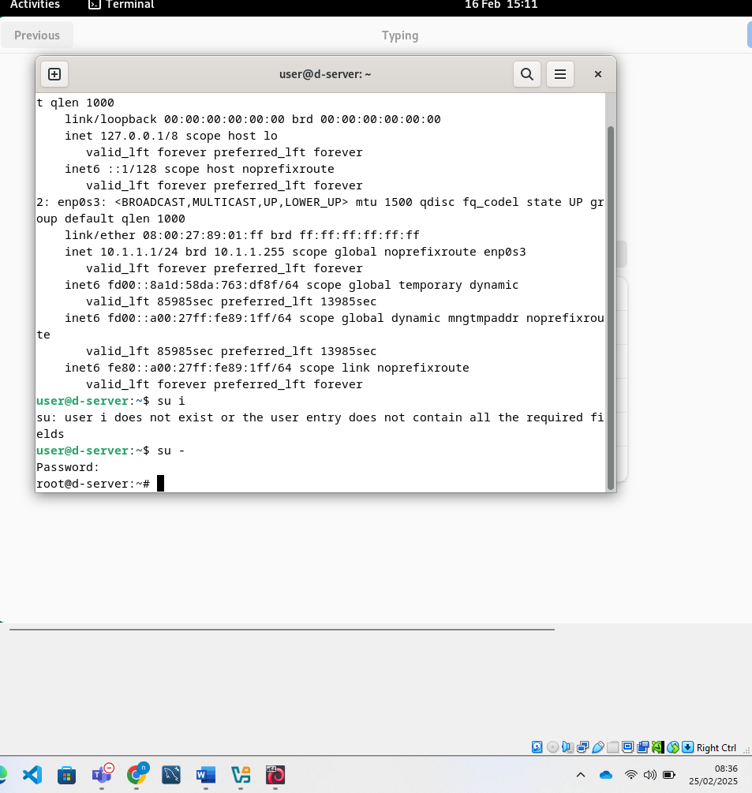
I then add the user to the sudo group
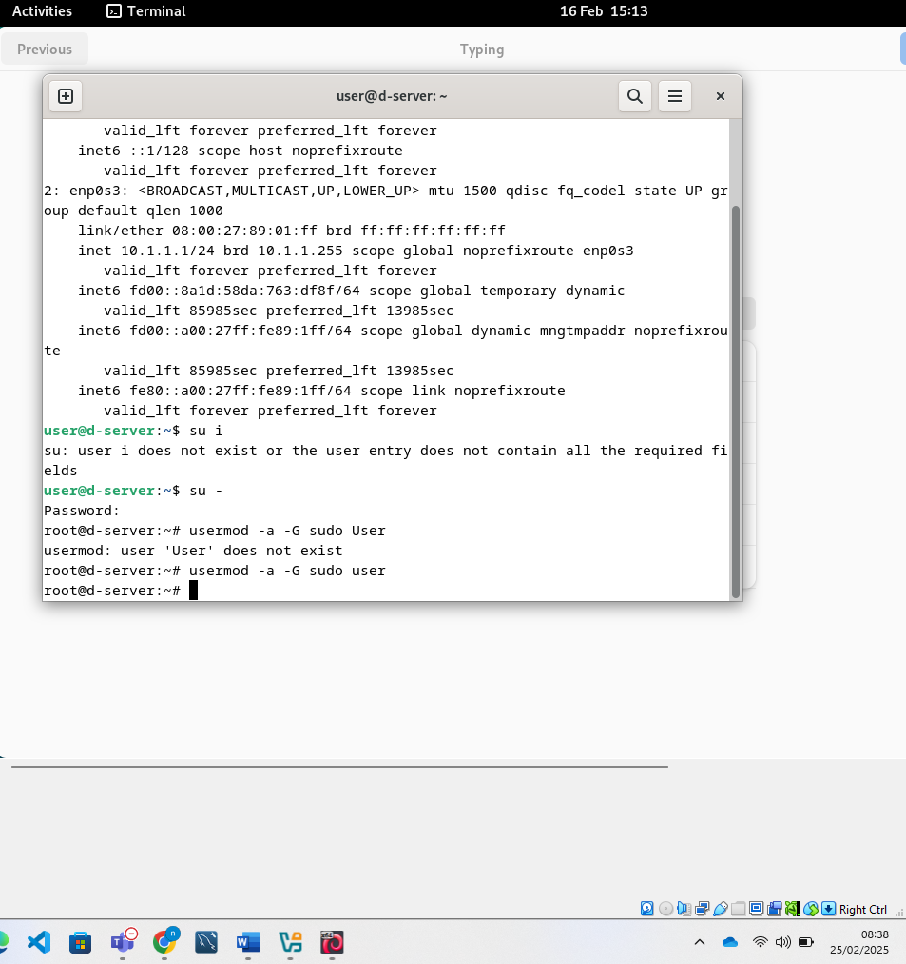
This required a restart before being able to use sudo with the user account, as before the restart even through the command groups user showed that sudo was in the list it wouldn’t allow progress until a restart was performed
c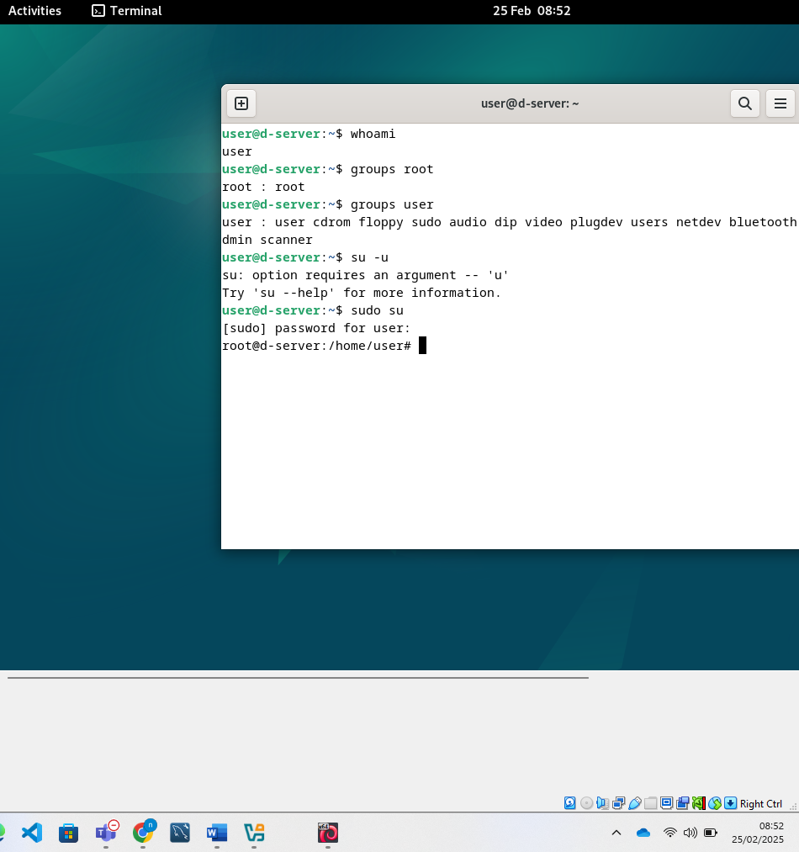

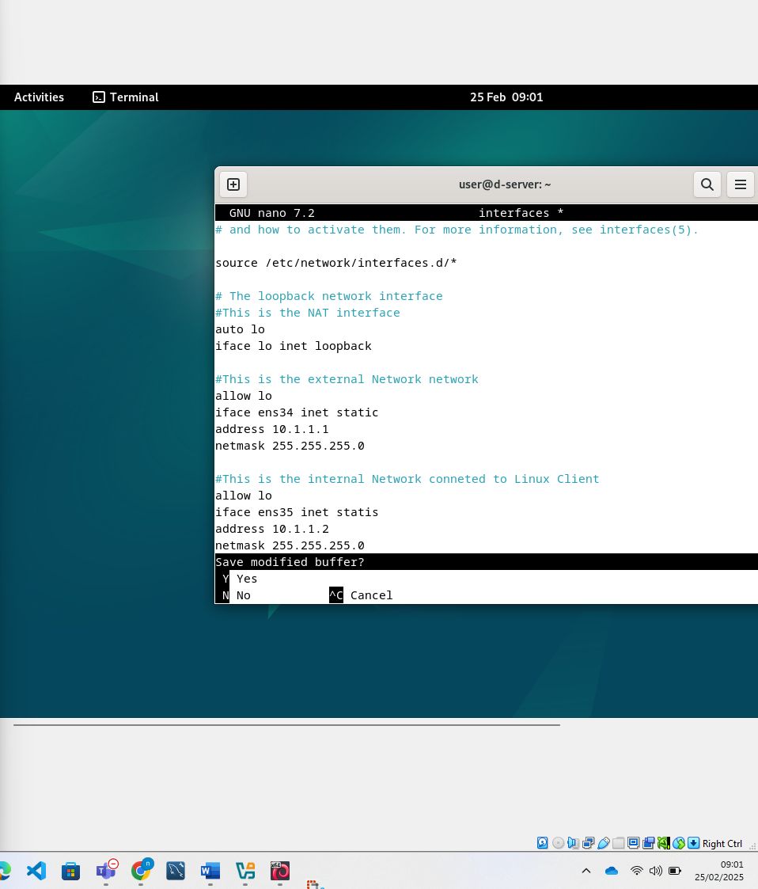
After this I tried to install dhcp on the server using apt-install isc-dhcp-server -y. But it couldn’t find the package, I pinged www.bbc.co.uk to see if an external ping would work and it failed. This meant that I didn’t have an internet connection as my network settings were incompatible with the router due to the IP range. To fix this I temporarily changed the IP settings to use DHCP from my router, this enabled the internet and then I was able to proceed with the steps below to install DHCP server. I then configured the DHCP server as shown below
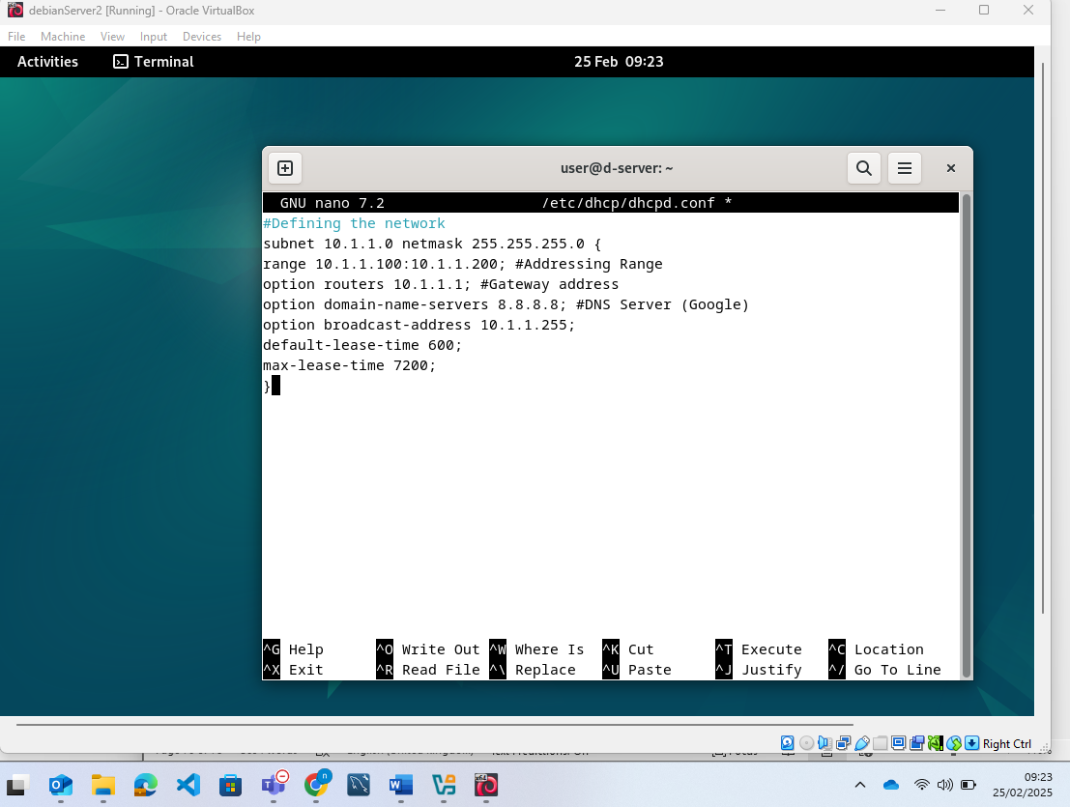
I then restored the network settings as required and restarted the DHCP service. I then checked it was running and it was as shown below
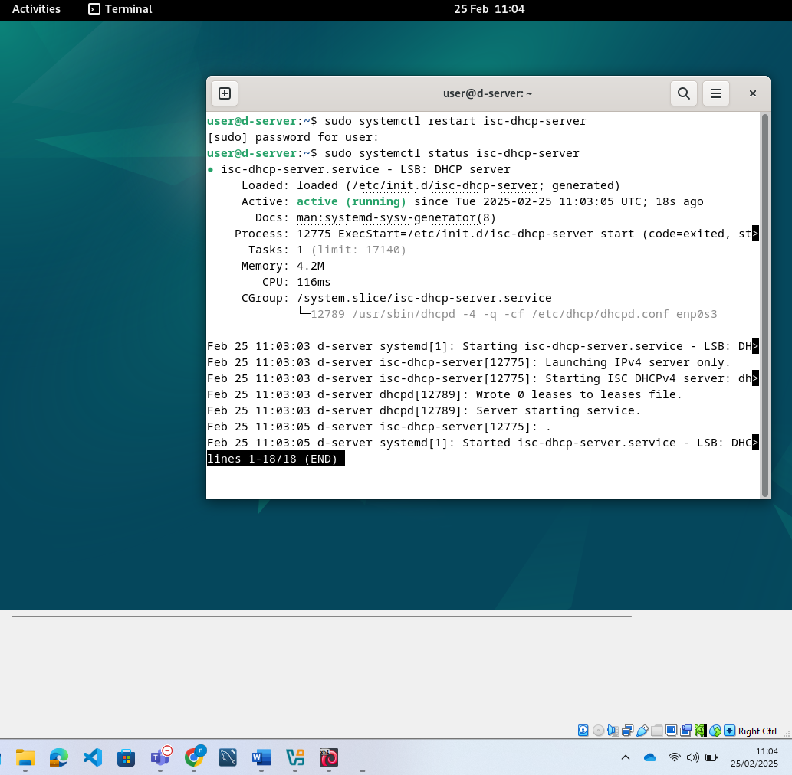

Installing the Linux Client Machine:

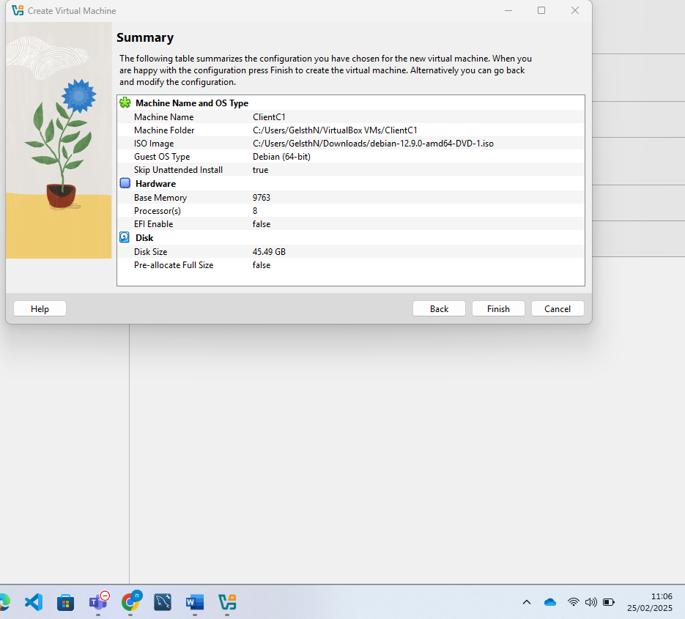
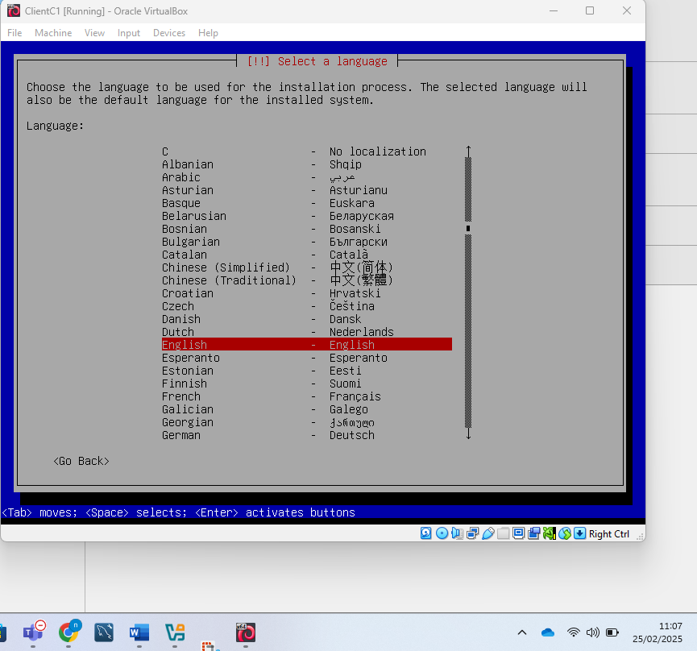
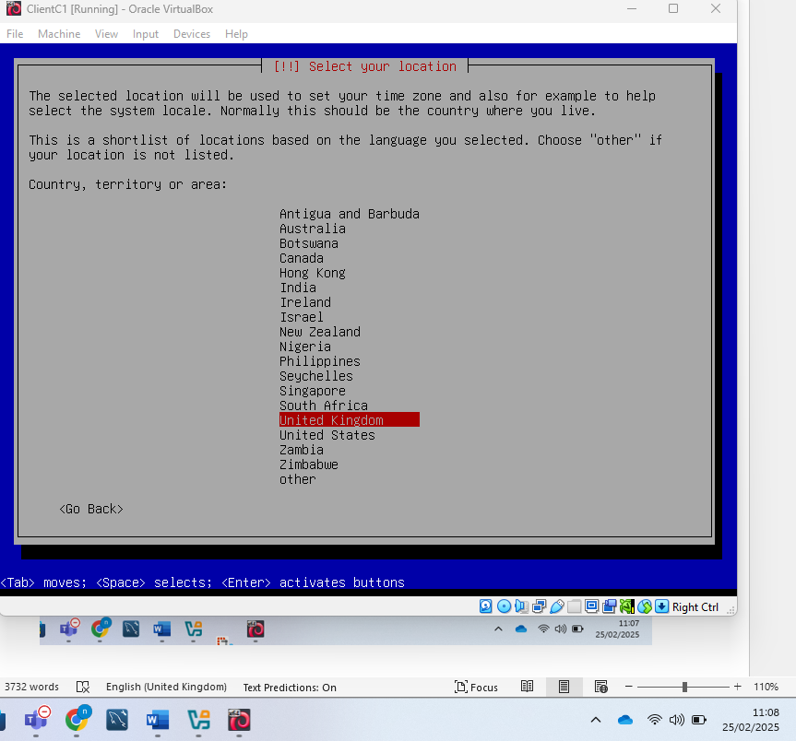
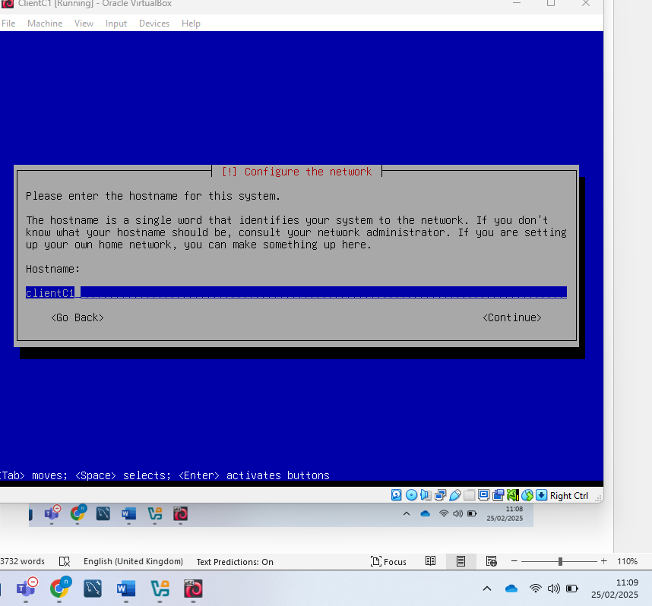
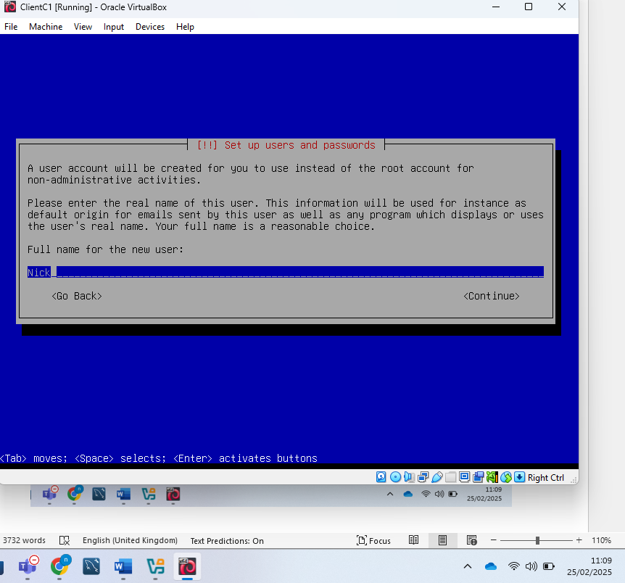

With the Linux DHCP setup and working I then installed the Linux client as shown above. I then added the user to the sudo group and configured the client machine as shown below
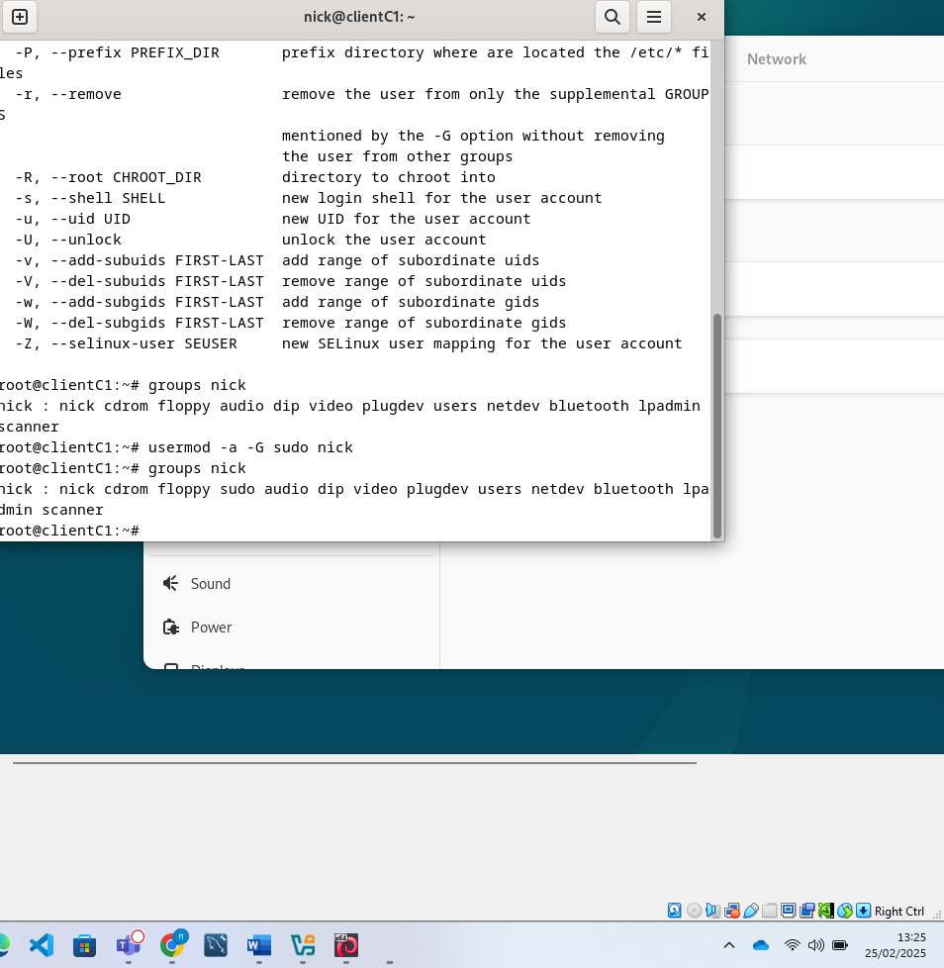
I then went to the terminal on the client machine and checked that the client could ping the server which was successful
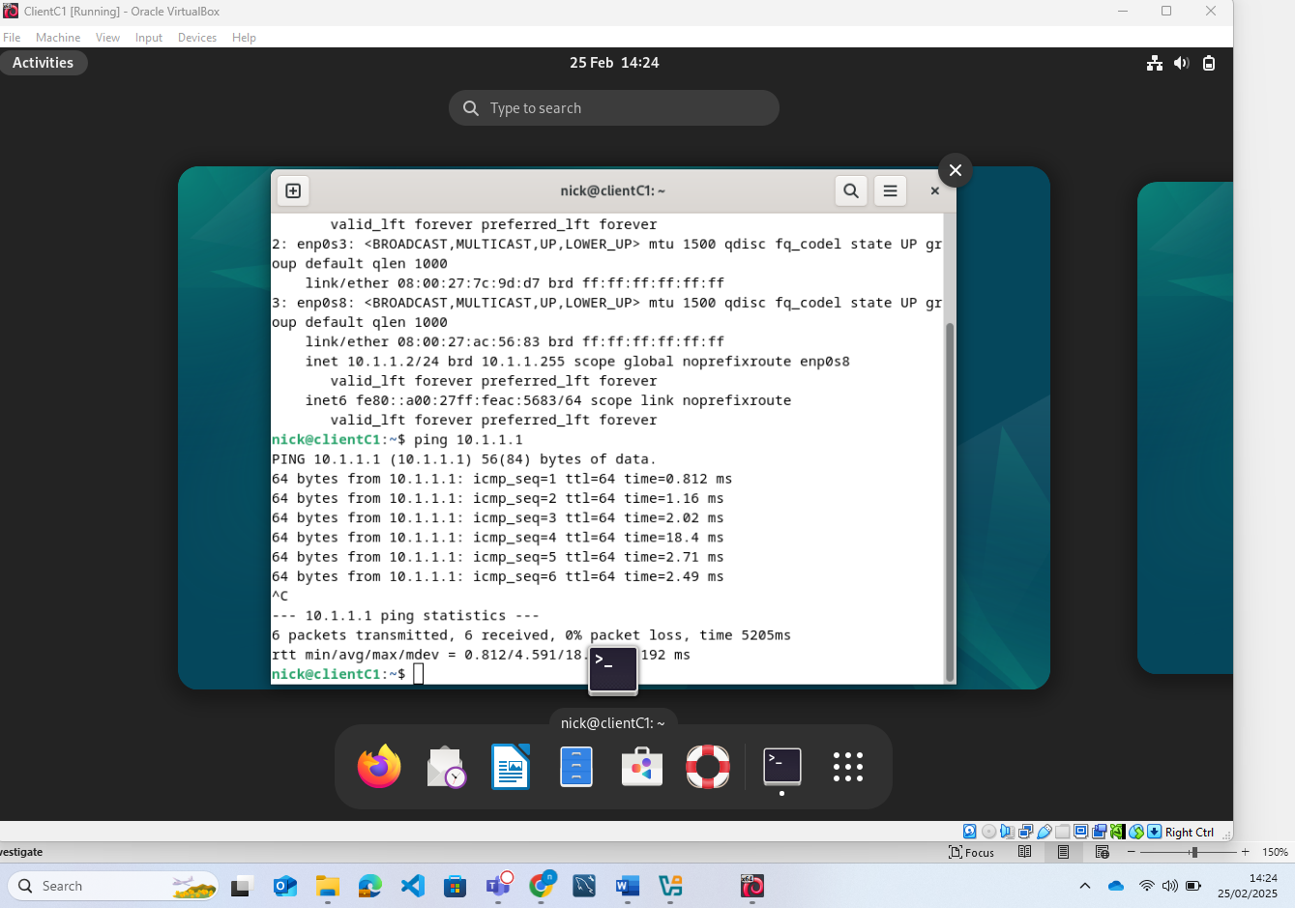
I did the same test from the server
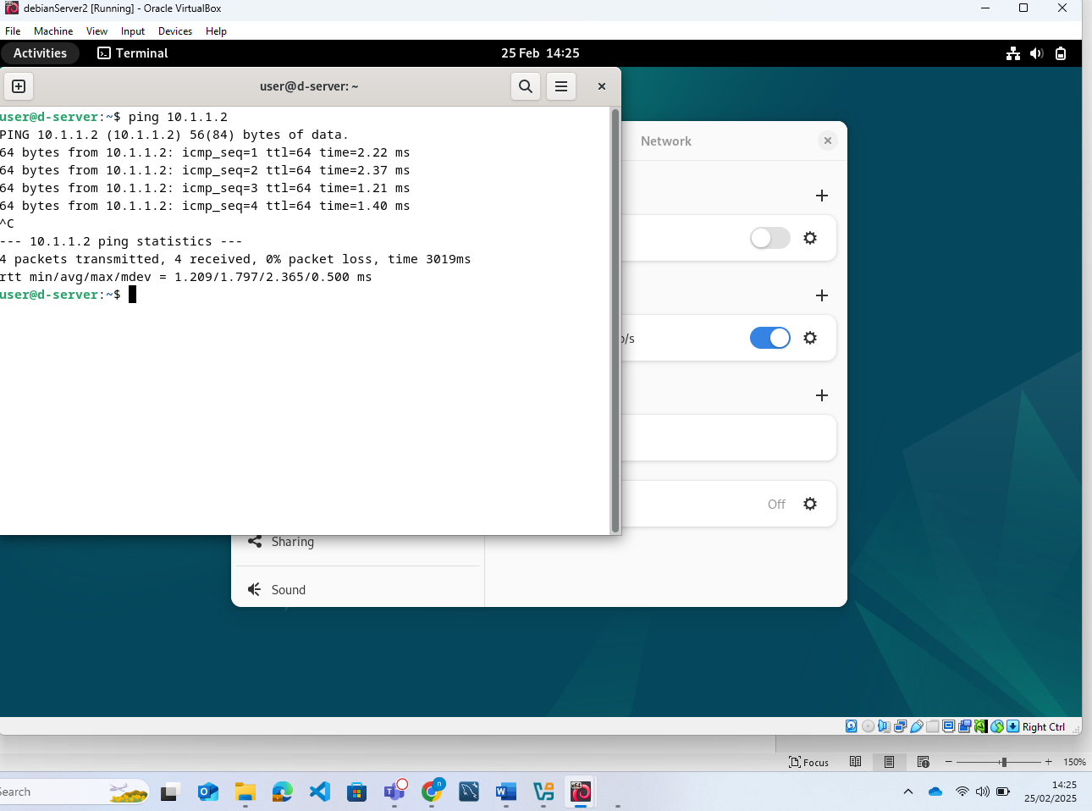
With communication established I now went to the client and forced the client machine to request an ip address from the dhcp server as shown below
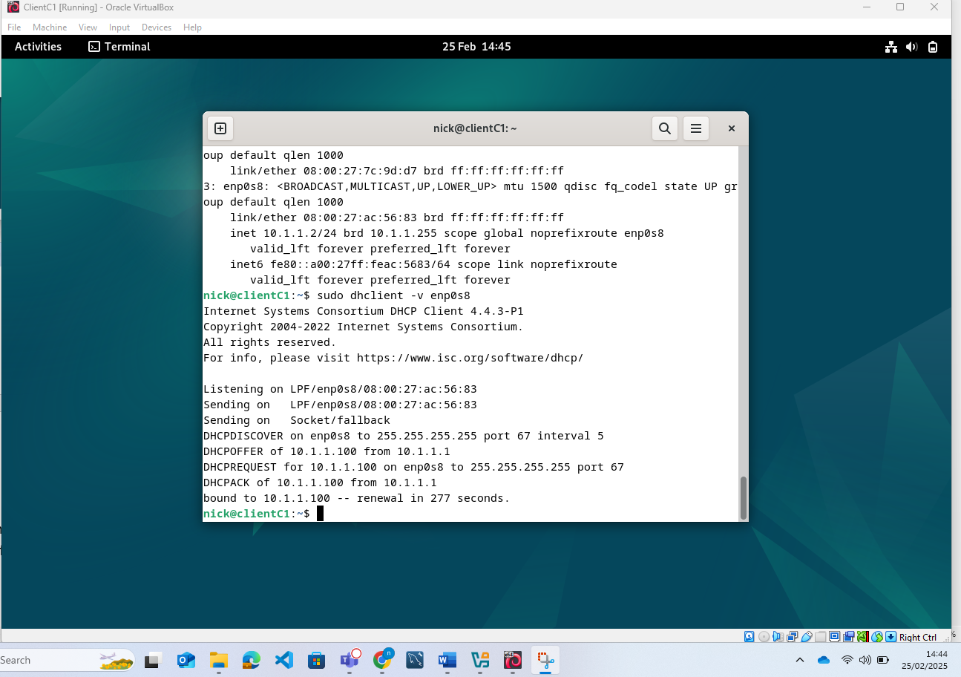
The range shows the same as what I designated which meant this was successfully done. Just to be sure though I ran a ping from the client machine again
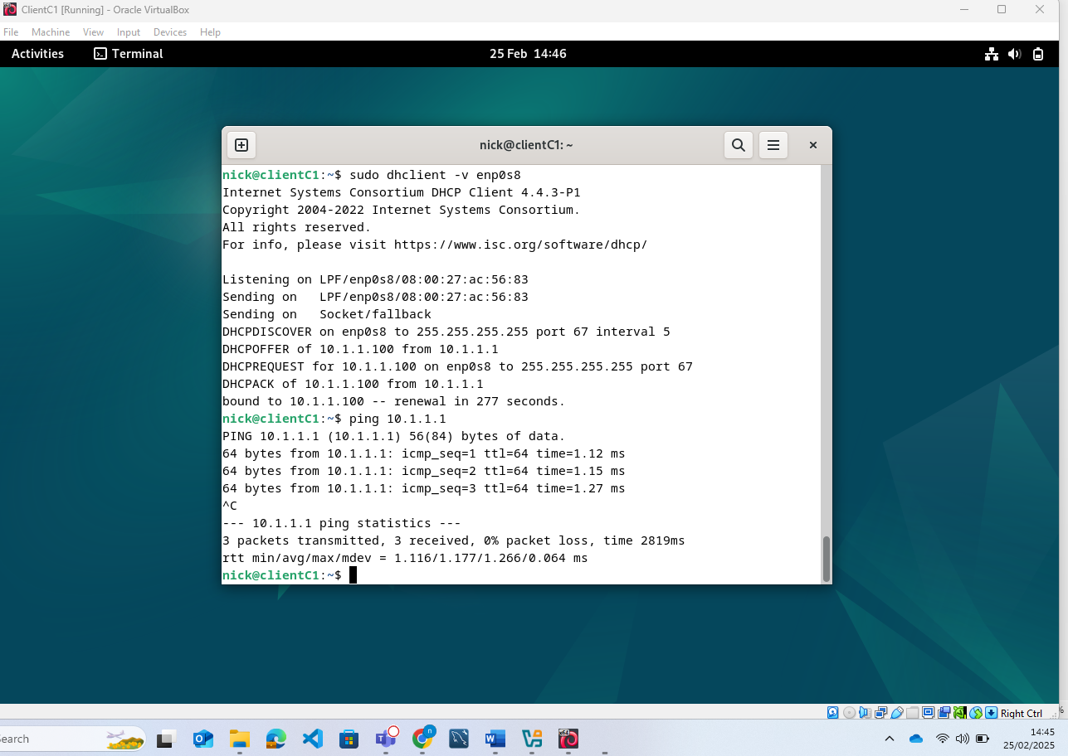
I then went on to the server and checked which Ip addresses it had assigned to make sure that it has assigned the IP address and there was no coincidence
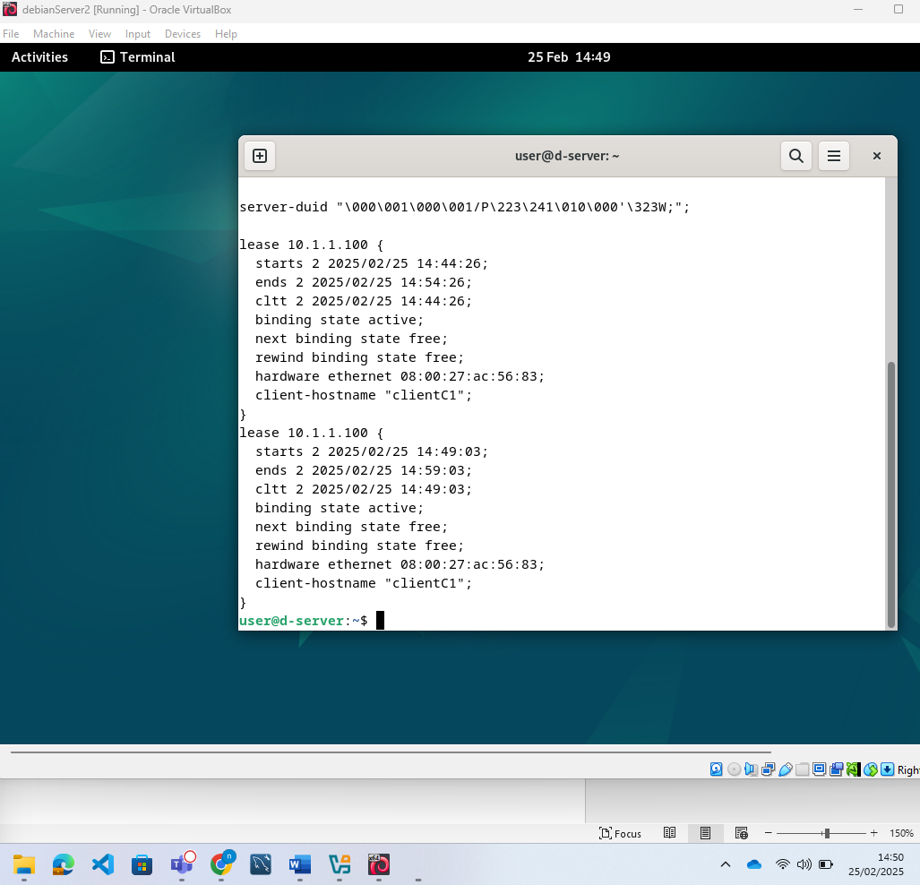

Reflection:

There were some issue with the installations, the windows client and server kept connecting to the work DHCP server and without disconnecting this network it was difficult to install. The Linux installation has issues where install and update wouldn’t work without modifying a file to remove a link to the CD ROM which was preventing these actions. The ping tests though were sufficient to test as shown in the screenshots. In the end both networks were successfully deployed and functioned as required.

References

[1] | VMware, “What is a Hypervisor,” Broadcom, [Online]. Available: https://www.vmware.com/topics/hypervisor. [Accessed 28th January 2025].
[2] | J. N. D. T. Edouard Bungion, “Hardware and Software support for virtualization,” Morgan & Calypool Publishers, 2017, pp. 9-10.
[3] | A. V. P. a. A. Implicaitons, Operating Systems Review, vol. 52, no. 1, p. 22=23, 2019.
[4] | J. N. D. T. Edouard Bugnion, Hardware and software support for virtualization, Morgan & Claypool Publishers, 2019.
[5] | aws, “What’s the Difference Between Type 1 and Type 2 Hypervisors?,” Aws, [Online]. Available: https://aws.amazon.com/compare/the-difference-between-type-1-and-type-2-hypervisors/. [Accessed 28th January 2025].
[6] | D. S. Mike Chapple, “(ISC)2 CCSP Certified Cloud Security Professional Official Study Guide, Third Edition,” Hoboken, John Wiley and Sons, 2023, p. 19.
[7] | E. Bauman, G. Ayoade and Z. Lin, “A Survey on Hypervisor-Based Monitoring: Approaches, Applications, and Evolutions,” ACM Computing Surveys, vol. 48, no. 1, pp. 1-33, 2015.
[8] | O. Pankevych, “Hypervisors: Type 1 vs Type 2. [PART 1],” StarWind, 20 July 2023. [Online]. Available: https://www.starwindsoftware.com/blog/type-1-vs-type-2-hypervisor-what-is-the-difference/. [Accessed 28 January 2025].
[9] | D. S. Mike Chapple, “(ISC)2 CCSP Certified Cloud Security Professional Official Study Guide,” Hoboken, John Wiley and Sons, 2023, p. 104.
[10] | V. Yfantis, “What Is a Hypervisor and What Are Its Benefits? | Parallels Explains,” Parallels, 28 April 2022. [Online]. Available: https://www.parallels.com/blogs/ras/hypervisor/#:~:text=Hypervisors%20allow%20multiple%20operating%20systems,independent%20of%20the%20physical%20machine.. [Accessed 28 January 2025].
[11] | S. Hong, A. Nicolae, A. Srivastava and T. Dumitraş, “Peek-a-boo: Inferring program behaviors in a virtualized infrastructure without introspection,” Computers & Security, vol. 79, pp. 190-207, 2018.
[12] | M. D. a. T.Rooney, Ip Address Management, New Jersey: Wiley, 2021.
[13] | Plixer, “The Network Layers Explained (With Examples),” Plixer, [Online]. Available: https://www.plixer.com/blog/network-layers-explained/. [Accessed 09 02 2025].
[14] | imperva, “OSI Modael,” [Online]. Available: https://www.imperva.com/learn/application-security/osi-model/. [Accessed 09 02 2025].
[15] | S. Panwar, in TCP/IP Essentials: a lab based approach., Cambridge, Cambridge University Press, 2004, pp. 1-25.
[16] | M. E. D. a. T. Rooney, in IP address management, New Jersey, Wiley, 2021, p. 33.
[17] | S. Griskenas, “What is routing and how does it work?,” NordVPN, 19th April 2023. [Online]. Available: https://nordvpn.com/blog/routing/. [Accessed 9th February 2025].
[18] | Cisco, “Routing and switching Essentials: V6,” Indianapolis, Cisco Press, 2017, p. 37.
[19] | Cisco, in Routing and Switching Essentials, Indianapolis, Cisco Press, 2017, p. 71.
[20] | R. wati, “Static vs. dynamic routing: What is the difference?,” TechTarget, 6th July 2021. [Online]. Available: https://www.techtarget.com/searchnetworking/answer/Static-and-dynamic-routing. [Accessed 9th February 2025].
[21] | L.TU, “Optimizing Routing Strategy in Software Defined Networking,” UWTSD, Swansea, 2024.
[22] | Cisco, “Cisco Networking Academy's Introduction to Routing Dynamically,” Cisco, 24th March 2014. [Online]. Available: https://www.ciscopress.com/articles/article.asp?p=2180210. [Accessed 9th February 2025].
[23] | Z. Kerravala, “What is a VPN?,” Network World, p. 1, 2022.
[24] | A. Bahl, A. Sharma and M. R. Asghar, “Vulnerability discolsure and Cybersecurity awareness campaigns on twitter during COVID-19,” Wiley Periodicals, vol. 4, no. 6, p. 11, 2021.
[25] | Akamai, “What is DHCP,” Akamai, [Online]. Available: https://www.akamai.com/glossary/what-is-dhcp#:~:text=Dynamic%20Host%20Configuration%20Protocol%20(DHCP,or%20other%20types%20of%20devices.. [Accessed 9th February 2025].
[26] | A. S.Gillis, “Active Directory,” TechTarget, June 2021. [Online]. Available: https://www.techtarget.com/searchwindowsserver/definition/Active-Directory#:~:text=Active%20Directory%20(AD)%20is%20Microsoft's,device%20such%20as%20a%20printer.. [Accessed 9th February 2025].

