

Module: Modern and Traditional Construction. Managing the Design and Construction Process / Civil Engineering Technology
Module Code: ACBA5000
Assignment Title: Case Study on the GSK Carbon Neutral Laboratory for Sustainable Chemistry
Lecturer: Rhodri Thomas

Table of Contents
Introduction 3
Foundation Requirements 4
Site Location & History 4
Ground Conditions 5
Bedrock Geology 5
Superficial Geology 5
Borehole Logs 6
Foundation Choice 7
Choice of Materials 8
Cross-Laminated Timber (CLT) 8
Reference List 9

Introduction
The GSK Carbon Neutral Laboratory was completed in February 2017 for the University of Nottingham. The architect for this project was Fairhursts Design Group and the contractor was Morgan Sindall. One of the key focuses for the design and construction of the laboratory was sustainability, and this is clear just by looking at the design of the building and the materials used, also the construction methods were focused on being as sustainable as possible. Since its completion this building has received multiple awards for sustainable building. A case study by UK GBC (2023) stated that the building is designed to offset the carbon emissions produced during the construction with 25 years.
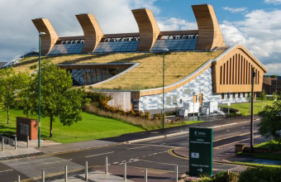

Figure 1

Sustainability has been a key focus in almost all aspects of the laboratory, which is clear just from the aesthetics of the building. There is a green roof on the north side of the building which adds to the sustainable aesthetic the architect was aiming for, this is a clever design as it is not only aesthetic pleasing but also benefits the performace of the building as it can improve the drainage of the roof and can also help boost the thermal perfomance of it. The sustainable aesthetic continues on to the south facing roof with it being lined with photovoltaic panels, this massively helps boost the sustainable performance of the building as photovoltaic panels are always most efficient when they are south facing. There are 4 massive wooden ventilation towers spanned across the ridge of the roof, these were prefabricated and designed so that they could be quickly assembled at the ground level so that they could be craned into position quickly, saving time on the programme, they were also cleverly designed so that direct the incoming air into the laboratory to provide natural ventilation.

Foundation Requirements

Site Location & History
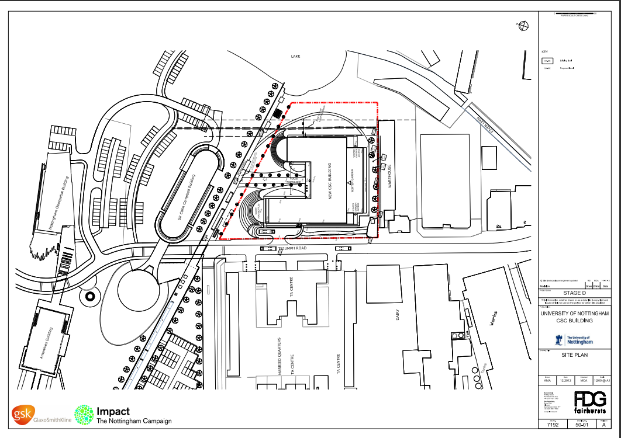
The building is in Nottingham, on the University of Nottingham – Jubilee Campus. Triumph Rd passes directly past the east side of the site with many local businesses located along the road. There are commercial buildings south of the site which are not within the university campus, and there is a man-made lake to the east of the site, and to the north is the Sir Colin Campbell Building. Before construction began, the site consisted of rough grassland, and some maintained along the side of Triumph Rd. It was noted in the decision notice by Nottingham City Council (2013) that the whole campus is built on former industrial land (the Raleigh Cycle Factory), meaning this is a brownfield site, so careful consideration needs to be taken during the excavation for the foundations. Due to the industrial history of the site it’s very likely that the soil could be contaminated, which brings a whole world of problems for the removal of soil for the excavations, a full soil investigation would need to take place before construction begins in various areas of the site to determine if the soil is contaminated. Contaminated soil can cause big problems to a project as it can be very expensive to dispose of when excavating for the foundations etc.. Asbestos could cause even bigger problems as it is a danger for the workforce, asbestos requires specialist to come in to perform tests, to isolate and to dispose of, at a massive cost.
Figure 2

Ground Conditions

Bedrock Geology
By using BGS Geology Viewer map we can get an idea of the ground conditions of the site without carrying out an intrusive ground investigation. By using the map on the BGS (2022) website, we can see the bedrock geology and the superficial deposits of the area. As show below the bedrock geology and the superficial geology varies all over the city.
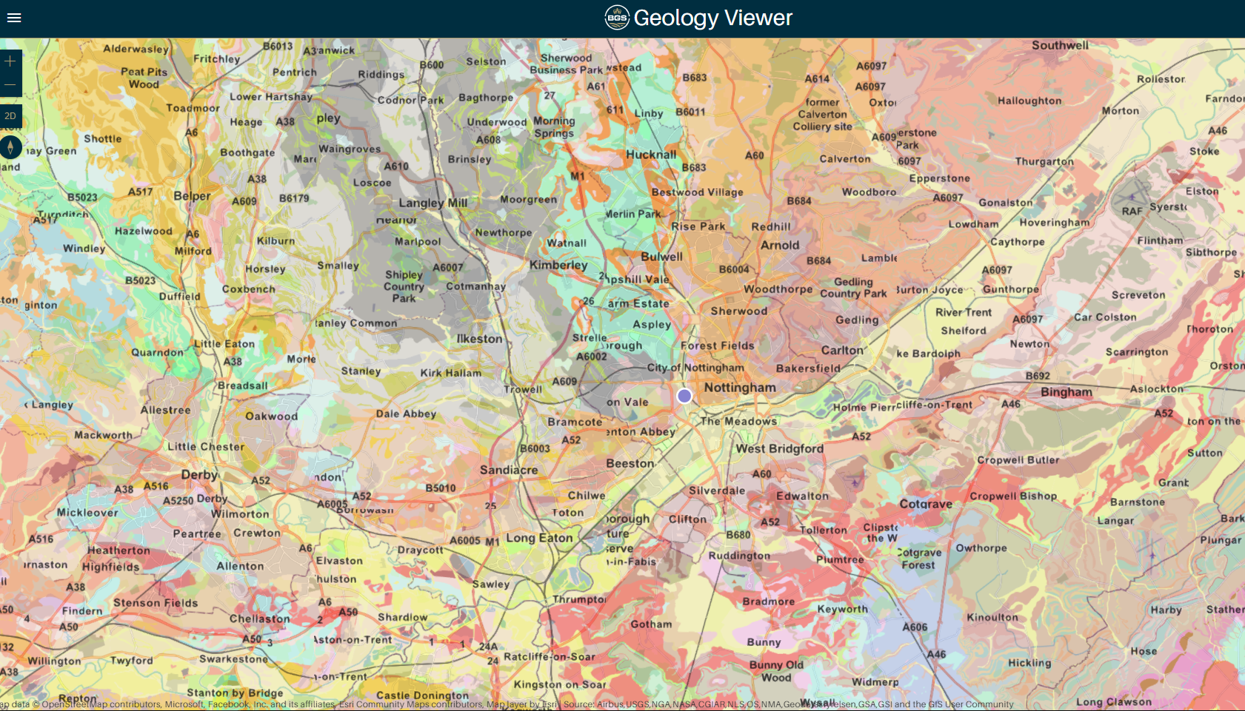
Figure 3
Looking only at the bedrock geology we can see that the Nottingham area is predominantly made up of a sandstone formation of some sort, more specifically to this site according to the BGS (2022), the bedrock geology of this site comprises of a “Lenton sandstone formation. Sedimentary bedrock formed between 272.3 and 247.1 million years ago”. Sandstone is usually found in the basins of the world, and is commonly found near rivers, which makes sense as there are many rivers near this site. Sand stone is an extremely durable rock, this has been proven through history with many ancient historic buildings being constructed with sandstone and some are still standing to this day. Bedrock formation being made up of sandstone the site has a solid geological build up.

Superficial Geology
The BGS Geology viewer map states that the superficial deposits of this area is made up of alluvium, which is loose soil or sediments that consists of clay, sand, gravel or silt. Alluvium can have both good affects on the site’s ground condition and bad affects. Depending on the build up of the given area, the texture of the soil can vary widely, ranging from a gravely texture to a silty clay texture. It would be ideal if the superficial build-up within the footprint of the building consisted of clay, but there is no guarantee without a ground investigation.

Borehole Logs
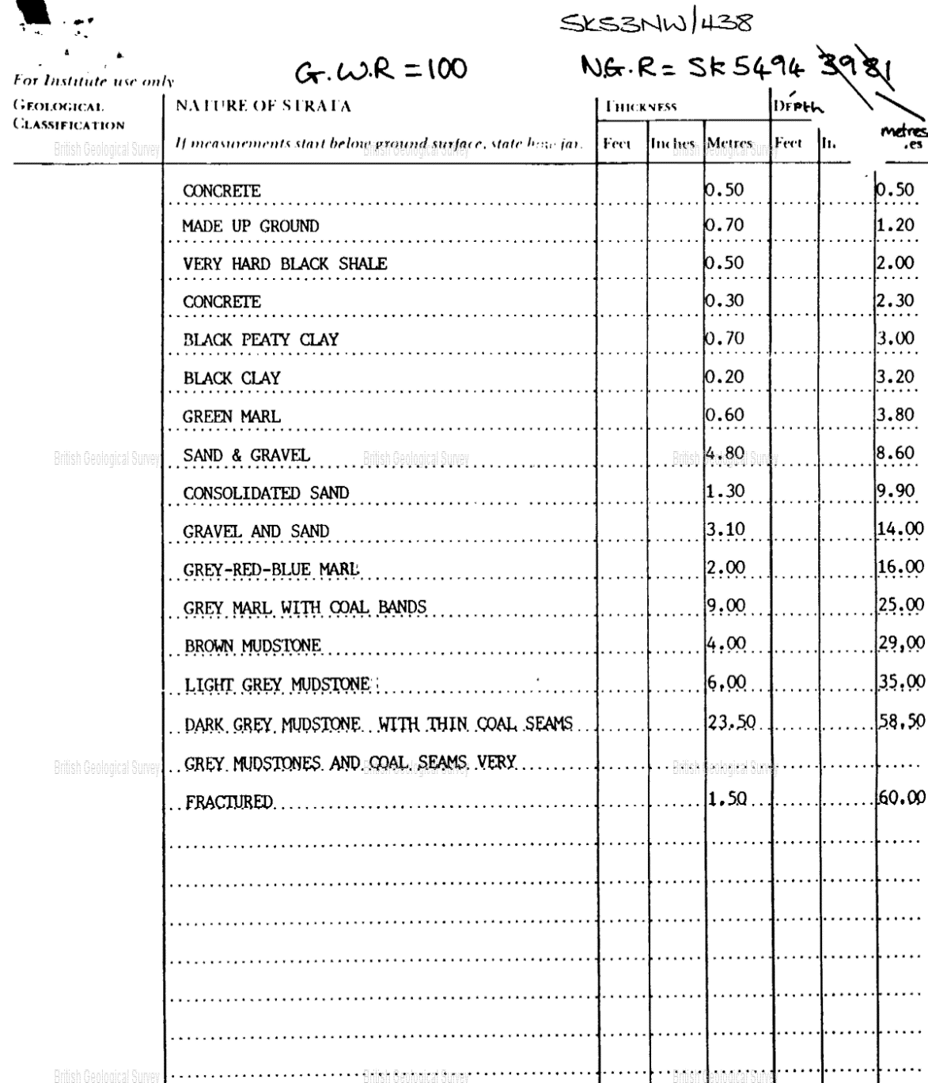
The BGS website also provides an geoindex map, this is an extremely handy tool when carrying out a desktop survey on a proposed site. This is a map that has many recorded boreholes on there and copies of the borehole logs, I found a bore hole log that was only 200m to the north of the site. This borehole log will help give a good idea of the build-up beneath the footprint of the building, and ultimately help make the decision on the foundation requirement.

Figure 4
The above borehole log was done on the 16th of February 1993 and due to its first close proximity to the proposed building, the above data can be used to assume the soil build up beneath the footprint of the building. This information gives us guidance on the type of foundation which will be needed to accommodate this building.

Foundation Choice
Given due consideration to the information of the areas ground conditions, and the bore hole log information that was close to the site, the most suitable foundation for the building is a pile raft foundation, a similar design to the below design made by Design Buildings (2022)
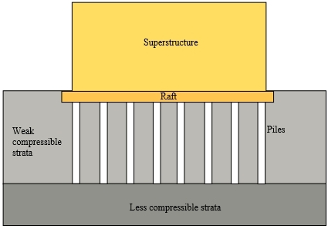
Figure 5
By using a pile raft foundation, you get both the benefits of a piled foundation and a raft foundation. And taking into consideration the ground conditions of the area, the history, and the size and weight of a building, a pile raft foundation is required. Raft foundations are commonly used where the ground has a poor load-bearing capacity, this is due to the increased surface area that the raft provides. Piled foundations are usually used on large, heavy buildings and also if the ground has poor load-bearing capabilities, but a piled foundation is usually more expensive than other types of foundations. By using the piled foundation you get the benefits of both combined, although the cost will increase, it is necessary due to the sheer size of the building, the soil of the site and the history of the site. The piles in the foundation reduces the settlement and differential settlement, which is essential on this project due to the size of the building and the weight of it, a lot of stress will be put on the ground so its essential to reduce the settlement as much as possible to increase the structural stability of the building.

Choice of Materials

Cross-Laminated Timber (CLT)
Just by looking at building it is obvious that sustainability played a massive part in the design and the construction of it. Timber was widely used throughout the building as it’s a sustainable material, cross limited timber (CLT) was widely used to increase the structural stability of the building, and was used in the structural parts of the building, like the floor structure, structural walls etc. Cross limited timber was the obvious choice for the architect due to the big focus on sustainability for the project. Cross laminated timber is a wood panel usually consisting of three, five, or seven layers of timber oriented at right angles to one another and then glued to form structural panels with excellent strength, dimensional stability, and rigidity which makes it ideal to use as a structural material, regular timber is an anisotropic material, meaning that the physical properties change depending on the direction in which the force is applied. By gluing layers of wood at perpendicular angles, the panel can achieve better structural rigidity in both directions. It is like plywood but with distinctively thicker laminations.
CLT was the obvious choice here for Fairhurts as it suits the sustainability theme for the construction and the aesthetic look of the building. One of the big advantages of cross laminated timber is its great fire resistance. Surprisingly, CLT can be designed to accommodate substantial fire resistance and unlike steel remains structurally stable when subjected to high temperatures.
Cross limited timber doesn’t only suit the sustainable aesthetic the architect was going for but also made the actual construction of building more sustainable, this is due to the ability to prefabricate CLT. All of the CLT components used in the building like the floor, walls, ventilation towers etc are likely to have been fully manufactured before they even reached the site, not only does this provide financial savings due to the reduced time on site, but also makes the construction phase more sustainable.

Reference List
Case study: GSK Centre for Sustainable Chemistry - UKGBC - UK green building council (no date) UKGBC. Available at: https://www.ukgbc.org/solutions/case-study-gsk-centre-for-sustainable-chemistry/ (Accessed: January 5, 2023).
BGS Geology Viewer (2022) British Geological Survey. Available at: https://www.bgs.ac.uk/map-viewers/bgs-geology-viewer/ (Accessed: January 12, 2023).
Bros, W. (1993) Page 4: Borehole SK53NW438: Borehole logs, Page 4 | Borehole SK53NW438 | Borehole Logs. Available at: http://scans.bgs.ac.uk/sobi_scans/boreholes/225908/images/10429779.html (Accessed: January 12, 2023).

Figure 1 - The Carbon Neutral Laboratory (no date) The Carbon Neutral Laboratory - The University of Nottingham. Available at: https://www.nottingham.ac.uk/chemistry/research/centre-for-sustainable-chemistry/the-carbon-neutral-laboratory.aspx (Accessed: January 5, 2023).
Figure 2 - Council, N.C. (2013) Planning applications, Planning Applications - Nottingham City Council. Available at: https://www.nottinghamcity.gov.uk/planningapplications (Accessed: January 5, 2023).
Figure 3 - BGS Geology Viewer (2022) British Geological Survey. Available at: https://www.bgs.ac.uk/map-viewers/bgs-geology-viewer/ (Accessed: January 12, 2023).
Figure 4 - Bgs (2022) Bore Hole Log, GEOINDEX - British Geological Survey. Available at: https://mapapps2.bgs.ac.uk/geoindex/home.html (Accessed: January 16, 2023).

Figure 5 - Piled raft foundation (2022) Piled raft foundation - Designing Buildings. Available at: https://www.designingbuildings.co.uk/wiki/Piled_raft_foundation (Accessed: January 12, 2023).

