28/07/2026
University Of Wales Trinity Saint David

AI Stock Market Analysis Platform

Module Name: Changemakers: Creativity and Value Creation
Module Code: ACCA5033
Student Name: Giuseppe Palumbo
Student ID: 2335642
Group:1
Lecturer’s Name: Fahad Ahmed
Table of Contents

Task 1: Ideation and Mindmap 2
Mindmap 2
Mind Map Summary 3
Task 2: Aim, Objectives and Research Area 4
Project / Research Area 4
Q1: Aim and Objectives 4
Q2: Research Philosophy 6
Q3: Search Tools, Databases and Search Strategies 7
Task 3: Research Strategies 9
Q1: Validity, Reliability, Generalisability and Ethics 9
Q2: Research Strategies and Data Collection Methods 10
Q3: Quantitative and Qualitative Analysis 11
References 12
Appendix: Pilot Questionnaire 14

Task 1: Ideation and Mindmap

Mindmap
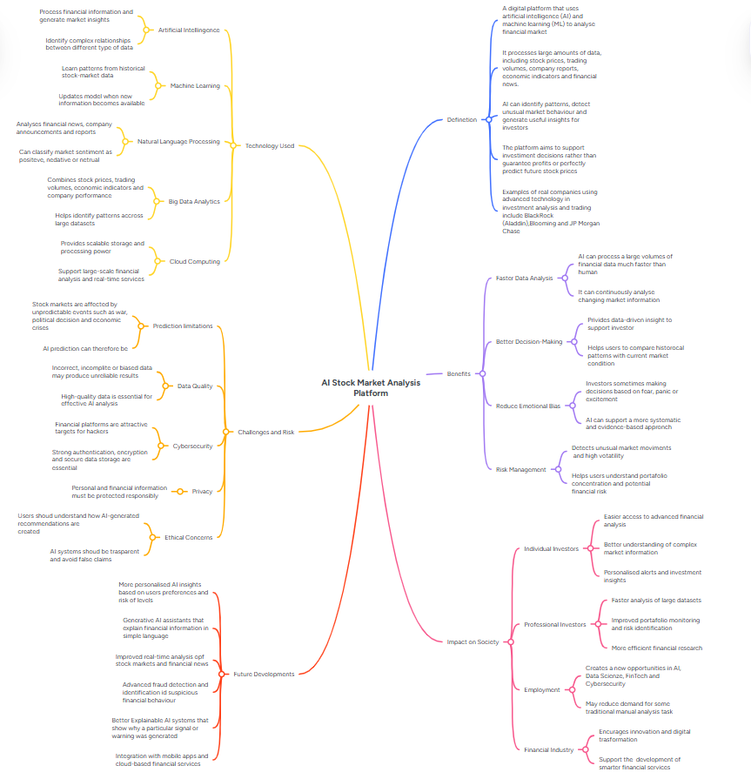
Figure 1: Mind map AI Stock Market Analysis Platform
https://mm.tt/map/4037474792?t=Uf9Entv0na

Mind Map Summary

The goal of this project is to design an AI Stock Market Analysis Platform that helps individual investors understand stock market information more easily. Many people find financial markets difficult because there is too much information, such as stock prices, trading volumes, company reports, economic news and financial updates.
The platform would use artificial intelligence, machine learning and data analysis to study this information and present it in a simpler way. AI and machine learning can help identify patterns, market changes and possible risks [1], [2]. The platform could include simple dashboards, charts, AI alerts, risk warnings and short explanations to help users make more informed decisions.
This project aims to improve users’ financial understanding, decision-making, risk awareness and confidence when studying investment information. It would not guarantee profit or perfectly predict the stock market, but it could support users by giving clearer information and useful insights [3].
If users do not understand the platform, the design could be improved by using simpler language, clearer charts, help buttons, examples and step-by-step guidance. This is important because AI in finance must be clear, honest and safe to use, especially when dealing with personal data, financial decisions and cybersecurity risks [4], [5].

Task 2: Aim, Objectives and Research Area

Project / Research Area

My selected project is an AI Stock Market Analysis Platform. This project is related to computing because it uses artificial intelligence, machine learning, big data, cloud computing and cybersecurity. The purpose of the project is to explore how AI can help investors understand financial market information more easily. Machine learning can learn patterns from training data and use them to make predictions or decisions, which makes it suitable for analysing stock market data [2]. AI is also becoming more important in capital markets, especially in areas such as trading, investment research and risk management [3].

Q1: Aim and Objectives

Aim

The aim of this project is to investigate and design an AI Stock Market Analysis Platform that helps individual investors understand stock market information more easily. The platform will use artificial intelligence, machine learning and data analysis to identify market trends, possible risks and useful investment insights. The main goal is not to guarantee profit, but to support users in making more informed and confident investment decisions.

Objectives

- Research AI and machine learning in stock market analysis
Within the first two weeks, I will review at least 5 reliable sources about artificial intelligence, machine learning and stock market analysis. This will help me understand how AI can be used to analyse financial data and support investment decisions. Machine learning is relevant because it can learn patterns from data and support predictions or decisions [2].

- Identify the main user problem
Within two weeks, I will identify at least 3 common problems that individual investors face when using stock market information. These may include too much data, difficult financial language, confusing charts and lack of clear risk information.

- Identify useful platform features
By week three, I will list at least 5 key features that could help users understand market information more easily. These may include a simple dashboard, AI alerts, risk warnings, portfolio tracking and financial news analysis.

- Investigate risks and limitations
By week three, I will identify at least 4 major risks linked to AI stock market platforms. These may include inaccurate predictions, poor data quality, cybersecurity threats and privacy issues. AI is becoming important in capital markets, but it also creates risks that need to be managed carefully [3].

- Design a basic platform concept
By week four, I will create a basic design idea for the platform, including the main dashboard layout and the key tools users would see. The design will focus on simple language, clear charts and easy navigation.

- Create a user feedback method
By week four, I will design a short questionnaire with at least 6 questions to collect feedback from potential users. The questionnaire will ask whether users understand the platform idea, which features they find useful and which parts are confusing.
- Improve the platform idea using feedback
After collecting feedback, I will identify at least 3 improvements that could make the platform easier to understand. These improvements could include simpler explanations, clearer charts, help buttons, examples or step-by-step guidance.

- Evaluate the value of the project
By the end of the project, I will evaluate whether the platform could help users improve their financial understanding, risk awareness and decision-making. This will be measured by reviewing the research findings and user feedback. The project must also consider ethical issues because financial AI systems should be transparent and avoid misleading claims [4].

Q2: Research Philosophy

The research philosophy selected for this project is pragmatism. Pragmatism is suitable because this project focuses on solving a practical problem: helping investors understand complex stock market information more easily. The project is not only about theory, but also about finding out what could work in a real situation.
This philosophy allows the use of both quantitative and qualitative research methods. Quantitative data could come from a questionnaire where users rate the usefulness of features such as AI alerts, risk analysis and dashboard charts. Qualitative data could come from open questions where users explain what they find difficult when using financial platforms.
Pragmatism is appropriate because the AI Stock Market Analysis Platform is a practical computing project. It needs technical research about AI and machine learning, but it also needs user feedback to understand what features would be useful. This makes pragmatism a good choice because it supports practical problem-solving and user-focused research [1].

Q3: Search Tools, Databases and Search Strategies

To research my AI Stock Market Analysis Platform, I used reliable online sources and would also use academic databases to find more detailed information. My project is connected to artificial intelligence, machine learning, financial technology and cybersecurity, so it is important to use sources that explain both the technical side and the financial side of the topic.
Machine learning is relevant to this project because it can learn patterns from data and support predictions or decisions [2]. AI is also becoming more important in capital markets, especially in trading, investment research and risk management [3].
For my research, I used official websites such as IBM, IMF and SEC. These sources are useful because they provide trustworthy information about machine learning, financial markets and AI risks. IBM helps explain the meaning of machine learning, the IMF gives information about AI in financial markets, and the SEC gives information about risks and misleading AI claims in investment services [4]. These sources are useful because they come from recognised organisations, not random websites.
I would also use academic search tools and databases such as Google Scholar, IEEE Xplore, ACM Digital Library and ScienceDirect. Google Scholar is useful because it can help me find academic papers, books and reports in one place. IEEE Xplore is suitable because it focuses on computing, artificial intelligence, software engineering and data systems. ACM Digital Library is also useful for computing research, especially topics linked to algorithms, AI systems and user-focused software. ScienceDirect can help me find journal articles about technology, finance, data analysis and digital innovation.
My search strategy would include keywords that are directly related to my project. Example search terms include “artificial intelligence stock market analysis”, “machine learning financial prediction”, “AI investment risk management”, “natural language processing financial news sentiment”, “cybersecurity financial technology” and “explainable AI finance”. These keywords are useful because they connect to the main parts of my project: AI, stock market data, risk, financial news, cybersecurity and user understanding.

I would also use Boolean operators to make my searches more accurate. For example, I could search “machine learning” AND “stock market prediction” to find sources that include both ideas. I could use OR to include similar words, such as “AI” OR “artificial intelligence”. I could also use quotation marks to search for exact phrases, such as “stock market analysis”. Using keywords, Boolean operators and filters makes the research process more focused and organised [5].
To choose good sources, I would check the author, organisation, publication date and whether the source is academic or official. Because AI and financial technology change quickly, I would focus mainly on recent sources from the last five years. However, I would still use older research methods books when explaining research philosophy because those sources are still useful for understanding research design. I would avoid unreliable websites, anonymous information and sources that do not clearly explain where their information comes from.

Task 3: Research Strategies

Q1: Validity, Reliability, Generalisability and Ethics

For my AI Stock Market Analysis Platform project, I would use research strategies that make the results more accurate, consistent, useful and ethical.
Validity means making sure the research measures what it is supposed to measure. To improve validity, my questionnaire and interview questions would focus directly on the project aim: understanding whether users find stock market information difficult and whether an AI platform could help them. I would avoid unclear or leading questions. I would also pilot test the questionnaire first to check if users understand the questions properly [1].
Reliability means making sure the research could produce consistent results if repeated. To improve reliability, I would use the same questionnaire questions for all participants. I would also use simple rating scales, such as 1 to 5, so answers can be compared more easily. Keeping the questions clear and structured would help reduce confusion [1].
Generalisability means how far the findings can apply to a wider group of people. My project would mainly focus on individual investors or people interested in investing. Because this is a small student project, the results would not represent all investors. However, I could improve generalisability by collecting feedback from people with different levels of experience, such as beginners, students and people who already follow the stock market [1].
Ethical considerations are very important because the project involves people’s opinions and could connect to financial decisions. Participants would be told the purpose of the research before answering. Their participation would be voluntary, and they could stop at any time. I would not ask for private financial information, bank details or investment amounts. Personal data would be kept anonymous and stored safely. This is important because research should protect participants and respect their rights [4], [5].

Q2: Research Strategies and Data Collection Methods

For this project, I would use a mixed-methods strategy because it combines both quantitative and qualitative data. This is suitable because I need numbers to measure user opinions, but I also need written feedback to understand why users think something is useful or confusing. Mixed methods are useful when a project needs both numerical data and personal opinions [2].
The main data collection method would be a short questionnaire. This would include rating-scale questions and open questions. Rating-scale questions would help me collect quantitative data. For example, users could rate how useful they find AI alerts, risk warnings and simple dashboards from 1 to 5. Open questions would help me collect qualitative data. For example, users could explain what they find confusing about stock market platforms.
I would also use a small pilot questionnaire before the final version. A pilot test is useful because it helps identify problems before collecting the main data. I would ask two or three people to complete the questionnaire and give feedback. If they say the questions are confusing, too long or too technical, I will improve them before using the final questionnaire.
For example, if pilot users do not understand terms such as “sentiment analysis” or “portfolio risk”, I would change them into simpler words. I could also add examples, clearer instructions or shorter questions. This connects directly to my project goal because the platform itself must be easy for users to understand.
The pilot questionnaire is included in the Appendix. The feedback from the pilot will be used to improve the focus of the project by making sure the platform features are based on real user needs.

Q3: Quantitative and Qualitative Analysis

Quantitative analysis is used to analyse number-based data. In my project, this could include questionnaire ratings. For example, if ten users rate AI alerts from 1 to 5, I could calculate the average score. I could also count how many users selected each answer. This would help show which features users find most useful. Common quantitative analysis methods include percentages, averages, charts and tables [2].
For example, if most users rate “risk warnings” as 5 out of 5, this will show that risk warnings should be an important feature in the platform. Quantitative analysis is useful because it makes results easier to compare and present clearly.
Qualitative analysis is used to analyse written opinions and explanations. In my project, this could include answers to open questions such as “What do you find difficult about stock market information?” I could use thematic analysis to find repeated ideas in the answers. Braun and Clarke explain that thematic analysis is a flexible method for identifying patterns or themes in qualitative data [3].
For example, if several users mention “confusing charts”, this could become a theme. Other possible themes could be “too much information”, “difficult financial language” and “lack of risk explanation”. These themes would help me improve the platform idea by using simpler language, clearer charts and better explanations.
Using both quantitative and qualitative analysis would make the research stronger because the numbers would show what users prefer, while the written answers would explain why they prefer it.

References

Task 1

[1] “AI in Asset Management: Tools, Applications, and Frontiers — Book | CFA Institute Research and Policy Center,” CFA Institute Research and Policy Center, 2025. https://rpc.cfainstitute.org/preview-link/node/125351/68e8ea21-e439-433d-953e-251e13672453 (accessed July 12, 2026).
[2] IBM, “What Is Machine learning?” IBM, Sept. 2021. Accessed: July 12, 2026. [Online]. Available: https://www.ibm.com/think/topics/machine-learning
[3] IMF, “Global Financial Stability Report, October 2024: analytical chapters available now, main chapter on October 22,” Oct. 2024. Accessed: July 13, 2026. [Online]. Available: https://www.imf.org/en/Publications/GFSR/Issues/2024/10/22/global-financial-stability-report-october-2024
[4] “SEC.gov | SEC Charges Two Investment Advisers with Making False and Misleading Statements About Their Use of Artificial Intelligence,” 2024. Accessed: July 13, 2026. [Online]. Available: https://www.sec.gov/newsroom/press-releases/2024-36
[5] “AI in Financial Services,” 2025. Accessed: July 14, 2026. [Online]. Available: https://initiatives.weforum.org/ai-in-financial-services/home

Task 2

[1] M. N. Saunders, P. Lewis, and A. Thornhill, “Research Methods for Business Students,” 2023. Accessed: July 15, 2026. [Online]. Available: https://www.researchgate.net/publication/240218229_Research_Methods_for_Business_Students
[2] IBM, “What Is Machine learning?” IBM, Sept. 2021. Accessed: July 16, 2026. [Online]. Available: https://www.ibm.com/think/topics/machine-learning

[3] IMF, “Global Financial Stability Report, October 2024: analytical chapters available now, main chapter on October 22,” Oct. 2024. Accessed: July 16, 2026. [Online]. Available: https://www.imf.org/en/Publications/GFSR/Issues/2024/10/22/global-financial-stability-report-october-2024
[4] “SEC.gov | SEC Charges Two Investment Advisers with Making False and Misleading Statements About Their Use of Artificial Intelligence,” 2024. Accessed: July 17, 2026. [Online]. Available: https://www.sec.gov/newsroom/press-releases/2024-36
[5] K. Dermody et al., “Construct a Search Strategy,” Toronto Metropolitan University Library, 2024. Accessed: July 17, 2026. [Online]. Available: https://pressbooks.library.torontomu.ca/graduatereviews3/chapter/construct-a-search-strategy/

Task 3

[1] R. Bermingham, “Interpreting research evidence,” UK Parliament, Sept. 2020, Accessed: July 21, 2026. [Online]. Available: https://post.parliament.uk/interpreting-research-evidence/
[2] “CRESWELL & CRESWELL (2023) Research Design Qualitative, Quantitative, And Mixed Methods Approaches: John W. Creswell & David J. Creswell: Free Download, Borrow, and Streaming: Internet Archive,” Internet Archive, 2023. https://archive.org/details/cresswell-researchdesign-6e-2023/page/n3/mode/2up (accessed July 22, 2026)
[3] B. Fonseca, “Braun & Clarke (2006). Using Thematic Analysis in Psychology_ Official Publication,” Scribd, 2026. https://www.scribd.com/document/342191921/braun-clarke-2006-using-thematic-analysis-in-pyschology-official-publication?_gl=1 (accessed July 22, 2026).
[4] ICO, “The research provisions,” May 2023. Accessed: July 23, 2026. [Online]. Available: https://ico.org.uk/for-organisations/uk-gdpr-guidance-and-resources/the-research-provisions/
[5] BERA, “Ethical Guidelines for Educational Research, Fifth Edition (2024),” British Educational Research Association, May 2024. Accessed: July 24, 2026. [Online]. Available: https://www.bera.ac.uk/publication/ethical-guidelines-for-educational-research-fifth-edition-2024-online

Appendix: Pilot Questionnaire

Title: Feedback on AI Stock Market Analysis Platform Idea
- Do you find stock market information easy to understand?
1 = very difficult, 5 = very easy
- Which information do you find most confusing?
Stock prices / charts / financial news / risk information / other
- How useful would a simple AI dashboard be?
1 = not useful, 5 = very useful
- How useful would AI alerts be for unusual market changes?
1 = not useful, 5 = very useful
- How useful would risk warnings be before making investment decisions?
1 = not useful, 5 = very useful
- What would make the platform easier to understand?
- Which feature would be most important to you?
- Do you have any suggestions to improve the project idea?

Pilot feedback section:
After testing the questionnaire with 2 or 3 people, I will write down their feedback. For example, I will note if they found any questions confusing, too technical or too long. I will then improve the questionnaire by using simpler words, clearer examples and shorter questions.

