

BMIH6004
Hotel Placement- Managing Hotel Administration
Level 6

Student Name: Mihai Diaconu
Student ID: 2131599
Module Lead: Giulia Chifari

Table of Contents
Introduction 3
Section 1: Reflection on Experience and Personal Development 4
Section 2: Critical Analysis of Work-Based Skills and Technical Knowledge 6
Section 3: Reflection on Organisational Issues 8
Conclusion and Action Plan 10
References 11

Introduction
The Human Resources (HR) department of The Ty Newport Hotel is responsible for facilitating staffing, management, legal and employee relations in the running of the hotel. HRM practices including staff performance evaluation and conflict solution ensure that service delivery is consistent through the provision of a qualified, motivated, result-oriented workforce to the hotel that complements the hotel’s corporate values (Nieves & Quintana, 2018). By doing a placement in this department, I aim to learn the Objectives for Placement:
- Observe and understand HR’s role in managing recruitment, onboarding, and training.
- Develop skills in conflict resolution and employee engagement.
- Gain practical knowledge of labour laws and compliance in a hospitality setting.
- Enhance communication and active listening skills in employee interactions.

Section 1: Reflection on Experience and Personal Development
This reflection follows Kolb’s experiential learning cycle, which includes stages of Concrete Experience, Reflective Observation, Abstract Conceptualisation, and Active Experimentation (Zisan et al., 2021).
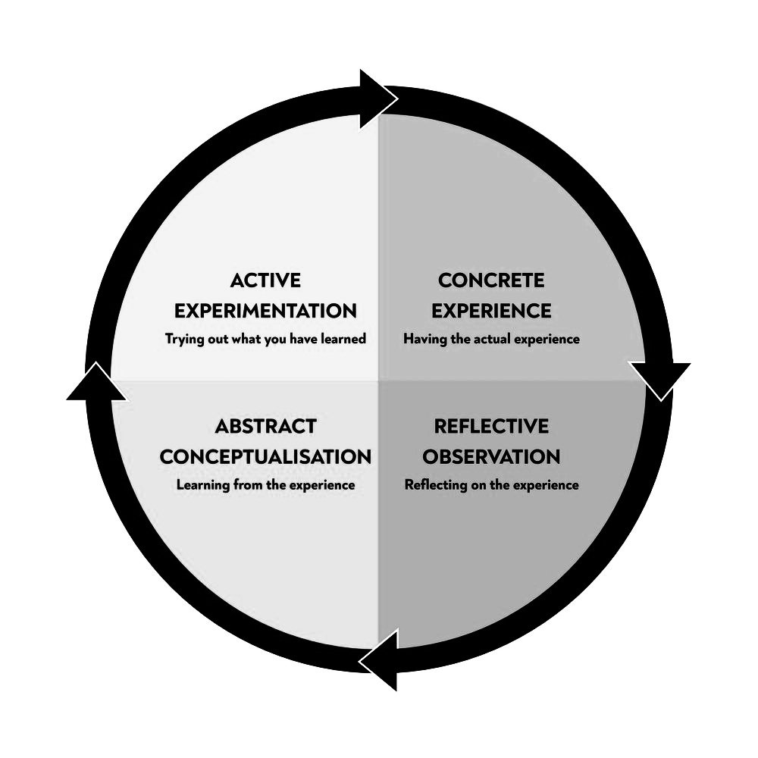
Figure 1: Kolb's Learning Cycle (Zisan et al., 2021)
Concrete Experience
While on my practical experience at The Ty Newport, I accompanied a supervisor to learn about specific responsibilities in recruiting employees, the hiring process, and employee relations. Specifically, an interesting assignment was to attend the recruitment process of a housekeeper. I observed the activities of this supervisor as he Shortlisted applicants, interviewed them and evaluated them in terms of their skills, experience and organisational culture (Wood, 2013). This process made it clear that proper screening is crucial to obtain the right set of employees with the right attitude towards work and fit in the organisation.
Reflective Observation
This knowledge highlighted the technical skills as well as the people skills required for any HR position. I learned that it is possible to be highly procedural while at the same time being very understanding and communicative (Martin, 2020). For instance, when an employee complained of an unfavourable working shift, the supervisor listened more attentively and responded to the employee’s concern aligning with the organisational requirements. This created awareness of the function of HR as an administrative and supportive section, whose function is to ensure good relations with the employees as well as motivate the workforce. From my academic knowledge, I understood how various strategies for engaging employees affect team dynamics and service delivery.
Abstract Conceptualisation
Considering these experiences, I note the importance of HR’s actions for making an appropriate workplace through recruitment and employee management. A model known as Maslow’s Hierarchy of Needs highlights the supervisor’s concern for the employees’ issues and development influences their level of satisfaction and motivation at the workplace. Such practices proved that meeting employee psychological needs leads to retention and performance particularly where the pressure is high as in hospitality organisations (Fanthorne, 2004).
Active Experimentation
For future roles, I want to enhance my skills in interview practices, particularly for questions that align with cultural and company values. Furthermore, I would like to improve my capability to identify and solve problems regarding employees and create a positive attitude and culture in compliance with the strategic objectives of HR.

Section 2: Critical Analysis of Work-Based Skills and Technical Knowledge
Concrete Experience
In HR, the tactical processes of recruitment, onboarding and managing employee relationships entail both technical knowledge and people skills. While performing my placement, I saw how the HR supervisor applied HR software for an easier enrolment process and also ensured the company complied with the laws of labour. For instance, while training a new front desk employee, the supervisor made sure that all necessary training modules were accomplished in the software tracking and conforming to organisational hotel policies. This brought focus on technical competencies in the Human Resource function, especially in record keeping, and compliance with regulations (ASET, 2017).
Reflective Observation
From this experience, the importance of technical and interpersonal skills in HR was also realised. During a performance appraisal, I observed how the supervisor managed to provide structured employee feedback and motivation for realising the improvement areas. From this interaction, it was evident that for HR professionals to nurture a positive environment and growth the professionals must engage in constructive communication (Cousins & Weekes, 2020). Interpersonal skills during feedback sessions not only improve morale but also foster employees’ relationships with their position and company.
Abstract Conceptualisation
From this, I realised that both technical and interpersonal skill is required in HR, according to the Emotional Intelligence (EI) Model. This incident also showed that even the technical aspect of HR and clear communication can be done simultaneously. Combining EI with technical skill enables HR to enforce compliance standards preserving a dignified and encouraging environment for employees.
Active Experimentation
To develop this experience further I would like to improve my knowledge of the management of HR software and my interpersonal skills, specifically listening and empathy (Walker, 2021). These skills will help me to carry out performance appraisal and other HR duties with efficiency and without compromising the achievement of organisational goals and objectives on one hand while facilitating personnel development on the other.

Section 3: Reflection on Organisational Issues
Concrete Experience
While on my placement assignment, I faced an organisational problem regarding a high employee turnover rate that endangered team performance. In the situation, the HR supervisor was working with a client, whose employee had resigned due to being dissatisfied regarding the shifts of working hours and the extra workload it placed on the other employees. Relative to this turnover, the pressure was put on the other workers who were overwhelmed by their workload and as a result, conflicts arose and made the team environment unfriendly (Vallen & Vallen, 2014). What the HR supervisor has done to address this problem was organise a meeting with all team members where he asked them about their opinion on how to reduce workload and find a solution together.
Reflective Observation
This experience was a good lesson on the cost of turnover not only in terms of output produced within a department but also in the morale of employees. I saw how the HR supervisor dealt with active listening and transparency; I saw how he or she listened to employees and was honest with them while doing so. This reaffirmed my belief that to mitigate employee turnover in organisations, strategies that HR uses must also address the work-family interface and job content (Johnston et al., 2012). I realised that turnover impacts not only quantity but the quality of services both in terms of the HR department among other departments in the organisation.
Abstract Conceptualisation
Concerning this scenario, I used the Service Gap Model to analyse the mismatch between the employees’ expectations and the physical working environment that led to turnover. The above gaps show that HR can organise ways to avoid dissatisfaction while encouraging staff retention through other measures such as flexibility in working hours or organising regular team feedback (Hagg, 2013). HR approach that focuses on what might be required to meet employee needs can assist in decreasing turnover and enhance organisational robustness.
Active Experimentation
In future organisation HR positions, I envision applying open feedback meetings and questionnaires to predict potential problems that might impact the satisfaction of people at work. Ways of preventing or reducing workload and encouraging the sharing of workload to improve its management Within my approach, I hope to prevent overload and stop it from becoming a factor that leads to employee attrition and lack of team stability (Fallon & Rutherford, 2010).

Conclusion and Action Plan
Being placed in the HR department and working in the organisation known as The Ty Newport has helped in develop an understanding of the Types of Skills that are crucial in the management of Employees. Analysing the recruitment process, conflicts and retention policies and practices showed how HR manages to be at the same time technical and people-oriented to foster a positive organisational climate and influence directly the hotel's operations and service delivery.
Objective | Specific Action | Measurable | Achievable | Relevant | Time-bound
Enhance Technical HR Skills | Complete training in HR management software | Track accuracy in managing records | Achievable through training | Essential for efficiency | Within 2 months
Improve Interpersonal Skills | Attend workshops on active listening and empathy | Measure through feedback and surveys | Achievable via workshops | Critical for employee relations | Within 1 month

References
ASET (2017). Good Practice Guide for Work-based and Placement Learning in Higher Education. Sheffield: ASET.
Cousins, J. & Weekes, S. (2020). Food and Beverage Service. 10th ed. London: Hodder Education.
Fallon, M. & Rutherford, D. (2010). Hotel Management and Operations. London: Wiley.
Fanthorne, C. (2004). Work Placements – Survival Guide for Students. Basingstoke: Macmillan.
Hagg, E. (2013). Internship Guide: Work Placements Step by Step. 5th ed. The Hague: Eleven International Publishing.
Johnston, R., Clark, G. & Shulver, M. (2012). Service Operations Management: Improving Service Delivery. 5th ed. London: Pearson.
Martin, A. (2020). The Practical Guide to Understanding and Raising Hotel Profitability. Abingdon: Routledge.
Nieves, J. and Quintana, A. (2018). Human resource practices and innovation in the hotel industry: The mediating role of human capital. Tourism and Hospitality Research, 18(1), pp.72-83.
Vallen, G.K. & Vallen, J.J. (2014). Check-In Check-Out: Managing Hotel Operations. 9th ed. Harlow: Pearson Education Limited.
Walker, J.C. (2021). Introduction to Hospitality. 8th ed. Harlow: Pearson Education Limited.
Wood, R.C. (2013). Key Concepts in Hospitality Management. London: SAGE Publications Ltd.
Zisan, K.A., Albattat, A. and Basar, S. (2021). Impact of experiential learning on student performance in hospitality and tourism education. Journal of Management and Science, 19(1), pp.1-9.

