ASSESSMENT 2 COMMUNITY ENGAGEMENT

Executive summary
This report has shed light on the community engagement projects of Burberry and enhanced knowledge as well as understanding through reflection. Kolb's reflective style has been chosen to make this report and to enhance the quality of this report. This assignment has helped to get an insight into innovative community engagement measures of Burberry and the way one can plan for enhancing communication development projects.
Table of Contents
Introduction 4
Main body 4
Conclusion 10
References 11

Introduction
Community engagement is a part of business and organisations are engaging their stakeholders to foster effective communication for enhancing the existence of organisation among communities. Community engagement establishes "internal interaction between communities and public decision-makers". Traditionally, organisations used to consider “shareholders, employees, customers, and regulators” as stakeholders. However, in recent days’ people, who are influencing or affected by business activities such as "residents, community development groups, environmental and development organisations" are becoming stakeholders of a business. Besides, “citizen associations, and non-governmental organisations (NGOs)” are also becoming a part of a business community. Social media has become the biggest platform to engage maximum people with minimal effort. Thus, organisations are choosing this platform to increase community engagement. This report is going to shed light on the “community engagement project” of Burberry by using the “Kolb’s Learning cycle”. This report aims to fortify knowledge and understanding regarding community engagement and find out the creativity in engaging people.

Main body
Kolb’s Learning Cycle
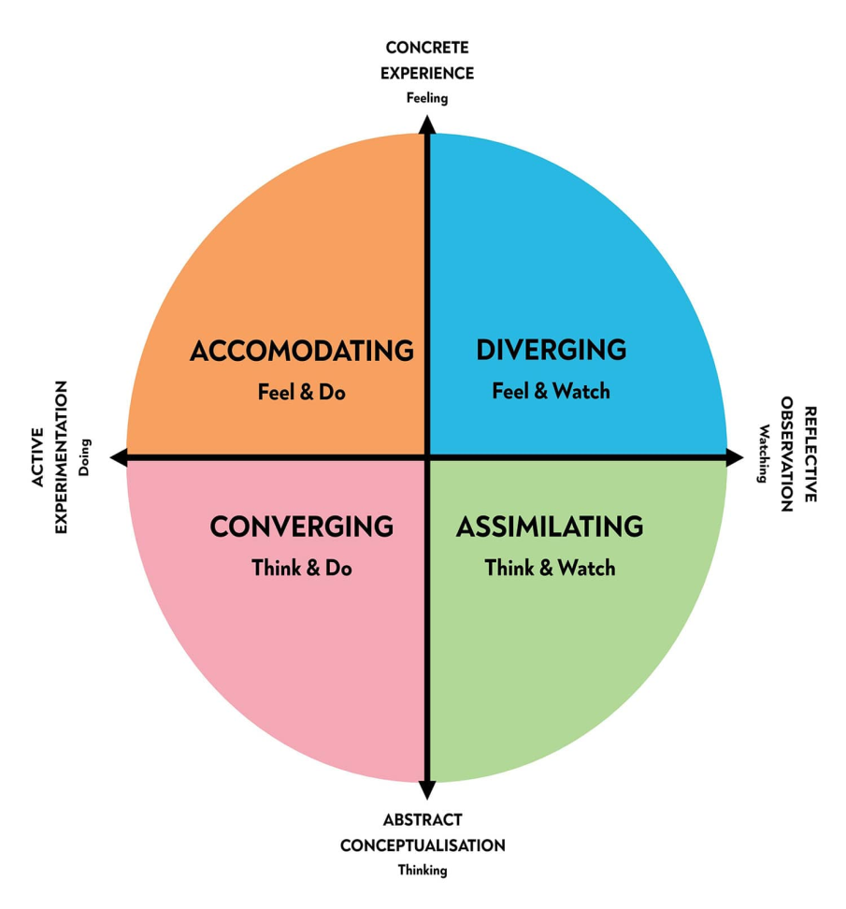
Figure 1: Aspects of Kolb’s Learning Cycle
(Source: Influenced by Morris, 2020)
“Kolb’s learning cycle” was introduced in 1984 by Kolb himself and it contains four different stages that strengthen the entire learning process. It defines that several factors influence learning style such as “social environment, educational experiences, cognitive structure of individuals” (Morris, 2020). Following this model, learners can establish deep learning as well as can engage their learning in the best suitable way.
Concrete experience
I have researched the “community engagement project of Burberry" to develop my learnings in this sphere. Burberry is using social media as a powerful tool to engage its stakeholders as well as contribute well-being of the community. The main important thing that I have experienced is that Burberry considers every person that influences or affects their business as their community members apart from stakeholders. As per the views of Johnston and Lane (2018), Burberry is using social media platforms for accusing the best talents for their organisation. This organisation increases "employee engagement surveys" on social media to gain knowledge of employees' requirements (BURBERRY, 2022). Moreover, their community engagement project is not only limited to employees but also "consumers, government, shareholders, partners, suppliers and local communities". Burberry has recently launched a store in Shenzhen, China that increases customer engagement through social media applications and enhances consumers' in-store experience at home (Williams, 2020). This organisation has collaborated with Tencent a Chinese social media developer for installing a "payment app, WeChat". It provides consumers rewards while they explore online as well as retail stores through "mini programs".
In my point of view, the above-mentioned activities are an excellent way to connect people through innovation and by power of technical advancement. They amalgamate technical revolution and community engagement together for increasing brand awareness. Furthermore, this organisation is supporting their suppliers for economic development of rural communities. For instance, "Cashmere" is a fibre that is used in Burberry clothes and it helps 47,000 rural communities in Afghanistan to empower them economically (BURBERRY, 2022). It helps to gain an insight into the ways community engagement is not only limited to its consumers and employees but also suppliers are benefited from their project. It provides me with knowledge to gain the core motive behind community engagement. I find that community engagement means not only engaging community with business activities but also helping them to nourish. As per the views of Alexander (2018), Burberry is great at engaging people in social media due to its “fast, flexible, dynamic and open to change” attitude. As per my opinion, their open to change attitude has the main reason to be creative in engaging people.
I have gained a lot of valuable experiences while researching community engagement activities of Burberry on social media. I feel that Burberry is great at attracting the best talents for their organisation due to open acquisition from social media platforms. There are many potential people who use social media for job searching, so this initiative is helpful to get the best potential candidates to associate with this organisation. Moreover, economic empowerment of rural communities in underdeveloped or developing countries is an excellent way to serve people. Thus, I feel Burberry has extraordinary and effective community engagement plans that help to increase not only brand awareness but also enhance brand reputation.
Reflective observation of the new experience
I have found one more excellent initiative by Burberry for engaging people. This is an innovative engagement policy that has benefited learners of Yorkshire. Burberry has inspired more than 5000 underrepresented youths and creative art institutes for nurturing creativity among the next generation (BURBERRY, 2022). It inspires youths and upcoming generations to take active participation in art-related fields to foster innovation. In "Kolb's learning cycle" "reflective observation” reflects on the observations from experiences. I have observed that Burberry has taken initiatives that are innovative in nature and also they foster creativity among youths. It indicates their appetite for art and respect for artists which also can be observed in their apparel. Moreover, they also focus to empower financially their suppliers and farmers, who cultivate raw materials for this organisation. They do this through long-term agreements and on social media platforms they post pictures so that people buy products even more. It helps this organisation in two ways, one is to help suppliers through long-term agreements and to increase profitability through advertising it on social media.
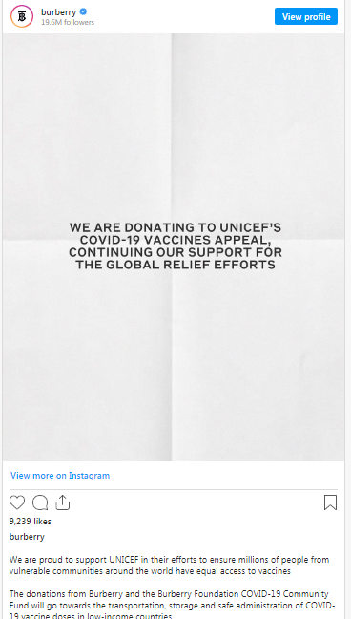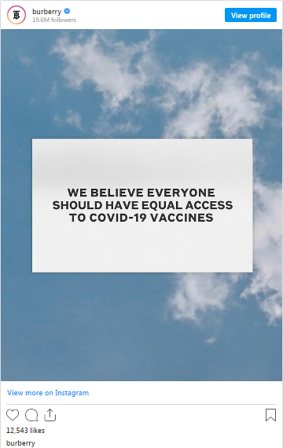
Figure 2: Social Media Post of Burberry regarding Contribution During Covid-19
(Source: BURBERRY, 2022)
Burberry has also effectively contributed to COVID-19 to generate community funds for helping millions of people. Their charity registration number is "1154468" and they donated vaccines to "low-income" countries. They provided 160,000 PPE kits to the UK National Health Service (NHS) and healthcare charities (Burberry, 2022). Moreover, they donated to charities to tackle food poverty and medical requirements of immediate communities in need. It is an example of community engagement and posting it on social media would be helpful to increase brand reputation. Organisational reputation increases attachment of community.
This organisation has also developed an innovative way to engage consumers on social media. As per the views of Kingdon (2018), Burberry inspires consumers to post pictures of them wearing appeal of this brand for engaging customers and also to advertise proficiently. All of the measures that have been taken by this organisation to engage people are innovative and great usage of technology has been observed. As per the opinion of Siette et al. (2021), Burberry installed a virtual assistant for online consumers to enhance their experience with this brand. In my opinion, Burberry is using social media platforms for engaging people by providing a better customer experience through technological innovation. In my observation, community engagement of the organisation is accelerated by social media platforms and their positive impact on the community is visible on their official website.
Abstract conceptualisation
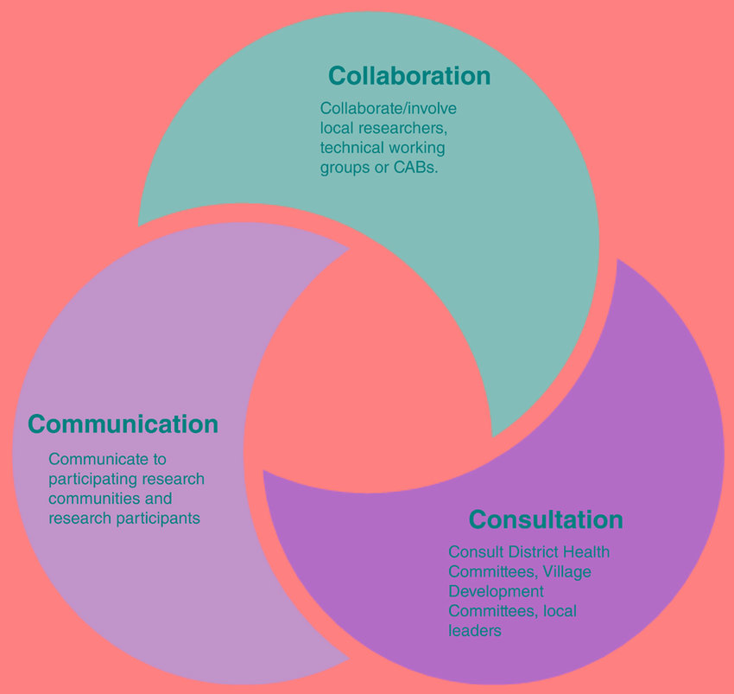
Figure 3: 3C Model of Community Participatory Community Engagement
(Source: Influenced by Key et al. 2019)
This part of “Kolb’s learning cycle” conveys to think deeply regarding gained experience while learning. I have learnt a lot of new concepts of community engagement and innovative projects that have been initiated by Burberry to engage people. As mentioned by Key et al. (2019), the "3C model of community participatory community engagement" is a model that conveys ways to engage participants actively. “Collaboration, consultation and communication” are the main principles of this model. In terms of Burberry, they also follow this rule to actively engage people as they communicate with their consumers effectively through social media and CRM software. Moreover, they actively collaborate with organisations for fostering their community engagement. For instance, Burberry has collaborated with “Oxfam and PUR project” for developing sustainable “Cashmere” industry (BURBERRY, 2022). It indicates that Burberry collaborates to increase community engagement and to serve people.
In terms of consultation, that helps to develop community, Burberry is fostering arts among youths and economically developing rural Afghanistan community. Thus, in my opinion, they follow the concept of the 3C model to engage community effectively. I think very deeply to evaluate effective ways of engaging community people with organisations and found that as this brand manufactures high quality luxury products it is only limited to women with high income. Thus, they engage more people on social media through effective communication for increasing their profitability and not only restrict their business for only particular people. They are engaging other groups of people to purchase their products and to expand their business to some extent.
According to my perception, Burberry requires to maintain their quality and requires to reduce their product price to engage more consumers. However, it has previously been discussed that engaging consumers or stakeholders does not only restrict to increase profitability but also to inspire people. It is clearly visible in Burberry’s community engagement that it is affecting economically underdeveloped communities and youths for a better future. It increases their profitability through effectively engaging potential customers on social media through personalised advertisement and suggesting products according to their preferences. Moreover, they use “virtual assistance” to help consumers navigate through their online stores. In this way, they increase customer loyalty and generate higher profitability. Besides, other engagement activities such as “educational initiative charity” and “COVID-19 community fund” help millions of people.
Active experimentation
This stage conveys that active experiment of the learner with learned things or gained experience in the course of researching. I have found that Burberry is corporate well with change and they use social media to advertise their charity or contribution for society. In my point of view, innovation is extremely important to engage consumers through creative ways of serving people. However, way this organisation helps the community during the pandemic crisis is exceptional. Even though their sales dropped but they -3%, they actively contributed for communities (STATISTA, 2022). Thus, it is visible they contributed for the well-being of people of their community and helped people worldwide in times of crisis. They not only think to help or boast on social media about their charities but also practically implement their initiative.
Initiatives of Burberry help millions of people and encourage youths to take part in charity programs. It has already mentioned that environmental development is a part of community engagement and Burberry has taken initiative to reduce carbon emission by 2040 (BURBERRY, 2022). Their goal is to produce 100% sustainable cotton by 2022 and 100% certified leather from compliance certificates through environmentally friendly tanneries. They actively participate to engage the community and positively impact them through innovative measures. In my opinion, they create a planned framework and implement their plans effectively to engage the community. Social media helped this organisation to reach maximum people and make their consumers aware of their charities. In this way they inspire their consumers and increase brand loyalty as well as reputation. It contributes to higher profitability at the end but most importantly it positively impacts millions of lives.

Conclusion
This report has shed light on the community engagement project of Burberry and it has found that they have undertaken several projects to serve people. This assessment has observed that traditionally community engagement is only associated with stakeholders. However, recently it has found that contributing in “environmental development, local residents, citizenm associates” are a part of community engagement. It has been found that Burberry engae community mostly through social media and utilises technical advancement to enhance consumer experience.
They donated a global pandemic 160,000 PPE kit to NHS and eco-friendly measurements to reduce carbon emission. Moreover, their “educational charity initiative” is helping youths to foster creativity as they support underrepresented art related fields. It has been witnessed that Burberry empowers rural communities of under developed countries economically through long-term agreement. Farmers of Afghanistan are benefited as this organisation collaborates with “Oxfam and PUR project” for contributing to the economic well-being of “cashmere” cultivators. This organisation also enhances consumers' experience through virtual assistance and engaging people with social media posting to acquiesce best talents. I can conclude that Burberry effectively engages communities through technical advancement and to contribute for the well-being of people.

References
BURBERRY, (2022) approach to responsibility. Available at: https://www.burberryplc.com/en/responsibility/approach-to-responsibility.html#:~:text=OUR%20GOAL%20TO%20BE%20CLIMATE,remove%20carbon%20from%20the%20atmosphere. [Accessed on: 22nd August, 2022]
BURBERRY, (2022) our communities. Available at: https://uk.burberry.com/our-communities/ [Accessed on: 22nd August, 2022]
BURBERRY, (2022) stakeholder engagement. Available at: https://www.burberryplc.com/en/company/stakeholder-engagement.html [Accessed on: 22nd August, 2022]
Johnston, K.A. and Lane, A.B., (2018). Building relational capital: The contribution of episodic and relational community engagement. Public Relations Review, 44(5), pp.633-644.
Key, K.D., Furr-Holden, D., Lewis, E.Y., Cunningham, R., Zimmerman, M.A., Johnson-Lawrence, V. and Selig, S., (2019). The continuum of community engagement in research: a roadmap for understanding and assessing progress. Progress in community health partnerships: research, education, and action, 13(4), pp.427-434.
Kingdon, V., (2018) Burberry launches a new educational charity initiative. Available at: https://www.harpersbazaar.com/uk/fashion/fashion-news/a23637040/burberry-launches-educational-charity-initiative/ [Accessed on: 22nd August, 2022]
Morris, T.H., (2020). Experiential learning–a systematic review and revision of Kolb’s model. Interactive Learning Environments, 28(8), pp.1064-1077.
Siette, J., Berry, H., Jorgensen, M., Brett, L., Georgiou, A., McClean, T. and Westbrook, J., (2021). Social participation among older adults receiving community care services. Journal of Applied Gerontology, 40(9), pp.997-1007.
STATISTA, (2022) Comparable sales growth of Burberry from 2014 to 2022. Available at: https://www.statista.com/statistics/870025/comparable-sales-growth-of-burberry-worldwide/ [Accessed on: 22nd August, 2022]

