

Design and Implementation of a Relational Database System

Program: CertHE Computing Skills for Workplace
Module Name: Introduction to Web and Database Concepts
Module code: ACCA4023
Name: Yonatan Grmay
Student Number: 2433740
Lecturer: Sadhana Jha
Submission Date: March/06 /2025

Table of Contents
0
Task 1: Database Implementation 3
Scenario Analysis 3
Entities and Attributes 3
Relationships and Cardinality 5
Entity-Relationship Diagram (ERD) 6
3. Data Structure Development: 6
Medicines Table 7
SQL for Medicines Table: 7
Suppliers Table 8
SQL for Suppliers Table: 8
Customers Table 9
SQL for Customers Table: 9
Prescriptions Table 10
SQL for Prescriptions Table: 10
Sales Transactions Table 11
SQL for Sales Transactions Table: 12
Sales_Medicines Table (for Many-to-Many Relationship) 12
SQL for Sales_Medicines Table: 13
4. Normalisation Compliance 13
1NF (First Normal Form) 13
2NF (Second Normal Form) 15
3NF (Third Normal Form) 17
3. Sample Data Population 18
Medicines Table: 18
Suppliers Table: 18
Customers Table: 19
4. Query Development 20
Query 1: View Available Stock of Each Medicine 20
Query 2: Calculate Total Sales for Each Customer 20
5. Validation and Testing 21
Validation Steps 21
Test Queries 21
Integrity Testing 22
6. Conclusion 23

Task 1: Database Implementation

Scenario Analysis
Within the framework of the database of the so-called MediLink Pharmacy, the main elements are Medicines, Suppliers, Customers, Prescriptions, and Sales Transactions.[1] They will contain and handle important information concerning the operations of the pharmacy. The following is an analysis of each entity, its attributes and the relationship among the entities.

Entities and Attributes
- Medicines
  - Medicine_ID (Primary Key): Unique identifier for each medicine.
  - Medicine_Name: Name of the medicine (e.g., Paracetamol, Ibuprofen).
  - Brand: Brand name of the medicine (e.g., ABC Pharma).
  - Quantity_In_Stock: Number of units currently available in the pharmacy.
  - Price: Price per unit of the medicine.
  - Supplier_ID (Foreign Key): Reference to the Suppliers table to identify which supplier provides the medicine.
- Suppliers
  - Supplier_ID (Primary Key): Unique identifier for each supplier.
  - Supplier_Name: Name of the supplier (e.g., PharmaSupplies, HealthTech).
  - Contact_Phone: Phone number of the supplier.
  - Contact_Email: Email address of the supplier.
  - Address: Physical address of the supplier.
- Customers
  - Customer_ID (Primary Key): Unique identifier for each customer.
  - Name: Full name of the customer.
  - Address: Customer’s delivery address.
  - Phone: Customer’s contact phone number.[2]
  - Email: Customer’s email address.
- Prescriptions
  - Prescription_ID (Primary Key): Unique identifier for each prescription.
  - Customer_ID (Foreign Key): Reference to the Customers table, indicating which customer the prescription belongs to.
  - Date: Date the prescription was issued.
  - Medicine_ID (Foreign Key): Reference to the Medicines table, indicating which medicine is prescribed.
  - Quantity_Prescribed: Number of units of the medicine prescribed.
  - Dispensed_Quantity: Number of units dispensed from the prescription.
- Sales Transactions
  - Transaction_ID (Primary Key): Unique identifier for each sales transaction.
  - Date: Date the transaction occurred.
  - Customer_ID (Foreign Key): Reference to the Customers table, indicating which customer made the transaction.
  - Total_Price: Total value of the transaction.
  - Payment_Method: Method of payment used (e.g., Cash, Credit Card, Online).

Relationships and Cardinality
- Suppliers → Medicines: There are also several-to-many relationships where a single supplier supplies a variety of medicines (One-to-Many relationship). A supplier can be the only provider of a medicine, whereas a medicine can be supplied by a number of suppliers.[3]
- Customers → Prescriptions: A Customer may have several prescriptions throughout time (One-to-Many relationship). The individual prescription is associated with a single customer, albeit multiple prescriptions.
- Medicines → Prescriptions: A prescription includes a certain medicine, and the same medicine can be found in numerous prescriptions (Many-to-One relationship). This means that there is only one prescription of a particular medicine, but that medicine may have many prescriptions.
- Customers → Sales Transactions: There is a possibility of having more than one sales transaction between a customer (One-to-Many relationship). The customer will have the option to purchase the medicines at various hours, and this will lead to numerous sales.[4]
- Sales Transactions → Medicines: There can be many medicines in one transaction (Many-to-Many relationship). To solve this, you can add a junction table, Sales Medicines, which captures the medicines sold in each transaction, and the quantity sold.

Entity-Relationship Diagram (ERD)
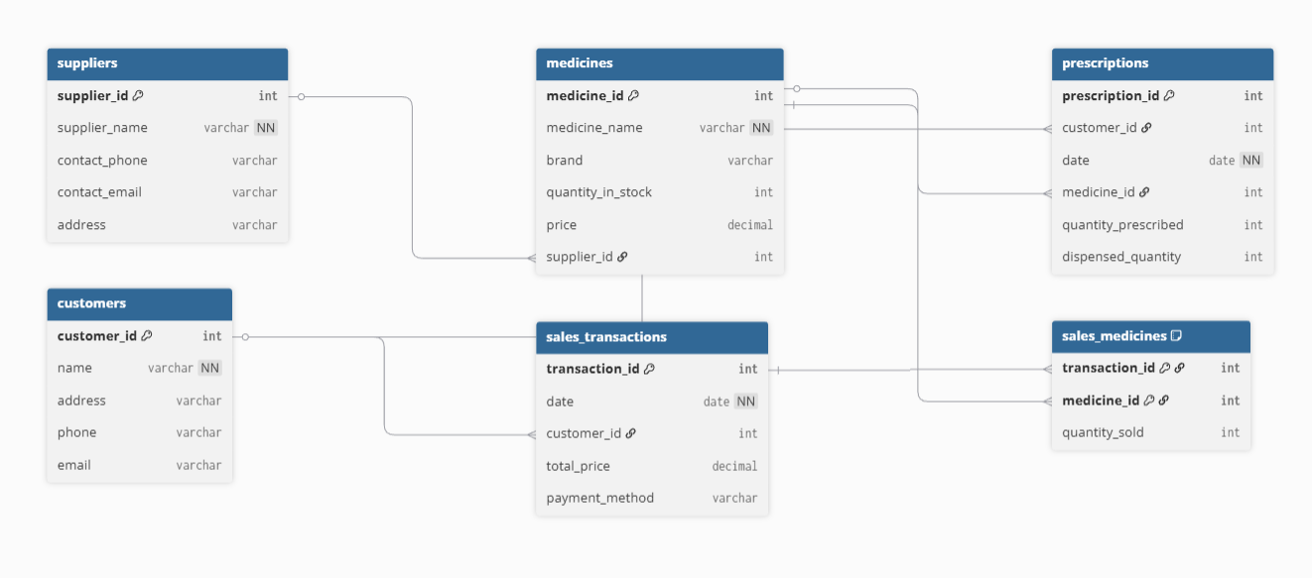

3. Data Structure Development:
In Microsoft Access, the following tables will be developed on the basis of the ERD provided. Information on medicines, suppliers, customers, prescription and sales transactions will be stored in each table, with the relation being made through foreign keys.[5]

Medicines Table
This table holds information about the medicines in stock.
Attribute | Description
Medicine_ID (PK) | A unique identifier for each medicine.
Medicine_Name | The name of the medicine (e.g., Paracetamol, Ibuprofen).
Brand | The brand name of the medicine (e.g., ABC, XYZ).
Quantity_In_Stock | The current number of units available in stock.
Price | The price per unit of the medicine.
Supplier_ID (FK) | Foreign Key linking to the Suppliers table to identify the supplier.

SQL for Medicines Table:
CREATE TABLE Medicines (
Medicine_ID INT PRIMARY KEY,
Medicine_Name VARCHAR(255) NOT NULL,
Brand VARCHAR(255),
Quantity_In_Stock INT,
Price DECIMAL(10, 2),
Supplier_ID INT,
FOREIGN KEY (Supplier_ID) REFERENCES Suppliers(Supplier_ID)
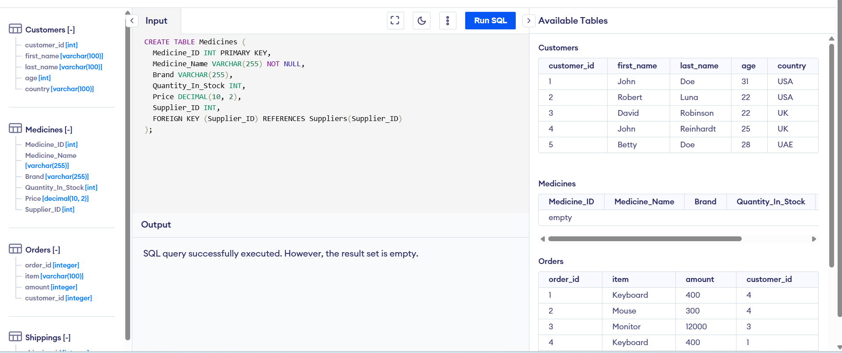

Suppliers Table
This table stores information about the suppliers of medicines.
Attribute | Description
Supplier_ID (PK) | A unique identifier for each supplier.
Supplier_Name | The name of the supplier (e.g., PharmaSupplies).
Contact_Phone | Phone number for contacting the supplier.
Contact_Email | Email address for contacting the supplier.
Address | The address of the supplier.

SQL for Suppliers Table:
CREATE TABLE Suppliers (
Supplier_ID INT PRIMARY KEY,
Supplier_Name VARCHAR(255) NOT NULL,
Contact_Phone VARCHAR(50),
Contact_Email VARCHAR(100),
Address VARCHAR(255)
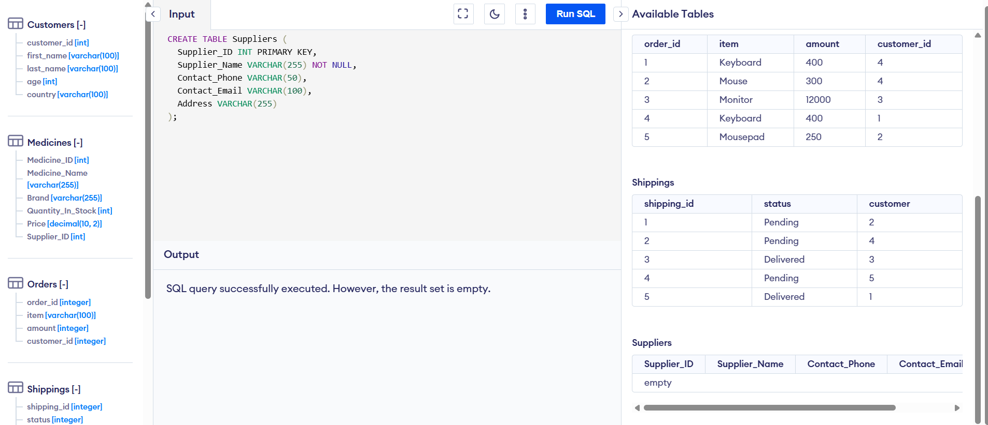

Customers Table
This table contains details about the customers.
Attribute | Description
Customer_ID (PK) | A unique identifier for each customer.
Name | The full name of the customer.
Address | The address of the customer.
Phone | The phone number of the customer.
Email | The email address of the customer.

SQL for Customers Table:
CREATE TABLE Customers (
Customer_ID INT PRIMARY KEY,
Name VARCHAR(255) NOT NULL,
Address VARCHAR(255),
Phone VARCHAR(50),
Email VARCHAR(100)

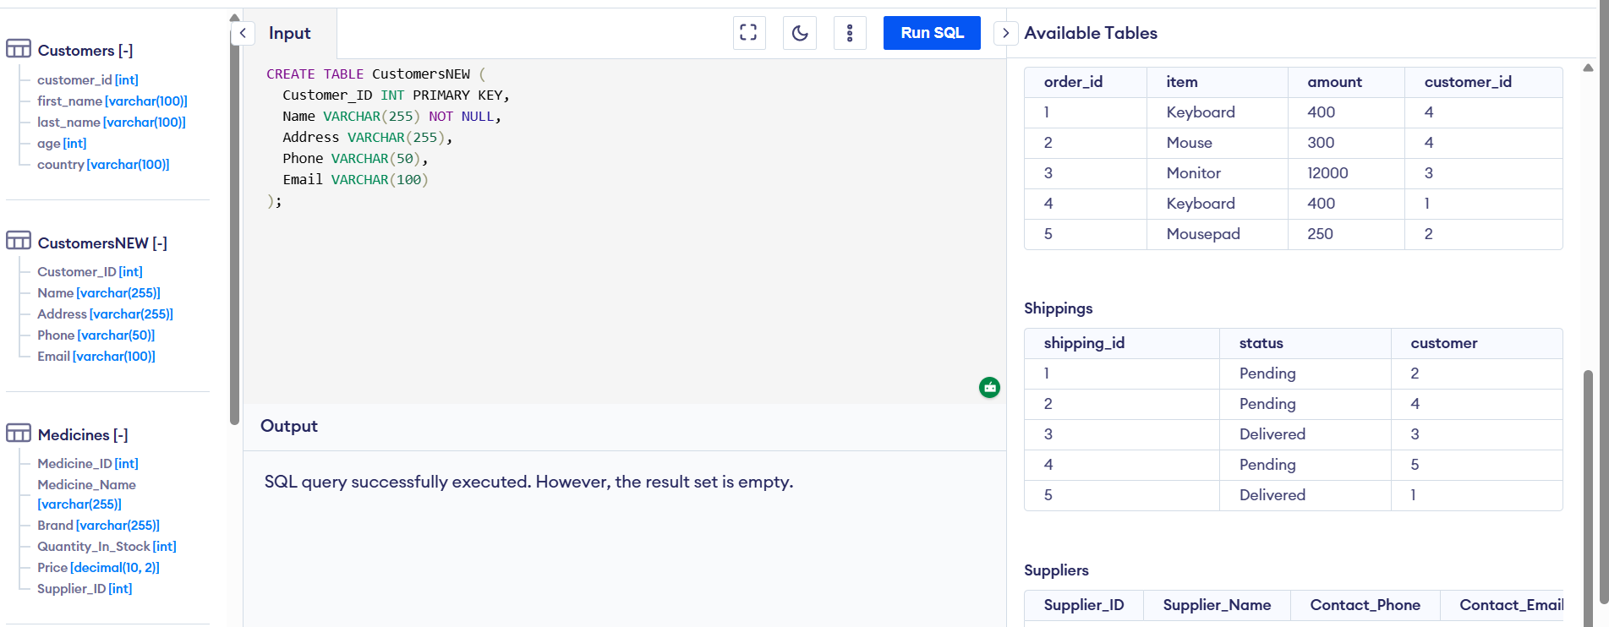

Prescriptions Table
This table stores information about the prescriptions issued to customers.
Attribute | Description
Prescription_ID (PK) | A unique identifier for each prescription.
Customer_ID (FK) | Foreign Key linking to the Customers table.
Date | The date the prescription was issued.
Medicine_ID (FK) | Foreign Key linking to the Medicines table.
Quantity_Prescribed | The quantity of the medicine prescribed.
Dispensed_Quantity | The quantity dispensed to the customer.

SQL for Prescriptions Table:
CREATE TABLE Prescriptions (
Prescription_ID INT PRIMARY KEY,
Customer_ID INT,
Date DATE NOT NULL,
Medicine_ID INT,
Quantity_Prescribed INT,
Dispensed_Quantity INT,
FOREIGN KEY (Customer_ID) REFERENCES Customers(Customer_ID),
FOREIGN KEY (Medicine_ID) REFERENCES Medicines(Medicine_ID)
);
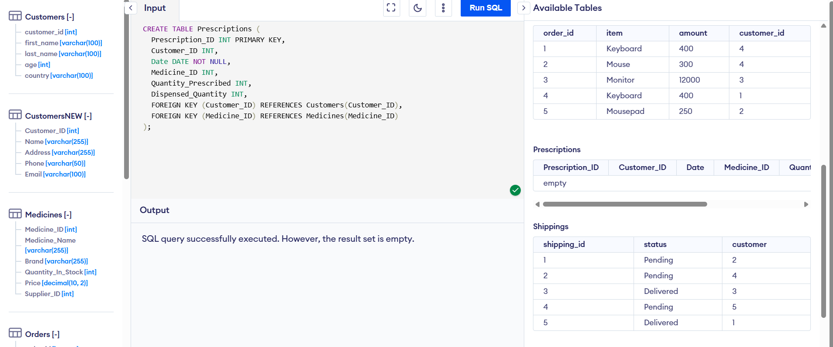

Sales Transactions Table
This table contains details about each sales transaction.
Attribute | Description
Transaction_ID (PK) | A unique identifier for each transaction.
Date | The date the transaction took place.
Customer_ID (FK) | Foreign Key linking to the Customers table.
Total_Price | The total price of the sale.
Payment_Method | The payment method used for the transaction (e.g., Cash, Credit Card).

SQL for Sales Transactions Table:
CREATE TABLE Sales_Transactions (
Transaction_ID INT PRIMARY KEY,
Date DATE NOT NULL,
Customer_ID INT,
Total_Price DECIMAL(10, 2),
Payment_Method VARCHAR(50),
FOREIGN KEY (Customer_ID) REFERENCES Customers(Customer_ID)

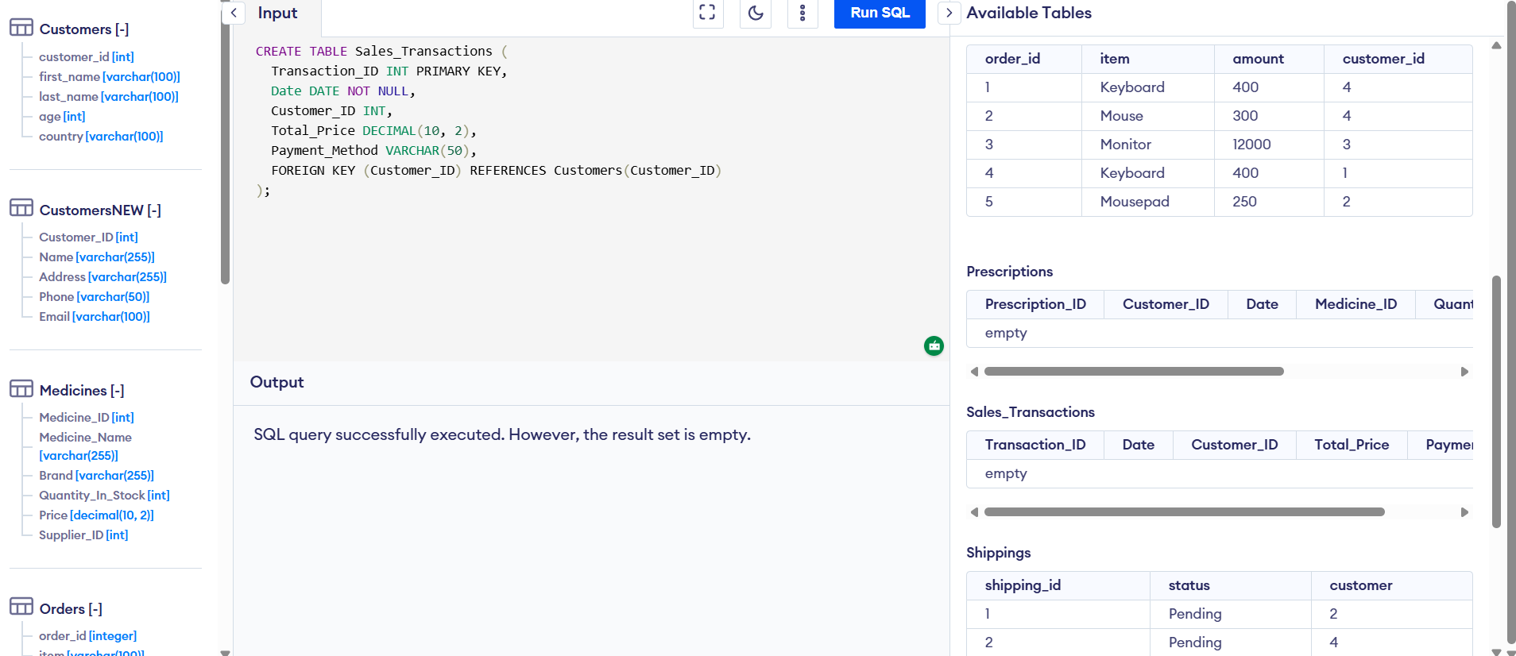

Sales_Medicines Table (for Many-to-Many Relationship)
This table is a many-to-many relation between Sales Transactions and Medicines. A transaction can have several medicines to be transacted on, and a certain medicine can be transacted on a number of times.[6]
Attribute | Description
Transaction_ID (FK) | Foreign Key linking to the Sales Transactions table.
Medicine_ID (FK) | Foreign Key linking to the Medicines table.
Quantity_Sold | The quantity of the medicine sold in the transaction.
Primary Key | Composite primary key of Transaction_ID and Medicine_ID.

SQL for Sales_Medicines Table:
CREATE TABLE Sales_Medicines (
Transaction_ID INT,
Medicine_ID INT,
Quantity_Sold INT,
PRIMARY KEY (Transaction_ID, Medicine_ID),
FOREIGN KEY (Transaction_ID) REFERENCES Sales_Transactions(Transaction_ID),
FOREIGN KEY (Medicine_ID) REFERENCES Medicines(Medicine_ID)
);
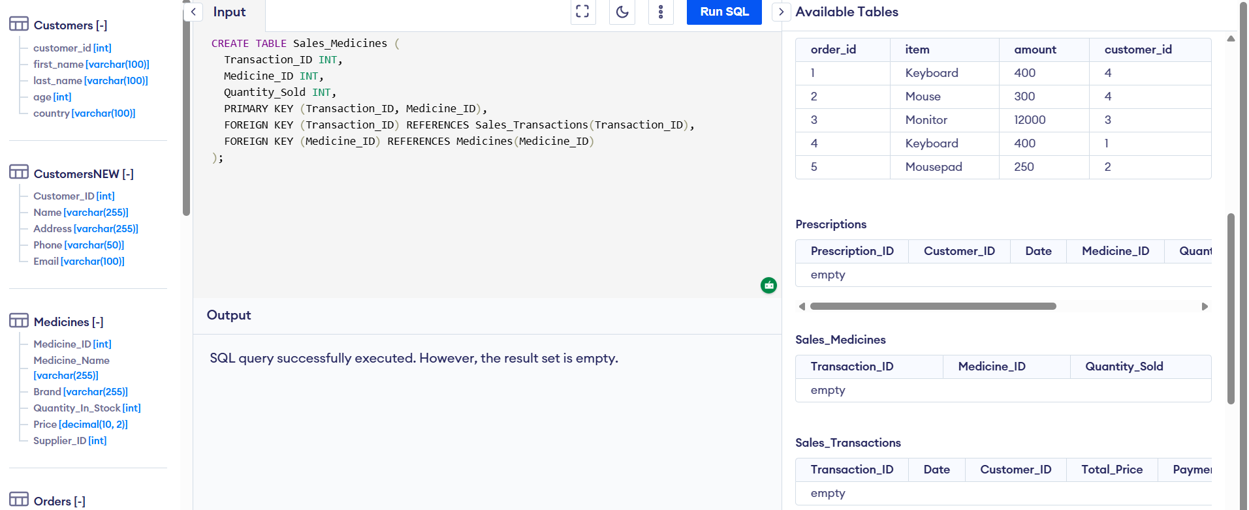

4. Normalisation Compliance
The data model should be normalised in order to reduce redundancy and make it consistent. We will run through 1NF, 2NF and 3NF to make sure that we comply.[7]

1NF (First Normal Form)
To meet 1NF, we must ensure that:
- Each table has a primary key.
- The atomics are used in all fields (there are no multiple values or repeating groups).
All fields in the tables above are atomic. E.g. Individual values are entered in the Contact_Phone and Contact_Email fields, that is, in the Quantity_Prescribed and Dispensed_Quantity in the Prescriptions table are numeric, and each data is an individual value.[15]

Table | Attributes | Explanation
Medicines | Medicine_ID (PK), Medicine_Name, Brand, Quantity_In_Stock, Price, Supplier_ID (FK) | All attributes are atomic and unique.
Suppliers | Supplier_ID (PK), Supplier_Name, Contact_Phone, Contact_Email, Address | All attributes are atomic and unique.
Customers | Customer_ID (PK), Name, Address, Phone, Email | All attributes are atomic and unique.
Prescriptions | Prescription_ID (PK), Customer_ID (FK), Date, Medicine_ID (FK), Quantity_Prescribed, Dispensed_Quantity | All attributes are atomic, and each prescription is identified uniquely.
Sales Transactions | Transaction_ID (PK), Date, Customer_ID (FK), Total_Price, Payment_Method | All attributes are atomic and unique.
Sales_Medicines | Transaction_ID (FK), Medicine_ID (FK), Quantity_Sold | All attributes are atomic and unique, and the composite key (Transaction_ID, Medicine_ID) ensures uniqueness.

2NF (Second Normal Form)
To meet 2NF, we must guarantee:
- The rest of the non-key attributes rely wholly on the primary key.
We are using a composite key in the SalesMedicines table, which consists of both the values of TransactionID and the values of MedicineID, and therefore nonkey values, including QuantitySold, are based on both components of the composite key.[8]

Table | Attributes | Explanation
Medicines | Medicine_ID (PK), Medicine_Name, Brand, Quantity_In_Stock, Price, Supplier_ID (FK) | No partial dependencies. All non-key attributes depend on the primary key (Medicine_ID).
Suppliers | Supplier_ID (PK), Supplier_Name, Contact_Phone, Contact_Email, Address | No partial dependencies. All non-key attributes depend on the primary key (Supplier_ID).
Customers | Customer_ID (PK), Name, Address, Phone, Email | No partial dependencies. All non-key attributes depend on the primary key (Customer_ID).
Prescriptions | Prescription_ID (PK), Customer_ID (FK), Date, Medicine_ID (FK), Quantity_Prescribed, Dispensed_Quantity | No partial dependencies. All non-key attributes depend on the composite key (Prescription_ID).
Sales Transactions | Transaction_ID (PK), Date, Customer_ID (FK), Total_Price, Payment_Method | No partial dependencies. All non-key attributes depend on the primary key (Transaction_ID).
Sales_Medicines | Transaction_ID (FK), Medicine_ID (FK), Quantity_Sold | No partial dependencies. The composite key (Transaction_ID, Medicine_ID) ensures all non-key attributes depend on the entire primary key.

3NF (Third Normal Form)
Transitive dependencies must be removed to fulfil 3NF. That is, the non-key attributes are not supposed to be dependent on the non-key attributes.
- As an illustration, the Supplier_Name, Contact_Phone, Contact_Email and Address in the Suppliers table are all dependent on the Supplier ID, which is the primary key. The table does not have any transitive dependencies.[9]

Table | Attributes | Explanation
Medicines | Medicine_ID (PK), Medicine_Name, Brand, Quantity_In_Stock, Price, Supplier_ID (FK) | No transitive dependencies. All non-key attributes depend only on the primary key (Medicine_ID).
Suppliers | Supplier_ID (PK), Supplier_Name, Contact_Phone, Contact_Email, Address | No transitive dependencies. All non-key attributes depend only on the primary key (Supplier_ID).
Customers | Customer_ID (PK), Name, Address, Phone, Email | No transitive dependencies. All non-key attributes depend only on the primary key (Customer_ID).
Prescriptions | Prescription_ID (PK), Customer_ID (FK), Date, Medicine_ID (FK), Quantity_Prescribed, Dispensed_Quantity | No transitive dependencies. Non-key attributes depend only on the primary key (Prescription_ID).
Sales Transactions | Transaction_ID (PK), Date, Customer_ID (FK), Total_Price, Payment_Method | No transitive dependencies. Non-key attributes depend only on the primary key (Transaction_ID).
Sales_Medicines | Transaction_ID (FK), Medicine_ID (FK), Quantity_Sold | No transitive dependencies. The composite key (Transaction_ID, Medicine_ID) ensures all non-key attributes depend on the entire primary key.

3. Sample Data Population
To test the structure and relationship, we will put realistic sample data into the database.

Medicines Table:
Medicine_ID | Medicine_Name | Brand | Quantity_In_Stock | Price | Supplier_ID
1 | Paracetamol | ABC | 100 | 5.00 | 101
2 | Ibuprofen | XYZ | 50 | 8.00 | 102
INSERT INTO Medicines (Medicine_ID, Medicine_Name, Brand, Quantity_In_Stock, Price, Supplier_ID)
VALUES
(1, 'Paracetamol', 'ABC', 100, 5.00, 101),
(2, 'Ibuprofen', 'XYZ', 50, 8.00, 102);
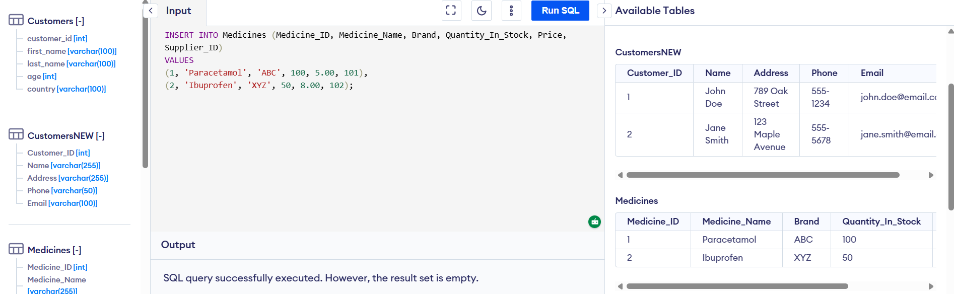

Suppliers Table:
Supplier_ID | Supplier_Name | Contact_Phone | Contact_Email | Address
101 | PharmaSupplies | 123-456-7890 | pharam@supplies.com | 123 Street, City
102 | HealthTech | 987-654-3210 | health@tech.com | 456 Avenue, City
INSERT INTO Suppliers (Supplier_ID, Supplier_Name, Contact_Phone, Contact_Email, Address)
VALUES
(101, 'PharmaSupplies', '123-456-7890', 'pharam@supplies.com', '123 Street, City'),
(102, 'HealthTech', '987-654-3210', 'health@tech.com', '456 Avenue, City');

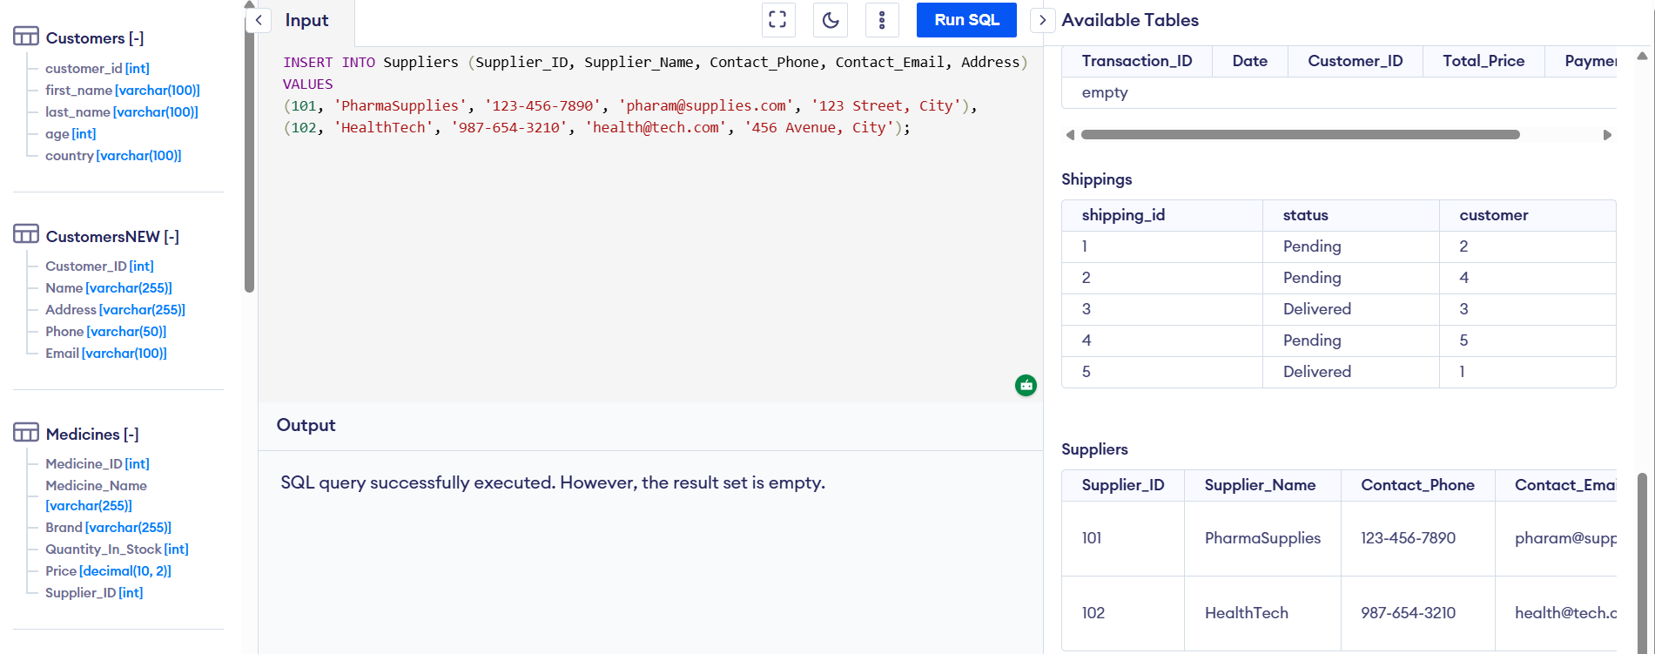

Customers Table:
Customer_ID | Name | Address | Phone | Email
1 | John Doe | 789 Oak Street | 555-1234 | john.doe@email.com
2 | Jane Smith | 123 Maple Avenue | 555-5678 | jane.smith@email.com
INSERT INTO Customers (Customer_ID, Name, Address, Phone, Email)
VALUES
(1, 'John Doe', '789 Oak Street', '555-1234', 'john.doe@email.com'),
(2, 'Jane Smith', '123 Maple Avenue', '555-5678', 'jane.smith@email.com');
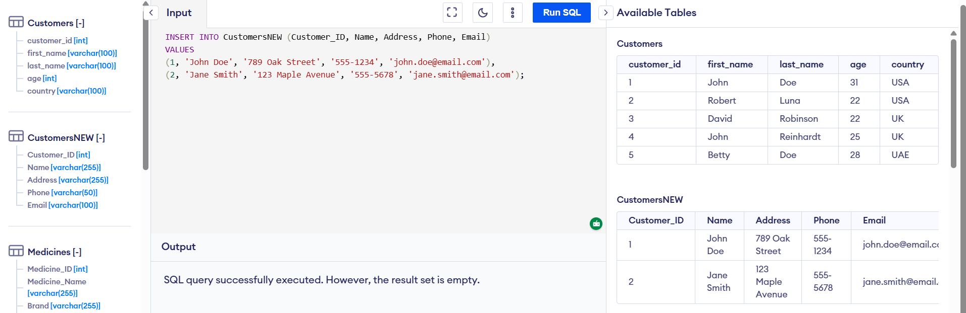

4. Query Development

Query 1: View Available Stock of Each Medicine
SELECT Medicine_Name, Quantity_In_Stock
FROM Medicines;
This query retrieves the names of medicines and their available stock.[10]
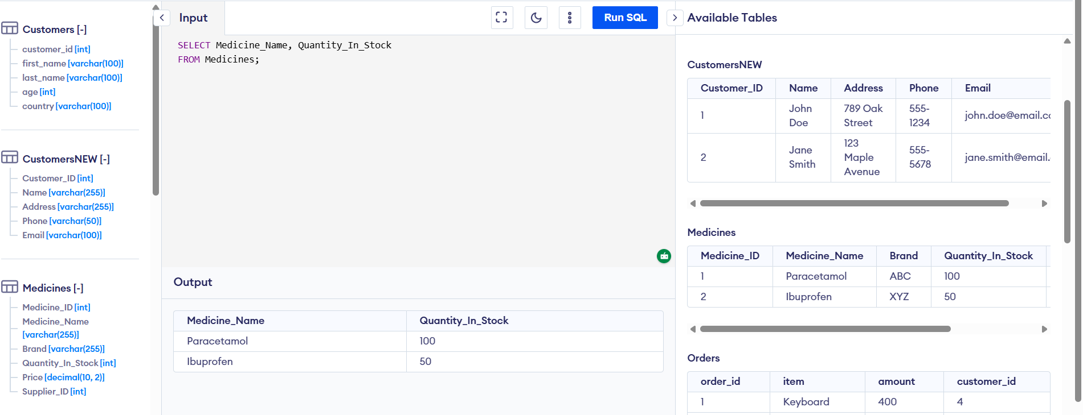

Query 2: Calculate Total Sales for Each Customer
SELECT Customers.Name, SUM(Sales_Transactions.Total_Price)
FROM Sales_Transactions
INNER JOIN Customers ON Sales_Transactions.Customer_ID = Customers.Customer_ID
GROUP BY Customers.Name;
This query determines the amount of sales made on an individual basis.[11]
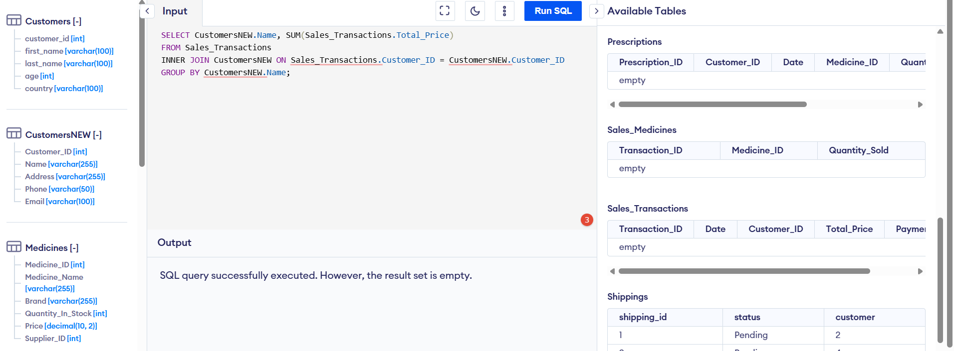

5. Validation and Testing
Once the database structure has been developed and sample data has been entered into the database, the database needs to be tested and validated to check that it corresponds to the functional requirements. The validation processes involve the execution of test queries and integrity testing, whereby one is supposed to make sure that the data, relationships and the outcomes of the queries are accurate.[12]

Validation Steps

Test Queries
- Query 1: View Available Stock of Each Medicine
  - Purpose: The query will extract the names of the medicines and the stock levels of the medicines in the Medicines table.
  - Expected Outcome: It should give a list of medicines and their stocks.
- SELECT Medicine_Name, Quantity_In_Stock
FROM Medicines;
Expected Result:
Medicine_Name | Quantity_In_Stock
Paracetamol | 100
Ibuprofen | 50
- The data expected to be presented in the Medicines table should be valid, such that the stock quantity is correct.
- Query 2: Calculate Total Sales for Each Customer
  - Purpose: This query will determine the aggregate sales of every client by adding the Total_Price in the Sales_Transactions table.
  - Expected Outcome: The query is expected to give the total sales of all the customers according to the transactions.[13]

Integrity Testing
Integrity testing is done to ensure that every relationship between the tables is properly created and the data is uniform. Below are key areas to check:
- Link Between Sales Transactions and Medicines via Sales_Medicines Table
  - Purpose: Be sure that the Sales_Medicines table is properly related to the Sales_Transactions table and the Medicines table, indicating the medicines sold at each transaction.
  - Test: Query the Sales_Medicines table to make sure that all sales transactions are associated with the appropriate medicines.[14]

6. Conclusion
The testing and validation process would ensure that the MediLink Pharmacy database is working as anticipated. The following important findings were made:
- Query Validation: The desired data were obtained in all of the test queries:
  - The stock of medicines available is correct.
  - The total sales per customer were computed appropriately.
- Data Integrity:
  - The Sales_Medicines table was able to join Sales Transactions with the Medicines table, whereby the right medicines are going to be sold in every transaction.
  - The prescription information is properly attached to the customers and medicines, and quantities are duly registered.

  - Medicine stock levels are correct and do not bring about negative stocks, so sales are only limited to stock levels.
- System Reliability: The relations between the tables are valid, and the database is free of data distortion in the instances of diverse data access and process operations.
Future improvements can include:
- Making it time-sensitive or adding more restrictions so that the stock levels will be automatically updated as the prescriptions or sales transactions take place.
- Using a more sophisticated validation rule to check in specific business logic, including not being able to sell medicines after the expiration date.
7. References
[1] P. P. Chen, “The Entity-Relationship Model: Toward a Unified View of Data,” ACM Transactions on Database Systems, vol. 1, no. 1, pp. 9–36, 1976.
[2] T. Connolly and C. Begg, Database Systems: A Practical Approach to Design, Implementation, and Management, 6th ed. Pearson, 2014.
[3] C. J. Date, An Introduction to Database Systems, 8th ed. Pearson Education, 2004.
[4] R. Elmasri and S. B. Navathe, Fundamentals of Database Systems, 7th ed. Pearson, 2015.
[5] J. Frye and D. Kim, Database Management and SQL Fundamentals, 5th ed. McGraw-Hill Education, 2022.
[6] H. Garcia-Molina, J. D. Ullman, and J. Widom, Database Systems: The Complete Book, 2nd ed. Pearson, 2008.
[7] J. A. Hoffer, M. B. Prescott, and F. G. McFadden, Modern Database Management, 12th ed. Pearson, 2021.
[8] W. Kennes, Database Design for Mere Mortals: A Hands-On Guide to Relational Database Design, 2nd ed. Addison-Wesley, 2003.
[9] J. Melton and A. Simon, SQL: 1999 – Understanding Relational Language Components. Morgan Kaufmann, 1993.
[10] Microsoft, “Introduction to database normalization,” 2021. [Online]. Available: https://docs.microsoft.com/en-us/sql/relational-databases/tables/database-normalization?view=sql-server-ver15. [Accessed: Feb. 20, 2026].
[11] E. Navarro, The Database Design and Implementation Guide, 2nd ed. Pearson, 2020.
[12] Oracle Corporation, “Understanding Referential Integrity Constraints,” 2020. [Online]. Available: https://docs.oracle.com/cd/B28359_01/server.111/b28318/consist.htm#CNCPT86849. [Accessed: Feb. 20, 2026].
[13] P. Robinson, Data Integrity and Database Normalization: A Guide to Building Reliable Databases. Wiley, 2018.
[14] K. Siau and X. Tan, “Database Design: Theory and Practice,” Journal of Database Management, vol. 28, no. 4, pp. 55–67, 2017.
[15] D. Steinberg, SQL Queries for Mere Mortals: A Hands-On Guide to Data Manipulation in SQL, 4th ed. Addison-Wesley, 2019.

