Abstract
A qualitative interview was conducted to analyse students’ abilities to cope with the change of moving to a new campus. Main themes were analysed while transcribing the interviews using IPA. These themes included, no information given prior to the move, first day nerves and positive change. It was assumed due to previous research that the more the individual felt they were part of the change the more they would understand and have more of an ability to cope with the change. In turn, this hypothesis was to be accepted as, as the students felt they settled in and were part of the university they had a greater ability to cope with the change.

Introduction
This report will be analysing how individuals have coped with the change of moving to a new university campus. An interview schedule was designed with open questions in order to converse with the participants to create an interview. It has been seen in previous studies including, Cunningham et al. (2002), that the ability to cope with change is positively related with enthusiasm for change, involvement in the change process, and apparent contribution to the change.
Although, Wanberg, C. R., & Banas, J. T. (2000) found that low to no levels of acceptance to change linked to less job satisfaction and more turnover intentions in the workplace. Furthermore, Huy, Q. N. (2002), noted that employees that have trust and attachment to the organization are more likely to support change.
Herscovitch and Meyer (2002) also suggested that aﬀective and continuance are two forms of commitment to change, and stated that these are likely to inﬂuence someone’s coping behaviour to the change. It was suggested that if the person holds a positive attitude towards the change process, although the change may be stressful at times, they will be able to cope with such transitions because it ultimately beneﬁts them.
Due to the research found it was assumed prior to the interviews that if the participants were enthusiastic about the move or involved in any way it would be a positive motive. Although, if they didn’t accept the move in any way, they would have little satisfaction and cope with the change less. It is seen throughout each interview that the participants understandings of change are more deceptive as they respond to the pressures of those changes. These understandings help to explain how the participants construct meanings about their university and how the changes have affected themselves and fellow university students.

Participants
The study consisted of three second year counselling and psychology undergraduate students. This consisted of two females and one male that all volunteered to participate.
Design
A qualitative study design that consisted of a semi-structured interview was conducted to explore how individuals cope with the change of moving to a new university campus. The interview was recorded via audio and transcribed and analysed later to produce themes using Interpretative Phenomenological Analysis (IPA).
Materials
A consent form (appendix D) was required for all participants to sign prior to the interview being conducted and recorded via a voice recorder. The interview schedule questions were prepared beforehand (appendix F) and were open questions in order to be able to create a conversation. Within the interview there were prompt questions in the event of the participant struggling to answer the question efficiently. These questions were designed to stimulate the participant into considering if moving to a new university had any impact on them in anyway. After the interview was conducted the participants were given a debrief form (appendix E) that explained what the interview was for.
Procedure

A slot was booked in the labs to enable the interviews to be conducted in a controlled environment. Each participant was invited into the lab separately and were seated. They were provided with a consent form to complete prior to the interview being conducted and the audio recorder was placed in the middle of the table. The topic was introduced to each and a verbal consent was given to enable the recording. The topic was introduced, and they were informed their names would be changed for confidentiality. Once they agreed the audio recorder was turned on. There were four questions and one prompt question asked to each and the interviews lasted around 10 minutes. When the interview finished the answers were summarised and the participants were asked if they had any further questions or thoughts. The recorder was then switched off and the participant was thanked and provided with a debrief form. The recordings were then transcribed using IPA to identify main themes throughout.

Results

A qualitative study that consisted of three 10-minute interviews was conducted in order to understand three university student’s ability to cope with the change of moving to a new university campus. Interviews were conducted with main and prompt questions and were analysed later to provide themes (Appendix, A, B, C). Three themes were identified and included, ‘no information given prior to the move’, ‘first day nerves’ and ‘positive change’.
The first theme- ‘no information given prior to the move’ appeared in all the interviews. Allanah stated when asked “Can you tell me what you knew about the transition to this campus?” ‘Um not too much actually, there wasn’t much information given to any of the students’ (8,9). When Richard was asked, it was stated ‘I don’t feel like there was much and the teachers didn’t really know much either’ (10,11). This shows neither staff or students were given much information on the move. When asked, Naomi stated, ‘um information was given that we were going to be moving to SA1 but we didn’t know where it was going to be, what the area was going to be like’ (9,10,11). This would be nerve-racking for anyone if there not sure what to expect.
The second theme found throughout was ‘first day nerves’. As seen, no one was sure what to expect from the move. Therefore, when asked “how did you feel on the first day in the new campus?” A theme appeared and the participants stated they were nervous on their first day. Naomi stated, ‘it was nerve racking trying to navigate your way around the place for the first time’ (19). Whereas, Allanah said ‘Um, excited, um, a bit worried, it’s a very large building isn’t it’ (18). Richard appeared the most nervous stating ‘I just felt really nervous really like everything just seemed to be making me nervous, like I didn’t know where to park, I didn’t know where to go’ (22,23).
The third and final theme that appeared throughout was ‘positive change’. It was clear that as the participants got used to their way around the building it was finally seen as a positive change and was clear they had coped well with the change. When Allanah was asked “Was it a big change for you in anyway?” a positive response was provided and detailed, ‘Um not me personally no but umm, umm, I feel like academically I can improve’ (31). This is a positive response as Allanah felt she was able to improve in ways through the move. Richard stated, ‘it’s a much more positive learning experience, everything’s there for you’ (43). Meanwhile when Naomi was asked “can you explain to me how you feel you have fitted in/settled into this new campus?” she stated, ‘I feel like I have fitted in quite well now’ (42). This shows all participants have settled in and now see the move as a positive experience as appose to how they felt when they were not involved with the move in anyway.
As it was assumed prior to the interviews that if participants were involved with the move in any way or enthusiastic about moving, they would have more of an ability to cope with change. But, if they did not accept the move, they would cope with change less. This is clear throughout these themes. As the participants did not know anything about the move, they were not able to be involved in any way. This was seen as a negative and led to nerves and each of them not knowing what to expect. Although, as they got used to the university, they found that they settled in more and it was changed to a positive experience for each of them, this is where they were able to accept the change and cope with it.

Discussion

A qualitative study was conducted to see how university students coped with the change of moving to a new university campus. As seen, due to the research found prior to the study taking place, it was assumed that students that understood the move and were involved in some way would have coped with change a lot better than those who had no understanding of the move. This was seen and stated by Cunningham, C. E., et al., (2002) that coping with change was positively related with involvement in the change process. As the participants were not involved in the move in any way it was clear they struggled to cope with the change at first, but it became positive when they felt they settled in and felt part of the university.
As Herscovitch, L., & Meyer, J. P. (2002) suggested previously, affective and continuance were likely to influence a person’s ability to cope with change. Linking this to the participants, it was clear as they became positive about the change, they were able to cope with the transition and in turn effectively cope with the change as it benefited them in many ways including academically.
As the participants didn’t know anything about the move, this linked to what Huy, Q. N. (2002) stated. He stated if there was no trust in the organisation there will be less to no support to the change. As participants didn’t know what was going on prior to the move, they had a lack of trust which permitted them to support or deal with the change initially. As they had more knowledge of the move, they began to trust the university and support the change.
Conclusion

Interviews were conducted on three university students to see their ability to cope with the change of moving to a new university campus. At first it was clear each participant did not cope with the move well, but over time felt more settled and resulting in their ability to cope. As it was assumed for ability to cope with change the participant needed to be enthusiastic or involved in some way. This hypothesis is to be accepted as the participants were not involved as they did not know anything about the move, although, when they felt a part of the university and felt they fitted in they began to accept the change and cope with it as they saw it benefited them.
Although, if these interviews were to be conducted again, there would need to be more students taking part for a reliable outcome. Also, as the students that took part live locally, it may benefit the study if there was more of a diverse set of students to get a true representation of how students cope with change living locally or further afield.
Therefore, to conclude, in this case, students who move university campus, tend to be unable to cope with change straight away, although, as they feel they start to fit in to the environment, see it as a positive not a negative.

References

Cunningham, C. E., Woodward, C. A., Shannon, H. S., MacIntosh, J., Lendrum, B., Rosenbloom, D., & Brown, J. (2002). Readiness for organizational change: A longitudinal study of workplace, psychological and behavioural correlates. Journal of Occupational and Organizational psychology, 75(4), 377-392.
Herscovitch, L., & Meyer, J. P. (2002). Commitment to organizational change: Extension of a three-component model. Journal of applied psychology, 87(3), 474.
Huy, Q. N. (2002). Emotional balancing of organizational continuity and radical change: The contribution of middle managers. Administrative science quarterly, 47(1), 31-69.
Wanberg, C. R., & Banas, J. T. (2000). Predictors and outcomes of openness to changes in a reorganizing workplace. Journal of applied psychology, 85(1), 132.

Appendices
- Interview with Allanah

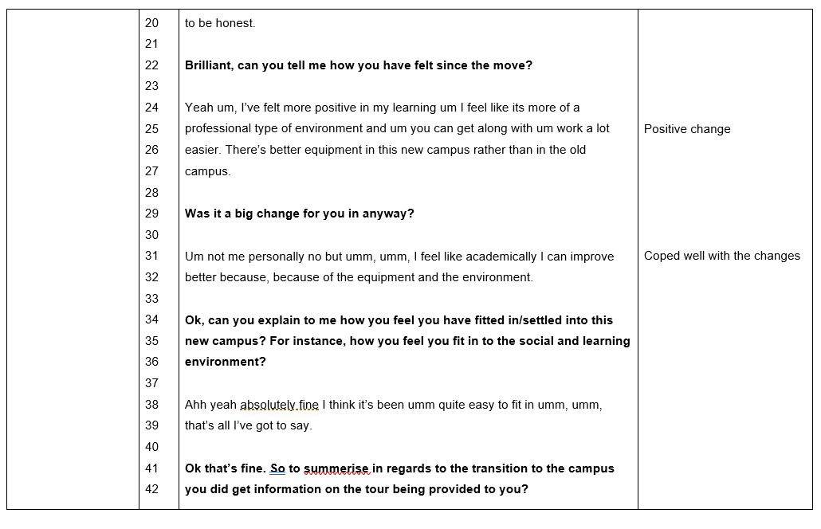
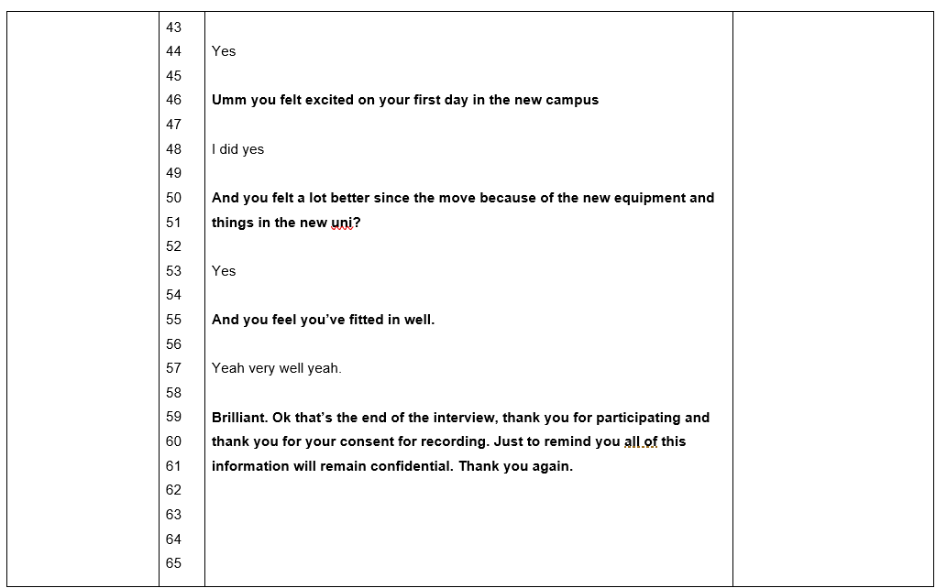

- Interview with Richard
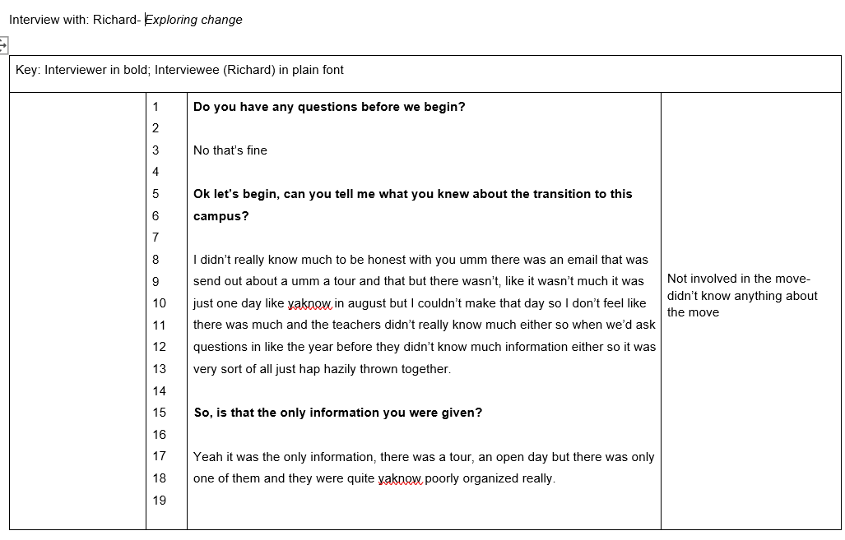
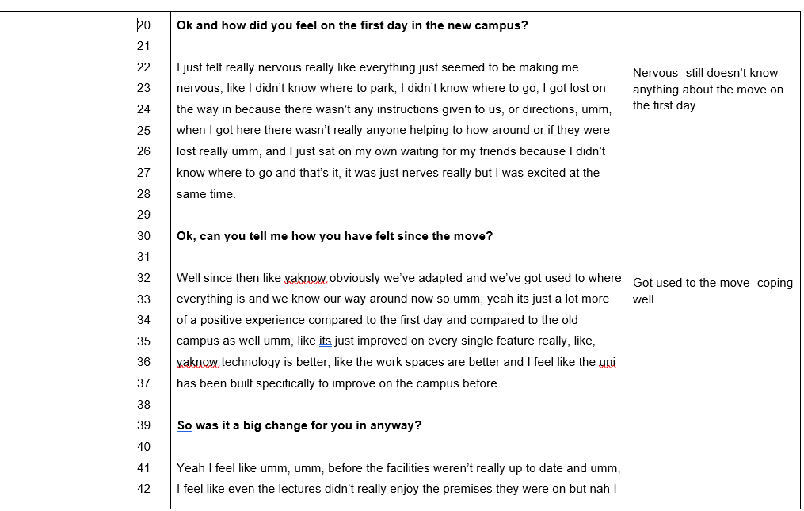

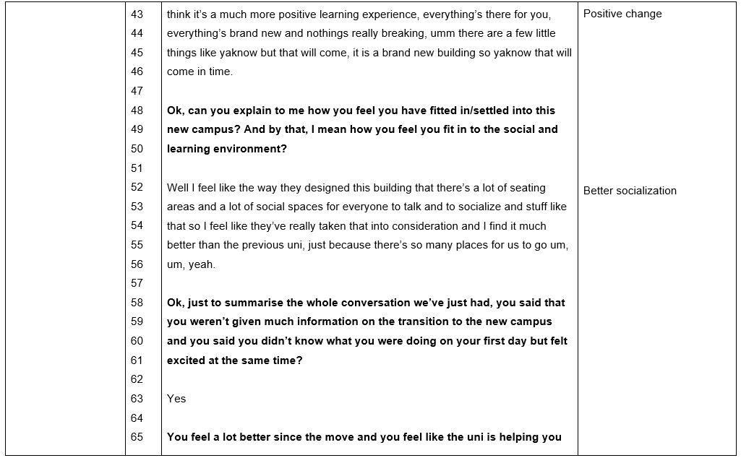
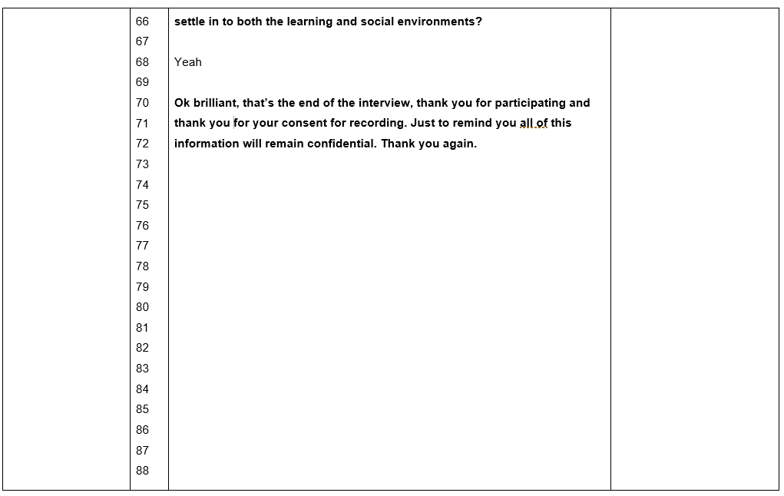

- Interview with Naomi
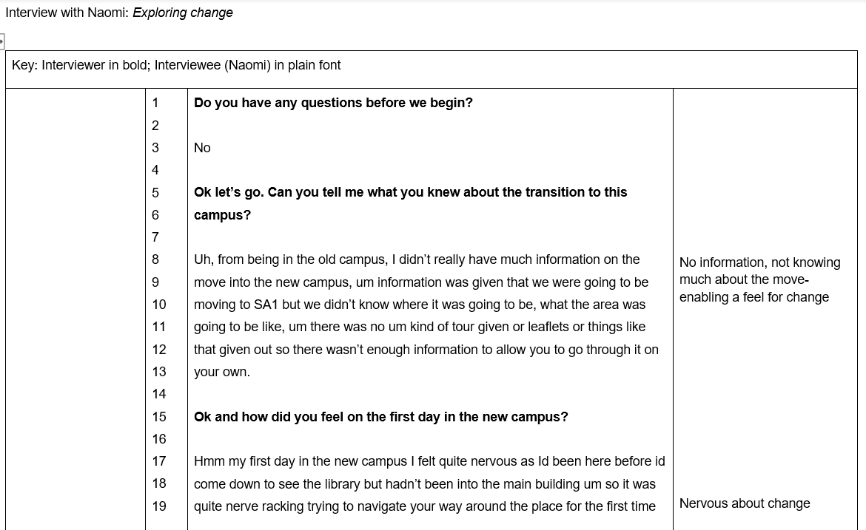

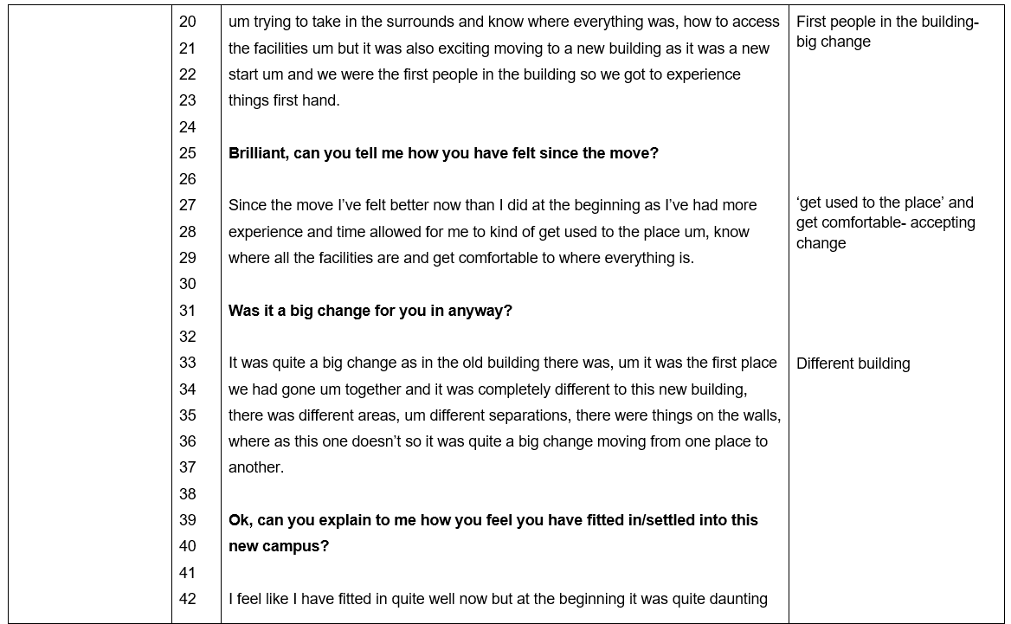
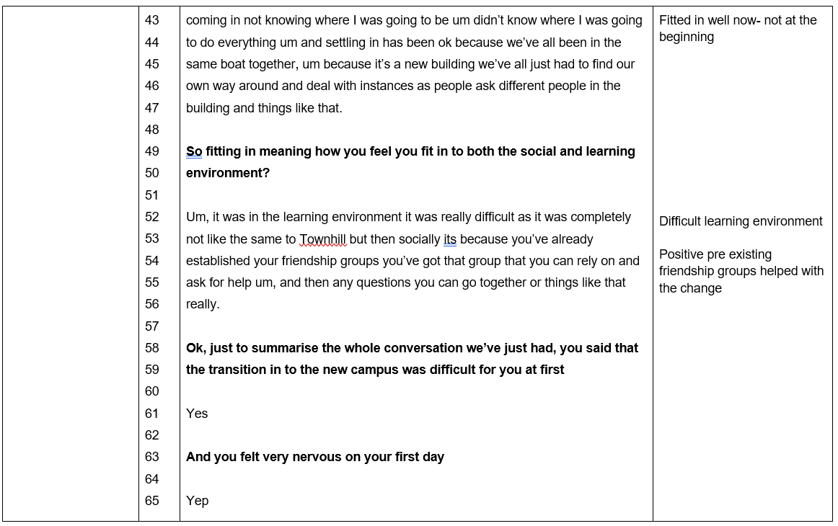
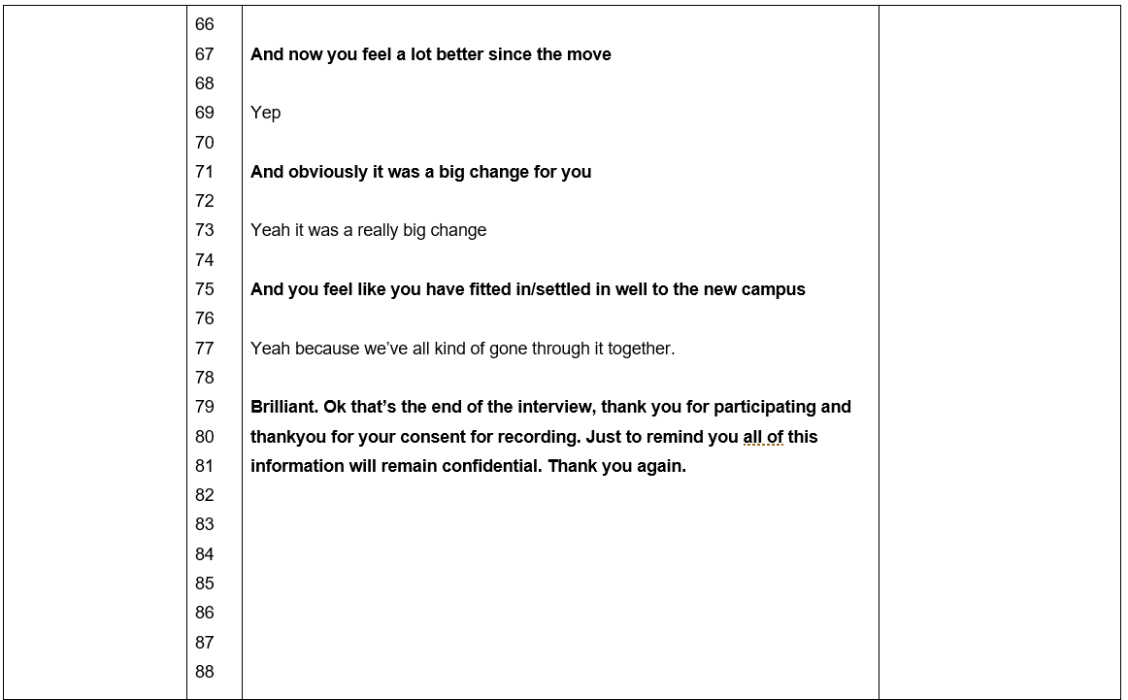

D- Consent form

E- Debrief form

F. Transcript questions


