Student Name: Vlad-Constantin Timpau

Student ID: 2208334

Title: An analysis of the impact of the introduction of Uber into the UK and its impact on traditional Hackney Carriage Drivers

Module Name: Independent Project

Module Code: BMSW6009

DEGREE TITLE: BA (Hons) Developing Leadership and Management

YEAR: 2025
Declaration
This work has not previously been accepted in substance for any degree and is not being concurrently submitted in candidature for any degree
Signed……Vlad-Constantin Timpau……… Date…07.07.2025……………………………………
STATEMENT 1
This dissertation is being submitted in partial fulfilment of the requirements for the degree of BA.
Signed… Vlad-Constantin Timpau ……… Date…07.07.2025…………………………………
STATEMENT 2
This dissertation is the result of my own independent work/investigation, except where otherwise stated. Other sources are acknowledged by footnotes giving explicit references. A bibliography is appended.
Signed…… Vlad-Constantin Timpau Date…07.07.2025………………………………
STATEMENT 3
I hereby give consent for my dissertation, if accepted, to be available for photocopying and for interlibrary loan, and for the title and summary to be made available to outside organisations.
Signed…… Vlad-Constantin Timpau ……… Date……07.07.2025…………………
STATEMENT 4
I hereby give consent for my dissertation, if accepted, to be available on the university’s IT system to those who have consent to use the system.
Signed… Vlad-Constantin Timpau …… Date……07.07.2025…………………………………

Acknowledgement
I sincerely thank my supervisor for their invaluable guidance and support throughout this dissertation. I also extend my gratitude to my family (especially my mother) and friends for their encouragement and patience. Special thanks to all participants and academic staff whose contributions and insights made this research possible and meaningful

Abstract
The research has shed light on the topic that is based on analysing the impact of the introduction of Uber into the UK and its impact on traditional Hackney Carriage Drivers. To learn what affects hackney drivers every day because of Uber’s algorithmic processes, high-demand pricing and open entry in the platform, this study aims to identify points where the two sectors can compromise or reform regulations. Therefore, it is quite important to conduct this research. In the case of the impacts of Uber on Hackney Carriage, it can be observed that increased competition, technological disadvantages, increasing automation and resistance to adaptation can have a negative impact on the latter quite significantly. A semi-structured interview method was followed to gather valuable information in addressing the concern of this study. NVivo soft has been used to analyse the interview data. To foster genuine collaboration, Uber could improve the initiative by providing organised on-boarding programs, promotional rewards, and guaranteeing continuous drier assistance and training that would promote greater participation from conventional Hackney driver.

Table of Contents
Chapter 1: Introduction 6
1.1 Research Background 6
1.2 Research aim, objectives and questions 7
1.3 Research rationale 7
1.4 Research significance 8
Chapter 2: Literature Review 9
2.1. Introduction 9
2.2. Concept of gig economy and Uber in the United Kingdom 9
2.3. Impacts of the gig economy in the United Kingdom with a special reference to ride-sharing applications 9
2.3.1. Flexibility and accessibility for both workers and consumers 9
2.3.2. Lack of worker rights and permanent status in employment 10
2.3.3. Economic as well as social implications for freelancers 10
2.4. Impact of Uber on Hackney Carriage drivers in the United Kingdom 11
2.4.1. Increasing competition in the market 11
2.4.2. Technological disadvantages 11
2.4.3. Disparities in regulations 12
2.4.4. Decline in the number of drivers as a result of automation 12
2.4.5. Resistance in adaptation 13
2.4.6. Perception of the public 14
2.5. Steps to integrate Uber in local markets of the United Kingdom with co-existence with the traditional Hackney Carriage services 14
2.5.1. Encouraging collaboration as well as interoperability 14
2.5.2. Promotion of technological adoption 15
2.5.3. Personalised and differentiated services 15
2.5.4. Market planning and dialogues 15
2.7. Literature gap 16
2.8. Chapter Summary 16
Chapter 3: Methodology 17
3.1 Introduction 17
3.2 Aims and Objectives 17
3.3 Research Rationale 17
3.4 Research Design 20
3.5 Research Paradigm 21
3.5 Sampling 21
3.6 Data Collection 21
3.7 Data and Analysis 22
3.8 Reliability and Viability 22
3.9 Limitations of the Research 23
3.10 Research Ethics 24
3.11 Summary 24
Chapter 4: Findings and Discussion 26
4.1 Introduction 26
4.2 NVivo Results 26
4.3 Thematic analysis 29
4.3 Discussion 33
4.4 Summary 36
Chapter 5: Conclusion and Recommendations 38
5.1 Conclusion 38
5.2 Recommendations 38
5.3 Future scope 39
5.4 Limitations 39
References 40
Appendices 51
Appendix 1: NVivo outcome 51
Appendix 2: Interview transcript 53

List of figures
Figure 3.1: Uber effect (Source: Colley, 2023) 18
Figure 3.2: Statistics about taxi use in England 19
Figure 3.3: The Impact of Uber Riders 19
Figure 3.4: Saunders Research Onion 20
Figure 4.1: Coding through NVivo 29
Figure 4.2: Coding through NVivo 30
Figure 4.3: Coding through NVivo 31
Figure 4.4: Coding through NVivo 32
Figure 4.5: Coding through NVivo 33
Figure 4.6: Gig economy in the UK 34
Figure 4.7: licensed taxi and private hire vehicles and drivers 35
Figure 4.8: offences by taxi and PHV drivers and operators 36

Chapter 1: Introduction

1.1 Research Background
In the last decade, the swift development of ride-hailing platforms has greatly changed how people travel in different cities. In the United Kingdom, in 2012, Uber introduced a new app-based system that paired passengers with drivers and circumvented parts of the traditional regulations made for governing Hackney Carriage services (Zhang and Xu, 2021). Hackney Carriages (black cabs in London and large UK cities) have always needed licenses, set picking points and had fixed fares, while Uber drivers can go anywhere with flexible rates while being operated under PHV (private hire vehicle) (Zainuddin et al., 2022). Because standards for cab companies are different from traditional taxi services and app-based PHV platforms, however, trade unions, taxi-drivers associations, local government officials could argue about fairness in competition, passenger security and financial stability of taxi-metered services.
To passengers, having fares set by Uber’s algorithm, using a cashless system instead of cash and being able to see where their ride is through GPS was more convenient than hailing taxis (Golub et al., 2022). For a large number of drivers, including those with Hackney Carriage licenses, the platform allowed them to earn without being tied to local taxi ranks or daily plate fees,which means charges associated with renting or leasing a taxi vehicle. At the same time, the independence Uber allowed in its application proved to have challenges. Drivers state that they are losing their old customers, the value of their taxi licenses has decreased, and complaints are not handled in a consistent way by Uber. Along with all the changes, policymakers and transport authorities in cities have to address new ideas while ensuring safety is not compromised, accessibility for disabled passengers continues, and taxi operators are not disadvantaged. For instance, Transport for London has introduced stricter PHV regulations, including English Language Testing, maintaining insurance standards in terms of ensuring safety with Hackney Carriage drivers (Tfl.gov.uk, 2025).
Studies on the gig economy in the UK mainly look at the extensive challenges of ride-hailing, like urban congestion, forms of transport being replaced and changes to emissions (Olayode et al., 2023). Less research has examined how technology-mediated services that bring competition from ride-sharing impact the lives of Hackney Carriage drivers. This means that it is necessary to gain more detailed and adequate information about how the presence of Uber has changed traditional ways of doing business, how drivers’ wages have changed and how local communities view taxis in the UK.

1.2 Research aim, objectives and questions
The aim of conducting this study is to analyse the impact of the introduction of Uber into the UK and its impact on traditional Hackney Carriage Drivers.
Objectives are as follows:
- To carry out a comprehensive literature review of the impact of the gig economy in the UK, with particular reference to ride-sharing apps.
- To conduct a qualitative study in the form of semi-structured interviews with Hackney Carriage drivers across the UK to determine the impact of Uber in Hackney, London.
- To perform a thematic analysis of the interview data using NVivo software.
- To develop practical recommendations for Uber on how to better integrate into local markets where traditional Hackney Carriage services exist.

1.3 Research rationale
What motivates this study is the confluence of factors from academia, practice and policy. Although it has been evidenced that the market share of licensed taxis drops in total after Uber arrived, little has been said about how each taxi driver responds to the competition (Garnham and Stacey, 2022). Talking with drivers in an interview setting often uncovers details about their lives, such as alterations in their community, responses to changes in income and new views on platform work, that are easily missed by large surveys or econometric research. From the Work Info Exchange Report, around 1.5 million Uber Trips and 258 UK drivers reported that gross hourly pay dropped from £22.20 to £19.06 after the implementation of dynamic pricing (Workerinfoexchange, 2025). On the other hand, a study also revealed that Uber drivers working around 70–80 hours a week experience financial anxiety, and sleep in their cars to deal with reduced earnings (Paul, 2025).
Taxi drivers who use traditional methods are still highly present and meaningful in UK culture, mainly in areas outside London, as the rules are not the same as those of TfL (Transport for London) in London (for example, in Manchester or Birmingham). Uber has generated $43.9 billion in revenue in 2024 (Businessofapps, 2025), which indicates significant levels of transformation from traditional Hackney carriage Systems. Hackney Carriages are required by many localities to have accessible vehicles, go through security checks and use fare cards, which the Uber PHV model does not do at all (Bilgin et al., 2023). The number of Hackney Carriage Systems issued in the UK has shown a significant decline over the past decades, with London Licence dropping from 22810, in 2013 to 14470 in 2025 (The Guardian, 2025).

1.4 Research significance
The research is quite important on different fronts. For example, it will provide unique insights for researchers studying digital transformation in regulated markets by looking at the experiences of Hackney Carriage drivers who are commonly overlooked in related studies. The qualitative approach adds focused understanding of aspects like drivers’ needs, the way they see their work and their relationship with the community, which numbers by themselves cannot represent. Examining how drivers all over the UK (London, Manchester, Birmingham and smaller locations) are influenced by the service helps the research to gain more general significance.
Evidence from this study should prepare city councils, TfL and national transport authorities for how Uber and similar PHVs work alongside London’s regulated taxi drivers. It is important for lawmakers in the UK to understand what taxi drivers think as they look at changes in rules, for example, uniform licensing and zero emission fleets, because this helps ensure that the new policies are balanced, useful and meet the expectations of the public (Prince, 2021). Regulations designed with knowledge can make sure the public is safe, London’s black-cab taxis are maintained, and residents have a range of mobility options.

Chapter 2: Literature Review

2.1. Introduction
Literature review is one of the crucial sections of a dissertation where the existing literature regarding the topic is discussed in a critical way. In this section of the research paper, the concept of the gig economy as well as Uber in the United Kingdom will be discussed in an appropriate manner. Moreover, the impact of Uber services on Hackney Carriage drivers will be showcased.

2.2. Concept of gig economy and Uber in the United Kingdom
In a gig economy, people tend to choose freelance jobs which are short-term as well as flexible in nature while compared to that of full-time jobs and permanent employment. According to the viewpoints of Çiğdem (2022), the gig economy consists of freelancers who work temporarily instead of a permanent job. In this case, flexibility and accessibility are the main factors that freelancers search for within a gig economy. It is observed by Younger (2023) that in the United Kingdom, the number of freelancers has increased to more than 4 million as of 2023, who generate an impressive revenue contribution of £278 billion to the UK economy. Therefore, a gig economy has a crucial role to play in enhancing the economic boost for a country quite significantly over the period of time. Considering Uber in the United Kingdom, Kleinman (2025) has reported that the company is planning to launch robotaxis in the streets of the United Kingdom by the mid of 2027. On the other hand, Topham (2025) has mentioned that the Department of Transport is expecting a creation of 38,000 jobs and an increase in the industry's worth to £42bn by 2035 in a simultaneous manner. Therefore, it can be observed that Uber is quite actively operating in the UK market and is looking forward to strengthening its position in the most significant manner in the upcoming days.

2.3. Impacts of the gig economy in the United Kingdom with a special reference to ride-sharing applications

2.3.1. Flexibility and accessibility for both workers and consumers
As far as flexibility for workers is concerned, the gig economy provides unparalleled flexibility for freelancers compared to those who are engaged in permanent jobs. In the words of Alvarez de la Vega et al. (2023), the gig economy can provide unparalleled flexibility for freelancers. Therefore, it can be observed that the chances of maintaining a proper balance between personal and professional lives also increase as far as freelancers are concerned. In this regard, the findings of Rusilowati (2022) have opined that flexibility in work can help in maintaining work-life balance for employees. In that case, the levels of productivity and performance levels of the freelancers also enhance, which further contributes to the overall economy quite significantly in the long run. Apart from the freelance workers, the gig economy also offers some flexibility for the consumers, which further ensures convenience in the long run. As per the viewpoints of Allon et al. (2023), a gig economy can be quite effective in increasing flexibility for consumers, which results in convenience. Considering riding experiences for the consumers, it can be observed that Uber can provide a more convenient experience compared to that of traditional taxi services.

2.3.2. Lack of worker rights and permanent status in employment
One of the major negative impacts of a gig economy is that it lacks worker rights as freelancers are considered independent contractors instead of employees. As per the viewpoints of Chaisse and Banik (2021), the gig economy can be quite consequential for freelancers as it lacks worker rights. Since the freelancers are not permanent workers, they cannot be considered under various government schemes such as minimum wage, paid sick leaves, pension schemes and paid holidays. Therefore, it can be observed that there can be certain evidence of work-related insecurities as well as anxieties among freelancers as a result of the above-mentioned consequences. As per the reports by Liversedge (2021), the Supreme Court of the United Kingdom has ruled a landmark decision where Uber will have to provide worker status for each one of its drivers instead of self-employed contractors. On the other hand, Euractive (2021) has also reported that Uber drivers have been provided with worker status in the United Kingdom, which means they will come under the Minimum Wage Act 1998.Hence, it can be observed that freelancers in the gig economy do have a significant chance of getting deprived of their rights as they are mostly considered self-employed contractors by the employers.

2.3.3. Economic as well as social implications for freelancers
Economic and social implications are also quite concerning for freelancers in a gig economy, where they have an unstable income. According to the opinions of Ali (2023), the on-demand nature of gig freelancers can lead to fluctuating income levels. Such a situation can certainly lead to a situation where the gig workers or freelancers will have unstable income, hence generating societal as well as economic disparities in the long run. On the other hand, a gig economy can also create a significant number of competitive dynamics in the market, which further can prove to be extremely convenient for the consumers in terms of better accessibility and competitive prices, which are lower in most cases. In this context, Emon (2023) has mentioned that high competition in the market can play a crucial role in lowering the prices of products and services. Considering the environmental concerns in the case of Uber, it can be observed that the number of vehicles will be increased on the streets, which can certainly increase the overall pollution and carbon emissions quite significantly. In this context, the statements by Massar et al. (2021) have state that an increased number of vehicles can enhance carbon emissions in the atmosphere.

2.4. Impact of Uber on Hackney Carriage drivers in the United Kingdom

2.4.1. Increasing competition in the market
The entrance of Uber into the UK transportation sector has heightened competition for Hackney Carriage drivers, resulting in lower fares and diminished income (Vickers et al., 2020). The pricing strategy of Uber, supported by its reduced costs and adaptable labour force, has drawn a large segment of the clientele looking for cost-effectiveness and ease. For example, in Darlington, local Hackney Carriage drivers voiced worries about being “overwhelmed” by Uber drivers, fearing that the surge would jeopardise their business sustainability (Edgar, 2024). Likewise, in Peterborough, conventional black cab drivers noted a drop in passengers as Uber drivers functioned at the train station of the city without pre-arranged fares, effectively luring away customers (Briggs, 2025). These examples demonstrate the way the pricing tactics, as well as the operational methods of Uber, have resulted in decreased ridership and income for numerous Hackney Carriage drivers.

2.4.2. Technological disadvantages
In the UK, Hackney Carriage drivers have traditionally been slower to embrace digital technologies in comparison to ride-hailing services such as Uber, resulting in a competitive disadvantage (Richardson, 2024; Elbaum and Whittaker, 2018). While Uber’s app provides effortless booking, live tracking, and cashless transactions, numerous conventional taxis continue to depend on phone reservations and street flags (Angrist et al., 2021). A 2024 survey indicates that about 81% of taxi drivers in the UK currently utilise booking or ride-hailing apps, although the rate of adoption differs across regions, with certain areas falling behind (Ground Transport Group, 2025). The gap in technology usage has created obstacles for Hackney Carriages. For example, in London, more than 80% of private hire taxi reservations are done through apps, showcasing the transition to digital-first transportation, conventional taxis that fail to adopt these technologies may lose clients who favour the ease and effectiveness of app-driven services (Bio Ideas, 2025). Moreover, the emergence of self-driving cars presents another obstacle. Uber intends to introduce self-driving taxis in London by spring 2026, representing a major advancement towards completely autonomous transport (Topham, 2025). Hackney Carriages, many of which still function with little digital integration, might face growing challenges in a fast-changing technological environment.

2.4.3. Disparities in regulations
Taxi drivers in the UK, especially in London, adhere to some of the strictest regulations globally. These consist of elevated licensing costs, extensive insurance, and the well-known demanding “knowledge of London” exam, which requires years to finish (Topham, 2025). In comparison, Uber drivers do not have to take the London “Knowledge” Test that consists of memorising various landmarks and streets (Siddiqui, 2016). Lack of regulatory focus on Uber drivers has caused significant frustration for black cab drivers, who claim that Uber has been permitted to function under a much more relaxed system (Davies, 2022; Perraudin, 2017; Makortoff, 2025). In May 2024, over 10,500 London black cab drivers initiated a £250 million lawsuit against Uber, claiming that the firm deceived TfL regarding its service operations from 2012 to 2018 (Makortoff, 2025). The assertion states that the method of Uber enabled them to circumvent booking rules, giving them an unequal edge that harmed the conventional taxi industry and resulted in considerable income loss for drivers.

2.4.4. Decline in the number of drivers as a result of automation
The count of licensed Hackney Carriage drivers in London has notably decreased following the entry of automation-driven ride-hailing services such as Uber into the UK market in 2012. TfL reports that the overall count of licensed black cabs fell from 22,810 in 2013-14 to only 14,470 by the close of 2023-24, a reduction of over one-third in 10 years. Additionally, just 104 new licenses were issued in 2024, underscoring the sector’s difficulty in drawing in new drivers (Topham, 2025). This drop is intricately connected to the surge of app-driven automation, as firms such as Uber utilise algorithmic matching, dynamic pricing, and real-time availability to provide a smooth customer experience, an aspect traditional taxis, limited by outdated systems and the Knowledge test, have failed to replicate (Scammell, 2018). Although services such as Gett and Free Now aimed at innovating the black cab industry, their acceptance has varied, with indications that numerous black cab drivers continue to favour street hails instead of app reservations. The proposal by Uber to encourage black cab drivers to join its platform faced significant opposition, as the Licensed Taxi Drivers’ Association dismissed the initiative, highlighting entrenched mistrust and worries over competition (Sky News, 2023; Minipip, 2023). This hesitation to interact with automated platforms obstructs the full capacity of the industry to modernise.

2.4.5. Resistance in adaptation
In reaction to the challenge from Uber, numerous Hackney Carriage firms have implemented substantial changes to stay pertinent in the changing transport scene in London. For instance, Goldline Cars, a private hire firm in East London, collaborated with 12 other local businesses in order to create the iGo platform, facilitating shared bookings and enhanced efficiency (Katwala, 2019). This partnership enables local businesses to compete more efficiently, especially in regions where Uber’s influence is weaker in certain locations as it does not have a full license (Young, 2025). Moreover, certain conventional taxi companies have launched their own mobile apps, providing functionalities like live tracking and cashless transactions to improve customer ease (Taxi Insurer, 2023). Even with these endeavours, difficulties remain. The size and technologies advancements of worldwide platforms such as Uber pose substantial challenges for local businesses. The large user network and sophisticated algorithms of Uber for predicting demand and adjusting prices provide a competitive advantage that smaller firms find hard to emulate, as a result, although adaptation initiatives are admirable, they frequently do not equate to the abilities of major players such as Uber (Richardson, 2025).

2.4.6. Perception of the public
Public opinion significantly influences the rivalry between Hackney Carriages and ride-hailing platforms such as Uber. Hackney Carriages are seen as a dependable and classic element of the transportation network of London. On the other hand, Uber offers a contemporary and user-friendly option that attracts a wide range of uses (Lee et al., 2021). A YouGov poll revealed that 62% of London residents think that vehicles utilising apps such as Uber should adhere to the same regulations as black cabs, emphasising worries about safety and equity (Dahlgreen, 2014). This viewpoint highlights the public opinion regarding equal regulatory standards across the board, Nonetheless, the attractiveness of Uber stems from its easy-to-use interface, competitive rates, and perceived convenience that have attracted a significant number of consumers, the differing views, classic dependability compared to contemporary ease, showcases the varied choices of consumers such as London’s travellers (Biswas, 2023). As the transportation environment keeps changing, public opinion will stay a crucial element affecting the interaction between conventional and ride-hailing services.

2.5. Steps to integrate Uber in local markets of the United Kingdom with co-existence with the traditional Hackney Carriage services

2.5.1. Encouraging collaboration as well as interoperability
Shared infrastructure is one of the factors that can ensure collaboration between Uber drivers and Hackney Carriage drivers in the long run. In the words of Nezami et al. (2022), shared infrastructure is one of the main factors that can promote collaboration among workers. On the other hand, the findings of Chinangkulpiwat et al. (2023) have stated that the integration of platforms can enhance communication levels among workers and employees. In this regard, integration of platforms is also another factor that can help in building collaboration through the means of effective communication. Although Uber has partnered with black cab drivers in 2023, participation from drivers has been minimal as it is noted that only a few hundred registered from about 10,000 qualifying drivers (Sky News, 2023; Minipip, 2023). This indicates that although shared infrastructure and platform integration show potential, simple accessibility does not ensure involvement.

2.5.2. Promotion of technological adoption
Technological adoption is also another crucial factor that needs to be ensured in the case of Hackney Carriage so that it can compete with the technological advancements done by Uber while operating in the United Kingdom. In this context, the opinions of Usai et al. (2021) have argued that technological adoption can enhance the performance levels quite significantly. On a positive note, there is also a need for enhancing digital literacy among the drivers so that they can adjust with the changing working experience and derive the best possible performance and outcomes in the long run. The findings of Hussain and Phulpoto (2024) have stated that enhancing digital literacy can increase awareness about the usage of technologies. Hence, the chances of performance enhancement will be increased quite significantly.

2.5.3. Personalised and differentiated services
Personalised as well as differentiated services for the consumers is another crucial step that can be implemented in order to attract the customers towards both Uber as well as Hackney Carriage. In this regard, Famoti et al. (2024) have mentioned that personalised services can help in satisfying the needs and expectations of the consumers. On the contrary, Darmawan and Grenier (2021) have argued that differentiated services can increase competition in the market. Therefore, it can be stated that this strategy will prove to be quite effective in terms of maintaining a proper competitive balance in the UK market.

2.5.4. Market planning and dialogues
In this case, enhancing the communication levels with the consumers can be the most appropriate strategy that the management of both Uber and Hackney Carriage needs to follow. This factor will certainly help both the organisations to understand the needs and demands of the consumers in the market and take appropriate actions for fulfilling the same. In this regard, the statements of Madanchian et al. (2022) have claimed that effective communication can help in understanding the needs and requirements of the consumers. In that case, earning their trust and loyalty will also become easier quite extensively.

2.7. Literature gap
The current literature addresses various themes related to the gig economy such as Uber’s growth in the UK, the flexibility it provides, worker risks, and its wider socio-economic effects, yet some significant gaps persists. Although the impact of Uber on conventional transportation services, especially black cabs, has been analysed, there is a lack of research that critically links that disruption to technological shortcomings and the reduction of the workforce among Hackney Carriage drivers due to automation. Additionally, while the differences in regulations between Uber and conventional taxis are recognised. Certain studies on the way these variations affect market competition and driver behaviour are still limited. Furthermore, many studies consider the gradual rate of technology acceptance among black cab drivers as a minor issue instead of analysing it’s as a main structural obstacle to their competitiveness.

2.8. Chapter Summary
From the above section, it can be concluded that a gig economy can be both advantageous as well as consequential for workers. Considering the advantages, flexibility and a proper work life balance can be mentioned which further enhances the overall engagement and performance levels of the workers. Taking the disadvantages into consideration, unstable income levels and lack of permanent status is a mentionable one. Considering the steps of ensuring co-existence of both Uber and Hackney Carriage in the United Kingdom, collaboration and interoperability, technological adoption, personalised and differentiated services as well as marketing planning dialogues can prove to be quite effective and beneficial by every means.

Chapter 3: Methodology

3.1 Introduction
Research methodology includes data gathering, analysis and interpretation procedures. It ensures a methodical, ethical investigation to answer research questions and goals. This chapter describes the research methodology used to assess how Uber’s UK launch affected Hackney Carriage drivers. The research uses a qualitative, interpretivist method to explore Hackney Carriage drivers lived experiences and socio-economic implications when Uber entered the UK transportation sector. To ensure openness and academic rigour, this chapter examines study dependability, ethics and constraints. It protects participant rights and data integrity throughout the research.

3.2 Aims and Objectives
The aim of conducting this study is to analyse the impact of the introduction of Uber into the UK and its impact on traditional Hackney Carriage Drivers.
Objectives are as follows:
- To carry out a comprehensive literature review of the impact of the gig economy in the UK, with particular reference to ride-sharing apps.
- To conduct a qualitative study in the form of semi-structured interviews with Hackney Carriage drivers across the UK to determine the impact of Uber in their locality.
- To perform a thematic analysis of the interview data using NVivo software.
- To develop practical recommendations for Uber on how to better integrate into local markets where traditional Hackney Carriage services exist.

3.3 Research Rationale
Uber’s arrival in the UK has affected the taxi business, especially Hackney Carriage (HC) drivers. Uber’s arrival has changed the operating environment for black taxi drivers that affecting legal, economic and customer behaviour dynamics.
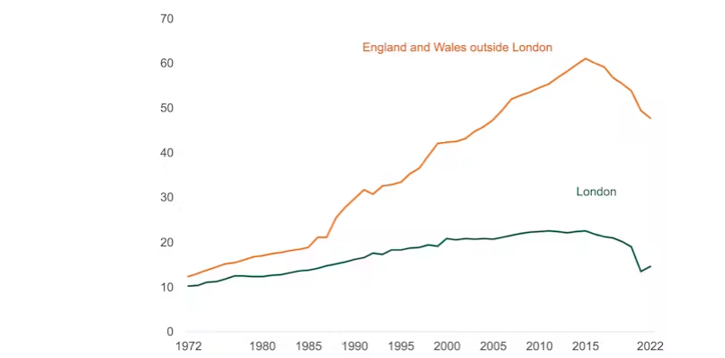

Figure 3.1: Uber effect
(Source: Colley, 2023)
According to Colley (2023), Uber’s growth has received mixed reviews. Uber has offered partnerships to black taxis in places like London, but trade groups representing these drivers have rejected them because of price inconsistencies, decreased kerb hailing demand and slower response times. In London, 45,000 Uber vehicles outnumber 15,000 black taxis, highlighting an unfair competition climate.

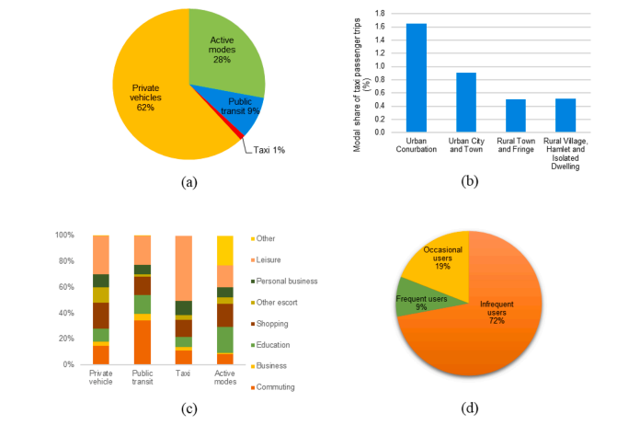

Figure 3.2: Statistics about taxi use in England
(Source:‌ Bilgin et al., 2023)
Bilgin et al. (2023) highlight regulatory gaps; unlike Private Hire Vehicles (PHVs), local administrations and Transport for London (TfL) enforce tougher licensing and tariff limits on HCs. These regulatory anomalies have created an unequal playing field that harms conventional taxis.
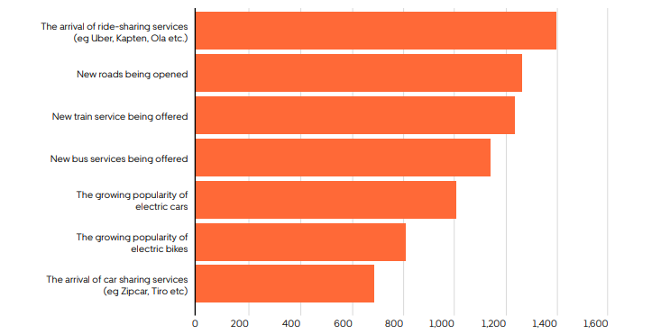

Figure 3.3: The Impact of Uber Riders
(Source:‌ Cloudfront, 2023 )
Uber serves 60% of the UK population in 40 cities, according to Cloudfront (2023). A Public First study found that 28% of people used Uber in the last year, mainly under-35s. Additionally, 49% of passengers use Uber at least once a month and 81% many times a year, which indicates a consumer shift toward app-based transport. This study will examine whether conventional Hackney Carriage services can survive increased competition and changing customer preferences.
Research Onion
Saunders’ Research Onion framework provides understanding of the research process as a starting point and guides to justify each of the processes (Seuring et al. 2021). In this study, research onion guided to deal with research philosophies, approaches, designs and sampling techniques including data collection and analysis to achieve the objectives of this research.
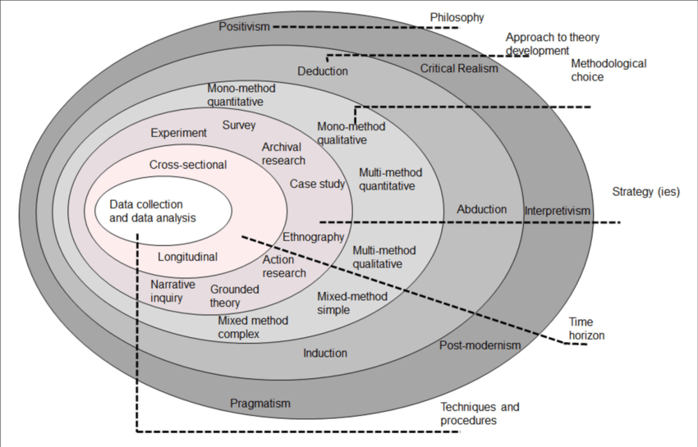

Figure 3.4: Saunders Research Onion
(Source: Seuring et al. 2021)

3.4 Research Design
This research adopted an exploratory research design in regard to investigating the impact of Uber’s introduction into the UK on traditional Hackney Carriage drivers. As explained by Casula et al. (2021), exploratory research design provides working hypotheses as flexible and leadto coherence across the steps in the research process. In this aspect, the influence of Uber on livelihood, customer base and regulatory environment has been critically explained with explanatory design. Additionally, exploratory design is also insightful in the context of comprehending underlying patterns, behaviours and outcomes by developing themes.
With which, the interpretation of primary data guides to drawing of meaningful conclusions from understanding of patterns that show the strength of this approach. Use of primary qualitative data guides to include the exploratory design that helped in highlighting the complex interactions between digital disruptions and traditional transport systems. Unlike explanatory design, exploratory design provides conceptual understanding of the existing patterns from the human participants (Sharma et al. 2023). Therefore, this study has gained a meaningful understanding of the research context and corresponding phenomena before technological innovations that symbolise the impact of Uber on the transport system.

3.5 Research Paradigm
Research paradigm is defined as a set of common beliefs, values and assumptions that guides how a research is conducted within a specific field (Omodan, 2024). This research integrated the interpretivism paradigm, which relies on subjective interpretations and perceptions of those affected by the introduction of Uber, shifting the UK's traditional hackney carriage systems. In this aspect, interpretivism is immensely suitable for exploring how drivers interpret strategic changes with respect to the economic conditions, customer interactions and maintenance of professional identity. Unlike the positivism paradigm, interpretivism allowed for nuanced exploration of real-time experiences through primary qualitative analysis and consideration of epistemological approach (Tanweer et al. 2021). With which, this research has gained meaningful insights on socio-economic impacts and drivers of emotional responses that helped in capturing human aspects oriented to technological disruption in public transportation systems.

3.5 Sampling
Purposive sampling method has been considered into this research that helped in collecting rich data by forming the research questions. In case of conducting an interview, purposive sampling is effective in selecting participants based on specific characters to get valid findings to the study questions (Nyimbili and Nyimbili, 2024). With which, 3 traditional Hackney carriage drivers have been selected for this study to gain meaningful information based on the impact of introducing Uber.

3.6 Data Collection
This research extensively relied on primary qualitative data collection through selecting human participants as sample to gain understanding of the impact of Uber on UK traditional hackney carriage systems. For this, a semi-structured interview method has followed to gather valuable information in addressing the concern of this study. In this regard, traditional Hackney Carriage Drivers have been selected for interviews to gather valuable information regarding their perception on introducing Uber. As studied by Bouchrika (2025), primary data collection is feasible for ensuring contextual understanding from human participants and ensures first-hand approach. In case of primary qualitative data visualisation, NVivo software has been used that helped in the facilitation of thematic coding, data categorisation and recognition of patterns within the large volumes of unstructured datasets (Kraiwanit et al. 2023). Additionally, NVivo software is effective in finding authentic and recently published sources, which are guided to include current trends based on data on the impact of the Introduction of Uber in the UK traditional hackney carriage systems. With this, this research study has gained appropriate source selection to present logical findings to draw conclusions in terms of addressing research questions.

3.7 Data and Analysis
Primary Quality data collected via interview has been analysed developing the interview transcript. Interview transcript is useful for identifying similarities in participants' response and oppositional prospects also to address the research questions effectively. Additionally, the thematic analysis method has been integrated into this research to analyse qualitative data and develop themes. Supporting this, Morgan (2022) highlighted that the thematic analysis method involves using specific approaches associated with a completely qualitative paradigm. In this research, thematic analysis entailed the identification of similar patterns and trends to evaluate the impact of the introduction of Uber on traditional hackney carriage systems in the UK. This study intensified the effectiveness of Uber with existing study-based knowledge, aligning theoretical insights effectively with thematic analysis.
This research included qualitative data from traditional Hackney carriage drivers. NVivo software helped code and categorise unstructured data as the data revealed economic displacement, regulatory imbalance and changing consumer preferences (Bouchrika, 2025). Uber’s app-based convenience, variable pricing and ubiquitous availability have reduced hackney carriage drivers’ client base and revenue. Traditional cab drivers were dissatisfied with unfair competition and inconsistent regulatory enforcement, according to an NVivo study. Customers favoured Uber owing to the convenience of booking, digital payment options and reduced rates. NVivo thematic maps showed Hackney Carriage drivers worried about emotional stress, professional identity loss and local authority trust. The data shows that Uber’s disruptive approach has changed taxi operations and driver livelihoods. The findings highlight the need for regulatory changes and platform responsibility to promote fair competition and sustainable transport technology integration.

3.8 Reliability and Viability
Reliability
The research draws on extensive secondary data from credible sources such as academic studies, industry reports and economic analyses. For example, empirical studies on ridesourcing impacts in England and Wales provide robust quantitative data on market changes (Bilgin et al., 2023). As they offer nuanced insights into income shifts and employment patterns among traditional taxi drivers and Uber drivers that show consistent findings of around a 10% income decline for traditional drivers alongside growth in self-employed drivers (‌Gaskell, 2018). Uber’s own UK impact reports and independent economic assessments show consistent trends of increased market size, flexible work opportunities and economic contributions worth billions of pounds (‌Foord, 2023). The convergence of findings across independent academic research, media analysis and industry data supports internal consistency and stability of the research effectiveness (‌Zego, 2025).
Viability
The topic is feasible as the data sources are reliable and widely reachable, which allows for confirmation and repetition. The research uses longitudinal and cross-sectional information, taking variations over time since Uber’s introduction that improve chronological steadiness (‌Zhong et al., 2022). Studies employ a consistent system of measurement, such as driver wages, employment numbers and marketplace segments that safeguard comparability across datasets and observers. Furthermore, the topic discourses a noteworthy socio-economic issue with applied significance for politicians, drivers and customers, ensuring sustained attention and data obtainability (Berger et al., 2018).
For instance, the multifaceted subtleties between Uber and outdated taxis involve factors like supervisory variations, driver cataloguing and market development that may not be completely apprehended in all datasets. Overall, the research topic is both dependable and feasible due to the dependable and stable secondary data foundations, internal consistency of findings across numerous spectators and the applied implication of the issue (Mcgregor et al., 2024). The meeting of indications from diverse, credible studies provides a robust examination of Uber’s impact on traditional Hackney Carriage drivers in the UK.

3.9 Limitations of the Research
This study aims to examine Uber’s influence on UK Hackney Carriage drivers; however, it has noteworthy disadvantages. As the research depends meaningfully on primary qualitative data, which may not sufficiently depict Hackney Carriage drivers’ real and lived experiences due to avoiding use of statistical data. Thus, new tendencies and outlooks may be ignored. On the other hand, thematic analysis improves data organisation to meet the objectives. Without relying on secondary data, the study lacks direct connection with the impacted persons, which may limit emotional and socio-cultural insights.
Due to its UK emphasis, the report may also overlook regional variances in how Uber has influenced local taxi markets. Statistically valid assertions are likewise limited by excluding exploratory quantitative data (Skok and Baker, 2018). Finally, time restrictions limited data gathering and analysis. Despite these limitations, the research sheds light on the complicated relationship between digital disruption and conventional transport services.

3.10 Research Ethics
The research follows the UK Data Protection Act 2018 and GDPR principles, including lawfulness, purpose restriction, data minimisation, accuracy, storage limitation, integrity and confidentiality, to protect participant information (Brookes.ac.uk, 2021). Hackney drivers were notified through a participant information sheet that the study’s main objective is to investigate Uber’s influence on their profession. The privacy notice clarified the legal basis for data processing, retention term (deleted within 6 months post-analysis), data controller and participant rights (access, correction, withdrawal). Consent forms required participants to acknowledge their comprehension and willingness to participate, with the ability to leave before the data anonymisation procedure and before analysis.
No other parties accessed all interview recordings and transcripts, which are encrypted and password-protected on a secure university server. No other parties have access to and reporting of special category information, such as socio-economic situations that are anonymised or censored to maintain confidentiality (Brookes.ac.uk, 2021). Six months after publishing, transcripts will be safely removed. A data management strategy assures academic governance-compliant erasure (‌Sklar and Crescioni, 2019). There were no conflicts of interest and no sponsorship or recruiting services impacted data collection or access. These safeguards guarantee the research respects participants’ autonomy, confidentiality, legal rights and academic integrity.

3.11 Summary
It is concluded that this research examines how Uber’s UK launch affected Traditional Hackney Carriage (HC) drivers. Uber’s effects on the transportation business, including economic issues, consumer preferences and regulation differences for HC drivers, will be examined. The goals are to research the gig economy literature, conduct semi-structured interviews with HC drivers and use thematically analyse the data to provide Uber’s local market integration suggestions. An explanatory study was used to examine Uber’s operations and HC drivers’ livelihoods. Thematic analysis utilising software for pattern recognition and coding was based on reliable secondary literature. As considering both empirical and subjective implications, the research provides a balanced perspective and strategic solutions to connect ride-sharing platforms and conventional taxi services.

Chapter 4: Findings and Discussion

4.1 Introduction
This chapter examines how Uber and other gig economy platforms impact the UK's transport system. It examines changing employment markets, consumer expectations and regulatory frameworks, using literature and interviews with Hackney Carriage drivers. The NVivo result is analysed, as well as interview responses are assessed, so that it will not be an issue to meet the research questions in a depth manner.

4.2 NVivo Results
Qualitative data analysis (QDA) software like NVivo analyses interviews, focus groups and open-ended survey results. NVivo helps researchers understand complicated tales by identifying repeating themes, patterns and linkages in qualitative data. NVivo was used to analyse Hackney Carriage driver’s interviews on Uber’s impact on the transport business.
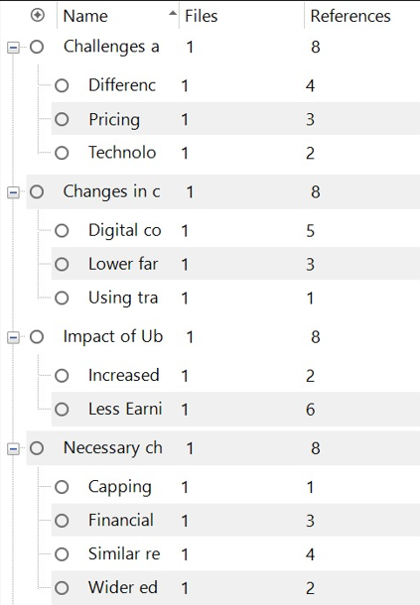
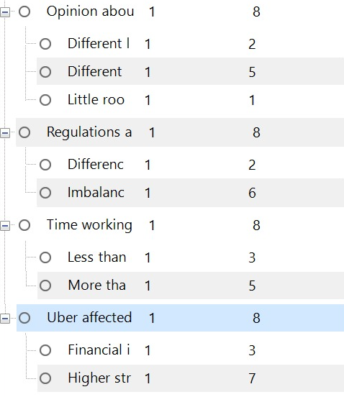
The NVivo analysis found multiple transcript themes as the subject was “Challenges and barriers while competing with Uber Drivers” with 8 references citing regulatory discrepancies (4), price concerns (3) and technology inefficiencies (2). Since Uber (8), drivers noted changes in client behaviour, notably regarding its digital ease (5) and reduced rates (3), with many remarking that conventional taxis are now only utilised when necessary (1). Uber’s influence on daily wages was another key issue, mentioned 8 times. Dissatisfaction resulted from longer hours (2) and lower pay (6) and drivers demanded a limit on Uber drivers (1), financial and technical help (3) and equivalent laws (4). Eight references raised issues about Uber’s license, price and lack of human connection. Finally, disparities in laws and licensing (8) and work satisfaction owing to financial uncertainty (3) and more stress (7) were major difficulties. This NVivo-based thematic analysis shows how Uber has changed taxi operations and driver experiences.
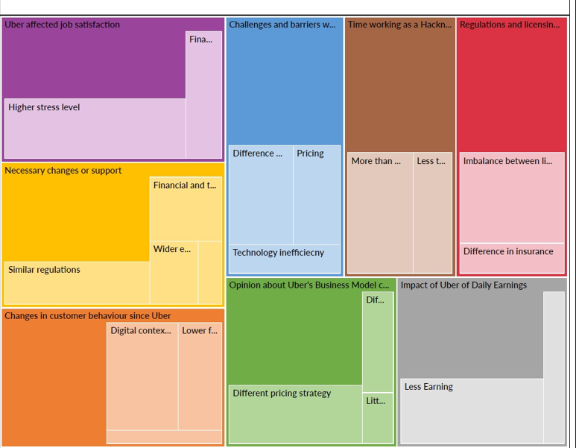

Figure 4.1: Coding through NVivo
(Source: Self-created)
Through the NVivo software, the coding has been developed.

4.3 Thematic analysis
4.3.1 Theme 1: The Emergence of Uber has created issues for the growth of Hackney Carriage
Hackney Carriage services have suffered from Uber’s dominance in the ride-hailing business. Due to its affordability, real-time monitoring, transparent pricing and reduced wait times, Uber’s primary business model that connects customers and drivers through a seamless smartphone interface has proved popular (Cascade.app, 2023). Hackney Carriage services have struggled to change with technology and customer expectations.

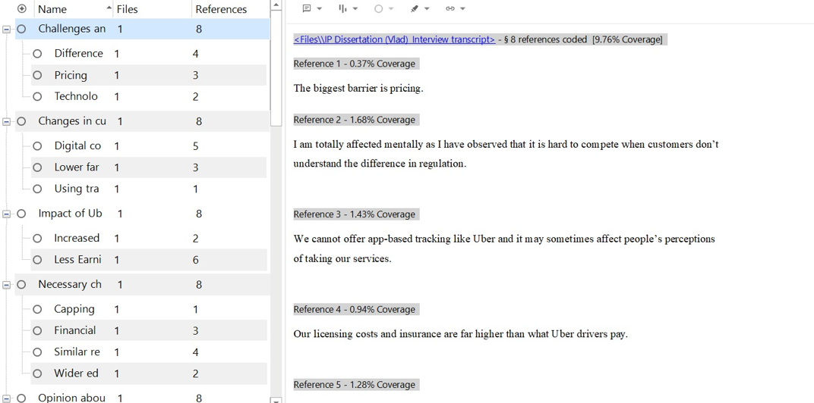

Figure 4.2: Coding through NVivo
(Source: Self-created)
The NVivo-coded interview transcripts provide crucial information. Prices were the largest impediment to competing with Uber in 58 references (9.76% total coverage) (Reference 1 - 0.37% coverage). One participant reported being psychologically impacted. It is impossible to compete when clients do not comprehend the difference in regulation” (Reference 2 - 1.68% coverage), showing how Hackney operators suffer from unawareness of licensing and safety regulations. Overall, Uber has transformed urban transport with technology and flexible pricing but it has also put regulatory and financial demands on Hackney Carriages. ‌Gaskell (2019) agreed that Uber has reduced the number of licensed Hackney carriages and their market share in numerous cities.
4.3.2 Theme 2: Changes in customer behaviour have made the need for necessary changes in Hackney Carriage
The changing expectations of passengers have driven Hackney Carriage service adjustments. NVivo-coded interview transcripts show a movement towards digital ease and affordability in consumer behaviour. According to Reference 1 (0.96% coverage), “People now expect to book a ride with apps, track the ride and pay digitally,” whereas Reference 3 (1.22%) says, “They are expecting lower fares and sometimes complain if we charge standard rates.” These findings highlight a major issue for Hackney Carriage drivers. Hackney Carriage services must adapt to consumer behaviour while preserving safety and accessibility to survive (Techxplore, 2020). This technology divide, together with younger consumer’s growing use of smartphones and ride-hailing applications has made Hackney Carriages seem ineffective. They make 3% of disabled journeys compared to 1% for the general population, highlighting their vital role in accessibility and inclusion (lichfielddc.gov.uk, 2025).
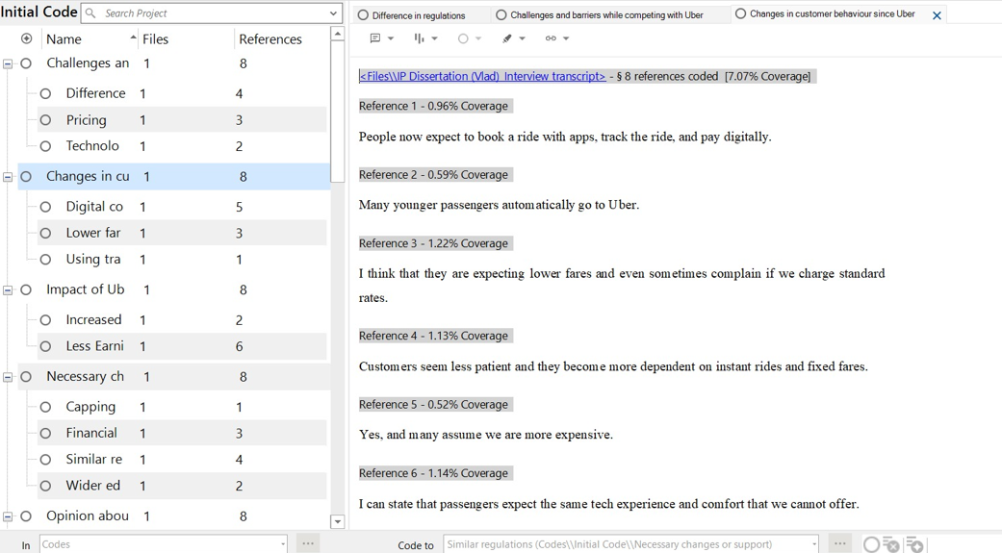

Figure 4.3: Coding through NVivo
(Source: Self-created)
Thus, app-based booking systems, competitive fixed pricing and digital user experience improvements are needed. Local Government Act 1976 allows licensing procedures to include executive or luxury cars, which might update the trade’s image.
4.3.3 Theme 3: Regulations and licensing requirements are less for Uber Drivers compared to Hackney Carriage
Many groups have been concerned about the regulatory gap between Uber and conventional Hackney Carriages. Interview transcripts recorded in NVivo show themes like "Similar regulations (4 references)," "Necessary changes/support (8 references)," and "Uber impact (18 references)". These findings suggest regulatory abnormalities. According to ‌Financialexpress, (2019), Uber drivers should be held to the same safety and training standards.
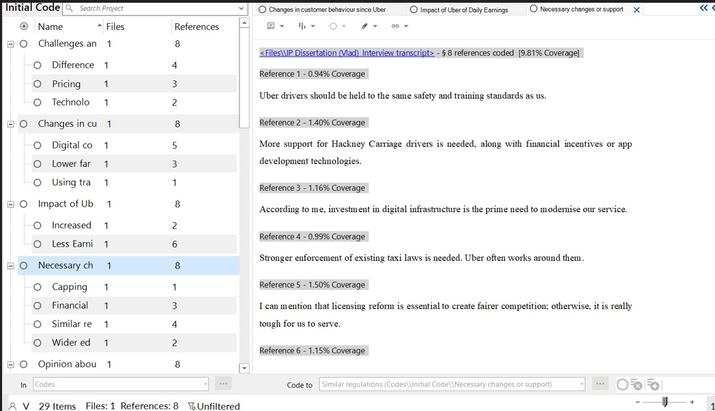

Figure 4.4: Coding through NVivo
(Source: Self-created)
However, most UK states allow Uber to avoid fingerprint-based background checks with name and Social Security verification. A hackney permit requires three in-person appearances and state-level screening for cab drivers. The results emphasise regulatory equivalence as Hackney carriage drivers face tougher, more expensive licensing regulations without universal standards that result in wage inequality and competitive disadvantage.
4.3.4 Theme 4: Job satisfaction of Hackney Carriage drivers are reducing effectively
‌Ntu.ac.uk. (2020) noted that job satisfaction among Hackney Carriage drivers has been dropping owing to economic constraints, increased competition and taxi sector restructuring. Due to an excess of drivers, particularly following Uber’s platform-based strategy, competition for customers has increased and wages have decreased.
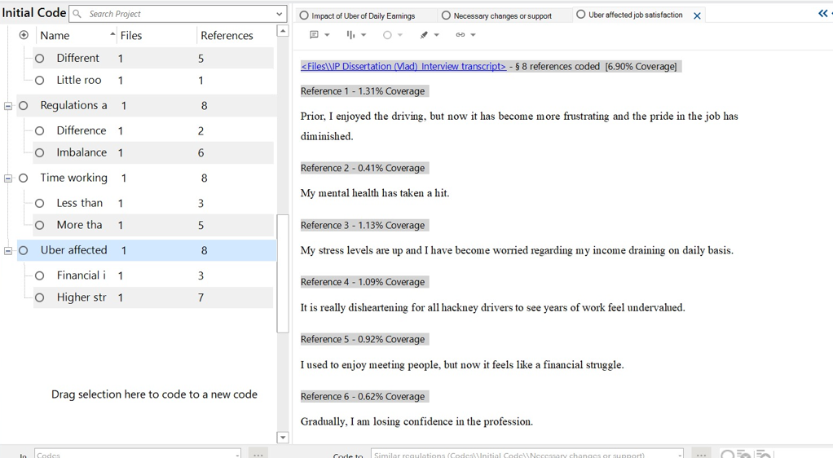

Figure 4.5: Coding through NVivo
(Source: Self-created)
This is supported by NVivo interview transcript analysis. “Uber affected job satisfaction” was found in 8 files with 66 references, indicating broad concern. Reference 3 (1.13%) states, “My stress levels are up and I have become worried regarding my income draining on a daily basis,” indicating a growing mental health burden. These experiences imply that job satisfaction is declining, both economically and in terms of purpose and pride in their work. Hackney drivers’ working conditions are deteriorating owing to self-employment status, expensive vehicle operating expenses and the municipality’s unwillingness to regulate private hire vehicle numbers (Techxplore, 2020). These concerns need rapid governmental adjustments to protect their livelihoods and restore professional dignity.

4.3 Discussion
4.3.1 Impact of the gig economy in the UK, with particular reference to ride-sharing apps
With ride-sharing applications like Uber changing established paradigms, the gig economy has transformed the UK job market. Workers seeking schedule flexibility like the gig economy’s short-term employment commitments (Cropanzano et al., 2023). As per the literature review, this system attracts non-permanent job seekers. As of 2023, almost 4 million drivers contributed £278 billion to the UK economy, according to Younger (2023). In 2017, 4.4% of the workforce (1.36 million) was gig workers but in 2021, 14.7% (4.8 million) were, suggesting a transitory effect in labour (‌Fennell, 2021). This estimates a smaller 1.4% workforce, 464,000 workers and the average of these findings implies 1.7 million UK gig workers in 2024.
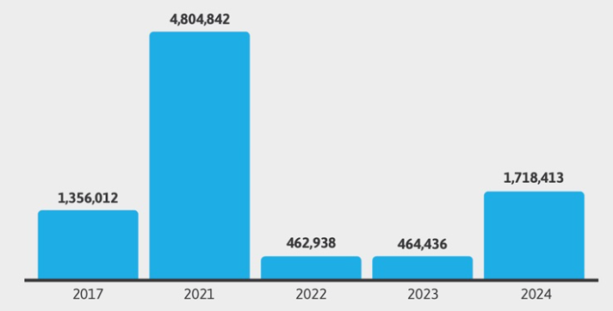

Figure 4.6: Gig economy in the UK
(Source:‌ Fennell, 2021)
Respondent 1 stated that “I have been a Hackney driver for 22 years. I had a collaboration with Uber but before Uber, we had a steady flow of customers”.These demonstrate Uber’s tech-based, low-resolution models of strictly regulated Hackney Carriage services. Respondent 1 also stated that “Of course, People now expect to book a ride with apps, track the ride and pay digitally”. In this regard, they are more regulated and the app-supported gig economy enhances national revenue and employment growth, but also challenges conventional service providers’ income and security.
4.3.2 Impact of Uber in comparison with Hackney Carriage Drivers in the UK market
Uber’s growth in the UK has changed customer expectations and competitive dynamics for Hackney Carriage providers (Cropanzano et al., 2023). Uber provides drivers and riders more freedom, like the gig economy. Drivers of Uber have unrivalled freedom in the gig economy, which helps them combine work and life, according to ‌Berger et al., (2019). As per the literature part, flexible work hours boost productivity. Gig-based services like Uber are more convenient and accessible for customers than taxis, according to Allon et al., (2023).
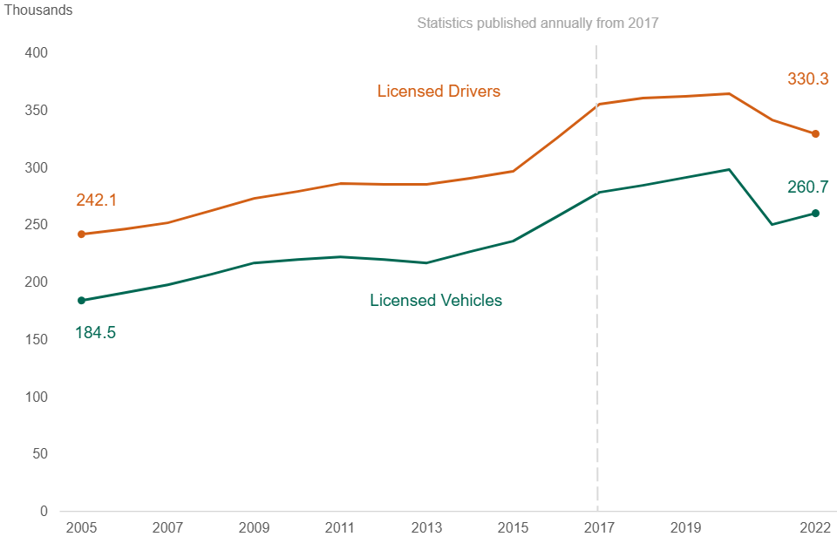

Figure 4.7: licensed taxi and private hire vehicles and drivers
(Source:‌ Gov.uk, 2022)
Gig workers generally lack paid leave and retirement, according to Behl et al., (2022).Uber was ordered by the UK Supreme Court to designate its drivers as workers rather than self-employed contractors, raising legal and ethical issues about gig employment arrangements.Total licensed automobiles increased from 184,500 in 2005 to 298,600 in 2020 but affected post-pandemic (Gov.uk, 2022). Data in Chart 2 shows that taxi numbers impacted until 2015 have declined notably outside London, due to Uber. Respondent 2 stated that “It has been really tough. I used to make £200 a day; now it’s a struggle to hit £100”. On the other hand, respondent 3 stated that “I know that Uber does not have to go through the same level of licensing and training and it can support them in earning good revenue”. This indicates a shift towards flexible, app-based transportation models, which poses a threat to the existence of the Hackney Carriage service.
4.3.3 Issues faced by Hackney Carriage Drivers in the UK market due to the emergence of Uber
Uber has transformed the UK taxi sector, especially for Hackney Carriage drivers. According to transcript replies, respondent 4 stated that “Our licensing costs and insurance are far higher than what Uber drivers pay”. Uber’s cheaper charges have made it harder for conventional Hackney Carriage drivers to attract clients by causing financial and emotional hardship. As per the literature also raises concerns about gig economy Uber drivers working under unknown legal and employment situations. According to Euractiv (2021), Uber drivers were just awarded UK employment status under the Minimum Wage Act 1998.
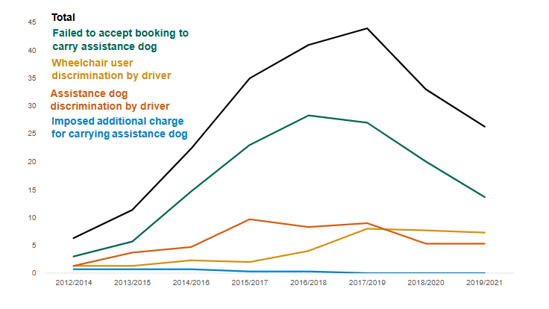

Figure 4.8: offences by taxi and PHV drivers and operators
(Source:‌ Gov.uk, 2022)
The Department for Transport (2021) reports that Equality Act 2010 charges, mostly for failing to transport assistance or wheelchair users, affected between 2012 and 2019 but fell post-pandemic. Taxi and PHV drivers committed most of these crimes, indicating service quality and legal compliance issues (Bilgin et al., 2023). On the other hand, respondent 2 stated that “It is not fair at all. I must point out that they should be held to the same standards if they are doing the same job”. Protection regulations vary widely across licensing bodies, resulting in disparities in enforcement and control. The absence of standardised regulations hampers Uber and conventional driver regulation and operating equivalence with 276 agencies, some in transitional stages. Hackney carriage drivers suffer economic disadvantages, regulatory imbalance, weaker safeguarding and legal control that create a fragmented and tough market.

4.4 Summary
The results show that Uber’s tech-driven gig model has transformed the UK taxi sector as bringing passengers convenience and flexibility while challenging Hackney Carriage drivers economically, legally and emotionally. The gig economy boosts employment but produces job insecurity and regulatory disparities. These gaps must be addressed to ensure fair competition, driver rights and service standards in the changing transport industry.

Chapter 5: Conclusion and Recommendations

5.1 Conclusion
It is concluded that the gig economy has transformed the UK's employment and service paradigms, notably in the transport sector. Uber has enhanced this change by giving drivers supple, on-demand work, appealing to people seeking autonomy over fixed schedules. The research and interviews show that though the gig economy has shaped and providing flexible employment to millions as it has also augmented rivalry and volatility in long-established businesses. Fair competition, equal driver treatment across subdivisions and sustainable coexistence are directly needed, according to the results. Policymakers should prioritise hybrid regulatory approaches that strike a balance between innovation and protection. Uber and other platforms should be incorporated into the local market through conversation with Hackney Carriages and open laws. Moreover, a balanced approach that promotes collaboration, addresses inequalities and updates regulatory structures is needed to create a fair and sustainable transport ecosystem for all stakeholders.

5.2 Recommendations
- Embrace App-Based Booking Platforms
App-based ride-booking services have changed the taxi industry due to customer desire for digital convenience. Partners or applications like Gett or Hailo, which can integrate London black taxis into the digital economy, may help traditional taxi companies reclaim market share (HexCars, 2024). Uber consumers prefer these systems for booking, fare estimates, cashless payments and driver ratings (Randolph, 2020). Digital solutions allow Hackney Carriage services to compete and modernise while retaining their trusted community presence and regulatory standards.
- Invest in Electric and Eco-Friendly Vehicles
The UK is moving towards greener mobility. The Clean Air Plan of Uber seeks to have an emission-free fleet in London by 2025 (HexCars, 2024). TfL requires zero-emission requirements for new cars and in Manchester and Birmingham, Hackney Carriage drivers should be incentivised to switch to hybrid or electric cars to stay competitive. Local authorities might provide Hackney drivers who buy eco-friendly fleets with bonuses or tax breaks like Uber drivers. This will satisfy UK sustainability aims and eco-conscious customers. Traditional taxis remain relevant in the evolving transport landscape by embracing electrification and aligning with public opinion and regulatory expectations.
- Upgrade Dispatch and Communication Systems
AI and predictive analytics help Uber estimate peak-hour and event demand (HexCars, 2024). Partnerships with software developers may provide real-time traffic data, AI-assisted route planning and surge-response allocation to public or cooperative taxi dispatch centres. They optimize fleet deployment, idle time and service dependability. Moreover, operating efficiency and revenue consistency for drivers who have lost income owing to Uber’s market disruption would improve (Wonderful.co.uk, 2025).

5.3 Future scope
Future studies may examine how robotaxis and AI-driven dispatch systems affect employment, regulatory frameworks and urban transportation patterns as Uber and other platforms advance. Technology and regulatory parity may help determine the long-term viability of conventional Hackney Carriages (Mckinsey, 2022). Further research on passenger preferences and the changing criteria for selecting between conventional and app-based services, particularly post-pandemic, is needed. To find optimal practices for integrating conventional and gig-based transportation, future studies might compare UK cities or worldwide marketplaces. Digital literacy initiatives for Hackney Carriage drivers and the socio-economic effects of Uber collaborations may also provide effectiveness. Innovation, regulation and stakeholder involvement to create a cooperative transport ecosystem are significant future areas of investigation.

5.4 Limitations
Only semi-structured interviews were used in this qualitative research which may not completely reflect all UK Hackney Carriage drivers. Geographically limited study may ignore regional differences. Participant bias from personal experiences and perspectives may impair objectivity. On the other hand, the research also lacks Uber driver viewpoints that restrict comparisons.

References
Ali, Z. (2023). Labor Market Dynamics In The Gig Economy: Opportunities, Challenges, And The Future Of Work. Journal of Applied Finance and Economic Policy, 7(01), pp.57-68.
Allon, G., Cohen, M.C. and Sinchaisri, W.P. (2023). The impact of behavioral and economic drivers on gig economy workers. Manufacturing & Service Operations Management, 25(4), pp.1376-1393.
Alvarez de la Vega, J.C., Cecchinato, M.E., Rooksby, J. and Newbold, J. (2023). Understanding platform mediated work-life: a diary study with gig economy freelancers. Proceedings of the ACM on Human-Computer Interaction, 7(CSCW1), pp.1-32.
Angrist, J.D., Caldwell, S. and Hall, J.V. (2021). Uber versus taxi: A driver’s eye view. American Economic Journal: Applied Economics, 13(3), pp.272-308.
Berger, T., Chen, C. and Frey, C.B. (2018). Drivers of disruption? Estimating the Uber effect. European Economic Review, 110, pp.197–210. https://www.sciencedirect.com/science/article/abs/pii/S0014292118300849
Bilgin, P., Mattioli, G., Morgan, M. and Wadud, Z., (2023). The impacts of ridesourcing services on the taxi market: Empirical evidence from England and Wales. Transportation Research Part A: Policy and Practice, 178, p.103880.
Bio Ideas (2025). From Apps To Electric Fleets – The Private Hire Taxi Trends Defining The UK In 2025. [Online]. Available at: https://bioideas.us/from-apps-to-electric-fleets-the-private-hire-taxi-trends-defining-the-uk-in-2025/ (Accessed 18 June 2025).
Biswas, A. (2023). How Uber Revolutionized Urban Transportation with User-Centric Design. [Online]. Available at: https://medium.com/@work.anweshbiswas/how-uber-revolutionized-urban-transportation-with-user-centric-design-a3eb1c5e9f5c(Accessed 30 June 2025).
Bouchrika, I. 2025. Primary research vs secondary research for 2025: Definitions, differences, and examples | research.com. Available at: https://research.com/research/primary-research-vs-secondary-research (Accessed: 18 June 2025).
Briggs, S. (2025). Peterborough taxi drivers fear for future of black cabs in city over issues with Uber drivers at Railway Station. [Online]. Available at: https://www.peterboroughtoday.co.uk/news/people/peterborough-taxi-drivers-fear-for-future-of-black-cabs-in-city-over-issues-with-uber-drivers-at-railway-station-4992092 (Accessed 18 June 2025).
Brookes.ac.uk. (2021). Data protection and privacy: considerations for research - Oxford | Brookes.ac.uk.[online] Available at: https://www.brookes.ac.uk/sites/research-support/research-ethics-and-integrity/policies-procedures-and-useful-documents/urec-guidelines-useful-resources/data-protection-and-privacy-considerations-for-res
Businessofapps (2025) Uber revenue and Usage Statistics (2025), Business of Apps. Available at: https://www.businessofapps.com/data/uber-statistics/ (Accessed: 30 June 2025).
Casula, M., Rangarajan, N. and Shields, P., 2021. The potential of working hypotheses for deductive exploratory research. Quality & Quantity, 55(5), pp.1703-1725. https://link.springer.com/article/10.1007/s11135-020-01072-9
Chaisse, J. and Banik, N. (2021). The Gig Workers Facing the Regulator: The Good, the Bad, and the Future. Transnat'l L. & Contemp. Probs., 31, p.1.
Chinangkulpiwat, I., Chaveesuk, S. and Chaiyasoonthorn, W. (2023, July). Collaboration platforms for organizational integration uses and benefits: A review. In Proceedings of the 2023 14th International Conference on E-business, Management and Economics (pp. 166-171).
Çiğdem, S. (2022). Motivation of freelance employees in the gig economy in Turkey. Ege Academic Review, 22(4), pp.502-520.
Cloud front (2023). The impact of Uber in the UK: urban mobility has been transformed Cloudfront .net [online] Available at: https://d1nyezh1ys8wfo.cloudfront.net/static/PDFs/33688+-+Uber+-+UK+Impact+Report_05.pdf
Colley, J. (2023). Uber’s U-turn over listing black cabs isn’t difficult to understand when you look at its finances | The Conversation.com [online] Available at: <https://theconversation.com/ubers-u-turn-over-listing-black-cabs-isnt-difficult-to-understand-when-you-look-at-its-finances-219039>
Bilgin, P., Mattioli, G., Morgan, M. and Wadud, Z., 2023. The impacts of ridesourcing services on the taxi market: Empirical evidence from England and Wales. Transportation Research Part A: Policy and Practice, 178, p.103880.https://www.sciencedirect.com/science/article/pii/S0965856423003002
Dahlgreen, W. (2014). Londoners: Uber should be regulated. [Online]. Available at: https://yougov.co.uk/politics/articles/9684-londoners-uber-should-face-same-regulation-black-c (Accessed 18 June 2025).
Darmawan, D. and Grenier, E. (2021). Competitive advantage and service marketing mix. Journal of Social Science Studies (JOS3), 1(2), pp.75-80.
Davies, H., Goodley, S., Lawrence, F., Lewis, P. and O’Carroll, L. (2022). A Challenging 2023 For UK Freelancers, But 2024 Optimism RisingUber broke laws, duped police and secretly lobbied governments, leak reveals. [Online]. Available at: https://www.theguardian.com/news/2022/jul/10/uber-files-leak-reveals-global-lobbying-campaign(Accessed 30 June 2025).
Edgar, B. (2024). Cabbies sound warning as Uber applies for licence. [Online]. Available at:
Elbaum, R. and Whittaker, F. (2018). London's iconic black cabs fear for the future in an age of Uber. [Online]. Available athttps://www.euronews.com/2018/06/27/london-s-cabbies-ask-fair-competition-court-rules-uber-n886541(Accessed 30 June 2025).
Emon, M.H. (2023). A systematic review of the causes and consequences of price hikes in Bangladesh. Review of Business and Economics Studies, 11(2), pp.49-58.
Euractive (2021). Uber grants UK drivers worker status in world first. [Onlne]. Available at: https://www.euractiv.com/section/tech/news/uber-grants-uk-drivers-worker-status-in-world-first/ (Accessed 18 June 2025)
Famoti, O., Omowole, B.M., Okiomah, E., Muyiwa-Ajayi, T.P., Ezechi, O.N., Ewim, C.P.M. and Omokhoa, H.E. (2024). Enhancing customer satisfaction in financial services through advanced BI techniques. International Journal of Multidisciplinary Research and Growth Evaluation, 5(06), pp.1558-1566.
Foord, R. (2023). The Impact of Uber in the UK | Uber.com [online] Uber.com Available at: <https://www.uber.com/en-GB/newsroom/the-impact-of-uber-in-the-uk-2/>
Garnham, A. and Stacey, D.G., (2022). Fighting for fares: Uber and the declining market price of licensed taxicabs (No. 1487). Queen’s Economics Department Working Paper.
Gaskell, A. (2018). Study Explores The Impact Of Uber On The Taxi Industry | Forbes.com[online] Available at: <https://www.forbes.com/sites/adigaskell/2017/01/26/study-explores-the-impact-of-uber-on-the-taxi-industry>
Golub, A., Brown, A., Brakewood, C., MacArthur, J., Lee, S. and Ziedan, A., (2022). Equity and exclusion issues in cashless fare payment systems for public transportation. Transportation Research Interdisciplinary Perspectives, 15, p.100628.
Ground Transport Group (2025). Is the Taxi & Private Hire Industry Thriving or Struggling? New Report Shows What Drivers Say. [Online]. Available at: https://groundtransportgroup.com/news-and-media/is-the-taxi-private-hire-industry-thriving-or-struggling-see-what-drivers-have-to-say/ (Accessed 18 June 2025).
https://www.bbc.com/news/articles/c2508gjx7pwo?utm (Accessed 18 June 2025).
Hussain, N. and Phulpoto, S. (2024). Digital literacy: Empowering individuals in the Digital Age. Assyfa Learning Journal, 2(2), pp.70-83.
Katwala, A. (2019). London's minicabs have a cunning plan to beat Uber at its own game. [Online]. Available at: https://www.wired.com/story/london-minicabs-taxis-uber-igo-merger/ (Accessed 18 June 2025).
Kleinman, Z. (2025). Uber brings forward trialling driverless taxis in UK. [Onlne]. Available at: https://www.bbc.com/news/articles/cwynm4wl1j7o (Accessed 18 June 2025)
Kraiwanit, T., Limna, P. and Siripipatthanakul, S., 2023. NVivo for social sciences and management studies: A systematic review. Advance Knowledge for Executives, 2(3), pp.1-11.https://d1wqtxts1xzle7.cloudfront.net/104584003/AKE_2_3_No._23-libre.pdf?1690550783=&response-content-disposition=inline%3B+filename%3DNVivo_for_Social_Sciences_and_Management.pdf&Expires=1750251034&Signature=ETLZYcVnyP0PSC0LRAbAWLMvWkd3NlpGwVhoPtOTd1GGjG5uCCV0UI~HUtZdgKMMiLkHOenek501f2Ue59Nc4dQBW43grgNOAtVnufzkUgolEXwqrtXW9WdBqtdsBdhmH4PsaBpD0~s0thJFdCIyZamPMid-rWmlIbAwy7iTcq1GyehwH7pNu7dYLdJEoLqQWxcT6R~gHxJ1sVvMht20wZqRLdVxHZYgRxSgpzleS42nYWJzpp3AxPbHGIKiBH4dnwblsuvmbHuE4f-8m8QavfZ4jjjdoX05rugK4PNhGdii4Qm-jYQNUqakHLUDvcrQXGZYy4odn9t~8OC8wyNuTg__&Key-Pair-Id=APKAJLOHF5GGSLRBV4ZA
Lee, C.C., Ruane, S., Lim, H.S., Zhang, R. and Shin, H. (2021). Exploring the behavioral intention to use collaborative commerce: a case of uber. Journal of International Technology and Information Management, 30(5), pp.97-119.
Liversedge, B. (2021). Uber drivers entitled to workers’ rights, Supreme court rules. [Onlne]. Available at: https://www.britsafe.org/safety-management/2021/uber-drivers-entitled-to-workers-rights-supreme-court-rules#:~:text=A%20landmark%20ruling%20from%20the,a%20long%2Drunning%20legal%20battle. (Accessed 18 June 2025)
Madanchian, M., Ariken, J. and Taherdoost, H. (2022). Role of effective leadership on empowerment, effective communication, and Motivation in customer service. Macro Management & Public Policies, 4(1), p.4530.
Makortoff, K. (2025). More than 10,000 London black-cab drivers launch £250m Uber lawsuit. [Online]. Available at: https://www.theguardian.com/business/article/2024/may/02/london-black-cab-drivers-uber-lawsuit (Accessed 18 June 2025).
Massar, M., Reza, I., Rahman, S.M., Abdullah, S.M.H., Jamal, A. and Al-Ismail, F.S. (2021). Impacts of autonomous vehicles on greenhouse gas emissions—positive or negative?. International Journal of Environmental Research and Public Health, 18(11), p.5567.
Mcgregor, M., Brown, B., Glöss, M. and Lampinen, A. (2024). On-Demand Taxi Driving: Labour Conditions, Surveillance, and Exclusion | ox.ac.uk [Online] Available at: http://blogs.oii.ox.ac.uk/ipp-conference/sites/ipp/files/documents/McGregor_Uber%2520paper%2520Sept%25201%2520PDF.pdf>
Minipip (2023). Uber opens up sign-ups for black cabs. [Online]. Available at: https://www.minipip.co.uk/details/news/uber-opens-up-sign-ups-for-black-cabs(Accessed 30 June 2025).
Morgan, H., 2022. Understanding thematic analysis and the debates involving its use. The qualitative report, 27(10), pp.2079-2090.https://core.ac.uk/download/pdf/534378655.pdf
Nezami, M.R., de Bruijne, M.L., Hertogh, M.J. and Bakker, H.L. (2022). Collaboration and data sharing in inter-organizational infrastructure construction projects. Sustainability, 14(24), p.16835.
Olayode, I.O., Severino, A., Alex, F.J., Macioszek, E. and Tartibu, L.K., (2023). Systematic review on the evaluation of the effects of ride-hailing services on public road transportation. Transportation research interdisciplinary perspectives, 22, p.100943.
Paul, K. (2025). The uber drivers forced to sleep in parking lots to make a decent living, The Guardian. Available at: https://www.theguardian.com/technology/2019/may/07/the-uber-drivers-forced-to-sleep-in-parking-lots-to-make-a-decent-living (Accessed: 30 June 2025).
Perraudin, F. (2017). Uber exploiting loophole to 'spread tentacles' across UK, union says. [Online]. Available at: https://www.theguardian.com/technology/2017/feb/17/uber-exploiting-loophole-to-spread-tentacles-across-uk-gmb-union-says(Accessed 30 June 2025).
Prince, S.J., (2021). The Shoe Is About to Drop for the Platform Economy: Understanding the Current Worker Classification Landscape in Preparation for a Changed World. U. Mem. L. Rev., 52, p.627.
Richardson, P. (2024). FEWER DRIVERS: Technology, costs and red tape leading to the decline of part-time taxi drivers[Online]. Available at: https://www.taxi-point.co.uk/post/fewer-drivers-technology-costs-and-red-tape-leading-to-the-decline-of-part-time-taxi-drivers#:~:text=Technology%20and%20the%20changing%20face,the%20viability%20of%20their%20work. (Accessed 30 June 2025).
Richardson, P. (2025). Competing against Uber: How cities have built their own taxi-hailing apps under differing models.[Online]. Available at: https://www.taxi-point.co.uk/post/competing-against-uber-how-cities-have-built-their-own-taxi-hailing-apps-under-differing-models?utm_source=chatgpt.com(Accessed 30 June 2025).
Rusilowati, U. (2022). An analysis of employee views and the effectiveness of implementing flexible work arrangements in improving work-life balance on employees of life insurance companies. International Journal of Artificial Intelligence Research, 6(1.2).
Scammell, R. (2018). Uber appeal: driving black cab innovation. [Online]. Available at: https://www.verdict.co.uk/uber-appeal-driving-black-cab-innovation/(Accessed 30 June 2025).
Sharma, L.R., Jha, S., Koirala, R., Aryal, U. and Bhattarai, T., 2023. Navigating the research landscape: A guide to the selection of the right research design. International Research Journal of MMC (IRJMMC), 4(1), pp.64-78. https://irjmmc.edu.np/index.php/irjmmc/article/view/166
Siddiqui, F. (2016). Uber drivers don’t have to take London’s legendary driving test. [Online]. Available at: https://www.washingtonpost.com/news/dr-gridlock/wp/2016/01/04/uber-drivers-dont-have-to-take-londons-legendary-driving-test/(Accessed 30 June 2025).
Sklar, T. and Crescioni, M., 2019. Research Participants' Rights to Data Protection in the Era of Open Science. DePaul L. Rev., 69, p.699.https://heinonline.org/hol-cgi-bin/get_pdf.cgi?handle=hein.journals/deplr69&section=26
Skok, W. and Baker, S., 2018. Evaluating the impact of Uber on London's taxi service: A strategic review. Knowledge and process management, 25(4), pp.232-246.https://onlinelibrary.wiley.com/doi/abs/10.1002/kpm.1575
Sky News (2023). Uber to offer partnership with black cab drivers in London. [Online]. Available at: https://news.sky.com/story/uber-to-offer-partnership-with-black-cab-drivers-in-london-13018595(Accessed 30 June 2025).
Tanweer, A., Gade, E., Krafft, P.M. and Dreier, S., 2021. Why the data revolution needs qualitative thinking. Harvard Data Science Review, 3. https://assets.pubpub.org/ccpx4yqj/61623947151090.pdf
Tfl.gov.uk (2025) Taxi-and-private-hire-policy-july-2023.pdf - london, tfl.gov.uk. Available at: https://content.tfl.gov.uk/taxi-and-private-hire-policy-july-2023.pdf (Accessed: 30 June 2025).
Theguardian (2025) London’s black cabs destined for extinction in 20 years, TFl warned, The Guardian. Available at: https://www.theguardian.com/uk-news/2025/mar/19/londons-black-cabs-destined-for-extinction-in-20-years-tfl-warned (Accessed: 30 June 2025).
Taxi Insurer (2023). The next generation of taxi apps you need to know about. [Online]. Available at:https://www.taxiinsurer.co.uk/contact-us/news/the-next-generation-of-taxi-apps-you-need-to-know-about/(Accessed 30 June 2025).
Topham, G. (2025). ‘They’re living in fantasy land’: Uber to trial self-driving taxis in London next spring. [Onlne]. Available at: https://www.theguardian.com/technology/2025/jun/10/uber-uk-trial-of-self-driving-taxis-brought-forward-to-spring-2026 (Accessed 18 June 2025)
Topham, G. (2025). ‘They’re living in fantasy land’: Uber to trial self-driving taxis in London next spring. [Online]. Available at:https://www.theguardian.com/technology/2025/jun/10/uber-uk-trial-of-self-driving-taxis-brought-forward-to-spring-2026 (Accessed 18 June 2025).
Topham, G. (2025). London’s black cabs destined for extinction in 20 years, TfL warned. [Online]. Available at: https://www.theguardian.com/uk-news/2025/mar/19/londons-black-cabs-destined-for-extinction-in-20-years-tfl-warned (Accessed 18 June 2025).
Usai, A., Fiano, F., Petruzzelli, A.M., Paoloni, P., Briamonte, M.F. and Orlando, B. (2021). Unveiling the impact of the adoption of digital technologies on firms’ innovation performance. Journal of Business Research, 133, pp.327-336.
Vickers, T., Dahill, D. and Holland, D. (2020). Decent and good work in the platform economy: private hire and taxi work in Nottingham.
Young, H. (2025). Uber rides to new UK cities, check if it’s near you. [Online]. Available at: https://startups.co.uk/news/uber-locations-uk/#:~:text=In%20most%20major%20towns%20and,workers%20in%20many%20UK%20locations. (Accessed 30 June 2025).
Younger, J. (2023). A Challenging 2023 For UK Freelancers, But 2024 Optimism Rising. [Online]. Available at: https://www.forbes.com/sites/jonyounger/2023/12/20/a-challenging-2023-for-uk-freelancers-but-2024-optimism-rising/ (Accessed 18 June 2025)
Zainuddin, S., LI, T.W., PHOA, F. and LEE, C., (2022). Precarity In Platform Work: A Study Of Private-Hire Car Drivers And Food Delivery Riders Mathew Mathews.
Zego. (2025). UK Uber Driver Statistics | ‌Zego.com [online] ‌Zego.comAvailable at: <https://www.zego.com/uk-uber-driver-statistics>
Zhong, J., Zhou, H., Lin, Y. and Ren, F. (2022). The impact of ride‐hailing services on the use of traditional taxis: Evidence from urban panel data. IET Intelligent Transport Systems,16(11), pp.1611–1622.https://ietresearch.onlinelibrary.wiley.com/doi/10.1049/itr2.12237
HexCars. (2024). How Taxi Services in the UK Are Adapting to Modern Technology | HexCars. co.uk [Online] Available at: <https://hexcars.co.uk/how-taxi-services-in-the-uk-are-adapting-to-modern-technology/> (Acessed on 9th July 2025)
Wonderful.co.uk (2025). UK taxi and airport transfer trends for operators in 2025| Wonderful.co.uk. [Online] Available at: <https://wonderful.co.uk/blog/uk-taxi-airport-transfers-2025-trends-challenges> (Acessed on 9th July 2025)
‌Randolph, H. (2020). The Impact of Uber in the UK | Uber.com [Online] Uber.com Available at: <https://www.uber.com/en-GB/newsroom/the-impact-of-uber-in-the-uk> (Acessed on 9th July 2025)
Fennell, A. (2021). Gig Economy Statistics UK | 2024 Industry Report|StandOut.com [online] StandOut.com Available at: <https://standout-cv.com/stats/gig-economy-statistics-uk> (Acessed on 9th July 2025)
Gov.uk (2022). Taxi and private hire vehicle statistics, England: 2022 |Gov.uk [online] GOV.UK. Available at: <https://www.gov.uk/government/statistics/taxi-and-private-hire-vehicle-statistics-england-2022/taxi-and-private-hire-vehicle-statistics-england-2022> (Acessed on 9th July 2025)
Mckinsey (2022). Sustainable and inclusive growth: A weekly briefing| Mckinsey.com [online] Mckinsey .comAvailable at: <https://www.mckinsey.com/featured-insights/sustainable-inclusive-growth/sustainable-and-inclusive-growth-a-weekly-briefing> (Acessed on 9th July 2025)
Cropanzano, R., Keplinger, K., Lambert, B.K., Caza, B. and Ashford, S.J., 2023. The organizational psychology of gig work: An integrative conceptual review. Journal of Applied Psychology, 108(3), p.492. https://psycnet.apa.org/fulltext/2023-07874-001.html
‌Berger, T., Frey, C.B., Levin, G. and Danda, S.R., 2019. Uber happy? Work and well-being in the ‘gig economy’. Economic Policy, 34(99), pp.429-477. https://academic.oup.com/economicpolicy/article-abstract/34/99/429/5536871
Behl, A., Rajagopal, K., Sheorey, P. and Mahendra, A., 2022. Barriers to entry of gig workers in the gig platforms: exploring the dark side of the gig economy. Aslib Journal of Information Management, 74(5), pp.818-839. https://www.emerald.com/insight/content/doi/10.1108/AJIM-08-2021-0235/full/html
Bilgin, P., Mattioli, G., Morgan, M. and Wadud, Z., 2023. The impacts of ridesourcing services on the taxi market: Empirical evidence from England and Wales. Transportation Research Part A: Policy and Practice, 178, p.103880. https://www.sciencedirect.com/science/article/pii/S0965856423003002

Cascade.app. (2023). Strategy Study: How Uber Disrupted An Industry With An Explosive Approach|Cascade.app[online] Cascade.appAvailable at:<https://www.cascade.app/studies/uber-strategy-study>
‌Gaskell, A. (2019). Study Explores The Impact Of Uber On The Taxi Industry| Forbes. com [online] Forbes. comAvailable at: <https://www.forbes.com/sites/adigaskell/2017/01/26/study-explores-the-impact-of-uber-on-the-taxi-industry/>
lichfielddc.gov.uk (‌2025) HACKNEY CARRIAGE AND PRIVATE HIRE LICENSING POLICY 2025| lichfielddc.gov.uk[Online]lichfielddc.gov.uk Available at: <https://www.lichfielddc.gov.uk/downloads/file/2878/taxi-policy-2025-2030>
‌Financialexpress.com. (2019). The Financial Express| ‌Financialexpress.com [online] ‌Financialexpress.comAvailable at: <https://www.financialexpress.com/business/industry-uber-lyft-vs-others-taxis-often-face-stronger-rules-than-ride-hailing-companies-294137>
Ntu.ac.uk. (2020). Working conditions putting taxi driver livelihoods at risk| ‌Ntu.ac.uk [online]‌Ntu.ac.uk Available at: <https://www.ntu.ac.uk/about-us/news/news-articles/2020/07/working-conditions-putting-taxi-driver-livelihoods-at-risk>
Techxplore (2020). Working conditions putting taxi driver livelihoods at risk|Techxplore.com. [online] Techxplore.com. Available at: <https://techxplore.com/news/2020-07-conditions-taxi-driver-livelihoods.html>
Zhang, W. and Xu, C., (2021). Exploring app-based taxi movement patterns from large-scale geolocation data. ISPRS International Journal of Geo-Information, 10(11), p.751.

Appendices

Appendix 1: NVivo outcome
Name | Description | Files | References
Challenges and barriers while competing with Uber Drivers |  | 1 | 8
Difference in regulations |  | 1 | 4
Pricing |  | 1 | 3
Technology inefficiecny |  | 1 | 2
Changes in customer behaviour since Uber |  | 1 | 8
Digital contexts of Uber |  | 1 | 5
Lower fares in Uber |  | 1 | 3
Using traditional taxi services during necessity |  | 1 | 1
Impact of Uber of Daily Earnings |  | 1 | 8
Increased working hours |  | 1 | 2
Less Earning |  | 1 | 6
Necessary changes or support |  | 1 | 8
Capping number of Uber Drivers |  | 1 | 1
Financial and technological support |  | 1 | 3
Similar regulations |  | 1 | 4
Wider education |  | 1 | 2
Opinion about Uber's Business Model compared to traditional taxi services |  | 1 | 8
Different license |  | 1 | 2
Different pricing strategy |  | 1 | 5
Little room for human interactions |  | 1 | 1
Regulations and licensing requirements for Uber Drivers compared to Hackney Carriage |  | 1 | 8
Difference in insurance |  | 1 | 2
Imbalance between license requirements |  | 1 | 6
Time working as a Hackney Carriage driver |  | 1 | 8
Less than 15 years |  | 1 | 3
More than 15 years |  | 1 | 5
Uber affected job satisfaction |  | 1 | 8
Financial insecurity |  | 1 | 3
Higher stress level |  | 1 | 7

Appendix 2: Interview transcript
Question 1: How long have you been working as a Hackney Carriage driver, and how has the job changed since the introduction of Uber?
R1: I have been a Hackney driver for 22 years. I had a collaboration with Uber, but before Uber, we had a steady flow of customers. Now it has become more unpredictable.
R2: Nearly 30 years in Hackney. But now Uber has changed everything. Fewercustomers on the streets and more frustration are developing.
R3:I am in this profession for 12 years. But now I am experiencing a massive reduction in customers over a unit time.
R4:I have driven Hackney cabs for 15 years. People now expect app-based service and in most cases, they do not care for higher fares.
R5: 8 years. I am supporting the fact that Uber brought in a wave of competition in the industry.
R6:Over 20 years in this profession. But now the situation is getting worse day by day.
R7:Been driving for 10 years. The job is now very transactional.
R8:18 years I am working for Hackney. Now it is not just a change, rather it’s a complete shift in how people commute.
Question 2: What impact has Uber had on your income or daily earnings as a Hackney Carriage driver?
R1: I am earning around 30–40% less on average compared to before.
R2: It has been really tough. I used to make £200 a day; now it's a struggle to hit £100.
R3: My income has been reduced significantly.There are days I drive around for hours before a decent fare.
R4: My income has fluctuatedabruptly recently. Weekends used to be peak times, but for Uber it has become a path of thorns.
R5: It’s cut deeply into my earnings. I’m working longer hours to make ends meet.
R6: I think that the expansion of Uber has definitely affected the earning level of all Hackney drivers. Uber drivers can afford to undercharge, but is it impossible for us.
R7: My revenue is dropped by almost half in the first two years.
R8: I can say that it is not sustainable long-term. Many colleagues have quit or switched to private hire.
Question 3: Have you noticed any changes in customer behaviour or preferences since Uber became available in your area?
R1: Of course. People now expect to book a ride with apps, track the ride, and pay digitally.
R2: Many younger passengers automatically go to Uber. Maybe they are thinking that we are outdated.
R3: Definitely. I think that they are expecting lower fares and even sometimes complain if we charge standard rates.
R4: Customers seem less patient and they become more dependent on instant rides and fixed fares.
R5: Yes, and many assume we are more expensive.
R6: I can state that passengers expect the same tech experience and comfort that we cannot offer.
R7: As per my views, regular customers now only use us during surge pricing times for Uber.
R8: Most bookings are now done through apps. Street pick-ups are becoming rare and this has become tough for us to earn stable livelihood.
Question 4: In what ways do you think Uber’s business model differs from that of traditional taxi services like Hackney Carriages?
R1: I can say that Uber operates on dynamic pricing and uses technology aggressively. In this regard, we are more regulated and predictable.
R2: They rely on algorithms, not meters. Somehow, this is accepted by passengers as beneficial.
R3: I know that Uber does not have to go through the same level of licensing and training and it can support them in earning good revenue.
R4: Uber’s system is fast and user-friendly, but there is very little room for human interaction.
R5: I must say that Hackney drivers work in a more regulated and safer structure, while Uber is more profit-driven.
R6: As per my comments, Uber focuses on volume and lower fares, whereas Hackney focuses on service and standards.
R7: Uber drivers can log on and off at will. But for us, the rule is different. We are bound by stricter rules.
R8: Yes, of course! Their costs are lower, and they pass that to the customer. We cannot compete on that front.
Question 5: Have you faced any challenges or barriers in trying to compete with Uber drivers? If so, what are they?
R1: The biggest barrier is pricing. Uber is always cheaper and passengers are commonly attracted to that.
R2:I am totally affected mentally as I have observed that it is hard to compete when customers don’t understand the difference in regulation.
R3: We cannot offer app-based tracking like Uber and it may sometimes affect people’s perceptions of taking our services.
R4: Our licensing costs and insurance are far higher than what Uber drivers pay.
R5: According to me, there is an unfair playing field. We are held to higher standards with more inspections.
R6:The most surprising fact in this regard is that most Uber drivers’ not have to take the same knowledge test as we do. This must be tackled with efficiency.
R7: According to me, the lack of regulation on Uber makes competition extremely one-sided and we are suffering for that massively.
R8: I think that even if we provide better service, customers are driven by cost and convenience.
Question 6: What are your thoughts on the regulations or licensing requirements for Uber drivers compared to Hackney Carriage drivers?
R1: It is really frustrating. I can say that we go through intense testing, background checks, and pay high fees, what Uber drivers do not.
R2: It is not fair at all. I must point out that they should be held to the same standards if they are doing the same job.
R3: There must be a huge imbalance. We have to learn every street, but Uber drivers follow GPS.
R4: Hackney Carriage licensing is much stricter, but Uber should be regulated equally. This partiality is totally unbearable for us.
R5: I think that our insurance, vehicle standards as well as training, are far more robust, while those are lenient for Uber drivers.
R6: It is often observed that Uber drivers operate in grey areas with licensing. That affects trust in the system.
R7: The regulations or licensing requirements of Uber clearly devalue our license. We paid thousands for it, and now anyone can drive for Uber.
R8: It is apparent that regulatory double standards need to be addressed for a level playing field.
Question 7: How has the presence of Uber affected your job satisfaction or personal well-being, if at all?
R1: Prior, I enjoyed the driving, but now it has become more frustrating and the pride in the job has diminished.
R2: My mental health has taken a hit. I can say that it’s hard to stay motivated when your efforts are not rewarded and openly devalued.
R3: My stress levels are up and I have become worried regarding my income draining on daily basis.
R4: It is really disheartening for all hackney drivers to see years of work feel undervalued.
R5: I used to enjoy meeting people, but now it feels like a financial struggle.
R6: Gradually, I am losing confidence in the profession. I think I need to find another profession for financial security.
R7: I am constantly anxious about the future as I have a family and 2 children. I am not seeing a sense of stability.
R8: It is demoralising us, all Hackney drivers. The sense of pride in being a Hackney driver has taken a hit.
Question 8: What changes or support would you like to see from local authorities or taxi regulators in response to Uber's presence?
R1: I need equal regulation first. Uber drivers should be held to the same safety and training standards as us.
R2: More support for Hackney Carriage drivers is needed, along with financial incentives or app development technologies.
R3: According to me, investment in digital infrastructure is the prime need to modernise our service.
R4: Stronger enforcement of existing taxi laws is needed. Uber often works around them.
R5: I can mention that licensing reform is essential to create fairer competition; otherwise, it is really tough for us to serve.
R6: I think it is essential to cap the number of Uber drivers in dense areas to protect livelihoods.
R7: Mass awareness needs to be developed and thus, proper education for the public is needed on why Hackney Carriages are safer and more regulated.
R8: Grants or funding can help Hackney drivers adapt to modern tools and platforms.

