
Skills for the Workplace
Module Assignment Submission
Student Name: | Annalea Evans
Student Number: | 1811484
Module No: | BMSK4006
Module Title: | Managing Enterprise in the 21st Century

Statement of Confirmation of Authenticity
By the act of making this submission, the student declares that this is the work of the student named above. The work has not, in whole or in part, been knowingly presented elsewhere for assessment, or where assessment has been built on a previous assessment, this has been identified. Where materials have been used from other sources it has been properly acknowledged. If this statement is untrue, the student acknowledges that an assessment offence has been committed.
Attention is drawn to the plagiarism and unfair practice policies of UWTSD.

Table of Contents
Introduction 4
The Red Team 4
The Business Plan 4
The Group 4
References 8
Appendix 1 9
10
Appendix 2 10

Introduction

During this assignment I will be reflecting on the experience of creating the business plan with Ashley and Caroline. I will do this using Gibbs Model of Reflection, S.W.O.T Analysis.

The Red Team

The teams were announced via the WhatsApp Group. I was pleased to find out that I was in a team with Caroline and Ashley as they are the strongest members of our class. However, I was horrified to find out that I was the team leader in the group. The responsibility I felt was overwhelming and I felt panicked at the thought of being the groups team leader. However, I embraced it and decided to deal with it in the morning. Our first meeting was decided over the WhatsApp group that Ash had created, this was also where Caroline put forward her idea of setting up a Vegan food delivery service. It sounded good to me and quite plausible, so I agreed. Ash wanted to go down a different route of recycling plastics to build homeless accommodation with a 3D printer. I personally just couldn’t see how we would make money from this, so it was a unanimous decision to go with the Vegan food delivery service.

The Business Plan

When I arrived at Caroline’s house for the meeting she had already started the Business Plan and was well underway through the introduction and the executive summary so I said for her to carry on with those as it would be unfair for her to change and do something else when she had done so much work already. So, it was decided that the rest of the business plan checklist (marketing, finance) would be shared amongst myself and Ash. It was assumed since I already run a business that I would know how to do the finances, so I was delegated the financial side of the business plan. Ash was given the marketing. Caroline and I started straight away bouncing ideas off one another, how the business would work. How many cars would we need? How it would be introduced? How we would market it? What would be needed to start up etc. ‘Vegan and Go’ was born.

The Group

Ash, if I’m honest really disappointed me during this assignment. He went from being one of the strongest members of the class to one that I didn’t trust or believe in. The day of the first meeting I arrived promptly, Ash however was an hour late and when he did arrive, he was more concerned with sorting out Caroline’s sons Sky box. This really annoyed me as we had been really getting into it and I just felt he was a distraction and just wasn’t interested at all. Just seemed to be there because he had to. He made references to the printer idea he had had earlier on, almost like he wanted us to change to what business he wanted to set up. We advised him that we didn’t really understand how that would work or how we would have any information to gather evidence to produce a business plan and said we were sticking to the Vegan food delivery service idea. Personally, I don’t think Ash liked this.

During the next week or so we messaged about meeting again and how our parts were coming along. Due to personal and work commitments I hadn’t really looked at what was wanted for the finance side of things. Ash was the same. Caroline, however, was amazing she was flying through it. I think she thought she was setting this business up. She was committed to the assignment. I was amazed at how she managed to find time due to her working full time and looking after her grandchild and her son.

After being motivated by Caroline’s commitment I got my laptop out and had a look at was needed for the finance section of the business plan. I was really taken aback by what was recommended for the finance. It just seemed to be chart after chart after chart. I panicked and messaged the group freaking out. They tried to calm me down to no avail. Ash messaged me privately asking if id passed all the previous assignments and advised of so then I could drop this one. The mood I was in I admitted defeat before even starting and thought this sounded like a good way out. Said I was happy to do so, and we would see if Caroline was going to opt for the ‘easy’ way out as well. As predicted Caroline wasn’t prepared to drop this assignment so I agreed to keep going for her. Now this is where Ash disappointed me. We agreed to meet up one night in the week again me and Caroline were left to our own devices. In all honesty though Caroline had done most of the business plan at this point it was just fine-tuning little bits and the finance part. We met on the Sunday before the business plan had to be submitted Ash did show for this meeting but was about forty-five minutes late as he was having dinner. When he arrived, we had done the finance and was literally just finalising things. We had messaged him to ask him if he had anything, he wanted to contribute to the business plan. He replied saying yes, he did and would be down in a bit. On his arrival he said he hadn’t been feeling very well which obviously I can’t comment on as apart from texting we don’t know each other personally. He said he had some work saved on his OneDrive which he couldn’t access on his phone as he didn’t have the password on him. I may be wrong, but I genuinely feel it was all a show as he didn’t want to do the assignment in the first place and just didn’t know how to tell us. On the day of the presentation he rung Caroline and told her he wasn’t going to be doing the presentation. When I was informed of this I instantly panicked as it was arranged that we would be presenting the parts that we had originally been assigned at the beginning of the assignment. Caroline was brilliant even though I was the group team leader she took me under her wing and calmed me down told me not to worry and we would manage just the two of us. I think I would have had more respect for him if he had said when he mentioned it first that he was going to continue with his original idea of not continuing with the assignment.

Reflection of my own performance as a team leader

Now that the assignment is over it is time to reflect on my own performance. I chose to do my self-reflection using the Gibbs model of reflection as this for me feels the more emotional over the Colb model. Colb can be too clinical with less feeling whereas Gibbs allows for more feeling and emotion to come through. My Gibbs model of reflection can be found in appendix 5.

With my personal reflection at hand I also asked my team members to complete an assessment of my performance as team leader. The assessment from my team members can also be considered feedback which was proposed by Shannon and Weaver 1948 that the receiver needs to listen to the messenger. (See Appendix 3). In asking my team members for feedback this allowed me to build a relationship with them as Stephen Covey suggests ‘you can’t get the fruits without the roots and it is important that you go from you to I to we’.
The assessments completed by my team members can be found in the appendix 6

Combining both my self-assessment and the written assessments from my team members I am to construct a S.W.O.T analysis.(see appendix 4)
From the S.W.O.T analysis and self-assessments its clear to me that I am in the 4th level according to Maslow’s Hierarchy of Needs. The Esteem Level. I am yet to achieve self-actualisation (Maslow, 1973)

Using all of the information collected from the assessments and by the S.W.O.T analysis I am now able to create a Personal Development Plan (PDP) using the S.M.A.R.T objectives approach. See appendix 1

Conclusion

In conclusion to this assignment, I am really pleased that I continued with it. It has taught me a lot on who I am as person and my strengths and weaknesses as a team leader or I should say just weaknesses. There are areas I can improve on and will be working closely with my manager to improve on these.

References

Maslow, A. (1973). Dominance, self-esteem, self-actualization. Monterey, Calif.: Brooks/Cole Pub. Co.
Covey, S. (n.d.). The 7 habits of highly effective people.

Appendix 1

Appendix 2

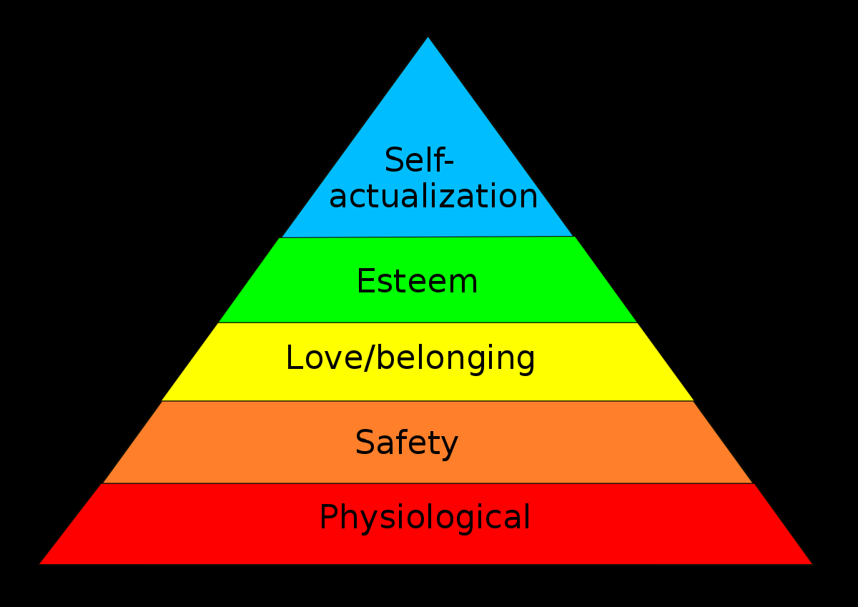

Appendix 3



Appendix 4

Appendix 5
Description – We were put into groups to create a business plan on a business that we wanted to set up. I was made team leader of the group.
Feelings – I felt stressed out at being the team leader and a lot of responsibility that I felt I couldn’t deliver.
Evaluation – Things went ok to begin with then they fell apart when I had a meltdown at the amount of work, I thought I had for the finance section of the business plan. Ash also let the team down last minute so that was added stress to the remaining group.
Analysis – if we had all remained as a group, I think that would have helped and if we had all done what had been delegated to us.
Conclusion – I could have stepped up as being a team leader instead of shying away from the responsibility. I have learnt that I am not a very good team leader and, in the future, I will try and accept the team leader role with more enthusiasm.
Action Plan – see PDP.

Appendix 6

