
Applied Leadership and Management in the Workplace
Module Assignment Submission
Student Name: | Lisa Williams
Student Number: | 2309068
Module No: | BMSK5009
Module Title: | Developing a High-Performance Culture

Statement of Confirmation of Authenticity
By the act of making this submission, the student declares that this is the work of the student named above. The work has not, in whole or in part, been knowingly presented elsewhere for assessment, or where assessment has been built on a previous assessment, this has been identified. Where materials have been used from other sources it has been properly acknowledged. If this statement is untrue, the student acknowledges that an assessment offence has been committed.
Attention is drawn to the plagiarism and unfair practice policies of both the University and of ILM.

Table of Contents
Introduction 3
Critical assessment of culture and context in an organisation. 3
Culture and Context 3
Models of Culture 4
Schein 4
Handy 5
Hofstede 5
Trompenaars 6
Johnson & Scholes 6
How these align within the organisation 7
Formal and informal relationships 8
2. Organisational Environmental analysis that can impact or influence culture. 9
SWOT 9
PESTEL 9
Political Factors 9
Economic Factors 10
Social Factors 10
Technological Factors 10
Environmental Factors 11
Legal Factors 11
Mc Kinsey 7S 11
Strategy 11
Structure 11
Systems 12
Shared Values 12
Style 12
Staff 12
Skills 13
3. Organisational comparison of culture and ethical behaviour. 13
Ethics and ethical behaviour 13
What shapes the behaviours within the organisation 14
Summary 15
References 16
Appendix A 17
Strengths 17
Weaknesses 17
Opportunities 17
Threats 17

Introduction
This report investigates the complex aspects that influence organisational culture, conduct, and performance, building on established theoretical models and applying them to real-world businesses. It investigates how values, leadership, formal and informal structures, and broader environmental influences shape and affect culture, as well as how ethical principles govern organisational decision-making. Using Tesco as the primary case study, the report examines how cultural models and environmental conditions influence its organisational climate, behaviour, and high-performance expectations, while a comparison to Amazon demonstrates how different strategic contexts produce contrasting cultural outcomes. The report's study attempts to give a complete knowledge of how culture and behaviour interact inside businesses, as well as how good cultural alignment may promote long-term organisational success.

Critical assessment of culture and context in an organisation.

Culture and Context
Organisational culture is commonly believed to be the shared values, beliefs, standards, and underlying assumptions that determine how people behave in the workplace. However, the idea is still debated both in theory and reality. (Schein, 2010) believes that culture functions on several levels, from apparent artefacts to implicit beliefs, making it difficult to examine directly and much more difficult to modify purposefully. (Hofstede, 2005) by contrast conceptualise culture as a collective “mental programming,” highlighting national and societal influences that shape organisational behaviour. Critics contend that such models risk oversimplifying culture by portraying it as uniform and unchanging, despite evidence that organisations frequently contain various sub-cultures that differ between teams, professions, and hierarchical levels (Alvesson, 2013a). The debate between functionalist and interpretivist perspectives also complicates the concept. Functionalists view culture as a managerial tool that can be engineered towards desired outcomes, while interpretivists argue that culture emerges dynamically through lived experiences and cannot be neatly manipulated (Alvesson, 2013b). Furthermore, some academics suggest that attempting to define culture too precisely may mask its political aspect, in which dominant groups impose ideals under the pretext of "shared beliefs," marginalising other perspectives. Thus, organisational culture should be viewed as a complex, diverse, and ever-changing social construct, rather than a single, fixed essence. This complexity has important consequences for efforts to foster a high-performance culture, since any intervention must address the interaction of power, identity, and meaning-making that drives day-to-day organisational activity.

In organisational studies, context refers to the set of external and internal elements that influence how organisations function, make choices, and behave; nevertheless, the notion is intrinsically multi-layered and controversial. (Cropanzano & Mitchell, 2005) argues that context has historically been under-theorized, despite its critical role in explaining why organisational practices succeed or fail, and that context is made up of both "omnibus" factors (broad situational variables such as industry, location, and economic conditions) and "discrete" factors (specific situational cues that directly influence behaviour). Similarly, (Waller et al., 2001) highlight that organisational events cannot be effectively explained unless they are understood in the context of their occurrence, cautioning against universalistic assumptions in management research. While it is crucial to recognise individual and cultural variations, there is also shared meaning across work settings, cultures, and organisational contexts (Steenkamp & Basson, 2013). Critics claim that many organisational models overlook context by prioritising internal processes over larger social, economic, and historical causes, oversimplifying why firms operate the way they do. Furthermore, context alters over time, and businesses must constantly adjust to changes in technology, labour markets, geopolitical events, and stakeholder expectations. Understanding context necessitates a comprehensive, dynamic approach that acknowledges the interplay of structure, agency, and environment. These complexities highlight why establishing a high-performance culture requires a comprehensive understanding of the organisational context in which such cultural transformation occurs.

Models of Culture

Schein
Schein claimed that modern organisations have challenges due to a lack of differentiation between various levels of organisational culture (Morente et al., 2017). Hence (Schein, 2010b), identified three layers of corporate culture: artefacts and creations, values and beliefs, and basic assumptions. The model views culture as existing on three interrelated levels: artefacts, espoused values, and basic underlying assumptions. Artefacts represent observable organisational structures and actions while professed ideals capture stated tactics and aims, then underlying assumptions indicate unconscious ideas that genuinely drive conduct. Schein believes that true cultural transformation must occur at the most fundamental level, making culture both strong and difficult to govern.
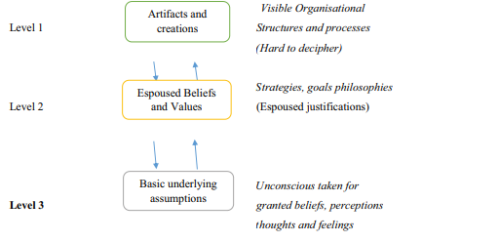
(Makumbe & Washaya, 2022).

Handy
Charles Handy proposes four kinds of organisational cultures: power, role, task, and person. Each represents distinct views regarding authority, organisation, motivation, and connections. Power cultures, for example, place a premium on control, whereas task cultures place a focus on collaboration and problem solving. Handy's theory assists businesses in understanding how structure and power dynamics influence everyday conduct (Handy, 1999).
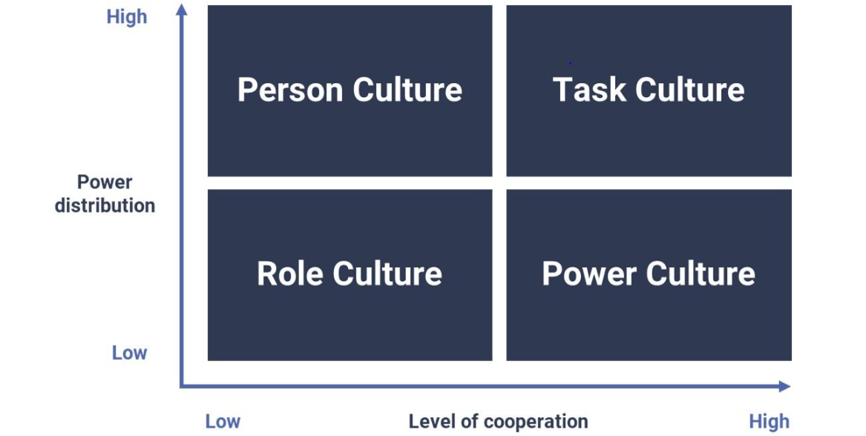
(Nine Dots Development Limited, 2024).

Hofstede
Hofstede's model identifies six dimensions; power distance, individualism/collectivism, masculinity/femininity, uncertainty avoidance, long-term orientation, and indulgence/restraint that explain how national cultures impact organisational behaviour. Though extensively employed, the model has been critiqued for portraying national cultures as unchanging and homogeneous.
1. Power Distance refers to the many solutions to the fundamental problem of human inequality.
2. Uncertainty Avoidance refers to a society's level of stress in the face of an unclear future.
3. Individualism vs Collectivism, concerning the integration of individuals into fundamental groupings.
4. Masculinity vs Femininity refers to the separation of emotional roles between men and women.
5. Long Term vs Short Term Orientation, which refers to whether individuals should focus their efforts on the future or the present and past.
6. Indulgence versus Restraint, which refers to the satisfaction versus management of fundamental human urges associated to enjoying life.
(Hofstede, 2011).

Trompenaars
Trompenaars and Hampden-Turner's seven elements of culture offer a framework for understanding how cultural variations influence interpersonal relationships, organisational practices, and management conduct. The first dimension, Universalism vs. Particularism, refers to whether rules or connections take precedence in decision-making. Individualism vs. Communitarianism asks whether people regard themselves primarily as independent individuals or as members of a collective. Neutral vs. Emotional separates societies that repress emotional expression from those who openly exhibit it. Specific vs. diffuse refers to how people divide or combine personal and professional realms. Achievement vs. Ascription examines whether status is gained by performance or assigned through age, gender, or social ties. The sixth dimension, Sequential vs. Synchronic Time, distinguishes cultures that regard time as linear and schedule-driven from those that see time as flexible and multifaceted. Finally, internal vs. external control reflects opinions about whether people shape their surroundings or adapt to them. These characteristics demonstrate that effective cross-cultural management necessitates awareness to varying assumptions about relationships, time, status, and controls.
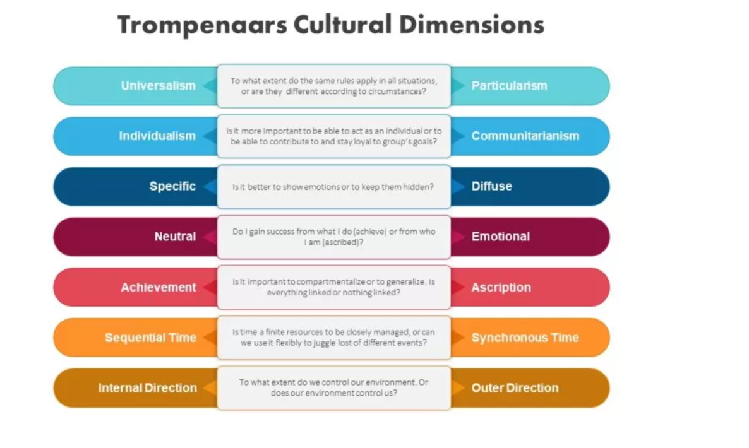
(Gerguri, 2023).

Johnson & Scholes
Johnson and Scholes suggest the Cultural Web, a model that outlines six interconnected elements. Stories, symbols, rituals, power structures, organisational structures, control systems, and the overall paradigm—that influence corporate culture. The approach focusses on how culture is replicated via everyday activities and organisational design. At the centre of both his diagram and his cultural thesis is what Johnson refers to as the "paradigm," which is the result of an organisation's taken-for-granted assumptions. These assumptions are complicated, sometimes unchallenged, and deeply buried within the practices and views at play in an organisation, and while they are implicitly known by many inside the company, they are difficult to expressed (Mc Donals & Foster, 2013).
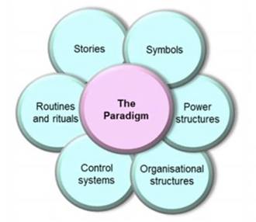
(Laura N., 2019).

How these align within the organisation
An examination of Tesco's organisational culture through the prism of recognised culture models finds a complicated but continuous pattern focused on operational efficiency, customer service, and organised management control. Using Schein's model, Tesco demonstrates clear cultural layers. At the artefact level, its standardised store layouts, uniform policies, performance dashboards, and tightly codified processes reflect a visible commitment to consistency and efficiency. At the espoused values level, Tesco emphasises customer focus, teamwork, and delivering value; and at the deeper level of underlying assumptions, there persists a belief that organisational success depends on disciplined executives. Handy's typology is also consistent with Tesco's structure, which demonstrates a dominating role culture using formal procedures, hierarchical reporting lines, and clear job responsibilities. All characteristics of a major, mature retailer. Elements of Task Culture can be found in project-based teams working on digital innovation and supply chain transformation, but the overarching cultural logic is rigid rather than adaptable, reflecting the need to manage risk, compliance, and operational scale across thousands of stores and employees. When considering Hofstede's dimensions, Tesco's culture tends towards low to moderate power distance in customer-facing operations, encouraging staff initiative within structured boundaries while maintaining high uncertainty avoidance, emphasising adherence to standards, audits, and protocols to ensure safety, consistency, and legal compliance. Tesco's UK origins situate it in an individualist national setting, but operationally, the company fosters cooperation and shared responsibility, resulting in a mix of individual accountability and group performance. Trompenaars' seven aspects offer insight into Tesco's cross-cultural operations. As an international retailer, Tesco tends to adopt universalist approaches through global policies, codes of conduct, and standard operating procedures. Its promotion systems are predominantly achievement-oriented, with progression linked to measurable performance; and its approach to time is sequential, reflecting the structured rhythm of retail operations. Meanwhile, Johnson & Scholes' Cultural Web demonstrates how Tesco's paradigm is reinforced by regular procedures, performance measures, corporate communications, and a heavy emphasis on operational discipline. Stories of lengthy service, great customer care, and operational improvements promote the organisation's ideals, while control mechanisms like KPIs, compliance checks, and productivity objectives affect behaviour throughout the organisational hierarchy. Schein's approach is the best fit for evaluating Tesco's culture since it reflects the multi-layered structure of a major organisation that combines observable routines with underlying beliefs about efficiency and customer service. Schein's emphasis on underlying assumptions is especially pertinent to Tesco's long-held commitment in operational excellence and value delivery—beliefs that continue to guide decision-making even as the retail industry advances. The Cultural Web is also an effective explanatory tool, particularly in demonstrating how Tesco's paradigm is maintained through rituals (daily briefings, performance evaluations), symbols (uniforms, branding), and structures. However, Schein's model provides the most comprehensive framework for understanding how Tesco's culture endures and develops over time, making it the best fit for evaluating the organisation's current behaviours, values, and strategic goals.

Formal and informal relationships
Formal and informal ties coexist inside companies, shaping the organisational atmosphere, cultural norms, and ethical conduct. Hierarchical structures, job roles, and rule-based coordination establish formal connections, which are congruent with Handy's Role and Power cultures, where authority, responsibilities, and communication flows are distributed through organisational design organisational climate. Recruitment processes, formal induction, written procedures, organisational charts, and reporting lines all help to establish and strengthen these ties. They provide predictability, role clarity, and compliance—essential characteristics of a structured organisational atmosphere (Ehrhart et al., 2014a). In contrast, informal connections emerge naturally because of social contact, shared experiences, personal trust, and voluntary collaboration. They are more closely aligned with Achievement and Support cultures, where influence comes from competence, peer esteem, relational links, and mutual support rather than organisational status (Cameron & Quinn, 2011). Informal networks evolve through everyday discussion, mentoring, cross-team interaction, and socially built conventions, resulting in what (Granovetter, 1973) refers to as "weak ties" that play a key role in information flow and problem resolution.
Informal networks have a substantial effect on ethical conduct because employees usually rely on trusted peers to understand unclear regulations, manage challenges, and perceive organisational expectations (Treviño et al., 2006). In environments with strong psychological safety and collaborative norms, informal interactions foster ethical voice, integrity, and shared moral reasoning. However, informal networks can spread unethical standards if powerful members minimise compliance or normalise improper behaviour. The organisational atmosphere, defined as workers shared impressions of policies and procedures, influences whether informal networks encourage or weaken integrity (Ehrhart et al., 2014b). Communication norms are crucial to this process: although formal communication provides official ethical standards, actual ethical decision-making frequently occurs inside informal interactions when individuals interpret regulations, seek advice, and negotiate "how things are really done" (Morrison, 2014). When informal communication is transparent and values-driven, it supports ethical behaviour; when it is secretive, defensive, or moulded by informal power holders, it has the potential to distort policies and undermine ethical decision-making. Finally, formal institutions provide ethical standards, but informal interactions shape how those expectations are perceived, implemented, and integrated into daily organisational life.
Within Tesco, the interaction between formal and informal connections has a significant impact on operational success, staff engagement, and ethical conduct. Tesco's formal connections reflect a role-based culture, with hierarchical reporting lines, established processes, KPIs, and compliance systems governing everyday operations across shops, distribution facilities, and head office activities. These formal frameworks create a culture that values operational efficiency, customer service, and adherence to performance criteria. However, Tesco relies largely on informal ties to keep operations running well in a fast-paced retail environment. Shop-floor colleagues develop informal networks that allow for speedy information exchange, emotional support, and practical issue solving—especially during busy business seasons. These networks frequently operate as Support or Achievement cultures, in which individuals earn influence via expertise, dependability, and interpersonal trust rather than formal authority.
Informal networks at Tesco have a considerable influence on ethical conduct. When interpreting regulations governing customer service, product handling, waste reduction, and safety compliance, employees frequently confer with more experienced colleagues. Informal connections built on trust can assist sustain ethical norms, such as reporting concerns, encouraging new colleagues, or criticising unethical conduct, especially in circumstances where managers actively promote open communication. In contrast, if informal networks arise around shared grievances or cynical attitudes towards norms, they may generate areas where shortcuts or noncompliance are tolerated.
2. Organisational Environmental analysis that can impact or influence culture.

SWOT
Please see Appendix A.
PESTEL

Political Factors
Political pressures have a considerable impact on Tesco's cultural values, particularly those related to compliance, transparency, and corporate responsibility. The UK government's rules on employment law, food safety, price transparency, and competition foster a culture that values responsibility, consistency, and risk management. Brexit-related trade challenges have strengthened a culture of adaptation and resilience at Tesco, which has had to handle supply chain interruptions and regulatory changes. Sustainability policies, such as carbon reduction objectives, packaging requirements, and waste management, also urge Tesco to foster an environmentally responsible culture, affecting behaviours from procurement to store-level operations. Political monitoring of major merchants fosters a culture of ethical behaviour and effective stakeholder communication.

Economic Factors
Economic situations have a direct impact on Tesco's corporate atmosphere and employee behaviour. Inflation, rising supplier prices, and cost-of-living constraints foster a culture of cost-cutting, efficiency, and performance intensity. During economic downturns, there is a greater emphasis on productivity, value generation, and operational discipline, which reinforces formal role cultures based on KPIs and performance monitoring. In contrast, advantageous economic conditions may allow for more investment in people development, creativity, and well-being, resulting in a more balanced and supportive culture. Competitive economic pressures from Aldi, Lidl, and internet retailers have shaped a culture of constant development, speed, and customer attention throughout Tesco's operations.

Social Factors
Tesco's cultural identity is highly influenced by shifting customer demands and staff demographics. Customers are increasingly valuing ethical sourcing, sustainability, and inclusion, creating a culture of accountability, transparency, and authenticity. Tesco is under pressure to establish a supportive culture centred on engagement and growth due to workforce demographics, particularly younger employees who value flexibility, well-being, and development. Social trends centred on work-life balance and mental health have also fostered an environment of empathy, transparency, and colleague support. Furthermore, Tesco's diversified workforce across regions and store types emphasises the value of an inclusive and collaborative environment.

Technological Factors
Technological progress is key to Tesco's culture of innovation, efficiency, and digital capabilities. The proliferation of online commerce, automation, AI-powered analytics, and digital communication tools has fostered a culture of flexibility, constant learning, and data-driven decision-making. Employees must accept change and upskilling when using technologies like self-checkouts, automated warehouses, and digital stock systems, resulting in a culture of digital literacy and adaptability. Internal communication platforms also have an impact on informal networks and cooperation, which helps to increase peer support and teamwork. However, fast technological change can cause worry or resistance, impact morale and cultural alignment if not managed properly.

Environmental Factors
Environmental concerns, particularly those concerning sustainability and climate responsibility, are progressively shaping Tesco's corporate culture. Public and legislative expectations for carbon reduction, reduced plastic usage, energy efficiency, and responsible sourcing build a culture of ethical stewardship and continual environmental progress. Tesco's dedication to decreasing food waste and reaching net-zero emissions promotes responsibility, innovation, and long-term thinking. Recycling programs, energy-efficient buildings, and sustainable supply chains all contribute to a culture in which environmental consciousness is integrated into day-to-day operations and decisions.

Legal Factors
Tesco is highly affected by legislative regulations regarding worker rights, equality, data protection (GDPR), food safety, customer protection, health, and safety. These legal frameworks foster an environment of compliance, integrity, and procedural uniformity. Stringent safety standards promote a culture of awareness and accountability, particularly in high-risk workplaces like warehouses and distribution centres. Employment laws demand fair treatment, anti-discrimination procedures, and protection of colleague welfare, all of which contribute to the development of a culture that values inclusion and ethical conduct. Legal repercussions for breaches, such as mislabelling, price mistakes, or safety violations, reinforce a risk-aware and accountability-focused culture.

Mc Kinsey 7S

Strategy
Tesco's strategy is centred on providing value to customers through low price, extensive product availability, better service quality, and a seamless omnichannel experience. The company focusses on efficiency, digital transformation, and long-term growth, with the goal of increasing loyalty and maintaining market leadership in the UK supermarket industry. This approach cultivates a culture of continuous improvement, operational discipline, and customer-centric conduct. Recent investments in data analytics, internet retail, and speedy delivery services support a forward-thinking, creative cultural approach.

Structure
Tesco employs a hierarchical yet decentralised structure that mixes centralised decision-making with store-level autonomy. The Group-wide organisation consists of commercial, operations, supply chain, digital, and corporate departments, all of which contribute to consistent service delivery. At the store level, clear reporting lines and job clarification represent a job Culture in which duties and processes are well defined. This framework encourages predictability and scalability, but it also necessitates effective communication to preserve cultural continuity across several locations and forms.

Systems
Tesco's systems, which include performance management, operational procedures, customer service standards, human resource practices, and technological platforms, play a key role in moulding behaviour. Advanced solutions like automated stock management, self-checkout technology, colleague portals, and KPI dashboards help to encourage a culture of data-driven decision-making and efficiency. HR systems such as organised training, career paths, and well-being initiatives promote cultural ideals of growth and inclusion. Compliance and auditing systems encourage responsibility, ethical behaviour, and safety.

Shared Values
Tesco's cultural basis is built on its key principles of "Every Little Helps," customer attention, respect for colleagues, integrity, and striving for perfection. These common ideals shape attitudes, govern conduct, and unite teams of thousands of people. The emphasis on service, community participation, and ethical sourcing fosters a sense of duty and integrity. Shared values also guide Tesco's approach to sustainability, diversity, employee well-being, and long-term responsible growth.

Style
Tesco's leadership style blends performance-driven management with an increasing emphasis on empowerment, inclusion, and open communication. Senior leaders foster transparency through frequent updates, colleague forums, and engagement surveys, therefore creating a supportive corporate atmosphere. Managers on the shop floor are supposed to set a good example, maintain standards, and promote collaboration. Tesco's leadership style fosters a combination of Role Culture (clarity, consistency) and Support Culture (collaboration, well-being), impacting how workers perceive their everyday work interactions.

Staff
Tesco employs diversified staff across retail, distribution hubs, and corporate operations. Staff development is aided by organised training, leadership programs, apprenticeships, and internal advancement chances. Workforce diversity, contract flexibility, and wellbeing initiatives demonstrate Tesco's dedication to fostering an inclusive and supportive company. However, concerns like frontline turnover need constant attention to ensure cultural continuity and employee engagement.

Skills
Tesco's core competencies are operational excellence, supply chain management, customer service, data analytics, and digital innovation. Employees at all levels are educated to sustain high operating standards, ensure product availability, provide customer happiness, and follow safety protocols. Tesco's expansion into automation, internet sales, and analytics has made digital skills increasingly crucial. Strengthening digital literacy and cross-functional cooperation fosters a culture of innovation and adaptation.
Overall, Tesco's 7S features are intricately interwoven and consistent. The organisation's strategy, systems, and structure drive consistency, efficiency, and customer focus, whilst shared values and leadership style encourage ethical conduct, teamwork, and employee well-being. Continued investment in digital capabilities and employee development will be critical to maintaining alignment and a strong, high-performance culture.

3. Organisational comparison of culture and ethical behaviour.

Ethics and ethical behaviour
Ethics refers to the principles, values, and standards that guide human activity and assist individuals in determining what is ethically good or wrong. In organisational contexts, ethics influences how choices are made, individuals are treated, and obligations are carried out. (Crane & Matten, 2007) describe business ethics as the application of ethical concepts to business activity, emphasising the need of honesty, fairness, accountability, and respect for others. Similarly (Treviño & Nelson, 2021) define ethical conduct as activities that are consistent with commonly recognised moral standards and organisational norms, highlighting that ethics is both an individual and communal duty. Organisational ethics involve operating with integrity, avoiding damage, respecting stakeholder interests, and promoting open, accountable processes. According to (Fraedrich & Ferrell, 1992), organisational ethics lay the groundwork for an ethical culture by creating codes of conduct, leadership standards, and the ethical atmosphere that drives everyday decision-making. Overall, ethics and ethical behaviour provide a moral basis for building trust, reducing misconduct, and supporting responsible organisational performance.
Consequentialist and non-consequentialist ethical theories provide two opposing perspectives on how people and institutions judge right and evil. Consequentialist ethics, most usually linked with utilitarianism, evaluates acts based on their results. An activity is deemed ethical if it provides the greatest overall benefit or reduces damage to the greatest number of people. This approach serves as the foundation for many cost-benefit judgements, corporate social responsibility efforts, and stakeholder studies that balance implications across groups in organisational contexts. Non-consequentialist (or deontological) ethics, on the other hand, emphasises the intrinsic morality of actions rather than the consequences they generate. This involves responsibilities, rights, equity, and respect for persons. Based on this theory, a company must act ethically even if it results in less beneficial short-term consequences—for example, stating the truth despite commercial difficulties or protecting employee rights even when it is costly.

What shapes the behaviours within the organisation
A complex mix of values, attitudes, leadership practices, and environmental variables shapes organisational behaviour, influencing how people think, feel, and act in the workplace. Tesco's attitude is influenced by common principles such as "Every Little Helps," which emphasise customer attention, integrity, respect, and cooperation; these values create a supportive corporate atmosphere in which collaboration, consistency, and service quality are valued. Tesco's leadership encourages these behaviours through role modelling, clear communication, and a focus on procedural reliability, reflecting a role-oriented and people-cantered culture. Environmental influences, such as high customer expectations, regulatory demands, and intense rivalry, support attitudes based on accountability, ethical conduct, and operational efficiency. In contrast, Amazon's organisational behaviour is determined by its leadership values, such as "Customer Obsession," "Bias for Action," and "Deliver Results," which foster a performance-driven, innovation-focused, and highly competitive culture. Amazon's environment, which is marked by fast technology development, global size, and aggressive market dynamics, promotes speed, experimentation, and high individual accountability. Tesco and Amazon differ due to their respective businesses, strategic interests, customer expectations, and operational strategies. Tesco's store-based retail operations rely on collaboration, stability, and trust, whereas Amazon's digital-centric, logistics-intensive approach necessitates agility, scalability, and innovation. These cultural differences have a significant impact; for example, Tesco's emphasis on support and role clarity fosters strong employee relationships and consistent service but may limit rapid innovation, whereas Amazon's high-performance culture drives technological advancement but can lead to stress, burnout, and ethical concerns. Tesco can benefit from Amazon's agility and data-driven innovation, giving it a competitive advantage in digital retail, while Amazon can learn from Tesco's people-focused, community-oriented culture, which improves employee wellbeing, trust, and long-term organisational sustainability. These comparisons emphasise how values, leadership, and environmental context influence conduct differently across businesses, as well as how cross-learning may enhance ethical, high-performance cultures.

Summary
To summarise, organisational behaviour and culture are influenced by a complex system of values, leadership practices, structural traits, and external environmental factors. Schein, Hofstede, Handy, Trompenaars, and the McKinsey 7S framework are examples of how common values, systems, and cultural factors shape how people view their jobs and behave within an organisation. Ethics also plays a key role, with consequentialist and non-consequentialist concepts influencing how companies approach decision-making and responsibility. The comparison of Tesco and Amazon demonstrates how differences in strategy, leadership style, operational environments, and cultural priorities lead to different behavioural expectations: Tesco's supportive, role-centered culture values consistency, service, and ethical behaviour, whereas Amazon's high-performance, innovation-driven culture values agility, experimentation, and outcomes. Both organisations are influenced by political, economic, social, technical, environmental, and legal variables, which define their internal cultures and ethical orientations. This research demonstrates that organisational behaviour is the result of several, interconnected elements, and that businesses may improve performance by aligning culture, ethics, structure, and leadership while learning from industry peers' methods.

References
Afif, A. N., Noviyanto, F., Sunardi, S., Akbar, S. A., & Aribowo, E. (2020). Integrated application for automatic schedule-based distribution and monitoring of irrigation by applying the waterfall model process. Bulletin of Electrical Engineering and Informatics, 9(1), 420–426. https://doi.org/10.11591/eei.v9i1.1368
Anderson, D. J., & Carmichael, A. (2016). Essential Kanban Condensed. Blue Hole Press.
Arshad, M., Saha, S., & Sahu, S. K. (2023, February 2). DEVELOPMENT OF RACI MATRIX FOR COMPLETE MACHINE LIFECYCLE. International Research Journal of Engineering and Technology . https://d1wqtxts1xzle7.cloudfront.net/99615126/IRJET_V10I277-libre.pdf?1678381799=&response-content-disposition=inline%3B+filename%3DDEVELOPMENT_OF_RACI_MATRIX_FOR_COMPLETE.pdf&Expires=1756501416&Signature=ZQD4xSKovR0FGMQhqdG8qeeJe6pCD-TEHm4xrNyLuxlTc-GBIqKAhr4aDo5zSFWRktKmygcn~moVPY0DZl~vFjWo2y~KGRgcliEFWlqQE4nUqwLIu5uu~rquMIpvceIr61ubs9t0bHmAH~BTOVLI9yLDM8WwDwG9PfyUkxl4MX14Lr4GisUD1NFNOothwInCiA5hs0RpqaGCpBoaPVn0XbpUe79CGp6hwCNn9CswJjS8VuMw91F~qO2irsG1EDhkYZIB0TH-~cCnU1-QCyPV45IqWs9qEF6XCijkIk8DAItHbBlxp5PDfz0mRyHZF32tbuH7pUFDht2Rijsye9XmKg__&Key-Pair-Id=APKAJLOHF5GGSLRBV4ZA
Barford, P., & Crovella, M. (2000). Critical path analysis of TCP transactions. ACM SIGCOMM Computer Communication Review, 30(4), 127–138. https://doi.org/10.1145/347057.347416
Besner, C., & Hobbs, B. (2021). Project Management Practice, Generic or Contextual: A Reality Check. Project Management Journal, 39(1), 16–33. https://doi.org/10.1002/pmj.20033
Bilgin, G., Eken, G., Ozyurt, B., Dikmen, I., Birgonul, M. T., & Ozorhon, B. (2017). Handling project dependencies in portfolio management. Procedia Computer Science, 121, 356–363. https://doi.org/10.1016/j.procs.2017.11.048
Chiang, H. Y., & Lin, B. M. T. (2020). A Decision Model for Human Resource Allocation in Project Management of Software Development. IEEE Access, 8, 38073–38081. https://doi.org/10.1109/access.2020.2975829
Davies, M. (2010). Concept mapping, Mind Mapping and Argument mapping: What Are the Differences and Do They matter? Higher Education, 62(3), 279–301. https://link.springer.com/article/10.1007/s10734-010-9387-6
Dinsmore, P., & Cabanis-Brewin, J. (2018). The AMA Handbook of Project management. / Dinsmore, Jeannette Cabanis-Brewin. Amacom.
Graessler, I., & Hentze, J. (2020a). The new V-Model of VDI 2206 and its validation. At - Automatisierungstechnik, 68(5), 312–324. https://doi.org/10.1515/auto-2020-0015
Graessler, I., & Hentze, J. (2020b). The new V-Model of VDI 2206 and its validation. At - Automatisierungstechnik, 68(5), 312–324. https://doi.org/10.1515/auto-2020-0015
Jabr, F. (2023). John A. Long - Publications List. Publicationslist.org, 14(6).
Leigh, D. (2009). SWOT Analysis (pp. 115–140). https://spada.uns.ac.id/pluginfile.php/766985/mod_resource/content/1/Leigh%2C%20D.%202010.%20SWOT%20Analysis%20Handbook%20of%20Improving%20Performance%20in%20the%20Workplace%20Volumes%201%203%2C%20115%20140.%20doi_10.1002_9780470592663_ch24.pdf
Pollack, J., Helm, J., & Adler, D. (2018). What Is the Iron triangle, and How Has It changed? International Journal of Managing Projects in Business, 11(2), 527–547. https://doi.org/10.1108/IJMPB-09-2017-0107
Senarath, U. (2021). Waterfall Methodology, Prototyping and Agile Development. Waterfall Methodology, Prototyping and Agile Development. https://doi.org/10.13140/RG.2.2.17918.72001
Sheffield, J. (2005). Systemic knowledge and the V-model. International Journal of Business Information Systems, 1(1/2), 83. https://doi.org/10.1504/ijbis.2005.007401
Simons, H. A. (2019). The Sciences of the Artificial, reissue of the third edition with a new introduction by John Laird. Google Books. https://books.google.co.uk/books?hl=en&lr=&id=yYSkDwAAQBAJ&oi=fnd&pg=PR9&dq=Simon
Todnem, R. (2005). Organisational Change Management: A Critical Review. https://www.avannistelrooij.nl/wp/wp-content/uploads/2017/06/Todnem-BY-2005-JoCM.pdf
Whiting, J. (2011). How to Make Matrix Methods of Risk Analysis More Effective and Accurate . How to Make Matrix Methods of Risk Analysis More Effective and Accurate, 613.

Appendix A

Strengths
- Strong company principles and a customer-centric approach - Tesco's long-standing principles, such as "Every Little Helps" and a focus on customer care, serve as a common cultural basis for shops, distribution facilities, and corporate activities. These principles assist to encourage habits centred on service, efficiency, and constant progress.
- Well-defined structures and processes - The organisation's clear operational frameworks, standard operating procedures, compliance systems, and performance dashboards contribute to a Role Culture that fosters stability and predictability in a high-volume retail environment.
- Leadership commitment to culture and engagement - Tesco makes significant investments in leadership development and training, reinforcing standards for inclusive behaviour, colleague welfare, and ethical conduct. This promotes a more friendly environment and reinforces both official and informal culture norms.
- Extensive internal communication routes - Daily group discussions, peer updates, digital communication applications, and scheduled team meetings all serve to spread values and expectations, minimising uncertainty and enhancing cultural alignment throughout the workforce.

Weaknesses
- Presence of subcultures across regions and store types - Large or geographically distributed organisations may have uneven cultural practices, resulting in misalignment and misunderstanding.
- Overreliance on hierarchy - Excessive bureaucracy or centralised decision-making might result in a restrictive culture that inhibits innovation and employee participation.
- High turnover in frontline roles - Frequent staff changes, particularly among customer service representatives, can undermine cultural continuity and lessen the impact of experienced colleagues who serve as cultural carriers.
- Communication overload - Even while communication channels are effective, the number of operational directions might cause information fatigue, reducing the effectiveness of cultural messages.

Opportunities
- Technological advances - Advances in automated checkouts, data analytics, and internet shopping (e.g., Tesco.com and Whoosh) allow for the creation of a more inventive, tech-enabled culture. This promotes agility, problem solving, and digital decision-making.
- Changing workforce demographics and expectations - Inclusion, flexibility, and growth are becoming increasingly important to younger employees. Tesco may embrace this move to develop a culture centred on empowerment, well-being, and career advancement, so reinforcing its employer brand.
- Sustainability and social responsibility trends - Tesco's public promises to decreasing food waste, boosting carbon efficiency, and ethical sourcing offer possibilities to foster an environmental and socially conscious culture.
- Regulatory and ethical requirements - Evolving regulatory frameworks for data protection, equality, and corporate accountability urge organisations to foster cultures of compliance, honesty, and transparency.
- Industry competitiveness - Pressure from Aldi, Lidl, Sainsbury's, and online competitors drives cultural development towards efficiency, cost-consciousness, and innovation, strengthening a high-performance culture.

Threats
- Economic insecurity and rising costs of living - Inflation, salary pressures, and growing operating expenses can all lead to morale issues, increased task stress, and decreased psychological safety, threatening cultural cohesiveness.
- Labour market changes - Tight labour markets can lead to a scarcity of experienced frontline workers, making it more difficult to maintain consistent cultural standards and team dynamics.
- Technological disruption - Rapid automation adoption may cause job security concerns, resistance to change, or skill shortages, jeopardising cultural alignment if not adequately handled.
- Public scrutiny and reputational risk - Tesco, a well-known retailer, is under constant investigation for its pricing, supply chain ethics, and employment policies. Any reputational crisis may undermine trust and necessitate cultural reforms that are difficult to accomplish.

