ACCA6011
AI and Machine Learning
Search and ML Clustering
Elizabeth Lowrie Proctor 1903551
4th January 2022

Contents
Introduction 2
Task 1 2
Task 2 3
Task 3 5
Conclusion 7
References 8

Introduction
The following report considers, applies and evaluates the Depth First Search and K Means algorithm, A.I and machine learning methods, in order to solve given problems.

Task 1
Although the accompanying solution is not in working order, acknowledgement of the important algorithm and data structures required are discussed below.
A depth first search (DFS) algorithm explores trees and graphs [1]. The Depth first search algorithm starts with the initial starting node within the graph and continues to travel through as far as possible. The algorithm then retraces backwards towards the most recent node that hasn’t yet been explored.
The implementation of a DFS requires the creation of a stack, pushing a visited node to the stack, pushing any available non-visited adjacent nodes onto the stack and repeating this process until there are no more left to add on the stack. A backtrack will then be completed to ‘pop’ a node from the stack and repeating the push process. This cycle will continue until the stack is empty.
The use of the ‘stack’ library was utilised for the usage of the ‘push’ and ‘pop’ calls.
Within the program the MAP.txt file is loaded and the dimensions of the height and width of the map stored within a 2d array.
The first starting position is placed into the bottom of the stack through the use of ‘push’. A while loop examines if the stack is empty and will continue if not empty.

Stack.push(findStart); //initialise stack with starting position
while (!Stack.empty()) //while loop commences if stack is not empty

If this while loop condition is satisfied, then the subsequent if statement checks commence.
The top of the stack is popped as the current position, this position on the map is replaced with a ‘.’ In order to see the route taken. In order to check if there are any valid adjacent nodes to be stacked checks are made to see if there are any obstacles (Within the map for this exercise an obstacle is recorded as a ’*’ for a wall or ‘.’ ,which identifies the node has already been visited). The code extract below illustrates the checks for any obstacles being made to the right of the current node.

{ //completed test to see if there are any obstacles to the right of the current position
if ((text[WIDTH * current.y + (current.x + 1)] != '*') && (text[WIDTH * current.y + (current.x + 1)] != '.')) //if there are no obstacles it enters the if statement
{
text[WIDTH * current.y + (current.x)] = '.'; //replaces the location with a breadcrum
adjPosition.x = current.x + 1; //places adjecent position into the struct
adjPosition.y = current.y;
Stack.push(adjPosition); //pushes this position to the stack as an available position
text[WIDTH * current.y + (current.x)] = '@'; //shows the location on the map
}
These checks are carried out in all directions through varying the x and y positions and placing any available nodes in the adjacent position structure.
If a clear path, with no obstacle is discovered, in any of these adjacent directions, then these positions are pushed onto the stack. This while loop will continue to record possible locations until the stack is empty, denoting all possible nodes have been visited.
The important data structures created are shown below. These are used in order to store the positions of the nodes throughout the depth first search process.
struct position { //creating the position structure to hold x an y axis
int x;
int y;
};
struct adjPosition { //creating the adjecent position structure to hold the x and y axis
int x;
int y;
};

std::stack<position> Stack; //defining the Stack class which will hold the data as defined in position struct

Task 2
The K-means algorithm is considered a popular data clustering algorithm, it allocates objects with alike characteristics to be grouped together. Xumin and Yong [2] describe the k-means as a “numerical, unsupervised, non-deterministic, iterative method. It is simple and very fast”.
The k-means algorithm classifies objects into different clusters through uniting to a local minimum [2]. The k-means algorithm consists of two stages. The first stage randomly choses k centres, with the second stage taking each data point to the nearest centre. The utilisation of the Euclidean distance is commonly used in order to calculate the distance between the cluster centres and each data object. After each data object is allocated a cluster the recalculation of the average is completed, and this process is repeated until the “criterion function becomes the minimum” [2].
The algorithm can be followed by firstly selecting the K as initial centroids; Form clusters through assigning to the closest centroid; Recalculate the centroids of the cluster and repeat until these centroids do not change [3]. Dibya Jyoti Bora et al cite revoledu.com’s [4] illustrative diagram of the algorithm, showing clearly the stages involved in the algorithm.
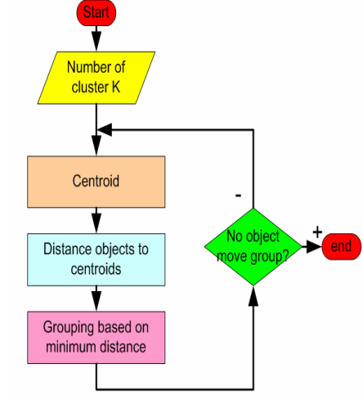
Figure 1: K-means algorithm [4]
During the K-means algorithm the distance calculation plays an important role. Although the Euclidean distance is most commonly used [2] , Dibya Jyoti Bora et al [4] consider the alternative distance measure techniques available and the impact these would have on the performance of the k-means algorithm. Their research examines the distance measures techniques Correlation, Cosine, Euclidean and Manhattan. Interestingly the results found that in terms of computation time the Manhattan technique presented better performance, whilst the Correlation measure illustrated a better understanding of the clustered data [4]. It is important to understand the type of data that is to be clustered as “choosing a proper technique for distance calculation is totally dependant on the type of data” [4].
Although a beneficial tool the K-means algorithm does have some shortcomings. Hamerly and Elkan [5] report one of these as being the requirement for the user to specify the number of k clusters and that electing the correct number k of clusters to use is “often not obvious”. Selecting the k is frequently considered on an ad-hoc basis and furthermore Hamerly and Elkan [5] report that this decision is made more difficult when there are many dimensions to the data.
Pham et all [6] also express that a clustering algorithm’s performance may be affected by the value of k chosen.
Various approaches and additional algorithms have been suggested in order to automatically determine the k, the majority of these methods have been “Wrapper methods” used for merging or splitting the rules for the centroids to decrease or increase as the algorithm proceeds [5]. Pham et all [6] examine various techniques that can be used to determine the k, including the use of statistical measures and through visualisation, providing their own solution method of introducing a factor function to evaluate the cluster results and use to assist in the selection of the cluster numbers. Utilisation of a method to assist in the selection of k clusters should be considered to enhance the algorithms performance.

The detection of any outliers is an important step in any analysis task, consideration of the impact of outliers is also important when utilising the k means clustering algorithm and removal can improve the accuracy [7]. In order to overcome this shortfall, there are various methods that could be adopted, from manually cleansing and removing any outliers or alternatively through the utilisation of techniques such as the inclusion of a “clustering algorithm with outlier detection” such as the KMOR algorithm explored by Gang and Kwok-Po [7], which naturally identifies and assigns any outliers into a group during the process of clustering.
Xumin and Yong [2] highlight the efficiency shortcoming of the k-means clustering algorithm, given the requirement to calculate the distance between all cluster centres and data objects at each iteration. This process is execution time consuming, especially when considering high capacity data. In order to improve efficiency and execution time, experiments were completed that discovered that it may not be necessary to re-calculate the distance on each iteration [2]. Xumin and Young [2] present an improved method through the creation of data structures to retain cluster labels and the distance of all objects to the nearest cluster. They report that by introducing the data structures it
“allows the function to reduce the number of distance calculations required to assign each data object to the nearest cluster, and this method makes the improved k-means algorithm faster than the standard k-means algorithm” [2].
The critical evaluation of the k means clustering algorithm has identified that whilst it is an effective and easy tool, one frequently used due to its performance [8], there are several shortfalls and considerations to be cognisant of, with some identified resolutions and approaches to utilise in order to enhance the algorithm’s performance.

Task 3
The steps below demonstrate a k-means calculation using the provided data points and randomised starting centroids.
 | x | y
a | 5 | 5
b | 0 | 5
c | 2 | 3
d | 2 | 2
e | 5 | 1
f | 3 | 3
g | 1 | 4
h | 5 | 3
i | 1 | 2
j | 4 | 2
Figure 2: data points
My random centroids (1903551)
 | x | y
C1 | 2.8 | 2.48
C2 | 2.2 | 1.67
Figure 3: Random starting centroids
The data has been plotted on a scatter graph in order to visualise the data and clusters – the starting random centroids have been added to the graph and highlighted in red.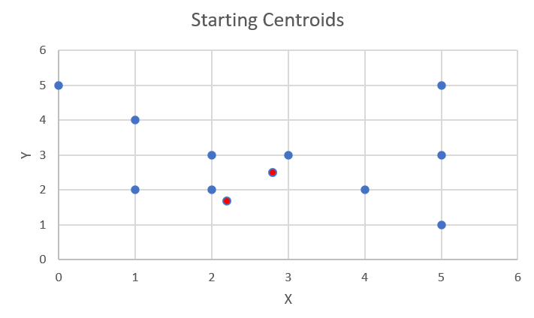
Figure 4: Starting Centroid scatter graph
The Euclidean distance calculation was used in order to calculate the distance between each data point’s X and Y value, and the random staring centroids provided.
( Euclidean distance formula used $d=\sqrt{{\left(x2-x1\right)}^{2}+{\left(y2-y1\right)}^{2}}$ )
An example can be seen below to how the Euclidean distance was used do calculate the distance of data point a from both random centroid points (C1 & C2).

Distance of a from C1
d= $\sqrt{{\left(2.8-5\right)}^{2}+{\left(2.48-5\right)}^{2}}$
d = $\sqrt{-{2.2}^{2}+ -{2.52}^{2}}$
d = $\sqrt{-4.84+ -6.35}$
d= $\sqrt{-11.19}$
d= 3.35 (2 decimal places)

Distance of a from C2
$$d=\sqrt{{\left(2.2- 5\right)}^{2}+{\left(1.67-5\right)}^{2}}$$
$$d= \sqrt{-{2.8}^{2}+ -{3.33}^{2}}$$
$$d=\sqrt{-7.84+-11.09}$$
$$d= \sqrt{-18.93}$$
d = 4.35 (2 decimal places)

This calculation was repeated for all data points within the data table (Figure 2: data points) and distance results shown in the table below.
 | Distance between C1 and data points | Distance between C2 and data points
a | 3.35 | 4.35
b | 3.77 | 3.99
c | 0.95 | 1.34
d | 0.93 | 0.39
e | 2.65 | 2.88
f | 0.56 | 1.55
g | 2.36 | 2.62
h | 2.26 | 3.10
i | 1.86 | 1.24
j | 1.29 | 1.83
Figure 5: Euclidean distance (Results shown in 2 decimal places)
The above table also highlights the closest centroid of the data point, enabling the data points to be assigned a cluster.
The table below assigns the data points to their clusters and calculates the mean value of the data points within these clusters. These results establish the new centroid values.
 | Clusters | Mean value of data points along X | Mean value of data points along Y
C1 | a,b,c,e,f,g,h,j | 3.13 | 3.25
C2 | d,i | 1.5 | 2

The updated scatter graph below illustrates the data points with the new calculated centroids (shown in red) and identifies, using colour (Yellow and Blue), the two k clusters.
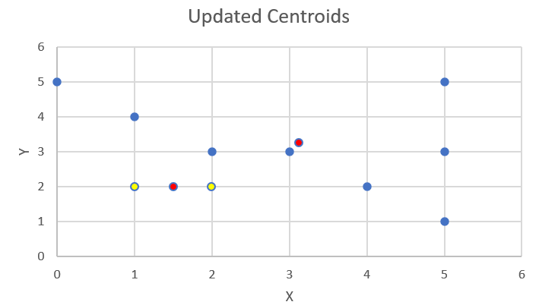
Figure 6: Updated centroid scatter graph
The above calculation completes 1 iteration of the k-means algorithm, in order to conclude the k-means, the process would be repeated until the updated centroids do not change.

Conclusion
Through the application and evaluation of the Depth First Search and K means algorithms it is clear that these A.I and machine learning methods can be utilised effectively and efficiently to solve various problems. Research also shows how methods could also be enhanced; consideration should be given to discussed improvement suggestions should these methods be utilised in future.

References

[1] | “simplilearn,” [Online]. Available: https://www.simplilearn.com/tutorials/data-structure-tutorial/dfs-algorithm. [Accessed 14 December 2021].
[2] | L. X. a. G. S. Na, Research on k-means Clustering Algorithm:An Improved k-means Clustering Algorithm, 2010, pp. 63-67.
[3] | T. M. A. R. S. &. M. K. Shaeela Ayesha, “Data Mining Model for Higher Education System",” European journal of Scientific Research, vol. 43, p. 27, 2010.
[4] | D. A. K. G. Dibya Jyoti Bora, “Effect of Different Distance Measurs on the Performance of K-Means Algorithm:An Experimental Study in Matlab,” International journal of Computer Science and Information Technologies, vol. 5, no. 2, 2014.
[5] | G. a. C. E. Hamerly, “Learning the k in k-means,” Advances in neural infromation processing systems, pp. 281-288, 2003.
[6] | S. S. D. a. C. D. N. D T Pham, “Selection of K in K-means clustering,” 27 Sep 2004.
[7] | G. a. M. K.-P. N. Gan, “K-means clustering with outlier removal.,” Pattern Recognition Letters, vol. 90, pp. 8 - 14.
[8] | S. R. P. T. M. S. Madhu Yedla, “Enhancing K-means Clustering Algorithm with Improved Initial Centre,” International Journal of Computer Science and Information Technologies, vol. 1, pp. 121 - 125, 2010.

