
MODULE NAME: MARKETING FUNDAMENTALS

MODULE CODE: LCBB4004

TOPIC: BLOGGING TO COMMUNICATE

STUDENT: MARTINA CHORLOVA

STUDENT NUMBER: 2028046

LECTURER NAME: TUSHARA BALENDRAN
DATE: 07/01/2022


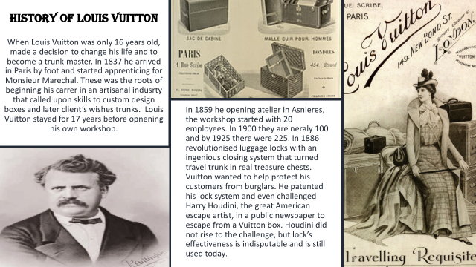





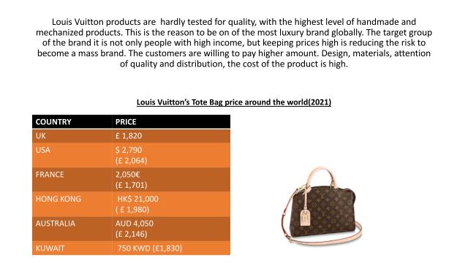

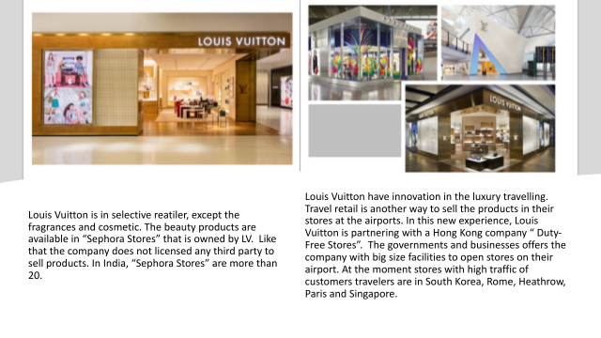


REFERENCES:

https://www.linkedin.com/learning/pricing-strategy-value-based-pricing/define-your-price-carrier-strategically?autoAdvance=true&autoSkip=false&autoplay=true&resume=false&u=77966930

https://www.lvmh.com/news-documents/news/lvmh-partners-with-other-major-luxury-companies-on-aura-the-first-global-luxury-blockchain/

