Brett Thomas (1807835)
University of Wales - Trinity Saint David
ACBA5004 – Geology and soil mechanics

Contents
1 Atterberg Limit Tests 1
1.1 Abstract 1
1.2 Introduction 1
1.3 Methodology for Liquid Limit test using Casagrande cup method 1
1.4 Methodology of Plastic Limit test 3
1.5 Results and Analysis 5
1.6 Conclusion 8
2 Constant Head Permeameter Test 9
2.1 Abstract 9
2.2 Introduction 9
2.3 Methodology 9
2.4 Results and Analysis 12
2.5 Conclusion 14
3 References 15

Atterberg Limit Tests

Abstract
In the following experiment a 250g soil sample is taken and tested using the Atterberg Limits procedure in order to allow us to classify the soil sample using its Plasticity Limit (PL), its Liquid Limits (LL) and its Plasticity Index (PI). The results of the testing will allow me to classify the soil sample.

Introduction
The classification of a soil sample is extremely important in civil engineering as it allows the engineer to understand the characteristics of the soil being tested. By understanding the mechanical properties of the soil materials, it allows the engineers to apply the knowledge of these properties to the engineering problems. The index properties of soil mechanics describe the physical characteristics with the influence on a soil’s behaviours. These index properties are the:
- Soil Texture – the makeup of the soil according their texture (the size, shape and gradation)
- Soil Consistency – the relative ease in which a soil can be deformed
- Soil Density – the mineral and its packing arrangement
Our experiment is to classify the soil sample using the Atterberg test which tests the soil consistency. The soil consistency will largely depend on the minerals and water content within the soil sample. There are two classes soils can be divided into for engineering purposes. Cohesive and Non-cohesive soils. Cohesive soils have shear strength and contain high clay minerals percentage which possesses plasticity. Non-cohesive soils (typically sand/gravel) have no shear strength. The identification of these types will assist in identifying the potential deformation of the soil. This behaviour is linked to the moisture content, plasticity and cohesion of the soil. The Atterberg limits are index tests, which is designed to give an idea or indicate how a soil will act under certain conditions.

Methodology for Liquid Limit test using Casagrande cup method
Equipment
- Casagrande cup machine
- Digital Scales
- Metal mixing bowl
- Spatula
- Gauging groove tool
- Marked containers for each sample
- Oven
- Soil sample
Firstly, we labelled and weighed the 4 empty containers and recorded the container weights down in our table. This gives us the cup weight so we can remove this from our soil samples once added.
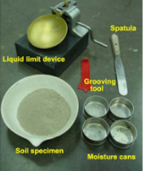
Figure 1 – Some of the equipment being used for the test
Next we placed a dry soil sample of around 250g of weight into the mixing bowl and stirred it with the spatula while adding very small amounts of water in order to produce a clay consistency. We were looking to have a firm clay which would require between 30-35 drops of the Casagrande cup for us to close the 12mm gap as per British Standards Procedure BS 1377-7:1990.
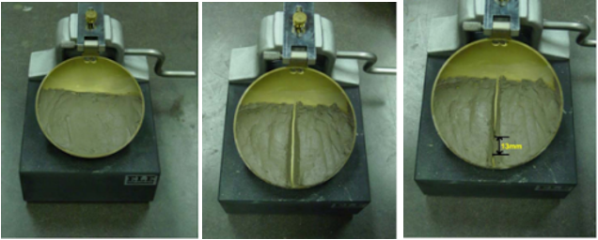
12mm closure
Figure 2 – Stages showing the clay sample testing steps
When we are happy with the consistency then we used the spatula to place a sample of the mixture into the Casagrande cup bowl. Then using the spatula, we had to make sure that we spread the sample across the bottom of the cup removing any air bubbles and as flat as possible to a depth of 10mm (see first photo above in figure 2).
We then took the gauging groove tool and cut a groove from the top of the sample down to the front of the cup in a continuous motion three times while avoiding disrupting the sides of the sample (see middle photo above in figure 2).
The sample is now ready for the testing phase. We made sure the Casagrande cup was set to zero. We turned the crank handle at a rate of two revolutions per second until the sample closed and the two halves of the sample had come together with a 12mm closure (see end photo in figure 2). When the two halves have come together turning of the crank handle is stopped and the number of blows visible on the counter is marked in our results table for sample one. The number of blows should be between 15-35 blows. As this is the first test and we would be adding the liquid to the sample as the test goes on then ideally the number of blows would be in the higher number (between 25-35 blows).
The sample is then removed from the cup and placed into the marked container for sample 1. This is then weighed using the digital scales and recorded in our table.
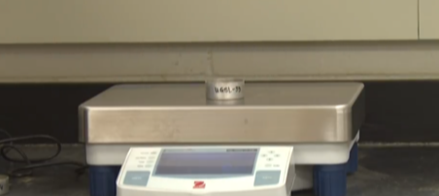
Figure 3 – Sample being weighed on digital scales
Then we will add water to the original sample to increase its moisture content. Once additional water is added, and the consistency becomes “wetter” we then repeat the above process and if the process is followed correctly then the number of blows that is required to close the 12mm gap should reduce. The sample will then be added to sample container two and weighed.
This is repeated for sample three and four.
When we have completed this process with the four samples and have weighed all four, we will then place the four samples into the oven and leave for 24 hours to dry the samples out. Once the 24 hours has passed then all four samples are re-weighed and recorded in our table.

Methodology of Plastic Limit test
The second stage of the Atterberg Limit test is completing a Plastic Limit test using the same soil sample used for the Liquid Limit test procedure. The plastic limit test is water content of the soil where it changes from the plastic state to a semi solid state. The test is completed by rolling out the soil/clay sample into a long cylindrical of 3mm thick without the sample crumbling. If the soil is drier than the plastic limit, then the thread will crumble at a diameter greater than 3mm. if the soil is wetter than the plastic limit the thread will crumble at a diameter less than the 3mm. Below is how to complete the test step by step. (Atterberg Limits, 2020).
Equipment
- Soil Sample
- Digital Scales
- Glass Rod
- Marked Containers
- Mixing Bowl
- Spatula
- Oven
The first step of the plastic limit test procedure is to mark out and weigh three empty containers. Record the container weights in your table. Take the soil sample and knead into a clay by adding water. Then mould the clay into a small ball using the fingers and palms of your hand. This should help warm the clay slowly and dry the clay. When a small crack appears on the surface of the clay ball then divide the clay sample into three equal parts of approximately 10g each.
Using the glass rod as an indicator of size, roll out the ball of clay to match the glass rod, this should be around 6mm. the thread must still be intact and homogeneous.
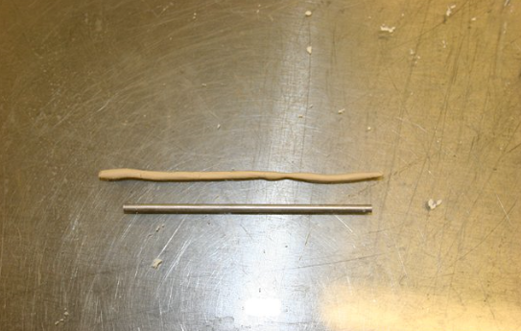
Figure 4 – The clay sample and the glass rod used as the indicator
Then using the palm of your hand, with a steady rolling pressure reduce the sample to around 3mm. Repeat this process until the thread starts to break and crumble which should ideally be around the 3mm mark. It is important that the sample starts to crumble due to the drying process due to the warmth of your hand and not due to the mechanical pressure of your hand.
Crumbling is defined as both shearing longitudinally and transversally as it is rolled. The crumbling point is the is the “Plastic Limit moisture content”. When this stage is reached, gather the crumbled and broken pieces of the clay and place them into your first container and weigh the wet soil on digital scales and record on your table.
This process is then repeated for the 2 other samples.
When all three samples have been weighed in their individual containers then they can be placed in the oven and left for 24 hours. When the 24 hours have passed then the samples can be re-weighed, and the dry samples recorded.

Results and Analysis
Now the two tests have been completed, from the data we have gathered, we can calculate the moisture content within each sample. So far, we have recorded the data below in figure 5. The four samples listed with type of test “LL” is the Liquid Limit test samples and the 3 sample tests with “PL” are our Plastic Limit test samples.
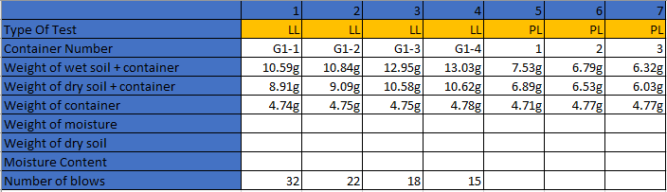
Figure 5 – Recorded findings from experiments
From our recorded data we can then workout the Weight of Moisture, Weight of dry soil and the moisture content by using simple arithmetic. I have completed the results below.
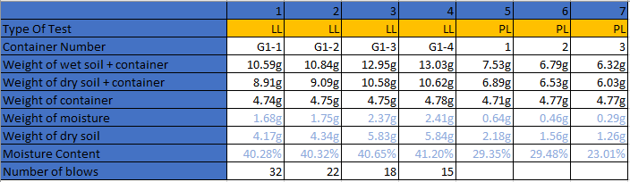
Figure 6 – Updated table showing calculated figures
To calculate the moisture within the sample a simple subtraction is completed, this is shown below for sample 1.
weight of wet soil + container – weight of dry soil + container = moisture content
10.59g – 8.91g = 1.68g
To calculate the weight of the dry soil another simple subtraction is completed.
weight of dry soil + container – weight container = Weight of Dry Soil
8.91g – 4.74g = 4.17g
The final calculation is the moisture content. This is where we work out the percentage of moisture within the sample.
weight of moisture / weight of dry soil x 100 = moisture content (Percentage)
1.68g / 4.17g x 100 = 40.28%

The above is then repeated for all the samples. This then gives us the percentage of moisture content of each of the samples.

The next step is to plot the Liquid Limit percentage figures against the number of blows on a graph. This is shown below in Figure 7. Once the numbers are plotted then an average line (red line) is drawn through the plots separating the plots as equally as possible. This ill give us the average figure of our Liquid Limit percentage.
Liquid Limit %
Number of Blows

Figure 7 – Table showing results of Liquid Limit Moisture content

From the above table and our results, we can see the similarity between our four samples. From drawing our average line (red line) we can derive our Liquid Limit (LL) of our sample as being 40.5%.

For our Plastic Limit figure, we simply take an average of our moisture content results. In this case we have our 3 test samples. The average, and therefore our Plastic Limit (PL) of our sample is 27.28% .

Now we have the Liquid Limit figure of 40.5% and our Plastic Limit of 27.28%, if we subtract the PL from the LL, this this will give us out Plasticity Index (PI) percentage. The Plasticity Index (PI) is 13.22%.

We now have the figures required for us to classify our soil sample using the Plasticity Chart for the classification of Fine Soils according to BS 5930:1999.

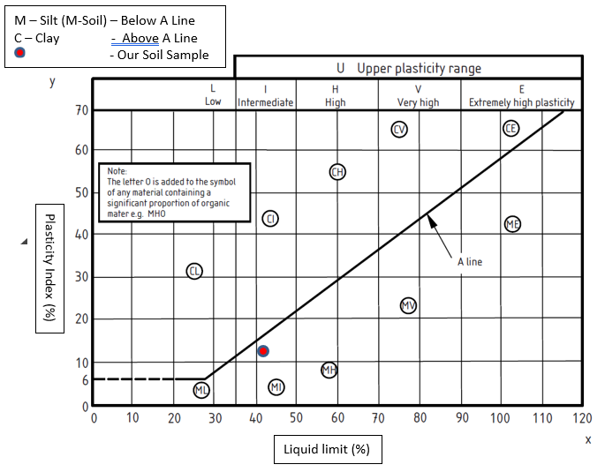

Figure 8 - Plasticity Chart for the classification of Fine Soils according to BS 5930:1999.

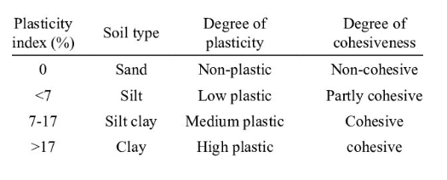

Figure 9 – Plasticity Index table from (Prakash and Jain, 2002)

From using the above graph as per BS procedures, we can see that our sample is classed as a Soil sample with intermediate/medium plasticity.

Conclusion

Now testing has been completed, we have identified the classification of our soil sample by using the Atterberg testing procedures, we can now see how this soil would behave in different conditions which can assist us in making a decisions affecting the engineering techniques that may be required depending on the type of project.

Using the Plasticity Index, we know that if a sample has a high Plasticity Index that it is more likely to be a clay type soil which has poor engineering properties. This is because clay can take on a high-water content. Strength of the soil/clay decreases as the water content increases. Soils will swell up when the water content is increased. What this means is the soil will be more at risk of excessive ground movement as the clay expands and contracts in differing weather conditions. This needs to be considered what type of foundations a construction can use. We also must consider the consolidation properties of the soil while calculating the bearing capacities and the settlement over time. The way the soil behaves as moisture content increases and decreases between the PL and LL will have an impact on the effective stresses of the soil.

From our results you can see from the table above in Figure 8 that our soil sample has recorded within the MI range. The sample is a silt/soil with intermediate plasticity. What this means is our sample has a degree of cohesiveness, and it does have a shear strength with plasticity properties.

The shear strength properties are of high relevance as it is one of the essential measurements for analysing and solving the stability problems (bearing capacity, slope stability). The liquid limits and plastic limits allow us to understand the behaviour of the soil and the soils shear strength capacities.

Constant Head Permeameter Test

Abstract
In the following experiment a 1kg sample of soil will be tested using the Constant Head Permeameter test to test the soils permeability and assist in classifying the soil type and its behaviours.

Introduction

The purpose of the Constant Head Permeameter Test is to determine the permeability of a soil sample. Permeability is the measure of the rate of flow of that of groundwater. The rate at which this happens depends on the soil sample. This test will allow is to ascertain the coefficient of permeability of the soil sample which can assist the engineer in solving issues relating to the yield of water on the bearing strata, stability of the earthen dams, seepage and settlement issues. (Engineering and Tests, 2020) There are several other factors we need to consider that affect the permeability of the soil which include, the particle size, the degree of saturation, void ratio and any impurities in the water.

We will use the constant head permeameter test to ascertain the coefficient of permeability of our soil sample for us to better understand how this soil will perform under these conditions.

Methodology

Equipment
- Constant Head Permeability Cell Test Cylinder (with protective screen)
- Manometer tubes
- Constant level water tank (reservoir)
- Digital Scales
- Hammer
- Measuring Beaker
- Soil Sample
- Container
- Ruler

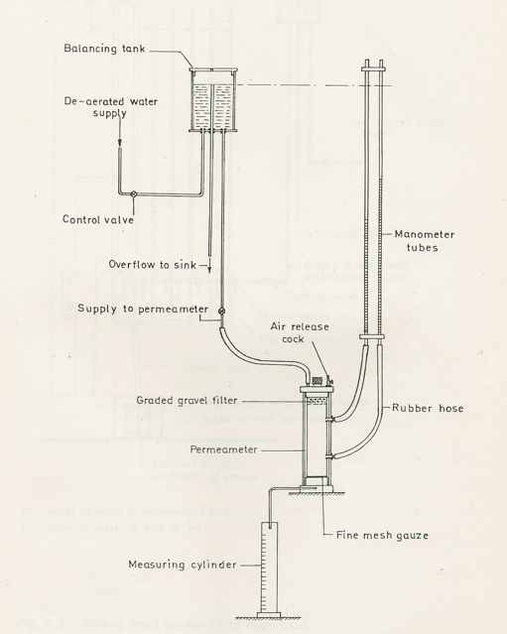

Figure 1 – Diagram showing the Constant Head Permeability test

The first step is to take approximately 1kg of our soil sample and weigh the mass of the soil plus the container. Record this in our table.

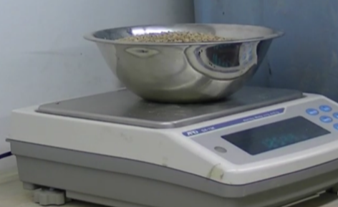4

Figure 2 – Soil Sample being weighed

Insert the protective screen at the bottom of the test cylinder. This will prevent any of the sample from being washed away. Then start filling the test cylinder cell with the soil sample. Carefully put the soil simply into the cylinder, pausing after a third has been filled to compact the soil simple using a hammer. Repeat until the cylinder is full.

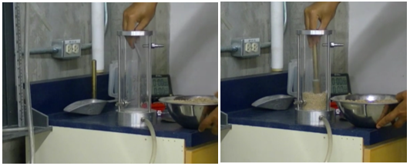

Figure 3 – Inserting soil sample for testing

Place another screen on the top of the sample with the separator and place the cap on top of the sample and secure the cap with the 3 screws.

Record the mass of the remaining soil in the container and note on the table.

Connect the intake line from the reservoir to the top of the test cylinder and the two tubes onto the manometer tubes from the outlet.

Connect the tube from the outlet tap and connect to the reservoir. Turn on the water tap.

Once the reservoir has filled and the overflow is running into the sink then the level of water in the reservoir is now constant.

Open the valve that connects the reservoir to our test cell. Before we measure any flow rates, we require the sample to remove all the air from the test cylinder. There is a small air valve vent on the top of the cell which can be opened if required.

We should now see the pore water pressure on the two manometers.

When we are happy the soil sample is saturated and there is no air within the sample then we can begin the next part of the test.

Start to fill the measuring beaker from the outlet flow at the same time as starting a stopwatch. Once the desired volume has been collected then stop the stopwatch. Record the mass of the beaker along with the time it took to fill.

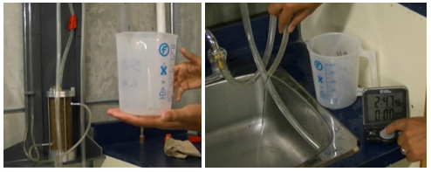

Figure 4 – Recording flow using Measuring Beaker

Repeat this process two more times looking to increase the volume collected each time.

Once these figures have been collected then a recording of the head of water will need to be taken from the manometers. A measurement of each monometers will need to be recorded for our head of water.

Results and Analysis

The constant head permeability test follows Darcy’s Law. (BS1377-Part 6) From our results we will now use Darcy’s law in order to derive the co-efficient of permeability of our soil sample.

The equation required for this is:

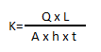

K = Coefficient of Permeability

Q = Flow over time ‘t’

L = Length of Flow Line

A = Area of Flow

h = Hydraulic Head Difference

t = Time in Seconds

I will now work out each of the three samples and calculate the co-efficient of permeability. There are several constants which will stay the same for each equation.

This is the L = Length of Flow Line, this was measured and is 0.2m.

The A = Diameter of our Testing cylinder, this is 0.1m. (radius will be 0.05)

Also, h = Hydraulic Head Difference, this was measured as 0.068m

Sample 1

Water collected for this sample was 920 x 10⁻⁷ m³ in 2 minutes and 45 seconds. Below is the calculation we now complete.

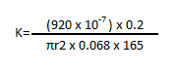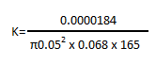

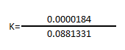

K= 2.088 x 10⁻⁴ m/s

Sample 2

Water collected for this sample was 185 x 10⁻⁶ m³ in 5 minutes and 30 seconds. Below is the calculation we now complete.

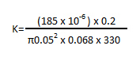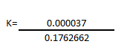

K= 2.099 x 10⁻⁴ m/s

Sample 3

Water collected for this sample was 36.8 x 10⁻⁵ m³ in 11 minutes. Below is the calculation we now complete.

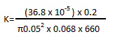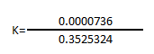

K= 2.099 x 10⁻⁴ m/s

We now have our 3 results. We will average these three results in order give us our final K value.

The final K value or co-efficient of Permeability for our soil sample is:

K= 2.092 x 10⁻⁴ m/s

Now our calculations are complete, and we have our Co-efficient result above. We can place this into the Darcy’s Law + Co-efficient of Permeability Table to give us the soils sample identification/classification.

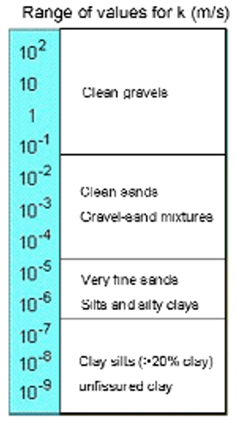

Figure 5 – Co-efficient of Permeability Table using Darcys Law

Our co-efficient range is 10⁻⁴ which we can see from our table falls within the Clean Sands, Gravel and Mixtures category.

Conclusion

From our constant head permeameter test we have been able to categorise our sample as a clean sand, gravel and mixtures type of soil.

The permeability of our soil sample can greatly impact how we approach engineering when it comes to building our structures. Ground water (natural rainwater) falls onto the ground and will permeate into the ground. It will seep by gravitation to lower levels and will then build up depending on the water table. The rate at which this happens can affect the soil and its engineering properties. This greatly effects the soils stability.

The water content within the soil effects the pore water pressure. When the soil is stressed from the engineering structure changes in the pore water pressure can affect the shear resistance on the soil. Water has a zero-shear resistance so if the soil becomes saturated this means the shear resistance to the structure can be greatly affected and cause deformation or failure of the structure. Understanding the permeability of the soil and the ground water table of a proposed site of the engineering structure can greatly affect the proposed methods for construction. Additional aspects to consider when looking at the soil sample and the permeability is the compaction of the soil after the structure has been completed. If the structure is constructed on a clay type soil in winter, the soil can hold large volumes of water, and then post construction completion there is a considerable dry period the shrinkage and compaction of the soil can have a great effect to the structure’s foundations. Whereas if we know the soil has a good rate of permeability and it is not held within the water table then the effect of change to our soil will be reduced and thus ground movement, compaction and consolidation is reduced.

References
British Standards Procedure BS 1377-2:1990 - Methods of test for soils for civil engineering purposes. Classification tests British Standards Procedure BS 1377-2:1990 -
Geoengineer.org. 2020. Atterberg Limits. [online] Available at: <https://www.geoengineer.org/education/laboratory-testing/atterberg-limits> [Accessed 18 March 2020].
2020.[online] Available at: <https://www.basiccivilengineering.com/2015/07/atterberg-limit-test-soil-mechanics.html> [Accessed 18 March 2020].
Prakash, S. and Jain, P., 2002. Engineering Soil Testing. Nem Chand & Brothers.
Engineering, G. and Tests, G., 2020. Permeability Of Soil By Constant Head Permeameter - Objectives & Procedure. [online] The Constructor. Available at: <https://theconstructor.org/geotechnical/soil-permeability-test-constant-head/2993/> [Accessed 22 March 2020].
British Standards Procedures 1377 – Part 6 - Methods of test for soils for civil engineering purposes. Compressibility, permeability and durability tests
British Standards Procedure BS 1377-2:1990 - Methods of test for soils for civil engineering purposes. Classification tests British Standards Procedure BS 1377-2:1990 -

