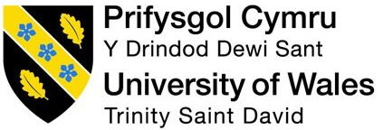

BMIH5003

Foreign Languages & Cultural Awareness

Intercultural Competence Report

Lecturer Name: Giulia Chifari
Name: Rowshan Ara Chowdhury
ID: 2231044

Executive Summary
The report uses GLOBE Project culture and leadership study scores to highlight France and England's cultural differences, analyse key findings and offer suggestions. France has a stronger performance, future, and humanitarian mentality, while England has higher assertiveness, institutional collectivism, and specific leadership styles. Communication, employment, and culture are issues. Clear goals, language training, and cultural sensitivity training can fix these challenges. Hospitality leadership requires team members to adapt, communicate, and understand. Hotel management teams can flourish by fostering cooperation and visitor happiness through cultural diversity and proactive actions.

Table of Contents
Executive Summary 2
Introduction 4
Analysis 5
Overview of culture 5
Analysis and comparison of England and France using the GLOBE Project 6
The challenges of inter-cultural leadership 8
Conclusion 10
Recommendations 11
References 12

Introduction
French and English cultures are compared in this report using GLOBE Project culture and leadership features. It will also discuss hospitality intercultural leadership issues and solutions. The goal is to compare cultural, customs, and leadership variations between the two nations using GLOBE Project data and examine their effects on multicultural hospitality workers. The study will analyse and provide solutions for multicultural leadership issues in this setting.

Analysis

Overview of culture
France and England have different traditions. Both France and England speak French and English. French may be formal, but English is direct. Etiquette and customs vary per country. English people wait and cherish punctuality (Neighbors, 2022). French eat slowly and may be late. Cuisines vary. French cuisine has cheeses, pastries, and gourmet dishes, while English cuisine has fish and chips, roast dinners, and afternoon tea. Longer French dinners have more courses than English ones. Work cultures differ in France and England. Production may be prioritised in England with fewer work hours and a hierarchy (Gilboa et al., 2020). Extended lunch breaks and collaborative decision-making enhance work-life balance in France.
Aspect | England | France
- Language and Communication | - English | - French
- Social Etiquette | - Queuing, Punctuality | - Leisurely Dining
- Cuisine and Dining | - Fish and Chips, Afternoon Tea | - Gourmet Cuisine
- Work Culture | - Efficiency, Hierarchy (Garrigos, Haddaji and Segovia, 2020) | - Work-Life Balance
- Social Structure | - Individualism | - Collectivism
- Authority | - Lower Power Distance | - Higher Power Distance
- Cultural Heritage | - Historical Landmarks | - Rich Cultural Traditions

Social structure and formality differ in both countries. England backs independence. Collectivist France promotes community and solidarity. Power distance is smaller in England than in France (Gilboa and Mitchell, 2020). England favours equality over hierarchy. England and France have many historical sites, festivals, and celebrations. Culture influences daily life and social customs in both countries.

Analysis and comparison of England and France using the GLOBE Project
The GLOBE Project is a research initiative that aims at developing an effective understanding of how cultural influence impacts organisational practice and leadership (Neighbors, 2022). The GLOBE Project's culture and leadership ratings show France and England's differences. France beats England on performance, future, compassion, in-group collectivism, and gender equality. England has more assertive, institutional collectivism, power distance, charismatic, team-oriented, and participative leadership. France's 5.9 score emphasises performance (Globeproject.com, 2020). England's 4.08 score indicates mediocre performance. France has good future planning at 5.06, whereas England has 4.28. This is a potential area of conflict because in France long-term planning is promoted but in England, it is not. France's 5.43 humane orientation grade values kindness and compassion over England's 3.72. France leads England in gender equality and in-group collectivism. French society values groups over individual’s more than English society (4.08). France's gender equality score is 5.17, surpassing England's 3.67. However, assertiveness, institutional collectivism, and power distance are higher in England. France's 3.7 assertiveness is less decisive than England's 4.15 (Ndiaye, 2022). English institutional collectivism is 4.27, indicating more organisational norms and processes than French 4.31. England's 5.15 power distance score promotes hierarchy and authority above France's 2.8.
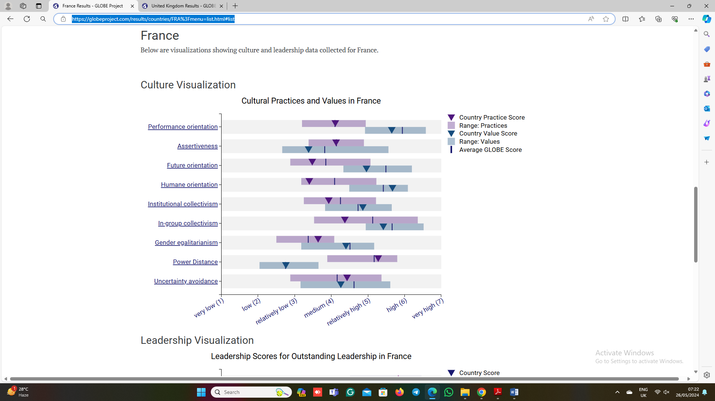
Figure 1: Cultural Visualisation of France
Source: (Globeproject.com, 2020)
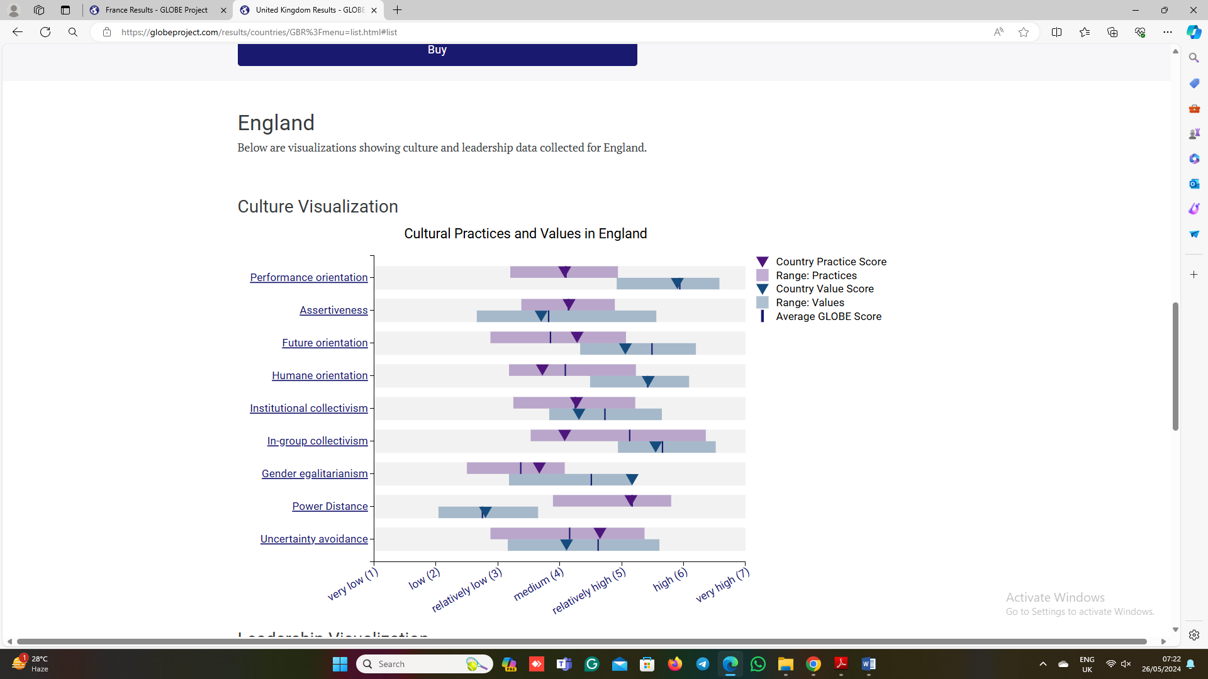
Figure 2: Cultural Visualisation of England
Source: (Globeproject.com, 2020)
England is ahead of France in charismatic, team-oriented, participatory leadership. France has charismatic leaders at 4.93, while England has inspirational leaders at 6.01. That means the leadership approach in both countries is different which might create a problem in the intercultural team. England's 5.71 team-oriented leadership score encourages collaboration, while France's 5.11 does (Globeproject.com, 2020). England's 5.57 participatory leadership score exceeds France's 5.9. Leadership and culture affect society, business, and hospitality. In a multicultural 5-star hotel, communication, collaboration, and leadership require cultural awareness. British hotel managers may need to be more hierarchical with French employees who value teamwork and egalitarianism. Culture can affect guest satisfaction and service. English guests may value efficiency and professionalism, while French guests may value personalisation (Spanaki, Papatheodorou and Pappas, 2021). Hotel workers should be trained to recognise and adapt to cultural preferences to give varied clientele a fantastic and memorable experience.
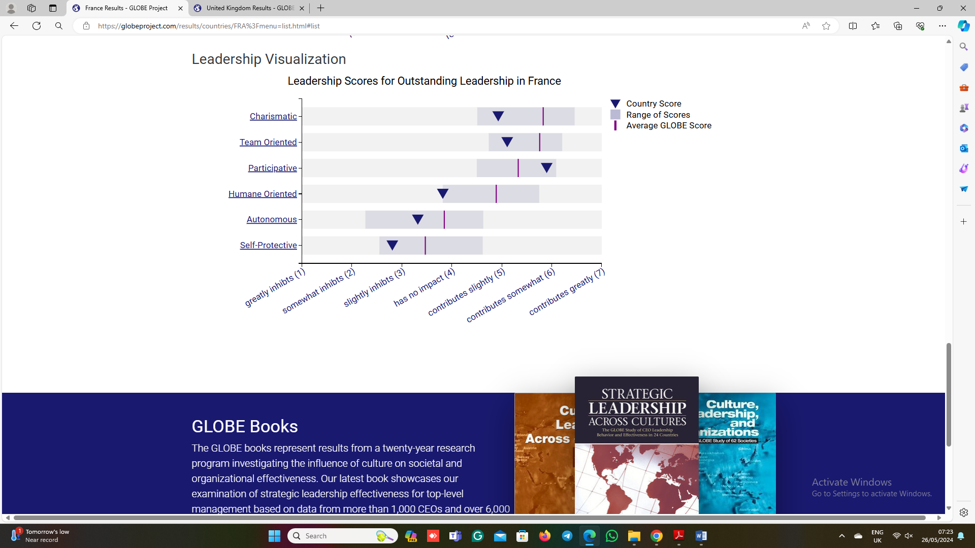
Figure 3: Leadership Visualisation of France
Source: (Globeproject.com, 2020)
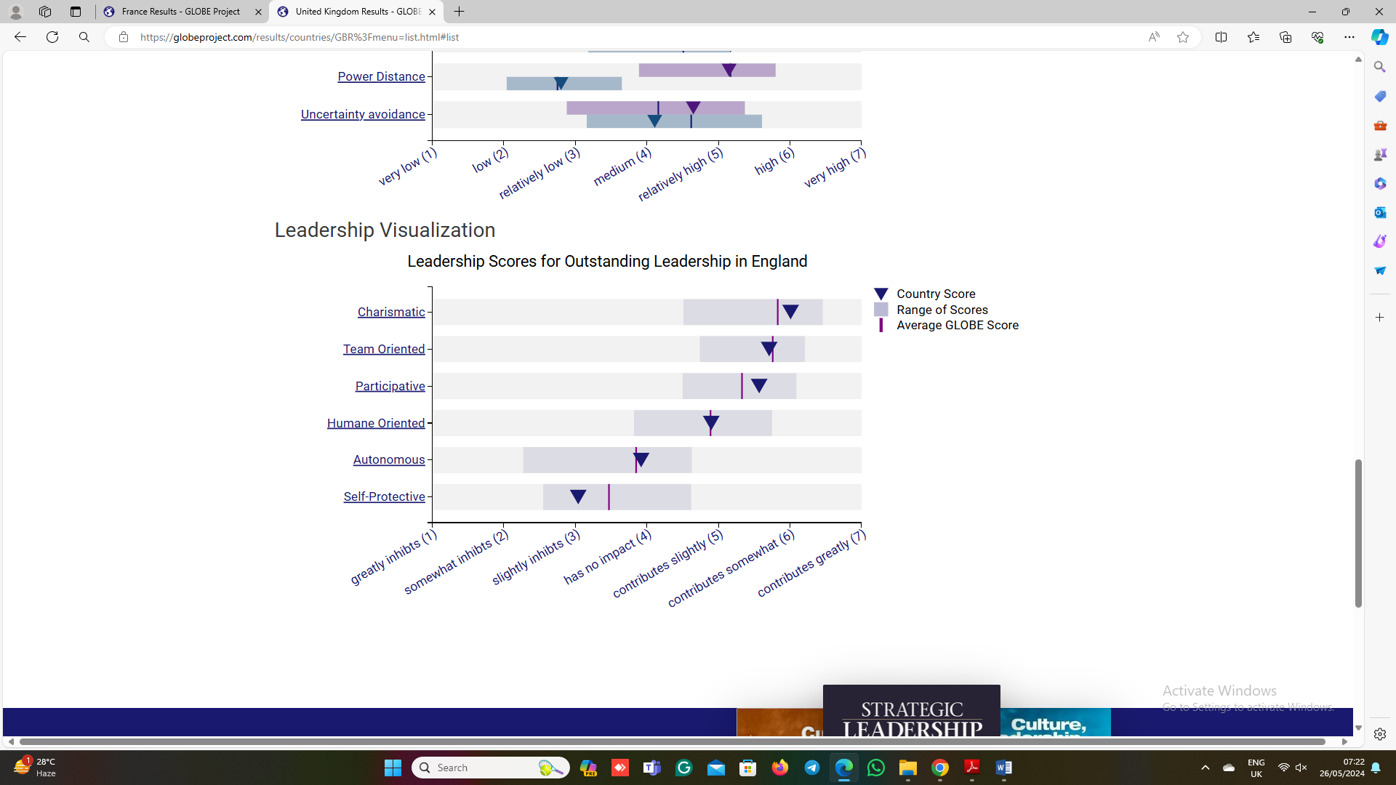
Figure 4: Leadership Visualisation of England
Source: (Globeproject.com, 2020)

The challenges of inter-cultural leadership
Communication Barriers: Language, accents, and communication styles can hinder intercultural hospitality teams. French co-workers may favour nonverbal indications, while English colleagues may prefer direct communication (Ndiaye, 2022). Differences might inhibit communication and production.
Work Styles and Expectations differences: This is among the most important challenges which an intercultural team faces. From the cultural overview of France and England, it can be seen that both country's work styles and the expectations they have from jobs are different from one another (Gilboa et al., 2020). To operate intercultural teams in both countries, it is essential to make sure that the team embraces the difference and develops a work plan on the basis of that.
Conflict management: This is obvious that there might be conflict in the workplace because of the difference in culture. Accepting change is hard and it might take time for that conflict will be created (Garrigos, Haddaji and Segovia, 2020). If the conflict has not been managed with effectiveness, this will reduce the chance of the business to have success and ensure high-quality service to the customers.

Conclusion
Understanding French and English cultures is necessary for hospitality leaders to operate in both these countries. The GLOBE Project identified leadership and cultural disparities. This study emphasises cultural sensitivity in managing heterogeneous teams and guests. Active efforts and an inclusive workplace can fix communication, work style, and cultural challenges. Hotel management teams can establish a strong, high-performing staff that provides excellent guest experiences by supporting cultural diversity, tolerance, and collaboration.

Recommendations
Personal language training may help the Hotel Management Team to communicate well. Language classes in English and French help teams communicate (Abramson and Moran, 2018). Active listening and encouraging team members to ask questions increase communication and prevent misunderstandings. Translation and communication software helps multilingual teams.
To accommodate different work styles and expectations, the Hotel Management Team can create job execution and performance objectives (Ndiaye, 2022). Open communication and regular team meetings help team members understand each other's work styles and expectations. A flexible team culture promotes diversity and productivity. Task assignment by abilities and preferences improves team effectiveness and diversity.
Hotel management can teach personnel cultural awareness to meet diversity challenges. These workshops can teach team members about cultural conventions, values, and communication styles, promoting diversity and understanding. Accepting dispute resolution rules and employing a mediator speeds resolution (Deresky, 2017). Teamwork and inclusivity reduce conflicts by fostering collaboration.

References
Abramson, N.R. and Moran, R.T. (2018). Managing cultural differences : global leadership for the 21st century. 10th ed. Abingdon, Oxon ; New York, Ny: Routledge.
Deresky, H. (2017). International management : managing across borders and cultures : text and cases. 9th ed. Boston: Pearson Higher Education.
Garrigos, J., Haddaji, M. and Segovia, P. (2020). Gender discrimination in haute cuisine: A systematic literature and media analysis. International Journal of Hospitality Management, 89, p.102569. doi:https://doi.org/10.1016/j.ijhm.2020.102569.
Gilboa, S. and Mitchell, V. (2020). The role of culture and purchasing power parity in shaping mall-shoppers’ profiles. Journal of Retailing and Consumer Services, 52, p.101951. doi:https://doi.org/10.1016/j.jretconser.2019.101951.
Gilboa, S., Vilnai-Yavetz, I., Mitchell, V., Borges, A., Frimpong, K. and Belhsen, N. (2020). Mall experiences are not universal: The moderating roles of national culture and mall industry age. Journal of Retailing and Consumer Services, 57, p.102210. doi:https://doi.org/10.1016/j.jretconser.2020.102210.
Globeproject.com (2020). Results - England GLOBE Project. [online] Globeproject.com. Available at: https://globeproject.com/results/countries/GBR%3Fmenu=list.html#list [Accessed 25 May 2024].
Globeproject.com (2020). Results - France GLOBE Project. [online] Globeproject.com. Available at: https://globeproject.com/results/countries/FRA%3Fmenu=list.html#list [Accessed 25 May 2024].
Ndiaye, N. (2022). Scripts of Blackness. Raceb4race: Critical Race Stud.
Neighbors, D. (2022). Beyond the Public/Private Divide: New Perspectives on Sexuality, Hospitality, and Diplomacy within Royal Spaces. Royal Studies Journal, 9(1), p.1. doi:https://doi.org/10.21039/rsj.356.
Spanaki, M.Z., Papatheodorou, A. and Pappas, N. (2021). Tourism in the post COVID-19 era: evidence from the hotel sector in the North East of England. Worldwide Hospitality and Tourism Themes, ahead-of-print(ahead-of-print). doi:https://doi.org/10.1108/whatt-01-2021-0013.

