
Submitted by:
Daniela Mihalkova
Module code: ACCA4025
Student ID: 2021925

Submitted to:
Terry Walcott

Essential skills for study and employment

Task 1 - Summary
I am currently a first-year computer major at UWTSD Campus London, and I have not decided yet which field I will focus on, but my journey during this year is overly exciting and I am happy to gain new skills. I learned a few things that I did not realize before how important they are. I already know that good study skills and consistent study behaviors are two of the most important components of general academic performance. I became more organized, started managing my time and set study goals. [1]


Figure 1. shows daily chaos without time management.

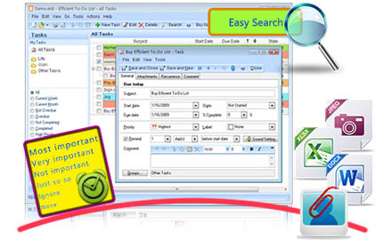
Making and following a task scheduler reduces anxiety. [2]

With the assistance of this course, I realized how important it is to gain digital literacy skills, to know how to find and consume digital content. How critical thinking and problem-solving skills can help me to improve flexibility and learning skills. How to separate facts from opinionated facts using logical thinking. I started weighing up all viable options to arrive at a reasonable solution. [3] The most important of all life skills for me is being able to communicate effectively and to work well in a team. Based on my research and my experience, I can say that employers want employees who can see the larger picture, solve problems, communicate effectively, and work well in groups. Even if an applicant has excellent credentials, their personality and soft skills determine whether they are employed. [4]
I believe that this course will help me to improve my personal skills and to gain needed knowledge, which will help me to find the right work position and to meet the employer's requirements.

© 2021 University of Wales Trinity Saint David Page 2

References

[1] | E. Administration, "Principal time management skills," Emerald Insight, 2015.
[2] | E. Software, "Efficient To-Do List," [Online]. Available: http://www.efficienttodolist.com/. [Accessed 25 04 2021].
[3] | E. A. Jones, "Critical Thinking Skills for Graduates," in Essential Skills in Writing, Speech and Listening, and Critical Thinking for College Graduates: Perspectives of Faculty, Employers, and Policymakers, 2010, pp. 5, 16, 46.
[4] | R. F. H. a. D. Daryanto, "Employability skills: Industry perspective and," Journal of Physics, p. 3, 2019.

© 2021 University of Wales Trinity Saint David Page 3

