Effective team working and comunication(BMSW_4002)
Lecturer: Richmond Lamptey

Paulina Andone(2027237)

Report: Effective Teamworking for team success

Table of content
Abstract 1
Introduction 2
Summary of Team working 2
Team development models 4
Tuckman’s team development model 6
Wheelan’s team development model 8
Team roles 8
Belbin’s Team roles 9
Discussion 10
The advantages of effective teamworking 10
The impact of ineffective teamworking 10
Conclusion 11
References 11

Abstract: Qin, Johnson and Johnson (1995) state that working in teams or groups can facilitate success in meeting personal needs and solving common problems through constructive collaboration. Within groups, members interact, exchange ideas and work together, so teamwork is important.
In a group, effective teamwork can have a positive impact on team success, and as some barriers can hinder the smooth evolution of the team as well the roles in a group filed by the right members can help to evolve as a successful team.

Introduction

Due to diversity, communication and management challenges are predominant acting as a barrier to team efficiency. This report highlights teamwork in a diverse cohort, how it can be effective, what stages are involved to form a well-rounded successful team and how through ineffective collaboration can lead to a failure of proportions. For success, members must work together to accomplish certain tasks that can be accomplished through quality teamwork, which is essential for any employee regardless of diverse background. For teamwork to be effective, communication between members should be idem as between members and the team leader (Cook, Cook and Ummer, 2009).
According to Katzenbach and Smith (1994) a team is a small group of people formed with the common and well-defined goal of performing in completing a task. All team members are equally responsible for the approach with which they try to achieve the purpose. Everything is based on efficient communication, respect, trust, and equal appreciation of each member contribution.
Students can develop an effective team by implementing different methods of teamworking. However, the results can be influenced by the members of the group, the context in which the activity takes place, and the interaction between the members (Kaba et all, 2016).

Summary of Team working

Morgan (2017) state that a person's behaviour draws consequences on him and the people in the group he belongs, and in some opinion, the group and the team are almost the same, being created of people involved in achieving something common.
Katzenbach and Smith (1993) they made a list with what factors make the difference when it comes to efficient and less efficient teams:
- size of the team
- different skills
- mutual commitment
- certain targets
- collective methodology
- common responsibility
Effective Team Working and Communication (BMSW4002_BIRM), Week 1 Defining Groups and Teams, https://moodle.uwtsd.ac.uk.

Analysing the exposed factors, we can define a team as several people with different skills and the common goal of fulfilling a specific task, through a common approach and for which it is necessary to assume mutual responsibility.
In the opinion of Katzenbach and Smith (1993), these factors contribute to effective teamwork because a well-proportioned team in size (not more than seven people) can be easier to coordinate. It is also ideal for members to have various skills so the knowledge will be complementary and not similar. Members must dedicate themselves to the team's goal and be willing to make certain sacrifices and provide mutual support. The goal of the team should be a clear and well-defined one and the members should agree on the chosen solution in fulfilling it. Thus, the responsibility being mutual, strong bonds are formed between the members, which concludes that the team is a strong one and in case of failure the team will be united in solving the problem.
Cook, Cook and Ummer (2009) confirms that transparent communication can also contribute to efficient teamwork, putting the needs of the team above the individual ones, knowing the individual responsibilities and the role in the team plus the personal sacrifice for a good functioning of the team. Team leaders must support and challenge members' abilities, listen and encourage and offer equal recognition. Cooperation is an asset towards achieving the goal, it appreciates the conflict that helps in the evolution of the team.

Team development models

Although there are so many models for developing a team the most used nowadays would be Tuckman's model with the acronym FSNPA. The below diagram belongs to this model.
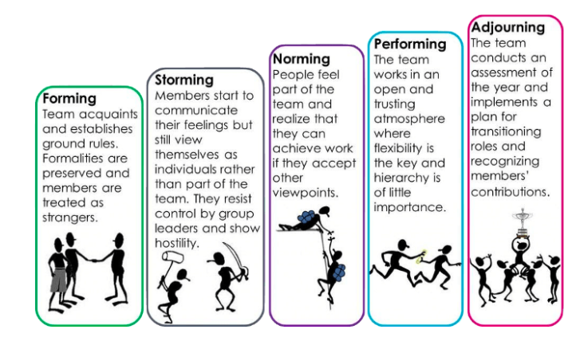
(Tuckman and Jensen 1977).
Another model that has been studied in class is Wheelan’s team development model and is very similar with Tuckman’s model.
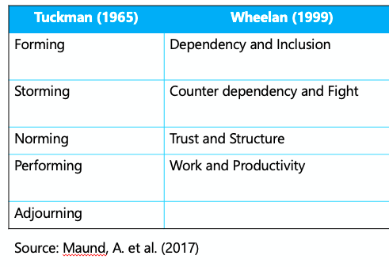
Other examples of models would be:
- GRPI model by Rubin, Plovnick and Fry (1997)
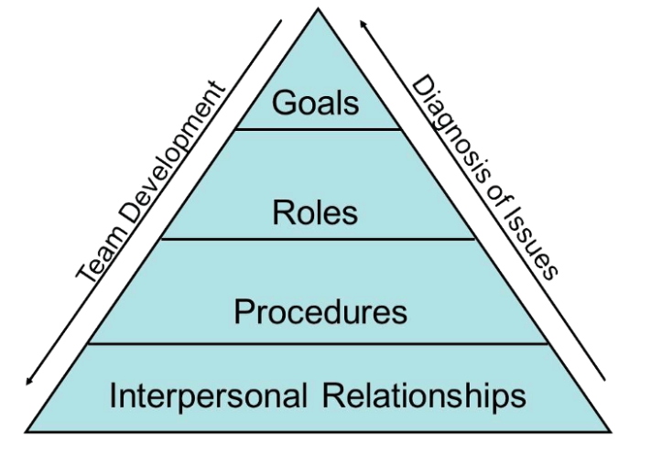
- The Katzenbach and Smith Model (1993)
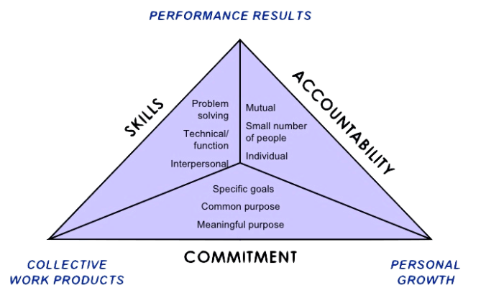

- The T7 Model of Team Effectiveness by Lombardo and Eichinger (1995)
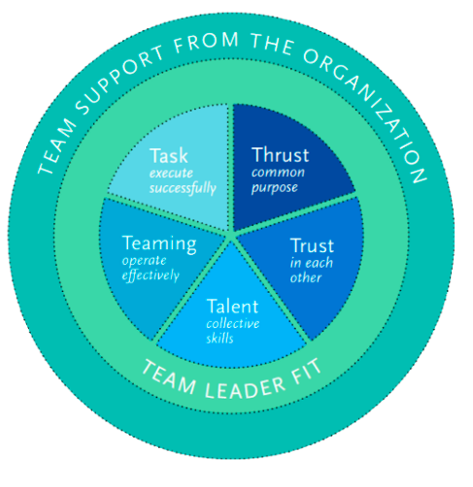
- The LaFasto and Larson Model (2001)
- Hackman’s Model (2002)
- The Lencioni Model (2005)
- The five keys to a successful Google team also known as Project Aristotle (2012)
All the diagrams and the team working models from the above can be found here: https://medium.com/@RiterApp/8-models-of-team-effectiveness-3a3b84efb3ae.

Tuckman’s team development model

For this report can be considered the Tuckman's model because it has all the necessary stages in a diverse group, from forming stage in which members meet each other and establish certain rules everything being formal all the way to the adjourning stage, stage in which the team has fulfilled its purpose and implements the dissolution of the group. At the end of this stage, there is a kind of disappointment because certain friendships have formed along the way (Tuchman, 1965).
Effective Team Working and Communication (BMSW4002_BIRM) Week 2 Stages of team development and team roles, https://moodle.uwtsd.ac.uk.

Using Tuckman's model in a diverse group of students can be helpful because any team goes through the inevitable stages of training that are necessary for proper functioning and development. In general, in any group formed within universities or any other institutions there are restraints, divergences, contradictions and even misunderstandings. Each member feels that they must act on their own, to assert themselves within the group, so in the first phase, the members must learn to accept themselves as a group and to cooperate.
In the second phase in which trust is formed between members, conflicts can still occur until each one establishes its position in the group, and the atmosphere is polite and positive. Tolerance and patience are needed at this stage because it is difficult and stressful. Now is the time for everyone to express their opinion and overcome divergences because the lack of cooperation can delay the development of the team and in some cases remain at this level of storming. Already in the norming stage, cooperation between members is evident and the idea of common purpose helps members to cooperate for the success of the team. and is considered equally responsible, but there may still be a danger that controversial ideas may be excluded or avoided. Already in the next stage in which the roles of each member are established, the members focus on the common tasks and can in some cases have unexpectedly high success. At this stage everyone is competent and able to make decisions without the presence of a coordinator, but sometimes even the best teams can go through earlier stages again. This could be influenced by changes in leadership, but in the case of a group of students they will go through all the stages each time a new group is formed for a new task.
The last stage takes place only in teams formed for a limited period. The latter was implemented in 1977 with Mary Ann Conover Jensen following a revision of the method. This last stage is important because the recognition for the effort made, and the proper dissolving of the group help the members to evolve and to perform much more efficiently in the future group projects (Bonebright, 2010).

Wheelan’s team development model

Another model of team development is that of Wheelan, very similar to Tuckman's model, the first stage being Dependency and Inclusion, Counter dependency and Fight, Trust and Structure, and Work and Productivity. In the first stage, the members want to be accepted and do not have very different opinions or initiative. In the second stage the divergences appear, the conflicts being inevitable and just like in the storming stage, the group remains stuck at this level. In the third stage, the members cooperate and involved more on the task, and the leader consults more than expected. In the fourth stage, the team already performs at high capacity, but some teams will never reach this stage (Wheelan 2016, pp.25-28).
The difference between the two models is the adjourning stage which helps in our case for students to remain friends, to respect and accept each other, to be less judgmental, accept and embrace the concept of diversity and to cooperate easier in future group projects.

Team Roles

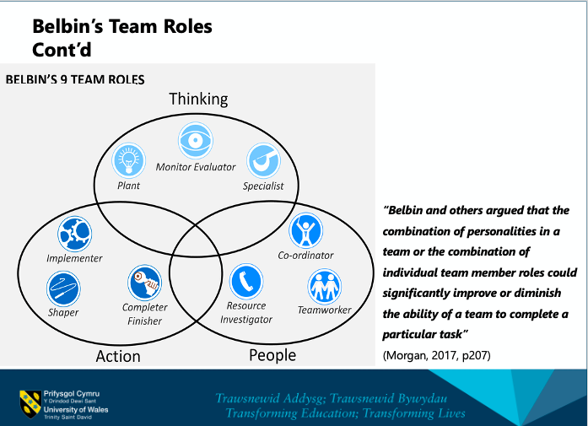
Effective Team Working and Communication (BMSW4002_BIRM) Week 2 Stages of team development and team roles, https://moodle.uwtsd.ac.uk.

Belbin team roles

In 1981 Meredith Belbin developed a method of evaluating a team that effectively distinguished between strengths and weaknesses. The method developed over nine years and is widely used to improve performance and structurally solidify a team. It defines the roles and predicts the potential success of a management team and specifying that diversity in a team can contribute to the formation of a strong team.
The role of a team in Belbin's description is strictly related to the behaviour, contribution, and interaction of each member with the other members. Three of the nine roles are action-oriented: Shaper, Implementer and Completer Finisher, three more people-oriented: Co-ordinator, Teamworker and Resource Investigator and three other brain roles: Plant, Monitor Evaluator and Specialist.
In theory, each role has certain contributions and weaknesses allowed, which makes them important in recruitment process.
Plant: creative, solves difficult problems but concerned in communication ignores incidents.
Resource investigator: opportunity exploration, communicative and enthusiastic, quickly loses interest.
Co-ordinator: good delegator, mature and confident, sees potential in members, can be manipulative.
Shaper: determined and efficient when under pressure, he does not consider the feelings of those in the group.
Monitor Evaluator: sober and accurate, does not inspire those around.
Teamworker resolves conflicts, cooperatively and diplomatically, avoids confrontations and cannot decide in critical situations.
Implementer: efficient, good organizer, practical, but inflexible.
Completer finisher: chiselled finisher, looking for errors, anxious, worries too easily and does not delegate too much.
Specialist: dedicated in everything he does, intelligent and competent, he contributes very restrictly (Fisher, Hunter and Macrosson, 1998).

Discussion
The advantages of effective team working

Cottrell (2016) confirms in the chapter on people skills that in a group everyone contributes according to the knowledge accumulated over time and that creativity of a group improves the productivity. Morale and motivation of the members is high, the group learns faster, and the stress is diminished compared to the individual work. Working together, group members have a common goal to succeed. Cooperation diminishes unproductive competition so that members focus on fulfilling the goal together. By cooperating, members share their own knowledge, thus exchanging knowledge and putting everyone's ideas together, reaching a result much faster than working individually. Communication is much more efficient due to cooperation and thus the performance of the group is positively influenced, conflicts and misunderstandings are lessened, and the delivery of a positive result is equivalent to success. The objectives of the group are met much more easily if the relationship between the members is a positive one. Determination and initiative contribute to the good functioning of the group, and the mutual encouragement of the members helps the easier integration in the team. And finally, the mutual trust that creates strong relationships between members, so each advantage or disadvantage affects each member.
According to Rock and Grant (2016), a diverse group increases the chances by 35% to have above average profits in the industry in which they work. And following the research in the field, it was also concluded that the diversity in a group has a high level of knowledge, being considered smarter teams. Diversity causes members to go beyond the outdated mentality and improve performance.

The impact of ineffective team working
The impact of inefficient teamwork begins with decreased: efficiency, collaboration, and productivity. Members focus on their success and not the group, the atmosphere is negative full of contradictions and awkward interaction. When a team fails refinement declines, mutual respect is lost, and hostility ends effective communication. Members no longer care about the common goal and responsibilities are fulfilled at a very low quality. The support and encouragement between the members disappear and with it the productivity and the capacity to face the challenges. The goal becomes one of survival because the mutual support is zero and the negative environment is accentuated by the failure that surrounds the team. This happens when employee involvement is non-existent, and the result is inefficient. When the team fails, stress intervenes, this is the killer of creativity, members no longer come up with new ideas for fear of criticism, focusing only on survival. When they cooperate, individuals learn new skills from each other which is not the case in poor teamwork (Shannon, A. 2017).
Even if a diverse team is smarter, that does not make it successful just because of this factor.

Conclusion

Productivity and efficiency have a huge impact on the result, because an inefficient team is a team only by name. When there is no common vision, efficiency in the team is non-existent.
In conclusion, teamwork is very important for proper functioning and for fulfilling the purpose for which the team was formed. The process a team goes through is a stressful one and if the members cannot accept each other the team it does not evolve. If there is a lack of respect, frustration intervenes and the members start to be competitive, one of the factors that endangers the team's success. All the stages a team goes through can be effective only if the people in the group are willing to work in a team, to communicate and cooperate, to respect each other, to have mutual trust and to be willing to sacrifice for the success of the team. Some can be teams only by title, some remain stuck at a stage of development while some can become very strong. It all depends on the people involved, the devotion to the group and common goal. There are people who can never fit into a team and some who can be effective only by working in a team, it all depends on the people involved, circumstances, team leader, the environment in which they work and the passion of the team to succeed.

References

Bonebright, D. (2010) ‘40 years of storming: a historical review of Tuckman's model of small group development’, Human Resource Development International. 13, pp.111–120. doi:10.1080/13678861003589099.
Cook, Cook and Ummer (2009) ‘Chapter1: Characteristics of a high-performance team’, Building a High Performance Team: Proven Techniques for Effective Team Working. Ely: IT Governance Ltd. Available from ProQuest Ebook Central. [4 February 2021]. Created from cardiffmet on 2021-02-04 03:25:38.
Cook, Cook and Ummer (2009) ‘Chapter3: Roles people play in a team’, Building a High Performance Team: Proven Techniques for Effective Team Working. Ely: IT Governance Ltd. Available from ProQuest Ebook Central. [4 February 2021]. Created from cardiffmet on 2021-02-04 03:25:38.
Cottrell, S. (2010) People skills: Team-work, Palgrave Study Skills: Skills for Success Personal Development and Employability. 2nd edn. Basingstoke: Palgrave Macmillan. Griffith, B. A. and Dunham, E.B. (2014), Working in Teams: Moving From High Potential to High Performance, SAGE Publications, Thousand Oaks. Available from: ProQuest Ebook Central. [18 September 2021]. Created from trinity on 2021-09-18 13:29:19.
Fisher, S.G., Hunter, T.A. and Macrosson, W.D.K. (1998) ‘The structure of Belbin’s team roles’, Journal of Occupational and Organizational Psychology, 71, p.283, ProQuest Central.
Kaba, A., Wishart, I., Fraser, K., Coderre, S. and McLaughlin, K. (2016) ‘Are we at risk of groupthink in our approach to teamwork interventions in health care?’, Medical Education 2016, 50, pp. 400-408. doi:10.1111/medu.12943.
Katzenbach, J.R. and Smith, D.K. (1993) ‘The discipline of teams’, Harvard Business Review, Accessed on 20/10/2021, Available at: https://hbr.org/1993/03/the-discipline-of-teams-2.
Maund, A., Schriek, M. and Tinkler, K.P. (2017) Effective Team Working and Communication, Certificate in Higher Education: Skills for the Workplace Student Yearbook. London: SAGE Publications Ltd.
Morgan, P. (2017) Employability Skills: Team-Working, The Business Student’s Guide to Study and Employability. London: SAGE Publications Ltd.
Rock, D. and Grant, H. (2016) ‘Why Diverse Teams are Smarter’, Harvard Business Review,
Accessed on 24/10/2021, Available at: https://hbr.org/2016/11/why-diverse-teams-are-smarter?registration=success.
Shannon, A. 2017’What Do You Lose When Teamwork Fails?’, The Center for Corporate and Professional Development-KENT STATE UNIVERSITY. https://www.kent.edu/yourtrainingpartner/what-do-you-lose-when-teamwork-fails.
Menu
Tuckman, W.B. and Jensen, C.MA. (1977) ‘Stages of Small-Group Development Revisited’, SAGE Journals, 2(4), pp. 419-427. https://doi.org/10.1177/105960117700200404.
Wheelan, S. A., Davidson, B. and Tilin, F. (2003) ‘Group Development Across Time: Reality or Illusion?’, SAGE Journals, 34(2), pp. 223–245. https://doi.org/10.1177/1046496403251608.

