Task 01 A
Essential skills required for academic studies and future employment
- Essential skills required for academic studies (use at least 2 credible sources which talk about Essential skills required for academic studies (apply IEEE referencing) (150 words)
Starting my new university course make me quickly realize that maintaining solid digital study habits is essential to keep up with the weekly workload. According to an academic guide by UniAdmissions, doing well at university comes down to foundational routines like essay writing, reading complex technical texts, and learning to think independently. I must learn how to search through online databases for credible articles while separating real data from bad internet sources. Time management is another massive hurdle in my student life because I have to balance my schedule carefully to avoid missing tough deadlines. These academic routines are incredibly helpful for personal technology projects too. For example, planning out my own startup concept, ELByteBridge Solutions, requires a strong understanding of security before I start offering services. Even though I have already fully designed the flyer and listed our service options, I am intentionally waiting to launch the official website or take on live clients. I want to gain more advanced technical knowledge from my university modules first, so I am fully prepared. [1]

- Essential skills required for future employment (use at least 2 credible sources which talk about Essential skills required for academic studies (apply IEEE referencing) (150 words)
Moving from the university classroom into a real technology job requires a good mix of career skills alongside technical knowledge. Professional guides show that the exact digital routines I build at university, like network research and data analysis, are highly valued by modern IT employers. As highlighted by the Robert Herjavec, clear communication and educating standard users are absolutely critical for navigating real workplace environments. In fields like cybersecurity, a professional has to be able to translate complex system threats into clear, simple instructions for regular clients. This matches the exact plan for my personal business concept, ELByteBridge Solutions, which aims to provide straightforward device setups and malware checks for local families. Waiting to put up the website and do a public launch ensures that my professional skills perfectly match industry standards before I start serving the community ultimately proving that my intensive higher education background guarantees excellent commercial result long term. [2]

- analyse 3-5 current popular AI assistants and briefly document the best use for each. use several screenshots of 3 – 5 AI assistants. ( 200 words)
Dealing with university paperwork and keeping track of technical project notes takes up way too much time. Using smart online tools can really help speed up everyday research and organization. Three big software assistants that people use a lot right now are ChatGPT, GitHub Copilot, and Google Gemini. ChatGPT is great when you just need to brainstorm ideas quickly, write draft emails to potential customers, or break down a massive wall of text into clean bullet points. GitHub Copilot is built specifically for coding, so it sits right inside your text editor and suggests lines of code while you type, which saves a lot of debugging time. Then there is Google Gemini, which is brilliant at live internet tracking, double-checking facts on the spot, and turning messy data into neat tables. Using these handy apps saves me from spending hours on boring typing tasks every single week. This means I can focus my personal energy on learning hands on hardware stuff and figuring out how to actually support real clients for my own new startup, ELByteBridge Solutions. It makes balancing my tough university modules and future business plans a whole lot easier for me at this stage of my education.

Criteria | ChatGPT | Copilot | Gemini
Generating answers | 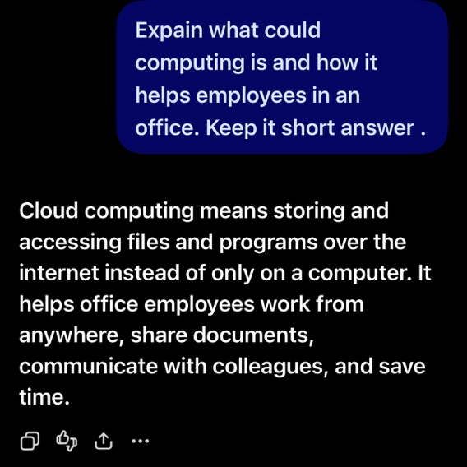  Great for long, natural chats and writing essays. | 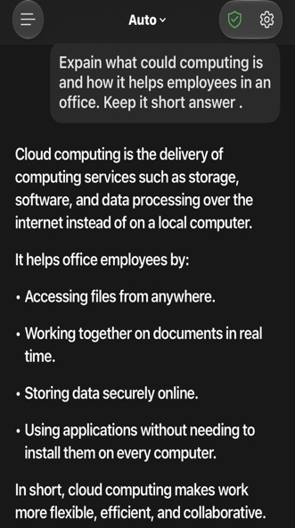  Gives short summaries but pairs them with actual web links. | 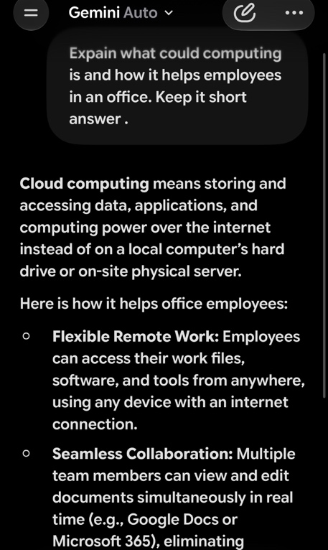  Best at pulling up to data focus using Google search.
creative work, code/diagram generation | 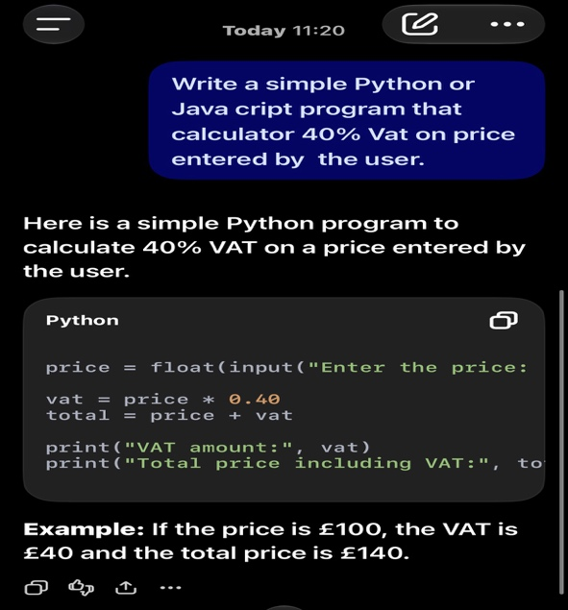  Writes clean code blocks but cannot make native diagrams. | 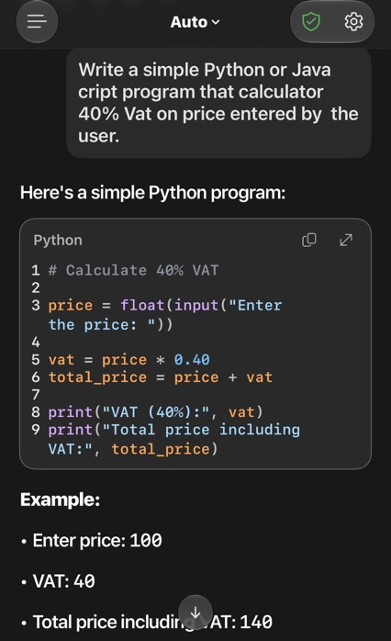  Lifesaver in text editors because it autocompletes code during typing. | 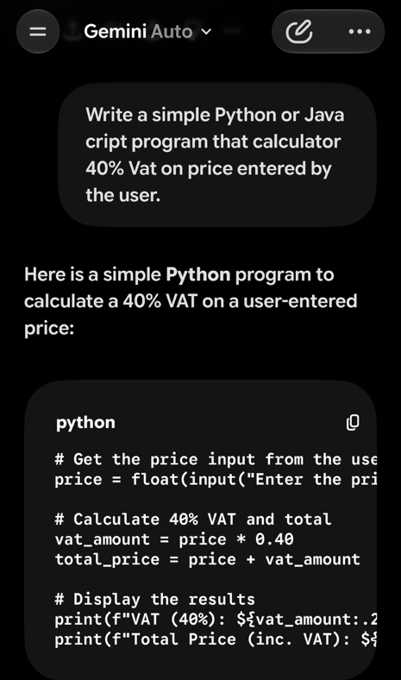  Excellent at making charts and exporting data cleanly.
data analysis | 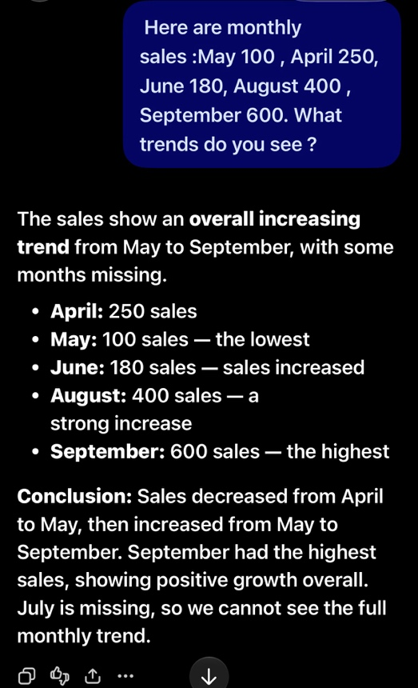  Has a built it sandbox where it runs Python to crunch data files. | 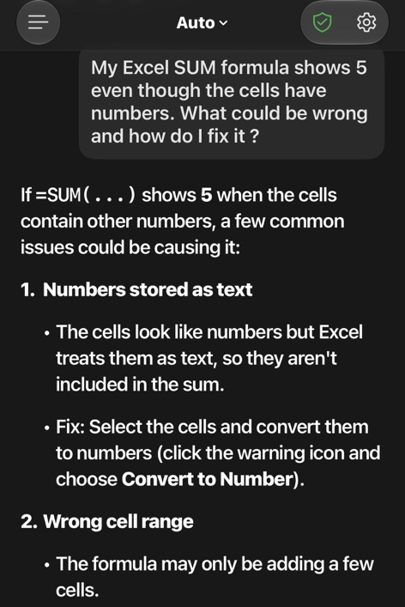  Best used for explaining small code snippets rather than huge data sets. | 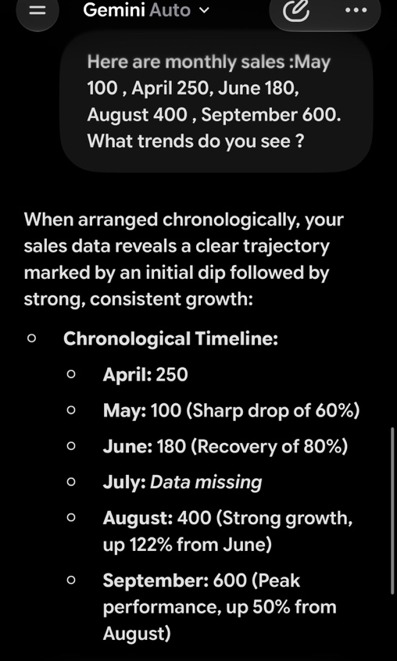  Connect right to Google Sheets and Workplace apps.
problem-solving | Strong logic for troubleshooting random tech errors or general issues.  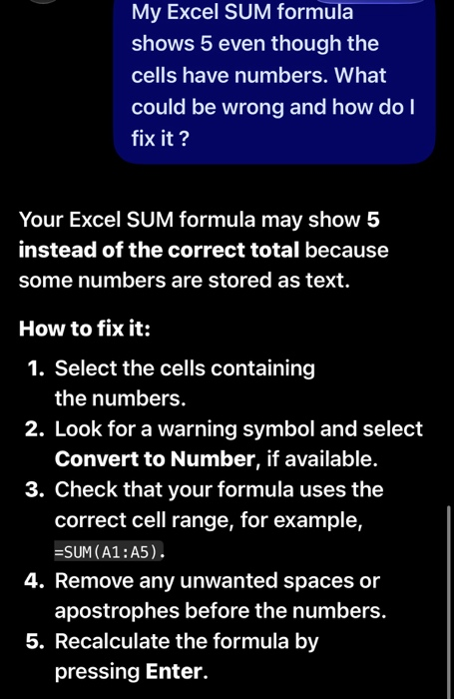 | Find bugs inside actual code folders and repositories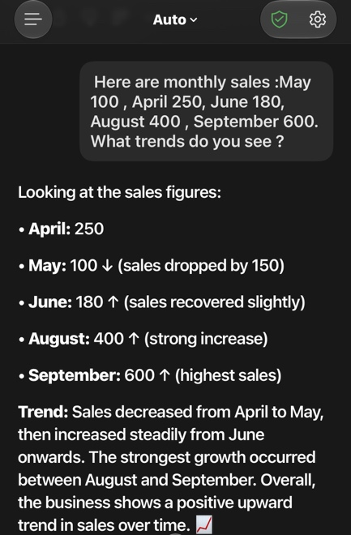. | Great for step by step breakdowns of hard conceptual problems.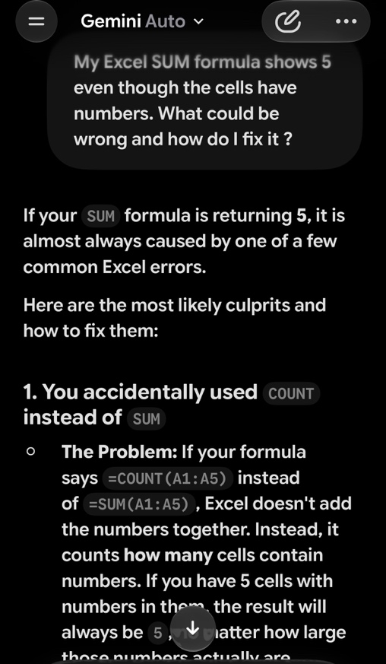

- Identify a course available in LinkedIn which talks about AI assistance.
The online course I chose on the LinkedIn Learning platform is “Machine Learning Foundations: Linear Algebra”. Taught by instructor Terezija Semenski are released on 30 of August 2022. This technical module provides a clear breakdown of how mathematical equations, vector spaces and linear structures directly power modern automated algorithms. Reviewing this specific course helps me understand the exact mathematical principles that software uses to process data behind the scenes, giving me a crucial technical upgrade for my studies and a deeper baseline understanding of how computer logic operates in real industry settings. [3]

- Submit this document to Turnitin and generate the similarity report and take a screenshot of your similarity report and paste it here. Please evaluate your similarity percentage. (200 words) – self evaluation

Bibliography

[1] | A. Sen, “uniadmissions,” 4th August 2025. [Online]. Available: https://www.uniadmissions.co.uk/application-guides/6-essential-skills-for-university-students/. [Accessed 8th October 2026].
[2] | R. Herjavec, “linkedin,” 15 December 2021. [Online]. Available: https://www.linkedin.com/pulse/look-back-cybersecurity-2021-robert-herjavec/. [Accessed 8th October 2026].
[3] | T. Semenski, “Machine Learning Foundations: Linear Algebra,” 30 08 2022. [Online]. Available: inkedin.com/learning/machine-learning-foundations-linear-algebra. [Accessed 08 10 2026].

