ECCP7002
Critical perspectives in policy, planning and delivery
November - December

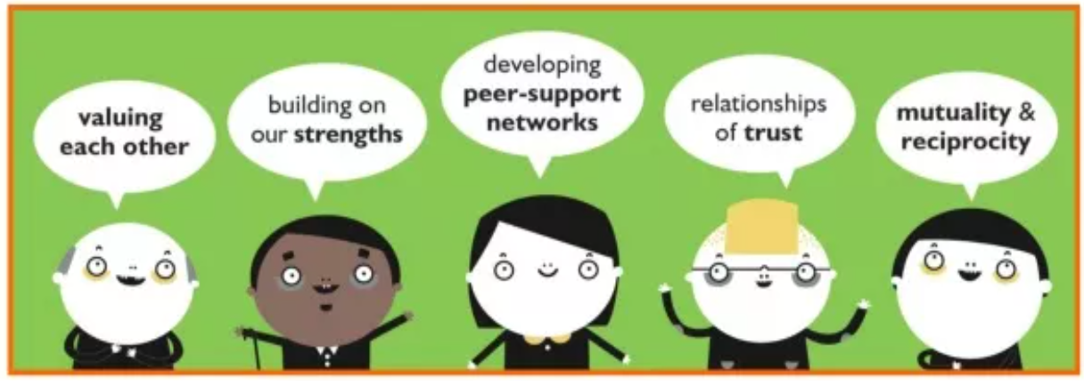

Introduction

This module requires you to complete asynchronous work– this means you must complete sections of this work before and after each session. This will give you a depth of knowledge and understanding and help you find some critical pieces of literature that may help you with your assignment. This is a personal handbook, and lecturers will not need to see it.

This will take approximately 4 hours

.

Complete for face to face session - Saturday 2nd November

Setting the scene:

In part 2 of your assignment you are asked to analyse a policy related to a controversial issue of your choice. You are asked to consider the policy’s implications to practice and the strengths and barriers to implementation. You are then asked to consider how you could overcome some of the barriers to implementing the policy.

This section considers ways to analyse your policy document both in terms of context (where, why, the type of policy etc). The next section of this handbook relates to some ways in which government and other agencies are working towards implementing policies in practice.

The theory and politics of policy making and enactment

This section considers Cairney’s (2013) work related to some of the issues that arise from thinking about the context of policy making and enactment.

Read Cairney’s work here and consider the terms below in the table. This will help you with understanding some of the complex theoretical terms related to policy studies and that you may incorporate into Part 2 when you think about ways to analyse the policy.

Policy and Policymaking in the UK (forthcoming, 2015) (Basingstoke: Palgrave) Chapter 2 Policymaking in the UK: What is Policy and How is it Made?

Key Tenets of Public Policy Studies – Theories

Consider your own policy for analysis. In what ways might these theories be an issue for policy enactment in practice? What may happen in practice?

Remember, this is one resource out of many that you can find yourselves to back up any ideas you may have. Read more about the ones that interest you. The ones which are starred are common theories that we will discuss in more detail on our second Saturday. This about the issues related to your chosen policy. Could any of these issues relate to it?

comprehensive rationality | policymakers have the means to translate values and aims into policy
bounded rationality*

The policy cycle*
(p.9)

Bounded Rationality and Punctuated Equilibrium Theory (p.12)

Bounded Rationality and Incrementalism* | Why might policies not work?
Policy Succession

Inheritance Before Choice

Historical Institutionalism and Path Dependence
Multi-level Governance
The Advocacy Coalition Framework
The Role of Ideas
Multiple Streams Analysis and ‘Garbage Cans’
Street Level Bureaucracy* | This will be discussed in more detail on the Saturday but this theory by Lipsky (1980) holds sway as to the issues facing practitioners.
Policy inertia*

The Globalised world:

Policy issues in the UK (Wales in particular) relates to culture and ways that we govern. This will look different in other areas of the world. If this is of interest to you, Sharto’s (2022) blog may be of interest to you, especially if your policy has implications for those in other countries.

Public Policy Series: New Approaches in Public Policy Studies (byarcadia.org)

Take notes if needed:

Analysing policy documents


Now we have considered the macro issues in policy enactment, think about the way we may look at analysing the document for issues relating to values. Carol Cardno’s (2018)’s article helps us frame the way we can analyse our policy document.

Read: Cardno, C. (2018) Policy Document Analysis: A Practical Educational Leadership Tool and a Qualitative Research Method Educational Administration: Theory and Practice. 24 (4), pp: 623-640

Think about the steps that you may need to look at when thinking about your own policy analysis. You could say in your presentation that you have used her work to frame your own analysis of your policy.

Innovative ways to overcome barriers

Your final section of part 2 of your assignment focusses in on an innovative way to overcome one of the barriers to implementing your policy. This will be personal to you and your thinking. What is considered here may not be relevant, but here are some ideas of the ways in which others have considered the issues of overcoming barriers

Podcast: Making and breaking social policy

This podcast is about how we all live together (social) and how we make that work (policy). This podcast was created as a central piece of content for two social policy topics in Social Work at Flinders University. It is hosted by Dr Ben Lohmeyer, Lecturer in Social Work at Flinders Uni (www.flinders.edu.au/people/ben.lohmeyer).

https://open.spotify.com/show/0qovvMOHnjXEIK7iRNvy1l?si=432dc39760314d7a

Notes:

Whole Systems Approaches

One way Welsh Government is thinking about making policies work is from a whole systems approach. You can find this in work related to Community Focussed Schools:

Community Focused Schools | GOV.WALES

Although your ideas may not be based in school systems, there may be some ideas about working together that resonates with your ideas.

Community Focused Schools: case studies | GOV.WALES

Here are some other resources that can help.

Organisation for Economic Co-operation and Development (OECD). (2017). Systems Approaches to Public Sector Challenges: Working with Change. OECD Publishing.

Online UWTSD Library: Fullan, M., & Gallagher, M. J. (2020). The devil is in the details : system solutions for equity, excellence, and student well-being. Corwin.

Co-creation / Coproduction and Stakeholder Engagement

Buzz words in policy making at government level is ‘co-creation’ or ‘co production’. This features strongly in the Future Generations Act (2015). This leads to ideas around ‘empowering’ communities. The term empowerment has its own issues, so if you feel you want to consider this issue then look around this word for problems

Find out more here:

Co-production | Social Care Wales

You can join Co-Production Wales here. It has some interesting case studies where it has worked for policy implementation.

Co-production Network for Wales (copronet.wales)

Podcast: Participatory processes with policymakers:

Andrew Orton chats about his experience of working with policymakers and practitioners in policy creation through participatory practices. They discuss the opportunities and challenges of participatory practices in this context including the ethical dilemmas, power structures, and building collaborative responses to social issues.

Participatory processes with policymakers: Navigating multiple perspectives with A/Pro Orton • Making & Breaking Social Policy (spotify.com)

What are the problems with being part of social policy initiatives and what does this mean for your practice?

Assets Based Community Development Approach

Lately, the term ‘assets’ is used in Welsh Government documents to consider what assets communities have and leads us away from looking at communities through a deficit lens.

Here are some websites that may help you with understanding this term and its use in local services:
Asset-Based Community Development for Local Authorities: How to rebuild relationships with communities through asset-based approaches | Nesta
Asset Based Community Development (ABCD) – Co-production Network for Wales Knowledge Base (copronet.wales)
Community-assets-generating-the-benefit-1.pdf (bevanfoundation.org)
Community assets in Wales: challenges and opportunities (senedd.wales)

