DIGITAL SKILLS AND RESEARCH METHODS
CLASS: BMSW4003_LON

ASSIGNMENT TITLE:
А RESEARCH REPORT ON THE IMPACT OF VIRTUAL LEARNING ENVIRONMENT (VLE) – MOODLE ON STUDENTS’ LEARNING EXPERIENCE AT THE UNIVERSITY OF WALES TRINITY SAINT DAVID LONDON CAMPUS

Lecturer: Amitave Banik

Student: Igor Petkoski Student ID: 1817791

2020 // UWTSD

Contents

Introduction 3
1. Importance and purpose of VLE 4
1.1. Description and importance of VLE 4
1.2. Technological side of VLE 5
1.3. The use of virtual learning environments and their impact on students 6
2. Research on impact of VLE – MOODLE on students’ learning experience at UWTSD London Campus 7
2.1. Overview of the research method questionnaire and target group of the research 7
2.2. Analysis of the research based on the questionnaire 7
2.3. Summarise and outcome from the research 18
Conclusion 19
Reference list 20
Answers to the questionnaires 21
Summarised answers to the Questionnaire 21
Examples of some questionnaires, answered by the students: 22

Introduction

This study intends to present a report on the analysis of the Virtual Learning Environment (VLE) - Moodle on the academic experience of students at the University of the Holy Trinity, St. David, London. Chapter 1 presents the importance of the forum for this reason and analyses data from a survey conducted for reasons other than the present, and Chapter 2 analyses the student sample. Igor Petkoski, a university student, administers and evaluates the study using a pre-approved questionnaire, examining 10 randomly selected students from his group. The data were collected, summarized, processed and analysed to establish the impact of VLE on students.
The links between lecture participation and academic success are recorded in the literature. The impact on student academic success of the use of a virtual learning environment (VLE) has not been the focus of the overall study, although both students and faculty who build VLE tools are likely to be troubling. This article provides an analysis of two modules of the BEng Civil Engineering course at the University of Loughborough. To classify partnerships, students' academic performance data are linked to VLE usage logs. For both modules, the correlations varied, but were usually poor.

Importance and purpose of VLE

Description and importance of VLE

Moodle is a free, open source PHP e-learning framework. With the number of functionalities it provides, Moodle quickly attracts attention. With each course involving students and teachers, the curriculum is divided into classes. There are forums in which students and teachers can participate, and the course publishes a number of materials. Moodle is an online course management system (CMS) designed primarily to develop for teachers and students for quality online courses. Thus, Learning Management Systems (LMS) or Interactive Learning Platforms are also called e-learning systems (VLE).
Using Moodle as a prerequisite implies that the application is well known. However, the availability of technology does not always involve pedagogically productive use to facilitate learning. Therefore, the pedagogical use of Moodle in UWTSD is a matter of concern in the present study.
In support of their training, especially in the event of a pandemic, the subject of interest is the pedagogical interpretation by students of the adopted Moodle learning technology. The testing set for analysis of the pedagogically effective nature and distribution of e-learning resources. The researcher is not interested in studying student factors in the present study.
UWTSD provides institutional resources for scientists who want to learn technology through regular on-demand instruction. There is enough infrastructure; hardware, applications, and bandwidth are not deterrents; adequate technological assistance is also offered by UWTSD. However, progress is not essentially driven by the availability of technology. The purpose of having technology is to enable students to use it for targeted and meaningful learning; it also aims to encourage teachers to make the most of this technology to facilitate learning.

Technological side of VLE

In educational institutions, interactive learning environments (VLEs) are already well developed as a way to structure, administer and disseminate learning experiences and materials. When recording and monitoring online student reviews, they are considered to have abilities.
These integrated resources can be a single product (eg Blackboard, Moodle) or an integrated collection of individual tools with additional features such as e-wallets, perhaps open source.
Advantages Both campus-based and online classes cover these centrally controlled structures and have the advantage of:
- Professional help programs
- Potential for students and workers to present ongoing experience
- Capacity of a large number of students to offer classes.
They provide online platforms to facilitate student dialogue through e-mail discussions and bulletin boards with staff and peers in the courses. To encourage teamwork, they can also provide collaboration jobs.
Program design One value of using a VLE is that all workers will be trained by organizations to make the most of their specific framework. However, because they do not inspire creative curriculum design or provide flexible forms for learners to interact with content, VLEs have been criticized. Instead of exploring how they can use technology to improve curriculum architecture, workers would tend to simply upload all of their original materials.
Inclusion Students can also present coursework using VLE, ​​including assessment and feedback through multiple choice questionnaires, in addition to providing content in a number of formats. However, the institutional ownership and regulation of these networks makes it impossible for non-institutional users to be included and may not be well integrated with social networks or other external technologies and services.
If verification is required, staff cannot easily disclose their work outside the organization, so VLEs can impede open practice by providing publicly supported material. By sitting outside the VLE and providing embedded export feeds and public / private sharing options, some content development tools (such as the Xerte toolkit) circumvent this problem.

The use of virtual learning environments and their impact on students

In the philosophy and reality of education, recent virtual learning environments (VLEs) have emerged as a significant topic. In general, a well-maintained VLE can encourage students with all types of training to follow the best training so that they do not focus only on serving participants on Wednesday's lecture base. A VLE is essentially an object if the VLE tools do not meet the needs of the students - both in terms of their structure and the material - and are not used to teach students' experiences. Ideally, sufficient knowledge should be provided to allow students to receive the lecture work and to achieve a broader and more in-depth breakdown of the topic, ideally in different presentation styles.
The experience of a student in a classroom or lecture theater depends on the extent of the recommended match with a technically specific learning style. With the same research on interactive environments and the necessary range of tools to provide all types of training. Many higher education institutions are highly divided and lack acceptance or unity and perceive VLEs as a means of dealing with entrepreneurs caused by a national leader in the number of students in universities and the greater workload, along with lectures and support for workers. It is likely that you can visit him to attend lectures if the services offered online, with pre-published extensive, instead choose to access healing materials online and undertake research from the comfort of your own home. Next it can be said that there are three forms of VLE: there is a lot of information, there is too little information and there is enough data to allow students to improve their lecture and get the topic widely disseminated.

Research on impact of VLE – MOODLE on students’ learning experience at UWTSD London Campus

Overview of the research method questionnaire and target group of the research

The aim of this study is to analyse the impact of VLE - Moodle on UWTSD students on the London campus. A field survey using a questionnaire given to 10 randomly selected students was conducted for this reason. The primary data gathered is stored, categorized, and evaluated. The study starts with the questionnaire used for the current study being introduced.
In December 2020, amid a global pandemic and lockout, a research was carried out by UWTSD students to explore and examine the influence of VLE-Moodle on them and their online learning. 10 students, picked by a random process, were chosen. Knowledge was presented with the responses of the 10 students surveyed. It is important to evaluate the answers provided by the students surveyed and to make appropriate assumptions and summaries. The sample is not anonymous, and it can be inferred that, using a two-factor way to classify themselves, everyone complied with this provision. The names and student numbers of all students were issued.

Analysis of the research based on the questionnaire

Each question should be considered separately, summarized and summarized answers received, graphical expression of the result, analyzed and processed information and data collected in the field on the occasion of the specific search. The questionnaire begins with standard demographic questions, examines whether the student uses and is familiar with VLE-Moodle, and examines the impact on the individual.

Table and Graph 1. Gender?
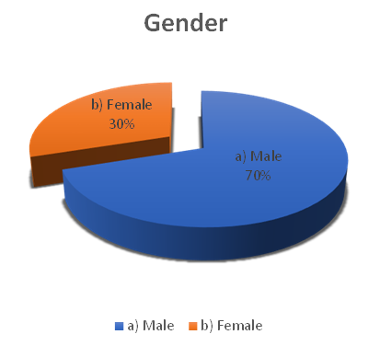

1 | Gender | a) Male | b) Female
1 | Gender | 7 | 3

Respondents were selected at random, no ex-ante restrictions were applied, such as being surveyed half men, half women, but at random. Analyses of the results show that 30% of the respondents were women and 70% were men. This is not essential for the final result of the search.

Table and Graph 2. Age group?
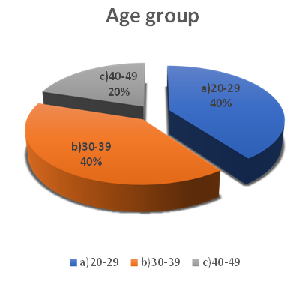

2 | Age group | a)20-29 | b)30-39 | c)40-49 | d)50-59 | e)over 60
2 | Age group | 4 | 4 | 2 | 0 | 0

In general, the age indicator is not basic and has no direct relationship with the impact of VLE on students or the degree of absorption. However, younger students are more likely to cope more easily with the platform and to experience some delay or difficulty with advancing age. The present study took participants of different ages. 40% are between 20-29 years old, 40% indicated that they are between 30-39 years old and 20% - between 40-49 years old. We do not have older people and in general we can say that we have a representative sample with a normal distribution, given the average age at which people start higher education.

Table and Graph 3. Do you use VLE?
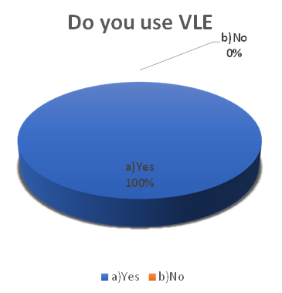

3 | Do you use VLE | a)Yes | b)No
3 | Do you use VLE | 10 | 0

This is the first of a series of serious questions. His answer has the strongest relation to the final result and the answer to this question has the final word whether the answer to the survey is relevant in the present study. If a student answers that he / she does not use VLE, ​​this makes the survey invalid for work and analysis, because there is no way for a student who has not used a platform to give any opinion about it or about how it has affected his / her educational process. 100% of all respondents answered Yes. Which is a guarantee for the validity and adequacy of the results of the following questions.

Table and Graph 4. How satisfied are you with VLE?
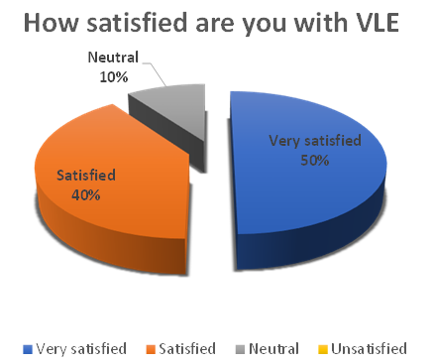

4 | How satisfied are you with VLE | Very satisfied | Satisfied | Neutral | Unsatisfied | Very unsatisfied
4 | How satisfied are you with VLE | 5 | 4 | 1

Satisfaction is the reason we use an object over and over again. This is the reason to include the question of how satisfied the student is with the use of VLE for student purposes. Only 10% answered neutrally. They may need a little more time to work with VLE to gain enough practice to form their opinion. 40% respond with satisfaction and 50% - very satisfied. It can be concluded that the users of VLE - Moodle among the students in UWTSD are satisfied with the chosen platform.

Table and Graph 1. What device do you use for VLE?
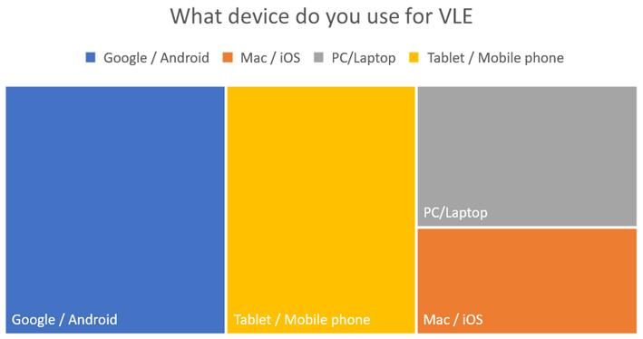

5 | What device do you use for VLE? | Google / Android |  | Mac / iOS | PC/Laptop | Tablet / Mobile phone
5 | What device do you use for VLE? | 7 |  | 3 | 4 | 6

Everyone in the 21st century has at least one device. Software developers usually work in the interest of one company, not all. Here comes the problem that most platforms are designed mainly to work with one type of device and one type of operating system. The purpose of the next question is not so much to determine the percentage, but whether users can use different devices and operating systems successfully enough. 70% successfully use VLE with Android and Google, but 30% manage to work freely with Apple and iOS. Apart from this criterion, 40% of students successfully use a personal computer or laptop, and the remaining 60% manage to work through their tablet or mobile phone. This means that the system is well developed and flexible enough to work. It does not require the purchase of a separate device of a specific type in order for each student to work successfully with it. Gives freedom in choosing technology.

Table and Graph 6. Is VLE easy to be used?
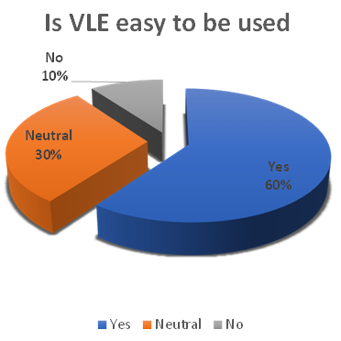

6 | Is VLE easy to be used | Yes | Neutral | No
6 | Is VLE easy to be used | 6 | 3 | 1

Online platforms aim to facilitate education and make it possible and successful even in a global lockdown. The main question is how easy it is to use VLE-Moodle. 10% said it was not easy, 30% remained neutral, and 60% of students said it was easy to work with. It would be good to study what exactly makes it difficult for this part of the students who have indicated No.

Table and Graph 7. How do you find VLE training?
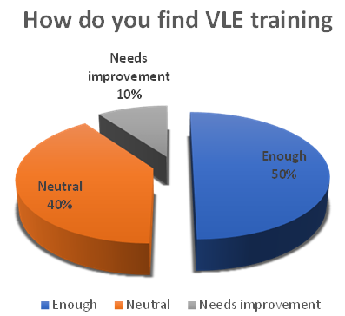

7 | How do you find VLE training | Enough | Neutral | Needs improvement
7 | How do you find VLE training | 5 | 4 | 1

Once an innovation is presented to its users, they need training on exactly how to use it and how to use it. The next question aims to determine the extent to which training is sufficient. 10% indicated that training needs improvement. 40% remained neutral, and the remaining 50% found the training sufficient to be able to use the platform and study their modules successfully.

Table and Graph 8. What are the advantages of VLE?
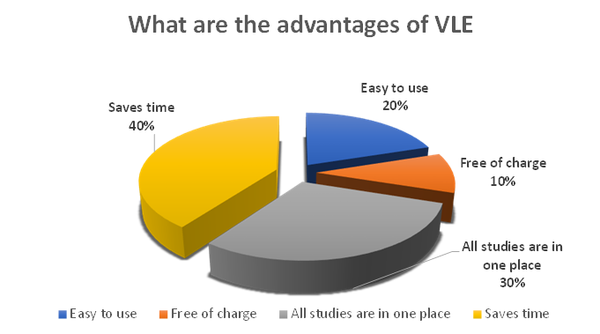

8 | What are the advantages of VLE | Easy to use | Free of charge | All studies are in one place | Saves time | No advantages
8 | What are the advantages of VLE | 2 | 1 | 3 | 4

The opinion of the students about the advantages they find in the platform chosen by Y was studied. 10% are satisfied that it is free, 20% consider it an advantage that it is easy to use, 30% are satisfied with the fact that all their items are placed in one place and the remaining 40% appreciate the fact that it saves time.

Table and Graph 9. What are the disadvantages of VLE?
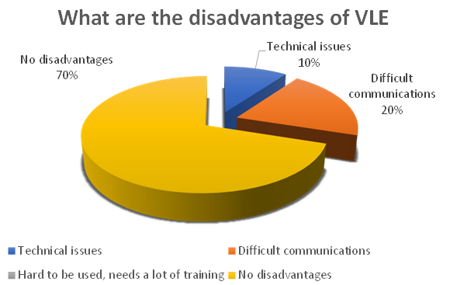

9 | What are the disadvantages of VLE | Technical issues | Difficult communications | Hard to be used, needs a lot of training | No disadvantages
9 | What are the disadvantages of VLE | 1 | 2 |  | 7

And the best product has drawbacks. Its users have the best idea of what they are, what they lack when using the platform. 10% of the surveyed students suffer from the technical problems they face. 20% of them have difficulties with communication, especially with the teachers in their modules. and the remaining 70% state that they do not see any shortcomings at the moment. It is good to consider how to work towards improving these shortcomings in order to make the use of VLE-Moodle more useful for students.

Table and Graph 10. What would you recommend VLE?
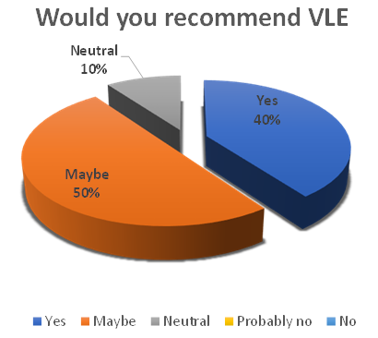

10 | Would you recommend VLE? | Yes | Maybe | Neutral | Probably no | No
10 | Would you recommend VLE? | 4 | 5 | 1

One of the best criteria to conclude about the overall impact of VLE-Moodle on students is whether they would recommend its use. 10% of respondents indicated that they were neutral. 50% answered with Maybe the other 40% with Yes. This means that most students are satisfied, like the platform, are useful and do their job well.

Summarise and outcome from the research

The "resource view" was by far the most frequent behaviour taken by students visiting the VLE, although the analysis did not directly examine the issue of the most utilized resource. The forums were far less utilized, but this could be attributed more to a lack of knowledge than to an indication of their importance. The two interviewing students replied favourably to the concept of platforms and agreed that they might be a valuable method. They also said that in the presentation of tools submitted to the VLE, neither module in the study allowed use of alternative media. It could be that if lecturers were motivated to build a greater variety of VLE tools to use the platforms as a means to address the questions of students, the VLE will be utilized to its maximum extent and may actually support students obtain the expected learning results.

Conclusion

Research on impact of VLE – MOODLE on students' learning experience at UWTSD London Campus. In December 2020, amid a global pandemic and lockout, a research was carried out by students to explore and examine the influence of Vle-Moodle on them and their online learning. 10 students, picked by a random process, were chosen. 30% of the respondents were women and 70% were men. Younger students are more likely to cope more easily with the platform and to experience some delay or difficulty with advancing age. The present study took participants of different ages. 40% are between 20-29 years old, 40% indicated that they are between 30-39 years old.
100% of all respondents answered Yes. 40% respond with satisfaction and 50% - very satisfied. 70% successfully use VLE with Android and Google, but 30% manage to work freely with Apple and iOS. Only 10% answered neutrally. VLE allows freedom in choosing technology. It does not require the purchase of a separate device of a specific type in order for each student to work successfully with it. It gives freedom in choice. It is a well developed and flexible enough to work. This means that the system is well developed, flexible enough.
Online platforms aim to facilitate education and make it possible and successful even in a global lockdown. The main question is how easy it is to use VLE-Moodle. 10% of the surveyed students suffer from the technical problems they face. 20% of them have difficulties with communication, especially with the teachers in their modules. 70% state that they do not see any shortcomings at the moment. What would you recommend VLE? 10% would recommend its use, 50% would say Maybe, and the other 40% would answer Yes. Table and Graph 9. What are the disadvantages of Vle? 9. Technical issues.Difficult communications. Hard to be used, needs a lot of training.

Reference list

- Boyle R., Neagle R., and Efford N. (2008) Evolving modes of student use - whither the VLE? ACMIFIP IEEIII 2008 Informatics Education Europe III Conference, 4-5 December 2008, Venice, Italy.
- Maltby A. and Mackie S. (2009) Virtual learning environments - help or hindrance for the ‘disengaged’ student? Association for Learning Technology Journal, 17 (1), 49-62.
- Richardson J. (2001) An evaluation of virtual learning environments and their learners: do individual differences affect perception of virtual learning environments? Interactive Educational Multimedia, 3, 38-52.
- Stanca L. (2006) The effects of attendance on academic performance: panel data evidence for introductory microeconomics. Journal of Economic Education, 37(3), 251-266.
- St Clair K.L. (1999) A case against compulsory class attendance policies in higher education. Innovative Higher Education, 23 (3), 171-180.
- Stewart M. Stott T. and Nuttall A.M. (2011) Student engagement patterns over the duration of level 1 and level 3 geography modules: influences on student attendance, performance and use of online resources. Journal of Geography in Higher Education, 35 (1), 47-65.

Answers to the questionnaires
Student ID | Student Name | Questions
Student ID | Student Name | 1 | 2 | 3 | 4 | 5 | 6 | 7 | 8 | 9 | 10
2010779 | Adriana Racu | Female | b | a | a | a d | c | b | d | d | a
2008172 | Billy Kamanda | Male | b | a | a | a d | a | b | c | d | a
1920793 | Dimitar Sokerov | Male | c | a | b | b d | b | b | d | d | b
2010295 | Ivan Chorbadzhiyski | Male | a | a | b | a c | b | c | b | a | b
2010424 | Ivaylo Tabandzhov | Male | a | a | a | b d | a | a | d | b | c
2007926 | Ivelina Draganova | Female | b | a | a | b c | a | a | a | d | a
2008334 | Kaloyan Dzhambazki | Male | b | a | c | a c | a | a | c | d | b
1816841 | Kristiyan Stanimirov | Male | a | a | a | a d | a | b | c | d | a
2007927 | Mariya Delieva | Female | c | a | b | a d | b | a | d | d | b
2009057 | Nikolay Stanimirov | Male | a | a | b | a c | a | a | a | b | b

Summarised answers to the Questionnaire
1 | Gender | a) Male | b) Female
1 | Gender | 7 | 3
2 | Age group | a)20-29 | b)30-39 | c)40-49 | d)50-59 | e) over 60
2 | Age group | 4 | 4 | 2 | 0 | 0
3 | Do you use VLE | a) Yes | b) No
3 | Do you use VLE | 10 | 0
4 | How satisfied are you with VLE | Very satisfied | Satisfied | Neutral | Unsatisfied | Very unsatisfied
4 | How satisfied are you with VLE | 5 | 4 | 1
5 | What device do you use for VLE? (choose 1 from the upper line and 1 from the bottom line) | Google / Android | Mac / iOS | PC/Laptop | Tablet / Mobile phone
5 |  | 7 | 3 | 4 | 6
6 | Is VLE easy to be used | Yes | Neutral | No
6 | Is VLE easy to be used | 6 | 3 | 1
7 | How do you find VLE training | Enough | Neutral | Needs improvement
7 | How do you find VLE training | 5 | 4 | 1
8 | What are the advantages of VLE | Easy to use | Free of charge | All studies are in one place | Saves time | No advantages
8 | What are the advantages of VLE | 2 | 1 | 3 | 4
9 | What are the disadvantages of VLE | Technical issues | Difficult communications | Hard to be used, needs a lot of training | No disadvantages
9 | What are the disadvantages of VLE | 1 | 2 |  | 7
10 | Would you recommend VLE? | Yes | Maybe | Neutral | Probably no | No
10 | Would you recommend VLE? | 4 | 5 | 1

Examples of some questionnaires, answered by the students:


