
ACCA4026 SSB Assessment 1
Rajeev NATH

15 December 2025
SSB Assessment 1
Mustafa AY - 2513629

Table of Contents
Introduction 3
Task 1. e-Commerce Website builders or software solutions 3
1.1 Shopify 3
1.2 Wix 4
Task 2. Mind-map of contemporary software applications 4
a. Mind mapping and explain the benefits of using mind mapping in business operations 4
b. Mind map of contemporary software applications 6
CONTEMPORARY SOFTWARE APPLICATIONS 6
Task 3. Office Applications 6
Four office software solutions for business operations 6
MS Word 6
MS PowerPoint 7
MS Excel 8
MS Access 9
B. Practical demonstration of Two Office Features 10
Mail Merge in Excel to Word 10
Fig 1: customer table in MS Excel 10
Pivot Table 13
Task 4. Communication and Collaboration applications 16
One contemporary Communication and one Online Collaboration applications/tools 16
MS Outlook 16
MS Teams 17
One feature of a freely available Communication (1) and one feature of a Collaboration (1) application 18
MS Outlook 18
Ms Teams 21
Conclusion 23
References 24

Introduction
Online e-commerce website builders enable users to create an e-commerce store on their own terms without requiring advanced technical skills. A typical e-commerce website builder provides users with everything they need in order to design web pages and maintain an online store, such as adding products, accepting payments, managing sales/orders, etc. E-commerce store development with an online website builder has a fast, inexpensive, and simple-to-use format. Additionally, e-commerce website builders provide access to pre-made templates, mobile applications and customer support resources for getting started with your own store. In the following section, I will discuss two of the most common e-commerce website builders – Shopify and Wix eCommerce – including their main features and benefits as well as limitations for various business types.

Task 1. e-Commerce Website builders or software solutions

1.1 Shopify
Shopify has become the premier provider of online store building solutions, providing users with a very simple method to build a store online. All the functions are available via an internet-only interface and therefore can easily be completed without the need to download software to any PC or laptop. Creating a shop, adding products, processing orders, managing customers, sending emails, etc. can all be accomplished in a matter of minutes. This makes the Shopify platform an excellent choice for anyone sell via the internet, or for small business owners searching for an easy way to get started selling on the internet.
The most significant feature of Shopify is its extensive library of pre-designed templates that make it possible to create visually appealing and professionally-looking stores without having to possess design expertise. With built-in inventory management, order management, and some basic e-commerce marketing tools, the Shopify platform contains everything needed to start an online store. You may also access and use the thousands of 3rd party apps available through the Shopify App Store to improve the functionality of your store. Examples of the types of apps available on the Shopify App Store include reviews, shipping tools, etc.
Shopify offers many different ways to pay when you use the platform. You can use a credit card as your primary method of payment or pay using your PayPal account or debit/credit card through other third-party payment processors such as Stripe or Authorize.Net. The secure payment system that is available through Shopify makes it safe and sound for customers to purchase from your store. Plus, if you ever have a question, you can reach out to the support team and receive help 24/7 with all your inquiries.
However, Shopify has a caveat. Monthly costs can be high, especially for smaller businesses. Some apps may also charge additional fees.

1.2 Wix

In my opinion, one of the reasons Wix eCommerce has become widely accepted among novice eCommerce developers is because creating a new online store is incredibly simple to do. New users can appreciate how easily they can design their new online store layout and its corresponding design elements with Wix eCommerce compared to other options.

Wix eCommerce began as an option for developing websites, but as they have expanded to include eCommerce capabilities, they are now a viable choice for small companies who wish to sell their product on the World Wide Web, but do not want to create a large amount of work/time to do so.

Among the most appealing features of the Wix eCommerce is the drag-and-drop editor feature. Using the drag-and-drop editor allows users to drag-and-drop products, images, text and buttons onto the website with their mouse. This feature allows users to create a unique store style, regardless of the user's previous experience in creating websites. Additionally, Wix eCommerce provides a variety of preloaded template options, allowing users to choose one with a nice and simple "clean" design.

In addition to the drag-and-drop editor, Wix eCommerce has many other useful features, including a full suite of tools for creating product pages, managing stock, payment methods and providing users with ease of use when shipping products.

Task 2. Mind-map of contemporary software applications
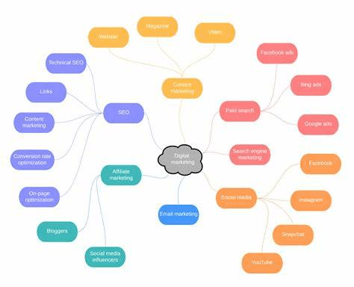
- Mind mapping and explain the benefits of using mind mapping in business operations
For me, mind mapping is an effective visual representation of information. When I create a mind map, I create a line down the centre of the page and draw small branches off this line to represent the different areas of information that I have written about. Each area of information, or section on the mind map, contains small bullets, keywords, or reminders for me to refer to. The benefit of a mind map is that I can see web of all the information that relates to one topic at once. This allows me to focus all of my attention on that subject, instead of having to read through a large paragraph of text. When there is more information collected about one idea from a mind map, the person using it can be more targeted in their efforts to understand that idea. Sometimes I will use colour pencils when I'm creating these maps, and sometimes I won't. I have also noticed that mind maps can speed up the process of collecting information into your brain, whereas they can also slow down the process of thinking, since you only have to think of the exact keywords you put down on the page. So, it depends on the size of the mind map and how many sections you are putting into it to entirely understand the effects of mind maps.
In the office, mind maps can be helpful to assist everyone in staying on track when discussing topics collectively rather than losing focus on an individual topic as each person. One typical example of a mind map in the office is a meeting agenda. The meeting generated too many different subjects, therefore writing down everything before, during and after the meeting, would be tedious and unnecessary. However, with a mind map the presentation of all of those subjects would show only the most significant points. The entire office knows what was important on the agenda at all times. Due to the above reasons, I feel it is a great collaborative tool between teams. Several companies use mind maps for creating potential marketing strategies, creating presentations using marketing material, and providing solutions for customers. Mind maps provide a structure where ideas are produced more freely, providing an opportunity for creative expression as the person does not have to write in full sentences, only briefly. Mind maps provide an easy to read visual organization of information helping reduce misunderstandings among teams and improving communication due to everyone having access to the same minds as a reference.
- I also think using a mind map when starting a new project is very useful. The project name is created, and the distribution of events, dates, responsibilities, and risks are added. This allows for visibility into what's happening together. This makes it easier to answer questions like who will do what within the team and when. Such a map also allows for better problem-solving before working on it. Whether on paper or with a computer program, a mind map always maintains order. You can change branches as needed, add new ideas, or delete unnecessary parts. This flexibility, in my opinion, is one of the things that makes mind mapping so useful. In conclusion, mind mapping is a very effective method for clearly seeing, combining and unifying both work structuring and personal organization.

b. Mind map of contemporary software applications

CONTEMPORARY SOFTWARE APPLICATIONS
Contemporary Software Applications in Business
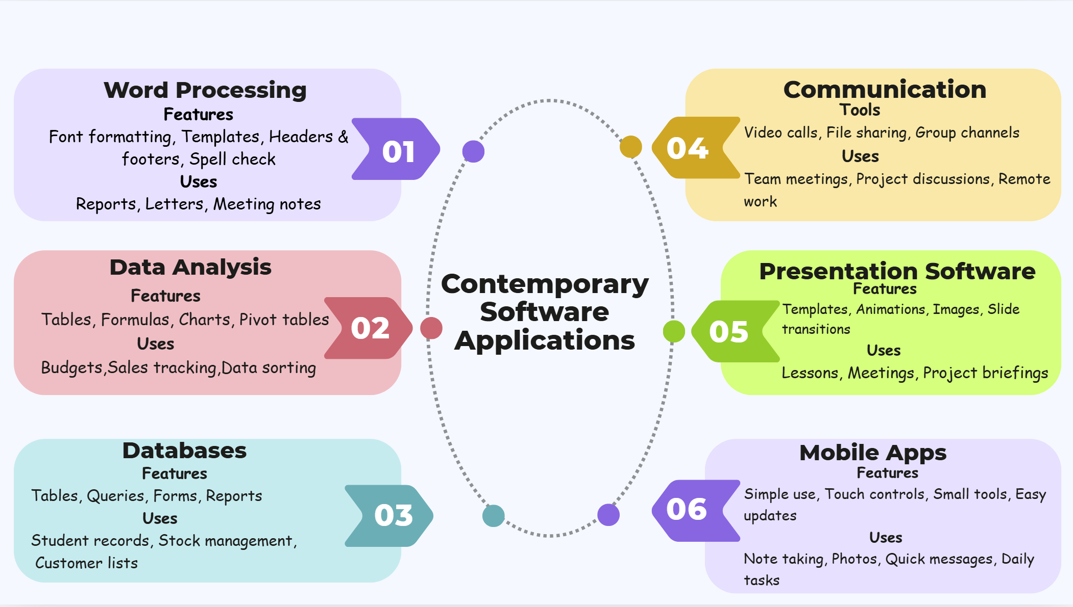

Task 3. Office Applications

Four office software solutions for business operations

MS Word

Microsoft Word is one of the most widely used programs by corporations and individuals, simply due to the ease of creating multiple types of documentation including letters, reports/abstracts/forms and records of meetings. The majority of users will agree on how simple Microsoft Word is to learn because everything you require comes up on screen, plus the tools are easy for any user to navigate through. You can change the font size, colour, style and add graphics/images/tables very easily. To ensure your documents look professional and are well-organised, Microsoft Word has been an excellent option for many companies. Although this software can assist you in creating professional-looking documents in an efficient manner, it also has built-in tools for helping users quickly identify and correct spelling and grammatical mistakes, which is again another reason why Microsoft Word is such a valuable application overall.
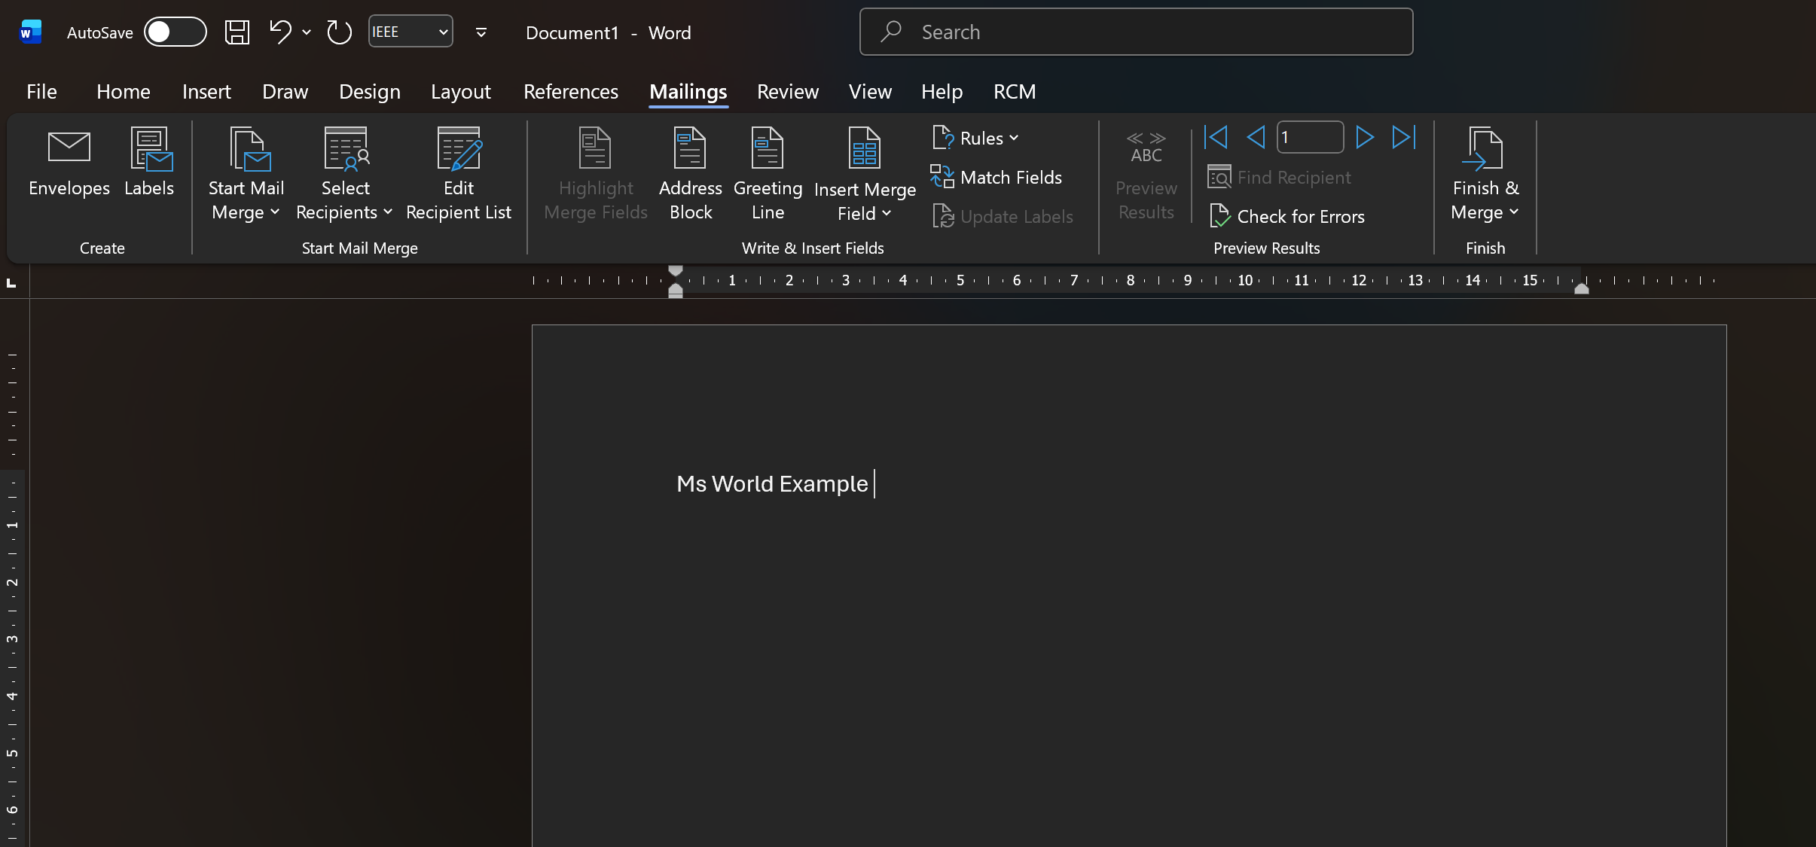
Another reason I believe Word's popularity among employees is mostly because of its practicality. For instance, when needed, I can make numerous edits to a document quickly and easily. If there's a spelling mistake, it shows up underlined immediately as a reminder. This has been a huge help for me as I have to complete my projects very quickly due to many projects on my plate. In addition to that, Word provides me with templates; there are different layouts for letters, forms, or reports. This eliminates the need for me to create new templates from scratch and saves me time as well. In conclusion, Word is very easy to use for everyday personal and business applications. The best thing about Word for me is that it allows me to present my finished documents neatly and professionally regardless of how long each document may be. Therefore, like many organizations, Word will be a program that I use regardless of whether I am running a small business or working in a corporate environment.
Microsoft Word'de sevdiğim birçok şey var. Bir belgeyi istediğim gibi düzenleyebilme özelliği, altın değerinde. Ayrıca, belgemi Word'e kaydedip başka bir bilgisayarda erişebildiğim için biçimlendirmem ve düzenim aynı kalıyor; bu nedenle, bu özellik, aynı stillerin tutarlı bir şekilde görüntülenmesini sağladığı için iş ortamında belge paylaşırken herkese fayda sağlıyor. Daha önce bahsedilen avantajlara ek olarak, Word'ün en sevdiğim özelliklerinden biri de çalışmamı PDF dosyası olarak kaydedebilme özelliği. PDF dosyaları, başkalarının yanlışlıkla değişiklik yapma olasılığını ortadan kaldırırken, cilalı ve profesyonel bir görünüm sağlıyor. Genel olarak, Microsoft Word'ün iş kullanıcıları için hâlâ etkili, kullanıcı dostu ve güvenilir bir kaynak yazılım olduğunu düşünüyorum.

MS PowerPoint
As a popular application for creating presentations, many companies utilize the features that Microsoft PowerPoint provides to build visually appealing presentations of their data. The interface of PowerPoint is simple and user-friendly so that anyone can create their presentation. One of the main features offered by PowerPoint is slide composition. Using this feature, users can design a slide that contains text and images, graphs or small videos related to the subject being presented. With these features, users can build an effective presentation that clearly communicates their message during training or meetings.
In addition to their slide-building capability, PowerPoint contains a variety of templates for slide design, allowing the user to produce attractive, professional-quality slides easily and with little effort. Companies utilize PowerPoint to present business ideas, corporate reports, and project proposals in an easy-to-read format. PowerPoint creates channels of communication between companies and provides a channel through which companies can deliver presentations that engage and retain the attention of the audience.
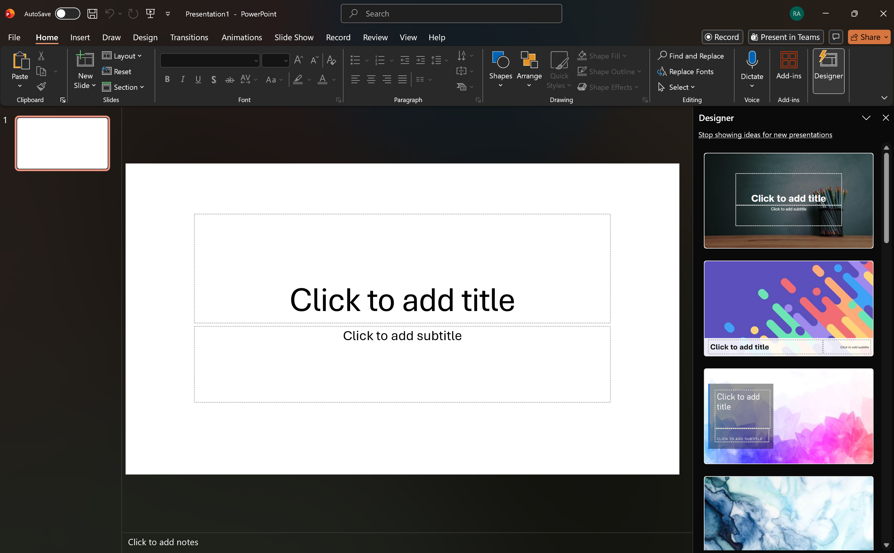
PowerPoint can be considered one of the most frequently used programs for business presentations. It is helpful in presenting organised data so that others can clearly see the information you are presenting. When preparing for a business meeting, it may not be enough to rely on just text because you may require additional visual data such as a chart, a table or even photographs. Therefore, by including additional visual data in your PowerPoint presentation, you can help make it much easier to understand and comprehend information. I love how I can quickly design a professional looking presentation because of all the template designs available in PowerPoint. When I am not skilled in designing, I can develop a presentation that appears professionally designed simply by changing a number of options in the templates. In addition to this, I have found that I can include animation effects and small video clips in my presentations to bring them to life. Thus, PowerPoint has been the ideal solution for many people to express themselves in many areas of the educational and business world.
PowerPoint has made it easy to refer to more than one thing at a time because all the items are grouped in one document instead of having to explain them separatelyWhen preparing for meetings, I can either only include my key points or provide a table of information. An elaborate presentation is not necessary for presenting information, but I always keep my presentations neat and easy to read. I also think that sending PowerPoint files by email is a simple process. I send the file to people via email and they are able to open and view it as I created it. In my opinion, PowerPoint has helped me when I needed to show somebody the details regarding a specific project. I benefit on a daily basis from this tool.

MS Excel
Microsoft Excel is a computer program that companies use to work with numbers and other types of information. Excel has helped companies do the calculations they need to, in order to make their lives easier and enable quick access to the answers. A person can use a spreadsheet to enter numbers into, create a table, and create a chart or graphs quickly. Companies use Excel to track their budgets, sales figures, and finances. There are a number of features that make Excel helpful, such as the ability to create formulas for obtaining quick results and being able to filter and sort information. Excel is a valuable tool for helping users manage and understand their business data.
Using Excel as a tool to change jobs offers speed and simplicity of programming as well as a simple, user-friendly interface that provides an organized way of working with data. Excel's spreadsheets allow me to clearly and concisely evaluate the values that I have recorded into an Excel spreadsheet. When trying to evaluate large amounts of numerical data, I can easily create a spreadsheet that clearly outlines the data for me. In addition to the ease of evaluating and organizing numerical data, Excel has made creating budgets much easier with the ability to create formulas that do not require any lengthy calculations by typing them into a formula bar. As in the case of a spreadsheet, I just select the cell where I want to record my budget entry and enter the formula. Excel also allows me to prepare budgets based on just entering my expenses, so that I can easily manage my budget without spending a lot of time on it. In addition to budget preparation, charts are also a great way to present numerical information during business meetings. . Charts can also be helpful when it comes to business meetings. Difficult things like explaining numerical data can be easier with the help of a chart, which allows people to comprehend the data much more quickly. Therefore, I find Excel to be a very useful resource for anyone that needs to do a lot of repetitive work or that would like to create and maintain their own accounting records.
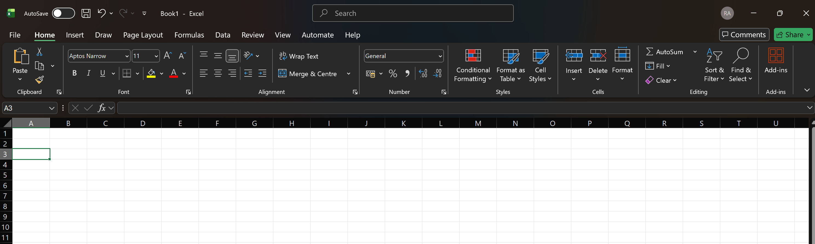
Ultimately, I think that Excel was a great learning experience for me because it helped me to see that spreadsheets allow me to visualize what could potentially become quite complicated (especially when dealing with many numbers), and thus can make understanding amuch easier. In addition, it was an easy tool for me to manage my time better when working with numerical data. The graphing component of Excel is an excellent example of how a visual representation of information is much easier to understand than looking at just the numbers. Another advantage that I discovered was the ease of sharing my spreadsheets with my fellow students. All my friends could easily open the same file and look at it using their computers. All these factors together have contributed to me considering Excel (and all other MS Office Applications we have used in school) to be very easy to use.

MS Access
Microsoft Access provides users with a single location to store large amounts of data. Many organisations such as hospitals, banks and retail shops have utilized Microsoft Access for managing their customers as well as tracking their inventories. Microsoft Access provides many features allowing users to create tables and forms as well as generate simple reports that will assist users in managing the information contained within a database. Although learning how to use Microsoft Access may take some time, it will become easier once the user understands the basic MS Access functionality. In recent years Microsoft Access has been increasingly beneficial for small businesses, allowing them to manage their data much more effectively than in prior years.
When I first encountered Microsoft Access, it was a bit confusing because it didn't seem as simple as Word or Excel. But I gradually learned to use it, saw that it was becoming more commonplace, and I saw that it actually worked for someone who ate it regularly. Access is especially helpful for storing multiple confidential pieces of information in one place. For example, I can keep a student list for a project, grades, or data from a simple inventory all in one database with Access.It was much easier than anticipated to create tables as well as create very small forms that corresponded directly to the tables. I am also able to correct incorrect data instantly. This results in the entire system self-updating.
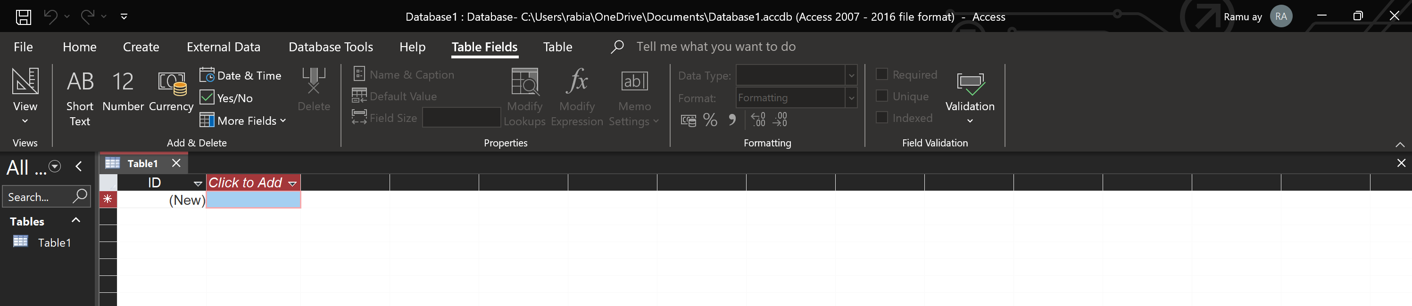
It allows for convenience by consolidating the data into one location, as opposed to collecting pieces of scattered information all over the place.
As you utilize Access, you will observe that what previously may have been challenging to manage with Excel are now made easier and are organized in a way that supports more efficient use. For example, I had trouble managing a very long list of items in Excel, whereas with Access I can create queries and only retrieve the information I need to evaluate. To me, this feature is similar to a filter; however, a query can allow me to become more efficient. Since I am looking for data with one click, this tool saves me a significant amount of time. I also appreciate the report file feature in Access; using this feature, I can gather all of the information related to my program and have it structured within a report page, which makes it easy for me when giving presentations. Although some elements of the program may seem very technical at first, with continued use, these elements become easier to navigate. In summary, Access is highly beneficial for anyone who desires to maintain their information in an organized manner.

B. Practical demonstration of Two Office Features

Mail Merge in Excel to Word

In Fig 1, I entered the people's information into Excel and created a list with all their details.
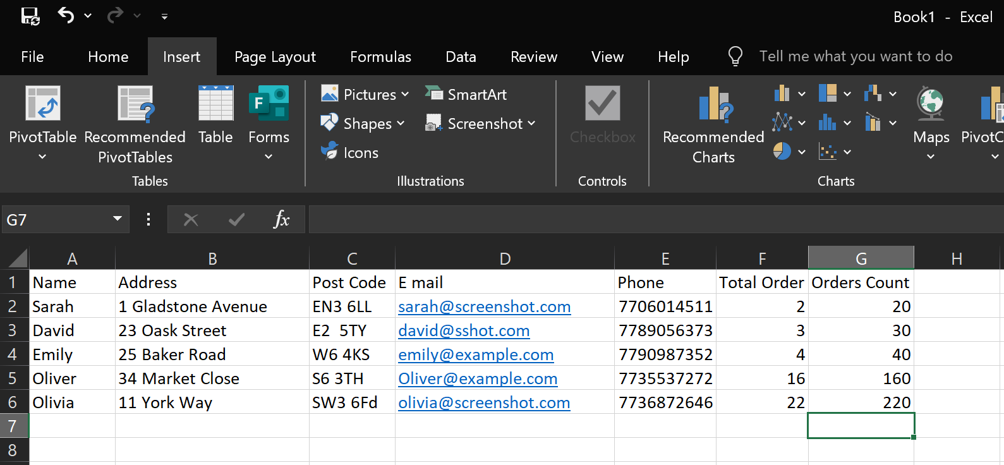
Fig 1: customer table in MS Excel [1]
I saved them, then inserted them into Word, clicked "Merge Mail," and tried to open my Excel list in Word.
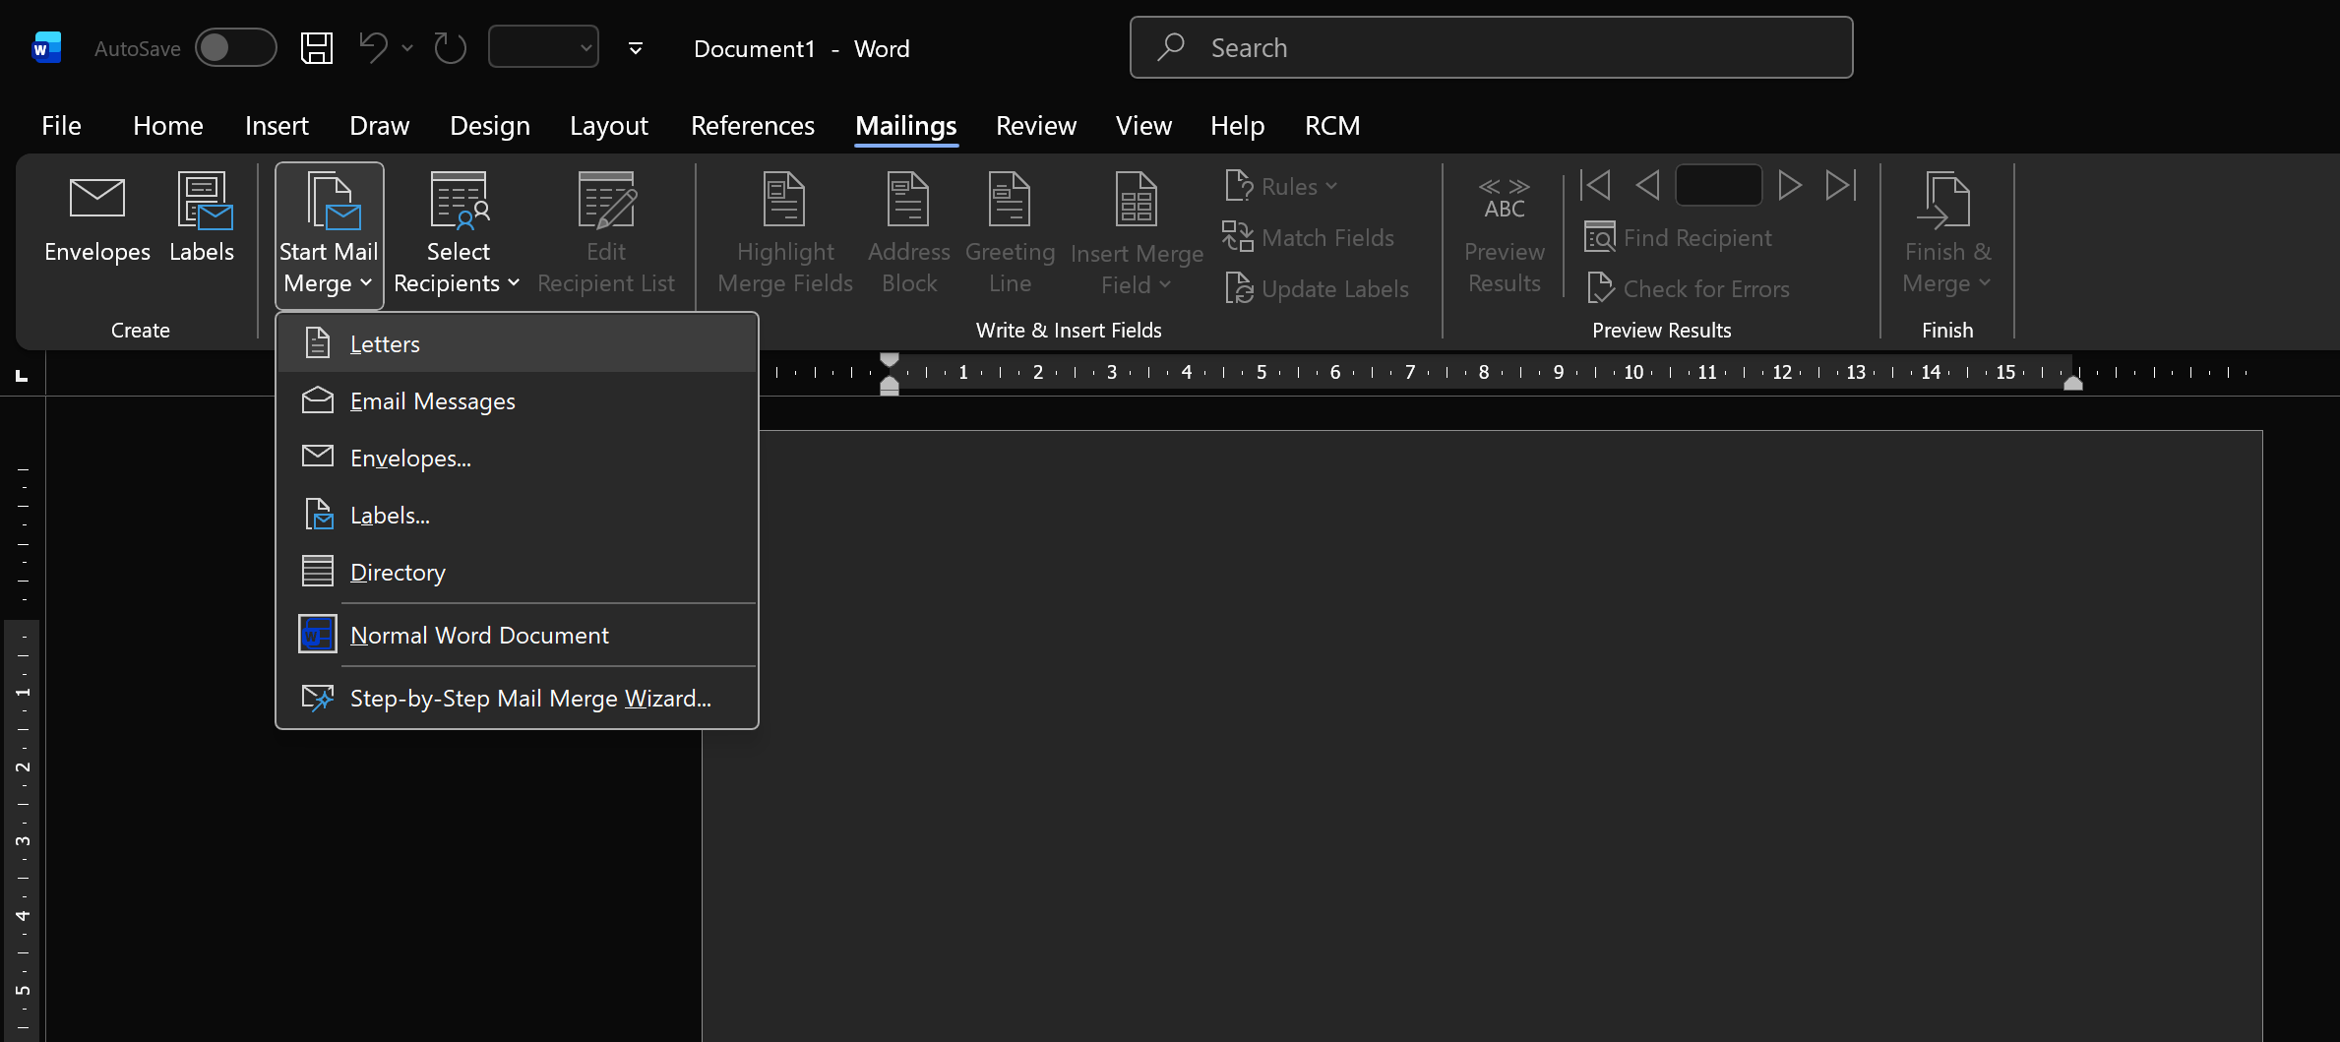
Fig 2 : Start Mail Merge [2]

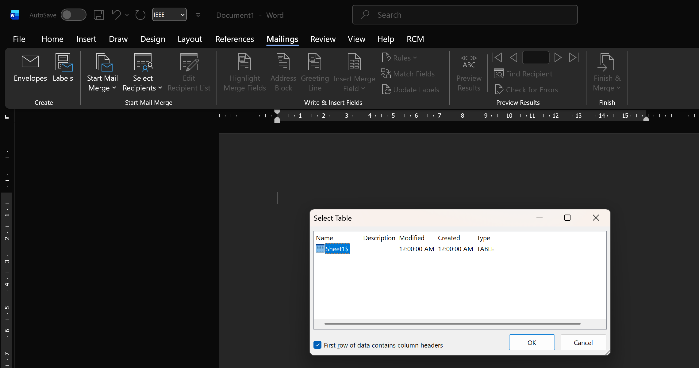
Fig 3 : Select Recipients
I went to edit the recipient list and checked if they existed.
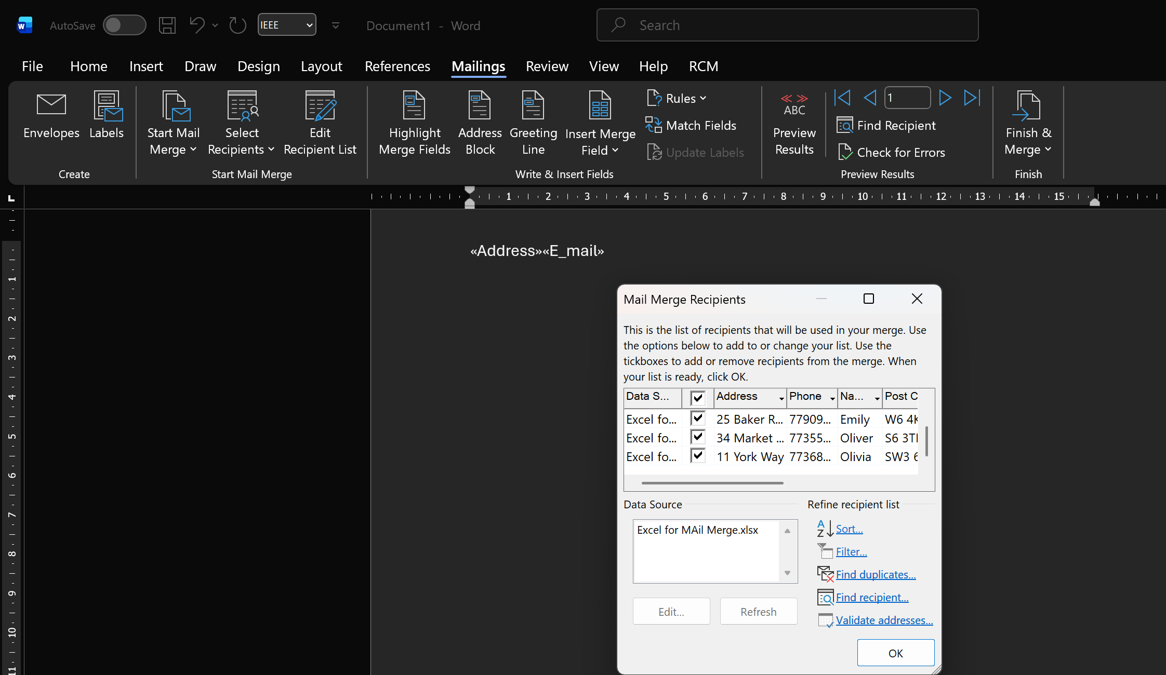
Fig 4: Edit Receipients List
I sorted them by clicking on the insert merga field
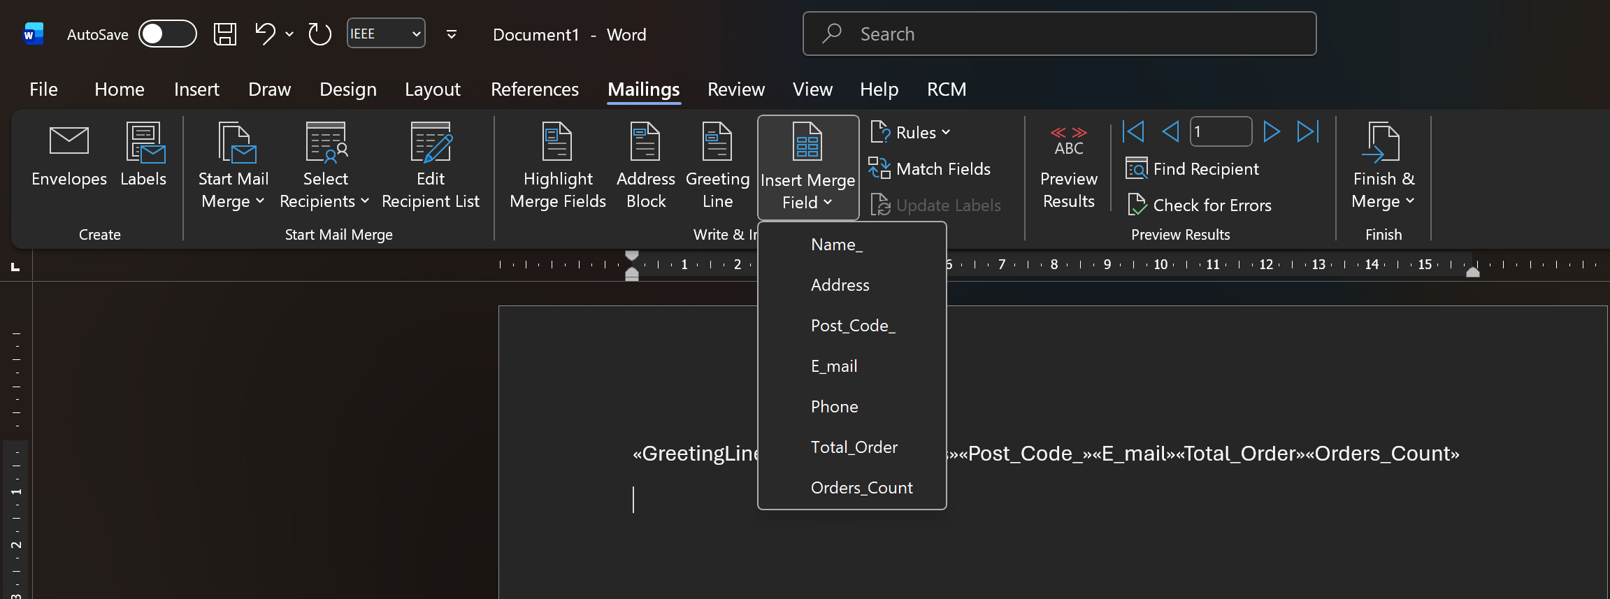
Fig 5 : Insert Merge Field
I clicked to preview results to view them.
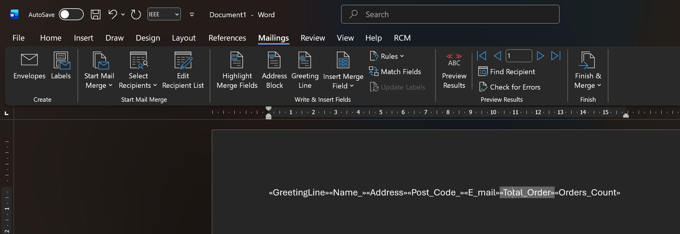
Fig 6 : Preview Results [3]
After finishing, I noticed that they were all displayed separately on 5 pages; you can see the other 5 pages opening in the corner.
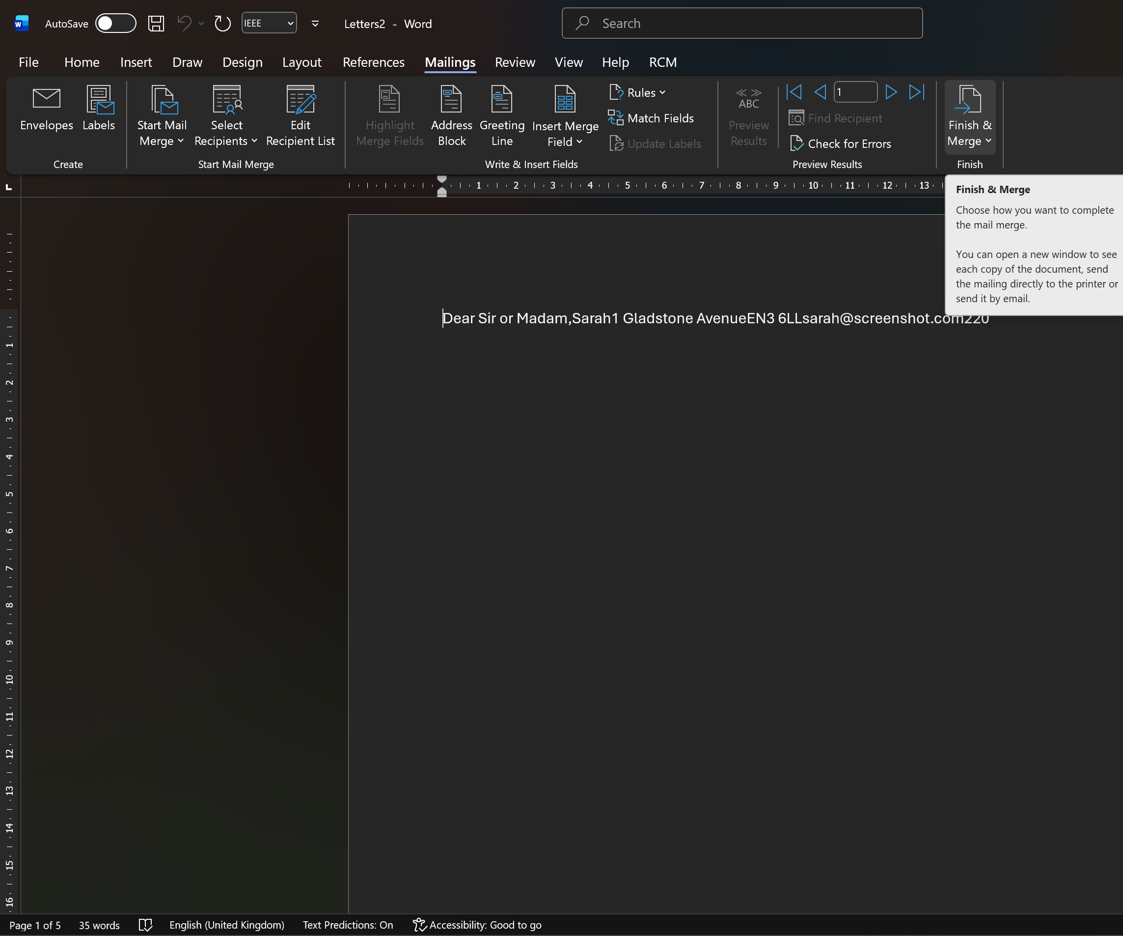
Fig 7 : Finishing Merge

Pivot Table
This screenshot shows the original Excel data used to create the Pivot Table.
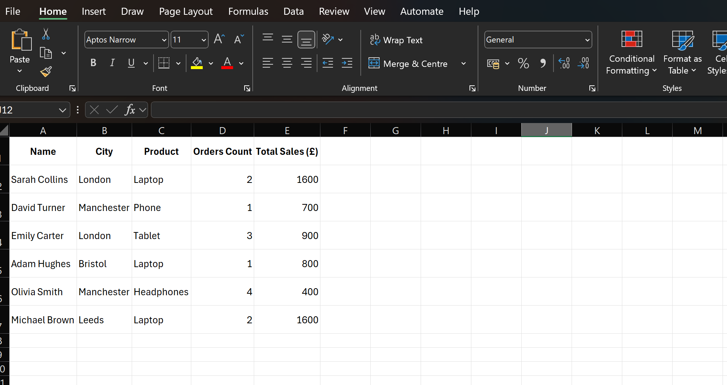
Fig 1 : Pivot Table in MS Excel [4]
Here I selected the data and created a new Pivot Table using the Insert menu.
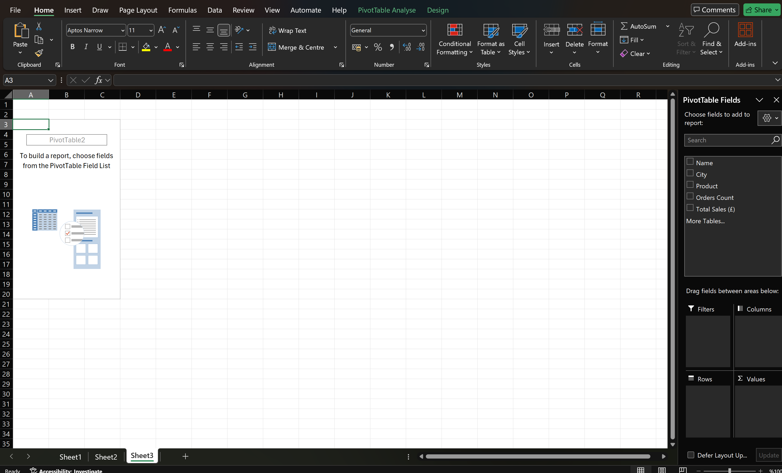
Fig 2 : Selecting data to create a Pivot Table [5]
This Pivot Table shows total sales grouped by city.
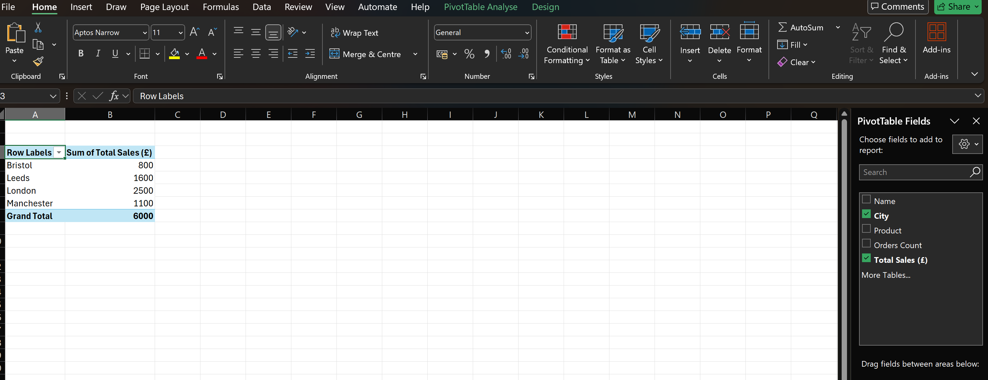
Fig 3: Pivot Table showing total sales by city (City → Rows, Total Sales → Values)
This Pivot Table shows how many orders were made for each product.
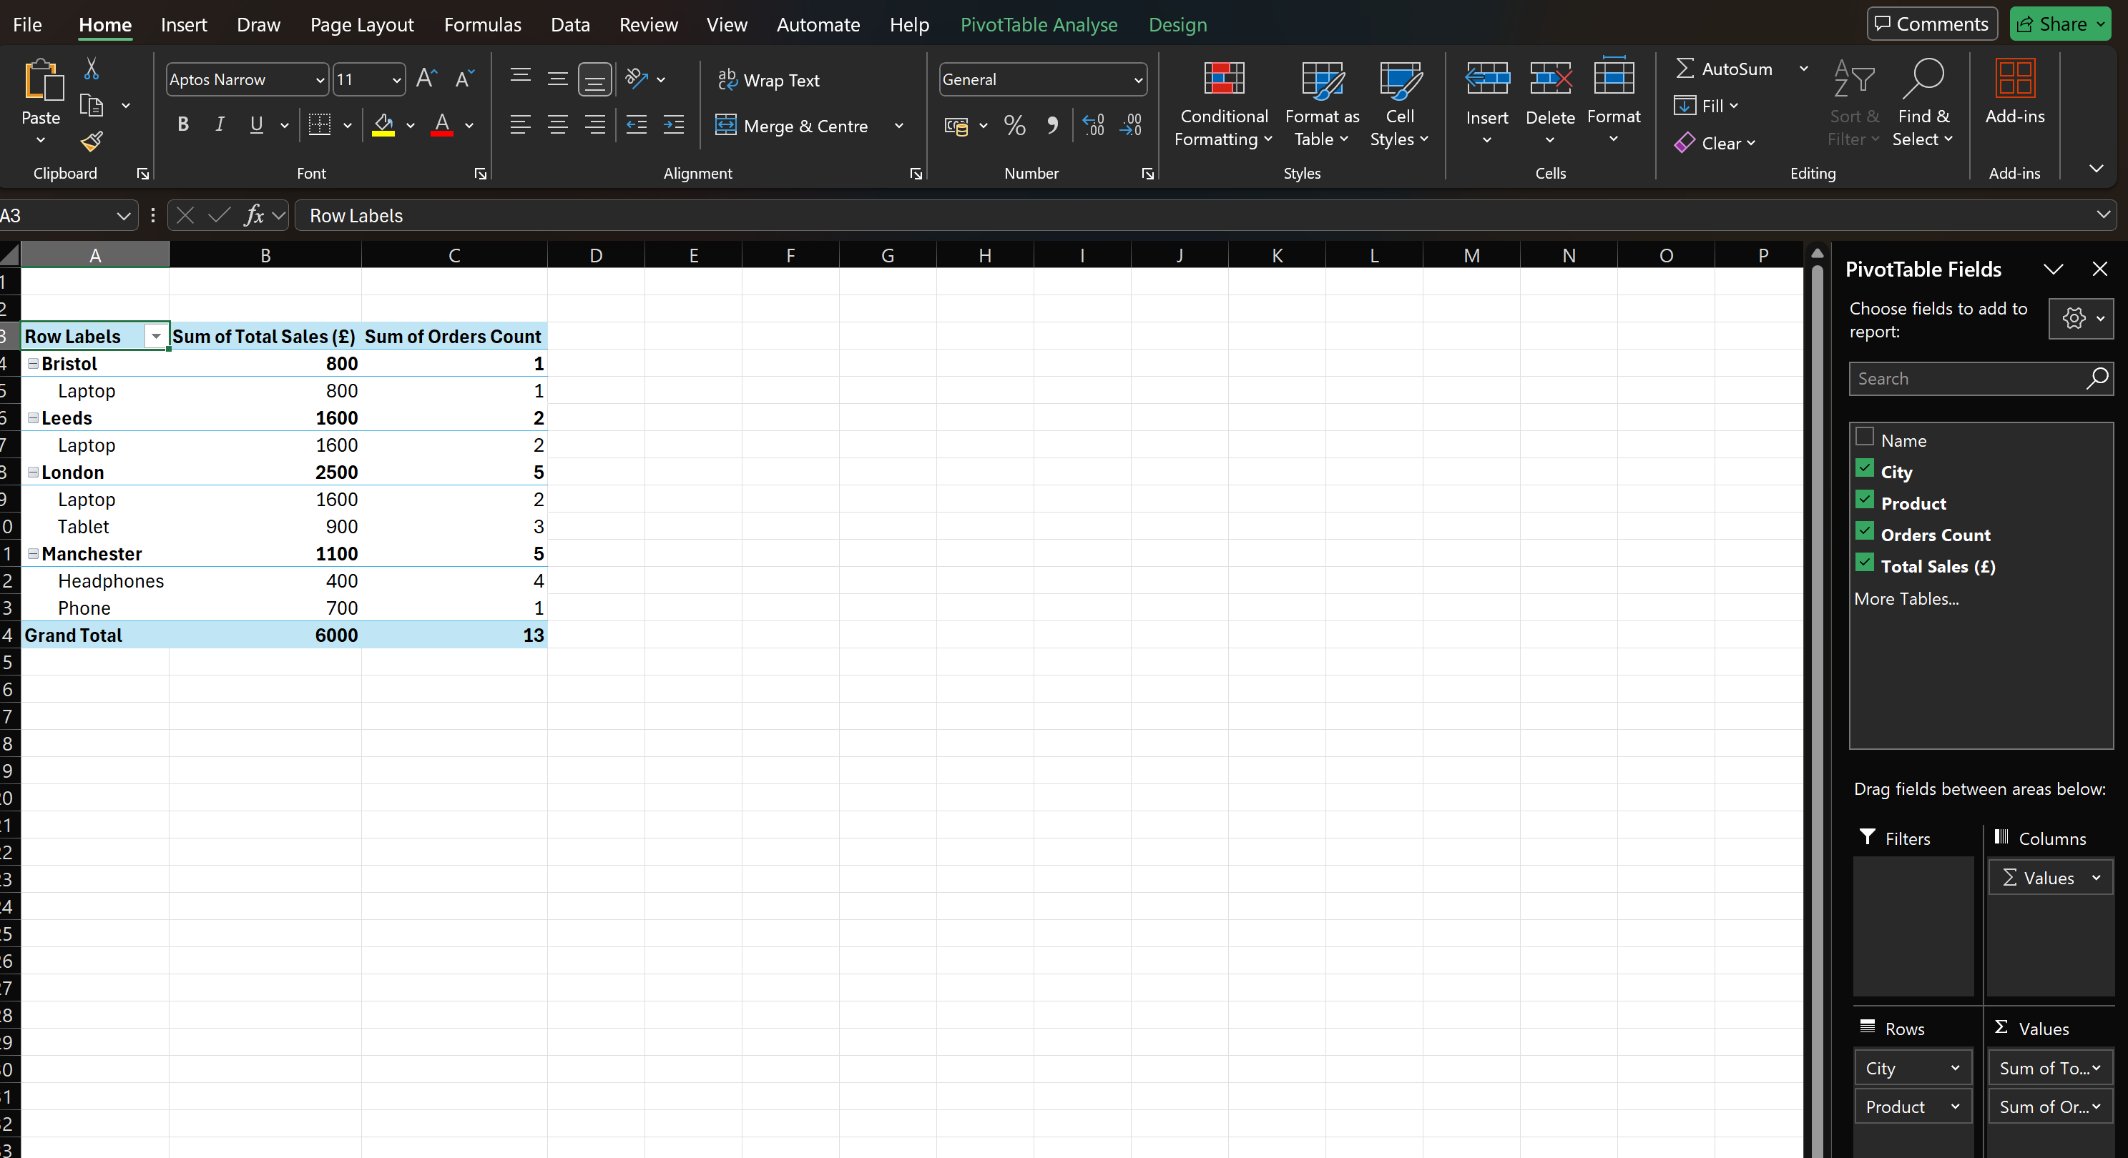
Fig 4 : Pivot Table showing number of orders by product (Product → Rows, Orders Count → Values)

In this step, I applied a simple design style to make the Pivot Table clearer.
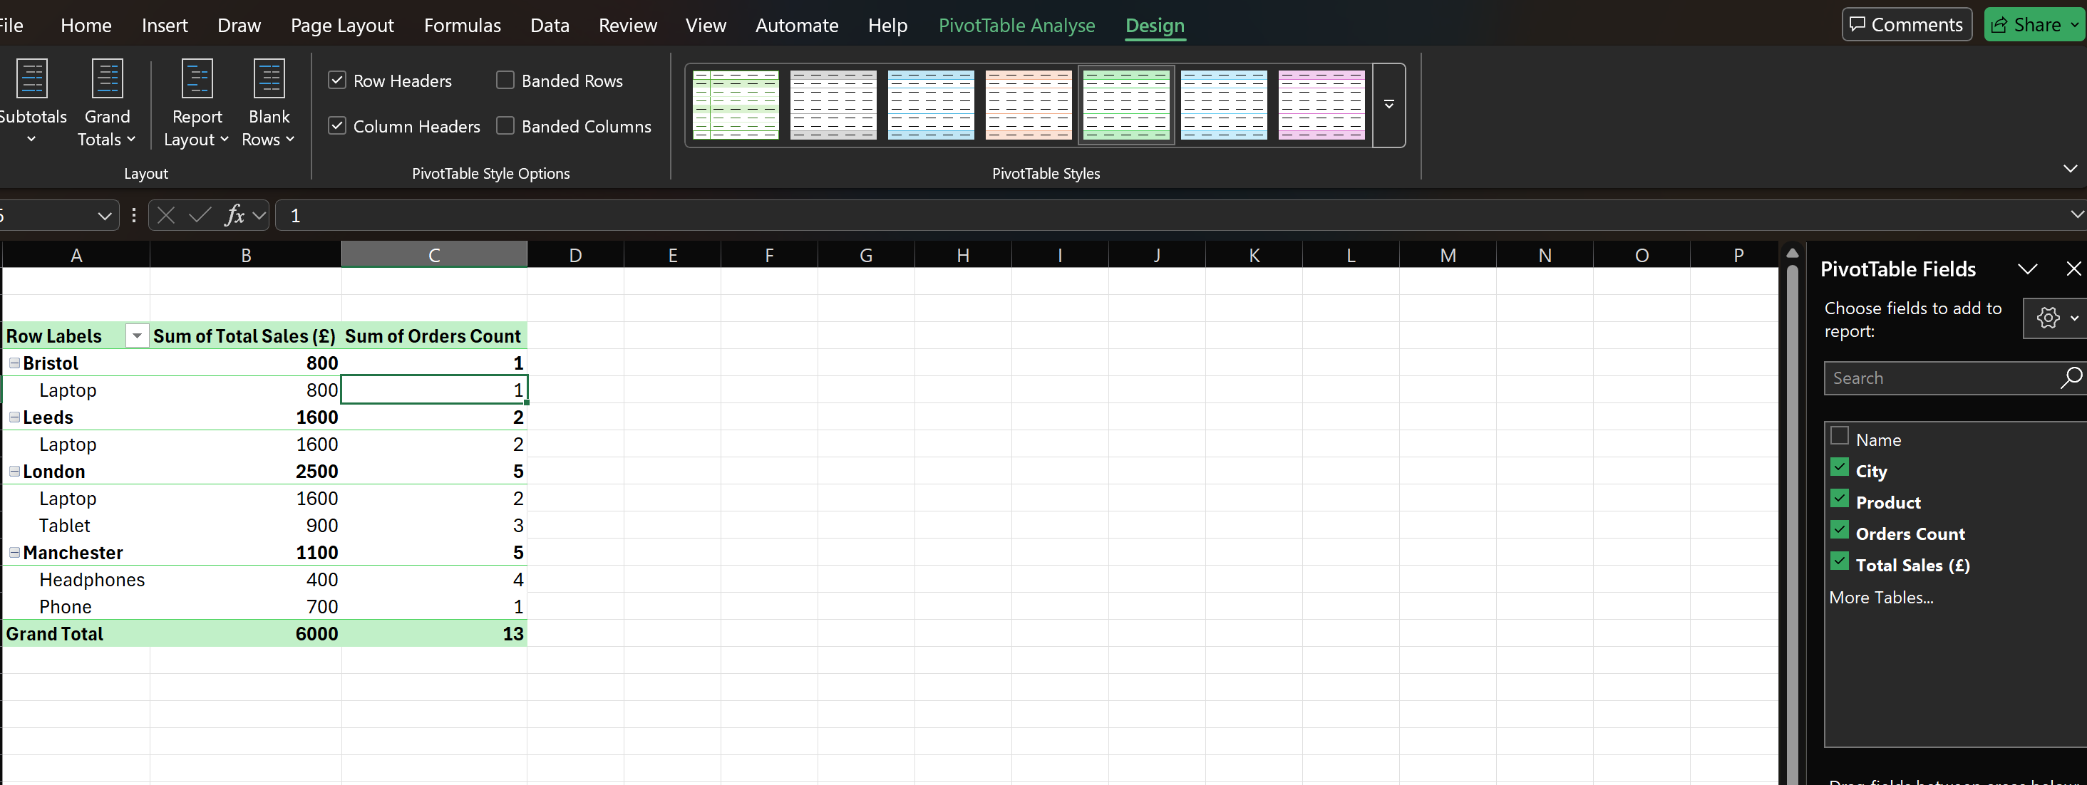
Fig 5 : Pivot Table with applied design style [6]
This screenshot shows a filter applied to view sales for one city only.
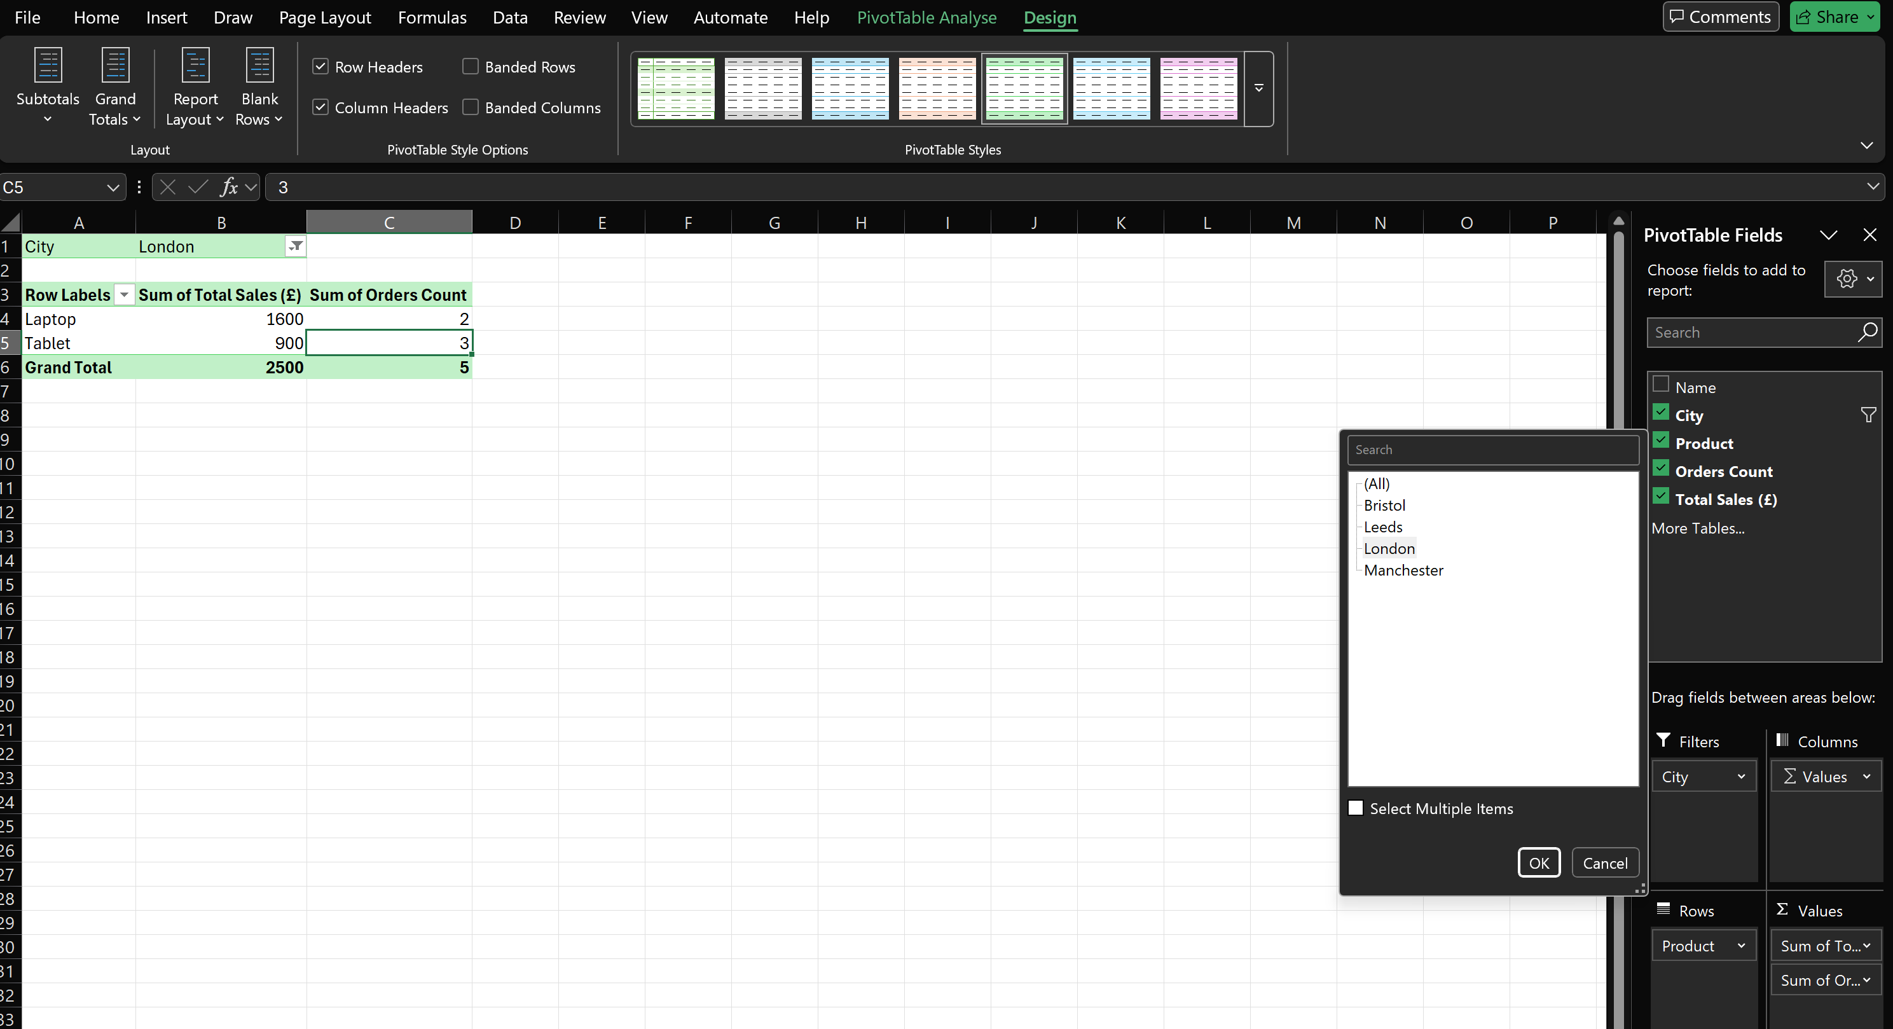
Fig 6 : Pivot Table filtered by city (London)

Task 4. Communication and Collaboration applications

One contemporary Communication and one Online Collaboration applications/tools
MS Outlook
Using multiple communications methods to interact with customers and partners is essential for any business to succeed in the digital world. Microsoft Office has developed a variety of communication programs, including Outlook, and they provide the ability for users to manage their communications efficiently. In addition to being versatile for both email and calendaring functions, the power of Outlook lies in its capability to create a well-organized notification system for your stored emails. The ability to create folders to group the messages allows the user to have a clearer view of their last received emails, so as to facilitate the individual process of locating the applicable messages amongst large volumes of unimportant emails. Outlook is additionally a program that is widely used by businesses around the globe due to its ability to work seamlessly with Microsoft 365 applications, and, in particular, provides easy access to documents created in Word, Excel, and PowerPoint. [7]
Outlook also includes a calendar system that is a major part of this software suite. In Outlook's calendar component, the user has an extremely simple interface by which to enter meeting requests; schedule appointments and inputs/reminders about when those meetings are due to occur. While this feature is useful for all employees, it is particularly important for teams working together, as they can create and manage shared calendars easily; when using this feature of Outlook to create a shared meeting, the tool identifies multiple employees working on similar projects in order to provide a time that works for both employees. As hybrid workforces become more common, the Calendar feature will continue to grow in importance - no matter where employees work, they will have a common place to view their upcoming schedules and can therefore plan their days accordingly. [8]
In addition to being extremely functional when it comes to managing emails, Outlook has advanced features for securing users' mailboxes and protecting their email content from being misused. Microsoft provides users with an email safety suite that includes spam filtering, anti-phishing measures, and abuse prevention programs. Security has become a key focus for organisations of all sizes as security breaches can create huge issues when confidential information has been inappropriately accessed. The email safety features make it easier for users to protect sensitive information that could be damaging to their organisation. Additionally, Outlook makes searching within the inbox easy. Users can quickly find the email they're looking for by searching by keyword, date, sender, or subject. [9]
Outlook has a competitive leg up on Microsoft 365 applications, as businesses rely heavily on email for day-to-day communication. Emailing Word, Excel, or PowerPoint documents creates inefficiencies when it comes to resending, re-editing, and resending documents as collaboration is done on a document being sent via email. However, the fact that Outlook integrates with Teams to allow users to schedule a Teams meeting directly from within their calendar saves time and provides an avenue for consolidating all forms of communication within a single location.

Outlook is a multi-functional tool that has been developed to assist businesses with their communication needs. Through its email, Calendar, Task Management and Security capabilities, Outlook enables business professionals to work in a more organized and productive manner than they otherwise might be able to. Consequently, Outlook is among the most commonly used forms of communication today within the business environment.

MS Teams
Microsoft Teams has become an essential online collaboration application for businesses due to the increasing amount of remote and hybrid working occurring in today's work environment. Teams combine multiple communication and collaboration functions into one easy-to-use application that includes instant messaging, video conferencing, file sharing, project scheduling, etc. Therefore, Teams allows business teams to regularly and effectively communicate and collaborate. [10]
With respect to the use of Microsoft Teams' most commonly utilised feature, that is its chat function. Microsoft Teams chat allows users to communicate instantly either in private (one-on-one) or group chat format). Users can also easily share documents, pictures, and other resources using chat. Due to the rapid-fire nature of chat vs email, businesses tend to prefer using chat for their low priority day-to-day communications. Microsoft Teams has several features (e.g. responding, adding emoji, pinning) that make it easier for users to keep their communication organised, concise and relevant.
Teams' video conferencing capabilities are a strong selling point for the product. With just one click, you can schedule or join a video conference call; this includes going directly from your calendar on Outlook to a Team's Meeting by selecting the specific Team that you need to connect to and then simply clicking on that Team. The many features that are included in Team's video conferencing functionality provide users with options for screen-sharing, taking live notes, changing their backgrounds, inviting new participants during a call, etc. These features make it feel like teams are working together in the same physical location (i.e., sitting in the same conference room) and provide excellent value for project teams, educational institutions, and consulting companies that conduct client meetings. The ability to record your meetings and access recorded videos at a later date is also a convenient feature that can help document meetings and aid in training new recruits. With the ability to easily share files and work collaboratively on documents in real-time, Teams integrates very well with SharePoint and OneDrive. Users can access/edit and comment on Word, Excel or PowerPoint files from within Teams. Users will save time as they do not need to save and upload documents. Changes made by a user are tracked and visible to other team members who are working on the same document at the same time. [11]
The addition of channels is an important way that Teams can support companies with their teamwork. Teams usually create a channel based on the department and/or the project or topic that is being worked on. Each channel has chat, file storage and meeting settings. Channels allow teams to work on complex projects more easily because everything is in one location. Because of this, there is less chance for losing critical data.

Modern businesses also consider security features to be extremely important. Teams use Microsoft’s enterprise security infrastructure that provides data encryption, multi-factor authentication, and security management to protect their information. As a result, Team members can send sensitive data to each other in a safe manner. [12]

In conclusion, Microsoft Teams is a complete solution for workplace collaboration and communication in today's business environment. Teams have the ability to chat, conduct video conferences, share files and collaborate with others while working remotely.

One feature of a freely available Communication (1) and one feature of a Collaboration (1) application

MS Outlook
From here, I clicked ‘New Email’ to start a new email.
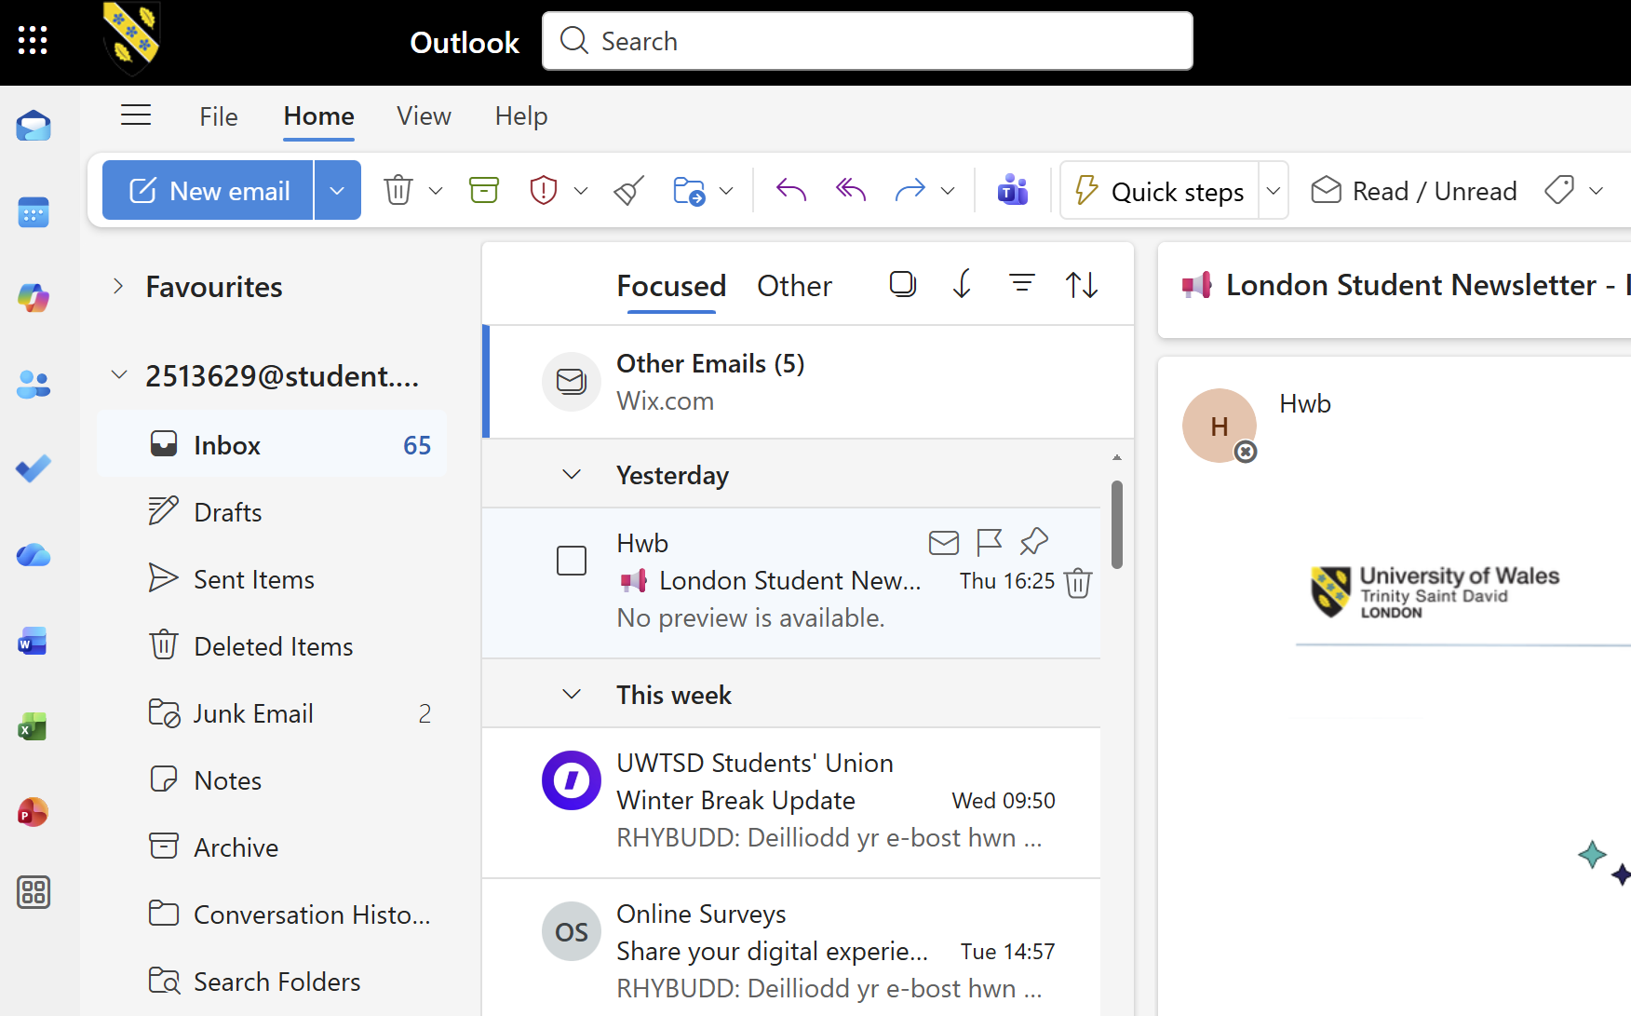
Fig 1: This image shows the Outlook inbox.
In this step, I'm creating a new email. I've added a sample email address to the recipient field and filled in the subject line.
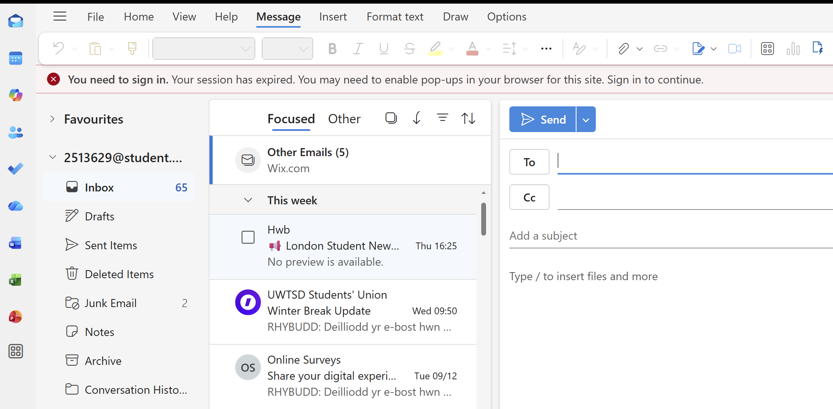
Fig 2: This image shows the outlook new email

In this image, I'm attaching a file to an email. I selected a file from my computer using the 'Attach File' option.
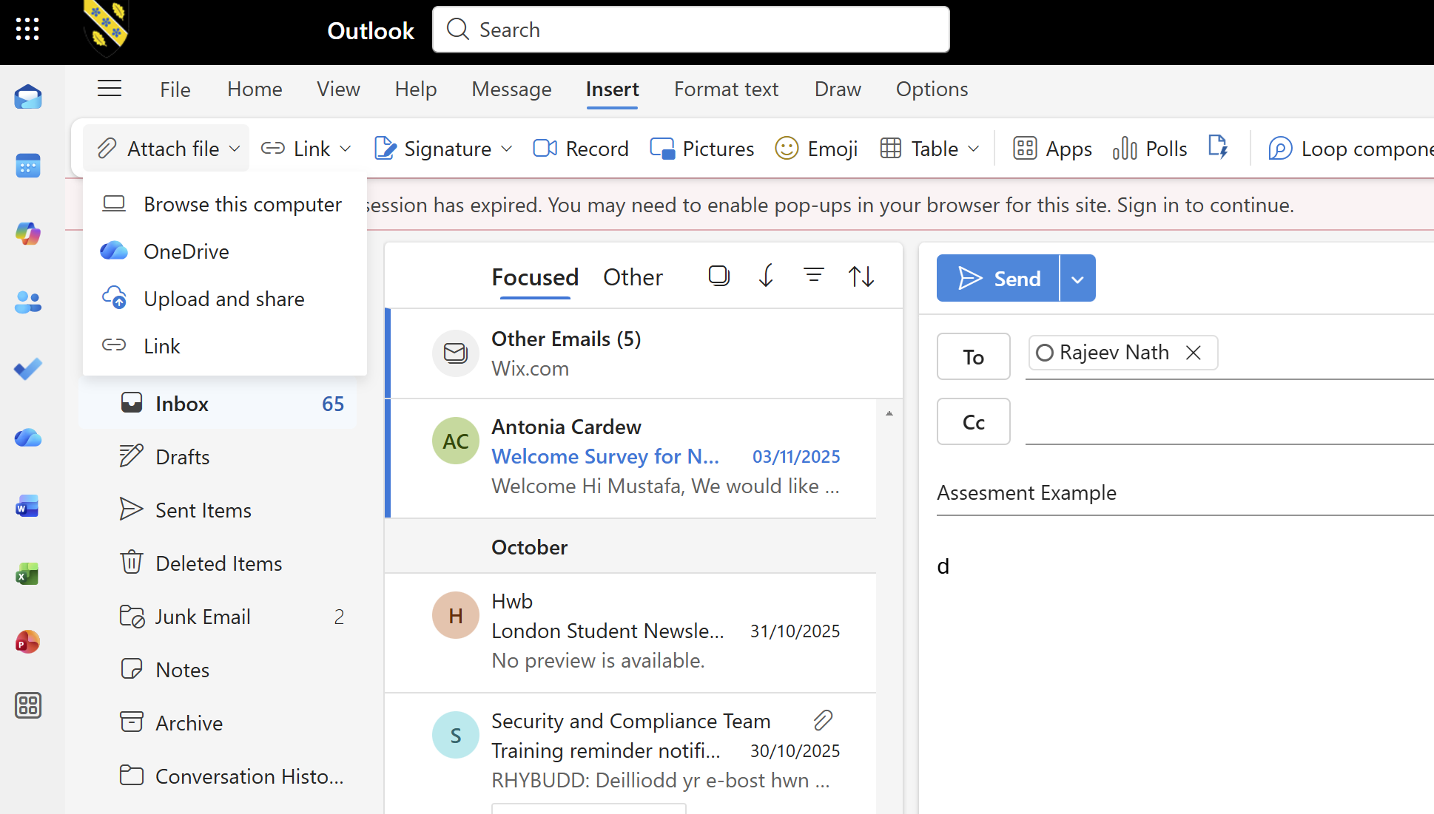
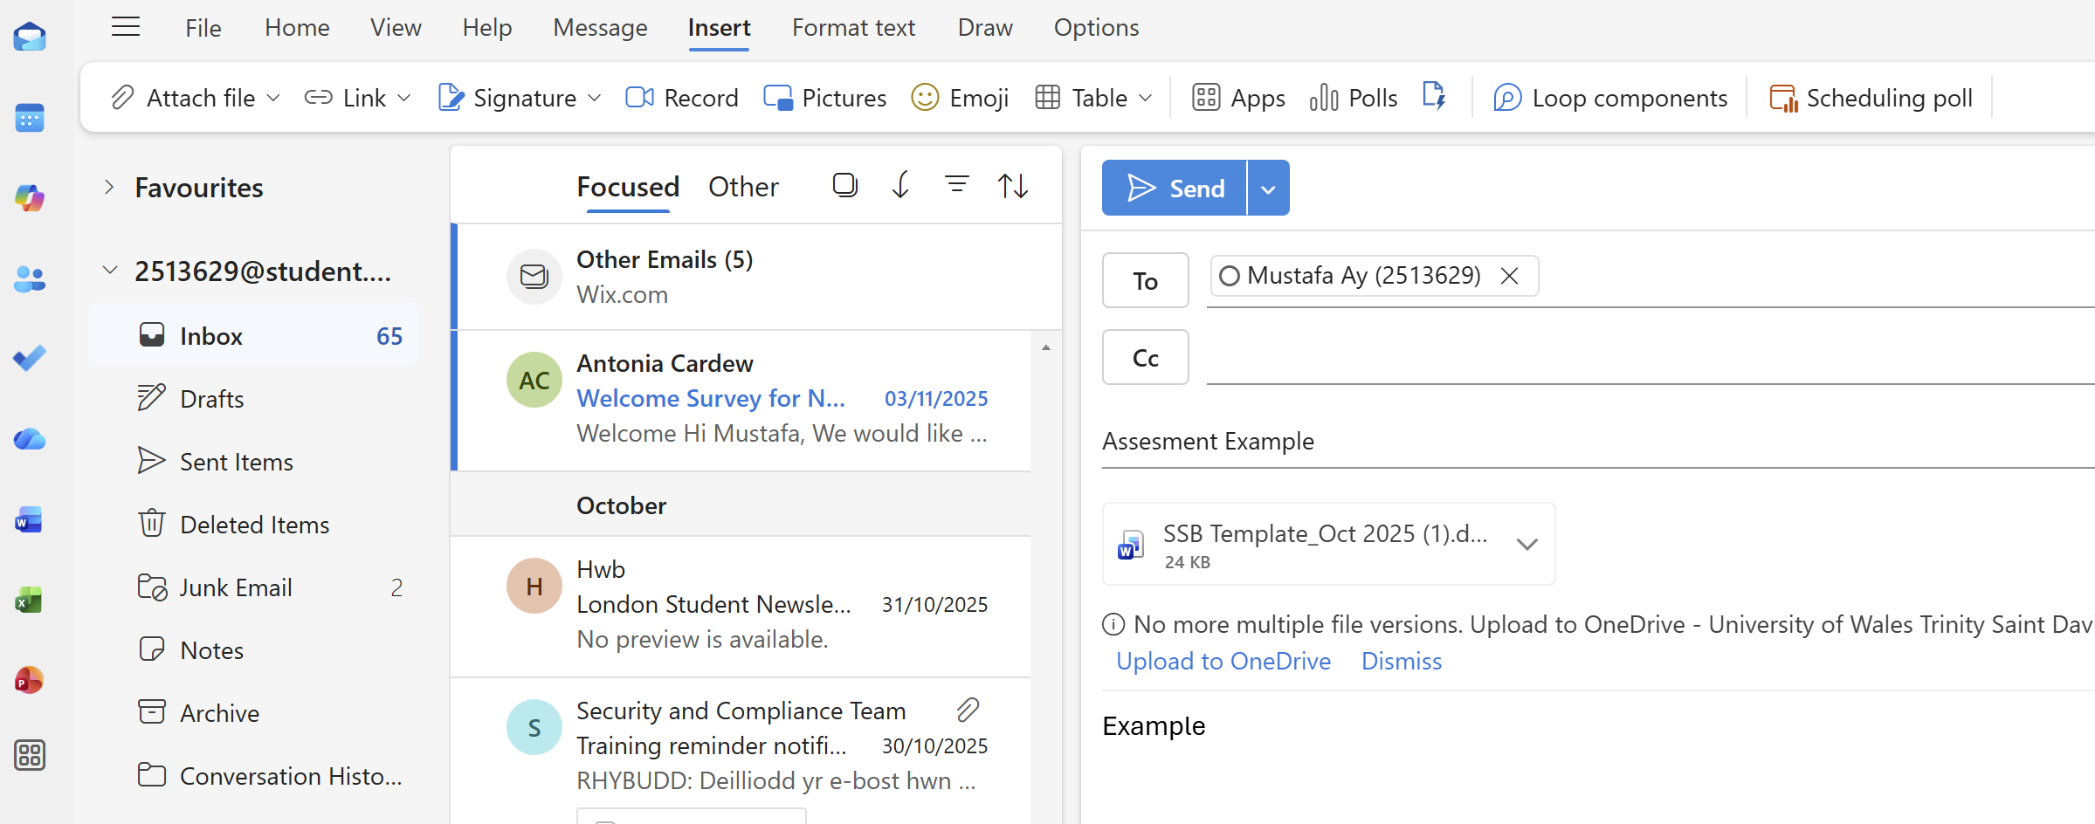
Fig 3 : This images shows the attach the files
"This image shows that the email I sent successfully appeared in the 'Sent Items' section."
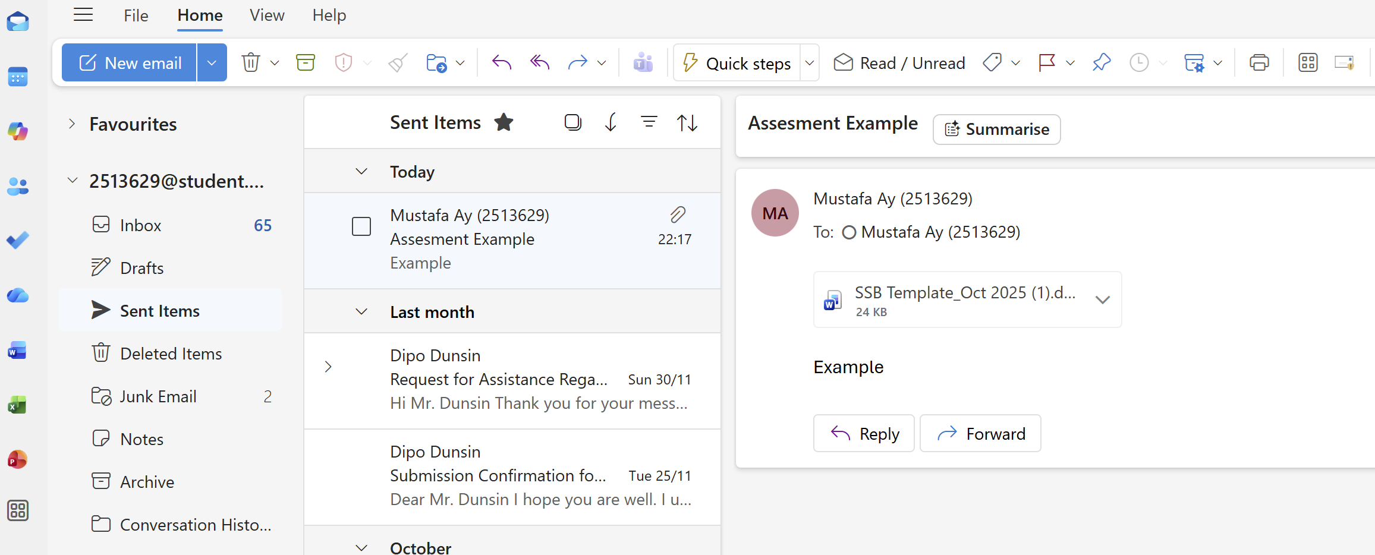
Fig 4 : This image shows sent items

Ms Teams
This image shows the Microsoft Teams home screen. From here, I selected the Calendar section to start a new meeting.
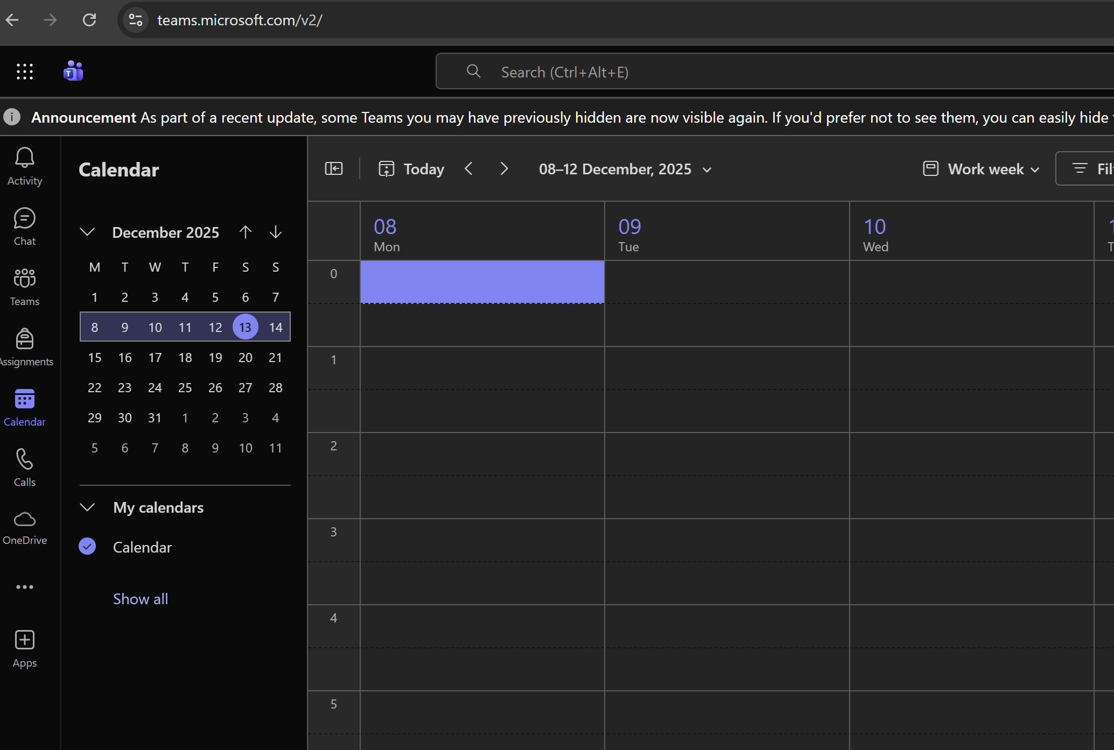Fig 1 : This image shows the Ms Teams Calender / Planned new meeting

"In this step, I clicked the 'New Meeting' option to schedule a new meeting."
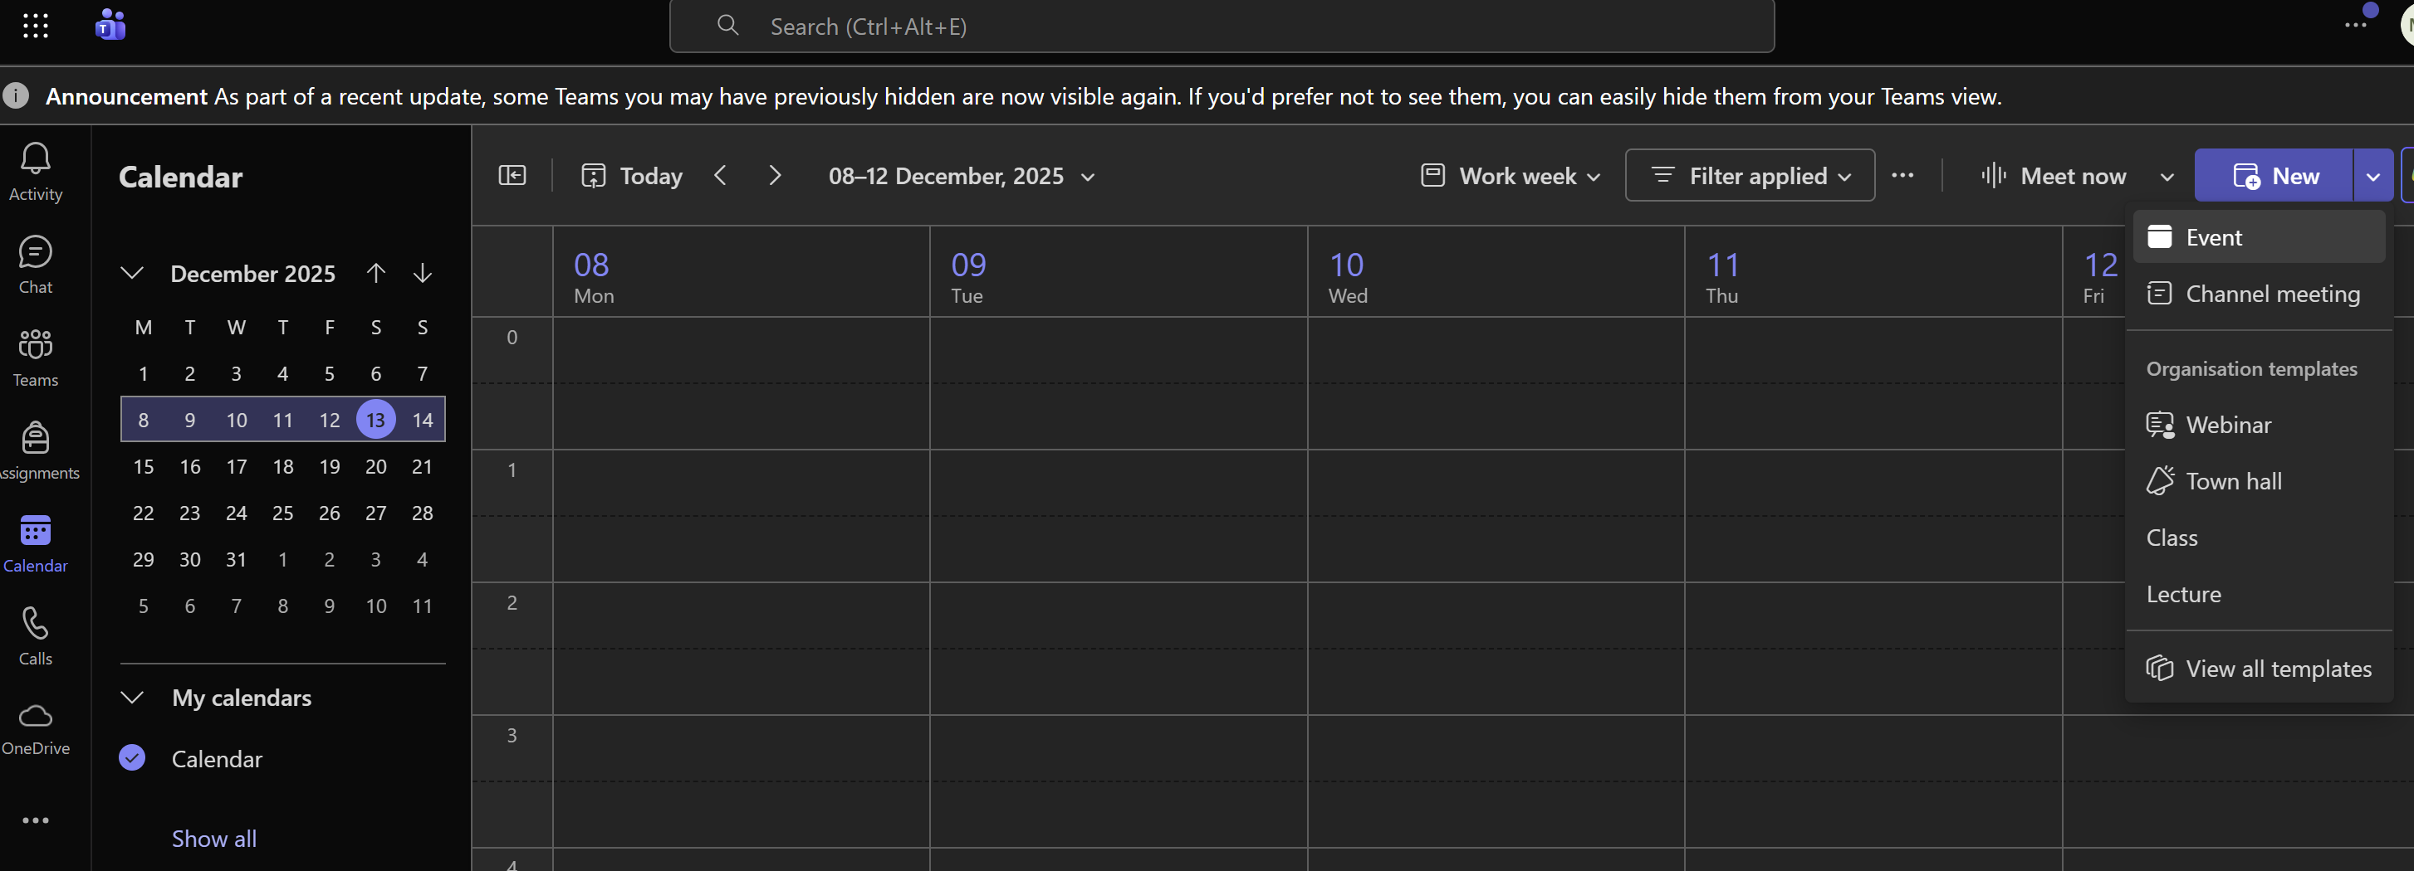
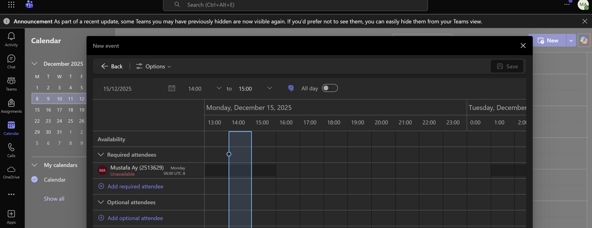
Fig 2 : This images shows the schedule new meeting
This image shows that I have filled in the meeting details. The title, date, and participants have been added.
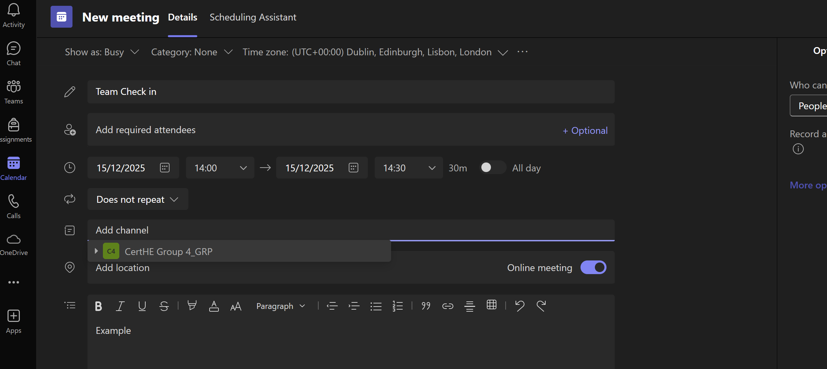
Fig 3: This image shows the scheduled a meeting (time , date , group or people )
and after we can join the meeting if it was real

Conclusion
To summarise, you don't need any technical expertise to set up an internet shop with Shopify or Wix eCommerce. Shopify provides the larger, more robust set of tools associated with a growing organisation, while Wix is geared towards those who wish to build a store with less complexity, such as a creative individual, small business owner or simply someone looking to quickly get their new venture off the ground. Both options present significant advantages and disadvantages to designers; regardless of which, you will be able to establish a professional and appealing internet shop in a matter of weeks or months at most.

References

[1] | Microsoft, “How to use the Mail Merge feature in Word,” 14 12 2025. [Online]. Available: https://support.microsoft.com/en-gb.
[2] | Microsoft, “Use mail merge to personalize letters,” 2025. [Online]. Available: https://support.microsoft.com/en-gb/office/use-mail-merge-to-personalize-letters-d7686bb1-3077-4af3-926b-8c825e9505a3.
[3] | Microsoft, “ Preview results in mail merge and complete the merge,” 2025. [Online]. Available: https://support.microsoft.com/en-gb/office/preview-results-mail-merge-9b0ae962-1bce-4d1d-8b8c-8e8fa2d6a2d2.
[4] | Microsoft, “Create a PivotTable to analyse worksheet data,” 2025. [Online]. Available: https://support.microsoft.com/en-gb/office/filter-data-in-a-pivottable-7d1c36f8-4b9a-4f8b-b3b2-7c02f8bdb3f1.
[5] | Microsoft, “Analyse data using PivotTables,” 2025. [Online]. Available: https://support.microsoft.com/en-gb/office/filter-data-in-a-pivottable-7d1c36f8-4b9a-4f8b-b3b2-7c02f8bdb3f1.
[6] | “Change the layout or format of a PivotTable,” 2025. [Online]. Available: https://support.microsoft.com/en-gb/office/change-the-layout-or-format-of-a-pivottable-3d1b06c2-5f7e-4f93-bd2b-7a1c1f55f0f9. [Accessed 2025].
[7] | Microsoft, “What is Outlook,” 2025. [Online]. Available: https://support.microsoft.com/en-gb/office/what-is-outlook-10f1fa35-f33a-4cb7-838c-a7f3e6228b20. [Accessed 2025].
[8] | Microsoft, “Create and manage calendars in Outlook,” 2025. [Online]. Available: https://support.microsoft.com/en-gb/office/create-and-manage-calendars-in-outlook-ef0a3d1f-7f26-4f6a-9f6c-9b4f7b9e3a89. [Accessed 2025].
[9] | Microsoft, “Protect yourself from phishing and scams in Outlook,” 2025. [Online]. Available: https://support.microsoft.com/en-gb/office/protect-yourself-from-phishing-and-scams-in-outlook-0c7ea947-6e89-4c4d-9d9a-5d7c7f9c3a0a. [Accessed 2025].
[10] | Microsoft, “What is Microsoft Teams?,” 2025. [Online]. Available: https://support.microsoft.com/en-gb/office/what-is-microsoft-teams-3f4b3a10-7c5b-4e34-9f06-8a1b9e4b9b8f. [Accessed 2025].
[11] | Microsoft, “Meetings and conferencing in Microsoft Teams,” 2025. [Online]. Available: https://support.microsoft.com/en-gb/office/meetings-and-conferencing-in-microsoft-teams-1c1e8a9e-9c60-4c8e-9b9f-47c5f7e8a2e4. [Accessed 2025].
[12] | Microsoft, “Security and compliance in Microsoft Teams,” 2025. [Online]. Available: https://support.microsoft.com/en-gb/office/security-and-compliance-in-microsoft-teams-3e6b7a6f-9c68-4c7e-8c49-4c1c9b2f6d0e. [Accessed 2025].

