

Kieran Howells

ABAQUS Simulation Analysis

UWTSD
OME

BEng
Academic Year: 2024 - 2025

Supervisor: Kelvin Donne
May 2025

Academic integrity declaration
I declare that:
- the thesis submitted has been written by me alone.
- the thesis submitted has not been previously submitted to this university or any other.
- that all content, including primary and/or secondary data, is true to the best of my knowledge.
- that all quotations and references have been duly acknowledged according to the requirements of academic research.
I understand that to knowingly submit work in violation of the above statement will be considered by examiners as academic misconduct.

Abstract
In this report a detailed and critical analysis of a ballistic simulation will be conducted with tensile and shear stresses being the focus. Two simulations have been recorded with each having a different property. In this case the velocities of each projectile have been altered to show when the armour plate fails and when it protects against the projectile. This will allow for the comparison between the two and help to identify points of failure. The points will then be analysed to identify what caused the failure. Shear stresses and tensile stresses will be analysed and then compared to identify the point of failure and which type of stress caused it.

Keywords:
Linear
Stress
Strain
Shear

Acknowledgements
Click here to enter acknowledgement text.

Table of Contents
Academic integrity declaration i
Abstract ii
Acknowledgements iii
List of Tables v
List of Figures v
List of Abbreviations vii
1 Introduction 1
1.1 Purpose of the experiment 1
1.2 Points of analysis 1
1.3 Materials 1
2 Results 4
2.1 Simulation results 4
3 Discussion 5
3.1 1200m/s projectile 5
3.2 1400m/s projectile 6
4 Conclusions 9
References 15
Appendices 15

List of Tables
Table 1 Mie-Gruneisen Parameters for steel 4340 2
Table 2 Johnson-cook Plasticity Parameters for Steel 4340 2
Table 3 Johnson-cook dynamic failure parameters 3

List of Figures
Figure 1 Table of Material Parameters of tungsten used in simulation 2
Figure 2 initial simulation set up 17
Figure 3 Initial direct stress 18
Figure 4 Initial Shear stress 18
Figure 5 Direct stress at frame 18 19
Figure 6 Shear stress at frame 18 19
Figure 7 Direct stress at frame 29 20
Figure 8 Shear stress at frame 29 20
Figure 9 Direct stress at frame 34 21
Figure 10 Shear stress at frame 34 21
Figure 11 Direct stress at frame 50 22
Figure 12 Shear stress at frame 50 22
Figure 13 Direct stress at frame 66 23
Figure 14 Shear stress at frame 66 23
Figure 15 Direct stress at frame 100 24
Figure 16 Shear stress at frame 100 24
Figure 17 Direct stress at frame 137 25
Figure 18 Shear stress at frame 137 25
Figure 19 Direct stress at frame 171 26
Figure 20 Shear stress at frame 171 26
Figure 21 Direct stress at frame 242 27
Figure 22 Shear stress at frame 242 27
Figure 23 Velocity time graph from initial speed of 1200m/s 28
Figure 24 Initial simulation setup for 1400m/s projectile 28
Figure 25 Direct stresses upon impact 29
Figure 26 Shear stresses upon impact 29
Figure 27 Direct stresses at 19th frame 30
Figure 28 Shear stresses at 19th frame 30
Figure 29 Direct stresses at 26th frame 31
Figure 30 Shear stresses at 19th frame 31
Figure 31 Direct stresses at 31st frame 32
Figure 32 Shear stresses at 31st frame 32
Figure 33 Direct stresses at 47th frame 33
Figure 34 Shear stresses at 47th frame 33
Figure 35 Direct stresses at 77th frame 34
Figure 36 Shear stresses at 77th frame 34
Figure 37 Direct stresses at 103rd frame 35
Figure 38 Shear stresses at 103rd frame 35
Figure 39 Direct stresses at 149th frame 36
Figure 40 Shear stresses at 149th frame 36
Figure 41 Direct stresses at 185th frame 37
Figure 42 Shear stresses at 185th frame 37
Figure 43 Direct stress at 210th frame 38
Figure 44 Shear stress at 210th frame 38
Figure 45 Direct stresses at 526th frame 39
Figure 46 Shear stresses at 526th frame 39
Figure 47 Velocity time graph for 1400m/s projectile 40

List of Abbreviations

Introduction

Purpose of the experiment
The simulation conducted in the ABAQUS package was a ballistics simulation. This involved projectile being fired at constant velocity towards an armoured plate. This projectile and plate are of known material and the properties of each have been researched and input into ABAQUS to assess the failure points of the metal plate.

Points of analysis
The analysis will be using the stress values observed when the results of the simulation were recorded and the probe tool within the package to get exact values of stress at a frame-by-frame level.
The values that have been recorded will show time, stress, strain and shear values. At each different time the values of each have been recorded to show how these change over time. The stress and shear values will be compared to identify the failure point of the material used.

Materials
The material used for the armour plate was a standard 4340 steel and the projectile was composed of pure tungsten. Figure 1 shows the table from the international journal of impact engineering. The table contains the values needed for ABAQUS to be able to simulate accurate plastic deformation. This is for tungsten material used in the simulation.
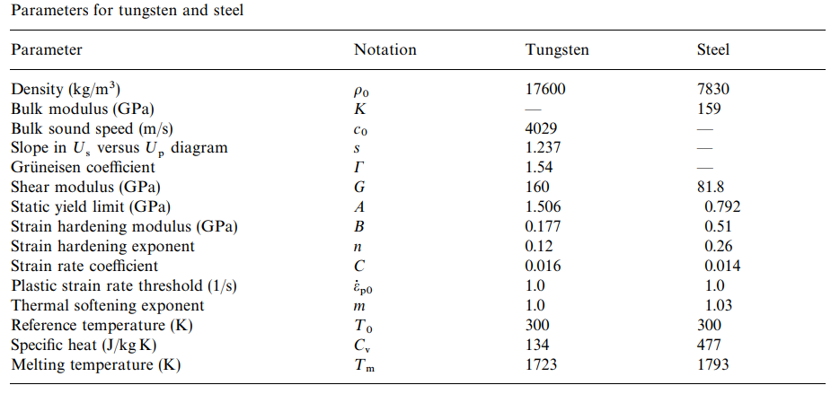
Figure 1 Table of Material Parameters of tungsten used in simulation [1]
In ABAQUS when creating a material, the parameters in figure 1 are needed be able to fill in Johnson-cook plastic properties.
Research into steel properties was conducted and the values were taken from Dassault systems. The paper found discussed the ballistic perforation of an aluminium plate using a steel projectile. As this was simulated using ABAQUS this meant that all values for steel 4340 were present and allowed for accurate results.
Density (g/cm³) | Gruneisen Coefficient | Parameter c₀ (cm/μs) | Parameter s | Reference temperature (K) | Specific Heat Capacity  (J/kgK)
7.83 | 1.67 | 0.4578 | 1.33 | 293.2 | 477.0
Table 1 Mie-Gruneisen Parameters for steel 4340 [1]
A. (MPa) | B. (MPa) | n | Temperature _{melt} (K) | Temperature _{Translation} (K) | m | C | ε₀
792 | 510 | 0.26 | 1793 | 293.2 | 1.03 | 0.014 | 1.0
Table 2 Johnson-cook Plasticity Parameters for Steel 4340 [1]
d₁ | d₂ | d₃ | d₄ | d₅
0.05 | 3.44 | 2.12 | 0.002 | 0.61
Table 3 Johnson-cook dynamic failure parameters [1]
Equation 1 shows Johnson-cook’s yield stress equation:
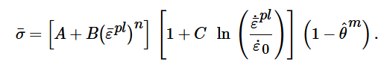
Equation 1 Johnson-cook yield stress equation [3]

For the deletion of nodes as the simulation progresses the Johnson-cook dynamic failure equation is also needed. This allows for the ABAQUS package to assess when the material has reached an absolute maximum stress and deformation causing the present node to be deleted.
As the main assessment being made is the failure points of the armour plate the damage properties will not be used on the projectile. Another reason for this is that while ABAQUS may be able to run intense simulations, Problems have been found with tungsten material dynamic failure as the simulation struggles to identify when to destroy nodes.

Results

Simulation results
The results gathered will be grouped if shown to be similar in nature. Each will be analysed but figures that show development of compression waves or hertzian cones will be grouped to gain an understanding of the development of these effects.
All results have been recorded in figures shown in the Appendices section as there are up to 43 figures. The reason for the amount is to gain an accurate understanding of the stresses and the effect that they have.

Discussion

1200m/s projectile

Figures 2 to figure 23 show the results from the 1200m/s projectile simulation. Figure 2 shows the initial set up where the projectile will enter the plate at a 0-degree angle. Figure 3 shows the direct stresses at the initial impact of the projectile. This consists of purely compression forces which will not make the steel plate fail. This compression measures at a -6.27GPa which when compared to the values in figure 4 of shear stresses the value is shown to be 0.24GPa. Though this might be early on within the simulation this does set the trend.
Figures 5 and 6 are both taken at the same frame. The compression value at the point of contact between the plate and the projectile measures at-3.2GPa. This is lower than figure 3’s direct stress but that is due to the compression wave that will move through the plate. At this point we can see the beginning of the wave. Figure 6 shows the shear stress at the point of contact which measures at 0.28GPa. So far, the direct stresses have had more effect on the deformation of the plate.
Figure 7 shows the point where the compression wave feeds back on itself. This causes tension to appear at the other side of the plate while compression is still occurring due to the projectile still moving. This compression measures at -6.6GPa which is higher than the initial compression. This is due to the feedback compression the point from both sides. The projectile from one and the compression wave from the other. Figure 8 shows the Shear stress at the same frame. This has the value of 0.12GPa. The deformation is still being caused by direct compression with the other side of the plate now experiencing tension.
Figures 9 to 12 show the progression of the compression wave and the increasing tension it is causing. While shear stresses are still increasing, they spread out through the plate dispersing their effect. The direct stresses are more concentrated meaning their effect if more pronounced. This can be seen in figure 11 as the compression wave is at the centre of the plate meaning that tension is now present at both sides of the plate. This tensions measures at 1.2GPa which is the beginning point for the plate to begin to deform on that side. The shear stress that figure 12 shows at that point is only 0.02GPa. This shows that the direct stresses are the ones testing the plate while shear are not actively causing it to deform.
Figures 13 to 22 then show each stage of the deformation with the final part being when the plate successfully stops the projectile. In each figure the bottom of the plate is shown to experience large amounts of tension compared to the shear forces occurring withing the middle of the plate. This tension is what causes the deformation as the tension in figure 15 measures at 1.1GPa and the tension in figure 21 measures at 1.3GPa. The shear stresses at these points goes from 0.02GPa to 0.13GPa from figures 14 to 20. The deformation of the plate is not minor. There is a large cavity where the projectile has penetrated through half the plate. The other side of the plate is deformed where the tension has become to much for it and the entry point has deformation from the compression wave.

1400m/s projectile

Figures 24 through to 47 show the results from the 1400m/s simulation. This begins with figure 24 showing off the simulation setup. Figure 25 then shows the direct stress at the initial impact. The compression due to the projectile hitting the plate may be lower than that of the 1200m/s projectile but this result was taken at an earlier point in the simulation. The shear stress from this is higher than that of the 1200m/s projectile with this measuring at 0.47GPa. This is early on and therefore the deformation of the plate has yet to occur.
Figures 27 to 30 show the beginning of the compression wave and the results from it hitting the other side of the plate. Figure 27 shows as the wave progresses through the centre of the plate while figure 29 shows as the wave hits the other side of the plate and causes the tension that can been seen. Figures 28 and 30 show how the shear stresses develop through the plate. This is at a faster rate than that of the 1200m/s simulation which is to be expected. So far the deformation of the plate is minimal.
Figures 31 to 36 show how the compression wave induces tension throughout the plate. The wave that was inducing the small amount of tension shown in figure 29 has now spread and fed back on itself causing the stresses to become greater. Figures 32, 34 and 36 show the shear stresses now reach a point where the deformation will start to occur. This is at the measured value of 110GPa which is much higher than the shear stresses but is deforming the outer parts of the plate. So far, the main deformation has been due to the physical compression between plate and projectile while now the shear stresses have reached a value of 1.1GPa and higher. This deformation is within the plate and has caused some nodes to change shape slightly. This is the first deformation seen from shear stresses.
Figures 37 to 40 most deformation. This is where the metal plate begins to neck and critically fail. In figure 37 the direct stresses caused by the continuous compression wave and the physical projectiles movement have reached a new high point. The point of above 1.15GPa has been recorded and now shown the destruction of several nodes. It is important to note that the projectile does not have dynamic failure properties and could have failed at this point but there are limits to ABAQUS. Shear stresses in figure 38 and 40 seemed to have peaked at the 1.1GPa area. While this does cause slight deformation within the cavity left by the projectile that is all that is noticeable from the shear stresses. It is clear that the plate will fail due to high direct stress.
Figures 41 and 42 reinforce the previous statement as the plate has reached the final point. The armour has thinned and necked to the point where it is barely holding on. The projectile is still traveling at a high velocity as shown by figure 43. Shear stresses have remained the same as figure 40. Direct stresses are also similar, but the plate cannot handle them. It must be noted that after this point the plate completely fails and the projectile passes through. The stress values cannot be analysed at this point as the nodes have been destroyed.

Conclusions
There were many conclusions that the student found in each section discussed within this report. To begin with the presentation the student found that they should not focus so much on the content and order of the presentation but on the audience and how engaged and interested they were in hear what the student had to say. This also relates to the students confidence in speak before an audience. Although the student spoke with confidence, the pace and material covered with the lack of interactivity with the audience left the presentation feeling dull.
The student had researched many skills to do with employment and higher education and how these skills may affect over the next few years of study. The student found that skills such as teamwork and communication we crucial in a professional setting but teamwork would not help them in a one-person project such as writing a report. The student looked into more skills such as problem solving and how important it is for both the academic and professional worlds to be able to effectively solve problems and thus determining this skill to be very important. The student also looked into soft skills which some of the skills previously mentioned fall into. These skills are useful in all aspects of work and academics meaning that these skills are especially important compared to hard skills, which are skills that are only important writing a professional setting.
The student then conducted evaluations of their own skills to determine what jobs and personality type they are suited for. The student was critical in their findings on what personality type they were agreeing with most of the description give (INTP). The skills assessment gave details on the student’s strengths in critical thinking and problem solving and showed their weaknesses of creative thinking and time management. This allowed the student to create a plan on how to further progress the strengths found and to help improve the weaknesses.
The student then discussed future goals of obtaining a BEng and improving their skills as an engineer. The student assessed these goals against the idea of SMART goals finding that these goals were fair and should be achievable within good time.
The student then discussed data protection methods for work and academic materials. The student found that it is incredible important to back up data as a loss without a backup can seriously damage the potential grades and cause unnecessary stress. The student then found multiple effective ways of protecting data and made a plan to use them when creating materials.
The student then created a plan that would help them manage their time. This plan would be one that needs to be altered regularly as the student already struggles with time management so by using this method it helps to develop this skill. The student found this to be of great importance as they student needed to finish this assignment within good time.
The conclusion that has been made from this simulation is that the direct stresses caused by compression waves that the physical compression are the causes the plate failures. The plate failed due to high tensions at the once the projectile has reached a certain point within the plate the compression waves feedback becomes constructive and generates too much tension. Shear stresses may be present but to do not appear to cause significant deformation of the plate. With the failure of the steel 4340 plate was caused by high direct stresses in both the 1200m/s simulation and 1400m/s simulation. While the 1400m/s was a total failure the 1200m/s did withstand the projectile but not without significant damage.

References

[1] | L. Westerling, P. Lundberg and B. Lundberg, “Tungsten long-rod penetration into con"ned cylinders of boron,” International Journal of Impact Engineering, vol. 25, no. 7, pp. 703-714, 2000.
[2] | D. Systems, “Simulation of the ballistic perforation of aluminium plates with Abaqus/explicit,” Simulia, 2012.
[3] | J. Shi and X. Wang, “Validation of Johnson-Cook plasticity and damage model using impact,” International Journal of Impact Engineering, vol. 60, pp. 67-75, 2013.

Appendices
Figures from 1200m/s projectile simulation
The first simulation was conducted with 1200m/s projectile. The following figures will show the recorded stress, frame and time.
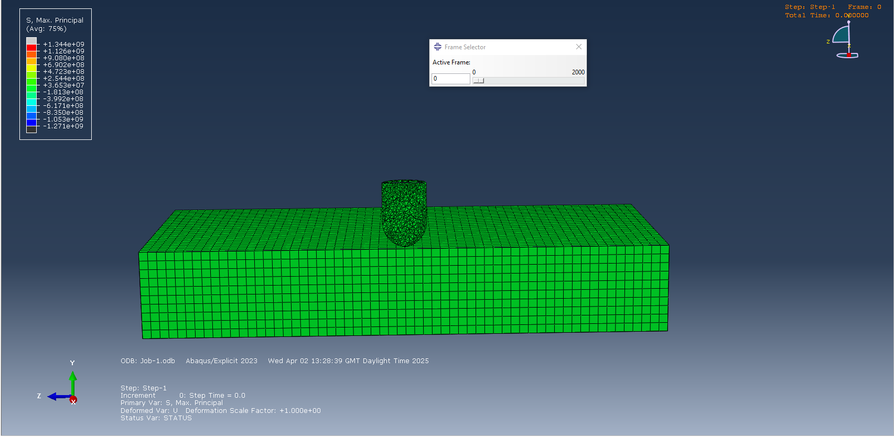
Figure 2 initial simulation set up
The simulation was set up so that the projectile would enter the plate from a 0-degree angle.
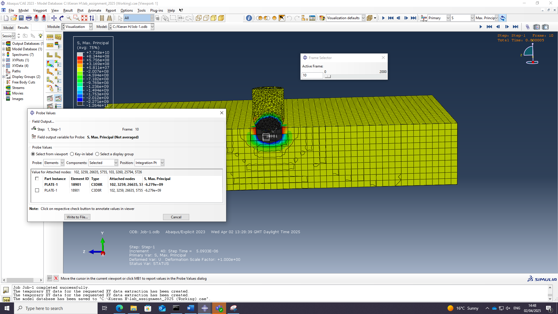
Figure 3 Initial direct stress
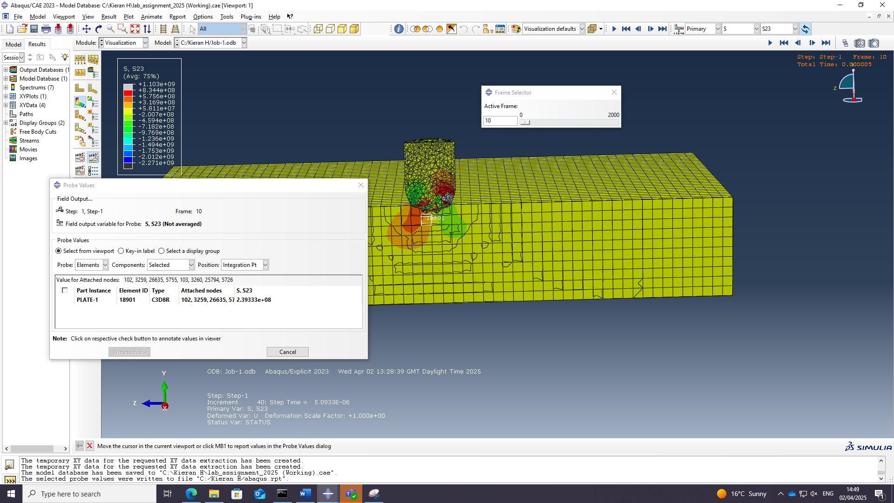
Figure 4 Initial Shear stress
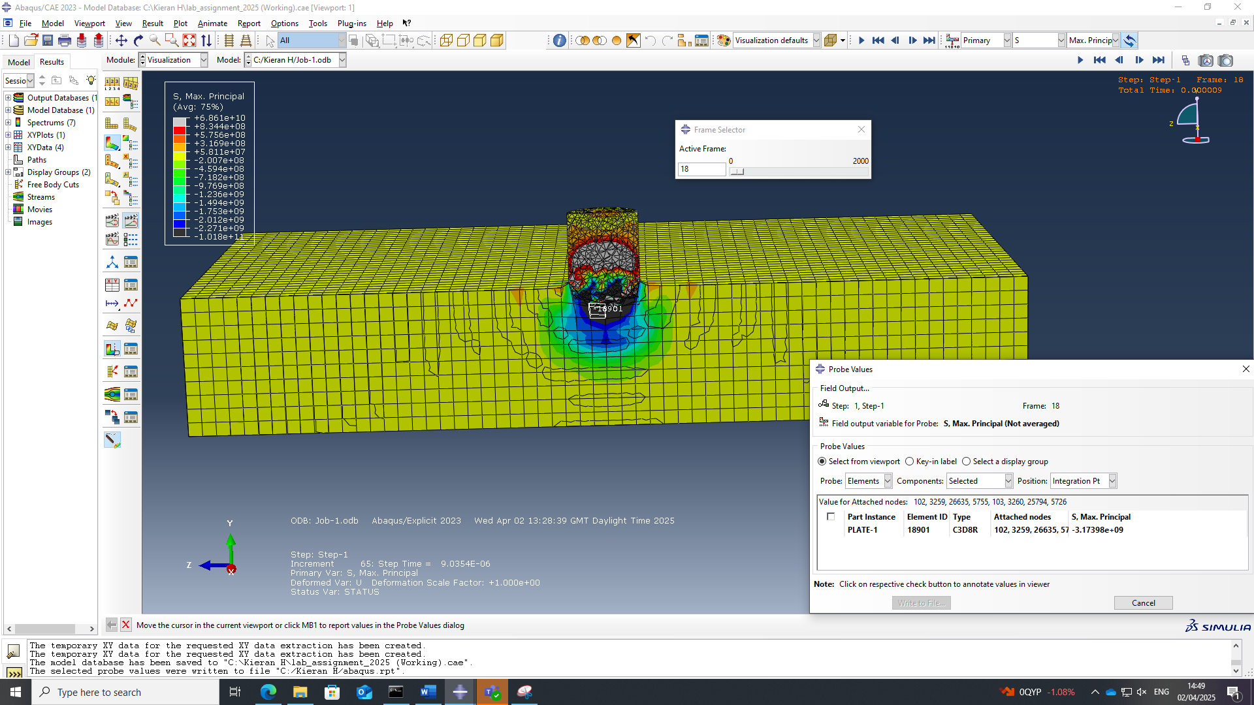
Figure 5 Direct stress at frame 18
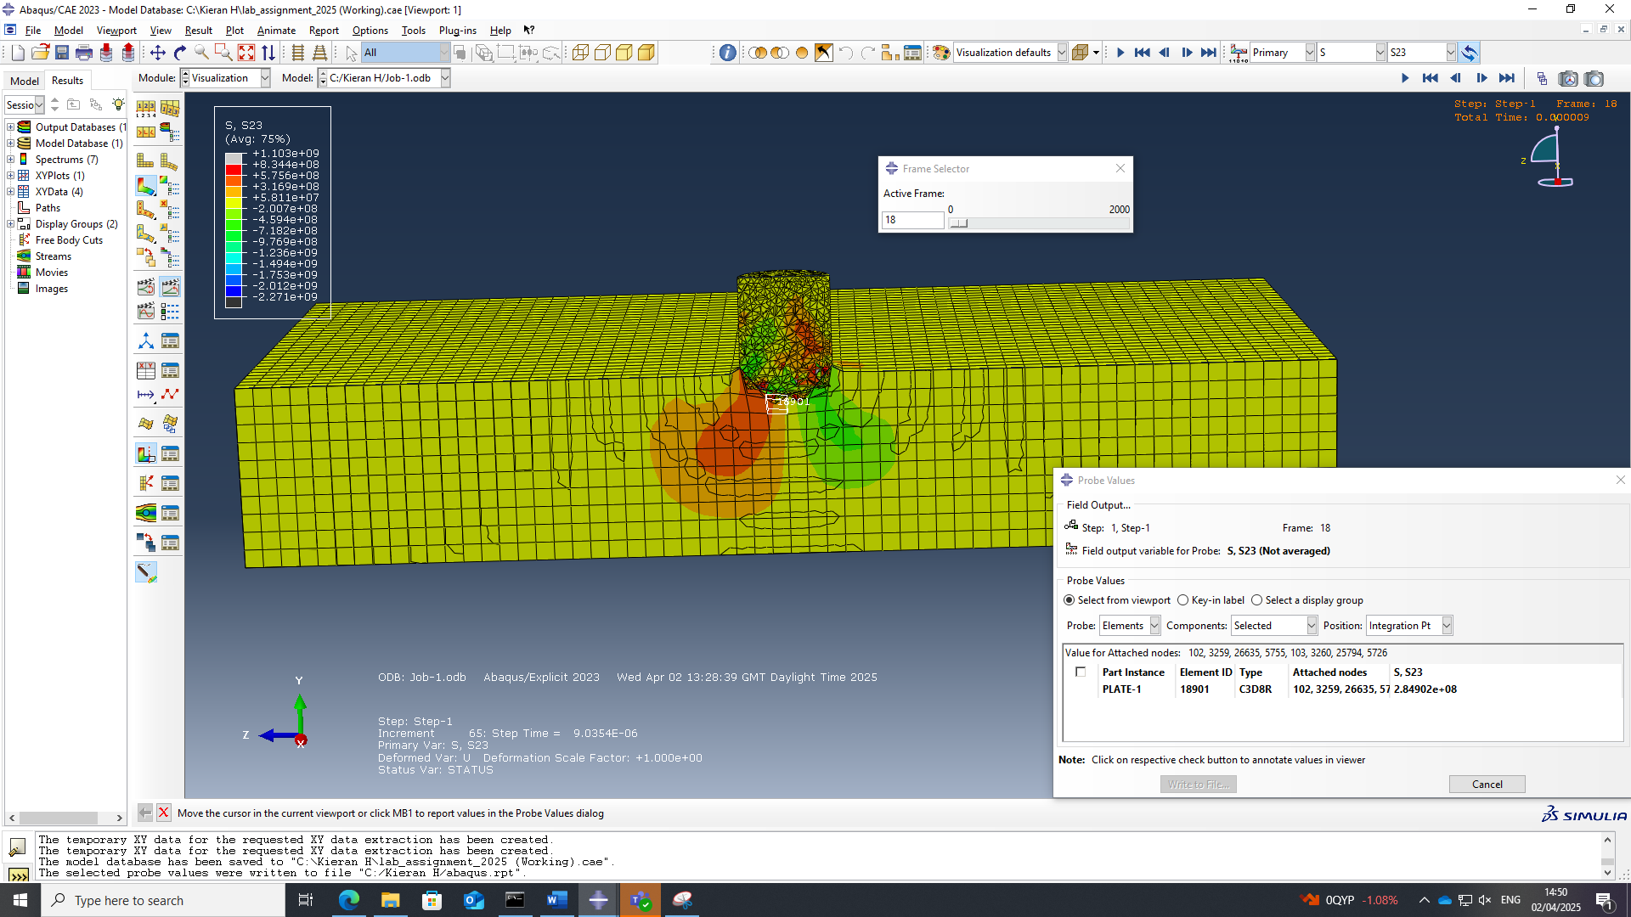
Figure 6 Shear stress at frame 18
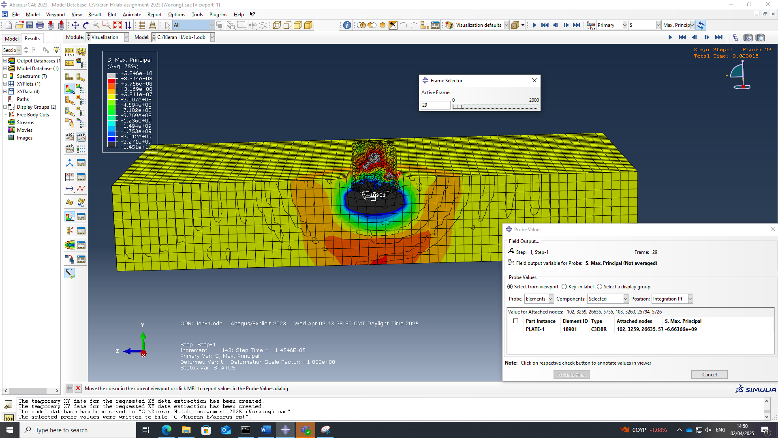
Figure 7 Direct stress at frame 29
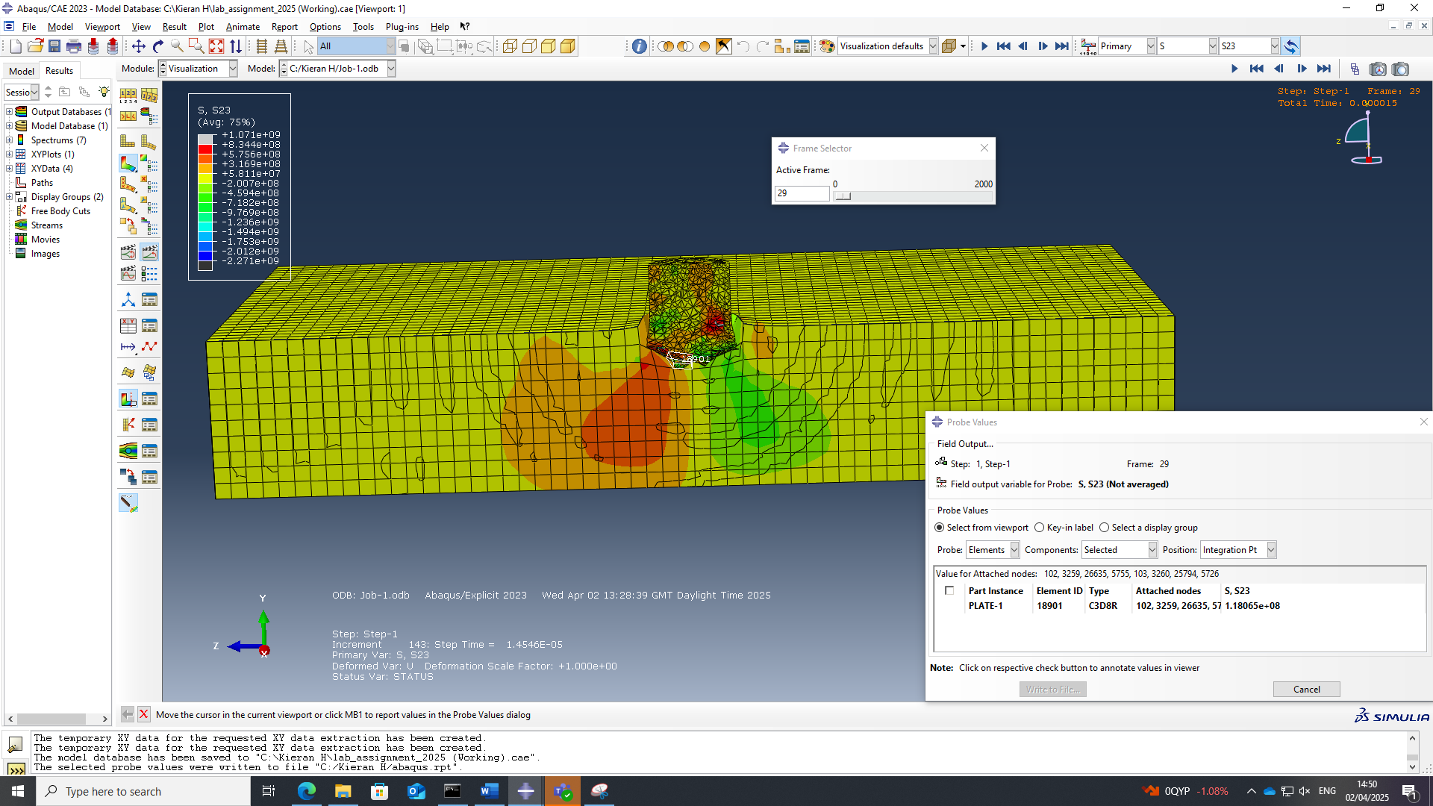
Figure 8 Shear stress at frame 29
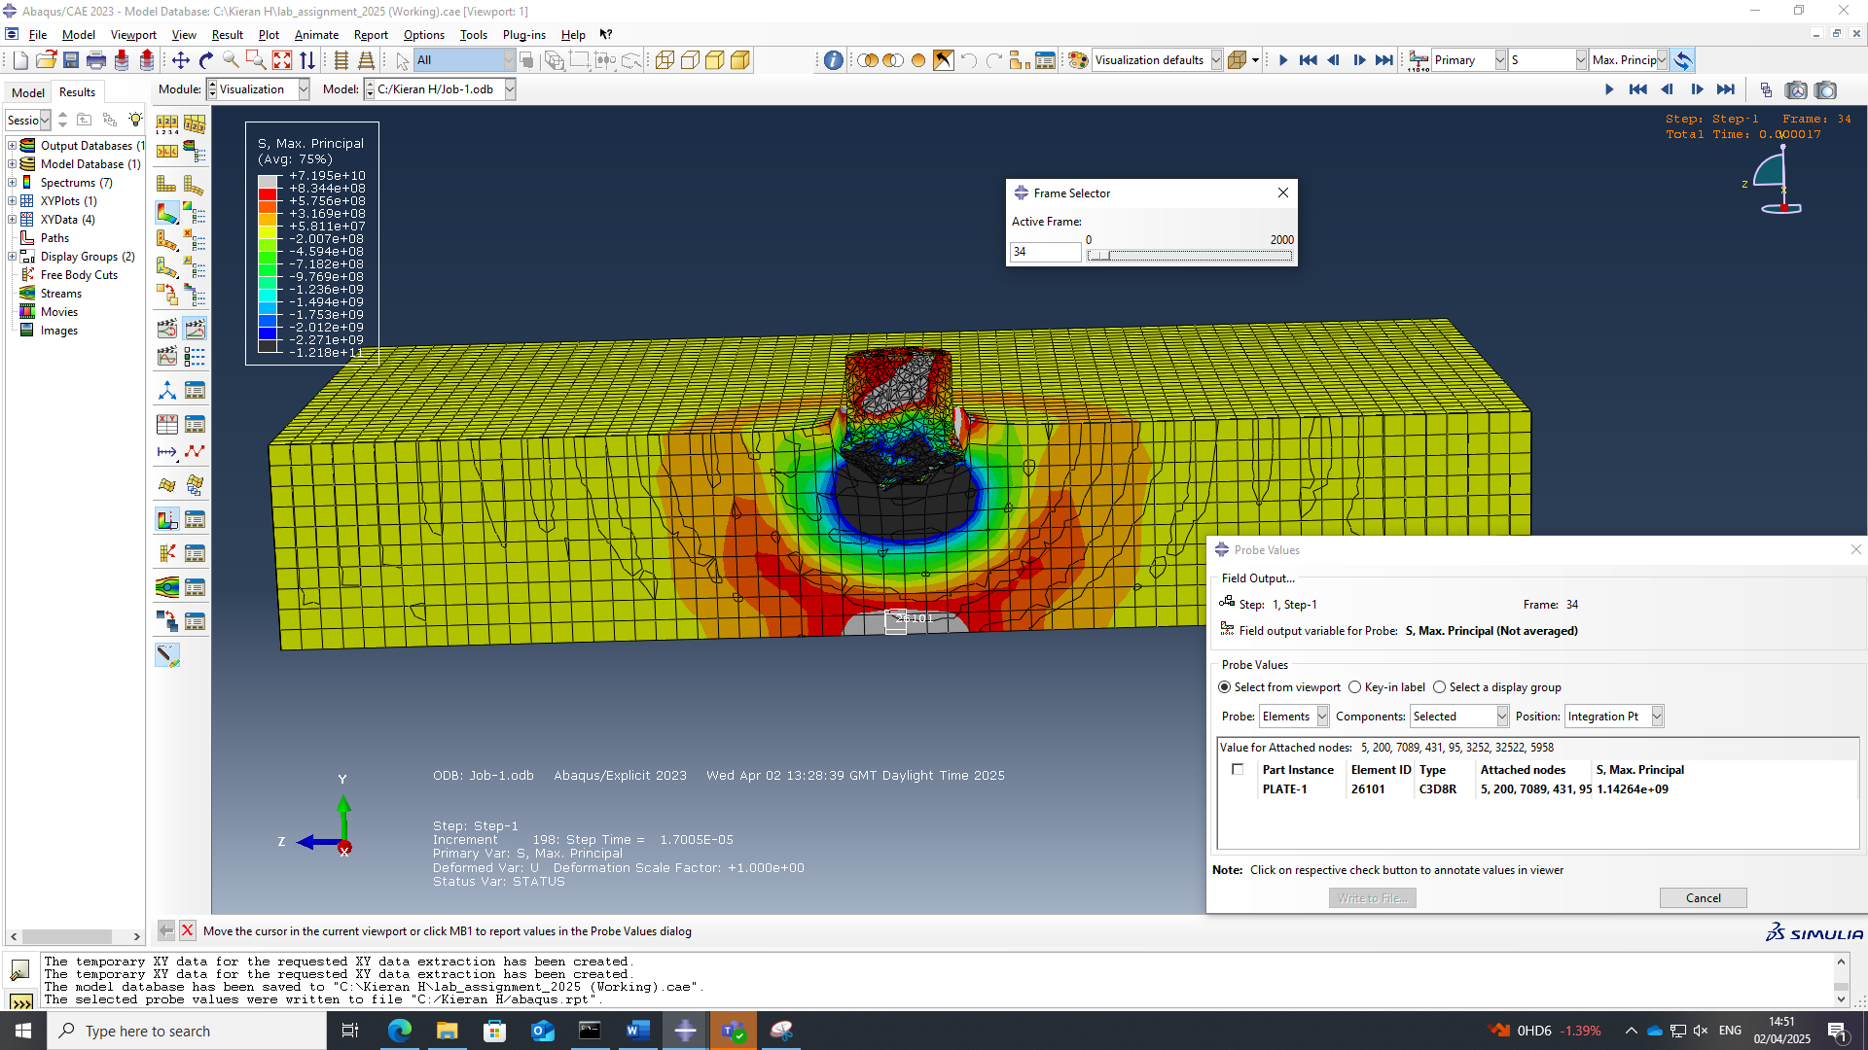
Figure 9 Direct stress at frame 34
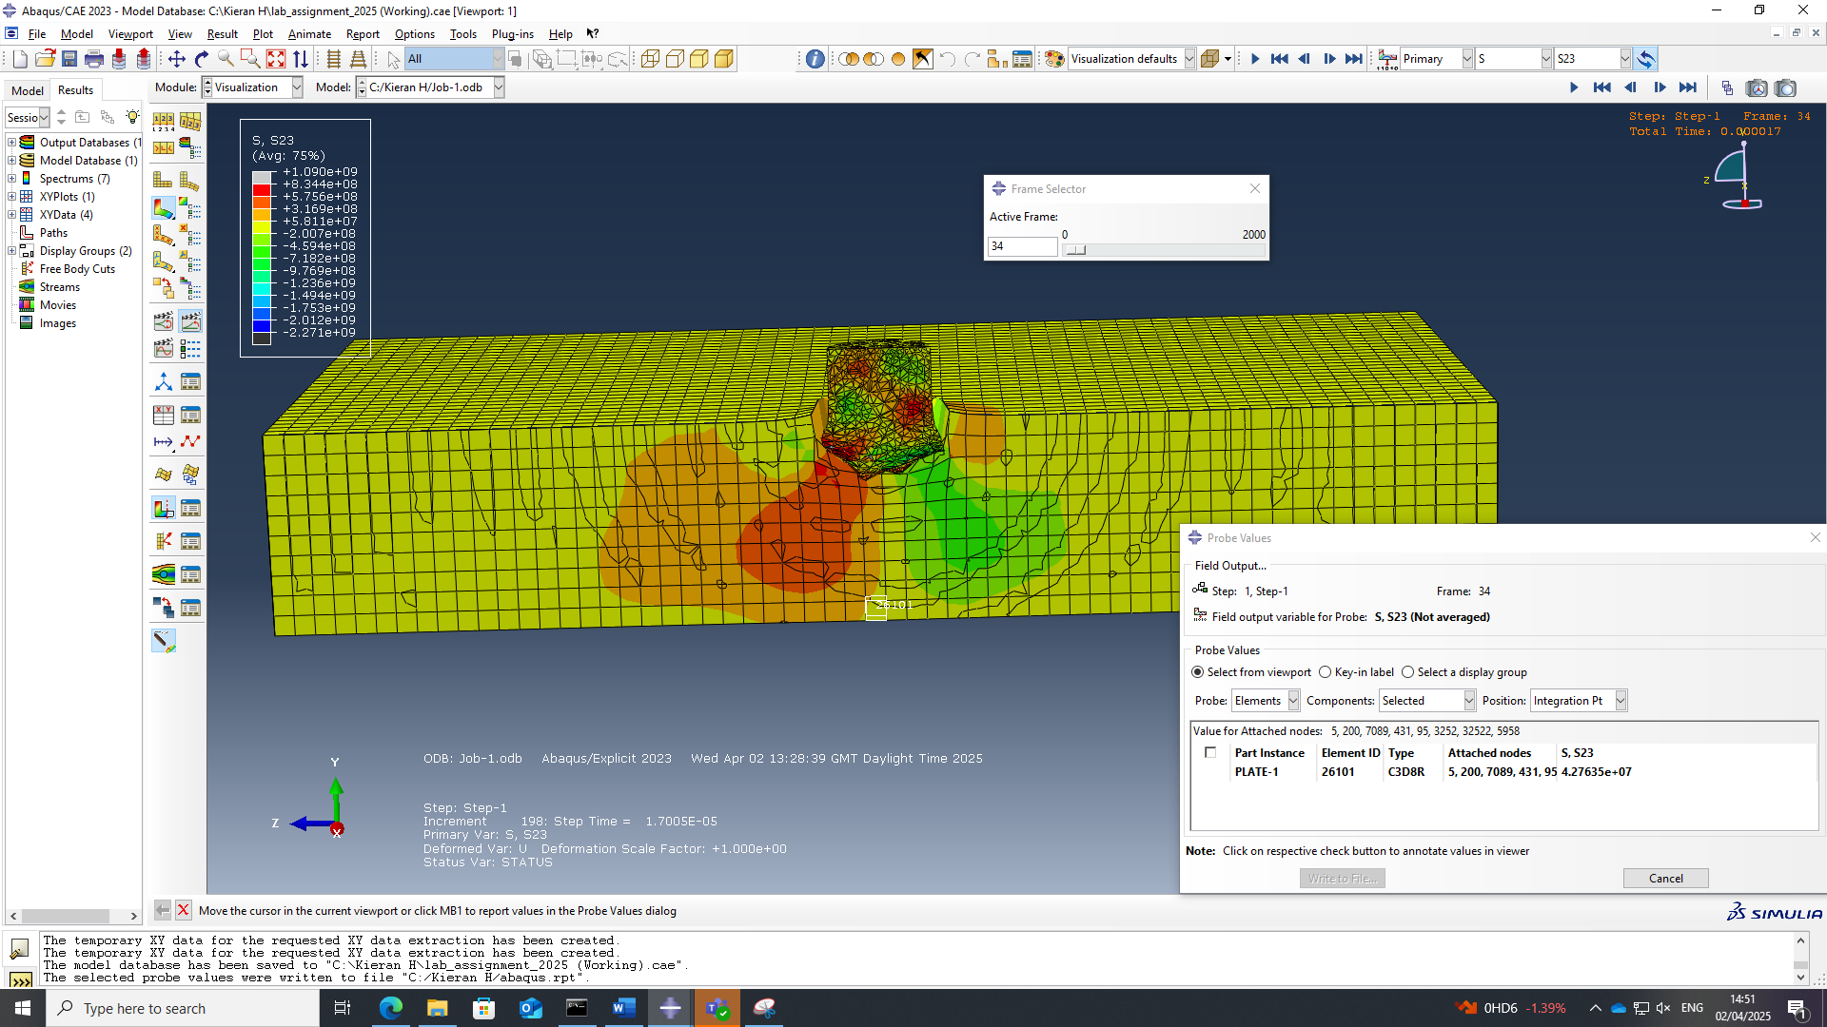
Figure 10 Shear stress at frame 34
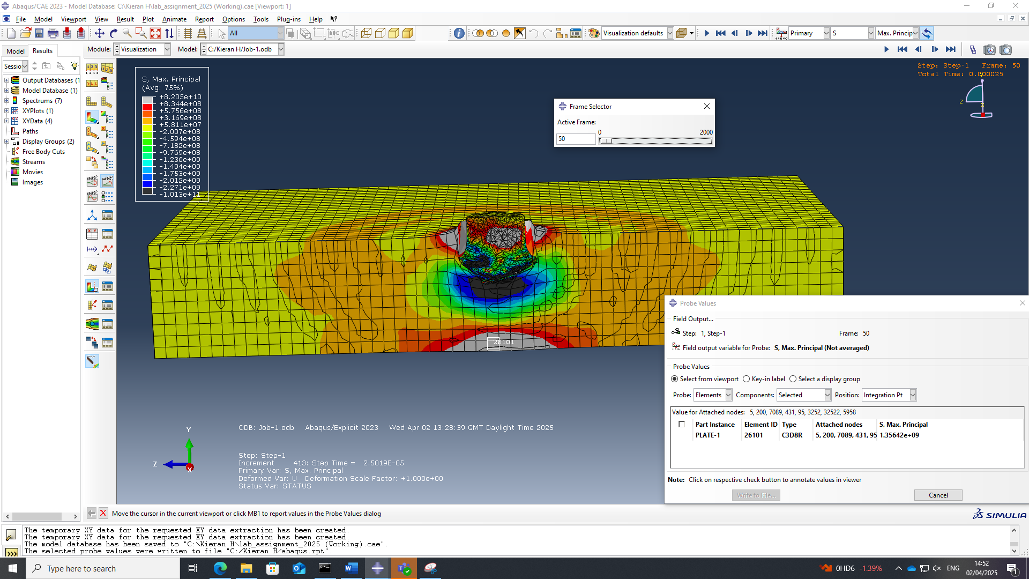
Figure 11 Direct stress at frame 50
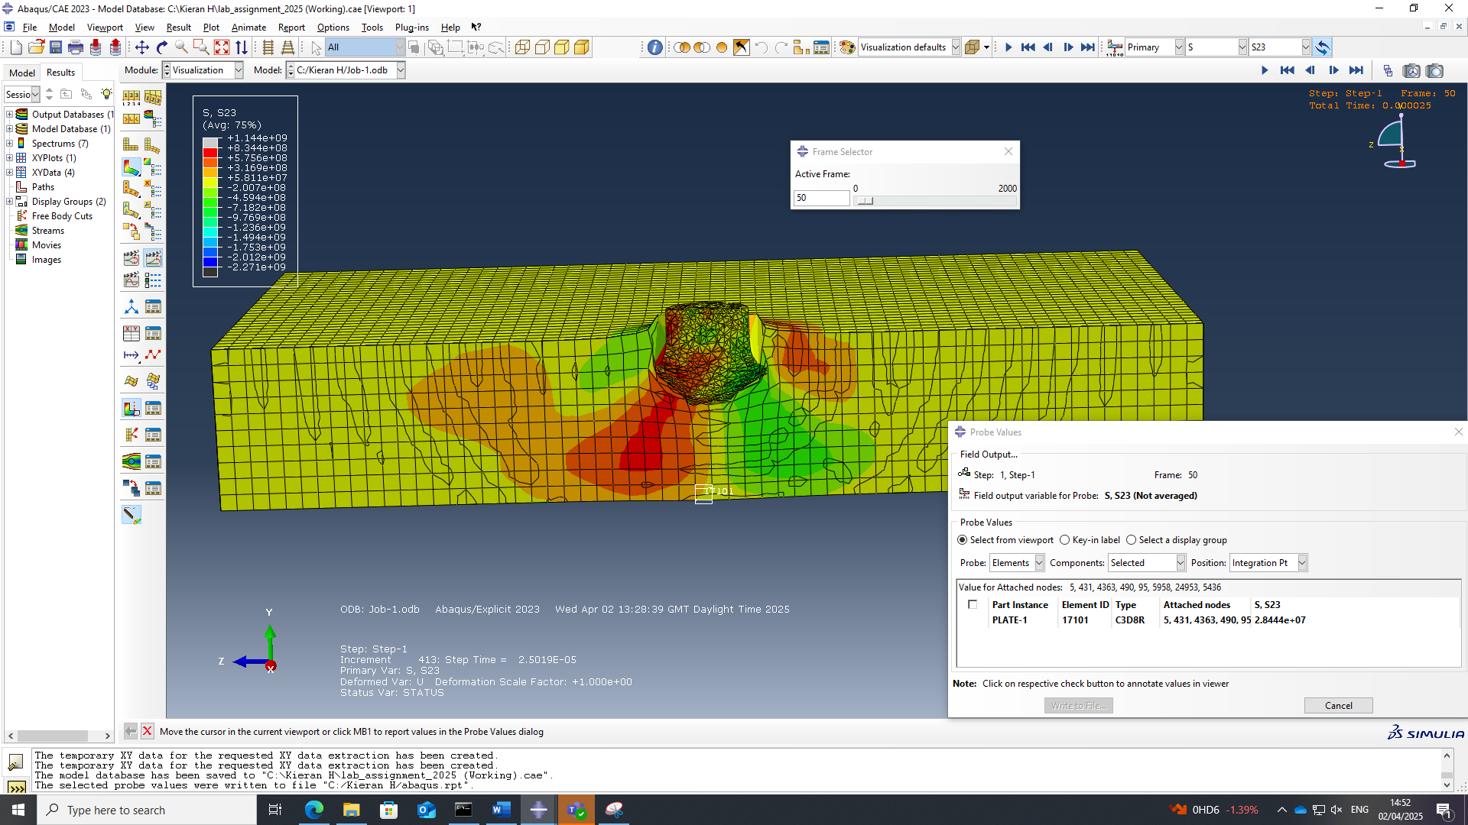
Figure 12 Shear stress at frame 50
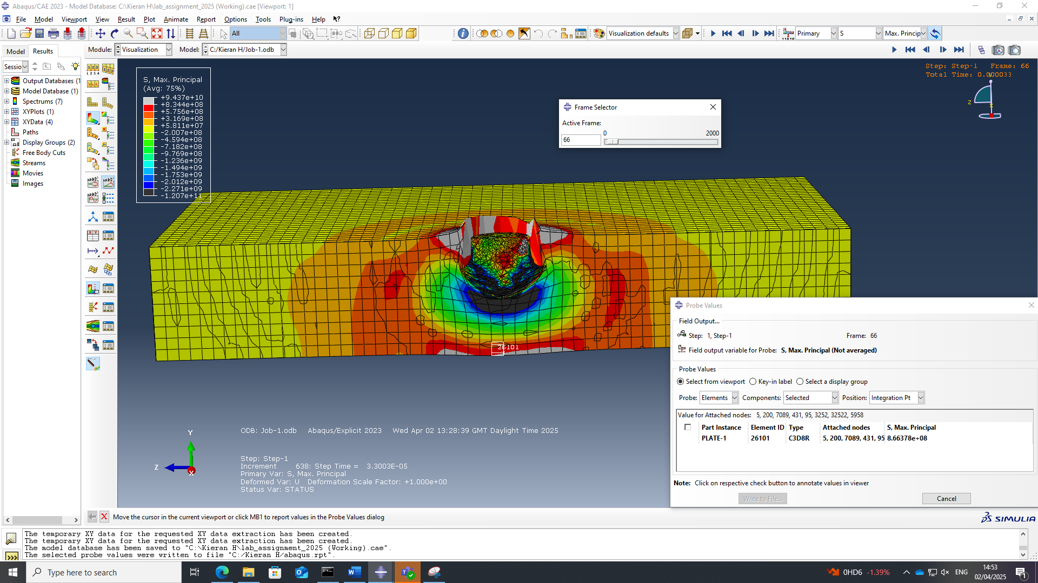
Figure 13 Direct stress at frame 66
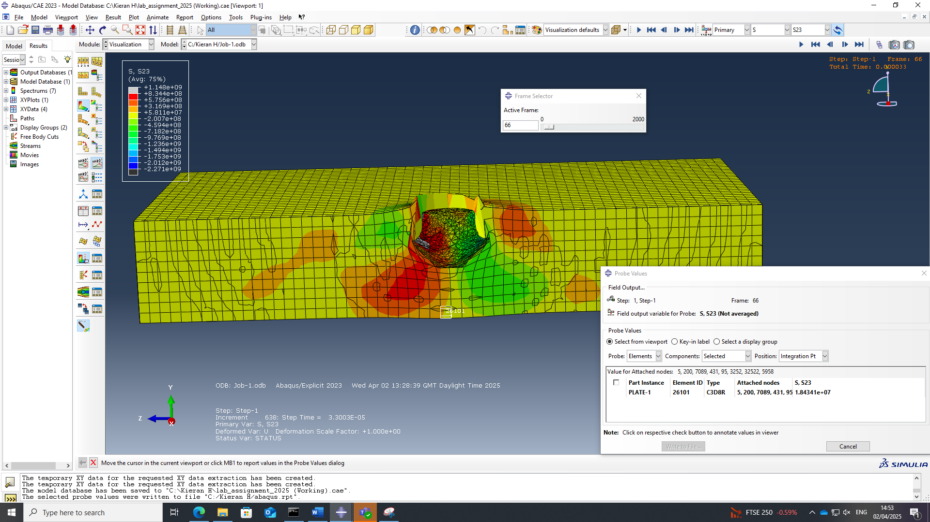
Figure 14 Shear stress at frame 66
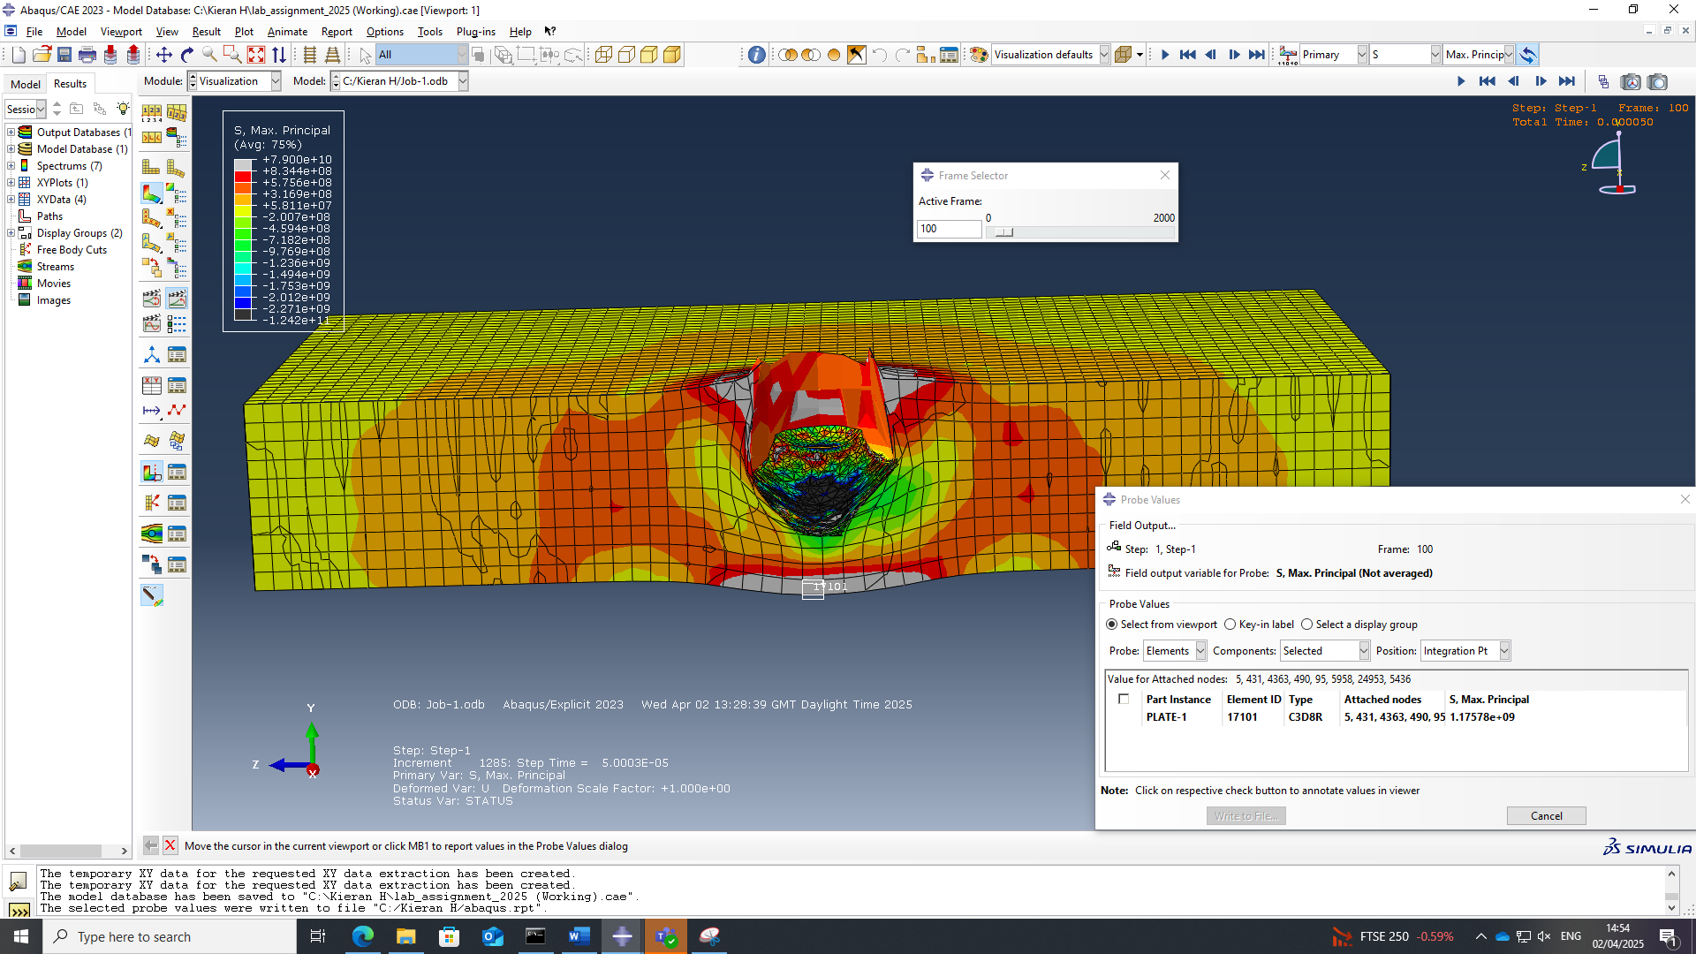Figure 15 Direct stress at frame 100
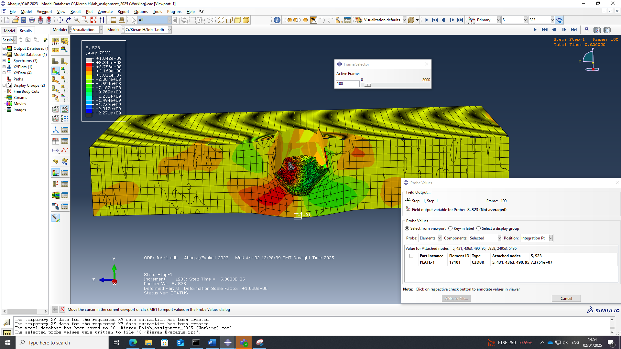
Figure 16 Shear stress at frame 100
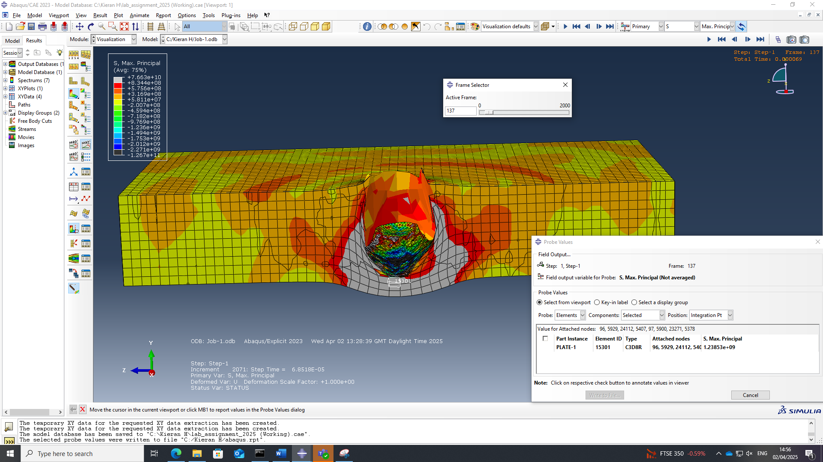
Figure 17 Direct stress at frame 137
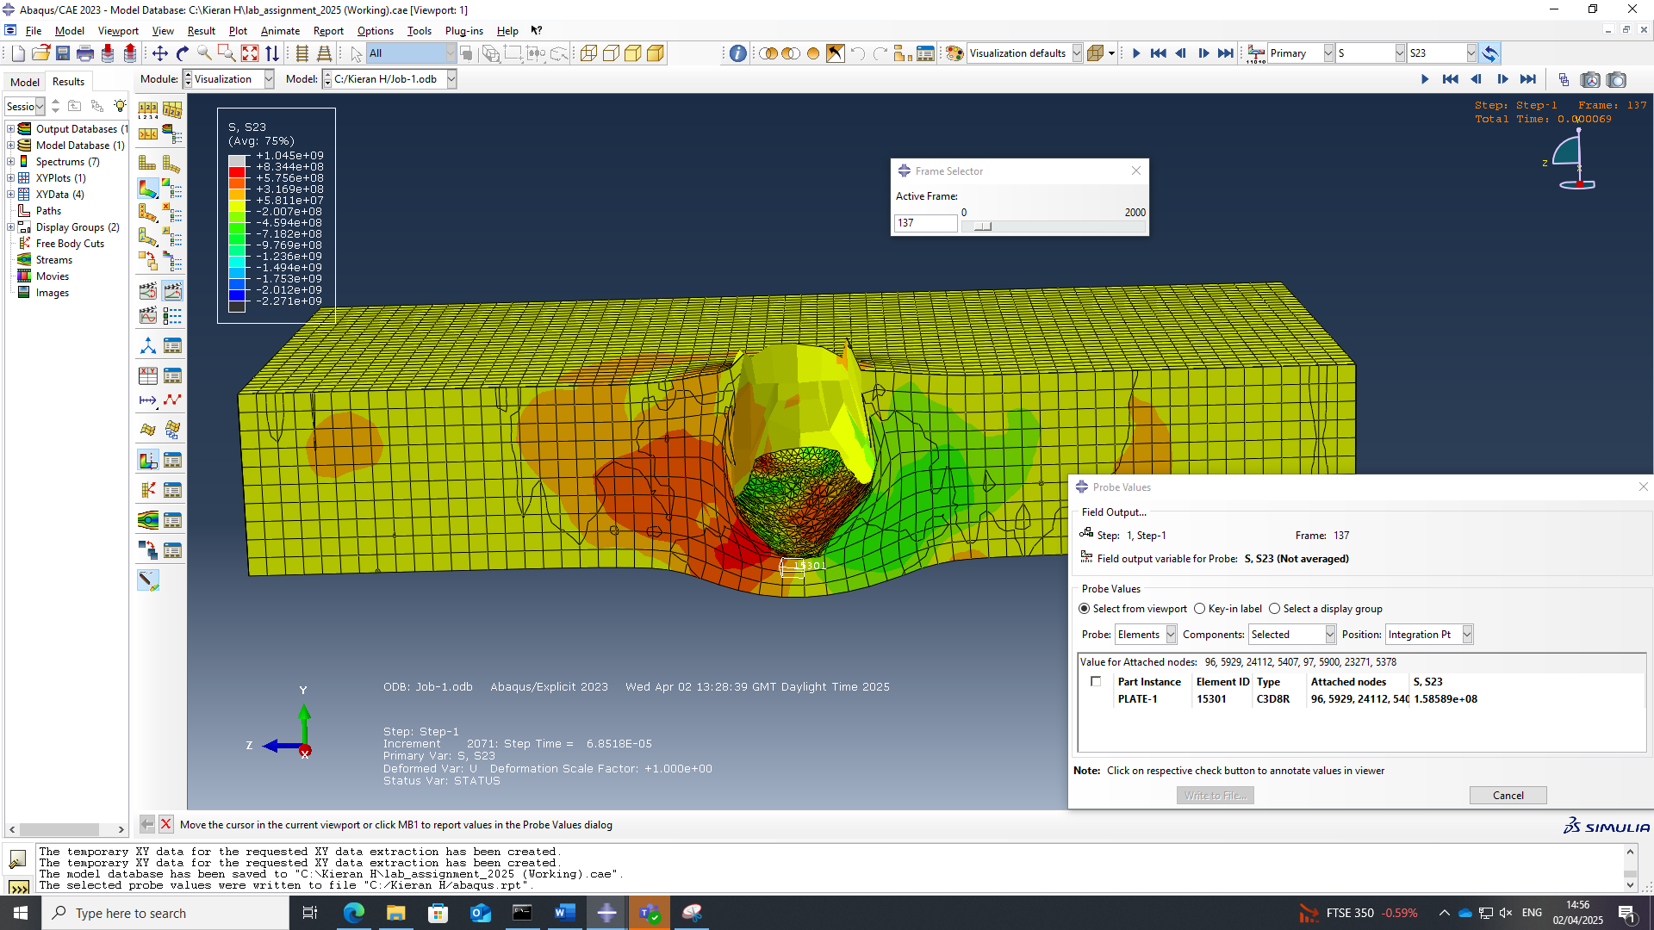
Figure 18 Shear stress at frame 137
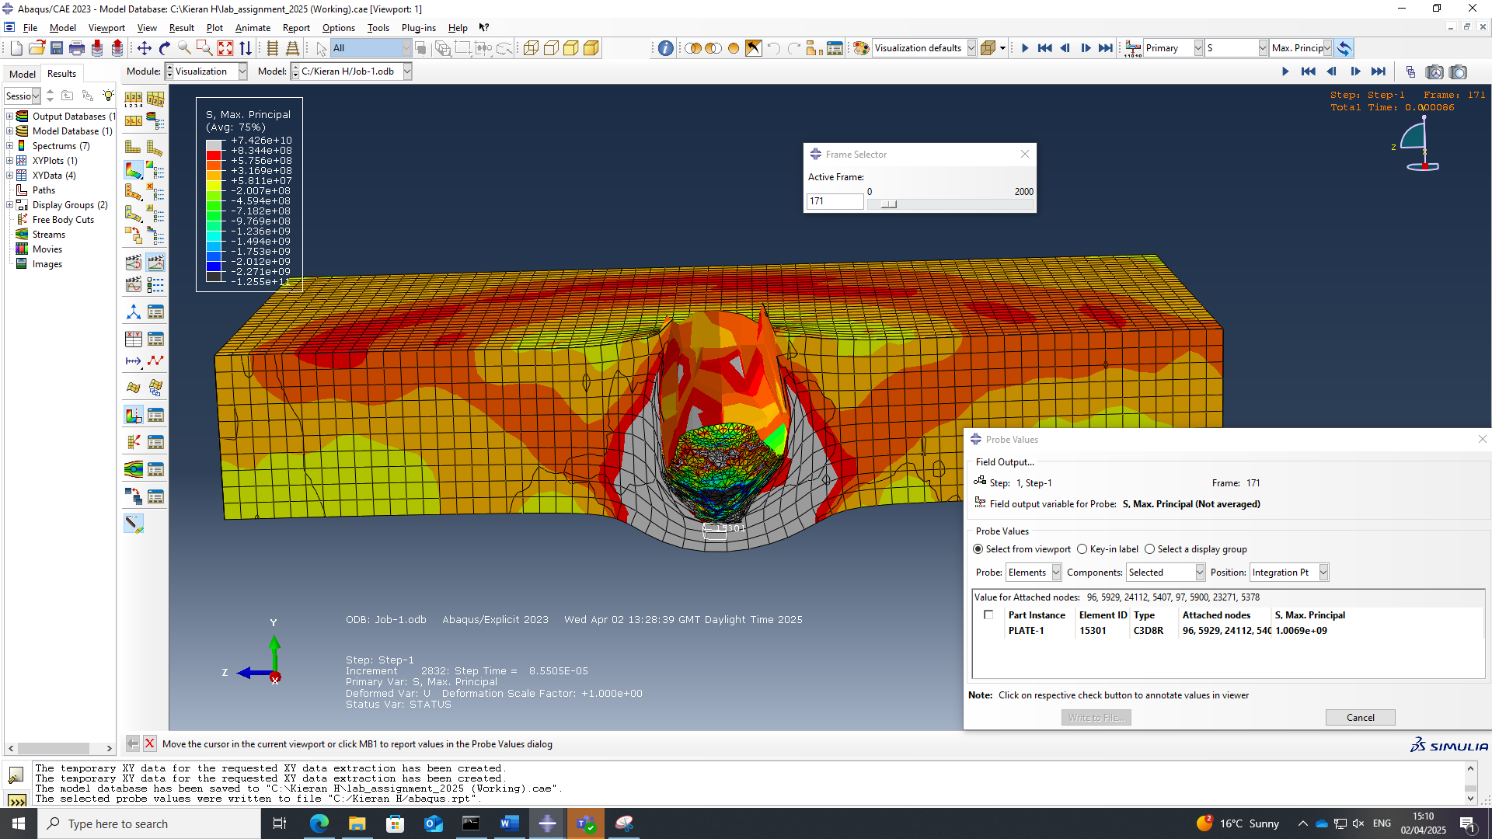
Figure 19 Direct stress at frame 171
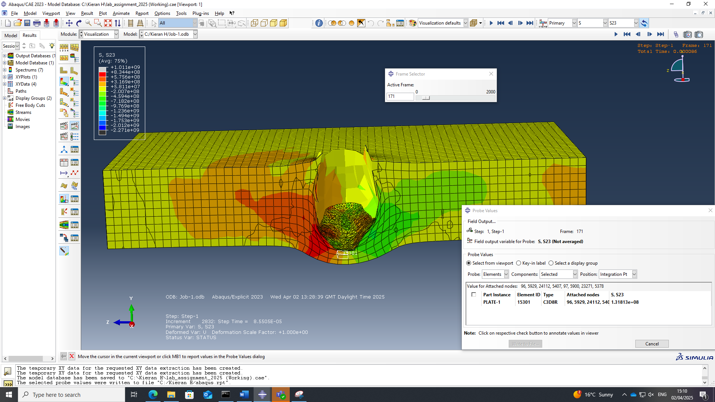
Figure 20 Shear stress at frame 171
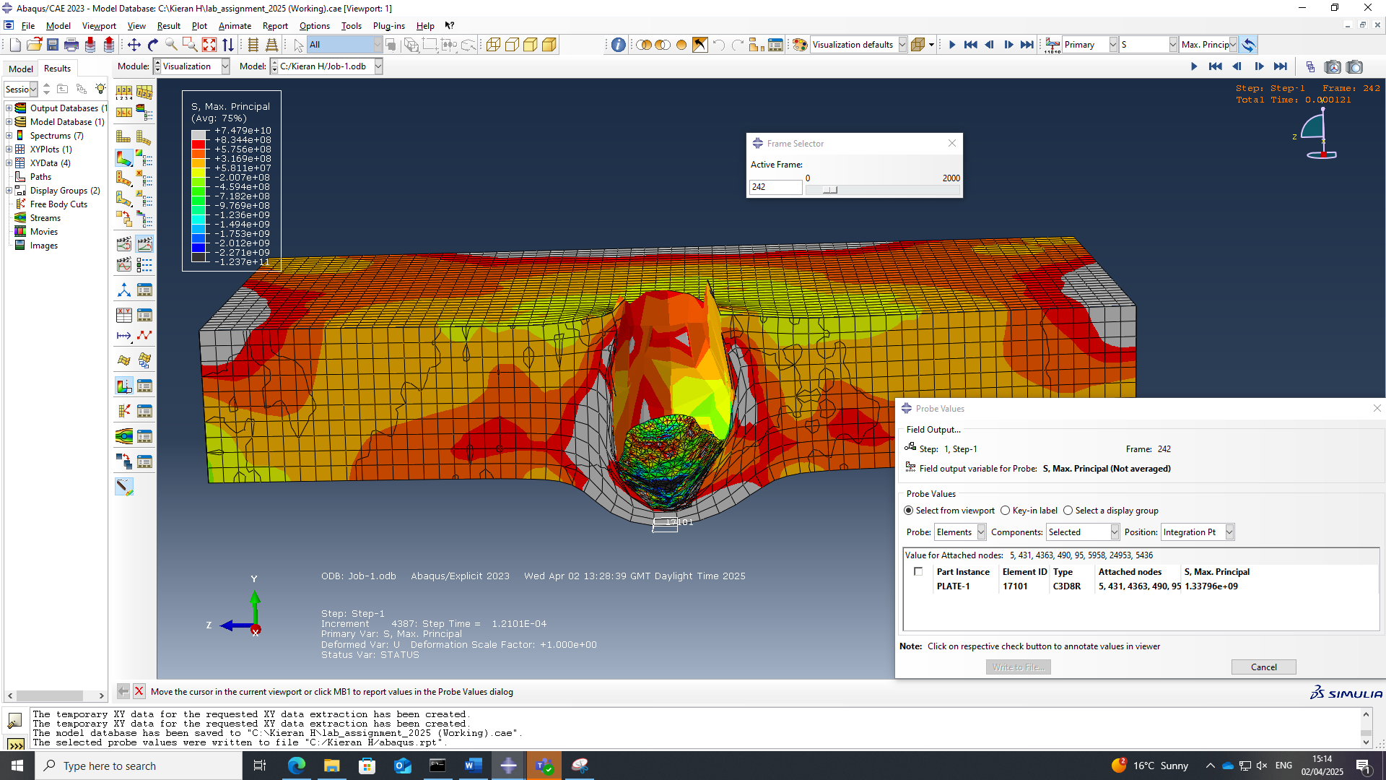
Figure 21 Direct stress at frame 242
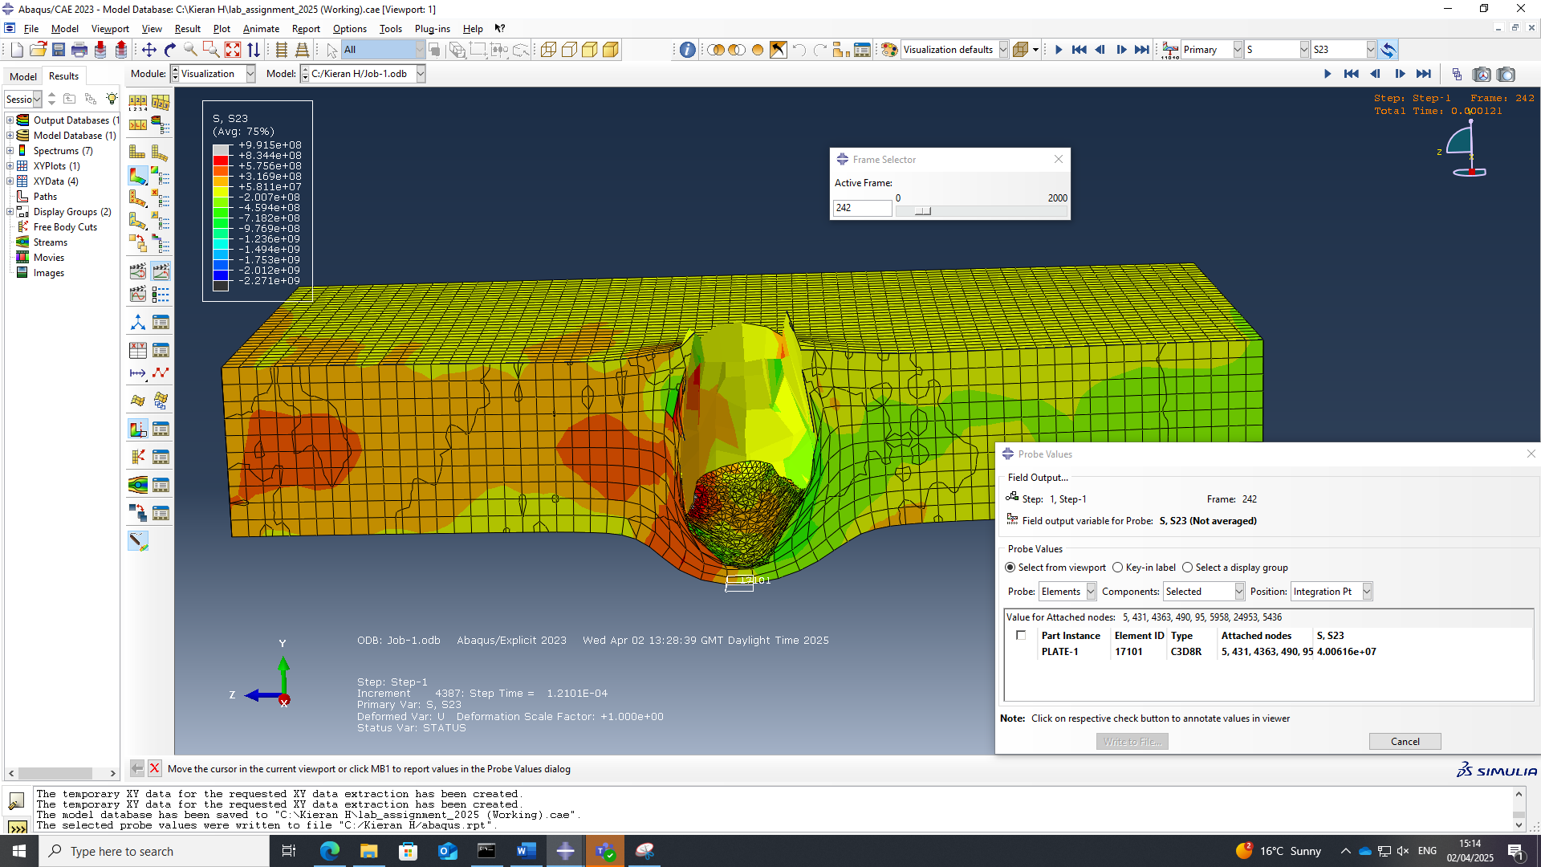
Figure 22 Shear stress at frame 242
The velocity of the projectile throughout the simulation was then compiled into a velocity time graph as shown in figure 23
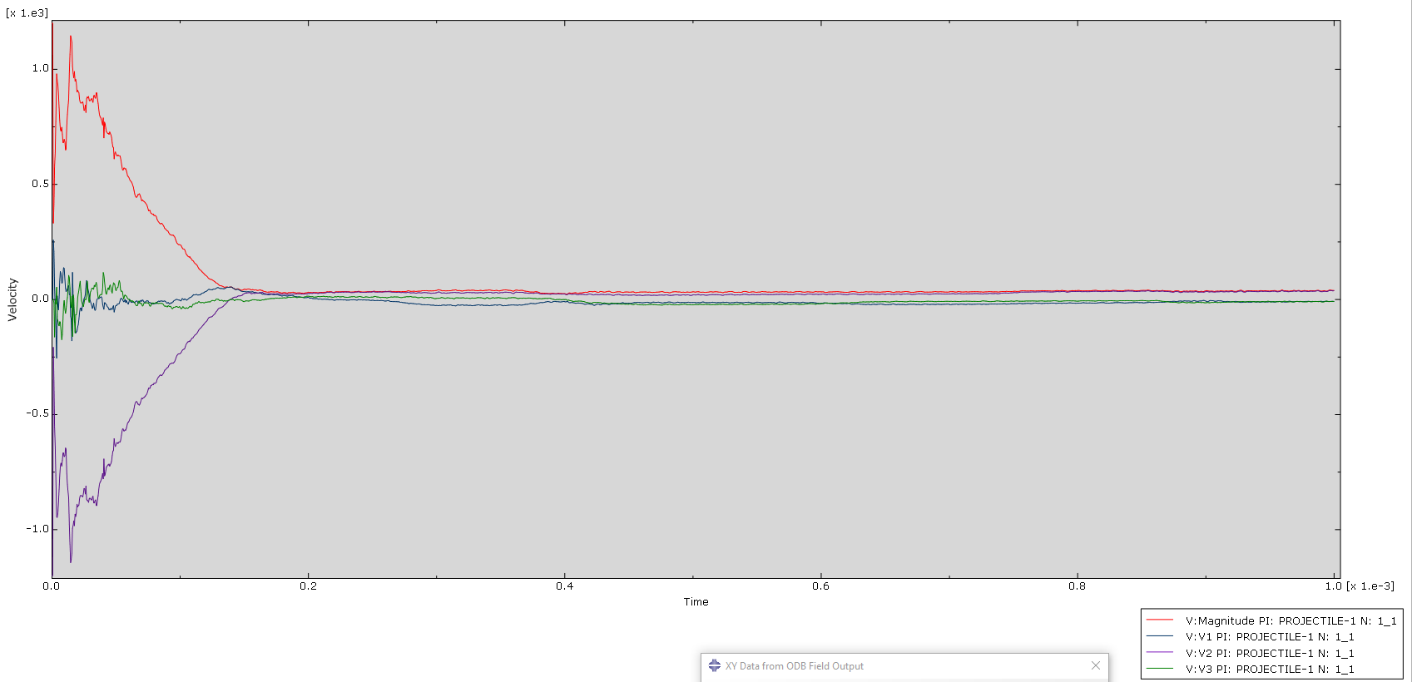
Figure 23 Velocity time graph from initial speed of 1200m/s

Figures from 1400m/s simulation
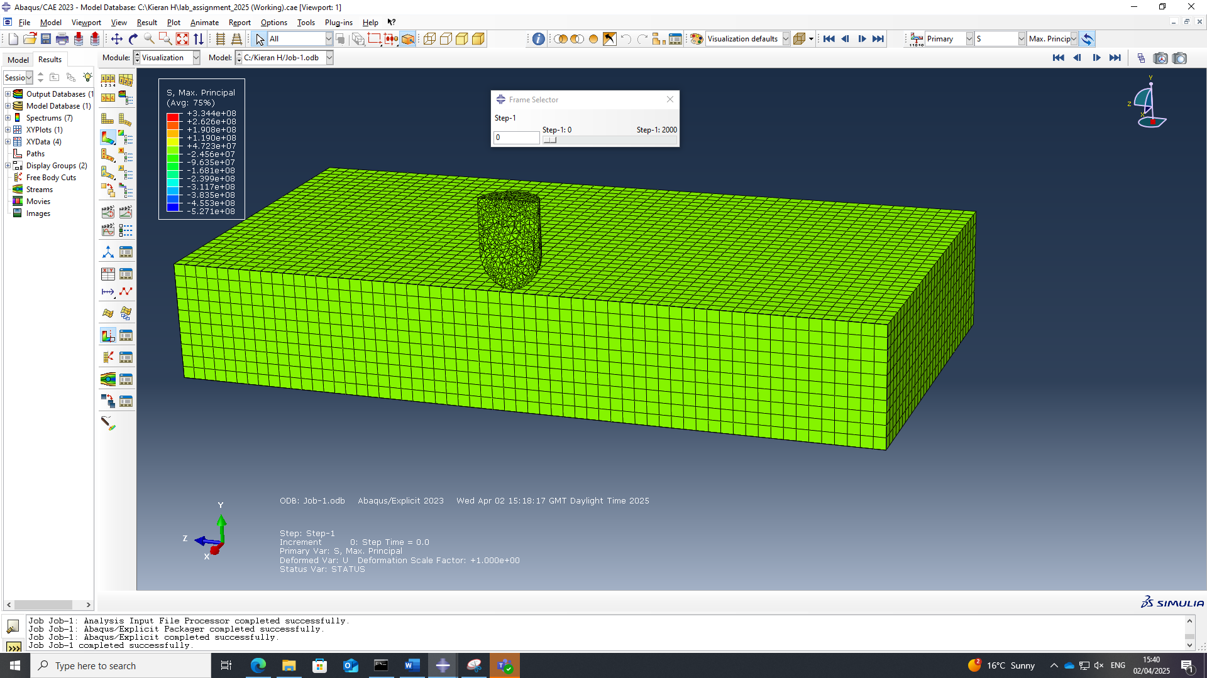
Figure 24 Initial simulation setup for 1400m/s projectile

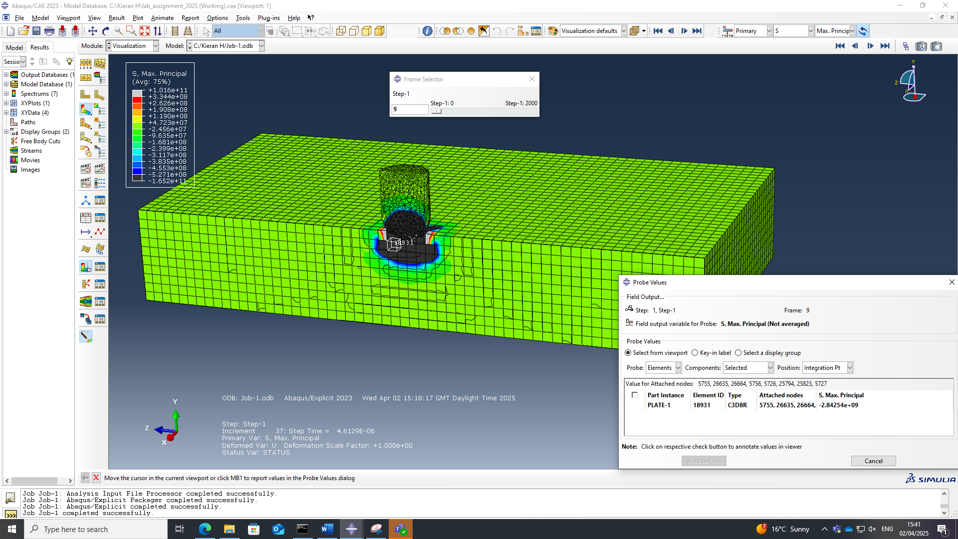
Figure 25 Direct stresses upon impact
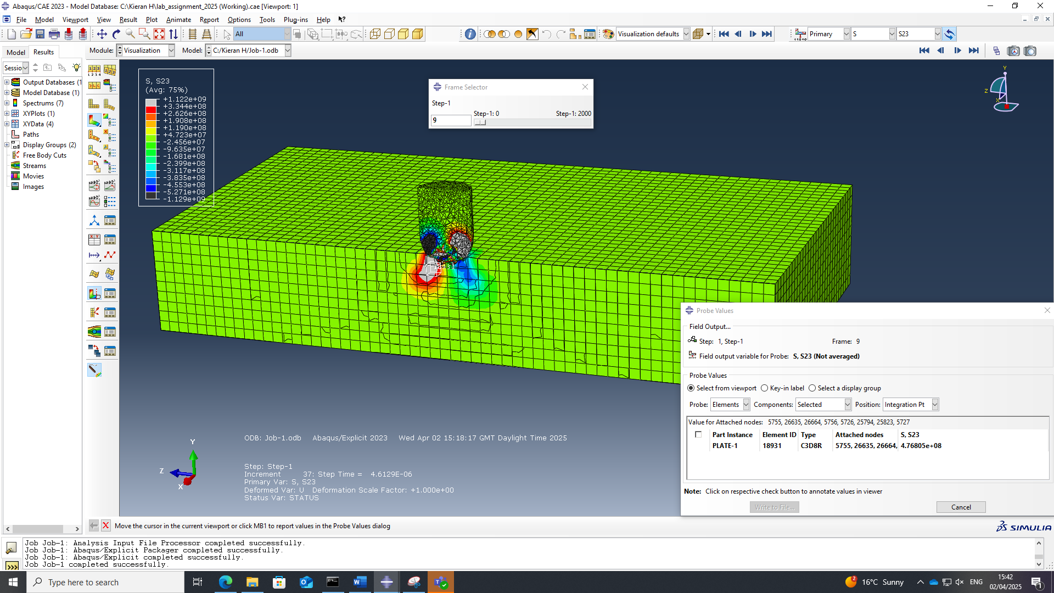
Figure 26 Shear stresses upon impact

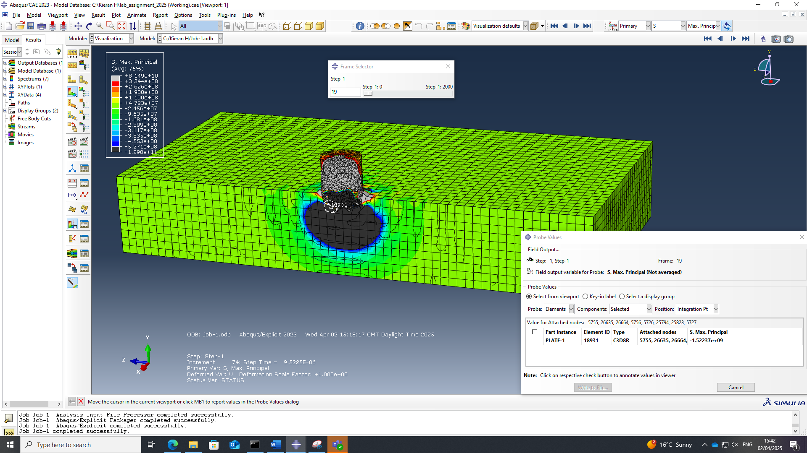Figure 27 Direct stresses at 19th frame
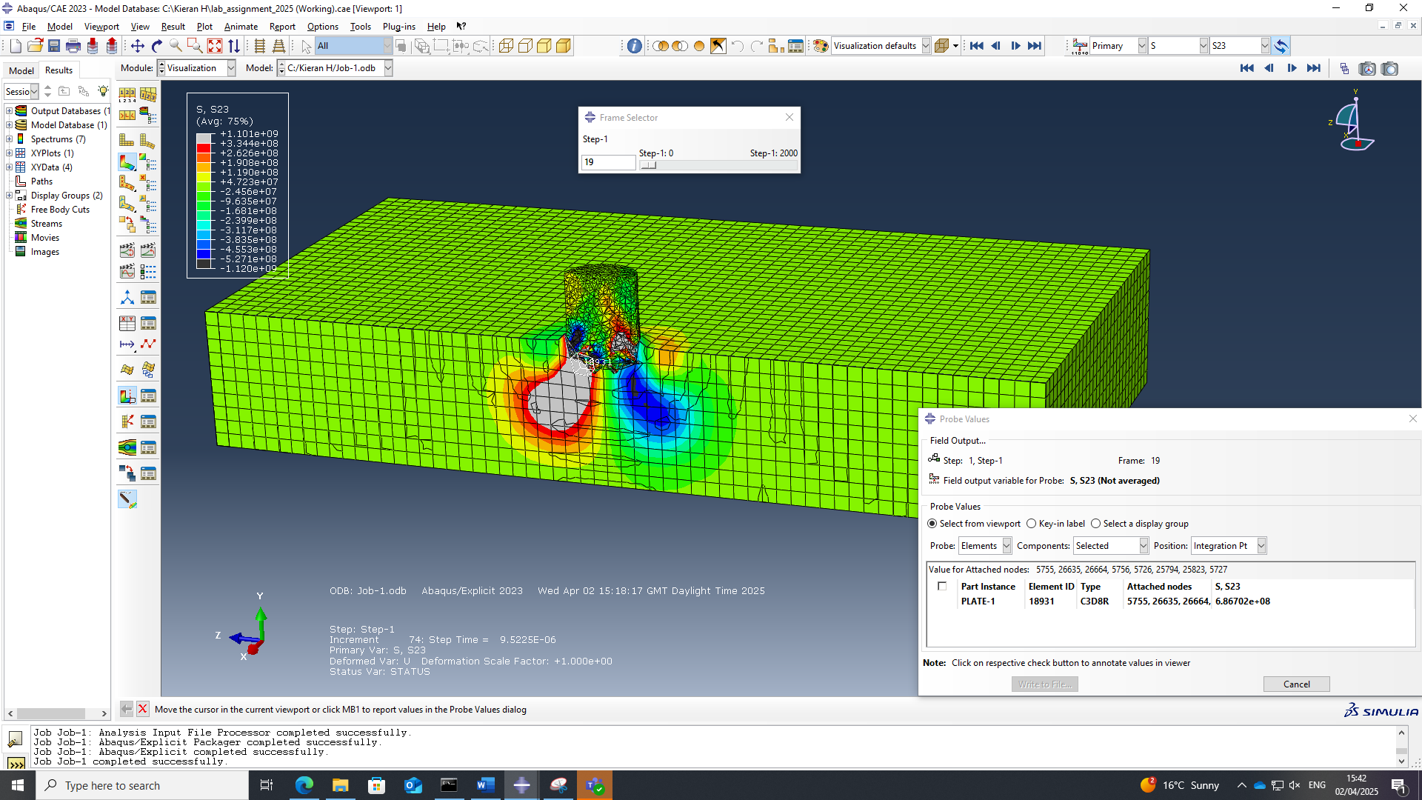Figure 28 Shear stresses at 19th frame
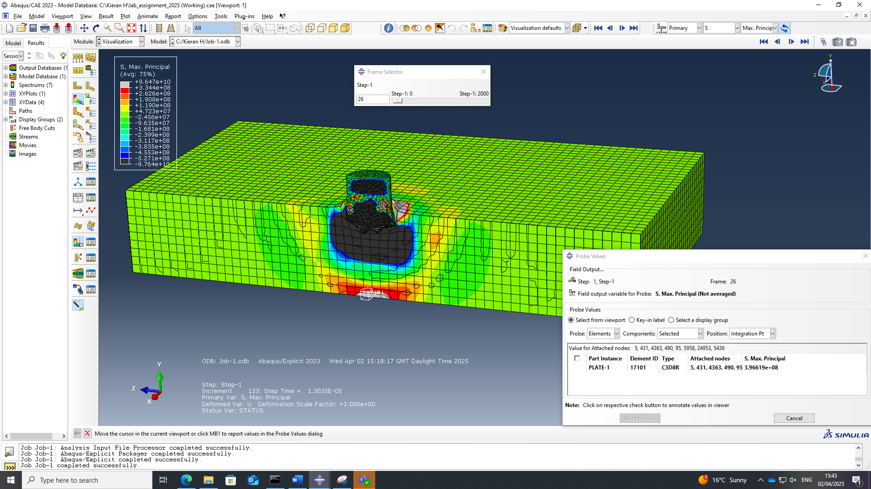
Figure 29 Direct stresses at 26th frame
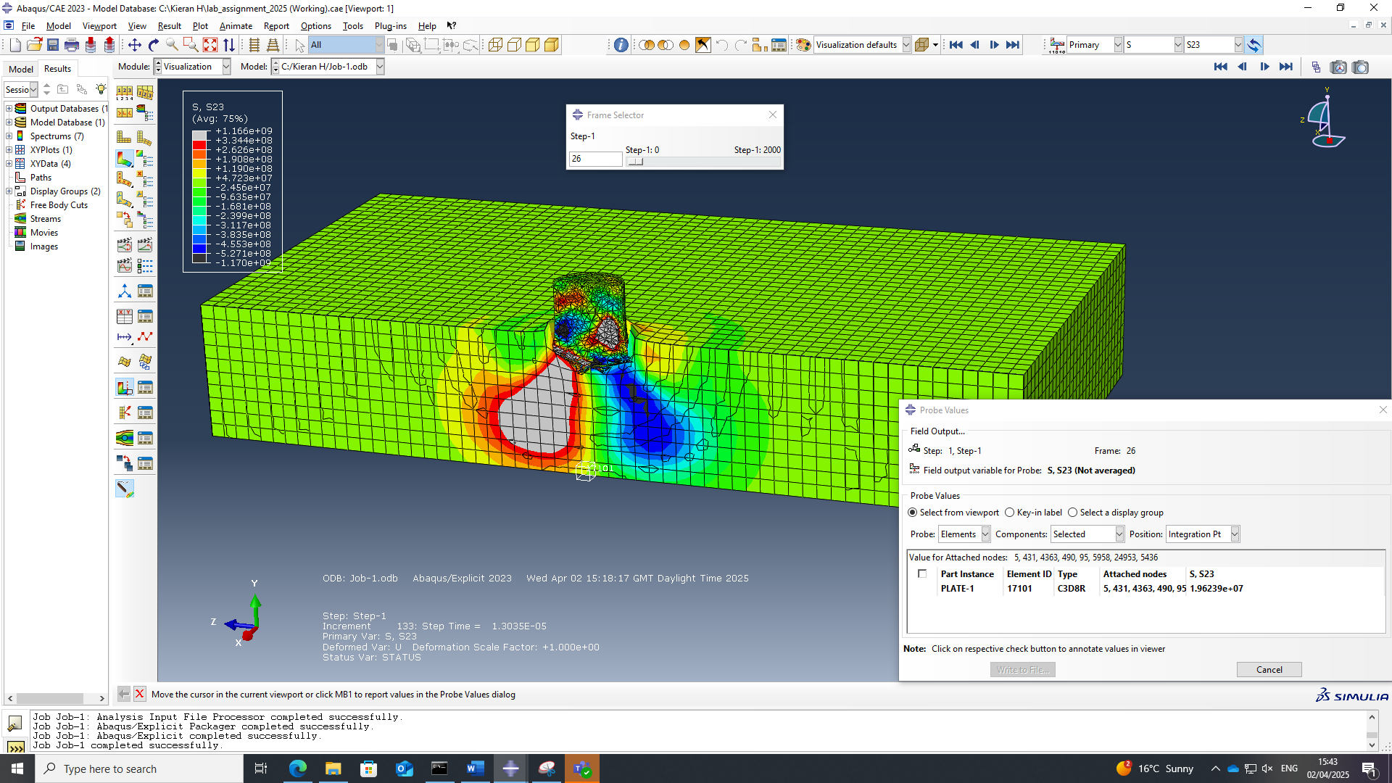
Figure 30 Shear stresses at 19th frame
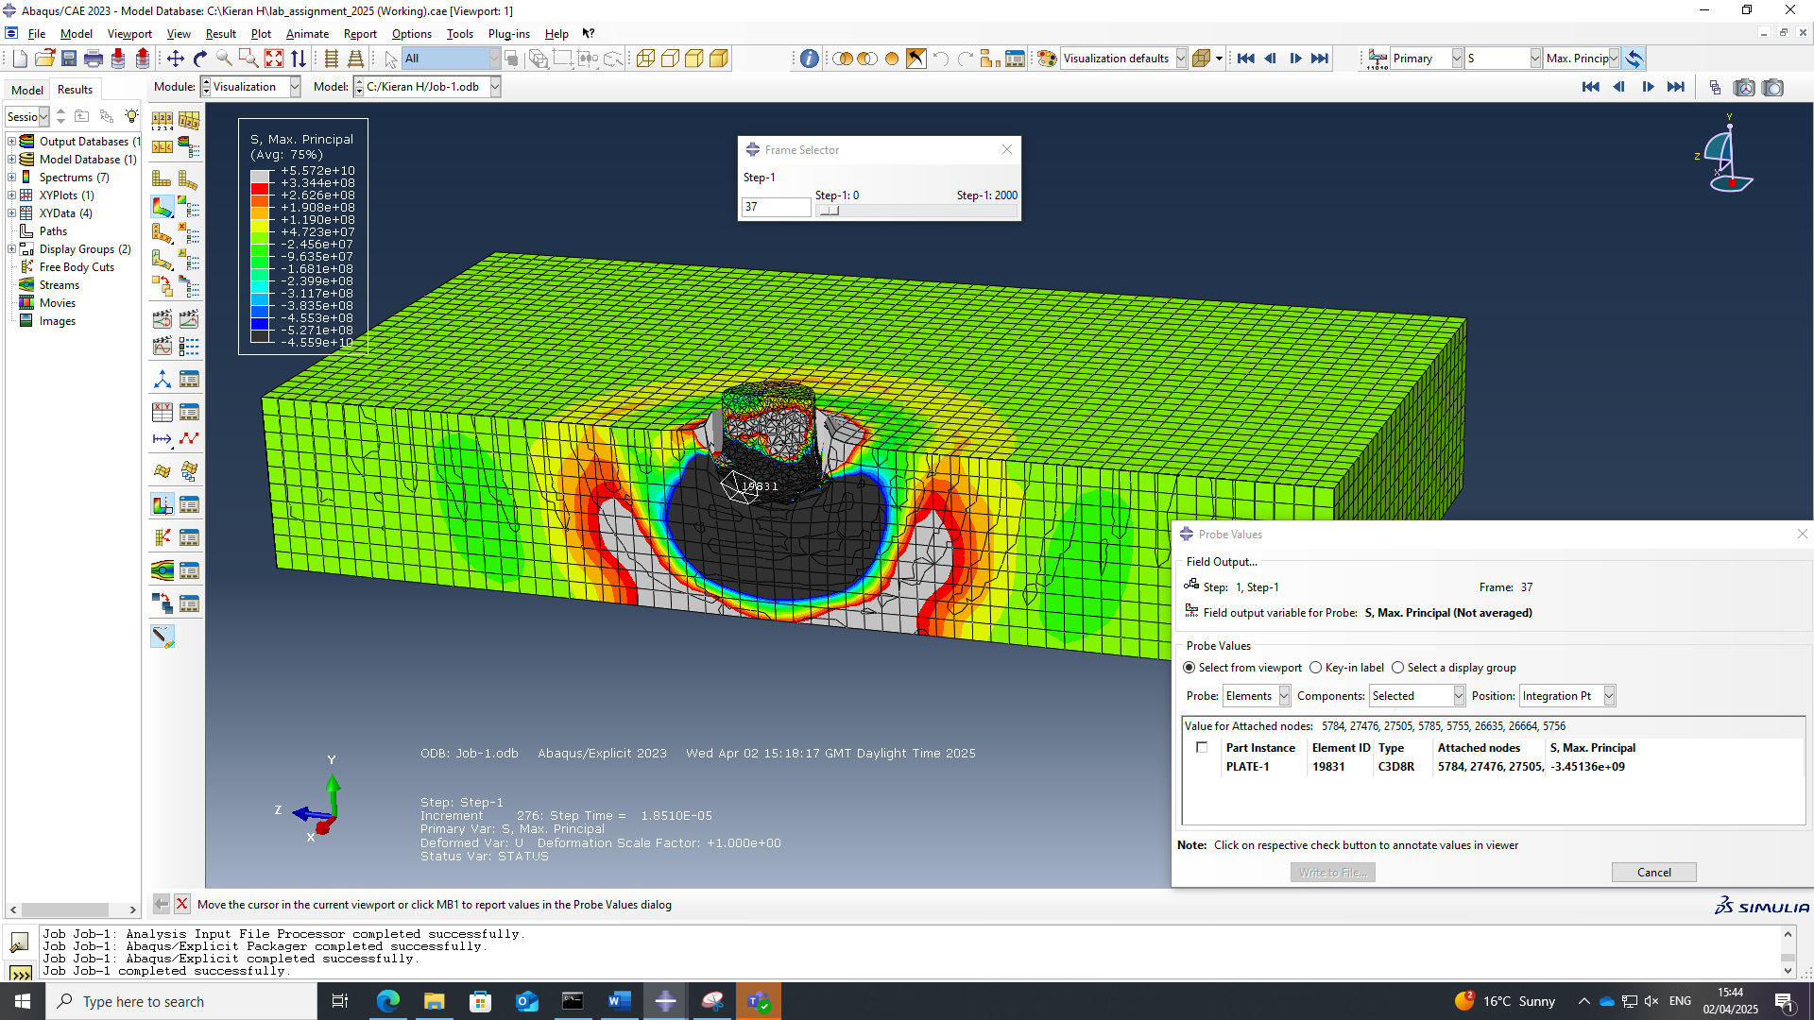
Figure 31 Direct stresses at 31st frame
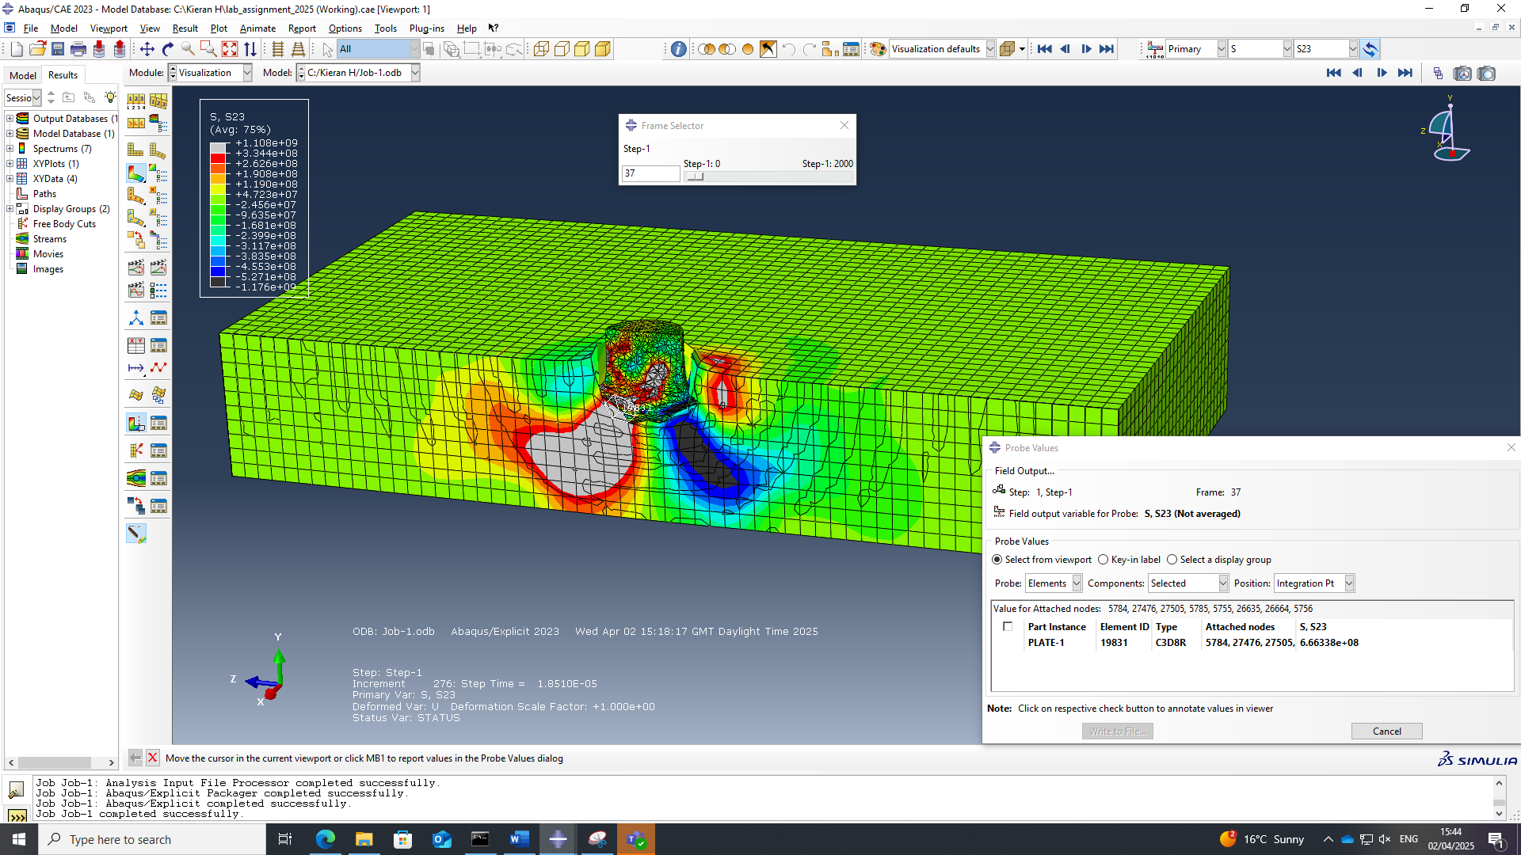
Figure 32 Shear stresses at 31st frame
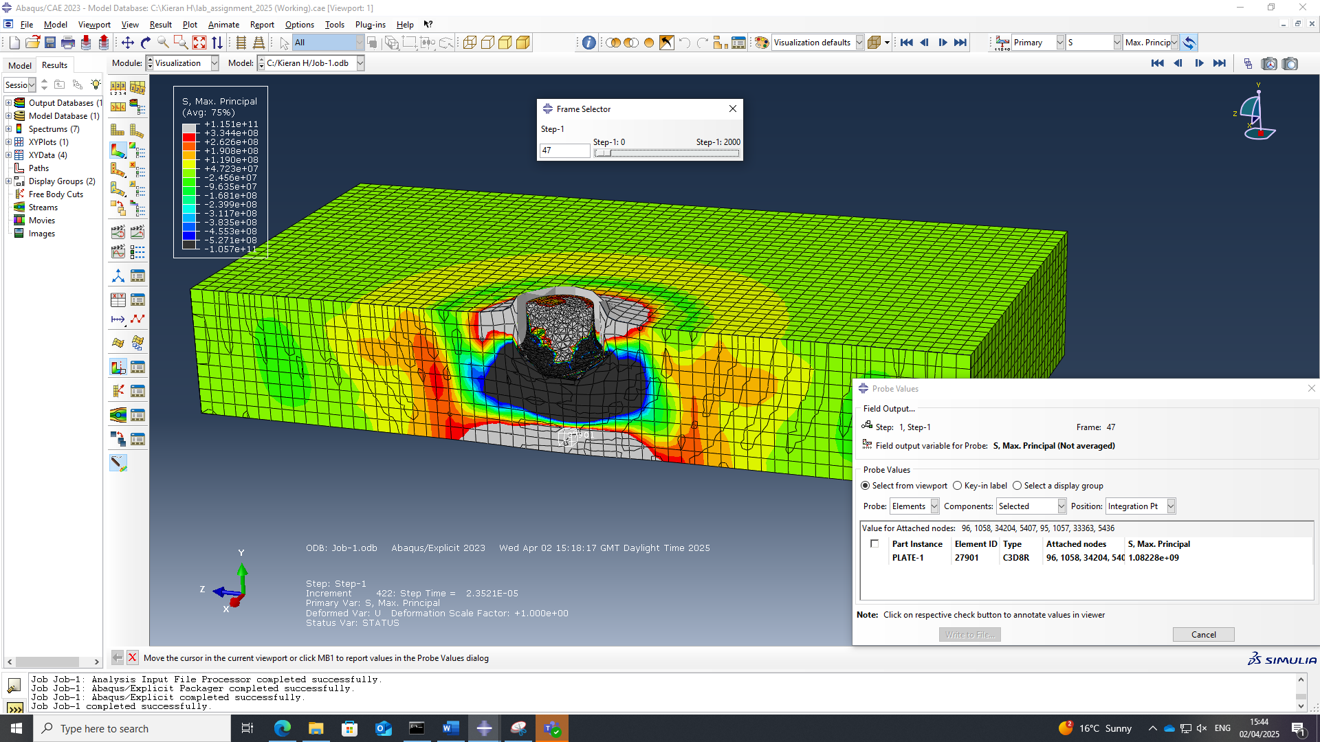
Figure 33 Direct stresses at 47th frame

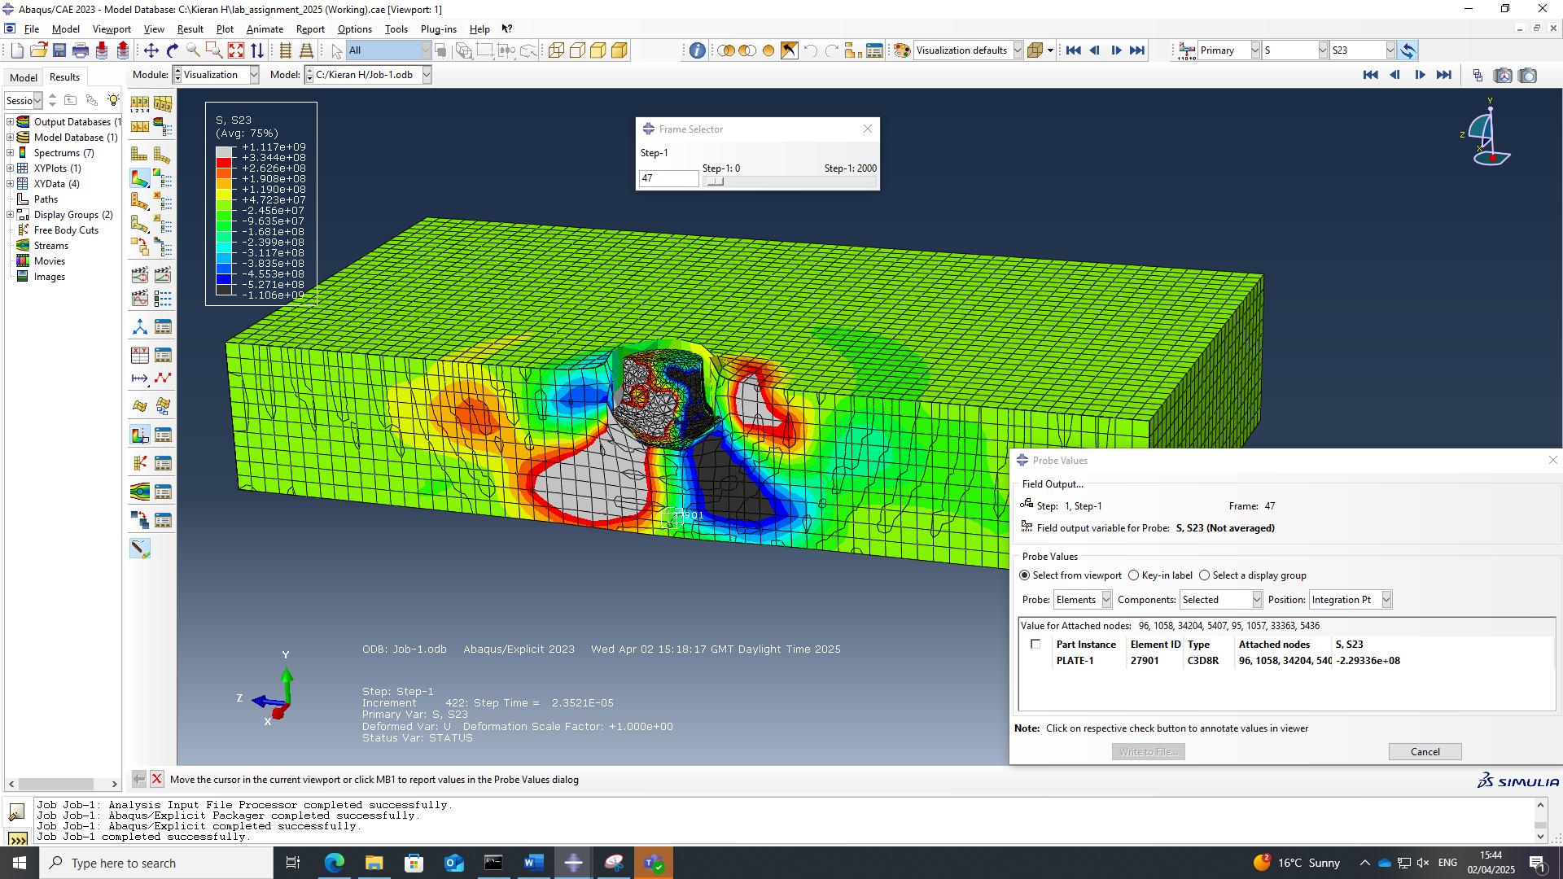
Figure 34 Shear stresses at 47th frame

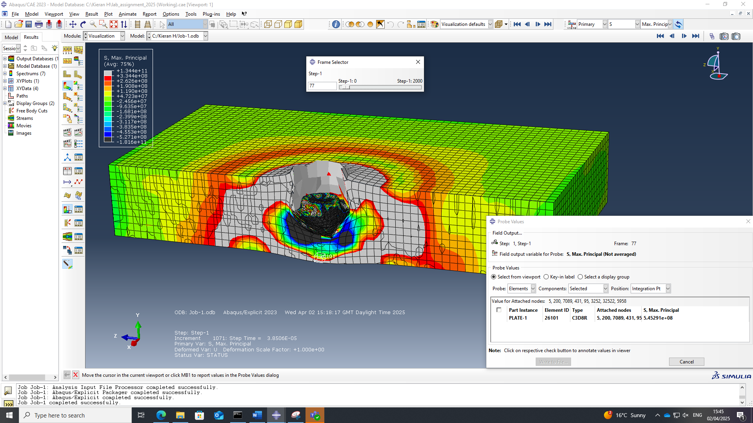
Figure 35 Direct stresses at 77th frame

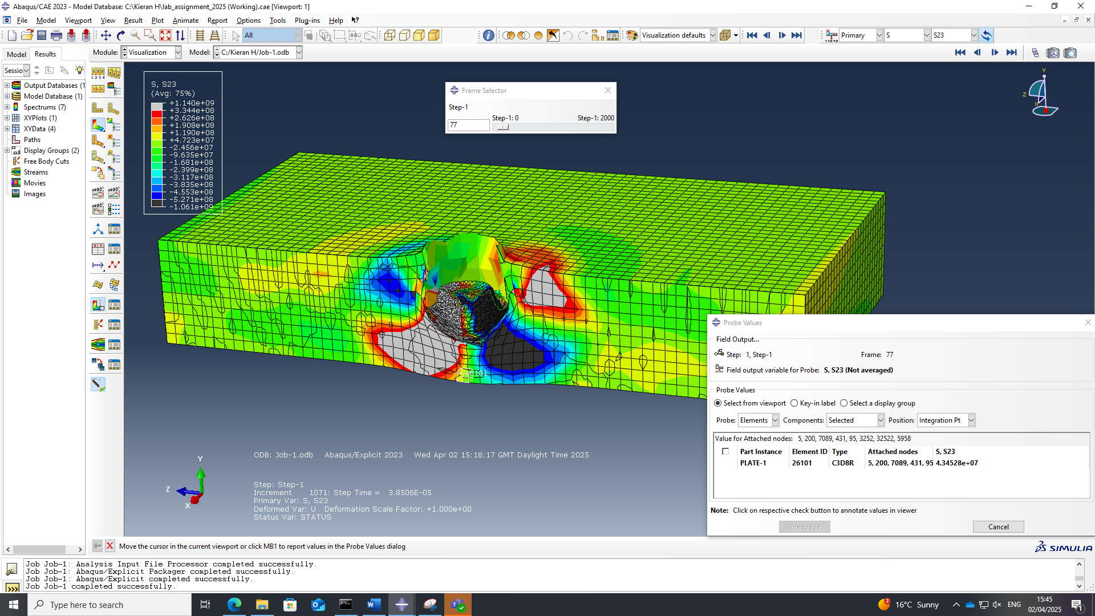
Figure 36 Shear stresses at 77th frame

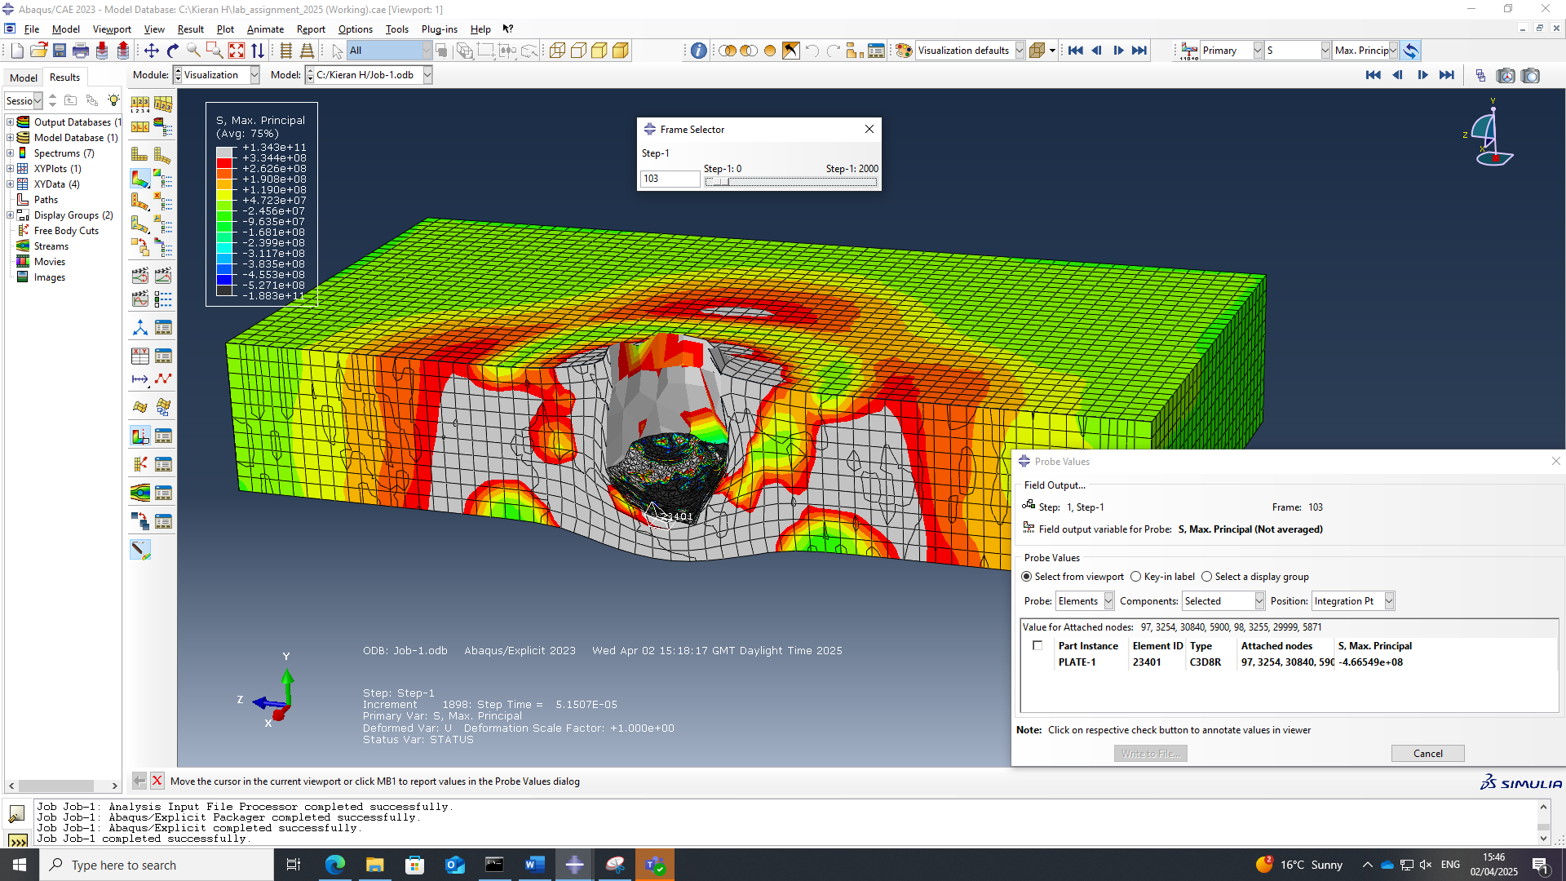
Figure 37 Direct stresses at 103rd frame

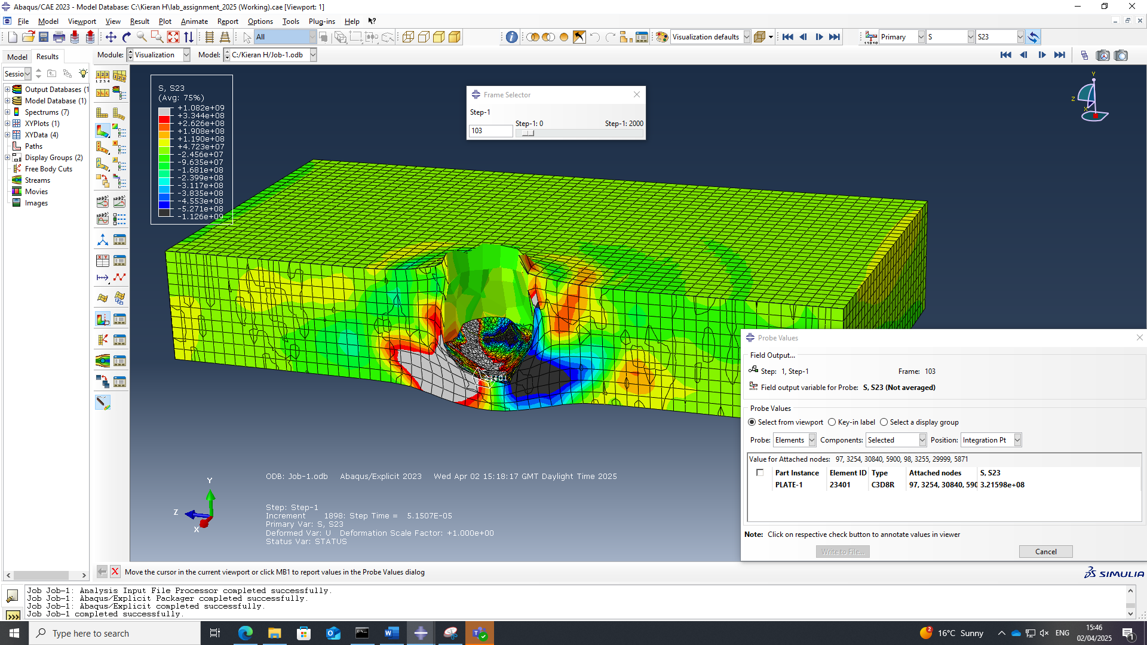
Figure 38 Shear stresses at 103rd frame

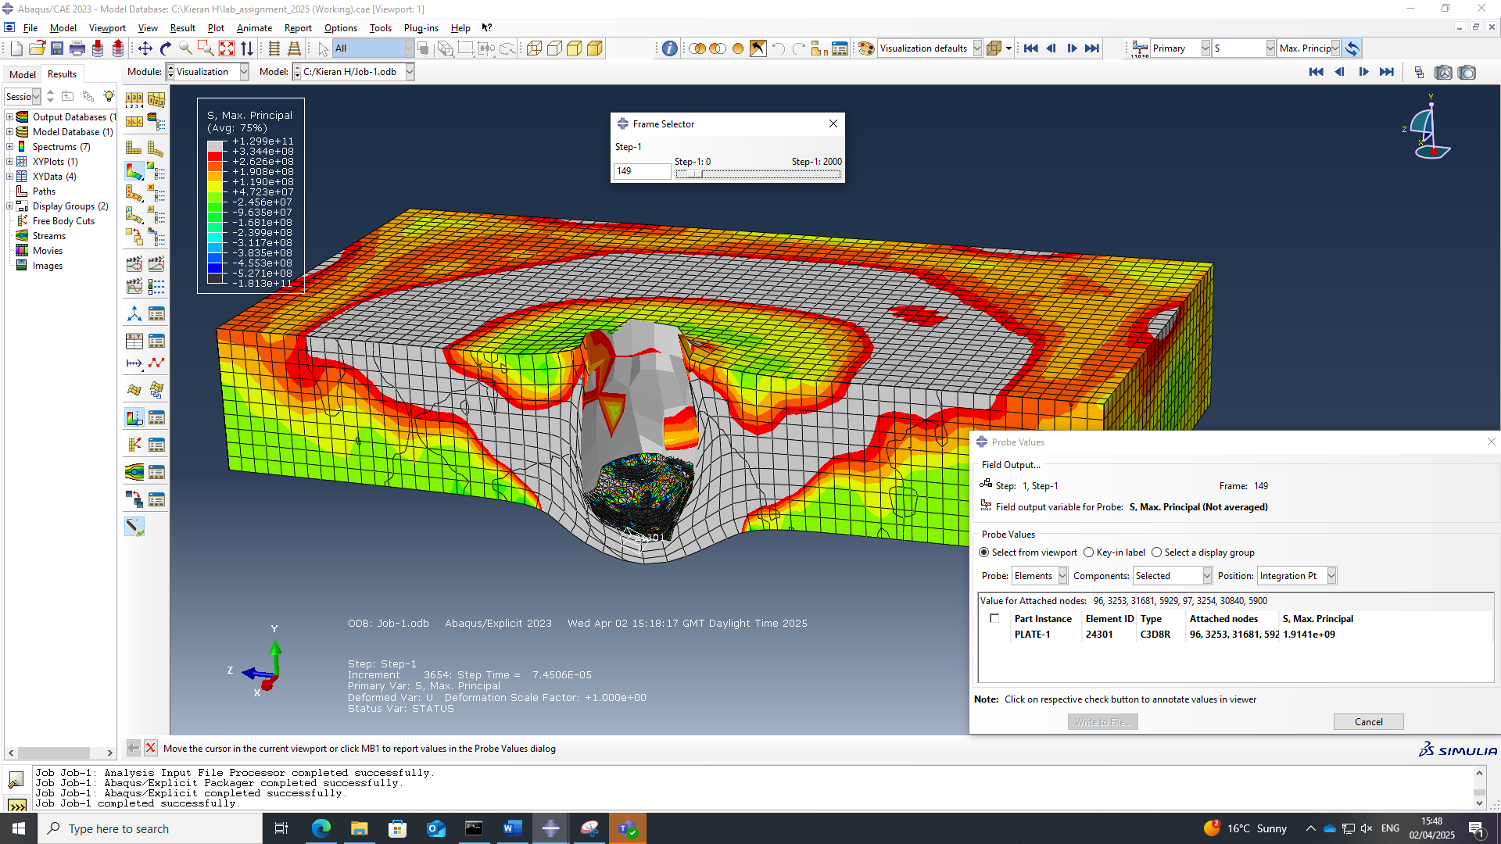
Figure 39 Direct stresses at 149th frame

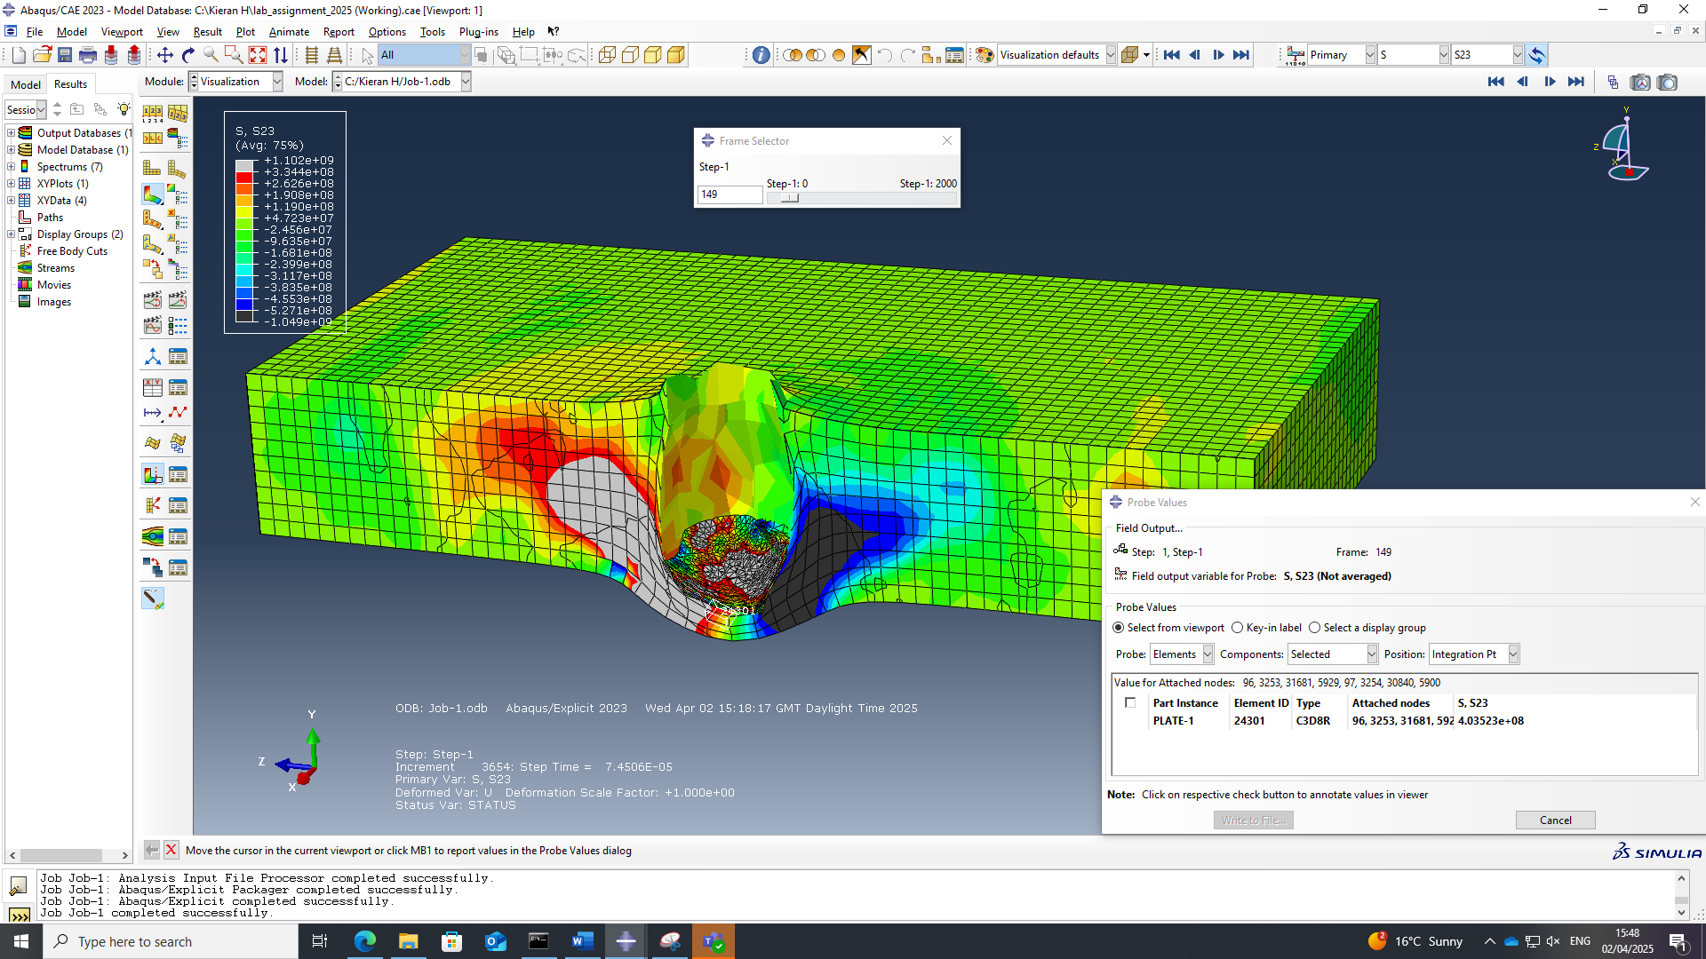
Figure 40 Shear stresses at 149th frame

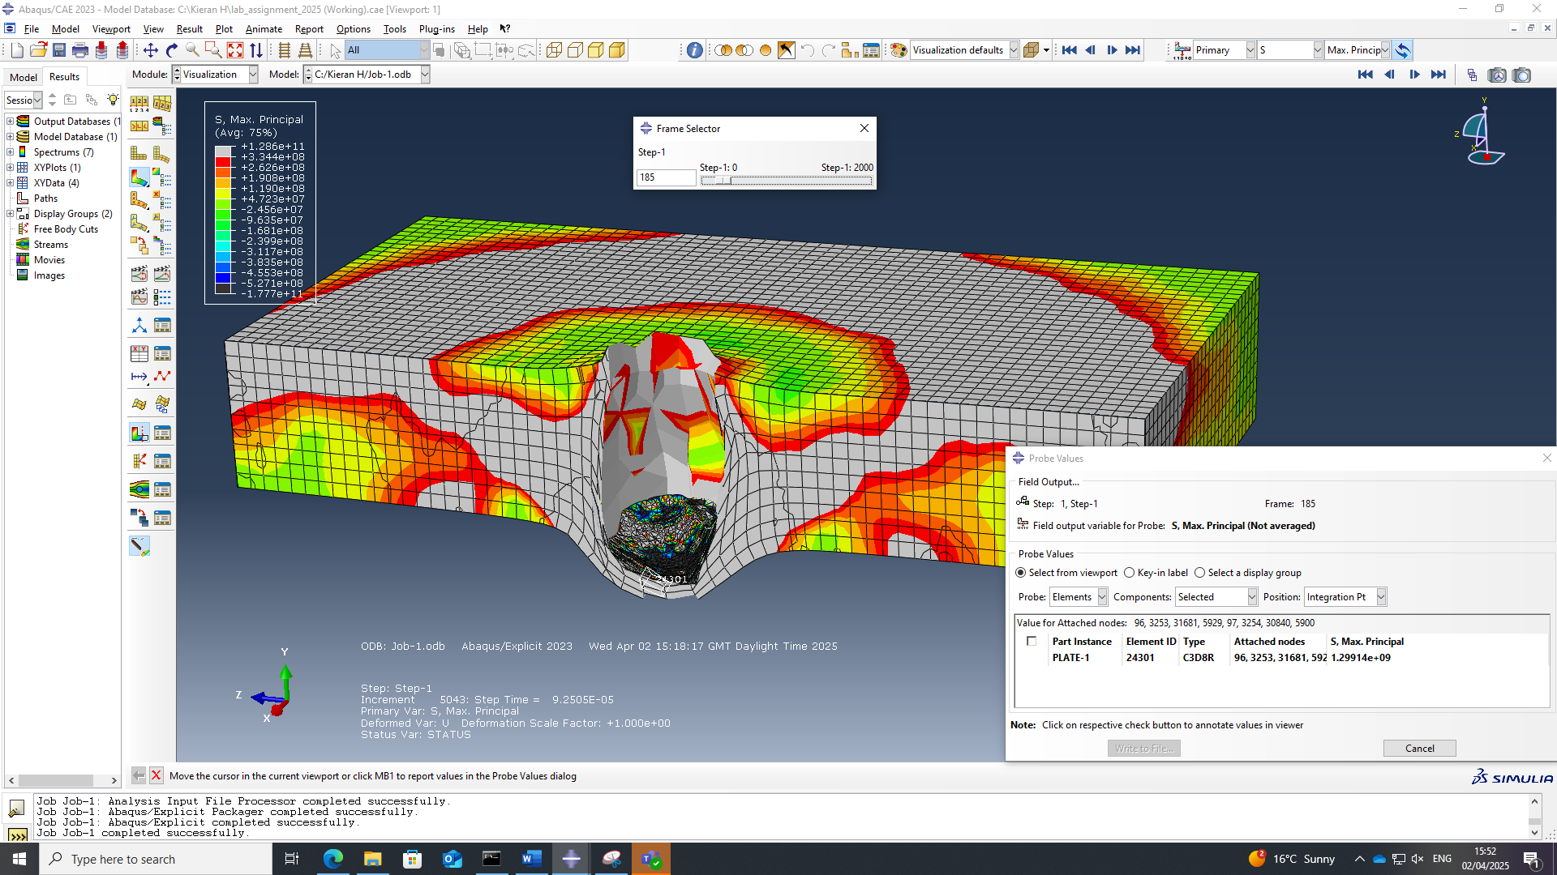
Figure 41 Direct stresses at 185th frame

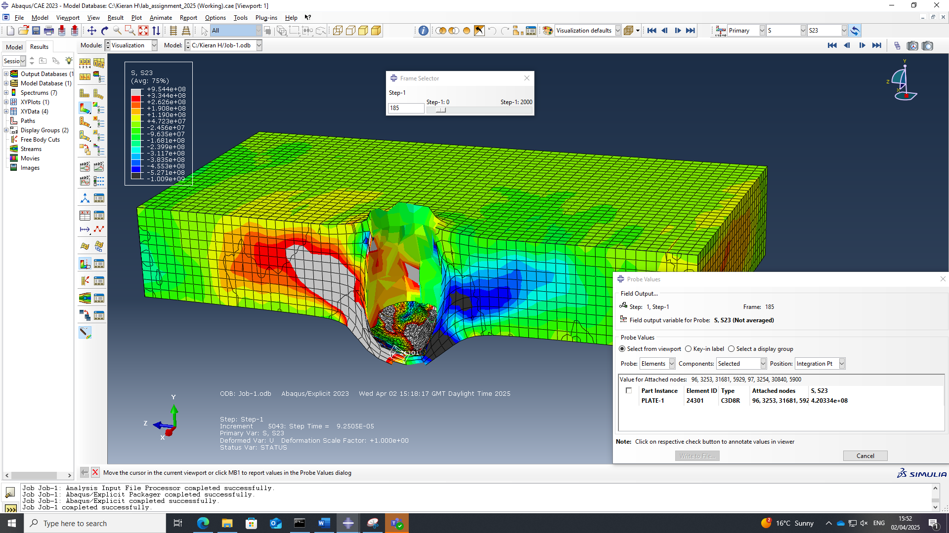
Figure 42 Shear stresses at 185th frame

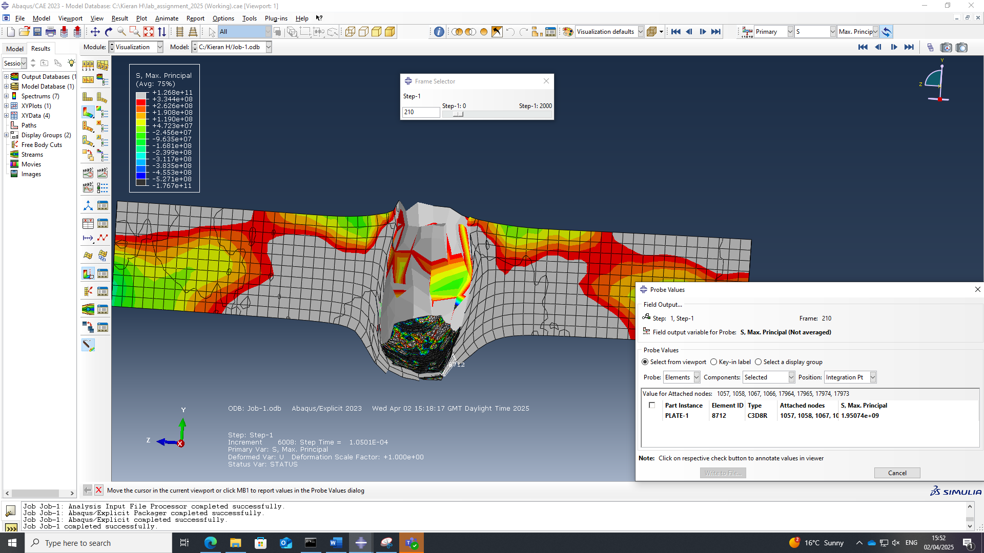Figure 43 Direct stress at 210th frame

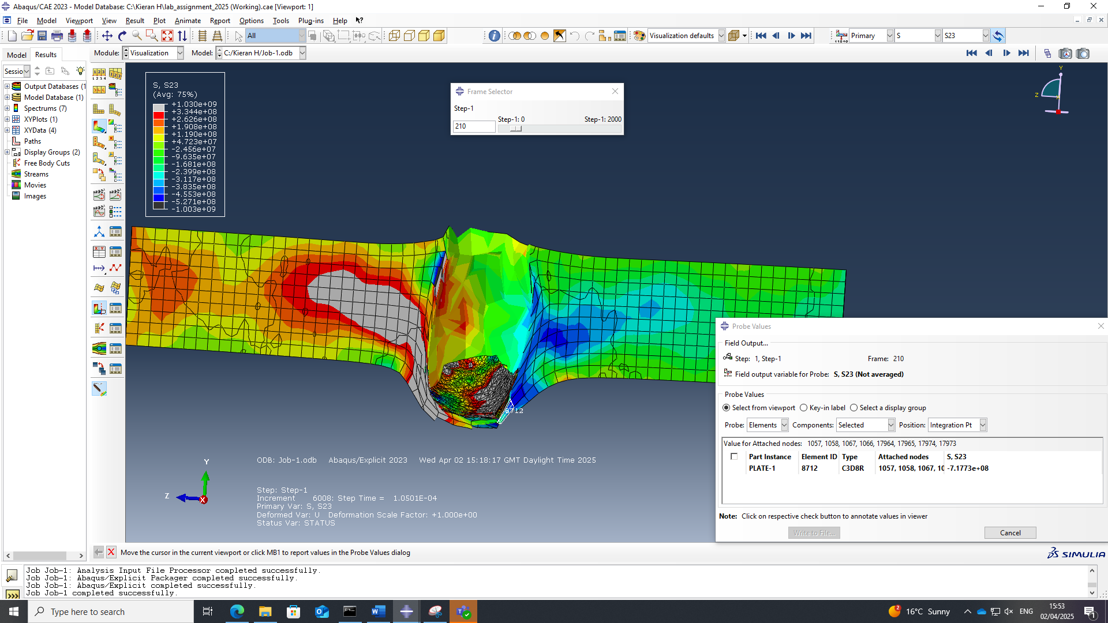
Figure 44 Shear stress at 210th frame

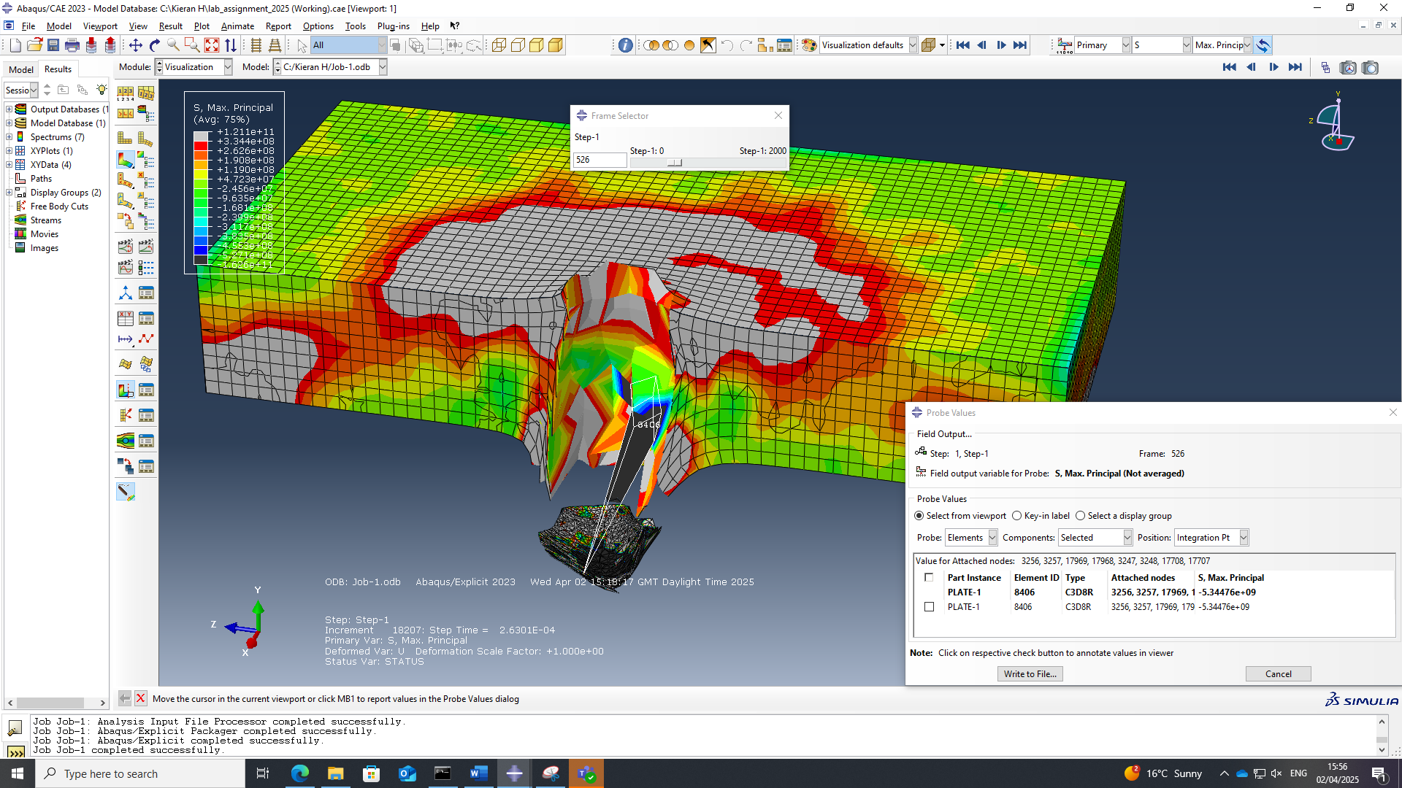Figure 45 Direct stresses at 526th frame

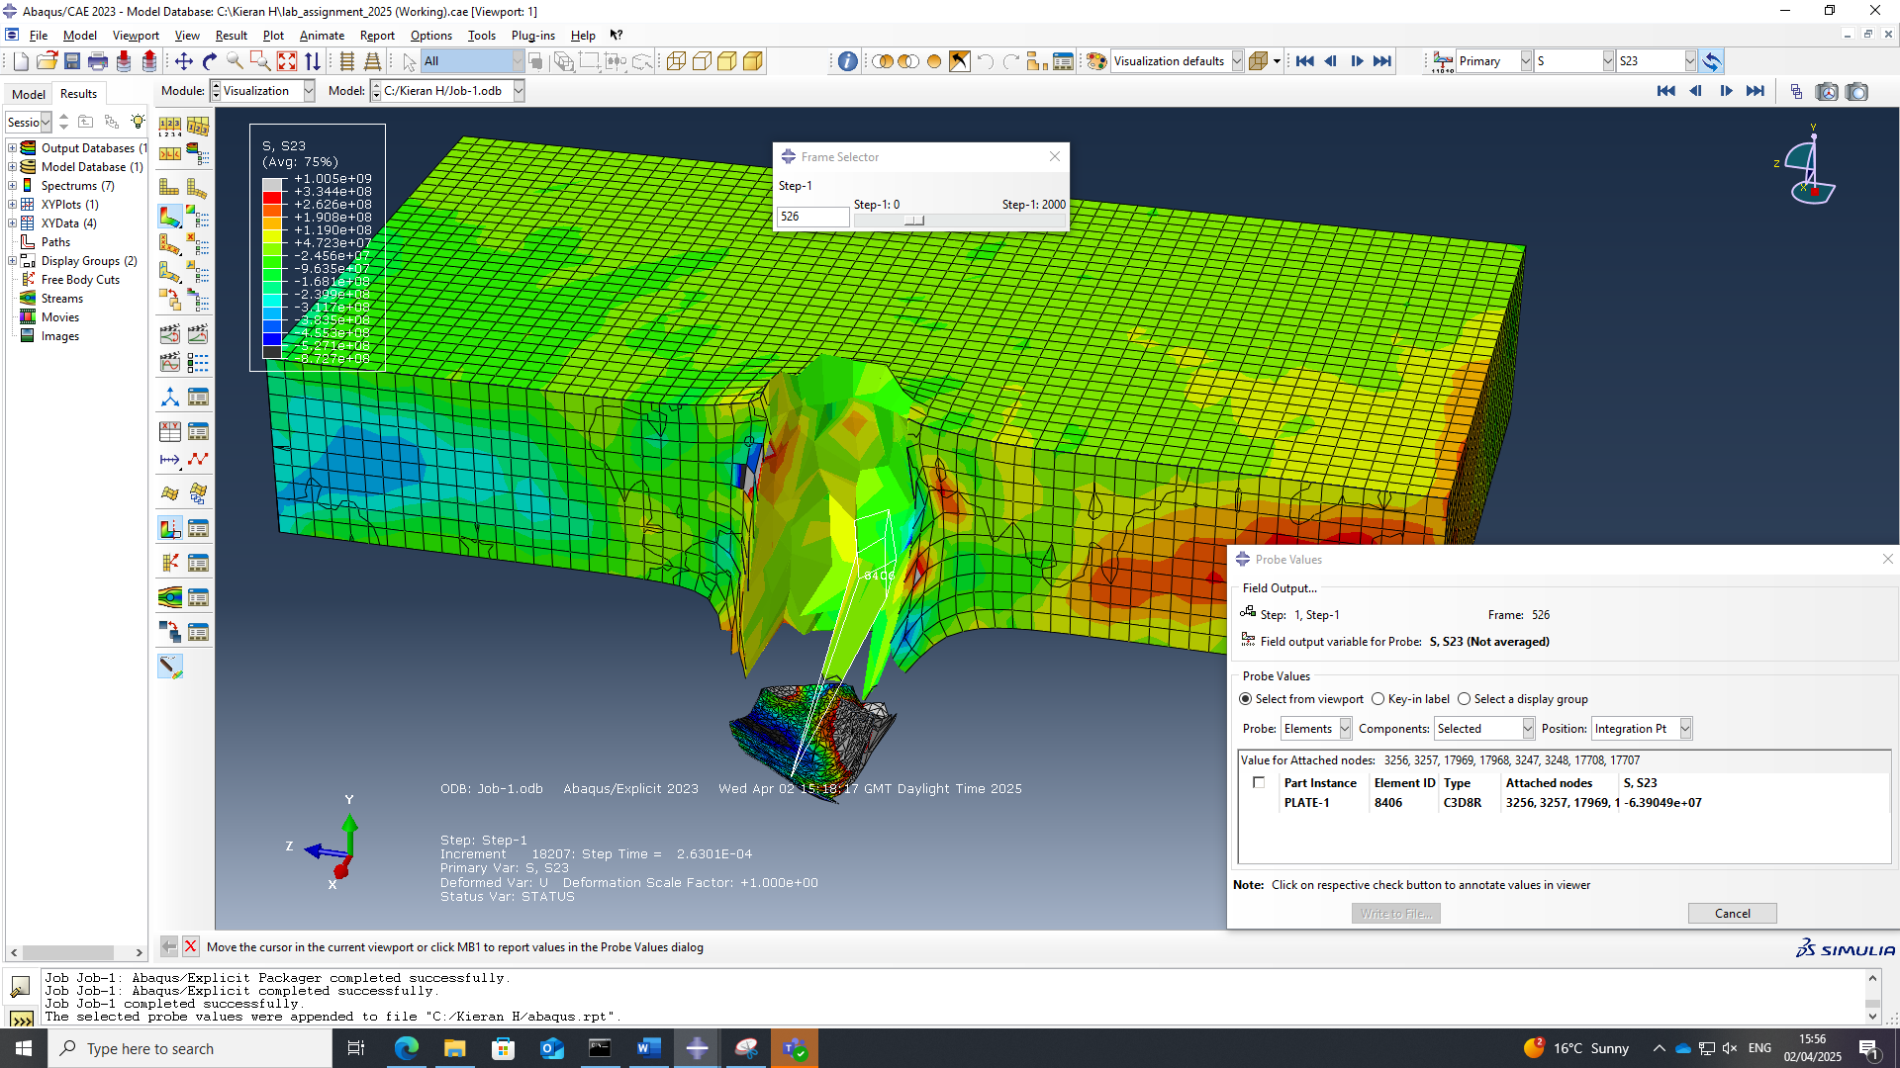Figure 46 Shear stresses at 526th frame

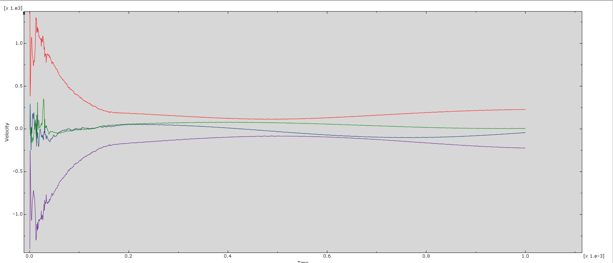
Figure 47 Velocity time graph for 1400m/s projectile

