Component 1 - Individual Report
Module code and name: LCBB4006_BIRM: Academic Skills

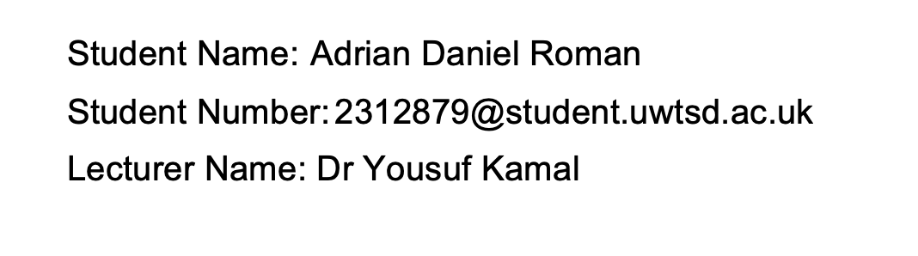

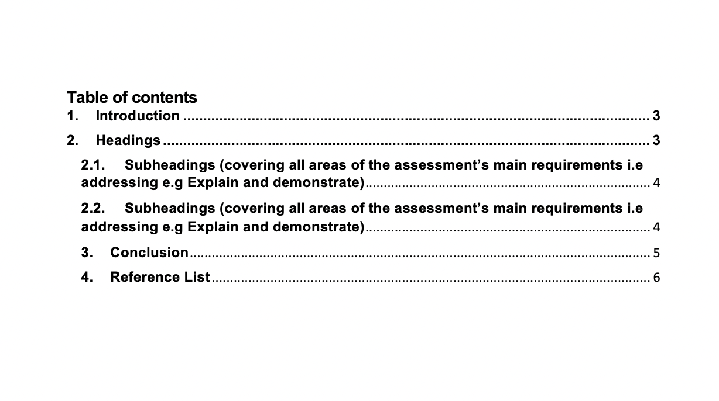

1. Introduction
In the context of a good academic paper, research skills and referencing are like the backbone of what means to have effective writing skills. They help in writing well-researched papers and therefore assuring that the ideas that has been used from others are good proper credit.
In today's digital age, there's a lot of considerable data available online, making it easy for students to find and use various sources and therefore it is important to be mentioned that without giving them credit is something known as plagiarism(Jordan, 2001). Additionally, there’s also the challenge of figuring out which sources are trustworthy, and which aren’t. Therefore, in this context, the academic paper will focus on why academic writing and referencing skills are so important, especially in avoiding issues like plagiarism. The paper therefore has considered to cover topics related to the value of being a good researcher, the right way to reference sources, and some tips on how to make better these skills. We will break down the topic step by step, discussing the need for research, how to reference properly, and give tips based on the UWTSD Referencing Guide. By the end, the final goal of the paper is to deliver a simple guide for students to become better at academic writing and referencing.

2. Headings

2.1. Subheadings

Understanding Academic Writing Skills
Writing well in an academic context requires academic writing skills. Universities and scholarly periodicals use therefore formal academic writing. This is "academic writing." The goal is to deliver brief, evidence-based information about a topic. Karlins, Michaels and Podlogar (198) define academic writing as formal sharing of research, arguments, or ideas. There in this cotext it is important to be mentioned that there are various techniques to improve academic writing. Student should start by understanding sentence structure and word order. Next, arrange your thoughts, state them properly, and support them with proof (Kilen and Dahl, 2021). This process requires practise, feedback, and openness to new knowledge. Academic writing is therefore crucial for many reasons. It makes information very simple to grasp and follow. It simplifies complicated concepts to further allowing those individuals share and grow. Academic writing skills are crucial for pupils. It impacts classroom performance and prepares students for occupations that need structured communication. Imagine a student submitting a research paper with substantial findings but in a disorganised approach (Rettinger and Gallant, 2022). Poor presentation may obscure the information. A well-written work can be praised even if its conclusions are unoriginal. Effective communication is essential. Students entering professional careers is another example. Clear communication in professional situations including reports, emails, and presentations may make or break a career. Knowledge sources are cited. Finding sources that impacted academic writing aids research. Citations show appreciation and honour others' work. Jordan (2001) says citation recognises intellectual legacy. This requires honouring thinkers and authors whose work inspires further investigations. Plagiarism Prevention: Copying and pasting is easy with readily available information. Citing helps students avoid plagiarism. It encourages scholars to create and build on others.
Using references effectively: Knowing APA, MLA, and UWTSD citation styles Harvard shows how much students value precision and detail. Citations and references improve the work like tools do for a craftsman (Jordan, 2001)
2.2. Subheadings
Delving into the World of Referencing
Now considering referecing skill that it is widely known as being termed as citation, being therefore the practice of acknowledging the sources or authors from which ideas or phrases have been taken and therefore placed in the academic ontext and therefore as has been suggested by Lang (2013) "referencing is the cornerstone of ethical academic practice, ensuring every contributor of knowledge receives due credit." Lang(2013) describes it as "a systematic way of providing a nod to the original thinkers and authors whose work has informed yours."As per the above to further consider the essence of this skill it is all about its benefits:
Plagiarism is stealing someone else's ideas, words, or work without credit. Proper referencing prevents academic dishonesty (Rettinger and Gallant, 2022).
A paper's in-text citation includes the source's author's last name and year of publication. Example: "(Taylor, 2020)".
APA, MLA, and UWTSD Harvard employ distinct referencing conventions. A list of sources at the conclusion of the paper is typical for each style. In another context it is important to be stated that students are trying therefore to pursue therefore
higher education, referencing is more than a mere formality. It authenticates one’s work, illustrating therefore it's built upon a foundation of setting up relevant knowledge.Proper referencing therefore also protecting therefore students from accusations of plagiarism, which can have therefore strong academic outcomes and therefore it is demonstrating the research ability to be able to engage with diverse sources, fostering a sense of academic integrity and being able to select from reliable and unreliable one(Rettinger and Gallant, 2022). Imagine two students submitting research papers. Student A wrote a decent paper with incorrect citations. Student B presents her paper similarly to Student A, but with exact text citations and a comprehensive reference list. Student A's work may be reviewed, questioned, or rejected for plagiarism or lack of references. Student B's work demonstrates meticulous investigation and academic responsibility. This boosts acceptance and appreciation. Building on earlier studies is another example (Rettinger and Gallant, 2022). Without correct references, future academics would struggle to trace ideas and discoveries. This would hinder knowledge growth.

3. Conclusion
Therefore, in this context it is important to be mentioned that in the realm of academia, the pillars of effective academic writing and strong referencing cannot be overstated. Academic writing skills, as discussed ae supporting the conduit and therefore by engaging with this students can be able to write content that is full of
complex ideas are communicated in a structured and comprehensive manner. Such skills not only suggests the students ability to engage with academic writing but also reflect their commitment to clarity, coherence, and structured presentation.
Parallelly, referencing here it is all about the hallmark of ethical academic practice being therefore it is all about acknowledging the intellectual contributions of others but also therefore protecting against the considerations of unintentional plagiarism. Therefore this process of in-text citation and considering to specific referencing conventions demonstrates a strong researcher's or student's dedication to keep the authenticity of academic discourse.This is why for those that are learning and are part of the education,the above skills become even more crucial. They not only determine the acceptance and credibility of their scholarly submissions but also set the tone for their future consideration in the context of professional or research landscapes. This is why as per above it is important to be mentioned that academic writing translates therefore thoughts into words, referencing is there to assure that ideas of other are acknowledge. Both of the above are therefore indispensable tools in the academic range of skills being therefore to guide students to be more ethical, honest and keeping integrity within their academic papers.

References:
Jordan, A. E. (2001). ‘College student cheating: The role of motivation, perceived norms, attitudes, and knowledge of institutional policy’, Ethics & Behavior 11(3), pp. 233–247.
Karlins, M., Michaels, C. and Podlogar, S. (1988). ‘An empirical investigation of actual cheating in a large sample of undergraduates’, Research in Higher Education, 29(4), pp. 359–364.
Killen, M. and Dahl, A. (2021). ‘Moral reasoning enables developmental and societal change’, Perspectives on Psychological Science, 16(6), pp. 1209–1225.
Kohlberg, L. (1971). ‘From is to ought: How to commit the naturalistic fallacy and get away with it in the study of moral development’. In T. Mischel (Ed.), Cognitive development and epistemology (pp. 151–235). New York: Academic Press.
Lang, J. M. (2013). Cheating lessons: Learning from academic dishonesty. Cambridge, MA: Harvard University Press.
Rettinger, D. and Gallant, T. B. (2022) Cheating Academic Integrity. 1st edn. Wiley. Available at: https://www.perlego.com/book/3449541/cheating-academic-integrity-lessons-from-30-years-of-research-pdf (Accessed: 15 September 2023).

