Psychiatric Nurses within the NHS
Student name: Sophie Darling
Student number: 1701106
Lecturer Name: Benjamin Duxbury

Abstract
Within this assignment will be on the research of the NHS but mainly in the Psychiatric Nurses department of the NHS. In this assignment, the background of the NHS and Psychiatric Nurses will be explained. NHS (2016) states that the NHS stands for National Health Service, which was put into place to be able to be available to everyone in the UK regardless of what their wealth is like. Best Master of Science in Nursing Degrees (2019) explains that a Psychiatric Nurse is an individual who helps to treat and medicate their patients who have been diagnosed with having a mental illness.
After talking about the background of the NHS, it will then go on to talk about the funding of the NHS and explain in more detail how, as Harker (2018) states, the money that is funded for the NHS comes from the charges that individuals have to pay to receive their prescriptions, dental and optical service charges and mainly from the people’s tax charges.
Then after the explanation of the NHS Funding, it will then go onto talking about the 7 principles of care, in detail, that the NHS must follow by.
The seven principles of the NHS, stated by NHS Constitution (2009) are;
- The NHS provides a comprehensive service, available to all.
- Access to NHS services is based on clinical need, not an individual’s ability to pay.
- The NHS aspires to the highest standards of excellence and professionalism.
- NHS services must reflect the needs and preferences of patients, their families, and their carers.
- The NHS works across organisational boundaries and in partnership with other organisations in the interest of patients, local communities and the wider population.
- The NHS is committed to providing the best value for taxpayers’ money and the most effective fair and sustainable use of finite resources.
- The NHS is accountable to the public, communities, and patients that it serves.
Then explains how my recommendation for the NHS is to give the mental health services more money for their funding as they are in desperate need for more as they are not getting enough, and many mental health services are closing to the lack of funding.

Contents

Section Page

Title 1
Abstract 2
Contents 3
Introduction 4
Background of the NHS and Psychiatric Nurses 5
Funding for the NHS and Psychiatric Nurses 6
Principles of the NHS 7
Recommendations 9
Conclusion 10
References 11

List of figures
Figure 1: The sources of funding for the NHS 6

Introduction
Within this assignment, it will explain in great detail about the background on how the NHS was put into place in 1948 by the Minister of Health, Aneurin Bevan, with the aim as the NHS being a service for individuals who lived in the United Kingdom who did not have to pay for their health care and that it was funded by the taxpayers, national insurance, and then optical and dental services and prescriptions, whereas people who live in Wales do not have to pay for their prescription. It then goes on to explains that when the NHS was put into place that it was made for the individuals who needed physical medical health rather than mental medical health, then was found that in 1959, there was an increase within the individuals who were having mental health issues when the government started to acknowledge the fact it was mental health within the community was rising but it was in 1997 when they actually started to improve the mental health care services. It explains that mental health services get less funding than they need. The assignment then goes on to explain the seven different principles of the NHS all in detail to understanding. Which then it will end on the recommendation that I believe has great importance that should be put into place by the NHS can do to help in funding more towards the Mental Health Services.

Background on the NHS and Psychiatric Nurses
NHS (2016) explains that the NHS was founded in 1948 and that the purpose of the NHS being put into place was so that everyone who lives in the United Kingdom was able to access the healthcare no matter what their wealth was like. However, with some exceptions that they have with charges such as dental and optical services and for individuals’ prescriptions that they require. NHS (2016) gives figures of at the time when their article was written the NHS was helping over 64.3 million people within the United Kingdom and that within this big amount of people 54.3 million of these people are within England on their own. It is also known that the NHS is in the top five of the world’s biggest workforces by having it employing more than 1.5 million people altogether.
Welch (2018) explains the history of the NHS, it is stated that before the NHS was put into place that most individuals who were ill had to pay for their treatment that they required, if the individual was seriously ill then they were put into their Voluntary and Local Hospitals to be treated and that if the individual had a mental health illness then they were put into the Victorian asylums and stigmatised. And then it is known that from the year 1911 every male who was working through the introduction of National Insurance all received medical care, although the males had this it still did not include anyone in their families, only on themselves. Welch (2018) goes on to explain that in 1939 at the start of the Second World War it was political agreed that there should be a National Health Service that needed to put into place, so it could help for all the expected civilian casualties that were to be injured during the war. In 1945 there was a General Election put into place and the Labour Party won and the former Welsh miner, Aneurin Bevan was given the title of Minister of Health and that his plans for the NHS system was that it was funded by the taxes made by the individuals of the United Kingdom and that the NHS was controlled by the Government. However, Welch (2018) than states that some doctors and hospital consultants did not like the fact that HealthCare was being given away for free so Aneurin Bevan mad a proposal to them to allow General Practitioner services, Dentist and Optical services to keep their independence and for that consultants were still able to see private patients when they paid for the private care. Then in 1948 Welch (2018) states that this is when the NHS was put into place and a new National Health Service act was created and that Bevan then opened the NHS at the Park Hospital, Davyhulme on the 5th July 1948, which is when for the first time individuals who required hospitals, general practitioners, pharmacists, dental and optical services, community nurse and the health visitors were all provided to the individual for free.
Individuals who have mental health issues, is seen to be dated back to during the period of the war years, however People’s History of the NHS (2016) states that when the NHS was put into place in 1948 it was more put into place for more the physical illness and not to provide the opportunity for mental health. Turner et al (2015) agrees with this but also adds that in 1959 the Mental Health Act and in 1962 the Hospital Plan presaged the closures of asylums and to put the psychiatric care within the hospital system although during the 1970’s Conservative and Labour both acknowledged the fact that mental health was starting to increase but did not address the needs of providing the mental health services any more resources within the community. It was not until 1997 where the care for individuals who have mental health illness was improved and was the principal focus of the policy. It is known that through this period, the spending that was to go towards the mental health care services were very low compared to the physical health care services.

Funding for the NHS and Psychiatric Nurses
Figure 1: the sources of funding for the NHS (as set out in How the NHS is funded. [The King’s Fund, 2017])
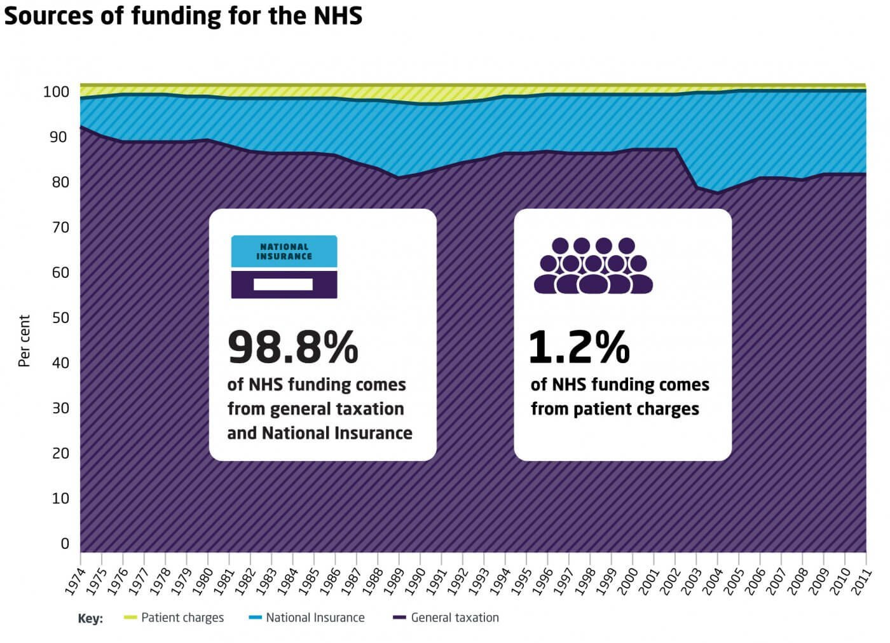
This graph that The King’s Fund (2017) has produced shows that with 98.8% is added up of the funds coming from mainly general taxation paid by all individuals in the United Kingdom and their National Insurance and then the other 1.2% of the funding for the NHS comes from the patient charges, such as the charges they face against such as prescriptions, dental and optical services, although individuals have to pay for these things, it still is a small proportion of the funding towards the NHS. However, NHS Wales (2019) agrees that these are how the NHS is funded, however it also states that from April 1st 2007, the charge for NHS prescriptions was scrapped for the people who are in Wales, so now for the people who are registered to a Welsh General Practitioner and go to a Welsh pharmacist to receive their prescriptions get it free of charge, this means that people who live in England still have to pay for their prescriptions.
Gilburt (2018) states that within the Health and Social Care Act of 2012, the government committed to achieving the funding between mental and physical health services to be shared out equally between the two, so that individuals with mental health problems are able to same effective and safe care as individuals with physical health problems, however this has not fully happened as the progress has been going slow. Gilburt (2018) states that during the summer of 2018, Theresa May had made an announcement to say that the funding that goes towards the NHS a year will increase up to £20.5 billion and that with this more money coming in to fund the NHS, it is seen to be at least £2 billion of the increasing amount of money will go towards new and vital improvements within the mental health services.

Principles of the NHS
When Aneurin Bevan was launched to become the then minister of health, NHS (2018) explains that the NHS was based on three essential principles such as the NHS will help and meet all of the individual’s needs, it is free for individuals to the point of delivery and that it will be based on the individuals clinical need and not their ability to pay. NHS (2019) states that within the NHS there are seven principles that must be followed, these are providing a comprehensive service to all, the service is based on the clinical need and not how the individual could pay, giving the highest standards of excellence and professionalism, patient being at the heart of everything being done, working organisational boundaries with other organisations in the interest of the individual, local communities and the wider population, being committed to provide the best value of the taxpayers money and using it the most effectively, lastly being accountable to the public, communities and the individual it serves.
The NHS provides a comprehensive service available to all
NHS (2019) explains that with this principle the NHS provides a complete service to everyone no matter what their gender, religion, ethnic, disability, age, sexual orientation, pregnant or even what their relationship status. This certain principle shows that the NHS will cover all the medical and allied activity and that they will always address the mental and physical health of the individual. Department of Health & Social Care (2015) agrees with this, but also adds that the NHS has the duty to make sure that all individuals who are requiring the car that their human rights remain respected.
Access to NHS services is based on clinical need, not an individual’s ability to pay
NHS (2019) states that this means that is very clear that the services given to individuals from the NHS are free, however in some cases they will have to pay for certain things, such as prescriptions, dental and optical services, and that if there was any need to have something else to be needed a new charge then it has to go through and agreed during parliament.
The NHS aspires to the highest standards of excellence and professionalism
NHS (2019) states that this principle is put into place so that individuals who are using the service are getting the best quality of care that they can receive. It is also that this principle can see that the NHS is dependents on the staff that are employed and that individuals who are receiving the treat get the best quality of care when staff are being supported and valued. Department of Health & Social Care (2015) also adds to this that with the employees getting the correct training, education, developing and the support also helps for them to give the individuals the best amount of care.
The Patient will be at the heart of everything the NHS does
NHS (2019) states that this principle means that all individuals are receiving the care should get all the support to be able to have their own health promoted and managed. For the individuals who are receiving the care and their family’s needs and preferences should be met by the NHS reflecting and working with them so that it can be achieved. Department of Health & Social Care (2015) adds on whenever it is allowed the individual and their families can be involved and be consulted too, about all the decisions that are been going on about their treatment and care that they will receive. Also, the NHS asks for patients, staff and the public to give feedback about the NHS so that if there are any complaints then they will identify it and try to resolve it.

The NHS works across organisational boundaries and in partnership with other organisation in the interest of the patients, local communities and the wider population
NHS (2019) states that the NHS will have the interests of the individual who is receiving care will come first before the interest of the institutional and that the organisations that are involved with the NHS must all work together to be able to achieve the improvements in the wellbeing and health of the population. Department of Health & Social Care (2015) adds on that the organisations that work together with the NHS are the local authority services, the voluntary and private services, and the public services.
The NHS is committed to providing best value of taxpayers’ money and the most effective, fair and sustainable use of finite resources
NHS (2019) explains that the NHS is being funded by the money from the public, this principle is to make sure that the funding that is towards the NHS is being used in a fair way that will help the individuals to benefit from using the NHS services.
The NHS is accountable to the public, communities and patients that it serves
NHS (2019) says that this principle is put into places that as the NHS is being funded by the public, but it is the Government within the Parliament that works out the spending on the NHS. It is very important that the patients, staff, and the public are all aware that there are many levels of responsibility and accountability the NHS has. Department of Health & Social Care (2015) adds onto this that the treatment for the individual and the organisation the individual can be linked that all these decisions are normally made by the individual themselves and the NHS.

Recommendation
Within my findings, I have found one main recommendation that could be put into place to help with the NHS. I believe that the funding from NHS for the mental health unit should be higher than what it is, as I believe that the mental health of an in is just as important as physical health, the reason why I say that the Mental Health side of the NHS should be funded the same amount as its currently not being funded the same amount as the physical side, and that the mental health services actually get the minimum amount compared to the other departments, due to within my research I found that many mental health hospitals are being shut down due to not having enough funding. As the Psychiatric hospital that is based in Swansea, known a Cefn Coed has been closing down due to the lack of funding, so now after this has been mostly closed down, all that is left within the Cefn Coed Psychiatric Hospital is just two small wards, male and female, two elderly care wards, one is for the psychiatric elderly and the other is for the psychiatric elderly with late-onset dementia and Alzheimer’s, assessment suite, where all the assessments are taken place to whether the individual with mental health should be put into hospital or allowed to be in the community if it is safe to do so, with care of the psychiatric community nurse and a rehab ward, which all sounds a lot, however this is just a small section of the hospital as the mass majority has been closed down.

Conclusion
Within this assignment, it has explained the background of how the NHS was put into place in 1948 by Aneurin Bevan, who was the titled as the Minister of Health, with the purpose of the NHS being funded for individuals in need from the taxes paid by the people who live within the United Kingdom. It then goes on to explain that when the NHS was put into place that it was made for the individuals who needed physical medical health rather than mental medical health, then was found that in 1959, there was an increase within the individuals who were having mental health issues when the government started to acknowledge the fact it was increasing, however it was not unit 1997 where the care for mental health patients was improved. The funding of the NHS is mainly from the taxes that are paid by the people who live within the United Kingdom and their national insurances, and then a small amount of the funding is from the patient charges, such as the pay for their optical and dental services and their prescription charges, however, Wales do not pay their prescriptions. It explains that the mental health services get less funding than they need. The assignment then goes on to explain the seven principles of the NHS. Which then leads on to my recommendation on what the main importance that the NHS can do to help in funding more towards the Mental Health Services.

References
Best Master of Science in Nursing. (2019). What is a Psychiatric Nurse? https://www.bestmasterofscienceinnursing.com/faq/what-is-a-psychiatric-nurse/ Accessed March 2019.
Department of Health & Social Care. (2015). Guidance. The NHS Constitution for England. https://www.gov.uk/government/publications/the-nhs-constitution-for-england/the-nhs-constitution-for-england Accessed March 2019
Gilburt, H. (2018). Mental Health funding in the 2018 Autumn Budget: the devil will be in the detail. The King's Fund. https://www.kingsfund.org.uk/blog/2018/10/mental-health-funding-2018-autumn-budget Accessed March 2019.
Harker, R. (2018). NHS Funding and Expenditure. file:///C:/Users/Owner/Downloads/SN00724.pdf Accessed March 2019.
NHS. (2016). About the NHS. https://www.nhs.uk/using-the-nhs/about-the-nhs/the-nhs/ Accessed March 2019.
NHS. (2018). Principles and values that guide the NHS. https://www.nhs.uk/using-the-nhs/about-the-nhs/principles-and-values/ Accessed March 2019
NHS. (2019). The Handbook to The NHS Constitution. https://assets.publishing.service.gov.uk/government/uploads/system/uploads/attachment_data/file/770675/The_Handbook_to_the_NHS_Constitution_-_2019.pdf Accessed March 2019
NHS Constitution. (2009). NHS Constitution – Interactive version. http://www.ncuh.nhs.uk/patients-and-visitors/nhs-constitution/nhs-constitution.pdf Accessed March 2019.
NHS Wales. (2019). Budget & Charges. http://www.wales.nhs.uk/nhswalesaboutus/budgetcharges Accessed March 2019.
People’s History of the NHS. (2016). Mental Health. https://peopleshistorynhs.org/encyclopaedia/mental-health/ Accessed March 2019
The King’s Fund. (2017). How the NHS is funded. https://www.kingsfund.org.uk/projects/nhs-in-a-nutshell/how-nhs-funded Accessed March 2019.
Turner, J., Hayward, R., Angel, K., Fulford, B., Hall, J., Milard, C., and Thomson, M. (2015). The History of Mental Health Services in Modern England: Practitioner Memories and the Direction of Future Research. Medical History. An International Journal for the History of Medicines and Related Sciences. 59(4): 599-634.
Welch, E. (2018). The NHS at 70. A Living History. Yorkshire – Philadelphia: Pen & Sword Books Ltd.

