

Research Proposal

An investigation into the potential of attracting Chinese tourism to Wales

Lucie Johnson
P147172

Contents
1.Introduction 2
2. Aims and Objectives 2
2.1 Aim 2
2.2 Objectives 2
3. Rationale 3
4. Literature Review 3
5. Research Design and Methodology 4
5.1 Data Collection 4
5.2 Proposed Research Methodology 5
5.3 Sampling 6
5.4 Qualitative and Quantitative 6
5.5 Strategies 7
5.5.1 Interviews 7
5.5.2 Questionnaires 7
6. Data Analysis 8
7. Research Ethics and Risks 9
7.1 Ethics 9
7.2 Risks 9
8. Conclusion 10
Appendices 11
Appendix 1 – Market and Trade Profile China 11
Appendix 2 - SMART objectives 11
Appendix 3 - Inductive and Deductive research 12
Appendix 4 – Sampling 13
Appendix 5 – Charts 13
6.Appendix – Gantt Chart 14
7. Matrix Table example 15
8. Question Examples 15
Reference & Bibliography 16

1.Introduction

The purpose of this research proposal is to introduce the proposed dissertation and to demonstrate the various techniques used in data collection. This aims to provide the reader with a step by step guide, whilst also highlighting any strengths, weaknesses, potential risks and limitations, potentially threatening the research success.

2. Aims and Objectives

2.1 Aim

The aim is to gauge Wales’ interest in the Chinese tourism market and examine any current strategies used and their effectiveness in attracting this tourism segment.

2.2 Objectives

- Research and critically analyse academic literature, to gain a deeper understanding of the subject.
- Conduct primary research, gauging Wales’ interest in the Chinese tourism market, and investigate strategies used by Welsh tourism and other stakeholders.
- Analyse and evaluate findings, highlighting potential benefits and challenges of Chinese tourism in Wales and offer recommendations for possible improvements.

These targets have been designed with the SMART objectives in mind, ensuring they are Specific, Measurable, Attainable, Realistic, and Time bound. According to the University of Glasgow (2018), “SMART Objectives are structured in a clear, concise and succinct way’… And …’are useful in…setting expectations for what can be achieved’. Meeting these criteria therefore aims to provide a sound base for a successful research.

3. Rationale

A sharp rise in Chinese tourism in recent years has seen countries globally competing for this tourism segment, with the United Kingdom being one of them. Whilst London may be the biggest draw for this tourism segment, Scotland is also proving to be very popular. This therefore raises questions, whether Wales could also benefit from attracting this target market and crucially, how effective are any current products and strategies used.

4. Literature Review

With the recent rise of the Chinese middle class, has come not only a higher disposable income, but also, as Peterson and McCaffrey (2018) point out, a different mind-set. Whilst the new middle-class consumers pay a lot of attention to their status and purchasing high end products, Peck (2017) explains, that Chinese consumers also increasingly seek travel and new experiences. In 2016, more than 70 million worldwide trips were taken, resulting in an increase of 11.7% since 2015. The Chinese were also amongst the world’s highest contributors, spending 24 billion Dollars in 2006, rising to 261 billion Dollars in 2016 (UNWTO, 2018). Furthermore, according to the World Tourism Organisation (UNWTO) 2018, this trend has remained, creating competitiveness for this tourist market globally.
According to the BBC (2016), the UK has also seen a rise and has benefited from Chinese tourism, especially in London and closely followed by Scotland. Visit Scotland (2018) has reported that in 2010, Chinese tourism spend alone has amounted to £7 million, which by 2017 has further risen to £44 million, with an increase of £37 million in 7 years (Scottish Government, 2018). The first minister Nicola Sturgeon stated that “Tourism is a vital part of Scotland’s economy, and these figures demonstrate the growing significance of Chinese visitors to our country” (Scottish Government, 2018). She went on to say, that with so much potential, it is vital to continue to build strong links with China, especially since the confirmation of the new direct air route between the two countries (Scottish Government, 2018).
This therefore raises questions whether Wales could also benefit from this tourist market. According to the Statistics for Wales (2018), in 2008, Wales has received 987, 000 visitors, contributing £339 million to the economy, marginally rising to 1,079 000 in 2017, with visitor spend of £369 million. The Welsh Government figures for 2016 show that, Wales biggest inbound tourist contributors were from the Republic of Ireland (129,000), France (105,000), Germany (97,000) and the United States (91,000). The Welsh Government survey in 2016 also suggests, that almost half of visitors to Wales are European, therefore, with the looming uncertainty of Brexit, Wales may need to review their strategies in attracting international tourism, particularly from further afield. There are signs however, that this could be happening already, with the new Qatar air route connecting Cardiff with other 150 global destinations, including China (Cardiff Airport, 2017, Qatar Airways, 2018). Being one of the highest financial contributors globally, could therefore qualify China to be a strong contender for Welsh tourism (Chen, 2018).

5. Research Design and Methodology

5.1 Data Collection

Sutton and Austin (2015) identify research as a data collection process, involving the accumulation of large volumes of information, by means of various methods and strategies (Bryman and Cramer, 2001; Veal, 2011). Data collection is the key in primary research, as demonstrated in the Research onion below (see in figure 1). The research Onion concept offers a clear guidance, whilst demonstrating the role and importance of each layer, to successfully conduct the proposed research (Saunders et al, 2009). Library, books, e-books, academic journals and articles will be used to enhance the research quality and computer will be used for data collection and analysis.

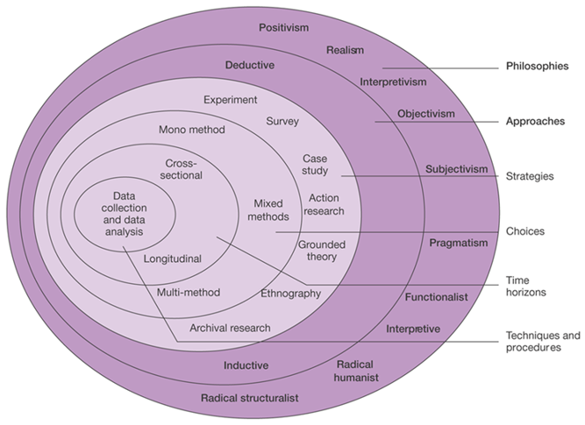
Figure 1- Research Onion (Saunders et al, 2009)

5.2 Proposed Research Methodology

According to Veal (2011), research methodology refers to the study of data collection processes and the various methods used, as seen in figure 1. Whilst collecting data, it is vital for the researcher to understand that the information provided represents the participant’s views and feelings at that given time.
Time, in terms of research, is represented by the cross sectional and longitudinal time horizons, differing in the way they are studied. According to the Learning Hub (2018), ‘The main difference is that cross-sectional studies interview a fresh sample of people each time they are carried out, whereas longitudinal studies follow the same sample of people over time’ (Saunders et al, 2007). This study therefore aims to use the Cross-sectional time horizon approach, allowing data collection from various sources in a relatively short time. This approach, however, could be considered superficial in comparison with longitudinal approach, only offering a snapshot of that given time and not giving a sufficient long-term overview (Saunders et al, 2012).

This proposal aims to use the ‘Mixed Method’, meaning data will be collected via surveys, in the form of online questionnaires (Survey Monkey) interviews and a case study (Collis and Hussey, 2014). Using these methods aims to gain unbiased information from several stakeholders, thus increasing the survey credibility (Saunders et al, 2012).
Due to the nature of this study, an inductive approach will be used (linked with realism), aiming to build a theory through the research process, thus gaining deeper understanding of the subject matter (Gabriel, 2013). Additionally, a combination of both primary and secondary research will be used, with the former concentrating on data collection first hand through interviews and questionnaires, and the latter examining and selecting data collected from previous research (Brown, 2018). Both methods will then compare past and present data results to gauge an overall project outcome.

5.3 Sampling

Sampling refers to a specific method which, as Bryman and Cramer (2001) state, aims to examine and analyse a small sample of a target group, representing that particular demographic (Collins et al, 2007). In this instance, it will not be practical or possible to survey all stakeholders, therefore three sample groups from the public and private sectors will be selected. This includes (group 1) tourist bodies (Visit Wales/Visit Pembrokeshire) and Cardiff Airport, (group 2) tourist attractions (St Fagans/Cardiff Castle) and (group 3) accommodation providers (hotels and B&Bs). The researcher aims to carry out a random sampling (probability), as it is not clear at this stage, which stakeholders cater for the Chinese tourist market and how. The collected data will aim to offer a true representation of the stakeholder’s performance, gauging whether their aims and objectives in achieving the end goal are shared across the board, whilst also bringing attention to any discrepancies (Saunders et al, 2012; Veal, 2011).

5.4 Qualitative and Quantitative

A mixture of Qualitative (Phenomenological) and Quantitative (Positivistic) methods, also referred to as the Mixed Method, will be used to gain required information (Veal, 2011). Punch (1998: 4, cited in Finn et al, 2000) states that quantitative research is …’where data are in the form of numbers, and qualitative research where the data is not in the form of numbers ‘. There is therefore a distinct variation between the two methods in the way they are presented, as well as analysed. Whilst it is relatively easy to analyse quantitative data (numbers), also being more precise, qualitative data (interviews/questionnaires) can be more complex. However, techniques such as searching for repeat and key words, can simplify the analysis process (Finn et al, 2000). Both, the qualitative and the quantitative methods will be utilised in this research.

5.5 Strategies

5.5.1 Interviews

Data, for instance, from tourism bodies representatives such as Visit Wales, will be gathered via interviews (either in person, or in the event of time restrictions, online), allowing approximately 15 minutes per person for around six to eight individuals. The questions will be carefully designed to gain more in-depth information in comparison with usual questionnaires. Using open questions will allow the participants to elaborate further, thus adding to the reliability factor (Collis and Hussey, 2014). As Collis and Hussey (2014) explain, both, reliability and validity will be of a great significance, as this will decide the overall credibility of the research.
This method however can also be associated with greater difficulties in processing data, due its qualitative properties and the significant time this may take (Collis and Hussey, 2014). Other limitations include time restrictions for both, the researcher and the participant, as using this technique requires a significant time, possibly resulting in participant unwillingness to take part (see section 7.2) (Saunders et al, 2012; Veal, 2011). Nevertheless, a viable option can be for the participant to respond via online interview and in their own time, within reason.

5.5.2 Questionnaires

Due to the suitability, data collection ease and analysis (see sections 5.1 and 6), a combination of paper and online questionnaires will aim to gain qualitative and quantitative data (see section 5.4). The researcher will need to ensure that significant time is allowed for the planning and preparation of questionnaires, using either paper or online versions (Saunders et al, 2012). In this instance, paper questionnaires will be used for interview purposes (group 1), although an online version will also be available in case of participant time constraints. An online version will be distributed either via Facebook or Survey Monkey to the remaining groups, aiming to reach a minimum of 120 participants. As Veal (2011) points out that, the greater the number of participants, the more accurate representation of the segment will be (Collis and Hussey, 2014). This from of data collection is also more cost effective than paper questionnaires, which are associated with higher costs such as printing and materials. Furthermore, online questionnaires can reach wider audiences, although this by no means guarantees higher participant response rate.
A mix of open and closed questions, as well as Likert style questions (see appendix 8), will be designed to gain quantitative and qualitative data. Nevertheless, as closed questions can be prescriptive and not always offering the most relevant choices to participants, open questions aim to allow for further elaboration. Moreover, by ensuring that questions are not leading or suggestive in any way, should provide the researcher with unbiased data.

6. Data Analysis

“Data Analysis is the process of systematically applying statistical and/or logical techniques to describe and illustrate, condense and recap, and evaluate data” (Northern Illinois University, 2018). Sutton and Austin (2015) state that, the most vital part of research analysis is for the researcher to fully gain the participant’s perspective.
In this instance, all data collected will be analysed using software such as the Survey Monkey for online questionnaires, Microsoft Excel, or SPSS (Statistical Package for the Social Sciences) programs for entering data manually, as in the case of interviews. Graphs and charts such as the Fast Line chart and Matrix table (see appendix 4, 5 and 6), will be used to present collected data, clearly demonstrating research findings. A Gantt chart will also be used to give a quick overview of the proposed research time scale, offering a quick visual reference of the anticipated time it may take for each task to be carried out and completed.

7. Research Ethics and Risks

7.1 Ethics

Ethics, according to Blumberg et al. (2005:92 cited in Saunders et al, 2007:178), ‘refers to the appropriateness of your behaviour in relation to the rights of those who become a subject of your work or are affected by it’. This therefore highlights the importance of the correct ethical code of conduct whilst carrying out research (Collis & Hussey, 2014; David and Resnik, 2015). Nevertheless, the nature of this research poses minimal ethical risks to its participants.

Ethical consideration for carrying out research;
- Ensuring anonymity and confidentiality of all participants and protecting data collected
- Not gaining or using personal data
- Storing all data securely, in locked room or files
- Minors and/or vulnerable adults must not be interviewed
- All differences must be respected
- UWTSD Ethic approval form must be completed prior to research
(Collis & Hussey, 2014; Saunders et al, 2012; Veal, 2011)

7.2 Risks

The following risks have been identified:
- Timing of preparation constraints
- Ensuring participants understand questions (piloting to test the questionnaire effectiveness)
- Limiting the amount closed questions, as this could limit the depth and quality of information provided.
- Participants completing questionnaires partially or not at all (This would void the questionnaires)
- Questionnaire being too long – participants may be reluctant to take part
- Not enough response from participants
- Human error – Whilst every precaution will be taken to deliver reliable results, human error cannot be ruled out.
(Saunders et al, 2012; Veal, 2011)

8. Conclusion

This research proposal has introduced the proposed dissertation and its aims and objectives. It has demonstrated the various research techniques used in data collection and provided a step by step guide for the reader, aiming to offer better understanding of the proposed study. This proposal has also highlighted strengths and weaknesses, as well as possible risks and ethical limitations, potentially threatening the success of this research.

Appendices

Appendix 1 – Market and Trade Profile China
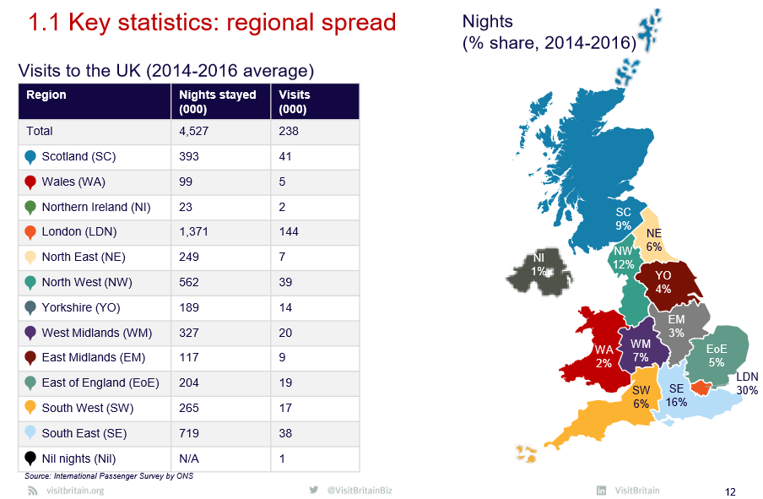

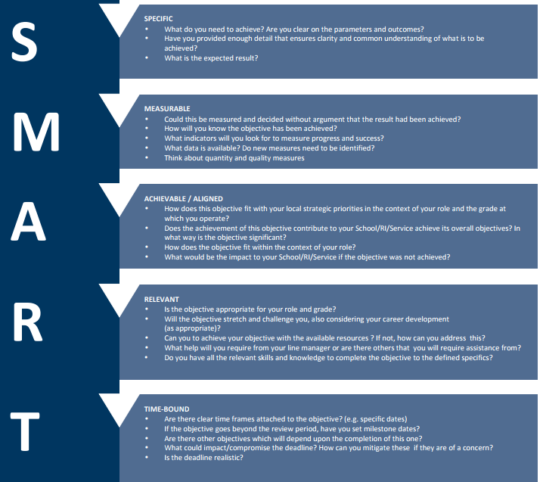
Appendix 2 - SMART objectives

Appendix 3 - Inductive and Deductive research

Inductive

Deductive
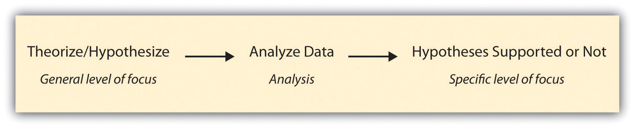

Appendix 4 – Sampling

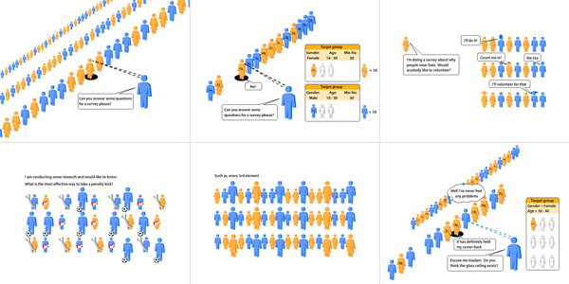

Appendix 5 – Line Graph example
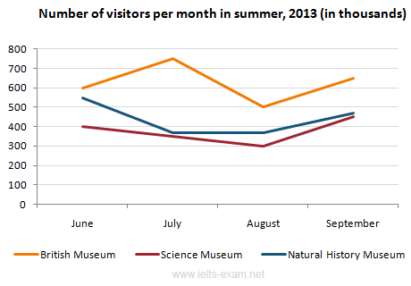

6.Appendix – Gantt Chart
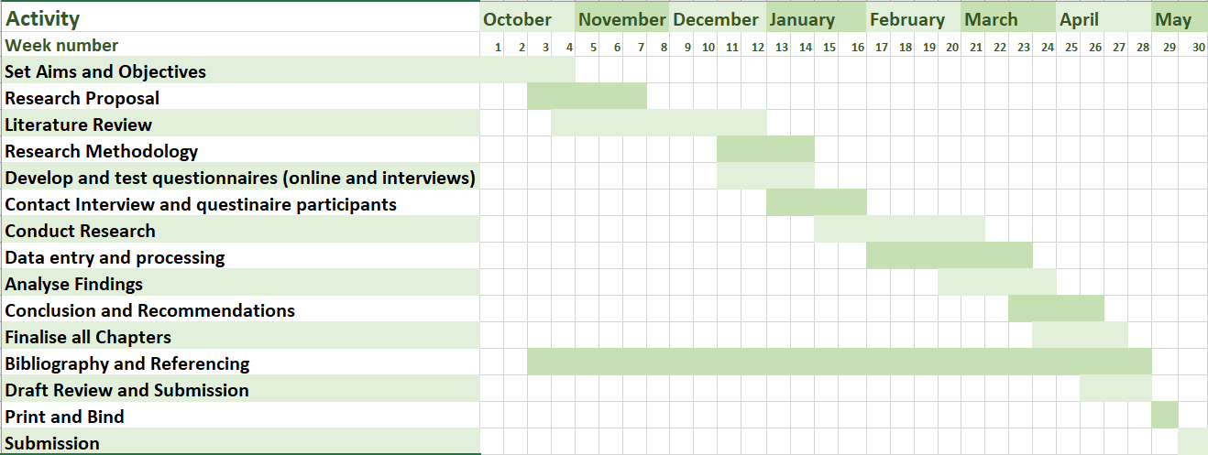

7. Matrix Table example
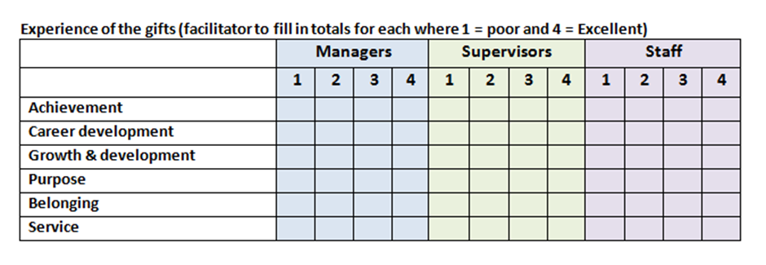

8. Question Examples

Qualitative question example
What are you current marketing strategies in attracting Chinese tourists?

Quantitative question example

Do you currently receive Chinese visitors?
Yes No

Likert scale example

How many Chinese visitors do you receive annually?

0 0-50 50-100 100-150

150-200 200-300 300-500 500-1000

1000+ Don’t know Prefer not to say

Reference & Bibliography

Brown, D. (2018) ‘Committing to Research: Primary vs. Secondary Research’. [Online] Available at: http://www.successfulacquisitions.net/committing-to-research/. (Accessed 25th October 2018).

Bryman, A. Cramer, D. (2001) Quantitative Data Analysis with SPPS Release 10 for Windows. Hove: Routledge.

Cardiff Airport. (2017) ‘Qatar Airways launches daily flights from Cardiff to the World’. [Online] Available at: https://www.cardiff-airport.com/news/2017/09/13/qatar-airways-launches-daily-flights-from-cardiff-to-the-world/. (Accessed 12th November 2018).

Chen, T. (2018) ‘To Understand China's Growth, Look at Its Tourists’. [Online] Available at: https://www.bloomberg.com/opinion/articles/2018-01-29/chinese-tourists-are-reshaping-world-economy. (Accessed 10th November 2018).

Collins, K. M. T., Onwuegbuzie, A. J., Jiao, G. Q. (2007) ‘A Mixed Methods Investigation of Mixed Methods Sampling Designs in Social and Health Science Research’. Journal of Mixed Methods Research. Vol 1, Issue 3, pp. 267 - 294
First Published July 1, 2007.

Collis, J. Hussey, R. (2009) Business Research. 3rd Ed. Basingstoke: Palgrave MacMillan.

Collis, J. Hussey, R. (2014) Business Research. 4th Ed. Basingstoke: Palgrave MacMillan.

Cottrell. S. (2014) Dissertation and Project Reports – A step by Step Guide. Basingstoke: Palgrave Macmillan.

David B. Resnik, J.D., Ph.D. (2015) ‘What is Ethics in Research & Why is it Important?’. [Online] National Institute of Environmental Health Sciences. Available at: https://www.niehs.nih.gov/research/resources/bioethics/whatis/index.cfm. (Accessed 26th October 2018).

Finn, M. Elliott-White, M. Walton, M. (2000) Tourism and Leisure Research Methods. Harlow: Pearson Education.

Gabriel, D. (2013) ‘Inductive and Deductive approaches to research’. [Online] Available at: http://deborahgabriel.com/2013/03/17/inductive-and-deductive-approaches-to-research/. (Accessed 5th November 2018).

Scottish Government. (2018) ‘Chinese tourism spend increases’. [Online] Available at: https://news.gov.scot/news/chinese-tourism-spend-increases. (Accessed 7th November 2018).

Welsh Government. (2016) ‘Latest Statistics’. [Online] Available at: https://gov.wales/topics/culture-tourism-sport/tourism/researchmain/latest-stats/?lang=en. (Accessed 12th November 2018).

Knight, D. (2018) ‘Calls to lure more Chinese tourists Down Under’. [Online] Available at: https://www.2gb.com/calls-to-lure-more-chinese-tourists-down-under/. (Accessed 18th October 2018).

Learning Hub. (2018) ‘Longitudinal vs cross-sectional studies’. [Online] Available at: https://learning.closer.ac.uk/introduction/types-of-longitudinal-research/longitudinal-versus-cross-sectional-studies/. (Accessed 2nd November 2018).

McAllister, F. McDonough, F. (2017) ‘Wales Visitor Survey 2016: Overseas Visitors’. [Online] Available at: https://gov.wales/docs/caecd/research/2017/170308-wales-visitor-survey-2016-overseas-en.pdf. (Accessed 15th November 2018).

Northern Illinois University. (2018) ‘Data Analysis’. [Online] Available at: https://ori.hhs.gov/education/products/n_illinois_u/datamanagement/datopic.html. (Accessed 16th October 2018).

Office for National Statistics. (2018) ‘International Passenger Survey: quality information in relation to migration flows’. [Online] Available at: https://www.ons.gov.uk/peoplepopulationandcommunity/populationandmigration/internationalmigration/methodologies/internationalpassengersurveyqualityinformationinrelationtomigrationflows. (Accessed 16th November 2018).

Onwuegbuzie, A. J., Johnson, R. B., & Collins, K. M. (2011). ‘Assessing legitimation in mixed research: a new framework.’ Quality and Quantity, 45(6), pp. 1253-1271

Peck, S. (2017) ‘The truth about Chinese travellers’. The Telegraph. [Online] Available at: https://www.telegraph.co.uk/travel/destinations/asia/china/how-chinese-tourists-travel-etiquette-and-money/. (Accessed 10th November 2018).

Peterson, E. R. and McCaffrey, C. R. (2018) ‘The Rise of China’s Middle-Class Consumer’. https://www.atkearney.com/web/global-business-policy-council/article?/a/the-rise-of-china-s-middle-class-consumer-article. (Accessed 16th November 2018).

Porter, M. E. (1990). “The Competitive Advantage of Nations.” Harvard Business Review. Mar-Apr 1990, pp. 75

Punch, K. F. (2014) Introduction to Social Research. 3rd Ed. Australia: Sage Publications.

Qatar Airways. (2018) ‘Going places together - Fly to more than 150 destinations with Qatar Airways’. [Online] Available at: https://www.qatarairways.com/en/destinations.html. (Accessed 11th November 2018).

Saunders, M. Lewis, P. Thornhill, A. (2007) Research Methods for Business Students. 4th Ed. Harlow: Pearson Education Limited.

Saunders, M. Lewis, P. Thornhill, A. (2012) Research Methods for Business Students. 6th Ed. Harlow: Pearson Education Limited.

Saunders, M., Lewis, P & Thornhill, A. (2009). Understanding research philosophies and approaches. Research Methods for Business Students. 4. 106-135. Ed. Harlow: Pearson Education Limited.

Statistics for Wales. (2018) ‘Wales Tourism Performance Report : January to June 2018’. [Online] Available at: https://gov.wales/docs/statistics/2018/181030-wales-tourism-performance-january-june-2018-en.pdf. (Accessed 15th November 2018).

Sutton, J., & Austin, Z. (2015). Qualitative Research: Data Collection, Analysis, and Management. The Canadian Journal of Hospital Pharmacy, 68(3), 226–231.

University of Glasgow. (2018) ‘Performance Development Review - Guide to Writing SMART Objectives’. [Online] Available at: https://www.gla.ac.uk/media/media_455373_en.pdf. (Accessed 8th November 2018).

World Travel Organisation. (UNWTO). (2018) ‘UNWTO Workshop on Chinese Outbound Tourism Market’. [Online] Available at: http://www2.unwto.org/event/unwto-workshop-chinese-outbound-tourism-market. (Accessed 10th November 2018).

Veal, A.J. (2011) Research Methods for Leisure and Tourism. 4th Ed. Harlow: Pearson Education.

Visit Britain. (2018) ‘Market and Trade Profile China’. [Online] Available at: https://trade.visitbritain.com/wp-content/uploads/2017/07/China-Market-Profile.pdf. (Accessed 9th November 2018).

Visit Britain. (2013) ‘Inbound tourism to Britain regions’. [Online] Available at: https://www.visitbritain.org/sites/default/files/vb-corporate/Documents-Library/documents/Regional_Activities_report_FINAL_COMPRESSED.pdf. (Accessed 14th November 2018).

Visit Scotland. (2018) ‘Insight Department – Visitors from China’. [Online] Available at: https://www.visitscotland.org/binaries/content/assets/dot-org/pdf/china-international-factsheet-2017.pdf. (Accessed 10th November 2018).

