

Cover Page
Student Name: Rubeena Ferman Karvekar
Student Number: 2406934
Module Title: Changemakers: Building your Personal Brand for Sustainable Employment
Module Code: BMHP5015
Module Lead: Joanne Davies
Lecturer’s Name: Wafa Nasir
Assignment Title: Component 1: Online Portfolio of Set Exercises
Date: 26th October 2026

TABLE OF CONTENTS

Task 1 – PERSONAL BRAND 3
Task 2 - NETWORK MAP and RATIONALE 4
Task 3- BLOG 6
Task 4 - NHS EQUALITY, DIVERSITY and INCLUSION QUIZ 9
Task 5- A LETTER to YOURSELF 12
Task 6- GANTT CHART 14
Task 7- MAKING CHANGES - REPORT 15
REFERNCE LIST 17

Task 1 – PERSONAL BRAND
Write about your own person brand and how you could develop this to enable you to reach your employment goals (250 words- Minimum of 2 referenced sources)
Introduction:
Personal branding is the way I present my skills, values, experiences, strengths and professional qualities to others. It is important for my career because it helps me communicate what I can offer in Health and Social Care, stand out from other candidates, and build confidence. Research suggests that personal branding supports employability and career satisfaction (Gorbatov, Khapova and Lysova, 2019). My career goal is to become a Healthcare Assistant.
Reflection on my Current Personal Brand:
My current personal brand is built around my commitment to pursuing a career in Health and Social Care, as well as my dependability, hard work and compassion. My experience in customer service and as a Teaching Assistant has helped me develop my communication skills, teamwork, patience, and sense of responsibility. However, I need to improve my professional confidence and digital presence for future career opportunities.
To strengthen my personal brand, I will update my LinkedIn profile, complete safeguarding training, and gain experience through regular volunteering. I will also reflect on feedback from lecturers, colleagues, and placement experiences to identify areas for improvement. Building a consistent professional identity can strengthen employability by adding value beyond an individual’s existing knowledge and skills (Gorbatov, Oostrom and Khapova, 2024). These improvements will help me present myself more confidently and prepare to support my future career opportunities.
Conclusion:
Developing my personal brand will help me demonstrate my strengths, values and commitment to Health and Social Care more effectively. By improving my skills, professional confidence and digital presence, I can enhance my employability and prepare for my desired career. Personal branding can support positive career outcomes through improved perceived employability (Khedher, 2019; Minor-Cooley and Parks-Yancy, 2020).

Task 2 - NETWORK MAP and RATIONALE
Create a map of your own network considering career, support, social and community dimensions. Additionally, you should provide a supporting rationale explaining and critically assessing this (250 words-Minimum of 2 referenced sources).
Network Map:
University Lecturers
- Academic Support
- Feedback
- Career Advice
Teaching Assistant Colleagues
- Teamwork
- Practical Experience
- Job Opportunities
Career
Professional guidance, opportunities and development

Health and Social Care Professionals
- Industry Knowledge
- Mentorship
- Professional Networks

University Peers
- Study Support
- Social Activities
- Collaboration
Social
Friendships, shared experiences and belongings
Support
Encouragement, guidance and wellbeing
Me
Career Goal:
Health and Social Care
Family
Emotional Support and motivation

Former Colleagues
- Professional Advice
- Networking

Mentors/Lectures
Guidance and Confidence Building
Community
Contribution, experience and wider impact
Friends
Encouragement and balance
Social Contacts
- Friendship
- New Perspectives
- Leisure Activities

Volunteering
- Real-world experience
- Building Skills

Community Services
- Understand diverse needs
- Cultural awareness
- Promote inclusion
Local Groups
- Interest-based activities
- Expanding network

Rationale:
My current network can be described as a hybrid network because it combines close relationships with family and friends with professional and community connections, providing emotional support and opportunities that contribute to my personal development, employability and future career in Health and Social Care. Research suggests that networking can improve employability by providing access to valuable information and resources (Batistic and Tymon, 2017).
My career network includes university lecturers, Teaching Assistant colleagues and Health and Social Care professionals who can provide professional advice, knowledge, feedback, and information about employment opportunities. My support network includes family, friends, lecturers and mentors offering encouragement, guidance, and constructive feedback when I face challenges in my studies or career planning. My social network, including university peers and former colleagues, gives me opportunities to share experiences and develop my communication and teamwork skills (Schmidt et al., 2026). My community network includes volunteering opportunities, local groups, and community services, which can help me understand different people's needs and strengthen my experience of collaborating with diverse communities.
Critically, my network has strengths because it includes both personal and professional relationships. However, I recognise that a weakness in my current network is having fewer direct connections with Health and Social Care professionals. Therefore, I need to broaden my connections by engaging with practitioners, attending relevant career events, and taking part in volunteering opportunities. Social connections can be valuable for career development as they can provide access to useful information, resources, and opportunities (De Schepper, Clycq and Kyndt, 2023). Overall, strengthening these connections would help me gain professional advice, industry knowledge, and potential career opportunities.

Task 3- BLOG
Write a blog exploring a current topic or issue of your choice within the health and social care sector in the UK. The purpose of this is to inform a specific target audience of your choosing (400 words) Referencing of your sources of information is not a compulsory requirement but could be beneficial.
Young Minds Matter: Improving Mental Health Support for Young Adults
Target audience: Young adults and their families
Introduction:
Starting adulthood can be exciting, but it can also involve pressures from education, work, relationships, finances, and major life changes. For some young adults, these pressures can affect their mental health. Mental health support therefore needs to be accessible, timely and appropriate to individual needs. Early intervention can support young people’s wellbeing by helping to identify and address mental health needs at an earlier stage (Office for Health Improvement and Disparities, 2023).
Why is young adults’ mental health important?
Mental health difficulties are a growing concern for young people in England. The Mental Health of Children and Young People in England 2023 survey found that 23.3% of 17–19-year-olds and 21.7% of 20–25-year-olds had a probable mental disorder (NHS England, 2023). The survey also showed that rates among young women in both age groups were more than twice as high as those among young men.
These figures highlight why young adults need access to effective mental health services. However, asking for help may sometimes feel difficult. Stigma limited mental health literacy and difficulties accessing support can create barriers to help-seeking among young people (Huff et al., 2024). Financial and social circumstances can also affect wellbeing (Mental Health Foundation, 2026). NHS England found that young people aged 17–25 with a probable mental disorder were more likely to struggle with the cost of activities such as socialising, sport or days out (NHS England, 2023).
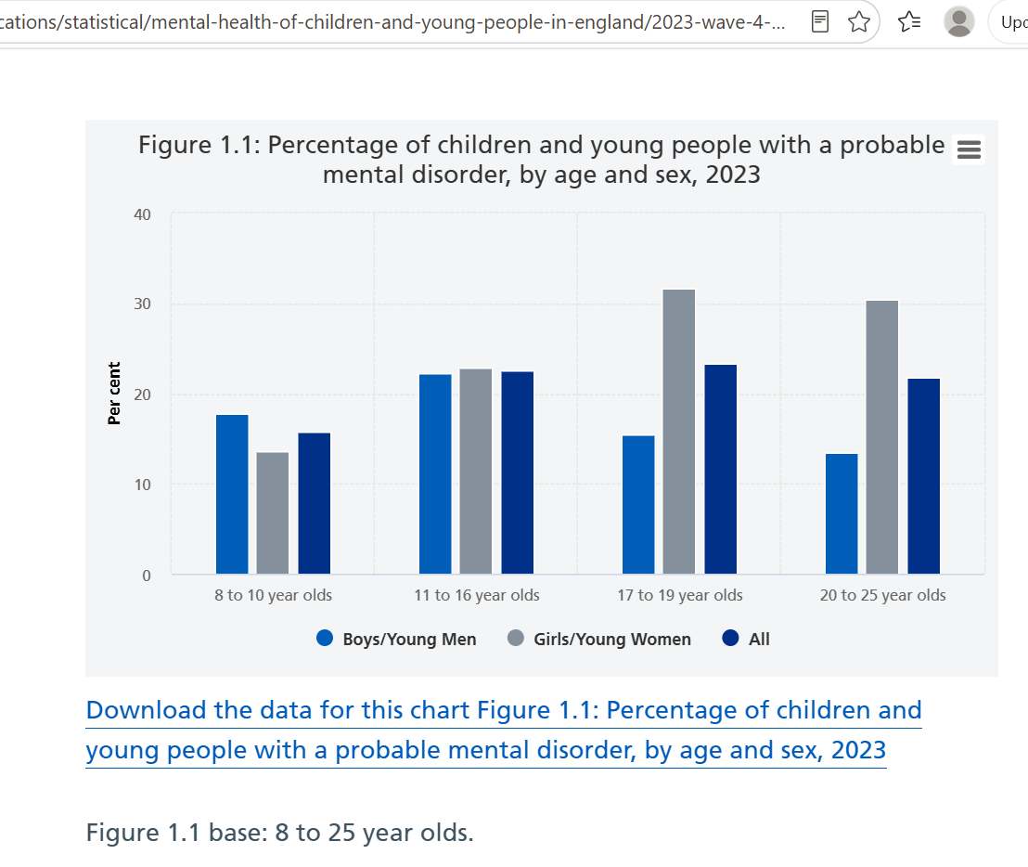
(NHS England, 2023a)
What support is available?
The NHS offers a range of mental health support, from community services to urgent and crisis care. NHS England is also introducing new ways to improve access, including Young Futures Hubs, which aim to connect young people with wellbeing support and NHS mental health services when specialist help is needed (NHS England, 2026a).
For young adults, knowing where to seek help is an important first step. Speaking to a GP, trusted adult, university support service, or another appropriate professional can help them find the right support (NHS England, 2023b). Family and friends can also play a significant role by providing support and encouraging young people to seek professional help when needed (Huff et al., 2024).
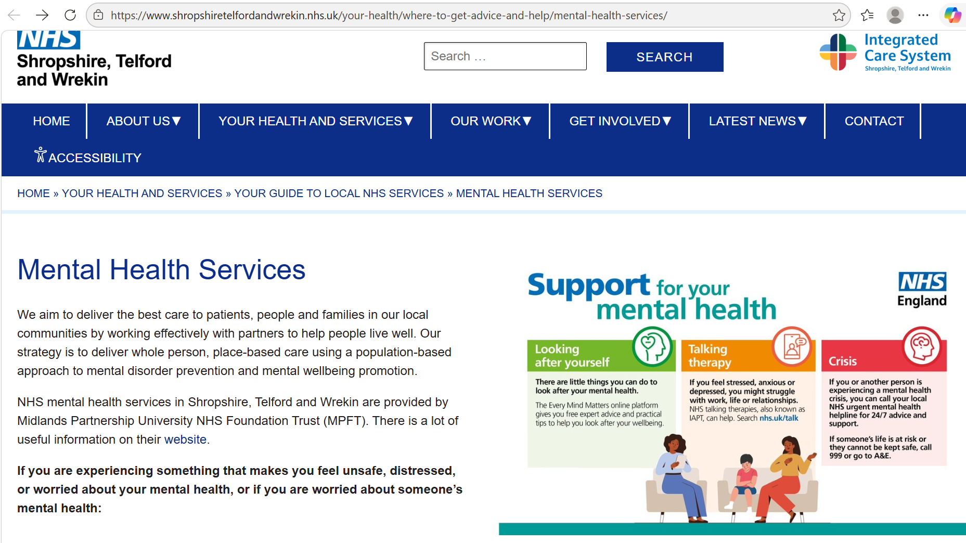
(NHS Shropshire, Telford and Wrekin, 2026b)
Conclusion:
Young adult mental health remains a critical issue across the UK health and social care sector. Although services are improving, young people need support that is accessible, timely and suited to their individual needs. Raising awareness and reducing barriers to help-seeking can make it easier for young adults to feel confident about reaching out for support.

Task 4 - NHS EQUALITY, DIVERSITY and INCLUSION QUIZ
(250 words equivalent)
- What is the primary goal of the NHS Equality, Diversity, and Inclusion Improvement Plan?
The primary goal of the NHS Equality, Diversity, and Inclusion Improvement Plan is to tackle direct and indirect prejudice and discrimination, reduce health inequalities, enhance the sense of belonging, and promote an inclusive NHS.

- How does the NHS EDI Improvement Plan propose to tackle the gender pay gap?
The NHS EDI Improvement Plan addresses the gender pay gap through High Impact Action 3, promoting measurable progress, fair recruitment, equal promotion opportunities, and improved career progression for women.

- What is meant by the term ‘intersectionality’ as used in the NHS EDI Improvement Plan?
The term ‘intersectionality’ in the NHS EDI Improvement Plan means understanding how various aspects of a person’s identity, including protected characteristics, as defined in the Equality Act (2010), overlap and contribute to discrimination or disadvantage.

- Why is it important for the NHS to create a psychologically safe work environment?
A psychologically safe NHS workplace allows staff to speak up, share concerns and contribute ideas, while ensuring they feel treated with dignity and respect, and can learn from mistakes without fear of blame or discrimination.

- How does the NHS EDI Improvement Plan suggest improving the experience of internationally recruited staff?
The NHS EDI Improvement Plan addresses internationally recruited staff through High Impact Action 5, which promotes comprehensive induction and onboarding, clear employment guidance, pastoral support, culturally aware teams, and equal access to training, and development opportunities.

- What role does leadership play in advancing EDI objectives according to the NHS Improvement Plan?
According to the NHS Improvement Plan, leadership drives EDI progress by promoting accountability, challenging discrimination, and ensuring equality, diversity and inclusion are embedded in NHS policies and practices.

- Identify one way the NHS EDI Improvement Plan aims to reduce health inequalities within the workforce.
The Plan aims to reduce workforce health inequalities through wellbeing support and interventions under High Impact Action 4, while promoting fair recruitment for all NHS staff.

- Why does the NHS EDI Improvement Plan emphasise the importance of collecting and analysing data on protected characteristics?
The NHS EDI Improvement Plan emphasises collecting and analysing protected-characteristic data to identify inequalities, measure progress, and develop targeted actions to improve fairness and inclusion.

- Explain how flexible working policies can contribute to equality and inclusion in the NHS workforce.
Flexible working policies promote equality and inclusion by accommodating diverse personal needs, supporting staff retention, improving accessibility, and reducing systemic barriers.

- What is one strategy mentioned in the NHS EDI Improvement Plan to combat bullying and harassment in the workplace?
One strategy mentioned in the Plan is implementing a zero-tolerance approach to bullying and harassment, ensuring incidents are reported, investigated, and addressed fairly and promptly.

Task 5- A LETTER to YOURSELF
Think of a time in the past when you may have been experiencing issues or difficulties, and after considering what you have learned in this module about emotional intelligence and resilience write a letter to your younger self explaining how these attributes were important at that time and perhaps how developing these areas could have been useful (300 words)

Dear Younger Me,

I remember how nervous you felt when starting a new job and speaking in front of others. You worried about making mistakes, being judged and not meeting expectations. You lacked confidence in your abilities and often kept your worries to yourself rather than asking others for help. I want you to understand that experiencing difficulties is a normal part of life, and you do not have to face every challenge alone. Looking back, I realise that developing emotional intelligence and resilience could have helped you manage these challenges more positively.

Emotional intelligence involves recognising, understanding and managing emotions effectively (Salovey and Grewal, 2005). Developing this skill could have helped you recognise and manage your nervousness when starting a new job or speaking in front of others. Sharing your worries, asking for help and accepting feedback could have helped you build confidence and communicate more effectively.

Resilience would also have helped you cope with unfamiliar situations, manage your nervousness and learn from difficult experiences. Skills for Care (2016) explains that resilience can be developed through self-awareness, positive thinking, problem-solving and seeking support when needed. Rather than allowing the fear of making mistakes to hold you back, you could have viewed each experience as a learning opportunity. Practising, learning from feedback and asking colleagues for support could have helped you feel more confident in your new job.

Most importantly, remember that you do not need to be perfect to succeed. Give yourself time to learn, share your worries and believe in your abilities. Be patient and recognise your progress, even when it feels small.

Keep building your emotional intelligence and resilience to face challenges, grow in confidence and develop personally and professionally.

With kindness and encouragement,
Your older self

Task 6- GANTT CHART
(200 words equivalent)
Compile a Gantt chart which illustrates the tasks you must complete to achieve your future employment goals
CAREER DEVELOPMENT GANTT CHART
My goal is to become a Healthcare Assistant in the UK. This Gantt Chart outlines the tasks, timeframes and dependencies required to achieve my future employment goal.
GANTT Chart for my future career as a Healthcare Assistant:
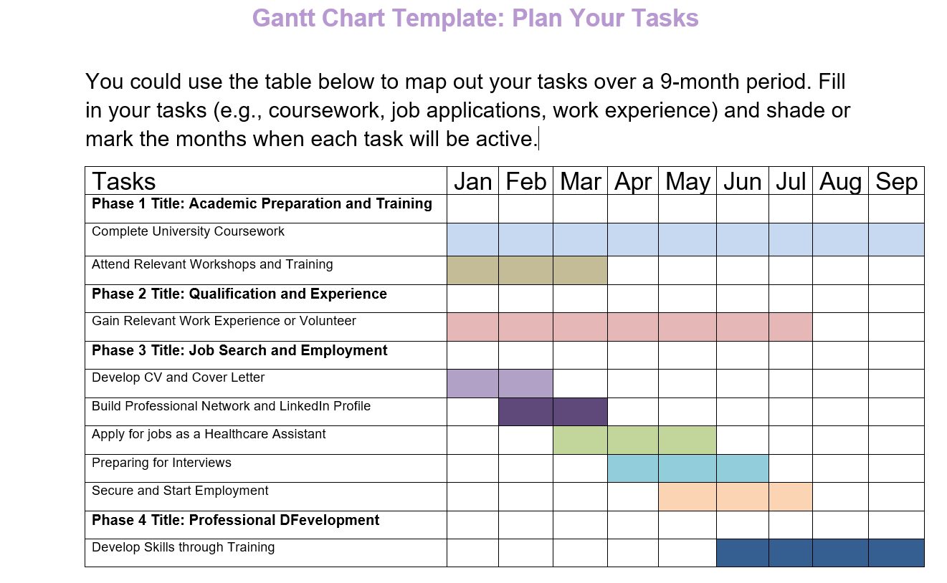

Milestones:
Completing Level 5 and Level 6 coursework, gaining experience, applying for jobs and securing a Healthcare Assistant role. Dates may change depending on coursework and job opportunities. I will also seek feedback, improve my communication and teamwork skills, and complete relevant training to strengthen my confidence and prepare for future healthcare responsibilities.

Task 7- MAKING CHANGES - REPORT
You are the manager of a care home and want to make changes to your workplace. Identify one specific change that you want to implement and write a brief report on how this is going to be achieved considering the necessary skills needed and addressing possible barriers to success. Relevant change models can be highlighted (350 words Minimum of - 3 referenced sources).
MAKING CHANGES IN A CARE HOME – REPORT
INTRODUCTION:
As a care home manager, I would introduce digital care planning to replace paper records. This change would improve communication, ensure care information is accurate and support safer, person-centred care while making it easier to access important information when needed (Care Quality Commission, 2024; Department of Health and Social Care, 2026a).
PLANNING THE CHANGE:
I would follow Lewin’s Change Management Model, which involves three stages: unfreezing, changing and refreezing (Lewin, 1951). During unfreezing, I will explain the benefits of digital records and discuss staff concerns. During the changing stage, I would introduce suitable software, provide staff training and test the system with a small team before wider implementation (Department of Health and Social Care, 2026a). Finally, during refreezing, I would set clear procedures, monitor staff progress and review feedback to help make the new system part of everyday practice. Staff, senior carers, nurses and IT support would contribute to implementation.
SKILLS REQUIRED:
Time management, collaboration, communication, and effective leadership would be crucial. I would organise training around work hours, promote staff participation, and explain the reasons for the change. Problem-solving and conflict-resolution skills would help address concerns. Digital skills would also be important to support staff in using the new system efficiently (Department of Health and Social Care, 2026b).
BARRIERS AND SOLUTIONS:
Staff may resist the change because they lack confidence using technology or prefer paper records. I would address this by involving staff in decisions, providing practical training and offering ongoing support (Malley et al., 2026). Staff shortages and time pressure could delay implementation, so I would introduce the system gradually and organise training carefully. Financial costs could be managed by comparing software options and preparing a realistic budget. Data security is another concern. I would choose a suitable secure system and ensure staff understand confidentiality, passwords and authorised access (Department of Health and Social Care, 2026b).
CONCLUSION:
Introducing digital care planning could improve person-centred care, information sharing, and record accuracy. Using Lewin’s model, effective leadership and practical solutions to potential barriers would help ensure a successful and sustainable transition, while supporting staff confidence, protecting residents’ confidential information and maintaining high standards of care throughout implementation.

REFERNCE LIST
Batistic, S. and Tymon, A. (2017) ‘Networking behaviour, graduate employability: a social capital perspective’, Education + Training, 59 (4), pp. 374–388. Available at: https://doi.org/10.1108/ET-06-2016-0100
Care Quality Commission (2024) Digital record systems: achieving good outcomes for people using adult social care services. Available at: https://www.cqc.org.uk/guidance-regulation/adult-social-care/digital-record-systems-adult-social-care (Accessed: 21 October 2026)
Department of Health and Social Care (2026a) Digital social care records: choosing and implementing solutions. Available at: https://www.gov.uk/guidance/digital-social-care-records-choosing-and-implementing-solutions (Accessed: 21 October 2026)
Department of Health and Social Care (2026b) Adult social care digital skills framework. Available at: https://www.gov.uk/government/publications/adult-social-care-digital-skills-framework/adult-social-care-digital-skills-framework (Accessed: 21 October 2026)
De Schepper, A., Clycq, N. and Kyndt, E. (2023) ‘Social networks in the transition from higher education to work: A systematic review’, Educational Research Review, 40 (100551). Available at: https://doi.org/10.1016/j.edurev.2023.100551
Equality Act 2010, c.15, Available at: https://www.legislation.gov.uk/ukpga/2010/15/contents (Accessed: 12 October 2026).
Gorbatov, S., Khapova, S.N. and Lysova, E.I. (2019) ‘Get noticed to get ahead: The impact of personal branding on career success’, Frontiers in Psychology, 10 (2662). Available at: https://doi.org/10.3389/fpsyg.2019.02662
Gorbatov, S., Oostrom, J.K. and Khapova, S.N. (2024) ‘Work does not speak for itself: examining the incremental validity of personal branding in predicting knowledge workers’ employability’, European Journal of Work and Organisational Psychology, 33 (1), pp. 40 - 53. Available at: https://doi.org/10.1080/1359432X.2023.2276533
Huff, N.R., Dunderdale, L., Kellogg, A.J. and Isbell, L.M. (2024) ‘Factors related to help-seeking and service utilization for professional mental healthcare among young people: An umbrella review’, Clinical Psychology Review, 114 (102504). Available at: https://doi.org/10.1016/j.cpr.2024.102504
Khedher, M. (2019) ‘Conceptualizing and researching personal branding effects on the employability’, Journal of Brand Management, 26, pp. 99 - 109. Available at: https://doi.org/10.1057/s41262-018-0117-1
Lewin, K. (1951) Field theory in social science: selected theoretical papers. Edited by D. Cartwright. New York: Harper & Brothers.
Malley, J., Westwood, J., Snow, M., Farrelly, N., Steils, N., Henderson, C. and Larkins, C. (2026) ‘A rapid evaluation of the implementation of Digital Social Care Records in England’, Health and Social Care Delivery Research, 14 (16), Available at: https://doi.org/10.3310/GJJW2821
Mental Health Foundation (2026) The Foundation Reports: The state of mental health inequality in the UK. Available at: https://reports.mentalhealth.org.uk/foundation-reports/june-2026/report/ (Accessed: 03 October 2026).
Minor-Cooley, D., and Parks-Yancy, R. (2020) ‘The Power of the Brand: Personal Branding and Its Effect on Job Seeking Attributes’, Journal of Internet Commerce, 19 (3), pp. 241 – 261. Available at: https://doi.org/10.1080/15332861.2020.1777028
NHS England (2023) Mental Health of Children and Young People in England, 2023: wave 4 follow-up to the 2017 survey. Available at: https://digital.nhs.uk/data-and-information/publications/statistical/mental-health-of-children-and-young-people-in-england/2023-wave-4-follow-up (Accessed: 03 October 2026).
NHS England (2023a) (Image) Mental Health of Children and Young People in England, 2023: wave 4 follow-up to the 2017 survey: Part 1: Mental health. Available at: https://digital.nhs.uk/data-and-information/publications/statistical/mental-health-of-children-and-young-people-in-england/2023-wave-4-follow-up/part-1-mental-health (Accessed: 03 October 2026).
NHS England (2023b) Mental Health of Children and Young People in England, 2023 – wave 4 follow up to the 2017 survey: Part 3: Education, services and support. Available at: https://digital.nhs.uk/data-and-information/publications/statistical/mental-health-of-children-and-young-people-in-england/2023-wave-4-follow-up/part-3-education-services-and-support (Accessed: 03 October 2026).
NHS England (2026a) Children and young people. Available at: https://www.england.nhs.uk/mental-health/cyp/ (Accessed: 03 October 2026).
NHS Shropshire, Telford and Wrekin (2026b) (Image) Mental Health Services. Available at: https://www.shropshiretelfordandwrekin.nhs.uk/your-health/where-to-get-advice-and-help/mental-health-services/ (Accessed: 03 October 2026).
Office for Health Improvement and Disparities (2023) 'You're Welcome': establishing youth-friendly health and care services. Available at: https://www.gov.uk/government/publications/establishing-youth-friendly-health-and-care-services/youre-welcome-establishing-youth-friendly-health-and-care-services (Accessed: 03 October 2026).
Salovey, P., and Grewal, D. (2005) ‘The Science of Emotional Intelligence’, Current Directions in Psychological Science, 14 (6), pp. 281-285. Available at: https://doi.org/10.1111/j.0963-7214.2005.00381.x
Schmidt, C.N., Oji, N.M., Hauer, K.E. and Kryzhanovskaya, I.V. (2026) ‘Development, implementation, and evaluation of the Student Optimized Learning Environment (SOLE): a longitudinal team-based communication skills curriculum for medical students’, BMC Medical Education, 26 (663). Available at: https://doi.org/10.1186/s12909-026-08988-0
Skills for Care (2016) Building your own resilience, health and wellbeing. Available at: https://www.workingwellglos.nhs.uk/wp-content/uploads/2019/01/Building-your-own-Personal-Resilience.pdf (Accessed: 19 October 2026).

