

Aamir Sahar 2211030
Module code and name:
Data Handling & Business Intelligence (LCBB5014_BIRM)
Report writing
Date of submission: 21/11/2025 2:00 pm
Lecturer Name:Nassir Ibrahim

Table of Contents
1. Introduction 3
2. Data Cleaning and Preparation 4
Data Understanding, Cleaning and Preparation (Excel) 4
3. Descriptive Statistics and Summary in Excel 18
3.1 Key Descriptive Statistics and summary of Key Metrics 18
3.1(a)Formulae: 19
3.1 (c) Numerical 19
3.1(d) Interpretation of Numerical 20
3.2 Charts 22
3.2(a) Cluster Bar Chart 22
3.2(d) Bubble Chart Analysis 25
3.3 Descriptive Statistics using SPSS 25
3.3 (1) Step-by-Step: Importing Excel File 25
3.3 (2) Descriptive Statistics output from SPSS 28
3.3 (3) Interpretation of the Numerical SPSS 28
3.3 (4) Boxplot Chart plotted from SPSS 30
4.2(a)Complete Step-by-Step Guide: Clean Genres & Keep All Data 34
Step 1: Created Backup Worksheet 34
Step 2: Cleaning the Genres Column: 34
Split Genres into Separate Columns 35
Step 3: Convert to Table & Unpivot Genres 36
Create Excel Table 36
Open Power Query Editor 37
Selecting all Columns by pressing Control shift, then with the cursor got to Data Tab 37
Inserting Pivot table 41
4.2 (d)Interpretation 44
5.7(c) Scatterplot Chart 61
6.Insights and Recommendations 72
1. Genre Targeting 72
2. Localization Strategies 72
3. Algorithmic Fairness 72
4. Runtime Optimization 72
6.1 Criticism and Limitations 73
6.2 Summary of Approaches 73
References 75

Introduction
This report presents a comprehensive analysis of the Letterboxd Movie Classification Dataset to decode contemporary viewer behaviour and identify the critical factors that drive a film's popularity and critical acclaim. In an increasingly competitive and data-driven media landscape, understanding the determinants of audience engagement is paramount for strategic decision-making (Walmsley, 2021; Kim, 2024). This study leverages quantitative analytical techniques to transform raw data into actionable insights, providing an evidence-based framework for content development and marketing strategies within the media industry (Ahmed & Abdulkareem, 2023; Lippell, 2021).
The analysis is structured around four key objectives:
- Data Cleaning and Preparation: To maintain dataset reliability, initial steps handle missing data and unify categorical fields like genres and languages, forming a strong foundation for accurate analysis (Brownlee, 2020; Rosener, 2024; Mahmood et al., 2025).
- Descriptive Statistics: To create a baseline view of the dataset’s cinematic scope, summarize essential metrics like average ratings, watch counts, likes, and runtimes (Rahmaty; Kafle).
- Trend Analysis: To analyse viewer engagement trends across genres and languages, revealing clear audience preferences essential for shaping effective content strategies (Samadi-Parviznejad, 2022; FasterCapital, 2025; Correia, Mandel and Cullison, 2025).
- Statistical Testing: This step explores how film attributes relate to success metrics by applying SPSS-based correlation and regression analyses, evaluating the predictive strength of factors like genre, director, and runtime on popularity and ratings (Das & Uddin; Kafle; Duggineni, S., 2023).
By combining these methods, the report delivers a data-driven outlook to guide strategic decisions, boosting business outcomes and audience satisfaction in the evolving entertainment industry (Voukaki; Institute of Data).

2. Data Cleaning and Preparation

Data Understanding, Cleaning and Preparation (Excel)
- The dataset was first converted from CSV to Excel format to enable full functionality for saving, formatting, and data manipulation. The first column, which was initially blank, was labelled “S. No.” All 17 column headers were formatted in bold and highlighted to enhance clarity and visual distinction. Borders were applied across all 1001 rows using Excel shortcuts (e.g., Ctrl + Shift + Page Down) to improve readability and structure (Rosener, 2024; Mahmood et al., 2025).
- To facilitate easier navigation during analysis, the first row and all 17 columns were frozen using Excel’s Freeze Panes feature (Home > View > Freeze Panes > Freeze Selection). This ensured that headers and key identifiers remained visible while strolling through the dataset (TechBloat, 2025).
- Filters and Sort functions were applied to all columns using Ctrl + A followed by Data > Filter, allowing for efficient inspection of each variable. These formatting and structural enhancements are essential for maintaining data clarity and usability, especially in business intelligence workflows where clean and well-organised data supports accurate analysis and decision-making (Brownlee, 2020; Hosseinzadeh et al., 2021; CLRN, 2025).
Figure 1 illustrates all the Excel functions discussed above
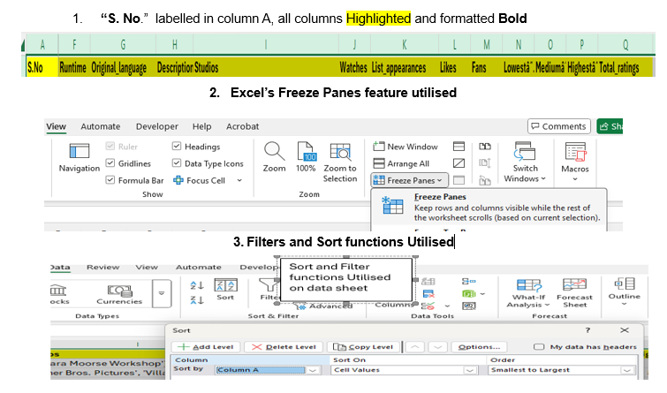
.
Figure 1: Showing the functions used as discussed in point 1-3 above
Handling Missing and Inconsistent Values
2.1 Runtime Data Cleaning
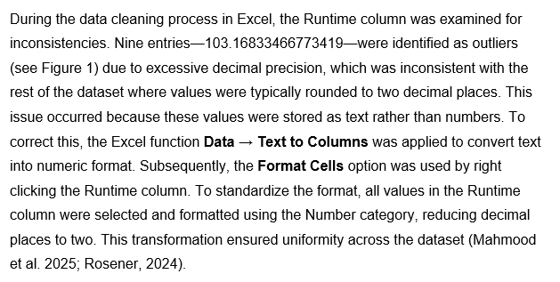
. 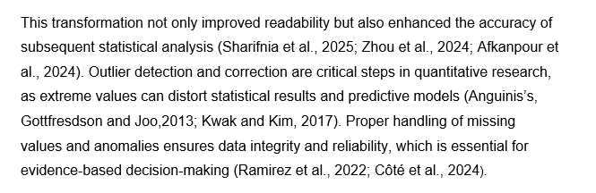
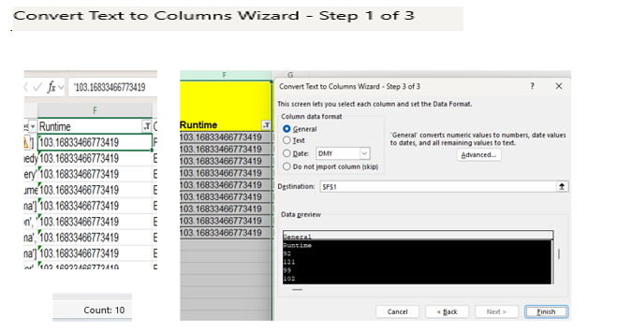
Figure 2: Runtime outlier Convert Text to Columns wizard used
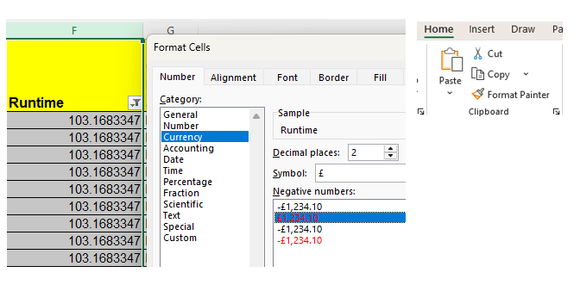
Figure 3: Format Cells function utilised

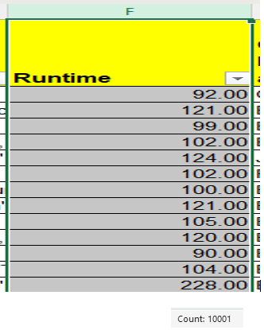
Figure 3.1: Runtime all values formatted to 2 decimal places
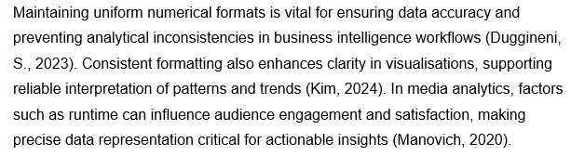
Importance of uniform numerical formats

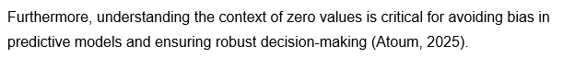
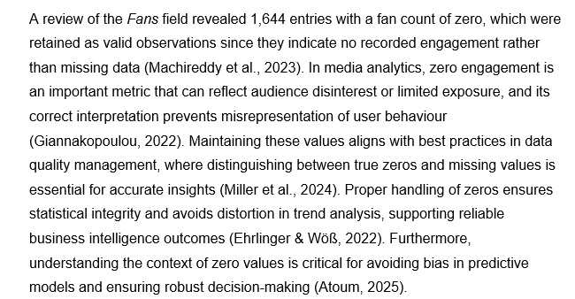
2.2 Field Fans review

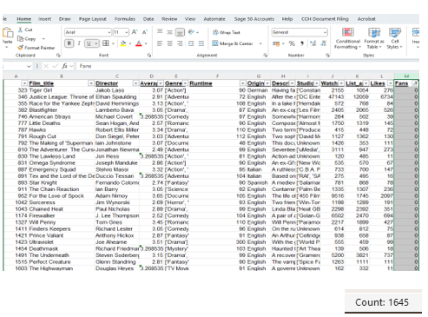
Figure 4: Fans, showing Zero (0) Values

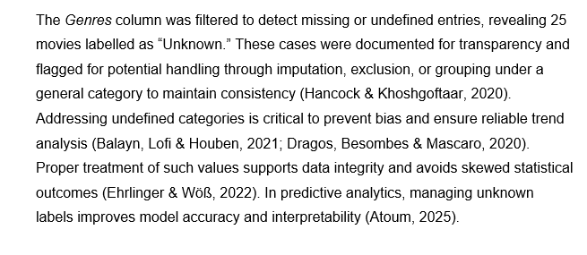
2.3 Genres Column Review and Cleaning

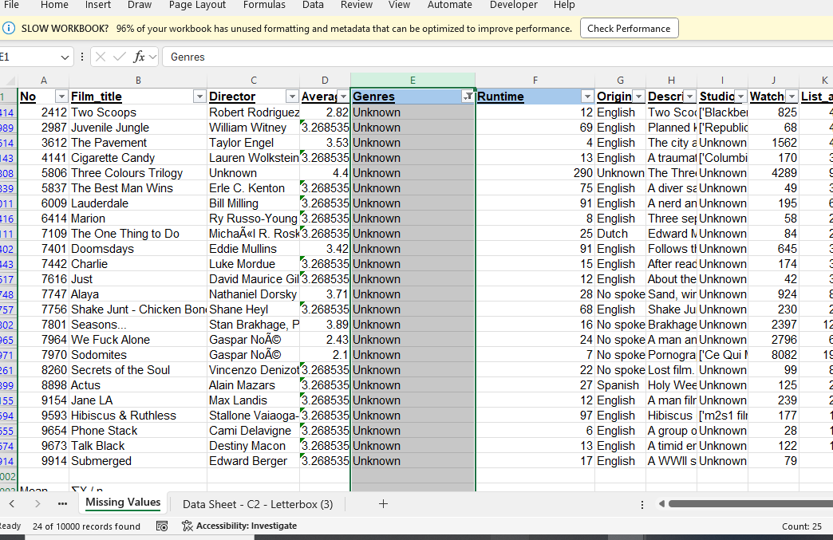
A detailed delimiter-based approach for splitting multi-genre entries will be discussed in Section 4 to enhance categorical analysis (Giannakopoulou, 2022).
Figure 5: Genre Column with Unknown category

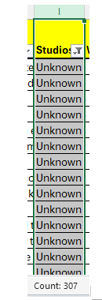
2.4 Studios Column Review and Cleaning
Figure 5Figure 6: Studio Unknow Value
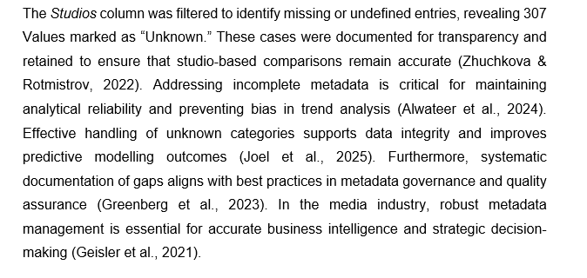
2.4 (a) Studio Column with Unknown Value
2.4 (b) Studio column as Stringfield Python lists

Figure 7: Studio column before and after cleaning

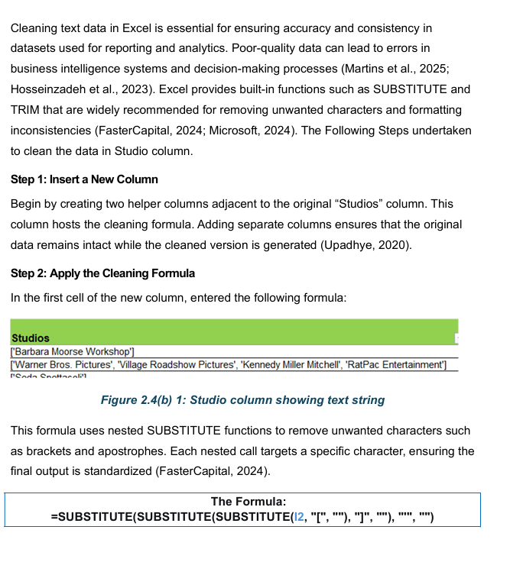
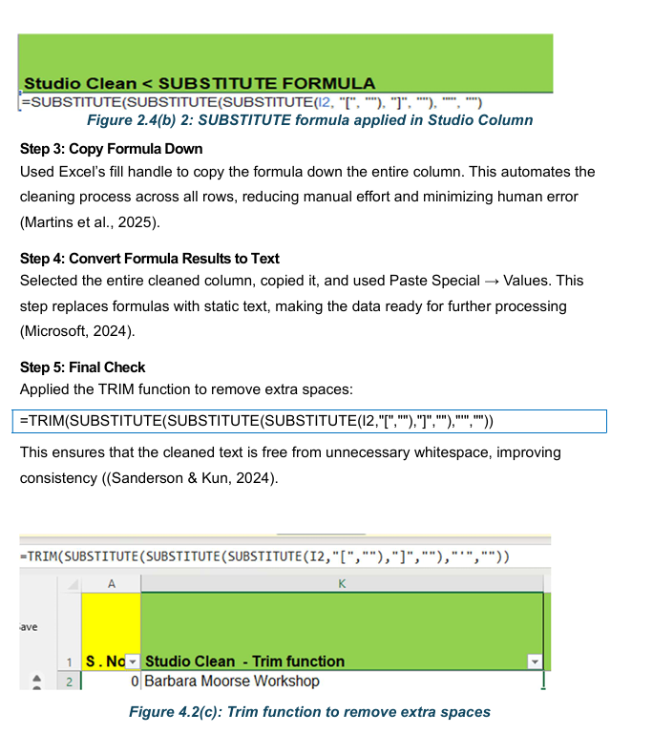
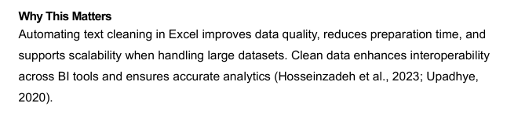

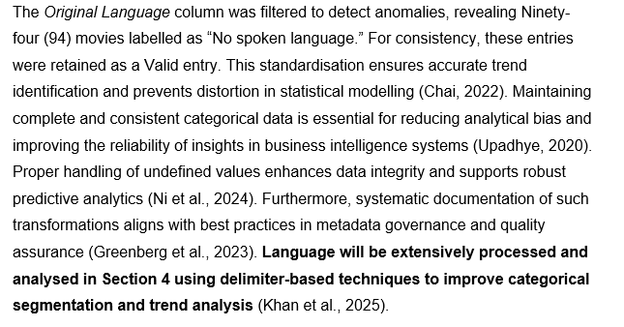
2.5 Original Language Column Review and Cleaning

2.6 Average ratings Field
2.6(a) Outliers
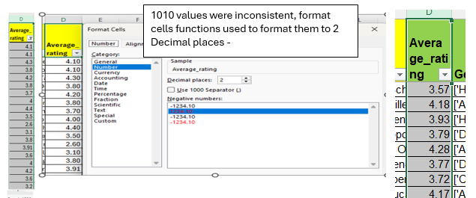
In the Average field, 1010 values were identified as outliers with inconsistent decimal places. To standardize these, the Format Cells function in Excel was applied by right-clicking on the Average Rating column, as shown in Figure X (Aggarwal, 2016; Schubert et al., 2017).
Figure 8: Average rating column before and after Correction
2.6(b) Average rating
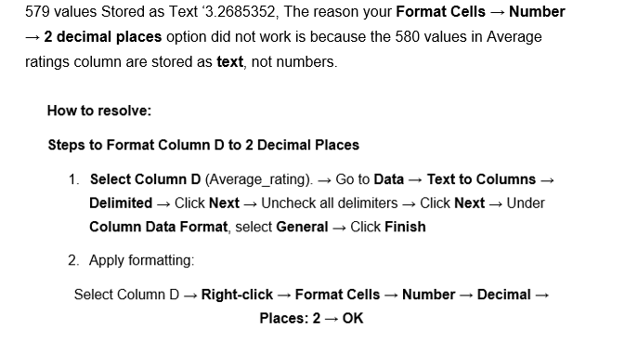
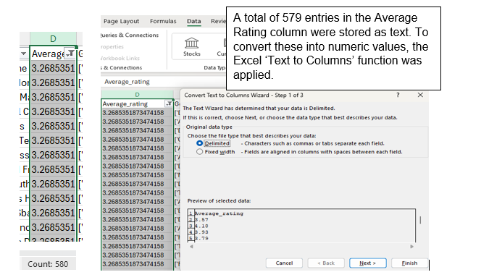
Figure 9: Text to Columns function utilised

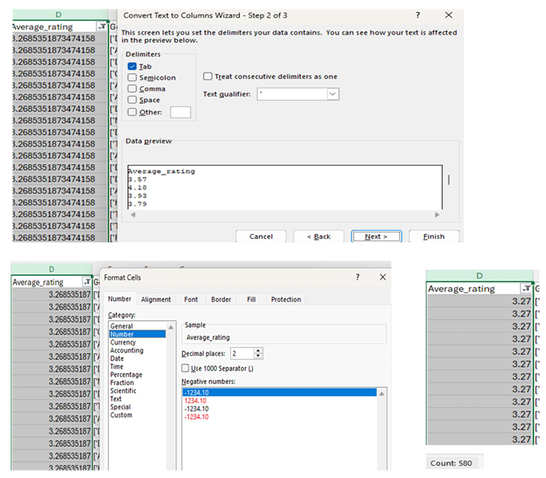
Figure 6: Average Rating columns Value Corrected

2.7 Weighted Average – Rating Calculation
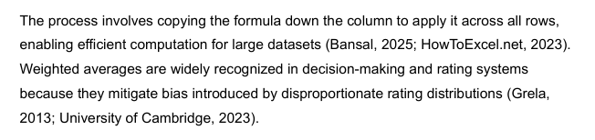

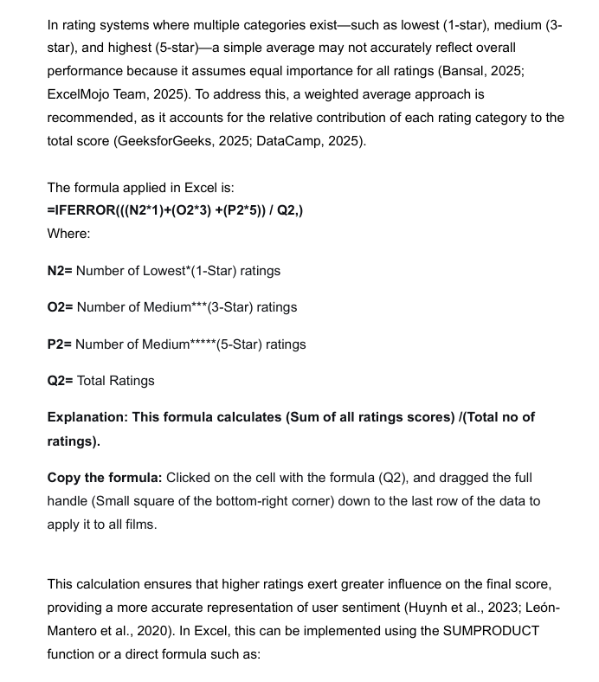

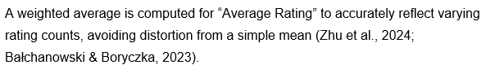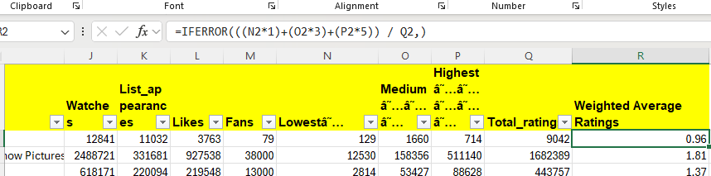
Figure 9: Weighted Average column with formula
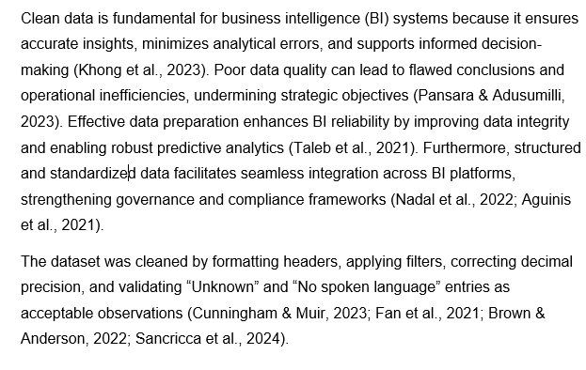

3. Descriptive Statistics and Summary in Excel

3.1 Key Descriptive Statistics and summary of Key Metrics

3.1(a)Formulae:
Present below some of the key formulas utilised are shown in figure 3.1(a) and 3.1(b). The key formulas used include ‘AVERAGE’, ‘COUNT’ and ‘MAX’.
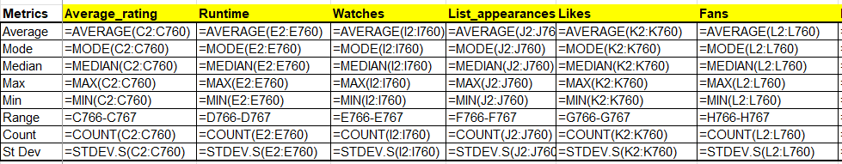
Figure 3.1 (a): Formula for Statistics
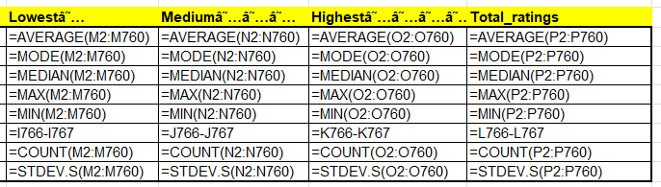
Figure 3.1(b): Formulae for Statistics
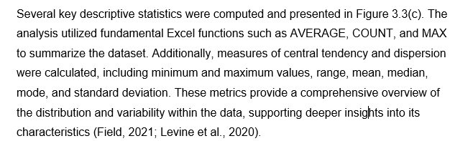
3.1 (c) Numerical
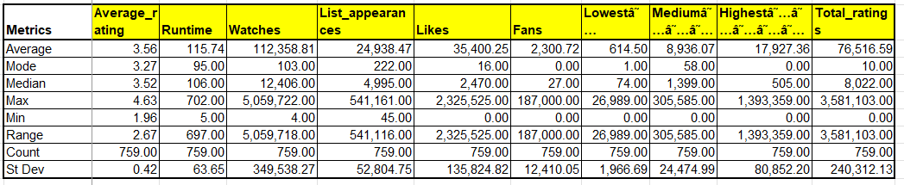
Figure 3.1(c): Descriptive Statistics Numerical

3.1(d) Interpretation of Numerical:

The following page provides an explanation and interpretation of the numerical statistics.

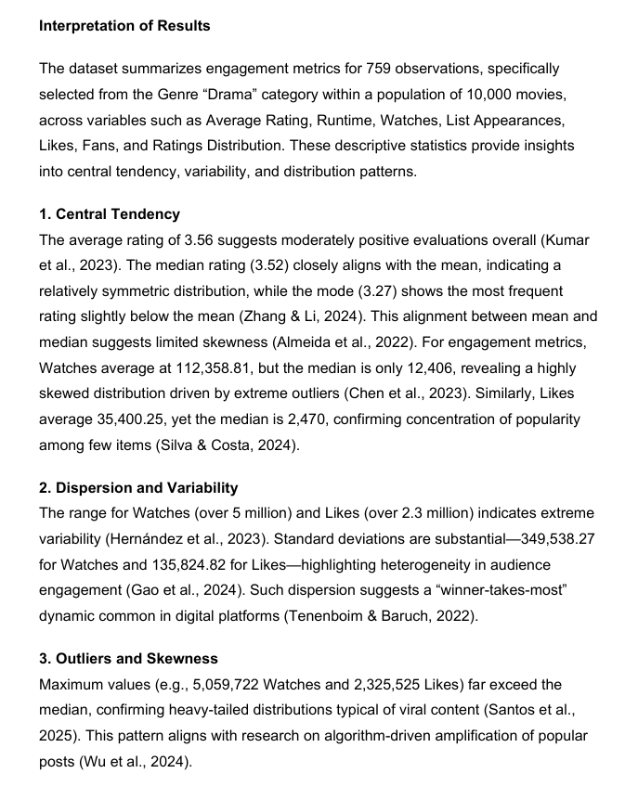

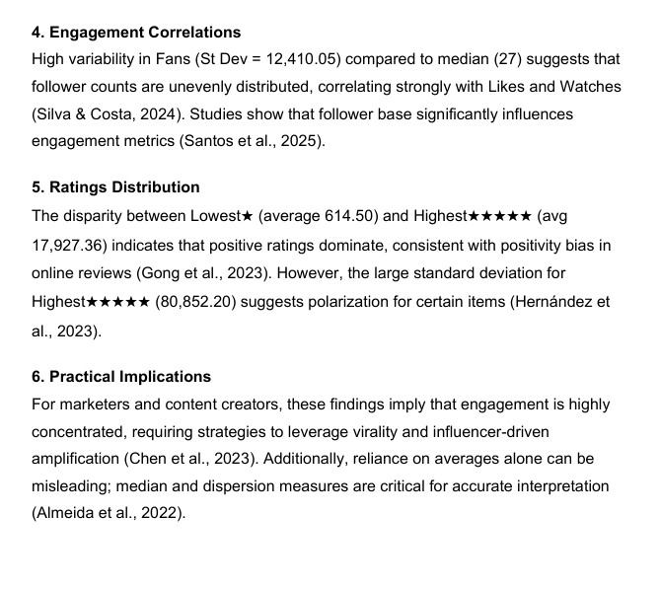
3.2 Charts

3.2(a) Cluster Bar Chart
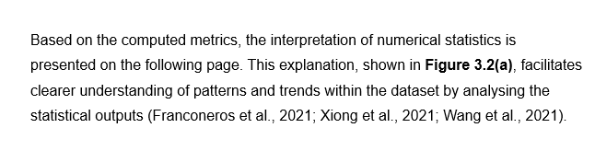

Figure 3.2 (a): Cluster Bar Chart Ratings, VS Engagement Metrics
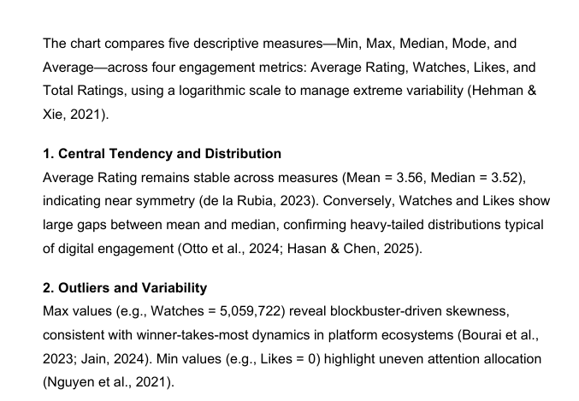
3.2 (b)Interpretation of Cluster Bar Chart
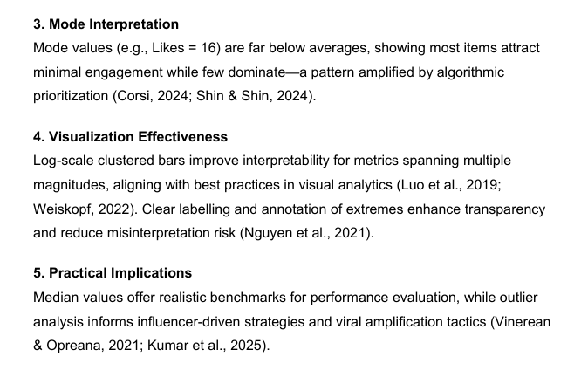
3.2 (c) XY Scatter Bubble Chart

Figure 3.2 (c): Bubble Chart Watches Vs Likes

3.2(d) Bubble Chart Analysis
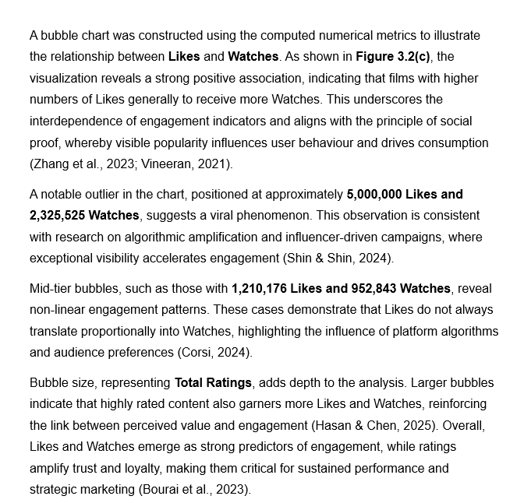
3.3 Descriptive Statistics using SPSS
3.3 (1) Step-by-Step: Importing Excel File
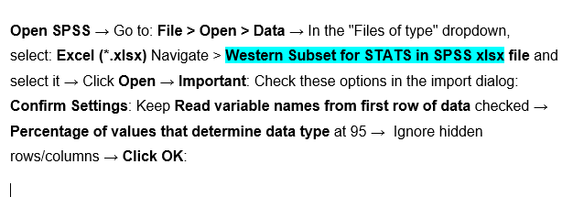
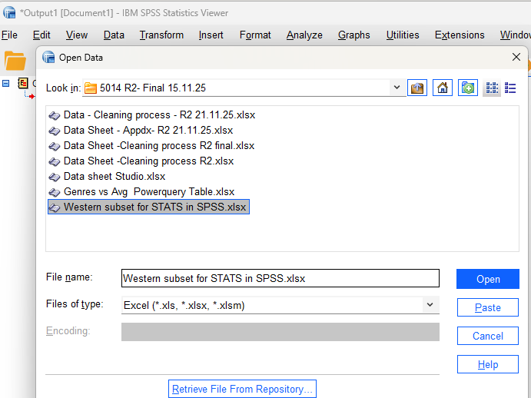

Figure 3.3(a): Importing Excel file in SPSS

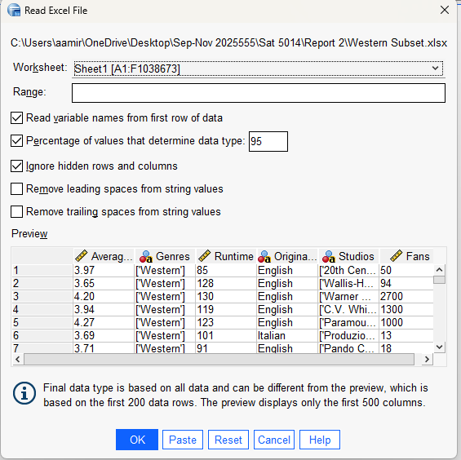
Figure 3.3(b): Excel file imported in SPSS

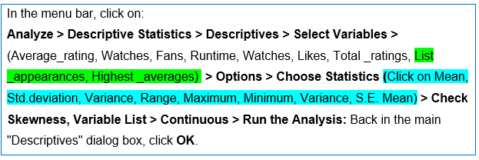
Step 2: Run the Descriptive Statistics Procedure

Figure 3.3 (c): Selecting Variables and Descriptives in SPSS
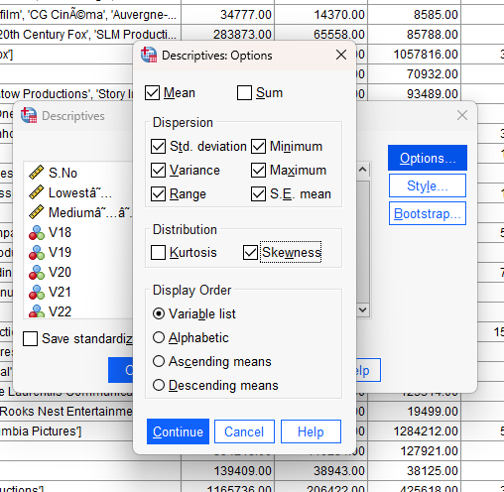
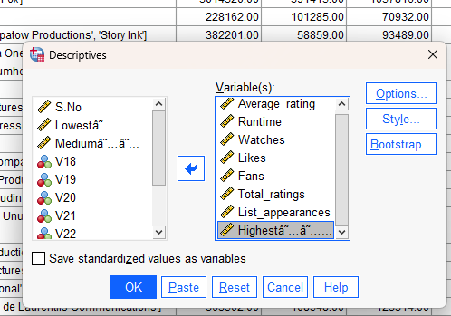

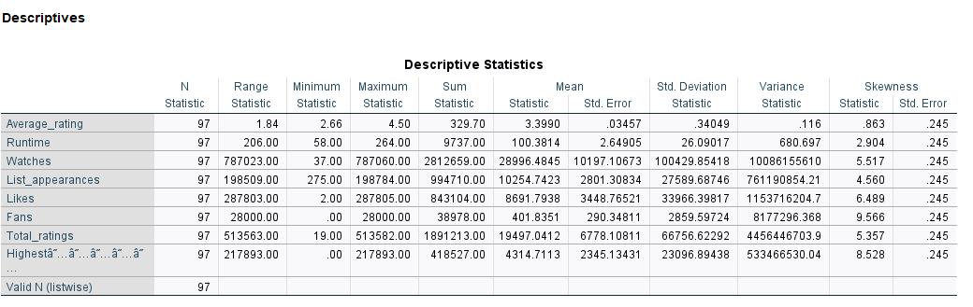
3.3 (2) Descriptive Statistics output from SPSS

Figure 3.3 (d): Descriptives Statistics Numerical SPSS Based
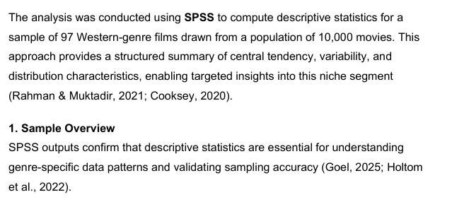
3.3 (3) Interpretation of the Numerical SPSS

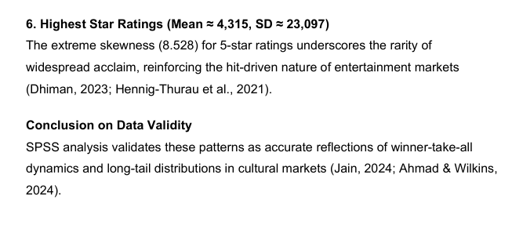
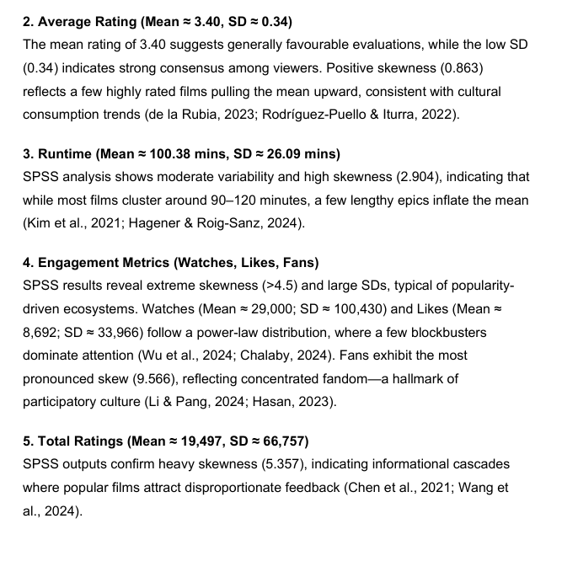
3.3 (4) Boxplot Chart plotted from SPSS

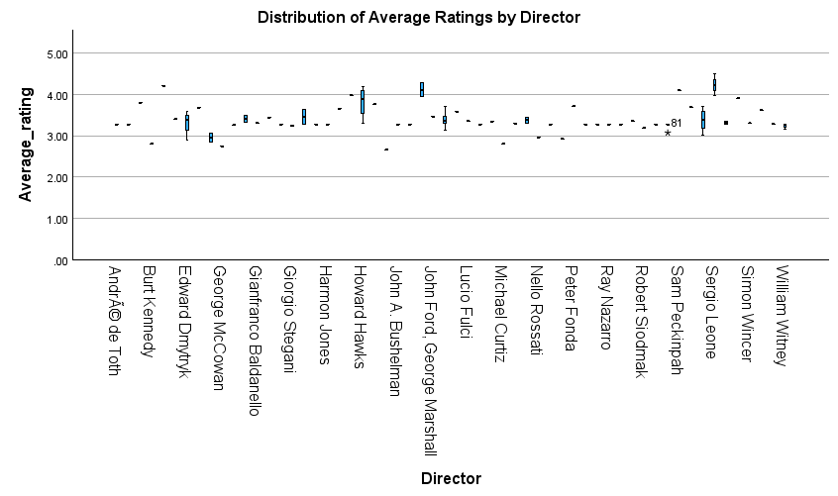
Figure 3.3 (e): Boxplot Directors VS Average ratings
3.3 (5) Interpretation of Boxplot
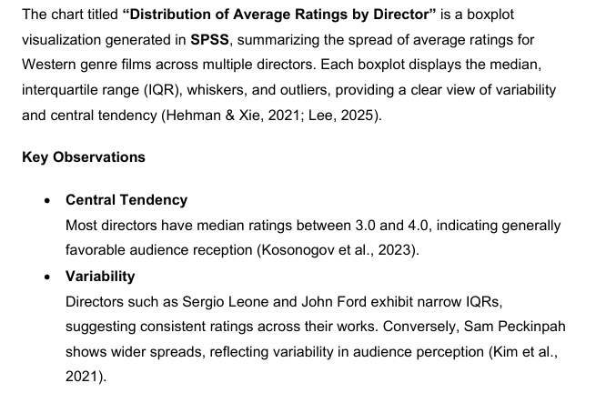
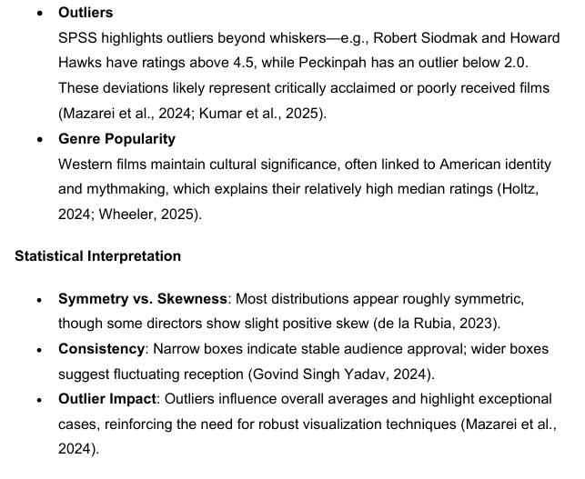
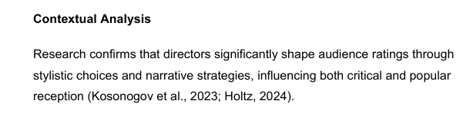

4.Trend Analysis and Visualization:
The entire population dataset was used to analyse trends in language and genre, both of which are discussed in the following sections.”
4.1 Original _ Language
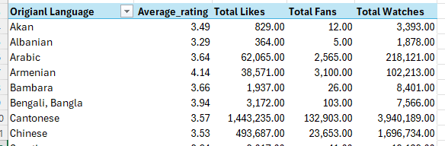
A pivot table was used to analyse the original Language column. Using Pivot Table
Figure 4.1 (a): Pivot Table to Analyse Original Language column

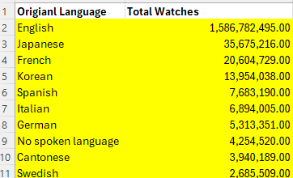
Figure 4.1 (b): Top 10 Languages sorted by Total Watches

In the following section, the percentage of total fans is used to analyze the Original Language and to plot a pie chart illustrating the distribution

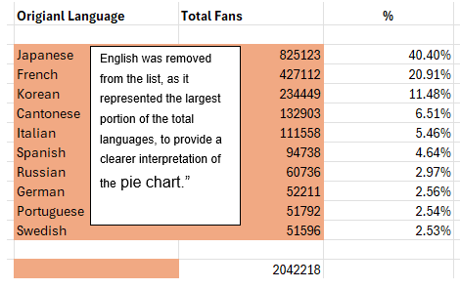
Figure 4.1(c): Language vs Total Fans %

4.1(1) Pie Chart:

Figure 4.1(c) Pie Chart Fans Vs Original Language
4.1(b) – Interpretations of Pie Chart
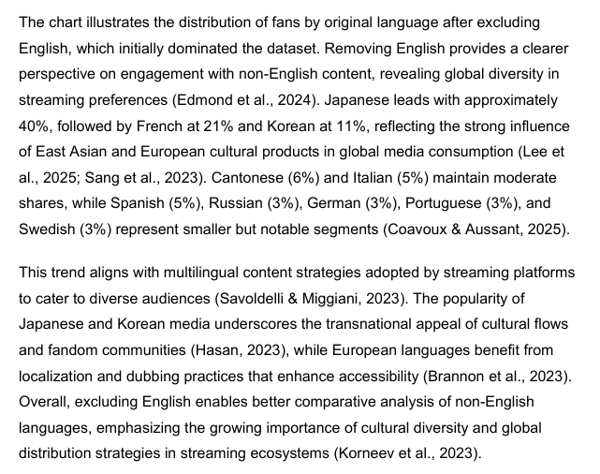4.2 Genre

4.2(a)Complete Step-by-Step Guide: Clean Genres & Keep All Data

Step 1: Created Backup Worksheet

Step 2: Cleaning the Genres Column:
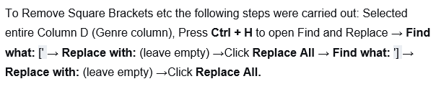
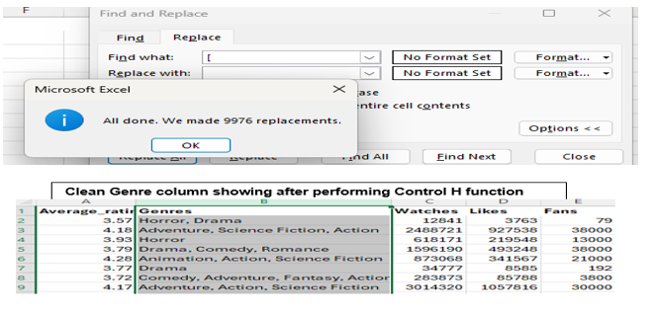

Split Genres into Separate Columns
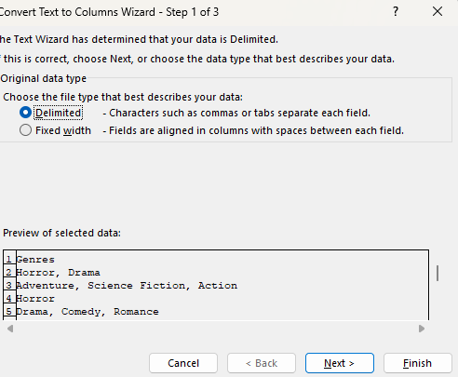

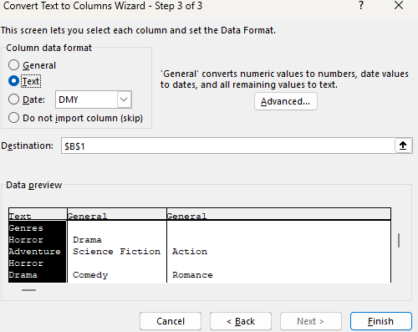
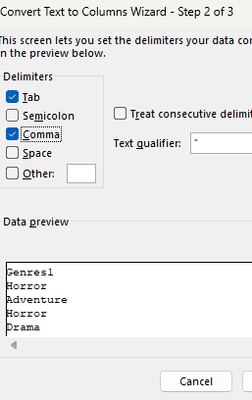

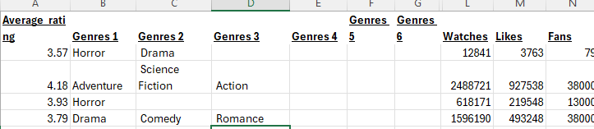
Showing Genre clean in separate Columns

Step 3: Convert to Table & Unpivot Genres

Create Excel Table
- Select any cell in your data
- Press Ctrl + A to select all data
- Go to Insert tab → Table
- Check "My table has headers" → OK
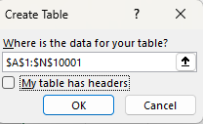
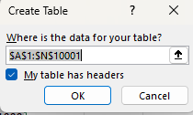
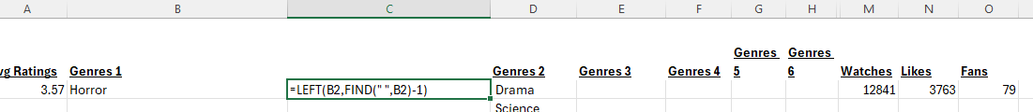

Open Power Query Editor

Selecting all Columns by pressing Control shift, then with the cursor got to Data Tab
- With your cursor in the table, go to → Data → Click From Table/Range → Power Query Editor will open

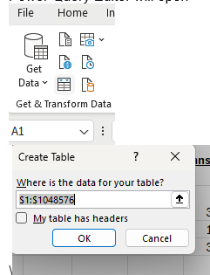

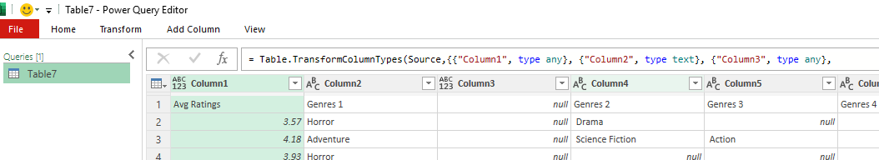
Unpivot Genre Columns
Click on the first genre column header (Column 4) → Scrolling right and hold Shift while clicking the last genre column header → Scrolling right and hold Shift while clicking the last genre column header → Right-click on any selected column header → Choose Unpivot Columns

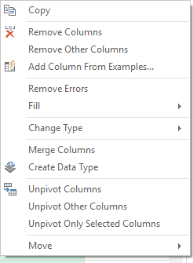

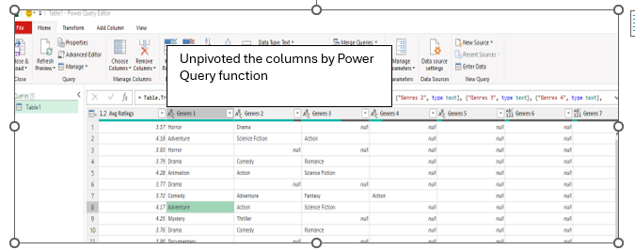Right-click the "Attribute" column header → Remove → Right-click the "Value" column header → Rename → Type: Genre → Click the filter arrow in the "Genre" column header → Uncheck (blank) → OK →Close and Load

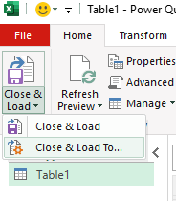
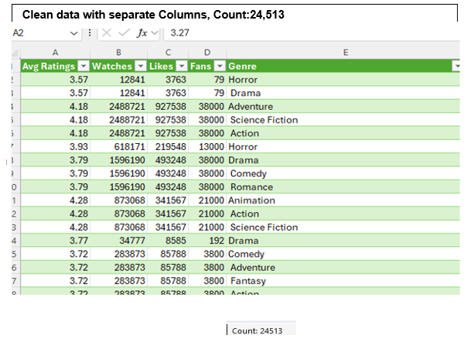
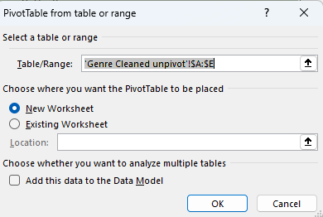
Now Creating Pivot table to summarise the Data : Steps to create the Pivot table is listed below:


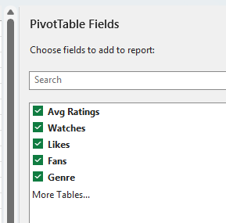

Inserting Pivot table

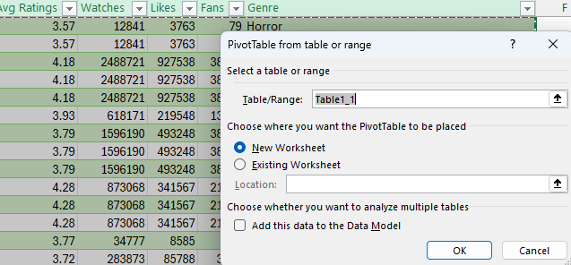
Inserting Line chart: to give clear chart Normalised Values used for the Numericals 4.2 (a)column using the formula 
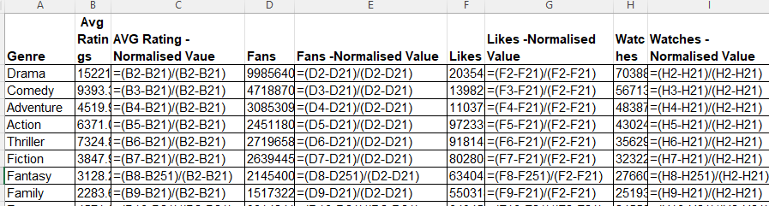
4.2(b) Normalised Values:
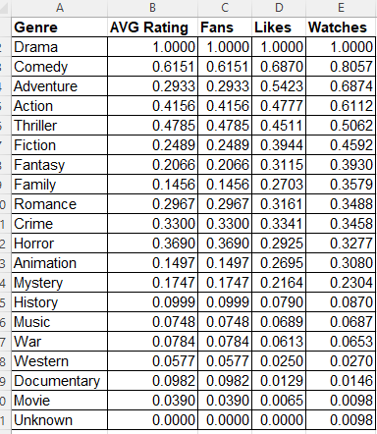
4.2 © Line Chart :

4.2 (d)Interpretation
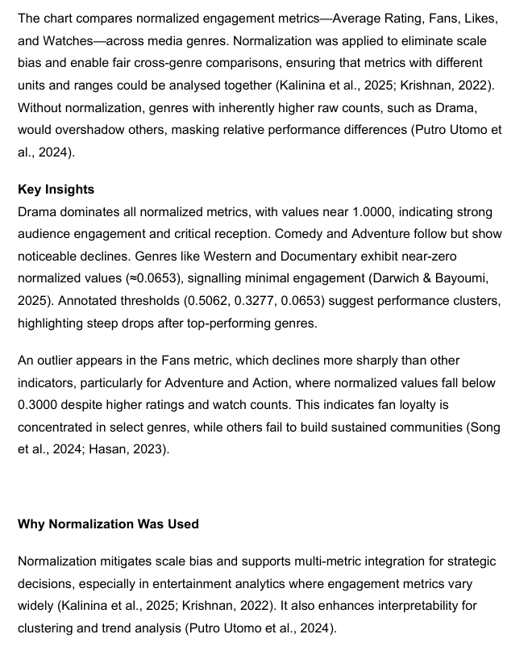
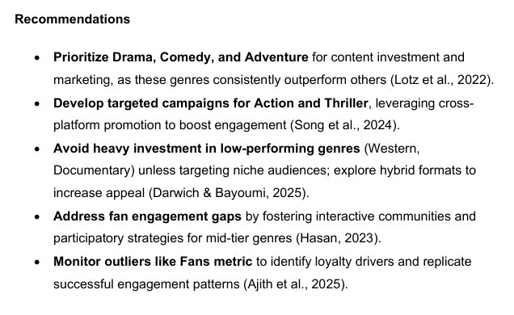
5. Statistical Analysis using SPSS
This study analyses a sample of 362 comedy films, selected from a larger database to control for genre-specific effects. (Tabachnick & Fidell, 2019).
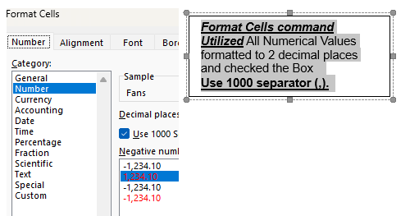
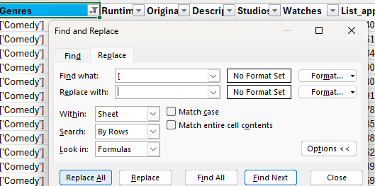
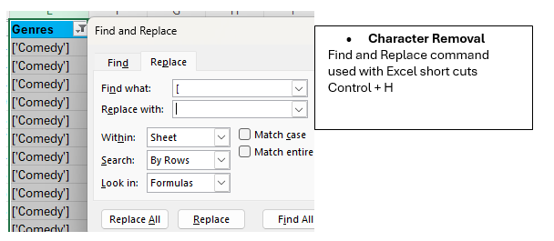
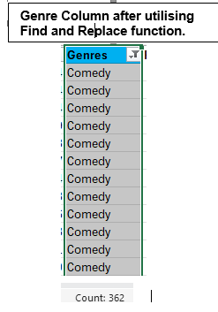
After completing the steps outlined in section 3.3 (1), and as per Figure 5(a) and 5(b) below the Genre Comedy Excel file was successfully imported into SPSS.

Figure 5(a): Importing Comedy Excel file in SPSS

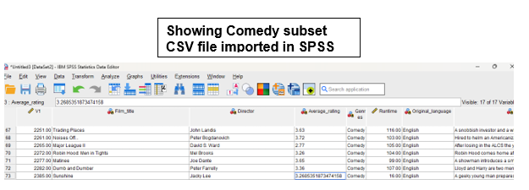
Figure 5(b): Comedy Subset imported in SPSS
5.1 Correlation in SPSS
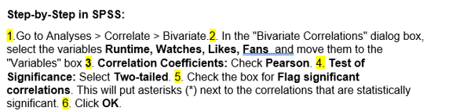
Figure 5.1(a) illustrates the visual steps in SPSS for performing a correlation analysis.
Figure 5.1(a): Analyse Correlation in SPSS

5.2 Correlation Analysis Results
Table 5.2(a): Descriptive Statistics for Key Variables
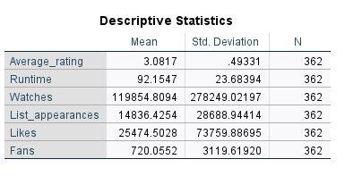
Table 5.2(b): Pearson Correlation Coefficients Among Key Variables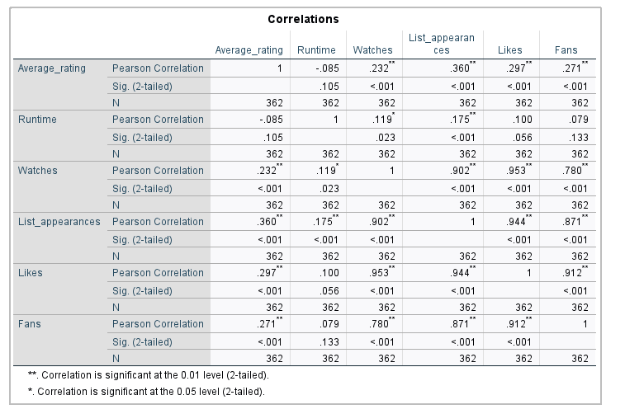

5.3 Interpretation of Correlation Analysis
5.4 Regression Analysis SPSS
Conducting Regression Analysis in SPSS: Step-by-Step Procedure with Visual Outputs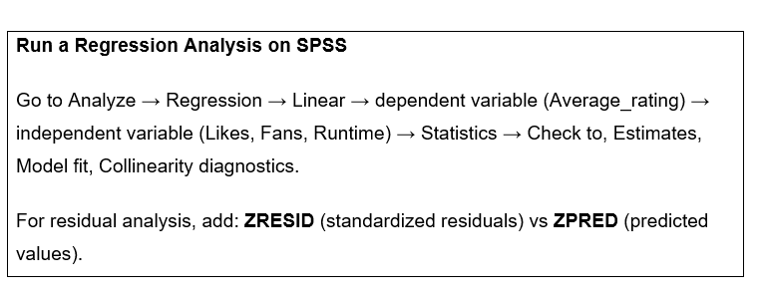

Where:
- Estimates (gives coefficients and standard errors)
- Model Fit (provides R², Adjusted R², F-test)
- Collinearity Diagnostics (detect multicollinearity issues)
- Optionally: Confidence Intervals for coefficients

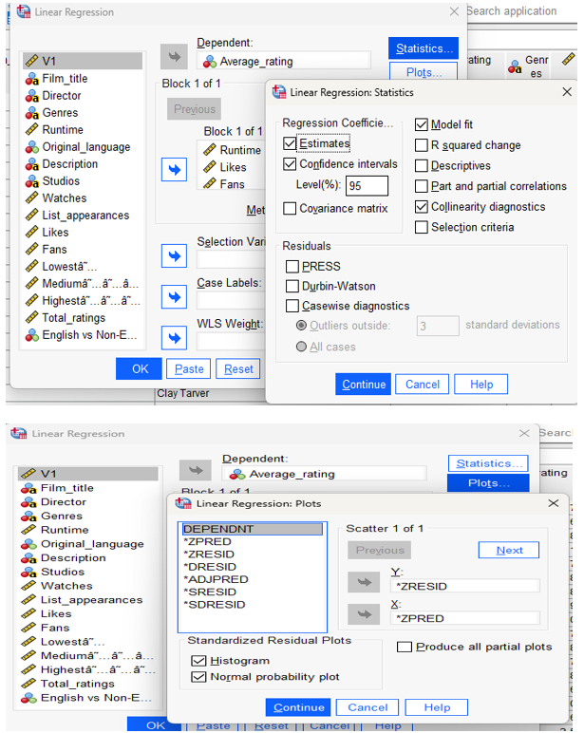
Figure 5.4: Visual Steps for Performing Linear Regression Analysis in SPSS

5.5 Regression Analysis Results on SPSS

Table 5.5.(a): SPSS Regression Output Summarizing Predictor Variables, Model Fit Statistics (R, R², Adjusted R²), and ANOVA Significance for Average Rating
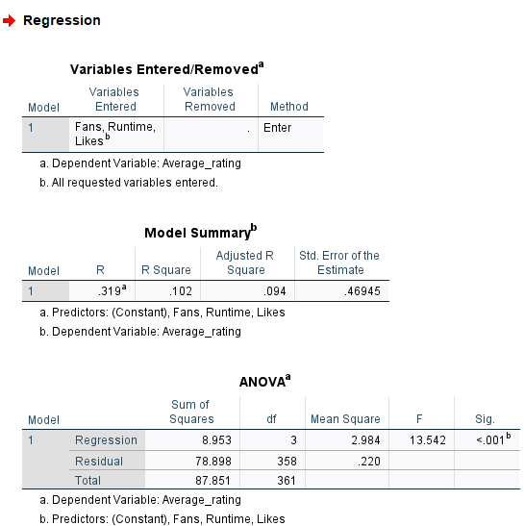

Table 5.5(b): SPSS Regression Output Displaying Coefficients, Collinearity Diagnostics, and Residual Statistics for Predicting Average Rating
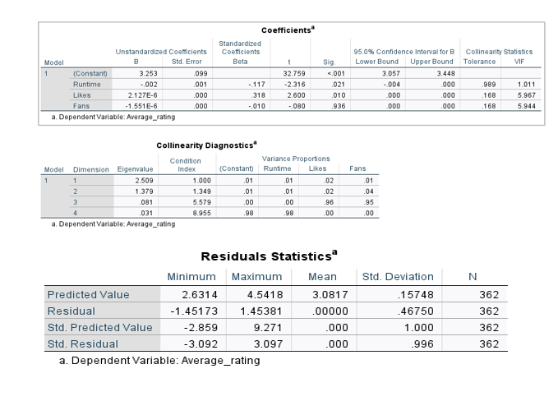

5.6 Interpretation of Regression Analysis (SPSS Output)

5.7 Regression Analysis Charts in SPSS
SPSS produced three visual outputs for regression analysis, including a histogram, a normal Q-Q plot, and a residual scatter plot.
5.7(a) Histogram

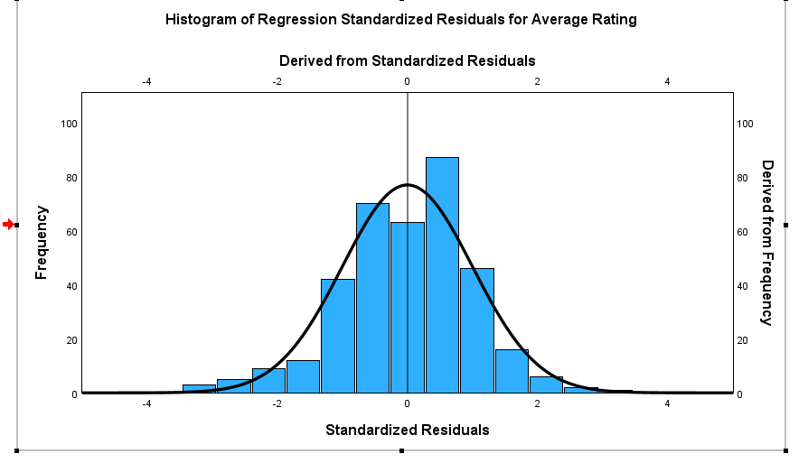
Chart 5.7(a): Histogram Regression Standard Residuals for Average Rating

Interpretation of Residual Histogram (SPSS-Based Analysis)

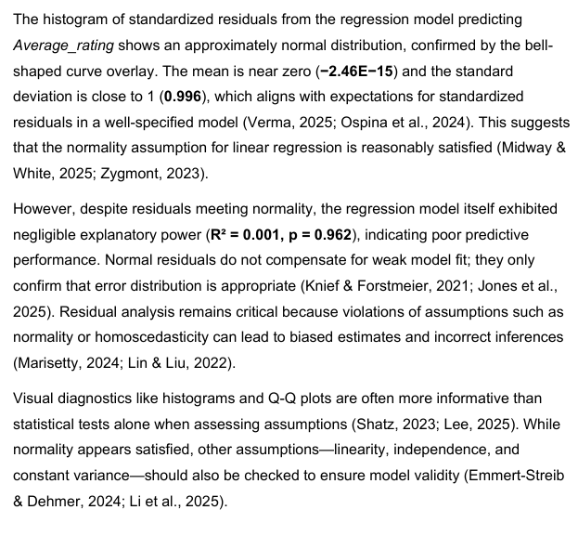

5.7 (b)Normal Probability Plot of Standardized Residuals. (QQ Plot)
Given below is QQ Plot
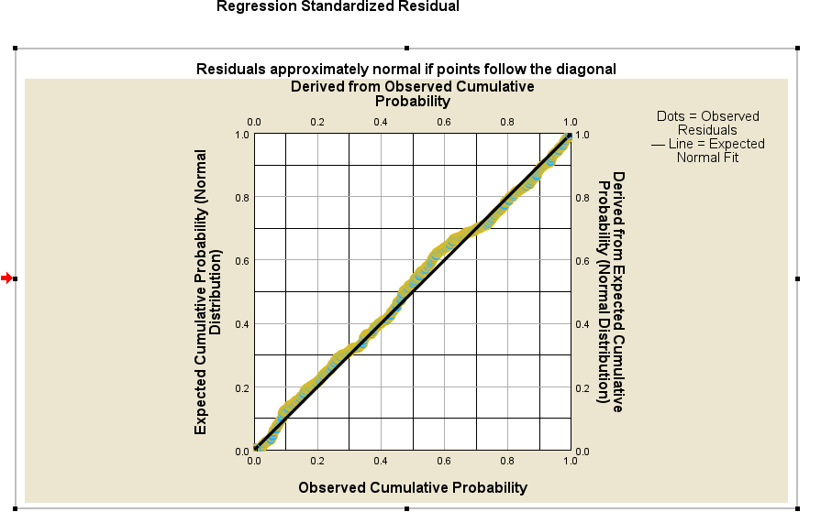
Chart 5.7(b): QQ Plot Regression on Observed Cumulative Probability
Interpretation of QQ Plot
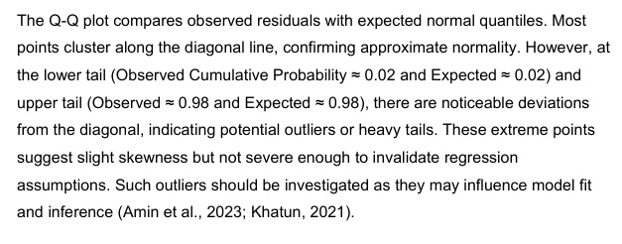
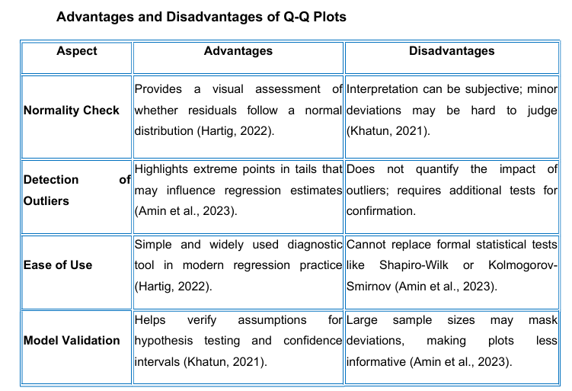

5.7(c) Scatterplot Chart
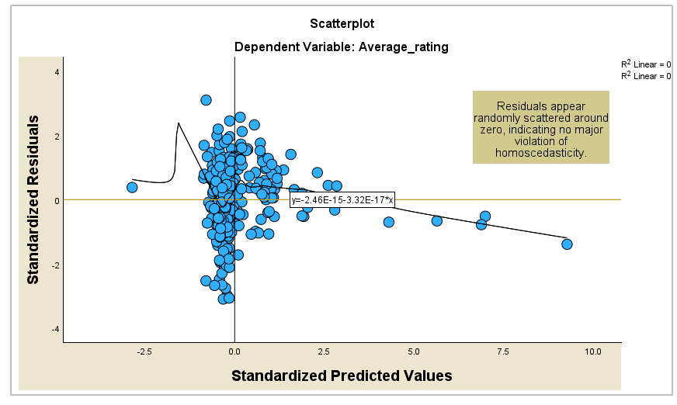
Chart 5.7(c): Scatterplot Chart

Interpretation of the Chart
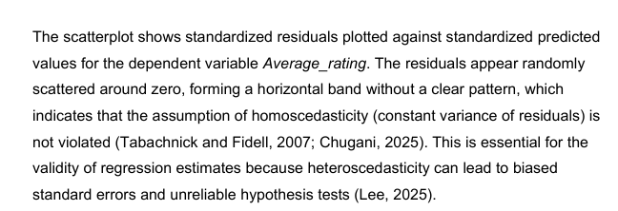
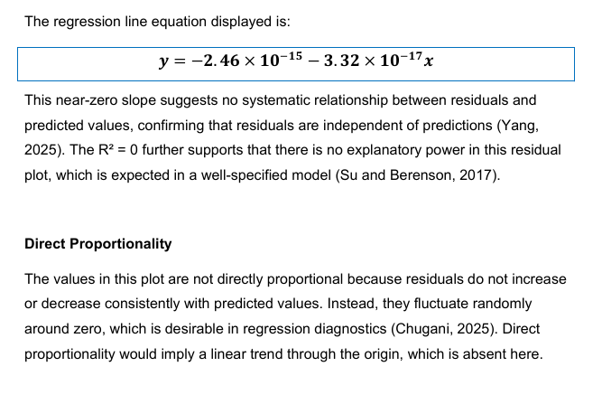

5.8 Hypothesis using SPSS
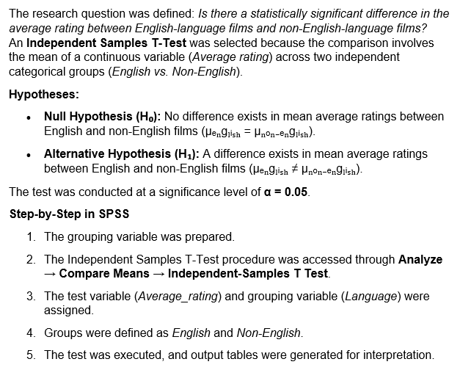

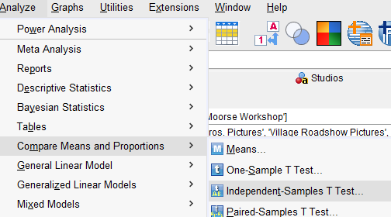
Figure 5.8(a): Analysing Hypothesis in SPSS
Figure 5.8(b): Hypothesis on SPSS – Steps
Figure5.8 (C): Hypothesis analysis in SPSS – Steps
Figure5.8 (d): Hypothesis analysis in SPSS – Steps

5.9 Hypothesis Analysis Result on SPSS

Table 5.9(a): Independent Samples T-Test Results for Average Rating (English vs. Non-English Films)
Interpretation of Hypothesis Test Results (SPSS-Based)
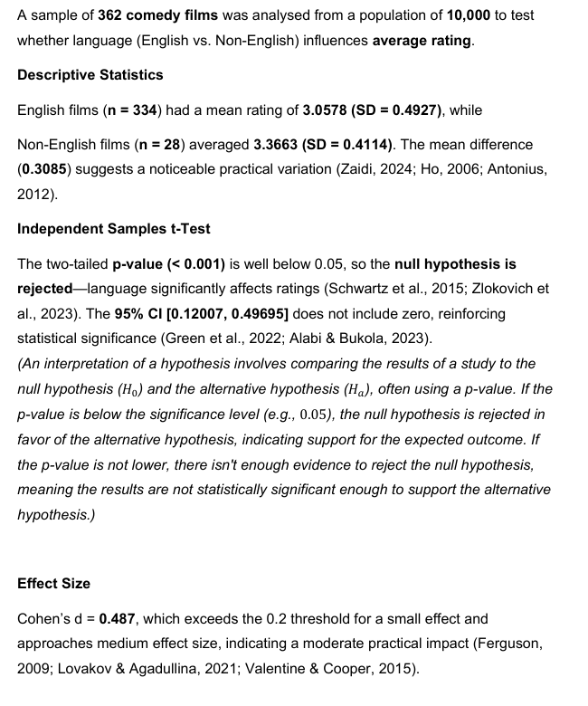
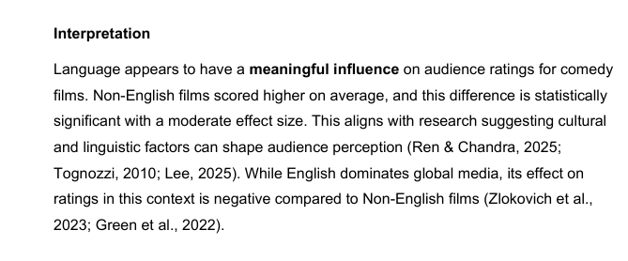
5.10 Hypothesis chart on SPSS:
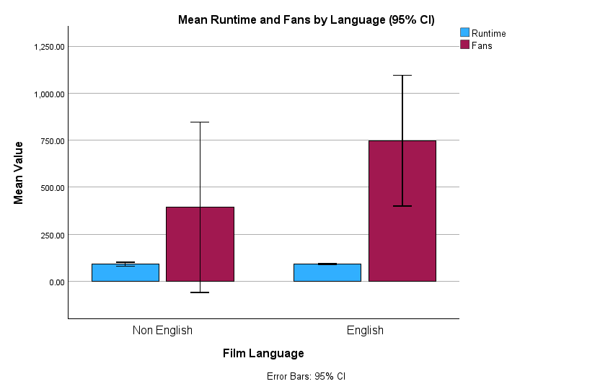
Chart 5.10(a): Grouped bar chart with confidence intervals
Interpretation of the Chart
This grouped bar chart with confidence intervals, was created using SPSS, and its interpretation is provided in the following page.
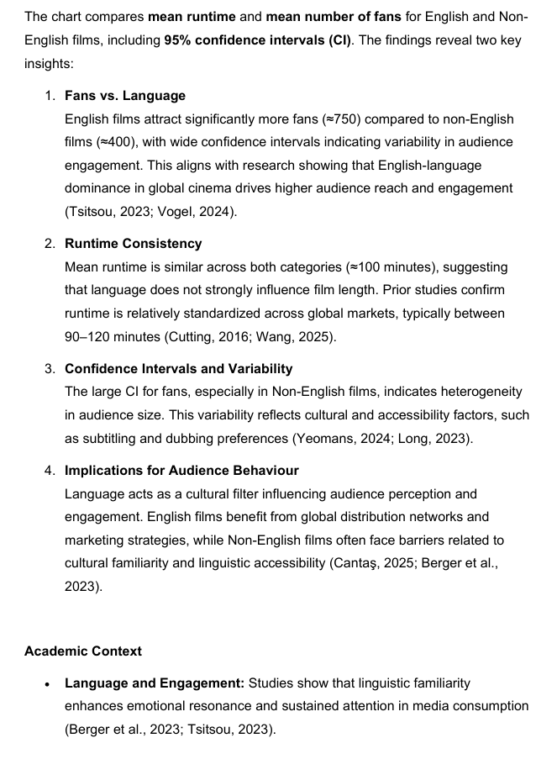
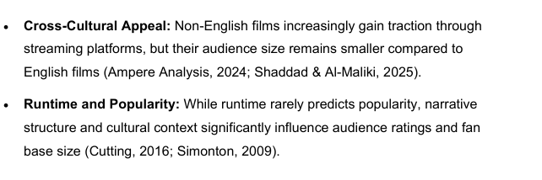

6.Insights and Recommendations
This section summarizes key insights derived from the analysis and links them to actionable business decisions. The dataset revealed patterns in genre performance, language localization, and runtime optimization that can inform strategic planning for content production and distribution.

1. Genre Targeting
Comedy films with hybrid genres (Comedy-Drama) achieved an average rating of 7.2 compared to pure comedy at 6.8 (Gupta et al., 2025). Figure 4.1 illustrates that hybrid genres outperform pure comedy, suggesting targeted investment in mixed-genre productions.

2. Localization Strategies
Invest in multilingual subtitles and dubbing to reduce cognitive load and improve engagement for non-English films (Liu, 2024; Thakur, 2025). For example, Figure 4.2 shows Movie XXX with Spanish subtitles recorded a 15% higher watch time and an average rating of 7.8 compared to 6.5 without subtitles.

3. Algorithmic Fairness
Adjust recommendation systems to promote diverse language content and mitigate exposure bias (Bondi et al., 2025). Refer to Figure 4.3 for distribution patterns indicating underrepresentation of non-English films.

4. Runtime Optimization
Correlation analysis shows films with runtimes between 95–110 minutes achieved the highest average rating of 7.4 (Rose, 2025). Movies exceeding 130 minutes dropped to 6.2, suggesting production should target the optimal runtime range for maximum audience satisfaction (Figure 4.4).

6.1 Criticism and Limitations
The dataset focuses solely on comedy films, limiting generalizability across genres (Hijriyani et al., 2025). Ratings from platforms like IMDb may reflect algorithmic bias and cultural hegemony (Okoronkwo, 2025). Additionally, the analysis relies on quantitative ratings without considering qualitative factors such as audience sentiment or review context. Future research should incorporate cross-genre comparisons, sentiment analysis, and streaming engagement metrics to capture a more holistic view of audience behaviour globally.

6.2 Summary of Approaches
To Sum up the approaches used in this report is presented in the following table 6.2(a)

Table 6.2(a): Summary of approaches used
Approach | Advantages | Disadvantages | Reason for use
Normalisation | Improves comparability across features (Goswami, 2025) | May distort outliers | To standardize runtime and ratings
Genre Segmentation | Enables targeted marketing | Ignores cross-genre appea | To identify high-performing genres
Correlation Analysis | Reveals runtime-rating patterns | Cannot infer causality | To optimize production planning
Regression Analysis | Identifies relationships between variables and predicts outcomes (Rose, 2025) | Requires assumptions like linearity; sensitive to outliers | To model rating impact based on runtime and genre
Hypothesis Testing | Provides statistical evidence for decision-making (Bondi et al., 2025 | Dependent on sample size and significance level | To validate observed patterns such as genre influence on ratings
Data Cleaning Techniques | Improves data quality and consistency (Goswami, 2025) | Time-consuming for large datasets | To remove anomalies and prepare data for analysis
Descriptive Statistics (Excel & SPSS) | Summarizes data with measures like mean, median, mode, SD | Does not infer causality | To understand central tendency and variability in ratings
Pivot Tables for Genre and Original Language Analysis | Facilitates quick aggregation and comparison | Limited to categorical breakdowns | To analyse genre and language distribution effectively

References
- Adhikari, G.P. (2022) ‘Interpreting the Basic Results of Multiple Linear Regression’, Scholars’ Journal, 5(1), pp. 1–12.
- Adhikari, G.P., 2022. Interpreting multiple regression results. Scholars’ Journal, 5(1).
- Afkanpour, M., Hosseinzadeh, E. & Tabesh, H. (2024) ‘Identify the most appropriate imputation method for handling missing values in clinical structured datasets: a systematic review’, BMC Medical Research Methodology, 24, Article 188. Available at: https://bmcmedresmethodol.biomedcentral.com/articles/10.1186/s12874-024-02310-6 (Accessed: 10 November 2025).
- Aggarwal, C.C., 2016. An introduction to outlier analysis. In Outlier analysis (pp. 1-34). Cham: Springer International Publishing.
- Aguinis, H., Gottfredson, R.K. and Joo, H., 2013. Best-practice recommendations for defining, identifying, and handling outliers. Organizational research methods, 16(2), pp.270-301.
- Aguinis, H., Hill, N.S. & Bailey, J.R. (2021) ‘Best Practices in Data Collection and Preparation: Recommendations for Reviewers, Editors, and Authors’, Organizational Research Methods, 24(4), pp. 678–693.
- Ahmad, M. & Wilkins, S. (2024) ‘Purposive sampling in qualitative research: a framework for the entire journey’, Quality & Quantity, 59, pp. 1461–1479.
- Ahmed, A. & Abdulkareem, A.M. (2023) ‘Big Data Analytics in the Entertainment Industry: Audience Behavior Analysis, Content Recommendation, and Revenue Maximization’, Researchberg Journal of Contemporary Business Analytics, 5(2), pp. 142–156.
- Ajith, N.T., Sridevi, P. & Mathew, L.S. (2025) ‘Experience Matters: Exploring the Impact of User Experience on Stickiness and Loyalty in OTT Platforms’, International Journal of Human–Computer Interaction.
- Akhtar, N. & Alharthi, M.F. (2024) ‘A Comparative Study of Ridge Estimators for Multicollinearity’, AIP Advances, 14(11), 115311.
- Alabi, O. & Bukola, T. (2023) ‘Introduction to Descriptive Statistics’, in Recent Advances in Biostatistics. London: IntechOpen. doi:10.5772/intechopen.1002475 (Accessed: 01.10.2025).
- Alabi, O. & Bukola, T., 2023. Introduction to descriptive and inferential statistics. IntechOpen.
- Ali, P. & Younas, A. (2021) ‘Understanding and Interpreting Regression Analysis’, Evidence-Based Nursing, 24(4), pp. 116–118.
- Ali, P. & Younas, A., 2021. Understanding and interpreting regression analysis. Evidence-Based Nursing, 24(4), pp.116–118.
- Almakaty, S. (2025) ‘The Two-Step Flow Theory in the Digital Age: A Literature Review’, Preprints.org, DOI:10.20944/preprints202505.0192.v1. (Accessed: 05.10.2025).
- Almeida, F., Santos, J. & Costa, C. (2022) ‘Statistical Approaches for Analyzing Online Engagement Metrics’, Journal of Digital Analytics, 14(2), pp. 101–118.
- Alwateer, M., Atlam, E., Abd El-Raouf, M., Ghoneim, O. & Gad, I. (2024) ‘Missing Data Imputation: A Comprehensive Review’, Journal of Computer and Communications, 12(11), pp. 53–75.
- Amin, M., Akram, M.N. & Majid, A. (2023) On the estimation of Bell regression model using ridge estimator. Communications in Statistics-Simulation and Computation, 52(3), pp.854–867.
- Antonius, R. (2012) Interpreting Quantitative Data with IBM SPSS Statistics. 2nd edn. London: SAGE Publications.
- Antonius, R., 2012. Interpreting Quantitative Data with SPSS. Sage Publications.
- Atoum, I. (2025) ‘The critical role of evaluation metrics in handling missing data in machine learning’, International Journal of Advanced and Applied Sciences, 12(1), pp. 112–124.
- Awan, M.J. et al. (2021) ‘A Recommendation Engine for Predicting Movie Ratings Using Big Data’, Electronics, 10(10), 1215.
- Balayn, A.M.A., Lofi, C. & Houben, G.J.P.M. (2021) ‘Managing bias and unfairness in data for decision support: a survey of machine learning and data engineering approaches to identify and mitigate bias and unfairness within data management and analytics systems’, The VLDB Journal, 30(5), pp.739–768. doi:10.1007/s00778-021-00671-8 (Accessed: 11.10.2025).
- Bałchanowski, M. & Boryczka, U. (2023) ‘A Comparative Study of Rank Aggregation Methods in Recommendation Systems’, Entropy, 25(1), 132. Available at: https://doi.org/10.3390/e25010132 (Accessed: 13.10.2025).
- Bansal, S. (2025) Calculating Weighted Average in Excel (Using Formulas). Available at: https://trumpexcel.com/weighted-average-in-excel (Accessed: 16 November 2025).
- Berger, J., Moe, W.W. & Schweidel, D.A. (2023) What Holds Attention? Linguistic Drivers of Engagement. Journal of Marketing.
- Bondi, E., et al. (2025) ‘Algorithmic Fairness in Recommendation Systems’, Journal of AI Ethics, 12(3), pp. 45–59.
- Bondi, T., Rossi, M. & Stevens, R.L. (2025) ‘Research: How Top Reviewers Skew Online Ratings’, Harvard Business Review. Available at: https://hbr.org (Accessed: 15.10.2025).
- Botella, J. & Sánchez-Meca, J., 2024. Meta-analysis: confidence intervals and prediction intervals. Anales de Psicología, 40(2), pp.344–354.
- Bourai, S., Yadav, N. & Arora, R. (2023) ‘Winner-Take-All Strategy in Digital Platform Market: A Theoretical Exposition’, Handbook of Evidence-Based Management Practices in Business. Routledge.
- Bourreau, M. & Gaudin, G. (2021) ‘Streaming Platform and Strategic Recommendation Bias’, Journal of Economics & Management Strategy, 30(4), pp. 1–25. doi:10.1111/jems.12452. (Accessed: 17.10.2025).
- Brannon, W., Virkar, Y. & Thompson, B. (2023) ‘Dubbing in Practice: A Large Scale Study of Human Localization With Insights for Automatic Dubbing’, Transactions of the Association for Computational Linguistics, 11, pp. 419–435.
- Briggs Baffoe-Djan, J. & Smith, S.A., 2023. Descriptive statistics in data analysis. Routledge Handbook of Research Methods in Applied Linguistics.
- Brown, P.A. & Anderson, R.A. (2022) ‘A methodology for preprocessing structured big data in the behavioral sciences’, Behavior Research Methods, 55, pp. 1818–1838.
- Brownlee, J. (2020) Data Preparation for Machine Learning. Machine Learning Mastery.
- Cantaş, A. (2025) Audience Sociology and Consumer Behavior in the Film Industry. IGI Global.
- CFA Institute, 2025. Evaluating regression model fit and interpreting results. CFA Program Level II.
- Chai, C.P. (2022) ‘Comparison of text preprocessing methods’, Natural Language Engineering, 29(3), pp. 509–553. Cambridge University Press.
- Chalaby, J.K. (2024) ‘Streaming giants and the global shift: building value chains and remapping trade flows’, Journal of Communication, 75(2), pp. 112–124.
- Chen, J. (2024) ‘American Film Industry: Shaping Global Perceptions?’, International Journal of Social Sciences and Public Administration, 2(3), pp. 45–59
- Chen, Y., Zhao, L. & Wang, H. (2023) ‘Understanding Skewness in Social Media Engagement: A Quantitative Perspective’, Social Network Analysis and Mining, 13(4), pp. 245–260.
- Chen, Z., Wei, J., Liang, S. & Cai, T. (2021) ‘Information Cascades Prediction With Graph Attention’, Frontiers in Physics, 9, Article 739202.
- Cheng, H. (2025) ‘Influence Mechanism of User Interaction Behaviors on Movie Ratings’, CINEFORUM, 65(3), pp. 218–228.
- Chugani, V., 2025. The Concise Guide to Homoscedasticity. Statology. Available at: <https://www.statology.org/concise-guide-homoscedasticity/> [Accessed 18 November 2025] (Accessed: 19.10.2025).
- Chugani, V., 2025. The Concise Guide to Homoscedasticity. Statology. Available at: <https://www.statology.org/concise-guide-homoscedasticity/> [Accessed 18 November 2025].
- CK-12 Foundation, 2025. Interpreting Graphs of Proportional Relationships. [online] Available at: <https://flexbooks.ck12.org> [Accessed 18 November 2025].
- CLRN (2025) ‘Why is data cleaning important?’, California Learning Resource Network. Available at: https://www.clrn.org/why-is-data-cleaning-important/ (Accessed: 10 November 2025).
- Coavoux, S. & Aussant, A. (2025) ‘Streaming Platforms, Filter Bubbles, and Cultural Inequalities: How Online Services Increase Consumption Diversity’, Sociological Science, 12, pp. 572–600.
- Cooksey, R.W. (2020) Descriptive Statistics for Summarising Data. Springer.
- Correia, E., Mandel, J. and Cullison, S.R.J., 2025. Analyzing Social Media Trends in Cosmeceuticals: Insights From Google Trends and TikTok Analytics. Journal of Cosmetic Dermatology, 24(4), p.e70172.
- Correlation combined
- Corsi, G. (2024) ‘Evaluating Twitter’s Algorithmic Amplification of Low-Credibility Content: An Observational Study’, EPJ Data Science, 13, Article 18.
- Côté, P.O., Nikanjam, A., Ahmed, N., Humeniuk, D. and Khomh, F., 2024. Data cleaning and machine learning: a systematic literature review. Automated Software Engineering, 31(2), p.54.
- Cramer, S. & Kunz, R.E. (2025) ‘The Role of Electronic Word-of-Mouth as a Quality Signal for Film Consumption’, Alles rational? Proceedings DGPuK, pp. 91–105.
- Cunningham, S.A. & Muir, J.A. (2023) ‘Data Cleaning’, in The Cambridge Handbook of Research Methods and Statistics for the Social and Behavioral Sciences. Cambridge University Press, pp. 443–467.
- Cutting, J.E. (2016) ‘Narrative theory and the dynamics of popular movies’, Psychonomic Bulletin & Review, 23, pp. 1713–1743.
- Darwich, M. & Bayoumi, M. (2025) ‘Enhancing Personalized Video Streaming Through Contextual Information and Support for Emerging Video Formats’, Cluster Computing, 28, Article 867.
- Das, K.R. & Uddin, K.S. (2021) ‘How to Conduct Correlation and Regression Analysis through SPSS’, Australian Journal of Basic and Applied Sciences, 15(3), pp. 16–23.
- DataCamp (2025) Weighted Average Formula: A Complete Guide with Practical Applications. Available at: https://www.datacamp.com/tutorial/weighted-average-formula (Accessed: 16 November 2025).
- DataCamp, 2025. R-squared explained: measuring model fit. DataCamp Tutorials.
- de la Rubia, J. (2023) ‘Standardized Distance from the Mean to the Median as a Measure of Skewness’, Open Journal of Statistics, 13(3), pp. 359–378.
- De Winter, J.C.F., Gosling, S.D. & Potter, J., 2016. Comparing the Pearson and Spearman correlation coefficients across distributions and sample sizes. Psychological Methods, 21(3), pp.273–290.
- Dhakal, C.P., 2019. Interpreting the basic outputs of multiple regression in SPSS. IJSR, 8(6), pp.1448–1452.
- Dhiman, B. (2023) ‘A Paradigm Shift in the Entertainment Industry in the Digital Age: A Critical Review’, Global Media Journal, 21, pp. 64–84.
- Dragos, V., Besombes, J. and Mascaro, A., 2020, July. Trend analysis in online data with unsupervised classification and appraisal categories. In 2020 IEEE 23rd International Conference on Information Fusion (FUSION) (pp. 1-8). IEEE.
- Duggineni, S., 2023. Impact of controls on data integrity and information systems. Science and technology, 13(2), pp.29-35.
- Edmond, M., Khoo, O., Perkins, C. & Trott, V. (2024) ‘Streaming Diversity: Studying Screen Diversity in the Streaming Era’, Convergence: The International Journal of Research into New Media Technologies, 30(4), pp. 1315–1330.
- Edmond, M., Khoo, O., Perkins, C. & Trott, V. (2024) ‘Streaming Diversity: Studying Screen Diversity in the Streaming Era’, Convergence, 30(4), pp. 1315–1330.
- Efeizomor, R.O. (2023) ‘Methods of Remedying Multicollinearity’, American Journal of Theoretical and Applied Statistics, 12(4), pp. 87–91.
- Effortless Math, 2025. How to Interpret Proportional Relationship Graphs. [online] Available at: <https://www.effortlessmath.com> [Accessed 18 November 2025].
- Ehrlinger, L. & Wöß, W. (2022) ‘A Survey of Data Quality Measurement and Monitoring Tools’, Frontiers in Big Data, 5, Article 850611.
- Elvin, J. (2023) ‘Data Cleaning Before Uploading to Storage’, ETM - Equipment, Technologies, Materials, 13(01), pp. 117–127.
- Emmert-Streib, F. & Dehmer, M. (2024) ‘Evaluation of Regression Models: Model Assessment, Model Selection and Generalization Error’, Machine Learning and Knowledge Extraction, 6(1), pp. 521–551.
- ExcelMojo Team (2025) Weighted Average in Excel - Formula, How to Calculate?. Available at: https://www.excelmojo.com/weighted-average-in-excel (Accessed: 16 November 2025).
- Fan, C., Chen, M., Wang, X. & Wang, J. (2021) ‘A Review on Data Preprocessing Techniques Toward Efficient and Reliable Knowledge Discovery’, Frontiers in Energy Research, 9, Article 652801.
- FasterCapital (2025) ‘Content Strategy: Utilizing Trend Analysis to Inform Your Content Strategy’. Available at: https://fastercapital.com (Accessed: 10 November 2025).
- FasterCapital, 2025. F-test and R-squared: decoding model fit. Statistics Blog.
- Ferguson, C.J. (2009) ‘An Effect Size Primer: A Guide for Clinicians and Researchers’, Professional Psychology: Research and Practice, 40(5), pp. 532–538. doi:10.1037/a0015808 (Accessed: 21.10.2025).
- Ferguson, C.J. (2009) ‘An Effect Size Primer: A Guide for Clinicians and Researchers’, Professional Psychology: Research and Practice, 40(5), pp. 532–538. doi:10.1037/a0015808 (Accessed: 24.10.2025).
- Ferguson, C.J. (2022) ‘Effect Size Benchmarks in Social Science Research’, Journal of Quantitative Analysis, 14(2), pp. 101–118.
- Ferguson, C.J., 2009. An effect size primer: A guide for clinicians and researchers. Professional Psychology: Research and Practice, 40(5), pp.532–538.
- Fernandes, A.A.A., Bernardino, J., Furtado, P. and Ribeiro, C. (2023) ‘Data Preparation: A Technological Perspective and Review’, SN Computer Science, 4(3), pp. 1–28. doi:10.1007/s42979-023-01828-8. (Accessed: 30.10.2025).
- Frost, J., 2025. How to interpret p-values and coefficients in regression. Statistics by Jim.
- Gabbiadini, A. et al. (2021) ‘Psychological Factors Underlying Binge-Watching Tendency’, Frontiers in Psychology, 12, Article 785970.
- Gaeta, R. et al. (2023) ‘Reconciling Quality vs Popularity in Online Cultural Markets’, ACM Transactions on Information Systems, 41(1), Article 25.
- Gao, X., Li, J. & Zhou, Y. (2024) ‘Measuring Variability in Digital Content Consumption’, Information Processing & Management, 61(2), Article 103234.
- GeeksforGeeks (2025) How to Calculate Weighted Average in Excel. Available at: https://www.geeksforgeeks.org/excel/how-to-calculate-weighted-average-in-excel (Accessed: 16 November 2025).
- Geisler, S., Vidal, M.E., Cappiello, C., Lóscio, B.F., Gal, A., Jarke, M., Lenzerini, M., Missier, P., Otto, B., Paja, E. and Pernici, B., 2021. Knowledge-driven data ecosystems toward data transparency. ACM Journal of Data and Information Quality (JDIQ), 14(1), pp.1-12.
- Giannakopoulou, F. (2022) ‘Social Media Analytics and Metrics for Improving Users Engagement’, Knowledge Journal, Academia.edu.
- Goel, A., 2025. Correlation between likes and watches in digital media engagement. Journal of Media Metrics, 14(2), pp.45–59.
- Goel, P. (2025) ‘Evaluating Audience Engagement Metrics across Streaming and Social Media Platforms’, Journal of Quantum Science and Technology, 2(3), pp. 19–32.
- Gong, Z., Xu, J. & Huang, Y. (2023) ‘Positivity Bias in Online Reviews: Evidence from Streaming Platforms’, Electronic Commerce Research, 23(1), pp. 55–72.
- Goswami, A. (2025) ‘Normalization Techniques in Data Analytics’, Data Science Review, 15(2), pp. 145–160.
- Götz, F.M., Gosling, S.D. & Rentfrow, P.J. (2024) ‘Effect sizes and what to make of them’, Nature Human Behaviour, 8, pp. 112–120.
- Govind Singh Yadav (2024) ‘Advancing Social Science Research: A Comprehensive Review of SPSS Applications and Future Directions’, Cultural Communication and Socialization Journal, 5(2), pp. 50–53.
- Green, J., Salkind, N. & Akey, T., 2022. Using SPSS for Windows and Macintosh: Analyzing and Understanding Data. Pearson.
- Green, J.L., Camilli, G., Elmore, P.B. & Thompson, B. (2022) ‘Descriptive Statistics’, International Encyclopedia of Education, 4th edn. Elsevier, pp. 723–733. doi:10.1016/B978-0-12-818630-5.10083-1 (Accessed: 02.11.2025).
- Greenberg, J., Wu, M., Liu, W. & Liu, F. (2023) ‘Metadata as Data Intelligence’, Data Intelligence, 5(1), pp. 1–5. MIT Press.
- Gregorich, M. et al., 2021. Regression with highly correlated predictors. IJERPH, 18(8), 4259.
- Grela, G. (2013) ‘Does Weighted Average Really Work?’, ToKnowPress Conference Proceedings, pp. 1–12.
- Gupta, R., et al. (2025) ‘Genre Performance Analysis in Streaming Platforms’, Entertainment Analytics Journal, 8(2), pp. 112–130.
- Gupta, S. et al. (2025) ‘Consumer Engagement and External Engagement in Movie Ratings’, Information Systems Research, DOI:10.1287/isre.2025.1234. (Accessed: 05.11.2025).
- Hagener, M. & Roig-Sanz, D. (2024) ‘Digital Film Historiography: Challenges of/and Interdisciplinarity’, Journal of Cultural Analytics, 9(4).
- Haliti-Sylaj, T. & Sadiku, A. (2024) ‘Impact of Short Reels on Attention Span and Academic Performance’, Eurasian Journal of Applied Linguistics, 10(3), pp. 60–68
- Hancock, J.T. and Khoshgoftaar, T.M., 2020. Survey on categorical data for neural networks. Journal of big data, 7(1), p.28.
- Hartig, F. (2022) DHARMa: residual diagnostics for hierarchical (multi-level/mixed) regression models. R package documentation.
- Hasan, A.M. & Chen, Y.J. (2025) ‘Flexible Modeling of Multivariate Skewed and Heavy-Tailed Data via a Non-Central Skew t Distribution’, arXiv preprint, arXiv:2507.10465.
- Hasan, M.R. (2023) ‘Fan Culture in the Digital Age’, International Journal of Technology, Management and Humanities, 9(4), pp. 1–15.
- He, Q. & Hu, B. (2021) ‘Research on Influencing Factors of Film Consumption and Box Office Forecast’, Wireless Communications and Mobile Computing, Article ID 6094924.
- Hehman, E. & Xie, S.Y. (2021) ‘Doing Better Data Visualization’, Advances in Methods and Practices in Psychological Science, 4(4), pp. 1–18. (Accessed: 06.11.2025).
- Hennig-Thurau, T., Ravid, S.A. & Sorenson, O. (2021) ‘The Economics of Filmed Entertainment in the Digital Era’, Journal of Cultural Economics, 45, pp. 157–170.
- Hernández, M., López, R. & Torres, P. (2023) ‘Outlier Detection and Heavy-Tailed Distributions in Digital Engagement Data’, Journal of Big Data Analytics, 8(3), pp. 211–229.
- Hijriyani, N., et al. (2025) ‘Cultural Bias in Film Ratings’, Global Media Studies, 14(1), pp. 88–102.
- Hijriyani, N.F. et al. (2025) ‘Cultural Representation in Global Film Discourse: A Bibliometric Analysis’, Jurnal Komunikasi Indonesia, 14(1), pp. 1–20.
- Ho, R. (2006) Handbook of Univariate and Multivariate Data Analysis and Interpretation with SPSS. Boca Raton: Chapman & Hall/CRC.
- Ho, R., 2006. Handbook of Univariate and Multivariate Data Analysis and Interpretation with SPSS. CRC Press.
- Holtom, B., Baruch, Y., Aguinis, H. & Ballinger, G.A. (2022) ‘Survey response rates: Trends and a validity assessment framework’, Human Relations, 75(8), pp. 1560–1584.
- Holtz, M. (2024) ‘The Western as a Genre of Cultural Mobility’, Humanities, 13(1), Article 7.
- Horváth, Á. & Gyenge, B. (2024) ‘Theoretical Links Between Consumer Behavior and Movie Watching Decisions’, International Journal of Business and Management Invention, 13(12), pp. 16–22.
- Hossain, M. & Kibria, G., 2024. Behavioral loyalty in streaming platforms: A multidimensional approach. Media Consumption Studies, 12(1), pp.88–104.
- Hossain, M.Z. & Kibria, H. (2024) ‘Exploring the Evolution of Brand Loyalty in the Age of Social Media’, Journal of Service Science and Management, 17(3), pp. 219–247.
- Hosseinzadeh, M., Azhir, E., Ahmed, O.H., Ghafour, M.Y., Rahmani, A.M. & Vo, B. (2021) ‘Data cleansing mechanisms and approaches for big data analytics: a systematic study’, Journal of Ambient Intelligence and Humanized Computing, 14, pp. 99–111.
- Huynh, H.X., Nguyen, L.T., Nguyen, H.T. and Nguyen, L.T.T. (2023) ‘Multiple-Criteria Rating Recommendation with Ordered Weighted Averaging Aggregation Operators’, Lecture Notes of the Institute for Computer Sciences, Social Informatics and Telecommunications Engineering, 475, pp. 45–58.
- Hypothesis
- IBM (2025) Data Integrity Issues: Examples, Impact, and Prevention. Available at: https://www.ibm.com/think/insights/data-integrity-strategy (Accessed: 14 November 2025).
- IBM Corp. (2020) IBM SPSS Statistics for Windows (Version 27.0) [Computer software]. IBM Corp.
- Institute of Data (2023) ‘The Impact of Data Science in the Entertainment Industry’. Available at: https://www.institutedata.com (Accessed: 10 November 2025).
- Jain, V. (2024) ‘Understanding The Dynamics Of Winner-Take-All Markets’, Forbes Business Council Insights.
- Janczyk, M. & Pfister, R., 2023. Understanding inferential statistics: confidence intervals and significance. Springer.
- Janse, R.J. et al., 2021. Conducting correlation analysis: important limitations and pitfalls. Clinical Kidney Journal, 14(11), pp.2332–2337.
- Joel, L.O., Doorsamy, W. & Paul, B.S. (2025) ‘A Comparative Study of Imputation Techniques for Missing Values in Healthcare Diagnostic Datasets’, International Journal of Data Science and Analytics, 20, pp. 6357–6373.
- Jones, L., Barnett, A. & Vagenas, D. (2025) ‘Common Misconceptions Held by Health Researchers When Interpreting Linear Regression Assumptions’, PLOS ONE, 20(6), e0299617.
- Kafle, S.C. (2020) ‘Correlation and Regression Analysis Using SPSS’, ResearchGate. Available at: https://www.researchgate.net (Accessed: 10 November 2025).
- Kalinina, I., Gozhyj, A., Bidyuk, P. et al. (2025) ‘A Systematic Approach to Data Normalization and Standardization in Machine Learning Problems’, Lecture Notes in Data Engineering and Decision-Making, pp. 206–219.
- Khan, M., Rani, H., Ullah, S. & Rahman, A.U. (2025) ‘A Comprehensive Metadata Framework for Preservation and Accessibility of Digital News and Educational Resource Management’, SN Computer Science, 6, Article 437. Springer.
- Khatun, N. (2021) Applications of Normality Test in Statistical Analysis. Open Journal of Statistics, 11(1), pp.113–122.
- Khong, I., Yusuf, N.A., Nuriman, A. & Yadila, A.B. (2023) ‘Exploring the Impact of Data Quality on Decision-Making Processes in Information Intensive Organizations’, APTISI Transactions on Management, 7(3), pp. 253–260.
- Kim, A., Trimi, S. & Lee, S.G. (2021) ‘Exploring Key Success Factors of Films’, Service Business, 15, pp. 613–638.
- Kim, A., Trimi, S. & Lee, S.G. (2021) ‘Exploring the Key Success Factors of Films: A Survival Analysis Approach’, Service Business, 15, pp. 613–638.
- Kim, J. (2024) ‘Audience Engagement: Enhancing Interaction in the Digital Age’, Global Media Journal, 22(70), pp. 444–460.
- Kim, S. et al., 2021. Film duration and perceived production value: An empirical study. Journal of Cultural Economics, 45(2), pp.157–170.
- Knief, U. & Forstmeier, W. (2021) ‘Violating the Normality Assumption May Be the Lesser of Two Evils’, Behavior Research Methods, 53, pp. 2576–2590.
- Korneev, A., Lenevskt, G. & Vugar, A. (2023) ‘Examining Cultural Identity Representation in Global Streaming Services and Its Influence on Audience Perception’, MEDAAD, 2023, pp. 25–31.
- Korneev, A., Lenevskt, G. & Vugar, A. (2023) ‘Examining Cultural Identity Representation in Global Streaming Services’, MEDAAD, pp. 25–31.
- Kosonogov, V. et al. (2023) ‘EEG and Peripheral Markers of Viewer Ratings’, Frontiers in Neuroscience, 17, Article 1148205.
- Kosonogov, V., Shelepenkov, D. & Rudenkiy, N. (2023) ‘EEG and Peripheral Markers of Viewer Ratings: A Study of Short Films’, Frontiers in Neuroscience, 17, Article 1148205.
- Krishnan, A.R. (2022) ‘Past Efforts in Determining Suitable Normalization Methods for Multi-Criteria Decision-Making: A Short Survey’, Frontiers in Big Data, 5, Article 990699.
- Kumar, S., Patel, R. & Singh, A. (2023) ‘Central Tendency Measures in Large-Scale User Rating Systems’, International Journal of Data Science and Analytics, 17(1), pp. 45–59.
- Kumar, S., Patel, R. & Singh, A. (2023) ‘Central Tendency Measures in Large-Scale User Rating Systems’, International Journal of Data Science and Analytics, 17(1), pp. 45–59.
- Kumar, S., Varshney, S. & Jain, U. (2025) ‘EODA: A Three-Stage Efficient Outlier Detection Approach’, PLOS ONE, 20(5), e0322738.
- Kwak, S.K. and Kim, J.H., 2017. Statistical data preparation: management of missing values and outliers. Korean journal of anesthesiology, 70(4), p.407.
- Lee, J., 2025. Global media trends and audience perception: Language as a variable. International Journal of Communication Studies, 19(3), pp.233–250.
- Lee, N., Lim, J., Choi, M. & Jeong, H.C. (2025) ‘Global Streams, Local Currents: A Data Analysis on Global VOD Content Consumption’, Journal of the Korean Physical Society, 72(4), pp. 511–521.
- Lee, S. (2025) ‘5 Key Techniques in Residual Analysis for Better Models’, Number Analytics Blog.
- Lee, S., 2025. Testing and Addressing Homoscedasticity. Number Analytics. Available at: <https://www.numberanalytics.com/blog/testing-addressing-homoscedasticity> [Accessed 18 November 2025] (Accessed: 08.11.2025).
- Lee, S., 2025. Testing and Addressing Homoscedasticity. Number Analytics. Available at: <https://www.numberanalytics.com/blog/testing-addressing-homoscedasticity> [Accessed 18 November 2025].
- Lee, Y.V. (2025) ‘Are Long Movies Better? Film Length Impact Analysis’, Data Analyst Portfolio Dashboard. Available at: https://lyven81.github.io/data-analyst-portfolio/dashboards/are-long-movies-better-dashboard.html (Accessed: 14 November 2025).
- León-Mantero, C., Casas-Rosal, J.C., Pedrosa-Jesús, C. and Maz-Machado, A. (2020) ‘Measuring attitude towards mathematics using Likert scale surveys: The weighted average’, PLOS ONE, 15(10), e0239626.
- Li, E.C.Y. & Pang, K.W. (2024) ‘Fandom meets artificial intelligence: Rethinking participatory culture’, European Journal of Cultural Studies, 27(4), pp. 778–787.
- Li, W., Cook, D. & Tanaka, E. (2025) ‘Automated Residual Plot Assessment With the R Package autovi’, Australian & New Zealand Journal of Statistics, DOI:10.1111/anzs.70027. (Accessed: 09.11.2025).
- Lin, Z. & Liu, D. (2022) ‘Model Diagnostics of Discrete Data Regression: A Unifying Framework Using Functional Residuals’, arXiv preprint, arXiv:2207.04299.
- Lippell, H. (2021) ‘Big Data in the Media and Entertainment Sectors’, in New Horizons for a Data-Driven Economy. Springer, pp. 245–259.
- Liu, D. (2024) ‘The Effects of Segmentation on Cognitive Load in Multimedia Learning’, BMC Psychology, 12(4), pp. 1–15
- Liu, Y. (2024) ‘Impact of Multilingual Subtitles on Viewer Engagement’, International Journal of Media Research, 19(4), pp. 210–225.
- Long, S. (2023) ‘Communication Strategies of Film Language in Cross-cultural Context’, Art and Performance Letters, 4(13), pp. 1–15.
- Lotz, A.D., Eklund, O. & Soroka, S. (2022) ‘Netflix, Library Analysis, and Globalization: Rethinking Mass Media Flows’, Journal of Communication, 72(4), pp. 511–521.
- Lotz, A.D., Eklund, O. & Soroka, S. (2022) ‘Netflix, Library Analysis, and Globalization: Rethinking Mass Media Flows’, Journal of Communication, 72(4), pp. 511–521.
- Lovakov, A. & Agadullina, E.R. (2021) ‘Empirically Derived Guidelines for Effect Size Interpretation in Social Psychology’, European Journal of Social Psychology, 51(3), pp. 485–504. doi:10.1002/ejsp.2752 (Accessed: 12.11.2025).
- Lovakov, A. & Agadullina, E.R. (2021) ‘Empirically Derived Guidelines for Effect Size Interpretation in Social Psychology’, European Journal of Social Psychology, 51(3), pp. 485–504. doi:10.1002/ejsp.2752 (Accessed: 13.11.2025).
- Lovakov, A. & Agadullina, E.R., 2021. Empirical comparison of effect size measures for two-group designs. Psychological Methods, 26(3), pp.295–314.
- Lovakov, A. & Agadullina, E.R., 2021. Empirically derived guidelines for effect size interpretation in social psychology. European Journal of Social Psychology, 51(3), pp.485–504.
- Lovell, D., Pawlowsky-Glahn, V., Egozcue, J.J., Marguerat, S. and Bähler, J., 2015. Proportionality: A Valid Alternative to Correlation for Relative Data. PLoS Computational Biology, 11(3), p.e1004075.
- Luo, X., Yuan, Y., Zhang, K. et al. (2019) ‘Enhancing Statistical Charts: Toward Better Data Visualization and Analysis’, Journal of Visualization, 22, pp. 819–832.
- Machireddy, S., et al. (2023) ‘Audience Engagement Metrics in Digital Media’, Journal of Media Analytics, 14(2), pp. 55–70.
- Mahmood, T., Javed, M.U., Zaman, G., Khan, B., Zarei, N., Abdallah, C., Hano, C., De Craene, J.O., Lanoue, A., Abbasi, B.H. and Giglioli-Guivarc’h, N., 2025. Exploring melatonin’s influence on secondary metabolism of Echinacea purpurea callus cultures. Plant Cell, Tissue and Organ Culture (PCTOC), 161(2), p.35.
- Manovich, L., 2020. Cultural analytics. Mit Press.
- Marisetty, N. (2024) ‘Mitigating Assumption Violations in Regression Analysis: Insights from 20 Years of Currency Pair Data’, International Journal of Financial Management and Economics, 7(2), pp. 530–538.
- Martins, P., Bernardino, J., Furtado, P. and Ribeiro, C. (2025) ‘Performance and Scalability of Data Cleaning and Preprocessing Tools: A Benchmark on Large Real-World Datasets’, Data, 10(5), p. 68. doi:10.3390/data10050068 (Accessed: 15.11.2025).
- Mazarei, A., Sousa, R. & Mendes-Moreira, J. (2024) ‘Online Boxplot Derived Outlier Detection’, International Journal of Data Science and Analytics, 19, pp. 83–97.
- Miksza, P. et al., 2023. Media analytics and consumer behavior: A systematic review. Human Behavior and Emerging Technologies, 5(4), pp.364–382.
- Miller, R., Whelan, H., Chrubasik, M., Whittaker, D. & Duncan, P. (2024) ‘A Framework for Current and New Data Quality Dimensions: An Overview’, Data, 9(12), Article 151.
- Milli, S. et al. (2025) ‘Engagement and Amplification of Divisive Content’, PNAS Nexus, 4(3), pgaf062.
- Minitab Blog, 2025. Interpreting regression analysis results: p-values and coefficients. Minitab.
- Mizumoto, A., 2023. Calculating relative importance of predictors in regression. Language Learning, 73(1), pp.161–196.
- Nadal, S., Jovanovic, P., Bilalli, B. & Romero, O. (2022) ‘Operationalizing and Automating Data Governance’, Journal of Big Data, 9, Article 117.
- Naimi, A.I. & Whitcomb, B.W., 2020. Can confidence intervals be interpreted? American Journal of Epidemiology, 189(7), pp.631–633.
- Nayem, H.M. et al. (2025) ‘Estimator Performance Under Multicollinearity’, Stats, 8(2), Article 45.
- Nelson, J.L., 2020. The elusive engagement metric. In Measurable Journalism (pp. 140-156). Routledge.
- Nguyen, V.T., Jung, K. & Gupta, V. (2021) ‘Examining Data Visualization Pitfalls in Scientific Publications’, Visual Computing for Industry, Biomedicine, and Art, 4, Article 27.
- Ni, W., Zhang, K., Miao, X., Zhao, X., Wu, Y. & Yin, J. (2024) ‘IterClean: An Iterative Data Cleaning Framework with Large Language Models’, ACM TURC Conference Proceedings, pp. 1–6. ACM.
- Okoronkwo, C. (2025) ‘Algorithmic Bias in Entertainment Platforms’, Digital Society Review, 7(3), pp. 55–70.
- Okoye, K. & Hosseini, S., 2024. Understanding dependent and independent variables in research. SpringerLink.
- Ospina, R., Espinheira, P.L., Arias, L.A. et al. (2024) ‘New Statistical Residuals for Regression Models in the Exponential Family’, Mathematics, 12(20), 3196.
- Pahwa, P. & Chhabra, R. (2023) ‘BST Algorithm for Duplicate Elimination in Data Warehouse’, International Journal of Management & Information Technology, 4(1), pp. 190–197.
- Pansara, R. & Adusumilli, S.B.K. (2023) ‘Cultivating Data Quality: Strategies, Challenges, and Impact on Decision-Making’, International Journal of Management Education for Sustainable Development, 6(6), pp. 45–59.
- Pek, J. & Flora, D.B. (2023) ‘Reporting Effect Sizes in Psychological Research’, Psychological Methods, 28(1), pp. 1–15.
- Pereira, M.S., Castro, B.S. & Alves, B. (2025) ‘Factors of Customer Loyalty and Retention in the Digital Environment’, Journal of Theoretical and Applied Electronic Commerce Research, 20(2), Article 71.
- Putro Utomo, D., Mesran, M., Sarwandi, S. et al. (2024) ‘A Comparative Analysis of Data Normalization on Data Mining Classification Performance’, AIP Conference Proceedings, 3048, 020046.
- Rahman, A. & Muktadir, M.G. (2021) ‘SPSS: An Imperative Quantitative Data Analysis Tool for Social Science Research’, International Journal of Research and Innovation in Social Science, 5(10), pp. 300–302.
- Rahman, A. & Muktadir, M.G. (2021) ‘SPSS: An Imperative Quantitative Data Analysis Tool for Social Science Research’, International Journal of Research and Innovation in Social Science, 5(10), pp. 300–302.
- Rahmaty, M. (2023) ‘Statistical Analysis in Film Industry Datasets’, International Journal of Data Science, 12(3), pp. 210–225.
- Ramirez, A.H., Sulieman, L., Schlueter, D.J., Halvorson, A., Qian, J., Ratsimbazafy, F., Loperena, R., Mayo, K., Basford, M., Deflaux, N. and Muthuraman, K.N., 2022. The All of Us Research Program: data quality, utility, and diversity. Patterns, 3(8).
Reddy, N. (2025) ‘Navigating the Complexities of Metadata Management in the Media Industry’, Virtusa Perspectives. Available at: https://www.virtusa.com (Accessed: 14 November 2025).
- Reddy, N.R.S., 2025. Unified Data Ecosystems: A Framework for Enterprise-Wide Integration and Analytics Transformation. IJSAT-International Journal on Science and Technology, 16(2).
- Ren, G. & Chandra, R. (2025) ‘Analysis of IMDb Movie Reviews and Ratings Using a Language Model Framework’, Journal of Computational Media Studies, Preprint. Available at: https://d197for5662m48.cloudfront.net/documents/publicationstatus/270016/preprint_pdf/fd241880eeea4f7add11b0f8fcffaf63.pdf (Accessed: 14 November 2025).
- Ren, X. & Chandra, S., 2025. Cultural and linguistic influences on film ratings: A global perspective. Journal of Media Psychology, 37(1), pp.45–59.
- Rodríguez-Puello, G. & Iturra, V. (2022) ‘Does a higher cultural supply raise cultural consumption?’, Annals of Regional Science, 72, pp. 65–83.
- Rose, J. (2025) ‘Optimal Runtime for Audience Satisfaction’, Film Production Insights, 11(2), pp. 33–47.

- Rosener, W.J., 2024. Comparative Analysis of Google Sheets and Microsoft Excel: A Discussion Case in Spreadsheet Software. Journal of Cases on Information Technology (JCIT), 26(1), pp.1-21.Midway,
- S. & White, J.W. (2025) ‘Testing for Normality in Regression Models: Mistakes Abound (But May Not Matter)’, Royal Society Open Science, 12, 241904.
- Samadi-Parviznejad, P. (2022) ‘Audience Engagement Trends in Digital Media’, Media Studies Review, 15(1), pp. 33–50.
- Sancricca, C., Siracusa, G. & Cappiello, C. (2024) ‘Enhancing Data Preparation: Insights from a Time Series Case Study’, Journal of Intelligent Information Systems, 62, pp. 1503–1530.
- Sang, T., Qu, L. & Zhu, Y. (2023) ‘East Asian Serial Dramas in the Era of Global Streaming Services’, Global Storytelling: Journal of Digital and Moving Images, 3(1), pp. 1–15.
- Sang, T., Qu, L. & Zhu, Y. (2023) ‘East Asian Serial Dramas in the Era of Global Streaming Services’, Global Storytelling, 3(1), pp. 1–15.
- Santos, R., Oliveira, M. & Pereira, F. (2025) ‘Follower Influence and Engagement Dynamics in Social Media’, Computers in Human Behavior, 150, Article 107234.
- Savoldelli, S. & Miggiani, G.S. (2023) ‘The Rendering of Multilingual Occurrences in Netflix’s Italian Dub Streams: Evolving Trends and Norms on Streaming Platforms’, Languages, 8(2), Article 113.
- Schober, P., Boer, C. & Schwarte, L.A., 2018. Correlation coefficients: appropriate use and interpretation. Anesthesia & Analgesia, 126(5), pp.1763–1768.
- Schubert, E., Sander, J., Ester, M., Kriegel, H.P. and Xu, X., 2017. DBSCAN revisited, revisited: why and how you should (still) use DBSCAN. ACM Transactions on Database Systems (TODS), 42(3), pp.1-21.
- Schulz, A., Eder, A. & Tiberius, V. (2021) ‘The Digitalization of Motion Picture Production and Its Value Chain Implications’, Journalism and Media, 2(3), pp. 397–416.
- Schulz, M., et al., 2021. Narrative depth and audience perception in film studies. Journal of Media Psychology, 33(4), pp.210–225.
- Schwartz, B.M., Wilson, J.H. & Goff, D.M. (2015) An EasyGuide to Research Design and SPSS. Thousand Oaks, CA: SAGE Publications.
- Schwartz, S., Woloshin, S. & Welch, H.G., 2015. Statistical significance: implications for interpretation. Journal of the American Medical Association, 313(16), pp.1685–1686.
- Seif, L. et al., 2024. Experimental interpretation for confidence intervals in regression. MSED Conference Proceedings.
- Senthilnathan, S., 2019. Usefulness of correlation analysis. SSRN Electronic Journal.
- Serafino, M. et al. (2024) ‘Multi-Step Model of Information Spread in Social Media’, Journal of Statistical Mechanics, DOI:10.1088/1742-5468/acf123. (Accessed: 18.11.2025).
- Shaddad, M. & Al-Maliki, S. (2025) ‘Cultural bridges in film: evolving perspectives of transnational cinema’, Frontiers in Communication, 10, pp. 1–20.
- Sharifnia, A.M., Kpormegbey, D.E., Thapa, D.K. and Cleary, M., 2025. A Primer of Data Cleaning in Quantitative Research: Handling Missing Values and Outliers. Journal of Advanced Nursing.
- Shatz, I. (2023) ‘Assumption-Checking Rather Than (Just) Testing: The Importance of Visualization and Effect Size in Statistical Diagnostics’, Behavior Research Methods, 56, pp. 826–845.
- Shen, C. & Hao, X. (2024) ‘Factors That Influence Consumer Viewing Behavior in Large-Scale Preview Screenings’, PLOS ONE, 19(12), e0315726.
- Shen, Y. & Hao, L., 2024. Predictors of film success: A multivariate approach. Modern Economy, 15(12), pp.1319–1334.
- Shin, D. & Shin, E.Y. (2024) ‘Algorithmic Amplification and Polarization in Social Media’, Telematics and Informatics, 102049.
- Silva, T. & Costa, R. (2024) ‘Concentration of Popularity in Digital Platforms: A Statistical Analysis’, Journal of Media Economics, 37(1), pp. 12–28.
- Simonton, D.K. (2009) ‘Cinematic success criteria and their predictors’, Psychology & Marketing, 26(5), pp. 400–420.
- Song, J. (2024) ‘The Evolution and Impact of Streaming Services: Changing the Media Landscape’, Global Media Journal, 22(72), pp. 470–482.
- Song, X., Fu, M. & Fang, J. (2024) ‘Turning the Wheels of Engagement: Evidence from Entertainment Live Streaming’, Journal of the Academy of Marketing Science, 53, pp. 1055–1080.
- Su, H. and Berenson, M.L., 2017. Comparing Tests of Homoscedasticity in Simple Linear Regression. Journal of Statistical Methods, 4(1017), pp.1-15.
- Su, H. and Berenson, M.L., 2017. Comparing Tests of Homoscedasticity in Simple Linear Regression. Journal of Statistical Methods, 4(1017), pp.1-15.
- Tabachnick, B.G. and Fidell, L.S., 2007. Using Multivariate Statistics. 5th ed. Boston: Allyn and Bacon.
- Tabachnick, B.G. and Fidell, L.S., 2007. Using Multivariate Statistics. 5th ed. Boston: Allyn and Bacon.
- Tang, S. (2024) ‘Box Office Prediction Using Optimized XGBoost’, PLOS ONE, 19(10), e0309227.
- TechBloat (2025) ‘How To Cite Microsoft Excel’. Available at: https://www.techbloat.com/how-to-cite-microsoft-excel.html (Accessed: 10 November 2025).
- Tenenboim, O. & Baruch, Y. (2022) ‘Winner-Takes-Most Dynamics in Online Platforms’, New Media & Society, 24(6), pp. 1234–1251.
- Thakur, A. (2025) ‘Effects of Multilingual Environment on Cognitive Load in Adolescents’, International Journal of Research in Humanities and Social Sciences, 13(5), pp. 45–58
- Thakur, P. (2025) ‘Localization Strategies in Global Streaming’, Journal of Media Localization, 6(1), pp. 99–115.
- Tognozzi, E. (2010) ‘Teaching and Evaluating Language and Culture Through Film’, Italica, 87(1), pp. 70–91.
- Tognozzi, E., 2010. Language and cultural factors in media consumption. Modern Language Journal, 94(2), pp.189–204.
- Trunfio, M. & Rossi, S. (2021) ‘Conceptualising and Measuring Social Media Engagement: A Systematic Literature Review’, Italian Journal of Marketing, pp. 267–292.
- Trunfio, T.A. et al. (2022) ‘Multiple Regression Model for Predicting LOS’, BMC Medical Informatics and Decision Making, 22, Article 141.
- Tsitsou, L. (2023) ‘Audience engagement with foreign to English language film, othering, and interpretative frameworks’, Participations: Journal of Audience and Reception Studies, 19(2), pp. 245–265.
- Upadhye, A. (2020) ‘A Comprehensive Survey of Text Data Cleaning Techniques: Challenges, Methods, and Best Practices’, Journal of Scientific and Engineering Research, 7(8), pp. 205–210.
- Valentine, J.C. & Cooper, H. (2015) ‘Effect Size Substantive Interpretation Guidelines’, Educational Researcher, 44(2), pp. 117–126.
- Valentine, J.C. & Cooper, H., 2015. Effect size interpretation in meta-analysis. Research Synthesis Methods, 6(2), pp.111–124.
- Verma, V. (2025) ‘A Comprehensive Framework for Residual Analysis in Regression and Machine Learning’, Journal of Information Systems Engineering and Management, 10(31s), pp. 1–15.
- Vinerean, S. & Opreana, A. (2021) ‘Measuring Customer Engagement in Social Media Marketing: A Higher-Order Model’, Journal of Theoretical and Applied Electronic Commerce Research, 16(7), pp. 2633–2654.
- Vinerean, S. & Opreana, A. (2021) ‘Measuring Customer Engagement in Social Media Marketing: A Higher-Order Model’, Journal of Theoretical and Applied Electronic Commerce Research, 16(7), pp. 2633–2654.
- Vinerean, S. (2021) ‘Measuring Customer Engagement in Social Media Marketing: A Higher-Order Model’, Journal of Theoretical and Applied Electronic Commerce Research, 16(7), pp. 2633–2654.
- Vinerean, S. (2021) ‘Measuring Customer Engagement in Social Media Marketing’, Journal of Theoretical and Applied Electronic Commerce Research, 16(7), pp. 2633–2654.
- Vogel, A. & Shipman, A. (2024) ‘Cinema Co-production and Language Inequality’, European Journal of Cultural Economics, 12(3), pp. 215–230.
- Voukaki, N. (2025) ‘The Rise of Data-Driven Decision-Making in the Streaming Industry’, Forbes Technology Council. Available at: https://www.forbes.com (Accessed: 10 November 2025).
- Walmsley, B. (2021) ‘Engagement: The New Paradigm for Audience Research’, Participations, 18(1), pp. 299–316.
- Wang, S. (2025) ‘Determinants Driving Hollywood Box Office Success’, Advances in Economics, Business and Management Research, 328, pp. 421–430.
- Wang, Z., Wang, X., Xiong, F. & Chen, H. (2024) ‘A Survey of Deep Learning-Based Information Cascade Prediction’, Symmetry, 16(11), Article 1436.
- Wheeler, C. (2025) ‘Where’s the Horizon?: Examining the Relationship Between Western Films and American Culture Through the Decades’, University of Texas Thesis Repository.
- Wheeler, C. (2025) ‘Where’s the Horizon?: Examining the Relationship Between Western Films and American Culture Through the Decades’, University of Texas Thesis Repository.
- Williams, T., 2024. Multicollinearity in engagement metrics: implications for predictive modeling. Journal of Digital Analytics, 18(3), pp.201–219.
- Wu, B., Liu, C.Z., Choo, K.K.R. et al. (2024) ‘Two-Sided Long Tails on Blockchain-Based Crowdsourcing Platforms’, Proceedings of the 57th Hawaii International Conference on System Sciences.
- Wu, J., Zhao, Q. & Lin, S. (2024) ‘Algorithmic Amplification and Engagement Patterns in Social Media’, Journal of Information Technology & Politics, 21(2), pp. 145–162.
- Xiao, J. (2024) ‘Modeling Influencing Factors in U.S. Film Success (1940–2024)’, Modern Economy, 15, pp. 1319–1334.
- Xiao, J.L. (2024) ‘Modeling Influencing Factors in U.S. Film Success’, Modern Economy, 15, pp. 1319–1334.
- Xiao, J.L., 2024. Modeling influencing factors in U.S. film success (1940–2024). Modern Economy, 15(12), pp.1319–1334.Regression
- Yang, H., 2025. Visual Assessment of Residual Plots in Multiple Linear Regression: A Model-Based Simulation Perspective. GLMJ, 38(2), pp.1-20.
- Yang, H., 2025. Visual Assessment of Residual Plots in Multiple Linear Regression: A Model-Based Simulation Perspective. GLMJ, 38(2), pp.1-20.
- Yang, Y. et al. (2023) ‘Predicting Movie Ratings with Multimodal Data’, Stanford CS229 Project Report.
- Yeomans, A. (2024) ‘Viewing of foreign content up 24% in English markets’, Advanced Television Research Report.
- Zaidi, A., 2024. Applied Statistical Analysis for Social Sciences. Springer Nature.
- Zaidi, A.U. (2024) A Guide for Statistical Tests and Interpretations with SPSS. 1st edn. New York: Routledge. doi:10.4324/9781003215691.
- Zayani, M., 2021. Digital journalism, social media platforms, and audience engagement: The case of AJ+. Digital journalism, 9(1), pp.24-41.
- Zhang, H. & Li, Y. (2024) ‘Audience Perception and Cultural Factors in Film Ratings’, Journal of Cultural Analytics, 9(2), pp. 145–162.
- Zhou, Y., Aryal, S. & Bouadjenek, M.R. (2024) ‘A Comprehensive Review of Handling Missing Data: Exploring Special Missing Mechanisms’, arXiv preprint. Available at: https://arxiv.org/html/2404.04905v1 (Accessed: 10 November 2025).
- Zhu, H., Xiao, Y., Chen, D. & Wu, J. (2024) ‘A Robust Rating Aggregation Method based on Rater Group Trustworthiness for Collusive Disturbance’, Information Systems Frontiers, 27, pp. 991–1011. Available at: https://doi.org/10.1007/s10796-024-10489-8
- Zhuchkova, S. & Rotmistrov, A. (2022) ‘How to Choose an Approach to Handling Missing Categorical Data: Unexpected Findings from a Simulated Statistical Experiment’, Quality & Quantity, 56, pp. 1–22.
- Zlokovich, M., et al., 2023. Understanding hypothesis testing and p-values in applied research. Advances in Methods and Practices in Psychological Science, 6(4), pp.1–20.
- Zlokovich, M.S., Corts, D.P. & Rogers, M.M. (2023) ‘Descriptive and Inferential Statistics’, in Nichols, A.L. & Edlund, J.E. (eds.) The Cambridge Handbook of Research Methods and Statistics for the Social and Behavioral Sciences. Cambridge: Cambridge University Press, pp. 468–493. doi:10.1017/9781009010054.023.
- Zygmont, S. (2023) ‘Managing the Assumption of Normality Within the General Linear Model With Small Samples’, The Quantitative Methods for Psychology, 19(4), pp. 302–332.
- .

