Manufacturing design and technology
CHARLIE MORGAN
acma5002
2219665

Robot gripper redesign abstract
This section will focus on the redesign process of a robot gripper to reduce manual handling and assembly times, enabling the incorporation of mass production techniques to hit the target of 1000+ units per week. Techniques such as a quality function deployment and failure mode effect analysis were adopted to optimise the products performance and reduce the costs. This allowed a direct analysis of the current design as well as the marketplace and the FMEA identified possible methods of failure in the design to improve.

The Kano model will also be used to identify “musts”, “performance” and “exciting” features to improve the design. CAD software will be used to redesign the gripper creating designs A, B and C which can be directly assessed. Design C emerged as the favourable design due to its balance in structural integrity, product functionality and reduced assembly time. The Lucas method for DFA helps to evaluate the final design, showing a 16% reduction in assembly time and 13.63% decrease in the number of parts. This design positions the gripper to be high performing, sustainable and a customer focused part by prioritising the “voice of the customer” from techniques such as the QFD.

Contents
1 Robot gripper redesign abstract ii
2 Robot gripper redesign introduction v
3 Concept design appraisal 1
3.1 Customer perception 2
3.2 Product specification 2
3.3 Quality function deployment 3
4 Manufacturing process proposal 6
4.1 CNC machining 6
4.2 Die casting 7
4.3 Injection moulding 7
4.4 Material selection 7
5 Design and development work undertaken 8
5.1 Initial design review 8
5.2 Design changes 10
5.3 Concept design analysis 13
5.4 The Lucas method 15
6 Robot gripper redesign conclusion 17
7 Additive manufacturing abstract 18
8 Additive manufacturing introduction 19
8.1 Traditional aerospace bracket review 20
8.2 Material usage 20
8.3 Manufacturing process 20
8.4 Environmental impact and cost 21
9 Design for additive manufacturing principles 22
9.1 Component consolidation 22
9.2 Internal structures 22
9.3 FEA 22
9.4 Topology optimisation 23
9.5 Anisotropy and inhomogeneity 23
9.6 Material selection 23
10 Design considerations 24
10.1 Residual stresses and stress concentrations 24
10.2 Shrinkage, porosity and distortion 24
10.3 Support structures 25
10.4 Anisotropy and inhomogeneity 25
10.5 Cost and environmental considerations 25
11 Redesign process 27
11.1 Initial design review 27
11.2 Topology optimisation 27
11.3 Generative design 27
11.4 Internal lattice structures 28
11.5 Finite element analysis 28
12 Additive manufacturing conclusion 29
13 Bibliography 30

Robot gripper redesign introduction
The objective of this report is to redesign the robot gripper arm to reduce the manual handling and assembly times to allow the product to be mass produced. Key customer constraints must be met meanwhile decreasing the assembly time, therefore tools such as a QFD will be used to help balance between these sectors of manufacturing the product. It needs to be cost effective, perform safely complying with safety standards, high gripper strength and a lightweight design. Finally, environmental implications will be considered to ensure that the product is being produced in a sustainable way, which is especially important in the modern day

Concept design appraisal
The robot gripper arm will be successful in its production when focusing on the customer requirements. The gripper arm will be expected to fulfil its function properly however there are ways to further impress the customer. This was proposed by the Japanese professor Noriaki Kani and his colleagues. This splits product attributes into three categories: must, performance and excitement and a competitive product will meet the basic must requirements, maximise its performance attributes and attempt to include as many excitement features as possible within its constrained price range (Kozer, 2017). Figure one shows the Kano model, demonstrating the impact of must, performance and excitement attributes on customer satisfaction.
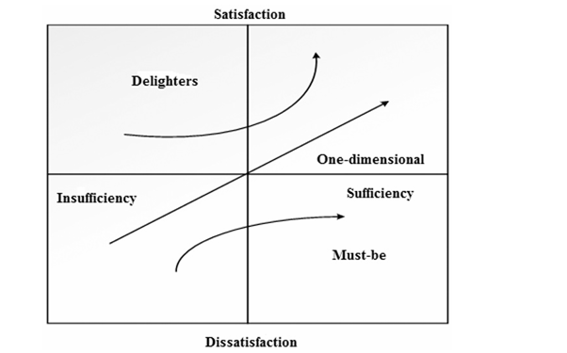
Figure 1- Kano model (Kozer, 2017)
The gripper must be able to grab, hold and release objects that it’s designed for in an effective manner. It must be durable and withstand prolonged use otherwise customers would give bad feedback due to the product breaking. It must comply with the ISO safety standards with no sharp edges to prevent harm to people. It should be able to work with other robots as a co-bot without compatibility issues.

For performance needs the gripper must be able to grab objects to a certain specification of precision, which is further shown in the QFD. The speed the gripper can open and close will increase productivity in manufacturing lines. Being low maintenance and requiring servicing at larger intervals build on the basic requirement, as it enhances performance and reduces downtimes.

Some excitement factors that can be added to the products consist of an ergonomic and modular design. If parts are easily interchangeable for different tasks, then it makes the product multi-functional, which will impress the customer but would not be expected. By using a smart sensor, the gripper can adapt the forces it applies on the object that is picks up and would certainly exceed customer expectations.

Customer perception
Despite function being a critical factor, the aesthetics of a design will further impress customers. A compact and sleek designed will allow a product to standout compared to other manufacturers models. If the product appears to be bulky, and overly engineered with too many parts then it will be perceived as poorly designed and inefficient. If the gripper arm is being used with humans, then a more simplistic designed may be preferred. It will allow the gripper arm to collaborate with humans easier making it safer to use.

Product specification
A product specification will help deliver the three aspects of the Kano model, by considering what the product is required to do and aspects that are crucial. This means the product will meet customer expectations by researching the market and generating new ideas for the product. Table one shows the design specification made for the gripper arm, to give a general idea of how the gripper can be made to excel in the marketplace.

Table 1- Product specification (Charlie Morgan, 2024)
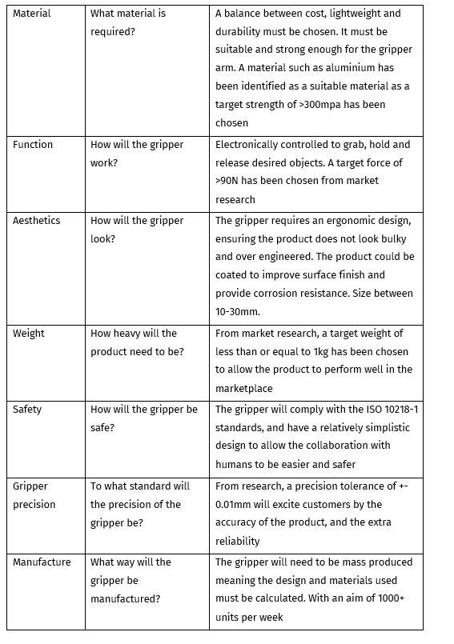

Quality function deployment
A QFD is a concept that provides a mean of translating customer requirements into the appropriate technical requirements for each stage of the product development and production (Mehrjerdi, 2010). This was developed in Japan during the late 1960s as a design process to incorporate the voice of customer, allowing a reduction in startup costs and development time (M.W.Lindsay, 2015). Completed a case study which identified the positive impact of a QFD has on a product within the marketplace displayed in figure two.

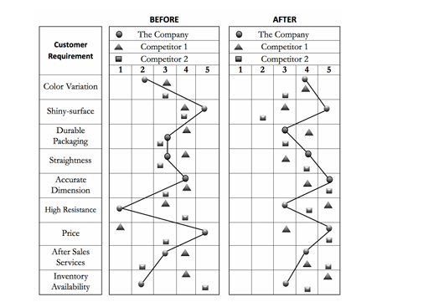
Figure 2- The before and after results when incorporating a QFD in a product design (Erdil, 2018)

A QFD provides many benefits such as:
- Shortening the products time to market
- Improving company and customer communication
- Enhancing teamwork amongst departments within the workplace
- Aid in trade-offs between affordability and customer demands
- Increasing customer satisfaction by prioritising their needs in the design and production of the product (Chan, 2005)
A typical approach is a four-phase process by the American supplier institute (ASI) in the USA, which is used widely (Cohen, 1995). In phase one, customer requirements or “whats” are translated into design-independent quality characteristics. Phase two examines the relationship between the quality characteristics and the various parts of the design. This prioritises the components’ ability to meet the desired characteristics. Phase three prioritises the manufacturing specifications for key process parameters that will then be deployed into the final step. Phase four allows the key manufacturing processes to translate into work instructions, reaction plans and requirements necessary to ensure the fulfilment of the processes maintained (Mehrjerdi, 2010).

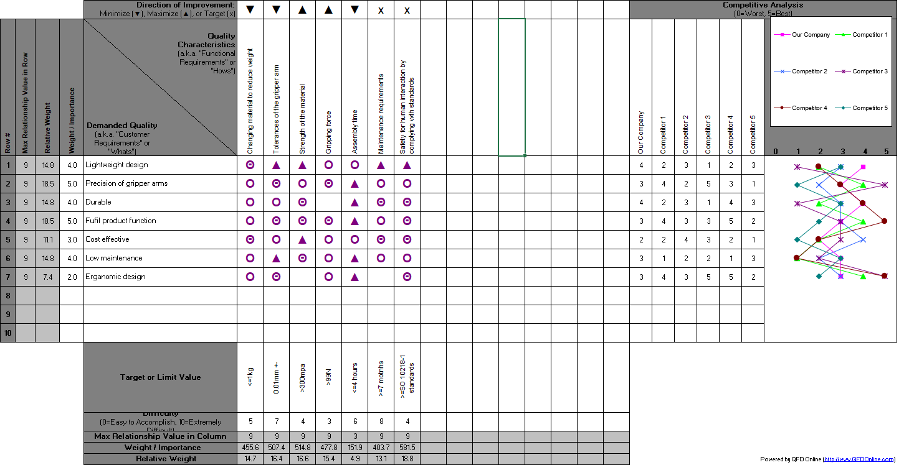
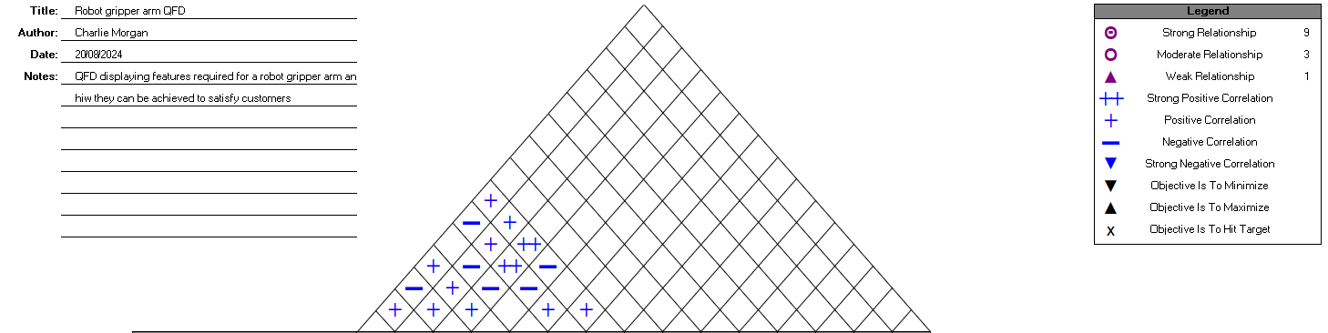
Figure 3 - QFD for the gripper arm (Charlie Morgan,2024)
Figure three displays the QFD created from the gripper arm. “whats” were taken from the product specification and were developed on. The QFD has also allowed research into the market and highlighted areas to focus on in the product design. It shows that making the cost effective meanwhile having high precision will allow the gripper to find a gap in the market and excite customers. Also, target values have been identified via research to ensure the gripper will be up to a standard that makes the gripper exciting for customers given its price range.

Manufacturing process proposal
There are several issues in the market considering economic, social and technical ones. Resource deprivation and environmental issues are two great examples of this. CNC machining is a great method for this when incorporating energy efficient machining and ecofriendly materials. Material selection is significant, where materials such as aluminium should be chosen over steel and plastics. Recycling waste from this process also greatly improves sustainability (Soori, et al., 2024).
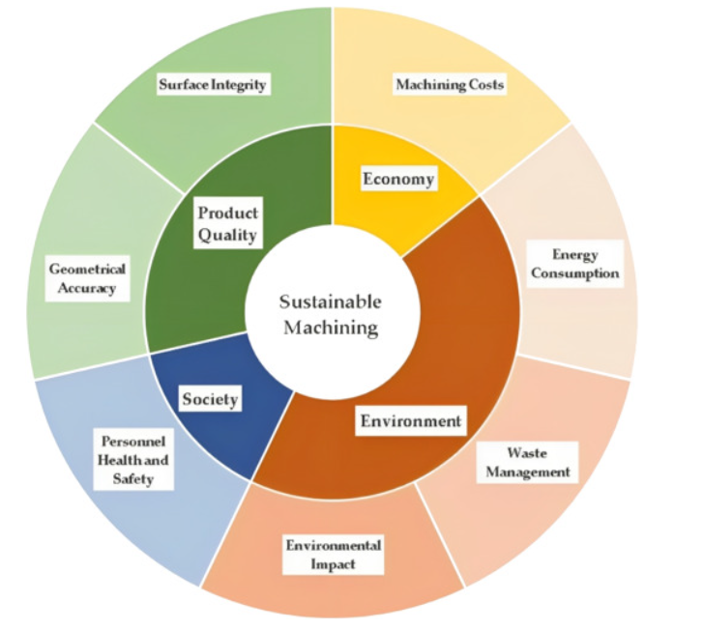
Figure 4- Sustainability factors to consider (Soori, et al., 2024)

CNC machining
CNC machining is brilliant for materials require precision and unique features. It works well with many materials however when compared to other design methods the cost per unit value is higher. Sustainability may be sacrificed to hit 1000+ units per week as this is a great method for low to medium production rates and it would be costly to have high precision when producing large quantities (Manuformance, 2023).

Die casting
Die casting works brilliantly with green materials such as aluminium. This has had production speeds injecting molten metal into a die under high pressure allowing fast cycle times. This also has high dimensional accuracy and is a great option for producing large volumes of parts with minimal lead times (Zetwork, 2007). This is an energy intense manufacturing method which supports the use of materials such as aluminium which is a great choice for the robot gripper. This is due to the price, strength and high recyclability which increases the sustainability of this process (Gupta, 2013) .

Renewable energy can be used to combat energy as a factor in an evolving world focusing on sustainability. Die casting can melt waste and then be reused significantly increasing sustainability. Also, metals such as aluminium tend to have a longer shelf life produced in this way reducing the need to create more products (Pagone, et al., 2020). This is the chosen method due to high production rates and sustainability balance.

Injection moulding
The best process for the plastic is injection moulding. This is hard to remain sustainable, but recycling plastics is required to improve this and benefit society (Singh & Verma, 2015). This has a high upfront cost but will have a low cost of production and short cycle times making it great to hit the target 1000+ units per week (Farooque, et al., 2020). This also allows a choice of a wide variety of plastics and high precision with consistent quality (Shaharuddin & Salit, 2006).

Material selection
Aluminium alloys are a brilliant choice to achieve weight reduction due their high strength to weight ratio. Recycling aluminium significantly reduces its environmental impacts making this a great choice (Engelen, et al., 2022). This will also help increase the speed for the gripper meanwhile ensuring structural integrity. Aluminium is also conduction, has excellent thermal properties and high resistance to corrosion increasing its service life. Also, no surface painting or protection is required, and it already has a clean surface finish improving the aesthetics (Gándara, 2013).

Design and development work undertaken
The aim of the design process is to redesign the gripper to allow 1000+ units per week via mass production. The QFD has highlighted there is a lack of cost-effective gripper arms on the market and reducing the assembly time will be an efficient method to do this. The original design will be analysed, and CAD will be used to further enhance the design to make it more efficient and reduce the assembly time. This may also make the product safer, which was also identified via the QFD. This is because if the design is more simplistic and not over-engineered it will make human interaction easier and safer.

Initial design review
The initial design has been evaluated to identify flaws and improvements that can be made to enhance the grippers performance. A failure mode effect analysis (FMEA) was generated to identify potential problems in the design A (initial design supplied) that could affect its safety and performance. Countermeasures can then be brainstormed to mitigate or minimize the effects of the potential failure mode. This tool measures severity, occurrence and detection which are multiplied to produce an RPN number which scores each potential failure mode in order of importance to target (Sulaman, et al., 2017). However, one disadvantage to an FMEA is multiplying severity, occurrence and detection may result in rank reversals, where a less important failure mode may receive a higher rating than an important one. This is because a ranking of two may not be twice as bad as a ranking of one (Lipol & Haq, 2010).

Figure five shows the FMEA generated with an RPN value given to each failure mode. From completing of the FMEA, the main failure modes identified are overly engineered, sensor malfunction and the loss of gripper strength.

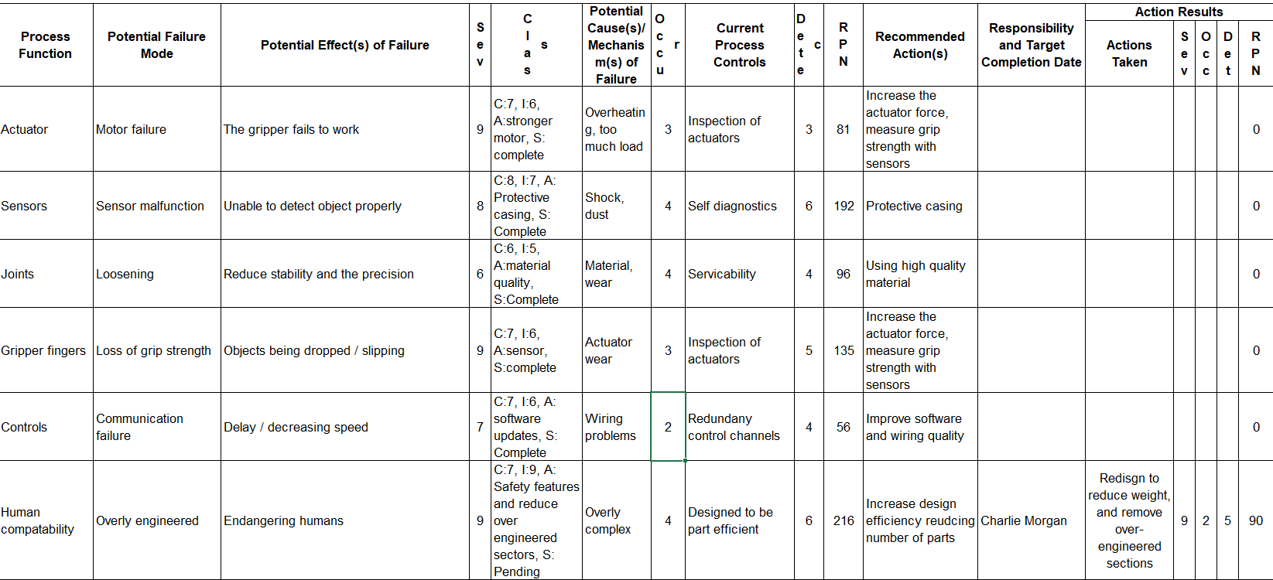
Figure 5- FMEA of gripper arm (Charlie Morgan, 2024)
Key features have been identified to analyse the initial design, allowing the ability to identify areas for improvement in the re-design process using CAD. Table two demonstrates that serviceability, simplicity, ease of manufacture and weight are currently the worst scoring values. As these features are slightly intertwined, new features such as removing unnecessary parts may improve more than one of these features.

Table 2 - Design A analysis
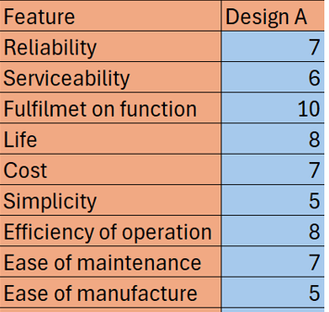

Design changes
In the first re-design weight reduction was prioritised. This has been labelled Design B with design A being the original design given. The gripper arms widths were narrowed down significantly to 15.25mm. however, when reconnecting the arms they appeared to be too narrow and reduced the product aesthetics as it looked flimsy. Also, 15.25mm was a slightly too small width as structural integrity may have been put at jeopardy. Also, there was no impact on the design efficiency or the assembly time of the product.

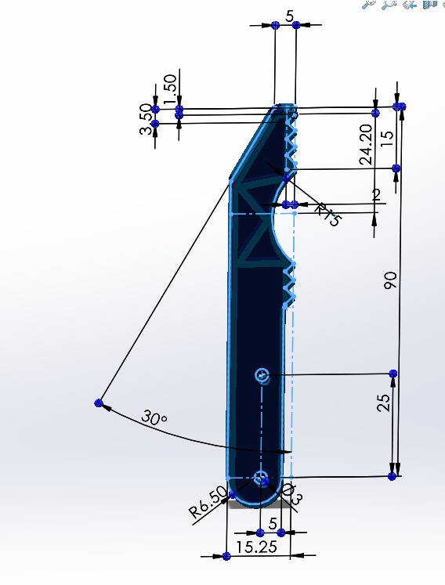
Figure 6- Design B gripper arm (Charlie Morgan, 2024)
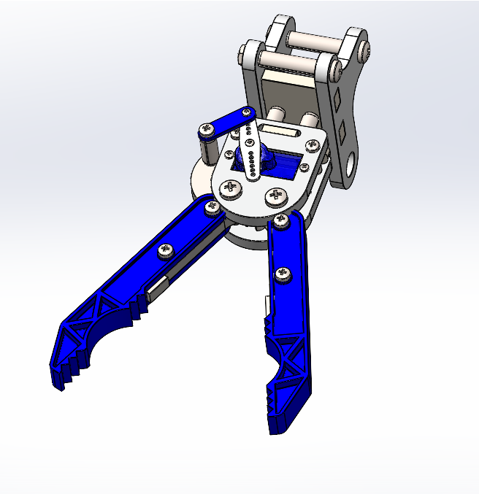
Figure 7- Design B gripper (Charlie Morgan, 2024)

Design C focused on weight reduction as well as reducing the assembly time to hit the 1000+ units per week in production. The arm diameter was changed from 15.25mm to 16mm opposed to 17.75mm in the original design. Despite not being a major change, this will help reduce weight meanwhile keeping structural integrity and resistance to strain. From the analysis, the four bolts were deemed over engineered and simplified via a snip fit joint. The snap fit on the gripper arm connects to the snap fit groove on the central mechanism which will reduce the assembly time and increase design efficiency. Figure eight shows the snap fit joined on the gripper arm and figure nine shows the gripper arm connected to the central mechanism.

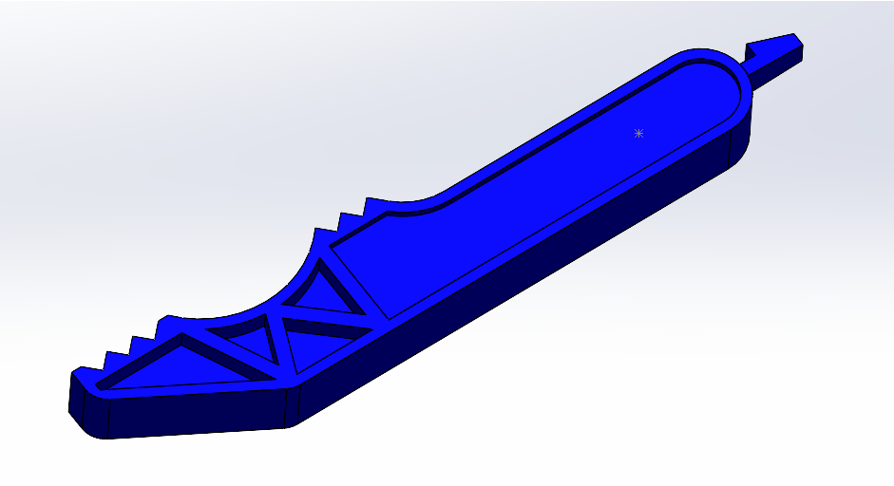
Figure 8- Design C snap fit joint on gripper arm

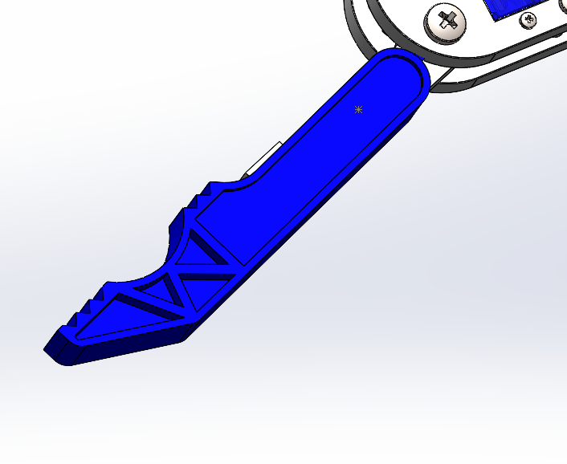
Figure 9 - Design C robot gripper

Concept design analysis
Design A, B and C have been analysed against the set of constraints evaluated for design A. This allows the ability to identify whether changed made have improved the design without cost being compromised of the product function. Tables three and four display the scoring used for the mass and for the price of the robot gripper to give an insight into the values for these features.

Table 3- Values for the scoring of cost (Charlie Morgan, 2024)

Table 4- Values for the scoring of weight (Charlie Morgan, 2024)
Table five identified improvements or compromises made in the redesign stage. This shows design B reduced weight, but the fulfilment of function and reliability was compromised due to the structural integrity being affected. Design C maintained a balance of this meanwhile increasing the design efficiency and reducing assembly time.

Table 5 - Design analysis of Design A, B and C (Charlie Morgan, 2024)
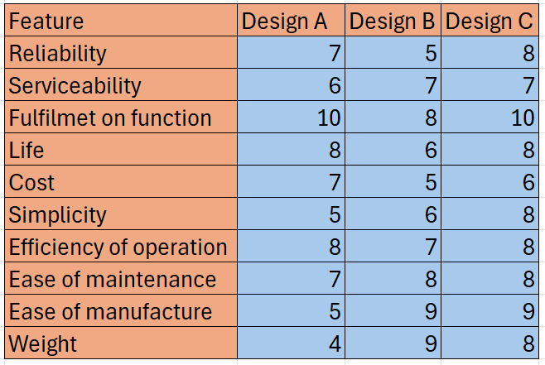
Each design was further analysed by applying a weight to each feature. This multiplied the score given against the weight, to highlight the importance of features such as reliability, fulfilment of function and cost. Table six shows design C performed significantly better than B and A making this the best concept design.

Table 6- Concept design analysis for A, B and C with weighting (Charlie Morgan, 2024)
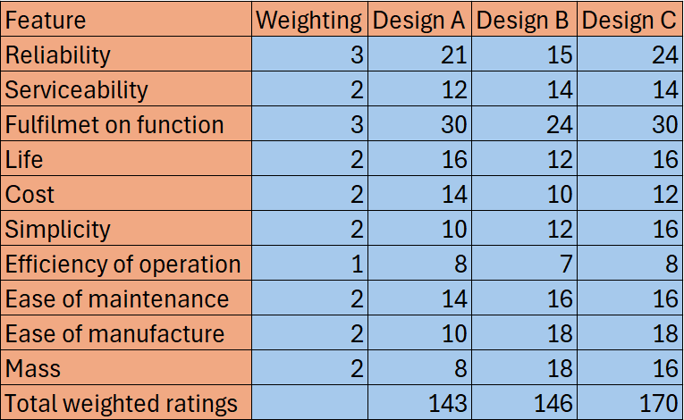

The Lucas method
Design for assembly (DFA) methods help designers consider the assembly process during the development phases of a product. The Lucas method was developed by Lucas Corporation and relatively assesses the difficulty of assembly (Ezpeleta, et al., 2019). This allows an analysis of the chosen design (design C) to ensure the assembly time has been reduced to hit the 1000+ per units per week target. Figure ten shows the Lucas method table to score the original design and design C against.

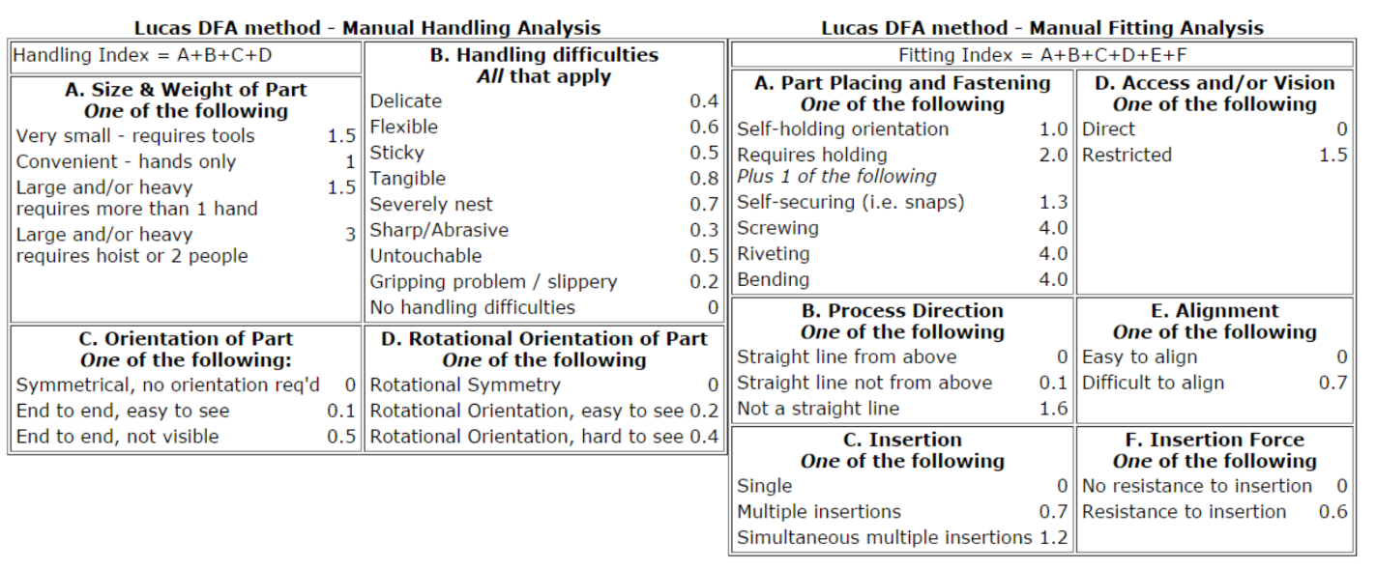
Figure 10- Lucas DFA table (Ezpeleta, et al., 2019)
Figure eleven shows the results of the manual fitting and assembly analysis of the original design against the chosen design C.
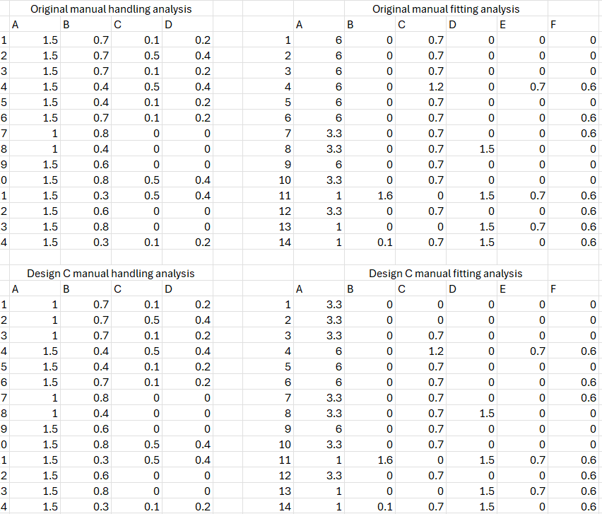
Figure 11- manual handling & manual fitting analysis (Charlie Morgan, 2024)

Finally, figure twelve displays the improvements from the redesign by the Lucas method. Assembly time has improved by 16% and the number of parts has improved 13.63% which will aid in reaching the target of 1000+ units per week.

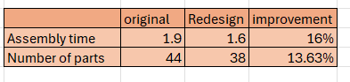
Figure 12- Lucas method DFA improvements

Robot gripper redesign conclusion
The focus of the redesign was improving the assembly time and reducing costs meanwhile achieving key customer requirements. Methodologies such as the QFD and FMEA allowed areas for key improvements to be identified, and the Kano model helps manufacturers to improve their products by adding “exciting” features. The redesigns B and C displayed trade-offs between weight, assembly time and fulfilment of function. Design C emerged as the optimal solution due to its balance between assembly time and functionality and the Lucas DFA method was a great way to identify this. The use of ecofriendly materials must be prioritised in the evolving marketplace where this is becoming the focus. Also, sustainable manufacturing methods must be considered such as die casting, which has a balance between being suitable for mass production and methods to be sustainable such as using renewable energy. By focusing on customer and sustainable requirements, the gripper is well-positioned to be high performing in the marketplace.

Additive manufacturing abstract
The design and manufacture of an aerospace bracket will play a critical role when analysing the performance, mechanical properties and safety in harsh conditions. This study recognises that traditional manufacturing methods result in bulky structures with several limitations such as dimensional accuracy, sustainability and material usage. The benefits of additive manufacturing will be explored, especially in the aerospace industry focusing solely on a bracket. By integrating design for manufacture principles, a design can be optimised for its end use making this method produce superior parts. Given this is a more sustainable way for production, this is a method that will constantly evolve and become increasing popular.

Key benefits of AM include the ability to create complex internal structures such as honeycombs and weight reduction without compromising strength. This is especially beneficial in the aerospace industry due to reducing the weight of the aircraft, hence reducing the fuel usage and the aerospace industry more sustainable. Critical design considerations are also accounted for, such as residual stresses, shrinkage and porosity and environmental factors with a brief suggestion of mitigating methods when creating the product. Techniques such as finite element analysis, generative design and topology optimisation enhance the performance of the bracket.

Additive manufacturing introduction
Additive manufacturing processes is transforming the traditional manufacturing methods across multiple industries. It allows complex geometries meanwhile reducing material waste hence shifting the methods of producing materials. Design for additive manufacturing is a specialized approach that will optimise components to take full advantage of additive manufacturing. This helps improve the functionality of materials, minimise assembly steps, reduce product weight and enhance the customisation of products to further excite customers. This can revolutionise the aerospace sector by introducing light weight lattice structures and optimising geometry to reduce material usage and performance. This results in significant cost and lead time reductions and enhanced performance (Blakey-Milner, et al., 2009). Finally, additive manufacturing offers a more sustainable process maximising material efficiency and having a low volume of waste.

Traditional aerospace bracket review
The design and structure of brackets in the aerospace industry is critical. These need to be able to maximise their performance in harsh and extreme conditions. This is paramount to safety and the function of the actual aircraft. Figure thirteen shows a traditional aerospace bracket which appears to be bulky, and the design will be thoroughly analysed to identify how AM can benefit a part such as a bracket in this sector.

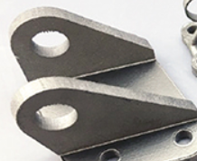
Figure 13- Traditional aerospace bracket (Samant, 2018)

Material usage
These brackets must have high strength to weight ratios and be able to perform in high stress and high environments. Typical materials consist of magnesium alloys due to the low specific gravity and high strength properties and are amongst the lightest structural materials. This massively contributes to mass reduction and financial gains on fuel usage. Typically, the addition of aluminium is used due to hugely increasing strength and hardness (Dziubinska, 2015). However, TI-6Al-4V makes a brilliant choice in additive manufacturing is this can reduce the compressive properties and is comparable to skeletal bones which is hugely beneficial. This has high specific strength, low density and great corrosion resistance (Pelleg, 2020).

Manufacturing process
Traditional brackets may be produced by casting or machining which comes with limitations. Casting is prone to defects which is a significant factor in the aerospace industry due to the high-performance requirements meanwhile minimising the chance of failure. This also has relatively poor dimensional accuracy and consistency which is a key requirement in this sector (Industries, 2021). Traditional manufacturing methods limit the complexity leading to a bulky structure and excessive material usage. Traditional methods also have performance limits in harsh conditions such as high temperature or corrosive environments This makes additive manufacturing a great alternative.

Environmental impact and cost
(Zheng, et al., 2020) demonstrated that additive manufacturing can drastically decrease the emissions of the casting process from 20.78% to 4.82 %. In an evolving modern world, this revolutionises manufacturing techniques due to a shift on focus on a production methods sustainability considerations. Additive manufacturing also has a production efficiency of 92.66% which demonstrates its economic superiority. High volumes of casting results in significant energy usage, resource depleting and severe pollution. (Zheng, et al., 2020). Additive manufacturing reduces environmental pollution and decreases waste making it a sustainable process in comparison to casting meanwhile achieve complex geometries with precision.

Design for additive manufacturing principles
Additive manufacturing takes information from CAD files that is then converted into a stereolithography (STL) file. The aerospace industries employs this technique to enhances structures by reducing weight (Wong & Hernandez, 2012). DFAM principles allow an easy structure through this change by analysing and integrating multiple techniques demonstrated below.

Component consolidation
This process allows multiple parts to be merged into a single, integrated structure. This helps reduce weight and create intricate internal geometries for heat transfer performance (Schmelzle, et al., 2015). This engineering bracket can be redesigned into one cohesive unit, eliminating the requirement for fasteners and assembly. Fasteners can be points of weakness in structures. By consolidating parts, AM removes these weak points increasing strength and reliability. The bracket can become more robust with fewer areas prone to failure through high stress.

Internal structures
With traditional design such as CNC machining or casting, complex internal structures are very difficult to achieve. During the design, the solid sections can be replaced with internal lattice or honeycomb structures which will recue without strength being lost as a cost. This will help contribute to fuel savings in the aerospace industry. AM builds the produced layer after layering and a honeycomb structure consists of repeating unit cells of hexagonal shape. This structure can be analysed via finite element analysis (FEA) (Goldmann, et al., 2022).

FEA
FEA models of honeycomb structures have been constructed using ABAQUS/CAE software’s. (T.A Alwatter, 2019) studied this structure with an equivalent elastic block and demonstrated the benefits of this structure with increased strength to weight ratios. FEA helps to identify any weak points and flaws in a design to ensure the final design will perform as required. This further allows the recognition of honeycomb structures being superior in comparison to solid structures.

Topology optimisation
This process in used to optimise the material layout and structure within a 3D geometrical design which is defined by a set of rules by the designer. This enhances part performance by mathematically modelling and optimising for conditions such as external forces within the design. This will reduce the stiffness to weight ratio, increase the strain energy to weight ratio and reduce the material volume to safety factor. This technology used FEA removing redundant material by analysing the product. This will reduce the bulkiness of the traditional aerospace bracket (design, 2021).

Anisotropy and inhomogeneity
Flaws in traditional methods include producing isotropic materials meaning it has equal strength in all directions. AM parts can exhibit anisotropy resulting in different strength properties in different directions due to layering. This allows the design to layer directions of the main loads to maximise design potential. Also, the part can be oriented to minimise the requirement for support material reducing material waste (Ullah, et al., 2020).

Material selection
With any design, it is vital to use the appropriate materials. This can balance numerous factors such as cost, ease of manufacture, the properties of the product and the final design. Materials are also central to the environmental performance of products and there are limited methods that offer sustainability with required materials (Prendeville, 2013). Therefore, material selection will be crucial in the design for the bracket and must be compatible with additive engineering manufacturing methods such as LSM.

Design considerations
There are many considerations that must been considered when designing the aerospace bracket using additive manufacturing. Once accounted for in the redesign process, these considerations will maximise a designs performance, sustainability and reduce the overall chance of failure.

Residual stresses and stress concentrations
Residual stresses are one of the primary reasons for a products failure in additive manufacturing. This is because it easily allows cracks to form and structural disorientation. A key method in stopping this is reducing the thermal gradients and optimising the deposition sequence and preheating the material prior to the AM process will contribute to reducing residual stresses. Also, by optimising the yield temperature it can reduce residual stresses by reducing the formation of plastic strain (Lu, et al., 2021). Therefore, this is a critical aspect of the design of the aerospace bracket to greatly reduce the chance of failure in an important part.

Shrinkage, porosity and distortion
Shrinkage occurs during the transformation from liquid to solid and is also responsible for residual stresses that directly impact the performance of the part. This contributes to dimensional inaccuracies and errors in parts and is a major design consideration in the chosen manufacturing process that has been chosen which will be described in the redesign process. Isothermal sintering is a major factor that affected the rate of shrinkage as it’s continuously changed the microstructure of the material (Anand, 2013).

Porosity is the level of solidity in the part. If the melting by a laser on powdered material does not melt it completely, it then results in cavities which are referred as porosity which can be caused by gas pockets in powder. Thorough research must be complete to use tested materials in additive manufacturing that have processing parameters set out to minimise porosity. (Sola & Nouri, 2019) identified the amount of porosity increases linearly with the laser powering decreasing.

Distortion can occur in additive manufacturing and refers to the warping of the part due to internal stresses in the manufacturing process and results in a reduction in the parts precision. Rapid heating and cooling can result in expansion and contraction in the material, leading t residual stresses which can cause the part to warp. If different areas of the part cool at different rates can also lead to distortion. This can weaken the structural integrity and lead to failure (Xie, et al., 2022). Therefore, carefully managing the heat distribution and cooling cycles will optimise the product to mitigate distortion.

Support structures
Support structures also help combat distortion and maintaining dimensional accuracy as it will help stabilise the product as it heats up and cools down, hence reducing residual stresses. When utilising SLM overhanging sections may collapse without supports making it crucial to identify these areas within the design. However, this will add to the cost of production therefore a balance between cost and structural integrity must be carefully thought out. Postproduction the supports need to be removed which could require specialised tooling, hence increasing the costs and will increase material consumption and energy usage (Jiang, et al., 2018).

Anisotropy and inhomogeneity
These are important factors to consider because it significantly impacts the mechanical properties and performance of the aerospace bracket. Because the part isn’t uniform like traditional processes create the variability from layering must be considered. Anisotropy refers to the direction of material properties such as strength and ductility and will change based on the orientation of the part. This can be mitigated by orientation the part so critical features experience stress in stronger directions (Wang, 2024).

Homogeneity refers to the variation in material properties within different areas in a part which leads to inconsistent performances. Uneven heat distribution cause uneven thermal gradients across the part. If regions cool faster than others then variations are caused in the microstructure, porosity and residual stresses resulting in inhomogeneity (Polonsky, et al., 2018).

Cost and environmental considerations
TI-6Al-4V is known for it’s superior properties and compatibility with SLM in additive manufacturing but is expensive. The cost of the raw materials is significantly higher than others such as steel. The powder production process also contributes to expense making this a costly process. However, despite being costly this is necessary and will resemble the product price and superior design and properties.

AM offers environmental benefits such as energy efficiency and less material waste due to being a layering process. However, this consumes materials and energy which contributes to environmental footprint (Rejeski, et al., 2018). Titanium has great recyclability as it can be melted down and reused but is energy intensive. To combat sustainability, solar wind or hydro energy can be used as renewable energy sources to reduce carbon footprint.

Redesign process
Selective laser melting (SLM) is a great choice for processing in AM. This process has gained interest widely in industrial application due to its high level of flexibility (Pelleg, 2020). This allows complex 3D parts to be created by consolidating successive layers of powder material on top of each other. This is commonly used in aerospace with materials such as titanium and aluminium alloys resulting in a strong and dense materials. As this is an additive process the only materials used are necessary to build the part reducing the cost of working with titanium (Mercelis, et al., 2004). TI-64-Al-4V is chosen due to its brilliant strength to weight ratio and compatibility with SLM. This allows the bracket to have superior mechanical properties, making it ideal for the harsh environment it’s designed for.

Initial design review
Excessive material is being used in the bulky original design. Using FEA, the distribution of forces on the bracket is analysed identifying peak stress point and areas of lower stress. This identifies where material can be removed and redistributed in the design. It helps identify the overly engineered sectors, where parts can be made hollow by integrating DFAM techniques.

Topology optimisation
Components previously requiring bolt assembly can be treated as a single part increasing strength and robustness. The original design can be optimised to achieve mass reduction by using Altair’s Solid Thinking Inspire software. This calculates stress and displacement distributions and identified regions that were supporting little load that could be scrapped (Muhamad, et al., 2020). Thick solid walls that don’t experience uniform stress have been replaced with a lattice structure reducing weight and maintaining strength. The central cylindrical section is solid and bulky and was hollowed out.

Generative design
The bracket can have alternative designs with Autodesk Fusion 360. A wide use of geometry can be used to achieve strength and mass reduction, and generative design helps with this. The geometry can be prioritised to different constraints and provides a wide range of design outcomes. These designs can be compared and the best design for the products requirements in chosen by rounding corners, optimising internal lattices and using suitable materials (Dhurjad, et al., 2023).

Internal lattice structures
The lattice structure inside the bracket allows for a significant weight reduction without compromising the structural integrity. This excellently distributed load evenly and maximises the material efficiency of the design. By aligning the lattice structure instead of completely filling it will allow the brackets weight to be reduced (Nagaraja, 2020).

Finite element analysis
FEA is a powerful numerical technique for analysis. This allows a stress analysis of the bracket and allows any weak points in the design to be identified, ensuring that the bracket will perform as per its requirements (Krishna, 2013). Agros2D is a software that will analyse the CAD design and ensure the changes made haven’t affected the parts performance.

Additive manufacturing conclusion
To conclude, a traditional aerospace bracket design can greatly benefit from AM. Insufficiencies in material usage and environmental impact can be greatly improved, by integrating materials such as TI-6Al-4V and applying DFAM principles a significant weight reduction can be achieved meanwhile enhancing strength. This will improve fuel efficiency and reduces environmental pollution making AM benefit this product. Also, AM allows the creating of complex geometries and internal structures that aren’t achievable in other processes which will enhance the brackets design and performance.

Utilising SLM and tools such as FEA demonstrate the potential for superior designs for brackets in the aerospace industry. As the aerospace industry continues to chance, the adoption of AM and concepts such as DFAM will be a necessary requirement for a product to excel in the marketplace and produce high performing parts meanwhile remaining sustainable. Furthermore, this study has highlighted design considerations that can be detrimental to the products performance, dimensions and mechanical properties. Methods of mitigation have been briefly suggested and further work is required to be undertaken in additive manufacturing to prevent potential failure such as anisotropy and inhomogeneity.

Bibliography
Anand, S., 2013. Material shrinkage modeling and form error prediction in additive manufacturing processes. ResearchGate, p. 1.

Blakey-Milner, B. et al., 2009. Metal additive manufacturing in aerospace: A review. Materials & design, Volume 209, pp. 1-100.

Chan, L.-K., 2005. A systematic approach to quality function deployment. Department of Management Sciences, pp. 119-142.

design, E. p., 2021. Introduction to Topology Optimization. [Online]
Available at: https://engineeringproductdesign.com/knowledge-base/topology-optimization/
[Accessed 23 September 2024].

Dhurjad, S., Shaikh, A. & Chinchanikar, S., 2023. Generative design for additive manufacturing (G-DFAM): An. Department of Mechanical Engineering, Vishwakarma Institute of Information Technology, Pune, India., 2492(1), pp. 1-13.

Dziubinska, A., 2015. magnesium alloys in aircraft brackets. Researchgate, pp. 1-3.
Engelen, B. et al., 2022. Techno-Economic Assessment of Robotic Sorting of Aluminium Scrap. ScienceDirect, pp. 152-157.

Erdil, N. O., 2018. Quality Function Deployment: More Than a Design Tool. Engineering and applied science education faculty publications, pp. 1-30.

Ezpeleta, I., Justel, D., Bereau, U. & Zubelzu, J., 2019. DFA-SPDP, a new DFA method to improve the assembly during all the product development phases. ScienceDirect, pp. 673-679.
Farooque, R., Asjad, M. & Rizvi, S., 2020. A current state of art applied to injection moulding manufacturing process – A review. Materials today: proceedings, Issue 43, pp. 441-446.

Gándara, M. J. F., 2013. Aluminium: the metal of choice. Materials & design, 3(47), pp. 261-265.

Goldmann, T., Wei-ChinHuang & Rzepa, S., 2022. Additive Manufacturing of Honeycomb Lattice Structure—From Theoretical Models to Polymer and Metal Products. Materials, 5(16), p. 1838.

Gupta, K., 2013. Innovations in Manufacturing. Springer, pp. 1-9.

Industries, S., 2021. Advantages and disadvantages of the metalcasting process. [Online]
Available at: https://sinowayindustry.com/advantages-and-disadvantages-of-casting/
[Accessed 20 September 2024].

Jiang, J., Xu, X. & JonathanStringer, 2018. Support Structures for Additive Manufacturing: A Review. Manufacturing and materials processing, 2(4), pp. 1-23.

Kozer, M., 2017. The Use of the Kano Model to Enhance. Faculty of Business, Management and Informatics, Volume 50, pp. 339-351.

Krishna, S., 2013. Design and Analysis of Mounting Bracket for Aero Space VEHIVLES. Mechanical engg dept, Sir CRR College of engineering, India, 2(9), pp. 3237-3245.

Lipol, L. S. & Haq, J., 2010. Risk analysis method: FMEA/FMECA in the organizations. International Journal of Basic & Applied Sciences, 11(5), pp. 74-80.

Lu, X., Cervera, M., Chiumenti, M. & Lin, X., 2021. Residual Stresses Control in Additive Manufacturing. manufacturing and materials processing, 5(4), p. 138.

M.W.Lindsay, 2015. An Introduction to Six Sigma & Process Improvement. 2nd ed. Stanford: Cengage Learning.
Manuformance, 2023. Alternative processes for CNC machining metal. Manuformance, pp. 1-30.
Mehrjerdi, Y. Z., 2010. Quality function deployment. Department of Industrial Engineering, Yazd University, Yazd, Iran, 27(6), pp. 616-650.

Mercelis, P., Froyen, L. & Rombouts, M., 2004. Binding Mechanisms in Selective Laser Sintering and Selective Laser Melting. Dept. of Metallurgy and Materials Engineering, pp. 44-60.

Muhamad, W., Wahid, A. & K.A.Saniman, 2020. Mass Reduction of a Jet Engine Bracket using Topology Optimisation for. International Journal of Advanced Science and Technology, 29(8), pp. 4438-4444.

Nagaraja, T. M., 2020. Design and Analysis of Additively Manufactured Components with Integrated Lattice Structures. Department of Industrial and Materials Science, pp. 1-6.

Pagone, E., Papanikolaou, M., Salonitis, K. & Jolly, M., 2020. Multi-criteria decision-making for the life cycle of sustainable high pressure die casting products. International Journal of Sustainable Manufacturing, 4(3), pp. 101-120.

Pelleg, J., 2020. Additive and Traditionally Manufactured Components: A Comparative Analysis of Mechanical Properties. Amsterdam: Elsevier.

Polonsky, A. T. et al., 2018. Defects and 3D structural inhomogeneity in electron beam additively manufactured Inconel 718. Department of Materials Science and Engineering, pp. 171-181.

Prendeville, S., 2013. Material Selection and Design for Sustainable Material Innovation. 0th European academy of design conference—crafting the future , pp. 1-12.

Rejeski, D., Zhao, F. & Huan, Y., 2018. Research Needs and Recommendations on Environmental Implications of Additive Manufacturing. Additive Manufacturing, Volume 19, pp. 1-28.
Schmelzle, J. et al., 2015. (Re)Designing for Part Consolidation: Understanding the Challenges of Metal Additive Manufacturing. Journal of mechanical design, 11(137), p. 1.

Shaharuddin, S. I. S. & Salit, S., 2006. A Review of the Effect of Moulding Parameters on the Performance of Polymeric Composite Injection Moulding. Journal of Engineering & Environmental Sciences, 1(30), pp. 23-34.

Singh, G. & Verma, A., 2015. A Brief Review on injection moulding manufacturing process. ScienceDirect , pp. 1-9.

Sola, A. & Nouri, A., 2019. Microstructural porosity in additive manufacturing: The formation and detection of pores in metal parts fabricated by powder bed fusion. Journal of advanced manufacturing and processing, 1(3), pp. 1-21.

Soori, M., Jough, F. K. G., Dastres, R. & Arezoo, B., 2024. Sustainable CNC machining operations, a review. Sustainable Operations and Computers, Volume 5, pp. 73-87.

Sulaman, S. M., ArminBeer, Felderer, M. & H¨ost, M., 2017. Comparison of the FMEA and STPA safety analysis. Software Wual J, Issue 27, pp. 349-387.

T.A Alwatter, A., 2019. Development of an Elastic Material Model for BCC Lattice Cell Structures Using Finite Element Analysis nd Neural Networks Approaches. J. Compos. Sci, 3(33), pp. 1-15.

Ullah, R., Akmal, J. S., Laakso, S. V. A. & Niemi, E., 2020. Anisotropy of additively manufactured AlSi10Mg: threads and surface integrit. The international journal of advanced manufacturing technology, Volume 107, pp. 1-30.

Wang, S., 2024. Inhomogeneity and anisotropy of Al-Zn-Mg-Cu alloy manufactured by wire arc additive manufacturing: microstructure, mechanical properties, stress corrosion cracking susceptibilit. Virtual and Physical Prototyping, 19(1), pp. 1-23.

Wong, K. V. & Hernandez, A., 2012. Energy Conversion and Management. International scholarly research notices, Volume 1, pp. 1-10.
Xie, D. et al., 2022. A Review on Distortion and Residual Stress in Additive Manufacturing. Chinese journal of mehanical engineering: addative manufacturing frontiers, 1(3), pp. 1-50.

Zetwork, 2007. Die casting automotive parts. [Online]
Available at: https://www.carteretdiecasting.com
[Accessed 12 September 2024].

Zheng, J., Chen, A. & Zheng, W., 2020. Effectiveness analysis of resources consumption, environmental impact and production efficiency in traditional manufacturing using new technologies: Case from sand casting. Energy Conversion and Management, Volume 209, pp. 1-9.

