Student name / ID - Kian Sheppard / 2519334
Academic year – 2025/2026
Unit tutor – Sergio Garate
Assignment title – Water resources and quality
Submission date – 13/05/26

Table of Contents
Question 1 2
Introduction 2
What Are Sewage Discharges? 2
Environmental effects 2
Why does it happen ? 3
Solutions 3
Question 2 4
Question 4 5

Question 1

Introduction
Sewage discharge into rivers, lakes and coastal waters, is becoming a serious environmental concern across the UK. In recent years there has been an increasing concern for this issue, with a lot of attention surrounding the worrying amounts of sewage being released into our waters. The sewage discharge can affect the natural cycles that occur in these water hotspots such as a loss of invertebrates and aquatic plants, along with low oxygen concentrations. Sewage discharge not only effects wildlife, it can effect human health too for people using these areas. Some research needs to be undertaken to see weather water companies are doing enough to prevent pollution and if there is growing pressure on the UK government to enhance the state and safeguard UK water bodies
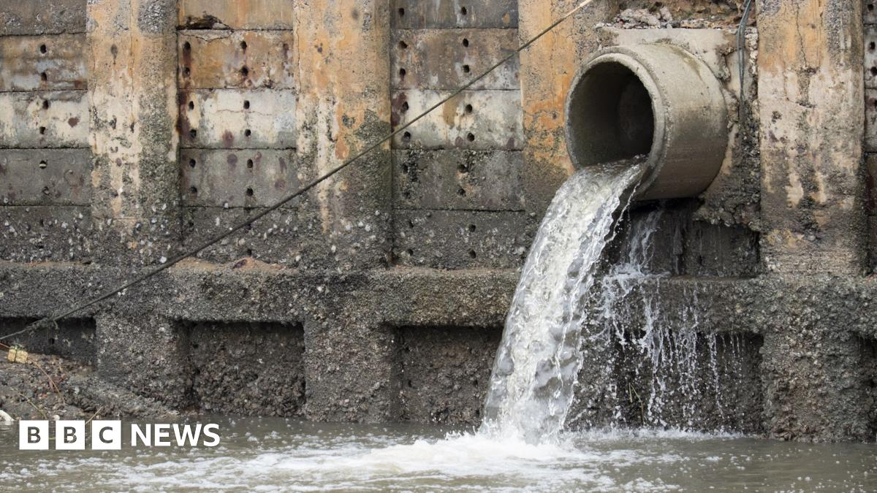
(https://www.bbc.co.uk, 2025)

What Are Sewage Discharges?
Sewage discharge is the release of untreated wastewater into rivers, lakes and coastal waters. This wastewater is usually a build up of waste from homes, commercial properties and industrial facilities. The waste may contain human waste, chemicals, cleaning products or any other harmful pollutants.
Combined sewer overflows (CSOs), which are typically used when older sewer systems are overloaded by heavy rainfall. These systems let extra wastewater into natural waterways and are one of the primary causes of sewage discharge. Because it has an impact on the general health of ecosystems, along with humans who use these features, this raises environmental concerns.
(biologyinsights.com, 2025)

Environmental effects
2022 figures from UK environmental regulators revealed untreated sewage was discharged into UK rivers and coastlines at the very least 399,864 times that’s 1,091 times a day. As stated earlier on in this report, sewage discharge is a health and safety concern and this is a statement that would support this view. From the operations engineer article on sewage discharge, It is stated that:
Sewage pollution is a major problem due to the effects on human health and it leads to less productivity. In 2022 alone, there were 1.924 reported cases for sickness due to exposure to sewage, which lead to nearly 2,000 sick days. And In 2023 there was over 18,000 alerts that showed how frequent we are being exposed to sewage discharge.

From the Available information, it is clear to see that sewage discharges have a very harmful effect on the environment in the UK. Only 14 percent of rivers meet the correct ecological standards in UK while 0 percent meet the correct chemical standards. This clearly shows that we are falling behind on having healthy water bodies and this needs major attention.
When it comes to Inland waters, it is stated that the effects these waters carry are sewage discharge, agricultural runoff and industrial activity. Around 36 percent of failing water bodies are linked to sewage discharges and this has led to the heavy fall in ecosystems which has reduced the environmental quality across the UK. It doesn’t just stop at inland water bodies, toxic contaminants are transported downstream into coastal waters and into the ocean which expands the environmental impact of pollution across the UK.

(www.operationsengineer.org.uk, 2024)

Why does it happen ?
Storm water overflows in the UK are commonly occurring due to many things. A major reason is that there is a substantial amount of ageing infrastructure across the UK which also cannot keep up with the increasing population or continuously changing environmental factors. Originally, the sewer systems in the UK were designed as combined network systems which could carry both stormwater and wastewater, but during heavy rainfall or full systems, they can become overloaded and crossovers can happen.
This has become more of an issue, since natural surfaces which would absorb rainwater have been widely replaced with areas consisting of a lot of concrete and paving. This has put increasing pressure on drainage systems by further increasing the volume that they are designed to handle.

Solutions
It is clear that something drastic needs to change to tackle the sewage discharge issue. Engineers are exploring ways that we can improve the quality of water bodies around the UK. This will include a better approach to managing water systems to reduce the pollution at source.
Companies are looking into how Sewage discharge can be used to produce green energy for homes and useful by products which could be a major step forward.
In my opinion the best option into creating a sustainable and efficient approach to tackling the sewage discharge issue, would be to start upgrading our sewage systems to new systems with advanced technologies that can handle the change in population and environmental factors. I think this could be a costly but heavily beneficial step forward for the UK which would be putting the environment and human comfort as a priority
(www.ice.org.uk, n.d.)

Question 2
calculate the total solute concentration per km2, use the formula given:
Load = C X Q X 86.4
Where:
- C = nitrate concentration (mg/L)
- Q = discharge (m3/s)
- 86.4 = conversion factor
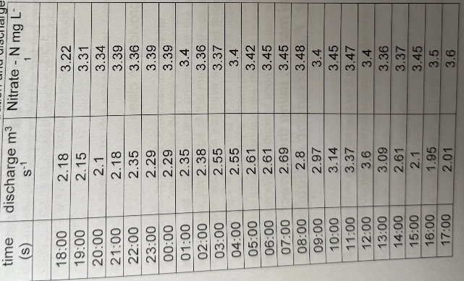
Because the aim is to use the specific time equation given to us on the sheet, I chose to divide 86.4 by 24 to get hourly
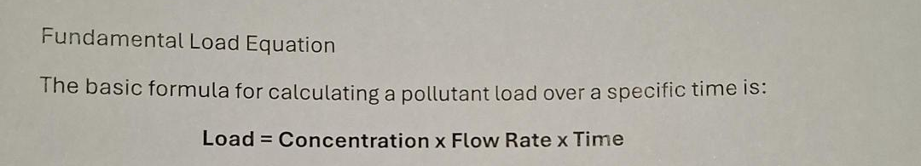
This now gives me an hourly concentration of C x Q x 3.6

This equation will be applied to each hour until we have calculated all of them.
Step 1.
18:00 = 25.28 kg 19:00 = 25.62 kg 20:00 = 25.25 kg 21:00 = 26.61 kg 22:00 = 28.43 kg 23:00 = 27.94 kg 00:00 = 27.94 kg 01:00 = 28.76 kg 02:00 = 28.79 kg 03:00 = 30.94 kg 04:00 = 31.21 kg 05:00 = 32.14 kg 06:00 = 32.42 kg 07:00 = 33.41 kg 08:00 = 35.08 kg 09:00 = 36.35 kg 10:00 = 39.00 kg 11:00 = 42.08 kg 12:00 = 44.06 kg 13:00 = 37.38 kg 14:00 = 31.66 kg 15:00 = 26.08 kg 16:00 = 24.57 kg 17:00 = 26.05 kg
From these hourly calculations we can now work out the Total daily concentration.
Step 2.
Total daily concentration = 744.26 kg/day
Step 3.
The question asks for the total solute concentration in Km2. To achieve this we need to divide 744.26 by the 321km2 catchment.
= 744.26 / 321 = 2.32 km2
This exercise is important in real world situations because the results can show the impact of the common challenges such as sewage discharge, and surface runoff on the water bodies. Monitoring nitrate levels is important because high concentrations can damage aquatic ecosystems by lowering oxygen levels in the water.

Question 4
For question 4 I was given the task of finding the dissolved oxygen concentration of a stream B (DOb) given the following:
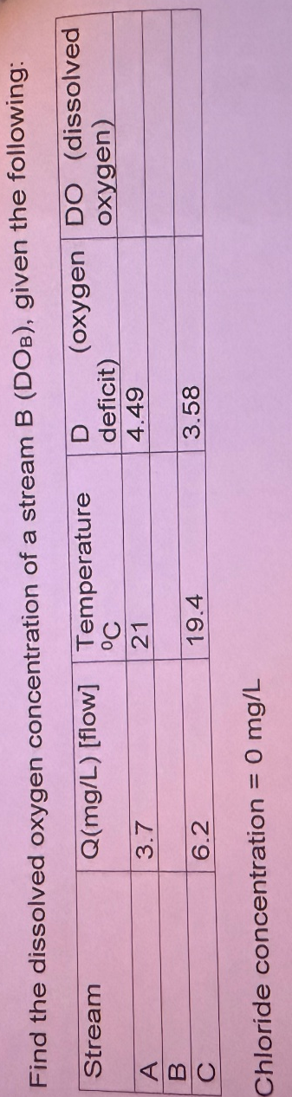

Step 1
The first step would be to calculate the DO concentration for stream A and stream C.
The temperatures are given to us as A = 21 and C = 19.4
D is also given to us as stream A = 4.49 and stream C = 3.58.
Stream A
At 21 degrees Celsius = DOa (saturated) 8.9 – 4.49 = 4.41mg/l DO
Stream C
At 19.4 degrees Celsius = DOc (saturated)9.2 – 3.58 = 5.62mg/l DO
Step 2
Because Stream B is between A and C , the dissolved oxygen concentration for stream B is now taken as the average.
Stream B
Calculations= 4.41 + 5.62 = 10.03
10.03 / 2 = 5.02 rounded
Answer= DOb = 5.02mg/l DO

The tests carried out on water bodies are significant because it can help water quality scientists and environmental companies monitor the overall health and safety of our waters. Measuring the temperature and dissolved oxygen allows for the identification of pollution from events such as sewage discharge and agricultural runoff. Dissolved oxygen tests are critical because of the aquatic life that depends on good oxygen levels to survive, by carrying out these tests we can try to work towards keeping a healthy and reproductive ecosystem and a good level of water quality. The Environmental teams can get a better understanding long term from the data, which gives them the opportunity to create management plans to safeguard ecosystems and water resources for future generations, by keeping an eye on these flagged issues over time.
(www.gov.uk, n.d.)

References
biologyinsights.com, 2025. https://biologyinsights.com/what-is-sewage-discharge-and-why-is-it-a-problem/. s.l.:https://biologyinsights.com/what-is-sewage-discharge-and-why-is-it-a-problem/.
https://www.bbc.co.uk, 2025. https://www.bbc.co.uk/news/articles/c201rz925nyo. s.l.:https://www.bbc.co.uk/news/articles/c201rz925nyo.
www.ebsco.com, https://www.ebsco.com/research-starters/environmental-sciences/pollution-danube-river. https://www.ebsco.com/research-starters/environmental-sciences/pollution-danube-river. https://www.ebsco.com/research-starters/environmental-sciences/pollution-danube-river ed. s.l.:s.n.
www.gov.uk, n.d. https://www.gov.uk/government/publications/temperature-and-dissolved-oxygen-trends-in-english-estuaries-over-the-past-30-years/temperature-and-dissolved-oxygen-trends-in-english-estuaries-summary. https://www.gov.uk/government/publications/temperature-and-dissolved-oxygen-trends-in-english-estuaries-over-the-past-30-years/temperature-and-dissolved-oxygen-trends-in-english-estuaries-summary ed. s.l.:s.n.
www.ice.org.uk, n.d. https://www.ice.org.uk/news-views-insights/inside-infrastructure/why-the-sewage-problem-is-likely-to-linger. https://www.ice.org.uk/news-views-insights/inside-infrastructure/why-the-sewage-problem-is-likely-to-linger ed. s.l.:https://www.ice.org.uk/news-views-insights/inside-infrastructure/why-the-sewage-problem-is-likely-to-linger.
www.operationsengineer.org.uk, 2024. https://www.operationsengineer.org.uk/content/features/the-impact-of-discharging-sewage. https://www.operationsengineer.org.uk/content/features/the-impact-of-discharging-sewage ed. s.l.:s.n.
www.sciencedirect.com, n.d. https://www.sciencedirect.com/science/article/abs/pii/S1642359321000513. https://www.sciencedirect.com/science/article/abs/pii/S1642359321000513 ed. s.l.:s.n.

