Five

Flooring!


Business proposal created by Savannah Davies, Akbor Ali, Shahnna Begum, Rusina Begum and Reena Ali.
Executive Summary
It is our aim to become a leading flooring store in the Cross Hands area. We aim to create a store that will be sector leading and well established. As a team we will help to bring our customers visions to reality, be it to supply the smallest of rooms to fitting entire homes and developments. We will grow the business through customer satisfaction and recommendations.

Keys to Success
* Marketing
* Customer service and aftercare
* Quality products
* Knowledgeable and approachable staff
* Current and up to date Training

Mission statement
Our company mission is to provide customers with the highest degree of value and service by identifying our customers’ needs.
We aim to serve every customer with a sense of warmth, friendliness, company spirit and individual pride to make them feel valued.
We will maintain our integrity through our continued commitment to honest business principles
To consistently offer the local community the finest level of expertise by upholding a “Tradition of Excellence” at a fair price.

Business description
We aim to be the first choice, when it comes to flooring buy offering a different range of flooring products that are not readily available to the public but only to trade accounts currently, this gives us a unique selling point; setting the company apart from any other in the country. Specializing in high quality solid wood and engineered wood flooring, 5 star flooring will pride themselves in offering outstanding customer service, quality and care. We are proud to offer the ‘Forest to Floor’ experience to all our customers, whatever their needs require.
This will be our first store with the intention of expanding and opening further stores in the imminent future; this is indicative of how committed and driven we are to providing the consumer with the opportunity of acquiring high end products at prices suitable to all. 5 star flooring will welcome both public and trade sales with the option of ‘Interest free’ credit and ‘trade’ accounts making it affordable and achievable to attain flooring for all. No room is too small and no development too big. We offer a range of our own products as well as a selection of laminates enabling us to be competitive when it comes to our competitors.
Business structure

5 Star flooring is a general partnership between 2 people. The reason we have chosen to do partnership in this business is because it is easier to get the business up and running faster as there will be more funds available. Each Partnership will have unlimited liability for the debts and have equal right of the losses and profits of the company. The benefit of going into partnership is that the business doesn’t have to pay income tax as this will be done individually. The partners can also share workload and the rewards of the business success. Partners will also have equal rights in the management of the business. Being in a partnership can bring more knowledge, skills and contacts for the company.

Marketing

The first step we will take is to ensure there is effective marketing of the products and that it meets our consumer’s expectations in terms of what they get and how it works. The product will be easily available to purchase for the target consumer, so therefore the company will advertise the products online via social media and Google ads. The product also should be priced reasonably, our products will therefore be priced differently ensuring the product is at a good standard and quality, so the customer should be happy to pay for them. The next step we will take is promoting the products through personal selling, sales promotions, advertising and PR and social media, ensuring that the message comes across to the right people. We will ensure that we have the right people who run the organisation from the managing director to the front-line sales staff as this is an essential part of the business as they offer the services and the products, and the company will rely on them. The service delivery is done usually in front of the customer so how the service is delivered is also part of what the consumer is paying for. Lastly, all companies provide physical product for even if in the form of a printed material, The Company will ensure the consumers have receipts and 1-year warranty on their products.

Human resources
Between the two partners they have a varied skill set that covers most aspects of running a store. The one partner already has previous experience in running a flooring store as a manager therefore has great knowledge on the products we aim to sell and how to source them at a great price. This partner also knows how to use the till systems and booking diary. The other partner has many years experience in running his own carpentry business therefore having gained a great knowledge of the products as he has fitted them before, he also is very good at organisation and customer service . Each partner will take a 20% cut from the profit.

Financial resources
Each partner will invest £20,000 this will be made up of funds from personal saving accounts, a joint business loan, funding from start up loans and grants provided by Business Wales. Both partners have done the relevant checks to ensure their eligibility.
Business Location
Cross Hands is based just off A48 and serves a vast area of potential customers. Cross hands is a growing residential and employment area and includes the established Cross Hands Food Park to the south west of the A48. A new business park - the Cross Hands Business Park is being developed to the northwest A48 making this an ideal location.
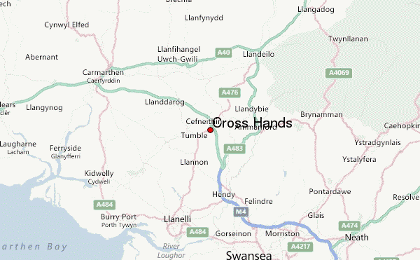

Physical resources
We will hire a shop fitting team and all interior is dealt with and fitted prior to management of the store the upkeep and layout will be kept at a high level of cleanliness and standard. Displays boards will be made to show case a range of floors.
The premises have the ability to house and display a range of wood and laminate as well as a carpet section which will optimize the choice for the customer and therefore enable a higher ratio of sales to be successful.
Conclusion
Action Plan
- To establish Cross Hands as a sector leading store.
Making a plan to establish Cross Hands as a sector leading store would be ideal. It would create more growth for the company and build the reputation of the company; it will attract more customers and bring in new ideas to expand the company.
- To create a reputation for impeccable customer service
Creating a good reputation for the company is first and most important. Good customer service will draw in more customers to the store. Having good customer service skills is vital as engaging with customers in an effective way could lead to big sales. Cross Hands Flooring company would offer excellence in this department as they both have previous experience with customers.
- To maximize sales by outreaching to traders
Maximizing sales is vital as it can attract traders and customers. Cross Hands Flooring Company would get in direct touch with different traders and exchange knowledge about the products we sell and what discounts we can give to traders.
- By leading by example and creating a popular brand
We will offer the best quality and value for money to keep customers returning and spreading the word.

SWOT Analysis
STRENGTHS  Experience  Fresh store with scope  Cross hands is up and coming  Fantastic location  High footfall | WEAKNESSES  Unknown site  No existing customer base
OPPORTUNITIES  Outreach  New site  100% customer focus (blank canvases) | THREATS  Leeks  Tops tiles  D G Heath Pontarddulais  Wood house Llanelli

Gannt chart

Reference list
1. Donovan, N (2018) MARKETING THEORIES – THE MARKETING MIX – FROM 4 PS TO 7 PS, Available at: https://www.professionalacademy.com/blogs-and-advice/marketing-theories---the-marketing-mix---from-4-p-s-to-7-p-s (Accessed: 31st October 2018).
2. Webfinance Inc (2018) what is partnership. available at: www.businessdictionary.com/definition/partnership.html (Accessed: 30th October 2018)

3.Investorswords (2018) Partnership. Available at: www.investorwords.com/3609/partnership.html (Accessed: 30th October 2018)

4. Keuilian, B. (2016) Partnership in business (video). Available at: https://youtu.be/fG_NBTeNN2s(Accessed: 30th October 2018)
5.(2017) Businesswalse, Available at: https://businesswales.gov.wales/businessfinance/types-finance-and-how-apply(Accessed: 2/11/18).

Appendices
Presentation slides

