Task 1

A production area in a factory measures 60 metres x 24 metres x 8 metres in height.
The factory’s work benches are set at a height of 1m above the floor level.
The area’s reflectances are 0.3 for the ceiling and 0.5 for the walls.
The Lighting design specifies Fluorescent lamps in recessed louvre with DLOR of 50%.
(The actual size for the luminaires is 1200mm (1.2m) in length and 200mm (0.2m) wide.)

A Lighting Design Lumen (LDL) output of 18,000 lumens is required.

The illumination required for the factory area is 200 lux at the working plane.
Light Loss Factor = 0.75

Calculations

- The Room Index

Room index = $\frac{(L x W)}{(Hm(L x W)}$
L = Length
W = width
Hm= height of luminaire from working plane

Room index = $\frac{(60 x 24)}{(7(60 + 24))}$ = $\frac{1440}{588}$ = 2.449

- The Utilization Factor (from table)
The Utilisation factor is = 0.46 as highlighted in the table below, the area’s reflectance’s are 0.3 for the ceiling and 0.5 for the walls.

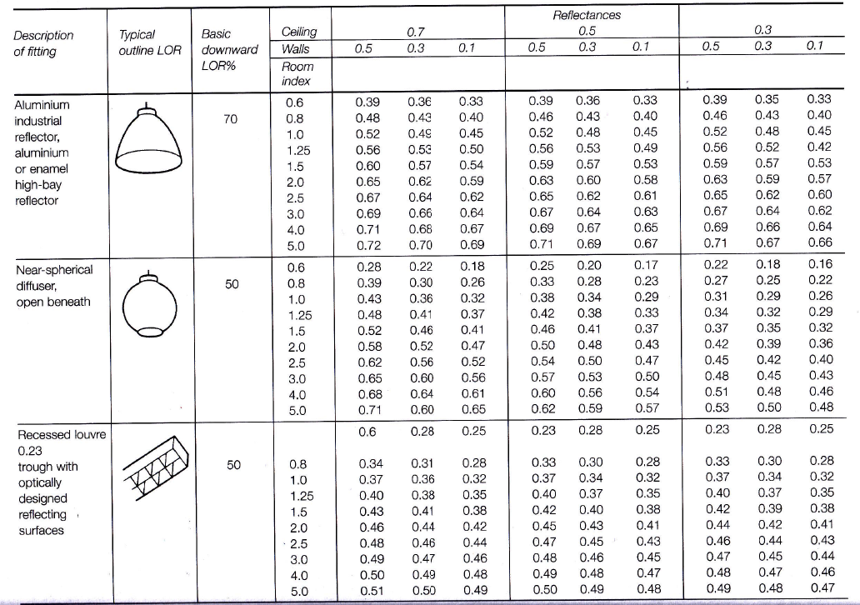

2

- The Number of lamps required

N = $\frac{E x A}{F x UF x LLF }$

N = number of lamps
E = illuminance required (lux) = 200
A = Area of working plane = 1440
F = average luminous flux from each lamp = 18000
UF = utilisation factor = 0.46
LLF = light lost factor = 0.75

N = $\frac{200 x 1440}{18000 x 0.46 x 0.75}$ = $\frac{288000}{6210}$ = 46.38

N= 47

- A suitable layout (value of S) for the lamp fittings

To provide the most suitable layout for the number of lamps would be to do a lay out 48 lamps please find the attached drawing.

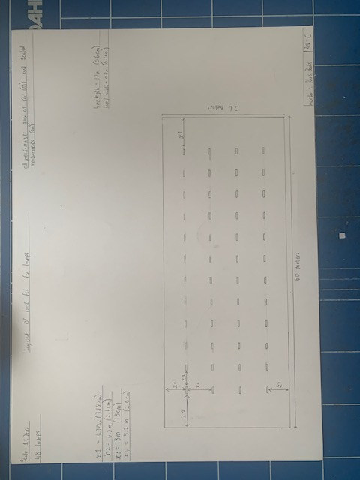

Task 2

- A brick wall of area 20m² contains a window of area 4m².

The values of sound reduction indexes are:
50dB for the brickwork and 10dB for the window.
Calculate the overall sound reduction index for the entire wall.

Sound Reduction Index Calculations
Brick work = SRI = 10 X ( LOG¹º(1/T1))
50 = 10 X (Log¹º(1/T1))
5 = (Log¹º(1/T1))
1/T1 = 10⁵
T1 = 10-⁵
T1 = 0.00001

Sound Reduction Index Calculations (continued)

Window = SRI = 10 X ( LOG¹º(1/T2))
10= 10 X (Log¹º(1/T2))
1= (Log¹º(1/T2))
1/T1 = 10¹
T1 = 10-¹
T1 = 0.1

T0 = $\frac{(T1 X A1) +( T2 X A2) }{A1 + A2 }$ = $\frac{(0.00001 x 16) + ( 0.1 x 4 ) }{16+4 }$ = $\frac{0.00016 +0.4}{20}$ = $\frac{0.40016}{20}$ = 0.020008

SRI = 10 x ( LOG¹º(1/T)) = 10 x (LOG¹º(1/0.020008) = 16.988 = 17 dB

- Discuss the implications of frequency and wavelength in internal sound management,
partition wall construction technique and insulation choice. (500 words)

Sound Definition

Sound can be defined as a pressure variation that the human ear can detect. Sound can be caused in many ways such as by moving objects (speakers, human vocal cords). The movement of air can also cause sound.

Sound has two major characteristics loudness and frequency, frequency is the variations in pressure that the sound makes while traveling through the air. The Loudness of the sound is due to size of the pressure variations that are made by the sound. The human ear can hear between 20 Hz and 20,000 Hz

Transmission/absorption & reflection

There are many factors that can affect the transmission, absorption & reflection of sound such as the property of the material that is used in the wall, size of wall, the wavelength of the sound.

Sound can travel through partition walls by transmission meaning it turns into a mechanical vibration. Sound transfer can be classified in 2 ways airborne & structure borne sound. Airborne travels from the source of the sound through the air. Structure borne sound travels through either by contact from the source of sound or impact of the sound hitting the material all structure borne sound must become airborne for the human ear to hear them.

The reason for this is sound travels by vibrating particles (due to the variations) for example in a plasterboard partition wall the sound would pass through the plasterboard quickly as the particles in the plasterboard are densely packed together. By adding insulation between the 2 skins of plasterboards slows the progression of sound through the wall. By the sound being slowed it loses its energy and eventually becomes quieter reducing the pressure in the variations it makes and travels slower through the particles.

Reflection

Reflection is sound waves being reflected (bounced) off one surface at a different angle.

In large rooms sound can be reflected off the surface of the barriers within the room, which can often lead to an ECHO. A echo is a sound that reflects more than 0.3 seconds after the original sound.

The shape of the wall can have an impact of the direction in which the sound travels, a curved wall will focus the sound to a certain direction depending on where on the wall the sound strikes. A convex wall will just disperse or spread the sound in an opposite direction.

Absorption
Absorption is the reduction of the sound energy as it has been reflected from a surface. To calculate the amount of sound, absorbed by a given material the absorption coefficient is used. See below table.
Absorption coefficient (a) = Absorbed sound energy
Incident sound energy

Partition wall construction

There are many different types of partition these partitions can reduce the amount of sound entering or leaving the room through the wall. The aspects of a wall that can affect how much sound travels through can be its construction materials, insulation, shape, if there are any windows or penetrations through the partition e.g services, doors.

A wall partition material will reduce the amount of sound that travels through it, the below is typical values that certain materials will reduce the sound by when it travels through it. See below table
Material | Amount of dB reduced
- Brick wall cavity | 53dB
- Solid brick wall | 50 dB
- Concrete block | 45 dB
- Plasterboard on timber stud | 35 dB
- Double glazed window with air gap | Up to 40 dB
- Single glazed window | Up to 25 dB

