What do you think the inclusion of ornament actually signifies, in architectural terms?

In this essay I will be comparing different types of movements within the architectural timeline to see how different ornament was used in the time periods, I will also be looking at how ornament is used from the past and to the present to see if the usage has changed in the types of buildings it would normally be used in, to help with this research I will be looking at contemporary architecture, modern architecture and the different types of ornament that you can use within a building.

What does ornament mean? as it can relate to many different things within architecture and also arts and crafts.

There are many different definitions of ornament due to it being able to describe many different kinds of objects or forms of art.

In the oxford dictionary they define “ornament” as

“a thing used or serving to make something look more attractive but usually having no practical purpose, especially a small object such as a figurine”

Also, “decoration added to embellish something”

Along with, “a quality or person adding grace, beauty, or honour to something.”

In conjunction with, “embellishments made to a melody.”

Even though the oxford dictionary gives these definitions for the word “ornament”, it suggests that to make the exterior or interior of a building look positive we add on to it. In all of the above definitions it implies that ornament adds something admirable to whatever it is attached to.

However, this isn’t the case, in most cases ornamentation is added to a building to sometimes give it symbolic meaning or even sometimes to show that it is a very important monument. For example, if you have a look at prisons and courts you will notice that on the ones around the UK will have a image placed above the entrance of each building, making sure that the public that enter this type of building either know what they are entering or even who owns that type of building.

There are many different types of architectural ornament these include, mimetic or imitative which is the type of ornament that has a definite meaning or symbolic significance, then you can have applied ornament which is when the designer intends to add an extra bit of beauty to the structure or building but is meant for aesthetic purpose only, for example the orders in Egypt have applied ornament due to the orders being very heavily decorated.

Meaning of ornament

Kent Bloomer who is a professor at Yale school of architecture suggests that ornament is a very specific type of visual element in architecture that is recognisable from symbol-making, illustration or articulating local space and structure. Even though ornament can include all of these agendas, ornament can engage multiple grounds at the same time by being erotic, soft and uncertain. With this in mind, ornament can address the physical building and the physics of the natural world around. Ornament can create space by settling and enlarging the transitions between elements such as, wall to ceiling, inside to outside, etc. you can say the purpose of ornament is to accomplish the conceivable of the architectural design in the public field.

Furthermore, Isabelle Frank who is an Associate Dean for the academic Affairs at The New School in New York (Frank 2008) questions the idea of the term ornament and suggests that it was implemented by the renaissance theorists as a way for them to describe the features between art and architecture. Isabelle Frank also suggests that ornament was around for several centuries until it was banished from the modernist architectural theory and practice.

Then you have Adolf Loos, who is an Austrian architect, who was one of the first to introduce this style in the Eclectic and Art Nouveau styles, he is considered that he influenced the Bauhaus and is also considered as one of the great pioneers of modern architecture. In Le Corbusier journal, Esprit Nouveau, he printed Adolf Loos texts which then Corb applied the ideologies of modest, pared-down style to the letter in the majority of his work in France.

Throughout Adrian Smalls’ thesis he refers to ornament as something that can entertain us or something that comes from something that we celebrate, can communicate with and can also be playful. But Adrian Small also argues that architecture is the public platform in which we can share our experience and enjoyment in a shared way (Small 2009).

Frank Lloyd Wright who was a well-known architect of the 20th century, considered ornament as an integral part of construction by saying

“elements of decoration and even musical instruments are integral parts of buildings, not annexes”.

From this we can see that Frank Lloyd Wright believed that ornament was an important part within the structure of the design.

Due to architecture always being a dishonest way of embodiment in life, we learn that buildings do not grow on their own as organisms or natural structures, however the designer can improve their skills by paying attention on the scales that evolve from their design decisions. Ornament within architecture can respond to the characteristics of the higher scale of the building.

Ornamentation can be found in many cultures which then other cultures will develop unique forms of decoration or modified ornament. In the culture of ancient Egypt, its said that they were the first to add pure ornament to their buildings; however you could say the prehistoric ages were the first to add ornamentation to their buildings even if it was just parietal art or cave art which they painted onto the walls of their rock shelters, in Egypt they would use or mimic natural forms such as plant like figures or animal figures, these would be used mainly on top of capitals of their columns and the walls of their buildings.

In the Assyrian culture you can see that they had influence from the Egyptian culture with their ornamentation by them also using plant like figures and animal figures the only difference is that the Assyrian culture used it more on their buildings.

Function of ornament

In order for architecture to be allowed to connect to the culture it needs mechanisms; this will happen when the architecture continually captures the forces that then shapes the society into material for the architecture to work with, the materiality then becomes a composite one which is then made up of different types of forces. Ornament then becomes the by product which transmits different unique affects ready for the architectural material.

Ornament is normally used within a building that particularly requires more attention than others, whether it's to take your attention from particular parts or if it's to emphasise other features of the building. Sometimes ornament will be used for places such as when a door meets a wall or when the façade touches the ground, these parts will then define the limit of a shape or object that has been well designed. If the designer uses construction methods that are hard to hide away, then ornamentation can disguise the apparent details that comes from them.

Ornament for the building can usually be carved from stone, wood or metals which then will be formed with plaster or clay and then sometimes will be painted or printed onto a surface and then that will be classed as applied ornament. When we put ornament into the building, we can either put it flat onto the surface of which you want, it can be incised below the surface and also raised about the surface depending on the desired look the designer is trying to achieve. Other examples of architectural ornament is antefix which is ornament that is carved at the eaves of the tiles covering the joints between them, then you have crocket which is curved foliage which is used at the edge of either a spire or a gable, you also have dogtooth ornamentation which is a carved pyramidal ornament which is mainly used in architecture in the 13th century England, another one is foliage which is leaf like detail on top of the object its being placed upon, an alternative one is frieze which is a type of ornament that consist of horizontal sculptured bands which can be seen between the architrave and the cornice, the final type of ornament is trefoil which is in the form of three arcs which is then arranged within a circle, you will mainly see this type of ornament as a type of window or even as just small cut outs within the building.

Within architecture ornament is normally created from a range of geometrical shapes and patterns, also plant like figures and human silhouettes and animal figures, if you were to use human silhouettes they are normally used very small within the ornament and the rest of the detail will be filled by other shapes and patterns.

The reason why designers use ornament within architecture could be that ornamentations purpose is to amplify the superiority within the building not to cover its inaccuracies. If the designers use ornament to cover up a bad design instead of using ornament to encourage the bad design this can then be classed as bad ornament.

Within architecture ornament is used to characterise a building and you could also say to show off its importance. Ornamentation will often be seen on entablatures, columns and especially on the tops of buildings such as near the eave of the roof or around the entrance of the building, almost as if it is giving you a guidance on how to move around the building and how you understand what part of the building, you’re in.

During the Renaissance and mostly later on for religious buildings, applying ornament was seemed as really important and showing that those particular buildings have symbolic meaning and a lot of importance.

Ornament is not necessarily needed within architecture but architects, designers and the public do continue to enjoy its presence within the buildings. Ornament in classical architecture was best known for crowning the magnificence of the building that it was on or in, during the classical period ornament was essential to be a part of the designing process. However, in the modern movement you had architects trying not to use ornament within their buildings as they also tried to move away from the classical building designs to try and come up with something newer.

The role of ornament at larger scales

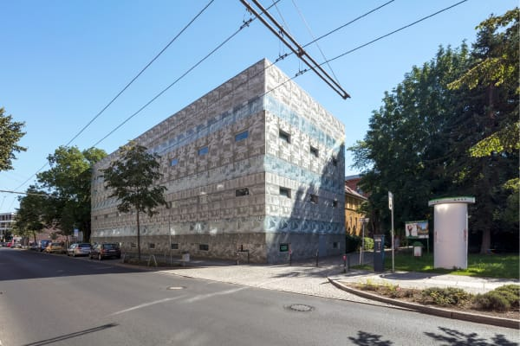
Figure 1 (Herzog & de Meuron Eberswalde Technical School Library)

If you look closely at Herzog & de Meuron, Eberswalde Technical School Library, 1997, you can see that the building is heavily ornamented, the façade of the building has photos printed into itself which was discovered by an artist called Thomas Ruff.

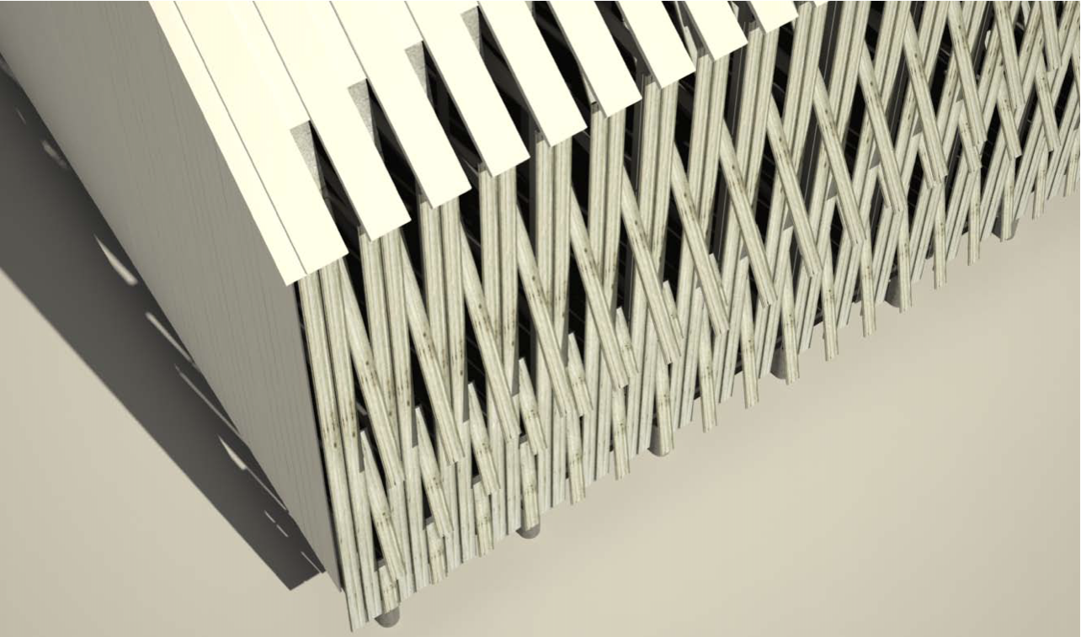
Figure 2 (Tobacco Barn Façade Design)

If you look closely at the Tobacco Barns Façade, ornamentation occurs naturally through the tactical assembly and active manipulation of the wooden slat system on the façade. With the façade having this type of ornamentation on it, it gains the façade thickness and volume due to its complex design, it has many different qualities that imbodies the overall design.
However, ornament can be designed and fabricated by many different people, this includes architects, artists and craftsman, it cannot be understood without looking at the various subjects that will be engaged in its fabrication and response.
From the past three periods ornamentation have been incorporated more into architectural designs, this is due to the frequent use of modern technology in project design. Architectural ornaments now differ from traditional ornaments due to them now appearing above all general feature of the building envelope rather than appearing as a component that has been added in a certain well-defined place of a design. In the 20th century ornament was connected to a wider discussion on how to come up with a new style representation on how to adapt to its environment that it will be in.
In conclusion, ornament signifies more than one element depending on what type of building it will be found in. Ornamentation can be taken as a mere expression or even sometimes a show of power, as it is developed over the centuries from cave art to technological designing of new buildings. With using the up to date technology that we know how we will be able to come up with more complex and interactive types of ornamentation that can suit most of the architecture that we have today. Overall, ornament can signify anything from showing a buildings religion, its power and its importance but not forgetting that ornament can also signify

References

COOMARASWAMY, A. K.

Ornament
Coomaraswamy, A., 1939. Ornament. The Art Bulletin, [online] 21(4), p.375. Available at: <https://www-jstor-org.ezproxy.uwtsd.ac.uk/stable/3046667?seq=4#metadata_info_tab_contents> [Accessed 5 March 2020].

FRANK, I.

Isabelle Frank - Is the Term Ornament Still Relevant Today? - Dezign Ark (Beta)
Frank, I., 2020. Isabelle Frank - Is The Term Ornament Still Relevant Today? - Dezign Ark (Beta). [online] Dezign Ark (Beta). Available at: <https://dezignark.com/blog/isabelle-frank-is-the-term-ornament-still-relevant-today/> [Accessed 7 February 2020].

MILLER, K.

organised crime: the role of ornament in contemporary architecture
Miller, K., 2020. Organised Crime: The Role Of Ornament In Contemporary Architecture. [online] Papers.cumincad.org. Available at: <http://papers.cumincad.org/data/works/att/acadiaregional2011_007.content.pdf> [Accessed 12 March 2020].

MOUSSAVI, F. AND KUBO, M.

The Function of Ornament - Harvard Graduate School of Design
Moussavi, F. and Kubo, M., 2006. The Function Of Ornament - Harvard Graduate School Of Design. [online] Harvard Graduate School of Design. Available at: <https://www.gsd.harvard.edu/publication/the-function-of-ornament-1/> [Accessed 12 January 2020].

ORNAMENTATION | ARCHITECTURE
Encyclopedia Britannica. 2020. Ornamentation | Architecture. [online] Available at: <https://www.britannica.com/topic/ornamentation-architecture> [Accessed 4 January 2020].

PICON, A.

Ornament
Picon, A., 2014. Ornament. Somerset: Wiley.

RE-THINKING THE CONCEPT OF "ORNAMENT" IN ARCHITECTURAL DESIGn
2020. Re-Thinking The Concept Of "Ornament" In Architectural Design. [Accessed 4 January 2020].

ROSENBAUER, W.

The Function of Ornament
Rosenbauer, W., 1947. The Function of Ornament. College Art Journal, 6(3), p.222.

STYLE AND ORNAMENTATION IN ARCHITECTURE
Slideshare.net. 2020. Style And Ornamentation In Architecture. [online] Available at: <https://www.slideshare.net/Anupamaholla1/style-and-ornamentation-in-architecture?qid=8da3d2df-c790-4f78-abbb-9e06ecc9916b&v=&b=&from_search=1> [Accessed 10 March 2020].

THE RETURN OF ORNAMENTATION IN ARCHITECTURE: FOR WHAT PURPOSE? TO EXPRESS WHAT?
Vmzinc.com. 2020. The Return Of Ornamentation In Architecture: For What Purpose? To Express What?. [online] Available at: <https://www.vmzinc.com/news78/10000275-the-return-of-ornamentation-in-architecture-for-what-purpose-to-express-what.html> [Accessed 12 March 2020].

WILKINSON, T. AND WILKINSON, T.

‘Ornament is the language through which architecture communicates with a broader public’
Wilkinson, T. and Wilkinson, T., 2020. ‘Ornament Is The Language Through Which Architecture Communicates With A Broader Public’. [online] Architectural Review. Available at: <https://www.architectural-review.com/essays/ornament/ornament-is-the-language-through-which-architecture-communicates-with-a-broader-public/8687822.article> [Accessed 23 December 2019].

WORK, D.

How Ornament is Functional
Work, D., 2020. How Ornament Is Functional. [online] dreams work. Available at: <http://www.mariavera.nl/portfolio/how-ornament-is-functional/> [Accessed 12 February 2020].

