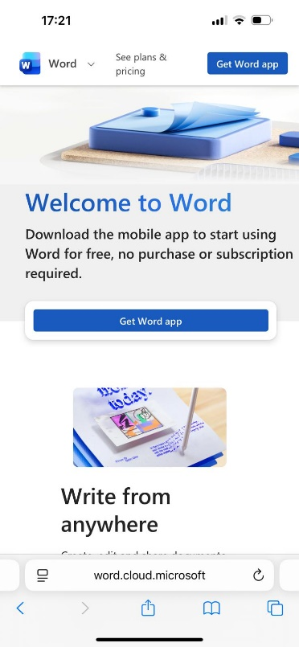
Microsoft Word Tools.
Microsoft Word is an essential features and utilities which is used to write, edit, format and collaborate on documents and reports using smart editors, formatting menus, and AI.
I choose this tool because I feel confident using it and because it is important for different kinds of reports which helps all types of users finish their tasks properly and easily.
I used information about the multi usage of the word tool, like creating, editing and formatting different types of documents.
I used the Microsoft website for the information because, I believe that it will be more professional, real, correct, and well organized.
Also, it allows users to do a wide range of documents from the easiest to the very difficult.
- [Learning the basics of working with word tool from Microsoft is very important because it has a deep range of options and features, for example you can take year to master, but it is also easy to get up and running a simple document] -. Referencing;
Brazzi, N, (2021) “Learning word desktop Microsoft 365”, - LinkedIn.com.
The changed what I made is that I tried to use a simple and proper information to make it easier and more effective.
Finaly the Word tool is one of the best Microsoft tools because it helps billions of people, students, teachers, universities, organizations, businesses and………etc do their reports and organized their documents quickly, smoothly and easy.

